Iridoviroses

Including gill necrosis virus, oyster velar virus disease, gill disease of Portuguese oysters and blister disease

From Aquatic animal diseases significant to Australia: identification field guide, 5th edition
Figure 1 Gill necrosis virus in oyster
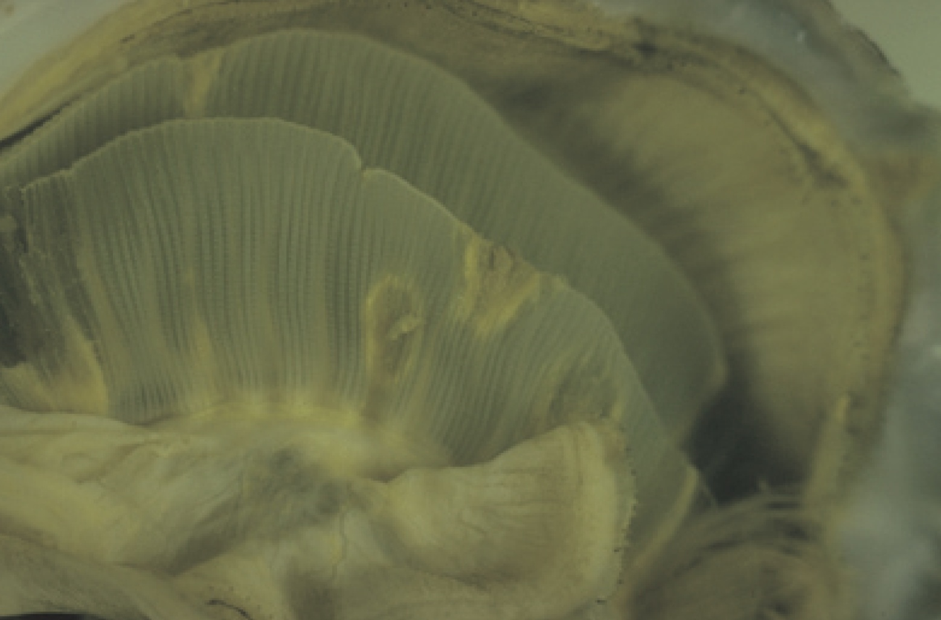
Note: Visible multifocal necrotic yellow or brown lesions in the gill tissue.
Source: D Alderman

Signs of disease
Important: Animals with this disease may show one or more of these signs, but the pathogen may still be present in the absence of any signs.
Disease signs at the farm, tank or pond level are:
- high mortality.
Gross pathological signs are:
- yellow or green pustules on mantle or adductor muscle
- yellow spots on gills and labial palps that spread as the disease progresses
- spots that increase in size and develop brown centres as the tissue dies, leaving a hole in the gill structure.
Microscopic pathological signs are:
- necrosis of gill or labial palp tissue
- massive haemocytic cellular infiltration around lesions
- basophilic cytoplasmic inclusions found in most lesions.

Disease agent
Iridoviroses are diseases caused by infection with one of several iridoviruses. Infections include gill necrosis virus, an icosahedral deoxyribonucleic acid (DNA) virus with affinities with the Iridoviridae.

Host range
Various species of oysters are known (or suspected) to be susceptible to infection with iridoviruses. It is reasonable to assume that the Sydney rock oyster (Saccostrea glomerata) is susceptible.
Table 1 Species known or suspected to be susceptible to infection with iridoviruses
Common name | Scientific name
European flat oysterª | Ostrea edulis
Pacific oysterª | Crassostrea gigas
Portuguese oysterª | Crassostrea angulata
Sydney rock oyster | Saccostrea glomerata
a Naturally susceptible. Note: Other species are suspected to be susceptible.

Presence in Australia
Exotic disease—not recorded in Australia.
Map 1 Presence of iridoviroses, by jurisdiction
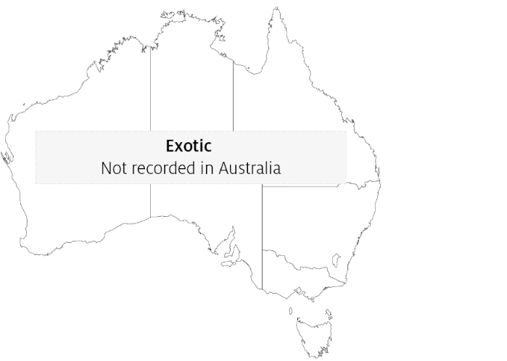

Epidemiology
- A number of iridoviruses that cause disease in oysters have been identified. Not all are associated with gill necrosis and some affect oysters at different life stages.
- Horizontal transmission occurs directly via the water column through the surface of the gills.
- Little is known about the distribution of the organisms responsible for this condition, but molluscan iridoviruses are generally considered to be distributed in oceans worldwide.
- A protist, Thankatostrea polymorpha in the phylum Sarcomastigophora, has also been associated with this disease.
- Outbreaks usually occur in spring and sometimes in summer.
- Surviving oysters do not repair perforated gill structures and are potential carriers of the virus.

Differential diagnosis
The list of similar diseases in the next section refers only to the diseases covered by this field guide. Gross pathological signs may also be representative of diseases not included in this guide. Do not rely on gross signs to provide a definitive diagnosis. Use them as a tool to help identify the listed diseases that most closely account for the observed signs.

Similar diseases
Infection with ostreid herpesvirus-1 microvariant (OsHV-1 µvar).

Sample collection
Only trained personnel should collect samples. Using only gross pathological signs to differentiate between diseases is not reliable, and some aquatic animal disease agents pose a risk to humans. If you are not appropriately trained, phone your state or territory hotline number and report your observations. If you have to collect samples, the agency taking your call will advise you on the appropriate course of action. Local or district fisheries or veterinary authorities may also advise on sampling.

Emergency disease hotline
See something you think is this disease? Report it. Even if you’re not sure.
Call the Emergency Animal Disease Watch Hotline on 1800 675 888. They will refer you to the right state or territory agency.

Further reading
CEFAS International Database on Aquatic Animal Diseases Infection with Irido-like virosis
Fisheries and Oceans Canada Gill disease of Portuguese oyster
Fisheries and Oceans Canada Oyster velar virus disease
These hyperlinks were correct at the time of publication.

Contact details
Emergency Animal Disease Watch Hotline 1800 675 888
Email AAH@agriculture.gov.au
Website agriculture.gov.au/pests-diseases-weeds/aquatic
© Commonwealth of Australia 2020
This work is copyright. It may be reproduced in whole or in part subject to the inclusion of an acknowledgement of the source and no commercial usage or sale.

