Koi herpesvirus disease (KHVD)

Also known as carp interstitial nephritis, gill necrosis virus, infection with koi herpesvirus (KHV) and infection with cyprinid herpesvirus 3 (CyHv3)

From Aquatic animal diseases significant to Australia: identification field guide, 5th edition
Figure 1 Koi carp (Cyprinus carpio) with gross lesions associated with KHVD
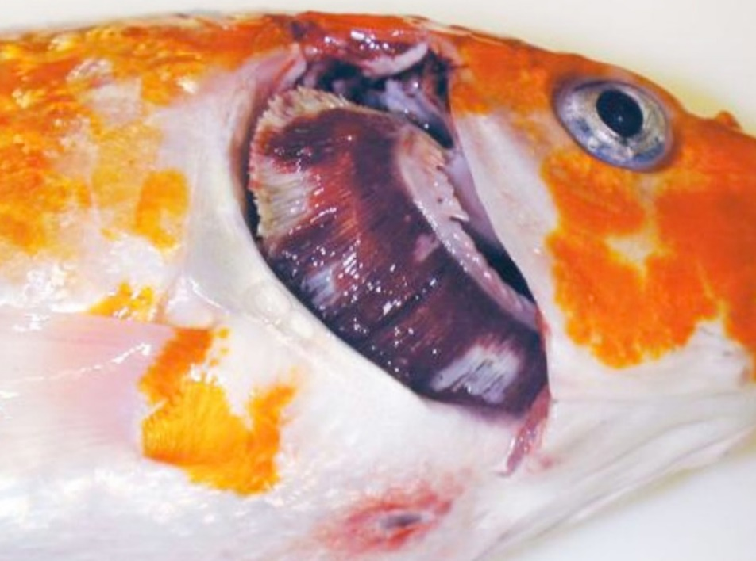
Note: Operculum is removed showing mottled red (haemorrhage) and white (necrosis) gill, sunken eyes and a single ulcer on the ventral skin.
Source: E Johnson

Signs of disease
Important: Animals with this disease may show one or more of these signs, but the pathogen may still be present in the absence of any signs.
Disease signs at the farm, tank or pond level are:
- mass mortalities, with many dead and moribund fish floating at the surface
- disorientation and erratic swimming behaviour (sometimes hyperactivity)
- fish coming to the surface and gasping
- fish separated from the shoal.
Gross pathological signs are:
- pale patches on the skin
- overproduction or underproduction of mucous on the skin and gills
- superficial branchial (gill) and skin haemorrhages
- endophthalmia (sunken eyes), erosion of the fins (occasionally), and blistering of the skin
- severe gill necrosis and/or erosion, seen as red and white patches
- focal or generalised loss of skin
- adhesions in the abdominal cavity and abnormal colouration of internal organs (lighter or darker or mottled)
- enlargement and surface haemorrhages of the kidney and liver.
Microscopic pathological signs are:
- inflammation and necrosis of gill tissues, and adhesion of gill filaments
- nuclear swelling, margination of chromatin and pale eosinophilic intranuclear inclusions of the epithelium
- non-specific inflammation and necrosis in other organs.

Disease agent
KHVD is caused by infection with koi herpesvirus (KHV), also known as cyprinid herpesvirus 3 (CyHv3), a virus classified as a member of the family Alloherpesviridae within the genus Cyprinivirus.

Host range
Naturally occurring KHV infections have only been recorded from common carp (Cyprinus carpio) and varieties of this species (such as koi carp). Goldfish × common carp hybrids, produced by hybridising male goldfish with female carp, have been reported to show some susceptibility to KHV infection.
Several fish species have been described as asymptomatic carrier species. These show no clinical signs of KHVD after natural or experimental exposure to KHV, but carry viral DNA, allowing them to potentially act as vectors of the disease. Viral DNA has been also been detected in two non-fish species, amphipods (Gammarus pulex) and swan mussels (Anodonta cygnea), making them potential vectors.
Table 1 Species known to be naturally susceptible to KHVD
Common name | Scientific name
Common carp and koi carp | Cyprinus carpio
Table 2 Potential carriers
Common name | Scientific name
Atlantic sturgeon | Acipenser oxyrinchus
Common roach | Rutilus rutilus
Crucian carp | Carassius carassius
Eurasian ruffe | Gymnocephalus cernua
Goldfish or shubunkin | Carassius auratus
Grass carp | Ctenopharyngodon idella
Ide | Leuciscus idus
Redfin or European perch | Perca fluviatilis
Russian sturgeon | Acipenser gueldenstaedtii
Silver carp | Hypophthalmichthys molitrix
Tench | Tinca tinca
Table 3 Non-fish carriers
Common name | Scientific name
Amphipods | Gammarus pulex
Swan mussels | Anodonta cygnea

Presence in Australia
Exotic disease—not recorded in Australia.
KHV has not been recorded from Australia, and is considered exotic. The potential use of KHV as a biological control for introduced populations of European carp is being investigated.
Map 1 Presence of KHV, by jurisdiction
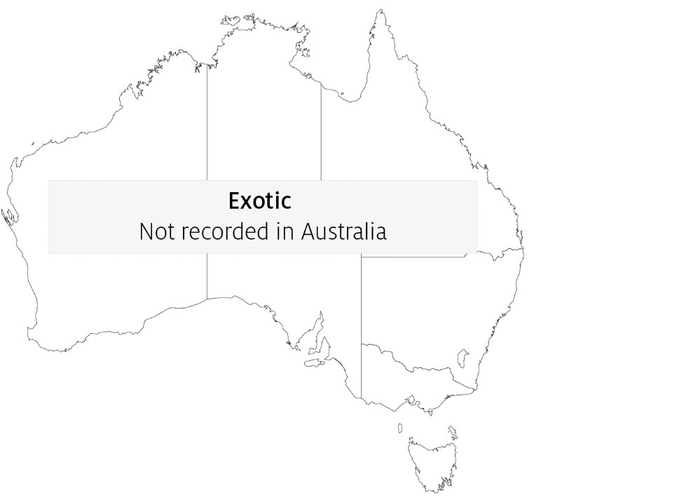

Epidemiology
- An outbreak of KHVD in Japan during the spring of 2004 occurred in wild carp populations in water temperatures of 15 to 16°C. Most of the dead fish were adult. In the field, it appears that adult carp are more susceptible than juveniles.
- The virus may survive at low temperatures (5°C), but the temperature range for disease outbreaks is primarily between 16°C and 25°C. Mortalities commonly appear between 22°C and 25°C, with few at temperatures above 30°C.
- The disease affects all age classes of common and koi carp, occurring in fingerlings, juveniles and adults.
- Moving infected fish from cool (13°C) to warm (23°C) water results in rapid onset of mortality.
- Mortality rates can vary between 70% and 100%.
- Reservoirs of KHV are clinically infected fish and covert carriers. Virus is shed via faeces, urine, gills and skin mucus.
- Transmission of KHV is horizontal, mainly via water, but possibly via animal vectors and fomites.
- Vertical transmission cannot be excluded as a possible transmission route.
- Secondary gill infections (including Flavobacterium columnare and Aeromonas spp.) are often associated with KHV infection.

Differential diagnosis
The list of similar diseases in the next section refers only to the diseases covered by this field guide. Gross pathological signs may also be representative of diseases not included in this guide. Do not rely on gross signs to provide a definitive diagnosis. Use them as a tool to help identify the listed diseases that most closely account for the observed signs.

Similar diseases
Infection with Aeromonas salmonicida—atypical strains, infection with Aphanomyces invadans (EUS) and spring viraemia of carp (SVC).

Sample collection
Only trained personnel should collect samples. Using only gross pathological signs to differentiate between diseases is not reliable, and some aquatic animal disease agents pose a risk to humans. If you are not appropriately trained, phone your state or territory hotline number and report your observations. If you have to collect samples, the agency taking your call will advise you on the appropriate course of action. Local or district fisheries or veterinary authorities may also advise on sampling.

Emergency disease hotline
See something you think is this disease? Report it. Even if you’re not sure.
Call the Emergency Animal Disease Watch Hotline on 1800 675 888. They will refer you to the right state or territory agency.

Further reading
CABI Invasive Species Compendium Koi herpesvirus disease
CEFAS International Database on Aquatic Animal Diseases Koi herpesvirus disease
World Organisation for Animal Health Manual of diagnostic tests for aquatic animals
These hyperlinks were correct at the time of publication.

Contact details
Emergency Animal Disease Watch Hotline 1800 675 888
Email AAH@agriculture.gov.au
Website agriculture.gov.au/pests-diseases-weeds/aquatic
© Commonwealth of Australia 2020
This work is copyright. It may be reproduced in whole or in part subject to the inclusion of an acknowledgement of the source and no commercial usage or sale.

