Anatomy

Molluscs

Abalone
Figure 1 Anatomy of abalone (Haliotis sp.)—ventral view
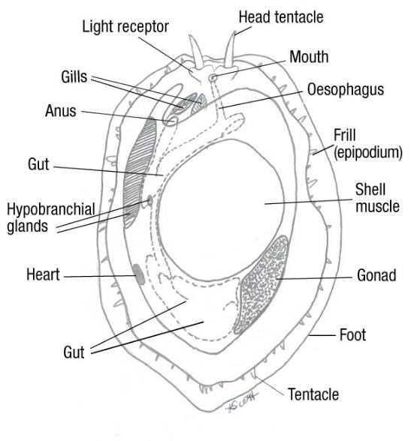
Source: K Scott
Figure 2 Anatomy of abalone (Haliotis sp.)—dorsal view
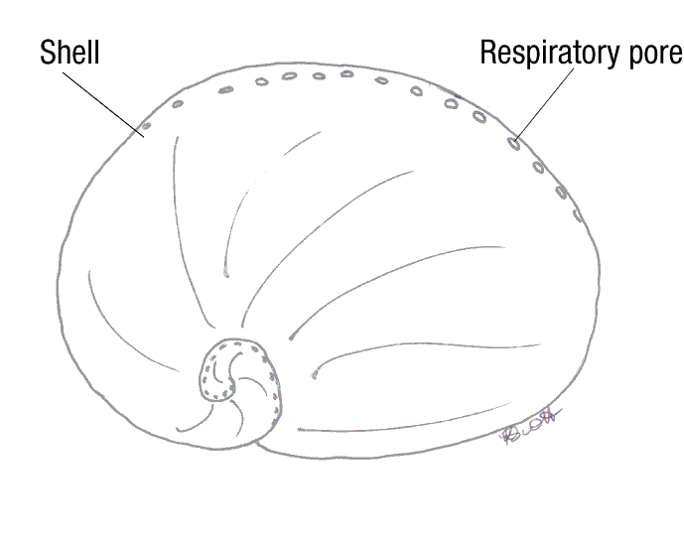
Source: K Scott
Figure 3 Abalone variations—ventral view
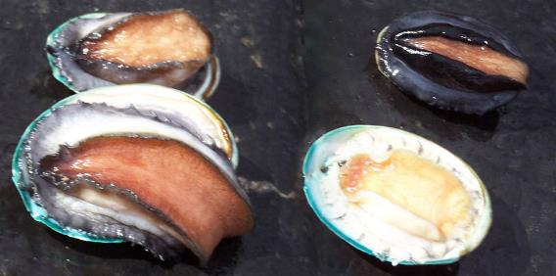
Note: Greenlip abalone, Haliotis laevigata (left). Blacklip abalone, Haliotis rubra (top right). Hybrid tiger abalone, Haliotis laevigata × H. rubra (bottom right).
Source: K Scott

Oysters
Figure 4 General anatomy of oyster (Ostrea sp.)
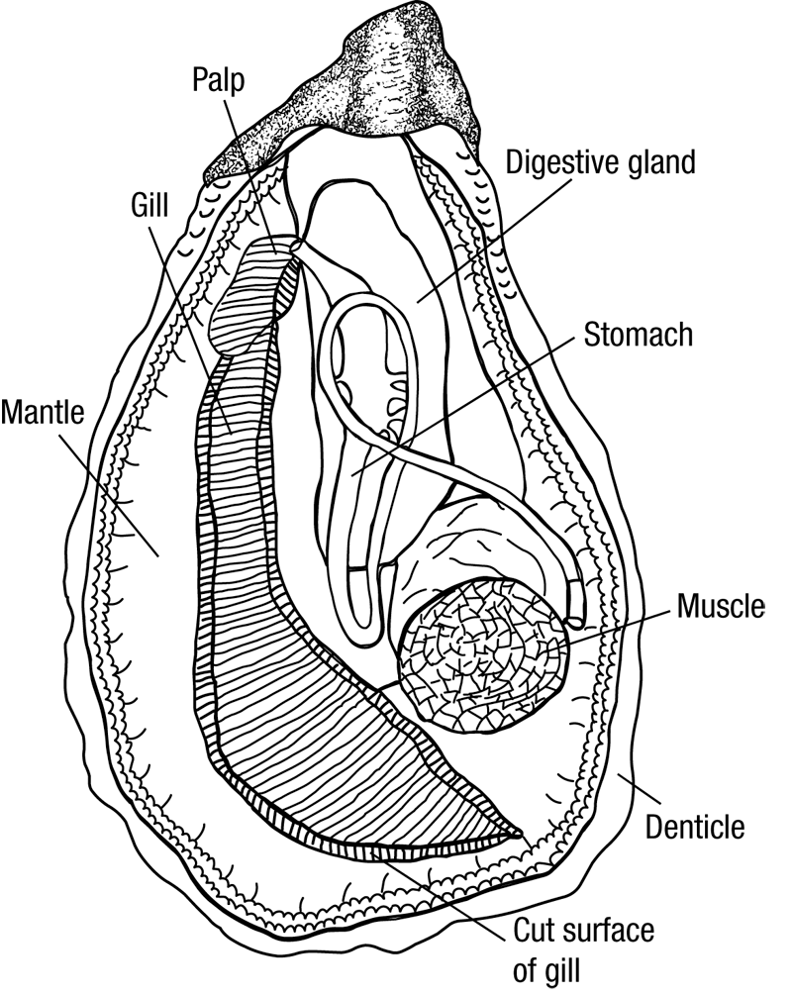
Source: Australian Government Department of Agriculture, Water and the Environment
Figure 5 Healthy European flat oyster (Ostrea edulis)
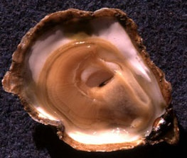
Source: I Arzul, French Research Institute for Exploration of the Sea

