Monodon slow growth syndrome (MSGS)

Including infection with Laem-Singh virus (LSNV)

From Aquatic animal diseases significant to Australia: identification field guide, 5th edition
Figure 1 Deformity of Penaeus monodon with MSGS
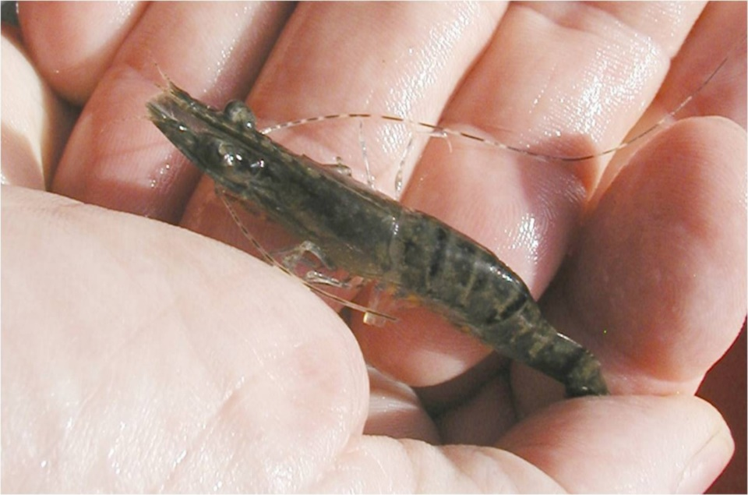
Note: Stunted growth and bamboo shaped abdominal segments.
Source: DV Lightner
Figure 2 Hepatopancreas of Penaeus monodon with MSGS
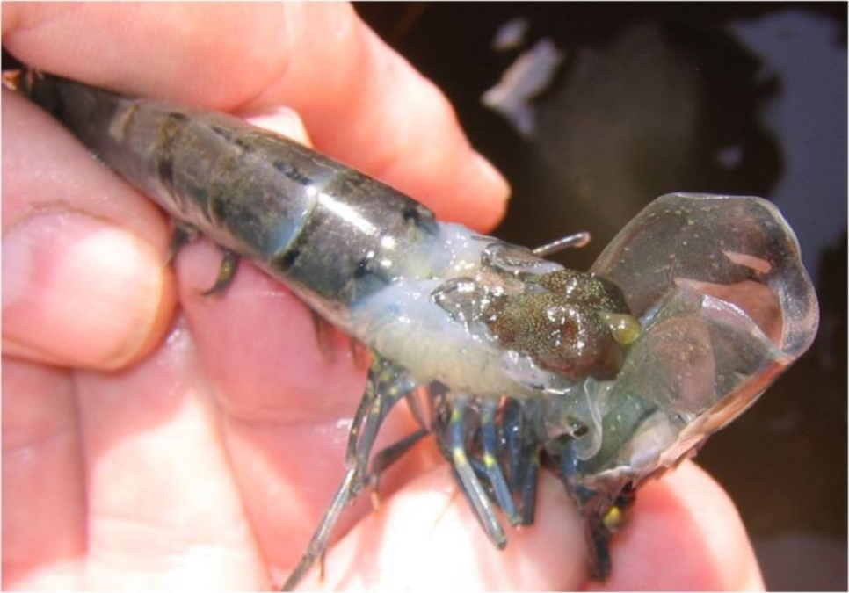
Note: Carapace lifted to show abnormal hepatopancreas.
Source: DV Lightner
Figure 3 Unusual markings on carapace of Penaeus monodon with MSGS
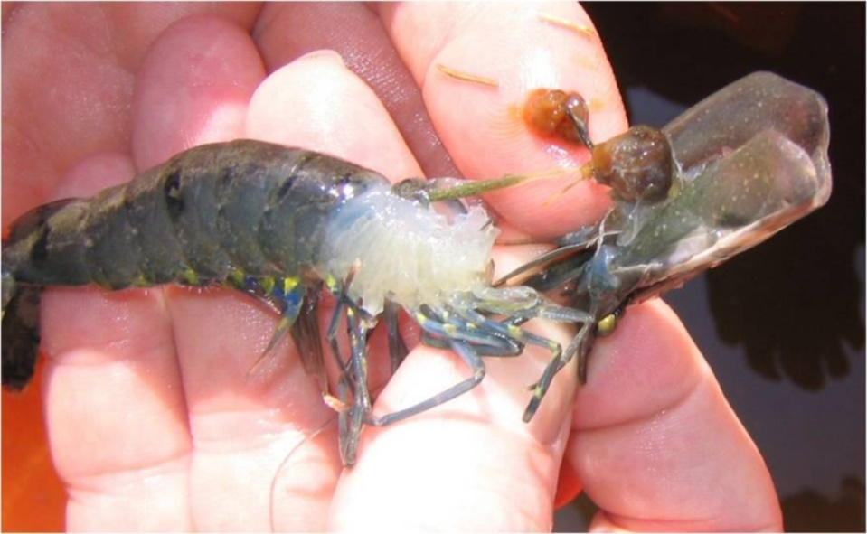
Note: Bright yellow markings on near legs.
Source: DV Lightner

Signs of disease
Important: Animals with this disease may show one or more of these signs, but the pathogen may still be present in the absence of any signs.
Disease signs at the farm, tank or pond level are:
- abnormally slow growth, resulting in irregularly sized prawns
- low average daily weight gain of less than 0.1g/day at 4 months of age.
Gross pathological signs are:
- unusually dark colour
- unusually bright yellow markings
- brittle antennae
- bamboo-shaped abdominal segments.
There are no definitive microscopic pathological signs.

Disease agent
MSGS is a disease associated with the Laem-Singh virus (LSNV). The complete aetiology for MSGS is uncertain and there is no clear case definition for this syndrome. A working case definition for surveillance and data gathering purposes is listed in the epidemiology section. A key component is the positive detection of LSNV by RT-PCR; LSNV is considered a necessary but insufficient component cause. Known pathogens are unlikely to be the cause of MSGS. Previous trials have indicated that a filterable infectious agent is involved.

Host range
Table 1 Species known to be susceptible to MSGS
Common name | Scientific name
Black tiger prawn | Penaeus monodon
a Naturally susceptible.

Presence in Australia
Exotic disease—not recorded in Australia.
Map 1 Presence of MSGS, by jurisdiction
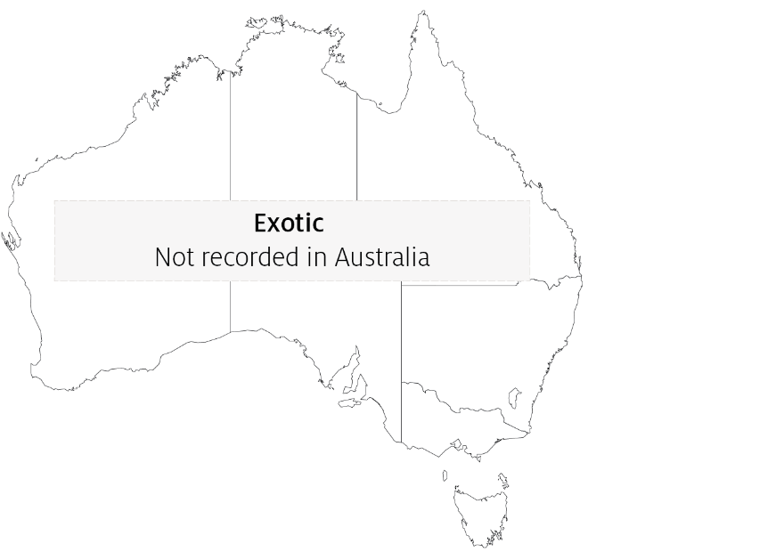

Epidemiology
- The cause of MSGS is uncertain, but a working case definition allows for suspected case data to be collected if the population:
  - tests positive for Laem-Singh virus
  - has a coefficient of variation of more than 35% by weight
  - is free from hepatopancreatic parvovirus infection or any other hepatopancreatic infection
  - shows 3 of the signs of disease listed here.
- In countries where the Pacific white shrimp (Penaeus (Litopenaeus) vannamei) has already been introduced, Pacific white shrimp and black tiger prawns (Penaeus monodon) should be reared separately. This is particularly important at the maturation and hatchery phases.

Differential diagnosis
The list of similar diseases in the next section refers only to the diseases covered by this field guide. Gross pathological signs may also be representative of diseases not included in this guide. Do not rely on gross signs to provide a definitive diagnosis. Use them as a tool to help identify the listed diseases that most closely account for the observed signs.

Similar diseases
No diseases listed in this field guide are similar to Monodon slow growth syndrome.

Sample collection
Only trained personnel should collect samples. Using only gross pathological signs to differentiate between diseases is not reliable, and some aquatic animal disease agents pose a risk to humans. If you are not appropriately trained, phone your state or territory hotline number and report your observations. If you have to collect samples, the agency taking your call will advise you on the appropriate course of action. Local or district fisheries or veterinary authorities may also advise on sampling.

Emergency disease hotline
See something you think is this disease? Report it. Even if you’re not sure.
Call the Emergency Animal Disease Watch Hotline on 1800 675 888. They will refer you to the right state or territory agency.

Further reading
Network of Aquaculture Centres in Asia-Pacific ‘Monodon’ slow growth syndrome and Laem-Singh virus retinopathy: disease card
Poornima, M, Seetang-Nun, Y, Alavandi, SV & Dayal, J 2012, Laem-Singh virus: A probable etiological agent associated with Monodon slow growth syndrome in farmed black tiger shrimp (‘Penaeus monodon’), Indian Journal of Virology, vol. 23.
These hyperlinks were correct at the time of publication.

Contact details
Emergency Animal Disease Watch Hotline 1800 675 888
Email AAH@agriculture.gov.au
Website agriculture.gov.au/pests-diseases-weeds/aquatic
© Commonwealth of Australia 2020
This work is copyright. It may be reproduced in whole or in part subject to the inclusion of an acknowledgement of the source and no commercial usage or sale.

