Piscirickettsiosis

Also known as infection with Piscirickettsia salmonis, salmonid rickettsial septicaemia

From Aquatic animal diseases significant to Australia: identification field guide, 5th edition
Figure 1 Piscirickettsiosis in Atlantic salmon (Salmo salar)
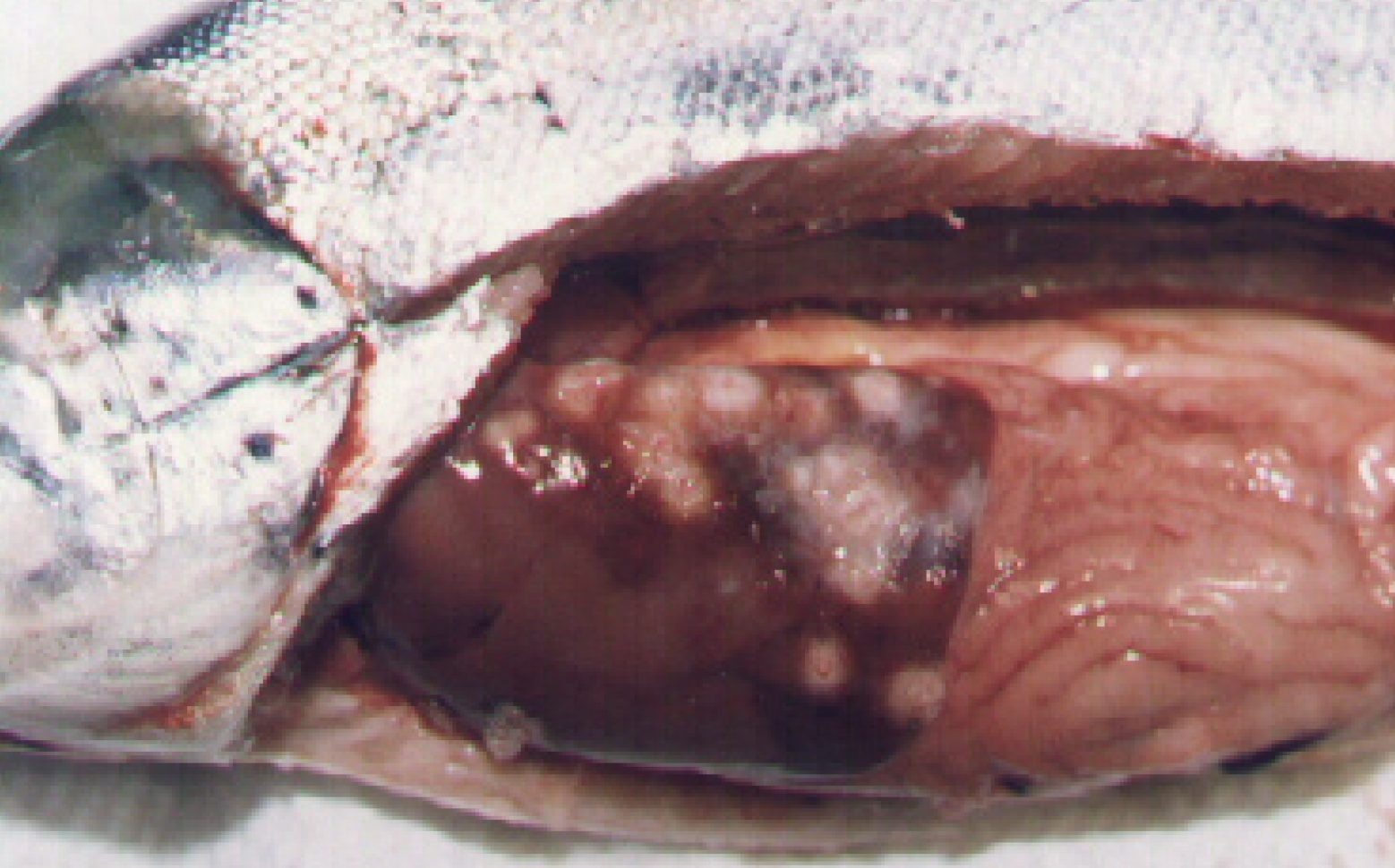
Note: Pale circular granulomas in liver and pinpoint haemorrhaging in pyloric caeca.
Source: S Bravo

Signs of disease
Important: Animals with this disease may show one or more of these signs, but the pathogen may still be present in the absence of any signs.
Disease signs at the farm, tank or pond level are:
- increased mortality
- loss of appetite
- emaciation
- lethargic swimming
- circling
- swimming near the surface or at the sides of the net or pens.
Gross pathological signs are:
- progressive skin lesions that range from areas of raised scales, to white raised plaques, to shallow ulcers on flanks and head
- darkening of skin and pale gills
- swollen abdomen
- grey, swollen spleen and kidney
- mottled liver (due to diffuse haemorrhages) or ring-shaped white to pale-yellow lesions (granulomas and areas of necrosis)
- ascites (fluid in the abdominal cavity)
- signs of peritonitis, including generalised diffuse inflammation of abdominal organs, adhesions and increased volume of free abdominal fluid
- petechial (pinpoint) haemorrhages of the gastrointestinal tract, swim bladder and visceral fat.
Microscopic pathological signs are:
- vasculitis and necrosis of the liver and kidney; inflammatory macrophage infiltration
- Rickettsia-like organisms in macrophages and epithelial cells.

Disease agent
Piscirickettsiosis (also known as salmonid rickettsial septicaemia) is caused by infection with the bacterium Piscirickettsia salmonis, a member of the gammaproteobacteria, family Piscirickettsiaceae.

Host range
Table 1 Species known to be susceptible to piscirickettsiosis
Common name | Scientific name
Atlantic salmonª | Salmo salar
Black spot grouper | Epinephelus melanostigma
Chinook salmonª | Oncorhynchus tshawytscha
Coho salmonª | Oncorhynchus kisutch (most susceptible)
European seabassª | Dicentrarchus labrax
Masu salmonª | Oncorhynchus masou
Muskellunge | Esox masquinongy
Pink salmonª | Oncorhynchus gorbuscha
Rainbow troutª | Oncorhynchus mykiss
Tilapias | Various genera and species
White seabass | Atractoscion nobilis
Yellow perch | Perca flavescens
a Susceptible to infection by Piscirickettsia salmonis. Note: Other species listed are infected by Piscirickettsia-like organisms.

Presence in Australia
Exotic disease—not recorded in Australia.
Piscirickettsiosis caused by P. salmonis has never been recorded in Australia and is considered exotic. However, Atlantic salmon cultured in seacages in Tasmania have been infected by a Piscirickettsia-like organism (Tas-RLO).
Map 1 Presence of Piscirickettsia salmonis, by jurisdiction
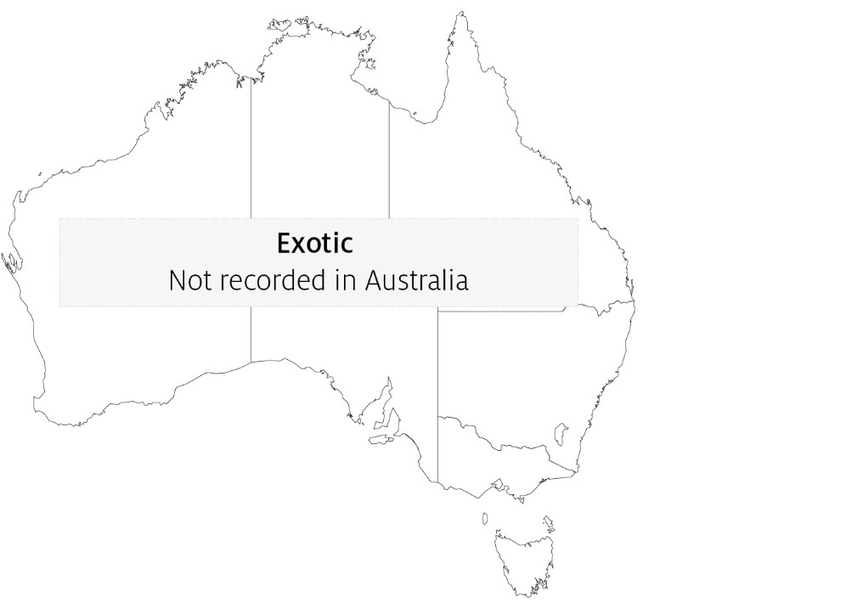

Epidemiology
- Salmonid rickettsial septicaemia describes diseases of salmonids caused by Rickettsia-like organisms, including P. salmonis. Piscirickettsiosis refers to the disease specifically caused by the bacterium P. salmonis. Related Piscirickettsia-like organisms can infect and cause disease in a range of fish species including cultured salmonids in Australia and New Zealand, tilapias cultured in waters up to 26°C in several countries, and white seabass and muskellunge in the USA.
- Outbreaks usually occur after fish are introduced to saltwater pens at water temperatures between 12°C and 18°C.
- Transmission is mainly horizontal (fish to fish). However, P. salmonis has been isolated from the reproductive organs of salmonids, and vertical transmission may explain outbreaks of this disease in freshwater areas following return of adult salmon from the sea to spawn.
- Bacteria are assumed to gain entry by breaching the physical barriers of the skin or gills. The invading bacteria then spread throughout the body via the blood (haematogenous spread), resulting in septicaemia.
- Mortality rates typically range between 10% and 30%, but have been recorded at 90% in seawater-raised coho salmon from Chile.

Differential diagnosis
The list of similar diseases in the next section refers only to the diseases covered by this field guide. Gross pathological signs may also be representative of diseases not included in this guide. Do not rely on gross signs to provide a definitive diagnosis. Use them as a tool to help identify the listed diseases that most closely account for the observed signs.

Similar diseases
Bacterial kidney disease (BKD) and infection with HPR-deleted or HPR0 infectious salmon anaemia virus.

Sample collection
Only trained personnel should collect samples. Using only gross pathological signs to differentiate between diseases is not reliable, and some aquatic animal disease agents pose a risk to humans. If you are not appropriately trained, phone your state or territory hotline number and report your observations. If you have to collect samples, the agency taking your call will advise you on the appropriate course of action. Local or district fisheries or veterinary authorities may also advise on sampling.

Emergency disease hotline
See something you think is this disease? Report it. Even if you’re not sure.
Call the Emergency Animal Disease Watch Hotline on 1800 675 888. They will refer you to the right state or territory agency.

Microscope images
Figure 2 Piscirickettsiosis in Atlantic salmon (Salmo salar)
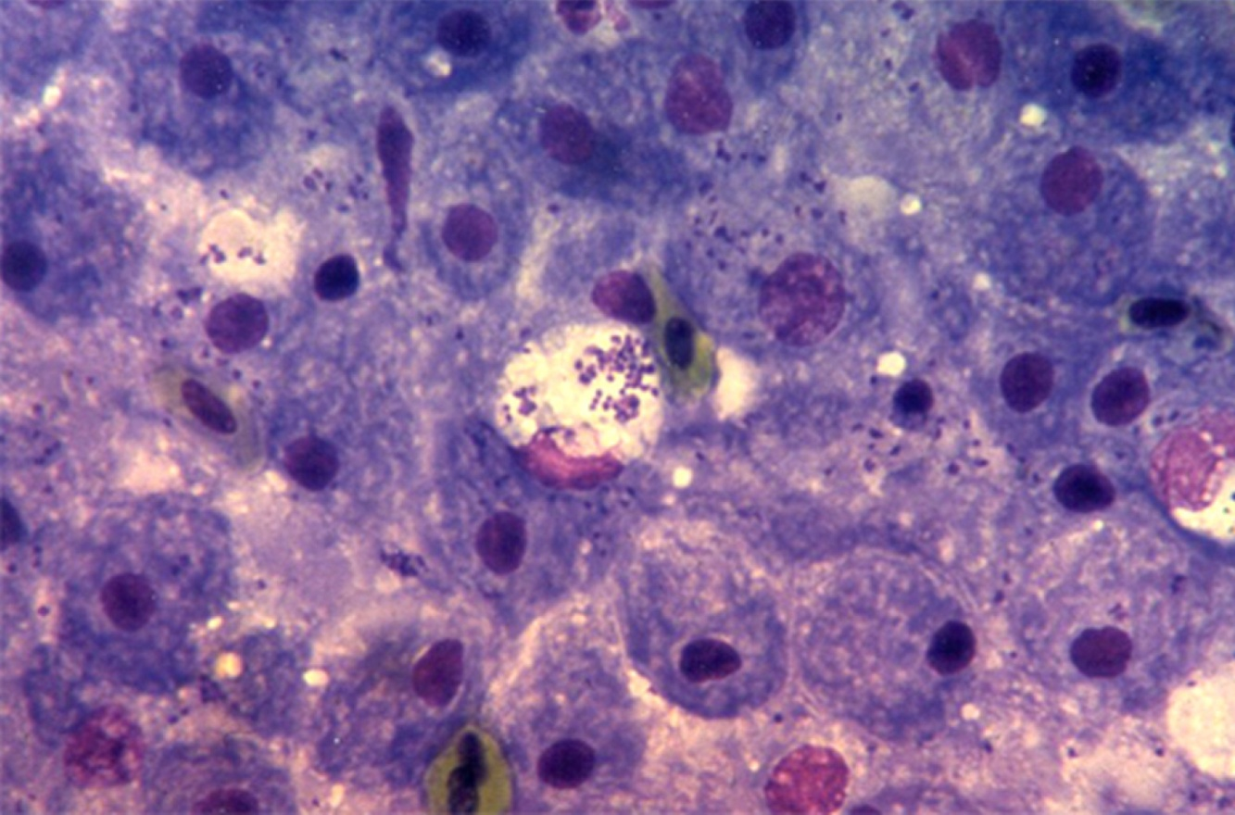
Note: Many bacteria (P. salmonis) evident in the tissue imprint.
Source: European Association of Fish Pathologists
Figure 3 Stained blood smear from Atlantic salmon (Salmo salar) with piscirickettsiosis
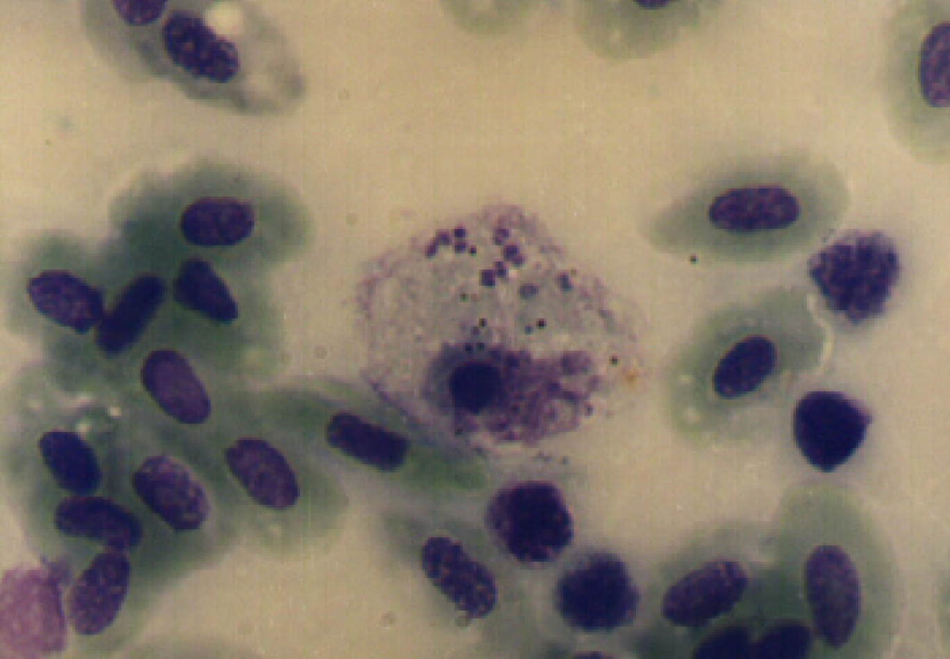
Note: Several P. salmonis bacteria evident in the cytoplasm of an inflammatory cell.
Source: S Bravo
Figure 4 Stained blood smear from Atlantic salmon (Salmo salar) with piscirickettsiosis
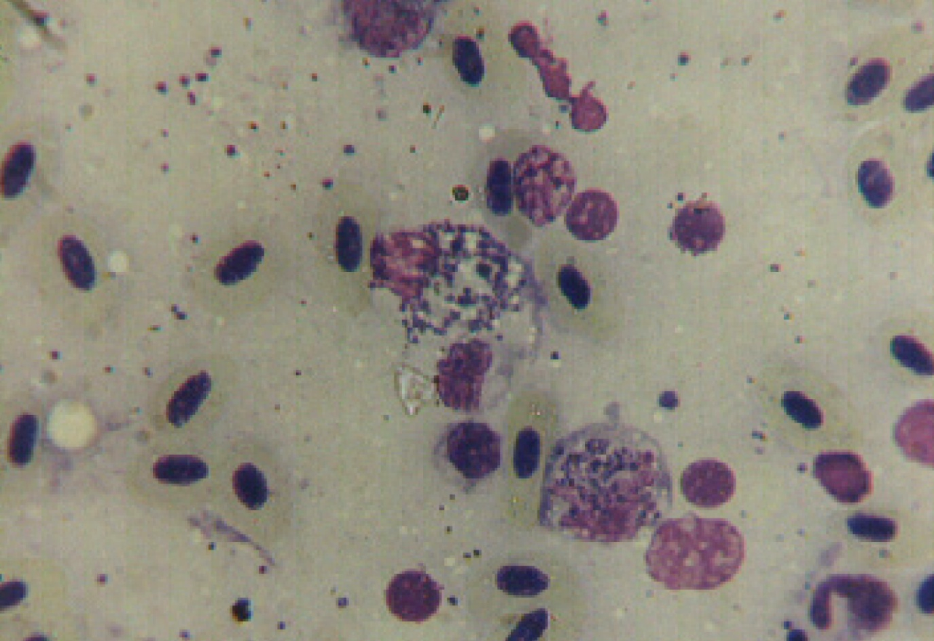
Note: Large numbers of P. salmonis evident within several inflammatory cells.
Source: S Bravo

Further reading
CABI Invasive Species Compendium Piscirickettsiosis
CEFAS International Database on Aquatic Animal Diseases Piscirickettsiosis
Department of Agriculture, Water and the Environment AQUAVETPLAN disease strategy manual: Piscirickettsiosis
These hyperlinks were correct at the time of publication.

Contact details
Emergency Animal Disease Watch Hotline 1800 675 888
Email AAH@agriculture.gov.au
Website agriculture.gov.au/pests-diseases-weeds/aquatic
© Commonwealth of Australia 2020
This work is copyright. It may be reproduced in whole or in part subject to the inclusion of an acknowledgement of the source and no commercial usage or sale.

