Red sea bream iridoviral disease (RSIVD)

Also known as infection with red sea bream iridovirus (RSIV)

From Aquatic animal diseases significant to Australia: identification field guide, 5th edition
Figure 1 Red sea bream (Pagrus major) from South Korea infected with RSIV
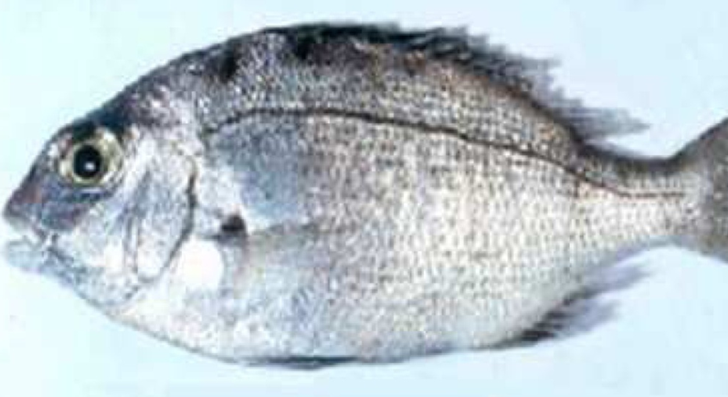
Note: Swollen abdomen due to enlargement of internal organs and fluid accumulation. P. major is a close relative of the Australian snapper.
Source: S I Park.

Signs of disease
Important: Animals with this disease may show one or more of these signs, but the pathogen may still be present in the absence of any signs.
Disease signs at the farm, tank or pond level are:
- low to high mortality
- lethargic swimming
- obvious opercular movement (increased respiratory effort).
Gross pathological signs are:
- dark skin (change in skin colour is a significant gross sign)
- petechial (pinpoint) haemorrhage of the gills
- pale gills and enlarged spleen.
Microscopic pathological signs are:
- enlarged cells, deeply giemsa positive, in the spleen, heart, kidney, liver and gills of infected fish, which are characteristic of this disease
- small dark spots within fresh wet mounts of gill lamellae (melano-macrophage centres).

Disease agent
RSIVD is caused by infection with red sea bream iridovirus (RSIV), from the genus Megalocytivirus within the family Iridoviridae.

Host range
Table 1 Species known to be naturally susceptible to RSIV
Common name | Scientific name
Amberjack | Seriola dumerili
Barramundi | Lates calcarifer
Black rockfish | Sebastes schlegelii
Black sea bream or black porgy | Acanthopagrus schlegelii
Brown marbled grouper | Epinephelus fuscoguttatus
Chicken grunt | Parapristipoma trilineatum
Chinese emperor | Lethrinus haematopterus
Chinese perch or mandarin fish | Siniperca chuatsi
Chub mackerel | Scomber japonicus
Cobia | Rachycentron canadum
Coral trout | Plectropomus leopardus
Crescent sweetlips | Plectorhinchus cinctus
Crimson seabream | Evynnis japonica
Devil stinger | Inimicus japonicus
Estuary cod | Epinephelus tauvina
Giant grouper | Epinephelus lanceolatus
Girella or rudderfish | Girella punctata
Japanese flounder | Paralichthys olivaceus
Japanese horse mackerel | Trachurus japonicus
Japanese parrotfish | Oplegnathus fasciatus
Japanese seabass | Lateolabrax japonicus
Japanese spanish mackerel | Scomberomorus niphonius
Large yellow croaker | Larimichthys crocea
Largemouth bass | Micropterus salmoides
Longtooth grouper | Epinephelus bruneus
Malabar grouper | Epinephelus malabaricus
Northern bluefin tuna | Thunnus thynnus
Orange-spotted grouper | Epinephelus coioides
Red sea bream | Pagrus major
Red-spotted grouper or Hong Kong grouper | Epinephelus akaara
Samson fish | Seriola hippos
Seabass | Lateolabrax spp.
Seven-band grouper | Hyporthodus septemfasciatus
Silver trevally | Pseudocaranx dentex
Six-bar grouper | Epinephelus sexfasciatus
Snapper | Chrysophrys auratus
Snubnose dart | Trachinotus blochii
Spangled emperor | Lethrinus nebulosus
Spotted coralgrouper | Plectropomus maculatus
Spotted halibut | Verasper variegatus
Spotted knifejaw | Oplegnathus punctatus
Tiger grouper hybrid | Epinephelus fuscoguttatus × E. lanceolatus
Tiger puffer | Takifugu rubripes
Yellow grouper | Epinephelus awoara
Yellowback seabream | Evynnis tumifrons
Yellowfin seabream | Acanthopagrus latus
Yellowtail kingfish | Seriola lalandi

Presence in Australia
Exotic disease—not recorded in Australia.
Map 1 Presence of RSIV, by jurisdiction
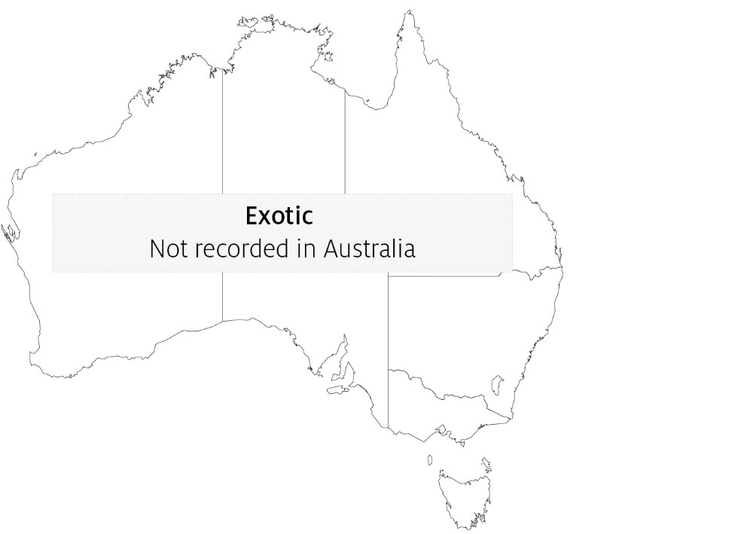

Epidemiology
- RSIVD is highly contagious.
- Juveniles are more susceptible to disease than adults.
- Mortality is highly variable (0% to 100%) and can depend on water temperature, with higher mortalities occurring at higher water temperatures.
- Transmission is horizontal, via the water column from other infected fish. Vertical transmission has yet to be confirmed.
- Outbreaks of disease occur at water temperatures greater than 20°C, with viral multiplication increasing with water temperatures up to at least 28°C.
- The virus is stable within tissue to –80°C, and can be inactivated by ether, chloroform and formalin.

Differential diagnosis
The list of similar diseases in the next section refers only to the diseases covered by this field guide. Gross pathological signs may also be representative of diseases not included in this guide. Do not rely on gross signs to provide a definitive diagnosis. Use them as a tool to help identify the listed diseases that most closely account for the observed signs.

Similar diseases
Epizootic haematopoietic necrosis (EHN), grouper iridoviral disease, infection with infectious spleen and kidney necrosis virus (ISKNV)-like viruses and Tilapia lake virus (TiLV) disease.

Sample collection
Only trained personnel should collect samples. Using only gross pathological signs to differentiate between diseases is not reliable, and some aquatic animal disease agents pose a risk to humans. If you are not appropriately trained, phone your state or territory hotline number and report your observations. If you have to collect samples, the agency taking your call will advise you on the appropriate course of action. Local or district fisheries or veterinary authorities may also advise on sampling.

Emergency disease hotline
See something you think is this disease? Report it. Even if you’re not sure.
Call the Emergency Animal Disease Watch Hotline on 1800 675 888. They will refer you to the right state or territory agency.

Microscope images
Figure 2 Giemsa positive staining of enlarged cells within tissue section of spleen of fish with RSIVD
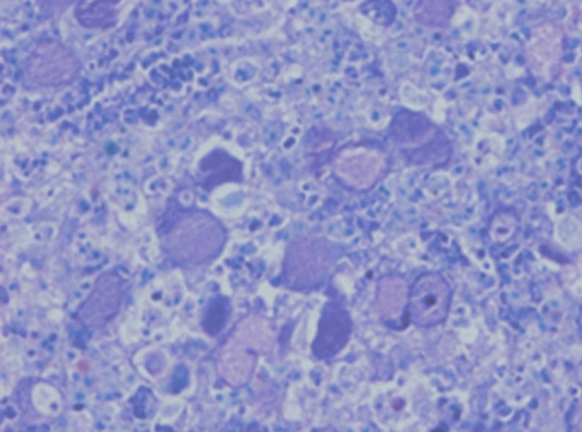
Note: Enlarged cells are characteristic of the disease.
Source: K Nakajima.

Further reading
CABI Invasive Species Compendium Red Sea Bream Iridoviral Disease
CEFAS International Database on Aquatic Animal Diseases Red Sea Bream Iridoviral Disease
World Organisation for Animal Health Manual of diagnostic tests for aquatic animals
These hyperlinks were correct at the time of publication.

Contact details
Emergency Animal Disease Watch Hotline 1800 675 888
Email AAH@agriculture.gov.au
Website agriculture.gov.au/pests-diseases-weeds/aquatic
© Commonwealth of Australia 2020
This work is copyright. It may be reproduced in whole or in part subject to the inclusion of an acknowledgement of the source and no commercial usage or sale.

