Spring viraemia of carp (SVC)

Also known as infection with spring viraemia of carp virus (SVCV)

From Aquatic animal diseases significant to Australia: identification field guide, 5th edition
Figure 1 SVC in common carp (Cyprinus carpio)
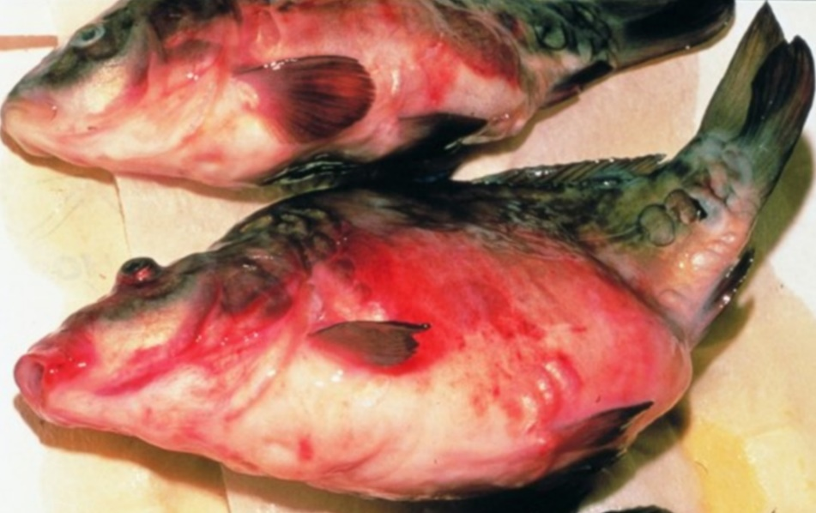
Note: Characteristic haemorrhagic skin, swollen stomach and exophthalmos (popeye).
Source: H J Schlotfeldt.

Signs of disease
Important: Animals with this disease may show one or more of these signs, but the pathogen may still be present in the absence of any signs.
Disease signs at the farm, tank or pond level are:
- mortality rates of 30 to 100%
- lethargy
- separation from shoal
- lethargic swimming
- accumulation of fish at the water inlet and sides of the pond.
Gross pathological signs are:
- exophthalmos (popeye)
- swollen abdomen and a protruding vent
- possibly a trailing white or yellowish faecal cast
- petechial (pinpoint) haemorrhages of skin, gills and eyes
- haemorrhages on skin and base of fins and around the vent
- darker body colour, with pale gills
- diffuse swelling and haemorrhage of internal organs and degeneration of gill lamellae
- ascites (fluid in abdominal cavity)
- intestines containing mucous instead of food.
Microscopic pathological signs are:
- liver hyperaemia and oedematous perivasculitis
- pericarditis and infiltration of the myocardium
- hyaline degeneration and vacuolation of the renal tubules, which are clogged with casts
- inflammatory and hyperaemic changes in all major organs.

Disease agent
SVC is caused by infection with spring viraemia of carp virus (SVCV), a rhabdovirus classified within the genus Sprivivirus. SVCV is closely related to infectious haematopoietic necrosis virus (IHNV) and viral haemorrhagic septicaemia virus (VHSV).

Host range
SVCV infects a range of fish species and has been detected infecting amphibians (newts) imported from Asia into the USA, as well as on several non-fish carriers.
Table 1 Species known to be susceptible to SVCV
Common name | Scientific name
Breamª | Abramis brama
Bighead carpª | Hypophthalmichthys nobilis
Common carp and koi carpª | Cyprinus carpio (species most susceptible)
Common roach | Rutilus rutilus
Crucian carpª | Carassius carassius
Goldfishª | Carassius auratus
Grass carpª | Ctenopharyngodon idellus
Guppy | Poecilia reticulata
Ide or orfeª | Leuciscus idus
Largemouth bass | Micropterus salmoides
Pikeª | Esox lucius
Pumpkinseed | Lepomis gibbosus
Rainbow troutª | Oncorhynchus mykiss
Silver carpª | Hypophthalmichthys molitrix
Tenchª | Tinca tinca
Wels catfish or sheatfishª | Silurus glanis
Zebrafish | Danio rerio
a Naturally susceptible. Note: Other species have been shown to be experimentally susceptible.
Table 2 Non-fish carriers
Common name | Scientific name
Chinese fire belly newt | Cynops orientalis
Salamanders, newts and sirens | Order Caudata
Fish louse | Argulus foliaceus
Grey heron | Ardea cinerea
Leeches | Piscicola spp.
Piscivorous birds | Various genera and species

Presence in Australia
Exotic disease—not recorded in Australia.
Map 1 Presence of SVCV, by jurisdiction
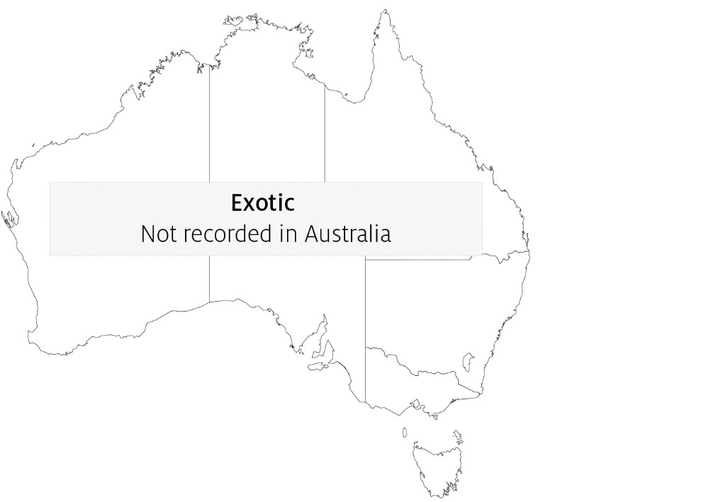

Epidemiology
- SVC is very contagious among common carp.
- Clinical disease is linked closely to environmental disturbances.
- Mortality rate is usually less than 40% but can range from 5% to 100%, with younger fish less than 1 year old more susceptible.
- Fry are susceptible to disease at temperatures up to 23°C. However some SVCV strains from Asia replicate in-vitro at up to 28°C and can cause disease at water temperatures up to 26°C.
- Disease may also occur in older fish (greater than 1 year), usually when water temperatures are between 11°C and 17°C (associated with the stress of an abnormally cold spring in Europe, and possibly due to cold temperatures weakening the fish's immune system during the spring).
- Fish that survive SVC are presumed to carry the virus.
- Outbreaks are most likely to occur with increased stress levels, such as around the time of spawning, and coincide with increased levels of virus excreted with spawning fluids.
- Transmission of the virus to uninfected fish is horizontal, and the virus enters fish through the gills and skin.
- The virus enters the water in faeces, urine and spawning fluids. Transport of live infected fish, contaminated water and contaminated eggs of infected fish (suggestive of vertical transmission) contributes to disease spread.
- The virus also infects and causes disease in some salamanders.
- Blood-sucking parasites such as fish louse and leeches can transmit the virus from fish to fish. Piscivorous birds can also spread the disease.
- Stressors (such as overcrowding) can trigger an outbreak in apparently healthy populations.
- The virus can remain viable outside the host for 5 weeks in river water at 10°C or more than 6 weeks in pond mud at 4°C.

Differential diagnosis
The list of similar diseases in the next section refers only to the diseases covered by this field guide. Gross pathological signs may also be representative of diseases not included in this guide. Do not rely on gross signs to provide a definitive diagnosis. Use them as a tool to help identify the listed diseases that most closely account for the observed signs.

Similar diseases
Enteric redmouth disease (ERMD), enteric septicaemia of catfish, infection with Aeromonas salmonicida—atypical strains and koi herpesvirus disease (KHV).

Sample collection
Only trained personnel should collect samples. Using only gross pathological signs to differentiate between diseases is not reliable, and some aquatic animal disease agents pose a risk to humans. If you are not appropriately trained, phone your state or territory hotline number and report your observations. If you have to collect samples, the agency taking your call will advise you on the appropriate course of action. Local or district fisheries or veterinary authorities may also advise on sampling.

Emergency disease hotline
See something you think is this disease? Report it. Even if you’re not sure.
Call the Emergency Animal Disease Watch Hotline on 1800 675 888. They will refer you to the right state or territory agency.

Further reading
CEFAS International Database on Aquatic Animal Diseases Spring Viraemia of Carp
World Organisation for Animal Health Manual of diagnostic tests for aquatic animals
These hyperlinks were correct at the time of publication.

Contact details
Emergency Animal Disease Watch Hotline 1800 675 888
Email AAH@agriculture.gov.au
Website agriculture.gov.au/pests-diseases-weeds/aquatic
© Commonwealth of Australia 2020
This work is copyright. It may be reproduced in whole or in part subject to the inclusion of an acknowledgement of the source and no commercial usage or sale.

