Tilapia lake virus (TiLV) disease

Also known as syncytial hepatitis of tilapia (SHT)

From Aquatic animal diseases significant to Australia: identification field guide, 5th edition
Figure 1 Nile tilapia (Oreochromis niloticus) infected with TiLV
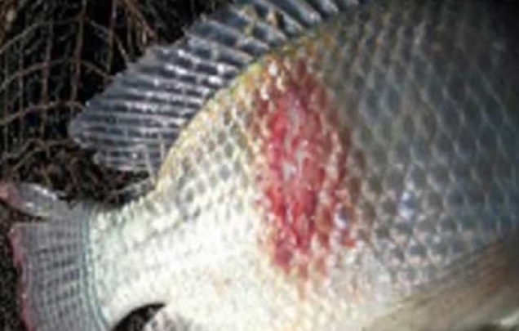
Note: Haemorrhagic skin lesion on flank.
Source: Worldfish
Figure 2 TiLV disease in Nile tilapia (Oreochromis niloticus) fingerlings
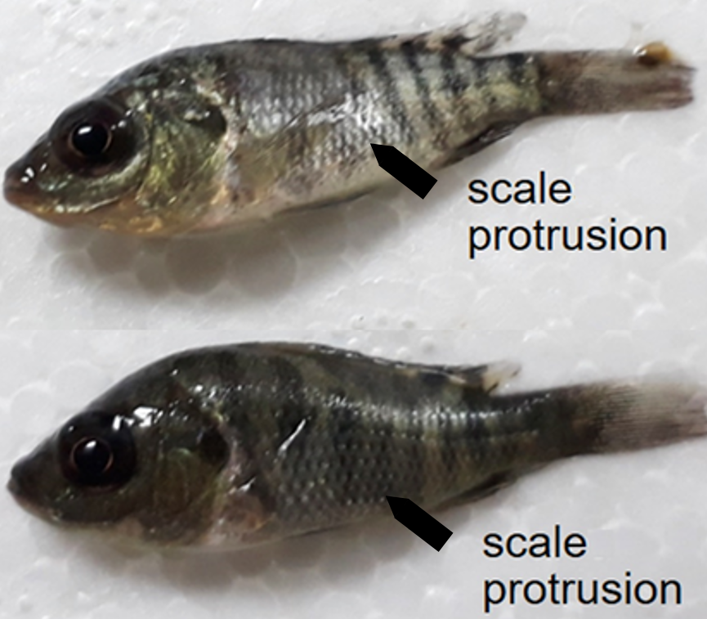
Note: Naturally infected fish exhibiting discolouration and scale protrusion.
Source: HT Dong.

Signs of disease
Important: Animals with this disease may show one or more of these signs, but the pathogen may still be present in the absence of any signs.
Disease signs at the farm, tank or pond level are:
- sudden unexpected increase in mortalities (greater than 2% per day) over several days during the summer months
- cumulative mortality up to 90% within 1 month of stocking fingerlings into freshwater or brackish water ponds
- high mortalities in 1 to 50g fish, lower mortalities (approximately 10%) in medium or large fish
- lethargy, loss of appetite, and respiratory distress (breathing at surface).
Gross pathological signs are:
- changes in body colour (darkening or lightening)
- skin erosion resulting in haemorrhagic dermal lesions
- scale protrusion
- exophthalmos (popeye) and opacity of the eye lens (cataract)
- abdominal distension (due to fluid or enlargement of spleen and other organs).
Microscopic pathological signs are:
- lesions in the brain including oedema, focal haemorrhages in the leptomeninges, and capillary congestion in both the white and grey matter and neural degeneration
- congestion of internal organs (liver, kidney, spleen, brain, gills) with foci of gliosis and perivascular cuffing of lymphocytes in the brain cortex, and melanomacrophage proliferation in liver and spleen
- formation of syncytia in the epithelium of hepatocytes (syncytial hepatitis of the liver)
- ocular inflammation including endophthalmitis and cataractous changes of the lens.

Disease agent
Tilapia lake virus disease, or syncytial hepatitis of tilapia (SHT), is caused by infection with tilapia lake virus (TiLV). TiLV is an enveloped, negative-sense, single-stranded RNA virus that has been classified as a relative of the Orthomyxoviridae family of viruses.
TiLV was first officially documented in Ecuador and Israel in 2013 and 2014, respectively. However, it is believed to have been responsible for mass mortalities in farmed tilapia in Israel since 2009. The disease agent has since been found in Thailand, Malaysia and the USA, and may have been spread to many other parts of Asia and Africa due to translocation of live tilapia for aquaculture.

Host range
Table 1 Species known to be susceptible to TiLV
Common name | Scientific name
Blue tilapiaª | Oreochromis aureus
Cichlids | Cichlidae, all species
Malaysian red hybrid tilapiaª | Oreochromis niloticus × O. mossambicus
Mango tilapiaª | Sarotherodon galilaeus
Nile tilapiaª | Oreochromis niloticus
Redbelly tilapiaª | Tilapia zilli
Tilapias | Various genera and species
Tilapia hybridsª | Oreochromis niloticus × O. aureus
Tinfoil barbª | Barbonymus schwanenfeldii
Tvarnun simonª | Tristramella simonis
a Naturally susceptible. Note: Other species have been shown to be experimentally susceptible.

Presence in Australia
Exotic disease—not recorded in Australia.
Map 1 Presence of TiLV, by jurisdiction
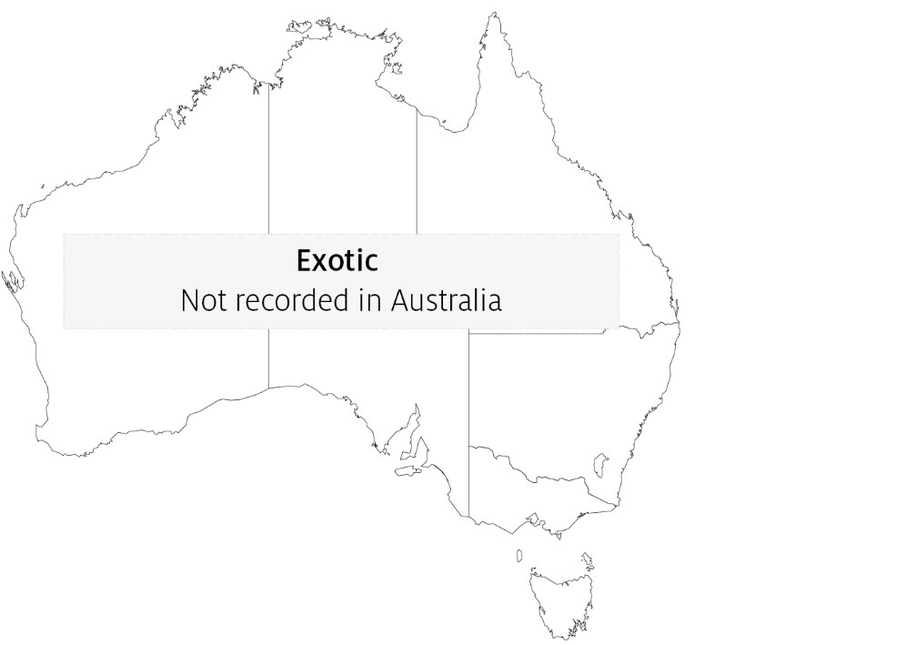

Epidemiology
- TiLV appears to cause disease mainly in tilapia and tilapia hybrids (Oreochromis spp., Tilapia spp.), but has also been detected causing disease in other wild cichlids (Sarotherodon galilaeus, Tristramella spp.) in Israel and tinfoil barbs (Barbonymus schwanenfeldii) in Malaysia.
- TiLV viral particles are sensitive to organic solvents (ether and chloroform), due to their lipid membrane. Other orthomyxoviruses similar to TiLV can be inactivated by desiccation or heat at temperatures above 56°C for 5 minutes, but are stable in water for extended periods.
- Horizontal transmission (via the water and cohabitation) and vertical transmission have both been demonstrated. Transmission via cannibalism is likely.
- Duration of viral survival outside the host has not been determined.
- Tilapia that survive experimental infection show immunity to disease upon subsequent challenge.

Differential diagnosis
The list of similar diseases in the next section refers only to the diseases covered by this field guide. Gross pathological signs may also be representative of diseases not included in this guide. Do not rely on gross signs to provide a definitive diagnosis. Use them as a tool to help identify the listed diseases that most closely account for the observed signs.

Similar diseases
Infection with Aphanomyces invadans (EUS), infection with infectious spleen and kidney necrosis virus (ISKNV)-like viruses, red sea bream iridoviral disease (RSIVD) and viral encephalopathy and retinopathy (VER).

Sample collection
Only trained personnel should collect samples. Using only gross pathological signs to differentiate between diseases is not reliable, and some aquatic animal disease agents pose a risk to humans. If you are not appropriately trained, phone your state or territory hotline number and report your observations. If you have to collect samples, the agency taking your call will advise you on the appropriate course of action. Local or district fisheries or veterinary authorities may also advise on sampling.

Emergency disease hotline
See something you think is this disease? Report it. Even if you’re not sure.
Call the Emergency Animal Disease Watch Hotline on 1800 675 888. They will refer you to the right state or territory agency.

Microscope images
Figure 3 Histopathology of liver of Nile tilapia (Oreochromis niloticus) infected with TiLV
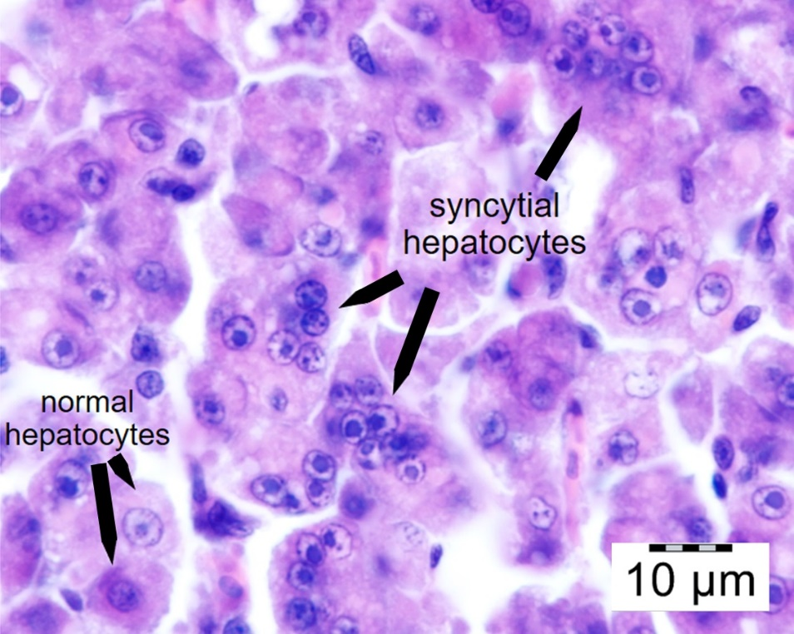
Note: Multifocal areas of syncytial hepatitis. Scale bar = 10µm.
Source: HT Dong

Further reading
Jansen MD and Mohan CV 2017, Tilapia lake virus (TiLV): Literature review, Penang, Malaysia: CGIAR Research Program on Fish Agri-Food Systems
Network of Aquaculture Centres in Asia-Pacific Tilapia Lake Virus (TiLV)—A novel orthomyxo-like virus: disease card
This hyperlink was correct at the time of publication.

Contact details
Emergency Animal Disease Watch Hotline 1800 675 888
Email AAH@agriculture.gov.au
Website agriculture.gov.au/pests-diseases-weeds/aquatic
© Commonwealth of Australia 2020
This work is copyright. It may be reproduced in whole or in part subject to the inclusion of an acknowledgement of the source and no commercial usage or sale.

