Viral encephalopathy and retinopathy (VER)

Also known as viral nervous necrosis (VNN)

From Aquatic animal diseases significant to Australia: identification field guide, 5th edition
Figure 1 Darkened colouration in seven-band grouper (Hyporthodus septemfasciatus) with VER
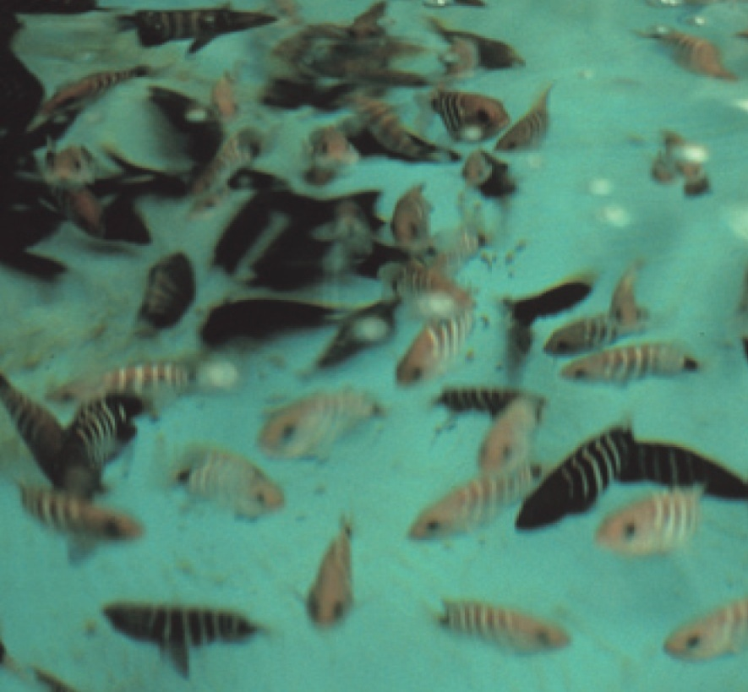
Note: Dark groupers are diseased, light fish are normal. Change in colouration is an important indicator for VER (species differ in what colour change occurs; diseased barramundi become lighter).
Source: B Munday

Signs of disease
Important: Animals with this disease may show one or more of these signs, but the pathogen may still be present in the absence of any signs.
Disease signs at the farm, tank or pond level are:
- 50% to 100% cumulative mortality over a period of 48 hours to several weeks
- higher mortalities in larvae and juvenile fish (9 to 28 days old), although older fish (greater than 28 days) may also be affected
- anorexia
- abnormal swimming behaviours, including erratic, uncoordinated darting, spiral and/or looping swim pattern, corkscrew swimming
- fish resting belly-up (loss of equilibrium)
- hyperactivity
- sporadic protrusion of the head from the water.
Gross pathological signs are:
- colour change
  - affected fish may become lighter ( such as larval barramundi) or darker (such as larval groupers), depending on the species affected and their environment
- blindness
- abrasions
- emaciation
- over-inflated swim bladder (the only significant internal gross pathological sign).
Microscopic pathological signs are:
- vacuolation of central nervous tissues, including retina
- intracytoplasmic inclusions in brain tissues as crystalline arrays or aggregates.

Disease agent
VER or VNN is a disease caused by a Betanodavirus, in the family Nodaviridae. In Australia, VER was formerly referred to as barramundi picorna-like virus.

Host range
Table 1 Species known to be susceptible to VER
Common name | Scientific name
Amberjackª | Seriola dumerili
Atlantic halibutª | Hippoglossus hippoglossus
Archer fish | Toxotes chatareus
Atlantic salmon^{b} | Salmo salar
Australian bassª | Macquaria novemaculeata
Banded archerfishª | Toxotes jaculatrix
Barcoo grunter | Scortum barcoo
Barfin flounderª | Verasper moseri
Barramundiª | Lates calcarifer
Brown-marbled grouperª | Epinephelus fuscoguttatus
Chinese catfishª | Silurus asotus
Cobiaª | Rachycentron canadum
Convict surgeonfish | Acanthurus triostegus
Coral trout | Plectropomus leopardus
Crimson snapperª | Lutjanus erythropterus
Common soleª | Solea solea
Dusky grouper | Epinephelus marginatus
Eastern freshwater codª | Maccullochella ikei
Estuarine rockcodª | Epinephelus tauvina
Estuary catfish | Cnidoglanis macrocephalus
European eelª | Anguilla anguilla
European seabassª | Dicentrarchus labrax
Floundersª | Paralichthyidae
Giant grouperª | Epinephelus lanceolatus
Gilt-head sea breamª | Sparus aurata
Golden grey mulletª | Chelon auratus
Golden perch | Macquaria ambigua
Grouper and estuary codª | Epinephelus spp.
Haddockª | Melanogrammus aeglefinus
Humpback grouperª | Cromileptes altivelis
Japanese flounderª | Paralichthys olivaceus
Japanese parrotfishª | Oplegnathus fasciatus
Japanese seabassª | Lateolabrax japonicus
Japanese tilefish | Branchiostegus japonicus
Longtooth grouperª | Epinephelus bruneus
Luderick | Girella tricuspidata
Macquarie perch | Macquaria australasica
Malabar grouperª | Epinephelus malabaricus
Mangrove jackª | Lutjanus argentimaculatus
Milkfish | Chanos chanos
Mulletsª | Mugilidae, all species
Mulloway | Argyrosomus japonicus
Murray cod | Maccullochella peelii peelii
Narrowstripe cardinalfish | Pristiapogon exostigma
Nile tilapia | Oreochromis niloticus
Orange-spotted grouperª | Epinephelus coioides
Permitª | Trachinotus falcatus
Red drumª | Sciaenops ocellatus
Red mullet | Mullus barbatus
Red-spotted grouperª or Hong Kong grouper | Epinephelus akaara
Russian sturgeonª | Acipenser gueldenstaedtii
Samson fish | Seriola hippos
Senegalese soleª | Solea senegalensis
Seven-band grouperª | Hyporthodus septemfasciatus
Shi drumª | Umbrina cirrosa
Silver perch | Bidyanus bidyanus
Silver trevallyª | Pseudocaranx dentex
Six bar grouper | Epinephelus sexfasciatus
Sleepy cod | Oxyeleotris lineolata
Snubnose dartª | Trachinotus blochii
Spotted coral grouper | Plectropomus maculatus
Spotted knifejawª | Oplegnathus punctatus
Spotted wolffish | Anarhichas minor
Striped trumpeterª | Latris lineata
Thread-sail filefishª | Stephanolepis cirrhifer
Tiger grouper hybrid | Epinephelus fuscoguttatus × E. lanceolatus
Tiger pufferª | Takifugu rubripes
Tilapias | various genera and species
Turbotª | Scophthalmus maximus
White grouperª | Epinephelus aeneus
White seabassª | Atractoscion nobilis
Winter flounderª | Pseudopleuronectes americanus
Winter whiting | Sillago maculata
Yellowfin bream | Acanthopagrus australis
Yellowtail kingfish | Seriola lalandi
a Naturally susceptible. b Experimentally susceptible to disease via intraperitoneal injection. Note: Other species have been shown to be experimentally susceptible.
Table 2 Non-fish carriers
Common name | Scientific name
Molluscs | Various genera and species
Polychaetes | Nereis spp.

Presence in Australia
VER has been officially reported from New South Wales, the Northern Territory, Queensland, South Australia, Tasmania and Western Australia. It is primarily reported to affect larvae or fry.
Map 1 Presence of VER, by jurisdiction
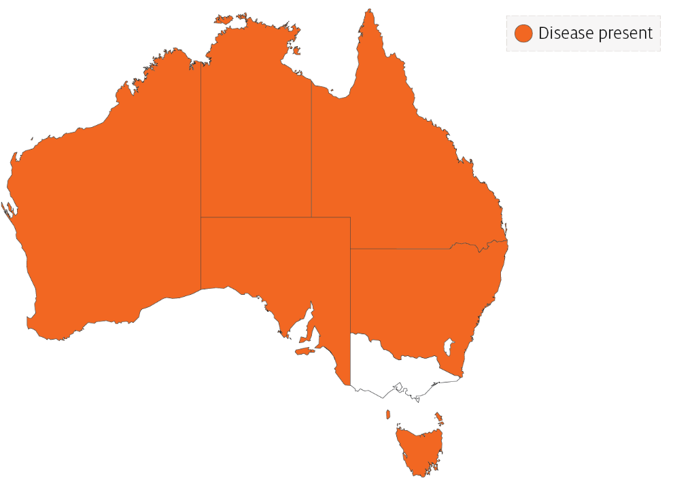

Epidemiology
- VER has occured in at least 70 species of marine fish from 16 families, and has been diagnosed in all inhabited continents.
- Most fish are affected as larvae or juveniles. However, in recent years, mortalities have occurred in older fish up to harvest size, particularly in European seabass, groupers (Epinephelus spp.) and Atlantic halibut. Disease incidence in the groupers and seabass has been associated with high water temperatures.
- Susceptibility and mortality are age dependent. Onset of clinical disease in younger fish of some species results in higher mortality.
- Batches of barramundi larvae for aquaculture are now routinely screened for this disease in Australia.
- The incubation period for the disease in barramundi is 4 days, with typical disease onset 9 to 28 days after hatching, rarely occurring in older fish (50 to 60 days old). In silver trevally, disease onset is 1 day after hatching.
- Transmission is believed to occur both horizontally through the water column (via mouth, gills and skin), and vertically (parent to offspring). The rate of transmission may be influenced by stressors, including handling, repeated spawning, high stocking densities, high ambient temperature and virulence of the particular Betanodavirus strain. Sand worms of the family Nereidae, genus Nereis, and bivalves collected in proximity to infected farms have had positive detection of Betanodavirus.
- The virus can survive for 1 year in the right environmental conditions (pH 2 to 9 and 15°C) and can persist subclinically in infected live fish. Therefore, fish products and by-products may facilitate the spread of virus to unaffected areas.
- Cumulative mortality at 1 month is typically 50% to 100% in barramundi and 100% in silver trevally. In Australian hatcheries, 100% mortality in less than 3 days in larval fish is typical.

Differential diagnosis
The list of similar diseases in the next section refers only to the diseases covered by this field guide. Gross pathological signs may also be representative of diseases not included in this guide. Do not rely on gross signs to provide a definitive diagnosis. Use them as a tool to help identify the listed diseases that most closely account for the observed signs.

Similar diseases
Grouper iridoviral disease and Tilapia lake virus (TiLV) disease.

Sample collection
Only trained personnel should collect samples. Using only gross pathological signs to differentiate between diseases is not reliable, and some aquatic animal disease agents pose a risk to humans. If you are not appropriately trained, phone your state or territory hotline number and report your observations. If you have to collect samples, the agency taking your call will advise you on the appropriate course of action. Local or district fisheries or veterinary authorities may also advise on sampling.

Emergency disease hotline
See something you think is this disease? Report it. Even if you’re not sure.
Call the Emergency Animal Disease Watch Hotline on 1800 675 888. They will refer you to the right state or territory agency.

Microscope images
Figure 2 Transverse histological section through head of larval (20 day old) barramundi (Lates calcarifer) with VER
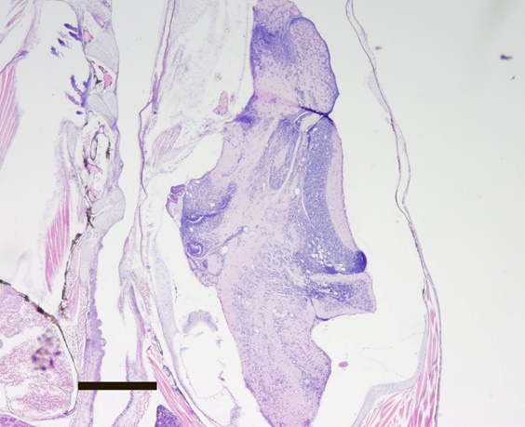
Note: Vacuoles associated with VER infection are readily visible in the brain. Haematoxylin and eosin stain. 20x magnification, scale bar = 300µm
Source: B Jones

Further reading
CEFAS International Database on Aquatic Animal Diseases Viral Encephalopathy and Retinopathy
Department of Agriculture, Water and the Environment AQUAVETPLAN disease strategy manual: Viral encephalopathy and retinopathy
World Organisation for Animal Health Manual of diagnostic tests for aquatic animals
These hyperlinks were correct at the time of publication.

Contact details
Emergency Animal Disease Watch Hotline 1800 675 888
Email AAH@agriculture.gov.au
Website agriculture.gov.au/pests-diseases-weeds/aquatic
© Commonwealth of Australia 2020
This work is copyright. It may be reproduced in whole or in part subject to the inclusion of an acknowledgement of the source and no commercial usage or sale.

