Viral haemorrhagic septicaemia (VHS)

Also known as infection with viral haemorrhagic septicaemia virus (VHSV)

From Aquatic animal diseases significant to Australia: identification field guide, 5th edition
Figure 1 VHS in rainbow trout (Oncorhynchus mykiss)
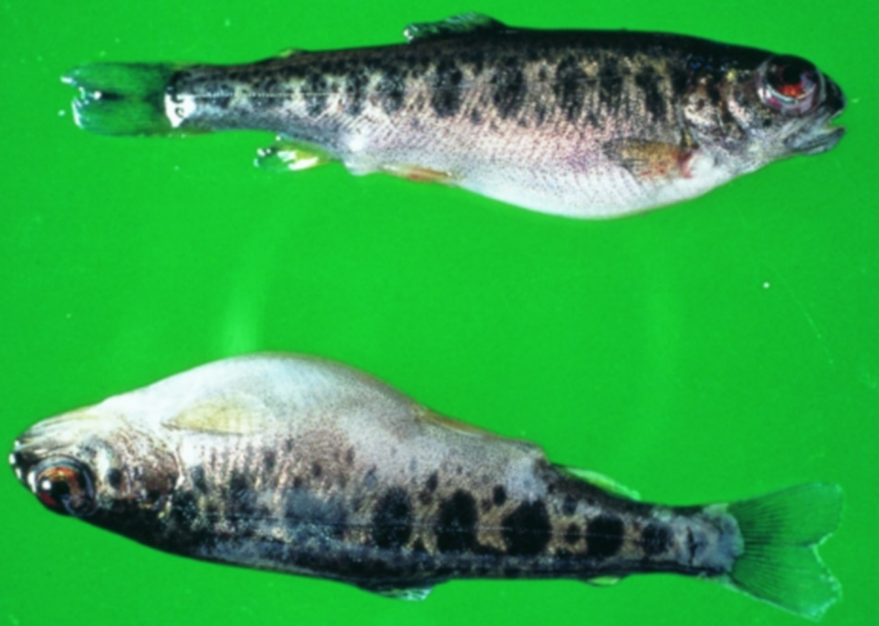
Note: Swollen stomach and exophthalmos (popeye).
Source: T Håstein
Figure 2 Internal organs of rainbow trout (Oncorhynchus mykiss) with VHS
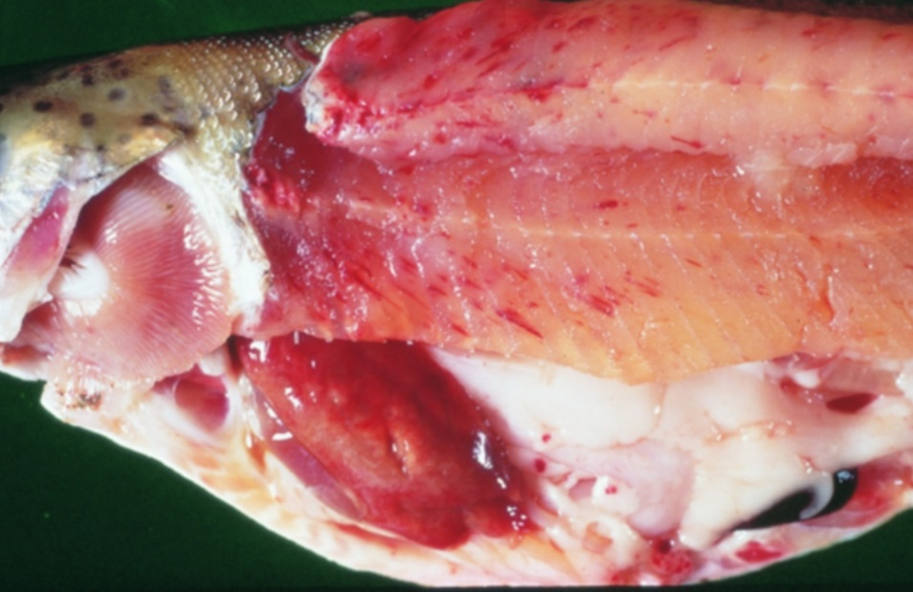
Note: Pale colour of stomach region, pinpoint haemorrhages in fillet and fatty tissue and pale gills.
Source: T Håstein

Signs of disease
Important: Animals with this disease may show one or more of these signs, but the pathogen may still be present in the absence of any signs.
Disease signs at the farm, tank or pond level are:
- acute infection
  - rapid onset of high mortality
  - lethargic swimming
  - separation from shoal
  - loss of appetite
  - crowding at pond edges.
- chronic infection
  - significant cumulative mortality (protracted)
  - uncoordinated swimming (ataxia) with rotating movement around body axis (spinning).
- neurological form
  - low mortality
  - severe abnormal swimming behaviour (flashing and spiralling).
Gross pathological signs are:
- general
  - exophthalmos (popeye)
  - haemorrhages under the skin, around the base of pectoral and pelvic fins and in the eyes
  - swollen abdomen
  - pale gills, with or without petechial (pinpoint) haemorrhages.
- acute infection
  - slight darkening of the body colour
  - exophthalmos (popeye)
  - bleeding around the eyes
  - bleeding under the skin around the base of the pectoral and pelvic fins
  - skin ulceration
  - swollen abdomen with ascites (fluid in the abdominal cavity)
  - pale gills with petechial (pinpoint) haemorrhages
  - petechial (pinpoint) haemorrhages in the fatty tissue, intestine, gonads, liver, swim bladder and muscle
  - dark-red kidneys.
- chronic infection
  - often an absence of external signs
  - intense darkening of the skin
  - exophthalmos (popeye)
  - pale gills (anaemic)
  - pale abdominal organs
  - pale and mottled liver (evidence of haemorrhages on surface)
  - pale gastrointestinal tract that is empty of food.
Microscopic pathological signs are:
- accumulation of erythrocytes in skeletal muscle fibres
- extensive focal necrosis in the liver, kidney and spleen
- VHS virus-positive endothelial cells in vascular system evident from immunohistochemistry.

Disease agent
VHS is caused by infection with viral haemorrhagic septicaemia virus (VHSV). VHSV is a rhabdovirus classified within the genus Novirhabdovirus, closely related to infectious haematopoietic necrosis virus (IHNV) and spring viraemia of carp virus (SVCV).
Several genogroups or genotypes of the virus have been identified from different environments in different parts of the world:
- type I, continental Europe—freshwater group, trout farms (highly pathogenic to rainbow trout)
- type II, European marine strain (Baltic Sea)—marine strain affecting wild and cultured marine and freshwater species (has low pathogenicity in rainbow trout)
- type III, north Atlantic marine group (Flemish Cap to Norway, including North Sea near the British Isles)
- type IVa, west coast of North America and east Asian group—marine group affecting a range of free-living marine and cultured species (highly pathogenic in Pacific herring; rainbow trout appear refractory to infection with this genotype)
- type IVb, Great Lakes region-significant mortalities in wild freshwater species in the Great Lakes of North America

Host range
VHSV has been isolated from a broad range of marine and freshwater fish in Europe and the north Pacific, including cod, sprats, herring, haddock and turbot.
Table 1 Species known to be susceptible to VHSV
Common name | Scientific name
American eel | Anguilla rostrata
Armoured weaselfish | Hoplobrotula armata
Atlantic cod | Gadus morhua
Atlantic halibut | Hippoglossus hippoglossus
Atlantic herring | Clupea harengus
Atlantic salmon | Salmo salar
Black crappie | Pomoxis nigromaculatus
Black sea bream or black porgy | Acanthopagrus schlegelii
Bluegill | Lepomis macrochirus
Blue whiting | Micromesistius poutassou
Bluntnose minnow | Pimephales notatus
Brook trout | Salvelinus fontinalis
Brown bullhead | Ameiurus nebulosus
Brown trout | Salmo trutta
Burbotª | Lota lota
Channel catfish | Ictalurus punctatus
Chinook salmon | Oncorhynchus tshawytscha
Chub mackerel | Scomber japonicus
Coho salmon | Oncorhynchus kisutch
Dab | Limanda limanda
Eels | Anguillidae, all species
Emerald shiner | Notropis atherinoides
English sole | Parophrys vetulus
Eulachonª | Thaleichthys pacificus
European eel | Anguilla anguilla
European seabass | Dicentrarchus labrax
European sprat | Sprattus sprattus
Flounder | Platichthys flesus
Fourbeard rockling | Enchelyopus cimbrius
Freshwater drumª | Aplodinotus grunniens
Gilt-head sea bream | Sparus aurata
Gizzard shad | Dorosoma cepedianum
Golden trout | Oncorhynchus aguabonita
Grayling | Thymallus thymallus
Greenland halibut | Reinhardtius hippoglossoides
Haddock | Melanogrammus aeglefinus
Hairtail | Trichiurus lepturus
Hong Kong grouper | Epinephelus akaara
Hybrid (rainbow trout × coho salmon) | Oncorhynchus mykiss × O. kisutch
Iberian nase | Pseudochondrostoma polylepis
Japanese eel | Anguilla japonica
Japanese flounderª | Paralichthys olivaceus
Japanese yellowtail | Seriola quinqueradiata
Korean flounder | Glyptocephalus stelleri
Lake trout | Salvelinus namaycush
Lake whitefish | Coregonus clupeaformis
Largemouth bass | Micropterus salmoides
Lesser argentine | Argentina sphyraena
Sea Mullet | Mugil cephalus
Mummichogª | Fundulus heteroclitus
Muskellungeª | Esox masquinongy
Norway pout | Trisopterus esmarkii
Pacific cod | Gadus macrocephalus
Pacific hakeª | Merluccius productus
Pacific herringª | Clupea pallasii
Pacific salmon | Oncorhynchus spp.
Pacific sand eel | Ammodytes personatus
Pacific sand lance | Ammodytes hexapterus
Pacific sardineª | Sardinops sagax
Pacific tomcod | Microgadus proximus
Pikeª | Esox lucius
Plaice | Pleuronectes platessa
Poor cod | Trisopterus minutus
Pumpkinseed | Lepomis gibbosus
Rainbow troutª | Oncorhynchus mykiss
River lamprey | Lampetra fluviatilis
Rock bass | Ambloplites rupestris
Rockfish | Sebastes spp.
Round gobyª | Neogobius melanostomus
Sablefishª | Anoplopoma fimbria
Sand eel | Ammodytes spp.
Sand goby | Pomatoschistus minutus
Senegalese sole | Solea senegalensis
Shiner perch | Cymatogaster aggregata
Shortfin eel | Anguilla australis
Shorthead redhorse | Moxostoma macrolepidotum
Silver pomfret | Pampus argenteus
Silver redhorse | Moxostoma anisurum
Smallmouth bassª | Micropterus dolomieu
Snapper | Chrysophrys auratus
Splake (lake trout × brook trout) | Salvelinus namaycush × S. fontinalis
Spottail shiner | Notropis hudsonius
Striped bass | Morone saxatilis
Surf smeltª | Hypomesus pretiosus
Three-spined stickleback | Gasterosteus aculeatus
Trout-perch | Percopsis omiscomaycus
Tubesnout | Aulorhynchus flavidus
Turbotª | Scophthalmus maximus
Walleye pollock or Alaska pollockª | Gadus chalcogramma
White bass | Morone chrysops
Whitefish (Muksun) | Coregonus muksun
Whitefish (Peled) | Coregonus peled
White perch | Morone americana
Whiting | Merlangius merlangus
Yellowback seabream | Evynnis tumifrons
Yellow perchª | Perca flavescens
a Naturally susceptible. Note: Other species have been shown to be experimentally susceptible.
Table 2 Non-fish carriers
Common name | Scientific name
Leeches | Piscicola spp.
Piscivorous birds | Various genera and species

Presence in Australia
Exotic disease—not recorded in Australia.
Map 1 Presence of VHS, by jurisdiction
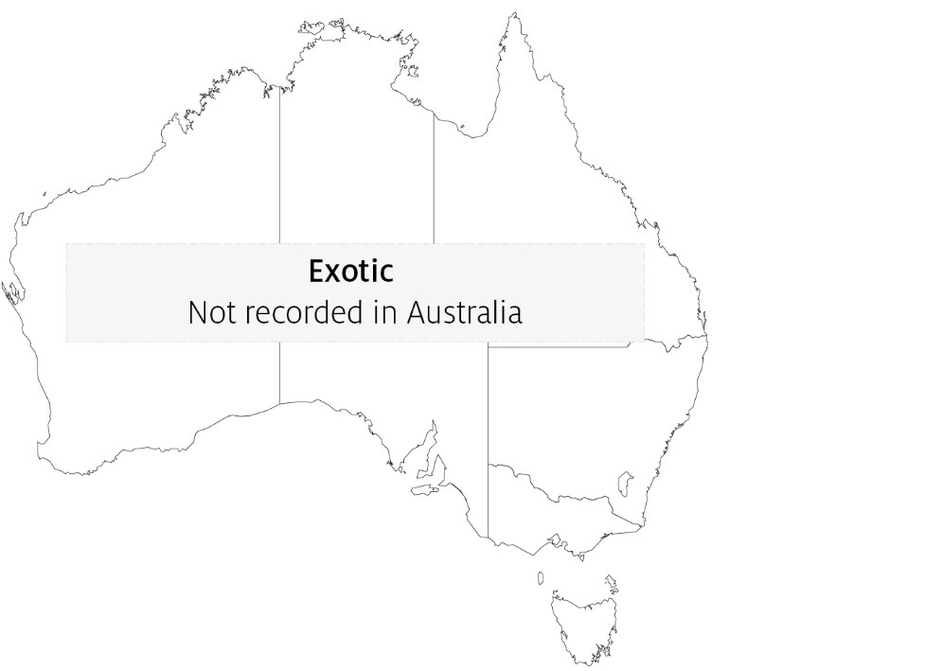

Epidemiology
- Variant strains of VHSV are responsible for disease in different geographical locations.
- Marine and freshwater species are susceptible to VHSV infection. Younger fish are generally more susceptible to disease.
- Rainbow trout appear to be less susceptible to infection by marine strains of the virus.
- Water temperatures in an outbreak are generally near 10°C. At water temperatures between 15°C and 18°C, the disease generally takes a shorter course with a modest accumulated mortality, but transmission can occur at water temperatures up to 22°C. Mortality and morbidity have rarely been documented when water temperatures are above 18°C, although VHS virus genotype IV has caused at least one fish kill at 20 to 22°C, and some isolates can replicate in vitro at temperatures up to 25°C.
- Transmission is horizontal directly through the water, from virus shed in faeces, urine (predominantly) and sexual fluids of clinically infected or carrier fish. The virus can also be spread by birds that have consumed infected fish, via blood-feeding vectors such as leeches, and on equipment that has been in contact with water from infected fish. The virus gains entry via the gills, skin wounds, oral exposure (predation) and possibly through the skin.
- Once infected, survivors are lifelong carriers of the virus, with intermittent shedding. Stressors (including overcrowding, extreme temperatures and overfeeding) will greatly reduce an animal's resistance to infection.
- Mortality rate can range from 10% to 80%, depending on the VHSV isolate, environmental variables (temperature), age, species, route of exposure and presence of additional stressors. The highest mortality rates occur with acute infection, and lowest mortality rates in the neurological form.
- VHSV is thought to have existed in the marine environment before its apparent transfer to fresh water, where it first became virulent in trout.
- It has been suggested that the European freshwater strains of VHSV originated from fish in the northern Pacific and Atlantic oceans. The mechanism of transfer was possibly through the feeding of marine fish to cultured freshwater species.

Differential diagnosis
The list of similar diseases in the next section refers only to the diseases covered by this field guide. Gross pathological signs may also be representative of diseases not included in this guide. Do not rely on gross signs to provide a definitive diagnosis. Use them as a tool to help identify the listed diseases that most closely account for the observed signs.

Similar diseases
Enteric red mouth disease (ERMD), epizootic haematopoietic necrosis (EHN), infection with Aphanomyces invadans (EUS), infectious haematopoietic necrosis (IHN), infectious pancreatic necrosis (IPN) and whirling disease.

Sample collection
Only trained personnel should collect samples. Using only gross pathological signs to differentiate between diseases is not reliable, and some aquatic animal disease agents pose a risk to humans. If you are not appropriately trained, phone your state or territory hotline number and report your observations. If you have to collect samples, the agency taking your call will advise you on the appropriate course of action. Local or district fisheries or veterinary authorities may also advise on sampling.

Emergency disease hotline
See something you think is this disease? Report it. Even if you’re not sure.
Call the Emergency Animal Disease Watch Hotline on 1800 675 888. They will refer you to the right state or territory agency.

Further reading
CABI Invasive Species Compendium Viral haemorrhagic septicaemia
Department of Agriculture, Water and the Environment AQUAVETPLAN disease strategy manual: Viral haemorrhagic septicaemia
World Organisation for Animal Health Manual of diagnostic tests for aquatic animals
These hyperlinks were correct at the time of publication.

Contact details
Emergency Animal Disease Watch Hotline 1800 675 888
Email AAH@agriculture.gov.au
Website agriculture.gov.au/pests-diseases-weeds/aquatic
© Commonwealth of Australia 2020
This work is copyright. It may be reproduced in whole or in part subject to the inclusion of an acknowledgement of the source and no commercial usage or sale.

