Whirling disease

Also known as infection with Myxobolus cerebralis

From Aquatic animal diseases significant to Australia: identification field guide, 5th edition
Figure 1 Skull deformity in rainbow trout (Oncorhynchus mykiss) with whirling disease
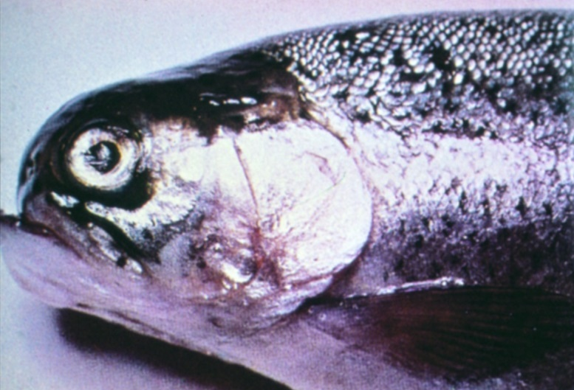
Note: Deformed skull resulting from long-term infection.
Source: T Håstein
Figure 2 Skeletal deformities in rainbow trout (Oncorhynchus mykiss) with whirling disease
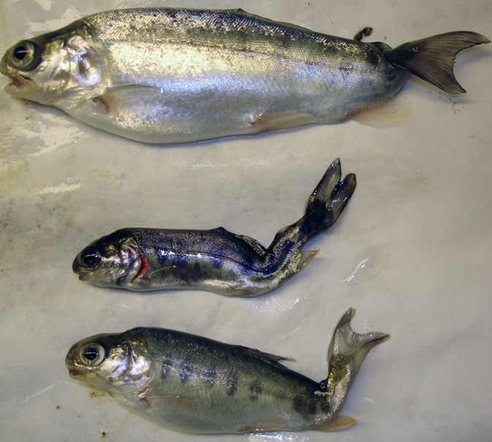
Note Typical skeletal deformities caused by infection with Myxobolus cerebralis.
Source: J Bartholomew
Figure 3 Discolouration of rainbow trout (Oncorhynchus mykiss) with whirling disease
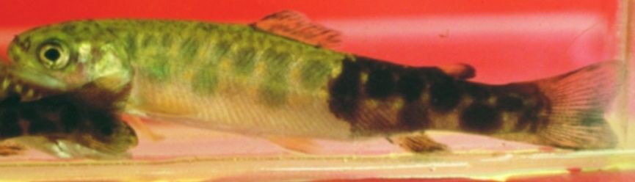
Note: Classic darkening of the skin from vent to tail.
Source: T Poppe
Figure 4 Discolouration of rainbow trout (Oncorhynchus mykiss) with whirling disease
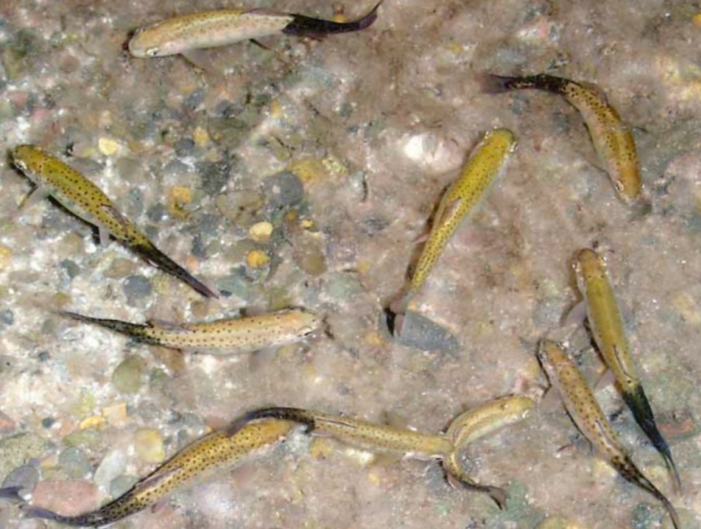
Note Classic darkening of the skin from vent to tail.
Source: J Bartholomew

Signs of disease
Important: Animals with this disease may show one or more of these signs, but the pathogen may still be present in the absence of any signs.
Disease signs at the farm, tank or pond level are:
- mass mortalities in fry
- convulsive movements
- increased respiratory rate
- jerking backwards movements
- swimming with a whirling motion (tail chasing)
- erratic, nervous darting movements until exhausted.
Gross pathological signs are:
- darkening of the skin from the vent to the tail (blacktail)
- spinal curvature, skull deformation and shortened gill plates.
Microscopic pathological signs are:
- myxospores and other developmental stages within the cartilage of the cranium and axial skeleton of juvenile fish.

Disease agent
Whirling disease is caused by infection with Myxobolus cerebralis, a parasitic myxosporean that affects salmonids. Myxosporean parasites are multicellular disease agents related to cnidarians, most of which have a multi-host lifecycle including fish (or amphibians) and aquatic invertebrate hosts (particularly annelids).

Life cycle
- Myxobolus cerebralis has a complex life cycle (Figure 5) involving two hosts: fish (trout or salmon species) and an intermediate host, the tiny bottom-dwelling tubifex mud worm (Tubifex tubifex).
- Myxobolus spores (myxospores) develop in infected fish and are released into the environment when the fish dies. The myxospores are very persistent and can survive in moist environments for many years.
- Myxospores are ingested from the environment by tubifex mud worms. The spores rapidly multiply in the worm's intestine.
- A fragile waterborne spore stage of the parasite (triactinomyxon stage) is released from an infected intermediate host and infects a definitive host (fish). This must occur within the survival window of the triactinomyxon stage (over 2 weeks at 15°C). The parasite then migrates through the fish skin into the central nervous system, and ultimately into the cartilage.
- Following death and decomposition of infected fish, myxospores are released into the environment and the life cycle continues.
- Spores survive passing through the digestive tract of predators (such as piscivorous birds), and can be transferred from place to place on muddy boots, waders and other equipment.
Figure 5 Life cycle of Myxobolus cerebralis
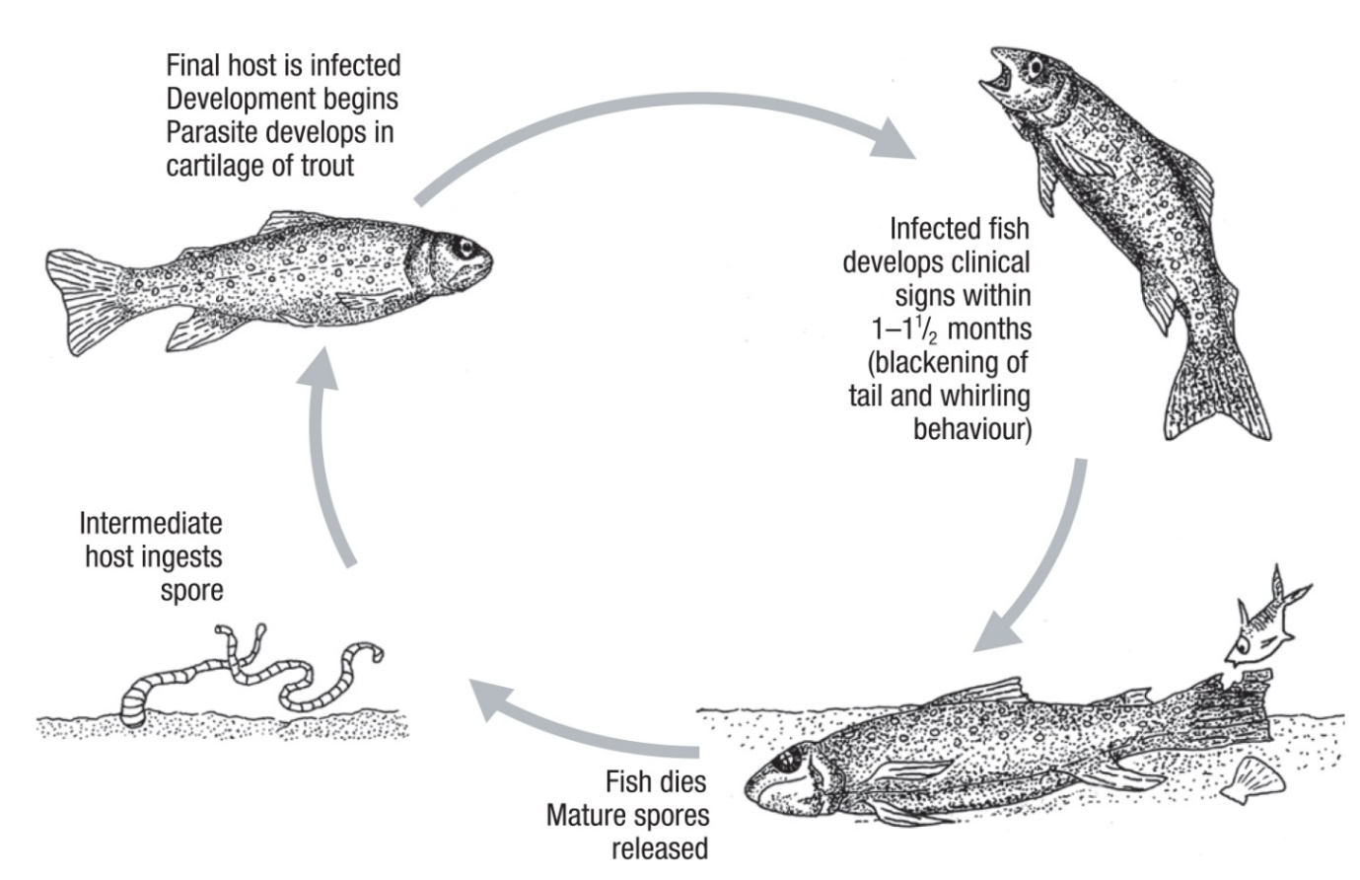
Note: The lifecycle of M. cerebralis is indirect and requires a tubificid worm as the intermediate host.

Host range
Rainbow trout are considered to be the species most susceptible to whirling disease.
The presence of clinical signs depends on many factors, particularly the age of the primary host of the initial infection. For example, infected rainbow trout older than 9 weeks will generally show no clinical signs and chinook salmon do not exhibit clinical signs of disease beyond the age of 3 weeks.
Tubifex worms (T. tubifex) are known intermediate hosts that are present in Australia.
Table 1 Species of fish known to be naturally susceptible to whirling disease
Common name | Scientific name
Atlantic salmon | Salmo salar
Brook trout | Salvelinus fontinalis
Brown trout | Salmo trutta
Bull trout | Salvelinus confluentus
Chinook salmon | Oncorhynchus tshawytscha
Coho salmon | Oncorhynchus kisutch
Cutthroat trout | Oncorhynchus clarkii
Danube salmon | Hucho hucho
Gila trout | Oncorhynchus gilae
Golden trout | Oncorhynchus aguabonita
Mountain whitefish | Prosopium williamsoni
Rainbow troutª | Oncorhynchus mykiss (most susceptible)
Sockeye salmon | Oncorhynchus nerka
Note: Other species not listed have been shown to be experimentally susceptible.
Table 2 Non-fish carriers
Common name | Scientific name
Annelids | Various genera and species
Tubifex wormsª | Tubifex tubifex
Piscivorous birds | Various genera and species
a Required intermediate host.

Presence in Australia
Exotic disease—not recorded in Australia.
Myxobolus cerebralis has not been recorded in Australia, and is considered exotic. However, various other species of Myxobolus have been recorded in marine and freshwater fish.
Map 1 Presence of whirling disease, by jurisdiction
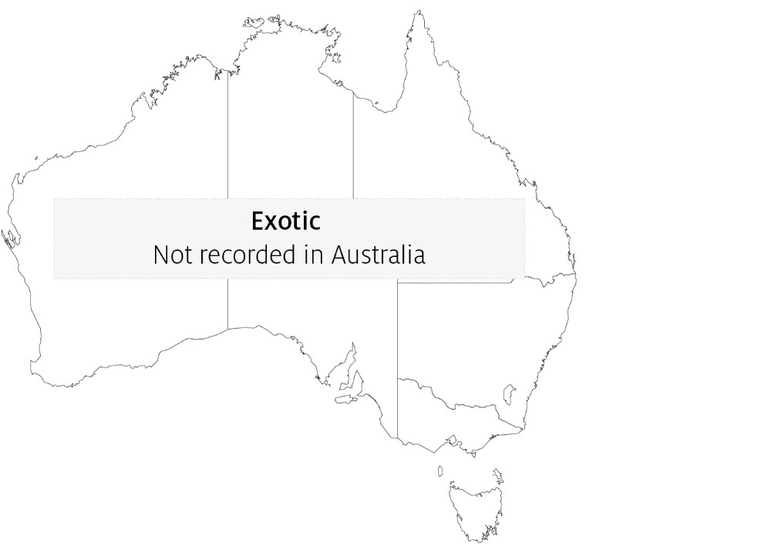

Epidemiology
- Whirling disease is chronic and primarily affects young fish.
- Susceptibility is influenced by water temperature, age and species.
- Young fish are highly susceptible because the parasite attacks their soft cartilage, resulting in nerve damage, skeletal deformities and sometimes death.
- Clinical signs of the disease are not evident until fish are approximately 7cm long.
- When fish are 8 to 10cm long, cartilage forms into bone and they are no longer susceptible to disease; however they remain carriers of the parasite.
- The intermediate host, the annelid worm T. tubifex, is found in Australia.
- Because Tubifex worms live in mud, the disease can be partly controlled in trout farms by growing young fish in concrete raceways.
- The parasite spreads mainly through the stocking of infected fish and through the alimentary tracts of fish-eating migratory birds.
- Myxobolus cerebralis is highly resistant in the myxospore stage. The myxospore released from the fish can withstand freezing and desiccation, and may survive in a stream for up to 30 years with appropriate environmental conditions. However, the triactinomyxon infective stage released from the worm is short lived (up to 2 to 3 weeks at 15°C) and susceptible to standard disinfection procedures.

Differential diagnosis
The list of similar diseases in the next section refers only to the diseases covered by this field guide. Gross pathological signs may also be representative of diseases not included in this guide. Do not rely on gross signs to provide a definitive diagnosis. Use them as a tool to help identify the listed diseases that most closely account for the observed signs.

Similar diseases
Enteric red mouth disease (ERMD), infectious haematopoietic necrosis (IHN) and viral haemorrhagic septicaemia (VHS).

Sample collection
Only trained personnel should collect samples. Using only gross pathological signs to differentiate between diseases is not reliable, and some aquatic animal disease agents pose a risk to humans. If you are not appropriately trained, phone your state or territory hotline number and report your observations. If you have to collect samples, the agency taking your call will advise you on the appropriate course of action. Local or district fisheries or veterinary authorities may also advise on sampling.

Emergency disease hotline
See something you think is this disease? Report it. Even if you’re not sure.
Call the Emergency Animal Disease Watch Hotline on 1800 675 888. They will refer you to the right state or territory agency.

Microscope images
Figure 6 Phase micrograph of Myxobolus cerebralis myxospores from infected rainbow trout (Oncorhynchus mykiss) cranial cartilage
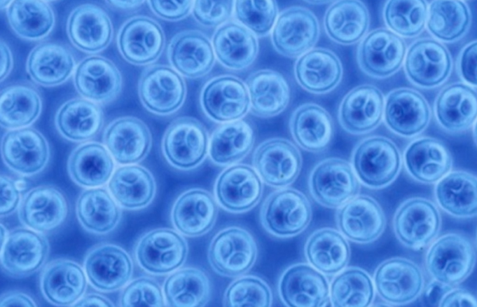
Note Spores measure approximately 10μm in diameter. Extracted by the pepsin trypsin digest method.
Source: J Bartholomew

Further reading
CABI Invasive Species Compendium ‘Myxobolus cerebralis’ (whirling disease agent)
Department of Agriculture, Water and the Environment AQUAVETPLAN disease strategy manual: Whirling disease
Elwell LC, Stromberg KE, Ryce EK, Bartholomew JL 2009, ‘Whirling disease in the United States: a summary of progress and research and management 2009’, Trout Unlimited
These hyperlinks were correct at the time of publication.

Contact details
Emergency Animal Disease Watch Hotline 1800 675 888
Email AAH@agriculture.gov.au
Website agriculture.gov.au/pests-diseases-weeds/aquatic
© Commonwealth of Australia 2020
This work is copyright. It may be reproduced in whole or in part subject to the inclusion of an acknowledgement of the source and no commercial usage or sale.

