National biosecurity plan guidelines for the Australian land-based abalone industry
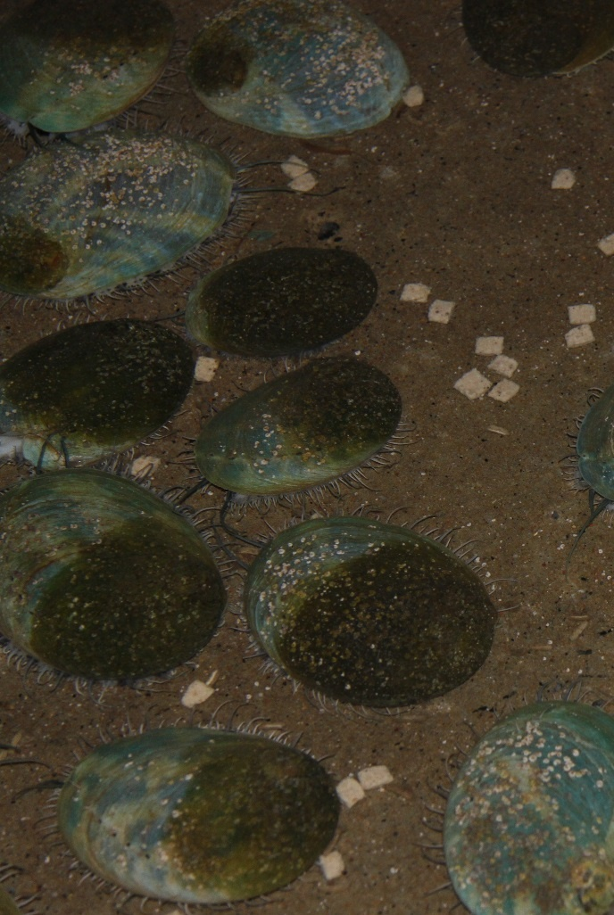
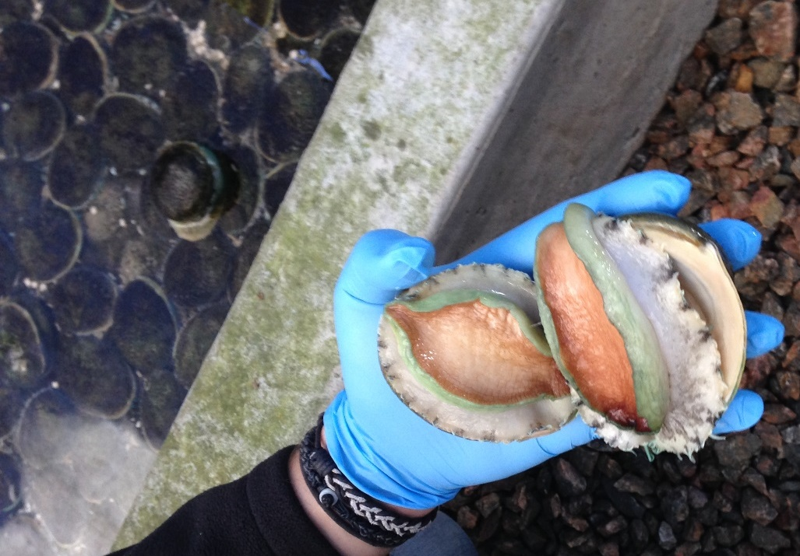
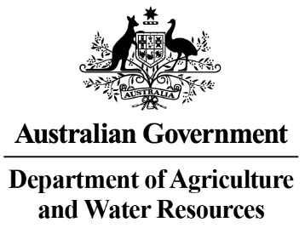
©Commonwealth of Australia 2018
Ownership of intellectual property rights
Unless otherwise noted, copyright (and other intellectual property rights, if any) in this publication is owned by the Commonwealth of Australia (referred to as the Commonwealth).

Creative Commons licence
All material in this publication is licensed under a Creative Commons Attribution 3.0 Australia licence, saved for content supplied by third parties, logos and the Commonwealth Coat of Arms.
Creative Commons Attribution 3.0 Australia Licence is a standard form licence agreement that allows you to copy, distribute, transmit and adapt this publication provided you attribute the work. A summary of the licence terms is available from creativecommons.org/licenses/by/3.0/au/deed.en. The full licence terms are available from creativecommons.org/licenses/by/3.0/au/legalcode.
Email inquiries about the licence and any use of this document to copyright@agriculture.gov.au.

Cataloguing data
Attribute this publication (and any material sourced from it, unless specified otherwise) as: Spark, E., Roberts, S., Deveney, M., Bradley, T., Dang, C., Wronski, E., and Savva, N., PIRSA Fisheries and Aquaculture 2018. National Biosecurity Plan Guidelines for the Land Based Abalone Industry. Department of Agriculture and Water Resources, Canberra August 2018. CC BY 3.0.
ISBN 9781760031671
This publication is available at www.agriculture.gov.au/animal/aquatic/guidelines-and-resources.

Department of Agriculture and Water Resources
Postal address GPO Box 858 Canberra ACT 2601
Telephone 1800 900 090
Web agriculture.gov.au
The Australian Government, acting through the Department of Agriculture and Water Resources, has exercised due care and skill in preparing and compiling the information and data in this publication. Notwithstanding, the Department of Agriculture and Water Resources, its employees and advisers disclaim all liability, including liability for negligence and for any loss, damage, injury, expense or cost incurred by any person as a result of accessing, using or relying upon any of the information or data in this publication to the maximum extent permitted by law.

About this publication
The National Biosecurity Plan Guidelines for the Land Based Abalone Industry were developed as part of Activity 1.1 of AQUAPLAN 2014-2019, Australia’s National Strategic Plan for Aquatic Animal Health, under Fisheries and Research and Development Corporation (FRDC) project 2016-245. The Department of Agriculture and Water Resources funded the project through the FRDC. Primary Industries and Regions South Australia (PIRSA) and the Australian Abalone Growers Association also provided in-part funding. The Sub-Committee on Aquatic Animal Health endorsed the document in October 2017 and the Animal Health Committee in February 2018.

Writing group members
Elise Spark – Primary Industries and Regions South Australia
Shane Roberts – Primary Industries and Regions South Australia
Marty Deveney – South Australian Research and Development Institute
Tracey Bradley – Department of Economic Development, Jobs, Transport and Resources, Victoria
Cecile Dang – Department Primary Industries, and Regional Development, Western Australia
Eileen Wronski – Department of Primary Industries, Parks, Water and Environment, Tasmania
Melissa Walker – Department of Primary Industries, New South Wales
Nicholas Savva – Australian Abalone Growers Association

Comments were provided by other persons during the development of the National Biosecurity Plan Guidelines for the Land Based Abalone Industry. These contributions are gratefully acknowledged, in particular the contributions of the industry and government participants who attended the abalone workshop.

Photos on front page provided by: Primary Industries and Regions South Australia.
Contents
INTRODUCTION 4
USING THESE BIOSECURITY PLANNING GUIDELINES 5
ABALONE DISEASES OF SIGNIFICANCE 7
MAJOR ROUTES FOR DISEASE TRANSMISSION 8
WHAT TO INCLUDE IN YOUR BIOSECURITY PLAN 10
Section 1. ENTERPRISE INFORMATION 10
Production details 10
Key contacts 10
Section 2. MAPS AND DIAGRAMS 11
Farm locality and features 11
Farm maps and schematic diagrams 11
Section 3. ROUTINE MEASURES TO ADDRESS MAJOR DISEASE TRANSMISSION ROUTES 14
Additional farm-specific risks – not covered by these guidelines 14
Animals 16
People 18
Equipment, vehicles and vessels 21
Water, waste and feed 22
SECTION 4. ADDITIONAL SUPPORTING MEASURES 24
Training 24
Record keeping 25
Section 5. EMERGENCY PROCEDURES 26
Section 6. LEGISLATIVE AND JURISDICTIONAL REGULATORY REQUIREMENTS 27
Section 7. DOCUMENT CONTROL AND REVISION RECORD 28
Section 8. AUDIT RECORD 28
Section 9. SUPPORTING DOCUMENTS 29

INTRODUCTION
These guidelines have been developed to provide Australian land-based abalone farms with the tools and templates to create fully auditable biosecurity plans.
Biosecurity plans are important because they provide disease prevention and response measures specific to your farm. They also fulfill biosecurity requirements for movement and trade in ‘like’ abalone.
In 2015, the Animal Health Committee endorsed the Abalone Health Accreditation Program as a nationally agreed document to facilitate trade in abalone livestock. The program requires that farms develop an auditable biosecurity plan in addition to, in most states, employing targeted and sentinel surveillance.
These guidelines are part of the Fisheries Research and Development Corporation (FRDC) project, Development of sector-specific biosecurity plan templates and guidance documents for the abalone and oyster aquaculture industries (project number: 2016-245). We have developed them:
- in accordance with the national Aquaculture Farm Biosecurity Plan: generic guidelines and template (www.agriculture.gov.au/fisheries/aquaculture/farm-biosecurity-plan)
- based on input from a government/industry workshop held on 8 and 9 September 2016.
Biosecurity is a set of measures that help to prevent or reduce the risk of introducing disease onto your farm, spreading disease within your farm, or spreading disease from your farm to the aquatic environment or to other aquatic enterprises.
Worldwide, there is increasing risk of significant aquatic animal diseases and pests, both known and unknown, emerging and spreading. Australia currently has a favorable aquatic animal health status. To maintain this, farmers must work towards implementing preventative biosecurity measures rather than reacting to a disease outbreak.
Effective biosecurity is integral to any successful production system as it helps minimise unnecessary costs, can improve production outcomes, and helps maintain trade and market access. Those measures aimed at preventing disease entering your farm in the first place can lead to a significant return on your investment.
Preventing disease not only protects your business, but has wider benefits for the industry and communities that would potentially be devastated by a significant disease outbreak. Ownership and buy-in by your staff is critical for successfully implementing and operating farm biosecurity.
Staff must understand that they can help protect their jobs, and ultimately the industry, by preventing the introduction of or minimising the spread of disease.

USING THESE BIOSECURITY PLANNING GUIDELINES
This document is designed to help abalone farmers:
- develop a farm biosecurity plan
- strengthen an existing farm biosecurity plan.
To develop an effective biosecurity plan, farmers need to consider a number of factors. These guidelines provide information, as well as templates and other resources, to help you assess risks common to land-based abalone farms. This will help you develop a biosecurity plan tailored for your farm.
The guidelines identify the major routes of potential disease transmission in abalone farms, including disease entry, spread within your farm and spread from your farm. This will help you assess:
- risks associated with each route of disease transmission
- on-farm measures to minimise the risk of disease transmission
- what other supporting documents you will need to develop a comprehensive plan, for example standard operating procedures (SOPs).
You will also need to consider any additional risks specific to your farm, and associated risk management measures, that you may require.
Each farm will have a different spectrum of biosecurity challenges and operating environments because of variations in:
- operation size
- farm location and layout
- disease status of the region or state/territory
- proximity to wild abalone populations, fish processors and other aquaculture sites
- number and type of species farmed
- available resources.
You will need to develop an individual farm biosecurity plan that takes your farm’s uniqueness into account. This ensures that the plan is practical for your operation, as well as being as simple and as low cost as possible to achieve desired biosecurity outcomes.
The guidelines provide supporting documentation, including templates and example SOPs, as appendices to help you develop your plan. You will need to tailor some documents (for example, farm-specific SOPs) specifically for your farm. See Appendix 8 for help on writing an SOP.
You will not need to duplicate existing documents, systems or records. However, where appropriate, reference these within your biosecurity plan.
Once you have navigated through these guidelines and assessed individual farm risks, you can create a farm biosecurity plan. Appendix 10 provides an electronic biosecurity plan editable template.
Appendix 9 provides a self-audit checklist against which you can assess your completed plan. Use this checklist to highlight any remaining gaps.
Symbols used in these guidelines:
- Pen and paper icon indicates supporting details and other information to include in your farm biosecurity plan.
- Tick on paper icon indicates risk management measures to implement and document. These measures are auditable.
- Open file icon indicates templates provided to help develop individual farm biosecurity plans.
A comprehensive biosecurity plan will be a mandatory requirement of any import protocol.

ABALONE DISEASES OF SIGNIFICANCE
Three diseases are currently listed as national reportable diseases of abalone (Table 1). These diseases are a threat to farm production and to market access and trade.
Table 1. National reportable diseases of abalone
Disease | Pathogen type | Presence in Australia
Abalone Viral Ganglioneuritis (AVG) | Viral | Endemic (in Australia)
Xenohaliotis californiensis | Bacterial | Exotic (not in Australia)
Perkinsus olseni | Parasitic | Endemic (in Australia)
Access the full and current list of National Reportable Diseases of Aquatic Animals on the Department of Agriculture and Water Resources website
(at www.agriculture.gov.au/animal/aquatic/reporting/reportable-diseases).
Under state and territory legislation farmers, aquaculture technicians, veterinarians and researchers, or anyone else involved in abalone aquaculture, must immediately report these, as well as any additional jurisdiction-specific diseases, to the relevant authority if suspected or detected. States and territories commonly refer to these diseases as Notifiable Diseases and lists are available on relevant jurisdiction websites.
The diseases shown in Table 1 include a range of pathogen types (viral, bacterial and parasitic). Farm biosecurity planning needs to consider these types and how they are spread when determining risk management measures such as appropriate decontamination.
Key reportable abalone disease resources to help you identify such diseases include:
- Aquatic Animal Diseases Significant to Australia: Identification Field Guide 4th Edition, available on the Department of Agriculture and Water Resources website (at www.agriculture.gov.au/animal/aquatic/guidelines-and-resources/aquatic_animal_diseases_significant_to_australia_identification_field_guide)
This guide is also available as a free App that can be downloaded from the App Store (Apple devices), Google Play (Android devices) and Microsoft Store (Windows devices). We recommend that you and your staff install this on your mobile phones.
- AQUAVETPLAN Disease Strategy Manuals, available on the Department of Agriculture and Water Resources website (at www.agriculture.gov.au/animal/aquatic/aquavetplan)
You can find AQUAVETPLAN manuals here for Abalone Viral Ganglioneuritis and Withering Syndrome of Abalone.
- OiE Disease Chapters – Diseases of Molluscs, available on the World Organisation for Animal Health website (at www.oie.int/international-standard-setting/aquatic-manual/access-online/).
The Fisheries Research and Development Corporation website (www.frdc.com.au) is also an excellent resource for emerging issues and latest research. In addition to known diseases of significance, or those listed as reportable, there are potentially other diseases (for example, emerging or unknown diseases) that may be a future risk to production. Good farm biosecurity should be aimed at preventing entry and spread of both known and unknown disease.

MAJOR ROUTES FOR DISEASE TRANSMISSION
Figure 1 outlines the biosecurity risk levels of a farm and the major ways that disease can be transmitted onto (entry-level), within (internal), and from (exit-level) land-based abalone farms:
- entry-level transmitters – stock (for example, broodstock, wild abalone, other farm stock), intake water, feed, people (for example, staff and visitors), equipment and vehicles, and other animals (for example, vermin, wild birds, other animals entering via the intake water or returning escapees)
- internal transmitters – stock, water, people, equipment, vehicles, and other animals can transmit diseases
- exit-level transmitters – stock (including mortalities, discarded product, escaped abalone), discharge water, people, equipment, vehicles, and other animals and wastes.
When high levels of infection come into close contact with susceptible hosts, it is likely that the disease will become established and spread.
Figure 1. Different levels of farm biosecurity. Source: K. Ellard, (2015). Disease control recommendations to support aquatic animal health? Proceedings of the Third OIE Global Conference on Aquatic Animal Health, Session 4, pages 137-143.
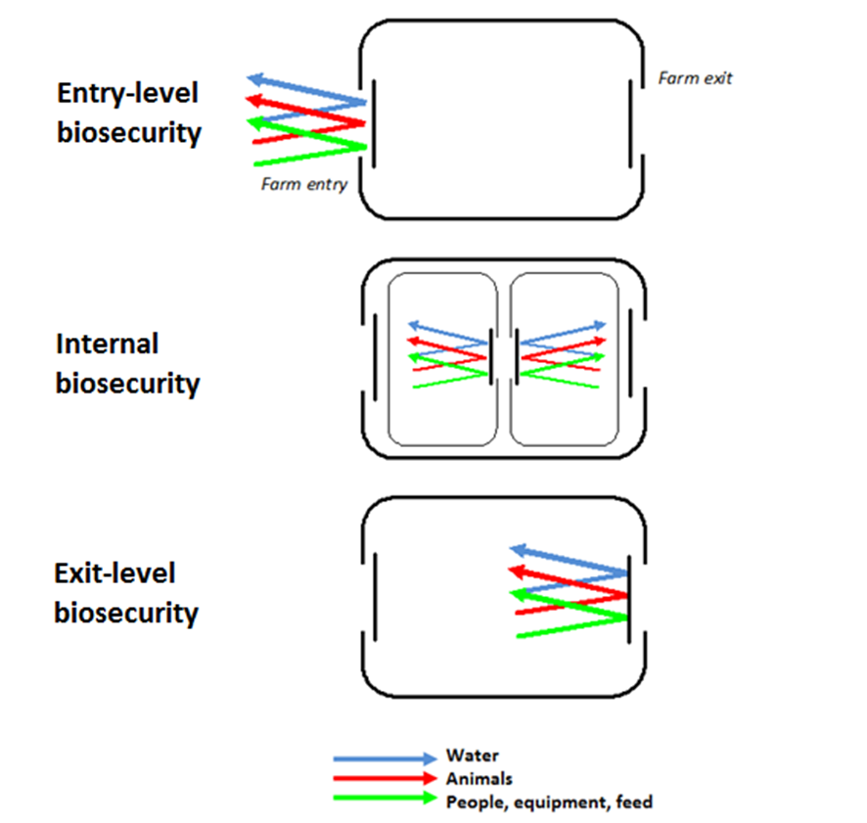
For farms, stock (especially broodstock) and wild abalone, water, and the movement of equipment and people present the highest risk pathways for introducing and spreading disease. Address these pathways as a priority.

WHAT TO INCLUDE IN YOUR BIOSECURITY PLAN
Your farm biosecurity plan needs to be read and interpreted by a range of people including farm staff, external auditors and jurisdictional staff. As such it should be easy to follow, with clear information and diagrams.
Below, we have outlined a suggested layout and inclusions to help you develop a comprehensive and concise biosecurity plan.

Section 1. ENTERPRISE INFORMATION
Enterprise information provides essential background detail about your farm. This includes the scale and scope of the operation.

Production details
- Summarise detail of all relevant elements of farm production.
Relevant details include:
- stock source(s)
- product, including species, size and market
- farm activities – all production and administrative activities
- staff – number and areas of responsibility
- any associated sites linked to the farm.

Key contacts
- Document key details for internal and external contacts, relevant to farm management, biosecurity and stock health.
Relevant contacts include:
- company, farm and specific area managers
- consulting veterinarians/abalone health professionals
- government aquatic animal health contacts
- laboratories used
- other industry representatives (for example, association representatives).

Section 2. MAPS AND DIAGRAMS
Farm design and availability of infrastructure will determine how you can manage biosecurity. Include relevant information in this section of the plan.

Farm locality and features
- Provide a locality map and associated farm information.

You will need to assess and document specific disease transmission risks based on farm location.
Relevant details include:
- status of state or territory, region and/or bay for known diseases or marine pests of concern (for example, Abalone Viral Ganglioneuritis [AVG])
- proximity to other aquaculture production (for example, marine-based abalone farms, other aquaculture leases, fish processors)
- proximity to potential high-risk sites (for example, wild abalone populations)
- presence and type of wildlife (birds), feral animals or vermin
- nearby roads, towns, boat ramps, marinas.

Farm maps and schematic diagrams
It is likely that you will need more than one farm map in your biosecurity plan, to cover different levels of detail.
Ensure maps and diagrams include the following information.

Facility layout
- Provide a farm layout map and associated access information.
- Appendix 1 includes a biosecurity sign.
Relevant details include the presence and location of:
- perimeter fences
- farm entry/exit points and gates (and if gates are lockable)
- access/biosecurity sign location(s)
- access road(s)
- car park(s)
- reception point for farm visitors
- sheds/storage areas, tanks and other infrastructure
- water intake and discharge pipes/channels
- water pumps and filtration equipment
- vehicle loading/delivery area(s)
- wash down/disinfection area(s)
- mortality pit(s)
- sedimentation pond(s)
- emergency muster point(s).
- R1. The farm has a secure perimeter or otherwise well-defined boundary establishing a clearly defined biosecurity zone.
- R2. You can close the main production area entrance to vehicle traffic if you activate the emergency response plan.
- R3. Access gates are lockable and locked when no company personnel are on site.
- R4. Clearly display entry signage that provides direction for visitors and includes company contact details.

Production areas and biosecurity zone classifications
- Provide a farm diagram outlining production areas and associated biosecurity zone classifications.
Be sure to include:
- entry and exit points for each production area/zone
- the location of any physical biosecurity measures between production areas/zones (for example, disinfection/sanitisation points, boot change areas)
- the class of stock within each production area/zone (for example, broodstock, juveniles, growout)
- the number of tanks or raceways in each area (to give an indication of farm size)
- typical stock and staff/visitor movements including those between farm production areas/zones and between sites (if applicable).
Ensure you describe biosecurity zones (Table 2) shown in diagrams, and used in your farm biosecurity plan, in detail within supporting SOPs.

Biosecurity zone | Access
Extreme (red) | - highly restricted  - authorised personnel only  - no entry to any other zones following access.
High (amber) | - limited access  - authorised personnel only.
Moderate (yellow) | - limited access  - authorised personnel only.
Low (green) | - no access restrictions (staff or visitors).
Table 2. Summary of example farm biosecurity zones
- R5. Divide the farm into biosecurity zones with zone-specific requirements relating to access, entry and exit procedures, and dedicated equipment.
- R6. Clearly display biosecurity zone signage, consistent with biosecurity zone definitions and familiar to all personnel.

Section 3. ROUTINE MEASURES TO ADDRESS MAJOR DISEASE TRANSMISSION ROUTES
This section outlines routine risk management measures to address major disease transmission routes common to land-based abalone farms (as per page 7).
Routine measures are implemented and followed as part of normal daily farm operations. For each measure, we have assigned a risk category. These will help to highlight the measures you need to prioritise to provide the highest degree of assurance that you will not introduce or spread disease.
The risk-rating categories, based on a risk assessment, are outlined in Table 3.
Table 3. Risk-rating categories
Risk category | Potential risk level
Category A | Failure to implement risk management measures may result in a critical risk of disease transfer.
Category B | Failure to implement risk management measures may result in a high risk of disease transfer.
Category C | Failure to implement risk management measures may result in a moderate risk of disease transfer.
Category D | Failure to implement risk management measures may result in a low risk of disease transfer.

Additional farm-specific risks – not covered by these guidelines
When developing your farm-specific biosecurity plan, you will also need to assess any additional risks associated with your specific farm, not covered in these guidelines. You will need to implement appropriate risk management measures. We have outlined this process below.
- Identify risks and perform a risk assessment
Identify any additional farm-specific risks (or routes of disease transmission). Perform a risk assessment for each risk identified:
- estimate the likelihood of disease entering the farm by this route
- determine the consequence of disease entry by this route.
The level of risk posed is disease-dependent. As your farm biosecurity plan is not targeted at a specific disease, however, it is best practice to consider the worst-case scenario – an exotic or other emergency (or significant) abalone disease such as Withering Syndrome.
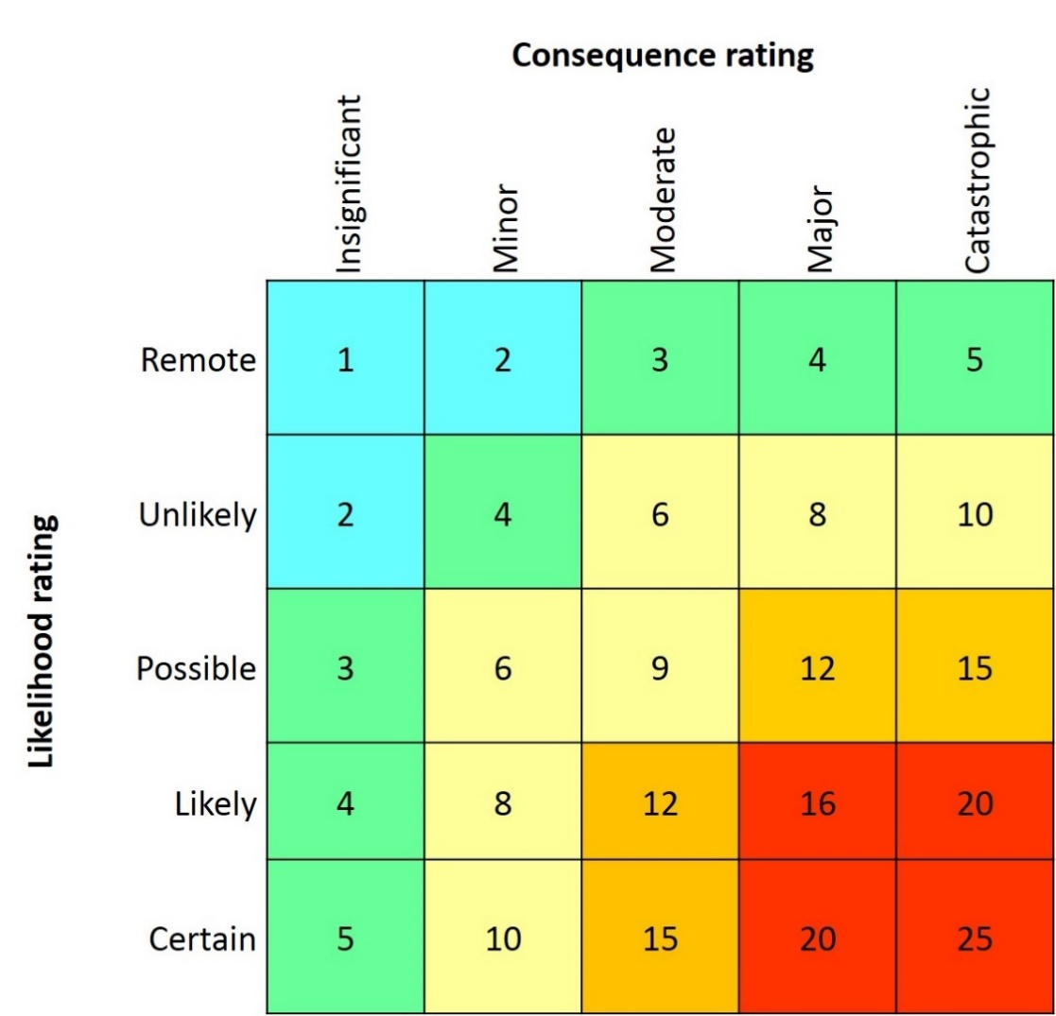
Figure 2. Risk estimation matrix
Figure 3. Assessment of disease consequences
Level | Action
1-2 Negligible | Acceptable level of risk. No action required.
3-5 Low | Acceptable level of risk. On-going monitoring may be required.
6-10 Medium | Unacceptable level of risk. Active management is required to reduce the level of risk.
12-15 High | Unacceptable level of risk. Intervention is required to mitigate the level of risk.
16-25 Extreme | Unacceptable level of risk. Urgent intervention is required to mitigate the level of risk.
Medium, high or extreme risks are considered unacceptable and require you to implement management measures. Monitor low risks to ensure the risk profile does not change over time.
You can find detailed information on performing a risk assessment in part 3 (pages 25 to 28) of the Aquaculture Farm Biosecurity Plan – generic guidelines and template, on the Department of Agriculture and Water Resources website
(at www.agriculture.gov.au/fisheries/aquaculture/farm-biosecurity-plan).
- Identify appropriate risk management measures
Manage risks with a variety of measures, including physical (for example, infrastructure and equipment), procedural (for example, production practices and training) or other supporting measures (for example, signage).
To address any specific additional risks identified for your farm, consider each of these measures as part of a standard approach.
- Develop or identify associated supporting documentation
Support risk management measures with appropriate documentation (for example, SOPs, checklists, record keeping templates) outlining detailed risk management measures.
For example, your biosecurity plan may identify a risk management measure as the ‘use of footbaths between biosecurity zones’. Appropriate documentation to support this practice would be a ‘Disinfection SOP’, which details the type of disinfectant used, when it requires inspection and how regularly and by whom the disinfectant is to be changed. Do not include this level of detail in the body of your farm biosecurity plan, but instead reference the appropriate supporting documentation. You could use a document number, name or other relevant code to reference an SOP.
Accompany SOPs by a date-stamped checklist wherever possible to provide evidence that an accountable staff member is following the SOP procedure(s). Supervisors, managers and/or auditors can readily monitor checklists.

Animals
Objective: Minimise the risk of stock and other animal movement introducing and spreading disease.
The most significant risk for bringing disease onto a farm is through stock, especially if you don’t know the health status of the stock.
Manage stock introduction and movement carefully to minimise this risk. See Table 4 for a summary of risk management measures.

Table 4. Risk management measures for stock and animal movement
Risk category | Risk management measures
(A) Critical | - R7. Obtain health status information and appropriate permits for stock before it enters the farm. Ensure the health status of any introduced stock is equal to or better than that of stock already present. Permanently quarantine stock if you cannot achieve this.  - R8. Permanently quarantine introduced stock of unknown (for example, wild) or lower health status. This includes isolation in separate water from all other farm stock in separate production units/dedicated quarantine facilities with appropriate biosecurity measures.  - R9. House multiple marine aquaculture species (for example, oysters and abalone) separately, with appropriate biosecurity measures and do not share water across species.
(B) High | - R10. Inspect stock on introduction to the farm and clean if required.  - R11. Dispose of mortalities or unwanted stock in an appropriate manner* that is approved by the relevant jurisdictional authority. Ensure dead or unwanted stock is not returned to the environment or accessible to scavengers (for example, birds).  - R12. Investigate health problems (suspected diseases) with assistance from aquatic animal health professionals.  - R13. Ensure staff responsible for managing abalone husbandry are trained in, and aware of, their role and responsibility in reporting signs of disease and high mortality.  - R14. In accordance with jurisdictional requirements, immediately inform relevant authorities of any significant, unexplained mortality event or suspected reportable disease.  - R15. Keep stock stress to a minimum by ensuring appropriate water quality, hygiene, stocking density, nutrition and handling.  - R16. Prevent escapees.  - R17. Control birds or exclude them from production areas.
(C) Moderate | - R18. Inspect abalone health, mortality and behaviour daily. Record this information.  - R19. Remove mortalities twice weekly (at a minimum).
(D) Low | - R20. Ensure domestic animals (for example, cats and dogs) do not have access to production areas at any time.  - R21. Bait vermin as necessary (if you observe live rodents, droppings or nests).
*For further disposal information, see the AQAUAVETPLAN Operational Procedures Manual – Disposal at www.agriculture.gov.au/animal/aquatic/aquavetplan/disposal.

People
Objective: Minimise the risk of people movement introducing and spreading disease
The risk of people introducing disease to your farm is greatest if they have recently visited other farms, or environments potentially containing diseases of concern.
Contaminated skin, clothing and footwear can all potentially spread disease. See Table 5 for a summary of risk management measures.

Staff
- Appendix 2 is an example of a pre-employment biosecurity declaration.

Table 5. Risk management measures for staff movement
Risk category | Risk management measures
(B) High | - R22. Do not permit staff to visit other aquaculture sites or seafood processors before entering the farm (unless they have been appropriately decontaminated).
(D) Low | - R23. To ensure effective disinfection at all times, locate footbaths (or provide the opportunity to change into zone-specific boots) and hand sanitation stations at the farm entrance/exit and between biosecurity zones.  - R24. Ensure boots worn in production areas are not worn or taken outside their designated production area.  - R25. Ensure staff attend work in laundered, clean clothes each day.  - R26. Only permit designated staff to routinely enter farm quarantine areas.  - R27. Ensure work flow is unidirectional (from low- to high-risk zones) when staff need to access multiple zones during a day. Make sure you have an appropriate procedure when this is not possible.

Visitors – contractors, suppliers and other service personnel, family and neighbours
- Appendix 3 provides a visitor biosecurity declaration template.
- Appendix 4 provides a visitor log template.
- Appendix 5 provides suggested farm entry conditions for visitors.
See Table 6 for a summary of risk management measures.

Table 6. Risk management measures for visitor movement
Risk category | Risk management measures
High | - R28. All visitors must complete a biosecurity declaration on arrival to ensure you assess their risk to farm biosecurity. Consider refusing entry to high-risk visitors.
(C) Moderate | - R29. Limit movement of people onto and through the farm, in particular restrict visitor access to quarantine zones.  - R30. Appropriately disinfect all visitors on production area entry and exit using footbaths (or provide the opportunity to change into zone-specific boots) and hand sanitation stations.
(D) Low | - R31. Visitors must sign-in on arrival (by completing the farm visitor log) and undergo a farm biosecurity induction.  - R32. Clearly display farm entry requirements to visitors at the sign-in point.  - R33. Ensure contractors conduct routine maintenance work within quarantine area(s), where possible, between batches and before final disinfection.  - R34. The farm manager must approve all visitors and visits must be unidirectional from lowest to highest risk areas.  - R35. Accompany visitors at all times when on site.

Equipment, vehicles and vessels
Objective: Minimise the risk of equipment, vehicle or vessel movement introducing and spreading disease.
Depending on their history of use, contaminated equipment, vehicles or vessels can carry and spread disease agents.
Equipment and vehicles pose the greatest risk of disease transfer if used off-site (for example, dive equipment or vehicles returning from fish processors) or in association with stock or wild fish, especially if these are diseased. See Table 7 for a summary of risk management measures.
Table 7. Risk management measures for equipment, vehicle and vessel movement
Risk category | Risk management measures
(B) High | - R36. Do not permit equipment, vehicles or vessels that have been in contact with off-site abalone or water used to hold or process off-site abalone to enter the farm. In exceptional circumstances, make sure you can appropriately clean and disinfect* such equipment, vehicles or vessels, or those of unknown origin or status, before using on the farm.
(C) Moderate | - R37. Use specific equipment, clearly labelled, per zone.  - R38. Do not remove equipment from its dedicated zone and use elsewhere on the farm.  - R39. Keep equipment used for multiple aquatic marine species (for example, oysters and abalone) species specific and do not share.  - R40. If moving equipment between zones or species (for example, an expensive item), ensure you clean and disinfect* it appropriately.  - R41. Keep equipment properly maintained and appropriately decontaminated* as required. Ensure maintenance records are maintained and up-to-date.
(D) Low | - R42. Park visitor vehicles in a dedicated parking area.  - R43. Ensure the farm has a dedicated delivery and loading area.  - R44. Regularly clean all farm areas and keep free of rubbish and clutter.  - R45. Clean contractor tools before entry and ensure they are free of dust/organic matter.
*Use appropriate cleaning and disinfection methods where deemed necessary based on risk.
Appropriate cleaning and disinfection methods are outlined in the:
- AQAUAVETPLAN Operational Procedures Manual – Decontamination, found on the Department of Agriculture and Water Resources website (at www.agriculture.gov.au/animal/aquatic/aquavetplan/decontamination)
- Australian Pesticides and Veterinary Medicines Authority (APVMA) permit to allow hypochlorite for disinfecting abalone harvesting equipment and for decontamination against Abalone Viral Ganglioneuritis (AVG) (permit number PER14917), found on the APVMA website (at permits.apvma.gov.au/PER14917.PDF).
You can also find biofouling management guidelines, for minimising the spread of marine pest species, on the Australian Government marine pests website (at www.marinepests.gov.au/marine_pests/publications/Documents/Aquaculture_guidelines.pdf).

Water, waste and feed
Objective: Minimise the risk of water, waste and feed introducing and spreading disease.
Farm water supply can pose a significant risk of disease transfer depending on if the source water carries disease. This is particularly important if there are host animals in the water source, or if it is close to water discharge from other aquatic enterprises or processors. See Table 8 for a summary of risk management measures.

Table 8. Risk management measures for water, waste and feed
Risk category | Risk management measures
(A) Critical | - R46. Treat incoming water appropriately (for example, screens on intake pipes, filtration) to minimise the risk of disease/pest entry.  - R47. Treat discharge water from dedicated quarantine facilities appropriately to minimise the risk of disease/pest establishment in the marine environment.
(B) High | - R48. Ensure water intake and outflow avoid cross contamination.  - R49. Ensure water flow within the farm minimises disease spread between biosecurity zones.  - R50. Dispose of other waste appropriately (for example, used water filters, fouling, faeces).
(D) Low | - R51. Regularly service and maintain filtration equipment and keep a record.  - R52. Ensure potable water is available for cleaning and disinfection procedures.  - R53. Only use manufactured or appropriately treated feeds.

Section 4. ADDITIONAL SUPPORTING MEASURES

Training
Objective: Ensure all farm staff understand they share the responsibility of maintaining farm biosecurity and must practice good biosecurity in all their work.
- Appendix 6 provides a training record template.
Ensure all staff are appropriately trained so they understand both farm- and role-specific biosecurity requirements.
Staff need to understand the major routes of disease transmission and signs of abalone ill-health.
Use a training record to ensure you do not overlook staff training. It will also remind you to refresh training regularly (annually at a minimum), as well as after you update any procedures or associated documents.
You can also use a training record to document additional role-specific training such as sample collection, packaging and submission.
- R54. Ensure the farm has a biosecurity manager responsible for creating, maintaining and reviewing the biosecurity plan, associated documents and activities including staff training.
- R55. Ensure that staff can readily access the farm biosecurity plan and all associated documents at all times.
- R56. Provide all staff with a farm biosecurity induction and ongoing biosecurity training relevant to their role. Document this and ensure it encompasses:
- the farm biosecurity plan
- the emergency response plan
- SOPs, associated documents including checklists and work practices that support these plans.

Record keeping
Objective: Record information necessary to support good biosecurity practices, in accordance with the farm biosecurity plan.
Good record keeping is necessary for auditing farm biosecurity plans and to provide demonstrable proof that you are following biosecurity protocols.
In the event of a disease outbreak, you can use these records to trace the potential source of disease and identify breakdowns in adherence to biosecurity protocols. You can also use them to help review and improve farming practices and protocols.
The minimum information that you should record is outlined below.

Stock movements
Records of stock movements and inventory are essential for tracing activities in the event of a disease outbreak.
At a minimum, we suggested you include:
- source of stock, including original and most recent source (if different)
- movement of stock within the farm (for movement between different biosecurity zones such as nursery and grow out)
- movement of stock from the farm, to other farms or to processors.
Records for each movement should include the following at a minimum:
- date of movement
- batch or other identifier
- number of individuals
- buyer (for sales) or stock origin, including contact details.
- R57. Maintain detailed records about stock movements and inventory and keep them readily accessible.

Stock health, mortality and water quality records
Health and performance records provide evidence that you are regularly monitoring stock. Records, especially of mortalities, help you monitor for unusual health problems.
At a minimum, we suggest you include:
- mortalities (including the method of disposal and if you have archived any samples)
- details of any poorly performing abalone
- water quality information
- results of laboratory testing associated with clinical disease or undertaken for health certification purposes or Abalone Health Accreditation Program surveillance.
- R58. Maintain detailed stock health, mortality and water quality records and keep them readily accessible.

Section 5. EMERGENCY PROCEDURES
Objective: Ensure you develop emergency procedures and identify additional biosecurity measures to implement if there is a suspected emergency animal disease or serious endemic disease. This could be either on the farm, or because of an increased threat of introducing disease if an outbreak is suspected in the state/territory or region.
- Appendix 7 provides an emergency response plan template.
An emergency response plan is an essential document for each farm and must provide clear guidelines as to the:
- specific trigger(s) for an emergency animal disease alert (for example, mortality rate, abnormal stock behavior)
- key emergency contacts
- notification pathways and responsibilities, including jurisdictional notification
- high biosecurity risk management measures that you need to immediately implement when you activate the emergency plan – this includes stock movement and farm access restrictions (examples of these are included within the emergency response plan template)
- sample collection, storage and submission guidelines
- disposal and quarantine protocols
- the physical location and/or web link of key response or other resource documents (for example, AQUAVETPLAN, jurisdiction disease response plan(s), farm disease response plan(s)).
This plan must be in line with AQUAVETPLAN, found on the Department of Agriculture and Water Resources (at www.agriculture.gov.au/animal/aquatic/aquavetplan), and other jurisdictional requirements.
Farm emergency plans should also include the procedures you need to follow in the event of a non-disease emergency that may influence farm biosecurity, for example a power failure, water treatment failure or natural disaster. This will ensure you have clearly identified responsibilities, notification pathways and other procedures before such an event.
- R59. Ensure the farm has an emergency response plan.

Section 6. LEGISLATIVE AND JURISDICTIONAL REGULATORY REQUIREMENTS
Farm practices must comply with:
- relevant agency and jurisdictional legislation (local, federal and state/territory)
- license conditions
- requirements of the Abalone Health Accreditation Program (for participating farms).
- R60. Adhere to applicable import requirements and obtain translocation permits for all stock and equipment movement.
- R61. Undertake batch testing or surveillance requirements in compliance with jurisdictional regulations or the Abalone Health Accreditation Program.
- R62. Only keep commercially farmed species on site in accordance with license conditions.
- R63. Ensure any veterinary medicines provided to stock are compliant with relevant state and national legislation (including the Commonwealth regulator, Australian Pesticides and Veterinary Medicines Authority).
We have looked at other regulatory requirements in previous sections, including:
- R11. Dispose of mortalities or unwanted stock in an appropriate manner that is approved by the relevant jurisdictional authority. Ensure dead or unwanted stock is not returned to the environment or accessible to scavengers (for example, birds).
- R14. In accordance with jurisdictional requirements, immediately inform relevant authorities of any significant, unexplained mortality event or suspected reportable disease.

Section 7. DOCUMENT CONTROL AND REVISION RECORD
- Include document control information and a revision record in your farm biosecurity plan.
This ensures you provide evidence to demonstrate your plan is being maintained as a living document and is continually reviewed and updated based on:
- changed biosecurity threats
- ongoing learnings
- infrastructure upgrades
- changes in farm practices
- newly available risk management tools or information
- audit recommendations.
- R64. Ensure you regularly review the farm biosecurity plan (annually at a minimum).

Section 8. AUDIT RECORD
- Include a record of any audits completed (if applicable).
Include both:
- internal and external audits
- scheduled and completed audits.
Note key outcomes/audit recommendations for reference and to demonstrate that you are critically reviewing your plan.
Include brief but specific notes of any findings or required corrections, or refer to a detailed document containing this information.
- R65. Regularly audit your farm biosecurity plan (annually at a minimum) to ensure you are implementing it effectively and improving on it as appropriate.

Section 9. SUPPORTING DOCUMENTS
- Include a list of associated documents (SOPs, checklists and record keeping templates) that are referenced within your farm biosecurity plan.
This list ensures you can readily identify supporting documents and make them accessible for review and audit. You do not need to include them in the body of your plan. Keep them elsewhere (to ensure version control is preserved) or include them as appendices.
We suggest you include the following supporting documents (Table 9), although you may incorporate multiple topics into the same SOP depending on your farm. Farm size, number of staff and scale of production are all likely to influence SOP requirements.
Checklists are essential supporting documents and you should use them in association with SOPs wherever possible. Checklists provide the evidence that an accountable staff member is following procedures outlined in an SOP at correct intervals.
Table 9. Standard operating procedures and record keeping
Suggested standard operating procedures and checklists | Record keeping templates/other documents
New employee induction and training | Pre-employment biosecurity declaration
Farm visitors | Visitor biosecurity declaration
Stock arrivals, movement and dispatch | Visitor log
Escapee prevention, inspection and collection | Farm entry conditions for visitors
Collecting and disposing of mortalities and other waste | Staff training record
Disinfection | Staff training record
Farm biosecurity zones | Staff training record
Emergency response plan | Staff training record
- R66. Clearly identify supporting documents (for example, SOPs, checklists and templates) associated with the farm biosecurity plan and keep them readily available.
Each individual farm’s biosecurity plan, and its effective implementation and operation, will directly influence the ability of the abalone industry to withstand an outbreak of disease, and the cost of control.

Appendix 1. BIOSECURITY SIGN
You can buy corflute signs at www.farmbiosecurity.com.au/buy-a-gate-sign/
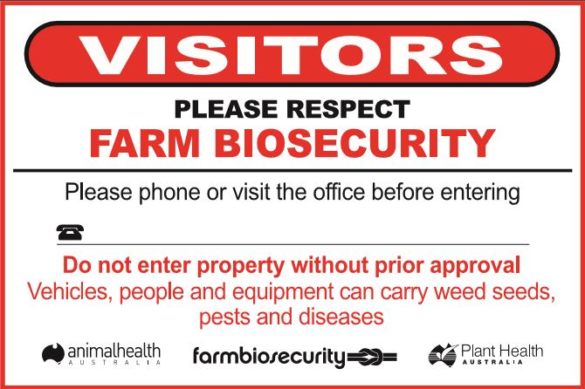
Appendix 2. PRE-EMPLOYMENT BIOSECURITY DECLARATION
I, …………………………………………………………………………………………… hereby agree to abide by MY EMPLOYER’S BIOSECURITY rules and standards.
I understand the following applies at all times:
I must:
- attend work in clean, laundered clothes
- only enter those areas of the farm I am approved to access
- follow a one-directional flow of work (from low-risk to high-risk zones) if required to enter more than one zone during daily work
- immediately report any biosecurity breaches to management
- immediately report any suspicion of disease to management.
I must not:
- visit other aquaculture sites or seafood processors for 24 hours before entering the farm unless I have had a full head-to-toe shower and changed into clean, laundered clothes and shoes
- wear or take boots outside their designated production area
- move any zone-specific equipment to any other zone.
Signature ……………………………………………………………… Date ………………………………………………

Appendix 3. VISITOR BIOSECURITY DECLARATION
- Are you entering production areas of the farm?
Yes □ No □
- Have you been in contact with any aquaculture or the aquatic environment in the previous 24 hours, including:
- recreational fishing
- seafood processors
- water sports/activities (including diving)
Yes □ No □
(Go to question 3)
- If yes, have you had a head-to-toe shower and changed into clean clothes and shoes?
Yes □ No □
- postpone non-essential visit
- farm manager to assess risk before granting access
I ……………………………………………………………. agree to abide by the entry conditions for visitors.
Signature ……………………………………………………………… Date ………………………………………………

Appendix 4. VISITOR LOG
Date | Name | Company | Contact number | Visitor biosecurity declaration completed | Time in | Time out

Appendix 5. FARM ENTRY CONDITIONS FOR VISITORS
Entry to this farm is subject to the following conditions:
 If entering production areas, visitors must not have been in contact with any other aquaculture, seafood processors or the aquatic environment on the same day (or within the previous 24 hours).
 Visitors must complete a visitor biosecurity declaration.
 Visitors must complete the visitor’s log.
 Visitors must wear boots provided.
 Visitors must clean/sanitise hands before entering production areas.

Appendix 6. TRAINING RECORD
Employee name: _________________________________________ Position: ____________________________________________________________
Minimum training requirements:
- Farm biosecurity plan: ____________________________________________________________
- Emergency response plan: _________________________________________________________
- Role-specific standard operating procedures: __________________________________________
- Other: _________________________________________________________________________
Date | Subject/topic/document | Trainer | I understand the training delivered and have read and understand the associated document(s)  (signature of employee) | Due date of refresher

Appendix 7. EMERGENCY RESPONSE PLAN TEMPLATE
This document outlines employee actions and responsibilities if an emergency animal disease is suspected on the farm.
Plan trigger
Unusually high, unexplained mortality. <Define this for your farm (for example, a specific mortality rate, abnormal stock behaviour)>.
Important contacts
Include contacts appropriate to your farm. The table below contains some examples.
Title | Name | Contact details
Company/general manager | <name> | Mobile:  Phone:  Email:
Farm manager | <name> | Mobile:  Phone:  Email:
District veterinary officer | <name> | Mobile:  Phone:  Email:
Aquatic animal health officer | <name> | Mobile:  Phone:  Email:
Consultant veterinarian | <name> | Mobile:  Phone:  Email:
Fishwatch Hotline (or equivalent) | <name> | Phone:
Laboratory | <name> | Mobile:  Phone:  Email:
Emergency Animal Disease Watch Hotline | <name> | Phone: 1800 675 888
Notifications and responsibilities
<Allocate responsibilities to relevant personnel.>
When this plan is triggered, employees must immediately implement the following practices.
Action | Responsibility | Complete/date
- Contact the relevant authority through the relevant reporting pathway for your state/territory (for example, district veterinary officer, aquatic animal health officer, the Emergency Animal Disease Watch Hotline or the Fishwatch Hotline) | Name:  Position: | Y/N  <date>
- Follow all instructions as the relevant authority directs. | Name:  Position: | Y/N  <date>
- Collect, package and submit samples for pathology as the relevant authority directs. | Name:  Position: | Y/N  <date>
- Do not dispatch any stock from the farm until the relevant authority approves it. | Name:  Position: | Y/N  <date>
- Isolate any suspected or known diseased stock. | Name:  Position: | Y/N  <date>
- Stop all movements f stock between tanks and zones. | Name:  Position: | Y/N  <date>
- Restrict farm access to visitors:  - secure the farm perimeter  - deny access to non-essential visitors  - postpone routine repair/maintenance  - postpone non-essential deliveries, including stock. | Name:  Position: | Y/N  <date>
- Check for escapees. | Name:  Position: | Y/N  <date>
- Check sentinel stock (if applicable). | Name:  Position: | Y/N  <date>
- Do not let personnel, equipment and machinery leave the farm until the relevant authority approves it. | Name:  Position: | Y/N  <date>
- Restrict staff access to farm production areas. Only let authorised staff carry out essential stock management and husbandry procedures. | Name:  Position: | Y/N  <date>
- Ensure you make all staff aware of the actions being taken and their individual responsibilities. | Name:  Position: | Y/N  <date>
- Advise all customers/processors immediately affected. | Name:  Position: | Y/N  <date>
- Compile a list of movements over the preceding two weeks – including stock, personnel, equipment and machinery. | Name:  Position: | Y/N  <date>
- Implement husbandry changes – reduce feeding to cut waste and uneaten food in tanks, and increase water flow. | Name:  Position: | Y/N  <date>
- Arrange a dive inspection of nearby wild populations to check for signs of disease (as the relevant authority advises). | Name:  Position: | Y/N  <date>
Sample collection, packaging and dispatch
Collect samples as the relevant authority advises.
Document which staff members you have trained in sample collection and packaging.
Sample collection
Follow these guidelines when submitting fresh samples:
- Collect samples aseptically.
- Do not submit dead animals unless specifically requested to do so, submit live (preferably moribund) samples from affected tanks.
- Place samples in individual sterile containers (do not mix ‘healthy’ specimens with those from affected tanks if asked to submit both).
- Keep samples refrigerated or on ice to prevent decomposition and ensure sufficient ice is included to keep samples cool throughout transport.
Sample labelling
- Ensure that sample labels will remain attached and legible.
- Unlabeled samples are unacceptable.
- Labels should include:
- farm descriptor (for example, name or license number)
- contact details
- date
- descriptor, based on what has been requested (for example, ‘abalone from affected tank’).
Packaging samples
- Carefully pack samples to avoid breakage, leakage or contamination.
- Place samples in non-breakable, leak-proof containers – do not use glass jars.
- Pack samples in an appropriate container (for example, a disposable poly box or foam esky) together with sufficient paper or other absorbent material to soak up any leakage. Secure the lid.
Sample submission
- Submit samples as soon as possible following collection.
- Submission details:
Name: of state or territory laboratory
Address: you are submitting samples to
Contact number: of laboratory liaison or case manager
Name and contact number: of courier – arrange transport directly through the relevant authority or laboratory (ensure these arrangements are clear in this plan)
Disposal and quarantine protocols
Insert disposal protocol information (for example, ‘In the event that this plan is triggered double-bag mortalities and dispose of in a mortality pit that is immediately covered over. Do not return dead stock to the environment or let scavengers have access to them’).
You need to consider disposal options in this plan, depending on the volume of stock. For further information, see ‘AQUAVETPLAN – Operational procedures manual – Disposal’, found on the Department of Agriculture and Water Resources website (at www.agriculture.gov.au/SiteCollectionDocuments/animal-plant/aquatic/aquavetplan/disposal-manual.pdf).
Insert details of quarantine protocols, including isolation and disinfection, or reference a farm-specific quarantine SOP.
Key response plans
Insert the details of any other response plans or documents for other abalone diseases if applicable.
If you identify Abalone Viral Ganglioneuritis (AVG), your farm will follow:
- the requirements of ‘AQUAVETPLAN – Disease Strategy Manual – Abalone Viral Ganglioneuritis’, found on the Department of Agriculture and Water Resources website (at www.agriculture.gov.au/Style%20Library/Images/DAFF/__data/assets/pdffile/0020/2403371/abalone-aquavetplan.pdf [include the electronic and/or physical location on site])
- any specific state or territory emergency response documents (insert their electronic and/or physical location on site)
- directions from the relevant authority.

If you identify Withering Syndrome (infection with Xenohaliotis californiesnsis), your farm will follow:
- the requirements of ‘AQUAVETPLAN – Disease Strategy Manual – Withering Syndrome of Abalone’, found on the Department of Agriculture and Water Resources website (at www.agriculture.gov.au/SiteCollectionDocuments/animal-plant/aquatic/aquavetplan/withering-abalone.pdf [include the electronic and/or physical location on site])
- any specific state or territory emergency response documents (insert their electronic and/or physical location on site)
- directions from the relevant authority.

Appendix 8. HOW TO WRITE A SIMPLE STANDARD OPERATING PROCEDURE
Standard Operating Procedures (SOPs) provide detailed and clear instructions on how to carry out a task/tasks. This means that any employee can carry out the task/tasks correctly each and every time.
A well-written SOP will also help ensure that trainers have covered all relevant details.
Key considerations when writing a standard operating procedure
- Ensure the SOP is concise, but still contains all the necessary information to perform the procedure.
- Keep SOPs short and consider breaking longer SOPs into multiple shorter SOPs.
- Where appropriate, use tables, lists, flow diagrams, photos, icons and/or other graphics rather than large blocks of text. These can be more effective than text alone.
- Write for the target audience (those using the SOP) in plain English. Ensure steps are clear.
- Avoid vague statements. Use language such as ‘must use’ rather than ‘please use’ or ‘should use’.
- Ensure SOPs follow a logical thought process and number the steps to complete the procedure.
Suggested format
Title
Example: Disposal of Biological Waste SOP (DBW1.0)
Consider assigning a brief reference code or number that you can use in your farm biosecurity plan and other documents.
Purpose
What is the reason for having this procedure, what is its aim?
For example: This procedure aims to ensure you dispose of biological waste properly, including abalone mortalities, to minimise the risk of spreading disease from the farm.
You may also need to include relevant additional (non-biosecurity) reasons for having this procedure (for example, work health and safety or environmental protection requirements).

Responsibilities
List staff member(s) and what they are required to do.
For example:
Staff member(s) | Responsibility
All | Understand and follow this procedure. Report any breach of this procedure to your supervisor or the farm manager immediately.
Administration officer | Order replacement mortality bags when supervisor or farm manager advises.
Farm manager | Ensure all staff follow this SOP.  Maintain and update this SOP.
Definitions
Include definitions of any technical terms or acronyms used. Omit this section if not required.
Procedure
List the activities and tasks that make up this procedure, as well as any checklists staff members need to use. For example:
- Check tanks daily for mortalities.
- Record any mortalities on the daily checklist.
- Immediately report any mortalities over x% to the farm manager. Do not remove mortalities in this instance until the farm manager advises, as you may need to observe the situation further and collect samples.
- Remove mortalities from tanks at the end of each day, moving from lower to higher risk zones (for example, grow out, then nursery).
- Sanitise hands and boots between zones as per the Disinfection SOP.
- Place mortalities into mortality bags and seal with tape.
- Place sealed bags into the mortality pit.
- Do not return to any production area following mortality disposal.
- Advise the administration officer when ‘x’ bags remain so they can order more.
Document control
To ensure the SOP remains relevant and appropriately updated, include document control information.
Document control | Details | Approval/review | Details
Version | e.g. 1.0 | Approved by | Name  Position
Status | e.g. Approved, Draft | Date approved | <date>
Contact | Name  Position | Next review due | <date> (should not exceed 12 months)

Appendix 9. AUDIT CHECKLIST
Page ref. | Associated req. | Infrastructure and facility standards | Yes | No | N/A | Corrective action/comments
12 | R1, R2 | Does the farm have a secure perimeter? Can you close off access to prevent vehicle entry when required?
12 | R3 | Are access gates closed and locked during non-business hours?
12 | R4 | Is there adequate signage to inform visitors of the biosecure area and what they need to do on arrival?
13 | R5 | Do clear biosecurity zones exist on the farm? Do zone-specific procedures support this?
13 | R6 | Are staff familiar with the farm’s biosecurity zones and associated requirements?
23 | R46 to R48 | Does water intake, discharge and flow throughout the farm minimise disease entry and spread?
17 | R16 | Do you prevent escapees appropriately?
23 | R51 | Can you provide evidence to demonstrate an appropriately maintained water treatment/filtration?
21, 22 | R41, R44, R52 | Can you provide evidence of appropriately maintained and cleaned farm infrastructure and equipment? Is potable water available for cleaning?
21 | R37 to R40 | Is equipment used on the farm dedicated to a zone (or species) and clearly labelled as such?
21 | R36, R45 | Do you assess any equipment brought onto the farm for risk and appropriately treat it (clean and/or disinfect)?
22 | R42, R43 | Does the farm have dedicated areas for visitor parking and delivery/loading?

Page ref. | Associated req. | Personnel standards | Yes | No | N/A | Corrective action/comments
19 | R22, R24 to R27 | Does each employee sign a ‘Pre-Employment Biosecurity Declaration’ that specifies farm and role biosecurity requirements?
19 | R23 | Are hand sanitisation stations and footbaths (or separate boots) available, and used, at production area entrance/exit and where required between biosecurity zones?
20 | R31 | Is there a visitors’ log that all visitors must complete on arrival?
20 | R28 | Do all visitors sign a visitor biosecurity declaration? Match this to the visitors’ log.
20 | R32 | Do you prominently display the farm entry conditions for visitors near the visitors’ log?
20 | R29, R30, R33 to R35 | Are there appropriate (and documented) procedures in place to manage the risks posed by visitors to the farm?
24 | R54 | Does the farm have a specified biosecurity manager?

Page ref. | Associated req. | Production practices | Yes | No | N/A | Corrective action/comments
17 | R8, R9, | Do you house and manage stock of different disease risk separately?
17 | R7, R10 | Is there an appropriate procedure in place for stock introduction and stock movement within and from the farm?
17, 18 | R11, R19 | Is there an appropriate procedure in place for disposing of dead stock?
17 | R15 | Are appropriate procedures in place to optimise stock health?
17, 18, 26 | R12, R18, R58 | Can you provide evidence to demonstrate you regularly monitor stock health and you investigate any health problems?
18 | R17, R20, R21 | Do you effectively prevent and control farm access by wildlife, vermin or domestic animals?
23 | R53 | Do you only use manufactured or appropriately treated feeds?
17, 27 | R11, R14, R60 to R63 | Can you provide evidence that employees know and adhere to all applicable legislative and/or jurisdictional requirements? Provide evidence of required documentation.

Page ref. | Associated req. | Documentation and training | Yes | No | N/A | Corrective action/comments
17 | R13 | Are farm production staff appropriately trained in reporting disease and mortality?
26 | R59 | Does the farm have an emergency response plan?
24 | R55, R56 | Are all staff aware of the location, content and their role and responsibilities associated with the farm’s emergency response plan, biosecurity plan and associated documents (for example, SOPs)?
24 | R56 | Do you have a current training record for each employee?
25 | R57 | Is there a system in place to record stock inventory and movements and can you readily interrogate this for tracing purposes?
28 | R64, R65 | Can you provide evidence, through revision and audit records, that you critically review the biosecurity plan and improve on it as appropriate?
29 | R66 | Can you readily identify and provide on request all supporting documents associated with the farm biosecurity plan?

Appendix 10. BIOSECURITY PLAN TEMPLATE
How to use template
Use this template to create a farm biosecurity plan. For further information, use the National Biosecurity Plan Guidelines for the Australian Land Based Abalone Industry (www.agriculture.gov.au/animal/aquatic/guidelines-and-resources) in conjunction with this template.
We have included explanatory text in blue, which you can delete after completing your plan.
Replace the text in red with details specific to your farm.
Available templates are shown in green next to the template symbol. The National Biosecurity Plan Guidelines for the Australian Land Based Abalone Industry has templates in the appendices, which you can modify for your farm.
Delete information or risk management measures that do not apply to your farm.
Add additional information or risk management measures applicable to your farm.
Delete this section when you have completed your plan.

Section 1. ENTERPRISE INFORMATION
Production details
Add additional categories to this table as required, or delete any categories or detail not applicable.
Category | Details
Broodstock and/or stock source | <enter details>
Species/product | Species:  Size of product:  Market:
Site activities | For example:  - broodstock quarantine, conditioning and spawning  - nursery and grow out  - company administration
Staff | Farm production staff: <number> (consider further breakdown of staff per zone)  Administration staff: <number>  Senior management: <number>
Associated sites | <enter details>
Key contacts
Add additional contacts to this table as required, or delete any contacts not applicable.
Internal contacts
Name | Position | Contact details
<name> | Company/general manager | Mobile/phone:  Email:
<name> | Farm manager | Mobile/phone:  Email:
<name> | Administration manager | Mobile/phone:  Email:
<name> | Operations manager | Mobile/phone:  Email:

External contacts
Name | Position | Contact details
<name> | Aquatic animal health officer | Mobile/phone:  Email:
<name> | District veterinary officer | Mobile/phone:  Email:
<name> | Consulting veterinarian | Mobile/phone:  Email:
<name> | Laboratory | Mobile/phone:  Email:
<name> | Industry representative | Mobile/phone:  Email:
<name> | Courier | Mobile/phone:  Email:

Section 2. MAPS AND DIAGRAMS
Obtain maps from google maps www.google.com.au/maps. Satellite images help demonstrate the farm location relative to major towns, roads and other infrastructure in the area.
Create diagrams easily within this document by inserting shapes of various colour and size.
Ensure maps are large, clear and legible.
You may be able to combine some maps or diagrams depending on the size and/or complexity of the farm.
Farm locality and features
Add additional categories to this table as required, or delete any categories not applicable.
Category | Details
Farm location and access | - address, state, region of state  - closest town name, distance from closest town  - GPS coordinates  - road(s) from which you can access the farm.
Disease status of state/region | Known diseases or marine pests of concern (for example, Abalone Viral Ganglioneuritis [AVG]) for the state (or region).
Proximity to other aquaculture production | For example:  - marine-based abalone farms  - other aquaculture leases  - processors.
Proximity to high-risk sites | For example, wild abalone populations, ports.
Other | For example:  - presence and type of wildlife, feral animals or vermin  - significant natural features  - boat ramps, marinas.

Insert a small map of the wider state area with the farm location marked. Then insert a larger farm locality map and mark applicable additional information. Use symbols to mark relevant features, for example:
Farm
Processor
Wild abalone population
Farm maps and schematic diagrams
Farm layout
Biosecurity sign
Insert a farm layout map/diagram and include details relating to the following risk management measures. Display these as part of the map/diagram or list them as additional information.
- R1. The farm has a secure perimeter or otherwise well-defined boundary establishing a clearly defined biosecurity zone.
- R2. You can close the main production area entrance to vehicle traffic if you activate the emergency response plan.
- R3. Access gates are lockable and locked when no company personnel are on site.
- R4. Clearly display entry signage that provides direction for visitors and includes company contact details.
Production areas and biosecurity zone classifications
Insert a diagram of farm production areas and their associated biosecurity zone classifications. Display details relating to the following risk management measures, applicable to your farm, as part of the map/diagram or as additional information.
- R5. Divide the farm into biosecurity zones with zone-specific requirements relating to access, entry and exit procedures, and dedicated equipment.
- R6. Clearly display biosecurity zone signage, consistent with biosecurity zone definitions and familiar to all personnel.

Example farm biosecurity zones:
Biosecurity zone | Access
Extreme (red) | - highly restricted  - authorised personnel only  - no entry to any other zones following access
High (amber) | - limited access  - authorised personnel only
Moderate (yellow) | - limited access  - authorised personnel only
Low (green) | - no access restrictions (staff or visitors)
Develop supporting SOPs to capture further detailed information relating to your biosecurity zone classifications, such as who is authorised to access each zone, entry and exit procedures and any additional relevant information.

Section 3. ROUTINE MEASURES TO ADDRESS MAJOR DISEASE TRANSMISSION ROUTES
Animals
Objective: Minimise the risk of stock and other animal movement introducing and spreading disease.
Amend the risk management measures outlined in the following sections to reflect actual farm practices. Add specific detail where applicable and delete any measures not applicable.
For example, amend ‘Mortalities or unwanted stock are disposed of in an appropriate manner.’ to reflect the actual procedure: ‘Place mortalities in plastic bags, seal with tape and place in a mortality pit. Cover the pit every x weeks.’
Risk category | Risk management measures | Supporting documentation
(A) Critical | - R7. Obtain health status information and appropriate permits for stock before it enters the farm. Ensure he health status of any introduced stock is equal to or better than that of stock already present. Permanently quarantine stock if you cannot achieve this.  - R8. Permanently quarantine introduced stock of unknown (for example, wild) or lower health status. This includes isolation in separate water from all other farm stock in separate production units/dedicated quarantine facilities with appropriate biosecurity measures.  - R9. House multiple marine aquaculture species (for example, oysters and abalone) separately, with appropriate biosecurity measures and do not share water across species. | Add titles or codes of any associated SOPs, checklists or record keeping templates in this column
(B) High | - R10. Inspect stock on introduction to the farm and clean if required.  - R11. Dispose of mortalities or unwanted stock in an appropriate manner that is approved by the relevant jurisdictional authority. Ensure dead or unwanted stock is not returned to the environment or accessible to scavengers (for example, birds).  - R12. Investigate health problems (suspected diseases) with assistance from aquatic animal health professionals.  - R13. Ensure staff responsible for managing abalone husbandry are trained in, and aware of, their role and responsibility in reporting signs of disease and high mortality.  - R14. In accordance with jurisdictional requirements, immediately inform relevant authorities of any significant, unexplained mortality event or suspected reportable disease.  - R15. Keep stock stress to a minimum by ensuring appropriate water quality, hygiene, stocking density, nutrition and handling.  - R16. Prevent escapees.  - R17. Control birds or exclude them from production areas. | Add titles or codes of any associated SOPs, checklists or record keeping templates in this column
(C) Moderate | - R18. Inspect abalone health, mortality and behaviour daily. Record this information.  - R19. Remove mortalities twice weekly (at a minimum). | Add titles or codes of any associated SOPs, checklists or record keeping templates in this column
(D) Low | - R20. Ensure domestic animals (for example, cats and dogs) do not have access to production areas at any time.  - R21. Bait vermin as necessary (if you observe live rodents, droppings or nests). | Add titles or codes of any associated SOPs, checklists or record keeping templates in this column
People
Objective: Minimise the risk of people movement introducing and spreading disease.
Staff
Risk category | Risk management measures | Supporting documentation
(B) High | - R22. Do not permit staff to visit other aquaculture sites or seafood processors before entering the farm (unless they have been appropriately decontaminated). | Add titles or codes of any associated SOPs, checklists or record keeping templates in this column  Pre-employment biosecurity declaration
(D) Low | - R23. To ensure effective disinfection at all times, locate footbaths (or provide the opportunity to change into zone-specific boots) and hand sanitation stations at the farm entrance/exit and between biosecurity zones.  - R24. Ensure boots worn in production areas are not worn or taken outside their designated production area.  - R25. Ensure staff attend work in laundered, clean clothes each day.  - R26. Only permit designated staff to routinely enter farm quarantine areas.  - R27. Ensure work flow is unidirectional (from low- to high-risk zones) when staff need to access multiple zones during a day. Make sure you have an appropriate procedure when this is not possible. | Add titles or codes of any associated SOPs, checklists or record keeping templates in this column  Pre-employment biosecurity declaration

Visitors - contractors, suppliers and other service personnel, family and neighbours
Risk category | Risk management measures | Supporting documentation
(A) High | - R28. All visitors must complete a biosecurity declaration on arrival to ensure you assess their risk to farm biosecurity. Consider refusing entry to high-risk visitors. | Add titles or codes of any associated SOPs, checklists or record keeping templates in this column  Visitor biosecurity declaration
(C) Moderate | - R29. Limit movement of people onto and through the farm, in particular restrict visitor access to quarantine zones.  - R30. Appropriately disinfect all visitors on production area entry and exit using footbaths (or provide the opportunity to change into zone-specific boots) and hand sanitation stations. | Add titles or codes of any associated SOPs, checklists or record keeping templates in this column
(D) Low | - R31. Visitors must sign-in on arrival (by completing the farm visitor log) and undergo a farm biosecurity induction.  - R32. Clearly display farm entry requirements to visitors at the sign-in point.  - R33. Ensure contractors conduct routine maintenance work within quarantine area(s), where possible, between batches and before final disinfection.  - R34. The farm manager must approve all visitors and visits must be unidirectional from lowest to highest risk areas.  - R35. Accompany visitors at all times when on site. | Visitor log  Entry conditions for visitors

Equipment, vehicles and vessels
Objective: Minimise the risk of equipment, vehicle or vessel movement introducing and spreading disease.
Risk category | Risk management measures | Supporting documentation
(B) High | - R36. Do not permit equipment, vehicles or vessels that have been in contact with off-site abalone or water used to hold or process off-site abalone to enter the farm. In exceptional circumstances, make sure you can appropriately clean and disinfect such equipment, vehicles or vessels, or those of unknown origin or status, before using on the farm. | Add titles or codes of any associated SOPs, checklists or record keeping templates in this column
(C) Moderate | - R37. Use specific equipment, clearly labelled, per zone.  - R38. Do not remove equipment from its dedicated zone and use elsewhere on the farm.  - R39. Keep equipment used for multiple aquatic marine species (for example, oysters and abalone) species specific and do not share.  - R40. If moving equipment between zones or species (for example, an expensive item), ensure you clean and disinfect* it appropriately.  - R41. Keep equipment properly maintained and appropriately decontaminated* as required. Ensure maintenance records are maintained and up-to-date. | Add titles or codes of any associated SOPs, checklists or record keeping templates in this column
(D) Low | - R42. Park visitor vehicles in a dedicated parking area.  - R43. Ensure the farm has a dedicated delivery and loading area.  - R44. Regularly clean all farm areas and keep free of rubbish and clutter.  - R45. Clean contractor tools before entry and ensure they are free of dust/organic matter. | Add titles or codes of any associated SOPs, checklists or record keeping templates in this column

Water, waste and feed
Objective: Minimise the risk of water, waste and feed introducing and spreading disease.
Risk category | Risk management measures | Supporting documentation
(A) Critical | - R46. Treat incoming water appropriately (for example, screens on intake pipes, filtration) to minimise the risk of disease/pest entry.  - R47. Treat discharge water from dedicated quarantine facilities appropriately to minimise the risk of disease/pest establishment in the marine environment. | Add titles or codes of any associated SOPs, checklists or record keeping templates in this column
(B) High | - R48. Ensure water intake and outflow avoid cross contamination.  - R49. Ensure water flow within the farm minimises disease spread between biosecurity zones.  - R50. Dispose of other waste appropriately (for example, used water filters, fouling, faeces). | Add titles or codes of any associated SOPs, checklists or record keeping templates in this column
(D) Low | - R51. Regularly service and maintain filtration equipment keep a record.  - R52. Ensure potable water is available for cleaning and disinfection procedures.  - R53. Only use manufactured or appropriately treated feeds. | Add titles or codes of any associated SOPs, checklists or record keeping templates in this column

Section 4. ADDITIONAL SUPPORTING MEASURES
Objective: Ensure all farm staff understand they share the responsibility of maintaining farm biosecurity and must practice good biosecurity in all their work.
Training
Describe what training is undertaken by staff, how it is recorded and how often it is refreshed.
Training record template
- R54. Ensure the farm has a biosecurity manager responsible for creating, maintaining and reviewing the farm biosecurity plan, associated documents and activities including staff training.
- R55. Ensure that staff can readily access the farm biosecurity plan and all associated documents at all times.
- R56. Provide all staff with a farm biosecurity induction and ongoing biosecurity training relevant to their role. Document this and ensure it encompasses:
- the farm biosecurity plan
- the emergency response plan
- SOPs, associated documents including checklists and work practices that support these plans.
Site biosecurity manager details:
Name | Contact details | Responsibilities
<name> | Mobile:  Phone:  Email: | <insert details>
Record keeping
Objective: Record information necessary to support good biosecurity practices, in accordance with the farm biosecurity plan.
Stock movements
Outline how and what stock movement information is kept and accessible – this may involve referencing existing systems.
- R57. Maintain detailed records about stock movements and inventory and keep them readily accessible.
Stock health, mortality and water quality records
Outline how and what stock health, mortality records and water quality records are kept and accessible. This may involve referencing existing systems.
- R58. Maintain detailed stock health, mortality and water quality records and keep them readily accessible.
Section 5. EMERGENCY PROCEDURES
Objective: Ensure you develop emergency procedures and identify additional biosecurity measures to implement if there is a suspected emergency animal disease or serious endemic disease. This could be either on the farm, or because of an increased threat of introducing disease if an outbreak is suspected in the state or region.
Emergency response plan template
Reference the site emergency response plan (ERP) here, clearly noting its electronic and physical location.
Outline the trigger for enacting the ERP, such as a specific mortality rate or abnormal stock behaviour.
- R59. Ensure the farm has an emergency response plan.

Section 6. LEGISLATIVE AND JURISDICTIONAL REGULATORY REQUIREMENTS
Outline any legislative and/or jurisdictional requirements that apply to the farm and describe how the farm is adhering to these.
- R60. Adhere to applicable import requirements and obtain translocation permits for all stock and equipment movement.
- R61. Undertake batch testing or surveillance requirements in compliance with jurisdictional regulations or the Abalone Health Accreditation Program.
- R62. Only keep commercially farmed species on site in accordance with license conditions.
- R63. Ensure any veterinary medicines provided to stock are compliant with relevant state and national legislation (including the Commonwealth regulator, Australian Pesticides and Veterinary Medicines Authority).
Section 7. DOCUMENT CONTROL AND REVISION RECORD
Document control | Details | Approval/review | Details
Version | e.g. 1.0 | Approved by | Name  Position
Status | e.g. Approved, Draft | Date approved | <date>
Contact | Name  Position | Next review due | <date> (should not exceed 12 months)
Revision record:
Date | Version | Revision description
Date | e.g. 1.0 | Should be brief but specific – avoid vague statement like ‘plan updated’ but rather state ‘SOP XXXX added’, ‘Key contact details amended’.
- R64. Ensure you regularly review the farm biosecurity plan (annually at a minimum).

Section 8. AUDIT RECORD
Audit record:
Date | Type | Auditor(s) | Audit notes – remedial action | Date of next audit
Date | Internal or external | Name of auditor | Should be brief but specific – avoid vague statements such as ‘minor changes made’. Instead provide details or reference to a full audit report. | Next audit date
- R65. Regularly audit your farm biosecurity plan (annually at a minimum) to ensure you are implementing it effectively and improving on it as appropriate.
Section 9. SUPPORTING DOCUMENTS
List documents that are referenced in, or associated with, this plan. Add documents to this table as required and delete any that are not applicable.
Standard operating procedures | Record keeping templates/other documents
New employee induction and training | Pre-employment declaration
Farm visitors | Visitor biosecurity declaration
Stock arrivals, movement and dispatch | Visitor log
Escapee prevention, inspection and collection | Farm entry requirements for visitors
Collection and disposal of mortalities and other waste | Staff training record
Disinfection | N/A
Farm biosecurity zones | N/A
Emergency response plan | Emergency response plan
- R66. Clearly identify supporting documents (for example, SOPs, checklists and templates) associated with the farm biosecurity plan and keep them readily available.

