 | 

National Biosecurity Plan Guidelines for Australian Barramundi Farms

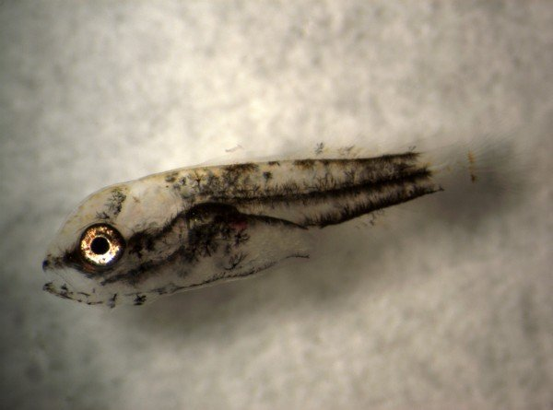
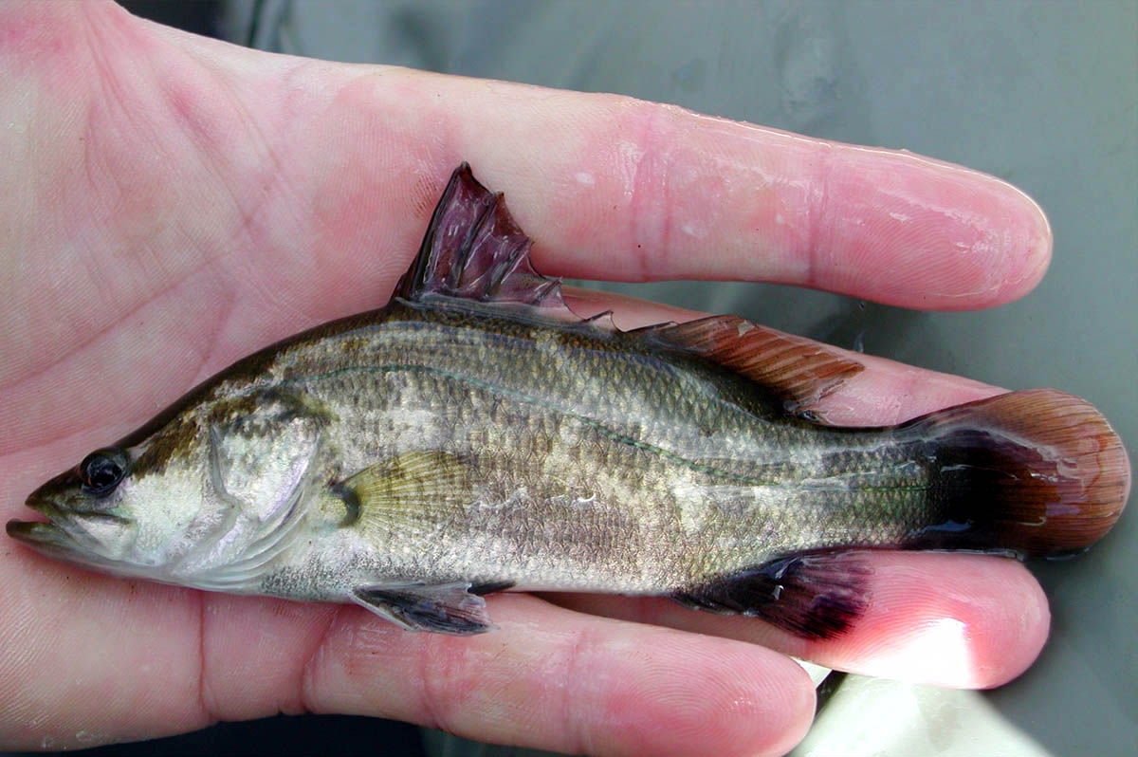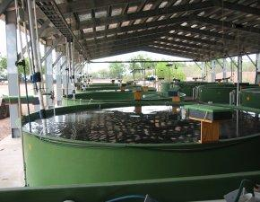



© Commonwealth of Australia 2019
Ownership of intellectual property rights
Unless otherwise noted, copyright (and any other intellectual property rights, if any) in this publication is owned by the Commonwealth of Australia (referred to as the Commonwealth).
Creative Commons licence
All material in this publication is licensed under a Creative Commons Attribution 3.0 Australia Licence, save for content supplied by third parties, logos and the Commonwealth Coat of Arms.
Creative Commons Attribution 3.0 Australia Licence is a standard form licence agreement that allows you to copy, distribute, transmit and adapt this publication provided you attribute the work. A summary of the licence terms is available from creativecommons.org/licenses/by/3.0/au/deed.en. The full licence terms are available from creativecommons.org/licenses/by/3.0/au/legalcode.
Email inquiries about the licence and any use of this document to copyright@agriculture.gov.au.
Cataloguing data
Attribute this publication (and any material sourced from it, unless specified otherwise) as: Landos, M., Calogeras, C., Hayward, S., Ruscoe, J. 2019. National Biosecurity Plan Guidelines for Australian Barramundi Farms. Department of Agriculture, Canberra June 2019. CC BY 3.0.
ISBN 978-1-76003-210-4
This publication is available at www.agriculture.gov.au/animal/aquatic/guidelines-and-resources
The Department of Agriculture
Postal address GPO Box 858 Canberra ACT 2601
Telephone 1800 900 090
Web agriculture.gov.au
The Australian Government, acting through the Department of Agriculture, has exercised due care and skill in preparing and compiling the information and data in this publication. Notwithstanding, the Department of Agriculture, its employees and advisers disclaim all liability, including liability for negligence and for any loss, damage, injury, expense or cost incurred by any person as a result of accessing, using or relying upon any of the information or data in this publication to the maximum extent permitted by law.
About this publication
The National Biosecurity Plan Guidelines for Australian Barramundi Farms were developed as part of Activity 1.1 of AQUAPLAN 2014–2019, Australia’s national strategic plan for aquatic animal health, under Fisheries Research and Development Corporation (FRDC) project 2016-147. The Department of Agriculture and Water Resources funded the project through the FRDC. In-kind contributions were provided by the Australian Barramundi Farmers Association and Future Fisheries Veterinary Service. The Sub-Committee on Aquatic Animal Health endorsed the document in October 2018 and the Animal Health Committee endorsed it in March 2019.
Writing group members
Matt Landos – Future Fisheries Veterinary Service
Chris Calogeras – Australian Barramundi Farmers Association
Jo-Anne Ruscoe – Australian Barramundi Farmers Association
Scott Hayward – Sealord King Reef Seafoods Pty Ltd
The authors gratefully acknowledge comments from other persons during the development of the National biosecurity plan guidelines for Australian barramundi farms. In particular, the authors acknowledge the contributions of the industry and government participants who attended the barramundi workshop.

Version 1.0, 2019
Contents
1 Introduction 5
2 How to use these Guidelines 6
3 Reportable diseases of finfish and other barramundi diseases 7
4 Resources for disease identification and management 9
5 Major routes of disease transmission 9
6 Where biosecurity measures can be applied 10
7 Biosecurity plan structure 11
7.1 Enterprise location 11
7.2 Production details 12
8 Detailed infrastructure maps 13
8.1 Site biosecurity zoning 14
9 Biosecurity risk analysis 16
9.1 Identify hazards 16
9.2 Risk assessment of hazards 17
Likelihood 17
Consequences 18
Risk estimation 18
9.3 Document the risk-analysis process 19
9.4 Mitigation measures to reduce disease transmission 20
Management of hatcheries 21
Management of grow-out systems 23
10 Emergency procedures 30
11 Legislative or jurisdictional regulatory requirements 31
12 Document control and revision record 31
13 Audit record 32
14 Training 32
15 Supporting documents 32
Appendices 34
References 55

Introduction
As the Australian barramundi industry continues to expand, there needs to be a growing emphasis on ensuring that nationally consistent biosecurity measures are implemented across all enterprises. In 2014, the aquatic animal industries and the Commonwealth and state and territory governments endorsed Australia’s third National Strategic Plan for Aquatic Animal Health; AQUAPLAN 2014–2019. AQUAPLAN outlines priorities for enhancing Australia’s management of aquatic animal health.
These guidelines have been developed to assist Australian barramundi farms with the tools and templates to create fully auditable biosecurity plans, from basic through to comprehensive in scope.
They are part of the Fisheries Research and Development Corporation (FRDC) Project 2016-147: Development of sector-specific biosecurity plan templates and guidance documents for the Australian farmed barramundi industry. They form a component of Activity 1.1 of AQUAPLAN, and also contribute to the strategic goal of the Australian Barramundi Farmers Association (ABFA) to achieve ‘effective management of biosecurity risk’.
The guidelines have been formulated using:
- a set of generic guidelines and a template for an Aquaculture farm biosecurity plan developed by the Sub-Committee on Aquatic Animal Health (SCAAH, 2016)
- a set of sector-specific biosecurity plan guidelines for the Australian land-based abalone and oyster hatchery industries (Spark et al. 2018a,b)
- input from a government–industry workshop held 6 September 2017
- consultation between the Future Fisheries Veterinary Service and industry on-farm and via phone and email.
Recent catastrophic disease outbreaks in the prawn industry (with white spot syndrome virus) and the oyster industry (with Pacific oyster mortality syndrome) have reinforced the need for the barramundi industry to develop these guidelines. Recently conducted risk assessment by the ABFA showed the presence of significant disease risks that are presently not within the Australian barramundi industry. History also suggests it is likely that new and serious diseases may emerge globally, which could substantially affect the Australian farmed barramundi industry.
Implementation of effective biosecurity is integral to any successful production system, delivering a range of benefits including:
- improved animal health and performance, through the prevention of disease outbreaks
- reduced disease transmission and amplification within and between farms and regions
- early disease detection, allowing faster response to reduce impact
- support of claims of freedom from disease, which can alter market access and trade
- support of aspects of industry best-practice certification programs.
Preventing disease protects your business and also has wider benefits for the industry and communities that would potentially be devastated by a significant disease outbreak. Ownership and ‘buy-in’ by your staff are critical for successful implementation and operation of farm biosecurity measures.
Staff must understand that by preventing disease introduction, or minimising disease spread, their jobs and ultimately the industry will be protected.

How to use these Guidelines
These guidelines have been developed to assist barramundi enterprises to:
- develop a farm biosecurity plan (for those with no current plan in place); or
- strengthen an existing farm biosecurity plan.
When creating a farm biosecurity plan, do not duplicate existing documents, systems or records. Simply refer to them in your plan, where appropriate.
These guidelines identify the major routes of disease transmission that should be incorporated into your farm biosecurity plan, including disease entry, and spread within and from your farm. The guidelines help assess:
- risks associated with each potential route of disease transmission
- on-farm measures to minimise the risk of disease transmission
- supporting documentation needs, such as standard operating procedures (SOPs), for a comprehensive plan.
Risks common to barramundi enterprises have been identified in these guidelines. You should consider any additional risks specific to your hatchery or grow-out enterprise, and associated risk-management measures that may be required.
Each enterprise will have a different spectrum of biosecurity challenges and operating environments due to the variation between factors, such as:
- operation size
- location and layout of the farm
- type of grow-out operation, for example recirculation system, ponds, raceways or sea cages
- disease status of the region, state or territory
- proximity to other wild fish populations, aquaculture sites or seafood enterprises (for example processors)
- number and types of species farmed
- available resources.
An individual farm biosecurity plan needs to be developed to ensure that your plan is practical for your operation, and is as simple and as low-cost as possible to achieve desired biosecurity outcomes. The individual farm should use this nationally endorsed plan as a guideline and template when developing their own farm plan. An effective farm plan does not necessarily mean that all of the items on the national plan have to be included. Your plan may require additional or customised actions.
Some of the required document templates are included as appendices to this plan. A guideline document on how to write an SOP is shown in Appendix 2.
In Section 9.4, the guidelines are in sections relevant to the type of barramundi farm. Only the guidelines relevant to your farm type need to be considered in this section of the document. In the remainder of the document, all guidelines are relevant to all types of farms, so should be considered.
When you have navigated through these guidelines and assessed your individual site risks, you can create your farm biosecurity plan.
A self-audit checklist has also been included (in Appendix 8) for you to assess your completed plan. This checklist may be used to highlight any remaining gaps.
Symbols used in these guidelines
 | Pen and paper icon indicates supporting details and other information to include in your farm biosecurity plan.
R | R-numbered statements are risk-management measures to implement and document.  These measures are auditable.
 | Open file icon indicates templates provided to help you develop your individual farm biosecurity plan.

Reportable diseases of finfish and other barramundi diseases
Table 1 National List of Reportable Diseases of Aquatic Animals – Finfish
Disease | Organism type | Exotic to Australia | Susceptibility of barramundi
Enteric septicaemia of catfish (Edwardsiella ictaluri) | Bacteria | No | Confirmed
Grouper iridoviral disease | Virus | Yes | Confirmed
Infection with Aphanomyces invadans (epizootic ulcerative syndrome ) | Fungus | No | Confirmed
Infectious spleen and kidney necrosis virus-like viruses | Virus | Yes | Confirmed
Red sea bream iridoviral disease | Virus | Yes | Confirmed
Viral encephalopathy and retinopathy | Virus | No | Confirmed (with new exotic strain risks)
Aeromonas salmonicida – atypical strain | Bacteria | No | Possible
Bacterial kidney disease (Renibacterium salmoninarum) | Bacteria | Yes | Possible
Enteric redmouth disease (Yersinia ruckeri – Hagerman strain) | Bacteria | Yes | Possible
Epizootic haematopoietic necrosis virus | Virus | No | Possible
European catfish virus | Virus | Yes | Possible
Furunculosis (Aeromonas salmonicida subsp. salmonicida) | Bacteria | Yes | Possible
Infectious haematopoietic necrosis | Virus | Yes | Possible
Infectious pancreatic necrosis | Virus | Yes | Possible
Spring viraemia of carp | Virus | Yes | Possible
Viral haemorrhagic septicaemia | Virus | Yes | Possible
Data sources: www.fao.org/fishery/culturedspecies/Lates_calcarifer/en#tcN800C5; www.oie.int/standard-setting/aquatic-manual/access-online; http://www.www.agriculture.gov.au/animal/aquatic/reporting/reportable-diseases.gov.au/animal/aquatic/reporting/reportable-diseases
Table 2. Additional disease risks associated with imported barramundi (identified in FRDC Project 2015-040: ABFA IPA: An assessment of the risk of exotic disease introduction and spread among Australian barramundi farms from the importation of barramundi
Disease | Organism type | Exotic to Australia | Susceptibility of barramundi
Pot belly disease | Bacteria | Yes | Confirmed
Scale drop syndrome | Likely viral | Yes | Confirmed
Streptococcosis | Bacteria | No | Confirmed (with new exotic strain risks)
Vibriosis | Bacteria | No | Confirmed (with new exotic strain risks)
Table 3. Endemic disease risks
Disease | Organism type | Exotic to Australia | Susceptibility of barramundi
Chilodonellosis | Ectoparasite | No | Confirmed
Trichodinosis | Ectoparasite | No | Confirmed
Turbellarian infestation | Endoparasite | No | Confirmed
Ichthyobodosis | Ectoparasite | No | Confirmed
Amylodiniosis | Ectoparasite | No | Confirmed
Diplectanid gill fluke infestation | Ectoparasite | No | Confirmed
Coccidiosis | Endoparasite | No | Confirmed
Cammalanid spp. infestation | Endoparasite | No | Confirmed
Cryptosporidiosis | Endoparasite | No | Confirmed
Henneguya spp. infestation | Endoparasite | No | Confirmed
Brooklynellosis | Ectoparasite | No | Confirmed
Cryptocaryonosis | Ectoparasite | No | Confirmed
Turbellaria spp. infestation | Ectoparasite | No | Confirmed
Leech infestation | Ectoparasite | No | Confirmed
Myxosporean infestation | Endoparasite | No | Confirmed
Blood fluke infestation | Endoparasite | No | Confirmed
Trypanosomiasis | Endoparasite | No | Confirmed
Streptococcosis | Bacteria | No | Confirmed
Aeromonas spp. infection | Bacteria | No | Confirmed
Flavobacterial infection (bacterial gill disease, saddleback, fin rot) | Bacteria | No | Confirmed
Epitheliocystis | Bacteria | No | Confirmed
Edwardsiellosis | Bacteria | No | Confirmed
Vibriosis | Bacteria | No | Confirmed
Tenacibaculosis | Bacteria | No | Confirmed
EUS (red spot) | Fungus | No | Confirmed
Branchiomycosis | Fungus | No | Confirmed

Resources for disease identification and management
The Commonwealth Department of Agriculture maintains the National List of Reportable Diseases of Aquatic Animals at www.agriculture.gov.au/animal/aquatic/reporting/reportable-diseases.
Most of these diseases are listed by the World Organisation for Animal Health (OIE), according to the definitions laid out in the Aquatic Animal Health Code (www.oie.int/international-standard-setting/aquatic-code). The Australian Government reports quarterly to the OIE on the disease status of Australia with reference to Diseases listed by the OIE in the Aquatic code.
Diagnostic methods are described for the OIE international list at www.oie.int/international-standard-setting/aquatic-manual.
To aid identification of important diseases, the Commonwealth Government has developed a field guide, available at www.agriculture.gov.au/animal/aquatic/guidelines-and-resources/aquatic_animal_diseases_significant_to_australia_identification_field_guide. This is available as a PDF download, or as a free app available from the App Store (Apple devices), Google Play (Android devices) and Microsoft Store (Windows devices). The app should be downloaded onto staff phones and farm computers.
If any of these diseases are detected or suspected on a barramundi enterprise, it is compulsory to report the disease or suspicion to the appropriate government authority. Individual state or territory legislation may require reporting of locally relevant diseases, which are additional to the National List of Reportable Diseases of Aquatic Animals.
Advice on generic (and some specific) disease responses can be found in the AQUAVETPLAN manuals available at www.agriculture.gov.au/animal/aquatic/aquavetplan and www.agriculture.gov.au/animal/aquatic/aquavetplan/viral-encephalopathy-retinopathy.
Biosecurity plans should be developed with the aim of excluding these types of disease threats, with the knowledge that emergence of new diseases is also likely to occur.

Major routes of disease transmission
Figure 1 outlines the biosecurity risk levels of a farm and the major ways that disease can be transmitted onto (entry-level), within (internal), and from (exit-level) barramundi farms:
- entry-level transmitters – stock (for example, fingerlings, broodstock, wild barramundi, other farm stock), intake water, feed, people (for example, staff and visitors), equipment and vehicles, and other animals (for example, vermin, wild birds, other animals entering via the intake water or returning escapees)
- internal transmitters – stock, water, people, equipment, vehicles, and other animals
- exit-level transmitters – stock (including dead stock, discarded product, escaped barramundi), discharge water, people, equipment, vehicles, and other animals and wastes.
When high levels of infection come into close contact with susceptible hosts, it is likely that the disease will become established and spread.
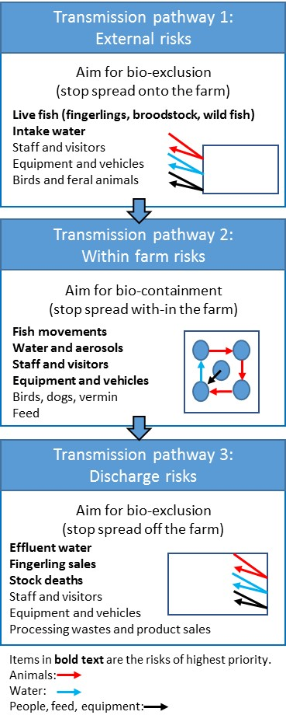
Figure 1. Pathogen transmission pathways and different levels of biosecurity. Adapted from Ellard (2015).

Where biosecurity measures can be applied
The following industry-level biosecurity plan can be used as a basis for developing your individual farm biosecurity plan for existing farms, and for new farms in the design phase.
Every farm is different and disease risks need to be managed accordingly, so it is important that you develop a specific, documented and auditable biosecurity plan for your farm. The plan should be reviewed annually and updated as farm circumstances and disease risks change. This may involve infrastructure changes to reach a higher standard of biosecurity (for example, filtration systems, settlement ponds, recirculating aquaculture system [RAS] capacity, disinfection systems, materials and surface designs).
This document will help you:
- identify and assess biosecurity risks to your farm
- develop procedures to manage biosecurity risks
- manage and reassess these risks on an ongoing basis.

Biosecurity plan structure
The plan for your farm needs to be structured so staff, external auditors and government staff can read and understand the plan.
This chapter outlines the information that should be considered in your biosecurity plan.

Enterprise location
A map should be used to identify the major farm areas including, for example, production ponds and sheds, feed shed, processing shed, roads, adjacent waterway names, water sources and any nearby town. For sea-cage sites, the coordinates of the lease areas and locations of cage infrastructure on the lease should be included. Nearby towns, cities, ports and water bodies should also be included (see Figure 2).

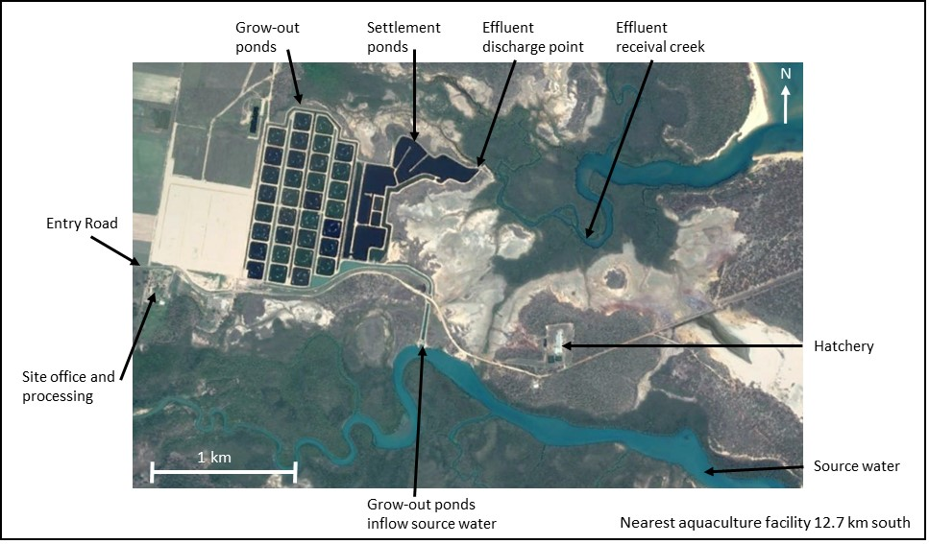
Figure 2. An example of a farm locality map

Production details
Outline the scale and scope of your enterprise, including:
- proximity to other farms and/or local waterbodies (especially inlet and outlet channels)
- type of effluent release, for example to land-based irrigation or release to a waterway
- proximity to other high biosecurity-risk areas (for example location of site office relative to grow-out ponds, grow-out ponds relative to the hatchery, or public-access areas relative to staff areas)
- location of hatcheries in relation to grow-out farm
- type of enterprise (for example hatchery or grow-out enterprise, or both)
- volume of inlet channel, individual grow-out ponds, settlement pond and discharge channel
- time it takes to fill and drain a pond
- pumping capacity
- estimate maximum farm biomass
- broodfish origin (number, source location, date introduced to farm) and housing (for example tanks on RAS or within pond)
- annual production outputs (for example 100 tonnes of 0.6–0.8 kg plate-sized barramundi, or 2,100,000 fingerlings at 25 mm body length)
- staff list and responsibilities (for example feed manager, health manager and health technician), phone and email contacts; include veterinary advisers, government aquatic animal health contacts, laboratory details and ABFA executive officer.
Table 4. Example of contact details for internal and external farm contacts
Name | Position | Phone | Email
 | General manager
 | Farm veterinarian
 | Jurisdictional aquatic biosecurity officer
 | State or territory laboratory contact
 | ABFA executive officer contact
 | Farm biosecurity officer
 | Aquaculture equipment supplier
 | Aquaculture feed supplier

Detailed infrastructure maps
Provide fine-scale detail of each functional area of the farm (for example hatchery, nursery and grow-out) in terms of:
- water source (including all inlet, outlet and isolation points), water treatments, water quality and flow diagrams to and from production units
- quarantine facilities
- vehicle movement patterns (entry and exit) and restrictions (gates; specify if kept locked)
- flow of stock, from entry to farm through to harvest and processing
- location of biosecurity signage
- allowed staff movements between areas of the farm (zoning), including movement of on-farm domestic pets
- fencing restricting access and potential points of unauthorised access or entry
- biosecurity barriers (visitor entry point, visitor office, boot-change station, foot baths, hand-wash stations, gates [specify if kept locked] and restricted areas)
- feed unloading and storage
- machinery storage
- marinas and boat ramps
- neighbouring farms
- escape-prevention measures (for example screens on pond outlets)
- vehicle spray station, net wash-down, disinfection bays
- emergency muster point
- dead stock disposal location and type (for example burial, silage or freezer).
It is suggested that you use a separate map for each layer of detail.
A biosecurity sign example is shown in Appendix 1.

Auditable risk-management measures (the numbered ‘R’-statements) that you may have implemented on your farm, and which you should add to your plan, include:
R.1 – The farm has boundary markers at all four corners of the lease, with navigation lighting.
R.2 – The production area of the farm is behind a lockable gate, with separate isolated visitor parking sign-posted with company contact details.
R.3 – The hatchery has secure perimeter fencing with security cameras (optional) at entry and exit points.

Site biosecurity zoning
Overlay biosecurity zones on a map of the facility. These zones will need to be described in detail within your plan and supported with SOPs.
The biosecurity zones will represent areas that are both physically and functionally separate, so you should be able to define the location and type of biosecurity measure(s) separating the areas. Separate zones should have infrastructure and/or sanitary protocols to prevent transfer of disease from one area to the other with movement of water, people, stock and equipment. These areas can be assigned the classifications listed in Table 5.
Table 5. A summary of farm biosecurity zones classifications
Biosecurity zone | Access requirements
High (most biosecure) | Highly restricted.  Authorised personnel only. Entry must not occur after visiting other areas of the farm.  For example:  - fully enclosed broodstock room on RAS with sanitised water source  - hatching room  - algae room  - larval rearing room.
Moderate (moderately biosecure) | Limited access.  Authorised personnel only. Can move from the highest security zone into this area, but not back again.  Accompanied visitor access only after biosecurity entry assessment and approval.  For example:  - nursery.
Low (low-level biosecurity) | No restricted access for staff.  Visitor access only after biosecurity entry assessment and approval.  For example:  - grow-out ponds  - raceways  - sea-cages.
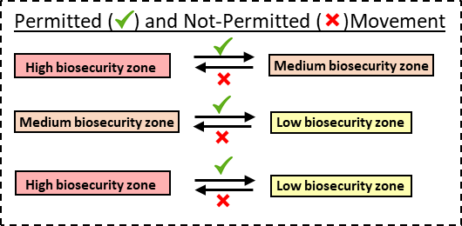
Figure 3. Summary of farm biosecurity movements permitted and not permitted between biosecurity zones
Consider drafting auditable risk-management measures such as these examples:
R.4 – The farm is divided into biosecurity zones, each with specific requirements for access, traffic direction, entry and exit procedures and equipment.
R.5 – Clear signage shows the biosecurity zone at the entry and exit points.
R.6 – Staff have training in the interpretation of the farm biosecurity zones.

Biosecurity risk analysis
This process helps identify the areas of the farm which need the greatest biosecurity investment to achieve maximum protection from occurrences and effects of disease.
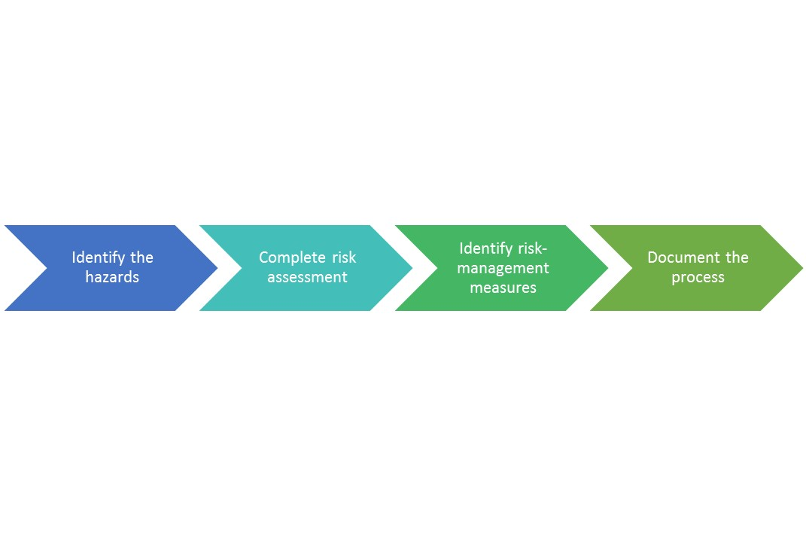
Figure 4. Four steps of conducting biosecurity risk analysis

Identify hazards
The identifiable hazards for a barramundi farm will vary with location and will be a combination of both endemic disease agents and the exotic agents outlined in Section 2. Your farm veterinarian may be able to assist you with identifying your farm’s hazards.
Table 6 below lists some pathogens which may be applicable to a freshwater site and an estuarine or marine site (note lists below are not exhaustive and farms should add locally relevant diseases):
Table 6. Potential freshwater, estuarine and marine infectious disease hazards
Freshwater disease | Pathogen type | Estuarine or marine disease | Pathogen type
Chilodonellosis | Ectoparasite | Brooklynellosis | Ectoparasite
Ichythyobodosis | Ectoparasite | Cryptocaryonosis | Ectoparasite
Tetrahymenosis | Ectoparasite | Amylodiniosis | Ectoparasite
Diplectanid gill fluke infestation | Ectoparasite | Turbellaria spp. infestation | Ectoparasite
Coccidiosis | Endoparasite | Leech infestation | Ectoparasite
Camallanid spp. infestation | Endoparasite | Myxosporean infestation | Endoparasite
Cryptosporidiosis | Endoparasite | Blood fluke infestation | Endoparasite
Henneguya sp. infestation | Endoparasite | Trypanosomiasis | Endoparasite
Streptococcosis | Bacteria | Streptococcosis | Bacteria
Aeromonas spp. Infection | Bacteria | Vibriosis | Bacteria
Flavobacterial infection (bacterial gill disease, saddleback, fin rot) | Bacteria | Tenacibaculosis | Bacteria
Epitheliocystis | Bacteria | Epitheliocystis | Bacteria
Pot belly disease | Bacteria | Pot belly disease | Bacteria
Edwardsiellosis | Bacteria | Edwardsiellosis | Bacteria
EUS (red spot) | Fungus | Photobacteriosis | Bacteria
Branchiomycosis | Fungus | EUS (red spot) | Fungus
Infection with exotic viruses (ISKNV, ECV, IHNV, SVC, VHS, RSBIV, GI virus*) | Virus | Viral encephalopathy and retinopathy (nodavirus) | Virus
Unidentified pathogen | Any of the above | Infection with exotic viruses (ISKNV, ECV, IHNV, SVC, VHS, RSBIV, GI virus) | Virus
 |  | Unidentified pathogen | Any of above
* Refer to Table 1 for full names of these diseases.
The process of identifying which of the above hazards apply to your enterprise triggers the next phase of the risk analysis: ‘risk assessment’. Identified hazards are those which have caused adverse impacts on fish health and production in the past. Diseases which are recognised as threats to fish health and production, but have not occurred on the farm, should also be assessed during the risk-analysis phase.

Risk assessment of hazards
To assign a level of risk to a hazard, you need to determine two factors – the likelihood of the hazard occurring on your farm and the consequences of it occurring on your farm. Your farm veterinarian may be able to assist with this section.

Likelihood
The likelihood of a disease occurring can be estimated by considering the transmission pathways necessary for entry of a disease, and for exposure of your fish to the disease. For example, the likelihood of entry and exposure might be ‘certain’ for a pathogen that occurs in untreated intake water such as Cryptocaryon sp. or Chilodonella spp.
Similarly, pathways involving infected live fish have the highest likelihood of entry and exposure because they may carry large quantities of viable pathogen.
The likelihood rating will vary, depending on:
- the properties of the disease
- the occurrence of the disease outside the farm or in nearby farms
- possible pathways for the disease onto the farm.
Likelihood ratings and descriptors are shown in Table 7.
Table 7. Assessment of disease likelihood
Rating | Description
1 Remote | Disease never heard of in this situation, but not impossible (less than once in 20 years)
2 Unlikely | Disease may occur in this situation, but only in exceptional circumstances (more than once in 20 years)
3 Possible | Clear evidence to suggest the disease is possible in this situation (more than once in 3 years)
4 Likely | Disease is likely, but not certain, to occur in this situation (more than once in 2 years [> 50%])
5 Certain | Disease is certain to occur in this situation (every year)

Consequences
The consequences of a disease occurring can be estimated by considering the impacts of a disease on the productivity of your farm. The consequences could include multiple aspects of production (for example, increased mortality; reduced growth, food conversion, product quality or market access; and increased treatment costs).
Consequence ratings and descriptors are shown in Error! Reference source not found.8.
Table 8. Assessment of disease consequences
Rating | Description
1 Insignificant | Impact not detectable or minimal
2 Minor | Impact on farm productivity limited to some production units or short-term only
3 Moderate | Widespread impact on farm productivity due to increased mortality or decreased performance
4 Major | Considerable impact on farm production resulting in serious supply constraints and financial impact
5 Catastrophic | Complete depopulation of the farm and possibly barriers to resumption of production

Risk estimation
The risk of a disease occurring is estimated as a product of likelihood and consequence (multiplying the likelihood rating by the consequence rating), resulting in risk ratings of 1–25. Risks are highest when both likelihood and consequence are high. However, the risk may be low even if the consequence is ‘catastrophic’, as the likelihood may be ‘remote’ for that particular circumstance; similarly, even if the likelihood is ‘certain’, the consequence may be ‘insignificant’. Risk ratings can be determined by applying estimates of likelihood (in which 1 is remote and 5 is certain) and consequence (in which 1 is insignificant and 5 is catastrophic) to the risk matrix shown in Error! Reference source not found.9.
Table 9. Risk-estimation matrix (colour code detailed in Table 10)
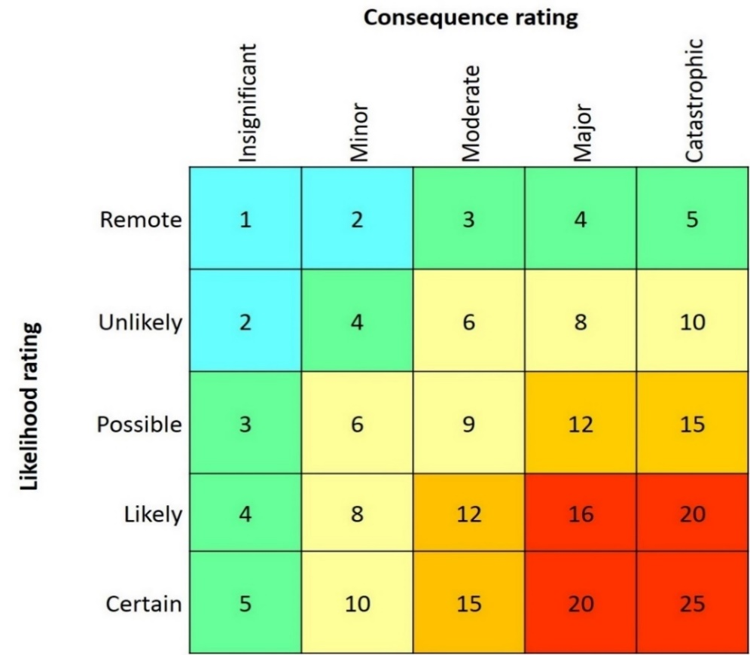

The management responses needed are arrived at from the risk estimation in Error! Reference source not found.9 and then the risk assessment shown in Error! Reference source not found.10.
Table 10. Risk levels and management responses
Risk level | Explanation and management response
1–2 Negligible | Acceptable level of risk. No immediate action required.
3–5 Low | Acceptable level of risk. Ongoing monitoring may be required.
6–10 Medium | Unacceptable level of risk. Active management is required to reduce the level of risk.
12–15 High | Unacceptable level of risk. Intervention is required to mitigate the level of risk.
16–25 Extreme | Unacceptable level of risk. Urgent intervention is required to mitigate the level of risk.

Document the risk-analysis process
It is important to record the entire process of risk analysis, so the farm manager or an auditor can identify which hazards have been considered, what risks have been apportioned and which management measures have been selected.
When a management measure is selected, such as pre-purchase fingerling health examinations, an SOP should be written to detail the exact functioning of the measure. In the example in Table 11, it might include details of how many fish are to be examined and which diagnostic techniques are to be applied. The farm biosecurity plan then only needs to refer to the relevant SOP. The farm could create its own coding system for each SOP, for example SOP-1 and SOP-2. It is a good idea to have a checklist accompanying each SOP with a date stamp and signature box, to document use of the SOP, enable traceability and assign responsibility to a specific staff member.
Table 11. Example of risk-analysis recording
Hazard | Likelihood | Consequence | Unmodified risk rating | Management response and control measures | Modified risk rating
Entry and spread of ‘disease X’ onto and within the farm. | Possible.  The disease is endemic and has occurred in source hatcheries previously. | Moderate.  Destruction of affected stock would be required due to effects on productivity. | 9 (medium). | Mitigation measures are required to reduce risk.  Likelihood reduced by sourcing stock only from hatcheries with a health-accreditation scheme.  Consequences reduced by ensuring all new stock are kept separate from other stock during the susceptible juvenile phase. | Control measures reduce likelihood to ‘unlikely’ and consequence to ‘minor’.  Measures reduce risk rating to 4 (low).  Modified risk is acceptable.

Mitigation measures to reduce disease transmission
This section outlines the common risk-management measures, such as infrastructure, signage and training, which can be used to reduce the risk of disease transmission through the pathways outlined in Section 5.
Diseases which score a ‘medium’, ‘high’ or ‘extreme’ risk rating should be prioritised for management action to mitigate (reduce) the risk. Risks which were identified as ‘low’ can remain the subject of monitoring and annual review within the plan.
The management measures which can be applied to mitigate risks are those which will be followed daily as part of routine farm operations. This section is broken up into management measures according to the type of enterprise, which can be:
- hatchery
- grow-out:
  - indoor RAS
  - outdoor ponds or raceways
  - sea cages.
You only need to consider the measures outlined below which are relevant to the type of enterprise you are operating. Note that there may be differences between state and territory legislation and restrictions on operating aquaculture enterprises. For example, in New South Wales, imported equipment that is second-hand is not permitted.
It should be remembered that for many, if not all, infectious diseases, a range of stressors can precipitate or exacerbate disease. Many of these stressors are well understood and can be part of control strategies on farms. Examples include dissolved oxygen levels, ammonia levels, nutritional factors, mechanical failure and sudden changes of environmental conditions.

Management of hatcheries
This section is intended to cover all forms of land-based, indoor hatchery culture.
Table 12. Risk-management measures for hatcheries (to implement and document)
Risk activity | Risk-management measures
New broodstock entry | R.7 Ensure health status is equal to, or higher, than the existing broodstock population, through: targeted testing for relevant pathogens (for example nodavirus); selection from populations that have not had disease outbreaks; and appropriate import or translocation permits in place for stock movement.  R.8 Broodstock are kept in a quarantine system on arrival, which is isolated from other onsite fish populations and has biosecurity barriers at entry and exit to mitigate risks associated with aerosol, water, staff and equipment. Tank identity is to be recorded.  R.9 Broodstock are provided with prophylactic treatments for control of ectoparasite and endoparasite risks under guidance of the farm veterinarian.  R.10 Any sick or freshly dead broodstock are investigated, with full field and laboratory diagnostic testing to attempt to identify cause of disease, with guidance of farm veterinarian and government authority. Immediate reporting takes place to appropriate government authority when required.  R.11 Broodstock deaths are recorded and dead stock removed daily and disposed of by a method approved by the relevant authority, which ensures no risk of release of pathogens from the dead stock into waterways, or access for scavenger birds or animals (for example pigs, foxes or water rats) that could spread a disease.  R.12 Staff receive annual training in identification of signs of disease and the steps involved in reporting, recording and investigating disease events.  R.13 Water quality (dissolved oxygen [DO], temperature, pH, salinity, total ammonia nitrogen [TAN], nitrite and nitrate) is monitored to maintain a low-stress environment. Tank hygiene is maintained daily with vacuuming and siphoning as required. Water-quality values are reported in a tank diary or other appropriate recording system.  R.14 Fish are visually examined daily. Unusual observations including colour change, inappetence, aberrant swimming, pop-eye, bloating, immobility, excess buoyancy, or skin or fin lesions are reported in a tank diary or other recording system and, when appropriate, trigger investigation as detailed in R.10.  R.15 Cats and dogs are excluded from all high and moderate biosecurity zones at all times. Vermin are controlled as necessary.  R.16 All doors remain closed within the facility at all times to avoid aerosol movement  R.17 All effluent from quarantine room is disinfected before discharge, and there is no open drainage through other areas of hatchery before disinfection.  R.18 Eggs are disinfected with a permitted or approved sanitiser.
Broodstock feed entry | R.19 Only sanitised feeds (extruded pellets or irradiated raw feed products [fish or squid]) are fed to broodstock. When untreated live or frozen raw feed products must be used for broodstock, feed is sourced from certified target-pathogen-free suppliers, or diagnostic screening is performed before feed entry onto farm. Details of batch, run and date of manufacture for all feeds are to be recorded.
Entry of algae, rotifers and Artemia spp. | R.20 Source algae from a biosecure supplier (for example Australian National Algae Supply Service) or a supplier of irradiated algae. When possible, source algae from specific-pathogen-free (SPF) suppliers.  R.21 Live feed cultures (algae, rotifers and Artemia spp.) are housed in separate and biosecure rooms with dedicated equipment and prevention of aerosol or water transmission to other hatchery zones. When possible, live feed culture is performed through batch culture with sanitisation methods in place.  R.22 All effluent from the live feed rooms is disinfected before discharge, and there is no open drainage through other areas of hatchery before disinfection.
Staff entry | R.23 Only designated staff may enter the hatchery and quarantine areas.  R.24 Staff must come directly to the hatchery. Staff must never enter the hatchery via grow-out areas, other farms, seafood processors or after recreational or commercial fishing activities. All staff are required to wear freshly laundered clothes daily and change into work footwear before hatchery entry.  R.25 All staff must pass through the footbath and hand sanitation station on entry and exit.  R.26 Staff must follow the work flow for the hatchery, and only move in the direction of highest to lowest biosecurity. This means only moving from a higher biosecurity zone (for example, broodstock, incubation, hatching and algae areas) to a lower biosecurity zone or more contaminated area (for example, rotifer, Artemia and larval-rearing areas), and never the reverse. If this one-way direction of movement is not possible, then the decontamination procedure must be followed.
Visitor entry | R.27 All visitors, contractors and researchers complete the visitor log and biosecurity questionnaire and sign a declaration before being considered for access. Visitors who are assessed as high risk are not allowed entry.  R.28 Access to hatchery and quarantine zones is avoided when possible.  R.29 Visitors granted access are required to undergo a hatchery biosecurity induction, at which entry requirements are explained.  R.30 Visitors are to follow routine disinfection entry protocol, including changing into hatchery-supplied boots, using the footbath and sanitising hands. Visitors must follow the work flow for the hatchery, and only move in the direction of highest to lowest biosecurity. This means only moving from a higher biosecurity zone (for example, broodstock, incubation, hatching and algae areas) to a lower biosecurity zone or more contaminated area (for example, rotifer, Artemia and larval-rearing areas), and never the reverse. If this one-way direction of movement is not possible, then the decontamination procedure must be followed.  R.31 Visitors are accompanied by a staff member at all times. Contractors can be inducted and may then be able to work unaccompanied.  R.32 Contractor maintenance work should be scheduled in between hatchery runs, when possible, to allow an additional disinfection step of the system to take place. When contractor access is required during runs, sanitary entry protocols should be followed.  R.33 Visitor vehicles must be parked in a dedicated parking area, preferably remote from hatchery entry.
Equipment | R.34 Where zones separate areas of the hatchery, dedicated equipment should be labelled and maintained for exclusive use in each zone, so there is no requirement to move any equipment between the hatchery zones.  R.35 Equipment that has been in contact with fish or culture water external to the hatchery should not be brought into the hatchery. If there is no alternative, a thorough cleaning and disinfection protocol must be followed before entry.  R.36 Equipment is always decontaminated after use and between runs.  R.37 Maintain compound microscope, dissection equipment and materials for preservation of tissues for histopathology and molecular testing. Make SOPs for equipment and procedures available for staff use.  R.38 Hatchery has dedicated delivery and loading area, separate to the production area.
Water intake and flows | R.39 If using a surface water source, use microfiltration and then completely disinfect. Options include ultraviolet (UV) and ozone (or alternative disinfection method). Efficacy of disinfection should be checked and logged. Options include bacterial total plate counts, oxidation–reduction potential (ORP) meter readings, or other suitable methods.  R.40 Filtration and sanitation infrastructure are regularly serviced on a maintenance schedule to ensure consistency of performance.  R.41 Water intake and holding facilities should be isolated from effluent flows and their potential aerosols.  R.42 Effluent water should preferably be piped away to wastewater effluent to avoid contamination of walkways through the hatchery.  R.43 If more than one run is being performed in the hatchery at the same time, it is preferable to rear each run in separate rooms, with separate water supplies and separate equipment and staff.  R.44 All culture areas are always dried out and sanitised in between each production run.  R.45 Consider running all effluent to a holding pond to permit batch decontamination before release to the environment.
Larval and fingerling culture | R.46 Observe stock daily. Record any abnormal observations, including colour change, inappetence, aberrant swimming, pop-eye, bloating, immobility, excess buoyancy, skin and fin lesions. Report abnormal observations in a tank diary or other recording system and, when appropriate, trigger investigation as detailed in R.10 above.  R.47 Remove, quantify and record stock deaths daily. Dispose of dead stock and biological waste through a method approved by the relevant authority. The method should ensure no risk of release of pathogens from the dead stock into waterways, or access for scavenger birds or animals (for example, cats and mice) that could spread a disease.  R.48 Stocking numbers and survival are quantified with each hatchery run, with broodstock origin and tank details and movements recorded, including all pack-out destinations with their contact details.  R.49 Water quality (DO, temperature, pH, salinity, TAN, nitrite and nitrate) is monitored to maintain a low-stress environment. Tank hygiene is maintained daily with vacuuming and siphoning as required. Report water-quality values in a tank diary or other appropriate recording system.  R.50 All discharge pipes have screens installed to prevent larvae and fingerlings from escaping.  R.51 Remove, quantify and record stock deaths daily. Disinfect equipment between tanks.

Management of grow-out systems

Indoor recirculating aquaculture systems
Indoor RASs provide complete exclusion from interactions with birds and other wildlife. Such grow-out systems should also be completely controlled for aerosol movements.
Table 13. Risk-management measures for indoor recirculating aquaculture systems (to implement and document)
Risk activity | Risk-management measures
New fingerling entry | R.52 Ideally, purchase from an SPF-certified supplier. When SPF supplies are unavailable, ensure health status is equal to, or higher than, the existing grow-out fish population through veterinary health certification of seedstock population including: assessment of survival in hatchery run; signs of disease in population; review of feed intake; general diagnostic screening (histology and microscopic examination of fresh gill biopsy and skin mucus); and other specific screening methods to exclude diseases and pathogens such as streptococcosis, edwardsiellosis and megalocytiviruses. Ensure appropriate import or translocation permits are in place for stock movement.  R.53 Ideally, hold new fingerlings in an isolated quarantine system for a minimum of four weeks to observe for any signs of disease emergence. Count stock and record destination tank in stock records.  R.54 Take a subsample of 10–20 fingerlings and archive in 10% formalin; label with date and hatchery source. Retain an equivalent number either frozen or in 70% ethanol or ‘RNAlater’ (Thermo Fisher Scientific) suitable for molecular diagnostics should the need arise.  R.55 Fish are visually examined daily. Unusual observations including colour change, inappetence, aberrant swimming, pop-eye, bloating, immobility, excess buoyancy, skin and fin lesions are reported in a tank diary or other recording system. When appropriate, trigger an investigation, for example, if any sick or freshly dead fingerlings are found that are beyond the number anticipated from cannibalism (for example, > 0.1% of population/day, for two consecutive days). This event must be investigated with full field and laboratory diagnostic testing to attempt to identify the cause of disease with guidance of the farm veterinarian. Immediate reporting should take place to the appropriate government authority.  R.56 Remove dead fingerlings and record deaths daily. Dispose of by a method approved by the relevant authority, which ensures no risk of release of pathogens from the dead stock into waterways or farmed fish, and allows no access for scavenger birds or animals (for example, pigs, foxes or water rats) that could spread a disease.  R.57 Staff receive annual training in identification of signs of disease and the steps involved in reporting, recording and investigating disease events.  R.58 Water quality (DO, temperature, pH, salinity, TAN, nitrite, nitrate, alkalinity and carbon dioxide) is monitored to maintain a low-stress environment. Tank hygiene is maintained daily with vacuuming and siphoning as required. Report water-quality values in a tank diary or other appropriate recording system.  R.59 Manage stocking densities to avoid excess stress and deterioration of water quality within the tank.  R.60 All doors remain closed within the facility at all times to avoid aerosol movement.
Fish grow-out | R.61 Record all stock-management activities such as treatments, grading and harvest, so stock can be traced back to their origin or source.  R.62 Fish are visually examined daily. Unusual observations including colour change, inappetence, aberrant swimming, pop-eye, bloating, immobility, excess buoyancy, skin and fin lesions are reported in a tank diary or other recording system. When appropriate, trigger an investigation, for example, if any sick or freshly dead fish are found that are beyond the number anticipated from cannibalism. This event must be investigated with full field and laboratory diagnostic testing to attempt to identify the cause of disease with guidance of the farm veterinarian. Immediate reporting should take place to the appropriate government authority.  R.63 Water quality (DO, temperature, pH, salinity, TAN, nitrite, nitrate, alkalinity and carbon dioxide) is monitored to maintain a low-stress environment. Tank hygiene is maintained daily with vacuuming and siphoning as required. Report water-quality values in a tank diary or other appropriate recording system.  R.64 Remove and record dead stock daily. Dispose of by a method approved by the relevant authority, which ensures no risk of release of pathogens from the dead stock into waterways or farmed fish, and allows no access for scavenger birds or animals (for example, pigs, foxes or water rats) that could spread a disease.  R.65 All discharge pipes have screens installed to prevent fish from escaping.
Fish feed entry | R.66 Only sanitised feed (for example, extruded pellets) should be fed to fish. Batch, run, date of manufacture, pellet size details are to be recorded so it is clear which fish received which feed.
Staff entry | R.67 New staff must receive biosecurity induction and sign a biosecurity declaration. All staff must read and know the location of SOPs for operating within the biosecurity plan of the farm.  R.68 Staff must come directly to the grow-out area. Staff must never come via other farms, seafood processors, or recreational or commercial fishing activities. All staff are required to wear freshly laundered clothes daily and change into work footwear before entry.  R.69 All staff must pass through the footbath and hand sanitation station on entry and exit.  R.70 Staff must follow the decontamination protocols when moving between the highest biosecurity zones (for example, quarantine) and lower biosecurity zones (for example, grow-out).
Visitor entry | R.71 All visitors, contractors and researchers must complete the visitor log and biosecurity questionnaire and sign a declaration before being considered for access. Visitors who are assessed as high risk will not be allowed entry.  R.72 Visitors granted access will be required to undergo a biosecurity induction, when entry requirements are explained.  R.73 Visitors are to follow the routine disinfection entry protocol, including changing into farm-supplied boots and using the footbath and hand-sanitiser equipment.  R.74 Visitors must be accompanied by a staff member at all times. Contractors can be inducted and may then be able to work unaccompanied.  R.75 Contractors must follow the same biosecure entry protocols, but can work without staff oversight after biosecurity induction. Contractor maintenance work should be scheduled in between hatchery runs, to allow an additional disinfection step of the system to take place.  R.76 Visitor vehicles are to be parked in a dedicated parking area, preferably remote to the loading area.
Equipment | R.77 Where zones separate areas of the grow-out (for example, grow-out nursery area tanks and grow-out tanks), dedicated equipment should be labelled and maintained for use exclusively in each zone, so there is no requirement to move any equipment between zones.  R.78 Equipment that has been in contact with fish or culture water external to the farm (including contractor equipment or plant) should not be brought into the farm. If no alternative exists, then a thorough cleaning and disinfection protocol must be followed before entry.  R.79 Decontamination of equipment must take place after use and always between tanks.  R.80 The farm has dedicated delivery, loading and pack-out areas, separate to the production area, which can be disinfected (for example, a concrete slab) to avoid fish transporters entering the production air space or shed.  R.81 A compound microscope, slides, cover slips, dissection equipment, tissue preservatives and pots, and laboratory specimen submission forms are to be kept available.
Water intake and flows | R.82 If using surface water, then microfiltration, ozonation and/or UV (or alternative disinfection method) are to be used to achieve complete disinfection of source water. Monitoring is to be used to demonstrate that the disinfection process is working (for example, weekly bacterial total plate counts and ORP meter readings).  R.83 Filtration and sanitation infrastructure is to be regularly serviced on a maintenance schedule, to ensure consistency of performance.  R.84 Water intake and holding facilities should be isolated from effluent flows and their potential aerosols.  R.85 Effluent water should preferably be piped away to wastewater to avoid contamination of walkways through the farm. Either irrigate effluent water onto a paddock or run it into an evaporation pond which is fenced and netted to exclude vermin and bird entry, or run it to the sewer (where permitted).  R.86 Record any changes to tank flows or infrastructure breakdowns.

Outdoor ponds and raceways
This section is intended to cover all forms of land-based outdoor grow-out. Not all facilities will discharge effluent flows to the environment, but both types are included below. These measures cover freshwater, estuarine and marine water sources.
Table 14. Risk-management measures for outdoor ponds and raceways (to implement and document)
Risk activity | Risk-management measures
New fingerling entry | R.87 Ideally, purchase from an SPF-certified supplier. When SPF supplies are unavailable, ensure health status is equal to, or higher than, the existing grow-out fish population through veterinary health certification of seedstock population, including: assessment of survival in hatchery run; signs of disease in population; review of feed intake; general diagnostic screening (histology and microscopic examination of fresh gill biopsy and skin mucus); and other specific screening to exclude diseases and pathogens such as streptococcosis, edwardsiellosis and megalocytiviruses. Ensure appropriate import and translocation permits are in place for stock movement.  R.88 Keep fingerlings in an isolated tank quarantine system on arrival (mandatory). The quarantine tank must be isolated from other fish populations on site and with biosecurity barriers on entry and exit for all aerosol, water, staff and equipment. Fingerlings should be kept in this system for a minimum of four weeks to observe for any signs of disease emergence. Count stock and record destination tank in stock records. Use of an all-in, all-out system is ideal. This allows shutdown, disinfection and dry-out in between batches.  R.89 When a quarantine system is unavailable, stock fingerlings into a fish-free pond which has been cleaned using a thorough clean-out protocol, including draining, drying, removal of excess organic matter, and liming when required. Keep new fingerling batches separate. Stocking into enclosed cages, ponds and areas avoids bird predation and associated biosecurity risks.  R.90 Take a subsample of 10–20 fingerlings and archive in 10% formalin, label with date and hatchery source. Also retain a similar number of fish either frozen, in 70% ethanol or in ‘RNAlater’ (Thermo Fisher Scientific) so they are suitable for molecular test analysis if required.  R.91 While fingerlings are in quarantine or within the fingerling pond, examine them at least weekly with microscopy for ectoparasites, and provide treatments to control ectoparasite risks under guidance of the farm veterinarian.  R.92 Fish are visually examined daily. Unusual observations including colour change, inappetence, aberrant swimming, pop-eye, bloating, immobility, excess buoyancy, skin and fin lesions are reported in a tank or pond diary or other recording system. When appropriate, trigger an investigation, for example, any sick or freshly dead fingerlings in numbers that are beyond those anticipated from cannibalism. This event must be investigated with full field and laboratory diagnostic testing to attempt to identify the cause of disease with guidance of the farm veterinarian. Immediate reporting is to take place to the appropriate government authority, as required.  R.93 Remove dead stock and record fingerling deaths daily. Dispose of by a method approved by the relevant authority, which ensures no risk of release of pathogens from the dead stock into waterways or farmed fish, and ensures no access for scavenger birds or animals (for example, pigs, foxes, water rats) that could spread a disease.  R.94 Staff are to receive annual training in identification of signs of disease and the steps involved in reporting, recording and investigating disease events.  R.95 Water quality (DO, temperature, pH, salinity, TAN and algal blooms) are monitored to maintain a low-stress environment. Pond, raceway and cage hygiene is maintained with cleaning, as required. Report water-quality values in a diary or other appropriate recording system.  R.96 Cage hygiene is maintained with cleaning of mesh to ensure good water flow to fish.  R.97 Manage stocking densities to avoid excess stress and deterioration of water quality within the tank, cage or pond.  R.98 Vermin are controlled as necessary.  R.99 All effluent from quarantine tanks should be either contained within a separate biosecure location and disinfected if a significant disease event occurs, or it can be disinfected before discharge from the tank quarantine area.
Fish grow-out | R.100 Record all stock-management activities, such as treatments, grading and harvest, so stock can be traced back to their origin or source.  R.101 Fish are visually examined daily. Unusual observations including colour change, inappetence, aberrant swimming, pop-eye, bloating, immobility, excess buoyancy, skin and fin lesions are reported in a pond or raceway diary or other recording system. When appropriate, trigger an investigation, for example, of any sick or freshly dead fish in numbers that are beyond those anticipated from cannibalism. These events must be investigated with full field and laboratory diagnostic testing to attempt to identify the cause of the disease, with guidance of the farm veterinarian. Immediate reporting is to take place to the appropriate government authority as required.  R.102 Water quality (DO, temperature, pH, salinity, TAN and algal blooms) is monitored to maintain a low-stress environment. Pond, raceway and cage hygiene is maintained with cleaning as required. Report water-quality values in a diary or other appropriate recording system.  R.103 Perform routine microscopic surveillance for ectoparasite infestations.  R.104 Remove dead stock and record deaths daily. Dispose of by a method approved by the relevant authority, which ensures no risk of release of pathogens from the dead stock into waterway or to farmed fish, and allows no access for scavenger birds or animals (for example, pigs, foxes or water rats) that could spread a disease.  R.105 All discharge pipes have screens installed to prevent fish escaping.  R.106 Ensure pond or raceway discharge can be sealed off if a major disease outbreak occurs, to prevent the risk of untreated water discharge.
Fish feed entry | R.107 Only sanitised feed (for example, extruded pellets) should be fed to fish. Batch, run, date of manufacture and pellet size details are to be recorded so it is clear which fish received which feed.
Staff entry | R.108 New staff must receive biosecurity induction and sign a biosecurity declaration. Staff must have read and know the location of SOPs for operating within the biosecurity plan of the farm.  R.109 Staff must come directly to grow-out. Staff must never come via other farms, seafood processors or recreational and commercial fishing activities. All staff are required to wear freshly laundered clothes daily and change into work footwear before entry.  R.110 Staff must follow the decontamination protocols when moving between highest biosecurity zones (for example, quarantine area) to lower biosecurity zones (for example, grow-out area).
Visitor entry | R.111 All visitors, contractors and researchers must complete the visitor log and biosecurity questionnaire and sign a declaration before being considered for access. Visitors who are assessed as high risk will not be allowed entry.  R.112 Access to quarantine zones is to be avoided when possible.  R.113 Visitors granted access will be required to undergo a biosecurity induction, when entry requirements are explained.  R.114 Visitors are to follow the routine disinfection entry protocol, including changing into farm-supplied boots, and using the footbath and hand-sanitising equipment.  R.115 Visitors must be accompanied by a staff member at all times.  R.116 Contractors must follow the same biosecure entry protocols.  R.117 Visitor vehicles are to be parked in a dedicated parking area, preferably remote from the loading area.
Equipment | R.118 Where zones separate areas of the grow-out (for example, quarantine and grow-out tanks), dedicated equipment should be labelled and maintained for use exclusively in each zone, so there is no requirement to move any equipment between zones.  R.119 Equipment which has been in contact with fish or culture water external to the farm (including contractor equipment or plant), should not be brought into the farm. If no alternative exists, then a thorough cleaning and disinfection protocol must be followed before entry.  R.120 Decontamination of equipment is to be performed after each use and is always performed between production runs. Records of decontamination are to be kept.  R.121 A compound microscope, slides, cover slips, dissection equipment, tissue preservatives and pots, and laboratory specimen submission forms are to be kept available.  R.122 The farm is to have dedicated delivery, loading and pack-out areas, separate to the production area, which can be disinfected (for example, a concrete slab), to avoid fish transporters entering the production air space or shed.
Water intake and flows | R.123 Avoid water intake if signs of fish disease appear in the source waterway.  R.124 Ideally, recirculate all waste effluent water through a constructed wetland to limit exposure to open natural waterways.  R.125 Where constructed wetland reuse is not available, effluent should be passed into a settlement pond before discharge. This settlement pond should have the capacity to be closed off in an emergency disease event to halt all farm discharge, unless high rainfall forces discharge.  R.126 Record any changes to tank, pond or raceway flows, and infrastructure breakdowns.
Culture of fish species other than barramundi | R.127 Different fish species should be cultured in separate ponds, not more than one species in the same pond. There could be common parasitic, bacterial or viral diseases to both species, or unique diseases. A risk assessment is needed. An exception may be when additional fish species (for example, cleaner wrasse) are being used for parasite control on barramundi.

Sea cages
This section is intended to cover all forms of sea cage grow-out culture.
Table 15. Risk-management measures for sea cages (to implement and document)
Risk activity | Risk-management measures
New fingerling entry | R.128 Ideally, purchase from an SPF-certified supplier. When SPF stock are unavailable, ensure health status is equal to, or higher than, the existing grow-out fish population through veterinary health certification of the new fingerling population. This will include assessment of survival in the hatchery run; signs of disease; review of feed intake; general diagnostic screening (histology and microscopic examination of fresh gill biopsy and skin mucus); and other specific screening to exclude diseases and pathogens such as streptococcosis, edwardsiellosis, photobacteriosis and megalocytiviruses. Ensure appropriate import or translocation permits are in place for stock movement.  R.129 When possible, stock fingerlings onto a lease which does not have other intakes co-habiting in close proximity. Count stock and record destination cage identity in stock records.  R.130 Stock fingerlings into a new net, or a net which has been dried and disinfected.  R.131 Divers should undertake basic decontamination measures between newly stocked cages and other farm populations, including disinfection of wetsuits, gloves and dead stock-collection bags. The deck of the dive boat should be decontaminated when moving between cages.  R.132 Collect and accurately record numbers of dead stock and their appearance, at least twice per week. Dead stock should be transported in a leak-proof vessel to avoid any spillage of fluids from the dead fish in transit between cages. Dispose of them by a method approved by the relevant authority which ensures no risk of release of pathogens from the dead stock into waterways, and allows no access for scavenger birds or animals (for example, pigs, foxes and water rats) that could spread a disease.  R.133 Take a subsample of each new intake of 10–20 fingerlings and archive them in 10% formalin, labelled with the date and hatchery source. Also, retain similar numbers of fish either frozen or in 70% ethanol or in ‘RNAlater’ (Thermo Fisher Scientific) so they are available for molecular testing at a later date if required.  R.134 Examine fingerlings at least weekly by microscopy for ectoparasites, and provide treatments to control ectoparasite risks under guidance of the farm veterinarian.  R.135 Cage-side fish are to be visually examined daily. Unusual observations including colour change, inappetence, aberrant swimming, pop-eye, bloating, immobility, excess buoyancy, skin and fin lesions are to be reported in a tank or pond diary or other recording system. When appropriate, trigger an investigation, for example of any sick or freshly dead fingerlings in numbers beyond those anticipated from cannibalism. These events must be investigated with full field and laboratory diagnostic testing to attempt to identify the cause of the disease with guidance of the farm veterinarian. Immediate reporting is to take place to the appropriate government authority as required.  R.136 Staff receive annual training in identification of signs of disease and the steps involved in reporting, recording and investigating disease events.  R.137 Water quality (DO, temperature, pH, salinity and algal blooms) is monitored to maintain a low-stress environment. Cage netting is maintained with routine cleaning. Report water-quality values in a diary or other appropriate recording system.  R.138 Manage stocking densities to avoid excess stress and deterioration of water quality within the cage.  R.139 Site leases are to be ~ 5 km apart and without direct hydrological current connectivity.  R.140 Manage lease benthos to avoid excessive eutrophication.
Fish grow-out | R.141 Record all stock-management activities such as treatments, grading and harvest, so stock can be traced back to their origin or source.  R.142 Fish are to be visually examined daily. Unusual observations including colour change, inappetence, aberrant swimming, pop-eye, bloating, immobility, excess buoyancy, skin and fin lesions are to be reported in a pond or raceway diary or other recording system. When appropriate, trigger an investigation, for example of any sick or freshly dead fish in numbers beyond those anticipated from cannibalism. These events must be investigated with full field and laboratory diagnostic testing to attempt to identify the cause of the disease with guidance of the farm veterinarian. Immediate reporting is to take place to the appropriate government authority.  R.143 Water quality (DO, temperature, pH, salinity and algal blooms) is monitored to maintain a low-stress environment. Cage netting is maintained with routine cleaning. Report water-quality values in a diary or other appropriate recording system.  R.144 Perform routine microscopic surveillance for ectoparasite infestations.  R.145 Record daily feed intake and observations on feeding vigour.  R.146 Remove and record dead stock daily. Dispose of dead stock by a method approved by the relevant authority that ensures no risk of release of pathogens from the dead stock into waterways, and allows no access for scavenger birds or animals (for example, pigs, foxes and water rats) that could spread a disease.  R.147 Divers are to inspect nets at least twice weekly and close holes to minimise stock escaping.  R.148 Manage lease benthos to avoid excessive eutrophication.
Fish feed entry | R.149 Only sanitised feed (for example, extruded pellets) should be fed to fish. Batch, run, date of manufacture and pellet size details are to be recorded so it is clear which fish received which feed.
Staff entry | R.150 New staff must receive biosecurity induction and sign a biosecurity declaration. Staff must read and know the location of SOPs for operating within the biosecurity plan of the farm.  R.151 Staff must come direct to grow-out. Staff must never come via other farms, seafood processors, or recreational, commercial fishing and diving activities. All staff are required to wear freshly laundered clothes daily and change into work footwear before entry to farms or farm vessels.  R.152 Only designated and authorised staff may enter quarantine areas.  R.153 All staff must pass through the footbath and hand sanitation station on entry and exit.  R.154 Staff must follow the decontamination protocols when moving between highest biosecurity zones (for example, quarantine area) to lower biosecurity zones (for example, grow-out area).
Visitor entry | R.155 All visitors, contractors and researchers must complete the visitor log and biosecurity questionnaire and sign a biosecurity declaration before being considered for access. Visitors who are assessed as high risk will not be allowed entry.  R.156 Access to quarantine zones is to be avoided when possible.  R.157 Visitors granted access will be required to undergo a biosecurity induction, when entry requirements are explained.  R.158 Visitors are to follow routine disinfection entry protocol, including changing into farm-supplied boots and using the footbath and hand-sanitising equipment.  R.159 Visitors must be accompanied by a staff member at all times.  R.160 Contractors must follow the same biosecure entry protocols.
Equipment | R.161 Where there is spatial separation of areas of the grow-out (for example, separate leases), equipment should be decontaminated between leases.  R.162 Movements such as cage tows, work-boat movements from areas of known disease status, or other aquaculture finfish enterprises, to areas of disease-free status should be avoided. If boats or new cages must be moved, then a thorough disinfection protocol should be put in place, including slipping the boat, removal of all ropes and replacement with new ropes, and disinfection of the vessel.  R.163 Equipment which has been in contact with fish or culture water external to the farm (including contractor equipment or plant), should not be brought into the farm. If no alternative exists, then a thorough cleaning and disinfection protocol must be followed before entry.  R.164 A compound microscope, slides, cover slips, dissection equipment, tissue preservatives and pots, and laboratory specimen submission forms are to be kept available.  R.165 The farm is to have dedicated delivery, loading and pack-out areas, separate from the production area, which can be disinfected (for example, a concrete slab), to avoid fish transporters entering the production air space or shed.  R.166 The farm should have equipment and contingency plans to manage high-mortality events, such as large airlifts, and prearranged high-volume disposal sites.
Harvest effluents | R.167 Harvest boats and well boats should not spill blood-water or holding water as they sail past leases on the way to the marina or processing plant.

Emergency procedures
Farms need to develop emergency procedures and additional biosecurity measures, beyond those identified in Section 9, to respond to a suspected emergency animal disease (EAD) or serious endemic disease occurring on the farm or in adjacent waterways.
R.168 – The farm has an emergency response plan.
An emergency response plan template is shown in Appendix 8.

An emergency response plan (aligned with AQUAVETPLAN) should provide clear guidelines on:
- events that trigger an EAD alert (for example, unusual or increased stock deaths or suspicious clinical signs)
- a list of key emergency contacts (industry and government)
- notification pathways within the business
- notification requirements for the responsible jurisdictional authority
- emergency biosecurity measures, which might include an entire shutdown of farm access or cessation of effluent release
- selection, collection, storage and laboratory submission of samples
- disposal and quarantine protocols
- physical location of or web links to key documents such as AQUAVETPLAN (www.agriculture.gov.au/animal/aquatic/aquavetplan), state response plans and site disease response plans
- farm response to events such as power failure, severe weather events (including cyclones) and water treatment failure.

Legislative or jurisdictional regulatory requirements
Farm practices must comply with:
- relevant agency and jurisdictional legislation (local, state or territory and Commonwealth)
- farm licence or permit conditions.
R.7, R.51, R.86, R.128 – Risk-management measures that relate to ensuring appropriate import or translocation permits are in place before stock movement.
R.10, R.54, R.91, R.135 – Risk-management measures that relate to reporting of unusual or suspicions signs of disease.
R.169 – Only species on the farm licence are kept at the farm.
R.170 – All veterinary medicines used on fish comply with relevant state and Commonwealth (Australian Pesticides and Veterinary Medicines Authority [APVMA]) legislation and have farm veterinarian oversight and prescriptions when required.

Document control and revision record
To demonstrate that your farm biosecurity plan is being maintained, it is necessary to review it. This should occur at least once annually. This provides an opportunity to update the plan with newly emerged risks, changes in farm management, changes to contact lists, audit recommendations and infrastructure upgrades. Use of a ‘document control’ footer table (such as the one shown in Table 16) on documents provides document control and an auditable revision record.
Table 16. Footer to use on biosecurity plan documents to maintain version control
Document control
Version | [for example ‘2.0’] | Approved by | [Name, position]
Status | [for example ‘Draft’] | Approved | [Date]
Contact | [Name, position, phone] | Next review due | [Date should not exceed 12 months]
R.171 – Farm biosecurity plan is regularly reviewed with detail available on the document control information and revision record

Audit record
The farm biosecurity plan should be audited through both internal and external processes. It is advisable for this to take place at least once annually. A record of all audits should be made, including any deficits or recommendations made by the auditor, and the farm responses to these.
R.172 – Regular auditing of the farm biosecurity plan is to take place at least once annually.

Training
All staff need to understand the purpose and operation of the farm’s biosecurity plan to prevent disease entry and spread. All staff need to be trained to recognise signs of disease, to be alert to the signs of emerging disease, and to be prepared to respond to disease detection.
To achieve this outcome, training exercises which detail general and specific staff roles should be undertaken. These training and refresher exercises should take place at least annually for each staff member.
One staff member should take on the role of biosecurity manager for the farm.
R.173 – The farm appoints a biosecurity manager who creates, maintains and reviews the farm biosecurity plan, and associated documents and activities, including staff training.
R.174 – The farm biosecurity plan and all associated documents are readily accessible to staff at all times.
R.175 – All staff are provided with a biosecurity induction to the farm biosecurity plan, including the emergency response plan and SOPs. All staff are provided with ongoing biosecurity training relevant to their role. The training is to be documented in a training log.

Supporting documents
The farm biosecurity plan should include a list of the supporting documents, such as SOPs, checklists and record-keeping templates. These documents outline the biosecurity practices of the farm and maintain a record demonstrating their use by staff.
Examples of SOPs include:
- biosecurity induction and training for new staff
- visitor biosecurity questionnaire
- contractor biosecurity induction
- collection and disposal of dead stock
- disinfection protocols for equipment and staff
- water quality testing
- packing samples to send to laboratory
- farm biosecurity zones
- emergency response plan.
Examples of record-keeping templates include:
- pre-employment biosecurity declaration
- visitor biosecurity declaration
- visitor log
- farm entry conditions for visitors
- staff training record
- mortality and water quality records.
R.176 – Supporting documents to the farm biosecurity plan are clearly identifiable and readily available.

Appendices

Appendix 1 Biosecurity sign
Corflute signs are available for purchase at www.farmbiosecurity.com.au/toolkit/buy-a-gate-sign
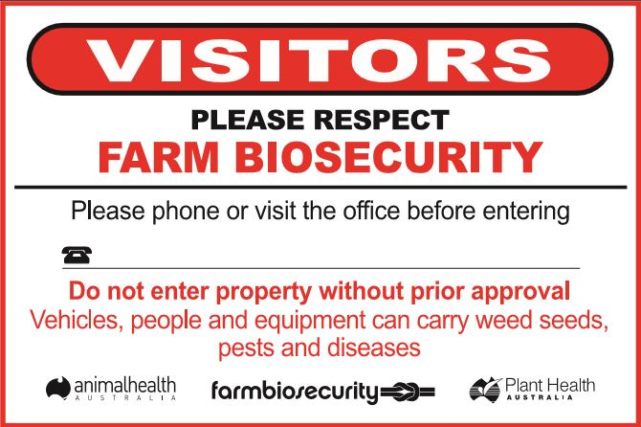
Figure A1. Example of a biosecurity sign

Appendix 2 How to write a standard operating procedure
Table A1 shows a sample template that can be used to create a farm SOP. Highlighted in red are some examples of information from an SOP. These should be stand-alone documents which allow staff to perform SOP tasks proficiently by following the methods outlined in the document.
Table A1. Example of standard operating procedure template for a farm
[Insert SOP category title] FLUKE SAMPLING TECHNIQUES
[Insert SOP Title] Quantifying and categorising skin fluke (Benedenia seriolae) and gill fluke (Zeuxapta seriolae)
LOCATION DETAILS
[Insert farm name]
[Insert farm location]
Standard OPERATING PROCEDURE DETAILS
Task/activity (specify particular equipment and substances)  [Insert equipment details]  - Equipment: Dissecting microscope, 2 x hand counters, fine pointed forceps, sharps container  - Consumables: Petri dishes, scalpel blade, 70% ethanol spray bottle, tissues, disposable gloves, paper towel, disposable pipettes, pen, paper |  |  |  | Date prepared:  [Insert date]
Prepared by
Name | [Insert name] | Position | [Insert role] | Signature | [Insert signature]
Standard OPERATING PROCEDURE DETAILS
Table A1. Example of standard operating procedure template for a farm (continued)
CAUTION
[List any cautions during procedure]
- If samples have been stored in ethanol solution (70% v/v), treat as potentially flammable and avoid direct contact, ingestion and inhalation.
Preparation – work area check:
[List any preparation steps required before commencing the task]
- Ensure there is ready access to a sharps-disposal container.
- Familiarise yourself with the location of the first-aid kit and fire extinguisher.
- Familiarise yourself with set-up, maintenance and general use of a dissecting microscope.
Definitions:
[List any definitions required to understand the procedure steps]
- Sample container: ethanol or seawater solution containing biological material obtained from fluke sampling at the sea cage.
Personal attire and safety equipment:
[List any definitions required to be used during the procedure]
- Standard personal protective equipment (PPE) – including a lab coat and gloves.
1. Preparation:
[List every step for preparation of equipment for the procedure]
1.1. Turn on and set up the dissecting microscope for viewing of parasitology specimens.

[describe every step]

1.4. Place paper towel on the bench with two disposable pipettes, a spare empty sample container, 70% ethanol (v/v) spray bottle and fine pointed forceps.

2. Procedure:
[List every step required to be performed to complete the procedure proficiently purely by following these steps, including figures and tables when required]

2.1 Open the labelled ‘test’ sample container, taking care not to disturb the contents.

[describe every step]

2.11 If wanting to store the sample, replace seawater with ethanol (70% v/v) or 10% neutral buffered formalin.

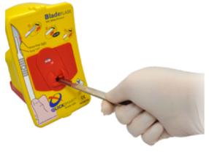
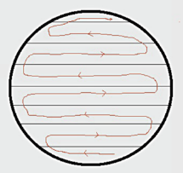
Table 1. Categorising adult and juvenile gill flukes (Z. seriolae) and skin flukes (B. seriolae).
Figure 2. Safe scalpel blade disposal.

Figure 1. Direction of sample analysis (red line) and lined scoring of petri dish base (black line).

Example of a data sheet used for recording adult (GF-A) and juvenile (GF-J) gill flukes (Z. seriolae), and adult (SF-A) and juvenile (SF-J) skin flukes (B. seriolae).

On completion of work:

[List every step required to be performed following completion of the task]
- Turn off dissecting microscope and pack away all equipment.
- Clean and wipe the bench area with disinfectant.

Be aware of:

[List all cautions, warnings and potential issues that the staff performing the task should be aware of]
- Ethanol evaporation creating fumes – ensure the room has adequate ventilation.

In case of an accident:

[List all steps to be performed and persons to contact if an accident, incident or ‘near miss’ occurs]
- Inform supervisor or site first-aid officer.
Note: Review this standard operating procedure:
a) after any accident, incident or ‘near miss’
b) when training new staff
c) if adopted by a new work group
d) if equipment, substances or processes change
e) within 5 years of date of issue.
Each SOP should contain the information shown in Table A2.
Table A2. Information to include in standard operating procedure
SOP section | Explanation
Title | Should be clear and unambiguous (for example, ‘Emergency procedures for high mortality’).
Objective | Should be clear and unambiguous (for example, ‘Describe procedures to be followed in the event of high unexplained mortality on the farm’).
Responsibilities | Describe who the SOP applies to and the roles they must perform. For example:  - All staff: understand this procedure, be able to follow initial response actions, report to biosecurity manager.  - Biosecurity manager: coordinate initial response, report to farm manager, liaise with farm veterinarian.  - Farm manager: decide response actions, report incident to government authorities.
Procedure | Clearly describe the steps that should be taken, as appropriate. For example:  - Cease all farm activity, including feeding, cleaning and stock movement.  - Check water-quality parameters, such as flow, DO and temperature.  - Secure the area to prevent access by unnecessary personnel and to prevent movement of equipment or stock.  - Assess the extent of the situation, for example, how many tanks are affected, the proportion of sick or dead animals, and any obvious signs of disease.
Precautions | Clearly describe any activities that must be avoided, for example:  - Staff must not visit other production areas of the farm.  - Equipment and animals must not leave the affected area.
Review date and further information | SOP should include the date it came into effect, author contact information, approving manager, date for review (within 12 months), any supporting information, and cross-references to the relevant components of the farm biosecurity plan.

Appendix 3 Training record template
Table A3. Training record template example
Employee name |  | Employee position
Minimum training requirements: |  | Site biosecurity plan:
 |  | Emergency response plan:
 |  | Job-specific SOPs:
 |  | Other:
Date | Subject/topic/document | Trainer | I understand the training delivered and have read and understand the associated documents (Signature of employee) | Due date of refresher training

Appendix 4 Pre-employment biosecurity declaration
I, …………………………………………………………………………. hereby agree to abide by the [INSERT FARM NAME] biosecurity plan and will follow SOPs provided.
I understand the following applies at all times, and I will:
- attend work in clean, laundered clothes
- only enter the areas of the farm which I am approved to access
- follow the one-directional flow of work from the low-risk (cleanest) areas of the farm to the highest-risk areas
- immediately report any biosecurity breaches to management
- immediately report any suspicion of disease emergence to management.
I understand that I must not:
- visit other aquaculture sites or seafood processes for 24 hours before entry to the farm, unless I have had a full head-to-toe shower and have changed into clean, laundered clothes and sanitised footwear
- wear, or take boots which are worn in a specific production area outside the production area for which they are designated
- move any equipment which is designated to stay within a zone of the farm, outside of that zone.
Signature: ……………………………………………………………….. Date: ………………………………………..

Appendix 5 Visitor biosecurity declaration
- Are you entering production areas of the farm?
Yes □ (go to question 2) No □ (go to signature section)
- Have you been in contact with any aquaculture enterprises or the aquatic environment in the previous 24 hours (including recreational fishing, seafood processors and water sports or activities)?
Yes □ (go to question 3) No □ (go to question 4)
- Have you had a head-to-toe shower and changed into clean clothes and shoes?
Yes □ (go to signature section) No □ (postpone non-essential visits, or manager to assess risk before farm entry being permitted)
- Are you bringing any equipment, fish feed, dive gear or fishing gear onto the farm?
Yes □ (go to question 5) No □ (go to signature section)
- Have equipment and other items been sanitised to eliminate fish pathogens?
Yes □ (go to signature section) No □ (stop equipment entry onto farm, or manager to assess risk before farm entry)
I, ………………………………………………………………………… agree to abide by the entry conditions for visitors
Signature:……………………………………………………………………………………….. Date: ……………………………………..

Appendix 6 Visitor log template
Table A4. Visitor log template example
Date | Name | Company | Contact number | Visitor biosecurity declaration completed | Responsible staff member | Time in | Time out

Appendix 7 Farm entry conditions for visitors
Entry to this farm is subject to the following conditions:

Entering Visitors MUST NOT have been in contact with any other aquaculture, seafood processors, ornamental fish or the aquatic environment on the same day of entry.

Visitors MUST complete a visitor biosecurity declaration.

Visitors MUST complete the visitor’s log.

Visitors MUST wear farm boots provided.

Visitors MUST clean and sanitise hands and boots at wash stations before entering production areas of the farm.

Appendix 8 Self-audit checklist
Table A5. Self-audit checklist example
Page ref. | Associated requirement | Audit questions | Yes | No | N/A | Corrective action/comments
14 | R.1 | Does the farm have boundary markers at all four corners of the lease with navigation lighting? (Only applicable to sea-cage sites.)
14  22  25  27 | R.2  R.33  R.76  R.117 | Is the production area of the farm behind a lockable gate, with separate isolated visitor parking sign-posted with company contact details?
14 | R.3 | Is the hatchery securely perimeter-fenced with security cameras (optional) on entry and exit points?
15  15  25  25  27  30 | R.4  R.5  R.68, R.69  R.78  R.109  R.152 | Does the farm have clear signage denoting biosecurity zones at the entry and exit points, complete with specific disinfection requirements in relation to access, traffic direction, entry and exit procedures, clothing and equipment?
15  24  25  27  27  27  30 | R.6  R.67  R.70  R.108  R.109  R.110  R.154 | Do staff understand the requirements and SOPs around the farm biosecurity zones after receiving their biosecurity induction?
Page ref. | Associated requirement | Audit questions | Yes | No | N/A | Corrective action/comments
21  23 | R.7  R.52 | Have new stock (broodstock, larvae, fingerlings, on-grown fish) been selected from disease-free populations and screened to
26  28 | R.87, R.91  R.128 | ensure health status is equal to, or higher than, the existing stock populations?
27  30 | R.112  R.156 | Is access to quarantine restricted to essential staff only?
21  21  26 | R.7, R.8  R.9  R.88 | Are new broodstock, fry and fingerlings kept in a quarantine system on arrival, provided with prophylactic treatments for control of ectoparasite and endoparasite risks under guidance of the farm veterinarian, with tank records and translocation approvals to document movement and minimise disease introduction?
26 | R.89 | Have new fingerlings been stocked into a fish-free pond that has been cleaned and decontaminated from biosecurity risks?
21  23 | R.10  R.46 | Are records of investigations and required reporting of sick or freshly dead fish available?
21  21  23  24  24  24  26  27  27  28  29  29  29 | R.11  R.14  R.47  R.55  R.56, R.57  R.62, R.65  R.92, R.93  R.101  R.103, R.104  R.132, R.134  R.135  R.142, R.144  R.145, R.146 | Are there records to demonstrate stock observations, feed intake, mortality counts and appropriate procedures for sanitary disposal of dead fish?
Page ref. | Associated requirement | Audit questions | Yes | No | N/A | Corrective action/comments
21  23  24 | R.12  R.55, R.46  R.56, R.57 | Are staff able to identify signs of disease and the steps involved in reporting, recording and investigating disease events?
24 | R.62
21  23  24  26  29  29 | R.13  R.49  R.58, R.63  R.95, R.102  R.137  R.143 | Is water quality monitored, recorded and kept within optimal ranges?
21  24  27 | R.15, R.16  R.60  R.98 | Are pets, vermin and aerosols excluded from quarantine, broodstock and hatchery high-biosecurity zones, by keeping doors closed (where applicable), or by other means?
21  27 | R.17, R.22  R.99 | Is the risk of discharge of pathogens in effluent from the quarantine and live feeds area controlled with a sanitary measure?
21 | R.18 | Are eggs disinfected with a permitted sanitiser?
21  24  27  29 | R.19  R.66  R.107  R.149 | Are all feeds sanitised (extruded or irradiated) with records of batch run, date of manufacture and date of feed out recorded?
21 | R.20 | Have algae been sourced from a biosecure supplier?
21 | R.21 | Are live feed cultures (algae, rotifers and Artemia) housed in separate, biosecure rooms with dedicated equipment and prevention of aerosol and water transmission to other hatchery zones?
22  22 | R.23, R.24 R.25 | Do staff take appropriate measures to ensure their entry to the production areas does not risk the entry of pathogens (on boots, hands or clothes)?
Page ref. | Associated requirement | Audit questions | Yes | No | N/A | Corrective action/comments
22  29 | R.24, R.26  R.150 | Are staff aware of workflow sanitary requirements to avoid spreading pathogens into or around the high and moderate biosecurity zones?
22  25  27  27  30 | R.27  R.71  R.111  R.116  R.155 | Is there a visitor and contractor log, biosecurity questionnaire and declaration which has to be completed by all visitors before assessing permission for entry?
22  22  25  27  30 | R.28, R.29 R.30  R.72  R.113  R.157 | Are documented procedures in place to manage risks posed by visitor entry to production areas of farm?
22  25  28  31 | R.30  R.73  R.114  R.158 | Are prominent signage and appropriate disinfection measures available at entry for staff and visitors?
22  25  27  30 | R.31  R.74  R.115  R.159 | Are visitors accompanied by a staff member at all times?
Page ref. | Associated requirement | Audit questions | Yes | No | N/A | Corrective action/comments
22  25  30  30  32  32  33 | R.32  R.75  R.154  R.160  R.174  R.175  R.176 | Are protocols in place for staff and contractors to ensure they follow biosecurity measures to minimise the introduction or spread of pathogens around production areas?
22  25  28  30  30 | R.34, R.35  R.77  R.118  R.161  R.163 | Is dedicated equipment and routine sanitation protocols available for each production biosecurity zone, so disease-transfer risks associated with movement between and within zones are minimised?
22  25  28  28 | R.36, R.41  R.79  R.119  R.120 | Is decontamination and dry-out of equipment and tanks always performed between batches of fish through the production unit?
22  25  28  30 | R.37  R.81  R.121  R.164 | Is a farm laboratory maintained with a compound microscope, dissection equipment, materials for preservation of tissues for histopathology and molecular testing, with guiding SOPs to support diagnostic investigations?
22  25 | R.38  R.80 | Does the hatchery have a dedicated delivery and loading area, separate from the production area?
22 | R.39 | Is water intake to the production unit appropriately sanitised to minimise entry of pathogens?
22  25 | R.39, R.40,  R.82, R.83 | Is there documentation of the service, maintenance and efficacy of water decontamination measures to ensure efficacy?
23  25 | R.41  R.84 | Are water intake and holding facilities isolated from effluent flows and their potential aerosols?
Page ref. | Associated requirement | Audit questions | Yes | No | N/A | Corrective action/comments
23  25 | R.42  R.85 | Is hatchery effluent contained within pipes until effectively disinfected to avoid transmission of pathogens via splash or aerosol?
23 | R.43 | Are concurrent hatchery runs operated in separate rooms with separate water supplies, equipment and staff?
23 | R.45 | Is all hatchery effluent run to a holding pond to permit batch decontamination before release to the environment?
25  28 | R.86  R.126 | Are water flow rate changes and infrastructure breakdowns recorded?
23 | R.48  R.51 | Are there records to confirm stocking numbers and survival in each production unit, including broodstock origin, hatchery origin, and movements to other locations with their contact details?
23  24  27 | R.50  R.65  R.105 | Do all discharge pipes and other production unit outlets have screens installed to prevent fish escaping?
24  26 | R.53  R.88 | Have larvae, broodstock and fingerlings been held in a quarantine system for a minimum of four weeks to observe for any signs of disease emergence and to count stock; and are destination tanks, cages or ponds recorded in stock records?
24  26  29 | R.54  R.90  R.133 | Has the farm collected and archived samples of new fish intakes in a range of fixatives, to enable subsequent diagnostics to explore the entry of potential diseases with fish intakes?
24  26  29  32 | R.57  R.94  R.136  R.175 | Are training records available to demonstrate that staff have received annual training in identification of signs of disease and the steps involved in reporting, recording and investigating disease events?
24  27  29 | R.59  R.97  R.138 | Has stock been managed to avoid stress and deterioration of water quality within the tank from excessive stocking densities?
Page ref. | Associated requirement | Audit questions | Yes | No | N/A | Corrective action/comments
24  27  28  29 | R.61  R.100  R.126  R.141 | Do farm records document all stock-management activities such as treatments, grading and harvest, so that stock can be traced back to their origin or source?
25  30 | R.68  R.151 | Have staff come direct to work (not via commercial, recreational fishing or seafood processing) in freshly laundered clothes?
26 | R.96 | Is cage hygiene maintained with cleaning of mesh to ensure good water flow to fish?
28  30 | R.122  R.164 | Does the production area have dedicated delivery, loading and pack-out areas, separate to the production areas, which can be disinfected (for example, a concrete slab), to avoid fish transporters entering the production air space or shed?
28 | R.123 | Does the farm have a contingency to shut off water intake if signs of fish disease appear in the source waterway?
27  28 | R.106  R.124  R.125 | Can pond or raceway production water effluent be contained and decontaminated before discharge to a waterway?
28 | R.127 | Are individual fish species cultured in separate ponds (not > 1 species in the same pond)?
28  28 | R.129  R.130 | Are fingerlings stocked into a new or decontaminated net, on a lease which does not contain other stock, or stock in close proximity?
28 | R.131 | Are appropriate measures taken by dive teams to reduce risk of transfer of diseases between cages and leases by their movement?
29 | R.139 | Are site ocean leases ~ 5 km apart and without direct hydrological current connectivity?
Page ref. | Associated requirement | Audit questions | Yes | No | N/A | Corrective action/comments
29  29 | R.140  R.148 | Is appropriate monitoring undertaken to ensure lease benthos condition is maintained?
29 | R.147 | Can records demonstrate the inspection of nets by divers and repairs to prevent fish escape?
30 | R.162 | Are appropriate biosecurity measures documented for boats and cages to demonstrate control of disease-transfer risks between leases of differing disease status?
30 | R.166 | Does the farm have equipment and contingency plans to manage high-mortality events, such as large airlifts, and prearranged high-volume disposal sites?
30 | R.168 | Does the farm have an emergency response plan?
31 | R.169 | Are the only species at the farm the species that are listed on the farm licence?
31 | R.170 | Does the farm have records to demonstrate all veterinary medicines used on fish comply with relevant state and
 |  | Commonwealth (APVMA) legislation, and that they have farm veterinarian oversight and prescriptions when required?
32 | R.171, R.172 | Can the farm demonstrate that its biosecurity plan is regularly reviewed and audited, with detail available on the document control information and revision record?
32 | R.173 | Who has the farm appointed as the biosecurity manager, to create, maintain and review the farm biosecurity plan, associated documents and activities, including staff training?

Appendix 9 Emergency response plan template
The emergency response plan template document needs to outline the actions and responsibilities to be undertaken in the event that an emergency fish disease is suspected in the farm. The text and tables below provide an outline that farms can use to draft their own emergency response plan. It is expected that individual farm response plans will provide sufficient detail to guide reasonable control efforts, before the receipt of laboratory results, in the face of a disease outbreak at the specific farm site. Sample text has been included in green font.

A. Define the trigger to execute the emergency response plan
Licence conditions commonly use terminology such as ‘unusually high, unexplained mortality’ to define triggers for an emergency response. Triggers needs to be defined for the individual farm areas, as triggers may differ according to fish size. Examples of triggers include increased daily mortality rate, abnormal stock behaviour, certain clinical signs such as ‘pop-eye’ (exophthalmos) or reddening at the fin bases and in eyes.

B. Important contacts
Table A6. Template example for important farm contacts
Position | Name | Contact details
Farm manager |  | Mobile:  Phone:  Email:
Nursery manager
Biosecurity manager
Logistics manager
Farm veterinarian
State government aquatic animal health officer
Emergency disease watch hotline |  | 1800 675 888
State government laboratory
Industry contact

C. Responsibilities for notification and subsequent actions
Table A7. Template example for contact responsibilities
Action | Person responsible | Signature | Date
- Contact farm manager | All staff should have capacity to elevate their concerns about a major disease outbreak | _______ | __/__/__
- Contact farm veterinarian |  |  | __/__/__
- Contact relevant Government authority |  |  | __/__/__
- Contact neighbouring farms, or farms which have received stock from the farm suspected to be affected |  |  | __/__/__
- Contact ABFA |  |  | __/__/__
- Document and follow instructions as directed by Government authority |  |  | __/__/__
- Halt all movement of live fish from the farm until disease status known and approval granted |  |  | __/__/__
- Stop water movement out of the affected pond, raceway or tank |  |  | __/__/__
- If extreme risk identified, stop water movement out of the farm |  |  | __/__/__
- Collect typically affected sick fish and immediately submit for laboratory diagnostics |  |  | __/__/__
- Isolate any suspected disease stock from other stock on farm |  |  | __/__/__
- Cease all non-essential visitor and contractor movements onto the farm |  |  | __/__/__
- Advise farm staff not to move any equipment from the area suspected of disease to other farm areas |  |  | __/__/__
- Restrict all non-essential staff movement into the area suspected of disease |  |  | __/__/__
- Compile a list of all movements of stock, staff, equipment, feed, visitors and machinery in the previous 2 weeks |  |  | __/__/__

D. Sample collection, packaging and dispatch
Samples are to be collected by trained farm staff, as advised by the relevant authority, using the sampling SOP.
Document which staff members have been trained in sample collection and packaging.

1. Sample collection
The following guidelines are to be followed when submitting fresh samples:
- Contact the farm veterinarian and laboratory to discuss samples with a fish pathologist and notify them of proposed shipment.
- Use www.agriculture.gov.au/animal/health/laboratories/procedures/anzsdp or contact the state laboratory and speak to a pathologist for advice on sampling priorities.
- Do not sample animals that are already dead unless specifically requested to do so.
- Preferably, submit stock that are typically sick but still alive.
- When live samples cannot be readily moved to the laboratory, some samples should be preserved in 10% neutral buffered formalin, and some freshly killed sick fish and/or healthy fish for comparison, sent on ice to the laboratory. Do not freeze the formalin-preserved samples or the fresh samples sent in individual plastic bags on ice. Collect and freeze separate samples if requested to do so by the fish pathologist (i.e. for molecular investigation and toxicological testing) or the farm veterinarian.
- Submit sick and healthy stock separately, in separate, labelled pots.

2. Sample labelling
- Legible and permanent labelling of samples is required.
- A keylist of samples should be sent to identify each sample in the package being sent to the laboratory. Keep all documentation separate from samples and ice, as ice and condensation will damage documentation or make ink unreadable. Place in separate zip-lock bag.
- Include the following information on a specimen advice form:
  - site address
  - contact details
  - date
  - history of the event: when, where, which stock were affected, or previous case number (if previous submissions have been sent to the laboratory).

3. Packaging samples
- Pack samples carefully to avoid breakage, leakage and contamination. Multiple layers of sealed packaging must be used.
- Pack samples in an appropriate container (for example, a disposable poly box or foam cool box) together with sufficient paper or absorbent material to soak up any leakage. Secure the lid with tape and pack into a cardboard box.
- Use the IATA 650 packing instruction (available at https://www.iata.org/whatwedo/cargo/dgr/Documents/packing-instruction-650-DGR56-en.pdf)

4. Sample submission
Samples must be submitted as soon as possible after collection (particularly any fresh material on ice). Decomposed samples are of limited diagnostic value. Ring the laboratory to notify them that a shipment of samples is being sent and provide courier details, if possible, to allow tracking.
Submission details should include:
- name of government laboratory
- address that samples are to be submitted to
- contact number of laboratory liaison person or case manager
- name and contact number of courier; transport may be arranged directly through the relevant authority or laboratory (ensure these arrangements are clear in this plan).

E. Stock destruction, disposal and quarantine protocols
AQUAVETPLAN has manuals which provide guidance on destruction of stock in a disease event, and disposal methods, available at www.agriculture.gov.au/animal/aquatic/aquavetplan.
For example, ‘If this emergency plan is triggered, dead stock will be rapidly collected using double-lined fish bins (or equivalent). They will be transported to the approved onsite burial site, and leakage will be prevented while dead stock are in transit. No dead stock will be returned to the environment and access by scavengers will be avoided’.
Disposal options need to be considered in this plan, taking into account the volume of stock (based on farm size) for which disposal may be required. See AQUAVETPLAN – Operational procedures manual – Disposal (available at www.agriculture.gov.au/SiteCollectionDocuments/animal-plant/aquatic/aquavetplan/disposal-manual.pdf) for further information.
Insert details of quarantine protocols, including isolation and disinfection, or refer to a site-specific SOP relating to quarantine.

F. Key response plans
If viral encephalopathy and retinopathy (nodavirus) is identified, the farm will refer to:
- the requirements of AQUAVETPLAN – Disease Strategy Manual – Viral encephalopathy and retinopathy (available at www.agriculture.gov.au/animal/aquatic/aquavetplan/viral-encephalopathy-retinopathy) (include the electronic and/or physical location on site)
- any state-specific emergency response documents (including their electronic and/or physical location in site)
- any directions from the relevant authority.
Insert details of any other response plans or documents for other fish diseases if applicable.

References
SCAAH 2016, Aquaculture Farm Biosecurity Plan: generic guidelines and template, Sub-Committee on Aquatic Animal Health, Department of Agriculture, Canberra.
Hernandez-Jover, M, Shamsi, S & Hayes, L 2017, An assessment of the risk of exotic disease introduction and spread among Australian barramundi farms from the importation of barramundi products, Charles Sturt University, Wagga Wagga, and Fisheries Research and Development Corporation, Canberra.
Spark, E, Roberts, S, Deveney, M, Bradley, T, Dang, C, Wronski, E and Savva, N 2018a, PIRSA Fisheries and Aquaculture. National biosecurity plan guidelines for the land-based abalone industry. Department of Agriculture and Water Resources, Canberra.
Spark, E, Roberts, S, Deveney, M, Bradley, T, Dang, C, Wronski, E and Zippel, B 2018b, PIRSA Fisheries and Aquaculture. National biosecurity plan guidelines for Australian oyster hatcheries. Department of Agriculture and Water Resources, Canberra.
Ellard K 2015, Disease control recommendations to support aquatic animal health? Proceedings of the Third OIE Global Conference on Aquatic Animal Health, Session 4, pp. 137-143.

