Nodavirus and biosecurity: be alert to avoid alarm (poster 1)

What is biosecurity?
Programs, procedures and actions you take to prevent the outbreak, or limit the spread of nodavirus and other infectious diseases in your hatchery.

Why worry about disease?
Disease – viral, bacterial, fungal or parasitic - is a real and present threat to the success of your farming operations. Disease is a major limiting factor to your farm making money (and you getting paid)!
Be alert to the risks! Be alert to the warning signs!

What are the risks?
Neglecting biosecurity will allow disease to:
- Get onto your farm; or
- Build up on your farm!
- Cause serious losses!
- Spread to other farms in the region.
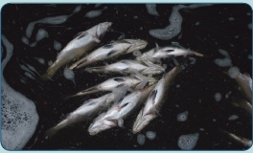

What are the warning signs?
- • Fish going off feed
- • Fish behaving abnormally:
- Lethargic
- Not schooling as usual
- Spiralling or swirling
- Not reacting to external stimuli like bright lights, noise, hand movements.
- Fish going darker or lighter than normal
- Fish dying for no apparent reason (i.e., you’ve checked water quality and it is NOT this)
- Scale loss
- Ulcers
- Bleeding from the fins, gills, eyes
- Lumps on fish
- Swelling of eyes and/or abdomen
- Pale or ragged gills.
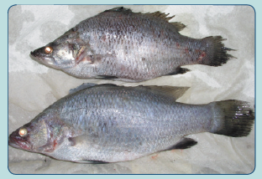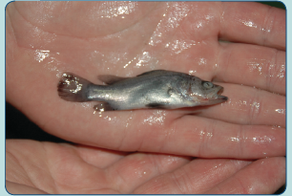
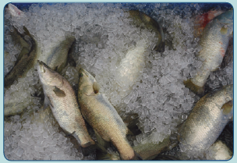

So what can you do?

Establish biosecure areas for your fish
- Clear signposting of areas
- Physical separation of areas with restricted access

Maintain biosecurity – prevent the introduction of disease
- Quarantine new fish
- Restrict visitor access
- Don’t mix fish species
- Don’t mix batches
- Start with a clean slate for each area and each batch
- Clean, disinfect and dry out between batches
- Rinse and disinfect eggs
- Be responsible for your own area - don’t go where you aren’t needed
- If you MUST move between areas, DECONTAMINATE – footbaths and handwash
- Have dedicated equipment for each area
- If you must move equipment, thoroughly CLEAN and DISINFECT it
- Remove sick fish as much as it is possible and practical
- Maintain good consistent water quality
- Minimise stress on fish AND staff
- Keep good records.

Investigate problems quickly!
- When warning signs appear - tell your manager immediately
- If you are the manager, tell your staff of the problem
- Make sure you know why the fish died – Get a diagnosis!
- Take a sample of the fish and send to your veterinary diagnostic laboratory
- Have your veterinarian investigate and take samples for laboratory analysis
- Implement Disease Control by:
- Having a Standard Operational Protocol in place – act quickly and decisively.
- The SOP must:
- Be easily accessible
- Be understood by staff BEFORE a disease event
- Include procedures to reduce stress on healthy remaining fish
- Describe decontamination and disinfection protocols
- Include up to date contact details of your vet and diagnostic laboratory
- Be read and understood by staff BEFORE a disease event
- Seeking advice from your veterinarian on treatment and control
- Maintain a sound active working relationship with your vet and diagnostic laboratory
- Getting in touch with your State/Territory health authority (which MUST be done if nodavirus confirmed)
- CONTACT DETAILS
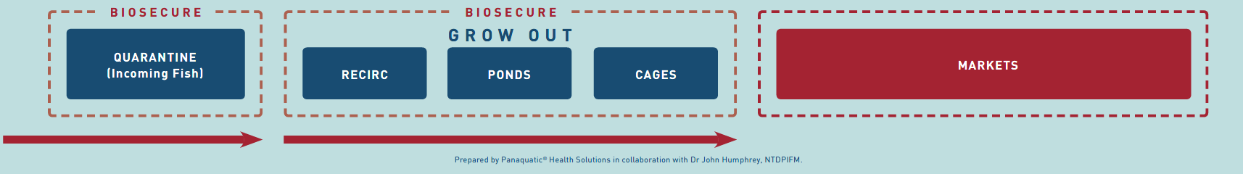

Nodavirus and biosecurity: be alert to avoid alarm (poster 2)

What is biosecurity?
Programs, procedures and actions you take to prevent the outbreak, or limit the spread of nodavirus and other infectious diseases in your hatchery.

What is nodavirus?
A virus that is found in many marine environments around Australia.

Why worry about nodavirus?
Nodavirus kills hatchery barramundi in their thousands by destroying their brains and eyes (retinas).
Be alert to the risks! Be alert to the warning signs!

What are the risks?
Neglecting biosecurity may allow nodavirus and other diseases to:
- Get in to your hatchery
- Build up and persist in your hatchery
- Spread to other hatcheries / regions
- Cause serious losses
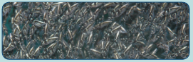

What are the warning signs?
- Fish going off feed
- Fish behaving abnormally:
- Lethargic
- Not schooling as usual
- Spinning, spiralling or swirling
- Not reacting to external stimuli like bright lights, noise, hand movements
- Fish going darker or lighter than normal
- Fish dying for no apparent reason (i.e., you’ve checked water quality and it is NOT this) in large numbers over a short time
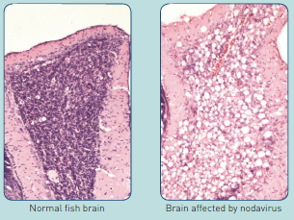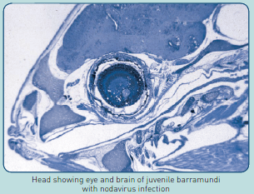
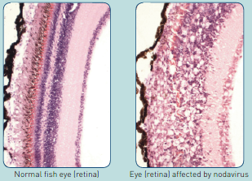

So what can you do?

Establish biosecure areas for your fish
- Clear signposting of areas
- Physical separation of areas with restricted access

Maintain biosecurity –prevent the introduction of disease
- Quarantine new fish
- Restrict visitor access
- Don’t mix fish species
- Don’t mix batches
- Start with a clean slate for each area and each batch
- Clean, disinfect and dry out between batches
- Rinse and disinfect eggs
- Only use live feeds (rotifers, copepods) of known quality
Grown in the hatchery for an extended period of time
- Be responsible for your own area - don’t go where you aren’t needed
- If you MUST move between areas, DECONTAMINATE – footbaths and handwash
- Have dedicated equipment for each area
- If you must move equipment, thoroughly CLEAN and DISINFECT it
- Remove sick fish as much as it is possible and practical
- Maintain good consistent water quality
- Minimise stress on fish AND staff
- Keep good records.

Investigate problems quickly!
- When warning signs appear - tell your manager immediately
- If you are the manager, tell your staff of the problem
- Make sure you know why the fish died – Get a diagnosis!
- Take a sample of the fish and send to your veterinary diagnostic laboratory
- Have your veterinarian investigate and take samples for laboratory analysis
- Implement Disease Control by:
- Having a Standard Operational Protocol in place – act quickly and decisively.
- The SOP must:
- Be easily accessible
- Be understood by staff BEFORE a disease event
- Include procedures to reduce stress on healthy remaining fish
- Describe decontamination and disinfection protocols
- Include up to date contact details of your vet and diagnostic laboratory
- Be read and understood by staff BEFORE a disease event
- Seeking advice from your veterinarian on treatment and control
- Maintain a sound active working relationship with your vet and diagnostic laboratory
- Getting in touch with your State/Territory health authority (which MUST be done if nodavirus confirmed)
- CONTACT DETAIL.
