National policy guidelines for the translocation of live aquatic animals
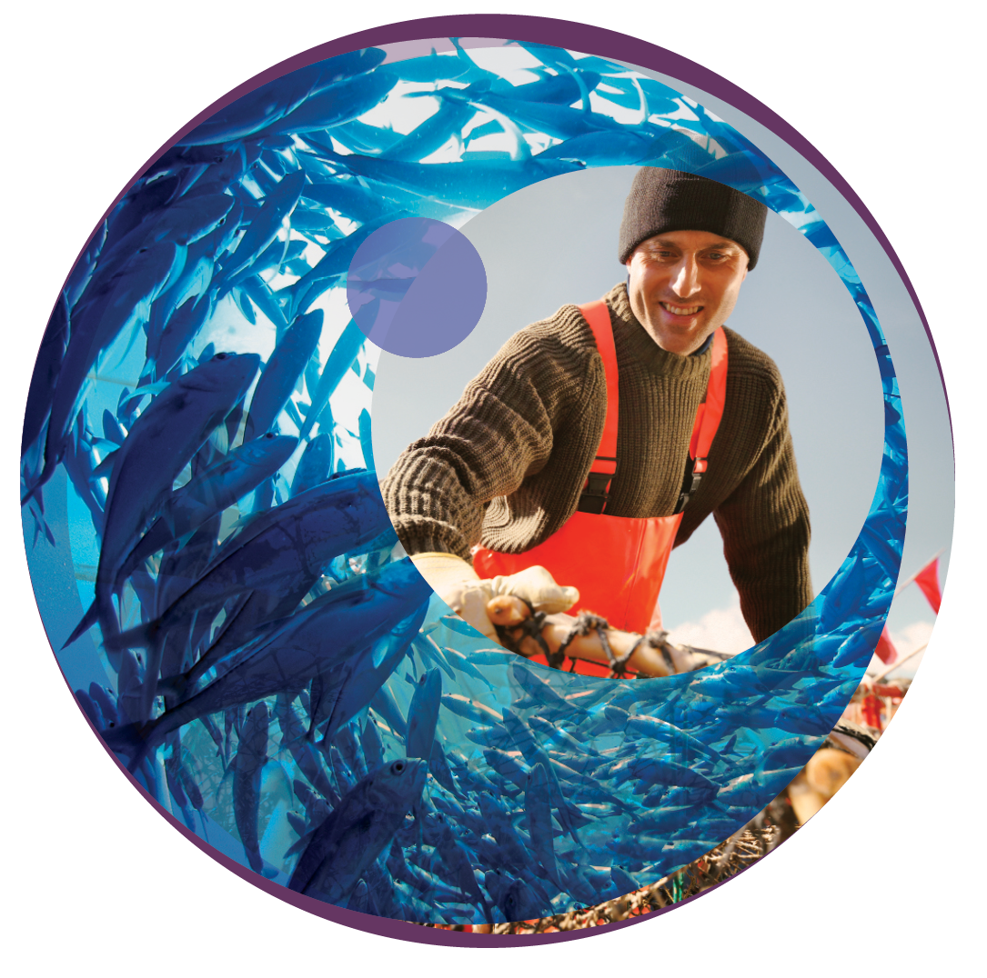
© Commonwealth of Australia 2020
Ownership of intellectual property rights
Unless otherwise noted, copyright (and any other intellectual property rights, if any) in this publication is owned by the Commonwealth of Australia (referred to as the Commonwealth).
Creative Commons licence
All material in this publication is licensed under a Creative Commons Attribution 4.0 International Licence except content supplied by third parties, logos and the Commonwealth Coat of Arms.
Inquiries about the licence and any use of this document should be emailed to copyright@agriculture.gov.au.

Cataloguing data
This publication (and any material sourced from it) should be attributed as: Department of Agriculture, Water and the Environment 2020, National policy guidelines for the translocation of live aquatic animals, Canberra, March 2020. CC BY 4.0.
ISBN 978-1-76003-263-0
This publication is available at agriculture.gov.au/animal/aquatic/guidelines-and-resources.
Department of Agriculture, Water and the Environment
GPO Box 858 Canberra ACT 2601
Telephone 1800 900 090
Web agriculture.gov.au
Preparation of this document
The Sub-Committee on Aquatic Animal Health (SCAAH) revised the National policy guidelines for translocation of live aquatic organisms 1999 to address new legislation, policies and international standards. SCAAH was nominated to lead the revision, and it convened a multi-sectoral working group to revise the policy. The working group included representatives from SCAAH, the National Aquaculture Council, the Aquaculture Committee, the Marine Pest Sectoral Committee and the Invasive Plants and Animals Committee Freshwater Fish Expert Group. The working group revised the guidelines and sought comment from participating groups. The revised guidelines were endorsed by SCAAH, the Australian Fisheries Management Forum, the Animal Health Committee, the Marine Pest Sectoral Committee, the Environment and Invasives Committee, and the National Biosecurity Committee.
The Australian Government acting through the Department of Agriculture, Water and the Environment has exercised due care and skill in preparing and compiling the information and data in this publication. Notwithstanding, the Department of Agriculture, Water and the Environment, its employees and advisers disclaim all liability, including liability for negligence and for any loss, damage, injury, expense or cost incurred by any person as a result of accessing, using or relying on any of the information or data in this publication to the maximum extent permitted by law.

Contents
Introduction 5
1.1 Purpose 5
1.2 Definition 5
1.3 Scope 6
1.4 Risk management 7
1.5 Risk analysis 8
2 Policy framework 10
2.1 Rationale 10
2.2 Objective 10
2.3 Policy guideline principles 10
2.4 Policy outcomes 12
2.5 Gaps in existing jurisdiction policies 12
2.6 Step-by-step approach—basic process 12
3 Context 14
3.1 Translocation scenarios 14
4 Risk analysis 19
4.1 Hazard identification 19
4.2 Risk assessment 19
4.3 Example risk analyses 30
Appendix A: Risk assessment likelihood tables 31
Appendix B: Risk assessment consequence table 32
Appendix C: Australian translocation policies and legislation 33
Appendix D: Gaps identified in existing translocation policies 37
References 39

Tables
Table A1 Example likelihood levels for risk assessment 31
Table A2 Likelihood ranges and qualitative likelihood categories 31
Table B1 Example consequence levels for risk assessment 32

Figures
Figure 1 Translocation assessment process flow chart 13
Figure 2 Risk assessment for translocation of aquatic animals, staged approach 20
Figure 3 Risk estimation matrix, likelihood and consequences of establishment and spread 28

.

Introduction
This document is based on the revised National policy guidelines for translocation of live aquatic organisms 1999, updated to address new legislation, policies and international standards.

Purpose
This document should be used to guide any translocation activity of live aquatic animals. This could be done by:
- Government biosecurity
- Government fisheries
- Aquaculture industry
- Conservationists (Government or eNGO)
- Farmers
These agents use translocations for fish stock enhancement (in ornamental fish trade), aquaculture (including open water ranching) and conservation (for re-introduction or enhancement of depleted stocks). Translocations for other purposes (for example—attempted biological control or fish rescue) may also be proposed.
The guidelines aim to provide information in translocation best practice and support development of consistent policies to:
- reduce potential for introduction or spread of aquatic animal pests and diseases
- improve Australia’s biosecurity
- protect industry productivity
- maintain ecological sustainability.
They also provide a guide to preparing risk assessments for proposals or applications for translocating live aquatic animals.

Definition
Translocation is the deliberate movement of live aquatic animals (including at all stages of the life cycle and any derived, viable genetic material):
- beyond their accepted distribution
- to areas that contain genetically distinct populations
- to areas with different disease status.

Scope
These guidelines explain how to use a risk-analysis approach to assess possible impacts of proposed domestic translocation of live aquatic animals between regions within Australia.
Risk analysis comprises:
- hazard identification
- risk assessment
- risk management
- risk communication.
Risk analyses should examine the likelihood of translocated live aquatic animals or other associated organisms establishing in and/or spreading outside the designated translocation area, and the potential impacts on the environment, the economy, population disease status and population genetics. Any proposed translocation activities must also comply with relevant federal and state legislation.
Under the World Trade Organization (WTO) Agreement on the Application of Sanitary and Phytosanitary Measures, countries or jurisdictions determine the appropriate level of protection (ALOP) to protect human, animal and plant life or health within their territory. Risks identified as higher than the ALOP can often be managed, including for translocation activities.
Live aquatic animals are viable aquatic animals (that is, they can spread disease or reproduce when mature). The term ‘aquatic’ is used to include all aqueous environments including hypersaline, marine, estuarine and freshwater environments.

Out of scope
These guidelines exclude animals from classes Mammalia, Aves, Amphibia and Reptilia. These classes are covered by different policies.
These guidelines do not directly address risks associated with importation of live aquatic animals (or animal products) into Australia from overseas. These are covered in national import policies and procedures. However, residual risks may be associated with the importation of aquatic animals/animal products. People planning translocation activities should consider these risks case by case in domestic translocation risk assessments.
The guidelines do not cover miscellaneous translocations (such as biofouling and ballast water) not associated with a deliberate translocation activity. Miscellaneous translocations include accidental movements not associated with a deliberate translocation or malicious translocations.
See DAWE (2015) for translocation guidelines for bait and berley.

Risk management
Translocation of live aquatic animals within and between Australian jurisdictions is increasing, and state and territory governments have developed policies to manage the associated risks. However, these policy documents have been focused on risk-management measures, and many do not include the associated risk analysis.
These guidelines are to assist people and organisations responsible for translocation of live aquatic animals by identifying potential risks associated with translocation activities and providing guidance on the risk analysis process for live aquatic animal movement. This will ensure consistent application of translocation policies across jurisdictions.

National context
Live aquatic animals are translocated for socio-economic and environmental benefit; such as for commercial and recreational fishery enhancement, to move aquaculture stocks (for example, between hatchery and grow-out facilities) or to restock endangered species for conservation purposes. They may also be translocated for other purposes, such as pest control or removal from compromised water bodies (fish rescue).
Translocation risks introducing diseases and pests, altering genetic structure of existing populations and changing the receiving environment.
Translocation activities may also affect species or areas of national environmental significance (for example—listed threatened species or ecological communities, listed migratory species and wetlands of national importance, including RAMSAR) identified under the Environment Protection and Biodiversity Conservation Act 1999 (EPBC Act). The EPBC Act should be considered in any translocation proposal.
People or organisations may propose translocation of aquatic species listed as threatened under the EPBC Act for conservation, and as mitigation or compensation to offset impacts on a species or its habitat resulting from actions referred (sent to the Australian Government Minister for the Environment for assessment) under the EPBC Act. The Department of Agriculture, Water and the Environment (DAWE 2020a) provides information on considering translocation proposals resulting from EPBC Act referral.
Aquatic animal translocation must be controlled because the spread of diseases and pests in open aquatic environments is difficult to manage and often irreversible. Translocation of species that may interbreed with local populations can alter genetic make-up, particularly within isolated populations that may have limited genetic exchange with other populations. Genetic status and differences between populations may not be understood and, even if they are, potential impacts of translocation on population genetics can be difficult to predict.
The Intergovernmental Agreement on Biosecurity (IGAB) (COAG 2012) sets national priorities for biosecurity. These include the development of a national management framework to ensure that nationally significant pests and diseases established in Australia are contained, suppressed or otherwise managed. The Australian and state and territory governments have given in-principle support to the management of translocation of animals to meet this priority. Under IGAB, national approaches have been agreed between parties to work together to prevent, prepare for, detect and mitigate biosecurity risks, and respond to, manage and/or recover from biosecurity incidents should they occur.
To facilitate interstate trade and support the operation of effective, efficient biosecurity controls, jurisdictions have agreed to limit the application of interstate biosecurity measures to the level necessary to mitigate risks to the economy, environment and community. These measures will be the least trade restrictive possible and based on a scientific analysis of the risk of entry, establishment and spread of a pest or disease, and applied only to the extent necessary to achieve Australia’s ALOP.
State and territory governments will accept alternative interstate biosecurity measures where they achieve equivalent biosecurity risk reductions. IGAB provides for the development and maintenance of regional disease and pest status subject to provision of scientific evidence to define and support it.

International context
Australia is a member of the World Trade Organization (WTO) and is bound by the Agreement on the Application of Sanitary and Phytosanitary Measures (SPS agreement) (WTO 1995). The WTO recognises the World Organisation for Animal Health (OIE) as the international standard–setting organisation for aquatic animal sanitary measures (OIE 2020a). OIE objectives include ensuring transparency in global animal disease and zoonosis, and publishing health standards for trade in animals and animal products. Australia is a member of the OIE and has established and maintained animal disease reporting and surveillance programs that demonstrate its disease status. To meet our international obligations, domestic translocation measures within Australia should be consistent with measures we apply at the border.
A coordinated national approach to managing disease and pest risks through translocation management will ensure Australia can meet its national biosecurity requirements and support international trading negotiations and declarations of disease freedom.

Risk analysis
Risk analysis is the main method used to assess the hazards and risks (positive and negative) associated with a proposed translocation activity, and to identify management measures to minimise potential adverse impacts.
Risk analysis provides a scientific basis for policy recommendations, decisions and legislative amendments. Risk analysis estimates the overall level of risk from proposed translocations—including environmental impacts, spread of diseases or pests, and genetic impacts. Risk analysis helps those undertaking translocation activities to rank or determine risks requiring management and allocate resources.
Risk analysis is defined in IGAB (COAG 2010) as:
Assessment of the level of biosecurity risk associated with the entry, emergence, establishment, and spread of pests and diseases and the identification of options to limit the level of biosecurity risk. Includes risk assessment, risk management and risk communication.
Risk analysis is widely used in commercial and industrial fields and in quarantine and translocation applications. Terminology varies. Terminology used in this document is consistent with the Aquatic Animal Health Code (OIE 2020a).
A risk analysis has five steps:
- Scope or context establishment
  - reason for considering translocation
  - outcome sought
- Hazard identification
  - what can go wrong
- Risk assessment
  - how likely it is to go wrong
  - consequences of it going wrong—what is acceptable and what is unacceptable
- Risk management
  - how we can reduce unacceptable risks to an acceptable level
- Monitor and regularly review effectiveness of all steps in the process and communicate with relevant stakeholders
The code provides information on risk analysis for translocation of aquatic animals for international trade.

Policy framework

Rationale
These guidelines recognise the sovereignty of each jurisdiction and acknowledges that the risks of translocation and adverse consequences related to aquatic diseases, pests, environmental change and altered population genetics may vary between regions. The processes described here should form the basis for each jurisdiction’s translocation analysis. Jurisdictions across Australia should adopt these policy guidelines to minimise risk in translocations. This will prevent adverse impacts on receiving habitats, and fauna and flora.

Objective
These guidelines provide a national framework for risk analyses on proposals for live aquatic animal translocations.
State and territory governments are responsible for managing translocations within and between borders. Each government determines its own policies, guidelines and legislation to manage risks. These guidelines aim to facilitate assessment of proposals and development of responsible, science-based and nationally consistent translocation polices. Individual jurisdictions may implement more rigorous processes, statutory requirements or criteria.
State and territory governments should use legislation, compliance activities, penalties, eradication/control and education programs to minimise accidental and malicious translocations.
Improved national translocation risk management will contribute to and complement state and territory measures.
See Appendix C: Australian translocation policies and legislation.

Policy guideline principles

Principles
These policy principles are guided by the IGAB (COAG 2012). The IGAB form the core of these guidelines and should guide any translocation proposal assessment. The IGAB sets national priorities for biosecurity and the OIE (2020b) provides standards for safe international trade of aquatic animals.
People or organisations planning translocation activities should conduct a risk analysis. This should consider likelihood of pests establishing a viable population, disease status at source and destination, and potential to introduce diseases and affect biodiversity. The risk analysis should assess the likelihood and consequences of translocation hazards, and the mechanism for risk management and minimisation. They should assess habitat preservation, economic impacts, threatened species status, disease status and possible genetic effects for aquatic animals being released into the wild. See Section 2.6 Step-by-step approach—basic process.
Anyone addressing translocation risk management should ensure they apply these policy principles, and consider the circumstances of the jurisdiction, scope of the proposed policy, expected costs and stakeholder impacts.
- Use an accepted risk-analysis methodology informed by scientific analysis of environmental, disease and genetic risks.
- Consider the accepted disease or pest status of the zone or compartment of origin and destination to determine risk of introduction.
- Consider the current and future suitability of destination environment, including potential environmental variation as a result of changing climates and future developments.
- Consider whether translocation is likely to affect species or areas of national environmental significance or others identified under the EPBC Act. If so, check whether ministerial approval is necessary (DAWE 2020).
- Mitigate any unacceptable risks identified by the risk analysis.
- Use only the least restrictive measures to mitigate risks. Consider circumstances of the risks, pathways, impact on stakeholders, feasibility and cost before choosing policy instruments.
- Assess impact of any proposed policy on stakeholders and disruption to existing trade or environmental values. If regulation is to be imposed, check jurisdiction requirements on whether a regulation impact statement is necessary.
- Ensure that benefits of risk-management measures outweigh costs.
- Consider unintended consequences of the policy—for example, changes in trade to manage high risk pathways.
- Ensure measures are consistent with Australian agreements and international obligations.
- Develop a stakeholder communication strategy to facilitate policy implementation.
- Review policy guidelines to ensure they continue to satisfy policy principles and are not affected by changes in distribution of diseases or pests.
Despite clear potential economic, social or conservation benefits, translocation of an aquatic species or non-local stocks may risk impacting the disease and pest status of the receiving ecosystem.
For translocations into catchments or maritime regions that fall under more than one jurisdiction—for example, the Murray–Darling Basin or the Lake Eyre catchment—approval from all affected jurisdictions and national environmental agencies is necessary.

Policy guidelines
The Aquatic Animal Health Code (OIE 2020a) provides guidance on importing animals from areas with defined disease status. It contains disease-specific chapters with articles relevant to translocation of live aquatic animals, including on importation from disease-free or infected areas. The code was developed to minimise risk of spread of disease internationally. However, it may also be applicable to domestic translocations. It provides standards on control of aquatic animal health risks associated with transport of aquatic animals, aquatic animal health measures applicable before and at departure, aquatic animal health measures applicable during transit and aquatic animal health measures applicable on arrival.
The code includes standards and surveillance requirements on country declaration of freedom from a disease. Jurisdictions seeking to declare a zone or compartment as being free from a specific disease should consult these. Users of these guidelines should adhere to these standards to ensure that movement of animals within Australia is consistent with measures that apply at the border. Jurisdictions can use the code as a basis to recognise disease-free populations for purposes of translocation. This may benefit international trade where certification to international standards is required.

Policy outcomes
These guidelines aim to achieve these key policy outcomes:
- Translocation policies are developed consistent with these guidelines and use consistent terminology, risk-analysis methodology and policy approaches.
- Translocation policies are supported by appropriate legislation or policy.
- Translocation policies are supported with adequate public awareness and enforcement activities, and lead to acceptable compliance.
- Translocation policies use a nationally accepted, explicit and transparent risk-analysis process that
  - is scientifically based
  - is appropriate to the circumstances
  - considers the likelihood of escape/entry and subsequent survival and establishment of translocated species and consequences.
- Translocation policies incorporate regular analysis and improvement of risk-management strategies, including
  - adequacy of risk analysis, decision-making and enforcement
  - education of all public and private individuals involved about the risks of unintentional introductions.

Gaps in existing jurisdiction policies
See Appendix D: Gaps identified in existing translocation policies.

Step-by-step approach—basic process
Figure 1 shows the translocation assessment process, and can be used as a checklist.
Figure 1 Translocation assessment process flow chart
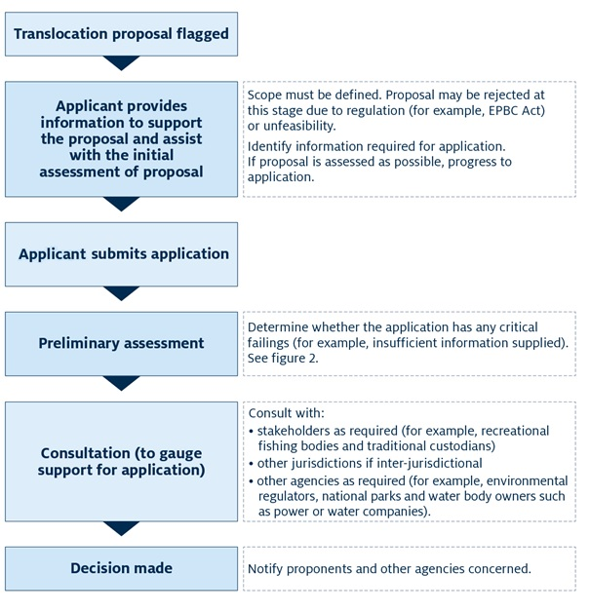

Context

Translocation scenarios
Consequences of translocating aquatic animals will be different depending on:
- the receiving environments and production systems
- any measures implemented to manage risks.
Biosecurity measures applicable to parts of production systems or receiving waters can be described as ‘entry level’, ‘internal’ and ‘exit level’. A risk analysis must consider where the risk is, whether it requires mitigation measures and whether these can be applied to the production system or receiving waters. For entry-level biosecurity, the risk analysis must include processes to demonstrate health status of the source stock, and management of water, fouling and fomites as pathways for the introduction of diseases or pests into the production system or receiving waters.
Internal biosecurity measures are those used to restrict potential spread of disease within a facility or area. They include internal quarantine measures and separation of sectors within a facility or area. Exit-level biosecurity measures apply to stock and by-products (including discharge of water or other wastes) as they leave the system, used to minimise risk of spread of diseases or pests from the production system or receiving waters. These include onsite processing or limiting areas of distribution of products (for example, waste pond sludge used for fertiliser) to areas with the same disease or pest status.
See Department of Agriculture, Water and the Environment (DAWE 2015a) for information on production systems and industry practices relevant to disease control.
See the Marine Pests website (DAWE 2020b) for information on marine pests and an interactive map showing distribution of known established marine pests in Australia.

Open systems
Open systems include stocking programs and ranching.
In open systems there is no control over animal movement or water flow. Translocation of aquatic animals into open water permits uncontrolled interaction of translocated animals with the environment. Translocation of animals into open systems in Australia is done for recreational fishery enhancement, for conservation purposes (reintroduction or stock enhancement of rare species) or ranching (release of stock, usually in a defined area, for later harvest—for example, scallops and abalone).
A proportion of translocated animals are likely to survive in the new environment and not be retrieved through harvest, despite that being the reason for the translocation. Unintended translocation of pest animals or diseases together with translocation of intended species into favourable environments can result in establishment of those species. This is a particular risk for open systems given limited management entry options. Unintended translocations may reduce positive impacts of the translocation or result in environmental damage or reduced amenity.
Floods, marine migration between catchments or further translocation may result in species being spread to unstocked systems. Eradication of pest species or disease from open systems is extremely difficult and costly to achieve and can have severe immediate environmental consequences. It is rarely successful.
Risk analysis for open systems must adequately consider biosecurity and input risk management, because options for control after release are limited. The risk analysis should include the likelihood of translocated animals spreading beyond the intended area, and the genetic status of native species being translocated compared with local populations. However, this information is not always available. Entry-level biosecurity is the primary risk mitigation tool. This includes sourcing stock from disease- or pest-free populations or testing cohorts using accepted standards.
Environmental managers have translocated animals between open systems for conservation purposes to establish additional sustaining populations. For example, eastern freshwater cod (Maccullochella ikei) listed under the EPBC Act as endangered were translocated from the Clarence River to the Richmond River, and Murray hardyhead (Craterocephalus fluviatilis) listed as endangered were transferred from South Australia to Victoria. However, for a conservation translocation proposal, environmental managers should consider whether the translocation will have a significant adverse impact on a protected species or area listed under national environmental legislation.

Semi-open systems
Semi-open systems include sea cages and contained shellfish grow-out facilities (such as land based abalone facilities).
In semi-open systems there is control over movement of animals and structures but not movement of the water. In semi-open systems animals are contained within or attached to a structure, and most introduced stock can be retrieved. However, the risk of animals escaping is inherently high due to a range of factors including net damage, predation, reproduction and extreme weather.
Animals in semi-open systems are likely to interact with the external environment. This increases the chance of diseases being transmitted between farmed and wild animals. Wild or escaped fish may be attracted to the cages. Farmed shellfish may spawn, allowing larvae to settle in the surrounding environment. Examples of animals farmed in semi-open systems include Atlantic salmon, tuna, yellowtail kingfish, barramundi and shellfish (such as oysters and mussels).
As with open systems, planned translocations to semi-open systems must include an assessment of the likely impacts of escapes and entry-level biosecurity to limit introduction of disease and pests. Possible genetic impacts should also be considered. Internal biosecurity is also important in limiting the spread of disease within and between production systems. However, due to the lack of water movement control, this primarily relies on distance between production systems and management of fomites to limit spread.

Semi-closed systems
Semi-closed systems include ponds and raceways.
In semi-closed systems there is strong control over animal movements and some control over water flow. Semi-closed systems may need to exchange water regularly; depending on the system, water exchange can be continuous-flow or periodic topping-up.
Semi-closed systems are connected to the environment via intake and discharge water. Volumes and treatments vary and affect risk of entry of animals and disease transmission. Diseases, pests and genetically distinct material/animals may enter the environment from the systems via water (or sometimes movement of animals). However, they can also be contained and eradicated within a system. In a system where water quality is maintained by continuous water flow, shutting off water for any period may have severe consequences—including loss of all stock.
Animals farmed in semi-closed systems may include land-based abalone, barramundi, prawn and freshwater crayfish. Freshwater fish fingerlings for stocking in open systems are often produced in these systems. Entry-level, internal and exit-level biosecurity measures can all be applied to semi-closed systems. Typically, entry-level biosecurity can be applied through health accreditation of stock entering facilities or treatment of intake water to deactivate pathogens.
Internal measures include separate equipment for each area within the facility, and adequate biosecurity measures to prevent spread of disease or contamination of different areas within a facility. Exit-level biosecurity (such as the use of filters, disinfection, screens or settlement ponds) may also be applied to water outflows to restrict escape of pests, pathogens or genetically distinct materials/animals with water. Exit-level biosecurity contingencies should also be considered when semi-closed systems become compromised (such as drying during drought conditions) and resident animals require translocation for rescue.

Closed systems
Closed systems include recirculation and aquariums.
In closed systems there is near complete control over water and animals. Water is usually sourced from a secure supply and can be treated prior to and/or after use in the system. Except in case of catastrophic damage to the system, animals or pathogens are unlikely to be introduced or to escape, when appropriate input biosecurity measures are implemented. Examples of closed systems include hatcheries for fish, soft-shell crab facilities and intensive indoor tank systems for freshwater fish production.
Some jurisdictions (including New South Wales) require zero discharge to waterways from closed and semi-closed freshwater native fish production facilities.

Live seafood trade
Live seafood trade includes transport and restaurant tanks.
The live seafood trade includes those animals transported to restaurants for holding live before sale and consumption. A source of risk is escape of animals and pathogens. Animals are usually held in closed aquarium systems with limited or no water exchange, and most are consumed on site. However, live seafood may be held before distribution (for example, by wholesalers) at premises with water flow or exchange.
Despite the apparent dead-end pathway of human consumption, waste disposal (effluent and raw animal waste) should be considered in risk analysis.
The WA Government has a translocation policy for aquatic animals used for the restaurant trade, and the SA Government has controls on restaurant abalone. The policies do not cover unregulated movement of animals for human consumption that can be transported and stored for limited times without water (for example oysters, yabbies, mud crabs). The Queensland Government has a policy for transhipment of oysters. See Appendix C: Australian translocation policies and legislation.

Aquarium trade
Aquarium trade includes marine and freshwater aquariums, and research and education pathways.
Aquarium animals are normally held in closed systems. This pathway is largely unregulated at the retail level, but some jurisdictions require licensing of retail aquarium fish outlets and have controls over movement of ornamental fish from other jurisdictions. Aquarium animals may also be used for education or research. This use may be short term, resulting in recurring need for stock disposal.
Release of aquarium animals into the wild has resulted in establishment of pest populations and transfer of diseases to native fish. Jurisdictions may have lists of declared noxious or prohibited species, and sale, possession or release of these species is regulated. Aquarium hobbyists and retailers should be educated on the impacts of fish release and encouraged to dispose of unwanted fish appropriately. For consumers, this may be returning unwanted fish to the retailer.
Fish may be transported for research from non-local populations or exposed to populations of other fish held in the same facility. Without adequate biosecurity measures, they may be exposed to or introduce pathogens. They may then be released into original or new areas and carry pathogens exotic to that area. Researchers should be educated on risks and appropriate practices to reduce this risk. In general, research stock should be destroyed and disposed of in a biosecure manner by the researchers.

Inadvertent translocation
Any translocation risks species other than those intended for translocation being transferred within transport water or containers. For example, the pest species Gambusia and banded grunters (Amniataba percoides) have been unintentionally introduced into many parts of Queensland in shipments of native fish fingerlings translocated for recreational fishery enhancement. Similarly, freshwater snails and their eggs are often carried on aquarium plants. Epibionts and commensals may be translocated with their hosts, and this could have unexpected consequences for similar native host species.
Any risk analysis should consider:
- source of animals to be translocated
- whether pest species or diseases are present in the area
- effectiveness of measures taken to reduce the risk of contamination of shipments.

Risk analysis
Risk analysis should be performed as part of aquatic animal translocations to identify, assess, manage, monitor and communicate risks associated with the activity.
The risk analysis should consider all components of a translocation and aim to ensure that identified risks are managed to an appropriate level.

Hazard identification
Pests, diseases or genetic considerations that may present risks in translocation should be identified before implementation of any risk mitigation measures. The desired outcome of a translocation should be considered when identifying potential risks. For example, establishment of a population in the receiving environment may be a risk in aquaculture-related translocations but a desired outcome in conservation-related translocations.
Stocking open systems and semi-open systems presents a higher risk than stocking closed and semi-closed systems, where animal and water movement can be managed.
Translocation scenarios may be subject to government regulations including legislation and permitting conditions. See Appendix C: Australian translocation policies and legislation. Relevant regulations should be identified and considered in any translocation risk analysis.
Those planning translocation activities should identify and categorise biological, chemical or physical agents in aquatic animals or products that have the potential to cause adverse effects to aquatic animal health, public health or the environment. They should consider whether:
- translocation could introduce or spread diseases or pests
- genetically distinct material could be exchanged between source and destination populations (intra-species and inter-species)
- diseases or pests are under official control (listed as reportable or noxious).
If hazards are not identified then no further risk analysis is necessary. If information is insufficient, further analysis is required before assessment and application process can progress.

Risk assessment
A staged approach is necessary for translocation risk assessment (Figure 2). Individual translocations are different and may require some or all stages of the risk assessment process. For example, a translocation into a secure closed facility will have very low likelihood of species entry into the surrounding environment. Therefore, these facilities should meet the appropriate level of protection (ALOP) without any further management measures.
Some jurisdictions have developed protocols for translocation in specific situations. If the translocation conforms to the protocols established, a full risk assessment is usually not required. See Appendix C: Australian translocation policies and legislation.
Figure 2 Risk assessment for translocation of aquatic animals, staged approach
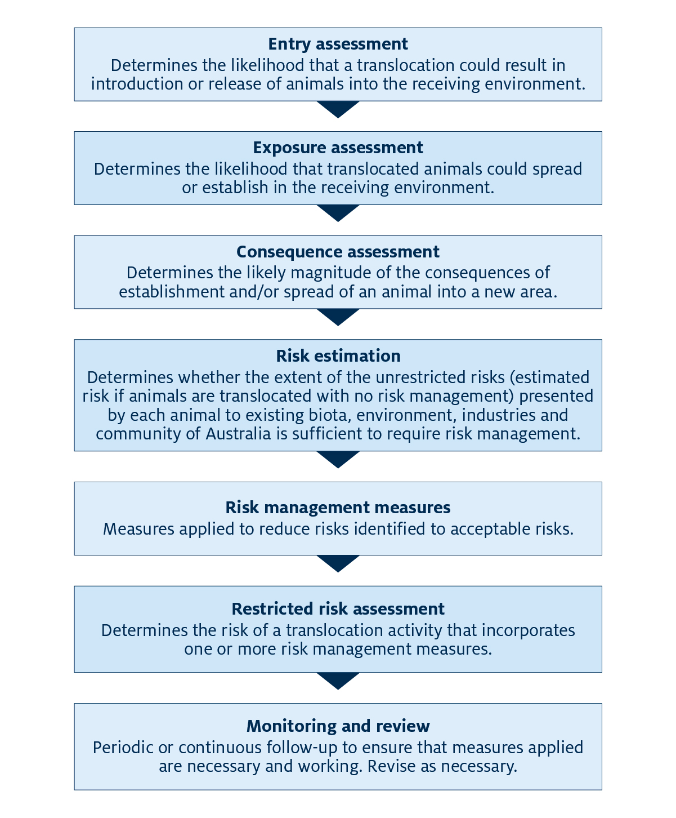
Note: ‘Animal’ refers to intended and unintended translocated animals and potential disease-causing agents.
Risk assessment involves three steps:
- entry assessment
- exposure assessment
- consequence assessment.

Entry assessment
Step 1 determines the likelihood of entry or release of translocated animals into an unintended environment. Entry of animals intended for translocation into open systems is certain. The likelihood of entry of species translocated into other types of systems depends on the adequacy of system containment measures. The likelihood of entry of pests and diseases unintentionally translocated presented by entry of intentionally translocated animals depends on several factors including:
- capacity of receiving system to contain the animals
- number of animals for translocation
- number of translocations over time
- nature of the animal, including prevalence of pathogens
- nature of the source environment
- transport and processing practices.
A high number of animals intentionally translocated and released may lead to a high risk of diseases or pests entering the receiving environment. Similarly, an increasing number of introductions over time increases the likelihood of accompanying diseases or pests being introduced with released stock. The species, strain or traits of animals influence the likelihood that diseases or pests associated with those animals will be released with translocated stock. Current management practices—including accreditation of source populations, surveillance and vaccination—substantially influence the likelihood of translocation and entry of particular animals. Increased incidence or prevalence of translocated diseases or pests at the source increases the likelihood of entry into the receiving environment. The effect of transport and handling on mortality rates and quality of unintended translocated animals also influences likelihood of entry.
The live animal food trade presents special risks because unregulated movement of live animals outside of the trade may result in entry of small numbers of animals into the environment. These animals could spread diseases and pests. Increased shedding of pathogens from subclinically infected and stressed animals in these systems is likely.
People or organisations planning translocation activities should gather this information for entry assessment:
- species for translocation
- source of animals
- quantity and frequency of intended translocations
- availability of testing or identification for recognised diseases or pests
- disease and pest status of source sites
- transport.
The type of receiving system should also be considered.

System factors for consideration in translocation
For open systems (for example, stocking) and semi-open systems (for example, net pens), consider whether:
- the translocation receiving environment needs special consideration—for example, if it is protected by the EPBC Act, has a pristine nature, is a high-value conservation area, if endangered species are present or if it has value to the local economy due to recreational fisheries or its ecosystem
- endemic populations of the species concerned are present and, if so, the status of those populations (population size, disease status and genetic information; compare status of existing and translocation source stock case by case)
- stocked animals are likely or intended to breed in the new environment—for example, suitability of conditions (temperature tolerances, requirement for saline water to reproduce) for breeding
- diseases or pests are known to be present in the source area, particularly within the source production area
- the consignment is certified free of diseases and pests—consider capacity of supplier to ensure freedom from diseases or pests in consignments and the assessment methods used.
For semi-closed systems, consider whether:
- licence conditions are flexible enough to permit special conditions for containment if required
- the translocation receiving environment needs special consideration—for example, if it is protected by the EPBC Act, it has a pristine nature, it is a high-value conservation area, endangered species are present or it has value to the local economy
- safeguards for water disposal are sufficient to minimise risk and impact of translocation of animals or diseases into the natural environment (if applicable)
- native populations in the area are known to be the same genetically as the stocked animals
- diseases or pests are known to be present in the source area, particularly within the source production area, that will not be eliminated by quarantine procedures before introduction into the system—for example, subclinical infection, or larval or cryptic life stages
- translocated animals will reproduce or persist in the environment—for example, whether they could breed or last long enough to breed in the new environment (and this may be an intended consequence)
- the consignment is certified free of diseases and pests—consider capacity of the supplier to ensure freedom from diseases or pests in consignments, the assessment methods used, and the disease/pest status of the source of stock.
For closed systems, consider same factors for semi-closed systems and whether:
- the system is built to minimise risk of entry of live animals into the environment even in case of catastrophic events—for example, water rising above known flood levels.
For live seafood, consider whether:
- diseases or pests are known to exist in the source area, particularly within the source production area
- translocated animals will reproduce or persist in the receiving environment
- translocated animals are likely to be onsold or whether pathogens they carry could enter the environment as waste—for example, via a waterfront restaurant or traditional belief-based live release practices.

Exposure assessment
Step 2 determines the likelihood that translocated animals (including associated diseases or pests) can establish in the receiving environment and spread into other environments. For deliberate translocations, the environment is likely to have been chosen because it can support the animal. Self-sustaining populations are likely to establish if the environment is conducive to successful spawning and larval survival. The likelihood of spread beyond the environment of entry will decrease as control over movement of animals and water into the receiving system increases.
People or organisations planning translocation activities should assess the species’ likelihood of establishment and spread. Many pest species can thrive in diverse environments. If pest species are present in the source environment, measures must be implemented to ensure those pests do not travel with the target species. These measures must also accommodate for the genetics of translocated and wild animals. Identity, presence, demography and behaviour of wild animals and potential vectors or disease hosts may influence the exposure likelihood of organisms in the receiving environment to harmful impacts.
Negative impacts associated with translocation activities will reduce as control over movement of animals and water in the receiving system is increased. For example, introductions into closed system aquaculture operations are usually less likely to spread to the external environment than introductions into less controlled systems. Escapees from cages may depend on feed provided to fish in cages. Most studies have demonstrated that movement of escaped fish from cage sites is minimal, and therefore wider effects may also be minimal (Brett Herbert [DAWE] 2018, pers. comm.). The likelihood of long-term establishment or spread may be lower for short-term translocation (for example, for Atlantic salmon to grow in seasonally cold environments for the winter or for prawns in hot environments in summer) if likelihood of survival outside of the season is negligible.
For exposure assessment, consider:
- the type of system (for example, open or closed) the stock will be translocated to
- receiving environment biological characteristics, environmental characteristics and qualities, and site suitability for translocated animals
- whether susceptible local species will be in contact with the translocated animals (including through contact with the same water as in a net-pen situation)
- whether the local environment can support development of sustained populations of the animal (some populations may only persist seasonally)
- whether the animal is likely to spread to other systems
- whether exposure likelihood includes propagule pressure from the translocated animals (from breeding).
See Appendix A: Risk assessment likelihood tables for qualitative and quantitative descriptions for each level of likelihood.

Consequence assessment
Step 3 estimates the potential for and magnitude of adverse biological, environmental or economic impacts resulting from the assumed establishment and spread of a hazard (translocated animal). This section outlines several potential consequences of translocations. The World Organisation for Animal Health (OIE) recommends considering possible public health consequences. This is a particular risk where parasite or disease reservoirs or carriers could be translocated inadvertently with other species, or where other species such as toxic algae (or even translocated animals with sequestered toxins) could be considered for translocation.
Anyone planning translocation activities should consider the consequences of unintended translocations occurring alongside translocations of target species (for example, Gambusia and banded grunter). In many areas invasive species may already be established, and stocking of predacious species of high recreational fishing value may make use of this resource. However, some species of invasive fish (particularly Gambusia, tilapia and banded grunter) are not palatable to many predacious fish. For example, banded grunters thrive in barramundi ponds.
In cases where farmed or stocked fish are inbred, of limited parentage or from different genetic stocks, the possible effects of genetic dilution of depleted natural stocks should be considered.

Potential consequences of translocation

Environmental impact of released animals
Non-native species once released may have unforeseen, deleterious impacts on the local environment, biota or amenity (usefulness for humans) of the affected area. However, in some cases establishment of a non-native species may be beneficial (for example, for recreational stocking or biological control programs). In these cases introduction must be planned and authorised. Potential impacts of non-native species include predation by existing fauna, competition for food and/or habitat, destruction or change of habitat, and reduced amenity.

Predation on existing fauna
Predation by introduced species can decrease abundance and diversity of native species. Non-native animals may establish and form large populations because of abundant food and lack of natural predators or diseases in their new environment. Native plants and animals may not adapt to or withstand the pressure of a new predator or larger numbers of a predator.
For example, trout introduced into alpine systems in southern Australia and Tasmania eat, and in some places have destroyed, native galaxias fish. In such cases, the value of recreation and tourism must be balanced against that of the environment. Another example is the mosquitofish (Gambusia). These small live-bearing fish were widely introduced throughout Australia to control mosquitoes. However, they can form dense populations that eat eggs and larvae of native fish species, breed throughout the year, are highly aggressive and tolerate poor water quality. Presence of Gambusia has been linked to disappearance of other small species of native fish. They are present in many areas where native fish fingerlings are produced for stocking purposes in semi-closed systems, and they may be inadvertently transferred with desirable species when used for stocking in recreational fishery enhancement.

Competition for food and/or habitat
Translocated species may compete with native species for food or habitat. An example (and a valuable industry) is Pacific oysters (Crassostrea gigas). In some conditions, these can overgrow and smother rocky reef habitat and native oysters such as Sydney rock oysters (Saccostrea glomerata).

Destruction or change of habitat
Translocated animals can modify habits, leading to ecological change. They modify habitats by digging, burrowing or disturbing sediments; by shading, smothering or overgrowth; or by altering chemistry or structures. For example, carp have altered large areas of aquatic animal habitat through muddying fresh water and preventing aquatic plant growth. In North America, zebra mussels have changed habitat by decreasing phytoplankton biomass, clarifying the water and favouring growth of cyanobacteria.
Where habitat preservation is a high priority, the translocation approval process should be more conservative in considering impacts than for already degraded areas.

Reduced amenity
Entry and establishment of translocated animals, diseases or pests can result in reduced amenity for general users (for example, beach users). Excessive population growth of marine animals such as salps or jellyfish can cover beaches in masses of jelly, prevent fishers from effectively using nets and reduce amenity for other recreational users such as participants in water sports. Changes in the ecology of an area also can reduce fish populations for recreational fishers. Colonisation of infrastructure by exotic species (leading to blockage of pipes and damage of navigation structures) can increase maintenance costs dramatically. These are most likely to be caused by inadvertent translocation of accompanying animals, and must be considered as a risk to be assessed.

Transfer of pathogens

Epizootics
An epizootic (epidemic in non-human animal populations) is an increase in the incidence of a disease within a nominated population that significantly exceeds what would normally be expected. Pathogens may be carried by translocated animals, in transport containers of water or with associated species inadvertently moved with the target organism during a translocation. The risk can be twofold—either to the translocated animals or to other susceptible species in the receiving area.
Testing for diseases that are potentially endemic in an area should be done before a translocation activity. Diseases may include viral encephalopathy and retinopathy (VER, caused by nervous necrosis virus) or epizootic haematopoietic necrosis virus (EHNV).
For example, in 2002 when golden perch (Macquaria ambigua) were translocated to northern Queensland for aquaculture purposes. The golden perch were exposed to Tetrahymena corlissi, and they did not have resistance to the parasite. Native fish in the area did not appear to be susceptible. The resultant epizootic and high mortalities led to failure of farming trials. Another example of a disease affecting native fish is epizootic ulcerative syndrome (caused by Aphanomyces invadans). The syndrome was spread worldwide with translocated fish, resulting in ongoing impacts and losses in wild and cultured fish populations. It is now considered endemic across much of mainland Australia.

Reservoirs
Translocated species may act as subclinical carriers or reservoirs for infectious diseases. Some ornamental fish act as subclinical carriers of megalocytiviruses; several species of native fish are highly susceptible to these. Parasites such as the tapeworm (Bothriocephalus achielognathi) may be carried by fish and establish in the environment.
Those planning translocation activities should use available information to consider the potential for subclinical carriage of disease. This information may be limited or non-existent. Diagnostic tools to detect subclinical infection are not always available or reliable, and the degree of confidence that a population is free of infection may need to be considered in some circumstances.

Disease status for trade
Movement of fish within and between jurisdictions is often governed by translocation policies requiring freedom from disease or robust surveillance conditions to prevent disease spread into new areas, or to minimise exposure of native or stocked fish populations. One example is policies on viral encephalopathy and retinopathy. This disease primarily affects young fish but can affect fish of all ages. Policies on inter-jurisdictional trade in barramundi, and within jurisdiction movement of fish such as barramundi or Australian bass for stocking purposes, may require stock testing to confirm freedom from nervous necrosis virus before their movement.
Aquatic animals intended for export may also need certification of freedom from disease, depending on importing country requirements.

Genetic impacts
Translocations to areas that have genetically distinct populations of the same species or closely related species that could hybridise present the highest risks. Interbreeding with translocated animals could result in changed population genetics, including the loss of genetically unique populations.
Most jurisdictions have policies in place to manage genetic risks of translocation for recreational fishery stock enhancement. These usually require that any seed stock produced for stocking in an area be derived from broodstock sourced from the same area.
The Office of the Gene Technology Regulator is responsible for regulation of production, introduction and import of genetically modified fish. It is illegal to create, import or possess genetically modified fish without appropriate authorisation under the Gene Technology Act 2000 and from the Department of Agriculture, Water and the Environment.
Different strains of pathogen being transferred from one region to another also present a genetic risk. Tasmania has commercial abalone fishing biosecurity protocols (DIPIPWE 2020) to reduce the risk of translocation of different strains of abalone viral ganglioneuritis (AVG) virus from one area to another through movements of abalone for farming or processing purposes to reduce risk of epizootics.
For consequence assessment, consider:
- consequences of translocated species or associated pest or disease establishing and/or spreading
- presence of endangered or rare species in the receiving or surrounding environment, and likely consequences and magnitude of establishment and/or spread of translocated animals
- likely consequences and magnitude of translocated animal interbreeding on genetic integrity of the local population if present
- whether establishment and spread of animals would reduce amenity
- potential for and likely magnitude of flow-on effects (for example, invasive species altering the environment and recreational fish species declining as an indirect result of translocation)
- likelihood of entry of disease or pest to cause negative effects in the receiving area (see Transfer of pathogens).
Ideally, the intended consequences will be the only realised consequences of translocation. These may be to harvest the target species after a suitable grow-out period, to enhance recreational or commercial fisheries, or to replenish depleted stocks of an endangered species. In many cases the translocated animals will be harvested, reducing their ongoing impacts on the environment. However, the translocation may involve unintended consequences on native species or the environment. Therefore, the risk and effects of this must be assessed before undertaking any translocation activities.
See Appendix B: Risk assessment consequence table for example factors to consider to determine consequence level.

Unrestricted risk assessment
Unrestricted risk assessments are used to estimate the risk of a translocation activity should no risk-management measures be applied. Risk estimation can include quantitative and qualitative data, depending on the types of information available. Data inputs are used to determine methods used to assess the risk. Those planning translocation activities should use sensitivity analysis when possible to rank each input and identify its contribution to the total risk output. Ideally, they should make methodology and workings available for review.
The National policy guidelines for translocation of domestic bait and berley (DAWE 2015b) propose methods to estimate the risk for each hazard. The guidelines advise combining the likelihood of the hazard entering the environment and establishing and/or spreading with the consequences associated with occurrence or expression of a particular hazard including biodiversity and habitat impacts, economic consequences and biological (and social) impacts.
For a risk score, the likelihood of hazard entry and exposure should be compared with the hazard consequence. The risk score is then used to determine whether risk-management measures are needed.
Figure 3 shows the combination of the likelihood of establishment and spread with the consequences of establishment and spread. Risk estimation can be used to determine the appropriate level of protection (ALOP). The ALOP is user-determined and will differ between jurisdictions for each identified hazard. It may also differ depending on the receiving system for translocated animals. For example, the ALOP may be set at a different level for relocation of threatened species into a pristine environment from relocating animals to stock an impoundment within a highly modified catchment.
Figure 3 Risk estimation matrix, likelihood and consequences of establishment and spread
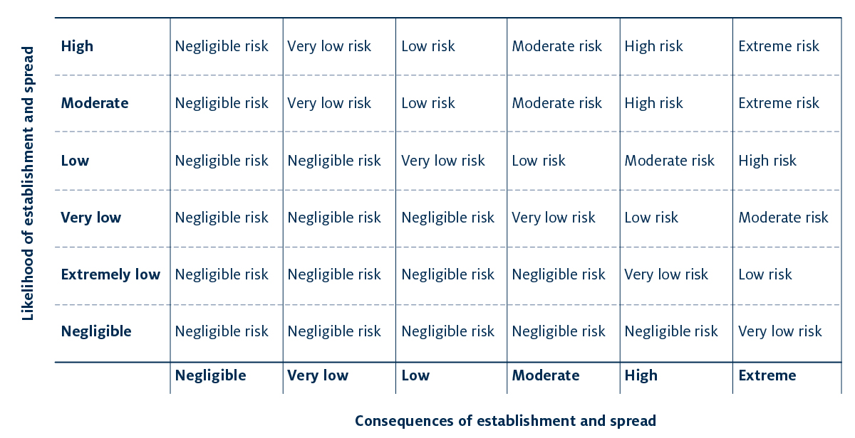
Note: Appropriate level of protection (ALOP) depends on the user. For example, if ALOP is achieved when risk is reduced to a very low level, any diseases that fall above very low risk will require additional risk management.
Source: DAWE 2015b
The unrestricted risk assessment method is most useful if it is based on comprehensive and accurate information. The assessment process should be well documented and include references to sources such as scientific literature and expert opinion. The assessment of likelihood against consequence will provide an estimate of risks associated with aspects of the translocation. Risk management measures must be written into the policy when necessary. Anyone undertaking translocation activities should be clear that they conducted risk analysis, even where risk is minimal (for example, when stocking locally sourced fish into a reservoir).

Risk management measures
Risk management measures are not necessary for all translocations. When the unrestricted risk assessment does not meet the ALOP, those planning translocation activities should develop all possible risk-management measures for consideration. This is also known as risk-management options analysis.
Measures could include:
- testing and/or certification of source stock as free from pests or pathogens
- implementing licence conditions for aquaculture operations, live fish suppliers or holding facilities stipulating requirements that reduce likelihood of escape or establishment of translocated species; many live fish suppliers/holding facilities/aquarium production are not licensed
- treating stock for known diseases or pests (for example, egg disinfection, parasite treatment and grading to remove pest fish)
- translocating animals during lower-risk life stages (for example, fertilised eggs)
- containing stock at destination to prevent exposure to or entry of disease
- reducing genetic risks by using reproductively sterile stocks (for example, triploid Pacific oysters) when available and reliably sterile.

Restricted risk assessment
Restricted risk assessments are used to estimate the risk of an activity that incorporates one or more risk-management measures. A restricted risk assessment should be conducted if the results of the unrestricted risk assessment show that a translocation activity does not meet the ALOP. In the restricted risk assessment, risk-mitigation measures are developed and tested.
Restricted risk assessments can be estimated using the same methods as for unrestricted risk assessments—for example, by combining the likelihood and consequence of a hazard and considering implementation of risk-management measures.
Performing multiple restricted risk assessment estimates can identify the most appropriate combination of risk-management measures to bring a translocation activity within the ALOP.
Restricted risk assessment should also include a sensitivity analysis step.

Policy development and implementation
Translocation policies may be developed, revised or implemented to manage identified risks. Policy makers should consider the species and environments involved, diseases or pests likely to be translocated, industry activities unique to each jurisdiction, and resources available. They should prioritise addressing any large gaps clearly identifiable within jurisdictions for high or extreme risks associated with translocations identified in the risk analysis. Translocation policies and other management instruments should take into account the approach that is best practice approach and least disruptive to industry.
Possible instruments for implementation include:
- international, national, state and territory legislation (see Appendix C: Australian translocation policies and legislation)
- policy documents
- licence conditions for stock suppliers and recipients (for example, aquaculture operations)
- voluntary guidelines—for example, codes of practice developed by hatcheries and industry associations
- educational materials—for example, the Invasive Plants and Animals Committee Freshwater Fish Expert Group (IPAC FFEG) is developing educational material on risks associated with ornamental fish; some of this material would apply to translocations
- compliance processes—for example, fisheries inspectors, liaison with stocking clubs and associations.
Any policy decisions based on these options should include stakeholder communication.

Monitoring, review and risk communication
Ongoing monitoring of translocation risks and effectiveness of current policies, and modification of existing policies when deficiencies are identified, is necessary to ensure that translocation policies continue to fulfil their intended purposes.
Implementing agencies should use monitoring programs to assess and improve the accuracy of predictions generated by risk assessments and the effectiveness of translocation management strategies. These programs would include analysis of the benefits of translocation and any effects translocated species (or inadvertently translocated species) have had on the environment or economy of the receiving area. Monitoring ensures that policy objectives continue to be achieved in a changing environment. Awareness campaigns to ensure non-regulated pathway risk management should be adjusted to maintain effectiveness for target audiences. Social media communications and effective public education should be updated regularly to maintain awareness and engagement.
New diseases in aquatic animals emerge regularly. These are often linked to increases in numbers of susceptible hosts and changes in ecosystems. Aquatic animal farming also contributes to emergence of clinical disease, due to lack of predation of sick individuals, higher stocking densities and stress associated with farmed populations. Those planning translocation activities should be vigilant in assessing potential effects of newly discovered diseases on the effectiveness of translocation policies to ensure that those policies remain effective in reducing risks.
Aquatic animals and diseases can behave very differently in new environments. For example, a virus that causes significant mortalities in Pacific oysters was translocated from Asia to Europe, Australia and New Zealand. However, clinical disease caused by this virus has not been reported in any of the receiving environments.
It is essential to review translocation policies as new information becomes available to maintain effectiveness in achieving desired goals.

Example risk analyses
These risk analyses (particularly for diseases) have been completed and can be used as guides:
- risk analysis for translocation of abalone and prawns (Jones & Stephens 2006)
- risks associated with aquaculture activities (Business Queensland 2011)
- National policy guidelines for translocation of domestic bait and berley (DAWE 2015b)
- generic import risk-analysis report for prawns and prawn products (DAWE 2016)
- Other diseases or problem species have also emerged in Australia and overseas. These include abalone viral ganglioneuritis (AVG), acute hepatopancreatic necrosis disease (AHPND) and white spot disease in prawns. Anyone planning translocation activities should consider the latest information from the state authorities and research institutions.

Appendix A: Risk assessment likelihood tables
Table A1 Example likelihood levels for risk assessment
Likelihood | Description
Certain | The event would definitely occur
High | The event would be very likely to occur
Moderate | The event is equally likely to occur or not occur
Low | The event would be unlikely to occur
Very low | The event would be very unlikely to occur
Extremely low | The event would be extremely unlikely to occur
Negligible | The event would almost certainly not occur
Zero | The event would not occur
Source: DAWE 2008
Table A2 Likelihood ranges and qualitative likelihood categories
Likelihood | Minimum | Maximum
Certain | 1 | —
High | >0.7 | →1
Moderate | >0.3 | →0.7
Low | >0.05 | →0.3
Very low | >0.001 | →0.05
Extremely low | >10–6 | →0.001
Negligible | >0 | →10–6
Zero | 0 | —

Appendix B: Risk assessment consequence table
Table B1 Example consequence levels for risk assessment
Consequence | Rating | Description
Negligible | 0 | Establishment of the disease or pest would have no significant biological consequences, may be transient and would require no management.  Disease or pest would not affect economic performance at any level.  Effects on the environment would be negligible.
Very Low | 1 | Establishment of the disease or pest would have very low biological consequence and be amenable to control or eradication.  May harm economic performance at an enterprise level for a short period but be of limited significance at an industry level.  Effects on environment would be very minor or temporary.
Low | 2 | Establishment of the disease or pest would have low biological consequence and be amenable to control or eradication  May harm economic performance at an enterprise level but be of limited significance at an industry level.  Effects on environment would be minor or temporary.
Moderate | 3 | Establishment of the disease or pest would have moderate biological consequence and may be amenable to control or eradication at a significant cost.  May harm economic performance at an industry level.  May affect the environment but not seriously and may be reversible.
High | 4 | Establishment of the disease or pest would have serious biological consequences (high mortality or morbidity). Effects that would be felt for a prolonged period and would be difficult to control or eradicate.  Will significantly harm economic performance at an industry level or regional level and may cause serious harm to the environment.
Catastrophic | 5 | Establishment of the disease or pest would significantly harm economic performance at a national level.  May cause long-term or irreversible harm to the environment.
Source: Northern Australia Biosecurity Initiative-Marine Pest and Disease Risk Assessment (Diggles, BK 2017)

Appendix C: Australian translocation policies and legislation
Table C1 Policies and legislation covering translocation in Australia
Jurisdiction | Policy/legislation | What it covers
International | ICES Code of Practice on the Introductions and Transfers of Marine Organisms 2005 | Primarily translocation of aquaculture species in the North Atlantic, but principles apply to other areas and species. The document lacks the appendixes that have the useful information in them.
International | World Organisation for Animal Health (OIE) Aquatic Animal Health Code | Guidance for importation of animals from areas with defined disease status. Each disease-specific chapter has articles relevant to translocation of live aquatic animals. These are articles X.X. 7 and X.X.8.  OIE has also developed standards on control of aquatic animal health risks associated with transport of aquatic animals (Chapter 5.5), aquatic animal health measures applicable before and at departure (Chapter 5.6), aquatic animal health measures applicable during transit (Chapter 5.7) and aquatic animal health measures applicable on arrival (Chapter 5.9).
Australia | Environment Protection and Biodiversity Conservation Act 1999 | –
Australia | EPBC Act Policy Statement—Translocation of Listed Threatened Species—Assessment under Chapter 4 of the EPBC Act | Focuses on removal and relocation (or proposed removal and relocation) of EPBC-listed threatened species from development sites, rather than the introduction of species to areas outside their natural range. Uses the term ‘translocation’ to mean moving/relocating individuals generally.
Australia | EPBC Act list of threatened fauna | Matters of national environmental significance under the EPBC Act.
Australia | EPBC Migratory species lists | Matters of national environmental significance under the EPBC Act.
Australia | Australian Wetlands Database | Matters of national environmental significance under the EPBC Act.
Australia | Recovery plans | EPBC Act requirement to not act inconsistently with a recovery plan.
Australia | Key threatening processes under the EPBC Act | EPBC Act listed key threatening processes include ‘Novel biota and their impact on biodiversity’, which can include disease.
Australia | Intergovernmental Agreement on Biosecurity (IGAB) | Overarching national policy to improve the national biosecurity system. See schedule 5 National management framework for established pests and diseases.
Australia | National policy guidelines for translocation of domestic bait and berley | National framework for creation of bait translocation policies in Australian states and territories to address identified disease risks. Provides information on bait and berley products, nature of disease risks, principles for policy development, possible instruments for managing identified risks and a staged approach for policy development.
Australia | Species Profile and Threats Database | Holds profiles for individual EPBC-listed threatened species. These recognise the translocation of other species into the range of the threatened species in question as a potential threat—for example, translocation of Murray cod into eastern cod habitats.
New South Wales | Protocol for health certification of barramundi fingerlings for aquaculture, prior to entry into NSW | –
New South Wales | Land Based Sustainable Aquaculture Strategy | Information on translocation issues and mitigation measures.
New South Wales | NSW Hatchery Quality Assurance Scheme manual | Covers translocation and health management.
New South Wales | Memorandum of understanding with Queensland Government | Addresses translocation disease issues for cross-border translocation of native freshwater finfish from hatcheries (excluding barramundi).
New South Wales | Freshwater Fish Stocking Management Strategy | Comprehensively guides/governs introductions of recreational fish species in NSW policies covering harvest stocking and conservation stocking. Covers individual species and areas and provides considerations for stocking in various areas.
New South Wales | Fisheries Management Act 1994 | Under section 216 unauthorised release of fish is illegal.
New South Wales | Biosecurity Act 2015 | Specifies the general biosecurity duty to reduce biosecurity risk when dealing with biosecurity matter or carrier. Provides for mandatory measures to eliminate, prevent or minimise biosecurity risk. Schedule 2, Prohibited Matter list, includes aquatic disease and pests prohibited for any ‘dealing’.
Victoria | Fisheries Act 1995 | A person must not stock fish in Victoria unless authorised to do so under this Act.
Victoria | Guidelines for assessing translocation of live aquatic organisms | Covers translocation and provides helpful links. Specific risk-assessed translocation protocols have been developed to cover the most common types of translocation, including inland public waters, abalone, blue mussels, recirculating aquaculture, eels and open aquaculture systems on private land. Approval can be sought for protocols developed by users (for example, by public zoos and aquariums) to cover their common translocations.
Queensland | Aquaculture policies and guidelines | Separate translocation protocols for live aquatic organisms, penaeid prawns, barramundi, bivalves, oysters, trans-shipment of oysters, marine crustaceans, freshwater crayfish and prawns, eels, freshwater fish other than barramundi and eels.
Queensland | Biosecurity Act 2014 | General biosecurity obligation to satisfy biosecurity requirements and reduce risk. Translocation policies on the Queensland Government website are enforceable under the Sustainable Planning Act 2009.
South Australia | Livestock Act 1997 | Importing live aquatic animals into South Australia. Covers disease risks, movement restrictions for aquaculture licence holders regarding high-risk species including restrictions on the importation of Pacific oysters and restrictions on entry of abalone for non-aquaculture (such as restaurants and fish processors).
South Australia | Policy for the Release of Aquatic Resources | Translocation (release) of live aquatic organisms into state waters for conservation stocking, stock enhancement and harvest stocking.
South Australia | Fisheries Management Act 2007 | Unauthorised release into natural waters of exotic or aquaculture fish not permitted unless authorised by the responsible minister.  Under section 78 a person must not, except as authorised by a permit issued by the minister, release or permit to escape into any waters exotic fish, aquaculture fish or fish that have been kept apart from their natural habitat.
Western Australia | Translocation guidelines and application forms | Covers translocation and provides helpful links.
Western Australia | Policy on Restocking and Stock Enhancement in Western Australia | Policy for managing translocations of live fish into and within Western Australia. Fish covered include an aquatic organism of any species but not aquatic mammals, aquatic reptiles, aquatic birds, amphibians or pearl oyster, Pinctada maxima.
Western Australia | Translocation guidelines and application forms. | Translocation approval process for commercial and non-commercial aquaculture, non-commercial farm dams, and restaurants.
Western Australia | Fisheries management papers | Policy documents covering translocation of barramundi (No. 159), trout (No. 250), silver perch (No. 145), coral and live rock (No. 245).
Western Australia | Aquatic Resources Management Act 2016 | Part 6 covers declared organisms and the importation, trading or deliberate release into aquatic environments.
Western Australia | Fish Resources Management Regulations 1995 | Covers movement of cultured and noxious species.
Western Australia | Fish Resources Management Act 1994 | Covers movement of cultured and noxious species.
Tasmania | Living Marine Resources Management Act 1995 (LMRMA) | Translocation of fish species is largely covered in Division 4: Release and importation of fish and Division 5: Noxious fish. These sections state that a person may not import or release fish into Tasmania unless authorised to do so.  The Act uses ‘fish’ to include all marine animals, including invertebrates and plants.
Tasmania | Inland Fisheries Act 1995 (IFA) | The licensing of fish dealers is a default mechanism for Director of Inland Fisheries authorisation. Inland fisheries maintains two lists of fish species: a noxious fish list and a permitted fish list.
Tasmania | Animal Health Act 1995 | Enforcement of requirements within the LMRMA and the IFA. The AHA bans the importation of live animals and animal products unless they are specifically permitted.
Northern Territory | NT zoning strategy for the NT | Available from NT Government on request.  Describes logic and methodology of zoning strategy approach. Main species cultured have a zoning strategy.
Northern Territory | Individual species–specific zoning and translocation policies | Available from NT Government on request.  Individual policies for each of the main species cultured for quarantine and health certification, disease control zoning and laboratory testing.
Northern Territory | Translocation guidelines and application forms | Available from NT Government on request.  Covers translocation and provides direction to further resources.
Northern Territory | Fisheries Act 1988 | Unauthorised translocation and release of fish or aquatic life is illegal.
Northern Territory | Fisheries Regulations 1992 | Unauthorised translocation and release of fish or aquatic life is illegal.
Australian Capital Territory | Fisheries ACT 2000 | Cross-border movement of live fish and open release of fish require permits under the legislation.
Australian Capital Territory | Nature Conservation Act 2014 | Controls translocation of threatened species in accordance with Conservator of Flora and Fauna guidelines.

Appendix D: Gaps identified in existing translocation policies
The Sub-Committee on Aquatic Animal Health (SCAAH) working group and reviewers of these guidelines identified gaps in existing translocation policies. These gaps are general and do not necessarily exist in all states and territories. For example:
- ‘Live rock’ and ‘live sand’ are translocated around Australia, and some jurisdictions do not have regulations or policies on this. These items can harbour (and are sold as harbouring) a variety of marine or freshwater animals and plants. This may present a pathway for introduction of invasive species. The WA Government has a policy on translocation of live rock, coral and associated organisms; other jurisdictions could use this as a model. See Appendix C: Australian translocation policies and legislation.
- Driftwood and plants may provide refuge for other species. Plants can harbour insects, sponges, fish eggs and snails. Plants are covered by noxious species legislation in many jurisdictions but some declared noxious species are sold and distributed by nurseries. The difficulty of differentiating between closely related species can complicate identification. The WA Government policy for live rock may address some of these considerations.
- Ornamental fish translocation may lead to introduction and spread of many exotic diseases. Quarantine requirements (as listed in BICON) manage risks of imported ornamental fish introducing disease and/or becoming pests. Translocation of potentially noxious species and native Australian fish into other areas can lead to establishment of non-native populations. This occurred when eel-tailed catfish (Tandanus tandanus) and Murray cod (Maccullochella peelii) were translocated from the eastern states as ornamental fish into Western Australia.
Management of noxious species is possible, but management of non-declared species is more problematic. The WA, Tasmanian and NT governments have measures in place to manage ornamental fish while permitting trade. The Invasive Plants and Animals Committee Freshwater Fish Expert Group (FFEG) is developing a public education strategy on the impacts of releasing fish into the environment.
- Management of unregulated pathways will rely on cooperation of retailers and education of the public. Strategies may include encouraging retailers to accept return of animals or other material they have sold, and to distribute or display educational material on how release of unwanted animals leads to environmental damage and animal cruelty. The FFEG education strategy and others will be the main vehicles to mitigate risks presented by translocation of ornamental fish.
- Translocation management is overly complicated in some jurisdictions. It can involve separate policies for different species and different terminologies covered by multiple Acts. In some cases policies are inconsistent. Most jurisdictions have or are reviewing their policies to simplify them and remove inconsistencies. Separate species-specific policies are still necessary for some species due to industry and program requirements.
- Bait translocation is covered by the Nation policy guidelines for translocation of bait and berley (DAWE 2015b).
New or revised policies may be developed to address these gaps. Examples provided may assist.

References
Business Queensland 2020, Moving live aquatic animals, Brisbane, February 2020.
COAG 2012, An Agreement between the Commonwealth of Australia, state and territory governments to strengthen the national biosecurity system. Council of Australian Governments, Canberra, accessed February 2020.
DAWE 2008, Final generic import risk analysis report for chicken meat, Department of Agriculture, Water and the Environment, Canberra.
—— 2015a, AQUAVETPLAN enterprise manual, Department of Agriculture, Water and the Environment, Canberra.
—— 2015b, National policy guidelines for translocation of bait and berley, Department of Agriculture, Water and the Environment Canberra.
—— 2016, Final generic import risk analysis (IRA) report for prawns and prawn products, Department of Agriculture, Water and the Environment, Canberra, accessed February 2020.
—— 2020a, Do you need to obtain approval under the EPBC Act? Department of Agriculture, Water and the Environment, Canberra, accessed February 2020.
—— 2020b, Marine Pests, Department of Agriculture, Water and the Environment, Canberra, accessed February 2020.
Diggles, BK 2017, Northern Australia Biosecurity Initiative—Marine Pest and Disease Risk Assessment, DigsFish Services Report DF17-02.
DIPIPWE 2020, Commercial abalone fishing biosecurity measures, Department of Primary Industries, Parks, Water and Environment, Hobart, accessed February 2020.
Jones, B & Stephens, F 2006, Aquatic Animal Health Subprogram: development of a national translocation policy using abalone and prawns as templates for other aquatic species, Fisheries Research and Development Corporation Project No. 2004/080, Department of Fisheries, Western Australia.
OIE 2020a, Aquatic Animal Health Code, World Organisation for Animal Health, Paris, accessed February 2020.
—— 2020b, International standards, World Organisation for Animal Health, Paris, accessed February 2020.
WTO 1995, Agreement on the Application of Sanitary and Phytosanitary Measures, World Trade Organization, Geneva, accessed February 2020.

