Improving on-farm biosecurity practices of small-scale aquaculture farms in Vietnam
Dr Yuko Hood; Dr Eleanor Lam
Animal Health Policy Branch; Aquatic Pest and Health Policy

Summary
Vietnam and Australia's technical capacity building project for improving on-farm biosecurity practices of small-scale aquaculture farms in Vietnam (the on-farm aquaculture biosecurity project) ran from early 2022 and successfully concluded in June 2024. This project focussed on identifying and implementing effective biosecurity measures for small scale aquaculture farms to prevent and manage aquatic animal diseases.

Introduction
The project began in response to Vietnam's request for increased technical collaboration with Australia. Australia acknowledges Vietnam's prominence as a seafood trading partner in the Asia-Pacific region and aims to improve understanding of and ways to meet Australia's stringent import requirements. The project sought to bolster Vietnam's capacity in aquatic animal health management through the development of practical on-farm biosecurity guidance materials and a training workshop.

Material development
Key deliverables included the adaptation of the Aquaculture Farm Biosecurity Plan from Australian guidelines to suit Vietnam. The Aquaculture Farm Biosecurity Plan for Vietnamese finfish and crustacean industries: Generic guidelines and template, covered the risk analysis methodology — including hazard identification, risk assessment, risk management measures, and documenting the risk analysis process. It also addressed major routes of disease transmission and hazards, practical disease management measures, record keeping, staff training, and emergency procedures specific to Vietnamese aquaculture farms. The plan detailed risk assessment matrices and example disease transmission pathways. Additionally, a set of flipcards were created as a user-friendly, on-site resource for aquaculture farmers.
The Aquaculture Farm Biosecurity Plan for Vietnamese finfish and crustacean industries: Generic guidelines and template, or the flipcards, are available on request. Please contact the Aquatic Pest and Health Policy section (APHP) of the department (DAFF) at AAH@aff.gov.au for an electronic copy (appropriate intellectual property requirements apply).

Workshop
Another key deliverable of the project was a two-day workshop held in Can Tho, Vietnam, from 6-7 March 2024, organised by DAFF, the Australia Embassy in Hanoi and the Vietnamese Department of Animal Health (DAH). The workshop was attended by 44 participants from Vietnam, including representatives from the Directorate of Fisheries (D-Fish), DAH Aquatic Animal Health Division, various regional offices of DAH, aquatic animal health diagnostic testing laboratories, universities, and a smaller number of farmers from the local aquaculture industries (from commercial catfish and prawn farms).
The workshop featured presentations on biosecurity principles, risks analysis and concepts around risk management, and insights into Vietnam's aquaculture industry challenges. At each step of the risks analysis methodology, a group exercise was conducted. The materials produced (Biosecurity Plan, flipcards) formed the foundation of the workshop content, and were used extensively to achieve the educational objective of the ‘train-the trainer workshop’.
Participants were engaged through a real-time survey conducted via an online, interactive platform before the opening of the workshop on Day 1, and post-workshop at the end of Day 2. The results, compared in Appendix 1, showed a notable increase in participants’ confidence in the risk assessment process and biosecurity planning.
Participants also had the opportunity to visit a commercial prawn farm and catfish farm, which were used as a model farm for group exercises to learn to develop an on-farm biosecurity plan. Participants were divided into two groups and each group was allocated to one site visit. A checklist was provided to prompt observations on biosecurity practices of the farm, focusing on the 6 major areas of disease transmission risk (animals, people, water, waste, feed, fomites).
On day 2, two groups were further allocated into four sub-groups for informal discussions on the observations made during the farm visit. A simulated farm scenario and group exercise question and guidance document, written in Vietnamese, served as the basis for discussion on biosecurity threats faced by small-scale aquaculture farms at entry, internal and exit farm biosecurity levels. Each group deliberated their thought process in applying the risk analysis process in a step-by-step method and considered different risk mitigation measures for each hazard identified. Groups then presented their findings to the audience, facilitating an exchange of ideas and perspectives across various areas of expertise.
The workshop presentations, group exercise questions, and other guidance documents were all translated into Vietnamese from English. A total of 4000 copies (2000 copies of the Biosecurity Plan and 2000 copies of the flipcards) were distributed to various sub-departments as requested by the Department of Animal Health in Vietnam at the completion of the project. These documents may be used as working copies in the future to train additional aquatic animal health officers and farmers, ensuring a lasting positive impact on the country’s capability to manage aquatic animal health.

Outcomes
The project's outcomes were positive and demonstrated key benefits, including enhancing disease prevention and management, improving industry sustainability and thus supporting industry productivity. Strengthened on-farm biosecurity practices will directly boost animal health, productivity, and product quality, benefiting both Vietnam and Australia through better pre-border risk management.
This activity also bolstered the Australia-Vietnam agricultural partnership. It highlighted Vietnam's recognition of Australian support in aquatic biosecurity capacity-building. The Director General of Vietnam’s Department of Animal Health, who also serves as Vietnam’s Chief Veterinary Officer, travelled from Hanoi to the Mekong Delta to participate. His attendance not only solidified a crucial relationship with an influential Vietnamese official but also enabled the Australia Embassy to advance several high-priority trade matters concurrently.

Conclusion
The successful completion of this project emphasised how Australia can foster collaborative agricultural relationships with neighbouring countries like Vietnam. By equipping Vietnamese farmers and officials with tailored biosecurity guidance and training, disease threats to their aquaculture sector can be better managed and promote sustainable industry growth. The positive reception and increased confidence among participants throughout the course of the workshop, highlighted the benefit and value of these types of programs.
Figure 1 Group photo of workshop participants
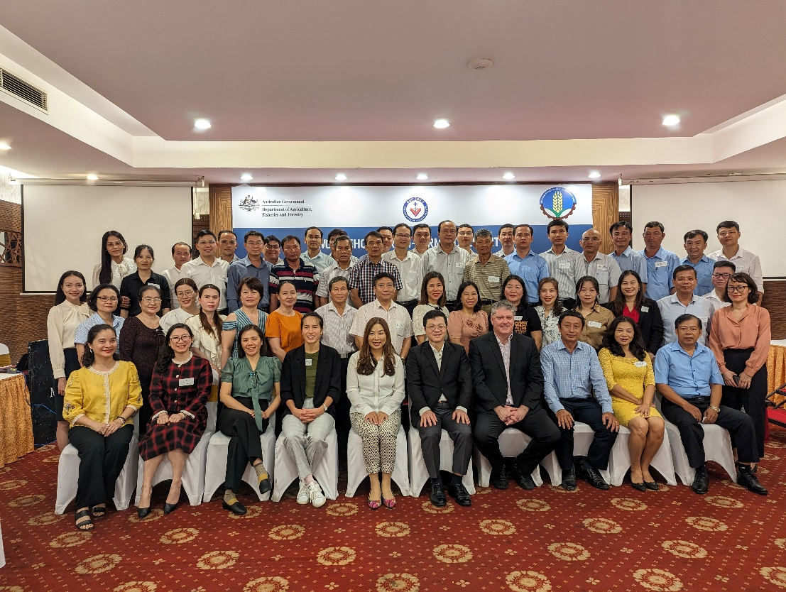

Appendix 1: Survey results

Comparative results between pre- and post-workshop surveys
- Legend:
  - 1 = strongly disagree
  - 2 = disagree
  - 3 = neither agree nor disagree
  - 4 = agree
  - 5 = strongly agree

© Commonwealth of Australia 2024
Unless otherwise noted, copyright (and any other intellectual property rights) in this publication is owned by the Commonwealth of Australia (referred to as the Commonwealth).
All material in this publication is licensed under a Creative Commons Attribution 4.0 International Licence except content supplied by third parties, logos and the Commonwealth Coat of Arms.
The Australian Government acting through the Department of Agriculture, Fisheries and Forestry has exercised due care and skill in preparing and compiling the information and data in this publication. Notwithstanding, the Department of Agriculture, Fisheries and Forestry, its employees and advisers disclaim all liability, including liability for negligence and for any loss, damage, injury, expense or cost incurred by any person as a result of accessing, using or relying on any of the information or data in this publication to the maximum extent permitted by law.

