The aquatic proficiency testing program for the Asia-Pacific region
2018 to 2022: final report
© Commonwealth of Australia 2024
Ownership of intellectual property rights
Unless otherwise noted, copyright (and any other intellectual property rights) in this publication is owned by the Commonwealth of Australia (referred to as the Commonwealth).
Creative Commons licence
All material in this publication is licensed under a Creative Commons Attribution 4.0 International Licence except content supplied by third parties, logos and the Commonwealth Coat of Arms.

Cataloguing data
This publication (and any material sourced from it) should be attributed as: DAFF 2024, Regional proficiency testing program for aquatic animal disease diagnostic laboratories in the Asia-Pacific 2018 to 2022: final report, Department of Agriculture, Fisheries and Forestry, Canberra, November. CC BY 4.0.
This publication is available at https://www.agriculture.gov.au/agriculture-land/animal/aquatic/international_activities.
Department of Agriculture, Fisheries and Forestry
GPO Box 858 Canberra ACT 2601
Teleph1 1800 900 090
Web agriculture.gov.au
Disclaimer
The Australian Government acting through the Department of Agriculture, Fisheries and Forestry has exercised due care and skill in preparing and compiling the information and data in this publication. Notwithstanding, the Department of Agriculture, Fisheries and Forestry, its employees and advisers disclaim all liability, including liability for negligence and for any loss, damage, injury, expense or cost incurred by any person as a result of accessing, using or relying on any of the information or data in this publication to the maximum extent permitted by law.
Acknowledgements
The regional proficiency testing program was funded by the Australian Government through its Agricultural Competitiveness White Paper.
The authors thank the collaborating partners – the Network of Aquaculture Centres in Asia-Pacific (NACA), Proficiency testing team and the Australian Fish Diseases Laboratory at CSIRO’s Australian Centre for Disease Preparedness (ACDP) – for their contributions to the planning, implementation and management of the program, and the 57 participating laboratories across the Asia-Pacific region for their enthusiastic input.
Acknowledgement of Country
We acknowledge the Traditional Custodians of Australia and their continuing connection to land and sea, waters, environment and community. We pay our respects to the Traditional Custodians of the lands we live and work on, their culture, and their Elders past and present.

Summary
The Regional Proficiency Testing Program for Aquatic Animal Diagnostic laboratories in the Asia-Pacific (APL-PT program) ran from 2018 to 2022. It carried forward the legacy of the successful Asia-Pacific regional proficiency testing program that ran from 2012 to 2014. The objectives were to strengthen regional capability to accurately diagnose important aquatic animal diseases that impact on trade, productivity and the environment. The program enhances the diagnostic capability of the regional network of aquatic diagnostic laboratories in Southeast Asia and the Oceanic region to detect significant aquatic transboundary diseases. These outcomes are increasingly important as countries in the Asia-Pacific are major producers and trading partners of aquaculture products with Australia. The future of production in the Asia-Pacific region only appears to accelerate. Further, the APL-PT program continued the work to increase confidence in the testing performance of Australia’s trading partner laboratories that are certified or approved to test the presence or absence of disease agents for aquatic animal commodity exports.
The APL-PT program was developed as an initiative of the Australian Government Department of Agriculture, Water and the Environment (DAWR; now replaced by the Department of Agriculture, Fisheries and Forestry (DAFF). The program was jointly managed by DAFF and the CSIRO Australian Animal Health Laboratory (AAHL; now renamed the Australian Centre for Disease Preparedness (ACDP). Development and implementation of the APL-PT program was managed by the Steering Committee, which caonsisted of members from ACDP Fish Diseases Laboratory (ACDP-AFDL), ACDP Proficiency Testing Scheme Provider (ACDP-PTSP), and DAFF.
A total of 57 laboratories including 19 countries in the Asia-Pacific region participated in the APL-PT program. 8 rounds were conducted according to ISO 17043 standards and participants were provided with confidential reports on their testing proficiency after each round. CSIRO-ACDP was available to provide technical guidance to participants experiencing difficulties in achieving accurate results. Diagnostic performance was assessed against 10 priority fish and crustacean diseases, with the selection of pathogens chosen from the following agreed-upon list:
- White spot syndrome virus (WSSV)
- Yellow head virus genotype 1 (YHV-1)
- Taura syndrome virus (TSV)
- Infectious myonecrosis virus (IMNV)
- Infectious hypodermal and haematopoietic necrosis virus (IHHNV)
- Vibrio parahaemolyticus Pir-A and Pir-B toxin gene (AHPND)
- Megalocytivirus (RSIV)
- Nervous necrosis virus (NNV)
- Koi herpesvirus (KHV)
- Spring viraemia of carp virus (SVCV).
Testing for acute hepatopancreatic necrosis disease causing Vibrio parahaemolyticus (AHPND) became accredited under ISO17043 for the APL-PT program in December 2020.
Over 8 rounds of testing, 57 laboratories from 19 countries were assessed, with an overall accuracy of 78%. The qPCR method consistently outperformed conventional PCR across all disease agents, with higher accuracy rates. Certain pathogens like SVCV and NNV showed variability and lower accuracy with conventional PCR, but qPCR yielded more reliable results, particularly for IHHNV, KHV, and YHV-1. Despite some fluctuations in accuracy, particularly with specific pathogens like TSV in certain rounds, the overall diagnostic performance was strong, with laboratories generally achieving over 80% accuracy using qPCR. The program successfully met its objectives, demonstrating the laboratories' ability to improve their accuracy in detecting selected priority aquatic pathogens.
The APL-PT program has been essential in ensuring accurate diagnostics and maintaining quality assurance in laboratories involved in aquatic animal health management. It supports countries' trade declarations, industry sustainability, and disease prevention. The program provided a critical opportunity for regional laboratories to enhance their diagnostic capabilities, especially since no similar international program exists. Participation in the program and its associated workshops allowed laboratories to improve their skills, share ideas, and address diagnostic challenges. The report for the regional workshop held in 2018 in Thailand can be found on the NACA website. The participants and the steering committee have recommended to continue fostering collaboration and discussion through similar structure PT programs and workshops, to further improve diagnostic performance and regional cooperation.

Proficiency Testing provider
The program provided access to proficiency testing services from an accredited provider and drew on the expertise of ACDP-PTSP and ACDP-AFDL to develop required testing reagents and materials for participants. ACDP was selected on a non-competitive basis due to its established record of delivering laboratory proficiency testing programs, specialist expertise and availability of material requires for the testing programs. The ACDP-PTSP is also a National Association of Testing Authorities (NATA) accredited proficiency testing provider (ISO 17043).
ACDP-AFDL is also Australia’s national reference laboratory for aquatic animal diseases and has the required experience and biosecurity infrastructure to coordinate delivery of this large-scale program. Roles and responsibilities were well-defined for project collaborators to ensure the effective contribution of expertise necessary to manage the program. Throughout the program, scientists in the PT provider team and ACDP-AFDL were able to provide expert advice troubleshooting to participants to improve their procedures if required.
Contents
Summary iii
Proficiency Testing provider iv
1 Program objectives and expected outcomes 1
1.1 Objectives 1
1.2 Expected outcomes 1
2 Planning and preparation – 2017 2
2.1 Collaborator responsibilities and pre-planning 2
2.2 Requirements for participation 2
2.3 NACA hosted workshop 3
3 Program implementation – 2018 to 2022 4
3.1 Sample preparation 4
3.2 Quality control – homogeneity testing 5
3.3 Quality control – stability testing 5
3.4 Positive controls 6
3.5 Sample distribution 6
3.6 Testing and reporting 6
3.7 Results analysis 7
4 Program results 9
4.1 Laboratory testing 9
4.2 Laboratory issues and feedback 17
5 Assessment against objectives and outcomes 19
5.1 Statement against the program objectives 19
5.2 Assessment against the expected outcomes 20
6 Recommendations for future proficiency testing programs 22
6.1 Ensure participant familiarity with proficiency testing processes 22
6.2 Ensure diseases are of highest priority to participants 22
6.3 Ensure the highest standards of quality assurance 22
6.4 Encourage testing continuity for all proficiency testing rounds 23
6.5 Maintain confidentiality proficiency testing 23
6.6 Enhance pre-border biosecurity 23
6.7 Proficiency testing workshop 23
7 Conclusions 25
Appendix A: Regional Proficiency Testing program partner responsibilities 26
References 27

Tables
Table 1 Disease agents in Crustacean and Finfish panel 6
Table 2 Assessment Key 7
Table 3 Example results summary table 8
Table 4 Average % of acceptable results across all rounds using conventional and qPCR 15
Table 5 Percentage increase of laboratories performing qPCR over time 17
Table 6 Organisational responsibilities 26

Figures
Figure 1 Number of laboratories participating in PT for each pathogen in rounds 1 and 2 9
Figure 2 Number of laboratories participating in PT for crustacean and finfish panels from round 3 to 8 10
Figure 3 WSSV ‘acceptable’ results 10
Figure 4 YHV-1 ‘acceptable' results 11
Figure 5 TSV ‘acceptable’ results 11
Figure 6 IMNV ‘acceptable’ results 12
Figure 7 IHHNV ‘acceptable' results 12
Figure 8 AHPND ‘acceptable’ results 13
Figure 9 Megalocytivirus ‘acceptable' results 13
Figure 10 NNV ‘acceptable’ results 14
Figure 11 KHV ‘acceptable’ results 14
Figure 12 SVCV 'acceptable’ results 15
Figure 13 Average % of acceptable results across all rounds using conventional and qPCR 16

Program objectives and expected outcomes
Proficiency testing is a means for laboratories to assess the effectiveness of their methods to detect pathogens. It is an opportunity for them to identify technical issues with their practices and to improve their performance over successive rounds with expertise from the ACDP-PTSP and the AFDL. Laboratories who participated in the previous regional PT program (2013 to 2014) showed significant improvement in their diagnostic performance for detection of aquatic animal pathogens. This initiative supports Australia’s commitment to address the lack of ongoing and accessible proficiency testing programs for aquatic animal health laboratories in the Asia-Pacific, which was identified as a major capability deficit by the Regional Advisory Group for Aquatic Animal Health (an advisory group to Network of Aquaculture Centres in Asia-Pacific (NACA)) at their ninth meeting in November 2010 and re-iterated at their 19th meeting in November 2020 (NACA 2010, NACA 2020).

Objectives
The 4 objectives of the regional PT program were to:
- Strengthen regional capability to diagnose important aquatic diseases that impact on trade, industry sustainability and/or productivity
- Support the region’s government laboratories in maintaining/improving their capacity to diagnose aquatic animal diseases through a proficiency testing service that includes analysis of results, provision of reports to laboratories and repeat testing (if necessary)
- Increase confidence in the testing performance of Australia’s trading partner laboratories that are certified or approved to test the presence or absence of disease agents for aquatic animal commodity exports
- Determine the potential for a self-supported laboratory proficiency testing program that meets regional needs and Australian objectives for aquatic animal health management in the region.

Expected outcomes
Expected outcomes from the regional PT program included:
- Increased confidence in the testing performance of laboratories certified/licensed by trading partner countries to test the disease status of aquatic animal commodity exports. This will be based on evidence that laboratory methods, protocols and reporting criteria are appropriate and that accurate results for proficiency testing rounds are reported
- Improved diagnostic capability of the regional network of aquatic diagnostic laboratories in Southeast Asia and the Oceanic region to detect important aquatic transboundary diseases. This will be measurable during the life of the project based on improvements in aggregated diagnostic proficiency testing results.

Planning and preparation – 2017

Collaborator responsibilities and pre-planning
The project ran for 5 years from 2018 to 2022, though preparatory activities occurred in 2017. Years 2 to 5 involved 8 rounds of proficiency testing (2 rounds a year) for participating laboratories.
The project was overseen by a steering committee consisting of representatives from the 2 partner organisations: DAWR (now DAFF) and AAHL (now ACDP). The Steering Committee was responsible for:
- finalising the regional PT implementation plan
- determining which international laboratories will participate in the program
- determining priority diseases to be included in the program
- considering communications and technical support required to encourage participation
- considering risks to project implementation and providing advice on actions to mitigate those risks
- monitoring project progress
- reviewing project reports and communications.
The department was responsible for funding the project through the Agriculture Competitiveness White Paper and overall project coordination. The ACDP-PTSP was responsible for communication with participating laboratories and logistics around fulfilling contractual obligations. This included preparing sample materials, conducting quality assurance checks in accordance with ISO 17043 requirements and drafting de-identified reports for each testing round. ACDP oversaw the sourcing and inactivation of disease materials, provided support in the preparation of sample materials, conducted quality assessment on the prepared samples and provided technical advice on the running of each round. NACA was responsible for co-hosting a workshop in March 2019 as a means of direct communication between representatives from the program and laboratory participants. Specific roles and responsibilities for each collaborative partner are detailed in Appendix A: Regional PT program partner responsibilities.

Requirements for participation
Across 19 countries (14 being NACA member countries), 57 laboratories participated in the 8 rounds of aquatic animal disease diagnostic proficiency testing. Participating countries included Bangladesh, Cambodia, China, Hong Kong SAR, India, Indonesia, Iran, Malaysia, Philippines, Sri Lanka, Thailand and Vietnam.
The Competent Authority (CA) in each country nominated laboratories to participate in the program. Nominated laboratories were principally government laboratories that were directly responsible for assisting the national CA with aquatic animal health management, which includes coordinating the national surveillance and disease reporting system, diagnosis of emergency aquatic animal diseases and other diagnostic activities to support trade of aquatic animals and their products. Laboratories were also required to possess adequate infrastructure, including trained personnel, hardware and reagents, to participate in at least 1 round of polymerase chain reaction. Up to 5 diagnostic laboratories of all countries in the Asia-Pacific region that receive an Official Development Assistance (ODA) defined by the United Nations, were invited to participate in the program at no cost to the participant. Additional laboratories from some countries were able to participate in later rounds as other countries could not nominate 5 laboratories or were willing to pay fees for their involvement. In general, non-ODA recipient countries were asked to pay small pre-determined fees. Some private laboratories were able to participate with the fees upon their nominations by CAs, if they provided diagnostic services, on behalf of the relevant CAs, for live aquatic animals (that is, ornamental fish) or seafood commodities (for example, frozen prawns for human consumption) that were traded with Australia.

NACA hosted workshop
A workshop on the APL-PT program was hosted by NACA on 13 and 14 March 2019 in Bangkok, Thailand. The aim was to provide an avenue for direct communication with laboratory representatives to discuss issues participants had during the first 2 rounds of completed testing. It was an opportunity for participants to enhance their understanding of diagnostic standards, quality assurance and proficiency testing procedures within a collaborative setting.
In total, 50 people representing 33 laboratories across 12 participating Asia-Pacific countries attended the workshop. Experts from the then Australian Government Department of Agriculture, Water and the Environment (now DAFF), NACA and CSIRO-ACDP facilitated the workshop. Learn more about the 2018 to 2022 workshop report.

Program implementation – 2018 to 2022

Sample preparation
ACDP-PTSP and ACDP-AFDL were responsible for preparing testing materials for the program. Pathogen material for the 10 previously identified priority diseases were generated and rigorous quality assurance procedures followed to develop test materials. In 2018, bulk lots of ethanol-fixed material (prawn tissue, bacterial suspensions and cell culture) containing non-viable (non-infectious) pathogens were produced at 2 different concentrations. In 2019 and 2020, bulk lots of prawn haemolymph, bacterial suspensions (for AHPND) or cell culture supernatant containing non-viable (non-infectious) pathogen were produced at 2 different concentrations via inactivation with 50 kGy of gamma-irradiation. Homogeneity and stability testing were performed on these samples afterwards.
Inactivated samples were sent to each participating laboratory with instructions to test for the pathogen using their standard diagnostic PCR assay according to the diagnostic capability of their laboratory. Participants were blinded to the disease agent contained in the sample, that is, laboratories did not know which pathogen they were testing for. Participating laboratories used a variety of extraction methods and PCR methodologies, including conventional PCR and real-time PCR (qPCR), commercial kit methods and referenced methods (such as those referenced in the WOAH Aquatic Manual).
In 2018 the 4 finfish viruses were prepared in cell culture and then fixed in a final ethanol concentration of 80% (v/v) at 23°C to 24°C for 24 hours. Following primary inactivation, the precipitate was consolidated by centrifugation, the supernatant discarded and the pellet resuspended in fresh 80% (v/v) ethanol to produce the working stock. The stock was further diluted in 80% (v/v) ethanol containing uninfected cell culture supernatant to achieve a range of concentrations expected in naturally infected fish. Negative samples were prepared using uninfected cell cultures. In 2019 and 2020, the sample format changed from ethanol-fixed to gamma-irradiated (50 kGy) lyophilised samples to facilitate more cost-effective transportation. The 4 finfish viruses were prepared in cell culture and gamma-irradiated (50 kGy). After irradiation, the stock material was diluted in uninfected cell culture supernatant (also gamma-irradiated 50 kGy) to produce a range of concentrations expected in naturally infected fish. Negative samples were prepared using uninfected cell cultures.
The 6 prawn pathogens were initially (2018) supplied as non-infectious prawn tissue homogenates and bacterial suspensions, fixed in 80% (v/v) ethanol. 1 batch of confirmed test-negative uninfected prawn tissue was used as a negative sample for all agents and was also used as the “diluent” for preparing positive samples of varying concentration. For the prawn viral pathogens, haemolymph was used and for the prawn bacterial pathogen, a bacterial suspension was used. Gamma-irradiated haemolymph and bacterial suspensions were diluted in a gamma-irradiated uninfected negative diluent to prepare positive samples of varying concentrations. The uninfected negative diluent was used as a negative sample for all prawn pathogens.
ACDP-AFDL prepared large volumes (>100 mL) of moderate and weak concentrations of sample for the program. The bulk preparations were checked in triplicate using real-time PCR (qPCR), prior to samples being aliquoted. The ethanol-fixed samples were aliquoted into tubes of 500 µL each, which permitted a single extraction only. The gamma-irradiated samples were aliquoted into glass vials of 200 µL each, which permitted multiple extractions. They then underwent homogeneity testing. Samples for DNA or RNA extraction were identified in the instructions provided to participants. A negative and positive control was required for each test as part of internal quality control.
In 2018 on commencement of round 1, ethanol-fixed samples were used to prepare the panels, and this continued until the completion of round 5 in 2020. In 2021, on commencement of round 6 and until the end of round 8 in 2022, gamma-irradiated lyophilised samples were used.
In 2019 on commencement of round 3, all disease agents were presented in combined pathogen panels covering diseases of crustacea and finfish, however prior to this, disease agents were presented pathogen specific panels.

Quality control – homogeneity testing
Quality control via homogeneity testing was conducted in accordance with NATA ISO/IEC 17043 standards.
Homogeneity quality control testing was performed on all new sample batches by randomly selecting 10 samples (tubes) and performing qPCR testing in duplicate. Where available, WOAH-recommended primers and probes were used for quality control analysis but if they were unavailable, ACDP-AFDL ‘in-house’ qPCR assays were used. Only samples passing homogeneity, with a coefficient of variation less than 5%, were utilised for proficiency testing.

Quality control – stability testing
Stability quality control testing was performed in line with NATA ISO/IEC 17043 standards and CSIRO ACDP stability testing protocols.
Stability testing was performed before and after of each round of PT. If samples did not meet stability criteria during pre-round testing, then these will not be included in the PT panel. If samples did not meet stability criteria during post-round testing, then these samples will not to be included in statistical analysis and would be for observation only.
For pre-round stability testing, samples were checked within 6 months of a PT round commencing, and for post-round stability testing, upon completion of each round 4 samples were re-checked to ensure samples were stable. Pre- and post-round stability testing was undertaken using real-time PCR. All samples were adequately stable for use in the 8 PT rounds.
The Quality Assurance system accounts for homogeneity results and stability outcomes and acceptance criteria for a sample was a mean Ct coefficient of variation of less than 5%.

Positive controls
A panel of positive control material for PCR testing was able to be prepared and sent to participating laboratories at their request. This was free of charge and for the purpose of initial PCR setup and to ensure conditions were adequate for testing in rounds.

Sample distribution
The PT panels were presented as either the crustacean and/or finfish panels, containing 6 or 4 disease agents respectively. Participating laboratories selected one or both species disease panels.
Table 1 Disease agents in Crustacean and Finfish panel
Panel | Disease agents
Crustacean | White spot syndrome virus (WSSV)
 | Yellow head virus genotype 1 (YHV-1)
 | Taura syndrome virus (TSV)
 | Infectious myonecrosis virus (IMNV)
 | Infectious hypodermal and haematopoietic necrosis virus (IHHNV)
 | Vibrio parahaemolyticus (AHPND)
Finfish | Megalocytivirus
 | Nervous necrosis virus (NNV)
 | Koi herpesvirus (KHV)
 | Spring viraemia of carp virus (SVCV)

Each country was to arrange appropriate permissions for import of the inactivated material and were to ensure appropriate disposal after testing. Participating countries had a predetermined coordinating laboratory that received packaged samples and distributed them to other laboratories within that country, using a transport and distribution method of their choice.
Samples for round 1 was sent in May 2018, round 2 in November 2018, round 3 in June 2019, round 4 in Nov 2019, round 5 in January 2021, round 6 in September 2021, round 7 in 31 January 2022 and round 8 in September 2022.
Samples were sent to each participating laboratory with instructions to test them for specified pathogens using their standard molecular diagnostic technique. Each laboratory received samples labelled with unique codes and could test the samples in any order.

Testing and reporting
Results were reported by the participating laboratory directly to ACDP-PTSP team, who then provided an independent assessment. De-identified aggregate results were generated as progress reports, which were shared with DAFF and all participants. Progress reports contained a summary of activities for the relevant testing period, including information on the tests provided, a list of participated laboratories for each round, de-identified aggregate results and a statistical analysis for PT rounds. DAFF did not have access to information on the identity of each PT result for an individual participating laboratory.
A confidential report was provided back to each laboratory by CSIRO-PTSP after each round and this was not shared with any other organisation. CSIRO-PTSP are qualified to provide this service by an independent laboratory accreditation authority and the terms of confidentiality are consistent with contractual arrangements and meet ISO 17043 standards.
A final report was provided to DAFF on project completion. It contained the de-identified information on all rounds, along with consideration of requirements and feedback for ongoing aquatic animal proficiency testing and how this could be facilitated. Countries or laboratories have the prerogative to use the results from the program as they wish.
One round of retesting was offered to laboratories who reported incorrect results at the end of each testing round.

Results analysis
For real time assays, Ct values and a qualitative interpretation were provided. For conventional assays, only a qualitative interpretation were provided.
Each laboratory was assessed based on agreement with the qualitative values assigned to each sample in the panel. Subsequent comments were rated:
- ‘Acceptable’ if results agreed with assigned values
- ‘Unacceptable’ if results did not agree with assigned ‘positive’ or ‘negative’ label.
Where laboratories use real time PCR, additional statistical analysis was performed on either identical or related samples to provide information on assay sensitivity and specificity. Laboratories needed to report detection of each sample in a panel and provide the Ct value for statistical analysis to be possible. Outputs of analysis may result in additional assessment comments such as ‘Acceptable with observation’ or ‘Acceptable with condition’.
Each laboratory was assessed according to Error! Reference source not found. based on agreement with the assigned qualitative values and performance in the statistical analysis. Ultimately, the basis of proficiency was based only on the qualitative interpretation of results submitted by the laboratory.
Table 2 Assessment Key
Qualitative Assessment | Comment  The overall rating for each laboratory will reflect the most significant findings made, but less significant findings will also be noted.
Acceptable | Agreement with assigned results. No statistical differences were noted for the sample pair assessed. No specific follow-up is recommended. | Qualitative results align with assigned result.  No statistical outliers identified.
Acceptable with observation | Qualitative results are acceptable. Statistical differences are noted but not considered significant. No specific follow-up is recommended. | Qualitative results align with assigned result.  Results may be identified as an outlier in the Youden plot.  Results may be identified as an outlier in Z-score assessment where they are <-3 - indicating increased analytical sensitivity compared to the median for the samples assessed.
Acceptable with condition | Qualitative results are acceptable. Statistical discrepancies are noted that warrant review. | Qualitative results align with assigned result. Results are identified as an outlier in the Z-score (and as a result the Youden plot) and are greater than the median.
Unacceptable | Results do not agree with assigned values. Review of procedures is highly recommended. | Irrespective of statistical analysis, qualitative results do not align with assigned results.
Observation | Observations noted about test results for additional assays performed beyond the scope of the PT panel.

Statistical analysis provided a Z-score which compared a laboratory result to the group median (and quartiles) and assessed the difference in Ct values reported by each laboratory. Z-scores indicate how many standard deviations a data point (in this case, a laboratory CT result) is from the mean. Youden plots were used to analyse real time PCR data. These are graphs used to evaluate laboratory performance results; the closer the plot points to the central diagonal line, the more accurate the diagnostic result was to the reference sample.
Results outside the produced ellipse may have resulted in the additional assessment comments for the laboratory as it indicates a data point outside the 99th percentile boundary for median Ct values. Data was provided in combination of graphs and tables. An example is provided in the summary, Table 3 Example results summary table, which compares the results of conventional PCR performed on KHV samples. Eight of 10 laboratories submitted results that aligned with the assigned values.
Table 3 Example results summary table
Agent | Batch | C1 | F1 | H1 | I1 | R1 | T1 | U1 | AD1 | AN1 | AT1 | Agreement
KHV | Mod | Positive | Positive | Positive | Positive | Negative | Highly positive | Positive | Light positive | Positive | Positive | 90%
KHV | Weak | Positive | Positive | Positive | Positive | Positive | Mild positive | Positive | Negative | Positive | Positive | 90%
KHV | Weak | Positive | Positive | Positive | Positive | Positive | Weak positive | Positive | Negative | Positive | Positive | 90%
RSIV | Mod | Negative | Negative | Negative | Negative | Negative | Negative | Negative | Negative | Negative | Negative | 100%
RSIV | Weak | Negative | Negative | Negative | Negative | Negative | Negative | Negative | Negative | Negative | Negative | 100%
RSIV | Weak | Negative | Negative | Negative | Negative | Negative | Negative | Negative | Negative | Negative | Negative | 100%
NNV | Mod | Negative | Negative | Negative | Negative | Negative | Negative | Negative | Negative | Negative | Negative | 100%
NNV | Mod | Negative | Negative | Negative | Negative | Negative | Negative | Negative | Negative | Negative | Negative | 100%
NNV | Weak | Negative | Negative | Negative | Negative | Negative | Negative | Negative | Negative | Negative | Negative | 100%
SVCV | Mod | Negative | Negative | Negative | Negative | Negative | Negative | Negative | Negative | Negative | Negative | 100%
SVCV | Mod | Negative | Negative | Negative | Negative | Negative | Negative | Negative | Negative | Negative | Negative | 100%
SVCV | Weak | Negative | Negative | Negative | Negative | Negative | Negative | Negative | Negative | Negative | Negative | 100%
Neg | Neg | Negative | Negative | Negative | Positive | Negative | Negative | Negative | Negative | Negative | Negative | 90%

Program results

Laboratory testing
Diagnostic performance should be interpreted by noting that each round contained a different number of laboratories, despite laboratories being encouraged to participate in consecutive rounds for continuity in data. Some laboratories were not able to participate in ongoing rounds due to financial, logistical and sometimes unknown circumstances. The results in this section reflect the broad variation of experience that different laboratories with the Asia-Pacific have with testing of the disease agents.
Despite a variable number of laboratories who participated in each round, there were a similar number of enrolments for each pathogen. From round 3 (inclusive), disease agents were combined to form either the crustacean or finfish disease panel. This was to better reflect a diagnostic setting wherein laboratories would be testing for several agents in the one sample and is reflected in Figure 2.
Figure 1 Number of laboratories participating in PT for each pathogen in rounds 1 and 2
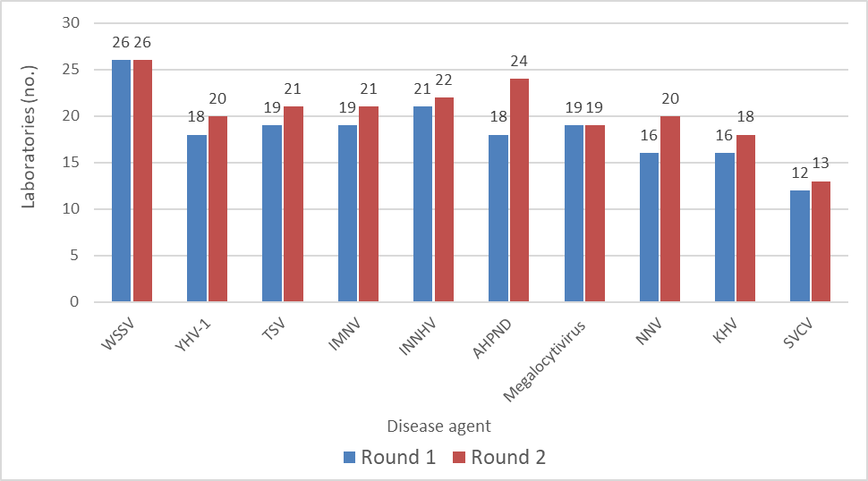
WSSV white spot syndrome virus. YHV-1 yellow head virus genotype 1. TSV taura syndrome virus. IMNV infectious myonecrosis virus. INNHV infectious hypodermal and haematopoietic necrosis virus. AHPND Vibrio parahaemolyticus. NNV nervous necrosis virus. KHV Koi herpesvirus. SVCV spring viraemia of carp virus.
Figure 2 Number of laboratories participating in PT for crustacean and finfish panels from round 3 to 8
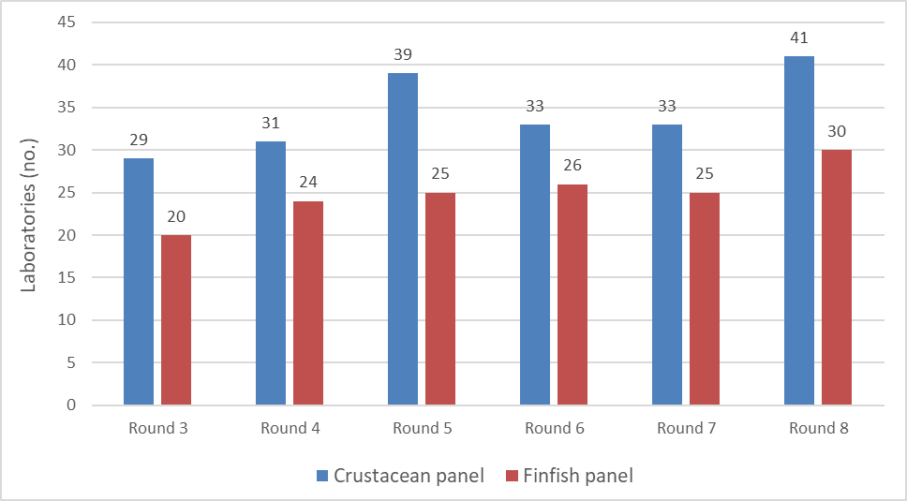
The average ‘acceptable’ diagnostic test result was designated as any laboratory who accurately assigned a positive or negative value to the samples in the panel. For example, in round one, 50% of laboratories testing for WSSV reported results correctly using conventional PCR. In round 8, 77% of laboratories reported WSSV results correctly using the same PCR method. The percentage of laboratories who had an ‘acceptable’ assessment during each round is presented in Figure 12.

Figure 3 WSSV ‘acceptable’ results
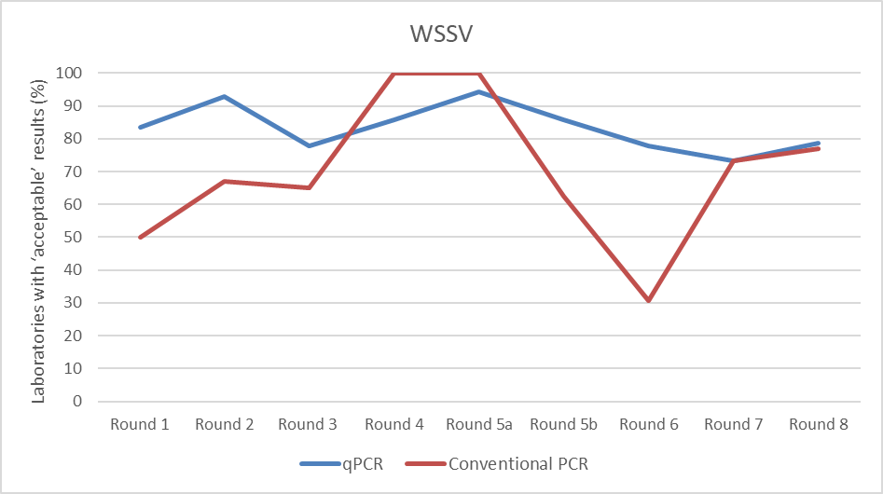

Figure 4 YHV-1 ‘acceptable' results
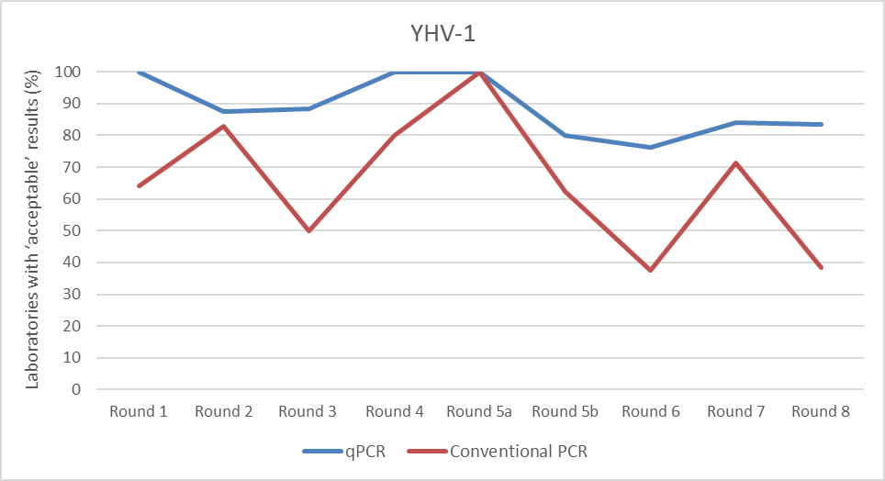
Figure 5 TSV ‘acceptable’ results
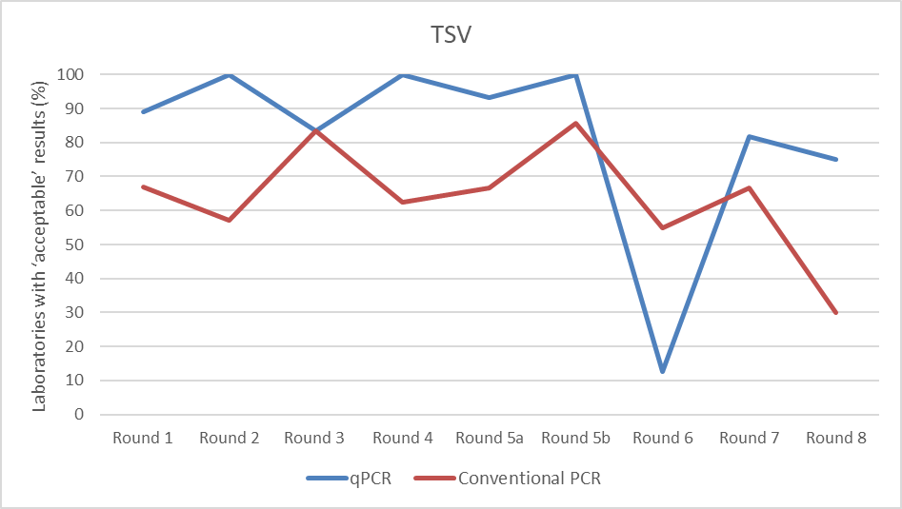
Figure 6 IMNV ‘acceptable’ results
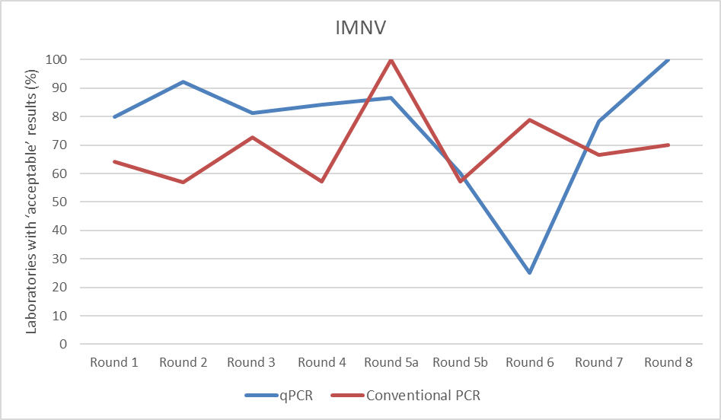
Figure 7 IHHNV ‘acceptable' results
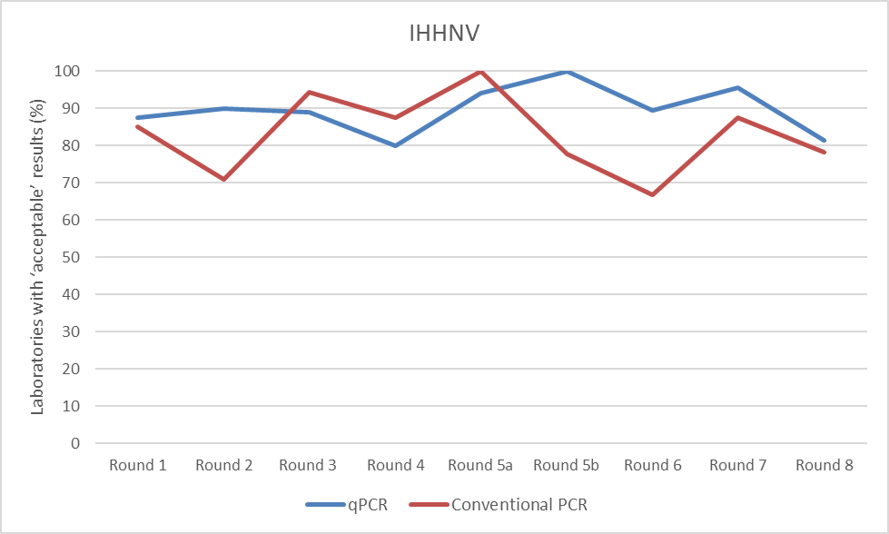

Figure 8 AHPND ‘acceptable’ results
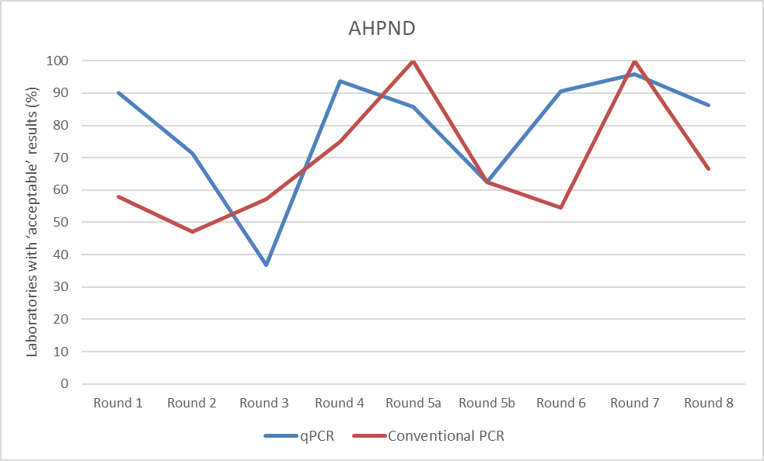
Figure 9 Megalocytivirus ‘acceptable' results
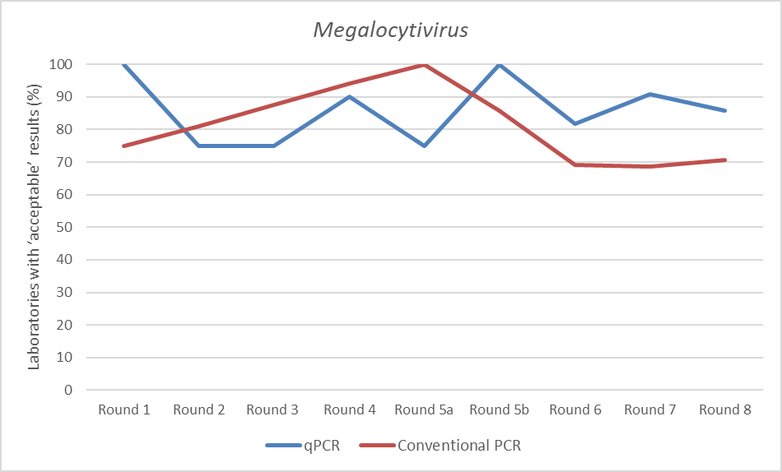
Figure 10 NNV ‘acceptable’ results
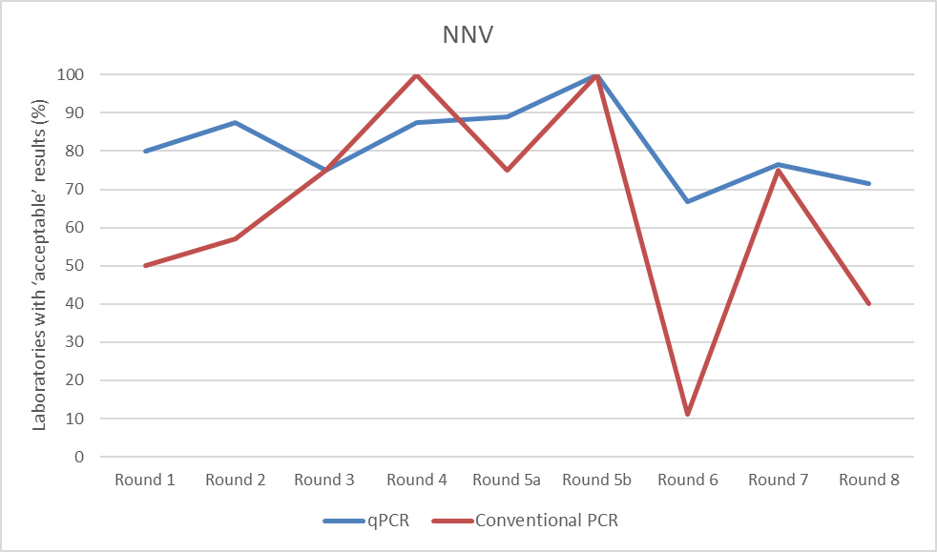
Figure 11 KHV ‘acceptable’ results
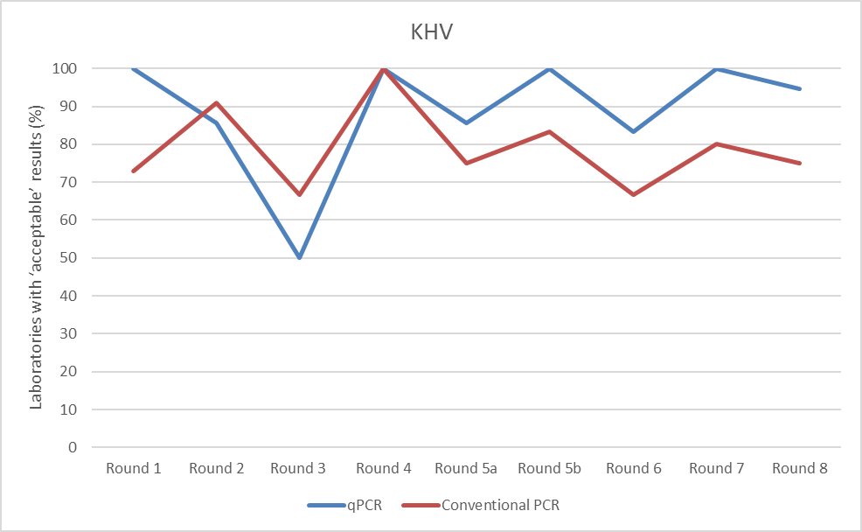

Figure 12 SVCV 'acceptable’ results
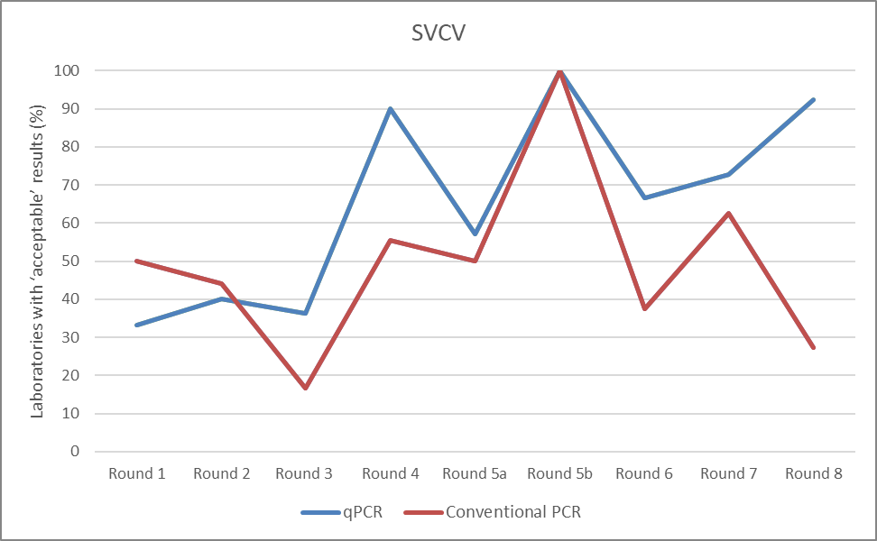
Table 4 Average % of acceptable results across all rounds using conventional and qPCR
Disease agent | Conventional PCR | qPCR
WSSV | 69.5 | 83.3
YHV-1 | 65.2 | 88.8
TSV | 63.8 | 81.7
IMNV | 69.3 | 76.4
IHHNV | 83.1 | 89.7
VpAHPND | 69 | 79.2
Megalocytivirus | 81.3 | 85.9
NNV | 64.8 | 81.5
KHV | 79 | 88.8
SVCV | 49.3 | 65.4
Figure 13 Average % of acceptable results across all rounds using conventional and qPCR
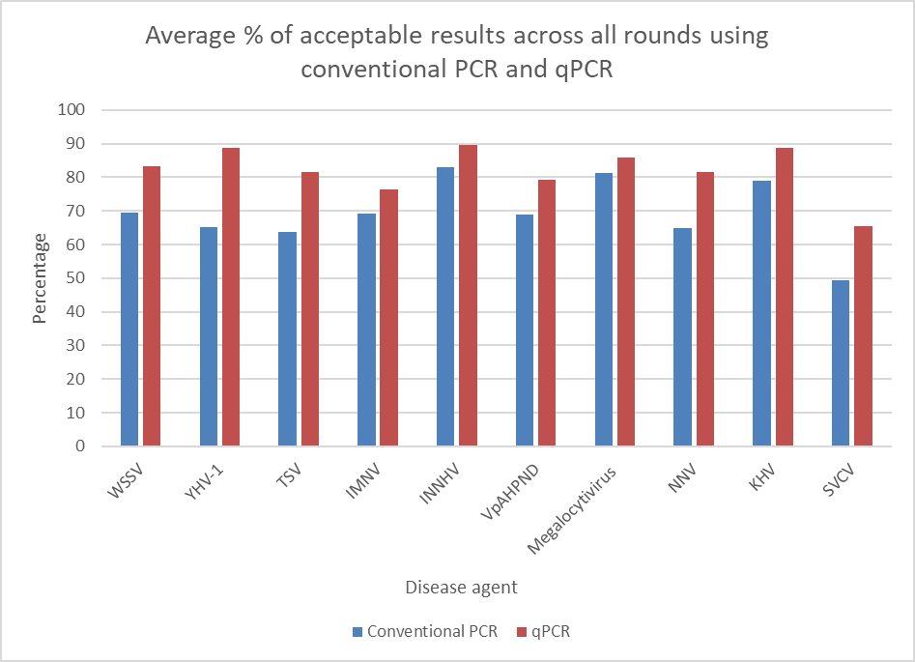
WSSV white spot syndrome virus. YHV-1 yellow head virus genotype 1. TSV taura syndrome virus. IMNV infectious myonecrosis virus. INNHV infectious hypodermal and haematopoietic necrosis virus. AHPND Vibrio parahaemolyticus. NNV nervous necrosis virus. KHV Koi herpesvirus. SVCV spring viraemia of carp virus.

Over 8 rounds of testing, a total of 57 laboratories across 19 countries were assessed 2,219 times. Laboratories received a correct assessment 1,732 times. Trendlines across all disease agents show a consistently higher percentage of laboratories with an accurate detection of the pathogen using qPCR compared to conventional PCR methods across all rounds and disease agents.
Using conventional PCR, SVCV showed an overall lowest average percentage of acceptable results across all rounds with a figure of 49.3% with a marked variability in accurate pathogen detection between each round. TSV and NNV similarly showed a reduced average, though the reduced performance in NNV could be attributed to the outlier in round 6, where only 11% of laboratories who participated returned an ‘acceptable result’. Conventional PCR methods were most accurate with IHHNV, Megalocytivirus and KHV, which is expected due to their relatively high rates of acceptable results across each round.
Using qPCR, SVCV also revealed the lowest average percentage of acceptable results across all rounds at 65.4%. This may be attributed to laboratory issues and feedback outlined in Section 4.2. IHHNV had the strongest diagnostic performance with the average at 89.7%, with both KHV and YHV-1 following closely in performance with their average at 88.8%. In round 6, TSV received the lowest accurate detection rate in that round across all disease agents. Despite this, TSV performed strongly across the rest of the rounds and maintained a strong average of 81.7% overall.
On completion of the 8 rounds, participating laboratories demonstrated a strong ability to accurately detect the selected pathogens. Accurate diagnostic results were consistently over 80% using the qPCR method and were only slightly reduced when using the conventional PCR methods.

Laboratory issues and feedback
Laboratories demonstrated a shift towards using qPCR over conventional PCR throughout the life of the program as seen in Error! Reference source not found.. There are consistently less erroneous results detected using qPCR compared to conventional PCR for each round. There is overall a modest improvement in the performance of laboratories using qPCR to detect pathogens accurately across each round, particularly with SVCV which has a positively sloping gradient as seen in Figure 12.
Table 5 Percentage increase of laboratories performing qPCR over time
Agent | % increase of labs using qPCR from R1 to either R6, R7 or R8
WSSV | 33
IHHNV | 25
IMNV | 26
TSV | 31
YHV-1 | 26
VpAHPND | 25
Megalocytivirus (RSIV) | 22
NNV | 37
KHV | 34
SVCV | 18

Of note, new laboratories from the region were invited to join from round 6 onwards. Not all participants in the program were able to complete proficiency testing in more than 1 round (as per initial requirement). This may account for the spike in ‘unacceptable’ results as seen in most disease agents, except for VpAHPND. Laboratories may not have had an opportunity to submit further results to show whether improvements in their techniques could impact their testing ability.
As with the previous regional PT program, the APL-PT program provided a valuable means for diagnostic laboratories in the region to improve their aquatic animal disease diagnostic capability. Improved diagnostic capability will have direct effects on preventing the introduction through early detection and early intervention, hence preventing establishment and spread of trans-boundary disease in the Asia-Pacific region. This supports domestic and international trade by strengthening their diagnostic competency to detect and manage aquatic animal disease of regional significance.
ACDP-PTSP and ACDP-AFDL ran the program efficiently and provided feedback to the individual laboratories. General feedback included:
- Failure to detect positive samples
  - Requires improvement in agent detection and assay sensitivity:
  - Review reagent storage conditions
  - Review nucleic acid extraction method
  - Review PCR methods including freeze-thaw cycles for primers and probes, regent conditions and pipetting techniques
- Reporting false positives
  - Review sources of contamination including handling protocols
  - Review technical and administrative issues to reduce incorrect reporting and sample contamination
- Delayed and misreporting
  - It was the participants’ responsibility to provide a qualitative result (despite obtaining a Ct value) as this was the basis of a result being assessed as acceptable or unacceptable. The PT provider was not able to assume or offer a result interpretation. Occasionally, when a laboratory did not provide a qualitative result, results were not able to be incorporated into final outcomes.
  - Incorrect data interpretation and failure of authorisation procedures (a positive gel band or valid Ct result being reported as negative)
  - COVID-19 resulted in significant challenges to logistics around panel delivery and subsequent delay in testing and reporting. The program was granted a 6-month extension such that ACDP PT could meet the milestones.
  - COVID-19 also resulted in the subdivision of round 5 into 2 reports in ensure an inclusive outcome for reporting. This occurred at a time when many laboratories were experiencing stop work orders and needed extra time to perform testing.
- Laboratory processing
  - Minor complications were reported by some laboratories affecting their ability to process test samples, such as difficulties in accessing diagnostic kits and reagents, inadequate staffing levels and equipment downtime.

Assessment against objectives and outcomes
This regional aquatic animal disease laboratory proficiency testing program delivered 8 rounds of high quality (stable and homogenous) proficiency testing materials, to a maximum of 57 aquatic animal disease diagnostic laboratories in 19 countries in the Asia-Pacific region over 5 years.

Statement against the program objectives
The APL-PT program was established with 3 objectives. A statement of achievement against each of the objectives is provided below:
- Strengthen regional capability to diagnose important aquatic diseases that impact on trade, industry sustainability and/or productivity – Achieved
10 aquatic animal pathogens of importance to the Asia-Pacific region were included in the regional PT program. The 57 participating laboratories prioritised these based on their importance for trade, impacts as trans-boundary diseases or their impacts on production.
There is some variability in the aggregate data, averaged across all participant laboratories across all rounds, depending on the disease agent tested. Reasons for this are discussed in Section 4.2 Laboratory issues and feedback. Despite this, The APL-PT program demonstrated improvement in diagnostic performance in almost every pathogen offered between individual rounds. The benefits of the program are profound; the unique ability of the APL-PT program to highlight areas of weakness for laboratories and to subsequently provide them an opportunity to access expert knowledge on improving their molecular diagnostic techniques cannot be understated. Small improvements in diagnostic capability for high-risk diseases (that is, high likelihood of spread and high consequence ratings) can have significant impacts for industry productivity in the affected countries, aquatic animal health and trade.
- Support laboratories in maintaining/improving their capacity to diagnose aquatic animal diseases through a proficiency testing service that includes analysis of results, provision of reports to laboratories and repeat testing (if necessary) – Achieved
At the completion of each testing round, participant laboratories were provided with their individual test results. These would either affirm their capability to correctly diagnose the selected pathogens or highlight deficiencies which may require further investigation or action (for example, to re-evaluate diagnostic protocols, increase staff training in diagnostic protocols and procedures or invest in improved technologies). Technical assistance and training in proficiency testing procedures were provided at the 2019 workshop and throughout testing rounds. ACDP-PTSP offered samples for retesting to laboratories who incorrectly reported results and wished to retest samples as part of their in-house troubleshooting protocol.
- Increase confidence in the testing performance of Australia’s trading partner laboratories that are certified or approved to test the presence or absence of disease agents for aquatic animal commodity exports.
This outcome has been well-demonstrated through the selection process for participating laboratories, which includes government and private laboratories. Government laboratories are selected as they perform diagnostic serves for their aquatic animal industries, including those involved in their export sectors. Private laboratories are eligible as fee-paying participants if they provide diagnostic services on behalf of their competent authorities (CA). The participation of these laboratories is managed to ensure their methods, protocols and reporting criteria are appropriate by Australia’s accredited PT provider (ADCP-PTSP). This allows for confidence in the interpretation of the de-identified collective data obtained at completion of the program. The improvement in accuracy across PT rounds enhances regional confidence in laboratory performance and their role in country certification and licencing, thereby supporting our pre-border biosecurity outcomes.
- Determine the potential for a self-supported laboratory proficiency testing program that meets regional needs and Australian objectives for aquatic animal health in the region – Achieved
The Asia-Pacific proficiency testing program meets regional needs for aquatic animal disease diagnostic testing and was accessed by 19 Asia-Pacific countries. Together with the previously completed APL-PT program from 2013, laboratories are now better accustomed to procedures involved in a proficiency testing program. This includes sample preparation techniques, testing methodologies, data analysis, and reporting procedures specific to the proficiency testing program.
The program is increasingly well known in the Asia-Pacific region; the ACDP-PTSP team received many enquiries from laboratories worldwide to participate. The fee-for-service structure allows laboratories that have not been selected for sponsorship to still engage in the program, though at a cost. This approach allows a broader range of laboratories to engage in the program and access the valuable opportunities it provides for quality assurance and performance assessment. It is recommended to continue the APL-PT program as the benefits are multinational and diverse.
Since completion of the APL-PT program, China has started their own national PT program to assess the diagnostic performance of selected aquatic animal health laboratories. It is Australia’s hope that other countries in the Asia- Pacific will follow their initiative and organise a suitable PT program that can meet the needs of their country. Doing so will expand the regional network of aquatic animal disease diagnostic laboratories and PT program providers, which will strengthen the confidence in safe trade between partner countries.

Assessment against the expected outcomes
- Increased confidence in the testing performance of laboratories certified/licensed by trading partner countries to test the disease status of aquatic animal commodity exports. This will be based on evidence that laboratory methods, protocols and reporting criteria are appropriate and that accurate results for proficiency testing rounds are reported.
The project successfully achieved this outcome, as outlined in Objective 3. The APL-PT program rigorously assessed and improved the diagnostic capability of participating laboratories, thereby contributing to regional safe and sanitary trade practices for aquatic commodities.
- Improved diagnostic capability of the regional network of aquatic diagnostic laboratories in Southeast Asia and the Oceanic region to detect important aquatic transboundary diseases. This will be measurable during the life of the project based on improvements in aggregated diagnostic proficiency testing results.
The project demonstrates that there is scope for improvement in the accurate detection of certain pathogens. The program helps facilitate harmonised testing procedures across participating countries in the SE Asia and the Oceanic region to elevate the region’s diagnostic capability. This is assessed using de-identified, aggregated PT results.

Recommendations for future proficiency testing programs

Ensure participant familiarity with proficiency testing processes
The face-to-face 2019 workshop and virtual 2020 workshop were valuable components of the program. They provide opportunities in further educate principles of laboratory quality assurance, proficiency testing process and preparation for subsequent PT rounds with improved understanding and knowledge for participating laboratories. It also addressed the broader goals of capacity building for aquatic animal disease diagnostic testing in the region and established a network with laboratory stakeholders.
Section 4.2 Laboratory issues and feedback of this report, identifies some issues that influenced laboratory participation and reporting—some issues are considered unavoidable (for example, COVID-19 restrictions) and represent ongoing challenges for certain countries but others can be mitigated. This program has demonstrated the benefit of a well-planned preparatory workshop to discuss collective priorities, to communicate proficiency testing processes and, to alert participants to any necessary preparations (e.g. securing funding, servicing equipment or training staff).

Ensure diseases are of highest priority to participants
The 10 pathogens selected for testing are pathogens of highest priority to the region, in terms of their potential impact if they were to enter or become established in a country. They are pathogens of highest common priority to aquatic animal disease diagnostic laboratories in the region.
In 2019, a change was made to the agent-specific panels; they were combined into either the crustacean or the finfish disease panel. Laboratories were able to select either one, or both, of these panels. This modification aimed to better represent a diagnostic setting, providing a more comprehensive and relevant testing scenarios for the participating laboratories.

Ensure the highest standards of quality assurance
The ACDP-PTSP was responsible for meeting ISO 17043 requirements which is essential for demonstrating their competence and impartiality in the provision of the PT program. The ACDP-PTSP team have extensive experience in providing the previous successfully completed APL-PT program and in the pathogens being tested.
The proficiency testing program has been well designed to meet the requirements of the broader laboratory quality management system for participating laboratories. Many laboratories which have ISO accreditation 17025 are required to participate in a proficiency testing program and the APL-PT program is the only PT program available to government laboratories in the Asia-Pacific region at no cost. Rigorous quality assurance measures are required to ensure valid diagnostic test results, that is, test materials can reliably produce expected results and all processes are sound and repeatable. This is necessary to meet Australia’s overall objectives of improved regional diagnostic capability and biosecurity management as assessed in Section 5 Assessment against objectives and outcomes.

Encourage testing continuity for all proficiency testing rounds
Laboratories were required to participate in at least 2 rounds of proficiency testing for the same pathogens or disease panels. However, this was not always the case due to unforeseen circumstances, such as new laboratories joining the program in place of other nominated ones or laboratories being unable to submit results in time. To obtain the greatest benefit, participating laboratories should be encouraged to commit to participation in proficiency testing as a routine and ongoing activity. Collecting information about reasons for inconsistent participation among laboratories would be a useful feedback tool. Steering committee members may consider measures to mitigate barriers to participation in future PT programs as a result. Information gathering may be considered via surveys or questionnaires.

Maintain confidentiality proficiency testing
To ensure strong participation, proficiency testing programs must be designed to provide clear benefits to individual laboratories (detailed confidential feedback and, where possible, assistance to improve) while seeking to achieve the wider objective of stronger regional diagnostic capability. The proficiency testing program must maintain a quality system and accreditation to ISO/IEC 17043 standards. All information supplied by laboratories as part of the program must be treated with strict confidentiality, and de-identified reports provided to ensure that no individual laboratory's results are disclosed.

Enhance pre-border biosecurity
The sustained and increasing interest in Australia’s APL-PT program, clearly demonstrates regional countries’ ongoing commitment to improving sanitary safe trade in aquatic animal and their products. By providing a means to increase confidence within the region to accurately detect significant aquatic diseases, meet quarantine and pre-border requirements, future PT programs remain an important mechanism to achieve Australia’s overall biosecurity and trade objectives.
To further strengthen these objectives, it is recommended that DAFF continue to play a central role in the laboratory selection process. This includes strategically inviting specific laboratories to participate, such that those laboratories with the greatest potential impact on regional biosecurity and trade are engaged in the program.

Proficiency testing workshop
A workshop with participating laboratories is recommended to address several key areas identified during the proficiency testing program, such as discussion on the programs key objectives and outcomes (Section 5 Assessment against objectives and outcomes) It is likely that some laboratories were unable to participate in sequential, or even more than 1 round, which limited their ability to demonstrate improvements in testing procedures. Further, feedback provided from the program revealed technical difficulties in detecting positive samples, false positives, delayed or misreporting and operational challenges (as detailed in Section 4.2 laboratory issues and feedback). A workshop would provide an ideal platform to collaboratively address these topics, facilitate direct communication of suggested improvements, and establish a regional network of laboratories. This network would foster optimal diagnostic performance, promote effective information sharing (including of the latest scientific information) and create a collective forum for problem-solving diagnostic challenges facing the Asia-Pacific region.

Conclusions
The APL-PT program rounds ran from 2018 to 2022 and successfully concluded with a total of 8 rounds of PT, 1 in-person participating laboratory workshop in Bangkok, and another online workshop seeking additional participants. A total of 57 aquatic animal disease diagnostic laboratories from 19 Asia and the Pacific countries participated in the program. Over 8 rounds of testing, those laboratories were assessed 2219 times, of which 1732 times laboratories received a correct assessment. PT panels consisted of 4 finfish diseases and 6 crustacean diseases of regional significance. All feedback reports were provided to participating laboratories confidentially, with some additional testing opportunities provided for laboratories who provided an incorrect initial result. The performance of participating laboratories has markedly improved during the 4-year program as shown in Figure 3 to Figure 12. Trendlines across all disease agents show a consistently higher performance for laboratories using qPCR for pathogen detection, compared to conventional PCR methods across all rounds and disease agents.
The APL-PT program has played a crucial role in assuring accurate and precise diagnostic test results and maintain laboratory quality assurance systems in association with aquatic animal health management. These laboratories support their countries’ competent authority declarations of sanitary safety for trade in aquatic animals and their products, industry productivity and sustainability and help prevent the spread of significant trans-boundary diseases. They have a responsibility to maintain a consistently high level of diagnostic competency to provide their aquatic animal industries with these services. With the absence of any similar international PT program for a range of aquatic animal diseases of regional significance, the 2018-2022 Asia-Pacific PT program for aquatic animal disease laboratories, has provided laboratories with critical opportunities to strengthen their laboratory diagnostic capability.
The program evaluated laboratory performance as part of a broader laboratory quality management system. Laboratories must uphold high standards of diagnostic capability provide confidence to industry stakeholders and trading partners, particularly as trade in aquaculture in Asia-Pacific countries expand rapidly. The competent authorities rely on a strong laboratory network to protect public health, support aquaculture and fisheries industries, and prevent the introduction and spread of trans-boundary diseases in the Asia-Pacific region.
Proficiency testing provides laboratories a unique and structured training opportunity to enhance their knowledge, skills and techniques in diagnostic aquatic animal diseases. The APL-PT program encouraged active participation and the associated workshop allowed personnel in the international diagnostic laboratory community to come together and discuss ideas and troubleshoot for improved diagnostic performance. These issue and feedback can be further discussed in the near future, at an in-person workshop that brings together representatives from all participating laboratories in the region.

Appendix A: Regional Proficiency Testing program partner responsibilities
The project partners include the Department of Agriculture, Fisheries and Forestry, ACDP-PTSP and ACDP-AFDL. Project partner responsibilities are described in Table 6 Organisational responsibilities.
Table 6 Organisational responsibilities
Organisation | Responsibilities
Department of Agriculture, Fisheries and Forestry (DAFF) | Overall project coordination  Chair project steering committee  Development of contracts with AAHL  Project reporting to funding scheme  Coordination with the Sub-committee on Aquatic Animal Health (SCAAH) on progress and findings of the APT-PT program
Australian Centre for Disease Preparedness-Proficiency Testing Scheme Provider (ACDP-PTSP) | Participate in project steering committee  Prepare planning document as required by ISO 17043  Prepare sample materials and conduct quality assurance, such that samples are suitable for international distribution  Communicate PT schedule, send out details and testing time frames to participants  Distribute samples to participating laboratories  Receive and collate laboratory test results  Draft de-identified reports for each testing round  Ensure confidentiality of testing results is maintained  Provision of limited technical advice to participating laboratories  Reporting on contractual obligations
Australian Centre for Disease Preparedness Fish Diseases Laboratory (ACDP-AFDL) | Participate in project steering committee  Source and inactivate disease materials, and aliquot samples suitable for nucleic acid analysis at a range of concentrations  Provide support in the preparation of sample materials and conduct quality assessment of samples prepared  Provide technical advisory role in the planning, assessment and reporting for each round.

References
NACA 2010, https://enaca.org/?id=606, Network of Aquaculture Centres in Asia-Pacific, Bangkok, Thailand, accessed 7 February 2023.
NACA 2020, https://enaca.org/?id=1147, Network of Aquaculture Centres in Asia-Pacific, Bangkok, Thailand, accessed 7 February 2023.

