National Investigation and Reporting Protocol for Fish Kills
2007
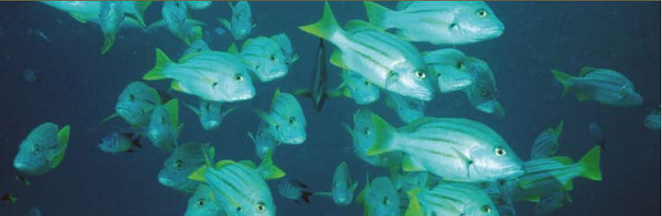

The National Investigation and Reporting Protocol for Fish Kills promotes a consistent national approach in the response to major fish kill incidents in marine, estuarine and freshwater environ¬ments in Australia. The protocol was jointly developed by national, state and territory governments, academic institutions, private industry sectors and conservation/native fisheries agencies. Its development was funded by the Australian Government budget initiative Securing the Future — Protecting our Industries from Biological, Chemical and Physical Risk.
The Primary Industries Standing Committee and Natural Resource Management Standing Committee endorsed the National Investigation and Reporting Protocol for Fish Kills in December 2006.
© Commonwealth of Australia 2007
ISBN 978¬0¬9751859¬9¬5 (paperback)
ISBN 978¬0¬9803843¬0¬7 (CD­ROM)
Photographs used in this publication have been provided courtesy of the Australian Government Department of Agriculture, Fisheries and Forestry (AG­DAFF) and the Great Barrier Reef Marine Park Authority (GBRMPA).
This work is copyright. Apart from any use as permitted under the Copyright Act 1968, no part may be reproduced by any process without prior written permission from the Commonwealth. Requests and inquiries concerning reproduction and rights should be addressed to the Commonwealth Copyright Administration, Attorney General’s Department, Robert Garran Office, National Circuit, Barton ACT 2600 or posted at http://www.ag.gov.au/cca.
The Australian Government Department of Agriculture, Fisheries and Forestry seeks to publish its work to the highest professional standards. However, it cannot accept responsibility for any consequences arising from the use of information herein. Readers should rely on their own skills and judgement in applying any information for analysis to particular issues or circumstances.
For further information regarding the development of this protocol, please see:
Nowak B, Crane M and Jones B (2005). Aquatic Animal Health Subprogram: Development of national investigation and reporting protocols for fish kills in recreational and capture fisheries. FRDC2005/620 Fisheries Research and Development Corporation, Canberra.
or contact
Aquatic Animal Health
Office of the Chief Veterinary Officer Australian Government Department of Agriculture, Fisheries and Forestry GPO Box 858
Canberra ACT 2601
aah@daff.gov.au
Editing: Biotext Pty Ltd, Yarralumla, ACT.
Design: Design ONE, Hall, ACT.
Cover photograph ©GBRMPA

Contents
Background 1
Fish Kill 1
Objective of the fish kill investigation protocol 1
Development of the protocol 1
Stages in the response to a fish kill incident 2
Pre-incident stage 4
Interagency communication 4
Public awareness activities 4
Developing fish kill investigation kits 5
Identifying relevant laboratories 5
Training response officers 5
Implementing changes from debriefs 5
Trigger stage 6
Fish kill notification 6
Determining the need to investigate 6
Roles and responsibilities of agencies in an investigation 7
Investigation stage 9
Investigation process 9
Resources for response officers 10
On-site survey 10
Sampling protocol 10
Submission of samples 12
Reporting during the investigation stage 12
Response actions 12
Communications 13
Internal 13
External 13
Stand-down stage 14
Reporting 14
Debriefing 14
Communication 14
Event closure 14
Records management 14
Appendix 16
Basic fish kill investigation kits — recommended contents 16

Background
Fish kill incidents, although not regular events, are known to occur in natural waterways across Australia.
Most fish kill incidents are not reported in the media.
Identifying the causes of significant wild fish kills may be important to the public, environmental groups, aquaculture, recreational and wild capture fisheries and governments as they may indicate significant environmental changes, disease incidents or major pollution events (both accidental and deliberate). However, the causes of fish kill incidents often remain unknown, and investigations to determine the cause are often complicated by the number and range of agencies that may be involved, even within individual jurisdictions.
These problems hinder appropriate management decisions being made to prevent future fish kill incidents.
Identifying the cause of a fish kill incident as soon as possible will minimise the impact of the incident, demonstrate Australia’s surveillance and monitoring capability at the international level, underpin export market access and strengthen our national biosecurity initiatives.

Fish Kill
A fish kill is defined as a significant and sudden death of non­mammalian aquatic animals. This definition applies to mortality events that occur in the wild (including both commercial and non commercial wild aquatic animal species), but does not refer to events occurring in aquaculture, although it is acknowledged that aquaculture operations may well be impacted by, or contribute to, fish kill events in the wild.
Note, ‘significant’ here is meant in the broadest terms (that is, any unusual occurrence in terms of either numbers or types [size, species] of aquatic animals involved).

Objective of the fish kill investigation protocol
This protocol aims to streamline the investigation and reporting of major fish kill incidents in marine, estuarine and freshwater environments in Australia, and to promote a consistent national approach in response to such incidents across states and territories. A nationally consistent approach will improve the management and prevention of such incidents, and the sharing of relevant information (such as response or diagnostic techniques) between jurisdictions.
The protocol sets out the recommended minimum requirements for each stage of the management of a fish kill incident, including preparedness, investigation and reporting activities.

Development of the protocol
This fish kill investigation protocol was developed at a national workshop funded by the Australian Government, through its budget initiative Securing the Future — Protecting our Industries from Biological, Chemical and Physical Risk. Workshop participants represented universities, Australian and state and territory government departments with responsibility for fisheries or aquaculture, environmental protection agencies and conservation/native fisheries organisations.
The protocol was reviewed by the National Aquatic Animal Health Technical Working Group and endorsed by the Primary Industries Standing Committee (and its supporting committees — Aquatic Animal Health Committee and Primary Industries Health Committee) and the Natural Resource Management Standing Committee (and its supporting committees — Australian Fisheries Management Forum, and Marine and Coastal Committee). It contributes to the outcomes of Australia’s National Strategic Plan for Aquatic Animal Health: AQUAPLAN 2005– 2010, specifically Strategy 1: Enhanced integration and scope of aquatic animal health surveillance in Australia, Objective 4.

Stages in the response to a fish kill incident
The response to a fish kill incident should follow a logical process, shown in Figure 1, which illustrates the four main stages and the typical steps in an investigation.
While these stages are described as separate events, they should be viewed as part of a continuous process. For example, due to the potential urgency and evolving timeline of an incident, the trigger stage may move immediately into the investigation stage.
The recommended actions for each of these stages are set out in the protocol. The tasks detailed are advisory in nature and are provided as guiding principles. During any incident, the decision to vary or add tasks will be at the discretion of the affected jurisdiction(s).
A number of agencies and personnel are involved in any investigation. The key roles are:
- the lead agency — responsible for leading the investigation and providing the incident coordinator; the lead agency may vary depending on the nature of the incident
- response officers — deployed to the site of the fish kill to conduct an on­site investigation
- the incident coordinator — appointed by the secretary, director general or other senior manager as appropriate; a senior manager who has authority to coordinate the agency’s resources and represent the agency and the area involved in the management of the incident response; responsible for appointing and leading the incident investigation team.

Figure 1 Checklist for responding to a fish kill incident
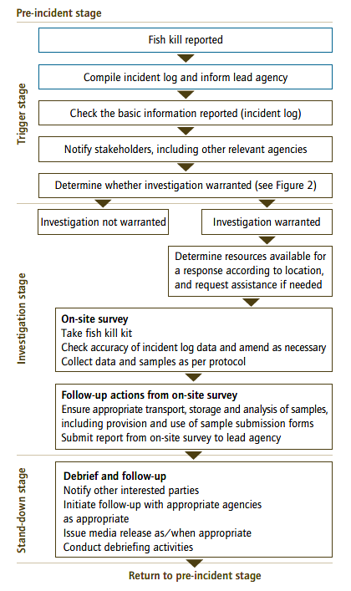

Pre-incident stage
The pre-incident stage is any time that there is not a report of a fish kill incident.
The pre­incident stage encompasses a range of ongoing tasks to develop and maintain an appropriate level of preparedness to facilitate best practice during an incident. During this stage, the following activities are recommended:
- interagency communication
- public awareness activities
- developing fish kill investigation kits
- identifying relevant laboratories
- training response officers
- implementing changes from debriefs.

Interagency communication
Fish kill investigation is a complex process and may involve many government agencies. The roles and responsibilities of the different agencies — based on their legislative responsibilities, expertise, skills and resources — should be determined before a fish kill incident occurs.
The agencies that may be directly involved during a fish kill investigation include the state or territory environment protection agency (or department of environment and conservation) and the department of primary industry or fisheries (or equivalent). It is also important to inform the department of health (or equivalent) so that any queries from the community regarding human health can be addressed.
The lead agency is likely to vary with the nature of the individual incident. However, during the pre­incident stage, agencies should consider pre­determining the lead agency based on certain circumstances (for example, location of fish kill incident in a state or national park). The agencies identified above should also provide each other with details of relevant officers to be contacted following a fish kill notification.

Public awareness activities
Members of the public are often the first to notice incidents in the wild involving animals. Many states have hotlines that are useful and effective ways for the public to pass on such information to government or community agencies. For fish, several hotlines exist for reporting, for example, illegal fishing, fish identifications and fish deaths (for example, Fish Watch, Department of Fisheries, Government of Western Australia). Where a fish kill hotline does not exist, the affected jurisdiction (through the lead agency) should consider establishing one. When a hotline is established, the hotline number should be promoted to the community on relevant websites, fish kill investigation brochures and posters, and during any interactions of relevant staff with the public. Hotlines should be operated 24 hours a day.

Developing fish kill investigation kits
A fish kill investigation kit contains equipment and resources for gathering and recording information during the on­site investigation of a fish kill incident by a response officer. The recommended contents of the kit are listed in the Appendix.
These kits should be sealed and under the control of nominated officers to ensure that items are not used except during incidents. It is also important to routinely check the contents of the kits — for example, the expiry dates, safety information, and registration details of any chemicals; the inclusion of spare batteries for devices such as cameras and aerators; and the inclusion of sufficient copies of the appropriate forms. These routine checks could be carried out by the nominated officer on a regular basis (for example, annually or quarterly, as appropriate).

Identifying relevant laboratories
While developing the fish kill investigation kits, agencies should establish a relationship with the relevant aquatic animal health and testing laboratories during the pre­ incident stage. This will allow laboratories to provide guidance (for example, on sampling techniques) and equipment (for example, water bottles, sample kits) before an event.

Training response officers
Potential response officers should be trained during the pre­incident stage in the use of the fish kill investigation kits. All new staff must be trained; existing staff should be given a refresher course periodically and whenever the kits are significantly updated. Training should be coordinated by the relevant agencies and include standardised sampling techniques and reporting requirements.

Implementing changes from debriefs
The pre­incident stage provides an opportunity to implement changes that have been suggested during debriefing from previous fish kill incidents.
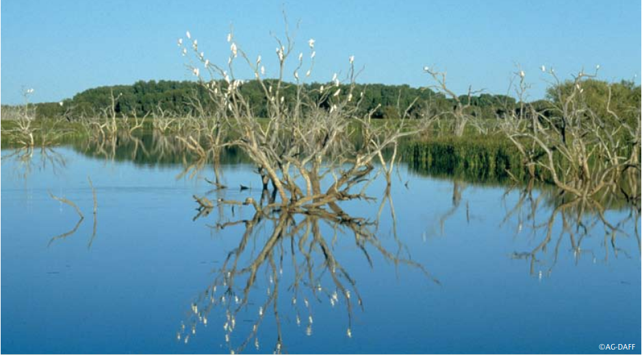

Trigger stage
The trigger stage is activated when a fish kill incident is reported to any state or territory agency.
During the trigger stage, details of the incidentare recorded and an assessment made as to whether the fish kill needs to be investigated to determine its cause.

Fish kill notification
When a fish kill incident is reported (either through a hotline or directly to an officer within a government agency), the following information should be recorded:
- personal identification and return phone number
- date and time of the notification
- location and extent of the incident
- date of observation of the incident
- type of aquatic animal affected (eg fish, mollusc)
- number of dead aquatic animals (and species, if possible) and other wildlife affected
- appearance of dead and any surviving aquatic animals
- flow conditions of the waterway
- weather conditions (current and over the previous 48 hours)
- any signs of discharge (eg pollution) into the waterway
- what actions, if any, have been taken
- who else has been notified.
The agency receiving the report should assess the available information and determine the appropriate type of response.

Determining the need to investigate
The main reason to investigate a fish kill incident is to determine its cause, as fish kills can indicate that there is an emerging environmental or pollution problem, or an outbreak of a new disease. Information from the investigation will assist in maintaining appropriate levels of environmental protection, natural resource protection, and aquatic animal disease control. This, in turn, will help manage public safety, public concern, and economic impacts relating to tourism and other industries dependent on aquatic resources.
The decision to proceed to the investigation stage is at the discretion of the affected jurisdiction(s), with such decisions made on a case­by­case basis. This decision should be undertaken by an appropriate person, which in most cases will be an experienced incident coordinator. For this reason, it is important to identify and collate the available information and report directly to the incident coordinator for further advice.
A decision tree is a useful tool to help decide on the appropriate response to an incident (Figure 2). However, there may be many factors to consider and it is recommended that advice is sought from an experienced incident coordinator.
The criteria used to trigger a fish kill investigation in Figure 2 below (for example, average body length of affected or dead fish >100 mm, more than 20 fish dead) have been used in this example for illustrative purposes only and are not intended to provide specific guidance on when/whether an incident requires further investigation. Agencies are encouraged to develop their own guidelines in consultation with experienced incident coordinators/personnel.
Figure 2 Example of a decision tree to determine whether a fish kill investigation is warranted
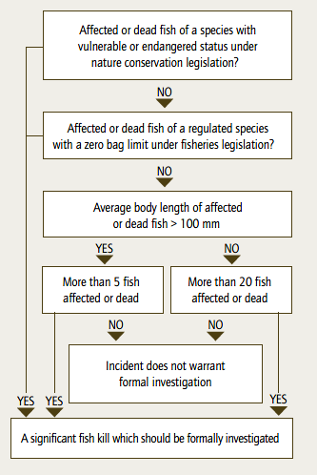

Roles and responsibilities of agencies in an investigation
If the incident is to proceed to the investigation stage, the agency receiving the initial report of the incident should notify other relevant agencies and reach an agreement as to who will act as the lead agency and who will provide support. If some agreement has been reached during the pre­incident stage, the lead agency should reaffirm its ability to act in this role (or seek assistance if it is unable to act). The lead agency is responsible for leading the investigation and providing the incident coordinator. However, full cooperation, resource and information sharing, and debriefing between agencies are essential for a successful fish kill investigation.
The incident coordinator should be appointed within the lead agency by the secretary, director general or other senior manager as appropriate within each jurisdiction. An incident coordinator checklist (Form 6) is a useful tool to guide the incident coordinator in their role and to help ensure that all appropriate tasks are completed.
If an investigation is to occur, regional directors within the response agencies and the appropriate media units should be notified. If no response/investigation is undertaken, other agencies may still need to be notified of the fish kill incident.
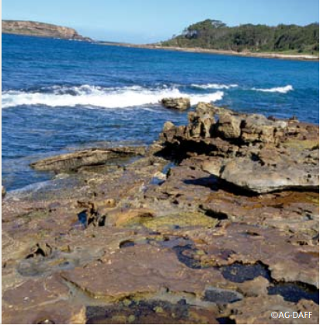

Investigation stage
The investigation stage begins if the decision to investigate the incident is made.

Investigation process
Following the decision to investigate a fish kill incident, the incident coordinator should appoint (as necessary) people to the five positions listed in Table 1. Collectively, these positions comprise the incident investigation team.
The recommended steps in an investigation include:
- collection of all information received to date on the fish kill incident
- deployment of response officers — since evidence deteriorates rapidly, site inspection should be undertaken as soon as possible
- on­site survey at the fish kill location, including the collection and storage of samples, evidence, photos, etc
- reporting on the on­site survey
- analysis and interpretation of data and results of sample analysis — this should be done in consultation/conjunction with the testing laboratory
- follow­up investigation and initiation of further actions dependent on the results of the sample testing — for example, if it is determined to be an environmental cause, actions may be put in place to avert future incidents; similarly, if the cause is determined to be an infectious disease, actions may be undertaken to identify the source of the disease and reduce the risk of disease spread.
During the investigation stage, the incident coordinator should notify other relevant government agencies of actions taken, and seek advice and support where necessary.
Table 1 Roles and responsibilities of officers assigned to a fish kill incident
Position | Role and responsibility
Response officers | Deployed to the site of the fish kill to conduct an on­site investigation.
Communications  manager | Responsible for coordinating communications activities, formulating and disseminating information to key stakeholders affected by the investigation, and releasing and capturing information from television, radio, print and internet media.
Laboratory liaison | Responsible for collating information from one or more laboratory.
Reporting officer | Responsible for compiling reports and drawing together information from all sources, including field and laboratory data.
Records manager | Responsible for ensuring that accurate records of meetings, investigations, laboratory results etc are compiled and stored appropriately (including electronic and hard­copy files or databases)

Resources for response officers
Nominated response officers, before leaving for the site, should ensure that they have the following resources:
• fish kill investigation kit (the officers should check the contents, especially the expiry dates and safety information for any chemicals).
• camera (unless already in the kit).
• fish kill incident log (Form 1) — used to record details of both the initial report and the on­site investigation to ensure that the current situation is accurately reflected.
• communications log (Form 2) — used to record details of all communication activities, by all members of the investigation team, during an investigation.
• job safety analysis record (Form 3) — used to assess potential risks and to ensure that officers have any equipment required to minimise these risks; risk assessment needs to be undertaken before the investigation and reviewed on site.
• chain­of­custody record (Form 4) — this tracks the movement of samples between parties; it should be signed each time the samples change hands and should be sent with a copy of the submission form and the samples to the aquatic animal health laboratory.
• interview record (Form 5) — provides a template for response officers to record witness accounts on site.
The response officers should also contact the state or territory aquatic animal disease diagnostic laboratory to seek advice on the collection of samples (if this information is not already included within the kit).

On-site survey
At the location of the fish kill, the response officers should complete the relevant sections of the fish kill incident log (Form 1). In addition to the information required on this form, the officers should also interview any witnesses (completing Form 5) and take photographs of the site.

Sampling protocol
Samples need to be taken from the aquatic animals and the environment, and must be stored and submitted to the appropriate laboratories for testing. Aquatic animal samples should be taken first as these will deteriorate rapidly, reducing the suitability of samples for diagnostic testing. Whole fish are preferable, but samples from major organs may be taken (see Table 2 for suitable procedures) and must be stored appropriately (see Table 3).
Table 2 Procedures for animal sampling
Sample | Procedure
Whole fish | - place in clean water  - take photographs  - describe external lesions
Dissected  animals | - photograph internal lesions  - take samples, aseptically if possible, from major organs (that is, gills, kidney, liver, spleen, heart, skin/muscle, gut, gonads [if sexually mature animals are sampled], brain)  - take samples for toxicological analysis
Table 3 Sample storage methods
Analysis | Sample storage method
Bacteriology, virology, molecular diagnostics, toxicology. | Fresh on ice.
Diagnostic polymerase chain reaction (PCR) assay. | 70% ethanol or RNAlater.
Histological procedures | <1 cm cube placed in formalin (1:10 tissue weight: formalin volume)
Toxicant residue analysis (toxicology) | Frozen gill

Prompt evaluation of the site environment is also fundamental to the successful investigation of fish kills. Environmental parameters change rapidly and any delay in obtaining data severely compromises the likelihood of a successful investigation.
Water samples should be collected from at least three points (at the kill site, upstream and downstream) for laboratory testing of nutrients, heavy metals, sulfides, phytoplankton, pesticides and sediment. Noting, for each of these substances, a different test is required. The submitter should provide guidance to the testing laboratory based on the on­site circumstances (for example, visible discharge into the waterway, excess algal blooms). Additionally, if a pathological examination excludes infectious causes of kill, the investigator is directed to environmental or toxic causes of the kill.
It is important to have suitably stored water and tissues to go back to in such cases. Background levels of toxicants vary within and between species, ages and geographical locations. Care is necessary to identify an expected background level in water or tissues and not ascribe such to a pollution event.
It may also be necessary to collect samples from upstream and/or downstream of any suspected pollution sources. The sampling locations should be recorded on the fish kill incident log (Form 1). Any samples taken should be recorded on the sample submission form provided by the relevant laboratory.

Submission of samples
The response officers should:
- contact the diagnostic laboratories to inform them of incoming samples (ensuring that appropriate records of this contact are kept through the use of the communications log [Form 2] and the chain­of­custody record [Form 4]) — this will facilitate the collection of the samples on arrival at, for example, the airport or docking bay.
- complete sample submission form(s)
- reconfirm transport arrangements as needed (the use of emergency transport procedure forms or dangerous goods transportation forms may be required in some jurisdictions).

Reporting during the investigation stage
Once the response officers have completed all of the relevant forms (fish kill incident log, interview record, etc; noting, the response officers should ensure that the details of the initial notification are included on the fish kill incident log), these should be provided to the incident investigation team. The reporting officer can then use this information to produce an initial investigation report for circulation to the relevant agencies.
Following the collection of samples, the chain­of­custody record (Form 4) should be submitted with the samples to the diagnostic/analytical laboratory, along with any sample submission forms, as required by the laboratory.
The response officers should then inform the incident coordinator that the samples have been submitted to the laboratory, and forward copies of the sample submission form(s) to the incident coordinator and the records manager for appropriate storage (for example, registry).
The incident coordinator should contact other relevant agencies as appropriate. Within agencies, reporting to ministers and the senior management should occur in accordance with regular reporting protocols and procedures.
As new and significant results (or other relevant information) are obtained, these data should be collated by the reporting officer who should prepare regular situation reports/updates for approval by the incident coordinator and subsequent circulation to all relevant agencies. The confidentiality of this information is at the discretion of the lead agency.
The reporting officer (in consultation with the records manager) should ensure that all relevant information is appropriately stored so that it can be drawn upon for the final diagnostic report, which is to be completed during the stand­down stage.

Response actions
At the discretion of the incident coordinator (in consultation with senior management within the lead agency and other relevant agencies, as appropriate) actions may be implemented to prevent further deaths. Follow­up monitoring and reporting may be put in place until the event is resolved (that is, upon return to the pre­incident stage).
The response actions will need to be determined on a case­by­case basis.

Communications
Communication is a vital element of any emergency response. Timely, clearly articulated and well­delivered communications substantially shape people’s willingness and capacity to help resolve the emergency and prevent disruption to the response strategy.

Internal
All members of the incident investigation team should complete the communications log (Form 2) for all activities carried out as part of an investigation, such as telephone contact with diagnostic laboratory, email contact with relevant departments, and so on.

External
Several organisations, media and members of the public have legitimate interest in fish kill incidents, any subsequent investigation and the outcomes of these activities.
To avoid transfer of inaccurate information, minimise potential confusion and demonstrate competent management of the incident to the media and the public, a set of media procedures should be developed and adhered to. These procedures will also ensure consistency of information provided and minimise the likelihood of conflicting reports from different agencies.
The development and implementation ofthese procedures should be overseen by the communications manager, and should include the:
- recognition of one person as the common communications manager for
  - all media inquiries
  - issuing of all media releases
  - management of media interviews with experts.
- development and circulation to the incident investigation team of an up­to­date list of contacts for all agencies involved (including environment agency, fisheries agency, aquatic animal health laboratories, boating and fisheries patrol, local government, analytical laboratories and technical advisors).
- development of talking points, as appropriate, for senior staff and ministers. If appropriate, agencies could develop these media procedures during the pre­incident stage.


Stand-down stage
The stand-down stage occurs when there will be no further investigation of the incident.
The stand­down stage occurs either when the trigger stage identifies no need for further investigation, or when the investigation stage of the incident is complete and activities return to the pre­incident stage. The stand­down stage includes preparation of a final report, debriefing, and collation and storage of relevant documents.

Reporting
Following the investigation, a post­result analysis, with conclusions, should be prepared by the reporting officer for the final diagnostic report. The analysis needs to be cleared by the incident coordinator and/or senior management within the lead agency and circulated to relevant agencies.

Debriefing
Debriefing facilitates the continual improvement of emergency preparedness and response. It is important to confirm what worked well and what did not, to capture those lessons and incorporate them into plans, procedures, arrangements, facilities or training to improve the management of future incidents. Debriefs also provide an opportunity for those involved to achieve closure regarding the incident.
The incident debriefing should be conducted with all agencies that were involved in the response to a fish kill notification (ie those involved in both the trigger and investigation stages), and should aim to identify actions to improve the response (ie investigation, communication) to future fish kill notifications.

Communication
Consideration should be given to issuing a final media release to stakeholders noting that the incident is officially closed. There should be consultation with, and agreement from, relevant agencies before the release of this statement.

Event closure
There should be a formal recognition of the closure of the event. This could accompany the circulation of the final report and actions.

Records management
Copies of the following items should be provided to the records manager for appropriate storage:
- all communication logs from the incident investigation team
- all communication with media outlets or other external groups
- any agendas, minutes and action lists relating to meetings about the incident investigation team or other groups as appropriate.
- fish kill incident log, chain­of­custody record, interview record and other forms, as appropriate.
Where a fish kill database exists, relevant summary data should be recorded in the database according to jurisdictional operating procedures.

Appendix

Basic fish kill investigation kits — recommended contents
Table 4 Fish kill investigation kit checklist
Item | Added Y/N
Paperwork
Contents checklist
Checklist for each activity to be done
Sampling protocol
Waterproof notebook
Contact person list
Forms:
- fish kill incident log (Form 1)
- communications log (Form 2)
- job safety analysis record (Form 3)
- chain­of­custody record (Form 4)
- interview record (Form 5)
Equipment
Camera(s) (digital or note caution with expiry of film)
Fish diagnostics — for sampling fresh animals (live moribund animals taken quickly to laboratory if close/possible, otherwise bagged, labelled and put on ice)
Plastic bags
Aluminium foil
Esky
Waterproof labels
Pen/pencil
Ice bricks (frozen)
Sample containers
Aerator
Batteries, 12 volt (for aerator)
Fish diagnostics — for tissue samples
Formalin working solution and associated safety formsª
Packing tape
Containers
Disposable gloves
Collection
Telescopic scoop net with suitable^{b} mesh size
Aquatic animal identification manuals/photo sheets
Bucket (at least 10­litre capacity) with lid
Ruler/fish metre board
Knife
Dissection kit
Water sampling
Sampling beaker to go on pole
Solvent­washed bottle for water (x6)
Acid­washed bottle for water (x6)
Lugol’s iodine and container (approx 1–5 mL per 100 mL water sample for phytoplankton) (x6)
Plastic bottles for nutrient sampling
Sediment sampling
Solvent­washed bottle for sediment (x6)
Acid­washed bottle for sediment (x6)
Cleaning equipment and disinfection
For example, Decon90® or Virkon® tablets (as appropriate)
Environmental monitoring
Thermometer
Dissolved oxygen bottles — Winkler reagent
pH strips
Safety
Safety glasses
Apron (made from waterproof fabric/plastic)
Sharps container
Eye wash bottle
Disposable latex gloves
Thicker nitrile gloves
Material Safety Data Sheet (MSDS)^{c}
Sunscreen
Dust mask (of appropriate class)
First aid kit
Disposable overalls (waterproof or splashproof)
Shipping documents
Sample submission form (from relevant laboratory)
Emergency goods transport form
Note: the kit can be broken into two parts to make it easier to carry. a Subject to suitability of formalin working solution. b Mesh size should be determined during kit development. c It is an occupational health and safety requirement that the manufacturer provides a hard copy of the data sheet for chemical or biological materials. The MSDS alerts the user to any cause for concern (toxicity/mutagenicity/ teratogenicity, etc) when handling the provided material.

