The national aquatic animal disease surveillance strategy

The national aquatic animal disease surveillance strategy is an industry-government strategy that addresses Australia’s surveillance system for infectious diseases of national significance within populations of wild and farmed aquatic animals in Australia. Production of the strategy was coordinated by the Aquatic Pest and Health Policy section, Biosecurity Animal Division, within the Australian Government Department of Agriculture, Fisheries and Forestry.
The strategy was endorsed by governments through the Sub-Committee on Aquatic Animal Health and Animal Health Committee. The plan was endorsed by industry through representatives of the aquatic animal industry’s peak bodies.
© Commonwealth of Australia 2025
Ownership of intellectual property rights
Unless otherwise noted, copyright (and any other intellectual property rights) in this publication is owned by the Commonwealth of Australia (referred to as the Commonwealth).
Creative Commons licence
All material in this publication is licensed under a Creative Commons Attribution 4.0 International Licence except content supplied by third parties, logos and the Commonwealth Coat of Arms.

Cataloguing data
This publication (and any material sourced from it, unless otherwise specified) should be attributed as: DAFF 2024, The national aquatic animal disease surveillance strategy, Department of Agriculture, Fisheries and Forestry, Canberra, December CC BY 4.0.
This publication is available at agriculture.gov.au/agriculture-land/animal/aquatic/aquaplan.
Department of Agriculture, Fisheries and Forestry
GPO Box 858 Canberra ACT 2601
Telephone 1800 900 090
Web agriculture.gov.au
Disclaimer
The Australian Government acting through the Department of Agriculture, Fisheries and Forestry has exercised due care and skill in preparing and compiling the information and data in this publication. Notwithstanding, the Department of Agriculture, Fisheries and Forestry, its employees and advisers disclaim all liability, including liability for negligence and for any loss, damage, injury, expense or cost incurred by any person as a result of accessing, using or relying on any of the information or data in this publication to the maximum extent permitted by law.
Acknowledgements
The authors would like to thank the industry-government writing group: Julie Petty, Colin Johnston, Tracey Bradley, Stephen Wesche, Matthew Bansemer and Rissa Williams for their contributions and guidance in developing the strategy. We would also like to thank the numerous industry and government representatives who attended and contributed to the online consultation sessions to develop the strategy, and who provided their comments and feedback on the discussion paper and draft strategy.
Acknowledgement of Country
We acknowledge the continuous connection of First Nations Traditional Owners and Custodians to the lands, seas and waters of Australia. We recognise their care for and cultivation of Country. We pay respect to Elders past and present, and recognise their knowledge and contribution to the productivity, innovation and sustainability of Australia’s agriculture, fisheries and forestry industries.

Contents
Strategy blueprint iv
Introduction 6
Purpose 7
Scope 7
Objectives of the national surveillance system 8
Overview of the national aquatic animal disease surveillance system 9
Types of surveillance 9
System components 11
Drivers for a national surveillance strategy 13
Aims of the strategy 15
Roles and responsibilities 15
Governments 15
Industry 16
Private aquatic animal health services 16
Research organisations 16
Training and education providers 17
Surveillance principles 17
Planning 17
Priorities 17
Data use and sharing 17
Standards 18
Funding and capability 18
Equity 18
Measuring the performance of the national surveillance system 18
Application of this Strategy 20
Appendix A Process to develop the strategy 21
Appendix B Existing national agreements, plans and policies 22
Appendix C Definitions 23
Appendix D Acronyms and abbreviations 23

Strategy blueprint
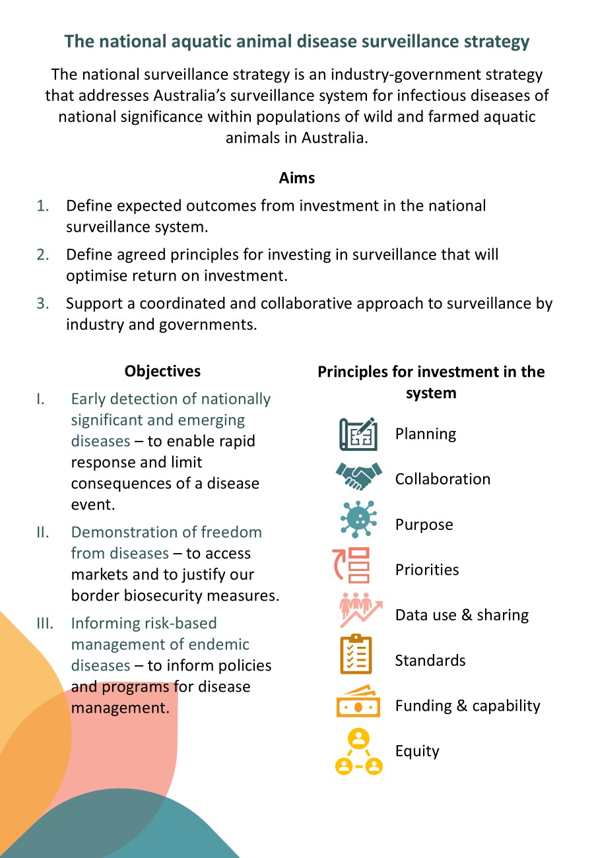
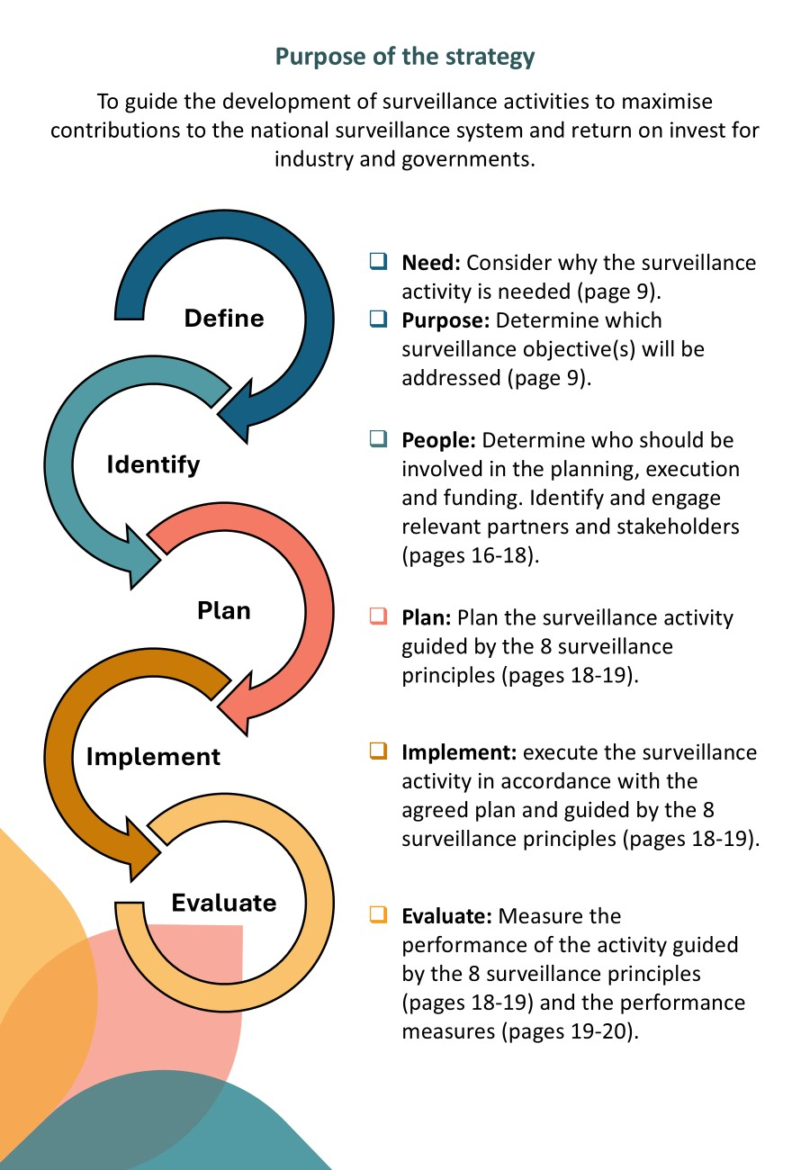

Introduction
‘Surveillance’ is a systematic series of investigations of a given population of aquatic animals to detect the occurrence of disease for control purposes, which may involve testing samples of a population (as defined in the WOAH Aquatic Animal Health Code).
Surveillance is a fundamental component of aquatic animal health management systems. It is important for early detection of nationally significant diseases, to inform measures to limit the spread of the disease (such as translocation policies and regional biosecurity measures) and to provide evidence of disease absence to meet market requirements. Surveillance information can provide additional benefits beyond these fundamental objectives, such as informing management decisions to optimise productivity, identifying disease risk factors and informing research priorities.
There has been significant investment in Australia’s aquatic animal disease surveillance system over the past 25 years. However, surveillance needs are changing, driven by changes within the seafood industry, changes in the environment, technological advances, changing requirements of trading partners, and new and emerging disease threats. Australia’s national surveillance system will need to evolve to address and anticipate some of these changes.
Through Australia’s fourth national strategic plan for aquatic animal health, AQUAPLAN 2022–2027, industry and governments identified a need for the industry and government investors in aquatic animal disease surveillance to collaboratively develop a national surveillance strategy.
The national surveillance strategy aims to identify common needs and objectives that can inform investment in the surveillance system and maximise return on investment among users and investors. The process to develop this first national aquatic animal disease surveillance strategy is summarised in Appendix A Process to develop the strategy

Purpose
The national aquatic animal disease surveillance strategy (national surveillance strategy) provides clarity on surveillance objectives, roles and responsibilities, and principles for investment in the national surveillance system. It recognises the strengths of the existing surveillance system and provides an agreed framework from which improvements can be made.
The national surveillance strategy also provides a framework against which aquatic animal industry sectors can choose to develop sector-specific surveillance plans, through AQUAPLAN 2022-2027 Activity 3.2. Through Activity 3.2, participating sectors, in consultation with governments, will agree on desired surveillance outcomes for their sector and identify the necessary surveillance activities to achieve them, including for specific diseases.
The surveillance strategy is not intended to identify specific activities or projects to strengthen the aquatic animal health surveillance system. Agreed activities to strengthen the surveillance system are included in Australia’s national strategic plan for aquatic animal health, AQUAPLAN 2022–2027, and are complementary to this strategy.

Scope
This national surveillance strategy addresses Australia’s surveillance system for infectious diseases of national significance within populations of wild and farmed aquatic animals in Australia. This scope includes exotic and emerging diseases and nationally significant endemic diseases of aquatic animals.
Some issues are not considered within the strategy because their associated surveillance objectives, roles and responsibilities, and investment principles would differ from those of the scope described above: for example, the disease status of aquatic animal populations outside of Australia and products derived from them, non-infectious diseases, marine pests, environmental toxins, microbes that may affect food safety, and chemical pollutants. Whilst excluded from the scope of this strategy, these issues may be addressed through other initiatives and where appropriate in a manner that is complementary to this strategy. It is acknowledged that these issues may also represent risk factors that should be considered when developing national surveillance programs.

Objectives of the national surveillance system
Aquatic animal disease surveillance is undertaken to achieve the following three key objectives, and outcomes, of the national surveillance system:
- Early detection of nationally significant and emerging diseases. Early detection is critical to increase opportunities to contain or eradicate a disease, thereby reducing response costs and economic, social, and environmental consequences of a disease event.
- Demonstration of freedom from diseases. Sound evidence of freedom from diseases (including country, zone, and compartment freedom) is important to meet our international obligations, to access domestic and international markets and to justify our border biosecurity measures (including national, state and territory measures).
- Informing appropriate risk-based management of nationally significant endemic diseases. Knowledge about the distribution of nationally significant endemic diseases informs policies and programs for disease management such as translocation policies and zoning arrangements.

Overview of the national aquatic animal disease surveillance system
Australia’s surveillance arrangements have been developed over time to meet a variety of stakeholder and end user needs. The national aquatic animal disease surveillance “system” consists of numerous activities and components, with responsibilities and investments shared among the private (aquatic animal industries, service providers) and public sectors (government authorities).
The aquatic animal disease surveillance system is closely linked to the broader animal health surveillance system. These linkages are most pronounced in areas of government responsibility (e.g., common regulation for terrestrial and aquatic animal surveillance) but can be distinguished in areas of policy (e.g., sector-specific measures), end users (e.g., aquaculture industries) and some areas of expertise.

Types of surveillance

Passive surveillance
Passive surveillance is defined as observer-initiated animal health surveillance. It often relies on observations of clinical or behavioural signs of disease (including from mortality or production data) and subsequent actions to investigate and diagnose the cause of the disease event. Passive surveillance is fundamental to achieving the objectives of the national surveillance system.
The sensitivity of passive surveillance for a given population may be affected by many factors along a chain of events from when a disease event is observed or suspected and leading to the diagnosis or exclusion of significant diseases. For example, passive surveillance is considered less sensitive in wild than in farmed populations because it is less likely that signs of disease or mortality will be observed in wild populations.
Australia’s passive surveillance system must meet international standards if it is to provide evidence to demonstrate and maintain freedom from aquatic animal diseases for trade and border biosecurity purposes. These standards are defined in the WOAH Aquatic Code and require that:
- observers have an awareness of the signs of listed diseases
- aquatic animal health professionals are trained in recognising and reporting listed diseases
- there is capacity to investigate disease events
- there is appropriate diagnostic capability
- there is a legal obligation to report suspicion or occurrence of listed diseases.
Passive surveillance offers many benefits, including being based on continuous observations (rather than a point in time, as is the case in active surveillance), it is cost-effective, and it is more likely to detect a new or emerging disease than targeted surveillance. However, passive surveillance may not always be effective for early detection or demonstration of freedom because it requires conditions in which disease signs would occur, be observed and subsequently investigated should the disease be present.
Improving how quickly aquatic stakeholders (e.g., farmers, fishers, processors, etc.) notice signs of disease and recognise it as a problem warranting further investigation is one of the most effective ways to improve sensitivity of passive surveillance.

Active surveillance
Active surveillance activities are initiated by an investigator using a defined protocol and are generally conducted on a sector-specific basis with specific goals in mind (e.g., market access, delimitation, etc.). A subset of active surveillance is targeted surveillance, where sampling and testing for a specific pathogen is planned and implemented.
For aquatic animal diseases, targeted surveillance is often implemented on a sector-specific basis to provide evidence of freedom from a particular pathogen, or multiple pathogens of interest. In recent years, governments and industries have jointly contributed to active surveillance to provide evidence of freedom. Some recent examples include national surveys to demonstrate freedom from white spot syndrome virus in wild crustaceans, megalocytiviruses in farmed ornamental fish, several diseases in wild and farmed abalone, and several pathogens in hatchery reared barramundi.
Additionally, industry sectors invest in targeted surveillance for other purposes; for example, to meet state and territory regulatory requirements for translocation of aquatic animals or for disease management purposes on farm. The investment in this type of surveillance by industry is substantial and provides a valuable source of information on Australia’s aquatic animal health status. A current example of a functioning active surveillance system is the national abalone health accreditation program where industry undertakes regular sentinel testing and annual audits of their biosecurity plans. This activity is completely funded by industry to support international and interstate movements and access to markets.
Benefits of active surveillance include that it can provide a comprehensive snapshot on disease status and can be particularly useful in demonstrating freedom from disease. However, active surveillance is costly.
Active surveillance activities must meet international standards if they are to provide evidence to demonstrate and maintain freedom from aquatic animal diseases for trade and border biosecurity purposes. The international standards for active surveillance are specified in Chapter 1.4 and the relevant disease-specific chapters of the Aquatic Code.

System components

Policy and regulation

National arrangements
Australia’s surveillance arrangements are developed to be consistent with the international standards of the WOAH, particularly where there is a need to substantiate our freedom from specific diseases – either for international market access or to justify our border biosecurity measures. The international standards for surveillance and demonstration of freedom are specified in the WOAH Aquatic Code.
Australia’s national list of reportable diseases of aquatic animals provides an agreed list of significant aquatic animal diseases that are reported on by state and territory governments to the Australian Government. The information is used to meet Australia’s international reporting requirements (e.g., to WOAH) and to provide evidence of our disease-free status for many WOAH listed diseases and other diseases of significance to Australia.

State and territory regulatory framework
State and territory governments have responsibility for managing aquatic animal diseases within their jurisdiction. They have regulatory instruments in place to require reporting of the presence or suspicion of significant diseases (including those on the national list) or for reporting of general disease signs (e.g., morbidity or mortality) that exceed certain thresholds. They also have surveillance and testing requirements under some circumstances to manage specific disease risks associated with translocation of aquatic animals within or between states.

Data collection and storage
Aquatic animal health data is collected through the national surveillance system. Aquaculture businesses collect and store aquatic animal health data for many purposes including biosecurity risk management, to inform husbandry practices, to meet customer requirements, and to meet regulatory requirements. Some of this data is provided to state and territory governments for specific regulatory purposes (e.g., translocation or disease reporting).
Governments, including the Australian, state and territory governments, collect aquatic animal health data from various sources including reporting of disease events, active surveillance programs, disease and fish kill investigations, fisheries and environmental surveys, translocation testing and research trials.
Data is collected, handled, stored and analysed in different ways by different businesses, industry sectors or government agencies. The approaches are usually developed to serve the needs of the individual data owner (e.g., laboratory information management systems, farm management software), rather than to meet shared needs or common goals. Data management may become increasingly important for surveillance activities that generate substantial data sets (e.g., metagenomics, whole genome sequencing). Investment in more universal approaches to data collection, storage and handling may be beneficial in some circumstances where it provides common benefit, leverages the investment in surveillance, and manages risks effectively.

Laboratory testing
Reliable laboratory testing is a key element of the national surveillance system. Australia has a network of government laboratories in the states and Northern Territory that have complementary expertise determined by the aquatic animal species and associated diseases of importance to them. The CSIRO Australian Centre for Disease Preparedness is the national reference laboratory for aquatic animal diseases and provides services for exclusion testing for exotic or other significant diseases. In addition, the private sector is providing an increasing level of diagnostic services to the aquaculture industry.
A range of measures are in place to underpin the quality of our diagnostic services. These include regulatory requirements, diagnostic standards, proficiency testing programs, and accreditation of quality management systems. Ongoing research, development and extension (RD&E) provides continual improvement to Australia’s diagnostic capability. RD&E investment to develop and validate diagnostic methods has been substantial with several Australian-developed and/or validated methods included in international standards as well as Australia and New Zealand Standard Diagnostic Procedures.

Drivers for a national surveillance strategy
Surveillance requirements are changing, and Australia’s national surveillance system will need to evolve to address, and anticipate, some of these changes and future trends. Some of the key drivers for developing a national aquatic animal health surveillance strategy are explored below.

New and emerging disease threats
Disease is a common and significant threat to Australia’s aquatic animal industries, including aquaculture, fisheries and ornamental industries, and aquatic environments. Disease can rapidly destroy businesses and impact aquatic animal resources.
There are many factors that contribute the emergence and spread of aquatic animal diseases, including the rapid growth of aquaculture, increasing domestication of species, the high diversity of farmed species, intensification of production, production in new environments, and large trade volumes. Changing environmental conditions (e.g., changes in water quality, climate, and pollution levels) and introduced aquatic pests and weeds can also impact the emergence and spread of aquatic animal diseases.
The national surveillance system needs to detect and respond to new and emerging disease threats.

Industry growth
Australia’s seafood industry focuses on premium products that generate significant economic value. Australia’s commercial fisheries and aquaculture sectors were valued at $3.42 billion in 2021–22, with $1.44 billion (or 44%) of this attributed to wild catch and $1.94 billion (or 56%) to aquaculture. As Australia’s aquatic animal industries continue to grow, and business consolidation occurs, so does the need to apply biosecurity measures to protect investment. Biosecurity measures at an enterprise or regional level are underpinned by surveillance to determine health status, assess risk and support management decisions. Surveillance is expensive so creating efficiencies through this strategy is desirable.

Social license
Australia is fortunate to have a diverse array of unique native species that support Australia’s aquatic ecosystems. Many of these native species are also farmed or fished across Australia. Community awareness of the importance of these native species and unique aquatic environments is strong. Seafood businesses may be challenged to demonstrate through surveillance outcomes that their activities do not affect the health of wild populations of aquatic animals.

Trade
Australia’s favourable disease status supports market access for seafood exports. However, trading partners are increasingly requiring assurance that export products meet their sanitary requirements. For example, claims of freedom for diseases may need to be supported with a higher standard of evidence as importing countries tighten their requirements, including for zone or compartment freedom. This trend is likely to continue, and Australia’s national surveillance system will need to provide the necessary data to meet the individual requirements of different markets.
Domestic translocation of live aquatic animals (including broodstock and genetic material) is necessary for efficient investment in domestication and genetic improvement. However, the aquatic animal health risks of translocation need to be assessed, and surveillance underpins the risk assessment process.
Changing diagnostic methods and technologies
New diagnostic approaches and technologies are being developed that are becoming powerful tools for field and laboratory application (e.g., the use of environmental DNA, point of care tests, metagenomic methods). While these new technologies are proving valuable, their appropriate application and performance for specific purposes of use must be determined. This is especially important where a given diagnostic tool is used to support decision-making.

Changing risk pathways and environments
Different factors or events can influence aquatic animal disease surveillance in different ways. Some factors may influence the disease, including transmission, replication, and the development of clinical disease (e.g., pathogen, host, environment, and husbandry factors). In this instance, surveillance can be used to identify factors that contribute to the disease risk (e.g., water temperature) and to inform management interventions. However, it is also important that the surveillance system can adapt and respond to changes in factors or events that influence disease risk.
Some factors or events can influence the emergence or spread of a disease (e.g., pathogen specific changes, changes in the environment, production methods, trade patterns, etc.). Identifying these types of changes is important for the effective allocation of surveillance resources and for managing biosecurity risks. The national surveillance system needs to be flexible and adaptive enough to cope with such changes and have the appropriate mechanisms in place to deal with changes in data analysis and interpretation methods (e.g., as new scientific information or technology arises).

Aims of the strategy
The national aquatic animal disease surveillance strategy aims to:
- Support a coordinated and collaborative approach to surveillance by industry and governments.
Industries and governments are the principal investors and users of surveillance information. Improved coordination and information sharing, between industry and governments, and across jurisdictions, will strengthen the surveillance system and likely improve efficiency and maximise common benefit. Clarity on roles and responsibilities will also facilitate coordination.
- Define agreed principles for investing in surveillance that will optimise return on investment for industry and governments.
The development and adoption of agreed principles for investing in surveillance will ensure benefits and uses of surveillance information can be maximised. These principles could serve as guidance for both shared and individual investments.
- Define expected outcomes from investment in the national surveillance system.
By defining the desired outcomes of the national surveillance system there is a possibility to measure the effectiveness of investments and the degree to which the system is meeting end-user needs.

Roles and responsibilities
Responsibilities for aquatic animal health surveillance are shared among the public (Australian Government, state and territory governments) and private (aquatic animal industries) sectors. This section details the roles and responsibilities of each of those parties.

Governments
The Australian Constitution defines the responsibilities of governments with respect to animal health. The Australian Government is responsible for border biosecurity and international engagement such as international disease reporting, export certification and technical trade negotiation. The Australian Government also provides funding to support Australia’s national reference laboratory for aquatic animal diseases at the CSIRO Australian Centre for Disease Preparedness. The Australian Government also has a coordination and support role during an emergency response.
State and territory governments are responsible for disease control within their borders, including disease investigation, diagnostic services and surveillance. Each jurisdiction has its own animal health legislation that defines the legal requirements for reporting listed diseases and requirements for testing when animals are translocated. The diseases listed within each jurisdiction include all those on Australia’s national list of reportable diseases of aquatic animals and additional diseases that may be of particular concern to that jurisdiction. Each jurisdiction provides information on the presence or absence of diseases on the national list to the Australian Government on a quarterly basis. This information is used to meet Australia’s international reporting obligations and to substantiate Australia’s disease status. Jurisdictions also maintain their own aquatic animal health laboratories.
Other government agencies (e.g., environment or human health agencies) may also be responsible for leading investigation of fish kills, for monitoring environmental toxins and microorganisms that may affect food safety, and for monitoring water quality and pollution levels. These agencies collect useful, complementary data that may be useful for disease investigations and understanding disease transmission and spread.

Industry
Aquaculture businesses are responsible for the health of the aquatic animals they own. Businesses have a vested interest in maintaining a high standard of aquatic animal health to facilitate productivity, product quality and welfare outcomes. Businesses are responsible for knowing and meeting their legal biosecurity responsibilities. Businesses must also ensure they meet domestic or international trade requirements which typically includes a combination of passive and active surveillance activities. Businesses are responsible for the cost of meeting these requirements; for example, testing to meet translocation requirements. Under some circumstances (e.g., mortality thresholds, suspicion of notifiable diseases), business owners or managers have a legal obligation to report diseases to the relevant state or territory government authority.
Other seafood industry stakeholders, such as commercial fishers, processors and recreational fishers, may have a legal obligation to report suspicion of notifiable diseases. These stakeholders are particularly important for passive surveillance, as they regularly observe animals. It is important that these stakeholders know the signs of disease and when and how to report a suspected disease event. Industry peak bodies may have a role in encouraging their members to undertake training on disease identification, and biosecurity and surveillance requirements.

Private aquatic animal health services
Private aquatic animal health services (including veterinarians, aquatic animal health consultants and private laboratories) contribute to the national surveillance system and have a legal obligation to report certain disease events to the relevant state or territory government authority (e.g., mortality thresholds, suspicion of notifiable diseases).

Research organisations
Research organisations may use surveillance data to inform aquatic animal health research activities. Active and passive surveillance data may also be used to identify gaps in knowledge or to inform research investment priorities for industry and governments. The Fisheries Research and Development Corporation (FRDC) invests in R&D activities that provide a strategic benefit, for example improving surveillance methodology or systems.

Training and education providers
In collaboration with industry and governments, training and education providers have a role in upskilling staff, and other relevant stakeholders, in surveillance methodology and disease identification and reporting.

Surveillance principles
The following set of principles are intended to guide investment in the national surveillance system, including sector-specific surveillance plans. These principles serve as a reference to maximise the impacts of surveillance initiatives and should be considered by all relevant parties when developing and implementing new or existing surveillance systems, plans or activities.

Planning
Surveillance activities should be planned to identify purpose, responsibilities, methods, response policy, and communication of results. Planning should engage all relevant stakeholders. A response policy should be agreed in advance if detection of a disease could result in an emergency response—this provides certainty for participants and allows for appropriate response actions to be agreed in advance. Risk factors should be identified (e.g., entry pathways, production methods, environmental factors) and where appropriate used to strengthen surveillance design and cost-effectiveness.

Priorities
Investments in national surveillance systems or activities should focus on priority areas where return on investment will be maximised, as agreed by industry and government stakeholders. Priorities should be based on risk and be cost-beneficial to both industry and governments.

Data use and sharing
Wherever possible, the use of existing data should be maximised (e.g., to inform policy setting, research priorities, business decisions, and/or biosecurity practices). This can increase return on existing investments and provide common benefit. To maximise the use of existing data, arrangements for data sharing, and a willingness to share data, will be necessary. Existing platforms and systems should be used as the foundation for improvements. Data sharing arrangements should be developed in consideration of these surveillance principles.

Standards
Where relevant for trade and border biosecurity purposes surveillance activities should be designed in accordance with the international standards of the World Organisation for Animal Health (WOAH). WOAH recommended diagnostic methods, or other methods validated for the particular purpose, should be used to ensure the surveillance outcomes are scientifically sound. In some circumstances, it may be necessary to exceed these standards to address a defined purpose.

Funding and capability
Surveillance activities should be designed to meet their objectives and provide positive return on investment. Costs of surveillance, which includes funding and resources, should be shared in proportion to the expected benefits of the surveillance activity, with governments contributing in proportion to the expected public benefits and industries contributing in proportion to the expected private benefits.

Equity
Surveillance activities should be executed in a manner that does not unduly disadvantage any one party over others. For example, consideration should be given to coordinating the timing of sampling or testing so that information can be considered in its entirety and actions taken accordingly. Confidentiality should also be applied as appropriate to protect businesses from being unfairly disadvantaged.

Measuring the performance of the national surveillance system
This section outlines an approach for assessing performance against the surveillance system objectives outlined in this strategy (refer to page 8). It is expected that these surveillance measures may be applied at the national or sector-specific level to demonstrate why system components are in place, that the system is fit-for-purpose and functioning as it should, and to justify any change in investment in surveillance capacity. Research may also be required to help establish a baseline for the national surveillance system from which performance can then be measured.

Performance measures
Performance of the surveillance system should be assessed in ways that are readily available and cost-effective. Either input-based (e.g., system components in place and functioning) or outcome-based measures (e.g., quantitative evidence that a specific disease is absent) may be appropriate under different circumstances. Responsibilities for performance assessment will depend on the purpose and aims of a given surveillance activity and should be agreed during their development.

Objective 1. Early detection of nationally significant and emerging diseases
Performance measures
- Meeting the biosecurity and surveillance system requirements of WOAH Aquatic Code Article 1.4.5. ª
- Meeting the early detection system requirements of WOAH Aquatic Code Article 1.4.7.
- For specific diseases, meeting the passive surveillance requirements of WOAH Aquatic Code Article 1.4.8.
- Quantitative modelling to determine outcome measures; for example, the likely speed of detection for a particular disease-host-production system combination (e.g., AQUAPLAN 2022–2027 activity 3.3).
Note: a Chapter 1.4 of the WOAH Aquatic Code provides ‘guidance on the surveillance approaches to be used by a Competent Authority to make and maintain a self-declaration of freedom from disease or to confirm the occurrence of a listed disease or an emerging disease’.

Objective 2. Demonstration of freedom from diseases
Performance measures
- Meeting the biosecurity and surveillance system requirements of WOAH Aquatic Code Article 1.4.5. ª
- Availability of surveillance evidence for priority diseases (as may be determined by AQUAPLAN 2022-2027 activities 1.3 and 3.2).
- Availability of dossiers presenting the evidence for claims of freedom from specific diseases at the level of country, zone or compartment in accordance with the WOAH Aquatic Animal Health Code.
Note: a Chapter 1.4 of the WOAH Aquatic Code provides ‘guidance on the surveillance approaches to be used by a Competent Authority to make and maintain a self-declaration of freedom from disease or to confirm the occurrence of a listed disease or an emerging disease’.

Objective 3. Informing appropriate risk-based management of nationally significant endemic diseases
Performance measures
- The proposed performance measures of objectives 1 and 2 above are met for the specific disease.
- Surveillance data, including translocation testing data, is analysed and collated and shows sound evidence for disease presence / absence.
- Surveillance and biosecurity plans for the specific disease are developed, agreed, implemented and routinely reviewed.

Application of this Strategy
This national surveillance strategy provides clarity on the agreed objectives of the national surveillance system, roles and responsibilities, principles for investment, and performance measures. It is a framework against which aquatic animal disease surveillance activities and programmes can be developed collaboratively to ensure desired outcomes are achieved and return on investment is maximised.
The national surveillance strategy is not time bound as it does not identify specific surveillance actions or projects. However, actions to strengthen the national surveillance system are identified within Australia’s national strategic plan for aquatic animal health, AQUAPLAN 2022–2027. A review of the national surveillance strategy may be warranted at the commencement of a successor strategy to AQUAPLAN 2022-2027, to determine whether it continues to meet its purpose and the needs of stakeholders.
Objective 3 of AQUAPLAN 2022–2027 aims to optimise government and industry investment in the national surveillance system. Development of this national surveillance strategy is the first of three AQUAPLAN activities contributing to Objective 3 on surveillance. The strategy provides an approach against which aquatic animal industry sectors can choose to develop and measure the performance of sector-specific surveillance plans (AQUAPLAN activity 3.2.) which will identify surveillance objectives and how they will be achieved. There are also clear linkages to activity 3.3. which aims to understand the sensitivity of the passive surveillance system for specific sector and disease combinations.
The national surveillance strategy has application to additional AQUAPLAN 2022-2027 activities that may contribute to strengthening, or may rely on, the national surveillance system, including:
- Activity 1.3 Strategic approach to meet technical requirements and support market access.
- Activity 5.2 Biosecurity action plans for priority aquatic animal diseases.
- Activity 5.3 Sector-specific simulation exercises.
The national surveillance strategy includes performance measures against the identified objectives of the national surveillance system. These performance measures are intended for application to specific activities or components of the national surveillance system where a need is identified, and a positive return on investment of resources is anticipated.

Appendix A Process to develop the strategy
The process to develop the national aquatic animal disease surveillance strategy is outlined below.
- AQUAPLAN 2022–2027
Industry and governments identified a need for industry and government investors in aquatic animal disease surveillance to collaboratively develop a national surveillance strategy (through AQUAPLAN 2022–2027).
- Discussion paper
A project plan was developed and agreed by industry peak bodies and governments (through the Sub-Committee on Aquatic Animal Health [SCAAH]) in May 2022. As per the agreed project plan, aquatic animal industry and Australian, state and territory government representatives were provided a discussion paper in November 2022. The aim of this paper was to facilitate consideration of their needs, objectives and priorities for a national surveillance strategy.
- Consultation sessions
Stakeholders were invited to attend two identical consultation sessions in November and December 2022. The aim of these sessions was to familiarise stakeholders with the discussion paper and the 12 questions being asked.
Thirteen responses to the discussion paper were received, with approximately half coming from industry and half from governments. Responses were deidentified and collated, such that consensus views of stakeholders were presented. Minority views were also maintained, where applicable.
- Strategy writing
An industry-government writing group was established to guide development of the strategy in March 2023. The draft strategy was provided to industry peak bodies and governments (through SCAAH) for comment in March 2024.
- Consultation sessions
Stakeholders were invited to attend two identical consultation sessions on the draft strategy in March 2024. The aim of these sessions was to familiarise stakeholders with the draft, update on progress to date and to answer any questions.
Industry and governments comments on the draft strategy were deidentified, collated and addressed by the writing group in May 2024.
- Endorsement
The national aquatic animal health surveillance strategy was endorsed by industry peak bodies and SCAAH in August 2024. The national aquatic animal health surveillance strategy was endorsed by Animal Health Committee in December 2024.

Appendix B Existing national agreements, plans and policies
Existing national agreements, plans and policies were considered in the development of the national surveillance strategy. The following documents provide complementary linkages with this strategy:
- AQUAPLAN 2022-2027, Australia’s national strategic plan for aquatic animal health. This plan sets out national priorities for collaborative actions to strengthen Australia’s aquatic animal health management systems.
- Intergovernmental Agreement on Biosecurity 2019. The agreement aims to strengthen Australia’s biosecurity system through enhanced national collaboration among Australian governments.
- Commonwealth Biosecurity 2030 Roadmap. Provides a clear and practical roadmap to direct and guide projects, initiatives and investments associated with the Australian Government’s biosecurity remit. Annual action plans will be developed to guide its delivery and ensure transparency.
- National Biosecurity Strategy (2022–2032). Strategy aligns current and future efforts of key stakeholders across the system in a common purpose, enhancing the long-held commitment to shared responsibility with a clear and transparent commitment to action and investment.
- National Animal Health Surveillance Business Plan 2016–2020. The plan was intended to guide the efficient and effective delivery of terrestrial livestock surveillance activities in accordance with nationally agreed objectives and priorities.
- National Animal Health Diagnostics Business Plan 2021–2026. The plan aims to further develop and strengthen the terrestrial animal health diagnostics component of Australia’s animal health system.
- Marine Pest Plan 2018-2023, Australia’s national strategic plan for marine pest biosecurity. The plan outlines our national priorities for marine pest biosecurity and sets the strategic direction for potential investment from 2018-2023.
- National Marine Pest Surveillance Strategy. Outlines priority requirements for enhancing surveillance of marine pests in Australia. It also aims to improve coordination and implementation of these surveillance activities.
- National Policy Guidelines for the Translocation of Live Aquatic Animals. These guidelines provide information on the potential risks associated with the movement of live aquatic animals, and guidance on how to conduct a risk assessment as an essential component of a translocation activity.
- Australian Weeds Strategy 2017–2027. This strategy outlines the principles that underpin weed management in Australia.
- New South Wales Marine Estate Management Strategy 2018–2028. Outlines how to protect and enhance NSW waterways, coastline and estuaries over the next ten years.

Appendix C Definitions
Term | Definition ª
Surveillance | A systematic series of investigations of a given population of aquatic animals to detect the occurrence of disease for control purposes, which may involve testing samples of a population.
Passive surveillance | Observer-initiated animal health surveillance. It often relies on observations of clinical or behavioural signs of disease, reporting those signs and investigation of an event. Also known as general surveillance.
Active surveillance | Activities are initiated by an investigator using a defined protocol and are generally conducted on a sector-specific basis with specific goals in mind.
Targeted surveillance | A sub-set of active surveillance where sampling and testing for a specific pathogen is planned and implemented.
Note: a as per the WOAH Aquatic Animal Health Code.

Appendix D Acronyms and abbreviations
Acronym | Meaning
AQUAPLAN | Australia’s national strategic plan for aquatic animal health
Aquatic Code | Aquatic Animal Health Code
WOAH | World Organisation for Animal Health
AHC | Animal Health Committee
SCAAH | Sub-Committee on Aquatic Animal Health
FRDC | Fisheries Research and Development Corporation

World Organisation for Animal Health Aquatic (WOAH) Animal Health Code: https://www.woah.org/en/what-we-do/standards/codes-and-manuals/aquatic-code-online-access/
Refer to Australia’s national list of reportable diseases of aquatic animals and Chapter 1.3 of the WOAH Aquatic code for the latest versions of these priority aquatic animal disease lists.
The national surveillance strategy does not predetermine response objectives. Response objectives and factors for decision-making are outlined in Australia’s Aquatic Veterinary Emergency Plan, AQUAVETPLAN.
May also include observations made through non-targeted laboratory results.
Delimitation in this context means: to determine the precise geographic boundaries or limits of a given area using active surveillance.
Disease surveillance and reporting: https://www.agriculture.gov.au/agriculture-land/animal/aquatic/reporting
Australian fisheries and aquaculture statistics 2022. https://www.agriculture.gov.au/abares/research-topics/fisheries/fisheries-and-aquaculture-statistics/production
Links to AQUAPLAN 2022-2027 Objective 7 Research and Innovation.
Previous surveillance programs which used a risk-based approach include: the national surveillance program for white spot syndrome virus, and the active surveillance programs for barramundi hatcheries and wild and farmed abalone. Further information on these programs is available on the DAFF website.

