Animalplan 2022 to 2027
  - Mid-term review Wednesday 18 June 2025
  - Summary report
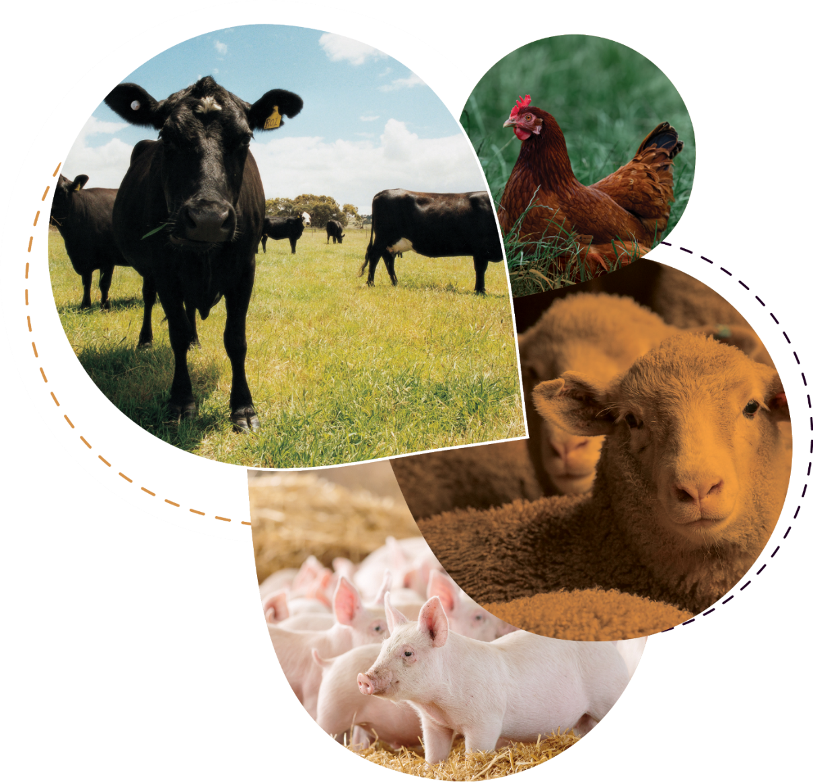

Contents
Overview 3
Mid-term review objectives 3
The review process 3
Review outcomes and recommendations 4
1. General considerations 4
2. Communications and stakeholder engagement 5
2.1 General communications 5
2.2 Stakeholders 6
2.3 Collaboration 7
3. Animalplan implementation 7
4. Animalplan Steering Committee 8
5. Animalplan project development pathways 9
6. Actions to improve Animalplan’s Objectives 10
6.1 Objective 1 – Activities to improve preparedness and ability to respond to emergency animal diseases 10
6.2 Objective 2 – Improve Australia’s surveillance and diagnostic capacity for animal pests and diseases 10
6.3 Objective 3 – Improve the adoption and implementation of biosecurity practices throughout the terrestrial animal industry supply chain 11
6.4 Objective 4 – Manage the risk of antimicrobial resistance (AMR) 11
6.5 Objective 5 – Improve Animal Welfare Outcomes Relevant to Emergency Scenarios 12
6.6 Objective 6 – Implement industry sustainability frameworks and plans 12
6.7 Objective 7 – Improve the integrity of animal health systems 13
Conclusion 14

Overview
Animalplan 2022 to 2027 (Animalplan) is Australia’s first national action plan for production animal health. It aims to strengthen animal health practices and position Australian industries to meet emerging trends and requirements in a globally competitive market.
This report summarises the key considerations of the Animalplan mid-term review workshop held on Wednesday 18th June 2025. These are based on the views of workshop participants – principally terrestrial production animal health industries, governments, and non-government organisations.
Participants contributed actively (both online and in person) and significant effort was made to distil those inputs and align them with Animalplan’s strategic components.

Mid-term review objectives
The workshop aimed to support successful implementation of Animalplan by:
- Strengthening engagement between industry, government, and other organisations.
- Broadening stakeholder understanding of Animalplan, its purpose and opportunities.
- Highlighting and reflecting on the key achievements to date.
- Identifying if Animalplan is adequately achieving its objectives and addressing identified challenges.
- Exploring any need to amend objectives and activities that may not be achieving Animalplan’s intended outcomes.
- Identifying any gaps to ensure these are addressed where possible, including assigning responsibility to any new activities or actions arising from the workshop discussions.

The review process
The workshop structure included an introduction from the First Assistant Secretary of Biosecurity Animal Division and National Animal Disease Preparedness Coordinator, presentations from the Animalplan Steering Committee Co-Chairs and Secretariat, and presentations on AQUAPLAN and the Australian Agricultural Sustainability Framework (AASF) which both shared lessons learnt that participants could consider in relation to Animalplan.
Participant feedback was collected through numerous individual and table activities, with ongoing room discussions, and question and answer sessions.
The agenda covered the following topics:
- Workshop purpose and objectives including an introduction to Animalplan 2022 to 2027
- Lessons learnt from AQUAPLAN
- Identifying areas of underinvestment and clarifying Animalplan’s role
- Bringing together Australian industry for a common purpose - presentation on the AASF
- Communications and engagement
- Animalplan governance
- Future planning
- Outcomes, recommendations and action items

Review outcomes and recommendations
This section summarises the key participant feedback received on Animalplan, its implementation and governance processes, and its individual objectives.

General considerations
- Overwhelmingly workshop participants agreed that Animalplan was on track to achieve its goals, and the workshop was effective in improving understanding of Animalplan and how stakeholders can engage with the process. Stakeholders identified opportunities for improving the visibility of the projects that sit under Animalplan, and for enhanced stakeholder engagement in the remainder of this iteration. Suggested improvements to the content of Animalplan’s objectives will be carried over for consideration in the end-of-term review and Animalplan’s next iteration.
- There was uncertainty about Animalplan’s relationship to other government strategies, and the outcomes it is meant to deliver. This suggests a need for more targeted guidance on implementation, and greater visibility of what success looks like. Ensuring stakeholders understand roles, overlaps, and points of influence, will enhance coordination and participation.
- The work of many organisations in animal health, surveillance, biosecurity, and welfare either pre-dates or operates independently of Animalplan. However, the work still aligns closely with Animalplan's objectives, indicating that Animalplan is useful as a reference point, alignment mechanism and amplifier, rather than the central driver of activity.
Making the existing activities more visible and clearly linked to Animalplan would highlight its value, strengthen its coordinating role, share learnings, and encourage broader involvement and harmonised approaches to complex, cross-sector biosecurity issues and shared challenges.
- Improved communications would increase awareness and participation, particularly among stakeholders who may see certain topics as someone else’s responsibility, who may lack visibility of national efforts, and with less-engaged sectors including those unsure of how their activities contribute to and align with Animalplan’s goals.
- Clarifying Animalplan’s value and benefits would help smaller, niche and resource-constrained organisations engage in ways that align with their mandates and capacity.

Actions:
The Animalplan Steering Committee and Secretariat will:
- Continue to communicate Animalplan’s role as a supporting framework to manage expectations and emphasise its function in amplifying and aligning existing efforts. Additional emphasis will be placed on working with stakeholders to highlight industry-led efforts, key frameworks, and sector-specific initiatives.
- Define and communicate the added value Animalplan provides such as enabling cross-sector benchmarking, consistency in language and reporting, and sharing lessons across industries.
- Maintain collaboration through ongoing dialogue, two-way feedback, and coordination with stakeholders.

Communications and stakeholder engagement
Participants highlighted a preference for simplified communication, targeted updates, and hybrid engagement approaches. Some participants were not aware of existing Animalplan communications pathways.

2.1 General communications
- Participants suggested tailored engagement, balancing broad digital accessibility with targeted, trusted face-to-face or peer-to-peer interactions:
  - A regular communication schedule including newsletters, emails, and webinars.
  - Streamlined updates in short form, outlining activities, outcomes, schedules, project snapshots, and success stories.
  - Periodic two-way/interactive formats including webinars with question and answer opportunities, communities of practice, and face-to-face workshops or conferences to deepen engagement. These could be sector or topic specific.
  - Broad-based forums to ensure that diverse perspectives shape priorities.
- Visible alignment of all organisations identified or recognised in contributing work to ensure the invisible labour of collaboration is captured in reporting.

Actions:
The Animalplan Steering Committee and Secretariat will:
- Continue to provide updates at other forums including the Animal Health Committee (AHC), Animal Health Australia (AHA) Industry Forum/member’s week. Stakeholders to assist in identifying additional relevant forums and opportunities.
- Highlight existing communications pathways to stakeholders:
  - Quarterly requests for project submissions and updates (Jan/April/July/Oct)
  - Quarterly communiqué highlighting Animalplan activities and news, including project updates (Feb/May/Aug/Nov)
  - Biannual Animalplan webinar series: presentations and Q&A – stakeholders to assist in identifying relevant topics and promote participation.
- Request that project leads identify organisations involved in projects aligned under Animalplan, for inclusion in Animalplan reporting and the project database. These channels rely on the information provided by the project teams.

2.2 Stakeholders
- Address resourcing: consider co-investment or support models to sustain partner involvement and reduce capacity strain.
- Map current gaps and target increased visibility of Animalplan among industry, research, and government groups.
- Clarify pathways for greater involvement and engagement from universities, industry, government, and research and development corporations (RDCs), including the Commonwealth Scientific and Industrial Research Organisation (CSIRO).
- Communicate which stakeholders are involved, including how they are selected, represented, and mobilised, and how others can contribute, to help strengthen trust and participation.
- Participants were asked which organisations they’d like to see included in Animalplan engagement. Many of those suggested are existing Animalplan stakeholders, who did participate or were invited to participate in this workshop for mid-term review of Animalplan.
- Expand regional face-to-face engagement and resource discussions.

Actions:
In addition to the actions identified under section 2.1, the Animalplan Secretariat will:
- Place all workshop participants and invitees on the Animalplan stakeholder list to receive regular correspondence about Animalplan. Individuals can contact the Secretariat at animalplan@aff.gov.au to be added or removed from the list.

2.3 Collaboration
- Animalplan could provide and/or participate in more structured, ongoing fora to exchange knowledge, surface risks, and identify collaboration opportunities, ensuring that strategic collaboration isn’t reserved only for crisis moments.
- Invest in stakeholder engagement mechanisms and collaborative initiatives that build capacity, share knowledge, enable co-investment, and leverage pooled resources and expertise.
- Establish accessible channels for stakeholders to engage and share ideas, including:
  - Simple submission methods e.g. forms or an open email channel.
  - An online ideas platform for submission, discussion, and pitching.
  - Low-barrier participation options like ideas incubators or topic-based discussions.

actions:
In addition to the actions identified under section 2.1, the Animalplan Secretariat will promote:
- Two-way communications opportunities:
- Webinars
- Quarterly communiqué
- The existing open email channel through animalplan@aff.gov.au

Animalplan implementation
Participant feedback identified a broad range of activities for potential action or improvement.
- Enhance visibility within systems: integrate Animalplan updates and reporting into existing sector channels, forums and working groups e.g. AHC agendas, peak body meetings.
- Continue investment in ongoing dialogue platforms that enable cross-sector and cross-jurisdictional collaboration to strengthen system resilience and continuous improvement.
- Facilitate cross-agency coordination on high-impact, cross-cutting issues such as vaccine access and regulatory readiness.
- Invest in enabling functions, including sector forums, collaboration platforms, and small-organisation capacity building.
- Legitimacy was seen to depend not on ownership of activities, but on responsiveness to gaps, challenges, and changing sector needs. Particularly in the wake of emergency animal disease (EAD) events or preparedness exercises e.g. for lumpy skin disease (LSD), Animalplan’s relevance was seen to increase when it helped capture learnings, identify weak points, and support system upgrades across multiple objectives.
- Implement clear, efficient priority-setting processes respecting stakeholder time constraints, and with consistent prioritisation criteria grounded in value and impact.
- Engage expert advisory bodies to guide risk-based prioritisation.
- Use data-driven frameworks and international experience to inform investments.
- Explore technology solutions to support decision-making and resource management.
- Encourage innovation through both structured and informal idea generation.
- Foster discussions that link sector-specific concerns to overarching system issues.

Actions:
In addition to the actions identified under the previous sections, the Animalplan Steering Committee and Secretariat will focus on increasing cross-sectoral collaboration opportunities. This will involve working with project leads to:
- improve the scope and cross sectoral benefits of projects to increase the likelihood of achieving funding from relevant stakeholders
- identify and fill any gaps in existing government and industry project work being undertaken
- expand existing outreach activities aligned with Animalplan’s strategic priorities
- continue to highlight the role and function of the Steering Committee, that there are no specific resources available to the group and that the benefit of the process lies in increasing the cost-effectiveness and value-adding to proposed improvements that are being made to Australia’s production animal health systems.

Animalplan Steering Committee
Participants sought an increased understanding of the Steering Committee’s role and processes.
- Clarify the Steering Committee’s role, contact pathway and governance processes, including insight into the Committee’s schedule, decision-making processes, and reporting requirements.
- Define roles and governance especially between the Animalplan Steering Committee and Secretariat.
- Simplify governance to reduce administrative load and focus on procedures, actionable priorities, partnerships and outcomes, while ensuring accountability and emphasising proactive engagement and facilitation.
- Consider actively linking Steering Committee work to funding priorities and day-to-day roles across sectors, to increase perceived relevance.

Actions:
The Animalplan Steering Committee and Secretariat will:
- Review and update the Steering Committee overview on the Animalplan website.
- Provide further clarity through communications activities including a quarterly communiqué, regular webinar series, and in presentations and discussions at industry and other events.

Animalplan project development pathways
A recurring theme was the need for better communication between Animalplan and stakeholders, including feedback on project proposals and visibility of funded work.
- Clarify processes for submitting and progressing project ideas:
  - how to access decision-makers and the Steering Committee
  - how project ideas move through Animalplan’s decision-making processes, including how they are evaluated and supported
  - the role of the Steering Committee
  - pathways for non-traditional actors
  - feedback loops on project proposals, enabling contributors to see how their information or ideas have been used, what decisions resulted, and where outcomes are visible.
- Refine and promote the Animalplan project proposal form, ensuring it is both practical and supportive of diverse stakeholder contributions.
- Introduce simple, flexible templates for early-stage idea submissions.
- Create mechanisms such as an “ideas incubator” to include and nurture grassroots and early-stage projects, or integrate idea-capture into after-action reviews, to ensure early concepts are nurtured and not lost.
- Support for early collaboration building, with Animalplan positioned as a facilitator and connector, not simply an endpoint for project proposals.
- Further establish the Secretariat role to manage idea intake, review, and promotion.
- Develop regular communications that showcase ideas and opportunities.

Actions:
In addition to the actions identified in the previous sections, the Animalplan Steering Committee and Secretariat will:
- Review and revise the project proposal process.
- Reconnect with key Animalplan stakeholders to reestablish their roles as activity leads in Animalplan, working with project leads on project proposals and submitting them to the Animalplan Steering Committee on behalf of the project team.
- Update the project proposal process on the Animalplan website.
- Review and revise the project proposal form.
- Develop an ideas incubator/idea capture mechanism.
- Include ideas and opportunities in regular communications methods i.e. the quarterly communique and webinar series.

Actions to improve Animalplan’s Objectives
Participants provided feedback on projects and activities being undertaken in alignment with Animalplan’s objectives. The Steering Committee encourages stakeholders to consider where actions could be taken.

6.1 Objective 1 – Activities to improve preparedness and ability to respond to emergency animal diseases
To further strengthen Objective 1 delivery, future efforts may benefit from:
- Sustaining investment in capability, especially in:
  - Training and preparedness simulations.
  - Laboratory capacity and diagnostic innovation.
  - On-farm biosecurity education and uptake.
- Ensuring national consistency, while respecting jurisdictional nuances, especially in remote and cross-border areas.

6.2 Objective 2 – Improve Australia’s surveillance and diagnostic capacity for animal pests and diseases
To strengthen the delivery and visibility of Objective 2, stakeholders could focus on:
- Promoting adoption of innovation: continuing to support diagnostic and data innovations (e.g. mobile laboratories, point-of-care tools, and data system improvements) and connecting these into national infrastructure and policy.
- Elevating and reinforcing the strategic role of surveillance beyond compliance, including in supporting trade, public health, early detection, and One Health priorities.
- Encouraging and clarifying cross-jurisdictional coordination: multiple actors contribute to surveillance systems, and shared data strategies may enhance value and avoid duplication.

6.3 Objective 3 – Improve the adoption and implementation of biosecurity practices throughout the terrestrial animal industry supply chain
To further advance and unify supply chain biosecurity under Animalplan, the following areas may warrant attention:
- Continuing to foster tailored, sector-specific initiatives: successful models (like One Biosecurity or pig-focused work) could be scaled or adapted for other sectors with support from Animalplan frameworks.
- Bridging communication gaps along the supply chain: targeted efforts to reach harder-to-engage actors (e.g. smallholders, independent transport operators) could ensure broader uptake of biosecurity practices.
- Using national platforms to better align daily operations of jurisdictions and industries under a stronger, more visible national framework. Regular collaboration with cross-sector bodies can identify common gaps, and improve consistency, value, and innovation in supply chain biosecurity.
- While some responses showed strong information-sharing with stakeholders, more systematic mechanisms to evaluate and report on how biosecurity practices are adopted may enhance accountability and continuous improvement.

6.4 Objective 4 – Manage the risk of antimicrobial resistance (AMR)
To enhance national coherence and broaden engagement under Objective 4, stakeholders may consider:
- Expanding diagnostics investment and collaboration: there is a clear recognition that diagnostics plays a foundational role in AMR surveillance and stewardship, but agreements on national standards and investment in capacity is uneven. Coordinated investment could yield cross-sectoral benefits.
- Sector-specific framing and education: AMR priorities may not resonate equally across all industries. Animalplan could support targeted communication or capacity-building tailored to sectors (e.g. poultry, aquaculture, extensive livestock) to encourage greater participation.
- Leveraging cross-government forums: the alignment between Animalplan and broader AMR strategies (e.g. Australia’s National AMR Strategy, One Health frameworks) could be strengthened to minimise duplication and encourage synergy.
- Broadening the implementation base: responses suggest the work is being led by a few key organisations. A model distributing responsibility (supported by clearer expectations and coordination) may help embed AMR awareness and action more widely.

6.5 Objective 5 – Improve Animal Welfare Outcomes Relevant to Emergency Scenarios
To better achieve national impact under Objective 5, stakeholders could consider the following:
- Clarifying the objective’s scope beyond emergency animal disease scenarios to explicitly include natural disasters, infrastructure failures and climate related events. While welfare during emergencies is well-acknowledged, broader improvements in animal welfare practices across industries may require clearer framing and articulation, especially in communications and planning guidance.
Note: Changes to the content of Animalplan 2022 to 2027 will be carried over for consideration in the end-of-term review and next iteration.
- Addressing infrastructure & regulatory bottlenecks, including effluent management, vaccine access and fair support for small producers.
- Supporting ethical decision-making frameworks to help navigate tensions between individual, farm and population-level welfare outcomes.
- Proactively managing political and social sensitivities - trusted processes, strong leadership and science-based communication.
- Investing in public-facing communications strategies that bridge expectations gap to inform dialogue about animal welfare in real-world emergency contexts.
- Resourcing national leadership & advocacy roles that give producers a voice and ensure policies are credible, grounded and co-designed with industry and the community where relevant.
- Improving visibility of sector-specific gaps and opportunities to surface under-addressed issues and invite new partnerships or solutions.
- Engaging and equipping less-involved stakeholders: some participants may support animal welfare implicitly (e.g. through general animal health or biosecurity programs) but don’t see their contribution reflected in this objective. Clearer definitions and examples of what “counts” as supporting this objective could increase alignment and participation.
- Leveraging expertise more effectively: organisations contributing through technical advice or research provide high-value input. Animalplan could better acknowledge and integrate these roles within its national reporting and coordination structures.

6.6 Objective 6 – Implement industry sustainability frameworks and plans
To strengthen the role and impact of Animalplan under Objective 6, stakeholders may consider:
- Respecting and reinforcing industry leadership: sustainability is best developed and owned by sectors themselves. Animalplan should continue to act as an enabler, not a director, of sustainability initiatives, supporting knowledge-sharing and alignment without duplicating existing frameworks.
- Supporting sectors at varying levels of maturity: not all industries have the same resources or progress in developing sustainability plans. Stakeholders can work with the Animalplan Secretariat and Steering Committee to identify gaps, offer templates or guidance, and provide a platform for emerging industries to learn from more advanced sectors.
- Building cross-objective links: sustainability intersects with biosecurity, market access, welfare, and system integrity. Making these cross-cutting benefits more explicit may help engage organisations who don’t traditionally see themselves as working in sustainability, but who influence it through core operations.

6.7 Objective 7 – Improve the integrity of animal health systems
To enhance implementation and visibility of Objective 7, stakeholders may consider:
- Expanding traceability coverage to sectors where current gaps pose risks to EAD response, trade integrity or animal welfare outcomes.
- Improving strategic alignment of traceability investment, ensuring resources are directed based on risk, sector readiness and public good outcomes, not just legacy systems or ease of delivery.
- Strengthening activity 7.2 by enabling data interoperability across supply chains, ensuring all participants can access and benefit from traceability data.
- Elevating and clarifying activity 7.3 by embedding feedback mechanisms that deliver actionable insights to producers and drive continuous improvement across animal health systems.
- Integrating traceability with regulatory or diagnostic systems, creating a more holistic approach to health intelligence and supply chain transparency.
- Reducing system fragmentation by improving interagency coordination, supporting smaller or emerging sectors, and ensure equitable regulatory environments across species.
- Continuing cross-jurisdictional collaboration, including through SAFEMEAT, NLIS governance and traceability taskforces, to drive consistent national outcomes while maintaining flexibility. Animalplan could help catalyse or coordinate innovation pilots.
- Improving understanding and relevance among niche or indirect stakeholders: clearer examples and targeted engagement may demonstrate how integrity in the animal health system relates to the work of those unsure of how they fit into Objective 7.

Objectives 1 to 7 - Actions:
Many of the suggestions made during the workshop were directed towards improving the scope of the current objectives, or towards the outcomes of individual projects. Where this feedback can’t be acted on immediately, it will be incorporated into the end-of-cycle review process, to inform improvements that can be made in the next iteration of Animalplan.
Where the feedback provided is relevant to Animalplan stakeholders more generally, the Steering Committee encourages everyone involved to incorporate potential improvements into their own work. This includes leveraging investments made by others, increasing the utility of projects for other sectors, and increasing the visibility of projects for the benefit of the entire Australian production animal sector.

Conclusion
Implementation of Animalplan activities will continue to be a shared responsibility between government, industry and non-government organisations. Collaboration and cooperation remain crucial to effectively implement the 21 activities that make up Animalplan.
The Steering Committee thanks all participants for engaging in the mid-term review and encourages stakeholders to stay engaged in Animalplan 2022 to 2027.
Information and updates on Animalplan and the projects under it are available at www.agriculture.gov.au/animal-plan.
Enquiries can be directed to the Animalplan Secretariat at animalplan@aff.gov.au.

