Eradication success story–Australia is free of brucella abortus
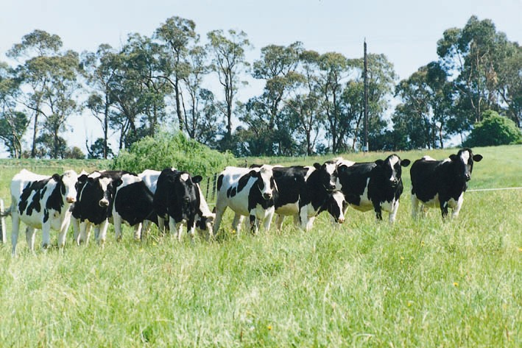

Summary
Australia has been free from brucella abortus (B. abortus), in both domesticated and wild animals for two decades.
Australia’s favourable animal health status is largely a result of our relatively recent history of ruminants on the continent, our geographical isolation and strict biosecurity arrangements. It is also due to several excellent disease eradication programs. Australia successfully eradicated contagious bovine pleuropneumonia in 1973, bovine brucellosis in 1989 and bovine tuberculosis in 1997.
Achievement of country freedom from B. abortus followed a joint industry, Australian government and state and territory government program of eradication that started in 1970. The Brucellosis and Tuberculosis Eradication Campaign (BTEC) included Australia’s entire cattle population–180 000 herds at that time.
No case of bovine brucellosis has been detected in any species in Australia for 20 years.

Introduction
Bovine brucellosis is caused by the bacterium brucella abortus. Infection causes abortion in cattle, the birth of weak or dead calves and infertility. B. abortus is also a human pathogen, causing undulant fever.
B. abortus is transmitted mainly via contact with the placenta, fetus, fetal fluids, urine or vaginal discharges of infected animals, particularly after calving. It is also found in milk, urine, semen, faeces and joint fluid. Human infection with B. abortus usually occurs through occupational contact with discharges from infected animals, particularly through calving, but also through slaughtering or ingestion of unpasteurised dairy products.
B. abortus is thought to have entered Australia in the late 1800s via imported dairy cattle. It became the most common cause of abortion in cattle and also a human health risk.
Why did Australia eradicate bovine brucellosis?
- To eliminate associated abortions and low production in cattle.
- To prevent an important zoonosis.
- To protect and enhance export of cattle, genetics and dairy products.

How did Australia achieve freedom?
Australia’s freedom from B. abortus was achieved progressively, with each individual state and territory first achieving freedom through independent brucellosis control programs. In 1970 industry, state, territory and the Australian government united to form the national Brucellosis and Tuberculosis Eradication Campaign (BTEC). The state of Tasmania was the first to declare B. abortus freedom in 1975. Individual state freedom continued until the last state declared freedom in 1989, and national freedom was achieved.
Australia has been free from B. abortus for 27 years. During this time, no cases of Brucellosis have occurred in Australia.

Vaccination
The first step in the eradication of B. abortus was compulsory vaccination of all heifer calves aged between three and nine months with strain 19. This reduced the prevalence of B. abortus prior to introducing a broad test and slaughter program. Strain 19 was later used for reduced dose vaccination of adult cattle to reduce disease spread after prevalence had been decreased. In areas where more extensive grazing was common, strain 45/20 was used as a preventative vaccination. Vaccination was progressively prohibited in each state and territory in the later stages of eradication. On the 30 June 1985, the use of B. abortus vaccination officially ceased in Australia and has not been used since.

Test and slaughter program
After decreasing the prevalence of brucellosis through vaccination, Australia began a compulsory test and slaughter program. This included abattoir monitoring and serum and milk testing.

Traceback
During BTEC compulsory tail tagging of cattle was introduced. Each property was allocated a Property Identification Code (PIC), allowing individuals to be traced back to their property of origin. It was a legal requirement that all cattle were identified by tail tags (imprinted with PIC of their property of origin) before sale or inspection at abattoirs. Trace-back and trace-forward of test positive cattle was integral to the success of brucellosis monitoring.

Milk Ring testing
Because of its efficiency and low cost, the milk ring test was selected for long-term surveillance of brucellosis in dairy herds. All states and territories conducted milk ring tests on dairy herds at least three times a year throughout the eradication phase, and for five years after becoming brucellosis free. The last infected herd detected by this method was in January 1987.

Herd monitoring
BTEC incorporated strict movement controls for cattle based on testing to prevent infection of free herds.
All infected herds were quarantined and appropriate management strategies adopted to minimise the within herd spread of B. abortus. Infected herds were tested at six-month intervals and all reactors were removed for slaughter. Herds then required three negative tests six months apart before being considered free of bovine brucellosis (or confirmed free). Finally, herds were required to undergo a negative test three years after being confirmed free or within two years of declaring a free area.

What does Australia do to maintain brucellosis freedom?
After Australia declared freedom from bovine brucellosis in 1989, various methods of ongoing surveillance were employed to demonstrate ongoing freedom. The effectiveness of these methods is demonstrated by the fact that there has been no case of B. abortus infection in any species in Australia for 20 years.

Abattoir monitoring
Abattoir monitoring was used as a surveillance method for B. abortus in Australia until 1993. During this abattoir monitoring phase, mature breeding cattle that were sent to abattoirs for slaughter were sampled and tested.

Abortion investigations
All suspicious cases of bovine abortions are reported to authorities and investigated to dismiss the possibility of B. abortus infection.

National Livestock Identification System (NLIS)
Australia uses mandatory NLIS to identify and trace cattle throughout Australia. It is a permanent, whole of life system that allows individual animals to be identified electronically and traced from property of birth to slaughter. This helps ensures food safety, product integrity and market access.

Data collection
Data on bovine brucellosis surveillance and results of laboratory investigations are obtained on a quarterly basis from each state and territory under the obligations outlined in the Standard Definitions & Rules (SRDs). SDRs are the national standards used by states, territories and industry in eradicating bovine brucellosis.

National Animal Health Information System
Data for bovine brucellosis is displayed on a national website to meet international obligations for animal health monitoring and compliance (www.aahc.com.au). This data is sourced from the National Animal Health Information System (NAHIS).

Border security
Border security plays a large role in helping maintain Australia’s brucellosis free status. Australia’s freedom from bovine brucellosis is maintained by appropriate biosecurity measures for imported live cattle, embryos and semen. These are consistent with the OIE Terrestrial Animal Health Code and enforced by biosecurity officers.

Australian Veterinary Plan Emergency (AUSVETPLAN)
AUSVETPLAN is the national contingency planning framework for the management of animal disease emergencies in Australia. In the unlikely event of a B. abortus incursion, Australia would follow the detailed instructions laid out in AUSVETPLAN Bovine Brucellosis disease manual.

Legal responsibilities
Legislation in each state and territory in Australia requires:
- Notification of suspected cases of bovine brucellosis
- Investigation of suspected clinical cases
- Prohibition of brucellosis vaccination and treatment
- Compliance with agreed Standard Definitions and Rules to ensure free country status for Australia, and
- All surveillance data to be supplied to NAHIS.

Australian Laboratory Capabilities
All Australian Government animal health laboratories are accredited to international standards (ISO/IEC 17025:2005) and use diagnostic techniques according to Australian and New Zealand Standard Diagnostic Procedures, in line with the OIE recommended procedures.
As well as culture and identification of B. abortus, the following serological tests are used to detect suspects: Brucella milk ring test, Rose Bengal plate test, complement fixation test, and the enzyme-linked immunosorbent assay (ELISA).
- State and territory laboratories remain responsible for:
  - Initial bacterial culture, serology and histopathology on samples
  - Routine quality assurance for diagnostic capability and competency (especially through participating in the Australian National Quality Assurance Program and maintaining relevant accreditation against ISO/IEC 17025:2005 through the National Association of Testing Authorities or NATA).
- The Australian Animal Health Laboratory (AAHL) in Geelong is the National Brucellosis Reference Laboratory responsible for confirming identification and typing of suspect Brucella organisms.
- Only AAHL, the maximum (PC4) biocontainment laboratory in Australia, is approved to hold the B. abortus material.

Bovine brucellosis – Australia meets OIE standards
Australia is able to ensure that all cattle for export originate from a bovine brucellosis-free country as defined in Article 11.3.2 of the OIE Code. This provides greater bovine brucellosis freedom assurance than testing individual animals for export. Additional testing of animals is therefore not useful or necessary.

