National H5 high pathogenicity avian influenza guidelines for veterinarians
© Commonwealth of Australia 2026
Ownership of intellectual property rights
Unless otherwise noted, copyright (and any other intellectual property rights) in this publication is owned by the Commonwealth of Australia (referred to as the Commonwealth).
Creative Commons licence
All material in this publication is licensed under a Creative Commons Attribution 4.0 International Licence except content supplied by third parties, logos and the Commonwealth Coat of Arms.

Cataloguing data
This publication (and any material sourced from it) should be attributed as: Animal Health Committee 2026, National H5 high pathogenicity avian influenza guidelines for veterinarians, Department of Agriculture, Fisheries and Forestry, Canberra. CC BY 4.0.
This publication is available at birdflu.gov.au
Department of Agriculture, Fisheries and Forestry
GPO Box 858 Canberra ACT 2601
Telephone 1800 900 090
Web agriculture.gov.au
Disclaimer
The Australian Government acting through the Department of Agriculture, Fisheries and Forestry has exercised due care and skill in preparing and compiling the information and data in this publication. Notwithstanding, the Department of Agriculture, Fisheries and Forestry, its employees and advisers disclaim all liability, including liability for negligence and for any loss, damage, injury, expense or cost incurred by any person as a result of accessing, using or relying on any of the information or data in this publication to the maximum extent permitted by law.
Acknowledgement of Country
We acknowledge the continuous connection of First Nations Traditional Owners and Custodians to the lands, seas and waters of Australia. We recognise their care for and cultivation of Country. We pay respect to Elders past and present, and recognise their knowledge and contribution to the productivity, innovation and sustainability of Australia’s agriculture, fisheries and forestry industries.
Credits
Cover photo: © Beatrice Banes.

Contents
Introduction 1
1 Purpose and scope 2
1.1 Out-of-scope 2
2 Veterinarians and emergency animal disease responses 3
2.1 Veterinarian engagement in an EAD response 3
2.2 Implications of a H5 bird flu response for veterinary premises 3
2.3 Veterinary premises in which H5 bird flu has been detected 4
3 When to suspect H5 bird flu 5
3.1 Clinical signs of H5 bird flu in animals 5
3.2 Notification 5
4 Health and safety precautions when H5 bird flu is suspected or confirmed 7
5 Recommendations for managing spread of H5 bird flu 8
5.1 Triage 9
5.2 Admission and isolation 11
5.3 Management of animals suspected or confirmed to have H5 bird flu 12
5.4 Management of deceased animals 13
6 General advice for clients 14
6.1 Health concerns and medical assistance 14
6.2 Other health considerations 15
Appendix A: Avian influenza: current knowledge 16
Overview of avian influenza viruses 16
Avian influenza transmission 16
Incubation period 18
Avian influenza and human health 19
Appendix B: Avian influenza response arrangements in Australia 20
Reporting obligations 20
Arrangements for emergency animal diseases 20
Vaccination for avian species 21
Appendix C: Avian influenza sampling, submission and testing 22
Sample collection 22
How to submit samples 23
State and territory details 25
Appendix D: Triage decision-making framework 27
Appendix E: Triage tent example 28
Appendix F: Resources 29
Glossary 31
Abbreviations 32
References 34

Tables
Table D1 Queensland contact details 26
Table D2 New South Wales contact details 26
Table D3 Victoria contact details 26
Table D4 Tasmania contact details 26
Table D5 South Australia contact details 27
Table D6 Western Australia contact details 27
Table D7 Northern Territory contact details 27
Figures
Figure A1 Avian influenza transmission pathways (a) 18
Figure A2 Avian influenza transmission pathways (b) 18
Figure D1 Procedure for swab collection 24
Figure D2 Biological substance label 25
Figure E1 Triage decision-making framework 28
Figure F1 Triage tent example 29

Introduction
If you are aware of, or suspect avian influenza in any animal, you must report it to the Emergency Animal Disease Hotline on 1800 675 888 (available 24/7). This number can be called from anywhere in Australia and will be connected to the local state or territory government agency for advice. Reporting is a legal requirement.
These guidelines have been produced to assist private veterinarians to manage the risk of H5 high pathogenicity avian influenza at their premises.
Since 2021, a new strain of high pathogenicity avian influenza (HPAI) H5Nx clade 2.3.4.4b, (colloquially and hereafter referred to as H5 bird flu) has resulted in severe and widespread outbreaks in poultry, wild birds, and terrestrial and marine mammals around the world.
H5 bird flu was first confirmed in a single wild migratory bird (brown skua) found in southern Western Australia in June 2026.
Compared to previous H5 bird flu viruses, the clade 2.3.4.4b viruses have increased pathogenicity, replication and viral shedding in wild birds; increased avian and mammalian host range; increased viral persistence in the environment; an ability to spread via a wide range of avian species; and the ability of wild birds to directly infect poultry without a low pathogenicity avian influenza (LPAI) mutation event.
Veterinarians should prepare for H5 bird flu, so that measures can be quickly implemented to limit disease spread, while continuing to provide appropriate veterinary services for animals in their care. This includes the development of a biosecurity plan and H5 bird flu protocols specific to their staff and premises. Information provided in this document will support this process.
Important additional information, such as current knowledge on H5 bird flu, response arrangements in Australia, sample collection and submission, examples of triage decision-making frameworks and triage tents can be found in the Appendices. Quick references, links to resources and fact sheets are also included as Appendices in this guidance document.

Purpose and scope
This document has been developed as a collaborative effort with state/territory government representatives, the Australian Veterinary Association, Wildlife Health Australia and private veterinary practitioners.
The purpose of these guidelines is to:
- assist Australian veterinarians to reduce the risk of introducing H5 bird flu into their premises
- limit the potential for disease spread
- provide advice on the management of suspected or confirmed cases of H5 bird flu.
The guidelines are aimed at veterinarians in clinical practice who provide veterinary services at veterinary premises to non-commercial domestic animals and wildlife.
These guidelines will support veterinarians to develop biosecurity plans and guide decision-making for H5 bird flu before, during and after a disease outbreak. The guidelines may also assist veterinary and non-veterinary managers of private practices to assess and mitigate potential risks and support business continuity.

Out-of-scope
The guidelines do not provide specific guidance for offsite veterinary activities, although many principles may be applicable to farm visits and house calls. Compensation, management of pest animals and response activities undertaken by veterinarians formally engaged by government in the field (e.g. surveillance/sample collection during an emergency animal disease (EAD) response) are also out of scope.
There is uncertainty about how a detection or outbreak of H5 bird flu may unfold in Australia. These guidelines will be revised as new information becomes available to maintain their currency.

Veterinarians and emergency animal disease responses
Additional information on EAD response arrangements in Australia can be found in Appendix B.

Veterinarian engagement in an EAD response
Veterinarians play an essential role in EAD responses. Private veterinarians may be involved through their routine clinical activities, such as identifying suspect cases among their patients, including wildlife, in addition to providing accurate, trusted information about H5 bird flu to their clients and the local community.
Veterinarians may also be formally engaged in a response through the responding government agency. The National Guidance document on the engagement of private veterinarians during an emergency animal disease response (updated June 2023) guides how private veterinarians are engaged during EAD responses.

Implications of a H5 bird flu response for veterinary premises
During an EAD response, private veterinarians will be required to liaise with their state or territory biosecurity agency to report animals suspected of being infected with H5 bird flu. Veterinarians may also be requested to support other response activities at their premises, such as triaging suspect cases, collecting samples for laboratory testing, and welfare assessments.
Heightened biosecurity measures and other response activities may influence how veterinary services can be delivered during an outbreak. For veterinary premises situated within declared areas (i.e. areas impacted by the outbreak and subject to disease control measures under relevant biosecurity EAD legislation), potential measures that may be implemented by state or territory government agencies include:
- Movement controls – if a veterinary premises is in, or an animal originates from, a declared area, movement restrictions may apply to animals, animal products, and vehicles. The specifics of these restrictions will be communicated by the authorities managing the outbreak.
- Disease surveillance – monitoring for and reporting of clinical signs, routine surveillance and/or sample collection (if directed) for laboratory testing (at a government veterinary laboratory) to detect H5 bird flu to determine the extent of an outbreak, inform response actions and preventative biosecurity measures, and support assessment of the effectiveness of control activities.
- Specific disposal and decontamination procedures for items that may be contaminated with virus, to avoid the spread of H5 bird flu (see section 5).

Veterinary premises in which H5 bird flu has been detected
If H5 bird flu is confirmed in a patient at a veterinary premises it needs to be reported to the relevant state or territory biosecurity agency who will work with the authorised decision maker for the premises. Risk assessment will determine actions to limit spread and zoonotic potential while optimising animal welfare outcomes and business continuity.
The state/territory biosecurity agency will work with the veterinary premises until any risk of further disease transmission is managed.
An established biosecurity plan for the veterinary premises will assist authorities and inform risk assessments to support management of cases suspected or confirmed to have H5 bird flu (see section 5).
H5 bird flu is a nationally notifiable human health disease, and any detection will be notified to the state/territory health department. They will determine what measures need to be implemented and whether any people require monitoring or medical support. The veterinary practice should also notify the relevant workplace health and safety (WHS) authority.
For H5 bird flu detections in new locations, a communication campaign will also be undertaken which will include notification of appropriate professional bodies, including the Australian Veterinary Association and state or territory veterinary registration authorities.

When to suspect H5 bird flu

Clinical signs of H5 bird flu in animals
A veterinarian may suspect an animal has H5 bird flu from the presenting clinical signs and history (see section 5.1.2). H5 bird flu affects a broad range of avian and mammalian species, and infection can lead to a wide range of clinical signs including:
- neurological (ataxia, paralysis, seizures, tremors, abnormal posture, torticollis, head tilt, circling, behavioural abnormalities)
- respiratory (conjunctivitis, nasal and oral discharge, excessive lacrimation, corneal oedema, coughing, sneezing, dyspnoea, tachypnoea, oedema of the head)
- gastrointestinal (diarrhoea)
- sudden death (without prior clinical signs) including the potential for mass mortality
- other (cyanosis – wattles, combs, legs; decreased and/or abnormal egg production).
Clinical signs in non-poultry avian species are variable between species and among individuals but generally include neurological or respiratory signs. Waterfowl, seabirds, shorebirds and predatory and scavenging species appear most susceptible to severe disease. Some species may be asymptomatic or show only very mild clinical signs.
While the risk of cats becoming infected with H5 bird flu is low, they appear to be particularly susceptible to severe, rapidly progressing illness, often resulting in death. The likelihood of dogs becoming infected with H5 bird flu continues to be low (Beacon 2025, AVMA 2025).
Dairy cattle may exhibit various nonspecific clinical signs (FAO 2024), including low appetite, reduced milk production, and abnormal appearance of milk (thickened, discoloured). In contrast to H5 bird flu infection in birds, most affected dairy cattle reportedly recover with supportive care, and mortality or culling rates generally remain below 2% (AVMA 2025). Note the estimated risk to the Australian dairy industry is low (DAFF 2025).
Based on cases overseas, wild mammal infections are most likely to occur in predatory or scavenging species, and marine mammals that have close contact with seabirds and their environments.
Additional information on H5 bird flu, including pathways of transmission can be found in Appendix A.
Video footage of clinical signs associated with H5 bird flu has been collected by the South African Foundation for the Conservation of Coastal Birds (SANCCOB) during avian influenza outbreaks in South Africa from 2017 to 2021. The video footage can be viewed on the SANCCOB website.

Notification
In Australia, infection with influenza A viruses in birds (including but not limited to H5 bird flu) is a nationally notifiable animal disease.
However, if you are aware of, or suspect avian influenza in any animal, you must report it to the Emergency Animal Disease Hotline on 1800 675 888 (available 24 hours, 7 days a week).
See Appendix B for more information on reporting obligations.

Health and safety precautions when H5 bird flu is suspected or confirmed
If H5 bird flu is suspected in an animal, based on clinical signs and history, veterinarians should implement measures to protect themselves and others (e.g. staff and clients) from potential exposure to the virus. This may include:
- keeping the animal in a clearly signed isolation area
- avoiding unprotected close or direct physical contact with the animal
- minimising the number of staff required to interact with the animal, where practicable
- wearing personal protective equipment (PPE) when handling the animal. If workers are required to wear PPE, they must be trained in and demonstrate an understanding of when and what PPE to use, how to properly put on, use, take off, dispose of, and maintain PPE
- taking particular care during aerosol-generating procedures
- practicing good hygiene and decontamination procedures
- timely disposal of all potentially contaminated PPE and other materials following interaction with the animal, in a designated, labelled, hazardous waste receptacle.
The current risk of H5 bird flu to people in Australia is low. Overseas, people have been infected with H5 bird flu, typically after close contact with infected birds, animals or contaminated environments.
The Australian Centre for Disease Control (CDC) has developed the National guidelines for avian influenza – protecting people who work with birds and wildlife, which outlines infection prevention measures, including hygiene practices and PPE use (including donning and doffing), to protect workers from exposure to H5 bird flu when handling birds and wildlife.
Annual seasonal influenza vaccination is recommended for all staff and volunteers at veterinary premises. Although the vaccine does not protect against bird flu, it may help prevent people being infected with seasonal flu at the same time, which will reduce the risk of the viruses mixing to create a new virus that may be more serious to human health.
Additional information
- Bird flu toolkit for people who work with birds

Recommendations for managing spread of H5 bird flu
Veterinarians and practice owners should assess biosecurity and WHS risks specific to their premises, daily routines and staff, particularly those that could become critical during a H5 bird flu outbreak. They should then identify practical measures to reduce those risks. All findings and actions should be clearly documented in a premises-specific biosecurity plan.
Veterinary premises should maintain robust baseline hygiene and biosecurity practices at all times, even with healthy animals and no known H5 bird flu. Enhanced biosecurity and hygiene measures, along with clear triggers for when they should be activated, should be documented in the biosecurity plan. Potential triggers include:
- confirmed H5 bird flu cases in Australia
- confirmed H5 bird flu detection within the state or territory
- veterinary premises located within a declared area
- advice/directives from state/territory authorities.
Enhanced biosecurity measures may include:
- enhanced PPE (refer to section 3.5 of the National guidelines for avian influenza: protecting people who work with birds and wildlife)
- patient triage for H5 bird flu (see section 5.1) before entry to premises (e.g. speaking to the owner by telephone, conducting the consultation outside)
- dedicated triage and isolation areas
- tailoring workflows to the H5 bird flu disease status of patients within the premises
- enhanced hygiene measures for disposal of waste products and equipment (biosecure disposal methods are listed in the AUSVETPLAN Response Strategy: Avian influenza, and the AUSVETPLAN Operational Manual – Disposal
- ensuring cleaning and decontamination processes are effective for H5 bird flu:
  - avian influenza viruses are very susceptible to detergents, soaps and many disinfectants
  - effective disinfectants that are safe for equipment and surface disinfection around animals include Safe4®, F10®and Virkon
  - prior to disinfection, all organic matter must be removed
  - refer to the disinfectant’s Safety Data Sheet (SDS) for correct concentration, application method, contact time and safety precautions
  - detailed information can be found in the AUSVETPLAN Operation Manual – Decontamination.
- creation of a standard operating procedure document and ensuring all staff are aware of and ready to action appropriate cleaning and decontamination processes in the event of a suspect or confirmed positive case
- in the event of a suspect or positive case being detected in the premises, delaying other non-essential or non-urgent veterinary consultations until full decontamination has occurred where feasible, with appropriate signage on affected areas.
Up-to-date contact information for all owners and wildlife rescuers, rehabilitators and carers should be maintained to facilitate rapid, thorough investigation in the event of a H5 bird flu detection relevant to the premises. This information will also assist state and territory authorities in managing potential human health risks.
Additional information
- NSW H5N1 Clinic Biosecurity Plan Template 2026 [Word]
- Wildlife Health Australia
National Wildlife Biosecurity Guidelines
WHA risk mitigation toolbox for wildlife care providers with a focus on H5 bird flu
- Australian Veterinary Association High Pathogenicity Avian influenza
This page includes:
Avian influenza preparedness toolkit poster
Avian influenza preparedness toolkit
High Pathogenicity Avian Influenza in pet birds, backyard poultry and wild birds
Guidelines for Veterinary Personal Biosecurity
- Zoo animals – Farm Biosecurity.

Triage
Triage procedures should reflect the premises and individual animal risk assessments and available resources. Triage should be undertaken prior to patient arrival or entry to the veterinary premises to support biosecurity management, where possible.
The premises and patient risk factors will inform and strengthen biosecurity planning across all stages of patient management, including enquiries, triage, admission, monitoring, treatment, discharge and waste disposal.

Premises risk factors
Veterinary premises should individually assess their specific risks which may include:
- considering the characteristics of their client base, location, service delivery area and the likelihood of receiving high‑risk species or cases
- evaluating risks associated with specific activities undertaken involving birds and wildlife or other high-risk species (e.g. admission, examination, hospitalisation, anaesthesia/surgery, euthanasia)
- considering whether temporary restrictions or alternative arrangements are required during an H5 bird flu outbreak and how they might be implemented (e.g. immediate referral of specific species or cases to alternative facilities at the time of initial contact from the client). These arrangements should be established in advance of an outbreak
- determining the potential pathways for virus entry, including animals, fomites carried by people, equipment, and biological materials and their implications for overall exposure risk
- appraisal of the physical layout and capacity of the premises to support separation, isolation, or dedicated isolation areas
- business continuity considerations, including staffing and any staff-specific risks.

Patient risk factors
When evaluating individual animals as part of triage the following factors should be considered to determine the likelihood of H5 bird flu infection:
- What is known about the origin of the animal
  - wild, captive, domestic
  - outdoor access
  - contact with wild birds
  - contact with an infected premises or animal
  - proximity to known H5 bird flu detections (including within declared areas)
  - proximity to wild bird mortality events
  - contact with/proximity to poultry farms, backyard poultry
  - exposure to potentially contaminated environments (e.g. wetlands, high-density wild bird areas).
- Species susceptibility
  - All bird species should be considered potentially susceptible, but higher risk taxa include poultry (chickens, turkeys), waterfowl (ducks, swans, geese), seabirds (e.g. gulls, terns, noddies, shearwaters), shorebirds (e.g. stilts, sandpipers, curlews, knots), and predatory or scavenging species (e.g. eagles, hawks, owls, crows, ravens).
  - Mammalian predators or scavengers may also be at increased risk through the ingestion of animals/carcasses infected with H5 bird flu (e.g. cats, foxes, ferrets, and possibly marsupial predators and scavengers such as Tasmanian devils and possums).
  - Note: cats infected with H5 bird flu appear to be particularly susceptible to severe illness, often resulting in death.
- More detailed information on bird species susceptibility is available on the AviFluMap: a H5 Bird Flu Model Tool for Australia’s Wild Birds (HPAI Dashboard).
- Recent introductions, movements or attendance at events where animals accumulate e.g. shows.
- Number of animals affected
  - High morbidity or mortality, or rates above expected baselines for the species may indicate increased index of suspicion for H5 bird flu.
- Presenting clinical signs
  - Neurological, respiratory, or gastrointestinal signs may be indicative of H5 bird flu.
- Consumption of raw dairy, egg or poultry products (including retail pet diets that contain raw chicken meat), where H5 bird flu involves poultry or dairy cattle.
- Owner or human contact with other susceptible species, contaminated environments, and known infected premises.
Information gathered during triage will guide subsequent actions, which may include:
- immediate notification via the Emergency Animal Disease Hotline (1800 675 888) if there is a suspicion that the animal is infected with H5 bird flu
- further evaluation and potential admission
- euthanasia on welfare grounds, consistent with relevant animal welfare legislation – animals should not be euthanised solely on the suspicion that they may have been exposed to H5 bird flu
- referral to another veterinarian, rehabilitator or facility, noting that such arrangements should be established in advance, as part of H5 bird flu biosecurity planning.
A process for managing animals, including those with clinical signs of H5 bird flu, presenting without prior notification should be established. This could involve:
- providing signage requesting people not to enter the building until they have contacted staff via phone
- directing clients to a designated triage area for patient evaluation by staff wearing appropriate PPE
- making prior arrangements with other veterinary practices or wildlife facilities for further evaluation.
An example of a triage decision-making framework can be found at Appendix D.

Admission and isolation
The approach to admission and isolation will be influenced by the level of suspicion for H5 bird flu (considering the outlined triage factors). The following provides guidance for patients that have been assessed as requiring further evaluation:
- examine outdoors whenever practical; if indoors, move the animal directly to the consultation/isolation room
- maximise ventilation (e.g. open windows – if feasible and appropriate, HEPA filtration if available)
- avoid contact with other animals and clients
- use disposable equipment where possible
- use appropriate PPE and infection prevention and control measures (refer to section 3.5 of the National guidelines for avian influenza: protecting people who work with birds and wildlife).
For animals assessed as requiring admission, additional measures to further reduce risks to other animals and staff should be considered and may include:
- Placement of new patient admissions in a dedicated isolation area with enhanced biosecurity and infection‑control measures.
- Prompt testing to confirm/exclude H5 bird flu
  - testing is undertaken in consultation with government authorities, in government veterinary laboratories.
- Isolation throughout the incubation period with frequent monitoring for clinical signs. The incubation period for avian influenza viruses varies with animal species and age, virus subtype, virus dose and virulence. HPAI virus incubation in wild birds can be up to 7 days (WHA 2025). Based on the World Organisation for Animal Health (WOAH) Terrestrial animal health code, the incubation period at the flock level is 14 days. The social welfare needs of certain species will need to be considered during the isolation period.
- For multiple animals originating from the same event or location, consideration can be given to managing these animals as a single isolation/quarantine unit, i.e. if one animal tests positive for H5 bird flu, control measures will apply to all animals in that unit.

Management of animals suspected or confirmed to have H5 bird flu
State or territory biosecurity agencies will work with the decision maker for the veterinary premises to manage confirmed cases of H5 bird flu in animals at the premises. The clinical decision-making for confirmed cases of H5 bird flu in an animal at a veterinary premises will be based on the veterinarian’s professional judgement, guided by advice from the state or territory biosecurity agency.
There may be situations, such as those involving confirmed H5 bird flu in livestock or where large numbers of confirmed and suspect cases are at the premises, where the management will be mandated by the state/territory biosecurity agency.

Euthanasia
Decisions regarding euthanasia will be based on the veterinarian’s professional judgement, animal welfare considerations, including the animal’s prognosis and risk of suffering and for owned animals, informed consent by the animal’s owner.
Some animals with clinical disease due to H5 bird flu have a poor prognosis for survival and pose an ongoing transmission risk. Where clinical signs consistent with H5 bird flu are observed and no alternative diagnosis is identified, especially in higher-risk animals (e.g. wild birds – see section 5.1.2), euthanasia may be appropriate. Confirmed cases may require euthanasia.

Treatment
If circumstances warrant consideration of treatment (e.g. domestic pets, cattle, valuable, rare, or endangered species) this should only be undertaken under advice and guidance from relevant government authorities and with a clear plan for mitigating any animal welfare and public health concerns and the resultant biosecurity risks.

Management of deceased animals
Unless specific alternate arrangements have been established by government authorities, small numbers of carcasses and any contaminated materials should be double-bagged (leakproof plastic bags), securely sealed and externally decontaminated with an appropriate disinfectant. Disposal of sealed bags should comply with clinical/hazardous waste protocols. Appropriate PPE must be worn.
For large numbers of carcasses that cannot be practically managed through normal waste disposal options, seek advice from state/territory biosecurity or environmental agencies.
National guidelines for carcass management and disposal following detection of H5 bird flu in Australia are available at:
- Public guidelines for carcass management
- Public guidance for disposal of dead wildlife
- National principles for wildlife carcass management.

General advice for clients
If H5 bird flu is suspected in a client’s bird or other animal, authorities should be immediately notified via the Emergency Animal Disease Hotline. Clients should also be advised of the zoonotic potential of H5 bird flu and directed to appropriate and current public health advice and resources for information on managing the risk of exposure to themselves and others.
Advice outlined in these guidelines can be used to inform clients of risks to other animals supported by the following resources.
Additional information and resources
- Australian Veterinary Association
- Prepare pets and wildlife for H5 bird flu - DCCEEW
Department of Agriculture Fisheries and Forestry
Fact sheets
Videos
Posters

Health concerns and medical assistance
H5 bird flu is a nationally notifiable human health disease. People should be informed to seek medical advice if they are concerned about possible exposure to H5 bird flu. They can contact:
- their local GP
- their nearest public health unit.
If bird flu is confirmed or strongly suspected in an animal, the relevant public health authorities will be notified. They will determine what measures need to be implemented and whether any people require monitoring or medical support. Notification directly to health authorities is especially important when human clinical signs are present or if potential exposure to H5 bird flu has occurred. To make these assessments, health authorities will work with veterinarians and animal owners to identify any individuals they may need to contact.
Additional information and resources
- Bird flu (avian influenza) – Australian Centre for Disease Control
- National guidelines for avian influenza: protecting people who work with birds and wildlife
- Bird flu toolkit for people who work with birds
- Bird flu (avian influenza) – NSW Health
- Avian influenza in humans (bird flu) - QLD Government

Other health considerations

Mental health
The response to an H5 bird flu outbreak can impact mental health. If you need mental health support, talk to your GP or other primary health care provider.
Additionally, the mental health and suicide prevention contacts page lists organisations, websites and services that offer support, counselling and information.
The AVA has a free and confidential telephone counselling service that can be accessed by AVA members and their immediate families, along with any veterinary professionals that work for an AVA member veterinarian (even if they are not members themselves). The service is available 24 hours a day, 7 days a week. To access the AVA’s telephone counselling service, call 1300 687 327 or visit AVA Telephone counselling.
Additional information and resources
- AVA Telephone counselling
- How to get help with your mental health – Queensland Government
- Mental Health Line – NSW
- Psychological first aid booklet – Australian Red Cross (PDF 2.6 MB)
- Psychological First Aid – Australian Red Cross

Appendix A: Avian influenza: current knowledge

Overview of avian influenza viruses
Avian influenza is an infectious disease caused by influenza A viruses that primarily affects domestic and wild birds but is increasingly being reported in both terrestrial and aquatic mammals. Influenza A viruses are classified according to the serological subtypes of their surface glycoproteins, haemagglutinin (HA) and neuraminidase (NA). To date, 17 HA and 9 NA subtypes are recognised in birds and are found in different combinations (WHA 2025).
Avian influenza virus strains are also classified into 2 categories according to molecular characteristics of the virus and the severity of disease in poultry (Figure A1):
- high pathogenicity strains (HPAI), which can cause severe clinical signs of disease and potentially high mortality
- low pathogenicity strains (LPAI), which typically cause few or mild clinical signs.
This classification only refers to the virulence of the avian influenza virus in poultry and does not correlate with severity of illness in humans or non-poultry species.
LPAI viruses are part of the natural viral community in wild birds. Avian influenza virus subtypes H5 and H7 have the capacity to mutate from LPAI into HPAI when they spill over from wild birds to poultry. All previous outbreaks of HPAI in poultry in Australia are linked to LPAI spillover from wild birds, including the 2024 and 2025 H7 outbreaks in Victoria, New South Wales and the Australian Capital Territory.
The dominant HPAI strain currently circulating globally is the HPAI H5Nx clade 2.3.4.4b (referred to as H5 bird flu in these guidelines). This strain has caused unprecedented outbreaks in poultry, wild birds and mammals (both wild and domestic) in many countries. Enhanced awareness, surveillance and response preparedness is required to facilitate early detection and effective and efficient management.

Avian influenza transmission
Avian influenza viruses are shed in the faeces and respiratory secretions of infected birds (wild and domestic). The virus is transmitted by direct and indirect contact with these secretions and excretions. Virus can spread through contact with contaminated environments and through the movements of infected live animals or contaminated animal products and fomites.
The emergence of the current H5 bird flu strain represents a significant shift, as it is now spreading as a high pathogenicity strain between wildlife species, within the poultry industry, and from poultry back to wildlife (Figure A1). Migratory wild birds infected with H5 bird flu play a role in the wider transmission of the virus.
A wide range of wild and domestic mammals have been infected with H5 bird flu overseas, particularly marine mammals and mammals that prey or scavenge on birds. The Food and Agriculture Organisation (FAO) website provides a comprehensive list of the species of birds and mammals that have been affected by H5 bird flu.
Detections in livestock (including dairy cattle, goats, sheep, alpacas and pigs) have generally been associated with environments and water sources contaminated by infected birds.
For dairy cattle, raw milk is recognised as the major source of infectious virus. Therefore, the movement of cows that are lactating or in late gestation are responsible for most transmission of virus between herds. Within-herd transmission predominately occurs via contact with raw milk during the milking process. To date, sustained H5 bird flu transmission has only been observed in dairy cattle in the United States and has been associated with only 2 genotypes (B3.13 and D1.1). All other livestock detections, including in Norwegian dairy cattle, have been limited to single farms with no onward spread. The risk H5 bird flu clade 2.3.4.4b poses to the Australian dairy industry is currently considered low (with high uncertainty) (Hall et al. 2025).
Infection of terrestrial carnivores with H5 bird flu typically occurs via the consumption of infected birds, carcasses or products. Sources of infection that have been implicated as potential sources of virus exposure for domestic cats, in particular, include:
- unpasteurised milk, cream or colostrum
- raw or undercooked meat, especially poultry – this may include retail pet diets that contain raw meat
- sick or dead infected birds, livestock and their environments.
Infection of marine mammals is thought to occur via close contact with or consumption of infected birds or contact with marine environments contaminated with virus from infected birds. Transmission between pinnipeds (seals and sea lions) is also thought to occur (Uhart 2024).
Spread patterns of high pathogenicity avian influenza have recently evolved from a historically known scenario to a new one (Figure A1). Both scenarios may coexist in the current epidemiological situation:
  - Historical pathway – prior to the emergence of H5 HPAI clade 2.3.4.4b (H5 bird flu). This includes all H7 outbreaks that have occurred in Australia.
  - Transmission pathways for H5 HPAI since emergence of H5 HPAI clade 2.3.4.4b overseas. This is based on overseas experience (adapted from a graphic courtesy of Michelle Wille). Note that the H5 bird flu dairy cow scenario depicted is based on clade 2.3.4.4b genotypes B3.13 and D1.1 which to date have caused disease in dairy cows in the United States only.
Figure A1 Avian influenza transmission pathways (a)
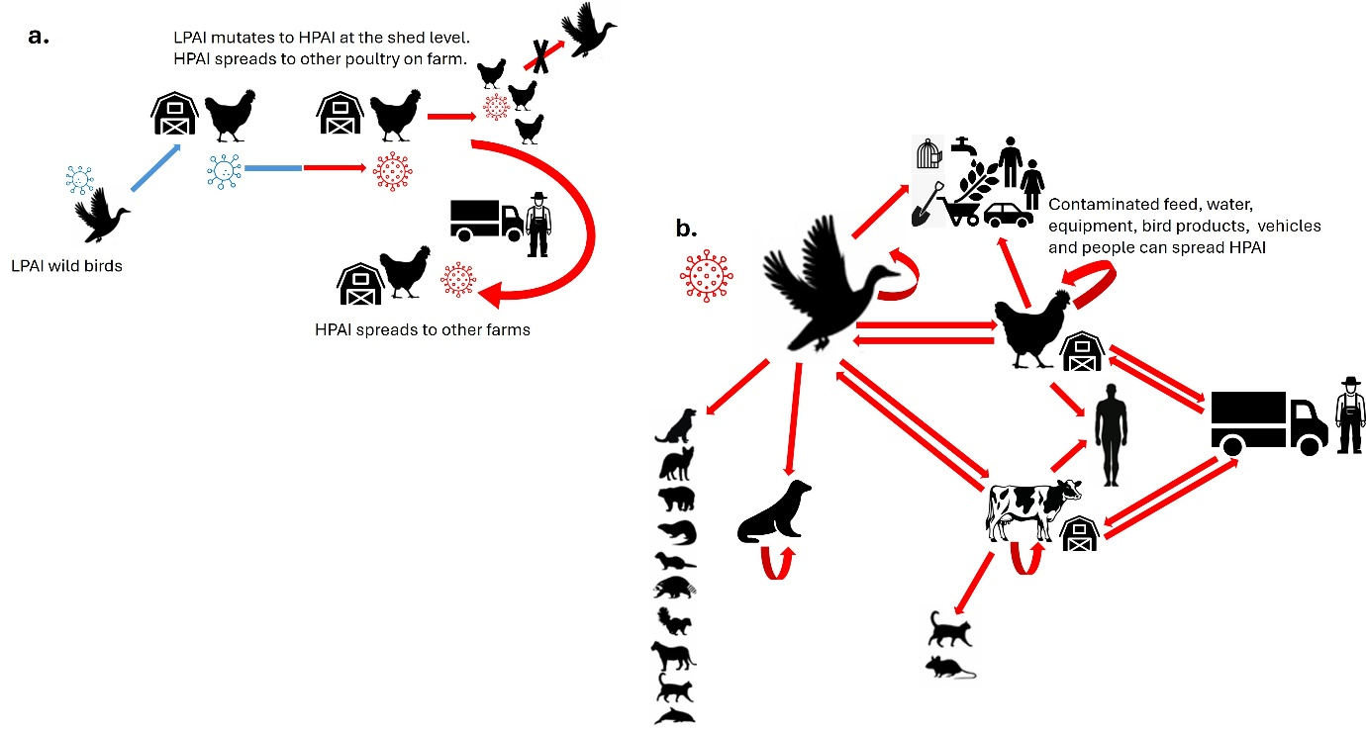
Source: Adapted from WOAH.
Figure A2 Avian influenza transmission pathways (b)

Source: Adapted from WOAH.

Incubation period
The incubation period for avian influenza viruses can vary in length, depending on factors such as the virus strain, the dose and route of exposure, host species, host age, and environmental conditions.
Clinical signs in birds typically develop 2 to 14 days after exposure. However, birds can start shedding the virus before showing clinical signs and may continue to do so after apparent recovery.
The World Organisation for Animal Health (WOAH) recognises 14 days as the incubation period for bird flu in poultry for control programs.
HPAI virus incubation in wild birds can range from a few hours to 7 days (WHA 2025).
The incubation period for other avian species and mammals is unknown.
For dairy cattle, clinical signs at the herd level can take up to 12 to 21 days to manifest after introduction (USDA 2024).

Avian influenza and human health
Although uncommon, human infection with H5 bird flu does occur, and is primarily acquired through close, prolonged or unprotected exposure to infected poultry/birds, dairy cows or contaminated environments. Most cases have been mild. However, in very rare cases, it has caused severe disease and death. People with a weak or compromised immune system are more at risk of severe disease.
Based on available information, the FAO, World Health Organization (WHO) and WOAH have assessed the global public health risk of influenza A (H5) viruses as low, and the risk of infection for occupationally exposed persons as low to moderate depending on the risk mitigation measures in place and the local avian influenza epidemiological situation.

Appendix B: Avian influenza response arrangements in Australia

Reporting obligations
In Australia, infection with influenza A viruses in birds, including but not limited to H5 bird flu, are notifiable at both national and state or territory levels. Although avian influenza infections in unusual hosts (e.g. cats, dairy cattle) are not specifically included on the national list, there is an expectation that such detections are promptly notified at the national level, consistent with Animal Health Committee Policy Decision 18-08. This is supported by state and territory legislation relating to notifiable animal diseases or prohibited matter.
Cases of HPAI in birds and some other animal species, need to be notified to WOAH through its global reporting systems. Reporting obligations vary slightly based on the animal species in which the detection occurs. The department is responsible for managing all international notifications to WOAH.

Arrangements for emergency animal diseases
Australia has nationally agreed response and cost-sharing arrangements in place to respond to emergency animal diseases (EADs).

EAD response deeds and agreements
The Emergency Animal Disease Response Agreement (EADRA) is a legally binding deed between the Australian Government, all state and territory governments, and livestock industries, to facilitate a nationally coordinated, cost-shared response to EAD outbreaks. Its primary aim is to ensure fast, effective containment and eradication of disease.
An outbreak of H5 bird flu in wildlife is unlikely to be eradicated or contained. The National Management Agreement for H5 HPAI in Wildlife (the H5 NMA) provides a national framework for responding to incursions of H5 bird flu in wildlife. The aim of a response to H5 bird flu in wildlife under the H5 NMA is to manage the immediate impacts of an outbreak on wildlife health and welfare, biodiversity and social amenity while establishing the necessary systems to move from an emergency response to longer term management.

AUSVETPLAN
The AUSVETPLAN (Australian Veterinary Emergency Plan) is a nationally endorsed framework for the management of EADRA listed diseases in Australia.
The AUSVETPLAN Response strategy: Avian influenza contains the nationally agreed approach for the response to an incident, or suspected incident, of avian influenza in poultry or captive birds (which includes zoo birds) in Australia.
While the default policy for an outbreak of HPAI in commercial poultry in the AUSVETPLAN Response strategy: Avian influenza is to contain and eradicate the disease using stamping out (culling) and a range of other strategies, this is not the case for other categories of birds (e.g. non-commercial poultry and captive birds). The strategies used during a response to an outbreak of H5 bird flu in these situations will depend on the assessed risk which will include consideration of the overall response objective, the risk of disease spread to humans and other susceptible species, and animal welfare.
International experience with H5 bird flu indicates that conventional control measures may be insufficient and unsustainable. Given the complexity of the disease and the potential involvement of a wide range of species, including wildlife, control strategies may need to be adapted to minimise disease spread.
There are several other AUSVETPLAN supporting documents of relevance to H5 bird flu including management and operational manuals (e.g. decontamination, disposal, destruction), and guidance documents. These are available through Animal Health Australia.

Incident management during an EAD outbreak
Technical decisions on EAD response strategies and activities are made at a national level by the Consultative Committee on Emergency Animal Disease (CCEAD), involving representatives from government, industry and other relevant stakeholders. Implementation of response activities is the responsibility of the biosecurity agency in each state and territory.

Vaccination for avian species
The Avian influenza vaccination policy for rare, protected and valuable avian species provides for vaccination of eligible rare, protected and valuable avian species with approval from the relevant national decision-making body and the jurisdictional Chief Veterinary Officer of the state or territory where vaccine use is proposed. The policy gives details on the requirements and circumstances under which vaccination could be permitted.
The vaccination of poultry is currently not permitted.

Appendix C: Avian influenza sampling, submission and testing
H5 bird flu is a notifiable disease and therefore diagnostic testing must only be undertaken with the oversight and approval of the relevant state/territory biosecurity agency and carried out at a government veterinary laboratory.
Point of care diagnostic testing (or pen-side testing) refers to the use of test kits in the field (outside of authorised laboratories), to test animals for specific diseases. The use of point of care testing for animals is regulated by the animal biosecurity authority in each state/territory. Currently, there are no point-of-care diagnostic tests for H5 bird flu approved for use in Australia.

Sample collection
If you suspect animal/s may be infected with H5 bird flu, immediately notify the Emergency Animal Disease Hotline on 1800 675 888 or the relevant state/territory biosecurity agency.
Duty Hotline staff may provide advice on sample collection and submission. Additional technical information is available on the website of the relevant state/territory veterinary laboratory.
The following information is largely applicable to the collection of samples from avian species. For advice on the collection of samples from mammalian species, please contact the relevant state/territory veterinary laboratory.
The recommended samples to be submitted from birds for avian influenza testing are oropharyngeal and cloacal swabs.
Using a clean, sterile swab, swab the mucosal surface of the oropharynx and cloaca (Figure D1), using a separate swab for each. Place the swab into a vial containing virus transport media (VTM), or saline, agitate briefly, then break off the swab tip into the vial and seal. Discard the remaining swab stem. Following collection, place the vials in labelled zip-lock bags and store at 4°C and maintain this temperature during transit to the laboratory.
Figure D1 Procedure for swab collection
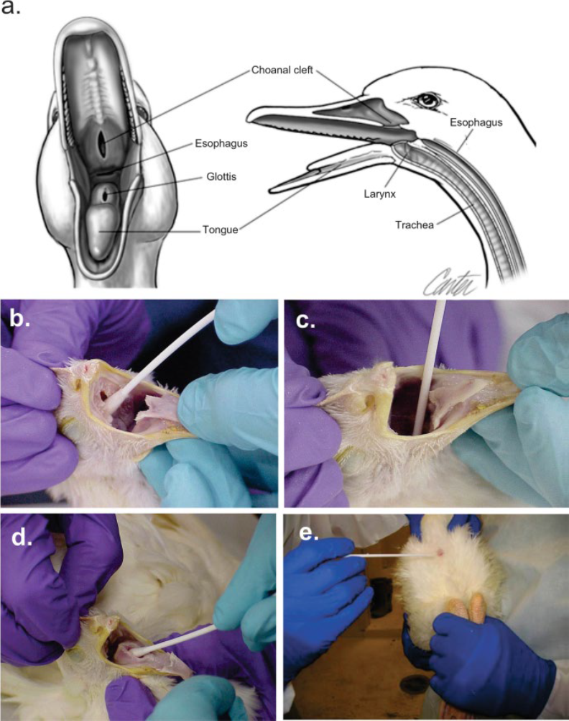
Note: Procedure for swab collection: a) diagram of oral cavity; b) to d) tracheal/oropharyngeal swab and e) cloacal swab. Source: Avian Sample Collection for Influenza A and Newcastle Disease, Animal and Plant Health Inspection Service (U.S. Department of Agriculture).

How to submit samples

Sample packaging
When packaging samples for avian influenza exclusion:
- Clearly label all samples with the anatomical location (i.e. oropharyngeal or cloacal) and bird ID, with a permanent marker.
- Send samples chilled and not frozen (e.g. in a box or esky with an ice pack or freezer brick).
- Samples must be properly packaged to prevent leakage and cross contamination during transport and to maintain their integrity for laboratory testing (double bagging is recommended).
- Do not send specimens in glass bottles, poor-quality plastic containers, syringes or gloves.
- Transport samples in a sturdy insulated container.
- If transporting with a commercial carrier, samples are to be consigned as ‘Biological Substance Category B’ (UN 3373) and packed according to International Air Transport Association (IATA) packing instruction 650 and if being transported by air, should be packed by someone certified in IATA packaging.
- A fully completed laboratory submission form, with a detailed history and record of clinical signs, treatments and contact details should accompany all submissions. Given the zoonotic risk, some laboratories may require submissions for H5 avian influenza testing to include a warning note, such as ‘avian influenza exclusion’.
- Samples are to be submitted using your preferred courier service to the relevant state/territory laboratory.
In NSW, the EMAI laboratory has a contract with Metrostate Couriers, and a consignment note can be provided by customer service staff to submitters to use this service at no cost to the submitter.

Shipping label for Category B biological substances
The label should print with the proper dimension of an Infectious Substance label (minimum dimensions: 50 mm on a side, and the proper shipping name ‘Biological Substance, Category B’ must be in letters at least 6 mm high).
Affix the label to the package by covering with clear plastic tape, so that moisture will not cause printer ink to run.
Ensure all samples are double bagged and shipped in a hard-sided container (a hard esky or a foam esky inside a cardboard box).
Figure D2 Biological substance label
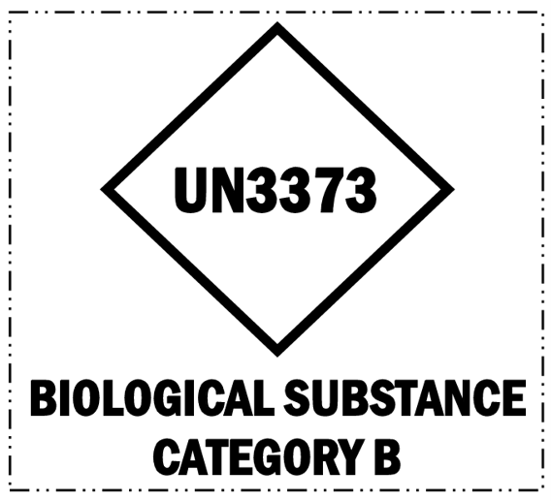
NSW specific H5 HPAI Preparedness Resource Videos have been prepared by the Australian Registry for Wildlife Health, covering H5 bird flu, correct donning and doffing of PPE, sample collection (swabbing) for H5 bird flu and sample shipping to the NSW government laboratory (EMAI lab).

State and territory details
Table D1 Queensland contact details
Laboratory name | Biosecurity Sciences Laboratory
Email | bslclo@dpi.qld.gov.au
Phone | (07) 3708 8762  After hours: EAD Hotline 1800 675 888
Delivery address | Specimen Receipt (Loading Dock 12)  Biosecurity Sciences Laboratory  Health and Food Science Precinct  39 Kessels Road  COOPERS PLAINS QLD 4108
Website | Biosecurity Sciences Laboratory
Table D2 New South Wales contact details
Laboratory name | Elizabeth Macarthur Agricultural Institute
Email | laboratory.services@dpi.nsw.gov.au
Phone | EMAI customer service – 1800 675 623
Delivery address | Regional Veterinary Laboratory  Elizabeth Macarthur Agricultural Institute  Woodbridge Road  Menangle NSW 2568
Website | dpird.nsw.gov.au/laboratory-services/veterinary
Table D3 Victoria contact details
Laboratory name | AgriBio – Veterinary Diagnostic Services
Email | Vet.Diagnostics@agriculture.vic.gov.au
Phone | (03) 9032 7515
Delivery address | AgriBio Specimen Reception  Main Loading Dock  5 Ring Road  La Trobe University  Bundoora VIC 3083
Website | agriculture.vic.gov.au/support-and-resources/services/diagnostic-services
Table D4 Tasmania contact details
Laboratory name | Animal Health Laboratory
Email | specimenreception@nre.tas.gov.au
Phone | (03) 6777 2111
Delivery address | Animal Health Laboratory – Specimen Reception  165 Westbury Road,  PROSPECT, TAS, 7250.
Website | nre.tas.gov.au/biosecurity-tasmania/animal-biosecurity/animal-health-laboratories/animal-health-laboratory
Table D5 South Australia contact details
Laboratory name | Gribbles Veterinary Pathology (VETLAB)
Email | glenside.enquiries@gribbles.com.au
Phone | (08) 8202 3300  After hours: EAD Hotline 1800 675 888
Delivery address | Glenside Laboratory  33 Flemington Street  Glenside, SA 5065
Website | gribblesvets.com.au
Table D6 Western Australia contact details
Laboratory name | DPIRD Diagnostics and Laboratory Services
Email | DDLS@dpird.wa.gov.au
Phone | (08) 9368 3351
Delivery address | Duty Pathologist – Specimen Reception  Department of Primary Industries and Regional Development  Building 102, 3 Baron-Hay Court  South Perth WA 6151
Website | dpird.wa.gov.au/businesses/biosecurity/diagnostics-and-laboratory-services/animal-pathology/
Table D7 Northern Territory contact details
Laboratory name | Berrimah Veterinary Laboratory
Email | bvl@nt.gov.au
Phone | (08) 8999 2249
Delivery address | Department of Agriculture and Fisheries  Berrimah Veterinary Laboratory  29 Makagon Road  Berrimah NT 0828
Website | daf.nt.gov.au/biosecurity/laboratory-services/berrimah-veterinary-laboratory

Appendix D: Triage decision-making framework
This document has been kindly shared by WA Wildlife Inc.
At the time of writing, this information was provided as a working draft only and is presented as an example that may not reflect current practices.
In the development of protocols, please use this document for reference only and be guided by consideration of risk factors for H5 bird flu specific to your location, species under care and work practices, as well as the outbreak status or number of detections in Australia at the time.
While clinical signs can suggest H5 bird flu, confirmation of infection requires submission of samples for diagnostic testing at the relevant state/territory government veterinary laboratory.
Figure E1 Triage decision-making framework
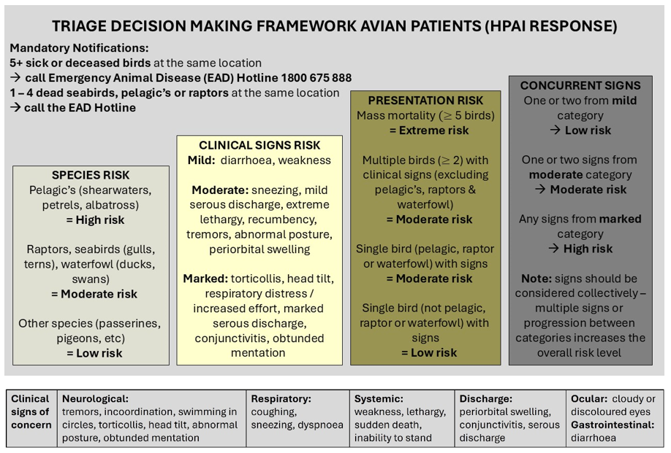

Appendix E: Triage tent example
Figure F1 illustrates a triage tent setup. This has been kindly provided by Dr Andrew Hill from Currumbin Wildlife Sanctuary.
Figure F1 Triage tent example
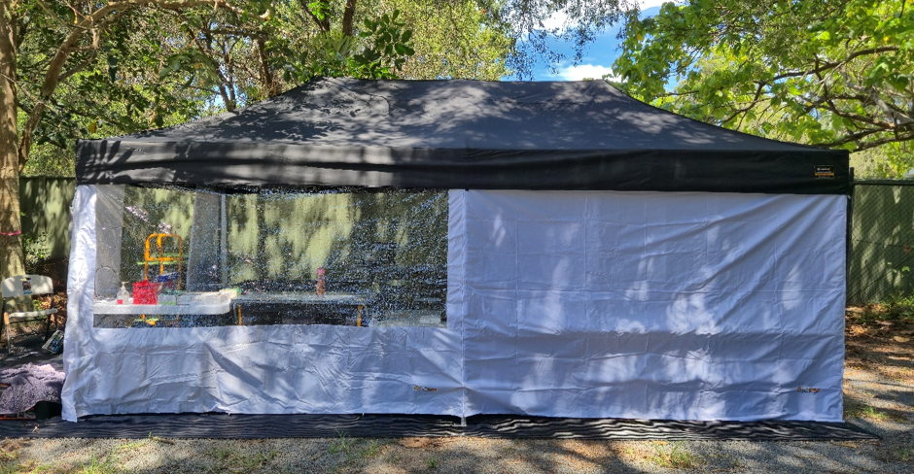

Appendix F: Resources
- Department of Agriculture, Fisheries and Forestry
  - Bird flu (avian influenza)
- Department of Climate Change, Energy, the Environment and Water
  - H5 avian influenza (bird flu)
- Wildlife Health Australia
Information for animal health professionals and wildlife carers
  - H5 bird flu Resource Centre
- Animal Health Australia
  - Informing EAD Responses – AUSVETPLAN – Animal Health Australia
  - AUSVETPLAN Response Strategy for Avian influenza
  - AUSVETPLAN Operational Manual – Disposal and Decontamination
  - AUSVETPLAN Wild animal response strategy
- Australian Registry for Wildlife Health
  - Highly Pathogenic Avian Influenza Preparedness Resources – Registry/ includes:
    - HPAI Field Officer Workshop Training – Resource Manual
    - HPAI Preparedness Workshop for Veterinary Professionals 2025 – Presentation
    - HPAI Preparedness Workshop for Veterinary Professionals 2026 – Resource Manual
    - H5N1 Clinic Biosecurity Plan Template 2026
    - HPAI Field Officer Online Training Module
    - HPAI Preparedness Resource Videos
- Australian Veterinary Association
  - AVA HPAI Webpage – includes downloadable resources
  - Australian Veterinary Association Personal Biosecurity
  - AVA Policy – High Pathogenicity Avian Influenza in pet birds, backyard poultry and wild birds
  - AVA Emergency Disaster Response
- Australian Centre for Disease Control
  - Bird flu (avian influenza) – Australian Centre for Disease Control
  - National guidelines for avian influenza: protecting people who work with birds and wildlife
  - Bird flu toolkit for people who work with birds
- State and territory avian influenza website resources
  - Queensland
  - New South Wales
  - Victoria
  - Tasmania
  - South Australia
  - Western Australia
  - Northern Territory
- International resources
- World Organisation for Animal Health
- American Veterinary Medical Association
- Avian influenza

Glossary
Term | Definition
captive bird | Any bird (other than poultry species) that is kept in (permanent) captivity, including but not limited to those that are kept for shows, exhibitions, zoological collections, or competitions, as well as pet birds, and those kept for breeding and/or selling. This includes wild birds that are temporarily in captivity under the dedicated care of a wildlife carer.
domestic animal | An animal that is of a domesticated state and lives under captive management and control to serve a purpose.
poultry | Chickens, turkeys, guineafowl, ducks, geese, quail, pigeons, pheasants, partridges, emus and ostriches that are reared or kept in captivity.
poultry (non-commercial e.g. backyard poultry) | Poultry kept in captivity for purposes other than the production of commercial animal products, restocking supplies of game, and/or breeding for these purposes.
wild birds | Any avian species that are free living in their natural environment without direct human intervention or control. This includes native and exotic/introduced bird species.
wildlife (captive) | Native or exotic non-domesticated animal species that live under captive management or control (e.g. zoo animals and animals in care).
wildlife (native) | Animal species that are endemic or indigenous to the whole or parts of Australia, whether captive or non-captive. Also referred to as native wildlife.
wildlife in rehabilitation/in care | A wild animal that is brought temporarily into captivity for care due to orphaning, sickness or injury.
AUSVETPLAN | Australian Veterinary Emergency Plan. A series of response plans that describe the proposed Australian approach to an emergency animal disease incident. The documents provide guidance based on sound analysis, linking policy, strategies, implementation, coordination and emergency-management plans (Informing EAD Responses – AUSVETPLAN - Animal Health Australia).
Consultative Committee on Emergency Animal Diseases (CCEAD) | The key technical coordinating body for animal health emergencies. Members are state and territory chief veterinary officers, representatives of CSIRO-ACDP and the relevant industries, and the Australian Chief Veterinary Officer as chair.
declared area | A defined tract of land that is subjected to disease control restrictions under emergency animal disease legislation. There are 2 types of declared areas: restricted area and control area.
restricted area | A relatively small legally declared area around infected premises and dangerous contact premises that is subject to strict disease controls and intense surveillance. The limits of a restricted area and the conditions applying to it can be varied during an incident according to need.
control area | A legally declared area that acts as a disease-free buffer between the restricted area and the outside area (the limits of a control area and the conditions applying to it can be varied during an incident according to need) where the disease controls and movement controls applied are of lesser intensity than those in a restricted area
decontamination | Includes all stages of cleaning and disinfection.
disinfectant | A chemical used to destroy disease agents outside a living animal.
disinfection | The application, after thorough cleansing, of procedures intended to destroy the infectious or parasitic agents of animal diseases, including zoonoses. Applies to premises, vehicles and different objects that may have been directly or indirectly contaminated.
Emergency Animal Disease Hotline | 24-hour free call service for reporting suspected incidences of exotic and notifiable diseases – 1800 675 888.
Emergency Animal Disease Response Agreement (EADRA) | Agreement between the Australian, state and territory governments and livestock industries on the management of emergency animal disease responses. Provisions include participatory decision-making, risk management, cost sharing, the use of appropriately trained personnel and existing standards such as AUSVETPLAN.
fomites | Inanimate objects (e.g. boots, clothing, equipment, instruments, vehicles, crates, packaging) that can carry an infectious disease agent and may spread the disease through mechanical transmission.
incubation period | The period that elapses between the introduction of the pathogen into the animal and the first clinical signs of the disease.
infected premises (IP) | A premises on which animals meeting the case definition are or the causative agent of the emergency animal disease is present, or there is a reasonable suspicion that either is present, and that the relevant chief veterinary officer or their delegate has declared to be an infected premises.
movement control | Restrictions placed on the movement of animals, people and other things to prevent the spread of disease.
notifiable disease | Means a disease listed by the Veterinary Authority, and that as soon as detected or suspected, should be brought to the attention of this Authority, in accordance with national regulations. For Australia:  A notifiable disease is one that must be reported to the relevant state or territory's department of primary industries or agriculture by phoning the Emergency Animal Disease Hotline on 1800 675 888.
stamping out | The strategy of eliminating infection from premises through the destruction of animals in accordance with the particular AUSVETPLAN manual, and in a manner that permits appropriate disposal of carcasses and decontamination of the site.
surveillance | A systematic program of investigation designed to establish the presence, extent or absence of a disease, or of infection or contamination with the causative organism. It includes the examination of animals for clinical signs, antibodies or the causative organism.
susceptible animals | Animals that can be infected with a particular disease agent.
suspect animal | An animal not known to have been exposed to a disease agent but showing clinical signs requiring differential diagnosis.
zoonosis | A disease or infection that is naturally transmissible from vertebrate animals to human.

Abbreviations
Term | Definition
AHA | Animal Health Australia
AUSVETPLAN | Australian Veterinary Emergency Plan
AVA | Australian Veterinary Association
CCEAD | Consultative Committee on Emergency Animal Diseases
CDC | Centre for Disease Control
EAD | Emergency animal disease
EADRA | Emergency Animal Disease Response Agreement
FAO | Food and Agriculture Organisation
H5 NMA | National Management Agreement for H5 HPAI in Wildlife
HPAI | High pathogenicity avian influenza
LPAI | Low pathogenicity avian influenza
PPE | Personal protective equipment
VTM | Virus Transport Media
WHO | World Health Organization
WHS | Work Health and Safety
WOAH | World Organisation for Animal Health

References
AVMA 2025, Avian influenza in pets and backyard flocks, American Veterinary Medical Association, accessed June 2026.
Beacon 2025, Infection with highly pathogenic avian influenza (HPAI) (H5N1) in a domestic, immunocompromised dog following consumption of wild waterfowl in Alberta, Canada, Beacon, accessed June 2026
DAFF 2025, Risk assessment of H5 bird flu in Australian dairy cattle and other livestock, Department of Agriculture, Fisheries and Forestry, accessed June 2026.
Hall, RN, White, P, Worsfold, D, Matsumoto, N, Schlosberg, O, MacPhillamy, I, Hillman, A, Badger, S, Zalcman, E, Cowled, BC, Hunnam, J. 2025, Risk assessment of high pathogenicity avian influenza to Australian dairy cattle: final report, report prepared for the Department of Agriculture, Fisheries and Forestry, accessed June 2026.
Uhart, M. M., Vanstreels, R. E. T., Nelson, M. I., Olivera, V., Campagna, J., Zavattieri, V., Lemey, P., Campagna, C., Falabella, V., & Rimondi, A. 2024, Epidemiological data of an influenza A/H5N1 outbreak in elephant seals in Argentina indicates mammal-to-mammal transmission, Nature Communications, DOI: 10.1038/s41467-024-53766-5, accessed June 2026.
WHA 2025, Avian influenza in wildlife in Australia, Wildlife Health Australia, accessed June 2026.

