Strengthening Indonesia's Veterinary Services


Australia Indonesia Partnership For Emerging Infectious Diseases

Achievements of The AIP-EID Animal Health Program 2011-2015

Contents
Foreword 3
Indonesian Ministry of Agriculture 3
Australian Department of Agriculture 4
About the AIP-EID Animal Health Program 5
Strengthening veterinary services 5
Guiding principles: partnership & sustainability 7
Preventing and Responding to Animal Disease Emergencies 8
Regulations, policies and guidelines for emergency response 8
Capacity to anticipate, identify and assess threats 8
Simulation exercises 9
Integrated Planning and Delivery of Disease Control Programs 11
Regulations and integrated plans 11
Budgeting, planning and advocacy 12
Surveillance systems and capacity to detect disease 13
Laboratory support 13
Assessment of risk pathways and operational risk 14
Investigation of routine disease events 14
Leadership and management 15
Information: Effective Systems and Use 17
Improving access to animal health information 17
Using information to enhance veterinary service performance 20
Strengthening human resources through technical training 21
The Role of National Reference Laboratories 23
Enhancing diagnostic test methods 23
Ensuring high-quality diagnostic test results 23
Key Results 25
Opportunities for the Future 27

Foreword

Indonesian Ministry of Agriculture

Ir. Syukur Iwantoro MS. MBA.
Director General of Livestock and Animal Health Services
The Australia Indonesia Partnership for Emerging Infectious Diseases (AIP-EID) 2011-2015 is a bilateral government-to-government partnership that has proven to be mutually beneficial for both countries. Indonesia and Australia are both keenly aware of the importance of strengthening the delivery of veterinary services. The AIP-EID Program focuses on combating threats of the incursion of disease, whether endemic and/or newly emerging, or diseases that have the potential to create a pandemic. The rate of such diseases has grown significantly in the last few decades, especially in the case of those that are zoonotic in nature.
The AIP-EID Program offers technical assistance in the area of human resource capacity-building, as piloted in the provinces of South Sulawesi and West Sulawesi. This technical assistance has been clearly beneficial for Indonesia and its veterinary services, which still require strengthening in terms of human resources, laboratory networks, disease surveillance and investigation capacity, quarantine systems, and a coordination system between the central and field offices for managing emergency disease outbreaks.
During the course of the AIP-EID Program, we have seen several achievements leading to a monumental outcome that brings together elements of strategic planning, coordination, technical capacity and management of animal diseases. This has strengthened capacity to prevent the incursion of diseases, and to stay alert and respond to emergency situations. Under the Program, we have seen the development of disease control programs at the sub-national level, the establishment of an integrated animal health information system (iSIKHNAS) and the strengthening of national laboratories as integral components of a greater laboratory network.
We would like to express our appreciation to the Australian Government through the Department of Foreign Affairs and Trade (DFAT) for the grants given to Indonesia in the effort to combat animal diseases, especially the infectious animal diseases that are priorities for the Government of Indonesia. We would also like to extend our thanks to the Australian Department of Agriculture, as well as all personnel from the AIP-EID Program, the provincial governments of South Sulawesi and West Sulawesi, and all those who assisted in ensuring the success of the program.
We hope that the partnership will continue in the future, with a focus on the concept of One World, One Health, in order to provide mutual benefit to both Indonesia and Australia, as well as contribute to food security and the health of humans, animals and the environment.


Australian Department of Agriculture

Rona Mellor PSM
Deputy Secretary
Department of Agriculture
It is with pleasure that I present this report on the achievements of the Australia Indonesia Partnership for Emerging Infectious Diseases (AIP-EID) Animal Health Program. The program's work over the past four years has made a substantial contribution to strengthening Indonesia's veterinary services.
Australia and Indonesia have a long history of collaboration in the area of animal health and the control of infectious diseases. During the 1970s and 1980s, this collaborative partnership contributed to the eradication of foot and mouth disease (FMD) from Indonesia. Since then, much has been achieved through technical partnerships involving the governments and academic institutions of both countries.
As we move forward in the 21st century, infectious diseases continue to pose a serious threat. The factors that favour the emergence of infectious diseases are plentiful and globalisation creates opportunities for diseases to spread with frightening speed. Meanwhile, economic growth is leading to greater demand for animal protein and other livestock products. The role of veterinary services is becoming ever more important for protecting our health and prosperity.
This report outlines advances that have been made under the AIP-EID program in many areas of Indonesia's veterinary services, such as disease prevention and emergency response; planning and implementation of disease control programs; information systems and laboratory capacity. Positive changes have been made through a genuine and effective partnership, and it is encouraging to see that steps have already been taken to ensure the sustainability of these changes.
None of these outcomes would have been attained without a strong commitment to improving animal health, for the good of people in Australia, Indonesia and the wider region. The Australian Government sincerely appreciates the ongoing collaborative partnership with the Government of Indonesia and commends the work of all those involved in the implementation of the AIP-EID program.
It is my hope that many people will benefit from the outcomes of the AIP-EID program. A strong animal health system in Indonesia not only serves the farmers and rural communities of Indonesia, but also helps to protect the health and prosperity of communities throughout the region.


About the AIP-EID Animal Health Program

Strengthening veterinary services
Australia and Indonesia recognise the importance of strong veterinary services to combat emerging infectious diseases. Diseases such as highly pathogenic avian influenza, brucellosis, anthrax and rabies threaten food security, rural livelihoods and public health. There is much to be gained from bilateral and regional collaboration to mitigate the threat of disease epidemics and their associated social and economic costs.
The AIP-EID Animal Health Program was implemented from 2011 to 2015 in partnership by the Australian Government Department of Agriculture and the Indonesian Ministry of Agriculture. The AUD 22 million program strengthened Indonesia's veterinary services across a range of technical and policy areas, at both central and sub-national levels.
Indonesia's veterinary services are now better able to prevent, detect and control emerging and important endemic infectious diseases. The AIP-EID program worked to strengthen animal health institutions and the capabilities of government staff to deliver veterinary services. Program outcomes were developed to align with the priorities of the Government of Indonesia and followed on from the World Animal Health Organisation (OIE) Performance of Veterinary Services (PVS) assessment missions.
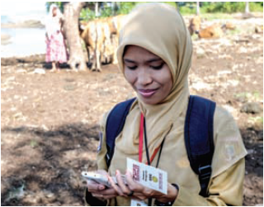
The program had a broad scope covering five inter-related areas. At the national level, the program set out to develop sound policies with the necessary supporting regulations and technical guidelines for emergency preparedness and response, as well as disease prevention and control. Core capabilities of veterinary services were strengthened in the areas of information systems, animal health laboratories and quarantine operations. At the sub-national level, training in animal health and non-technical areas such as planning and advocacy was delivered in tandem with support for local disease control programs.
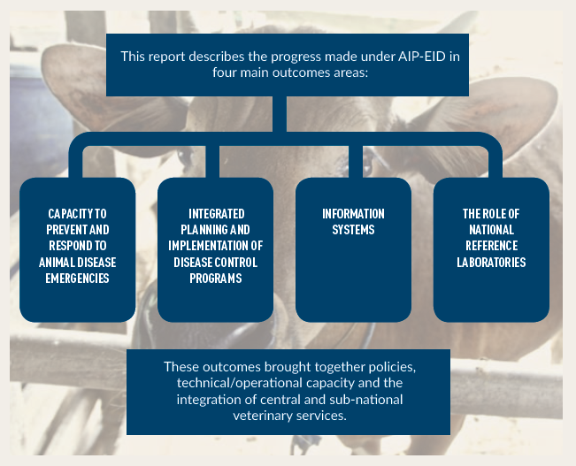
The AIP-EID program was delivered in the true spirit of partnership, and with a focus on strengthening sustainable systems. Australian technical experts from the Department of Agriculture worked closely with counterparts in the Indonesian Directorate of Livestock and Animal Health Services (DGLAHS), the Indonesian Agricultural Quarantine Agency (IAQA) and diagnostic laboratories throughout Indonesia. At the sub-national level, the program implemented a series of pilot projects in the provinces of South Sulawesi and West Sulawesi. The Australian Animal Health Laboratory (AAHL) made a strong contribution to the strengthening of diagnostic laboratories.
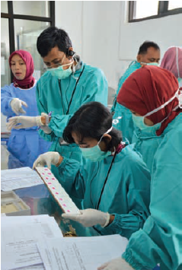

Guiding principles: partnership & sustainability
Partnership and sustainability were core principles of the AIP-EID program. The program was delivered entirely within the Indonesian Government framework and with a strong focus on the sustainable improvement of government veterinary services. A shared responsibility for design and monitoring helped to ensure that the program was aligned with Indonesia's priorities. Australian advisers worked on a day-to-day basis with their Indonesian counterparts to facilitate knowledge transfer and ensure that program interventions were appropriate and scalable in the Indonesian context.
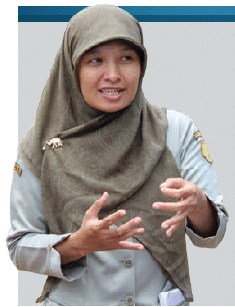
Health and Livelihoods
A large proportion of cattle in Indonesia are raised by small-holder farmers. Better control of infectious diseases improves animal production and the livelihoods of people in rural communities.

Preventing and Responding to Animal Disease Emergencies
When outbreaks of disease occur, the social and economic impacts can be very high. These impacts can be avoided or greatly reduced if systems are in place to prevent or rapidly respond to animal disease emergencies.

Regulations, policies and guidelines for emergency response
The AIP-EID program supported the development of a series of regulations, policies, guidelines and standard operating procedures (SOPs) to underpin the emergency response to disease outbreaks. Government staff were closely involved in this work, leading to improved understanding, greater capacity and stronger commitment to implement a more effective emergency management system.
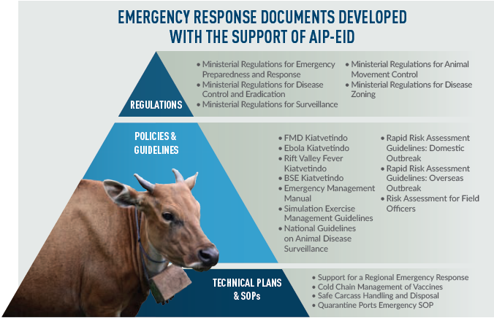

Capacity to anticipate, identify and assess threats
The likelihood of disease incursions can be greatly reduced if threats are identified early, are rapidly assessed, and steps are quickly taken to manage the risks. Guidelines on the assessment of risks associated with the movement of animals and animal products were developed and tested in the field during the course of the program. These were complemented by the development of a training course on operational (applied) risk assessment for officers in the areas of quarantine and animal health. Protocols on scanning for emerging disease threats using various information sources were developed in tandem with guidelines and training on the rapid assessment of risks arising from overseas or domestically.
Collaboration in developing these guidelines has resulted in improved coordination between animal health, quarantine and veterinary public health personnel, as well as greater understanding between policy makers and field staff.
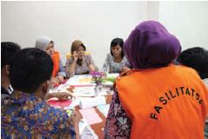
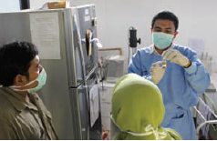
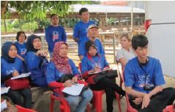
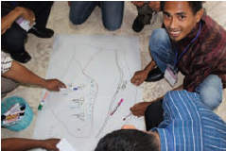
"Rapid risk assessment guidelines and scanning protocols have been tested and we have positive feedback on all elements. The guidelines are easy to implement and have been well understood by field officers around Surabaya, Malang and Manado."
Veterinary Officer, Directorate of Animal Health

Simulation exercises
Disease outbreak simulation exercises are an important part of preparedness and contribute to the ongoing refinement of emergency response systems. A manual on simulation exercises has been developed by the program and used each year in the planning, delivery and review of foot-and-mouth disease (FMD) exercises. In 2014, additional exercises were conducted to assess preparedness for a rabies outbreak, and to review the process of submission and testing of field samples to a diagnostic laboratory. The training and experience gained through simulation exercises support ongoing efforts to strengthen coordination and overall emergency response capability.
More than 450 representatives from national and sub-national agencies participated in the FMD simulation exercises from 2011 to 2014. These exercises resulted in a greater awareness of the need for a clear organisational structure, with defined agency and staff roles and responsibilities, to enable a rapid and coordinated whole-of-government response to disease emergencies.
Findings and recommendations from the simulation exercises have informed the development of an emergency management manual, which will guide further development of an integrated emergency management system.
"Through simulation exercises, coordination between related units has been improved. There was intense communication and effective coordination when a suspected FMD case was detected recently in Bone District. We were successful in launching a quick and effective response."
Head of Provincial Livestock and Animal Health Office, South Sulawesi

Zoonotic Diseases
such as bird flu, anthrax and brucellosis reduce animal production and directly threaten human health.

Integrated Planning and Delivery of Disease Control Programs
The broad scope of the program covered a range of policy, systems and human resource capacities at the national and sub-national level. This enabled an integrated approach to the planning and delivery of disease control programs. The control of brucellosis in three pilot districts was a particular focus in developing coordinated disease control policies and plans, though all interventions were designed to build essential management and technical capacities that can be applied to all disease control programs.
A number of elements of the veterinary services are required to effectively prevent and control disease. Elements include regulations, policies, plans, management and coordination structures, human resources and funding. The program worked to strengthen each of these elements and contribute to better and more integrated planning and delivery of animal disease control programs. This schematic highlights how the AIP-EID program worked holistically across different elements of the veterinary service at the national and subnational levels of government.
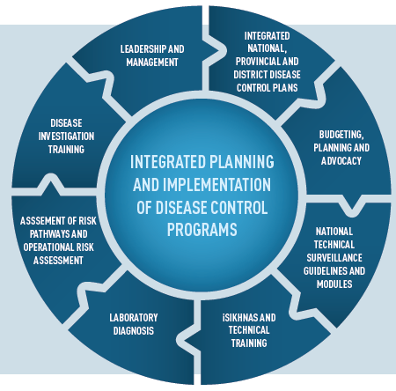

Regulations and integrated plans
Coherent plans for the progressive control and eradication of brucellosis have been developed at the national, provincial and district level with support from laboratory and quarantine services. These plans are guiding local control programs which are now being implemented in three districts in South Sulawesi (Barru, Enrekang and Pinrang). The plans promote a technically sound and integrated approach to disease control; they have also been used as a basis for advocating for increases to budgets and resources. A national roadmap has since been developed for the control of Classical Swine Fever.
"Before we received training and were J involved in brucellosis control plan activities, we didn't use a consistent sampling method. We have also gained other knowledge from our involvement in the AIP-EID program. Now we are very optimistic that the cattle population in Pinrang District will increase and become healthier in the coming years"
Head of Pinrang District Animal Health Service, South Sulawesi

Budgeting, planning and advocacy
The delivery of effective veterinary services requires funding and the efficient use of limited resources. This means that veterinary service personnel must be able to develop plans and budgets, and advocate for appropriate funding. During the course of the program, a training course on budgeting and planning was delivered to 477 participants in South Sulawesi and West Sulawesi. Personnel there are now able to develop operational plans and budgets that are more closely linked to strategic objectives. In districts where training has been provided, the budget allocation for animal health has increased and there has been more effective and efficient use of the available resources.
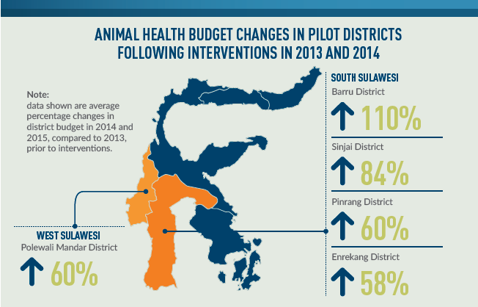
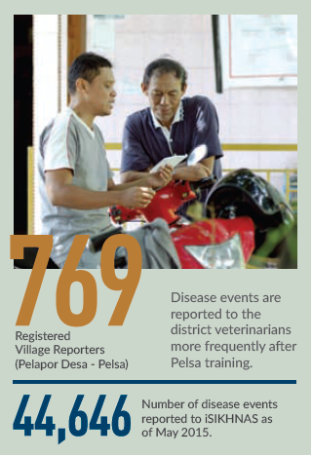
"We used to have difficulty in contacting BAPPEDA (the Regional Development Planning Agency), but as a result of the training in budgeting provided by the AIP-EID program, we are now developing better proposals and our engagement with BAPPEDA has improved significantly."
District Veterinarian, South Sulawesi

Surveillance systems and capacity to detect disease
Surveillance to detect disease events is a cornerstone of disease control. Under the AIP-EID program, comprehensive guidelines on animal health surveillance were published and distributed nationally, together with a supporting poster. A three-day course on surveillance was developed to complement the guidelines. The guidelines and training encouraged the adoption of a range of measures to improve the efficiency and sensitivity of surveillance for animal diseases. The guidelines have been used to review early detection and surveillance programs for FMD, brucellosis and other diseases.
The establishment of an integrated national animal health information system known as iSIKHNAS has allowed simple and real-time communication between farmers or voluntary participants known as 'village reporters' and the local animal health post. In order to harness the power of the community in reporting disease events, the program developed a short course for voluntary village reporters on how to recognise signs of poor health and report them using iSIKHNAS. In districts where village reporters have been trained, better communication and faster responses have strengthened the relationship between the community and veterinary service personnel.

Laboratory support
Animal health laboratories play an important role in diagnosing diseases and supporting disease control programs. With regional Disease Investigation Centres and provincial laboratories, the AIP-EID program worked to harmonise test methods and establish quality assurance processes. Achievements in strengthening the laboratory network are described in detail later in this report.

Assessment of risk pathways and operational risk
The prevention of disease incursions is an important element of disease control. Animals and animal products are often moved in the course of production and marketing, and this can result in the spread of disease. Under the program, guidelines to assess risk pathways were developed to encourage a methodical and proactive approach to risk management, and to strengthen collaboration between central government, local government and industry stakeholders.
A training course in operational (applied) risk assessment was developed to enable animal health and quarantine officers at the field level to better identify and manage the risks associated with animal movements. The training has been modified as an E-learning package to increase its accessibility.
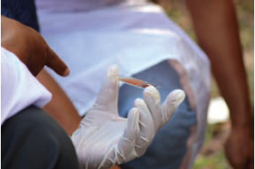

Investigation of routine disease events
Investigation of routine disease events is one of the primary roles of field veterinarian and para-veterinarians. Such investigations form the basis of diagnosis and treatment, and are an essential service provided by veterinary services to farmers.
The program developed training modules in disease investigation that were delivered to 45 veterinarians and 376 para-veterinarians in South Sulawesi and West Sulawesi. As a result of the training, field staff developed a more methodical and systematic approach to disease investigation. They are now more confident of their technical skills and are more motivated to respond to routine disease notifications.
In the pilot districts where disease investigation training was delivered, farmers are now receiving a better service because of more rapid responses, better communication and more effective disease investigation. This is helping to build stronger relationships between veterinary authorities and the communities they serve.
Government staff were integral to the development and delivery of the training. Training materials and capacity now exist to enable replication in other areas.

Leadership and management
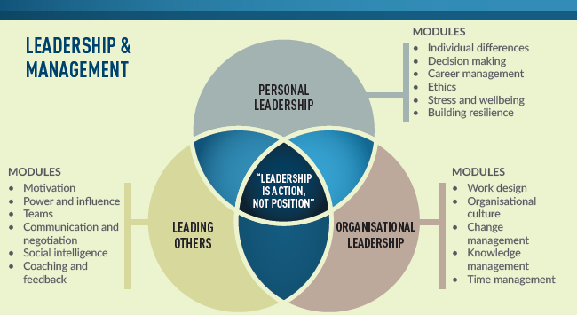
Veterinary Leadership is now recognised internationally as a critical requirement of any veterinary service. Under the AIP-EID program, one core activity was the delivery of veterinary leadership training to next generation leaders. More than 50 young managers from Indonesia's veterinary services have now completed the Indonesia Veterinary Leadership (IVL) course.

The IVL course was developed by the Bogor Agriculture University (IPB) and the University of Gadjah Mada (UGM) in collaboration with the University of Sydney. The core Indonesian trainers have now developed the skills and abilities to deliver dynamic, experiential training in veterinary leadership. The course developed the critical, non-technical skills necessary for good leadership. It covered personal leadership, leading others and organisational leadership, with modules on topics such as individual differences, ethics, career-building, time and change management and team building.
"The mental revolution initiated by IVL will build the institutional culture needed to strengthen veterinary services."
Sub-directorate head, Directorate of Animal Health
"I have learnt a lot from the IVL. I feel like I am 'reborn' to be not only a better person but also a better leader. This has been a good experience"
Section Head, Animal Health and Veterinary Public Health, West Sulawesi
Government veterinary middle managers have increased confidence and competence in leadership and are challenging leadership paradigms. This is most clearly seen in the management of their day-to-day tasks, which is showing improved scheduling and prioritisation. They have also dramatically increased their engagement with senior managers and are driving changes in vision and policy.
Veterinary Leadership has now been recognised by the Indonesian Veterinary Medical Association, which has been established the IVL Commission. The commission is developing a formal accreditation process and is guiding the extension of the IVL more broadly for senior managers, district veterinarians, postgraduate and undergraduate students.
6,993
government officers trained from 2011 to 2015 in technical areas related to animal health and non-technical areas such as veterinary leadership, planning and budgeting.

Information: Effective Systems and Use
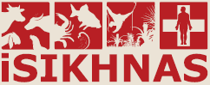
Access to information underpins many aspects of the delivery of veterinary services. Field services, disease control programs, policy development and advocacy are all improved when there is ready access to quality information. Because of the central importance of information systems to veterinary service delivery, this was a key area of collaboration under the AIP-EID program.
A comprehensive review of Indonesia's animal health information needs and capabilities was conducted in 2012. The review looked at the work being done at all levels of veterinary service to better understand the needs for information and the strengths and constraints of existing information systems. The review took into account organisational and technical elements, and the cultural and psychological factors that motivate or discourage people from contributing and using information.
The review generated a detailed roadmap for the development of an integrated national animal health information system that became known as iSIKHNAS. Design, development and pilot projects took place from 2013 to 2014, followed by a first phase of national extension in late 2014. In recognition of the benefits and demand from stakeholders at the local level, further national extension—funded and implemented by the Government of Indonesia—is underway in 2015.

Improving access to animal health information
iSIKHNAS is Indonesia's integrated national animal health information system. It is a powerful and comprehensive information system that uses modern technology and a people-centred philosophy to support animal health and production.
iSIKHNAS is based on strong principles and a philosophy that puts people at the heart of the system. The innovation and power of iSIKHNAS comes from its ability to provide immediate benefit to all users; for example, by making communication easier, removing menial and repetitive reporting tasks, and providing fast and positive feedback.
With iSIKHNAS, modern technologies link existing databases and replace paper-based systems to create a very powerful and integrated information system. It is a comprehensive and flexible system that manages a large and rapidly growing number of information types including disease notifications, laboratory test results, surveillance and vaccination programs, animal movements and animal identification. It allows users to contribute and extract information easily and in real time, using SMS, instant messaging, email and the internet. The powerful iSIKHNAS database automatically generates reports, graphs and maps and sends these to the people who need them. Importantly, iSIKHNAS is built on open-source software and works with existing ICT infrastructure.

Key features of iSIKHNAS
- Simple: uses existing tools such as SMS, spreadsheets, internet and email.
- Integrated: a single system for all relevant data.
- Fast: data submission from the field to the database is direct and electronic.
- Win-win for data users: data is captured electronically in the field making field work easier; data is readily available at higher levels for policy and decision-making.
- Provides a service to all: gives direct benefit to farmers and their communities, improves communication for animal health staff at all levels and makes reporting faster and easier.
- Sustainable: developed to be managed and adapted by Indonesian Government staff.


How the system works
Data types managed:
- Field disease reporting
- Laboratory data identification
- Slaughter statistics
- Active surveillance
- Breeding management
- Livestock movement
- Population data
- Vaccination programs
- Animal
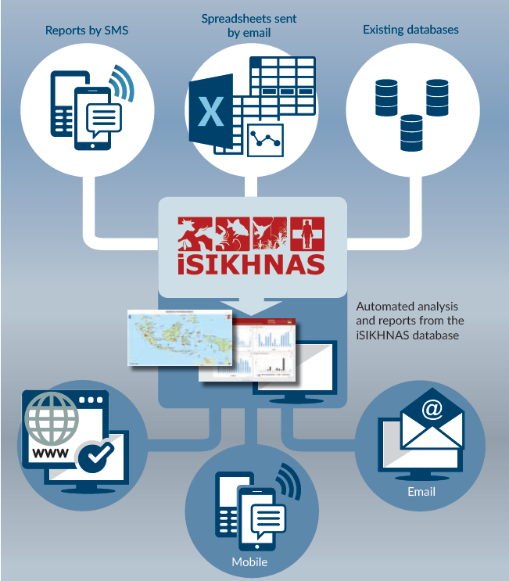
Average Daily Number of SMS messages received by the iSIKHNAS Database, by Month
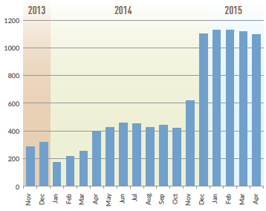
People are the most important element of any information system and the program has invested heavily in the development of iSIKHNAS 'Champions' and coordinators at all levels of government.
As of May 2015, iSIKHNAS is being used by almost 5000 people in 382 districts across 33 provinces. In excess of 1000 SMS messages are received by the iSIKHNAS database each day and more than 300 people log in to the iSIKHNAS website each day to view over 200 automatically generated reports, graphs and maps.

Using information to enhance veterinary service performance
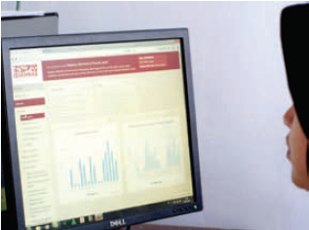
The establishment of iSIKHNAS has enabled people to communicate more easily and engage with information more effectively in the course of their daily work. As intended, this has resulted in stronger linkages between veterinary service staff and the farmers and communities they serve. Decision-makers are now using information from iSIKHNAS to plan and implement disease control programs, monitor the performance of staff, allocate resources more efficiently and advocate for the provision of animal health services. Information is more readily accessible and people are becoming more motivated to use it on a daily basis.
To further promote the effective use of information, the program developed a suite of training courses for veterinarians and para-veterinary staff. Each training 'package' includes comprehensive materials for facilitators and participants—all are freely accessible at wiki.iSIKHNAS.com
By May 2015, 277 people had received training in topics such as field epidemiology, surveillance, data analysis and Geographic Information Systems. Several of these courses have already been replicated by the Government of Indonesia at the central and sub-national level, resulting in more trained staff.
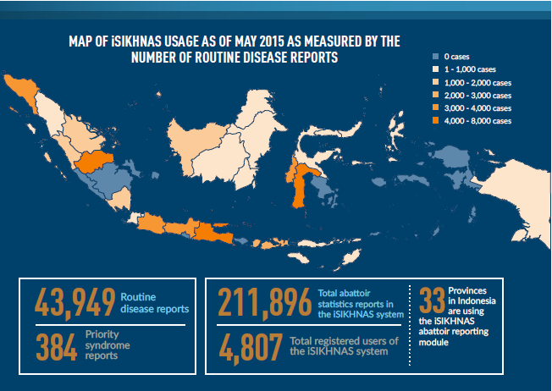

Strengthening human resources through technical training
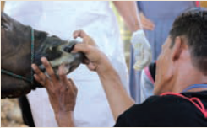
People with the right knowledge, skills and attitudes are an essential element of veterinary services. Providing training to enhance human resources is not easy, particularly when the target is several thousand field officers dispersed across rural Indonesia. The task becomes almost impossible when training is expensive or requires 'expert' trainers.
The AIP-EID program took a fresh approach to the training of field staff, inspired by a saying from advertising: 'Content is king but distribution is almighty'. The content of the training was designed to provide relevant and widely applicable technical material, using methods that support adult learning. To enable distribution (replication) across Indonesia, the courses were designed to be delivered by competent facilitators who are not necessarily experts. Presentations, videos, E-learning materials and comprehensive resources for facilitators and participants were made freely accessible, making it easier for the courses to be replicated at low cost, wherever and whenever people were motivated to learn.
Over time, it is hoped that these training courses will continue to be used widely and encourage a culture of ongoing professional development that can be done in 'everyday' settings without a lot of time, money or specialist expertise.
Vet Service Personnel
are using information from iSIKHNAS to support planning, decision making, advocacy and the delivery of field services. They are more motivated to access information and make evidence-based decisions.

The Role of National Reference Laboratories
Indonesia has eight regional Diseases Investigation Centres and a network of laboratories serving animal health, veterinary public health and quarantine. These laboratories provide diagnostic services that underpin many elements of diseases control.
With a focus on national reference laboratories, the AIP-EID program supported the advancement of diagnostic test methods for several high-priority diseases, and the establishment of processes to assure the quality of test results.

Enhancing diagnostic test methods
The program worked with national reference laboratories to embed standard test methods for the diagnosis of brucellosis, anthrax, avian influenza and rabies. Personnel from many other laboratories attended training, and standard methods are now being used more routinely across the country. The standard methods have strengthened diagnostic capacity for these four zoonotic diseases (animal diseases that can spread to humans) and can also be applied to the diagnostic testing of other viral and bacterial diseases.
At the Disease Investigation Centre in Bukittinggi, West Sumatra, a new test method was developed for the diagnosis of rabies. The Rabies Immunoperoxidase Antigen Detection (RIAD) test performs as well as the 'gold standard' Fluorescent Antibody Test (FAT), but unlike the FAT, it can be performed without an expensive fluorescent microscope. RIAD test kits are now being produced by the Bukittinggi laboratory and used in provincial laboratories to provide rapid and accurate diagnosis of one of the most important zoonotic diseases.

Ensuring high-quality diagnostic test results
Reference laboratories play an important role in establishing standards and maintaining the quality of diagnostic tests. This is vital for internal quality control and for quality assurance processes throughout the laboratory network. Since receiving training and mentoring through the AIP-EID program, reference laboratories have planned and implemented Proficiency Testing (PT) rounds for avian influenza, rabies and brucellosis. At the Disease Investigation Centre in Maros, South Sulawesi, the program supported the development of a standard serum for use in tests for brucellosis.
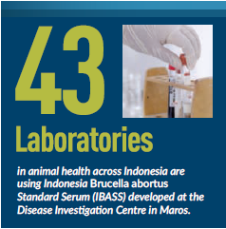

National Reference laboratories

- The roles and functions of the designated reference laboratories have been better defined with the development of 19 key criteria adapted from the OIE. These allow laboratories to better prioritise their work programs, and enable them to measure and track their performance.
- Several reference laboratories are now exercising their reference roles more actively, and providing technical support for other laboratories. They are developing new test methods, providing confirmatory diagnostic testing, and have become leaders in the establishment of quality assurance processes.

Key Results
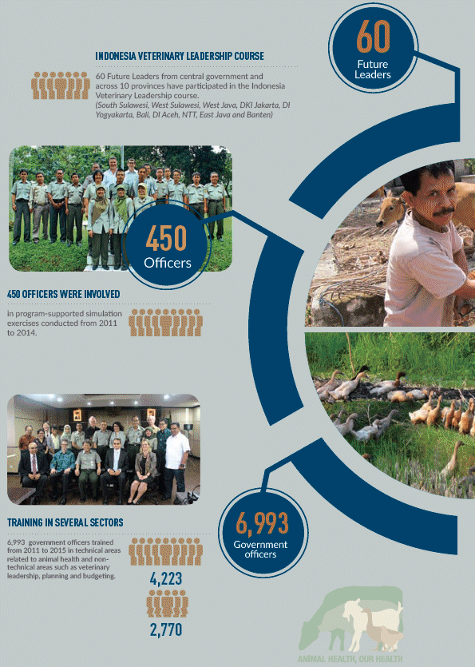
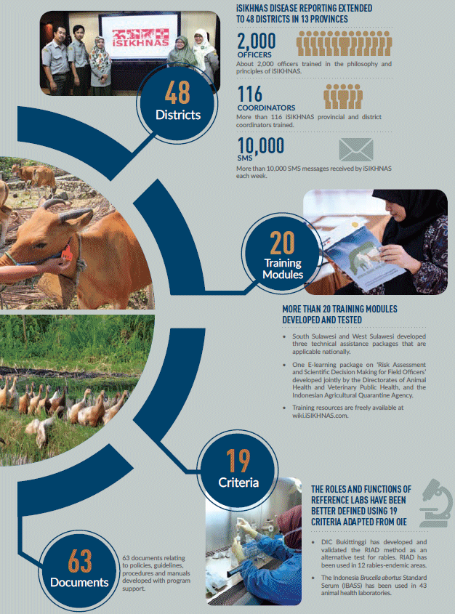

Opportunities for the Future
We all hope for a future where our health and livelihoods are protected against the danger of infectious disease. However, it is very likely that the strength and resilience of our public health and animal health systems will be tested in the face of various threats. Rapid changes in agricultural systems, demography and the environment will create new opportunities for germs that may alter the balance in the ongoing war against infectious diseases. Veterinary services will play an increasingly important role in securing a healthy and prosperous future.
The AIP-EID Animal Health Program demonstrates that strong partnerships can substantially strengthen veterinary services. As outlined in this report, clear results were achieved in the four years from 2011 to 2015. In addition to the benefits realised during this period, opportunities were created that have great potential to further transform Indonesia's veterinary services.
Even greater impact can be attained with sustained investment to capitalise on these achievements. National extension of iSIKHNAS and full utilisation of its existing capability will transform field service delivery and provide robust and accessible evidence to inform decisions, policies and programs. With relatively little investment, enhancements to iSIKHNAS could bring great value to veterinary public health, quarantine and public health. There are already strong foundations and a firm commitment to develop a robust emergency management system, and tremendous demand for leadership training.
Whatever the future holds, animals will remain integral to our societies and economies. As new diseases continue to emerge, our health remains inextricably linked to the health of animals and the environment. Stronger health systems— both for animal health and for human health— will deliver local benefits and contribute to an important global public good.
Veterinary services will become more important than ever, and there will a growing need for collaboration across agencies, sectors and disciplines, and among countries with common goals and interests. Together, we can shape our future for the betterment of animal health and our health.
'Animal Health, Our Health'
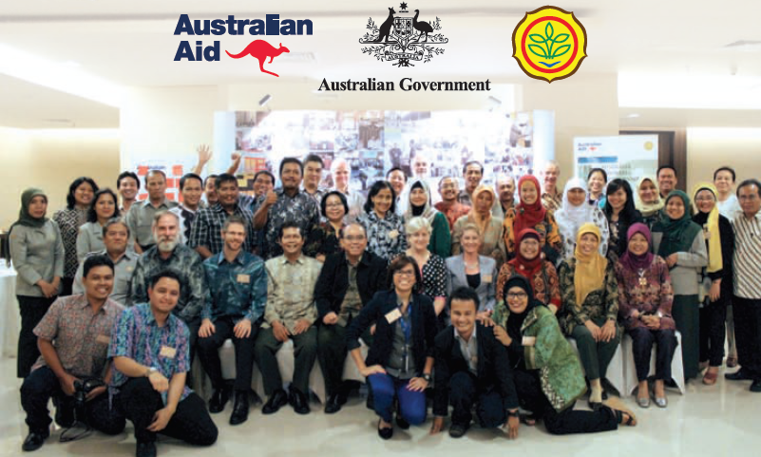
Secretariat of the AIP-EID Animal Health Program
Tel: 62-21-780 2119 / 781 5580
Fax: 62-21-780 5238 / 781 5581
Email: sekretariat@aipeid.org

