Canine monocytic ehrlichiosis

A guide for veterinarians
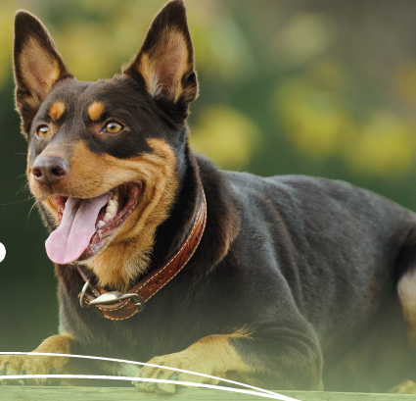
© Commonwealth of Australia 2022
The content in this guide was originally authored by the Queensland Government (© State of Queensland 2021) and the Northern Territory Government.
Ownership of intellectual property rights
Unless otherwise noted, copyright (and any other intellectual property rights) in this publication is owned by the Commonwealth of Australia (referred to as the Commonwealth).
Creative Commons licence
All material in this publication is licensed under a Creative Commons Attribution 4.0 International Licence except content supplied by third parties, logos and the Commonwealth Coat of Arms.
Inquiries about the licence and any use of this document should be emailed to copyright@agriculture.gov.au.

Cataloguing data
This publication (and any material sourced from it) should be attributed as: DAFF 2022, Canine monocytic ehrlichiosis: a guide for veterinarians, Department of Agriculture, Fisheries and Forestry, Canberra, February. CC BY 4.0.
This publication is available at https://www.agriculture.gov.au/biosecurity-trade/pests-diseases-weeds/animal/ehrlichiosis-in-dogs
Department of Agriculture, Fisheries and Forestry
GPO Box 858 Canberra ACT 2601
Telephone 1800 900 090
Web agriculture.gov.au
Disclaimer
The Australian Government acting through the Department of Agriculture, Fisheries and Forestry has exercised due care and skill in preparing and compiling the information and data in this publication. Notwithstanding, the Department of Agriculture, Fisheries and Forestry, its employees and advisers disclaim all liability, including liability for negligence and for any loss, damage, injury, expense or cost incurred by any person as a result of accessing, using or relying on any of the information or data in this publication to the maximum extent permitted by law.
The information contained herein is subject to change without notice. The Queensland Government and Northern Territory Government shall not be liable for technical or other errors or omissions contained herein. The reader/user accepts all risks and responsibility for losses, damages, costs and other consequences resulting directly or indirectly from using this information.
Acknowledgements
The authors would like to acknowledge the input of the many veterinarians who contributed valuable insights, information, feedback and photographs in the development of this resource – in particular, Professor Peter Irwin, staff of Animal Management in Rural and Remote Indigenous Communities (AMRRIC), and private veterinarians who have been at the frontline of the E. canis response in northern Australia. Thank you.
Acknowledgement of Country
We acknowledge the Traditional Custodians of Australia and their continuing connection to land and sea, waters, environment and community. We pay our respects to the Traditional Custodians of the lands we live and work on, their culture, and their Elders past and present.

Contents
Canine monocytic ehrlichiosis i
A guide for veterinarians i
About canine monocytic ehrlichiosis 1
Susceptible species and risk factors 3
Clinical signs: acute ehrlichiosis 4
Subclinical infection 6
Chronic ehrlichiosis 8
Sampling 10
Laboratory testing 11
Laboratory findings and differential diagnoses 12
Differential diagnoses 12
Postmortem findings 13
Transmission 14
Treatment 15
Response to therapy 15
Prevention 17
Risk profiles 19
Reporting obligations 21
State and territory laboratory contact details 22
More information 25

Tables
Table 1 Interpretation of infection status 10
Table 2 Test sensitivities and specificities 10
Table 3 Summary of acaricidal options 17
Figures
Figure 1 Epistaxis 1
Figure 2 Emaciation 1
Figure 3 Corneal oedema 5
Figure 4 Petechiae and ecchymoses 5
Figure 5 Oculonasal discharge 7
Figure 6 Jaundice 7
Figure 7 Dependent oedema 8
Figure 8 Corneal oedema and emaciation 9
Figure 9 Monocyte with possible morula in a blood smear magnified 1000 times. 12
Figure 10 Splenomegaly 13
Figure 11 Nymphs and adult female and male ticks 14
Figure 12 Concurrent chronic ehrlichiosis and treatment-resistant dermatophytosis 16

Maps
Map 1 Geographical distribution in Australia 2

About canine monocytic ehrlichiosis
Canine monocytic ehrlichiosis (CME) is a tick-borne disease of dogs caused by infection with the bacterium Ehrlichia canis. Around the world, the disease is known as ehrlichiosis, canine tropical pancytopenia, tracker dog disease, canine haemorrhagic fever and canine typhus.
E. canis is an obligate, intracellular, rickettsia-like bacterium that infects monocytes. Infected dogs can present with a range of clinical signs. In Australia, dogs are infected with E. canis after being bitten by an infected brown dog tick (Rhipicephalus linnaei; tropical lineage of R. sanguineus).
Figure 1 Epistaxis
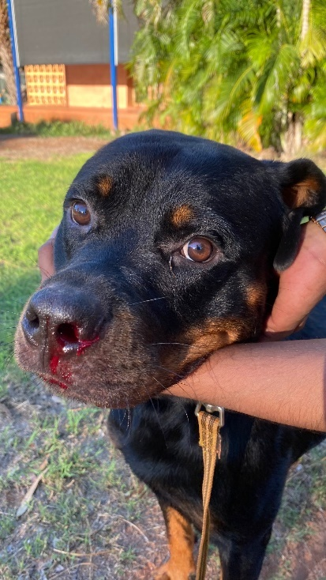
Photograph: ©Dr John Beadle.
Figure 2 Emaciation
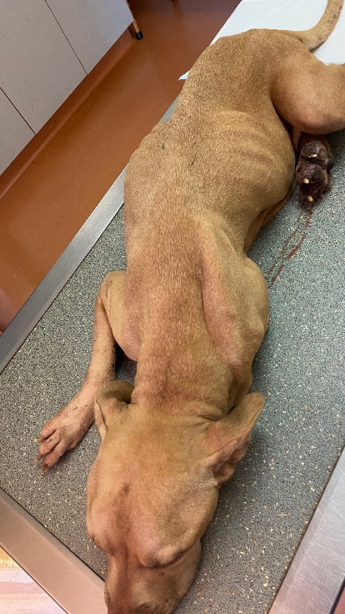
Photograph ©Dr John Beadle.
E. canis occurs worldwide, particularly in tropical and subtropical regions. The first detection of ehrlichiosis in Australia was in May 2020, and community transmission is now confirmed in Western Australia, the Northern Territory, northern South Australia and Queensland. The disease is not considered to be eradicable.
The current geographical distribution of E. canis in the Australian canid population is unknown, but the disease may be present in any region where brown dog ticks are prevalent.
Human-assisted dog movement accelerates spread of the disease between geographical regions.
The shaded area in Map 1 that includes all of Queensland and the Northern Territory, northern and coastal Western Australia, most of South Australia and northern NSW, indicates a higher likelihood of exposure to brown dog ticks. However, E. canis-infected ticks are currently limited to northern WA and SA, all of NT and northwestern Queensland.
Map 1 Geographical distribution in Australia
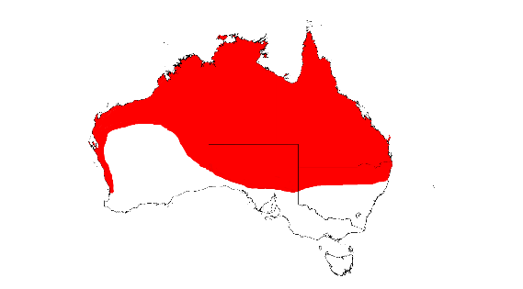
Infection with Ehrlichia canis (ehrlichiosis) is a notifiable disease in Australia. If you suspect infection with Ehrlichia canis in dogs, you must report it to your state or territory animal biosecurity authority, according to jurisdictional requirements. This may include reporting via the Emergency Animal Disease Watch Hotline on 1800 675 888.

Susceptible species and risk factors
Domesticated or wild animals in the family Canidae, including dogs and foxes, are susceptible to E. canis infection.
Dingoes are closely related to domestic dogs and are widespread in the areas of Australia where E. canis has been detected. Knowledge gaps exist around factors that would lead to infection of dingoes, including:
- the amount of mingling that occurs between wild dingoes and domestic dogs
- the susceptibility of dingoes to parasitisation by brown dog ticks
- the susceptibility of dingoes to disease following infection with E. canis
- the pathogenicity and virulence of infection in dingoes.
Ehrlichiosis has had a devastating impact on dogs in remote Indigenous communities in northern Australia, with estimated prevalence as high as 100% and mortalities above 50% in some locations. Some community dogs roam freely, and may have direct and indirect contact with wild dingoes. Other owned dogs – such as pig-hunting dogs or pets travelling with owners – may also have contact with wild dingoes or move through areas where dingoes live.
Because the brown dog tick is habituated to human settlements and built environments, it is less likely to thrive on wild dingoes. The likelihood of E. canis establishing and spreading in wild dingo populations is therefore low, but the consequences of such an event would be significant. For this reason, the best way to control the risk to dingoes is to apply regular, effective tick control to all domestic dogs in at-risk areas, with a particular focus on dogs in remote Indigenous communities. Veterinarians who work with dingoes should report suspect cases through their government biosecurity officers, so that outbreaks are detected quickly. Further information is available from Wildlife Health Australia, including a factsheet. Canine ehrlichiosis in Australia fact sheet.
Several published reports suggest that cats are susceptible to infection with E. canis, although the natural transmission pathway is not established in Australia, and infection is considered uncommon worldwide.
Infected dogs do not transmit E. canis to humans. In rare instances overseas, humans have been infected with E. canis after a bite from an infected tick. There have been no reported cases of infection with E. canis in humans in Australia.

Clinical signs: acute ehrlichiosis
A range of clinical signs may be observed in both acute and chronic phases:
- fever
- lethargy
- anorexia
- epistaxis (Figure 1)
- petechiae and ecchymoses (Figure 4)
- lymphadenopathy
- splenomegaly (Figure 9)
- dyspnoea
- generalised or limb oedema
- muscle pain
- weight loss
- corneal oedema (Figure 3)
- hyphaema, uveitis and retinal haemorrhages
- polyarthritis
- seizures.
A number of haematological abnormalities are associated with ehrlichiosis. Most, if not all dogs will present with thrombocytopenia, which can range from moderate to severe.
The incubation period for ehrlichiosis ranges from 1 to 3 weeks. The acute phase of illness then typically lasts for 2 to 4 weeks. Concurrent infection with other tick fever organisms (Anaplasma platys and Babesia canis) is common and worsens prognosis.
In countries where ehrlichiosis is established and endemic, death is rare during the acute phase. Most dogs recover after 1 to 2 weeks without treatment, although some may remain persistent, subclinical carriers for months or years.
However, in Australia, where the disease is infecting a naive population, very high morbidity, with severe illness, and mortality occur in the acute phase. This situation is common in remote Indigenous communities that receive intermittent veterinary services.
Figure 3 Corneal oedema
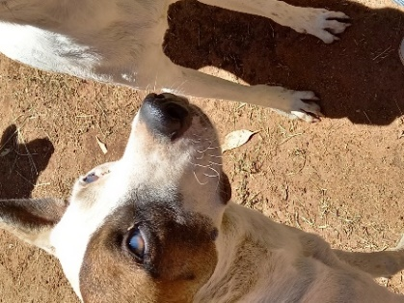
Photograph: ©AMRRIC
Figure 4 Petechiae and ecchymoses
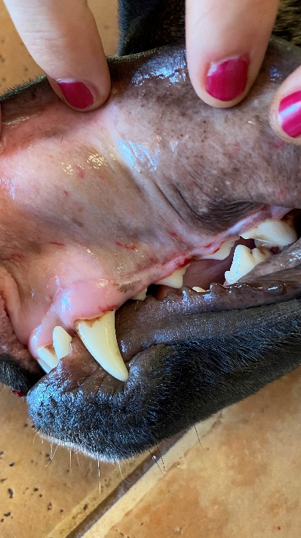
Photograph: ©Dr John Beadle

Subclinical infection
Some dogs may be infected subclinically. Post-infection, they may clear the organism from circulation naturally. Alternatively, they may become subclinical carriers of the organism sequestered in the spleen and bone marrow for months or years. These dogs may not need veterinary attention unless the disease progresses to its chronic form.
Some dogs may be infected subclinically. Post-infection, they may clear the organism from circulation naturally. Alternatively, they may become subclinical carriers of the organism sequestered in the spleen and bone marrow for months or years. These dogs may not need veterinary attention unless the disease progresses to its chronic form.
Subclinical cases of ehrlichiosis may be detected via preoperative complete blood counts, which can show marginal thrombocytopenia and/or other haematological abnormalities in clinically normal dogs, leading to submission of samples for E. canis exclusion. The northern Australian experience has shown the value of performing preoperative complete blood counts for healthy but suspect dogs. Suspect dogs are those that:
- live in an infected area
- have an unknown movement history (including dogs that roam)
- have an unknown or poor tick control history
- live in close contact with a confirmed case of ehrlichiosis.
Infection with E. canis (ehrlichiosis) is a notifiable disease, and the states and territories have various requirements for movement controls between jurisdictions. As a result, some subclinical cases are detected through screening tests of dogs before they are transported interstate.
The likelihood that subclinically infected dogs will go on to develop chronic, end-stage ehrlichiosis is unknown. Because subclinical carriers are a risk for introduction of the disease into previously disease-free areas, any dog diagnosed with ehrlichiosis should be considered a lifelong carrier.
More information on the risks and management of confirmed or potentially infected dogs is provided in the accompanying fact sheets.
Figure 5 Oculonasal discharge
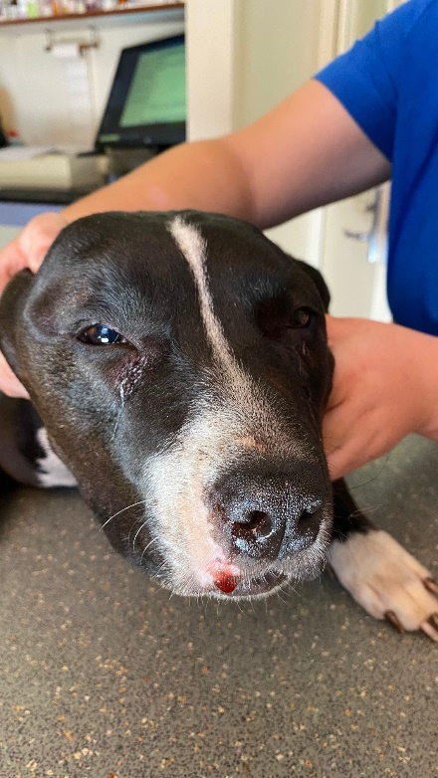
Photograph: ©Dr John Beadle
Figure 6 Jaundice
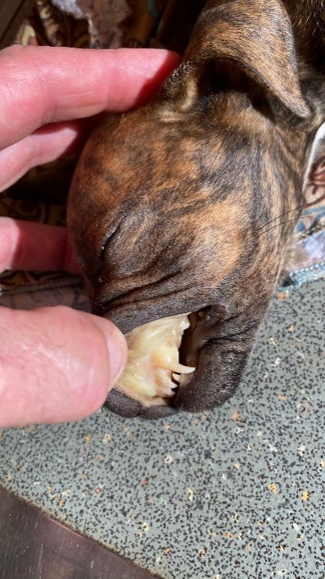
Photograph: ©Dr John Beadle

Chronic ehrlichiosis
Chronic stages of infection are associated with clinical and laboratory abnormalities that are similar to the acute phase but tend to be more severe and terminal in their outcome.
As the infection progresses, a range of immune complex pathologies may develop, including vasculitis, uveitis and glomerulonephritis. Terminal bone marrow failure is associated with pancytopenia and sepsis.
Clinical presentations include all of the signs seen in the acute phase. Infected dogs are also more susceptible to secondary infections, and therefore may present with nonhealing wounds, dental infections and apparently resistant infections or treatment failures. Many present with significant and rapid wasting, even if the dog is well fed.
Blood tests often show severely low platelets, low white blood cells and anaemia, progressing to nonregenerative pancytopenia. This form of the disease is usually fatal, and treatment efforts are likely to be futile.
Figure 7 Dependent oedema
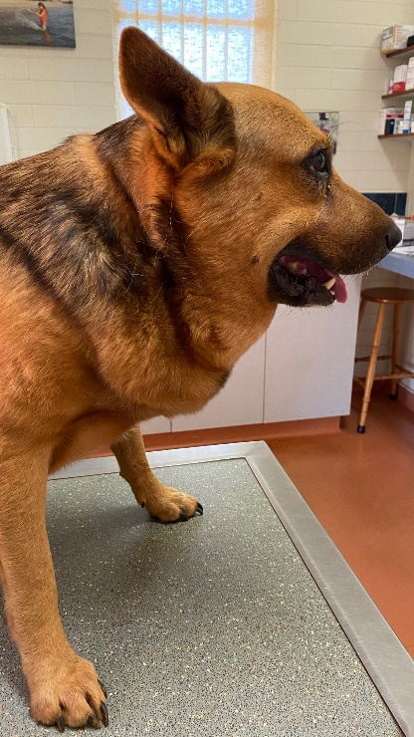
Photograph: ©Dr John Beadle
Figure 8 Corneal oedema and emaciation
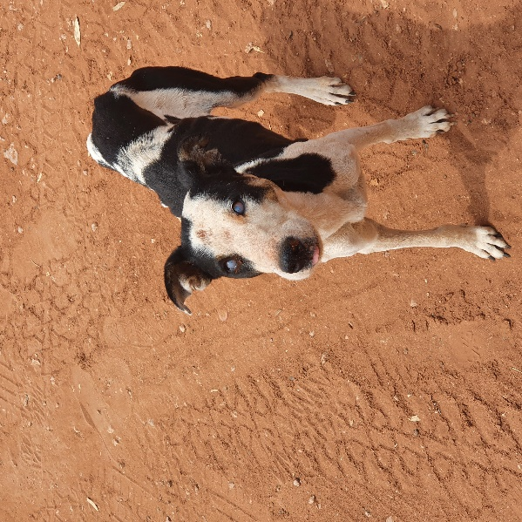
Photograph: ©AMRRIC

Sampling
E. canis can be detected by real-time polymerase chain reaction (PCR). Serological tests include enzyme-linked immunosorbent assay (ELISA) and an indirect fluorescent antibody test (IFAT).
The required blood samples from live or recently deceased (including euthanased) animals are:
- for PCR testing, 2–5 mL in an EDTA tube (purple top)
- for serological testing, 2–5 mL in a serum separator tube (yellow top) or plain tube (red or grey/red speckled top). If possible, a 1–2 mL aliquot of clear serum should be obtained.
Samples to collect from dead animals are:
- unclotted heart blood (if available)
- resh and formalin-fixed samples of brain, lung, spleen, liver, kidney and submandibular lymph nodes.
Obtain a full range of samples to increase the opportunity for a definitive laboratory diagnosis.
If you need further advice about sampling and E. canis diagnostic tests, contact the veterinary diagnostic laboratory in your state or territory (see State and territory laboratory contact details).
Submit samples to the veterinary diagnostic laboratory in your state or territory. The laboratory will provide relevant samples to the Australian Centre for Disease Preparedness in Geelong, Victoria, if required.
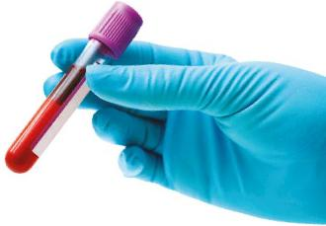

Laboratory testing
A dog’s infection status should be interpreted based on laboratory results, clinical signs and response to previous treatment. The matrix shown in Table 1 is a guide to interpretation:
Table 1 Interpretation of infection status
PCR test result | ELISA test result  Positive | ELISA test result  Negative
Detected (positive) | Acute, subacute or subclinical infection | Acute infection
Not detected (negative) | Subacute, subclinical or chronic infection, or recovered | Not infected a
a A negative PCR and serological test can occur in animals early in infection before development of antibody responses, or may indicate a subclinical carrier.
Diagnostic tests sensitivities and specificities are as shown in Table 2.
Table 2 Test sensitivities and specificities
Diagnostic test | Estimated diagnostic sensitivity | Estimated diagnostic specificity
PCR | 90% | >90%
ELISA | 95% | 97%
IFAT | 95% | 90%
Antibody may take 1 to 3 weeks to develop from the time of infection. The longevity of antibody varies between individuals but may remain at detectable levels for years after infection. A single antibody titre result does not indicate the stage of the disease process.
Resample and retest indeterminate or borderline results at least 14 days from the first sample collection.
A referral quantitative IFAT will help with assessing persistently borderline ELISA results, or where infection history is unknown, and improved understanding of the infection status is desired.

Laboratory findings and differential diagnoses
Laboratory abnormalities associated with ehrlichiosis include:
- thrombocytopenia (moderate to severe)
- leukocytosis (acute) to leukopenia (chronic)
- monocytosis
- lymphocytosis (acute) to lymphopenia (chronic)
- anaemia (mild to severe)
- pancytopenia (chronic, end stage)
- hyperglobulinaemia
- hypoalbuminaemia
- mild elevations in liver enzyme activities
- mild to moderate azotaemia.
Dark-staining clusters of bacteria (morulae) are sometimes observed as intracytoplasmic inclusions in monocytes in acute and subacute infections. However, this is a rare finding, and is therefore considered a poor diagnostic indicator.
Figure 9 Monocyte with possible morula in a blood smear magnified 1000 times.
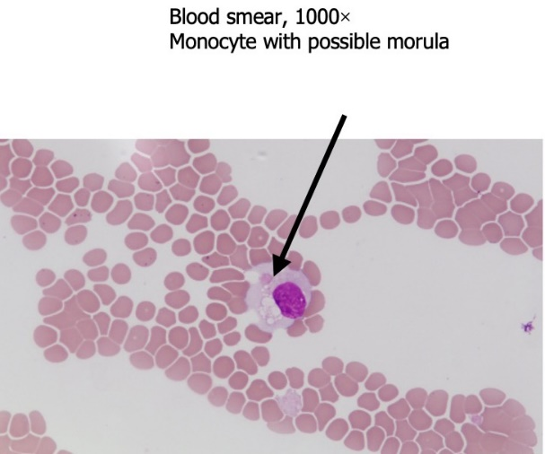
Photograph: ©Berimah Veterinary Laboratory

Differential diagnoses
The clinical signs of ehrlichiosis are nonspecific and occur in many systemic diseases of an infectious and/or inflammatory nature, including immune-mediated diseases and neoplasia. Differential diagnoses may include anaplasmosis, babesiosis, lymphoma, multiple myeloma and immune-mediated thrombocytopenia.

Postmortem findings
Postmortem findings may include an emaciated carcass, pale mucosae, ocular abnormalities (including corneal opacity and anterior uveitis), haemorrhage in organs and subcutaneous tissues, limb oedema and ascites, enlarged lymph nodes and splenomegaly.
Figure 10 Splenomegaly
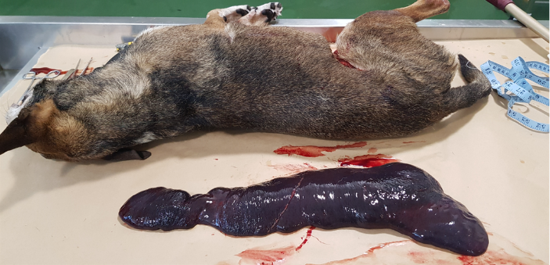
Photograph: ©Department of Agriculture, Fisheries and Forestry.

Transmission
The brown dog tick is widely distributed worldwide, including in Australia. It acts as the primary vector of E. canis, spreading the bacterium between hosts during blood meals.
In other countries, the bacterium has been experimentally transmitted by other tick species, but there is currently no evidence that it is transmitted by the Australian paralysis tick (Ixodes holocyclus), which is almost certainly not a competent vector.
The tick retains the bacterium through its life stages (trans-stadial transmission), and can infect hosts in both nymph and adult stages.
Brown dog ticks use canids as a primary host, and therefore ehrlichiosis is predominantly associated with dogs. Unexposed ticks acquire the organism after feeding on an infected dog and then transmit the infection to other dogs during successive life stages.
Transmission of E. canis from infected ticks to uninfected dogs occurs within a few hours of attachment. The organism is also transmissible through blood transfusions.
In vivo experience of ehrlichiosis in Australia suggests that, although a single tick bite is sufficient to transmit infection, increasing disease severity is correlated with heavy tick burdens, as well as comorbidities.
People who work with or manage dingoes should be aware that dingoes may be susceptible to ehrlichiosis. Monitor dingoes for signs of ill health and the presence of ticks. More information is available from Wildlife Health Australia. Veterinarians who wish to test for or report possible signs of ehrlichiosis in dingoes can also contact their state or territory Wildlife Health Australia representative for more information.
Figure 11 Nymphs and adult female and male ticks
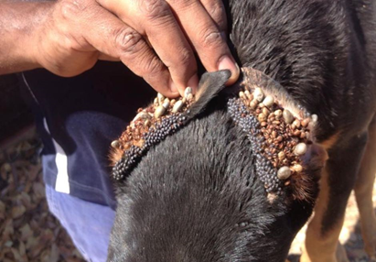
Photograph: ©AMRRIC

Treatment
Doxycycline at 10 mg/kg PO every 24 hours (or 5mg/kg every 12 hours) for 28 days is the recommended treatment for ehrlichiosis in acute and chronic forms.
The stage of infection is not always clear in clinical situations, but cases treated later in the course of infection do not appear to respond as well. This can result in persistent infections and apparent failures in therapy. The reason for this is unclear, but may be associated with bacterial sequestration in the spleen and/or bone marrow. Early treatment of acute infection results in better outcomes.
Most other antibiotics are ineffective. Rifampicin at 15 mg/kg PO every 12 hours for 7 days may be a suitable choice if doxycycline fails to clear infection. However, under current guidelines for antimicrobial stewardship, rifampicin is not registered for use in animals and should not be used off-label, except in exceptional circumstances for individual animals with laboratory-confirmed, persistent E. canis infection.
Two intramuscular injections of imidocarb dipropionate (5–6 mg/kg) given 14 days apart are useful to treat babesiosis when there is concurrent infection, but this medication is not effective for treating ehrlichiosis.
It is important to manage immune complex pathology, which can cause significant morbidity. A 7 to 10-day course of prednisolone at an anti-inflammatory dose (1 mg/kg PO every 24 hours) appears to help recovery and reduce complications associated with ehrlichiosis.
Consider supportive treatments (e.g. blood transfusion, fluid therapy) and treatment of comorbidities, as appropriate. However, chronic ehrlichiosis associated with pancytopenia carries a grave prognosis regardless of treatment effort, and recovery is rare.

Response to therapy
There is no straightforward test to monitor treatment success. A positive PCR test post-treatment may indicate that the dog is still bacteraemic and treatment was unsuccessful. Given the ability of the organism to sequester in tissues, and be undetectable in circulation, a negative result does not indicate that the dog has successfully cleared the infection. Similarly, ELISA serology after treatment is not useful, as antibody titres stay high for months to years after treatment.
Figure 12 Concurrent chronic ehrlichiosis and treatment-resistant dermatophytosis
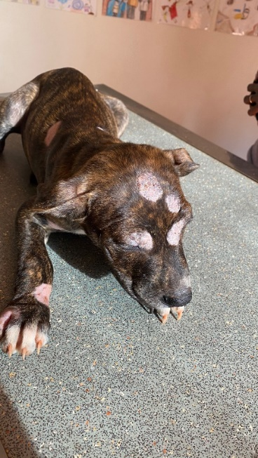
Photograph: ©Dr John Beadle

Prevention
To prevent onward transmission, dogs with suspected or confirmed ehrlichiosis should be treated immediately with a registered acaricide, even when there is no visible tick burden. Inform owners of future disease risk to other dogs, and the need to maintain the E. canis–positive dog on lifelong tick control, and advise treatment of the dog’s home environment by a pest controller.
There are 2 major categories of acaricides for dogs:
- Topically acting products that repel and kill – These products are applied topically (collar or spot-on application). The acaricidal active ingredients (flumethrin or permethrin) enter and remain within the lipid layer of the dog’s skin and hair. These products do not need the ticks to feed, but instead affect ticks rapidly when the tick comes into contact with the treated dog’s hair. Most ticks are repelled and will not bite the dog but will die following short exposure to the active ingredient. Two products are efficacious for preventing transmission of canine ehrlichiosis: Seresto® (long-lasting collar) and Advantix® (spot-on). In Australia, Seresto® is registered to reduce the risk of transmission of E. canis by brown dog ticks, but Advantix® is not. Tick repellent products are essential to protect individual dogs from infection with E. canis, but their use may be problematic if collar retention or regular spot-on application is difficult.
- Systemically acting products – These products are given to dogs either orally (tablets or chewables) or topically (spot-on application). Regardless of the method of action, the acaricidal active ingredient of these products (isoxazolines are most common) will reach the dog’s bloodstream. The products require the tick to feed and ingest a lethal dose of acaricide, with the time from attachment to kill being 8 to 48 hours. It is crucial to note that E. canis can be transmitted within 3 hours of tick attachment, which is faster than most isoxazolines kill ticks. Consequently, systemically acting products do not prevent transmission of E. canis to dogs from the tick, and are not registered for the prevention of canine ehrlichiosis. Although isoxazolines are highly effective acaricides and are useful to kill the brown dog tick vector in settings where reducing the rate of community transmission of ehrlichiosis is important, these products are not recommended as the sole method of tick control to prevent ehrlichiosis.
Dogs that live in high-risk situations may benefit from the application of both repel and kill and systemically acting products. However, most dogs can be efficiently protected from ehrlichiosis using repel and kill products only. It is important to keep in mind that no product offers 100% efficacy against ticks. Therefore, no topically acting tick repellent can provide 100% protection from ehrlichiosis.
A summary of acaricidal options for dogs is provided in Table 3. However, this list is not exhaustive, and there may be additional registered products available.
Table 3 Summary of acaricidal options
Acaricide type | Active acaricide | Brand name | Route | Frequency of administration | >90% proven efficacy for prevention of ehrlichiosis?
Topically acting products that repel and kill | Flumethrin + imidacloprid | Seresto (Bayer–Elanco) | Collar | 4-monthly | Yes a
Topically acting products that repel and kill | Permethrin + imidacloprid | Advantix (Bayer–Elanco) | Spot-on | Monthly | Yes b
Topically acting products that repel and kill | Flumethrin + propoxur | Kiltix (Bayer–Elanco) | Collar | 5-monthly | No
Topically acting products that repel and kill | Delamethrin | Scalibor (MSD) | Collar | 6-monthly | No
Systemically acting products | Sarolaner | Simparica, Simparica Trio (Zoetis) | Oral | Monthly | No
Systemically acting products | Afoxolaner | Nexgard/Nexgard Spectra (Boehringer Ingelheim) | Oral | Monthly | No
Systemically acting products | Fluralaner | Bravecto (MSD) | Spot-on or oral | 3-monthly | No
Systemically acting products | Lotilaner | Credelio/The Big 5 (Elanco) | Oral | Monthly | No
a Stanneck D & Fourie JJ (2013). Imidacloprid 10%/flumethrin 4.5% collars (Seresto®, Bayer) successfully prevent long-term transmission of Ehrlichia canis by infected Rhipicephalus sanguineus ticks to dogs. Parasitology Research 112:21–32.
b Fourie JJ, Luus HG, Stanneck D & Jongejan F (2013). The efficacy of Advantix® to prevent transmission of Ehrlichia canis to dogs by Rhipicephalus sanguineus ticks. Parasite 20:36.
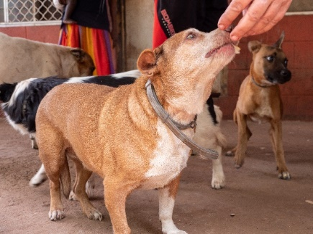
Photograph: ©Northern Territory Department of Industry, Tourism and Trade

Risk profiles
Interstate relocation and rehoming of subclinically infected dogs into noninfected regions is a significant risk. Some of these dogs will progress to develop chronic ehrlichiosis.
Veterinarians across Australia need to be aware of this risk in dogs that are acquired either privately or from rehoming and rescue organisations in infected areas, and dogs that have travelled with their owners into infected areas. History taking should include questions about recent movements, as well as ehrlichiosis testing, treatment and tick control, particularly for pets of unknown origin. A separate fact sheet is provided that veterinarians can provide to organisations they work with.
Veterinarians should consider ehrlichiosis as a differential diagnosis when severe, nonresponsive illness or haematological abnormalities are found in any dog that has travelled to a region with infected brown dog ticks.
Before moving dogs, particularly into areas where E. canis is not known to be present, the likelihood of E. canis infection should be assessed by the dog owner, the dog carer, the person in charge of the dog and/or a veterinarian.
Key criteria for assessment are:
- the health status of the dog
- the dog's medical and travel history
- whether the dog has been on an effective tick preventative
- whether the dog has been present in areas where E. canis is known to be active or is likely to be active
- whether the dog has had close contact with, or is a cohort of, a dog that has a confirmed or suspected case of ehrlichiosis.
Dog owners may ask for advice about reducing the likelihood of their dog becoming infected or preventing disease spread. Advice will vary from general advice to advice associated with travelling. It may include:
- undertaking a thorough clinical examination and diagnostic testing for clinically consistent dogs
- inspecting dogs and cohorts for brown dog ticks regularly, and removing any ticks
- maintaining the dog on an effective brown dog tick prevention and control program, including use of external tick products that kill ticks on contact
- avoiding taking dogs into brown dog tick-infested areas
- for dogs originating from interstate and travelling into areas where E. canis is not known to be active
  - undertaking diagnostic testing before travel, with negative results before travel
  - observing that the dog is, and remains, clinically healthy between the time of testing and travel
  - isolating dogs from other dogs and brown dog ticks from the start of a testing regime.

Reporting obligations
Any suspected case of infection with E. canis (ehrlichiosis) must be reported immediately to your state or territory biosecurity authority. This may include reporting via the Emergency Animal Disease Watch Hotline.
Collect as much relevant history, clinical information and epidemiological information as possible. This information will improve understanding of the distribution of E. canis in Australia, and inform risk assessments and next steps, including steps to minimise spread of the disease.
This is particularly important in areas where E. canis has not been detected, or where there are other dogs at risk.
The Emergency Animal Disease Watch Hotline phone number is 1800 675 888.

State and territory laboratory contact details

New South Wales and Australian Capital Territory
NSW Animal and Plant Health Laboratories
Phone: 1800 675 623
Email: laboratory.services@dpi.nsw.gov.au
Website: New South Wales Department of Primary Industries
Delivery address:
Elizabeth Macarthur Agricultural Institute (EMAI)
Woodbridge Road
Menangle NSW 2568

Northern Territory
Berrimah Veterinary Laboratory
Phone: (08) 8999 2249
Email: bvl@nt.gov.au
Website: Department of Industry, Tourism and Trade
Delivery address:
29 Makagon Road
Berrimah NT 0828

Queensland
Biosecurity Sciences Laboratory
Phone: (07) 3708 8762
Email: bslclo@daf.qld.gov.au
Website: Business Queensland
Delivery address:
Block 12, Health and Food Sciences Precinct
39 Kessels Road
Coopers Plains QLD 4108

South Australia
Gribbles Veterinary Pathology
Phone: (08) 8202 3300
Email: glenside.enquiries@gribbles.com.au
Website: Gribbles Veterinary Pathology
Delivery address:
33 Flemington Street
Glenside SA 5065

Tasmania
Animal Health Laboratory
Phone: (03) 6777 2111
Email: specimenreception@dpipwe.tas.gov.au
Website: Biosecurity Tasmania
Delivery address:
165 Westbury Road
Prospect TAS 7250

Victoria
AgriBio Veterinary Laboratory
Phone: (03) 9032 7515
Email: vet.diagnostics@agriculture.vic.gov.au
Website: Agriculture Victoria
Delivery address:
5 Ring Road
La Trobe University Campus
Bundoora VIC 3083

Western Australia
DPIRD Diagnostics and Laboratory Services – Animal Pathology
Phone: (08) 9368 3351
Email: ddls@dpird.wa.gov.au
Website: Department of Primary Industries and Regional Development
Delivery address:
DDLS, C Block
Department of Primary Industries and Regional Development
3 Baron-Hay Court
South Perth WA 6151

More information
Infection with Ehrlichia canis (ehrlichiosis) is a notifiable disease.
For more information, visit your state or territory website, outbreak.gov.au or agriculture.gov.au/ehrlichiosis
