Drought Response, Resilience and Preparedness Plan: Australian Government implementation review 2020–21
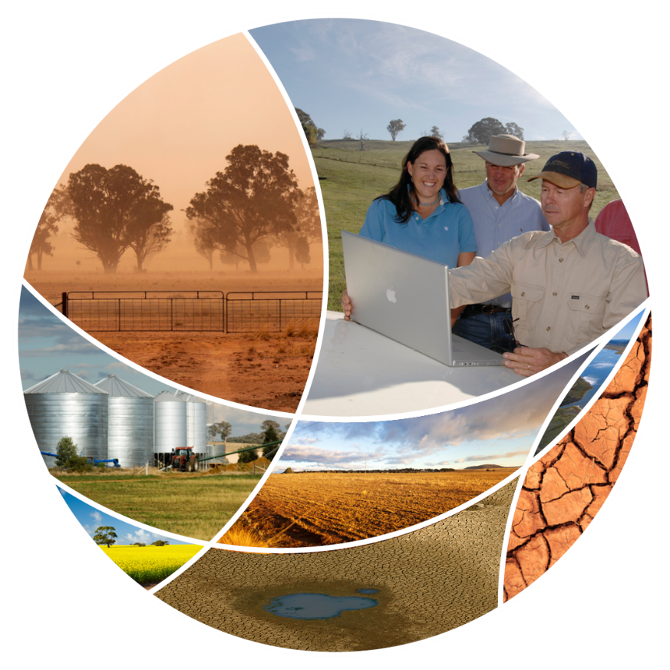
© Commonwealth of Australia 2021
Ownership of intellectual property rights
Unless otherwise noted, copyright (and any other intellectual property rights) in this publication is owned by the Commonwealth of Australia (referred to as the Commonwealth).
Creative Commons licence
All material in this publication is licensed under a Creative Commons Attribution 4.0 International Licence except content supplied by third parties, logos and the Commonwealth Coat of Arms.
Inquiries about the licence and any use of this document should be emailed to copyright@awe.gov.au.

Cataloguing data
This publication (and any material sourced from it) should be attributed as: DAWE 2021, Drought Response, Resilience and Preparedness Plan: Australian Government implementation review 2020–21, Department of Agriculture, Water and the Environment, Canberra, CC BY 4.0.
ISBN 978-1-76003-477-1
This publication is available at awe.gov.au/agriculture-land/farm-food-drought/drought/drought-policy
Department of Agriculture, Water and the Environment
GPO Box 858 Canberra ACT 2601
Telephone 1800 900 090
Web awe.gov.au
Disclaimer
The Australian Government acting through the Department of Agriculture, Water and the Environment has exercised due care and skill in preparing and compiling the information and data in this publication. Notwithstanding, the Department of Agriculture, Water and the Environment, its employees and advisers disclaim all liability, including liability for negligence and for any loss, damage, injury, expense or cost incurred by any person as a result of accessing, using or relying on any of the information or data in this publication to the maximum extent permitted by law.
Acknowledgements
We gratefully acknowledge the input of the Department of Infrastructure, Transport, Regional Development and Communications, the Department of Health, the Bureau of Meteorology, Department of Education, Skills and Employment, the National Recovery and Resilience Agency and divisions within the Department of Agriculture, Water and the Environment.

Contents
Introduction 1
Climate 1
Drought Response, Resilience and Preparedness Plan 2
Focus of review 3
Australian Government drought response is not ‘set and forget’ 5
Drought policy and coordination 6
1 Immediate action for those in drought 8
Putting food on the table of the farmers who feed the nation 8
Rural Financial Counselling Service–the angels at the kitchen table 9
Backing our farmers with concessional loans 10
Better on-farm water management 11
Providing better information 12
Making up to 100GL available to secure fodder 17
Dealing with the stresses of drought 18
Battling pest and weeds 19
Financial and regulatory frameworks that encourage planning and resilience 20
2 Support for wider communities affected by drought 22
Keeping drought-affected regional communities open for business 24
Financial counselling for small business 27
3 Long-term resilience and preparedness 29
Future Drought Fund 29
Just add water 31
Invest in research and development to build drought resilience 32
Effective and strategic management of Australia’s soil, vegetation and water resources for profitable farm performance, sustainability and resilience to droughts 34
Completed measures 36
The year ahead 37
Appendix A: Funding for drought measures 38
Glossary 40

Maps
Map 1 Australian rainfall deficiencies, 1 July 2020 to 30 June 2021 2
Map 2 Australian rainfall deficiencies, 1 July 2019 to 30 June 2020 2

Figures
Figure 1 Australian Government funding for drought response, 2018–19 to 2020–21 5

Tables
Table 1 Status update on 14 actions 3
Table 2 Review of Australian Government drought response, 2020 6
Table 3 Cross-government, industry and community meetings, including drought agenda items, 2020–21 15
Table 4 Location of Drought Community Outreach events, 2020–21 23
Table 5 Grant funding for FRRR Rounds 17 to 20, 2020–21 26
Table 6 Completed drought measures, 2018–19 to 2019–20 36

Table A1 Australian Government funding for drought measures, 2018–19 to 2024–25 38

Photographs
Photograph 1 National Recovery and Resilience Agency Coordinator-General and NRRA Advisory Board members, National Drought Forum, Toowoomba, 2021 17

Case studies
Case study 1 Glamorgan–Spring Bay Council serrated tussock control program, Tasmania, 2020 20
Case study 2 Drought Community Outreach event in the Upper Hunter region, New South Wales, 2020 23
Case study 3 Goondiwindi Regional Council, Queensland, 2020 24
Case study 4 Warwick Recycled Water for Agriculture, Queensland, 2021 32

Introduction
Drought is part of Australian agriculture. Farmers and rural communities routinely prepare for, manage, and recover from drought, knowing the next drought may be around the corner. They recognise it as a business risk to be managed.
However, drought events have increased in frequency and severity over the last 20 years. Droughts are likely to become more frequent, severe and longer lasting. Depending on their location, industries and farmers will be at different stages of the drought cycle at any one time – preparing for drought, recovering or in the middle of a drought.
The Australian Government has committed over $11 billion to drought-related measures since 2018–19 for farmers and rural communities. This investment is strengthening rural Australia’s capacity to withstand drought, investing in drought preparedness and resilience activities as well providing targeted support where it’s needed most.
The Australian Government is working with industry and people on the ground to develop the tools, science and support they need to better manage the impact of drought and build resilience. The government continues to listen to them as it improves on its programs and services.
By continuing to adapt to the drought cycle, Australian farming can remain profitable and sustainable. This also strengthens rural communities, secures the nation’s food supply and grows our economy.

Climate
Over the past 2 years, climatic and agricultural production conditions have improved over much of Australia, largely in response to a timely and widespread 2020 autumn break event and the onset of a La Niña event peaking in October to November 2020. This turn-around in conditions benefitted crop and pasture production, saw many producers replenish fodder supplies and allowed restocking and herd and flock rebuilding to commence. Water storage levels have also increased across much of the country, especially in the Murray–Darling Basin.
In 2020–21, widespread favourable climatic conditions across much of Australia resulted in Australia's second-biggest winter crop on record. The Australian Bureau of Agricultural and Resource Economics and Sciences (ABARES) forecasted gross agricultural production to be a record $66 billion in 2020–21, with gross value of production forecast to reach $73 billion in 2021–22.
The trajectory of recovery from drought conditions over the past year is clear in a comparison between rainfall deficiencies in 2020–21 (Map 1) and 2019–20 (Map 2).
Map 1 Australian rainfall deficiencies, 1 July 2020 to 30 June 2021
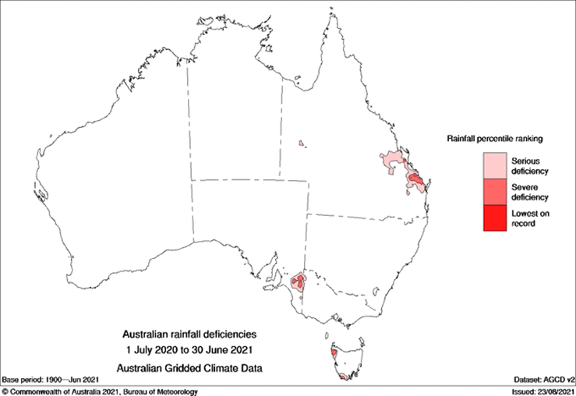
Source: Bureau of Meteorology
Map 2 Australian rainfall deficiencies, 1 July 2019 to 30 June 2020
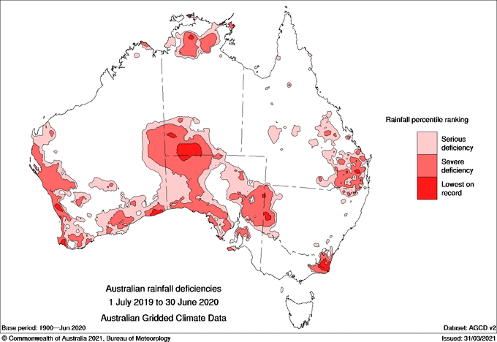
Source: Bureau of Meteorology

Drought Response, Resilience and Preparedness Plan
The Australian Government is committed to providing the support that is needed across the entire drought cycle. The Australian Government Drought Response, Resilience and Preparedness Plan demonstrates how the government is helping farmers and rural communities prepare for, manage and recover from drought. The plan was released in November 2019 and focuses on 3 key areas:
- Immediate action for those in drought – comprising measures to support farmers and communities facing prolonged drought conditions.
- Support for wider communities affected by drought – recognising that many rural and regional communities depend on farmers for their livelihoods.
- Long-term resilience and preparedness – accepting that the next drought is inevitable and the importance of building capacity to withstand drought periods in the long-term.
The Australian Government has committed more than $11 billion towards this plan since 2018 – 19, comprising 25 individual measures. These measures contribute to both the implementation of the plan and delivering on the Australian Government’s responsibilities under the National Drought Agreement (NDA). The NDA is the nationally agreed framework for drought support, signed by the Commonwealth and all states and territories in December 2018. It sets out a joint approach to drought preparedness, response and recovery, with a focus on accountability and transparency. The National Drought Agreement annual report 2019–20 outlines the activities and achievements of the NDA. The 2020–21 annual report is in preparation.

Focus of review
This implementation review covers July 2020 to June 2021 and is an annual requirement established under the plan. It builds on the baseline and approach established by the first review, the 2019–20 implementation review, and assesses progress against the 14 actions in the plan.
The review looks at how the Australian Government’s drought measures performed in 2020–21, against the relevant actions in the plan. Consideration has also been given to issues that may affect successful delivery of each action and future direction. Progress on the 14 actions is evaluated using these status indicators:
- Completed – all deliverables against the action have been completed.
- Underway (on track) – all deliverables required to complete the action are underway, and throughout 2020–21 there were minimal risks to delivery.
- Underway (implementation issue) – an identified issue was or continues to affect the action being completed on time or within the plan’s parameters.
- Underway (critical risk) – severe delivery risks have been identified for this action.
This review found that two actions have been completed, all ongoing programs are on track, and none are currently deemed at risk of not being delivered, despite some interruptions and delays caused by the COVID-19 pandemic. Table 1 provides a status update of each of the 14 actions.
Table 1 Status update on 14 actions
Action | Status
Action 1.1: Continue to provide and improve Farm Household Allowance | Underway (on track)
Action 1.2: Continue to provide and improve the Rural Financial Counselling Service to assist farmers to make changes for their future | Underway (on track)
Action 1.3: Continue to provide concessional loan products that help farm businesses prepare for, manage through and recover from drought | Underway (implementation issue)
Action 1.4: Continue to investigate options to help farmers become more water efficient | Underway (implementation issue)
Action 1.5: Drought indicators will be developed to assist government to understand changing conditions and emerging impacts | Underway (on track)
Action 1.6: Continue to deliver and improve FarmHub, a centralised point of trusted information on support and programs from all levels of Australian governments, industry groups and not-for-profit organisations | Completed
Action 1.7: Convene cross-government and industry meetings to share information on drought, response measures, and emerging risks and options, and ensure consistent communication to farmers and rural communities on drought matters | Underway (on track)
Action 1.8: Continued investment in mental health support programs in rural communities | Underway (on track)
Action 1.9: Continue to explore options to reduce the impact of pests and weeds in drought-affected areas | Underway (on track)
Action 1.10: A review on the effectiveness of the Farm Management Deposits Scheme will be undertaken in 2020–21 to inform any future changes | Completed
Action 2.1: Continue to investigate options that will help rural and regional communities respond to the drought | Underway (implementation issue)
Action 2.2: The Regional Investment Corporation to develop a Small Business Drought Loan product | Completed
Action 2.3: The pilot $7 million Drought Communities Small Business Support Program will be assessed mid-program in late 2021 to monitor its effectiveness and it will be amended if necessary | Underway (on track)
Action 3.1: Modernise the Research and Development Corporations system to deliver value for money, drive collaboration and participation across the agricultural innovation system and target long-term cross-sectoral and transformative R&D | Underway (on track)
Case studies provide on-ground examples of some of the drought programs and actions delivered during this time. Figure 1 shows how these programs and actions align with the Australian Government drought plan and different stages of the drought cycle. This review also provides an overview of the government’s ongoing drought policy work, and complementary programs that support the agricultural sector, the environment and communities to adapt to and prepare for future droughts.
Figure 1 Australian Government funding for drought response, 2018–19 to 2020–21
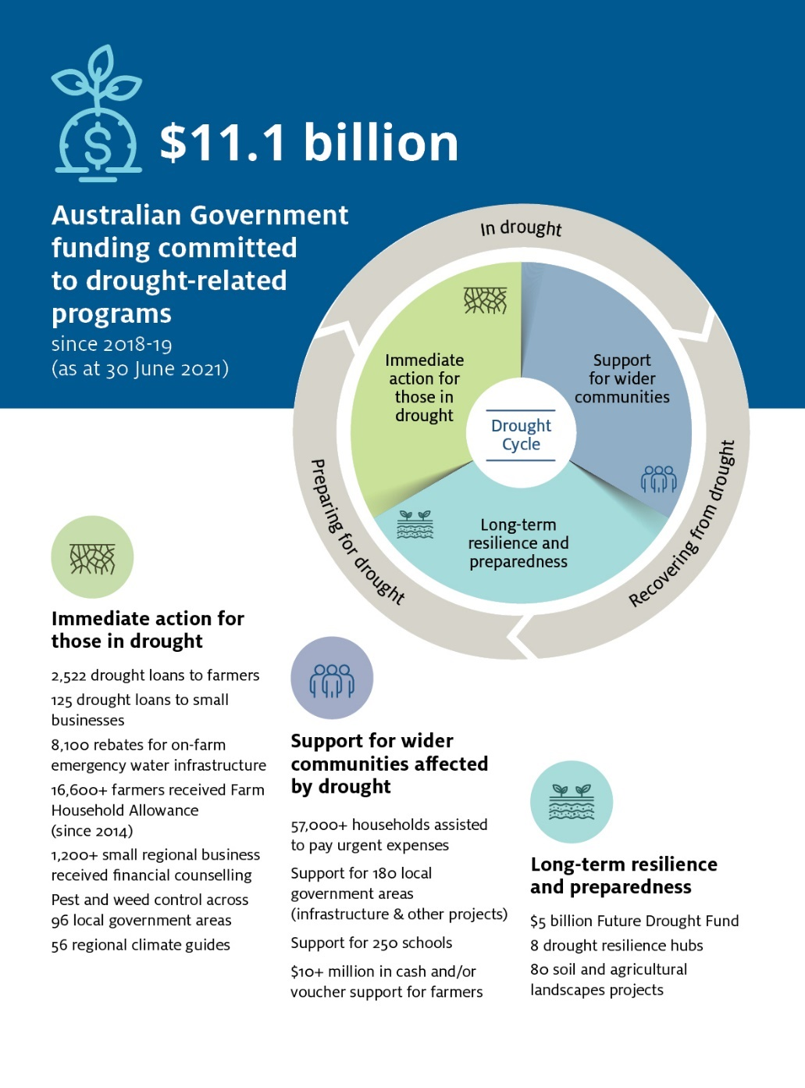
Source: Department of Agriculture, Water and the Environment

Australian Government drought response is not ‘set and forget’
The easing of drought conditions in most areas over the past 12 months has enabled government to take stock of the drought response. This has been achieved by engaging stakeholders through a range of channels, including the expanded on-ground network of National Recovery and Resilience Agency’s Recovery Support Officers, roundtables chaired by the Minister for Agriculture and Northern Australia, the Hon David Littleproud MP, charity roundtables and the National Drought Forum. A 2020 Review of Australian Government drought response was undertaken to find out what did and did not work and what can be done better in the future. This also drew strongly on feedback from stakeholders. The review identified 6 areas for improvement (Table 2).
Table 2 Review of Australian Government drought response, 2020
Gaps identified by the Review | Progress towards addressing gaps
There is opportunity to streamline the current suite of 25 measures. | The government is exploring opportunities to rationalise the range of drought measures on offer as part of ongoing policy development in consultation with industry.  Work being explored will also aim to provide faster, targeted support and reduce duplication. This work will continue to recognise the diverse needs of farmers and regional communities affected by drought.
Eligibility for in-drought support is often complex and inconsistent.  Consistent indicators of drought are needed. | Drought support programs with different objectives often have different eligibility by necessity and in recognition of the diverse needs and circumstances of people experiencing hardship due to drought. Recovery Support Officers (RSO) and Rural Financial Counselling Service officers are available on the ground to help individuals experiencing hardship such as drought, including navigating eligibility for available assistance. These networks also provide regular feedback to loop back into policy design. Opportunities to better align program eligibility or consider issues identified with individual programs will be considered as part of program centric reviews.  The government is continuing to explore opportunities to further develop practical environmental, social and economic drought indicators to help understand drought conditions – building on work commissioned by the former National Drought and North Queensland Flood Response and Recovery Agency (NDNQFRRA) in late 2020.
Provision of in-drought support has been reactive, and there is opportunity to plan ahead about when and how government should offer support. | The government is working with stakeholders to give greater clarity to all players in the drought support landscape. This includes developing a strategic framework to guide timely decision making on rolling out drought support and developing a collective understanding of stakeholder roles across the drought cycle (shared responsibilities framework). Our shared responsibilities partners include industry, the finance sector, councils, as well as states and territories that have signed the National Drought Agreement, with the intention to include charities in 2021–22.
Communication about support, and how to access it, could be improved. | The government is addressing the gaps around communication of available support by establishing the RSO network to provide a face-to-face service for those affected by drought, and by continually strengthening the information offerings of the Recovery Connect website. In 2020–21 the RSO network expanded from around 20 officers to 40, significantly increasing its reach across Australia.
Our monitoring and evaluation efforts need to be stronger. | The government has agreed on a suite of monitoring and evaluation principles for drought programs, and related guidance for application. The advice has been attached to the Drought Response, Resilience and Preparedness Plan, and is to be applied to all future drought program designs.
Data to inform government decision-making could be better managed and coordinated. | The government is establishing systematic whole of government reporting on government investments in drought support, including the future use of drought indicators to inform government decision-making.  Released in 2019, the National Drought Map combines authoritative climate and agricultural data with community information on a single online mapping platform. The government is also working with delivery partners to expand Climate Services for Agriculture and the Drought Resilience Self-Assessment Tool, to make climate information more accessible and useful for farmers.
The government has already worked to adapt policy and responses to address these gaps and this review will continue to inform future work.

Drought policy and coordination
In 2019–20 the Australian Government demonstrated national leadership by creating the National Drought and North Queensland Flood Response and Recovery Agency (NDNQFRRA) to provide a more coordinated and collaborative approach at the height of the drought. The NDNQFRRA continued in this role throughout 2020–21. A defining feature of its approach was the increased on-ground presence provided by its network of Recovery Support Officers (RSOs). RSOs provide a direct line of communication from people in the regions to government, so that policymakers can consider on-ground experience in regional Australia in real time. RSOs also assist with recovery and resilience in communities affected by disaster or drought and work with all levels of government, industry, charities and other organisations.
On 1 July 2021 drought policy and coordination functions were transferred to the Department of Agriculture, Water and the Environment. This aligns the development of drought policy with the delivery of the $5 billion Future Drought Fund and other drought and hardship measures that we lead.
This shift of drought policy functions followed the announcement on 5 May 2021 of the establishment of the National Recovery and Resilience Agency (NRRA), led by the Hon Shane Stone, AC QC. The NRRA brings together the former NDNQFRRA, the National Bushfire Recovery Agency and the disaster risk reduction and recovery functions from the Department of Home Affairs.
NRRA will drive disaster risk reduction, enhance natural disaster resilience and ensure effective relief and recovery from natural disasters and drought across Australia. The NRRA network of RSOs will continue to deliver on-ground drought recovery and resilience outreach and community engagement. The ongoing role of the RSOs will ensure policy development and government decisions on drought are informed by the experience of farmers and their communities.

Immediate action for those in drought
When dealing with the impact of drought, the Australian Government’s priority is to support farming families. In line with our obligations under the NDA, we manage several measures and programs that support farming families facing prolonged drought conditions.

Putting food on the table of the farmers who feed the nation
Action 1.1: Continue to provide and improve Farm Household Allowance
Status: Underway (on track)

Farm Household Allowance
The Farm Household Allowance (FHA) assists farming families who are experiencing financial hardship, no matter the cause of that hardship. Assistance is available for up to 4 years in every 10-year period. The FHA’s dual objectives are to provide income support and assist structural change. The program helps farmers put food on the table and provides access to vital support as they make difficult decisions to improve their long-term financial situation.

Progress and implementation in 2020–21
In 2020–21 an amendment to the Farm Household Support Act 2014 was passed to provide a permanent waiver of repayments for historical business income reconciliation debts. We have developed new case management guidance which will be piloted by the Services Australia Farm Household Case Officers in 2021–22.
Across 2020-21 FHA made over $181.3 million in payments to over 9,800 farmers and their partners who were experiencing financial hardship. At 30 June 2021 around 6,800 farmers and their partners were receiving support through FHA – this represents over $3.5 million each week to rural communities.

Key risks and future direction
In 2021–22 the FHA will continue to focus on improving the efficacy of the case management framework and public communications. Management of key risks to the program centre on better data collection and evaluation, which will help ensure the program continues to promote structural change and minimises the risk of welfare dependency.

Drought Community Support Initiative
The Drought Community Support Initiative provided payments of up to $3,000 to eligible farming households that were experiencing financial stress due to the drought. Payments were designed to meet urgent expenses such as food, petrol and utilities.

Progress and implementation in 2020–21
Round 2 provided $148.5 million, including administration costs, and assisted 45,290 households in 180 LGAs.

Key risks and future direction
The Salvation Army exhausted its Round 2 funding by 31 December 2020. The St Vincent de Paul Society expended its funding by 30 June 2021. The program has concluded.

Drought Community Outreach Program – Country Women’s Association of Australia
The Country Women’s Association of Australia (CWAA) provided payments of up to $3,000 to eligible farming households that were experiencing financial stress due to drought. Payments could be used to meet urgent household expenses, including utilities and education.

Progress and implementation in 2020–21
The $2.5 million grant, including administration costs, assisted 1,025 households across New South Wales, Queensland, South Australia, Victoria and Western Australia.

Key risks and future direction
The CWAA exhausted its funding by 30 June 2021 and the program has concluded.

Rural Financial Counselling Service–the angels at the kitchen table
Action 1.2: Continue to provide and improve the Rural Financial Counselling Service to assist farmers to make changes for their future
Status: Underway (on track)

Rural Financial Counselling Service
The Rural Financial Counselling Service (RFCS) provides free financial counselling to assist farmers facing, or at risk of facing, financial hardship. The service helps clients understand their financial position and the viability of their enterprise, and shows them how to develop and implement plans to become financially self-sufficient. This assistance is expected to help businesses become more resilient to risks or to take steps to exit the industry with dignity if long-term viability is not achievable.

Progress and implementation in 2020–21
Continued demand due to drought, bushfires and COVID-19 led to over 5,700 clients accessing support through the RFCS at 30 June 2021. Clients ranged from those receiving ongoing, intensive case management to those requiring more casual transactional assistance. In 2020–21 1,400 clients exited the service.
On 28 April 2021 the government announced the names of the 10 organisations that will deliver rural financial counselling services across 12 service regions from 1 July 2021. In response to the 2016 to 2020 RFCS program review, the 2021 to 2024 RFCS program has been refocused and streamlined. The existing service delivery model has been enhanced, to drive behavioural change and support better decision-making.

Key risks and future direction
From 1 July 2021 administration of the RFCS transferred to the NRRA. This will boost government efforts to build on-ground support for primary producers. Focus for the future will include enhanced approaches to managing fluctuating caseloads and periods of high demand, with the aim of reducing administrative burden on counsellors.

Backing our farmers with concessional loans
Action 1.3: Continue to provide concessional loan products that help farm businesses prepare for, manage through and recover from drought
Status: Underway (implementation issue)

Regional Investment Corporation
The government established the Regional Investment Corporation (RIC) to deliver Commonwealth farm business concessional loans. Drought Loans are available to farmers to help them prepare for, manage through, and recover from drought. The loans provide farmers with cash to manage through drought by buying fodder, renting livestock agistment, transporting water and netting for horticulture. The loans also support recovery by assisting with replanting and restocking when conditions improve.

Progress and implementation in 2020–21
In 2020–21 the RIC approved 1,983 loans valued at $2.139 billion. Of these, 1,814 were for farm business drought loans valued at $2,016.87 million. It is estimated that RIC Drought Loan customers will benefit from around $120,000 in interest savings through the loan’s 2-year interest-free terms (based on a $1 million loan at a 6% business loan interest rate).
Changes and improvements to the RIC occurred throughout 2020–21. In recognition of the strong demand for RIC drought loans, the government provided an additional $2 billion in loan funding for 2020–21. The RIC was also provided with a further $50 million over 4 years for operational funding to deliver the additional loan funding and process the significant volume of applications.
The government recognises the importance of attracting a new generation of farmers to the sector. The RIC’s AgriStarter Loan program, launched on 1 January 2021, offers up to $2 million to assist first-time farmers and support farm succession arrangements. The government provided $75 million for the loan product in 2020–21.
With drought conditions stabilising across many areas, on 30 September 2020 the 2-year interest-free period applied to loans under the Drought Loan and AgBiz Drought Loan programs ended.

Key risks and future direction
The unprecedented demand for RIC loans up to 30 September 2020 put pressure on processing times for Drought Loan applications.
The RIC worked to reduce service delivery time frames through the implementation of various improvement initiatives. This included recruiting more than 80 people to the organisation (such as additional assessors), implementing more efficient triage and quality assurance, and working with banks to speed up settlements. At 30 June 2021 97% of new loan applications received in 2021 were within the RIC’s 65-day loan-handling target. Service delivery time frames will remain a key focus for the RIC.

Better on-farm water management
Action 1.4: Continue to investigate options to help farmers become more water efficient
Status: Underway (implementation issue)

On-farm Emergency Water Infrastructure Rebate Scheme
The national On-farm Emergency Water Infrastructure Rebate Scheme (OFEWIRS) supports farmers to buy and install on-farm water infrastructure to water livestock and permanent plantings. This includes support to buy and lay pipes, install water storage devices such as tanks and troughs associated with stock watering, and desilt dams and water bores.

Progress and implementation in 2020–21
At 30 June 2021, 11,500 applications were received, and 8,100 rebates were approved, delivering over $42.7 million to drought-affected farmers. In 2020–21 over $11 million in rebates was paid to over 2,000 farmers.

Key risks and future direction
The Australian Government is investing a total of $100 million in the immensely popular scheme, this includes an initial commitment of $50 million in 2018, and an extra $50 million announced in October 2020.
The government has also extended the scheme by 12-months (to 30 June 2022) to ensure states and territories have adequate opportunity to join the scheme and get funding to drought-affected farmers.
A component of the Australian Government’s second round $50 million investment was used to address over–subscription to the first round of the scheme in some states. The first round of the scheme was very popular and oversubscribed as it occurred through the height of a significant drought across large parts of Australia. To ensure there is sufficient funding to meet demand and to maximise funding available to drought–affected farmers, states and territories have been asked to match commonwealth funding for any new applications received as part of the second, current, round of the scheme.

Improving Great Artesian Basin Drought Resilience program
The Improving Great Artesian Basin Drought Resilience (IGABDR) program is designed to improve water security outcomes and drought resilience in the Great Artesian Basin. Basin jurisdictions have access to up to $27.6 million of matching Australian Government funding over 5 years to 30 June 2024.
This funding will support activities to improve water security and drought resilience by increasing artesian pressure and reducing wastage of the resource. These activities include bore capping and piping, education and communication programs to manage Basin water, and research to develop new management arrangements.

Progress and implementation in 2020–21
All Basin jurisdictions completed work under the IGABDR program in 2020–21. The 31 projects completed represented a total of $2,820,227.50 in Australian Government funding. These projects contributed to saving 2.019 gigalitres per year of water in the Basin. The government has been working closely with Basin jurisdictions on their annual work plans. The focus is on flexible project delivery to fully maximise the uptake of the program across the Basin.

Key risks and future direction
The IGABDR program did not spend the full allocated budget during 2019–20 and 2020–21 due to unforeseen circumstances, including COVID-19 restrictions and extreme weather events. To reduce underspends in future, state and territory governments have sought to run expressions of interest processes early to seek applications for more projects. Where underspends are likely – due to continued COVID-19 related site access restrictions – jurisdictions will work with the Australian Government to either reallocate funding to other states that can undertake additional works early or will undertake a combined multijurisdictional project that will deliver whole–of–Basin benefits. Several works that were not completed in 2020–21 are underway for delivery in 2021–22.

Providing better information
Action 1.5: Drought indicators will be developed to assist government to understand changing conditions and emerging impacts
Status: Underway (on track)
An objective of the NDA is to provide government, communities, industry and the public with access to common sources of quality drought-related information and data to improve decision-making.

Improved drought indicators
The development of improved drought indicators will help government to better understand changing conditions and emerging impacts of drought.

Progress and implementation in 2020–21
In 2020 the NDNQFRRA commissioned the management consultancy Nous Group to identify drought vulnerability and impact indicators.
Nous Group reported that applying specific indicators for drought is complex and requires more work. Environmental indicators such as rainfall, soil moisture and time of rainfall are relatively simple to identify and apply, but socio-economic indicators such as regional profit, household wealth and wellbeing are more complex. Further work is required to correlate these types of indicators to drought conditions.

Key risks and future direction
In December 2021 the Government announced $4.1 million to develop a drought early warning system. We will work with stakeholders to develop a framework on how the early warning system can be used to inform government of changing conditions and emerging drought impacts.

National Drought Map
Released in 2019, the National Drought Map combines authoritative climate and agricultural data with community information on a single online mapping platform.

Progress and implementation in 2020–21
The map is updated monthly, and current data is available on:
- Catchment Scale Land Use of Australia (ABARES)
- Drought Communities Program
- Drought Risk (ABARES)
- Farm Household Allowance
- Farm Management Deposits Scheme
- health services (for example general practitioners, Headspace Centres, mental health data, Medicare offices, primary health networks and social workers)
- Australian Hydrological Geospatial Fabric (Bureau of Meteorology)
- NSW Combined Drought Indicator
- number of farm businesses
- Queensland shires fully and partly drought-declared
- rainfall and temperature (Bureau of Meteorology)
- RFCS offices and regions
- satellite imagery (Geoscience Australia)
- various regional social-economic data based on Australian Bureau of Statistics and Bureau of Infrastructure and Transport Research Economics statistics
- vegetation cover data (CSIRO).

Key risks and future direction
With the transfer of responsibility for drought policy on 1 July 2021, we are now responsible for the maintenance of the map. The government has been working hard to consolidate the range of online information sources available to assist farmers and regional communities. Information about drought support has been centralised on the Recovery Connect website to create a one-stop-shop for drought assistance information, and the information published there continues to be refined.
The government is making significant strides in improving its online tools. Climate Services for Agriculture (CSA) and the Drought Resilience Self-Assessment Tool (DRSAT) under the Future Drought Fund are making relevant data and decision-support tools more accessible to farmers. These tools are currently in the prototype phase and will continue to expand and strengthen in the coming years. The government is also consolidating the range of tools available to farmers by integrating the information provided through the National Drought Map into CSA and DRSAT.

Bureau of Meteorology radars and rain gauges
In the 2019–20 Budget, the Australian Government allocated $77.2 million to install and operate new Bureau of Meteorology radars and rain gauges. This includes the installation of 4 weather radars in the Queensland regions of Darling Downs (near Oakey), Upper Burdekin (near Greenvale), Taroom and Flinders catchment (near Richmond), as well as the relocation of the Moree Radar to Boggabilla in northern New South Wales. The new weather radars will fill significant radar coverage gaps and provide agricultural and related industries with improved access to real-time weather information.

Progress and implementation in 2020–21
Site selection and construction works have progressed on the Upper Burdekin and Taroom weather radars. Images from the Upper Burdekin radar are now available to the community and images from the Taroom radar will be available by February 2022. Work is progressing on installation of new rain gauges in the Upper Burdekin and Flinders catchment regions. Site selection activities have commenced for the Darling Downs and Flinders radars, which are anticipated to be available to the community by mid-2023.

Key risks and future direction
COVID-19 caused global interruptions to logistics. The Bureau of Meteorology is informing key stakeholders about the impacts on contingency and delivery timelines.

Regional weather and climate guides for on-farm decision-making
The Regional Weather and Climate Guides program is a collaboration between the Bureau of Meteorology, CSIRO and FarmLink Research. It aims to improve the resilience of farming businesses by providing localised and regional data on trends in the likelihood, severity and duration of key weather variables in Australia’s Natural Resource Management (NRM) regions.
The guides, which correspond to Australia’s 56 NRM regions, were developed with representatives from each region to ensure the information was tailored to the needs of local farmers and agribusinesses. The guides are available on the Bureau of Meteorology’s website, the National Drought Map, and the NFF and Climate Kelpie websites.

Progress and implementation in 2020–21
Around 16,000 guides have been downloaded from the Bureau of Meteorology website.

Key risks and future direction
The Bureau of Meteorology finalised a project impacts review in July 2021.

FarmHub
Action 1.6: Continue to deliver and improve FarmHub, a centralised point of trusted information on support and programs from all levels of Australian governments, industry groups and not-for-profit organisations
Status: Completed
FarmHub is an online resource that connects Australian farmers to a range of services and support. The National Farmers’ Federation (NFF) established FarmHub with a 2-year grant (to 30 June 2021) from the Australian Government.

Progress and implementation in 2020–21
In 2020–21 around 38,500 users accessed the information and tools available on the site, including a Farm Risk Management Resource and Drought Preparedness E-Guide developed by the NFF specifically for FarmHub. According to FarmHub’s final report (June 2021), around 110,000 users accessed the website since its commencement. In 2020–21 the government and NFF invested in and updated FarmHub.

Key risks and future direction
The Review of the Australian Government Drought Response (2020) highlighted the need to streamline the government’s communication channels for drought support. In keeping with this, the government will continue to enhance and strengthen the Recovery Connect website, which details services and support from charities, organisations and government. The government recognises that these and other online services are key communication platforms for Australian farmers needing support. While the 2-year contract between the Australian Government and the NFF expired on 30 June 2021, the NFF is continuing to maintain the FarmHub site. We remain committed to sharing information with NFF about new initiatives and programming that can be used in FarmHub.

Cross-government and industry meetings
Action 1.7: Convene cross-government and industry meetings to share information on drought, response measures, and emerging risks and options, and ensure consistent communication to farmers and rural communities on drought matters
Status: Underway (on track)
Cross-government and industry collaboration enables the delivery of well-targeted Australian Government support to affected families, primary producers, businesses and communities, so they can manage through current droughts and are better positioned for future droughts.
The government engaged in cross-government and industry meetings during 2020–21 to discuss drought issues (Table 3).
Table 3 Cross-government, industry and community meetings, including drought agenda items, 2020–21
Meeting/event | Date | Purpose
Australian Government Disaster and Climate Resilience Reference Group | 3 May 2020  15 September 2020 26 November 2020 | This coordinating group of senior officials considers the risks, challenges and opportunities arising from climate change and natural disasters.
Assistant Secretary Working Group | 16 March 2021 1 June 2021 | This working group was established in 2021 to further support the Australian Government Disaster and Climate Resilience Reference Group.
Agriculture Senior Officials’ Committee (AGSOC) | 23 September 2020 | AGSOC comprises all department heads and CEOs of Australian, state, territory and NZ government agencies responsible for primary industry policy. It is chaired by the Secretary of the Australian Government Department of Agriculture, Water and the Environment. AGSOC provides for cross-jurisdictional cooperative and coordinated approaches to matters of national interest. It also supports the Agriculture Ministers’ Meeting (AMM) in achieving its objectives. AGSOC has several subcommittees and task groups that report to it for defined work. AGSOC met a total of 22 times in 2020–21; drought issues were included on the agenda on 23 September 2020.
National Charities Roundtable | 8 December 2020 | Seeks feedback from charities that currently or have previously delivered Australian Government drought assistance measures.
Minister Littleproud’s Roundtable on Drought | 20 July 2020 4 February 2021 | Shares updates from organisations and members on key developments and the work being undertaken by the government to support regional communities, farmers, and the agricultural sector to get through drought and recover and prepare for the next inevitable drought.
Agriculture Finance Roundtable | 24 February 2021 | Shares information and identifies ways that interested parties can work in partnership to support farms and other rural businesses to become more competitive, profitable and sustainable.
Western Australia Regional National Charities Roundtable | 29 April 2021 | Seeks feedback from charities that currently or have previously delivered Australian Government drought assistance measures.
National Drought Forum | 9 June 2021 | Seeks feedback from representatives of government and industry on issues facing drought-affected communities.
Agriculture Ministers’ Meeting (AMM) | 15 June 2021 | Comprises Australian, state and territory government ministers with responsibility for primary industries and is chaired by the Australian Government minister responsible for agriculture. The role of AMM is to enable cross-jurisdictional cooperative and coordinated approaches to matters of national interest. The AMM is supported by an officials’ Working Group on Drought (chaired by the Hon Shane L Stone, AC QC). In 2020–21 the Working Group on Drought collaborated to produce the first National Drought Agreement annual report. AMM met 4 times during 2020–21; drought issues were on the agenda for the 15 June 2021 meeting.
Drought Communication and Engagement Cross-Government Group | Once a month | This group is open to representatives of all agencies, government and non-government, who are involved in delivering government drought programs and funding. The group includes not-for-profit organisations, industry peak bodies and state agencies.

National Drought Forum
On 9 June 2021 the NRRA and the NFF hosted the National Drought Forum in Toowoomba, bringing together key stakeholders to reflect on the progress made in drought reform and recent drought programs, and to discuss any further work that needs to be done.

Progress and implementation in 2020–21
The forum brought together representatives with a role and interest in strengthening our approach to drought response, resilience and preparedness. Representatives were drawn from Australian, state, territory and local governments; national, state and industry farming bodies; the finance sector; charities; and other stakeholders. Discussion topics included:
- Drought indicators – how they can help us understand changing conditions and emerging impacts of drought.
- Shared responsibilities – what makes a resilient farm business, and shared roles and responsibilities of different parties across the drought cycle.
- Australian, state and territory government interactions – how these parties can work together to share knowledge, experiences and lessons learnt in the recent drought.

Key risks and future direction
The Australian Government is continuing to consult with stakeholders on its approach to drought recovery and preparedness. This includes improving drought indicators and exploring ways that farmers and rural communities can be supported during drought.
Photograph 1 National Recovery and Resilience Agency Coordinator-General and NRRA Advisory Board members, National Drought Forum, Toowoomba, 2021
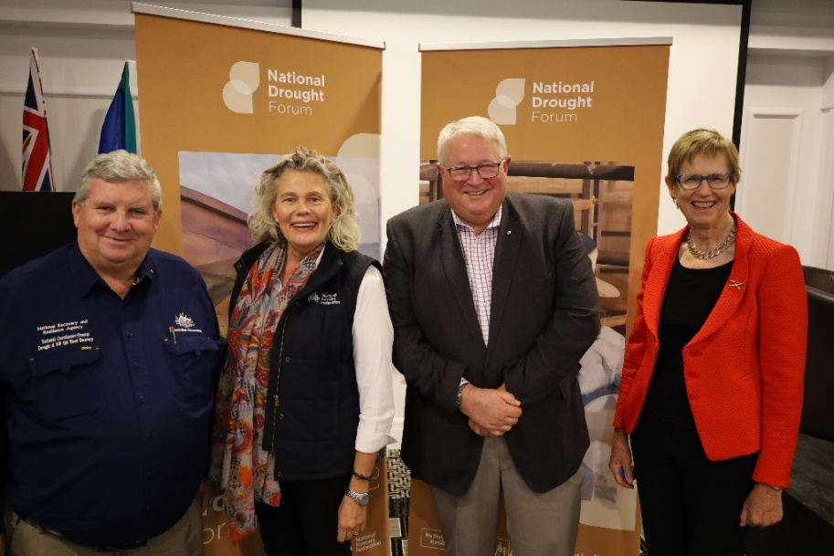
Left to right: Coordinator-General of the NRRA, the Hon Shane L Stone, AC QC, and NRRA Advisory Board members Fiona Simson, President, National Farmers’ Federation, Andrew Metcalfe AO, Secretary, Department of Agriculture, Water and the Environment and Dr Wendy Craik, Member, Future Drought Fund Consultative Committee.
Source: National Recovery and Resilience Agency

Making up to 100GL available to secure fodder

Water for Fodder program
Under the Water for Fodder program, farmers in the southern connected Murray–Darling Basin were able to apply to purchase South Australian River Murray water (Trading Zone 12) at a discounted rate. The Adelaide Desalination Plant produced 40 gigalitres of water and an equivalent amount was released upstream from the River Murray. The water was used to grow fodder and pasture. This helped farmers maintain their breeding stock during the drought.

Progress and implementation in 2020–21
A total of 800 farmers participated in the program. Reconciliation of final production figures is underway. At 30 June 2021 farmers reported planting over 34,000 hectares and harvesting more than 54,000 tonnes of fodder. South Australia received a total of $4 million for their drought resilience fund. Round 1 was successful, but more water became available in the southern Murray–Darling Basin due to autumn rainfall in 2020. This reduced the need for Round 2 as an emergency drought response.

Key risks and future direction
In September 2020 it was announced that due to improved seasonal conditions Round 2 would not proceed. Remaining funding was redirected to the Murray–Darling Communities Investment Package, which is putting communities at the centre of the implementation of the Murray–Darling Basin Plan. The Water for Fodder program closed on 30 June 2021.

Dealing with the stresses of drought
Action 1.8: Continued investment in mental health support programs in rural communities
Status: Underway (on track)

Mental health support programs
Drought can be a major source of stress for farmers and their communities. For farmers, seeing their crops fail, being forced to sell breeding stock, long hours of feeding animals and land deterioration can take its toll. Members of rural communities, particularly small business owners, experience similar stresses as business slows and budgets tighten. The Australian Government has invested $29.8 million since 2018 for drought mental health initiatives. The investment comprises:
- Empowering our Communities measure ($24.4 million)
- Trusted Advocates Network Trial ($463,815)
- expansion of telehealth services for the Better Access to Psychiatrists, Psychologists and General Practitioners under the Medicare Benefits Schedule (Better Access) to improve access to mental health support in drought-affected areas ($1.2 million).

Progress and implementation in 2020–21
The Empowering Our Communities measure ceased on 30 June 2020. Funding enabled Primary Health Networks to provide mental health first aid training, workshops, and community recovery and resilience programs to their communities. Murrumbidgee Primary Health Network and Western NSW Primary Health Network were granted an extension to continue the activities through to 30 December 2021.
The Trusted Advocates Network Trial for farmers was completed in 2021. Nine communities in drought-affected areas in New South Wales, Queensland, South Australia and Victoria participated. Primary Health Networks partnered with existing service providers to recruit and train ‘Trusted Advocate’ volunteers to offer peer support within drought-affected communities. The University of Wollongong undertook an evaluation of the trial, which was the first program of its kind in Australia.
On 30 March 2020 the government announced a telehealth model designed to address COVID-19 related public health restrictions and ensure ongoing access to mental and physical health care for all Australians. As a result, people in rural and remote communities, including those in drought-affected areas, can now book Better Access treatment sessions via telehealth. On 26 April 2021 the government announced telehealth would be extended until 31 December 2021.
In recognition of the impact of the COVID-19 pandemic on mental health, the number of sessions available through the Better Access initiative has temporarily increased from 10 to 20 until 30 June 2022. The additional sessions can also be accessed via telehealth where this is safe and clinically appropriate in the person’s circumstances.

Key risks and future direction
Both the Empowering Our Communities measure and the Trusted Advocates Network Trial have ceased. The government has developed a National Natural Disaster Mental Health and Wellbeing Framework to guide a coordinated approach in Australia to psychosocial and mental health responses in the context of national disasters and hazards such as drought. The framework outlines how all governments can build resilience and preparedness into communities affected by disasters. Telehealth enables people to see a health professional who is available when they need them, and not necessarily in their locality. Government continues to work with peak bodies to co-design permanent post-pandemic telehealth for all Australians as part of broader primary care reforms to modernise and provide flexibility of access to primary and allied health care services.

Battling pest and weeds
Action 1.9: Continue to explore options to reduce the impact of pests and weeds in drought-affected areas
Status: Underway (on track)
Landscape health, groundcover and critical stock forage need to be maintained during drought. Under its Biosecurity Management of Pests and Weeds initiative, the Communities Combating Pest and Weed Impacts During Drought Program funds eligible local government areas to manage pest animals and weeds in drought-affected areas. The projects aim to stimulate employment and local economies, and support farmers and land managers to reduce the impact of pest animals and weeds on agricultural production and the local environment at a time when they have little capacity to do so. The work undertaken by Glamorgan–Spring Bay Council on controlling serrated tussock grass illustrates the success of this program (Case study 1).

Progress and implementation in 2020–21
In 2020–21, $10 million was delivered for 23 projects across 33 drought-affected LGAs through round 2 of the program. This builds on the $15 million to support 48 projects across 74 drought-affected LGAs through round 1 of the program (in 2018–19). These projects will reduce grazing pressure and predation from pest animals through culling and exclusion fencing, and the impact of priority weeds on agricultural production and the environment.
Program eligibility was updated during round 2 to ensure that funding was targeted to areas most in need of drought assistance.

Key risks and future direction
All projects are scheduled for completion by 31 December 2021.
The Australian Government continues to support established pest animal weed management, with more than $212 million committed towards established pest animal and weed management programs and projects across Australia between 2015–16 and 2024–25. This is in addition to other Australian Government programs that support the management of established pest animals and weeds, including the Regional Land Partnership and National Landcare programs, the Threatened Species Strategy and bushfire recovery programs.
The commencement of the Future Drought Fund programs includes the Future Drought Fund’s NRM Drought Resilience Program – Landscapes and Grants streams. The programs have provided an opportunity for organisations, farmer groups and individuals to build drought resilience through NRM activities that may include the control of pests and weeds.
Case study 1 Glamorgan–Spring Bay Council serrated tussock control program, Tasmania, 2020
The drought-resistant serrated tussock (Nassella trichotoma) infests pastures on the East Coast of Tasmania. The weed significantly affects the carrying capacity and agricultural return of the land when many farmers do not have the time or money to effectively manage the weed. Glamorgan–Spring Bay Council has started a serrated tussock control program funded by the Australian Government’s Communities Combating Pest and Weed Impacts During Drought Program.
The weed has no nutritional value to livestock due to its high-fibre and low-protein content. If grazed, the weed can end up as an undigested ball in the stomach of the animal, causing a loss of condition and, in extreme cases, starvation. Serrated tussock also smothers desirable pasture species, rendering pastures incapable of supporting livestock. The project helped landholders actively spot treat the weed across large areas, reducing the spread further afield. It also enabled them to plant drought-tolerant pasture mix for the ongoing management of serrated tussock and the landscape where the infestations were detected. The project raised awareness of the invasive species across the broader community through workshops and field days.
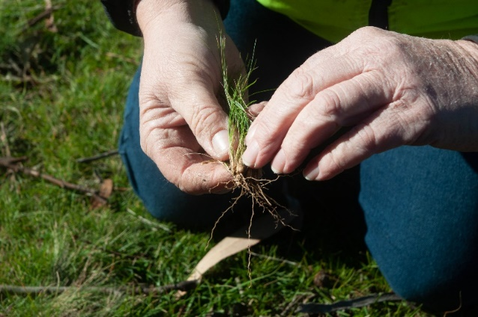
Source: National Recovery and Resilience Agency

Financial and regulatory frameworks that encourage planning and resilience
There are a number of taxation concessions available to help farmers better manage their cash flows and invest in the profitability and resilience of their farms. This includes:
- the Farm Management Deposits (FMD) Scheme
- income tax averaging
- accelerated depreciation arrangements for fodder storage assets, water facilities and fencing
- immediate deductibility for eligible assets up to $30,000
- the ability to spread income earned from forced disposal or death of livestock.

Farm Management Deposits Scheme
Action 1.10: A review on the effectiveness of the Farm Management Deposits Scheme will be undertaken in 2020–21 to inform any future changes
Status: Completed
The Farm Management Deposits (FMD) Scheme assists primary producers to deal more effectively with fluctuations in cash flows. It is designed to increase the self-reliance of Australian primary producers by helping them manage their financial risk and meet their business costs in low-income years by building up cash reserves.

Progress and implementation in 2020–21
At 30 June 2021 the level of FMD holdings was more than $6.196 billion, held in 46,946 FMD accounts. This is a decrease of around $297 million (4.57%) from 1 July 2020. A decrease in FMD holdings was recorded nationally for the 12 months to 30 June 2021, but the picture was mixed at the state level. For example, Western Australia recorded a decline of $216.09 million (20.6%), but Tasmania recorded an increase of $7.5 million (6.8%) over the same period.
The FMD scheme review commenced in March 2021 to assess the delivery of the scheme’s stated outcomes and its administrative efficiency. In March and April 2021, the reviewers consulted with stakeholder groups, including agricultural industry bodies, national and state farming organisations, the banking and finance sectors, and Australian and state and territory government agencies.
The review fulfils the government’s commitment under the NDA to undertake an evaluation of the FMD scheme, as well as recommendations made by the Australian National Audit Office audit and a Joint Committee of Public Accounts and Audit inquiry. Both the audit and the inquiry recommended the evaluation determine the extent to which the FMD scheme is assisting primary producers to become more financially self-reliant.

Key risks and future direction
The FMD scheme evaluation report and government response have been released concurrent with this review. The evaluation found that the FMD Scheme is one of a suite of tools used by primary producers to manage business and climate risks. The scheme provides financial benefits to those who can participate and has the support of most stakeholders. The government has agreed to the evaluation’s 7 recommendations, which seek to improve the scheme, including ensuring consistency with other government priorities (including drought resilience), and better communication, monitoring and reporting.

Support for wider communities affected by drought
The Australian Government has a range of measures and programs to support rural and regional communities that are facing prolonged drought conditions. These programs are consistent with the government’s obligations under the NDA.

Drought Community Outreach Program
The Drought Community Outreach Program (DCOP), in partnership with Rotary Australia World Community Service (Rotary), takes services and information to farmers and their communities in regional Australia through drop-in sessions. On 20 February 2020 the Australian Government announced $10 million for DCOP to fund Drought Community Outreach events and vouchers for eligible households experiencing financial hardship due to drought.

Progress and implementation in 2020–21
Rotary received a grant of $2.5 million in 2020–21 to continue delivering support to Drought Community Outreach events and to farming households affected by drought.
RSOs and Rotary deliver Drought Community Outreach events in partnership, providing farmers and community members with information that enables them to increase uptake of drought support measures. Under this initiative, Australian Government agencies, in partnership with state government agencies and non-government organisations, travel to regional communities to assist farming households and small businesses.
At the face-to-face events, farmers and community members learn how to access Australian Government drought initiatives, COVID-19 support and whole-of-government regional assistance measures. Their feedback to RSOs helps identify which policy and program settings are working well, where improvements are required, and whether there are gaps in existing drought support and recovery measures.
At each event, Rotary distributes vouchers in the form of a debit card. These provide immediate financial assistance to affected individuals, and the money they spend supports local businesses and communities.
COVID-19 restrictions resulted in Drought Community Outreach events being put on hold from July 2020 to October 2020. As restrictions eased, the program resumed. A total of 53 events were held across Western Australia, South Australia, Tasmania, New South Wales, Queensland and Victoria (Table 4). These were attended by 2,195 people, and 1,257 Rotary vouchers were distributed to community members. This equates to over $628,000 being injected back into these local communities. Case study 2 focuses on Drought Community Outreach events in the Upper Hunter region.
Table 4 Location of Drought Community Outreach events, 2020–21
NSW | Qld | SA | WA | Vic. | Tas.
Blayney  Coolah  Merriwa  Oberon  Quirindi  Scone | Childers  Cloncurry  Cunnamulla  Gayndah  Gin  Goondiwindi  Hughenden  Jandowae  Julia Creek  Kingaroy  Miles  Morven  Richmond  Roma  St George  Winton | Angaston  Burra  Cleve  Cowell  Elliston  Eudunda  Karoonda  Keith  Kimba  Peterborough  Pinnaroo  Quorn  Robertstown  Tanunda  Tailem Bend  Waikerie  Wudinna | Lake Grace  Lake King  Newdegate  Pingrup | Birchip  Hopetoun  Kerang  Murtoa  Ouyen  Robinvale  Sea Lake  Werrimull | Bothwell  St Marys
Source: National Recovery and Resilience Agency

Key risks and future direction
Uncertainties associated with COVID-19 will affect Drought Community Outreach events. Events are being planned, in line with restrictions in each state. Rotary will continue to provide support to farmers outside these events.
Case study 2 Drought Community Outreach event in the Upper Hunter region, New South Wales, 2020
The first Drought Community Outreach Program events were held in Quirindi, Scone, Merriwa and Coolah to support farmers and regional communities living through the immediate and longer-term effects of drought. The events were supported by RSOs and Rotary, who provided around 335 attendees with information, advice, options and financial assistance. There was strong demand for Rotary’s $500 vouchers for drought-affected households.
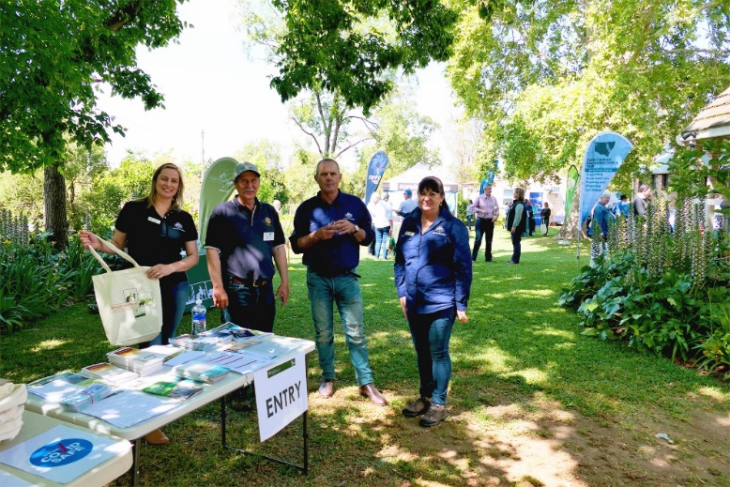
Source: National Recovery and Resilience Agency

Keeping drought-affected regional communities open for business
Action 2.1: Continue to investigate options that will help rural and regional communities respond to the drought
Status: Underway (implementation issue)

Drought Communities Programme Extension
The Drought Communities Programme Extension provides immediate economic stimulus to drought-affected communities by funding local infrastructure projects, events and drought-relief activities, supporting local businesses and creating jobs. Grants of $500,000 and $1 million are made to councils in eligible LGAs.

Progress and implementation in 2020–21
All councils have been contracted and grant payments are being made according to agreed milestones. At 30 June 2021 payments of $272.3 million had been made to councils. Case study 3 shows how the Goondiwindi Regional Council in Queensland made use of funding to support local farmers and businesses.

Key risks and future direction
The program end date has been extended to 30 June 2022. This allows for extensions to completion dates where the project has been affected by COVID-19 restrictions or other exceptional circumstances.
Case study 3 Goondiwindi Regional Council, Queensland, 2020
The Goondiwindi Local Government Area sits on the border of New South Wales and Queensland. It is a key producer of cotton, wheat and fodder crops and has a robust livestock industry. However, the continuing drought created tough conditions for local farmers and businesses and had a flow-on effect on the broader community. The Goondiwindi Regional Council received 2 grants of $1 million each under the Australian Government’s Drought Communities Programme (DCP) Extension and used the funding to deliver locally selected projects to help support the community through the drought.
The funding directly stimulated the region’s economy. Projects made use of local suppliers and resources, and tradespeople, creating employment for 37 local workers. The initial funding boosted tourism in Yelarbon and surrounds, with the Yelarbon Silo Project putting the region on the map of Australia’s silo art trail. Funding was also used to install solar panels on the roof of the local hall, fund Landcare information sessions on the Long Range Wide Area Network (LoRaWAN) and drill 2 bores to supplement the existing urban water supply to Goondiwindi town. The bores will provide additional water security.
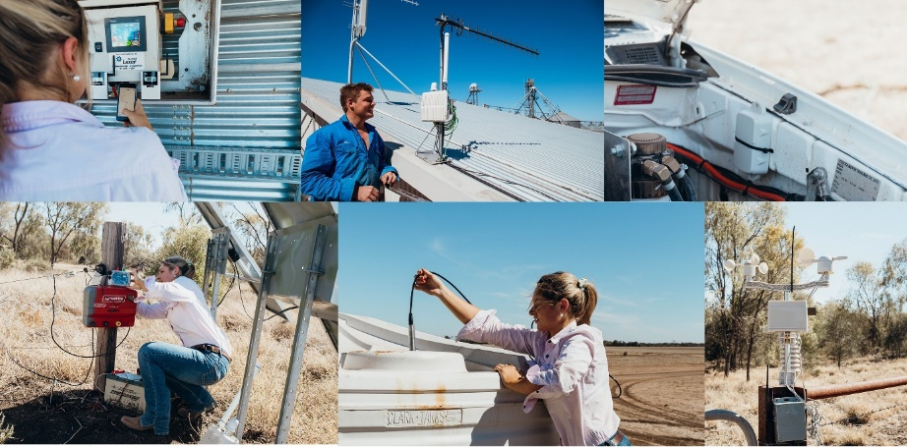
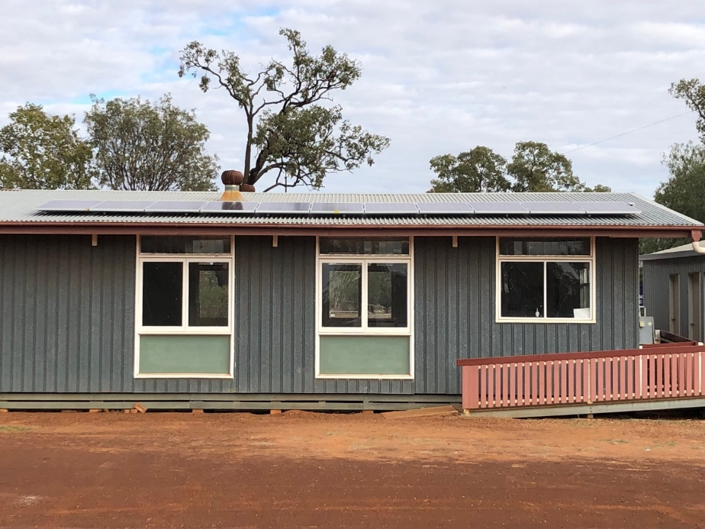
Source: Goondiwindi Regional Council

Roads to Recovery Program
The Roads to Recovery (R2R) Program supports the maintenance of the nation’s local road infrastructure asset. R2R facilitates greater access for all road users and improves safety and economic and social outcomes. The program provides funding to all local councils or to states and territories in unincorporated areas where there are no councils. Local councils are funded to choose road projects that meet their local priorities.

Progress and implementation in 2020–21
The full allocation of $138.9 million in drought funding has been paid to eligible councils through the R2R Program.

Key risks and future direction
This program was successfully administered, and funding is now exhausted. Implementation of the drought funding will be reviewed in 2023–24 during evaluation of the R2R Program.

Building Better Regions Fund
The Building Better Regions Fund (BBRF) is a competitive, merit-based grants program open to local government bodies, incorporated not-for-profit organisations and non-distributing cooperatives. Under BBRF, grants are available through 2 funding streams:
- The Infrastructure Projects stream – supports projects that involve construction of new infrastructure, or the upgrade or extension of existing infrastructure.
- The Community Investments stream – funds community development activities such as new or expanded local events, strategic regional plans, leadership and capability building activities.

Progress and implementation in 2020–21
In 2020–21 the Australian Government provided $200 million towards BBRF Round 5, which closed for applications on 12 March 2021. On 8 October 2021, the government announced an additional $100 million for Round 5. Successful Round 5 projects were announced on 8 October 2021.
Under BBRF Round 4 at 30 June 2021 funding agreements had been executed for 52 Community Investments projects (to a total of $1,939,800 in funding) and 99 Infrastructure Projects ($168,183,504), and 1 successful grantee had declined an offer of funding.

Key risks and future direction
Successful projects under Round 5 were announced on 8 October 2021. A further $250 million was made available in the 2021–22 Budget for a sixth BBRF round, which will open for applications at the end of 2021. Although BBRF Rounds 5 and 6 do not have the drought focus of Round 4, project funding through these rounds will flow to communities throughout regional Australia, including those affected by drought.

Foundation for Rural and Regional Renewal – Tackling Tough Times Together
The Foundation for Rural and Regional Renewal (FRRR) delivers the Tackling Tough Times Together program, which provides grants to not-for-profit organisations and community groups in drought-affected regions. Projects focus on reducing social isolation, leadership development and skills training, social and educational participation, and addressing disadvantage.

Progress and implementation in 2020–21
All grant funding has been paid to the FRRR and supports Rounds 17 to 20. During 2020–21 grant funding was provided for Rounds 17 to 20 as detailed in Table 5. Applications for Round 21 closed on 24 May 2021 and announcements were made in August 2021.
Table 5 Grant funding for FRRR Rounds 17 to 20, 2020–21
Round | Date announced | Number of projects | Unit | Funding
Round 17 | 26 August 2020 | 30 | $m | 1.1
Round 18 | 27 November 2020 | 36 | $m | 1.2
Round 19 | 26 February 2021 | 24 | $m | 1.1
Round 20 | 1 June 2021 | 27 | $m | 1.0

Key risks and future direction
Applications for Round 22 opened on 25 May 2021 and closed on 24 August 2021. The announcement of successful applicants was made on 23 November 2021. Round 22 is the final round to be funded from the Australian Government’s grant.

Regional Investment Corporation
Action 2.2: The Regional Investment Corporation to develop a Small Business Drought Loan product
Status: Completed
The RIC’s AgBiz Drought Loan is designed to mitigate the effects of drought on eligible small businesses that predominantly supply primary production-related goods or services to farm businesses in drought-affected areas.

Progress and implementation in 2020–21
The AgBiz Drought Loan will continue to be available to small businesses that predominantly supply goods or services to primary producers in affected areas. Examples of these businesses include harvesting and fencing contractors, carriers, stock and station agents, and businesses dealing in agricultural equipment and repairs.
In 2020–21 the RIC approved 109 AgBiz Drought Loan agreements, totalling $30.77 million, of which 55 loans have settled.

Key risks and future direction
Uptake of AgBiz Drought Loans will continue to be monitored.

Financial counselling for small business

Drought Communities Small Business Support Program
Action 2.3: The pilot $7 million Drought Communities Small Business Support Program will be assessed mid-program in late 2021 to monitor its effectiveness and it will be amended if necessary
Status: Underway (on track)
The $7 million Drought Communities Small Business Support Program enables the Rural Financial Counselling Service (RFCS) to provide financial counselling services to small businesses that are experiencing hardship in drought-affected areas. Under the pilot program, small regional and rural businesses will be able to work with local financial counsellors on business planning, mentoring and coaching to improve their financial capability.

Progress and implementation in 2020–21
In 2020–21 the pilot funded 44 full-time equivalent small business financial counsellors and 10 support staff across Australia. The program was initially a drought support measure, but it was modified in mid-2020 to include support for small regional businesses affected by bushfires and COVID-19.
In June 2021 an interim internal evaluation of the program assessed outcomes and effectiveness. Initial findings point to a demonstrated demand for small business hardship support in regional Australia. At 30 June 2021 more than 1,200 small businesses employing over 2,900 people had accessed the pilot program across the country.
Of the clients that accessed the program, 64% cited COVID-19 as the predominant cause of hardship, with drought accounting for 19% and bushfire 17% (noting that many experienced multiple sources of hardship). Feedback from RFCS providers and exited clients indicates the program has had a positive impact on small regional businesses, providing timely and effective support to those experiencing hardship and improving business financial viability.

Key risks and future direction
The pilot is progressing, and an internal evaluation of the program will be completed in 2022. The pilot program has been extended to 31 December 2021.

Long-term resilience and preparedness
Drought is a recurring feature of the Australian landscape. The Australian Government is committed to providing support to build resilience and preparedness. Providing farmers and communities with support that enables them to recover and continue adapting and building their drought preparedness ensures that Australian farming can remain profitable and sustainable.

Future Drought Fund
Commencing on 1 September 2019, the $5 billion Future Drought Fund (FDF) provides secure, continuous funding for drought-resilience initiatives. It will help Australian farms and communities prepare for the impacts of drought.
Each year, $100 million will be available to help Australian farmers, agricultural businesses and communities be better prepared for inevitable future droughts. In 2020–21 the entire $100 million was allocated to programs.
For information about the FDF’s activities during 2022–21, see the Future Drought Fund annual report.

Progress and implementation in 2020–21
Eight foundational FDF programs were developed in 2020–21, structured around the FDF’s 5 themes of harnessing innovation, better risk management, better climate information, more resilient communities and better land management. Programs are being delivered in accordance with the principles outlined in the FDF’s 2020–24 Drought Resilience Funding Plan, including where practicable, a requirement of co-investment to maximise program outcomes.
Key outcomes of 2020–21 include:
- Established 8 Drought Resilience Adoption and Innovation Hubs across Australia to drive regionally focused effort to develop, extend, adopt and commercialise drought-resilient practices and technologies.
- Established tailored programs in each state and territory to build the capability of farm business, local councils, regional bodies and others to plan for and manage drought risks.
- Released the first online tools for farmers that will make climate risk and resilience information more accessible and useful.
- Partnered with the Australian Rural Leaders Foundation and the Foundation for Rural and Regional Renewal to bolster the role of community organisations, networks, leaders and mentors in improving drought preparation and supporting people through drought.
- 80 new on-ground projects focused on land management practices that support agricultural productivity during drought and enable farms to recover quickly after drought.

Key risks and future direction
The coming year will see the ongoing delivery and expansion of the FDFs foundational programs through 5 key themes:
- Harnessing innovation – driving the adoption of drought resilient technologies and practices to help Australian farming and communities to be less impacted by future droughts. We will support demonstration, adoption and commercialisation of these practices through our 8 Adoption and Innovation Hubs, the Drought Resilience Innovation Grants, finalisation of our Drought Resilience Research and Adoption Investment Plan, and our annual Science to Practice Forum.
- Better risk management – we will continue to build the capability of farmers to plan for the risk of droughts to their business through the expansion of the Farm Business Resilience Program. We’ll also be helping local governments and other regional stakeholders as the Regional Drought Resilience Planning Program rolls out and is also extended for 3 years, to proactively plan for the risk of drought. This program will also support small grants for regions to take forward priority actions identified in regional plans.
- Better climate information – we will continue the development of an online Climate Services for Agriculture platform and Drought Resilience Self-Assessment Tool that will make it easier for farmers and others to access and understand climate information. These digital prototypes will help users assess the risks they face from drought and their resilience.
- More resilient communities – we will continue to build community leaders, mentors, networks and organisations that will lead conversations and action in their community to prepare for drought, and to be part of the safety net during the hard times of drought. The Drought Resilience Leaders and Networks to build Drought Resilience are the foundational programs.
- Better land management – we will focus on targeting innovative and transformational activities, on a broad scale, that support the trial and adoption of land management practices that can help agricultural lands stay more productive during, and coming out of, drought under the Drought Resilient Soils and Landscapes program. Activity will continue under the Natural Resource Management Drought Resilience Programs.
In 2021–22 work will continue to identify measures of success for Future Drought Fund investments. This will involve ongoing development of the FDF’s monitoring and evaluation framework, including stakeholder consultation, development of indicators and methodologies and the identification of new data sources. The framework will support the evaluation of FDF performance. It will also increase our understanding of broader trends in drought resilience to inform a wide range of policies, programs and actions by governments, industry and others.
Risks to the FDF are managed through detailed program planning, ongoing stakeholder engagement and monitoring and reporting. The independent FDF Consultative Committee provides us with governance and policy advice. It meets monthly to discuss issues such as the design and delivery of FDF programs, monitoring, evaluation and learning arrangements for FDF programs, stakeholder engagement approaches and feedback, communications strategies, and risks to FDF delivery and management strategies.

Just add water

National Water Grid Authority
The Australian Government has established the National Water Grid Fund as a rolling 10-year water infrastructure program to fund water infrastructure investments. In 2020–21 an additional $2 billion in funding was announced, bringing the Australian Government’s total funding commitment under the NWGF to $3.5 billion.

Progress and implementation in 2020–21
In May 2021 the Australian Government renamed the National Water Infrastructure Development Fund (NWIDF) the National Water Grid Fund (NWGF) to better reflect the government’s commitment to the National Water Grid. Significant progress was made in delivering projects under the NWGF. Despite the impacts of COVID-19 in 2020–21, work on construction projects continued:
- 3 projects were completed, increasing total construction projects delivered from 5 to 8
- 2 projects began construction work, bringing total projects under construction to 6
- 9 construction projects were contracted with the relevant state or territory government (taking the total from 13 to 22).
The National Water Grid Investment Framework, first released in October 2020, was developed in consultation with state and territory governments. It provides guidelines on how the Australian Government will make investment decisions on water infrastructure projects.
In 2021–22 $258 million in funding was committed from the $3.5 billion NWGF. This includes:
- $68.2 million towards the construction of 4 new water infrastructure projects
- $7.5 million in additional funding for the Rookwood Weir to increase the height of the weir wall and total capacity
- $22.3 million towards the development of 8 business cases that will help inform decision-making on water infrastructure investment in the National Water Grid
- $160 million for the National Water Grid Connections funding pathway; which allows delivery of smaller-scale water infrastructure projects over the next 2 years that collectively make a nationally significant contribution to the National Water Grid. Under this funding pathway, $108 million has been committed to 40 projects.

Key risks and future direction
The Australian Government is working closely with state and territory governments to develop a forward plan of projects for future investment consideration. At the end of 2020–21, more than $1.9 billion had been committed through the NWGF to support 30 construction projects and more than 60 business case projects. The government is working to deliver a program of national water infrastructure investments that will improve the reliability and security of water for Australia’s regions and for the agricultural and primary industry sectors.
The Warwick Recycled Water for Agriculture project in Queensland illustrates the success of this funding program (Case study 4).
Case study 4 Warwick Recycled Water for Agriculture, Queensland, 2021
In 2019 the Australian Government announced funding for the construction of the Warwick Recycled Water for Agriculture project through the Drought Round administered by what was then the NWIDF.
A 4-kilometre water pipeline was constructed to extend an existing recycled water distribution network in the Warwick Industrial Estate, Queensland.
Construction of the pipeline was completed in February 2021, enabling the supply of approximately 73 megalitres annually of high-quality recycled water to agricultural and industrial users. This project has secured an affordable and reliable water supply that helps ensure drought resilience for primary producers.

Invest in research and development to build drought resilience
Action 3.1: Modernise the Research and Development Corporations system to deliver value for money, drive collaboration and participation across the agricultural innovation system and target long-term cross-sectoral and transformative R&D
Status: Underway (on track)
The government is delivering an ambitious National Agricultural Innovation Agenda to improve our agricultural innovation system. The agenda will provide national leadership and drive a more coordinated strategic approach to agricultural innovation.

Progress and implementation in 2020–21
The government announced the National Agricultural Innovation Agenda on 1 September 2020. Key actions delivered under the agenda in 2020–21 include:
- establishing Agricultural Innovation Australia (AIA) in October 2020 to capitalise on cross-industry opportunities to drive productivity, sustainability and profitability in agriculture by leveraging the power of collaboration
- $1.3 million (GST exclusive) to support AIA efforts to drive a cross-industry approach to agricultural innovation and fast track action on the ground
- launching the agricultural innovation sharing digital platform growAG in April 2021, which will enable Rural Research and Development Corporations (RDCs) and others across the system to showcase their research and technologies to the world
- investing $600,000 in the Australian AgriFood Data Exchange as an initial grant to fund the proof-of-concept stages of the project. The data exchange will enable the safe sharing of data across the agricultural and food sectors.
During 2020–21 the government adopted governance arrangements for RDC funding agreements. The funding agreements were revised to streamline arrangements, reduce the compliance burden, minimise duplication between the funding agreement and relevant legislation, and introduce a principles-based approach to performance.
The 5 performance principles are:
- Engage stakeholders to identify research, development and extension (RD&E) priorities and activities.
- Ensure RD&E (and marketing) priorities and activities are strategic, collaborative and targeted.
- Undertake strategic and sustained cross-industry, cross-sectoral and cross-innovation system collaboration.
- Ensure governance arrangements and practices fulfil legislative requirements and align with contemporary Australian best practice.
- Ensure monitoring and evaluation demonstrates positive outcomes and delivery of RD&E (and marketing) benefits.

Key risks and future direction
Through the National Agricultural Innovation Agenda, the government is providing national leadership and driving improvements across the agricultural innovation system. Under the agenda, the government has also:
- delivered a National Agricultural and Innovation Policy Statement to position the agricultural system to deliver maximum benefits to industry and the broader economy. The statement establishes 4 new National Agricultural Innovation Priorities including a priority on championing climate resilience to increase the productivity, profitability and sustainability of the agricultural sector
- committed to delivering a Digital Foundations for Agriculture Strategy focusing on the fourth Innovation Priority to help drive the widespread adoption of digital technologies in the sector and its related value chains
- provided a further $1.5 million to Agricultural Innovation Australia to deliver investment strategies to support the new innovation priorities – trade, biosecurity, climate and digital agriculture.
- announced an additional $20 million allowing the 8 existing Drought Resilience Adoption and Innovation hubs to expand their remit into broader innovation activities.
For the RDCs we are now developing Guidelines for statutory funding agreements that will provide key performance indicators for each of the 5 performance principles to ensure maximum value to the taxpayer and the levy payer. Also under development is a Best practice guide for consultation.
The Council of Rural Research and Development Corporations has also developed a guide to RDC knowledge transfer and commercialisation. The guide will provide guiding principles for Knowledge Transfer, including commercialisation, for the adoption of R&D investment within the Research and Development Corporation context.

Effective and strategic management of Australia’s soil, vegetation and water resources for profitable farm performance, sustainability and resilience to droughts
The drought-specific measures that contribute to the plan are only part of the picture.. They are complemented by other programs and strategies that also support improved drought resilience and preparedness. These include the National Landcare Program, a key part of the government’s commitment to protect and conserve Australia’s water, soil, plants, animals and ecosystems, as well as support the productive and sustainable use of these resources. The National Landcare Program Phase 2 will deliver $1.1 billion to national priorities between 2018 and 2023.
Healthy soils are central to building resilience to the impacts of climate change, including the increasing frequency and severity of drought. The National Soil Strategy was released in May 2021 to address key soil priorities for Australia designed to secure and protect our soil for the future.
The strategy highlights 3 overarching goals:
- Prioritise soil health.
- Empower soil innovation and stewards.
- Strengthen soil knowledge and capability.
The government has committed $214.9 million over 4 years from 2021–22 to implement the strategy and associated measures. Key measures include:
- $20.9 million over 4 years (2021–22 to 2024–25) for a National Soils Science Challenge grants program.
- $5.9 million over 4 years (2021–22 to 2024–25) to implement the National Soil Strategy.
- $67 million over 4 years (2021–22 to 2024–25) for the Food Waste for Healthy Soils Fund.
- $1.1 million over 2 years (2021–22 to 2022–23) to develop an accreditation standard to enhance soil education and expertise.
- $120 million over 2 years (2021–22 to 2022–23) for a Pilot National Soils Monitoring and Incentives Program including testing, review of data, purchase of data, soil extension activities, the development of the Australian National Soil Information System, and the development of a National Land Management Classification System.
Through the 2021–22 Budget, the government is also investing an additional $32.1 million to promote biodiversity stewardship. This builds on the ongoing Agriculture Stewardship Package worth $34 million over 4 years (2018–19 to 2022–23). The package aims to encourage adoption of improved on-farm land management practices and develop a mechanism where farmers are rewarded for their efforts in delivering biodiversity and sustainability services that benefit their farms and the broader community. The package is aiming to have wide reaching benefits for farmers, the environment and across agricultural communities and landscapes.
It will demonstrate that environmental markets and other mechanisms, such as certification systems, that reward farmers for protecting and improving biodiversity, can provide a real way to diversify, and potentially boost, farm income.
Well-managed agricultural landscapes will sustain high quality ecosystem services, such as:
- healthy soils
- clean air and water
- soil carbon storage and biodiversity.
They will also help drive industry profitability and build resilience.
Environmental–economic accounting is another way that the government is working with the states and territories to improve our understanding of the natural resources that contribute to agricultural productivity and drought resilience. In June 2021 we collaborated with the Australian Bureau of Statistics, Geoscience Australia and CSIRO on the publication of the first National Land Account for Australia.

Completed measures
Drought measures detailed in Table 6 were completed before the commencement of this implementation review, which covers July 2020 to June 2021.
Table 6 Completed drought measures, 2018–19 to 2019–20
Action | Drought measure | Unit | Funding | Years of activity (calendar and financial)
1.8 | Mental Health – Medicare Benefits Schedule for General Practitioners | $m | 3.6 | 2018 to 2020
1.8 | Mental Health – ReachOut Australia | $m | 0.22 | 2018 to 2019
2.1 | Community Child Care Fund | $m | 5 | 2019 to 2020
2.1 | Education Special Circumstances | $m | 20 | 2019 to 2020
2.1 | Country Women’s Association of Australia | $m | 5 | 2019 to 2020
2.1 | Drought Communities Programme | $m | 34.5 | 2014–15 to 2018–19
Source: Department of Agriculture, Water and the Environment

The year ahead
The Australian Government Drought Response, Resilience and Preparedness Plan is not just about responding to and preparing for drought. It is about giving our farmers and regional communities hope for the future and building resilience.
The Australian Government’s drought support package to 30 June 2021 committed more than $11 billion since 2018–19 across 25 measures. This implementation review assessed the performance of the measures in 2020–21 and found that the government is meeting its obligations under the plan. COVID-19 restrictions have resulted in some delays, but programs have largely adapted to ensure that information and support is still being delivered to farmers and communities. Several programs are now complete.
The Australian Government will continue to monitor the effectiveness of drought policies and programs and adjust delivery, as necessary, to ensure the appropriate level of targeted assistance is available. We will publish the third implementation report on the plan in the second half of 2022.
The government will also continue to work directly with rural communities to support preparation for drought through ongoing programs. These include the Future Drought Fund, National Soil Strategy, the National Landcare Program and the Agriculture Stewardship Package.
New resources will be created to support farmers, including accessible climate data and self-assessment tools, and better systems to forecast drought. The RSOs will remain a key element of on-ground drought support and resilience. Engagement and collaboration will continue throughout the next stage of the drought cycle. Links with state and territory governments and partners in industry, the finance sector, local government, charities and community groups will be maintained and strengthened as we shift our focus to drought preparedness and resilience.
The coming year will see the commencement of consultation with state and territory governments on a review of the NDA. A review of the plan is also scheduled for 2022–23.

Appendix A: Funding for drought measures
Table A1 Australian Government funding for drought measures, 2018–19 to 2024–25
Measures at 30 June 2021 | Program | Funding committed since 2018–19 ($) | Funding committed under contract ($) | Funding spent ($) | Financial years
Supporting those affected now | Accelerated depreciation for fodder storage assets | 75,000,000 | n/a | Estimated foregone revenue | Estimate for 2018–19 only
 | Bureau of Meteorology radars | 77,200,000 | 15,495,899 | 6,292,942 | 2019–20 to 2041–42
 | Communities Combating Pests and Weed Impacts During Drought Program | 25,000,000 | 24,998,828 | 24,998,828 | Round 1: 2018–19, Round 2: 2019–20 to 2020–21
 | Country Women’s Association of Australia (June 2019 grant) | 5,000,000 | 5,000,000 | 5,000,000 | 2019–20 to 2020–21
 | Drought Communities Small Business Support Program | 7,000,000 | 7,000,000 | 7,000,000 | 2019–20 to 2021–22
 | Drought Community Outreach Program (Rotary and CWAA) | 10,000,000 | 10,000,000 | 10,000,000 | 2019–20 to 2021–22
 | Drought Community Support Initiative | 181,500,000 | 180,458,228 | 180,458,228 | 2018–19 to 2021–22
 | Empowering our Communities, Trusted Advocates, Connecting Youth Awareness-raising Initiative and Telehealth Services | 29,888,815 | 26,456,359 | 26,475,509 | 2018–19 to 2020–21
 | Farm Household Allowance | 629,800,000 | n/a | 429,764,977 | 2018–19 to 2024–25
 | FarmHub (managed by National Farmers’ Federation) | 774,400 | 774,400 | 774,400 | 2018–19 to 2020–21
 | Improving Great Artesian Basin Drought Resilience | 27,600,000 | 27,600,000 | 3,667,759 | 2019–20 to 2023–24
 | National Drought Map | 4,200,000 | 2,495,446 | 1,693,209 | 2019–20 to 2022–23
 | On-farm Emergency Water Infrastructure Rebate Scheme | 100,000,000 | 80,871,054 | 42,740,525 | 2018–19 to 2021–22
 | Regional Investment Corporation loans | 4,075,000,000 | 3,003,060,000 | 1,346,340,000 | 2018–19 to 2022–23
 | Regional weather and climate guides for on-farm decision-making | 2,700,000 | 2,700,000 | 2,700,000 | 2018–19 to 2019–20
 | Rural Financial Counselling Service | 5,000,000 | 5,000,000 | 5,000,000 | 2018–19 to 2020–21
 | Water for Fodder | 33,000,000 | 82,600,000 | 30,000,000 | 2019–20 to 2020–21
Supporting communities | Building Better Regions Fund Round 4 | 207,000,000 | 170,123,304 | 8,301,286 | 2020–21 to 2022–23
 | Community Child Care Fund | 5,000,000 | 2,972,789 | 2,972,789 | 2019–20
 | Drought Communities Programme Extension | 297,000,000 | 295,846,012 | 272,143,042 | 2018–19 to 2021–22
 | Drought Communities Programme Extension – Roads to Recovery | 138,852,750 | 138,852,750 | 138,852,750 | 2019–20 to 2020–21
 | Education Special Circumstances | 20,000,000 | 20,000,000 | 20,000,000 | 2019–20
 | Foundation for Rural and Regional Renewal | 15,000,000 | 15,000,000 | 15,000,000 | 2018–19 to 2020–21
Enhancing long-term resilience and preparedness | Future Drought Fund | 5,000,000,000 | 3,900,000,000 | 76,615,738 | 2020–21
 | National Water Grid Authority | 100,000,000 | 27,555,558 | 9,094,235 | 2019–20 to 2023–24
 | Total | 11,071,515,965 | 8,042,360,627 | 2,665,886,217 | n/a
n/a Not applicable.
Note: The Regional Investment Corporation $4.075 billion amount includes funding provided through the RIC’s AgRebuild loan product.
Source: Department of Agriculture, Water and the Environment

Glossary
Term | Definition
ABARES | Australian Bureau of Agricultural and Resource Economics and Sciences
Basin | Great Artesian Basin
BBRF | Building Better Regions Fund
CSIRO | Commonwealth Scientific and Industrial Research Organisation
CWAA | Country Women’s Association of Australia
FDF | Future Drought Fund
FHA | Farm Household Allowance
FMDs | Farm Management Deposits
IGABDR | Improving Great Artesian Basin Drought Resilience
IGABIIP | Interim Great Artesian Basin Infrastructure Investment Program
LGA | Local Government Area
NDA | National Drought Agreement
NDNQFRRA | National Drought and North Queensland Flood Response and Recovery Agency
NRRA | National Recovery and Resilience Agency
NWIDF | National Water Infrastructure Development Fund
NWGF | National Water Grid Fund
RDCs | Research and Development Corporations
RD&E | Research, development and extension
RFCS | Rural Financial Counselling Service
RIC | Regional Investment Corporation
RSO | Recovery Support Officer
R2R | Roads to Recovery

