National Drought Agreement annual report 2023–24
Parties to the National Drought Agreement
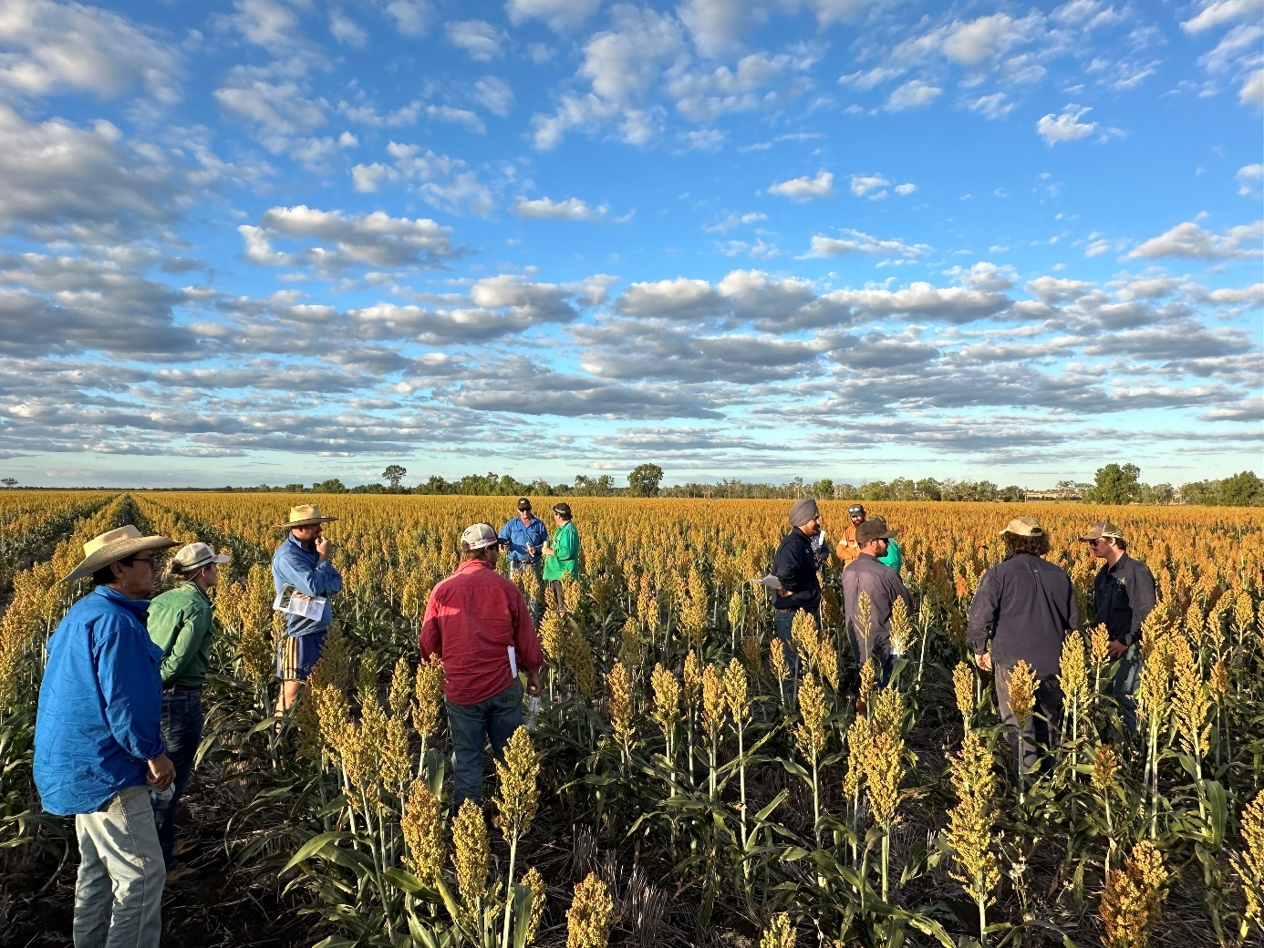
© Commonwealth of Australia 2025
Ownership of intellectual property rights
Unless otherwise noted, copyright (and any other intellectual property rights) in this publication is owned by the Commonwealth of Australia (referred to as the Commonwealth).
Cover photograph: ‘Grains Farm Business Resilience Program Workshop, Orion Queensland Nitrogen Incorporation, Queensland’ © Mohammad Ali, Queensland Department of Primary Industries.
Creative Commons licence
All material in this publication is licensed under a Creative Commons Attribution 4.0 International Licence except content supplied by third parties, logos and the Commonwealth Coat of Arms.

Cataloguing data
This publication (and any material sourced from it) should be attributed as: Parties to the National Drought Agreement 2024, National Drought Agreement annual report 2023–24, Department of Agriculture, Fisheries and Forestry, Canberra, January. CC BY 4.0.
This publication is available at agriculture.gov.au/agriculture-land/farm-food-drought/drought/drought-policy/national-drought-agreement.
Department of Agriculture, Fisheries and Forestry
GPO Box 858 Canberra ACT 2601
Telephone 1800 900 090
Web agriculture.gov.au
Disclaimer
The Australian Government acting through the Department of Agriculture, Fisheries and Forestry has exercised due care and skill in preparing and compiling the information and data in this publication. Notwithstanding, the Department of Agriculture, Fisheries and Forestry, its employees and advisers disclaim all liability, including liability for negligence and for any loss, damage, injury, expense or cost incurred by any person as a result of accessing, using or relying on any of the information or data in this publication to the maximum extent permitted by law.
Acknowledgement of Country
We acknowledge the Traditional Custodians of Australia and their continuing connection to land and sea, waters, environment and community. We pay our respects to the Traditional Custodians of the lands we live and work on, their culture, and their Elders past and present.

Preface
This is the fifth annual report of the National Drought Agreement (NDA) 2018 to 2024, signed by the Australian Government and state and territory governments. In keeping with the reporting obligations set out in clauses 12 to 16 of the NDA, progress reports are compiled annually by the NDA Secretariat (or as required by the governing bodies) and cover the previous financial year.
The NDA annual report 2023–24 provides an overview of national progress on implementing the NDA and is the last report completed under the NDA 2018 to 2024.

Background to the NDA
On 12 December 2018, the Australian Government and the states and territories signed the NDA 2018 to 2024. The NDA replaced the 2013 Intergovernmental Agreement on National Drought Program Reform.
The NDA 2018 to 2024 focused on long-term preparedness, sustainability, resilience and risk management for farming businesses and farming communities in Australia. It encouraged Australian governments to cooperate and collaborate on drought-related programs and initiatives and outlined responsibilities when supporting farming businesses, families and communities. The NDA aimed to provide a collaborative jurisdictional framework for a consistent policy approach to drought response across Australia. It sought to reduce duplication in program delivery between jurisdictions and share monitoring and reporting on the progress of each jurisdiction’s efforts.
The existing jurisdictional forums of the Agriculture Senior Officials Committee (AGSOC) and the Agriculture Ministers’ Meeting (AMM) governed and reported on the NDA 2018 to 2024.
The Department of Agriculture, Fisheries and Forestry has secretariat responsibility for the NDA.

Contents
Preface iii
Background to the NDA iii
Agriculture ministers’ message vi
Summary viii
1 Progress on areas for improvement 1
2019–20 areas for improvement 1
2020–21 areas for improvement 2
2021–22 areas for improvement 2
2 Climate 4
3 NDA Outcomes 7
4 Delivering on roles and responsibilities 9
5 Investment 12
6 Reviews and evaluations 13
7 Next steps 16
Future NDA priorities 16
Jurisdictional activity 16
Appendix A: 2023–24 jurisdictional measures 23

Tables
Table 1 Commonwealth responsibilities 9
Table 2 State and territory responsibilities 10
Table 3 Shared responsibilities 10
Table 4 Proportional investment across the drought cycle, 2018 to 30 June 2024 12
Table 5 Reviews of parties’ drought support measures 13
Table A1 NDA roles and responsibilities met by each measure, by jurisdiction 23
Figures
Figure 1 Farm Business Resilience planning participants Brasington Family, Queensland 8
Figure 2 A swollen Roe Creek reaches the road, Northern Territory 11
Figure 3 Victorian Farm Business Resilience Program participant, Ed Rickard 17
Figure 4 Apricot Farm in Shepparton, Northern Victoria 19
Figure 5 Dry conditions on King Island, Tasmania 21
Figure 6 Cattle at a water trough, Northern Territory 22

Maps
Map 1 Australian rainfall deciles, 2023–24 4
Map 2 Root–zone soil moisture deciles, 2023–24 5

Agriculture ministers’ message
This year’s NDA annual report marks the end of one era and beginning of another.
For the last 6 years, the Australian, state and territory governments have operated under the 2018 to 2024 agreement to support farmers and rural communities facing drought.
From mid-2024, that changes. We will move under a new agreement that guides our approach to drought through to the end of the decade.
This report outlines jurisdictional achievements in the final year of the current NDA and the next steps from here. It shows the strong foundation we have laid for the next agreement.
Over the last 12 months we have continued to shift the conversation about drought towards preparing for and building resilience to dry conditions.
We have cooperated on joint initiatives such as the Regional Drought Resilience Planning Program, Farm Business Resilience Program, Helping Regional Communities Prepare for Drought Initiative, and Drought Resilience Adoption and Innovation Hubs.
We have improved regional and national climate data and tools so farmers can make better, more informed decisions about their business.
We have jointly funded rural financial counselling services to help farmers in hardship become more profitable, financially self-reliant and better prepared for risks like drought.
All of these programs have adopted local, community-led approaches, because there is no one-size-fits-all approach to drought. Drought can occur anywhere, from the arid centre to the coastal strip. Its impacts are wide-ranging, extending beyond farmers and their families to their whole communities.
Drought is not new. Australia has always experienced cycles of wet and dry weather. Farmers know from their own experiences, family history and records that drought is never far away.
But we are now operating in an environment where droughts are forecast to become more frequent, severe and longer lasting in many regions. We are already seeing drier conditions in some areas of Australia as we near the end of this reporting period.
2023–24 was the second-warmest financial year on record. South-western Western Australia, south-eastern South Australia, south-western Victoria and northern Tasmania have reported record-low rainfalls. Parts of Tasmania and King Island experienced drought on a scale they had not seen for 50 years.
We are better placed to support farmers and rural communities to manage the risks of a warming climate because of the work done over the last 12 months. Like farmers and rural communities, we have learned from and adapted our approaches. We are at our strongest when we collaborate. We look forward to working together again in the coming year to ensure Australian agriculture remains prosperous, sustainable and resilient.

Hon Julie Collins MP, Minister for Agriculture, Fisheries and Forestry

Hon Tara Moriarty MLC, Minister for Agriculture, Minister for Regional New South Wales, and Minister for Western New South Wales

Hon Ros Spence MP, Minister for Agriculture

Hon Anthony Perrett MP, Minister for Primary Industries
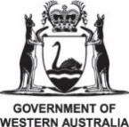
Hon Jackie Jarvis MLC, Minister for Agriculture and Food, Minister for Forestry and Minister for Small Business

Hon Clare Scriven MLC, Minister for Primary Industries and Regional Development and Minister for Forest Industries

Hon Jane Howlett MP, Minister for Primary Industries and Water

Hon Gerard Maley MLA, Minister for Agriculture and Fisheries

Suzanne Orr MLA, Minister for Climate Change, Environment, Energy and Water

Summary
The NDA annual report 2023–24 demonstrates the ongoing commitment by Australian governments to work in partnership with farming businesses and rural communities to prepare for, manage and recover from drought.
Australian farmers are considered to be the best in the world at drought innovation and adaptation. Australian governments support and engage with farming businesses and rural communities to help them prepare for challenging dry conditions and be self-reliant for longer.
Many farming businesses and rural communities responded to the fluctuating rainfall and drying conditions experienced across Australia in 2023–24 with extraordinary resilience.
All Australian governments have continued to deliver on their NDA roles and responsibilities in a manner that is appropriate to their operating context.

Progress on areas for improvement
Areas of improvement noted as ‘ongoing’ will be progressed in the NDA 2024 to 2029 work plan. Completed areas for improvement have been included in the principles of the NDA 2024 to 2029. All parties agreed on these principles to guide drought preparedness, response and recovery work in their respective jurisdictions, whilst working together.

2019–20 areas for improvement

Area for improvement 1: Data availability
The reporting process highlighted gaps and limitations in the data available to report against the proposed measures in the NDA reporting framework. Learnings from the initial report were used to review how information is collected and reported against the NDA for future reporting periods.

Status
Ongoing – will be carried forward and incorporated into the NDA 2024 to 2029 reports.

2023–24 progress
An outcomes reporting framework is under development as part of the NDA 2024 to 2029. Future NDA annual reports will use available data to focus more on how jurisdictions work with and learn from each other.

Area for improvement 2: Interjurisdictional collaboration
Providing clarity to end users about available support in any specific place or at any point in time is complicated by the fact that each jurisdiction employs different methodologies to classify or declare drought, and there is little guidance available for policymakers about when the impacts of drought ‘start’ and ‘stop’ at points in time. Despite potential complications, there would be benefit in working towards greater interjurisdictional consistency in the criteria to define drought and inform government intervention on drought assistance.

Status
Complete – the NDA 2024 to 2029 clarifies the roles and responsibilities of all jurisdictions.

2023–24 progress
All parties met regularly to share information and understanding of the impacts of drought to inform their decisions on drought assistance.
The new NDA outlines how jurisdictions will work individually, together and with non-party stakeholders to help Australian agriculture better prepare for and withstand the impacts of drought.

Area for improvement 3: Streamlining support
Urgent need experienced by stakeholders during previous reporting periods resulted in a strong reaction from governments and the proliferation of many measures to help. This generated administrative inefficiencies and, in some cases, confusion on the ground. As we plan for the next drought, there are opportunities to improve the way we work during dry times; to rationalise, streamline and simplify support, in order to most appropriately assist when needed.

Status
Complete – the new NDA acknowledges the need to work with non-party stakeholders, including industry and First Nations peoples and communities.

2023–24 progress
The National Drought Network (NDN), established in November 2023, allows NDA parties and non-party stakeholders to share information. The network aims to build relationships and trust early and disseminate information to a range of stakeholders.
Principle 6 of the NDA 2024 to 2029 addresses this area for improvement. This principle states that:
parties should collaborate for improved and sustained coordination, planning and implementation of drought preparedness, response and recovery, and avoid duplication and adverse outcomes for stakeholders, including those in other jurisdictions, rural communities and environment. Such efforts can be coordinated and complementary whilst still being regionally suitable.
The new NDA also recognises that drought policies and programs should be flexible, streamlined and efficient to benefit the agricultural sector, regions and rural communities across the drought cycle of preparedness, response and recovery.

2020–21 areas for improvement

Area for improvement 4: Policy integration
Through the 2020–21 report, the majority of jurisdictions noted greater integration between drought, soil, water and climate policy. Improving the management of our natural resources and the ecological systems that underpin them – is fundamental to sustainable, profitable agricultural production and strong regional economies. However, this is a complex space and there will be inevitable challenges in fully integrating policy and translating policy to practice. Opportunities exist to utilise collaboration under the NDA to build shared understandings, identify successful approaches, and collectively address common challenges.

Status
Complete – jurisdictions met regularly in 2023–24 to share information and discuss challenges and lessons learned across related policy areas. Guest presenters from policy areas attended, enhancing understanding and collaboration.

2023–24 progress
Principle 5 of the NDA 2024 to 2029 addresses the complexity of policy integration, specifying the need for ongoing efforts to ensure drought policies and programs are developed across relevant agencies and align with intersecting policies.

2021–22 areas for improvement

Area for improvement 5: Community support
The 2021–22 report showed that there is ongoing jurisdictional work to fund a greater level of community-driven, place-based resilience activities, reflecting the growing recognition that communities are best able to self-identify what actions or skill sets they need to increase their resilience to drought. Opportunity exists for jurisdictions to further work together to support local governments, regional organisations, communities and industry to identify actions to prepare for and recover from drought.

Status
Complete – jurisdictions have continued to work together in 2023–24 on a range of drought preparedness and recovery activities.

2023–24 progress
The jurisdictions identified a range of activities they are undertaking to build drought resilience (Appendix A).

Climate
The 2023–24 financial year was the second warmest on record since 1910–11, with Australia’s national mean temperature 1.31°C above the 1961 to 1990 average. Maximum temperatures were above average, except for an area of central Northern Territory. Minimum temperatures were above average, except for isolated pockets across southern Australia.
Rainfall was above average for most of northern Australia, inland areas of Western Australia, western Queensland and inland and coastal areas of New South Wales, with highest-on-record rainfall for central parts of the Northern Territory (Map 1).
Map 1 also shows rainfall was below average for parts of southern Australia and the west coast of Western Australia, with lowest-on-record rainfall for south-west Western Australia, south-eastern South Australia, south-western Victoria and northern Tasmania. August to October 2023 was Australia’s driest 3-month period on record since 1900, and September 2023 was the second-driest month on record.
Major global oceanic and atmospheric processes were active in 2023–24. These included El Niño in the tropical Pacific from September 2023 to early 2024, and a positive phase of the Indian Ocean Dipole from late August 2023 until late January 2024. A positive phase of the Southern Annular Mode was active at times during the year, particularly in November and December 2023. The Madden–Julian Oscillation was active in the Australian tropical region at times in January, March and April 2024.
Map 1 Australian rainfall deciles, 2023–24
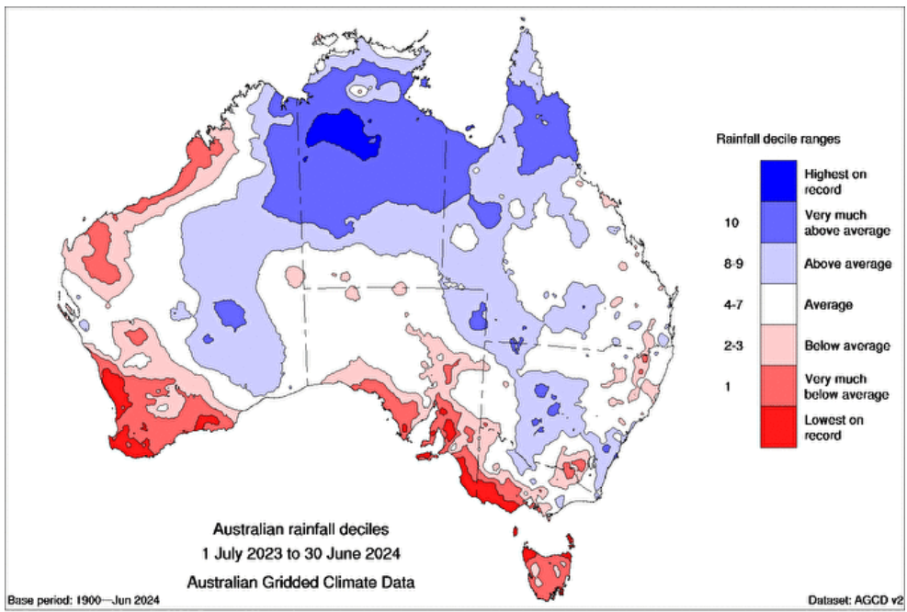Source: Bureau of Meteorology
The total surface water storage volume across Australia decreased from 78.0% to 73.6% of accessible capacity at the end of 2023–24. This was due to dry catchment conditions across much of southern parts of Australia. In northern Australia, rainfall that was above average to very much above average in early 2024 resulted in high soil moisture and inflows to Lake Argyle, the largest water supply storage in Australia. At the start of the financial year, the Lake Argyle storage volume was at full accessible capacity, which then declined to 85.4% in January.
In 2023–24, soil moisture in the root zone (the top 100 cm) was above average for much of northern Australia (Map 2). It was very much above average (in the highest 10% of all years since 1911–12) for most parts of the Northern Territory, and parts of northern Queensland and north-east Western Australia. This was largely due to above average rainfall across much of northern Australia during the wet season (October 2023 to April 2024). January was the tenth wettest on record since 1900 for northern Australia and March was the second wettest on record).
In contrast, soil moisture was below average to very much below average (in the lowest 10% of all years since 1911–12) for large parts of western and south-west of Western Australia, southern parts of South Australia, south-west of Victoria, Tasmania, and eastern New South Wales (Map 2). This was due to very much below average rainfall (in the lowest 10% of all years since 1900) from July to October 2023 across much of southern Australia, and again from February to June 2024. To learn more, see Financial year climate and water statement 2023–24.
Map 2 Root–zone soil moisture deciles, 2023–24
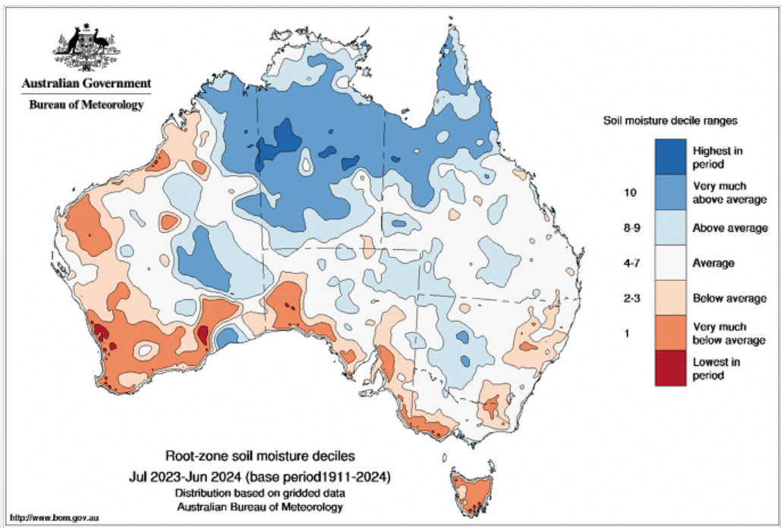 Source: Bureau of Meteorology
The financial performance of cropping farms across the 2023–24 financial year has seen an estimated decrease in the farm income due to lower grain prices and a reduction in winter crop production. On a national level, average farm cash income for specialist cropping farms is estimated to have decreased by 53% and mixed livestock-crop farms cash income was estimated to have decreased by 64%.
The financial performance of livestock farms across the 2023–24 financial year has seen an estimated decrease in farm income due to lower prices for beef cattle, sheep, lambs and wool. However, increased turnoff of cattle and sheep is expected to have moderated this decrease. At the national level, average farm cash income for specialist beef farms is estimated to have decreased by around 66% and specialist sheep farms estimated to have decreased by 25%. Learn more about Financial performance of livestock farms 2021–22 to 2023–24.

NDA Outcomes
The NDA 2018 to 2024 has 7 agreed outcomes. This annual report presents a national picture of how jurisdictions collectively progressed against these desired outcomes. The outcomes reported against were:
- Farming businesses have an improved capability to manage business risks and the tools to implement sustainable and resilient risk management practices.
- Farming businesses, industry service providers, agri-finance, community organisations and local government are partners of government and support rural communities to prepare for, and respond to, drought.
- Farming businesses, farming families and farming communities are supported in times of hardship and have an increased understanding of, and access to, available support.
- Roles and responsibilities of jurisdictions in responding to drought
  - are clear
  - promote consistency of drought policy and reform objectives
  - complement drought preparedness, response and recovery programs
  - reduce gaps and unnecessary duplication.
- Improved sharing, and quality, of common sources of data and information across jurisdictions to strengthen policy and business decision-making.
- Future programs related to the objectives of this agreement are consistent with the principles for reform at Attachment A of the NDA.
- Future programs providing temporary in-drought support are consistent with the principles and processes at Attachment B of the NDA.
All jurisdictions undertook activities to further drought resilience and preparedness in 2023–24 (Appendix A). This aligns with the NDA policy position to prioritise objectives and outcomes that enhance long-term preparedness, sustainability, resilience and risk management for farming businesses and farming communities. The NDA policy position is also reflected in the funding split between national drought preparedness and in–drought support measures (56% and 37% respectively). The remaining funding went to communities (see Table 4).

Figure 1 Farm Business Resilience planning participants Brasington Family, Queensland
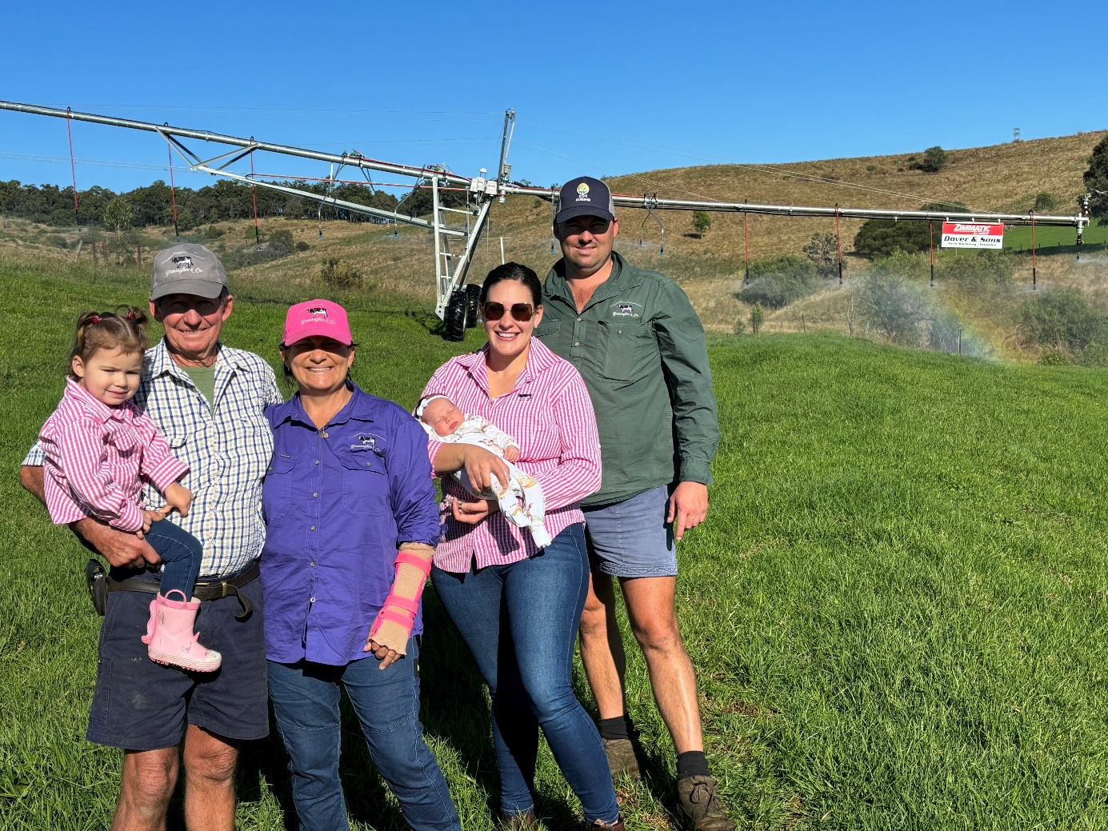
Photograph: © Roslyn D’Addona, Queensland Department of Primary Industries

Delivering on roles and responsibilities
The NDA outlines joint and individual responsibilities for all Australian governments. These responsibilities clarify the roles of government in relation to drought. This section of the report considers how the parties have met their roles and responsibilities under the NDA. Each party has self-assessed its progress, contributing to this collective view of overall national progress against each area of responsibility.
Table 1 Commonwealth responsibilities
Commonwealth responsibilities | Status
9a Funding and delivering a time-limited household support payment based on individual and farming family needs, including:  - reciprocal obligations that encourage resilience  - case management to support reciprocal obligation requirements. | On track
9b Establishing and operating a Future Drought Fund, to enhance drought preparedness and resilience. | On track
9c Providing continued access to incentives that support farming businesses’ risk management, including taxation concessions, the Farm Management Deposit Scheme and concessional loans. | On track
9d Improving and maintaining national, regional and local predictive and real-time drought indicator information, drawing on the Bureau of Meteorology’s observation network and forecasting. | Good progress
Note: On track - responsibilities have been fully met; Good progress - responsibilities have been met with a small amount of additional work required.
The Farm Household Allowance (FHA) assists farming families who are experiencing financial hardship. It continues to offer a package of assistance that drives financial self-reliance, resilience and structural change. The FHA made over $63.4 million in payments to over 5,600 recipients, providing around $5.3 million each month to rural communities in 2023–24.
Since 2020, the $5 billion Future Drought Fund (FDF) has provided secure, continuous funding for drought-resilience initiatives. The FDF’s next funding phase (2024 to 2028) and suite of programs were developed over this reporting period. Learn more about FDF programs.
The Australian Government also continued to provide incentives that help farming businesses manage risk. The Regional Investment Corporation (RIC) approved 196 concessional loans valued at $199.9 million in 2023–24. These included 31 farm business drought loans with a total value of $31.1 million.
At 30 June 2024, primary producers held a total of $7 billion across 44,877 accounts through the Farm Management Deposit (FMD) Scheme, which helps them manage fluctuations in cash flows, including during the dry conditions experienced in some states during 2023–24. A minor reduction in total FMD holdings was observed nationally over the financial year, with more significant drawdowns by broadacre cropping in Western Australia and sheep and beef enterprises in Western Australia and Tasmania.
The Australian Government progressed its work to make climate information more accessible for farmers, industries and communities. It continued to develop an Australian Agricultural Drought Indicators project (formerly the Drought Early Warning System project) and update the FDF’s $29.9 million My Climate View tool (formerly Climate Services for Agriculture).
Table 2 State and territory responsibilities
State and territory responsibilities | Status
10a Encouraging the delivery and uptake of capability-building programs to improve farming businesses’ skills and decision-making that are flexible and tailored to farming businesses’ needs. | On track
10b Ensuring animal welfare and land management issues are managed during drought. | On track
Note: On track - responsibilities have been fully met.
The responsibilities of the states and territories under the NDA were highlighted when conditions started to dry in some jurisdictions in 2023–24.
Jurisdictions focused more on encouraging the uptake of drought resilience programs and on available support in drying regions.
Jurisdictions provided funding and support for the implementation of broad-scale initiatives such as the Regional Drought Resilience Planning Program, Farm Business Resilience Program, Helping Regional Communities Prepare for Drought Initiative, and Drought Resilience Adoption and Innovation Hubs.
The NDA helped jurisdictions affected by dry conditions manage animal welfare and land management issues by clarifying their responsibilities. It supported the sharing of lessons learned from previous droughts and processes.
Table 3 Shared responsibilities
Shared responsibilities | Status
11a Developing, designing, implementing and funding drought preparedness, response and recovery programs that are consistent with the NDA, encourage robust risk management and seek to avoid market distortions. | On track
11b Developing capability-building programs, tools and technologies to inform and improve farming businesses’ decision-making and promote resilience. | On track
11c Provision of rural financial counselling services. | On track
11d Support to mitigate the effects of drought on the health and wellbeing of farming families and farming communities. | On track
11e Sharing, coordinating, collaborating and communicating information on drought preparedness, response and recovery policies and programs being developed and implemented. | Good progress
11f Ensuring information on assistance for drought preparedness, response and recovery is accessible and readily available. | Good progress
11g Ensuring consistency of drought policy and reform objectives and complementarity of drought preparedness, response and recovery programs. | Good progress
11h Contributing to the development of quality, publicly available data, including but not limited to:  - weather, seasonal and climate forecasts  - regional and local predictive real-time drought indicator information  - a consistent early warning system for drought  - an improved understanding of fodder crops and holdings across Australia | Good progress
Note: On track - responsibilities have been fully met; Good progress - responsibilities have been met with a small amount of additional work required.
All parties collaborated closely to draft the NDA 2024 to 2029. This approach reflected their positive working arrangements and collective intent to deliver programs and policies that are consistent with the NDA. It set jurisdictions up well to continue sharing, coordinating, collaborating and communicating drought information.
The NDA parties recognised the cumulative impact of other adverse events, such as flooding or fire, on the health and wellbeing of farming families and communities.
They continued to support rural financial counselling services throughout 2023–24.
A new Bureau of Meteorology weather radar in Toowoomba went live April 2024, providing improved access to real-time weather information.
Figure 2 A swollen Roe Creek reaches the road, Northern Territory
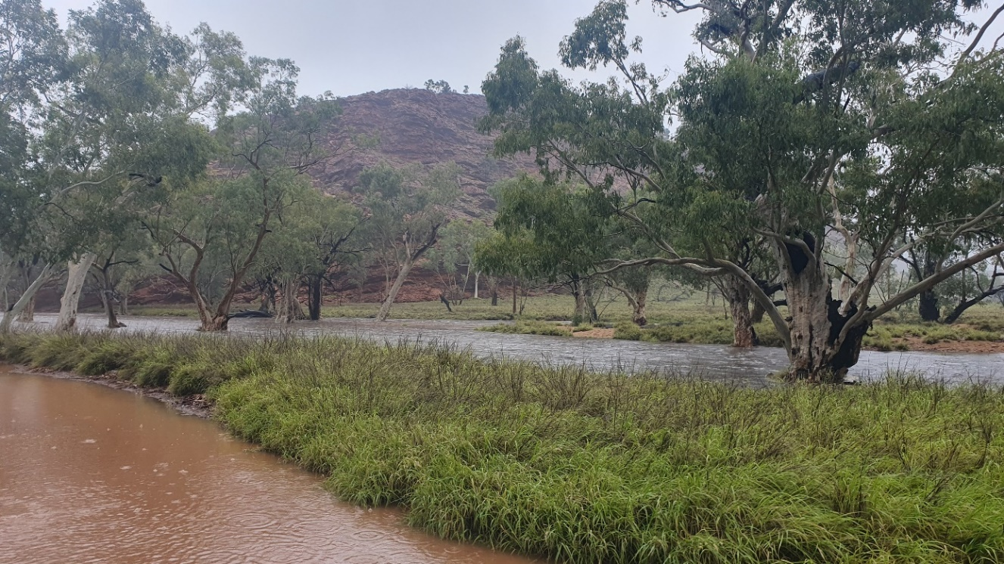
Photograph: © James Christian.

Investment
The investment reported in Table 4 includes funding committed since 2018, when all jurisdictions signed the NDA. It outlines the share of investment jurisdictions spent across the drought cycle.
Integrated investment occurs across the drought cycle, and the implications extend beyond the drought context. For example, programs targeted at improving resilience to drought often result in greater resilience to other climate hazards, which is particularly relevant in the context of an increasingly variable climate. Similarly, investing in mental health ensures communities can immediately access support. Through that support, those communities also become more resilient.
Table 4 Proportional investment across the drought cycle, 2018 to 30 June 2024
Jurisdiction | In-drought support (%) | Supporting communities (%) | Enhancing long-term resilience and preparedness (%)
Commonwealth | 46 | 6 | 48
New South Wales | 0 | 12 | 88
Victoria | 37 | 16 | 47
Queensland | 48 | 2 | 50
Western Australia | 5 | 0 | 95
South Australia | 0 | 11 | 89
Tasmania | 2 | 1 | 97
Northern Territory | 79 | 0 | 21
Australian Capital Territory | 8 | 30 | 62
All jurisdictions | 37 | 7 | 56
Note: Includes funding committed on active measures since jurisdictions signed the NDA in 2018, up to 30 June 2024. Due to rounding, the sum of individual numbers may not add up to 100%.
Source: NDA parties’ self-assessment data

Reviews and evaluations
Table 5 shows the reviews and evaluations into drought measures that parties have undertaken since they signed the NDA in 2018.
Table 5 Reviews of parties’ drought support measures
Measure | Responsible jurisdiction | Review date | Review and any government response
Future Drought Fund Act | Australian Government | 2023 | Productivity Commission Inquiry Report
Rural Financial Counselling Service | Australian Government | 2019 | Internal review of the 2016 to 2020 Rural Financial Counselling Service Program
Farm Household Allowance | Australian Government | September 2018 to February 2019 | - Farm Household Allowance review report  - Australian Government response
Drought Communities Programme Extension | Australian Government | January 2020 | Drought Communities Programme Extension review
Water for Fodder | Australian Government | April 2020 | Water for Fodder review
Review of Australian Government Drought Response | Australian Government | October 2020 | Review of Australian Government Drought Response
Farm Management Deposit Scheme | Australian Government | June 2021 | Farm Management Deposit Scheme: 2021 evaluation
Federal Government’s response to the drought, and the adequacy and appropriateness of policies and measures to support farmers, regional communities and the Australian economy | Australian Government | October 2021 | Federal Government’s response to the drought, and the adequacy and appropriateness of policies and measures to support farmers, regional communities and the Australian economy  Australian Government response
Agriculture Biodiversity Stewardship Pilots | Australian Government | 2022 | Review of the Agriculture Biodiversity Stewardship Pilots Report
Improving Great Artesian Basin Drought Resilience | Australian Government | – | Report due September 2024
Regional Investment Corporation Loans | Australian Government | 2024 | Review of the Operation of the Regional Investment Corporation Act 2018
NSW Strategic Drought Evaluation | New South Wales | 2018 to 2021 | Strategic Drought Evaluation Summary and Response 2022 Report
Future Ready Regions Update | New South Wales | 2023 | Not available
Drought Stimulus Package | New South Wales | 2021 | Process and interim outcomes evaluation of the Drought Stimulus Package
NSW Government Drought Relief Measures Evaluation | New South Wales | 2021 | NSW Government Drought Relief Measures Evaluation Report
NSW Emergency Drought Relief: Mental Health Support Package Final Evaluation Report | New South Wales | 2020 | The NSW Emergency Drought Relief: Mental Health Supports Package Final Evaluation Report
Farm Business Resilience Program | New South Wales | 2022 | FBRP Pilot Report
2017 to 2020 Water Drought Response Evaluation | New South Wales | 2021 to 2022 | Extreme Events Policy
Future Ready Regions Update: Enhanced Drought Information System Development | New South Wales | 2023 | Not available
Valley Drought Snapshots | New South Wales | 2021 | The 2017 to 2020 drought: Water
Review of the 2018 to 2020 Drought Relief Package | Victoria | 2018 to 2020 | Report due late 2024
Farm business skills and risk management programs | Victoria | – | Not available
Health and wellbeing programs | Victoria | – | Not available
Queensland Government Response Drought Program Review | Queensland | January 2019 | Queensland Drought Program Review
Drought and Climate Adaptation Program | Queensland | July 2020 | Drought and Climate Adaptation Program report
Evaluation of the Western Australian Drought Pilot Programs | Western Australia | June 2019 | Evaluation report of WA Drought Pilot Programs (PDF 1.7 MB)
Pest Animal Control – State Barrier Fence | Western Australia | 2019 | Pest Animal Control Site Barrier Fence update
Review of the Animal Welfare Act 2002 – Government response | Western Australia | June 2021 | Review of the Animal Welfare Act 2002 – Government response
State Barrier Fence Esperance Extension – Public Environmental Review | Western Australia | 2018 | State Barrier Fence Esperance Extension Public Environmental Review
Pipeline to Prosperity | Tasmania | 2018 | Final report on Tasmanian Irrigation
Financial literacy program | Northern Territory | – | –
Regional Drought Resilience Planning Program | Northern Territory | – | Not yet available
Farm Business Resilience Program | Northern Territory | – | Not yet available
On-Farm Emergency Water Infrastructure Rebate Scheme | Northern Territory | – | Not available
Animal Welfare and Land Management Agreements | Australian Capital Territory | June 2022 | Not yet available
Landholder Training and Capacity Building | Australian Capital Territory | – | Not yet available

Next steps

Future NDA priorities
Future reporting priorities have not been listed because this is the last reporting cycle under the NDA 2018 to 2024.

Jurisdictional activity

Australian Government
In late 2024, the Australian Government is expected to release the Australian Government Drought Plan. The Drought Plan will guide drought policy at the Australian Government level and explain how the government will deliver on its commitments under the NDA 2024 to 2029. The recommendations provided in the 2023 review of the Australian Government’s Drought Response, Resilience and Preparedness Plan have helped shape the new Drought Plan.
The Australian Agricultural Drought Indicators (AADI) project will help the Australian Government improve its understanding of how drought affects the agricultural sector. The AADI is being delivered by the Australian Bureau of Agricultural and Resource Economics and Sciences (ABARES) in partnership with CSIRO. It combines weather data and forecasts with agricultural modelling to indicate the impacts on pasture growth, crop yields, soil moisture and farm profits. However, this tool does not declare regions as being in drought or provide a trigger for the provision of support.
The Australian Government is implementing a drought response framework to support its own preparedness, planning and response. The framework will monitor drought conditions and impacts to support proactive decision-making. The framework will draw on the AADI and the Bureau of Meteorology’s weather information and forecasts. It will also seek regional and on-ground information from state and territory governments and other online and on-ground networks.
The Australian Government will continue its delivery of drought preparedness initiatives for farmers and regional communities through the FDF, having administered $110.4 million (GST exclusive) in the 2023–24 financial year.
On 7 May 2024, the Australian Government announced a new suite of FDF programs, allocating $519.1 million over the next 8 years. As per the NDA, the Australian Government will continue working with the state and territory governments on drought resilience and preparedness activities. The next reporting period will see continued co-design and implementation of programs, including the Farm Business Resilience Program, which has helped build the drought resilience of farmers like Victorian Ed Rickard (see Figure 3). The program helped Ed develop a better farm business plan, which identified his need for weather stations, soil moisture probes and implement a succession plan that ensure his farms long-term viability. The FBRP and Regional Drought Resilience Planning (RDRP) programs were extended to 2028–29. In addition, consultation will take place on the design and delivery of interconnected programs, including the Drought Resilience Adoption and Innovation Hubs and the FDF Communities program.
Figure 3 Victorian Farm Business Resilience Program participant, Ed Rickard
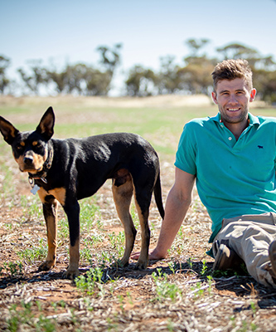
Photograph: © Kit Duncan-Jones, Agriculture Victoria.
The Australian Government will also consult with jurisdictions, where appropriate, on the development and implementation of other programs such as Long-term Trials, Resilient Landscapes, Scaling Success, Innovation Challenges Pilot, First Nations Pilot, First Nations Participation Activities, and National Enabling, which supports monitoring, evaluation and learning (including knowledge sharing).
The Australian Government is expected to release an FDF investment strategy in late 2024. It will help delivery partners understand the intended nature and timing of program design and delivery so they can participate in the activities of the FDF.
The national Climate Services for Agriculture program, funded by the FDF, provides a free online climate information platform called My Climate View. Delivered in partnership with CSIRO and the Bureau of Meteorology, the platform provides accessible climate information to help farming businesses and communities understand the implications of climate change. In May 2024, the Australian Government announced an additional $17.2 million for the Climate Services for Agriculture program and My Climate View platform. The platform will continue to be improved through co-design with end users and will explore opportunities to integrate new data sets and information where appropriate, including the Drought Resilience Self-Assessment Tool, ABARES financial forecast data and First Nations knowledge. Funding has been allocated until 2027–28.

New South Wales
The NSW Government has a strong and committed focus on drought resilience and preparedness, which included committing $250 million to establish the Drought Ready and Resilient Fund. This initiative is designed to bolster the resilience of NSW farmers to adverse weather events and climatic conditions such as drought. The Drought Infrastructure Fund, previously known as the Farm Innovation Fund, has been refocused to increase awareness and emphasise that the loans distributed by the fund can be used for drought preparedness and mitigation.
NSW was managing a succession of regional droughts at the start of 2023–24, which affected most coastal regions, stretching inland through the north-west of the state. The epicentre of the event was the Hunter region, which had experienced rapid drought onset in early 2023. Recovery from this event progressed into 2024. Drought conditions started to build in the south of the state in early 2024, particularly in the eastern Riverina, and have continued to persist.
The NSW Government monitors seasonal conditions and provides all stakeholders access to the Enhanced Drought Information System and the Combined Drought Indicator, supporting high levels of drought awareness and preparedness. Work programs have delivered significant improvements in:
- local and regional accuracy of climate data
- expansion in the range of indices
- capability to forecast drought
- the range of outreach and data products.
Under the NSW Climate Change for Primary Industries Climate Change Research Strategy, high quality forward projections of drought risk over the next century were also produced for the state and released in 2023–24. The Farm Business Resilience Program (FBRP) will continue to build the strategic management capacity of farmers, farm managers and employees to prepare for and manage risk, adapt to a changing climate and improve their farm business’s economic, environmental and social resilience. The 2024–25 financial year is the last year of the 3-year FBRP extension (2022 to 2025). The priorities for the final year are to meet key deliverables for the Project Implementation Plan. The NSW Government has begun co-design workshops for the next round of the program (2025 to 2029).
The NSW Government has several programs and policy initiatives underway to support and develop resilience in primary production and to prepare for drought. Rounds 1 and 2 of the RDRP program are underway in parts of NSW to ensure more regional communities are supported to manage future drought risks. A co-design process for the next phase of the RDRP program is also underway.
The NSW Government will continue to implement a comprehensive range of programs and policy initiatives in 2024–25 and beyond, to support and develop resilience in primary production and improve water security across regional NSW. The Farms of the Future program will continue to deliver education activities, agtech demonstrations, planning guidance and decision-making tools to accelerate the rate of agtech adoption on-farm to boost productivity. The program will increase competitiveness and improve the sustainable use of resources (water efficiency, drought preparedness and increasing resilience to climate change).

Victoria
The Victorian Government is committed to supporting farmers, agricultural industries and communities across the state with long-term, place-based, approaches to build drought resilience and preparedness through a variety of programs and initiatives. The Future Drought Fund’s Regional Drought Resilience Planning and Farm Business Resilience programs are key to this, as well as the ongoing partnership with the Victorian Drought Resilience Adoption and Innovation Hub.
The Victorian Government will continue to work with farm businesses and communities to improve risk management, support the adoption of climate and drought resilient farming management practices and technologies, upskill young farmers, and improve the cultural safety of First Peoples in agriculture industries.
Promoting social connectedness and wellbeing for farming communities through health and wellbeing checks for farmers and ensuring access the Rural Financial Counselling Service are also key to Victoria’s drought resilience commitments.
Figure 4 Apricot Farm in Shepparton, Northern Victoria
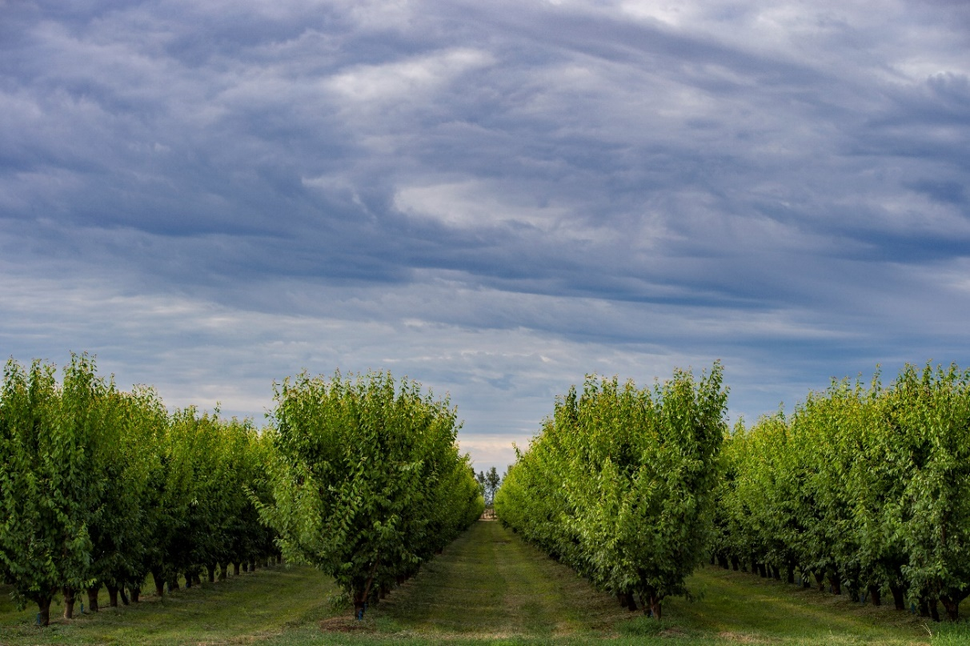
Photograph: © Agriculture Victoria.
The Victorian Government will play an important role in providing accessible and up-to-date information and forecasts to support farmers for the seasons ahead. Farmers will continue to receive information about soil moisture tools and monitoring, farm economic analysis and benchmarking, risk mapping and monitoring, and seasonal forecasts.

Queensland
The Queensland Government has made significant investments through the Drought and Climate Adaptation Program since 2016, the program aims to help producers better manage drought and climate impacts. The best climate scientists, government and non-government agencies, producers and industry leaders are working together on a number of cutting-edge research projects and partnerships.
Queensland is also co-investing in Future Drought Fund programs such as the Farm Business Resilience Program and Regional Drought Resilience Program as well as partnerships in Drought Resilience and Innovation Hubs located in Queensland.
In line with national drought policy principles, the main drought measures available to Queensland primary producers to support drought preparedness such as the Drought Preparedness Grant and the Drought Ready and Recovery Loan Scheme which are not contingent on being drought declared. Over 500 producers have been assisted under these new programs that opened in 2021-22.

Western Australia
The WA Government continues to support emission reduction across a range of sectors, including agriculture, heavy industry and transport, identifying further opportunities for carbon sequestration and carbon farming. WA will continue its investment and involvement as a partner in 2 Drought Resilience Adoption and Innovation Hubs – South-West WA, and Northern WA and NT – and is working towards delivering the FBR and RDRP programs.
The WA Agriculture Climate Resilience Fund will see continued investment in natural resource accounting, carbon farming and soil health to support farmers to develop resilience to climatic changes and changing market expectations. This investment is in parallel to the WA Government’s Climate Policy and Climate Adaptation Strategy, which is delivering priority actions to ensure our communities and economy are resilient to risks posed by climate change.

South Australia
The SA Government is continuing to monitor the dry seasonal conditions across the state and has established governance structures to ensure support provided is coordinated with our industry stakeholders.
The SA Government is committed to supporting farmers and communities across the state to prepare for drought and build long term resilience to climate risks.
One way we are doing this is continuing the delivery of FDF programs such as the FBR and RDRP programs. The SA Government will also continue its investment and involvement as a partner in the South Australian Drought Resilience Adoption and Innovation Hub.

Tasmania
In 2024–25, the Tasmanian Government will work towards successfully delivering the FBR and RDRP programs.
The current dry and drought conditionsFigure 5 Dry conditions on King Island, Tasmania impacting many Tasmanian regions since early 2024 have created an opportunity to identify and bring together capability in government, organisations such as the TAS Farm Innovation Hub, industry, rural support organisations and business to better respond to the current challenge and improve drought preparedness.
The value of the combined Australian and state government investment into strategic Tasmanian irrigation schemes, combined with agricultural research development and extension investments, has been justified. Irrigated agriculture underpinned the 2023–24 season and managed climate risks for many agricultural sectors and producers. The Tasmanian Government is focused on continuing with the proposed new schemes under Tranche Three of the Irrigation Scheme development.
Figure 5 Dry conditions on King Island, Tasmania
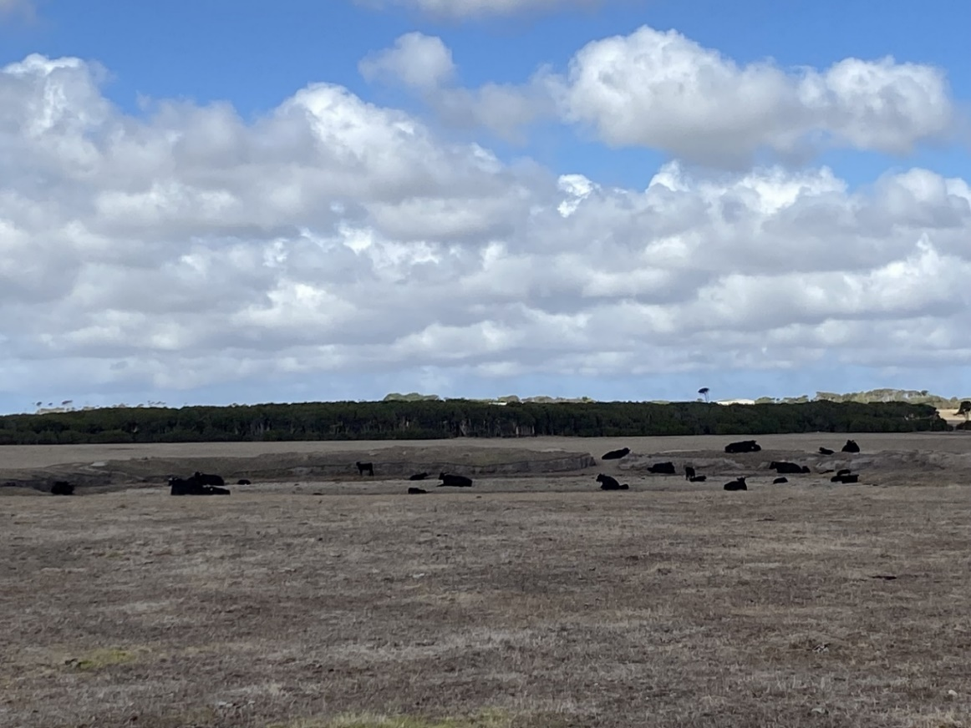
Photograph: © Laura Richardson, Department of Natural Resources and Environment, Tasmania.

Australian Capital Territory
The ACT Government is in the process of adopting and implementing the ACT Regional Drought Resilience Plan and partnering to implement the National Soil Action Plan 2023 to 2028.
The ACT Government continues to work towards drought resilience through the FBR and RDRP programs and aims to improve drought mitigation through farm diversification.

Northern Territory
The NT Government aims to help drive growth, diversity and resilience in the agribusiness sector with the implementation of a new economic agenda. The NT Government seeks to continue increasing the diversity of business undertaken on the agricultural land. There is potential for pastoralism, horticulture, forestry, aquaculture, tourism and many other business streams to be interwoven or vertically integrated, to build drought resilience among rural businesses and communities.
The NT Government continues to encourage businesses to make decisions that are informed by data analysis. It is also focused on the NT biosecurity regulatory environment to ensure a practical and robust framework that protects its flora and fauna and agricultural trade.
Figure 6 Cattle at a water trough, Northern Territory
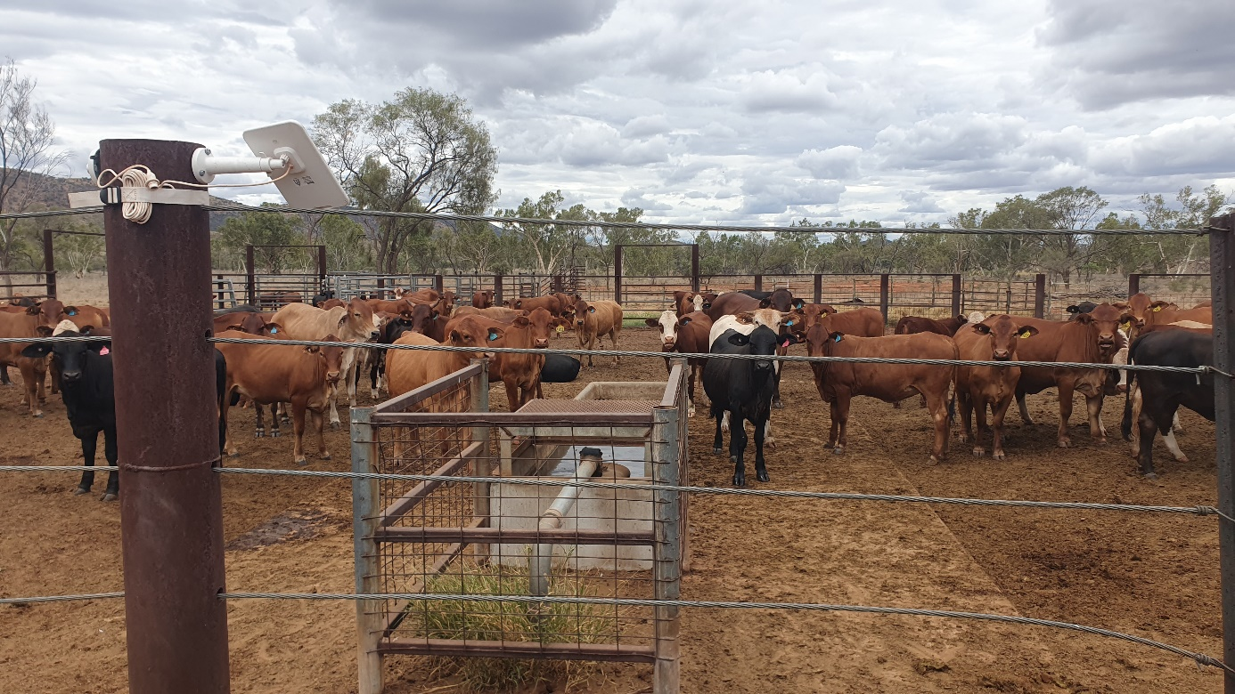
Photograph: © James Christian.

Appendix A: 2023–24 jurisdictional measures
Table A1 NDA roles and responsibilities met by each measure, by jurisdiction
Jurisdiction | Measure | NDA roles and responsibilities met
Commonwealth | Farm Household Allowance | 9a, 11a, 11b, 11d
Commonwealth | Future Drought Fund | 9b, 11a, 11b, 11d, 11e
Commonwealth | Regional Investment Corporation loans ª | 9c, 11d
Commonwealth | Rural Financial Counselling Service ª | 9c, 11c
Commonwealth | Drought Community Outreach Program | 11e, 11f
Commonwealth | Recovery Support Officer Network ª | 11g
Commonwealth | FarmHub ª | 11e, 11f
Commonwealth | Improving Great Artesian Basin Drought Resilience | 11a
Commonwealth | On-farm Emergency Water Infrastructure Rebate Scheme | 11a
Commonwealth | Mental Health and Wellbeing Support ª | 11d
Commonwealth | Communities Combating Pest and Weed Impacts During Drought Program | 11a
Commonwealth | Farm Management Deposit Scheme ª | 9c, 11a, 11b
Commonwealth | Drought Communities Programme Extension | 11a, 11d
Commonwealth | Drought Communities Programme Extension – Roads to Recovery | 11a, 11d
Commonwealth | Building Better Regions Fund Round 4 | 11d
Commonwealth | Tackling Tough Times Together | 11d
Commonwealth | National Water Grid Fund & National Water Grid Authority ª | 11a, 11d
Commonwealth | Climate-Smart Agriculture Program ª | 11a, 11b
Commonwealth | Agriculture Stewardship Package ª | 11a, 11b
Commonwealth | Emissions Reduction Fund ª | 11a, 11b
Commonwealth | National Soil Strategy and National Soil Action Plan ª | 11a, 11b
NSW | Future Ready Regions | 10a, 11a, 11b, 11f, 11h
NSW | Drought Infrastructure Fund | 11a, 11b
NSW | Doppler radars and BoM ª | 11a, 11b, 11h
NSW | Safe and Secure Water Program | 11d, 11g
NSW | Drought Staffing Entitlement Maintenance | 10a
NSW | Threatened Species Husbandry | 10b, 11a
NSW | Emergency water carting | 11d, 11g
NSW | Improving the Great Artesian Basin Drought Resilience | 11d
NSW | Belubula Water Security Project | 11d
NSW | Macquarie-Wambuul Water Security Project | 11d
NSW | Water Infrastructure projects ª | 11d, 11g
NSW | Drought Ready Resilience Fund | 11a, 11b
NSW | Nyngan to Cobar Pipeline | 11d
NSW | Lostock Dam to Glennies Creek Dam Pipeline | 11d
NSW | Wilcannia Wier Replacement Project | 11d
NSW/Commonwealth | Future Drought Fund: Southern Qld and Northern NSW Drought Resilience Adoption and Innovation Hubs | 10a, 11a, 11b, 11d, 11e
NSW/Commonwealth | Future Drought Fund: Southern NSW Drought Resilience Adoption and Innovation Hubs | 10a, 11a, 11b, 11d, 11e
NSW/Commonwealth | Future Drought Fund: Regional Drought Resilience Planning Program | 10a, 11a, 11b, 11d
NSW/Commonwealth | Future Drought Fund: Farm Business Resilience Program | 10a, 11a, 11b, 11d
NSW/Commonwealth | Rural Financial Counselling Service ª | 11c
Vic. | Drought response, recovery and preparedness programs | 10b, 11g, 11d
Vic. | Farm business skills and risk management programs ª | 10a, 11a, 11b
Vic. | Information and forecasting programs ª | 11e, 11f, 11h
Vic. | Health and wellbeing programs ª | 11d
Vic./Commonwealth | Rural Financial Counselling Service ª | 11c
Vic./Commonwealth | Future Drought Fund: Regional Drought Resilience Planning Program | 10a, 11a, 11b, 11d
Vic./Commonwealth | Future Drought Fund: Farm Business Resilience Program | 10a, 11a, 11b, 11d
Vic./Commonwealth | Future Drought Fund: Victorian Drought Resilience Adoption and Innovation Hub | 10a, 11a, 11b, 11d, 11e
Qld | Drought and Climate Adaptation Program ª | 10a, 11a, 11b, 11e, 11f, 11h
Qld | Drought Relief Assistance Scheme | 10b
Qld | Drought Preparedness Grants | 11a
Qld | Farm Management Grants | 11a
Qld | Drought Ready and Recovery Loans Scheme | 11a
Qld | Drought Carry-on Finance Loan Scheme | 11a
Qld | Emergency Drought Assistance Loan Scheme | 11a
Qld/Commonwealth | Rural Financial Counselling Service ª | 11c
Qld/Commonwealth | Future Drought Fund: Regional Drought Resilience Planning Program | 10a, 11a, 11b, 11d
Qld/Commonwealth | Future Drought Fund: Farm Business Resilience Program | 10a, 11a, 11b, 11d
WA | State Natural Resource Management Program: Community Stewardship Grants | 10a, 11a, 11b, 11h
WA | Grants for Biosecurity Groups | 10b
WA | Grower Group Alliance | 10a
WA | Southern Rangelands Restoration Project ª | 10a, 10b, 11a, 11b, 11d
WA | Southern Rangelands Restoration Project: Drought Resilient Soils and Landscapes | 10a, 10b, 11a, 11b, 11d
WA | WaterSmart Farms Project ª | 10a, 10b, 11a, 11b, 11d
WA | WaterSmart Farms: Making Dams Work Again ª | 10a, 10b, 11a, 11b, 11d
WA | Horticulture Business Capacity Building Program ª | 10a, 10b, 11a, 11b
WA | Western Australia Agricultural Research Collaboration ª | 10a, 10b, 11a, 11b, 11h
WA | Western Australian Agriculture Climate Resilience Fund ª | 11a, 11b, 11e, 11f, 11g, 11h
WA | Soils Systems Master Class ª | 10a, 10b, 11a, 11b
WA | Carbon Farming and Land Restoration Program ª | 10b, 11a, 11b, 11e, 11h
WA | Rural Business Development Corporation: Farm Debt Mediation Scheme ª | 11c
WA | DPIRD Regional Intelligence and Adoption Team ª | 10a, 10b
WA | Western Farming Systems ª | 11a, 11b, 11e, 11f, 11g
WA | Wild Dog Action Plan 2021–2025 ª | 10b
WA | Wild Dog Action Plan: State Barrier Fence Wild Dog Control ª | 10b
WA | Wild Dog Action Plan: Research and Development Fund ª | 10b, 11b
WA | Animal Welfare ª | 10b
WA | Animal Welfare Grant Programs ª | 10b
WA | Animal Welfare in Emergencies Grant Program – Local Government ª | 10b
WA | Making Every Drop Count – Below and Above Ground Targeted Soil Moisture Conservation from Paddock to Landscape ª | 10a, 10b, 11a, 11b, 11d
WA | Soil and Land Conservation Council ª | 10b
WA | Soil re-engineering project ª | 11b
WA | Grains Science Partnerships ª | 11b
WA | InterGrain Pty Ltd Majority Shareholding ª | 11a
WA | Australian Export Grains Innovation Centre membership ª | 11h
WA | WA SheepLinks Program ª | 10b, 11a, 11b, 11e
WA | WA SheepLinks Program: Future Sheep | 10b, 11a, 11b, 11e
WA | WA SheepLinks Program: Feed365 | 10b, 11a, 11b, 11e
WA | Katanning Research Station ª | 10b, 11a, 11b, 11e
WA | Katanning Research Station Demonstration Site ª | 10b
WA | Operation of Web Application Portal Interface ª | 11h
WA | Operation of Weather Stations & Doppler Radar ª | 10b, 11b, 11h
WA | Regional Telecommunications Resilience: Mobile Network Hardening Program ª | 10b, 11b, 11h
WA | WA Regional Digital Connectivity Program ª | 10b, 11b, 11h
WA | Digital Farm Grants & Regional Telecommunication Project ª | 11b, 11d, 11f, 11h
WA | Pastures from Space service ª | 10b, 11b, 11h
WA | Digital Tools, Mapping and Apps ª | 11e, 11f, 11h
WA | Mosaic Agriculture ª | 10b, 11b
WA | Aboriginal Corporate Governance Development (ACGD) Grant ª | 10a, 11b
WA | Land Enterprise Support – Native Grains Trial ª | 10a, 11b
WA | Bushfoods Guide and Indigenous Ecological Knowledge ª | 10a, 11b
WA | Climate Dashboard ª | 11b, 11d, 11f, 11h
WA | Cropping after paddock fires ª | 11a, 11e, 11f
WA | Bushfire Recovery Support and Coordinator ª | 11a, 11b, 11d, 11e, 11f, 11h
WA | District Recovery Co-ordinator ª | 11a, 11e, 11f
WA | Regional Snapshots ª | 10a, 11a, 11b, 11h
WA | Pirra Jungku: Contemporary and traditional fire management ª | 10b
WA | Water carting ª | 10b, 11d, 11g
WA | Regional Climate Alliance pilot program ª | 10a, 11a, 11b, 11h
WA | Community town dam project ª | 10a, 11a, 11b, 11h
WA | Community Water Supplies Partnership Program – non potable | 10b, 11d
WA | Climate Science Initiative ª | 10a, 11a, 11b
WA | Climate Action ª | 10a, 11a, 11b
WA | WA Government Drought Support Package | 10b, 11c, 11d, 11f
WA/Commonwealth | Future Drought Fund: Southwest WA Drought Resilience Adoption and Innovation Hub | 10a, 11a, 11b, 11d, 11e, 11f
WA/Commonwealth | Future Drought Fund: Northern WA & NT Drought Resilience Adoption and Innovation Hub | 10a, 11a, 11b, 11d, 11e, 11f
WA/Commonwealth | Future Drought Fund: Farm Business Resilience Program | 10a, 11a, 11b, 11d
WA/Commonwealth | Future Drought Fund: Regional Drought Resilience Planning | 10a, 11a, 11b, 11d
WA/Commonwealth | On-farm Emergency Water Infrastructure Rebate Scheme ª | 10b, 11a
WA/Commonwealth | Rural Financial Counselling Service ª | 11c
SA | Family and Business Support Program (FaBS) ª | 10a, 11a, 11c, 11d
SA | Wild Dog Management Programs ª | 10b
SA | Animal Health Officers ª | 10b
SA | Rebuilding the Dog Fence in South Australia ª | 10b
SA | Fox Bounty ª | 10b
SA | Animal Welfare Legislation and Policy Framework ª | 10b
SA | SA Red Meat Industry Support | 11e, 11f
SA | Growing Carbon Farming Demonstration pilot ª | 10a, 11h
SA/Commonwealth | Future Drought Fund: Farm Business Resilience Program | 10a, 11a, 11b, 11d
SA/Commonwealth | Future Drought Fund: Drought Resilience Adoption and Innovation Hub (state contribution) | 10a, 11a, 11b, 11d, 11e 11f
SA/Commonwealth | Future Drought Fund: Regional Drought Resilience Planning | 10a, 11a, 11b, 11d
SA/Commonwealth | On-farm Emergency Water Infrastructure Rebate Scheme ª | 10b, 11a
SA/Commonwealth | Rural Financial Counselling Service ª | 11c
Tas | Rural Water Use Strategy ª | 11a
Tas | Rural Alive and Well ª | 11d
Tas | King Island Drought Coordinator and Fodder Hub | 11d, 11e, 11f
Tas | Rural Relief Fund | 11d
Tas | Seasonal Conditions Scheme – King and Flinders Islands | 11b, 11d
Tas | Seasonal Conditions Scheme – Mainland Tasmania | 11b, 11d
Tas/Commonwealth | Rural Financial Counselling Service ª | 11c
Tas/Commonwealth | Future Drought Fund: Regional Drought Resilience Planning Program | 10a, 11a, 11b, 11d
Tas/Commonwealth | Future Drought Fund: Farm Business Resilience Program | 10a, 11a, 11b, 11d
Tas/Commonwealth | Future Drought Fund: Drought Resilience Grant – Tas Farm Innovation Hub | 10a, 11a, 11b, 11d, 11e 11f
Tas/Commonwealth | Pipeline to Prosperity – Tasmanian Irrigation Program | 11b
NT | Financial Literacy Program ª | 10a, 11b
NT | Pastoral Feed Outlook ª | 10a, 10b, 11a, 11b, 11h
NT/Commonwealth | On-farm Emergency Water Infrastructure Rebate Scheme | 10b, 11a, 11d
NT/Commonwealth | Future Drought Fund: Regional Drought Resilience Planning Program | 10a, 11a, 11b, 11d
NT/Commonwealth | Future Drought Fund: Farm Business Resilience Program | 10a, 11a, 11b, 11d
NT/Commonwealth | Future Drought Fund Northern WA/NT Drought Hub | 10a, 11a, 11b, 11d, 11e , 11f,
NT/Commonwealth | Rural Financial Counselling Service ª | 11c
ACT | Community engagement and communication | 10a,11a, 11b, 11c, 11d. 11e
ACT | Briefing sessions of ACT Government officials and ministers across departments | 11a, 11e
ACT | Dam Enhancement Project | 10a, 10b
ACT | Dung beetle project | 10a, 10b
ACT | Healthy Waterways – Gudgenby Project & Naas River Restoration Project | 10a
ACT/Commonwealth | Future Drought Fund: Regional Drought Resilience Planning Program | 10a, 11a, 11b, 11d
ACT/Commonwealth | On-farm Emergency Water Infrastructure Rebate Scheme | 10b, 11a
a Measure supports agricultural resilience and productivity but is not drought specific.

