Review of the National Drought Agreement
Parties to the National Drought Agreement
© Commonwealth of Australia 2022
Ownership of intellectual property rights
Unless otherwise noted, copyright (and any other intellectual property rights) in this publication is owned by the Commonwealth of Australia (referred to as the Commonwealth).
Creative Commons licence
All material in this publication is licensed under a Creative Commons Attribution 4.0 International Licence except content supplied by third parties, logos and the Commonwealth Coat of Arms.
Inquiries about the licence and any use of this document should be emailed to copyright@agriculture.gov.au.

Cataloguing data
This publication (and any material sourced from it) should be attributed as: Parties to the National Drought Agreement 2022, Review of the National Drought Agreement, Department of Agriculture, Fisheries and Forestry, Canberra, December. CC BY 4.0.
This publication is available at agriculture.gov.au/agriculture-land/farm-food-drought/drought/drought-policy/national-drought-agreement
Department of Agriculture, Fisheries and Forestry
GPO Box 858 Canberra ACT 2601
Telephone 1800 900 090
Web agriculture.gov.au
Disclaimer
The Australian Government acting through the Department of Agriculture, Fisheries and Forestry has exercised due care and skill in preparing and compiling the information and data in this publication. Notwithstanding, the Department of Agriculture, Fisheries and Forestry, its employees and advisers disclaim all liability, including liability for negligence and for any loss, damage, injury, expense or cost incurred by any person as a result of accessing, using or relying on any of the information or data in this publication to the maximum extent permitted by law.
Acknowledgement of Country
We acknowledge the Traditional Custodians of Australia and their continuing connection to land and sea, waters, environment and community. We pay our respects to the Traditional Custodians of the lands we live and work on, their culture, and their Elders past and present.

Contents
Summary 1
Terms of reference 4
Purpose 4
Scope 4
Governance 4
Methodology 6
The review process 6
Feedback and analysis 8
Recommendations 10
Key issue 1: Purpose of the National Drought Agreement 10
Key issue 2: Beneficiaries of the National Drought Agreement 10
Key issue 3: Policy underpinnings of the National Drought Agreement 10
Key issue 4: Coordination and collaboration 11
Key issue 5: Roles and responsibilities 12
Key issue 6: Drought impacts beyond the farm gate 13
Key issue 7: Non-party stakeholders 13
Key issue 8: First Nations people 14
Key issue 9: Intersecting policy areas 14
Key issue 10: Principles 15
Key issue 11: Monitoring, evaluation, learning and reporting 16
Key issue 12: Readability 17
Summary of key issues and recommendations 18

Tables
Table 1 Key issues and recommendations 18

Figures
Figure 1 Progression of Australian drought policy 2
Figure 2 Timeline 7
Figure 3 Relative frequency of key themes mentioned in responses to the review 8

Summary
Australia is the driest inhabited continent in the world and drought is a recurring feature of Australia’s climate. Australian farmers are some of the best in the world in innovation and adaption, and are getting better at handling dry conditions. There is already evidence of strong farm adaptation responses to climate change with improvements in technology and management practices helping to increase farm productivity. However, with drought events expected to become more frequent, widespread, prolonged and severe in many regions as a result of climate change, unique challenges will arise for farming businesses and communities no matter how resilient and prepared they are.
We need a shared effort to ensure we are better placed come the next drought. Farm businesses have a responsibility to prepare for, manage through, and recover from drought by taking active steps to build resilience to, and manage farm-level risks associated with, drought.
Governments must also be prepared. The shared approach to drought policy by the Australian Government and state and territory governments dates back to the early 1990s, and continues to evolve over time. Successive drought policies and intergovernmental agreements have increasingly emphasised long-term preparedness, sustainability, resilience and risk management. This approach is consistent with agriculture industry and business expectations about the respective roles of the farming sector and government.
The significant effort that has been invested over decades to improve drought policy speaks to the inherent complexities that need to be navigated. Drought is relatively common in Australia, but every drought is different and there are significant regional variations in how it is experienced. While it is inextricably linked to climate variability and climate change, it remains a discrete challenge requiring a dedicated intergovernmental response that is fit for purpose.
Figure 1 Progression of Australian drought policy
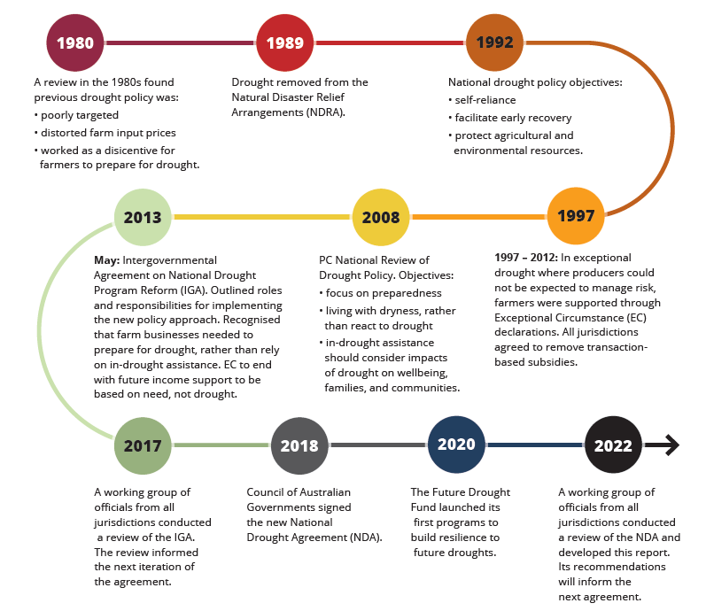
The National Drought Agreement (NDA) is the current intergovernmental agreement that guides our drought efforts, signed by first ministers from the Australian Government, states and territories (the parties). It provides an overarching framework to facilitate complementary drought policy and programs across the country. It describes the roles and responsibilities that the different parties have, and outlines policy principles agreed by all jurisdictions.
The NDA includes a requirement for it to be reviewed at least 2 years before its expiry on 30 June 2024. The review process commenced in February 2022 and focused on how the NDA can be strengthened to ensure that farm businesses, farming families and farming communities across the country are appropriately supported in advance of, during, and post drought events. The review has culminated in this final report and the recommendations that will inform the development of a new agreement in 2023.
The review has made 33 recommendations across 12 key issues that were explored through the review.
Some recommendations are on the importance of facilitating increased intergovernmental collaboration across the drought cycle. A gap exists in systemic mechanisms to support sustained communication and collaboration around drought investments, and to ensure an intergovernmental ‘no surprises approach’ to drought policy and program development. The lack of specific mechanisms for coordination under the NDA was most acutely felt at the time of the last major drought when a sudden proliferation of drought responses resulted in confusion on the ground. This gap has also become noticeable with increasing collaboration on drought preparedness activity such as the Future Drought Fund. It is important that this gap is addressed as an immediate priority.
There are also a number of recommendations that seek to better capture the broader context in which drought is being experienced and ensure that the next agreement is appropriately framed within this context. These include:
- explaining how drought relates to intersecting policy priorities such as climate and water
- providing better clarity of roles and responsibilities for parties and non-party actors
- embedding greater awareness that drought is just one of many challenges that farmers face and that their experience as end-users of drought related programs and activities is important
- more strongly recognising that the impacts of drought – economic, social, and environmental – extend well past the farm gate.
Finally, the report includes recommendations to make monitoring, evaluation, learning and reporting under the NDA more meaningful. There are opportunities to better understand what is and isn’t working, and to share those lessons for continuous improvement of our shared efforts. These recommendations are important if we are to support the best possible outcomes for Australian farmers and their communities.

Terms of reference
The terms of reference for the review were agreed by agriculture ministers on 4 February 2022 through the National Drought Agreement Review Framework and are summarised in this section.

Purpose
The review will make recommendations to the NDA parties to:
- improve the objectives and intended outcomes of the NDA, to best support the intent of the agreement
- optimise the structure and content of the NDA to enable its objectives
- ensure the NDA considers not just ‘what’ governments work together on, but ‘how’ they work together – and with local governments and non-government actors – to realise the outcomes of the agreement
- ensure that the shared responsibilities of the Australian Government and state and territory governments are adequately captured within the agreement, and that these are considered in the broader context of responsibilities shared with local governments and non-government actors
- strengthen the NDA’s provisions for reporting and evaluation to better inform continuous improvement of collective effort.

Scope
The review will consider:
- all parts of the NDA, and whether any changes to the text of the NDA are required
- the supporting attachments to the NDA (‘Attachment A: Principles for reform’ and ‘Attachment B: Principles and processes for in-drought support’)
- the NDA reporting, to ensure that the reporting framework can be updated in parallel with the NDA itself
- assessment outcomes from the annual NDA reporting process to identify lessons learned and gaps and ensure these are captured in the next iteration of the NDA.
The review will not consider:
- evaluation of individual government drought measures
- evaluation of the collective impact or efficacy of government drought measures
- the degree to which the NDA has met its specified objectives and outcomes, which is already reported on through the annual NDA reporting process.

Governance
The review has been carried out by the NDA Review Project Board, comprised of a nominated representative from each NDA party.
The project board has worked in consultation with the Agriculture Ministers’ Meeting Working Group on Drought, comprised of representatives from the Australian Government, states and territories, the National Farmers’ Federation, the Australian Local Government Association and the Australian Banking Association.
The project board has been supported by a secretariat resourced by the Australian Government.
The review report has been endorsed by the Agriculture Senior Officials Committee (AGSOC) and approved by the Agriculture Ministers’ Meeting (AMM).
Full detail of the roles and responsibilities of each of these groups as it relates to the NDA review is detailed in the NDA Review Framework.

Methodology

The review process
From the outset, the project board was mindful of drawing on the lessons learned from implementing the NDA. It sought views and priorities from the AMM Working Group on Drought, considered feedback received from various stakeholders over recent years, and drew directly on reflections and insights from the National Drought Summit in Moree in December 2019 and the National Drought Forum in Toowoomba in June 2021. These inputs were critical in identifying issues to be explored through the NDA review.
In the early stages of the review, the review secretariat commissioned an independent National Drought Agreement technical assessment report to inform thinking about potential areas for improvement. The technical review did not consider the policy settings behind the NDA. Rather, it looked at options to optimise the structure of the agreement, how it compared to other intergovernmental agreements, and whether there were elements that were missing or could be improved.
The technical review was packaged with a summary of the existing issues that had been collated by the project board. Together they formed the basis for public consultation during the review (see National Drought Agreement review public consultation summary).
Public consultation was open from April to June 2022. Any person or group who wished to make a written submission were able to do so. Submissions were received from some individuals, as well as a number of organisations.
During the public consultation period, targeted discussions were also held with a wide range of stakeholders identified by the project board as having a vested interest in drought. These stakeholders included representatives from the agricultural and financial industries, local government, research bodies, and the not-for-profit sector.
The findings from the consultation process were considered by the project board.
The AMM Working Group on Drought were consulted at key points throughout the process to test the project board’s thinking and ensure that the review comprehensively considered and represented stakeholder interests.
The report has been approved by agriculture ministers from the Australian Government and state and territory governments.
This review has found that there is an enduring need and universal support for an interjurisdictional agreement focused on drought. The recommendations will be used to inform the development of the next agreement. Parties will negotiate text for the new agreement from January 2023 and there will be further opportunities for public consultation and feedback.
Figure 2 Timeline
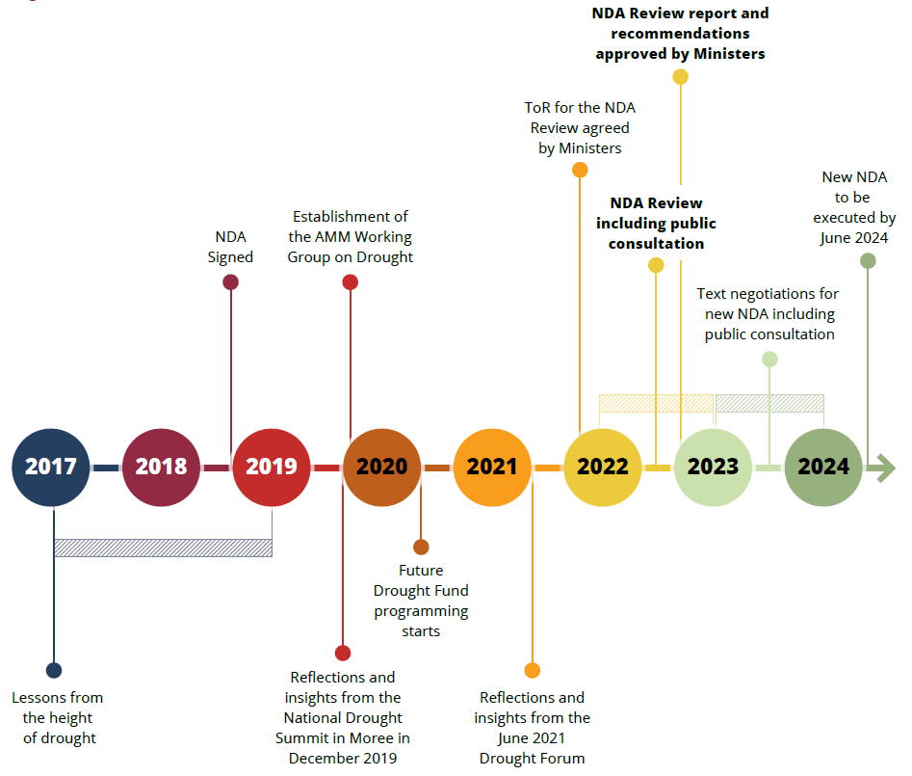
AMM Agriculture Ministers’ Meeting. NDA National Drought Agreement.

Feedback and analysis
The NDA review consultation included discussions with 30 non-party stakeholders, including AMM Working Group on Drought members, as well as other key stakeholders in the farming, charity, and financial sectors. Consultation also included a Have Your Say feedback process, which was opened to the public.
The consultation process found that there was strong support for the themes identified in the technical review and summary of issues collated by the project board. However, some of these issues were viewed by stakeholders as more important than others. All stakeholders were invited to raise any other issues they felt should be included as part of the review.
Figure 3 Relative frequency of key themes mentioned in responses to the review
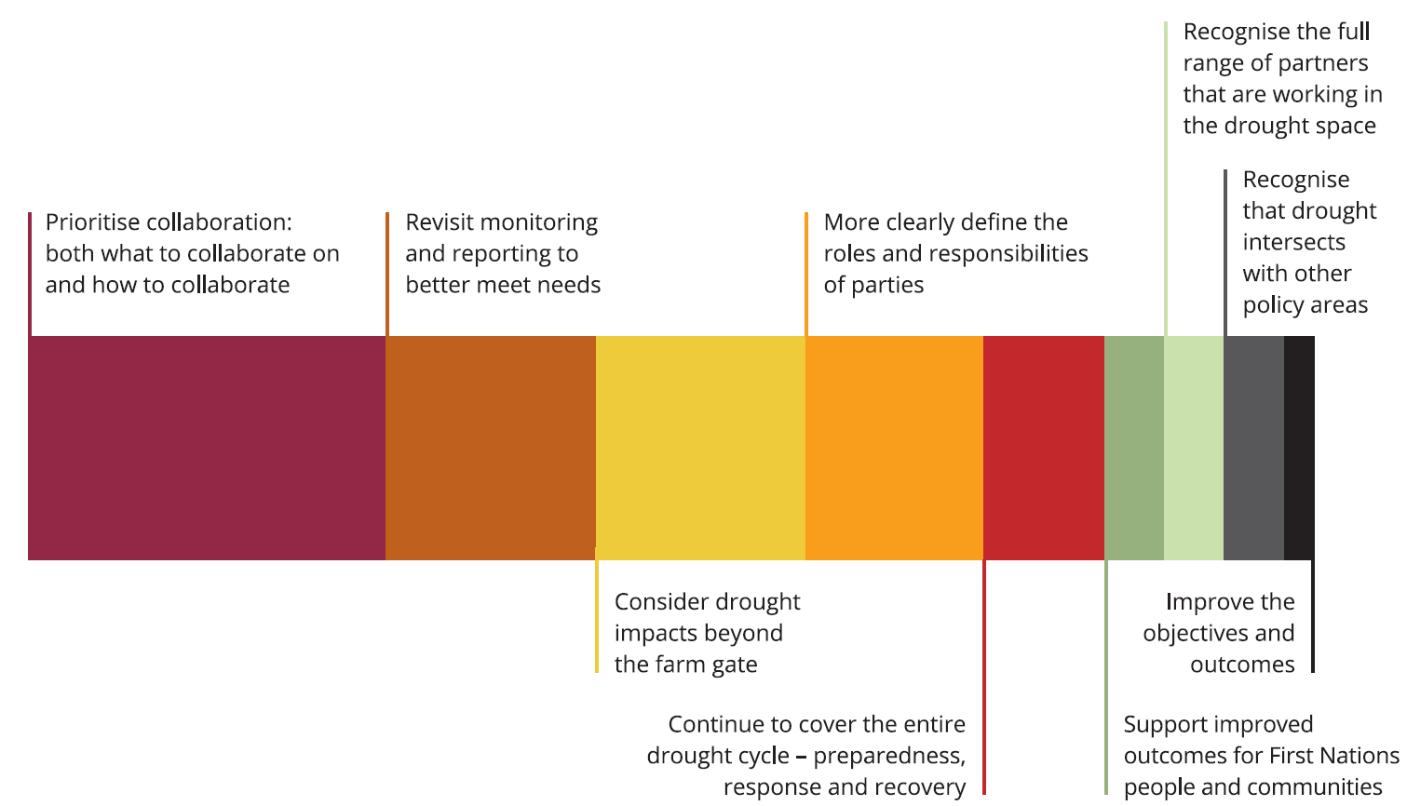
By far the most commonly supported issue was the need for the NDA to better support effective and meaningful collaboration between the parties, and with other key sectors such as industry, local governments and non-profit organisations. There was clear recognition of the benefits of establishing patterns of working cooperatively before needing to do so in a crisis. A component of this was a request to be clearer about the parties’ roles and responsibilities. Stakeholders also raised linkages to the shared responsibilities work currently being undertaken by the Australian Government.
The shared responsibilities work incorporated stakeholder consultation to develop an outline of the roles and responsibilities of those involved in drought and principles to guide how we can work together better. Further information is available on the relevant Have Your Say page. Understandably, there was an expectation that this work would be complementary to the NDA review.
Another aspect raised in the review consultation was related to sharing of information including updates on policies, programs and lessons learned to build and maintain shared knowledge and validate information. There was also acknowledgement of the potential for more focussed cooperation on common challenges, such as improved data collection and utilisation.
Another issue that received particular attention was for the impacts of drought beyond the farm gate to be more predominantly reflected in the next agreement. It was suggested that the NDA currently overlooks the economic impacts of drought on farming communities, despite the significance of these impacts on the wellbeing of the communities. There were also requests for mental health to be more explicitly referenced in the NDA, and the need to promote a culture of positive mental health across the drought cycle instead of only during drought when it tends to be most challenging.
There were multiple requests for monitoring, evaluation, learning and reporting to be more meaningful than what is currently provided for in the NDA reporting framework. Stakeholders requested a greater focus on the benefits of drought policy and programs to farmers and their communities (i.e. outcomes), rather than descriptive reporting on programs or how much is being invested in drought related initiatives. The desirability of better understanding the collective impact of governments’ efforts in responding to drought and preparing for drought was raised, but with recognition that it would be difficult to achieve given the difficulties with data consistency and attribution.
Finally, stakeholders almost universally raised that drought does not exist in isolation from other issues and farmers manage drought as just one of a multitude of business risks. There was a strong appetite for the next agreement to reflect the multi-hazard environment in which farmers operate. For many stakeholders, this recognition was particularly important in order to appropriately acknowledge the efforts and successes of farming businesses, farming families and their communities in managing risk.

Recommendations

Key issue 1: Purpose of the National Drought Agreement
While drought preparedness and response is a shared responsibility between many stakeholders – not least the farm businesses, farming families and farming communities that bear the brunt of drought impacts – the NDA is a discrete tool with a discrete purpose. It is an intergovernmental agreement primarily intended to facilitate a complementary approach to drought policy and programs between the Australian Government and state and territory governments.

Recommendation
- A new national agreement on drought should be developed and come into effect when the current NDA expires on 30 June 2024.
- The next agreement should continue to be an intergovernmental agreement, with signatories (parties) limited to the Australian Government and state and territory governments.

Key issue 2: Beneficiaries of the National Drought Agreement
The impacts of drought are first felt on-farm, by farming families and farm businesses, then by regional businesses and communities. The impacts are economic, social and environmental, and in agriculture-dependent regions are cumulative and increase in severity as drought persists.
Rural, regional and remote areas of Australia with more diversified economies via mining or tourism may experience drought but may not be impacted to the same extent as areas with undiversified economies. Equally, urban experiences of drought do not often equate to economic hardship. Given this, the role for government in supporting stakeholders to prepare for, manage through, and recover from drought, is inextricably connected to the agriculture sector and efforts to build farm resilience.

Recommendation
- The next agreement should retain its focus on delivering benefit for farm businesses, farming families and farming communities affected by drought.

Key issue 3: Policy underpinnings of the National Drought Agreement
Drought is a recurring part of the Australian climate, a business risk that should be anticipated and planned for. With climate change, droughts are predicted to increase in frequency, intensity and duration. Preparedness is key to mitigating the impact of extreme events and enabling capacity to recover when extreme events occur. Drought and climate change will continue to affect regions differently and it is important that adaptation and drought preparedness, response, and recovery activities are sensitive to the type of activity that is regionally appropriate now, and for the future. Coordination and collaboration among stakeholders is crucial for a successful approach.
Farming businesses, families and regional communities have increasingly been taking action to plan and prepare for the risk of drought, with governments investing to support these efforts. However, when drought hits, it is often for a prolonged period with real impacts on environmental degradation, animal welfare, household income, social cohesion and personal wellbeing. At such times, the role of government changes, and the need to work collaboratively to deliver public good outcomes is heightened.
It is important for governments to keep working together even when seasonal conditions are favourable, to improve community capacity and establish ways of working that support the best possible outcomes for Australian farmers and their communities.

Recommendations
- The next agreement should continue to prioritise long-term preparedness, resilience and risk management for farming businesses and farming communities affected by drought and a changing climate.
- The next agreement should note that an element of preparedness is to acknowledge changing climatic and environmental conditions at the farm level (such as less rainfall, changes in rainfall patterns or warmer temperatures). Adaptation to these changing conditions as a ‘new normal’ will be necessary for many farm businesses. These changes are likely to impact recovery activities, as some areas are likely to experience good seasons less often.
- The next agreement should continue to promote collaboration and coordination across all phases of the drought cycle (preparedness, response and recovery).

Key issue 4: Coordination and collaboration
The objectives and outcomes in the NDA cover a significant breadth of intent. They cannot be fully realised without a way to facilitate strong collaboration and communication at an intergovernmental level, as well as between party and non-party stakeholders. This is important so that drought policy and programs are complementary and avoid duplication, inadequate or mismatched support and unintended adverse outcomes. While the parties to the current NDA meet regularly, and also meet with some non-party stakeholders, the NDA is silent on any mechanisms to support sustained communication or collaboration on shared priorities. In the absence of such mechanisms there isn’t an established way to identify or progress shared priorities. Nor is there a space for intergovernmental discussions that would better facilitate a coordinated ‘no surprises’ approach to policy and program development and implementation.
The lack of specified mechanisms for coordination was most acutely felt during the last drought, although it has also become noticeable as collaborative drought preparedness activity increases under the Future Drought Fund (FDF). The FDF operates across Australian Government and state and territory governments, bringing together regional organisations, local government, communities, industry and other stakeholders. Coordination and collaboration between all entities is required to effectively deliver the broad range of resilience and drought preparedness activities under the FDF.

Recommendations
- The next agreement should strengthen its focus on collaboration and coordination.
- The next agreement should include a specified mechanism for interjurisdictional coordination, and this mechanism should be used to identify and pursue collaborative priorities on an ongoing basis.
  - This mechanism should be established and activated prior to the new agreement coming into force, to facilitate complementary and coordinated efforts across the drought cycle immediately.
  - The interjurisdictional mechanism should be flexible, responsive to changes in the capacity and priorities of each jurisdiction, and useful in taking forward priorities that apply to all parties or a subset of parties.
  - Priorities for interjurisdictional coordination should be shared publicly, for example via the Australian Government Department of Agriculture, Fisheries and Forestry’s website.
- While the next agreement should continue to promote collaboration and coordination across all phases of the drought cycle, an early priority for interjurisdictional coordination should be to establish improved communication and collaboration to monitor seasonal conditions, and collaboratively respond effectively and efficiently to worsening drought conditions.
- The project board should consider options for a mechanism to facilitate regular dialogue between the parties and non-party stakeholders, including local governments, industry, the non-profit sector and the financial sector.
  - Should such a mechanism be developed and agreed to, it should be established and activated prior to the new agreement coming into force, to facilitate complementary and coordinated efforts across the drought cycle immediately.
- The next agreement should identify the Australian Government as responsible for providing secretariat services for the mechanisms established under the agreement to promote communication, coordination, and collaboration, including any associated functions such as working groups or reporting.

Key issue 5: Roles and responsibilities
The NDA assigns drought related roles and responsibilities to the Australian Government and state and territory governments. Roles and responsibilities are not always black and white, with elements of responsibility sitting across both levels of government. More clearly defining the nuance of roles and responsibilities would give greater clarity to the parties and other stakeholders, including rural communities. The Future Drought Fund has been identified as a good example where better-defined roles and responsibilities between levels of government could be helpful. There are also some roles and responsibilities not currently captured (such as water management) or duplicated (such as capacity building). Improving clarity of roles and responsibilities has been highlighted as a priority for stakeholders over the course of the review. Doing so will also deliver benefits in terms of working relationships between parties, and between parties and non-party stakeholders. There are interdependencies between this issue and issue 4 (coordination and collaboration) and issue 7 (non-party stakeholders).

Recommendation
- Refine the existing roles and responsibilities section to more fully capture, and more clearly articulate, the breakdown of responsibilities, particularly where elements of responsibility sit across both levels of government.

Key issue 6: Drought impacts beyond the farm gate
Drought is often viewed as an event which impacts farm businesses and farming families. While true, the impacts of drought ripple through rural and regional communities. Businesses that are heavily reliant on expenditure from farmers, and communities whose social fabric is reliant on an active farming network, are often impacted early and can experience sustained financial hardship and social challenges as farmers cut back on discretional spending and focus on managing through the drought. Their recovery can also be slow, reflecting the cash flow constraints experienced by farm businesses well after the drought has broken. Closely associated with this are the mental health impacts of drought, and the need to build a positive approach to mental health across the drought cycle rather than only providing emergency support when times are difficult. The current NDA is silent on the economic impacts of drought beyond the farm gate, and only references the need for heightened wellbeing support during times of drought.

Recommendations
- The new agreement should commit governments to work across agencies and portfolios within their jurisdiction (led by agriculture portfolios), noting the impacts of drought beyond the farm gate and the need to work collaboratively to prepare, respond and recover appropriately.
- The new agreement should recognise that the economic impacts of drought are felt beyond the farm gate, and that farming communities need to prepare for, respond to, and recover from drought alongside farming businesses.
- The new agreement should explicitly recognise that health and wellbeing includes mental health, and that a positive approach to mental health needs to be fostered across the drought cycle.

Key issue 7: Non-party stakeholders
Governments do not work in isolation in the drought space, yet the current NDA does not strongly recognise non-party stakeholders or the importance of governments working with them throughout the drought cycle. We all have a role in drought, and a shared effort will make sure we are better placed come the next drought, as outlined in key issue 4. This premise has been explored extensively through the Australian Government’s shared responsibility stakeholder consultation in 2021 and 2022 and was strongly supported by industry, farm businesses and other agriculture sector stakeholders. Farm businesses have a responsibility to prepare for, manage through and recover from drought by taking active steps to manage farm-level risks associated with drought, and build resilience. Governments partner with non-government actors to enable farm businesses and communities to take appropriate and meaningful steps. Everyone has a shared interest in promoting and enabling a culture of self-responsibility and preparedness, and a responsibility to work together for a holistic and integrated approach to drought efforts.
As well as being providers of support, many non-party stakeholders also have a unique role as end-users of services and support. Their lived experiences of engaging with drought related programs has significant value for policy and program design, and the implementation of support must be sensitive to their user needs. This was highlighted as an important point for stakeholders during the review consultations, particularly in the context of farmers and their families and communities having recently experienced the cumulative impact of multiple hazards in close succession.

Recommendations
- The next agreement should more clearly acknowledge non-party stakeholders and recognise their role in preparing for, responding to and recovering from drought.
- The next agreement should commit jurisdictions to working with non-party stakeholders when planning and delivering drought initiatives, as appropriate to the context.
- The next agreement should commit governments to take an active role in working with non-party stakeholders to build understanding of drought preparedness, response and recovery as a shared responsibility.

Key issue 8: First Nations people
The NDA is silent on First Nations people and their interests as they relate to drought. This lack of recognition and silence on opportunity for First Nations people is inconsistent with the intent of a range of existing commitments and policy positions of Australian Government and state and territory governments, already demonstrated through the National Agreement on Closing the Gap, the Voice to Parliament and treaty discussions.

Recommendations
- The next agreement should acknowledge First Nations people as the Traditional Owners of Country throughout Australia and their continuing connection to land, sea and community, and recognise that their social, cultural, environmental and economic interests intersect with drought in Australia.
- The next agreement should include a principle for drought related program and policy development to consider First Nations interests.

Key issue 9: Intersecting policy areas
Recent years have seen significant policy developments in a range of matters which intersect with drought, such as climate change, water, soils, biodiversity, and natural resource management. However, these policy developments are not reflected in the current NDA. There is an opportunity to recognise the linkages and potential synergies between drought and other policy areas, without growing scope of the agreement itself. A joined-up approach allows for mutually beneficial outcomes for multiple stakeholders and the environment.

Recommendations
- The next agreement should acknowledge the significant breadth of intersecting policy activity that the NDA operates within, while retaining a focus on agriculture and the impact that drought has on farm businesses, farming families and farming communities.
- The next agreement should include a principle for aligning drought policy and programs with intersecting policy activity, such as climate change, water, soils and biodiversity, where practicable.

Key issue 10: Principles
The principles are a key aspect of the NDA as they underpin how the parties interact and develop drought policies and programs. However, there are 2 separate lists of principles in the NDA, which can cause confusion. The separation of principles is also unnecessary. The first list of principles are principles of reform, and the second list includes principles and processes for in-drought support. They are all interconnected in practice and can be presented, read and applied as a single suite. The current principles do not reflect some key policy developments which have occurred since the NDA was negotiated, such as recognition and inclusion of First Nations people, acknowledging intersecting policy, the value of proactive interjurisdictional collaboration, and the imperative for improved coordination of drought response efforts across jurisdictions. They also include some principles that were important at the point in time at which they were drafted but have reduced relevance now, or would be better captured in the roles and responsibilities section. There is an opportunity to rationalise and improve the list of principles to better support the intent of the NDA and better reflect the evolution and current context of drought policy.

Recommendations
- The principles are a key aspect of the NDA and need to be retained as central to the new agreement.
- They should be incorporated into the main body of the agreement rather than being attachments and should be consolidated into a single set of principles for clarity and ease of use.
- The following list of updated principles should be used as the basis for drafting the principles for the new agreement, though remain subject to further iteration in response to stakeholder consultation and deliberation by the parties
  - The new agreement should recognise that farming businesses, farming families and farming communities operate within a multi-hazard environment and drought is one of a number of business risks that they actively prepare for.
  - Government policies and programs should support farming businesses, farming families and farming communities to prepare for drought and climate variability and enhance their long-term sustainability and resilience.
  - Drought policies and programs should
    - recognise the important role of farming businesses as the nation’s food and fibre producers, and export revenue earners, which are vital to strong and cohesive rural communities
    - recognise the importance of maintaining and supporting the natural resource base and safeguarding animal welfare
    - align with intersecting policies and programs wherever practicable, including but not limited to those related to climate, water, soils, and biodiversity
    - occur where there is a clear role for government and deliver a public benefit
    - consider the interests of First Nations people and communities
    - be planned and delivered with non-party stakeholders, as appropriate to context and place
    - be streamlined and efficient to deliver timely assistance that is responsive to peoples’ experiences as end-users.
  - Parties and non-party stakeholders have a shared responsibility to work together for a holistic and integrated approach to drought efforts.
  - Parties should collaborate proactively when planning drought preparedness policies and programs.
  - Parties should work towards improved and sustained coordination of in-drought response efforts, which avoids duplication and enables links with other measures or between service providers to best serve the interests and needs of end-users.
  - Decisions by parties should seek to avoid creating adverse outcomes for stakeholders, including those in other jurisdictions.
  - Support needs are highly variable, and eligibility should be based on need, not activated by drought declarations.

Key issue 11: Monitoring, evaluation, learning and reporting
The monitoring and reporting arrangements for the NDA were developed retrospectively, after the NDA was signed. They are detailed and time consuming, and do not deliver proportional value to the parties or stakeholders. They rely on subjective self-assessment tools. The logic is questionable as it is not possible to attribute many of the metrics or data to the NDA itself. The time-lag for release of the report (January or February of the year following the previous financial year) means the information is shared too late to provide real-time value. The current arrangements have been criticised by some stakeholders as not realising an opportunity to evaluate the on-ground impact of collective drought programs or initiatives. There is opportunity to reduce administrative burden and strengthen reporting to be of mutual benefit to the parties and non-party stakeholders more broadly.

Recommendations
- Continue to provide annual reporting through AGSOC and the AMM.
- Establish a monitoring, evaluation, learning and reporting framework
  - at the same time as drafting the agreement itself
  - which is fit-for-purpose for the NDA as an intergovernmental agreement, as distinct from a program
  - which includes a focus not just on monitoring and reporting, but also on learning
  - which includes a forward-looking component about future priorities
  - which considers timing of reporting to better align with AMM schedules.
- Future efforts should not seek to measure or evaluate the collective impact of drought initiatives. While well intentioned, such efforts would prove difficult and costly to undertake and would be unlikely to realise proportionate benefits. The importance of evaluation is key to continuous improvement, but more targeted and effective efforts should be prioritised.
- Include a joint responsibility which commits all jurisdictions to undertake appropriate monitoring and evaluation for all relevant initiatives, and to make the replicable learnings from these public.
- Utilise the interjurisdictional coordination mechanism (see recommendation 8) to progress efforts that can contribute to improved monitoring, evaluation and learning over time, such as:
  - prioritise key targeted evaluation pieces to progress together (for example, how to understand and measure progress in drought resilience)
  - explore improved data capabilities for monitoring, evaluation, learning and reporting purposes (including use of data from industry and the financial sector)
  - consider options to better facilitate sharing between parties, particularly as it relates to real-time information and lessons and evidence to support future policy and program design.
- The new agreement should retain the requirement for a review of the NDA to commence at least 2 years prior to its expiry date.

Key issue 12: Readability
The NDA could be easier to navigate and digest. There is duplication within the document, some confusion in the hierarchy and logic, and there is unnecessary complexity in some of the language and syntax. The independent technical review of the document found that the structure, format and narrative of the NDA is not effective in creating a strong narrative or communicating in a way that would be accessible to stakeholders and the community.

Recommendation
- An editorial approach should be taken to the new agreement to make sure that there is not duplication between different sections and that readability and useability of the agreement as a whole is maximised. This will assist with comprehension and translation of the agreement into action.
- Attention should be given to strengthen the logic between objectives and outcomes, and ensuring that the objectives and outcomes align with the purpose of the NDA as an intergovernmental agreement.

Table of recommendations
Table 1 Key issues and recommendations
Key issues and recommendations | Recommendations in detail
Key Issue 1 | Purpose of the National Drought Agreement
Recommendation 1 | A new national agreement on drought should be developed and come into effect when the current NDA expires on 30 June 2024.
Recommendation 2 | The next agreement should continue to be an intergovernmental agreement, with signatories (parties) limited to the Australian Government and state and territory governments.
Key Issue 2 | Beneficiaries of the National Drought Agreement
Recommendation 3 | The next agreement should retain its focus on delivering benefit for farm businesses, farming families and farming communities affected by drought.
Key Issue 3 | Policy underpinnings of the National Drought Agreement
Recommendation 4 | The next agreement should continue to prioritise long-term preparedness, resilience and risk management for farming businesses and farming communities affected by drought and a changing climate.
Recommendation 5 | The next agreement should note that an element of preparedness is to acknowledge changing climatic and environmental conditions at the farm level (such as less rainfall, changes in rainfall patterns or warmer temperatures). Adaptation to these changing conditions as a ‘new normal’ will be necessary for many farm businesses. These changes are likely to impact recovery activities, as some areas are likely to experience good seasons less often.
Recommendation 6 | The next agreement should continue to promote collaboration and coordination across all phases of the drought cycle (preparedness, response and recovery).
Key issue 4 | Coordination and collaboration
Recommendation 7 | The next agreement should strengthen its focus on collaboration and coordination.
Recommendation 8 | The next agreement should include a specified mechanism for interjurisdictional coordination, and this mechanism should be used to identify and pursue collaborative priorities on an ongoing basis.  a) This mechanism should be established and activated prior to the new agreement coming into force, to facilitate complementary and coordinated efforts across the drought cycle immediately.  b) The interjurisdictional mechanism should be flexible, responsive to changes in the capacity and priorities of each jurisdiction, and useful in taking forward priorities that apply to all parties or a subset of parties.  c) Priorities for interjurisdictional coordination should be shared publicly, for example via the Australian Government Department of Agriculture, Fisheries and Forestry’s website.
Recommendation 9 | While the next agreement should continue to promote collaboration and coordination across all phases of the drought cycle, an early priority for interjurisdictional coordination should be to establish improved communication and collaboration to monitor seasonal conditions, and collaboratively respond effectively and efficiently to worsening drought conditions.
Recommendation 10 | The project board should consider options for a mechanism to facilitate regular dialogue between the parties and non-party stakeholders, including local governments, industry, the non-profit sector and the financial sector.  a) Should such a mechanism be developed and agreed to, it should be established and activated prior to the new agreement coming into force, to facilitate complementary and coordinated efforts across the drought cycle immediately.
Recommendation 11 | The next agreement should identify the Australian Government as responsible for providing secretariat services for the mechanisms established under the agreement to promote communication, coordination, and collaboration, including any associated functions such as working groups or reporting.
Key issue 5 | Roles and responsibilities
Recommendation 12 | Refine the existing roles and responsibilities section to more fully capture, and more clearly articulate, the breakdown of responsibilities, particularly where elements of responsibility sit across both levels of government.
Key issue 6 | Drought impacts beyond the farm gate
Recommendation 13 | The new agreement should commit governments to work across agencies and portfolios within their jurisdiction (led by agriculture portfolios), noting the impacts of drought beyond the farm gate and the need to work collaboratively to prepare, respond and recover appropriately.
Recommendation 14 | The new agreement should recognise that the economic impacts of drought are felt beyond the farm gate, and that farming communities need to prepare for, respond to, and recover from drought alongside farming businesses.
Recommendation 15 | The new agreement should explicitly recognise that health and wellbeing includes mental health, and that a positive approach to mental health needs to be fostered across the drought cycle.
Key issue 7 | Non-party stakeholders
Recommendation 16 | The next agreement should more clearly acknowledge non-party stakeholders and recognise their role in preparing for, responding to and recovering from drought.
Recommendation 17 | The next agreement should commit jurisdictions to working with non-party stakeholders when planning and delivering drought initiatives, as appropriate to the context.
Recommendation 18 | The next agreement should commit governments to take an active role in working with non-party stakeholders to build understanding of drought preparedness, response and recovery as a shared responsibility.
Key issue 8 | First Nations people
Recommendation 19 | The next agreement should acknowledge First Nations people as the Traditional Owners of Country throughout Australia and their continuing connection to land, sea and community, and recognise that their social, cultural, environmental and economic interests intersect with drought in Australia.
Recommendation 20 | The next agreement should include a principle for drought related program and policy development to consider First Nations interests.
Key issue 9 | Intersecting policy areas
Recommendation 21 | The next agreement should acknowledge the significant breadth of intersecting policy activity that the NDA operates within, while retaining a focus on agriculture and the impact that drought has on farm businesses, farming families and farming communities.
Recommendation 22 | The next agreement should include a principle for aligning drought policy and programs with intersecting policy activity, such as climate change, water, soils and biodiversity, where practicable.
Key issue 10 | Principles
Recommendation 23 | The principles are a key aspect of the NDA and need to be retained as central to the new agreement.
Recommendation 24 | They should be incorporated into the main body of the agreement rather than being attachments and should be consolidated into a single set of principles for clarity and ease of use.
Recommendation 25 | The following list of updated principles should be used as the basis for drafting the principles for the new agreement, though remain subject to further iteration in response to stakeholder consultation and deliberation by the parties.  a) The new agreement should recognise that farming businesses, farming families and farming communities operate within a multi-hazard environment and drought is one of a number of business risks that they actively prepare for.  b) Government policies and programs should support farming businesses, farming families and farming communities to prepare for drought and climate variability and enhance their long-term sustainability and resilience.  c) Drought policies and programs should  i) recognise the important role of farming businesses as the nation’s food and fibre producers, and export revenue earners, which are vital to strong and cohesive rural communities  ii) recognise the importance of maintaining and supporting the natural resource base and safeguarding animal welfare  iii) align with intersecting policies and programs wherever practicable, including but not limited to those related to climate, water, soils, and biodiversity  iv) occur where there is a clear role for government and deliver a public benefit  v) consider the interests of First Nations people and communities  vi) be planned and delivered with non-party stakeholders, as appropriate to context and place  vii) be streamlined and efficient to deliver timely assistance that is responsive to peoples’ experiences as end-users.  d) Parties and non-party stakeholders have a shared responsibility to work together for a holistic and integrated approach to drought efforts.  e) Parties should collaborate proactively when planning drought preparedness policies and programs.  f) Parties should work towards improved and sustained coordination of in-drought response efforts, which avoids duplication and enables links with other measures or between service providers to best serve the interests and needs of end-users.  g) Decisions by parties should seek to avoid creating adverse outcomes for stakeholders, including those in other jurisdictions.  h) Support needs are highly variable, and eligibility should be based on need, not activated by drought declarations.
Key issue 11 | Monitoring, evaluation, learning and reporting
Recommendation 26 | Continue to provide annual reporting through AGSOC and the AMM.
Recommendation 27 | Establish a monitoring, evaluation, learning and reporting framework  a) at the same time as drafting the agreement itself  b) which is fit-for-purpose for the NDA as an intergovernmental agreement, as distinct from a program  c) which includes a focus not just on monitoring and reporting, but also on learning  d) which includes a forward-looking component about future priorities  e) which considers timing of reporting to better align with AMM schedules.
Recommendation 28 | Future efforts should not seek to measure or evaluate the collective impact of drought initiatives. While well intentioned, such efforts would prove difficult and costly to undertake and would be unlikely to realise proportionate benefits. The importance of evaluation is key to continuous improvement, but more targeted and effective efforts should be prioritised.
Recommendation 29 | Include a joint responsibility which commits all jurisdictions to undertake appropriate monitoring and evaluation for all relevant initiatives, and to make the replicable learnings from these public.
Recommendation 30 | Utilise the interjurisdictional coordination mechanism (see recommendation 8) to progress efforts that can contribute to improved monitoring, evaluation and learning over time, such as:  a) prioritise key targeted evaluation pieces to progress together (for example, how to understand and measure progress in drought resilience)  b) explore improved data capabilities for monitoring, evaluation, learning and reporting purposes (including use of data from industry and the financial sector)  c) consider options to better facilitate sharing between parties, particularly as it relates to real-time information and lessons and evidence to support future policy and program design.
Recommendation 31 | The new agreement should retain the requirement for a review of the NDA to commence at least 2 years prior to its expiry date.
Key issue 12 | Readability
Recommendation 32 | An editorial approach should be taken to the new agreement to make sure that there is not duplication between different sections and that readability and useability of the agreement as a whole is maximised. This will assist with comprehension and translation of the agreement into action.
Recommendation 33 | Attention should be given to strengthen the logic between objectives and outcomes, and ensuring that the objectives and outcomes align with the purpose of the NDA as an intergovernmental agreement.

