National Drought Agreement annual report 2024–25
Parties to the National Drought Agreement

© Commonwealth of Australia 2026
Ownership of intellectual property rights
Unless otherwise noted, copyright (and any other intellectual property rights) in this publication is owned by the Commonwealth of Australia (referred to as the Commonwealth).
Creative Commons licence
All material in this publication is licensed under a Creative Commons Attribution 4.0 International Licence except content supplied by third parties, logos and the Commonwealth Coat of Arms.

Cataloguing data
This publication (and any material sourced from it) should be attributed as: Parties to the National Drought Agreement 2024-29, National Drought Agreement annual report 2024–25, Department of Agriculture, Fisheries and Forestry, Canberra, 2026. CC BY 4.0.
This publication is available at agriculture.gov.au/agriculture–land/farm–food–drought/drought/drought–policy/national–drought–agreement.
Department of Agriculture, Fisheries and Forestry
GPO Box 858 Canberra ACT 2601
Telephone 1800 900 090
Web agriculture.gov.au
Disclaimer
The Australian Government acting through the Department of Agriculture, Fisheries and Forestry has exercised due care and skill in preparing and compiling the information and data in this publication. Notwithstanding, the Department of Agriculture, Fisheries and Forestry, its employees and advisers disclaim all liability, including liability for negligence and for any loss, damage, injury, expense or cost incurred by any person as a result of accessing, using or relying on any of the information or data in this publication to the maximum extent permitted by law.
Acknowledgement of Country
We acknowledge the continuous connection of First Nations Traditional Owners and Custodians to the lands, seas and waters of Australia. We recognise their care for and cultivation of Country. We pay respect to Elders past and present, and recognise their knowledge and contribution to the productivity, innovation and sustainability of Australia’s agriculture, fisheries and forestry industries.
Image credits
Cover photograph: © James Christian.

Preface
This is the first annual report of the new National Drought Agreement 2024 to 2029 (NDA), signed by the Australian Government and state and territory governments (NDA parties).

Background to the NDA
On 1 July 2025, the new NDA 2024 to 2029 was published by the NDA parties, replacing the first NDA 2018 to 2024. Prior to this, the NDA replaced the 2013 Intergovernmental Agreement on National Drought Program Reform.
The NDA 2024 to 2029 aims to provide clear definitions of the roles and responsibilities of government to help support farmers and communities to prepare for and manage drought. The agreement encourages a consistent, collaborative approach to drought across the country by prioritising policies and programs that support the long-term preparedness, sustainability and resilience of farm businesses and communities.
The existing jurisdictional forums of the Agriculture Senior Officials Committee (AGSOC) and the Agriculture Ministers’ Meeting (AMM) govern and report on the NDA 2024 to 2029. The Department of Agriculture, Fisheries and Forestry has secretariat responsibility for the NDA.
Contents
Preface iii
Background to the NDA iii
Agriculture ministers’ message v
Summary vii
Climate summary 1
Impacts on farm performance 2
Outcomes 4
Working together under the NDA 5
Case studies 6
Co-design of Phase 2: Farm Business Resilience and Regional Drought Resilience Planning programs 6
Stakeholder engagement through the NDN 7
Regional Drought Resilience Planning program 8
Infrastructure grants 9
Jurisdictional and climate summaries 10
National 10
New South Wales 10
Queensland 11
Northern Territory 11
Victoria 12
South Australia 12
Western Australia 13
Australian Capital Territory 14
Tasmania 14
Future priorities 2025–26 16

Figures
Figure 1 RDRP Program face-to-face co-design workshop, Canberra 6
Figure 2 Connecting with our stakeholders 7
Figure 3 Water tank on the Barkly Tableland, Northern Territory 9
Maps
Map 1 Australian rainfall deciles, 2024–25 2
Map 2 Regional Drought Resilience Planning program participating regions 8

Agriculture ministers’ message
The National Drought Agreement annual report 2024–25 marks an important milestone – the first reporting period under the new agreement and the first full financial year of its implementation. It is also the first time this new agreement has been tested under significant drought conditions, providing an early demonstration of how strengthened collaboration across governments can help improve preparedness, response and resilience.
This new agreement sets out a shared vision for how the NDA parties work together to manage drought – combining national leadership with local knowledge to deliver coordinated, practical support. This strengthened partnership across governments reflects our ongoing commitment to support farmers, industries and regional communities to manage drought.
Over the past year, this approach has been central to our response. Through joint initiatives, such as the Farm Business Resilience Program, Regional Drought Resilience Planning Program and the Rural Financial Counselling Service, we have supported farmers to plan for risk, adopt climate-resilient practices, and make informed business decisions. We have also enhanced data, forecasting and decision-making tools to help farmers and communities prepare for and respond to changing conditions.
Seasonal conditions in 2024–25 showed both the variability and complexity of Australia’s climate. Many regions experienced severe and prolonged drought, while others faced rapid shifts to wetter conditions, including storms and flooding. Throughout these challenges, the agreement has enabled us to act in a more coordinated and complementary way by aligning investments, sharing information and delivering support that is locally tailored and nationally consistent.
This includes much of South Australia and Victoria, which have recorded some of their lowest rainfall levels on record. Some parts of NSW are also experiencing ongoing drought and areas across Tasmania and parts of Western Australia have also been affected. These conditions reinforce the importance of a nationally coordinated response that supports local needs.
As we look ahead, our shared commitment remains clear. The agreement provides a solid foundation for ongoing collaboration to strengthen the resilience of our primary industries and regional communities. By working together, we will continue to support Australian agriculture to remain productive, sustainable and ready for the challenges and opportunities of a changing climate.


Hon Julie Collins MP, Minister for Agriculture, Fisheries and Forestry

Hon Tara Moriarty MLC, Minister for Agriculture, Minister for Regional New South Wales, and Minister for Western New South Wales

Hon Ros Spence MP, Minister for Agriculture

Hon Anthony Perrett MP, Minister for Primary Industries
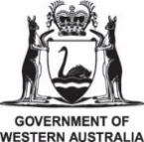
Hon Jackie Jarvis MLC, Minister for Agriculture and Food; Fisheries; Forestry; Small Business; Mid West
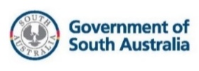
Hon Clare Scriven MLC, Minister for Primary Industries and Regional Development and Minister for Forest Industries

Hon Gavin Pearce MP, Minister for Primary Industries and Water

Hon Gerard Maley MLA, Minister for Agriculture and Fisheries

Suzanne Orr MLA, Minister for Climate Change, Environment, Energy and Water

Summary
The NDA annual report 2024–25 demonstrates the ongoing commitment by the NDA parties to work in partnership with each other, farming businesses and rural communities to prepare for, respond and recover from drought.
Some Australian farmers and farming communities, in particular across Southern Australia, have been doing it tough; with those responding to the extensive drying conditions with exceptional resilience.
Stakeholder feedback from the 2025 National Drought Forum, and lessons learned in the application of the NDA during recent drought conditions, provide an opportunity to refine and improve how the NDA is operationalised during drought and can help inform the 2027 review of the NDA.
All NDA parties have delivered on their NDA roles and responsibilities in a manner that is appropriate to their operating context.

Climate summary
The 2024–25 financial year was Australia’s warmest on record, with the nationally-averaged mean temperature 1.68°C above the 1961 to 1990 average. The previous record of 1.40°C above average was in 2015–16.
All months across the 2024–25 financial year were warmer than average, with August 2024 to March 2025 among the top 5 warmest on record for their respective months.
The nationally-averaged total rainfall for the 2024–25 financial year was 10% above the 1961 to 1990 average. Area-averaged rainfall was 21% above average overall across northern Australia. While southern Australia was 5% below average, much of south-eastern South Australia and western Victoria had their driest financial year on record since 1900–01 (Map 1).
There was a notable contrast in soil moisture conditions between northern and southern regions of Australia. Much of northern Australia saw high moisture levels, driven largely by major tropical activity that brought substantial rainfall. In contrast, over southern Australia soil moisture was generally below average and, in some areas, the lowest on record due to severe rainfall deficiencies that have persisted over the past 2 years.
Australia’s surface water storage levels declined overall, largely due to ongoing dry conditions across the south. Heavy rainfall in March 2025 increased water levels in Wivenhoe and the Menindee Lakes. By the end of June, total water storage across Australia was at 64.9% of capacity, 8.7% lower than at the same time in 2024.
Map 1 Australian rainfall deciles, 2024–25
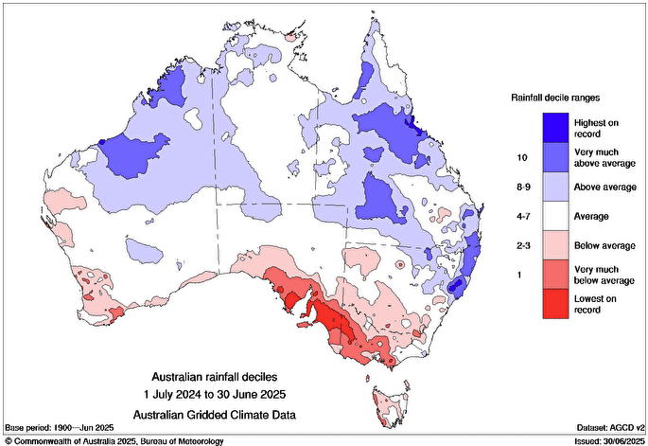Source: Bureau of Meteorology
Groundwater levels varied widely across Australia. The northern Murray–Darling Basin, south-eastern Queensland, the Top End and Tasmania experienced groundwater recovery, driven by widespread rainfall and flooding and improved surface water availability. In contrast, groundwater levels continued to decline across south-eastern South Australia, southern and western Victoria, and the south-west of Western Australia.
To learn more, see Financial year climate and water report 2024–25.

Impacts on farm performance
Australian average broadacre farm business profit increased by $158,000 from $11,000 in 2023–24 to $169,000 per farm in 2024–25. This was driven by higher livestock prices and improving seasonal conditions, which boosted total crop production. It is important to note that this figure represents a national average. There are significant differences in farm business profit across jurisdictions and at the individual farm level (ABARES Australian Agricultural Drought Indicators (AADI) at July 2025).
Cropping farm business profits rose significantly, increasing by $507,000 from $260,000 in 2023–24 to $767,000 per farm in 2024–25. Strong winter crop production in larger growing areas of Western Australia, New South Wales and Queensland outweighed lower production in areas of South Australia and Victoria that are experiencing drought conditions. This increased production offset easing grain prices in 2024–25, while reduced costs for chemicals, fertilisers and fuel also boosted cropping farm profits (ABARES Australian Agricultural Drought Indicators (AADI) at July 2025).
Livestock farms business profits increased in 2024–25, mainly due to rising prices and production. Beef farm business profits increased by $31,000 from −$16,000 in 2023–24 to $15,000 per farm in 2024–25, supported by stronger climate conditions across the north of Australia and rising prices. Sheep farm profits increased by $49,000 from -$80,000 in 2023–24 to -$31,000 per farm in 2024–25 due to price increases. However, sheep farm profits remained low because of dry conditions across South Australia and Victoria, and low mutton and wool prices. Elevated costs for fuel, interest, materials and services, and shearing costs continued to weigh on livestock farm profits. To learn more, see the ABARES Agricultural Commodities Report June 2025.
In 2024–25, farm business profits for Australian broadacre farms were ‘average’ (44th percentile of the last 33 years). Favourable climate conditions and improved beef prices drove profits to be ‘above average’ in Northern Territory (77th percentile of the last 33 years) and Queensland (75th percentile of the last 33 years). However, significantly drier conditions, easing crop prices, and low mutton and wool prices resulted in profit to be ‘lowest 5%’ in South Australia (4th percentile of the last 33 years), and ‘below average’ in Victoria (25th percentile of the last 33 years) and Western Australia (31st percentile of the last 33 years). Farm business profits were ‘average’ in NSW (61st percentile of the last 33 years) and Tasmania (51st percentile of the last 33 years) (ABARES Australian Agricultural Drought Indicators (AADI) at July 2025).

Outcomes
The NDA 2024 to 2029 has 3 agreed outcomes:
- Government drought policies and programs are aligned nationally, and consistent with the principles of the NDA.
- Government responses across the drought cycle (preparedness, response and recover) reflect a focus on preparedness and the ability to respond and recover quickly from drought.
- Information, tools and lessons learned are actively shared to improve clarity, decisions, and policy and programs, for parties and non-party stakeholders.
The NDA defines non-party stakeholders as stakeholders of the NDA that are not signatories of the agreement but have intersecting interests across the drought cycle. This includes, but is not limited to, local governments, industry groups, the non-profit sector and the financial sector.
The NDA 2024 to 2029 Outcomes Reporting Framework describes how the NDA is monitored and reported on by the parties to the NDA, and how learnings are shared. This annual report presents a national picture of how the NDA parties collectively progressed against these outcomes.

Working together under the NDA
During 2024–25, the NDA parties continued to work in partnership to progress agreed outcomes under the NDA 2024 to 2029. Parties collaborated on drought-related issues and provided each other with support and advice, particularly in response to drought conditions in South Australia and Victoria, as well as in some regions of New South Wales, Tasmania and Western Australia. During 2024–25, all parties fulfilled their roles and responsibilities outlined in the NDA.
The Agriculture Ministers’ Meeting Working Group on Drought (AMMWG) was established under AGSOC and AMM to bring parties to the NDA together regularly to share and discuss drought-related policies and programs, information and issues. The AMMWG developed an annual workplan for 2024–25, endorsed by AGSOC and AMM, to progress implementation of the NDA, and provided regular workplan updates to both governing bodies throughout the year.
In December 2024, the NDA parties published a framework to monitor and report on their progress against the NDA outcomes and share lessons learned. Learn more about the NDA Outcomes Reporting Framework.
The AMMWG met 8 times during 2024–25, including a face-to-face meeting and a workshop on First Nations engagement. The group regularly shared information on seasonal conditions and lessons learned from previous drought responses and continued to adjust the focus of its discussions based on emerging issues. The main themes discussed included:
- current drought responses
- jurisdictional drought support packages
- development and use of climate indicator tools
- impacts of climate change on drought events
- regional and rural mental health support
- stakeholder engagement initiatives and shared communications approaches.
The National Drought Network (NDN) was established under the NDA as an information sharing forum. It continues to provide an opportunity for the NDA parties to connect with non-party stakeholders. Learn more about the National Drought Network.
In addition to the NDN, many NDA parties also held engagement forums and meetings with non-party stakeholders, with the aim of informing in-drought responses and sharing drought-related information on support measures available. This included collaborating across jurisdictions where appropriate to ensure consistency of messaging and a united approach to stakeholder engagement.

Case studies

Co-design of Phase 2: Farm Business Resilience and Regional Drought Resilience Planning programs
Figure 1 RDRP Program face-to-face co-design workshop, Canberra

Left to right (front row): Alex Earnshaw, Agriculture Victoria; Lucy Marshall, Tasmanian Department of Premier and Cabinet; Jacinta Chaffey, DAFF; Mary Bonet, ACT Natural Resource Management. Left to right (back row): Nicole Smith, QLD Department of Primary Industries and Regional Development; Caroline Brown, Department of Natural Resources and Environment Tasmania; Brett Bartel, SA Department of Primary Industries and Regions; Georgina Lucas, QLD Department of Primary Industries and Regional Development; Jarrod Ruch, ACT Natural Resource Management; Keith Brightman (on screen), DAFF; Brendan Nicholas, WA Department of Primary Industries and Regional Development; James Christian, NT Department of Agriculture and Fisheries; Gemma Heemskerk, Agriculture Victoria; Rachael Kelly (on screen), SA Department of Primary Industries and Regions; Laura Olsson, DAFF; Kaylene Parker, WA Department of Primary Industries and Regional Development; Francois Sauzier, WA Department of Primary Industries and Regional Development; Kate Manion, NSW Department of Primary Industries and Regional Development; Kylie Walsh, SA Department of Primary Industries and Regions.
Throughout 2024–25, the NDA parties worked in partnership to co-design a 4-year second phase of the Regional Drought Resilience Planning and Farm Business Resilience programs – 2 key FDF initiatives that support farmers and regions to strengthen drought resilience.
A series of tailored workshops, facilitated by the Australian Government, brought together cross-government expertise and learnings from the first phase to collaboratively shape the next phase. This resulted in a principles-based design that balances national consistency with flexibility for jurisdictional tailoring. Phase 2 Federation Funding Agreement schedules were executed by the Hon Minister Julie Collins MP in June 2025, with delivery commencing from late 2025.

Stakeholder engagement through the NDN
Figure 2 Connecting with our stakeholders
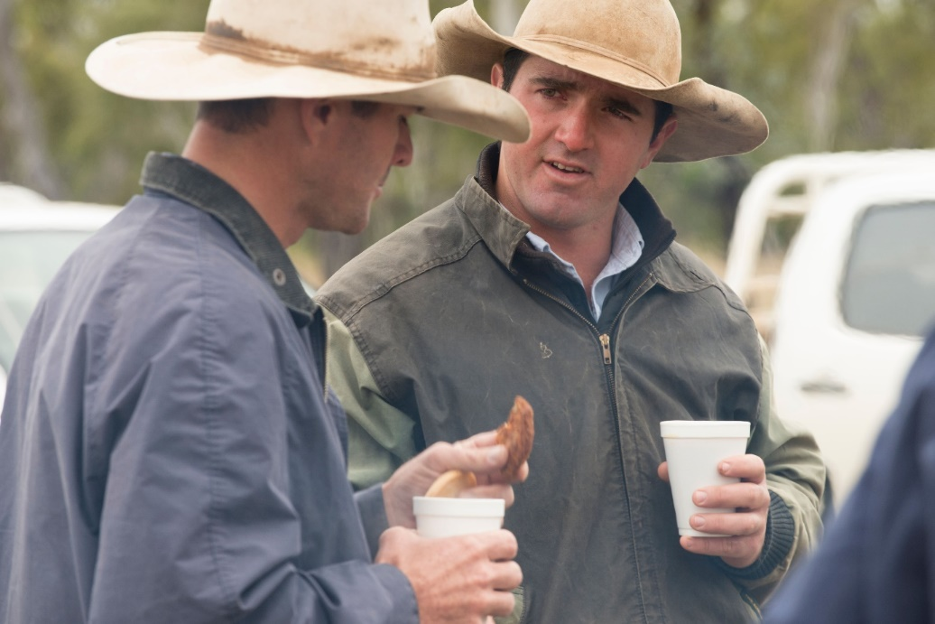
The NDN assists in helping non-party stakeholders to build understanding and sharing of information across the drought cycle, a joint responsibility of all NDA parties. The NDN met virtually twice in 2024–25. 120 participants attended the August 2024 meeting, and 135 participants attended the February 2025 meeting. Attendees included government, industry, finance, research and charity groups. NDA parties shared updates on topics such as climate information and tools, drought support measures and initiatives, and policy and program updates. The Bureau of Meteorology provided seasonal updates. NDA parties including the Australian, South Australian, Victorian and Tasmanian governments shared information on drought policies, support measures available, and program updates. Non-party stakeholders including the National Farmers’ Federation, the Australian Rural Leadership Foundation and the Foundation for Rural and Regional Renewal also provided updates.
The NDN has been instrumental in strengthening communication and stakeholder awareness and understanding of drought information and support measures available. This aligns to the NDA’s key outcome that information tools and lessons learned are actively shared, and the NDA’s goal of ensuring the agricultural sector and rural communities know what support is available and how to access it. The NDN will continue to be promoted by the NDA parties to ensure it reaches all relevant and interested stakeholders over the coming financial year.

Regional Drought Resilience Planning program
Map 2 Regional Drought Resilience Planning program participating regions
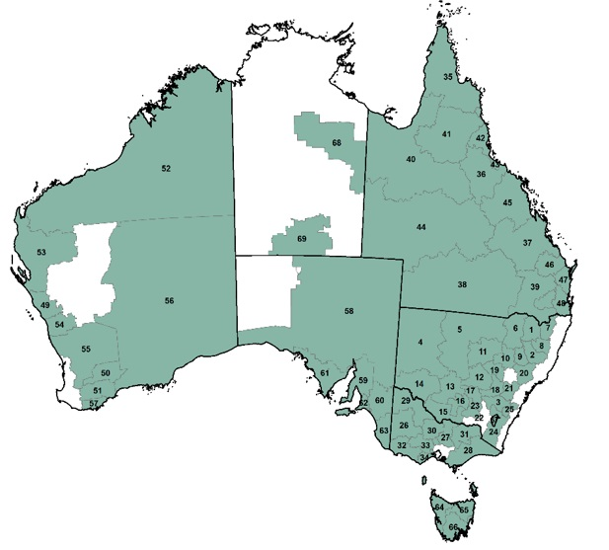
The Regional Drought Resilience Planning (RDRP) program is a prime example of the NDA parties working in partnership as intended under the NDA. RDRP takes a nationally consistent, yet place-based approach to drought resilience planning and action. Recognising that drought and other related challenges affect landscapes, communities and economies differently, implementation across jurisdictions is tailored to respond to suit each region. Almost 70 locally led plans are developed or underway, covering most of Australia, driving actions that strengthen resilience regionally and, collectively, at a national level (Map 2). These plans also generate valuable insights into regional priorities to help inform policy and investment at all levels of government. Visit Regional Drought Resilience Planning to learn more, and to read each region’s plan.

Infrastructure grants
Figure 3 Water tank on the Barkly Tableland, Northern Territory
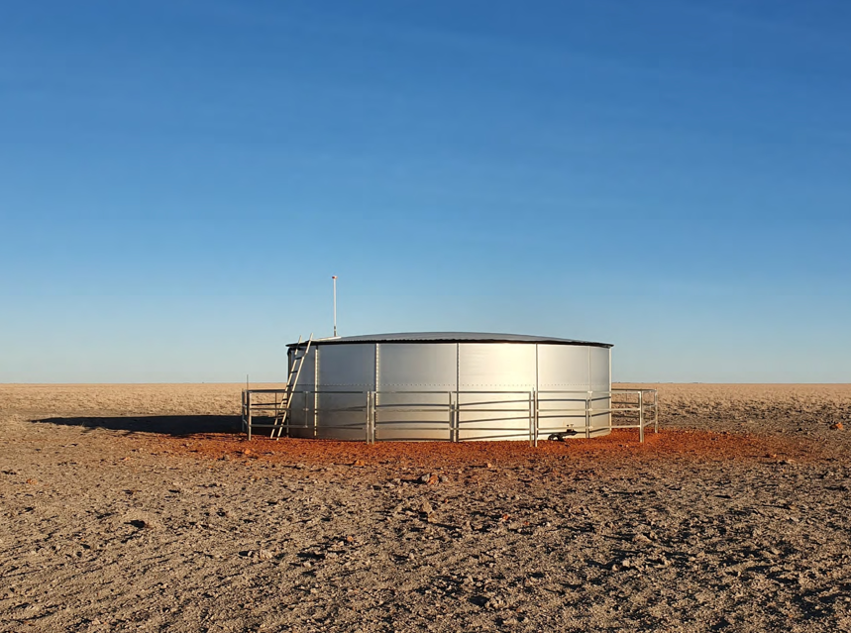
Photograph: © James Christian.
In 2024–25, NDA parties such as New South Wales, Victoria and South Australia administered a variety of on-farm infrastructure grants – for example, providing assistance with constructing new or upgrading old, irrigation systems, improving fodder and feed storage, and other projects that support farm resilience.
These grants contribute towards the NDA’s goals and outcomes by encouraging farm investment and preparedness, helping the agricultural sector and rural communities build resilience for challenging times. This example shows that although the NDA parties may face different circumstances and challenges in preparing for drought, they have delivered tailored initiatives which still achieve national consistency by aligning with the NDA principles.
For more information on state and territory grants, see:
- Australian Capital Territory – Rural Resilience Grants
- New South Wales – Drought Infrastructure Fund and Drought Ready and Resilient Fund
- Northern Territory – Agricultural Value-Add Grant
- Queensland – Drought Preparedness Grants
- South Australia - On-farm Drought Infrastructure Rebate Scheme
- Tasmania – Bass Strait Islands Water Resilience Program
- Victoria – Farm Drought Support Grants
- Western Australia – Financial support for WA farmers in the dry season.

Jurisdictional and climate summaries

National
In 2024–25 the Australian Government met its responsibilities under the NDA, delivering a broad range of drought-related policies and programs aligned with the NDA principles. The Australian Government Drought Plan was released in December 2024 articulating how the Australian Government will meet and implement its obligations under the NDA. The Future Drought Fund (FDF) Investment Strategy was released in January 2025, providing a roadmap for building drought resilient farms, landscapes and communities, and how FDF objectives will be achieved.
During 2024–25, an estimated total of $385,314,842 was spent on implementation of drought policies and programs, demonstrating the Australian Government’s focus on preparedness and building resilience, whilst ensuring programs were available to help those in drought. In addition, the Farm Management Deposits Scheme resulted in an estimated $160 million in taxation revenue forgone (note, subject to change as taxation data becomes available).
Farmers continued to have access to a range of initiatives, including taxation measures such as income tax averaging. Additional funding was also allocated to a number of programs broader than drought alone (e.g. mental health initiatives).
In 2024–25, the Australian Government published a Review of the operation of the Regional Investment Corporation Act 2018.
Learn about the Australian Government’s drought-related programs and policies at drought, disaster and rural support.

New South Wales
New South Wales experienced contrasting seasonal conditions throughout 2024–25 with flooding and high rainfall across the north-east of New South Wales and coastal regions. To the south of the state producers in the Riverina, Murray and parts of the far west are managing drought, linked to the widespread event being experienced in Victoria and South Australia. This is an ongoing drought with financial impacts on livestock producers who have been drought feeding for a number of months.
Rainfall was above to very much above average (wettest 10% of all financial years since 1900–01) for inland northern New South Wales and coastal areas north of Sydney. In contrast, rainfall was below to very much below average (driest 10% of all financial years since 1900–01) for southern and north-western areas of New South Wales. Farm business profits were ‘average’ in NSW (61st percentile of the last 33 years).
In 2024–25 the New South Wales Government met its responsibilities under the NDA, delivering a broad range of drought-related policies and programs aligned with the NDA principles.
During 2024–25, an estimated total of $75,972,743 was spent on implementation of drought policies and programs, demonstrating both a focus on preparedness as well as response to drying conditions across parts of New South Wales.
Learn more about the New South Wales Government’s drought-related programs and policies.

Queensland
Seasonal conditions varied across Queensland during 2024–25. After a mixed season during winter and spring 2024, there was a rapid improvement in seasonal conditions with average to well above average rainfall to finish off the 2024–25 summer rainfall season. Significant weather events including the North and Far North Tropical Low during January, Tropical Cyclone Alfred during March and Western Queensland Rainfall and Flooding between March and May led to disaster activations across much of Queensland. Optimism levels for primary production across Queensland remain positive however, with generally good soil moisture and no widespread shortages of water availability.
Rainfall was above to very much above average (wettest 10% of all financial years since 1900–01) for most of Queensland, with some areas having their highest on record monthly rainfall. Favourable climate conditions and improved beef prices drove profits to be ‘above average’ in Queensland (75th percentile of the last 33 years).
In 2024–25 the Queensland Government met its responsibilities under the NDA, delivering a broad range of drought-related policies and programs aligned with the NDA principles.
During 2024–25, an estimated total of $20,028,082 was spent on implementation of drought policies and programs, demonstrating a focus on preparedness.
In 2024–25, the Queensland Government published:
- Drought and Climate Adaptation Program Phase 3 Monitoring and Evaluation Annual Report
- Evaluation of Queensland’s Drought Assistance Programs
- Drought program evaluations – Queensland Department of Agriculture and Fisheries (scheme has now ceased).
Learn more about the Queensland Government’s drought-related programs and policies.

Northern Territory
The Northern Territory recorded above median rainfall during 2024–25, particularly across the Top End and northwest, despite a notably late monsoon onset. Temperatures remained above average, with persistent heat and record-setting overnight minima. Seasonal rainfall supported pastoral and northern cropping regions, though the delayed monsoon compressed the effective growing window north of Katherine. Elsewhere, rainfall was sufficient to maintain typical ecological and grazing conditions. Although increased fuel loads driven by the preceding high rainfall and late onset wet season combined with warmer conditions, the 2024–25 bushfire season was typical in extent and severity when compared with recent extreme fire years.
Rainfall was above to very much above average (wettest 10% of all financial years since 1900–01) for large parts of the Northern Territory. Favourable climate conditions and improved beef prices drove profits to be ‘above average’ in Northern Territory (77th percentile of the last 33 years).
In 2024–25 the Northern Territory Government met its responsibilities under the NDA, delivering a broad range of drought-related policies and programs aligned with the NDA principles.
During 2024–25, an estimated total of $158,843 was spent on implementation of drought policies and programs, demonstrating a focus on preparedness.
Learn more about preparing for and managing drought in the Northern Territory.

Victoria
Victoria faced challenging drought conditions during 2024–25, with a significant rainfall deficiency in southwest Victoria extending back to the winter of 2023 and the drought footprint widening across the state from early 2024. The challenging seasonal conditions exacerbated impacts and stressors for Victorian farmers and farming families, and rippled out beyond the farm gate into rural businesses and communities. Drought related hardship was accelerated by factors, including cashflow pressures, access and cost of fodder, and declining on-farm water storages, and declining mental health and well-being amongst some in our farming community.
Rainfall was below to very much below average (driest 10% of all financial years since 1900–01) for most of Victoria, with parts of Victoria’s Mallee and Wimmera districts experiencing the lowest rainfall on record. Significantly drier conditions, easing crop prices, and low mutton and wool prices led to profit forecasts to be ‘below average’ in Victoria (25th percentile of the last 33 years).
In 2024–25 the Victorian Government met its responsibilities under the NDA, delivering a broad range of drought-related policies and programs aligned with the NDA principles.
During 2024–25, an estimated total of $20,882,887 was spent on implementation of drought policies and programs, demonstrating a focus on both preparedness as well as response to the current drought conditions being faced across Victoria.
In response to worsening drought conditions, during 2024–25 the Victorian Government announced $68.9 million in drought support, with an additional $75 million announced in July 2025 – much of this will be expended in 2025–26. The Premier’s Drought Response Taskforce was convened in June 2025 to provide a central, coordinated consultation and engagement process that best supports those impacted by drought conditions across Victoria.
Learn more about the Victorian Government’s drought-related programs and policies.

South Australia
In early 2023 severe rainfall deficiencies (rainfall totals in lowest 5% since 1900) developed in South Australia. Rainfall deficiencies have been especially significant in regions with western facing coastlines including the south east of SA. Since February 2024 agricultural regions of South Australia has experienced severe or serious rainfall deficiencies (rainfall totals in the lowest 5% or 10% of periods respectively since 1900). Most of the agricultural areas of South Australia have experienced lowest on record rainfall. In June 2025 part of SA received above average rainfall including the lower southeast with the northern and parts of eastern SA experiencing below average to very much below average.
However, there were pockets in northern South Australia where rainfall was above to very much above average (wettest 10% of all financial years since 1900–01). Significantly drier conditions, easing crop prices, and low mutton and wool prices led to profit forecasts to be ‘lowest 5%’ in South Australia (4th percentile of the last 33 years).
In 2024–25 the South Australian Government met its responsibilities under the NDA, delivering a broad range of drought-related policies and programs aligned with the NDA principles.
During 2024–25, an estimated total of $21,012,838 was spent on implementation of drought policies and programs, demonstrating a focus on both preparedness and resilience, as well as response to drying conditions across South Australia.
In response to worsening drought conditions, during 2024–25 the South Australian Government announced a $73 million drought support package. The drought support is comprehensive and includes financial relief for those who need it, support for regional communities, programs to ensure critical water needs are met, pest animal management and funding for drought preparedness and resilience program. Recommendations from and extensive engagement with industry and primary producers directly informed the Government’s response. This engagement includes the establishment of a Drought Advisory Group to formally engage with industry and government stakeholders and the appointment of a Commissioner for Drought Support.
In 2024–25, the South Australian Government completed an evaluation and review of the Family and Business Mentor Service.
Learn more about the South Australian Government’s drought-related programs and policies.

Western Australia
WA experienced its warmest year on record for mean minimum temperatures, while the mean maximum temperature ranked as the second warmest on record. The April to October southern growing season was below average (decile 3), characterised by a dry start in April (decile 1), near normal rainfall for May to August, and a dry finish in September (decile 1). Growing season temperatures where above average, and despite dry conditions during the critical grain-fill period, WA grain production exceeded 22 million tonnes, WA’s third highest yield on record. In contrast, northern WA experienced a wetter than average summer season, largely due to tropical cyclone activity.
Rainfall was above to very much above average (wettest 10% of all financial years since 1900–01) for northern and inland areas of Western Australia. Tropical cyclones brought heavy rain to the Pilbara and Kimberley regions in particular. In contrast, rainfall was below to very much below average (driest 10% of all financial years since 1900–01) for southern and western coastal areas of Western Australia. At time of reporting, significantly drier conditions, easing crop prices, and low mutton and wool prices led to profit forecasts to be ‘below average’ in Western Australia (31st percentile of the last 33 years).
In 2024–25 the Western Australian Government met its responsibilities under the NDA, delivering a broad range of drought-related policies and programs aligned with the NDA principles.
During 2024–25, an estimated total of $34,688,690 was spent on implementation of drought policies and programs, demonstrating a focus on preparedness.
Learn more about the Western Australian Government’s drought-related programs and policies.

Australian Capital Territory
Conditions in the equatorial Pacific and Indian Oceans were largely neutral during the 12 months to June 2025, with rainfall totals across the ACT below average and daytime temperatures around 2°C above the long–term average.
In 2024–25 the ACT Government met its responsibilities under the NDA, delivering a broad range of drought-related policies and programs aligned with the NDA principles.
During 2024–25, an estimated total of $533,000 was spent on implementation of drought policies and programs, demonstrating a focus on preparedness.
Learn more about the ACT Government’s drought-related programs and policies.

Tasmania
Tasmania experienced drought conditions during 2024–25 and faced its driest start to 2025 on record. In drought impacted districts like King Island and Flinders Island and the far North West the year proved to be very challenging. Many producers across Tasmania considered strategies, including purchase of alternative feed and fodder and destocking to manage the conditions. The Tasmanian Government responded with over $9 million in programs to support producers making informed decisions, grant programs targeted to animal welfare and logistics and expanded animal outreach services, wellbeing and counselling outreach support. The Tasmanian Government worked closely with the TAS Farm Innovation Hub, rural support organisations and agricultural service providers to ensure a collaborative and coordinated community informed response to the drought. The role of the relatively new TAS Farm Innovation Hub was fundamental to a collaborative effort where each part successfully delivered practical support to farmers and rural communities across preparedness, future resilience and in-drought response.
Rainfall was below to very much below average (driest 10% of all financial years since 1900–01) for much of Tasmania. Farm business profits were ‘average’ in Tasmania (51st percentile of the last 33 years).
In 2024–25 the Tasmanian Government met its responsibilities under the NDA, delivering a broad range of drought-related policies and programs aligned with the NDA principles.
During 2024–25, an estimated total of $24,935,168 was spent on implementation of drought policies and programs, demonstrating a focus on preparedness.
In 2024–25, the Tasmanian Government:
- finalised a review of the Primary Producer Seasonal Conditions Scheme
- concluded the King Island Drought Coordinator Activities
- concluded the Livestock Coaching Animal Welfare Bass Strait Islands Program
- published the Rural Water Use Strategy Progress Report 2024.
Learn more about the Tasmanian Government’s drought-related programs and policies.

Future priorities 2025–26
In 2025–26, the collective dedication of the NDA parties to continue to build resilience to, and manage risks associated with drought, remains strong. As drought conditions continue across much of Southern Australia, the NDA parties will continue to work together under the NDA, helping to build the resilience of Australia’s agricultural sector and rural communities so that they are better prepared for and able to manage drought.
The AMMWG will continue to meet and engage regularly, monitoring conditions closely, sharing information across the group, and maintaining an adaptive and flexible approach to ensure emerging issues are discussed and addressed by the group.
Regular engagement with both AGSOC and AMM will continue. Lessons learned from the 2024–25 reporting period will also continue to be reflected on by the group, providing an opportunity to further refine how the NDA is operationalised during drought, as well as improve how we work across government and with non-party stakeholders. These will also be considered in light of the planned review of the NDA in 2027. Planning for this review will commence during the first half of 2026.
The 2025 National Drought Forum provides an opportunity for the NDA parties to connect with non-party stakeholders on the relevance, purpose and effectiveness of drought policies and programs at both a national and state and territory level. The feedback from the forum will be used by the AMMWG to inform future meeting agendas and will guide initial steps leading to the 2027 review of the NDA. Feedback from the forum in relation to drought related policies and programs will be considered by the AMMWG, as the NDA parties seek to add value to existing programs for drought.
The NDN will continue to be utilised as a platform for sharing drought related information with non-party stakeholders, with a minimum of 2 virtual meetings planned for 2025–26.
Another priority includes further development of the AADI tool, which will assist the NDA parties in better understanding drought indicator information, and farm profit impacts, in their specific areas. Improving government access to program data will also remain a focus for the AMMWG.
The NDA parties will continue to collaborate on joint initiatives such as the Farm Business Resilience Program, Regional Drought Resilience Planning Program and the Rural Financial Counselling Service.
Following release of the Drought Resilience Adoption and Innovation Hubs review, the Australian Government will review the recommendations to inform design and launch of a new competitive grant round for the Drought Hub program by the end of March 2026. The AMMWG will be provided with an overview of the recommendations and an opportunity to contribute towards the design of the Drought Hub program.
The AMMWG will also continue its work in identifying and discussing linkages with intersecting policies and programs related to drought, such as climate (including adaptation), water, soils, animal welfare and biodiversity.

