July 2023
Farm Household Allowance

Training Providers and the $10,000 Activity Supplement
Farm Household Allowance (FHA) is an Australian Government support package available to eligible farmers and their partners. It gives farming families practical support to assess their situation and plan their long-term financial security.

Training providers
If you have a specialised skill and train others with your expertise, FHA recipients may want to access your training.
People who receive FHA have a $10,000 Activity Supplement available to help develop skills, access training and pay for advice to improve their long-term financial position. Thousands of people have already accessed the Activity Supplement with tens of millions of dollars paid. There is a diverse range of training activities to help them achieve financial self-reliance.
FHA can support recipients to undertake your training. If approved, your fee could be paid directly or you could receive upfront payment from a participant who will be reimbursed.

Businesses that are not a Registered Training Organisation
If you are a training provider who is not a Registered Training Organisation (RTO), you can still take part if you meet a couple of key requirements.
As a small business operator, it will put your mind at ease to know that if your training is approved by the Department of Agriculture, Fisheries and Forestry and the trainee has attended, payment is guaranteed at the agreed cost.
You are also helping to upskill rural Australia. Aside from business and farm-based training, approvals have been given for a diverse range of activities that can help generate income on-farm or off-farm.
If the activity is not approved for reimbursement, the participant can still undertake the training at their own expense.

Assessment process
Each Non-RTO request is assessed on its own merits – there is no hard pass / fail. The training offered by a Non-RTO can be niche, unique or mainstream.

There are a few things we need:
- Proposed learning outcomes
- Business insurance
We will also ask you about:
- Qualification/s of the trainer/s
- Experience in delivering training
- Membership of professional / industry organisations
Once you’ve provided this information you won’t need to supply it again if more FHA recipients are interested in your training, unless your insurance needs updating or your trainers change.

More information
If you are a Non-RTO provider and have any questions about eligibility, or want clarification, please email fha@aff.gov.au
For any other enquiries about the FHA program, call the Farmer Assistance Hotline on 132 316 from 8am to 5pm each weekday.

Non-RTO Assessment Process Chart
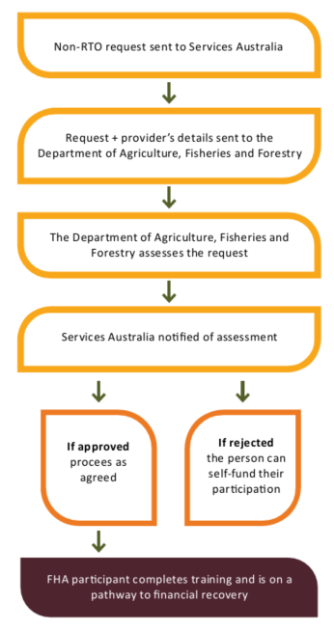

The $10,000 Activity Supplement
The $10,000 Activity Supplement available to FHA recipients is taxpayer funding to help develop skills, access training or receive professional advice with a view to assist farming families to improve their financial circumstances.
Services Australia assesses requests relating to professional advice and Registered Training Organisation (RTO) training. The Department of Agriculture Fisheries and Forestry assesses Non-RTO requests. Previous approvals show that most training costs between $600 to $3,000.
Previous examples of training include:
- Business and accounting courses
- Computer and web design courses
- Leadership and strategy courses
- Pasture and grazing management training
- Marketing courses
- Risk management training
- Animal husbandry training
- Chemical and food safety certification
- Regenerative land management training
- Natural resource management courses
- Pilot licence training
- Heavy vehicle training
- Yoga and massage courses
- Aerial drone training
This is not an exhaustive list but it does highlight a diverse range of training approvals.
Acknowledgement of Country
We acknowledge the Traditional Custodians of Australia and their continuing connection to land and sea, waters, environment and community. We pay our respects to the Traditional Custodians of the lands we live and work on, their culture, and their Elders past and present.
© Commonwealth of Australia 2023
Unless otherwise noted, copyright (and any other intellectual property rights) in this publication is owned by the Commonwealth of Australia (referred to as the Commonwealth).
All material in this publication is licensed under a Creative Commons Attribution 4.0 International Licence except content supplied by third parties, logos and the Commonwealth Coat of Arms.
The Australian Government acting through the Department of Agriculture, Fisheries and Forestry has exercised due care and skill in preparing and compiling the information and data in this publication. Notwithstanding, the Department of Agriculture, Fisheries and Forestry, its employees and advisers disclaim all liability, including liability for negligence and for any loss, damage, injury, expense or cost incurred by any person as a result of accessing, using or relying on any of the information or data in this publication to the maximum extent permitted by law.

