Rebuilding the FHA: a better way forward for supporting farmers in financial hardship

An independent review of the Farm Household Allowance
Michele Lawrence (Chair), Georgie Somerset and Robert Slonim
February 2019

© Commonwealth of Australia 2019
Ownership of intellectual property rights
Unless otherwise noted, copyright (and any other intellectual property rights, if any) in this publication is owned by the Commonwealth of Australia (referred to as the Commonwealth).
Creative Commons licence
All material in this publication is licensed under a Creative Commons Attribution 4.0 International Licence except content supplied by third parties, logos and the Commonwealth Coat of Arms.
Inquiries about the licence and any use of this document should be emailed to copyright@agriculture.gov.au.

Cataloguing data
This publication (and any material sourced from it) should be attributed as: Lawrence, M, Somerset, G & Slonim, R 2019, Rebuilding the FHA: a better way forward for supporting farmers in financial hardship, an independent review of the Farm Household Allowance, Canberra, February. CC BY 4.0.
ISBN 978-1-76003-196-1
This publication is available at agriculture.gov.au/fha-review
Department of Agriculture and Water Resources
GPO Box 858 Canberra ACT 2601
Telephone 1800 900 090
Web agriculture.gov.au
The views expressed in this report do not represent the views of the Australian Government. The Australian Government—including the Department of Agriculture and Water Resources, their employees and advisers—and the review panel members disclaim all liability, including liability for negligence and for any loss, damage, injury, expense or cost incurred by any person as a result of accessing, using or relying on any of the information in this report to the maximum extent permitted by law.

Letter of transmittal
The Hon. David Littleproud MP
Minister for Agriculture and Water Resources
Parliament House
Dear Minister
In September 2018 you appointed this panel to review the current settings of the Farm Household Allowance (FHA) program.
In accordance with the review’s terms of reference, we are pleased to present the final report—Rebuilding the FHA: a better way forward for supporting farmers in financial hardship.
This report offers recommendations to decouple the FHA from social security legislation and improve mutual obligations to meet the needs of farmers in financial hardship, and encourage a more proactive approach to address the challenges farmers face in order to improve their long-term financial outcomes.
We commend the government’s willingness to review the FHA and expose it to independent scrutiny. Regular periodic review is necessary to maintain confidence in this important program’s effectiveness and ensure its continuous improvement.
The Panel unanimously supports all of its recommendations and actions and takes full responsibility for the views expressed.
Yours sincerely
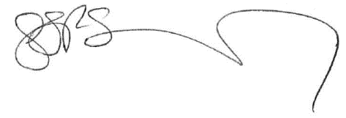
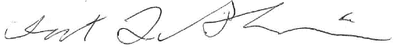
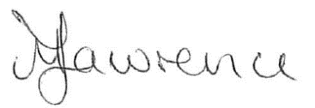

Michele Lawrence (Chair) Georgie Somerset Robert Slonim

Acknowledgements
The Panel thanks the many stakeholders who contributed to the review, especially those who gave their time to make written submissions, participated in meetings during the consultation process and other discussions, or assisted with research and advice. This includes farmers, who often shared their personal and emotional experiences, representatives from the Australian and state and territory governments, industry and community groups, the Rural Financial Counselling Service (RFCS), Department of Human Services (DHS) and other individuals. These contributions have offered the Panel useful insights into the FHA and how to improve the program.
The Panel acknowledges the professional support of the review secretariat from the Australian Government Department of Agriculture and Water Resources. The Panel would also like to express its gratitude to other departmental officers and the RFCS providers who provided invaluable on-the-ground knowledge and support.

Contents
Letter of transmittal iii
Acknowledgements iv
Contents v
Executive summary vii
Recommendations x
Observation x
Recommendations with guiding actions xi
Observation xiv
Introduction 1
Background to the FHA 1
Reviewing the FHA 3
Consultation and resources 3
The important role of the FHA 4
Report structure 8
1 Decoupling from social security and tailoring access—applications, income, assets and eligibility 9
1.1 Linkages with broader social security 9
1.2 Application process 11
1.3 Means tests—assets and income 17
1.4 Eligibility 25
2 Facilitating long-term business success and reducing dependency risks 28
2.1 Content of current mutual obligations 29
2.2 Timing of current mutual obligations 31
2.3 Redesigning the mutual obligations 32
2.4 Increasing access to the FHA while encouraging self-sufficiency and structural change 37
3 Refocus the roles in FHA delivery towards business support 40
3.1 Effectiveness of current roles 40
3.2 Refocusing roles 42
4 Improve communications 44
4.1 Re-branding the FHA 44
4.2 Improving communication 46
4.3 Training information 47
4.4 Rethinking ‘don’t self-assess’ 47
4.5 Improving communication support for RFCs 49
5 Distinguish the FHA from drought 51
5.1 Drought in Australia 51
5.2 Confusion over demand for the FHA in drought 51
5.3 Expectations of drought support 53
5.4 Messaging about the FHA 54
5.5 Impact of supplementary payment 54
5.6 Drought in the redesign of the program 55
6 Build in regular assessment of performance 56
6.1 Improved data collection 56
6.2 Exit survey data 57
7 Observation: avoiding financial hardship should be the long-term goal 59
Appendix A: FHA program settings 60
Eligibility test 60
Assets tests 60
Income test 61
FHA support 62
Activity requirements 63
Appendix B: Terms of reference 65
Guiding principles 65
Scope of the review 65
Out of scope 66
Appendix C: Review panel biographies 67
Mrs Michele Lawrence (Chair) 67
Ms Georgina Somerset 67
Dr Robert Slonim 67
Appendix D: Submissions and consultation 69
Written submissions 69
Face-to-face consultations 70
Have your say survey 70
Glossary 71
References 72

Executive summary
The Farm Household Allowance (FHA) is the Australian Government’s income support payment for farmers and their partners experiencing financial hardship, regardless of its cause. Since its commencement in July 2014, the program has provided support to 10,054 people. As at 21 December 2018, 5,136 people were currently on payment.
In September 2018 an independent panel was appointed to review the FHA program in accordance with terms of reference set by the Hon. David Littleproud MP, the Minister for Agriculture and Water Resources. The members of the Panel were:
- Mrs Michele Lawrence (Chair), member of the Agricultural Industry Advisory Council and dairy farmer, Tasmania
- Mrs Georgie Somerset, General President of AgForce Queensland and cattle farmer, Queensland
- Professor Robert Slonim, Professor of Economics at the University of Sydney and former director and current chair of the Academic Panel of the Australian Government’s Behavioural Economics Team.
To inform its work, the Panel completed an extensive consultation program in October and November 2018. This involved seven and a half weeks of face-to-face consultations across each state and territory except the Northern Territory, five weeks for written submissions and seven weeks for a stakeholder survey. The Panel welcomed input from both successful and unsuccessful FHA applicants, other farmers, industry groups, government agencies, as well as bankers and people in support and advisory roles such as rural financial counsellors, the Country Women’s Association, Isolated Children’s Parents’ Association, and accountants. During this consultation period the Panel spoke to over 235 individuals, and received 33 written submissions and 83 completed surveys.
The Panel presents this report to government as a guide to rebuild the FHA to allow the program to better meet its dual objectives to provide income support and assist structural change. The Panel is of the view that the policy approach for income support introduced under the FHA was a necessary positive step forward for farmers experiencing financial hardship and the agricultural industry more broadly.
This report offers six strategic recommendations with supporting actions to achieve each of these recommendations. The Panel considers these changes will create an improved FHA which builds on previous work, including moving from exceptional circumstances to a standalone income support payment, and takes the next step forward to assist farmers in financial hardship, regardless of the cause.
The Panel found the single biggest challenge facing the success of the FHA was the program’s tension between addressing farm business issues while being designed around the social security; a system designed to support individuals. The Panel heard stories during almost all consultations detailing people’s difficulties and frustrations in applying for the FHA. Most farmers the Panel spoke with found the process frustrating, demoralising and disheartening. The Panel strongly believes that decoupling the FHA program from the Social Security Act 1991 will create a tailored program that should more effectively reach those farmers in financial hardship.
In undertaking the review, the Panel considered the program’s dual objectives of providing support and assisting structural change, as outlined in the terms of reference. The Panel has found there is no systematic data collection with the goal to quantify whether the FHA’s long-term outcomes are being reached. In undertaking the review, the Panel relied on available descriptive data and anecdotal evidence to consider the dual objectives. During consultations the Panel heard from several farmers who described how the FHA had a positive impact on both their family lives and farming businesses. Moreover, very few people that were consulted recommended removing the program entirely, yet most people consulted were keen to offer insights on how it could be improved. The Panel found that achieving the objectives of both providing support and assisting structural change is a challenging balancing act, but overall worthwhile, and should continue.
This report offers recommendations to improve mutual obligations to meet the needs of farmers in financial hardship, and encourage a more proactive approach to address the challenges farmers face in order to improve their long-term financial outcomes.
This report centres on strategic recommendations with supporting actions:
- First and foremost, there is a need to decouple the FHA from the social security legislation to tailor access and delivery to recognise the unique, and often complex, financial and business nature of Australian agriculture businesses.
- The next step is to redesign the program to develop a revised farmer centric approach to mutual obligations that will allow farmers to work with the RFCS to plan a path through their financial situation (business and personal) or to make informed decisions about their longer term viability. The redesigned program should allow some flexibility to acknowledge the wide range of reasons people access income support and should ensure the program does not hinder structural change or create welfare dependency.
- A key aspect of the next phase of the program is also a need to improve the communication of the FHA. This report offers recommendation to re-brand the program to communicate more clearly the program’s objectives.
- Finally, this report recommends improving data collection methods for evaluation to allow the FHA to continually adapt and change in a timely manner to ensure the program is meeting its dual objectives.
The report also offers insights on how the FHA has responded to farmers experiencing the recent drought. The Panel believes that adding a drought supplement payment to the FHA resulted in confusion around the eligibility and intention of the program. The Panel considers the temporary increase to the net assets limit was a positive step for the program and should be maintained.
In addition, the FHA is a safety net and the Panel encourages government to continue to explore innovative pre-emptive policies, in addition to those already available, which assist farmers in avoiding financial hardship and therefore the need for FHA-type assistance. Proactive preventative policies are especially critical to improve the overall wellbeing of small farm businesses.
The Panel has welcomed the opportunity to review this important program and considers its recommendations provide a pathway to better supporting farmers in financial hardship.

Recommendations
This independent review of the Farm Household Allowance (FHA) offers six strategic recommendations with supporting actions to achieve each of these recommendations.
Recommendation 1: Decouple from social security legislation
Decouple the FHA from the Social Security Act 1991 with the aim of simplifying and tailoring the application process and eligibility settings to farm businesses.

Recommendation 2: Strengthen the mutual obligation
On commencement of the rebuilt FHA program, prioritise a meaningful mutual obligation process, whereby farmers work with the Rural Financial Counselling Service (RFCS) to engage in a viability assessment enabling them to either plan through the current financial hardship and prepare for future business shocks, or exit the industry with dignity.

Recommendation 3: Revise the Rural Financial Counselling Service (RFCS) role within the FHA towards business support
Enhance the role of the RFCS under the FHA program to focus on business coaching of recipients, with the addition of a role for a financial advisor. To minimise duplication, this should utilise existing processes undertaken by the RFCS.

Recommendation 4: Improve communications
Prioritise effective communication of the FHA to provide clarity of program purpose and requirements at all stages from application to completion.

Recommendation 5: Distinguish the FHA from drought
The FHA was designed to support farmers during financial hardship irrespective of the cause and should be communicated and promoted to align with its broader purpose.

Recommendation 6: Build in regular assessment of performance
In rebuilding the FHA, the agency tasked with delivering the program must capture information to effectively measure its performance. This data should be used as the basis for regular reviews and to guide future changes.

Observation
Observation 1: Avoiding financial hardship should be the long-term goal.

Recommendations with guiding actions
Recommendation 1: Decouple from social security legislation
Decouple the FHA from the Social Security Act 1991 with the aim of simplifying and tailoring the application process and eligibility settings to farm businesses.
Action 1.1 Following decoupling of FHA from the social security legislation the government should ensure the agency delivering FHA is managed to meet the key performance indicator targets included in Action 1.2 c).
Action 1.2 Following decoupling of the FHA from the Social Security Act, redesign the application process with these principles:
a) The FHA application form should be significantly simplified and shortened, with just one form that captures the relevant information and minimal supplementary information. The revised form should be reviewed by the communication advisory panel outlined under Action 4.3.
b) The level of supporting evidence required should be significantly reduced.
c) The revised FHA application process should allow for the vast majority (85 per cent) of applicants to be able to receive a decision, and if eligible a payment, within two weeks of submitting an application.
d) The information requested on the application form should be tailored to the program’s needs.
e) The applicant should be kept informed of the status of their application, have an easy means to check on the status at any time, and be provided with a decision as soon as possible.
f) The process for people to return on payment should also be streamlined and should recognise information provided in earlier applications.
Action 1.3 Following decoupling of the FHA from the Social Security Act, redesign the means tests for income and assets for the FHA with these principles:
a) Use existing taxation classifications and processes for income treatment, where appropriate.
b) Change the income reporting and assessment process so it recognises the irregularity of farm income over multiple years and reduces the likelihood of farmers being overpaid and incurring a debt.
c) Replace the business income reconciliation process with targeted fraud compliance.
d) Ensure means tests are not a disincentive for good business practices or resilience building.
e) Quarantine income and liquid assets generated from the forced sale of livestock.
f) Ensure the treatment of non-farm income, such as from contracting and agistment, does not create disincentives for generating cash flow.
g) Recognise the need for farm businesses to have cash reserves to continue to operate.
Action 1.4 Following decoupling of the FHA, ensure that the recipients of the rebuilt FHA program maintain access to the health care card and other supplementary allowances currently available under social security.
Action 1.5 Permanently move the on-farm asset test limit to $5.0 million (net and CPI indexed from 2018).
Action 1.6 Reconsider whether the current definitions of who can access the program under the eligibility settings remain appropriate and sufficiently meet the program’s objectives.
Action 1.7 Government needs to be cognisant of the aging farming population and value the role they play in the natural, physical and social capital in regional Australia by developing an explicit pathway to the age pension for eligible recipients under the rebuilt program.
Recommendation 2: Strengthen the mutual obligation
On commencement of the rebuilt FHA program, prioritise a meaningful mutual obligation process, whereby farmers work with the Rural Financial Counselling Service (RFCS) to engage in a viability assessment enabling them to either plan through the current financial hardship and prepare for future business shocks, or exit the industry with dignity.
Action 2.1 Remove the requirement for FHA recipients to undergo a Farm Financial Assessment (FFA), sign on to a Financial Improvement Agreement (FIA) and to undertake an activity in the FIA.
Action 2.2 Require FHA recipients to meet with a rural financial counsellor a minimum of every three months to have structured discussions about their business and individual situation and the opportunities for change. To minimise duplication, this should utilise existing processes undertaken by the Rural Financial Counselling Service (RFCS), such as the development of action plans.
Action 2.3 Require FHA recipients to consider aspects of financial, land and animal management in discussions with their Rural Financial Counsellor.
Action 2.4 Require FHA recipients to work through a viability assessment of their farm business with a rural financial counsellor or external advisor after they have received the FHA for 12 to 18 months. The outcome of this assessment would guide discussions with the counsellor and future actions by the recipient.
Action 2.5 Upon commencement of the rebuilt program, prioritise the viability assessment of farmers who are currently receiving the FHA.
Action 2.6 Develop a decision-making template or flow chart to help guide rural financial counsellors or external advisors through the viability assessment with the FHA recipient.
Action 2.7 Provide FHA recipients with optional funding to help them undertake training and other activities to improve their situation.
Action 2.8 Provide farmers with access to the FHA program for a maximum period of four years in every ten years.
Action 2.9 Ensure farmers who have already accessed the FHA for four years in the last ten years do not receive additional years of income support within any rebuilt FHA program.
Recommendation 3: Revise the Rural Financial Counselling Service (RFCS) role within the FHA towards business support
Enhance the role of the RFCS under the FHA program to focus on business coaching of recipients, with the addition of a role for a financial advisor. To minimise duplication, this should utilise existing processes undertaken by the RFCS.
Action 3.1 Change the role of the Rural Financial Counselling Service (RFCS) under the rebuilt FHA program to focus on business coaching of recipients, utilising existing processes undertaken by the RFCS where possible.
Action 3.2 Enable the RFCS to provide the viability assessment function either internally or through accessing appropriately skilled and qualified external advisors.
Action 3.3 Enable the RFCS to develop stronger relationships with Primary Health Networks to allow for greater collaboration with on-the-ground health support.
Action 3.4 Change the role of the case officer in the delivery agency to focus on assisting farmers through the application process and payment management.
Recommendation 4: Improve communications
Prioritise effective communication of the FHA to provide clarity of program purpose and requirements at all stages from application to completion.
Action 4.1 Re-position and rebrand the messaging for the FHA so it is clearly distinct from social security and emphasise that FHA is for financial hardship, as defined by the program.
Action 4.2 Engage farmers who have successfully exited the industry to communicate to other farmers about their experiences.
Action 4.3 As a matter of priority, create a small communication advisory panel to assist with implementing the rebuilt FHA program and all the communication action items, with membership representing:
- experience in behavioural insights
- an agricultural industry body
- the Rural Financial Counselling Service
- the agency responsible for program delivery
- the Department of Agriculture and Water Resources (as the agency with policy responsibility).
Action 4.4 As a matter of priority, have the communication advisory panel review all FHA webpages and written communications provided to recipients under the current program (such as program materials and letters) to ensure the information dissemination, tone and messaging is appropriate.
Action 4.5 Create a dedicated website for the FHA that is separate and distinct from Centrelink and provides simple, farmer-centric information about the program.
Action 4.6 Expand the recently developed Farm Hub to include information on training, advisors and consultancies that are relevant to small agricultural businesses.
Action 4.7 As a matter of priority, have the communication advisory panel develop a simple, farmer-centric one-page fact sheet that explains each of the FHA’s eligibility settings.
Action 4.8 As a matter of priority, have the communication advisory panel develop a simple, one-page summary for each of the support measures that are available to farmers so they can choose the right source of assistance. Each fact sheet should feature eligibility, benefits, how to apply, contacts and links.
Action 4.9 Ensure the expectations and requirements of FHA recipients are clearly communicated in all stages of the program.
Action 4.10 Establish an information hub on the FHA for rural financial counsellors.
Recommendation 5: Distinguish the FHA from drought
The FHA was designed to support farmers during financial hardship irrespective of the cause and should be communicated and promoted to align with its broader purpose.
Action 5.1 Ensure communication and marketing clearly indicates that the FHA is available to farmers in financial hardship, irrespective of cause.
Action 5.2 If the government determines it will provide assistance targeted specifically to drought, it should be delivered through an individually tailored program.
Recommendation 6: Build in regular assessment of performance
In rebuilding the FHA, the agency tasked with delivering the program must capture information to effectively measure its performance. This data should be used as the basis for regular reviews and to guide future changes.
Action 6.1 Ensure data is collected throughout the delivery of the FHA program to allow greater monitoring and evaluation of policy and delivery settings.
Action 6.2 Arrange for an independent streamlined review of the rebuilt program every two years of operation to examine how the revised settings are meeting the program’s objectives.
Action 6.3 Undertake an exit interview of every recipient that leaves the FHA program to collect information on the change in a recipient’s situation over the course of the program.

Observation
Observation 1: Avoiding financial hardship should be the long-term goal.

Introduction

Background to the FHA
The Farm Household Allowance (FHA) is the Australian Government’s income support program for farmers experiencing financial hardship, regardless of its cause. Since its commencement in July 2014, the program has provided support to 10,054 people. As at 21 December 2018, 5,136 people were currently on payment.
The FHA provides income support to farmers via a fortnightly payment that is intended for use on household needs. The rationale for this was to ensure farmers are provided with a safety net, are treated equitably and have access to the same benefits and services as other social security income support recipients.
The program also aims to assist structural change by providing recipients with a limited period of income support during which time they are required to undertake activities aimed at improving their long-term financial circumstances (mutual obligations). Time limiting access to the program is intended to incentivise change to reduce the risk of long-term welfare dependency. The time on payment is intended to assist farmers experiencing financial hardship to: learn new skills, have the time to recover and return to profitability, create new income streams either through diversification or off-farm income, or explore options for a dignified transition out of farming. All of these outcomes support structural change at the farm level.
The break-up of FHA recipients by state, industry type and age group are shown in Figure 1, Figure 2 and Figure 3.
Figure 1 FHA recipients, by state and territory
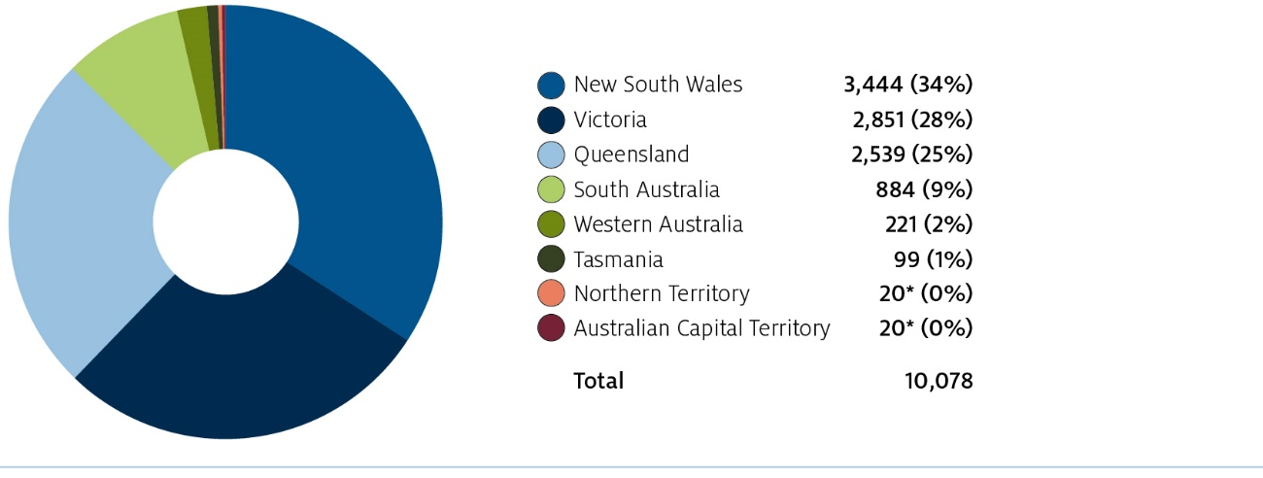
Note: Numbers represent granted FHA recipients over the life of the program. Where there are fewer than 20 claims in any one state or territory, numbers have been masked for privacy reasons. Data as at 21 December 2018.
Source: Department of Human Services
Figure 2 FHA recipients, by industry type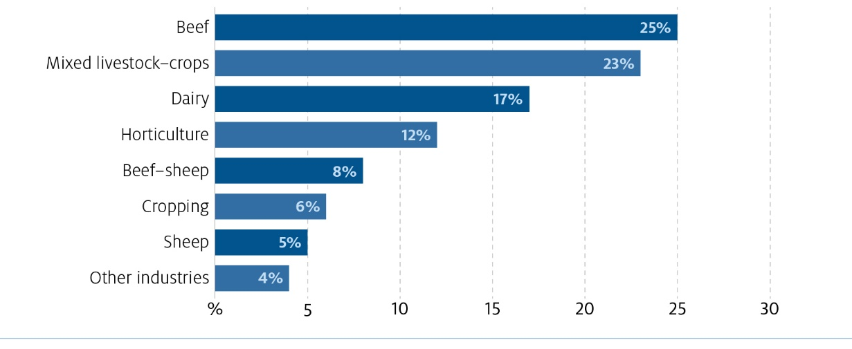
Note: Numbers represent the industry of granted FHA recipients over the life of the program. Horticulture includes: fruit, vegetables, grapes and viticulture. Beef includes: beef and beef combined with other industry. Dairy includes: dairy and dairy combined with other industry. Other industries includes: rice, cotton, sugarcane, flowers, poultry, pig, and other livestock. Data as at 21 December 2018.
Source: Department of Human Services
Figure 3 FHA recipients, by age, compared with general population of farmers and farm managers
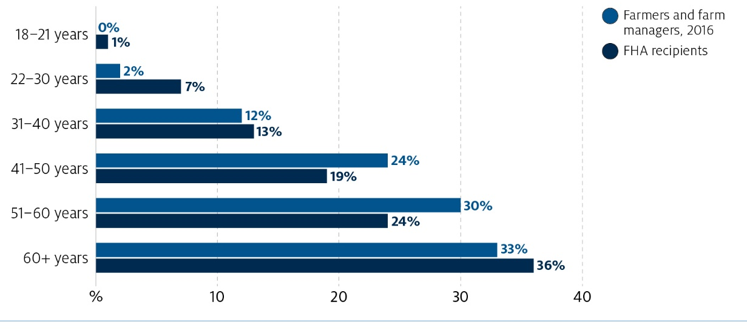
Note: FHA numbers represent granted FHA recipients over the life of the program. Data as at 21 December 2018.
Source: Department of Human Services, Census of Population and Housing, 2016, TableBuilder.
The introduction of the FHA program was a significant shift in the government’s approach to providing financial support to farmers. It was introduced after the 2009 Productivity Commission Inquiry into Government Drought Support and after testing of the option through the pilot of drought reform measures in Western Australia from 1 July 2010 to 30 June 2012.
The provision of farm household support, through the FHA, has also been embedded into the Intergovernmental Agreement (IGA) on National Drought Program Reform, which was agreed by Australian, state and territory primary industries ministers in May 2013. The IGA was developed in recognition of Australia’s history of drought events, the increasing likelihood of such conditions, and the agreed principle that farm businesses need to prepare for drought, rather than rely on governments’ response as an exceptional circumstance.
The FHA has been mainstreamed with the social security system. The government set up the FHA in legislation under the Farm Household Support Act 2014 (FHS Act), which has strong links to the Social Security Act 1991. There are also a number of Minister’s Rules under the FHS Act. The Act introduced a permanent, demand-driven and uncapped income support program for Australian farmers to access for any type of financial hardship.
The policy for the program is managed by the Department of Agriculture and Water Resources and the program is delivered by the Department of Human Services, through Centrelink.
Further detail on the settings of the program is provided in Appendix A.

Reviewing the FHA
On 29 July 2018 the Hon. David Littleproud MP, the Minister for Agriculture and Water Resources, announced an independent review of the FHA program. After four years of operation, the government considered it was timely to review whether the current settings of the program:
- are effective and efficient in meeting the original objectives to provide assistance while assisting farmers to improve long-term financial circumstances
- remain fit for purpose
- contribute to an enduring approach to income support for farmers in financial hardship, including drought.
In September 2018 the government appointed an independent panel to review the program in accordance with terms of reference set by Minister Littleproud. The Panel consisted of:
- Mrs Michele Lawrence (Chair), member of the Agricultural Industry Advisory Council and dairy farmer, Tasmania
- Mrs Georgie Somerset, General President of AgForce Queensland and cattle farmer, Queensland
- Professor Robert Slonim, Professor of Economics at the University of Sydney and former director and current chair of the Academic Panel of the Australian Government’s Behavioural Economics Team.
The full terms of reference for the review are provided at Appendix B and biographies of the members of the Panel are at Appendix C.

Consultation and resources
The Panel completed an extensive consultation program in October and November 2018 to inform its review of the program. This involved seven and a half weeks of face-to-face consultations across each state and territory except the Northern Territory, five weeks for written submissions and seven weeks for a stakeholder survey. The Panel conducted a public consultation process and welcomed input from those who have received the FHA, those who had not received the FHA, industry groups, government agencies and those in support and advisor roles such as rural financial counsellors and accountants.
The Panel also consulted with the Special Envoy for Drought Assistance and Recovery, the Hon. Barnaby Joyce MP, and the Coordinator-General for Drought, Major General Stephen Day.
During the consultation period the Panel spoke to over 235 individuals, and received 33 written submissions and 83 completed surveys. A full list of written submissions is provided in Appendix D.
The Panel also obtained information about the history, design and intent of the program from the policy agency, the Department of Agriculture and Water Resources, as well as information about the program’s delivery from the Department of Human Services. The Panel received descriptive statistics of FHA applications and overall take-up across states and farming sectors. However, the Panel found that limited data has been collected on the outcomes being achieved by the program, which has reduced the Panel’s ability to fully evaluate whether program objectives are being realised.

The important role of the FHA

Australian agriculture
Agriculture plays an important role in our economy and our food security. The majority of food consumed in Australia is grown and supplied by Australian farmers—food produced in Australia accounts for around 85 per cent of our expenditure on household food consumption (Hogan 2018). Australian farmers also have a strong focus on overseas trade. Around two-thirds of the total value of Australian agriculture, fisheries and forestry production is exported (Jackson, Zammit & Hatfield-Dodds 2018), with the value of exports estimated to be nearly $49 billion in 2017–18 (ABARES 2018).
Farming is also a key pillar of our rural and regional communities, contributing to local economic activity and the social fabric of these communities. More than 88,000 agricultural businesses operate in Australia across just over half (51 per cent) of Australia’s total land area (ABS 2018). Around 228,000 people are employed in Australian agriculture, with around 82 per cent of these people living in regional areas of Australia (Binks et al. 2018).
Australian farmers face significant variability in their work, including a highly variable climate and volatile commodity prices. These factors generate substantial differences in farm output across seasons. The volatility of Australian agriculture is greater than that experienced by farmers in most other countries, as well as those experienced by business owners in other sectors of our economy, as shown in Figure 4 and Figure 5 (Jackson, Zammit & Hatfield-Dodds 2018).
Figure 4 Index of volatility of national annual agricultural output value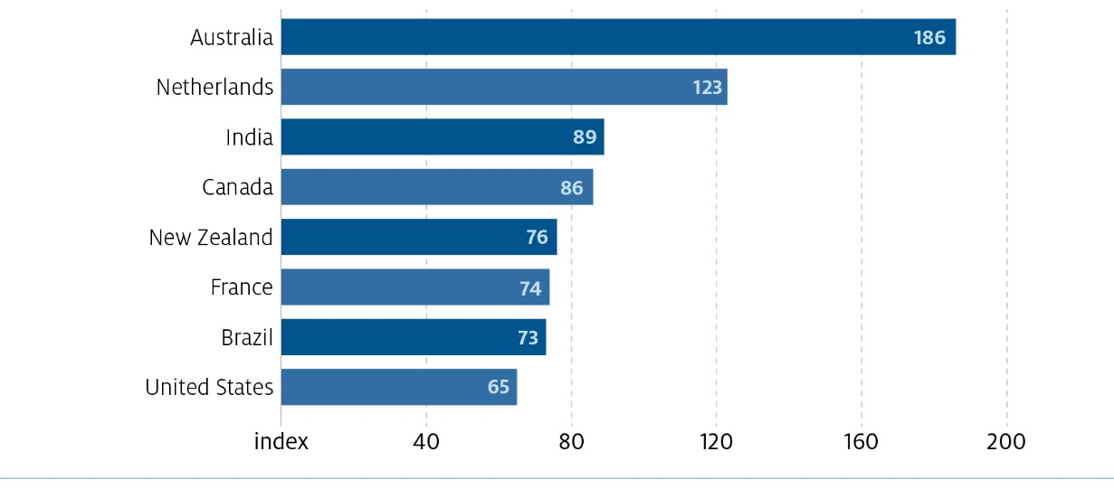
Note: Average volatility of agricultural output across 15 countries (not all shown) = 100.
Source: Jackson et al. 2018, adapted from Keogh (2012) including risk in enterprise decisions in Australia's riskiest business.
Figure 5 Index of relative volatility in annual value of output for selected Australian economic sectors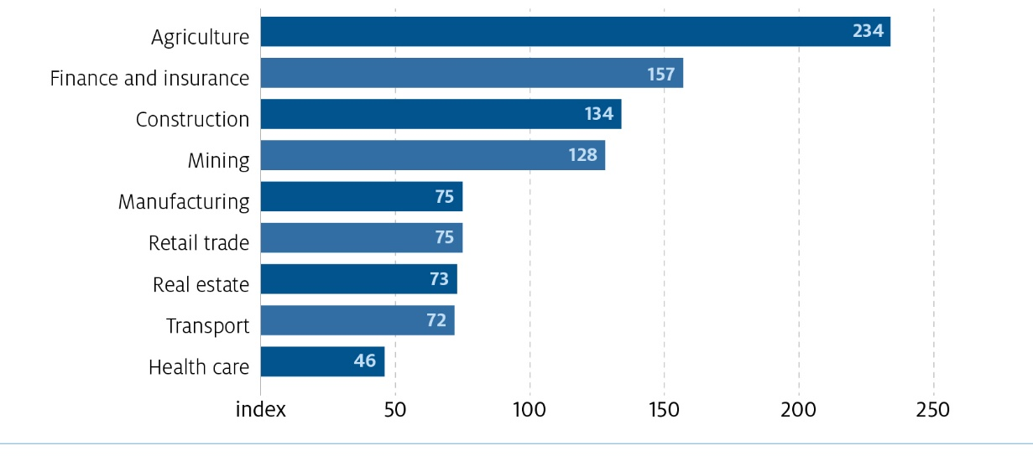
Note: Average volatility of agricultural output across 15 countries (not all shown) = 100.
Source: Jackson et al. 2018, adapted from Keogh (2012) including risk in enterprise decisions in Australia's riskiest business.

Supporting farmers and assisting structural change
The FHA program intention is to provide a safety net for farmers facing financial hardship, and the establishment of the program built on previous policy experience relating to farm and drought support. The FHA program provides monetary support to allow farmers to secure household needs. The Panel also recognises that alleviating some of the financial pressures faced by farm households has flow-on effects to the community—for example, it could allow for families to continue to shop locally or for continued participation in after-school activities and local events.
As part of the exit surveys undertaken for the program, recipients were asked about how they used the income support payment. The majority indicated that they used it to meet household needs until seasonal conditions or prices improved (Figure 6).
Figure 6 How the FHA fortnightly payments are used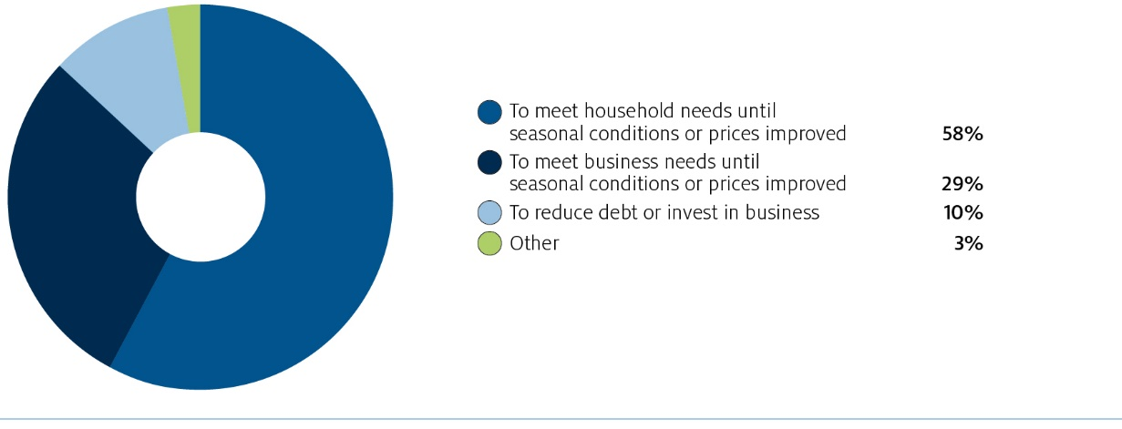
Source: Exit surveys from the FHA Program, which had 839 respondents from 2,200 requests as at 3 May 2018.
Importantly, the program also provides incentives to allow recipients to plan and take steps to improve their long-term financial circumstances. The majority of farmers who completed the exit survey for the program indicated they thought the program had enabled them to improve their circumstances for the long-term future.
An example of a success story from the program was a case study provided by the Rural Financial Counselling Service (RFCS) in Southern Queensland.
The fortnightly payments have enabled the farmers some breathing space by ensuring their large family’s basic needs are met and allowing them to make critical business decisions under less stressful circumstances. Having also undertaken the Financial Improvement Agreement they have been able to look into the future and see what it could possibly mean for them once they get through their business plan and the initial restructuring phase. The relief provided by the FHA is well appreciated by these farmers. (RFCS Southern Queensland)
In addition to providing income support, the program aims to assist with structural change in agriculture. Structural change is dynamic and inevitable, largely driven by changing economic conditions, circumstances and technology (RIRDC 2007). On the whole, structural change can lead to greater efficiencies and opportunities for agriculture. However, the unique nature of farming justifies some support from government in the change process. This support should seek to assist farmers through structural change in order to realise benefits and reduce any negative impacts.
The FHA is intended to assist farmers in financial hardship who are at a key point in the structural change process. Farmers at a critical crossroad for their future will make decisions that will likely lead them to either becoming profitable and remaining in farming, obtaining off-farm income to improve their financial situation, or selling their farm and exiting the sector. These decisions will, at the farm level, influence structural change in agriculture.
The exit survey for the FHA program asked recipients what expectations they had for their future. The majority of farmers (50 per cent) indicated that they intend to stay on the farm with greater farm income and/or less debt (Figure 7).
Figure 7 FHA recipients’ expectations for their future
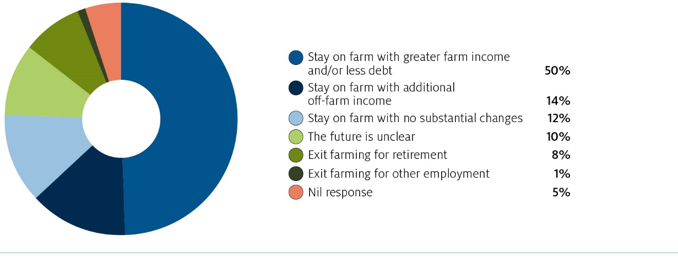
Source: Exit surveys from the FHA Program, which had 839 respondents from 2,200 requests as at 3 May 2018.
Supporting farmers through structural change is appropriate because, compared with many other occupations, farmers face greater and often uninsurable risks, and lack flexibility in seeking alternative sources of income in downturns. The demands of the farm continue regardless of the revenue being obtained, limiting the time that farmers have to make changes to their situation, such as seeking and obtaining off-farm income. For farmers who need to exit the industry, changing jobs will likely mean selling the farm, relinquishing their income, their home and sometimes their life’s work and identity. This is an enormous financial and personal change for these farmers and their families. The goal should be for any exit to be made by choice and with dignity, rather than under financial duress.

The FHA in the broader context of farm support
The Panel observed that farmers in financial hardship are often facing a range of issues when they decide to seek assistance. These issues are complex and intertwined, including health problems, caring responsibilities, succession transition, bereavement and recovery from previous downturns. Any program dealing with cohorts experiencing any combination of these issues needs to utilise the right mix of skills, experience and tools in order to assist.
During the consultation process many stakeholders advised the Panel that it is important ‘to consider the whole’ when working with farmers facing financial hardship. With this in mind, the Panel is keen to highlight that, while this review is focused solely on the FHA, there are many channels for a broader range of support and assistance from all levels of government, industry and non-profit organisations. As one counsellor in Western Australia pointed out, their job is working together with farmers to ‘solve the puzzle’ and the FHA is just one piece of this puzzle. The issues farmers attempting to access the FHA face can be multi-dimensional and complex and it is remiss to think one program in isolation could provide all the answers and support. The FHA is the only income support payment available to farmers in financial hardship but is delivered alongside many other support mechanisms.
At the Australian Government level, a range of support is available to farmers in the normal course of business as well as in financial hardship, such as concessional loans, taxation measures, farm management deposits, water infrastructure projects and the Rural Financial Counselling Service. At the state level, the support and information varies from state to state but includes such assistance as transport subsidies, concessional loans and innovation funds. Charitable groups also provide various levels of support to farmers in hardship.

Report structure
This review has provided an important opportunity to examine the settings and delivery of the FHA program and whether it is meeting the objective of assisting the farming community.
The Panel has come to the view that while there are some success stories from the FHA, there are weaknesses in the design of the program and a rebuild is necessary in order for the objectives of the program to be better achieved. This rebuild must focus on the practical implementation of objectives, with greater tailoring to the needs and circumstances of the recipient.
Specifically, the Panel has found that the FHA needs to be decoupled from social security, with the mutual obligations better tailored to the needs of recipients and the program’s objectives. The Panel also considers there is scope for the Rural Financial Counselling Service to have a greater role in case management, for improvements to be made around communication, and arrangements made for monitoring and evaluating program outcomes.
To this end, the Panel has made six strategic recommendations to improve the FHA program and has also proposed a series of actions that will guide the implementation of each recommendation.

Decoupling from social security and tailoring access—applications, income, assets and eligibility
Recommendation 1: Decouple from social security legislation
Decouple the Farm Household Allowance from the Social Security Act 1991 with the aim of simplifying and tailoring the application process and eligibility settings to farm businesses.
In 2014 the Farm Household Allowance (FHA) was introduced to replace the exceptional circumstances framework and transitional farm family payment—the previous income support programs to farmers experiencing financial difficulties. In line with recommendations from the 2009 Productivity Commission (PC) Inquiry into Government Drought Support and principles agreed as part of the 2013 Intergovernmental Agreement on National Drought Program Reform, access to the payment was set out through eligibility criteria and means tests (income and assets), rather than being tied to drought declarations.
To create a broad safety net for farmers experiencing financial hardship that was equitable and in line with community expectations for assistance, the FHA was aligned with mainstream social security, with several key exceptions. To achieve this and leverage existing frameworks, the FHA’s legislation, delivery and assessments (including applications and some means tests) were largely aligned with other social security payments.
While logical and practical for implementation, feedback received throughout this consultation highlighted many areas where using the social security framework to provide support to farmers added unnecessary complexity and simply did not work for farm business operators. One farmer speaking to the Panel described the alignment as a ‘square peg in a round hole’. In some cases, this has resulted in a large inequity and burden on farmers compared with other cohorts applying for income support such as job seekers, students and pensioners.
This chapter outlines the Panel’s consideration of the effectiveness and appropriateness of the FHA application process, means tests (income and assets thresholds) and eligibility settings. Removing means testing, making the payment ongoing and recommendations that lead to significant increases in expenditure were out of scope for the review. The Panel’s consideration of how to improve access to the program has taken this into account.

Linkages with broader social security
The FHA was designed and implemented to be consistent with the broader social security system following recommendations from the 2009 PC Inquiry on Government Drought Support. This resulted in the Farm Support Act 2014—the legislation that sets out the FHA—having strong links and references to the Social Security Act 1991.
However, the 2009 PC Inquiry Report (Productivity Commission 2009) also referenced that any new payment should not set up any major inequities and/or adverse incentives in the way it interacts with the general social security system.
Unfortunately, throughout consultation the Panel heard of many stories, circumstances and situations where the broader social security legislation and framework has created adverse incentives and outcomes for individuals operating farming businesses. One farmer described Centrelink and social security as ‘catering to unemployed wage-earners’ rather than employed business owners. Through discussions with Australian Government agencies, the Panel discovered that much of the complexity and rules stemmed from requirements in social security law.
Outlined in further detail in later sections of the chapter are some of the issues brought to the Panel’s attention including:
- length of the application form and process, and detailed questioning that didn’t seem tailored to farmers
- complexity of farm business structures
- requirements for supplementary documentation
- difficulties in estimating income due to both variability and confusion around the definition of income for the purposes of social security
- carrying income for upcoming business expenses.
The Panel feels strongly that the onerous requirements being asked of farmers in financial hardship during the FHA process, including the application, the mutual obligations and eligibility settings are not aligned with the support being provided, and would benefit from significant simplification and tailoring for people operating farm businesses.
Therefore, the Panel recommends that the Farm Household Allowance be decoupled from the Social Security Act 1991 and rebuilt with the strong focus of simplifying and tailoring it to farmers.
The Panel recognises that this would be a significant and complex undertaking requiring time, as well as careful legal and policy analysis. Instead of suggesting specific recommendations on how to rebuild the underpinning FHA legislation, in this chapter the Panel focuses on the outcomes to be achieved under a new framework and a set of actions to achieve these outcomes.

Delivery
Some stakeholders suggested the delivery agency should also be reconsidered. The Panel considers that following de-coupling of the program from social security, the Government will be in a strong position to decide on the most effective delivery agency. The Panel recommends the government consider which delivery agency can allow the program to achieve the service level standards included in Action 1.2 c). The Panel is of the view the simplification of the FHA program as outlined in this report should allow the agency delivering FHA to achieve quick turn arounds in the application process while maintaining the accuracy of payments. Focused management of key performance indicators, including but not limited to the actions outlined in this report, will be critical to ensure better outcomes for applicants.
Action 1.1 Following decoupling of FHA from the social security legislation the government should ensure the agency delivering FHA is managed to meet the key performance indicator targets included in Action 1.2 c).

Application process
The application process was one of the prevailing issues raised with the Panel both in written and verbal consultations. Stakeholders identified the length, complexity and supplementary evidence requirements as key barriers for the program’s take-up and the largest hurdles when engaging with the program. A number of stakeholders who spoke to the Panel stated that without assistance through the application process from their rural financial counsellors (RFCs) or accountants they would not have made it through the process and would have given up. Frustrating experiences throughout the application process also likely coloured some recipients’ thoughts on other aspects of the program, such as the mutual obligations. This may have in turn impacted on the effectiveness of these settings.
Box 1 FHA application form
The FHA application form is available in both paper and dynamic electronic formats on the Department of Human Services (DHS) website.
Each individual applying for the FHA is required to submit a separate application form with the supporting modules of information. This includes when members of a couple have the same assets and income.
The form contains questions to establish a person’s eligibility, assess their ability to financially support themselves via means tests and establish a rate of payment.
Although the form itself is 10 pages (recently reduced from 15 pages in October 2018), the detail in the process lies with the extra information or ‘modules’ required to assess the farm business. As farm businesses often involve complex structures, applicants often need to complete a number of additional ‘modules’ for income and assets, business details, real estate and private companies or trusts.
The extra modules can be tens of pages and the supporting information they require can include copies of tax returns, title deeds, profit/loss statements balance sheets and loan agreements.

Length
Throughout consultation, many stakeholders, including farmers, accountants and advisors, commented that the length of the application was just ‘too much’. It was not uncommon to hear that completed applications with supplementary information ran to several hundred pages long.
The paperwork is unbelievable. [Our application ended up being] a few hundred pages long. (Farmer, Tasmania)
The application process, although slightly improved, is still cumbersome, frustrating, time management poor and a deterrent to [applying]. (Rural Business Tasmania)
As part of the online survey conducted during the review, the difficulty in applying was the main reason participants stated why they would not use government support (Figure 8).
Figure 8 FHA Review Survey: reasons people would not use government support
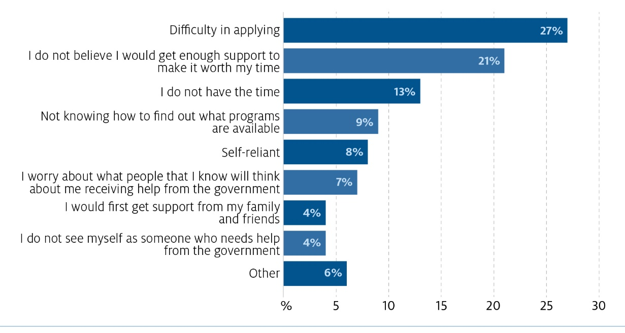
Source: 2018 FHA Review 2018 Have Your Say Survey, which had 83 respondents as at 18 November 2018.
Related to the length, was the time and resources required to assemble the documentation. More than one farmer at the Dubbo public consultation stated that they spent ‘over 40 hours’ putting their initial application forms together. An accountant from South Australia added that assisting a client to complete their FHA application took ‘five to ten hours at least’ and that more often than not they incurred a loss to their business for assisting these clients.
Applicants also felt that the application process took time away from managing the farm and where applicable, looking after livestock. For many people, this burden came at a time when they were often working longer hours and under more pressure—financially and also mentally and emotionally.
Farmers are time poor, and usually exhausted by the time we finish [our] day, and the huge number of forms to fill out is very daunting. (Farmer, New South Wales)
Some RFCs noted that being under additional stress and pressure can also make difficult tasks even harder and cause further frustration. Many stakeholders commented that parts of the application and questions between modules were duplicative and repetitive, such as for income streams, trusts, properties and land titles. Stakeholders questioned why each individual within a farm business is required to submit a separate application form with the supporting modules of information. Additionally, for example, each title of land owned requires its own module to be completed, creating additional work. Some farmers as well as advisors and accountants assisting in the preparation of applications were also frustrated by what they saw as irrelevant and inflexible questioning.
In assessing our assets, the value of our furnishings should have nothing to do with the application, we are not likely to start selling the curtains or lounge suite, nor should we have to. (Farmer, New South Wales)
However, discussions with application processing staff revealed that there were often broader reasons for questions being asked and that it was often based in ensuring the delivery of the FHA was consistent with broader social security. The Panel observed that stakeholder frustration often focused on questions that were only likely to apply to a small number of individuals, leaving the majority of applicants feeling they were irrelevant or not applicable. The Panel also notes that the government has revised the application form several times to reduce the number of questions.

Complexity
Another key issue was complexity, which was driven by both the nature of the questions but also complex farm business structures.
The forms are…just too hard. The complexity is a joke. (Accountant, New South Wales)
The application form includes precise definitions (what constitutes income) that could be different to how some farmers view or think about their business.
Confusion exists as to the meaning of some of the questions and what type of response is being sought. (RFCS Southern Queensland)
Difficulties in understanding questions can also be compounded for applicants with complex business structures that were established for longer term business purposes on the advice of professionals such as lawyers, accountants and business advisors. FHA application processing staff also noted that farming businesses, more often than applicants for other social security payments, had complex business structures, sometimes with several different legal entities including trusts, complex partnerships and companies and multiple income streams going different places. Processing staff stated that unpacking complex business structures was often difficult and time consuming. This also included unpacking and verifying farm assets, which often represents a large component of the processing, but rarely resulted in people being found to be ineligible.
Technological impediments also contributed to the difficulty of the process. Issues relating to applicants’ digital access, connectivity and literacy were compounded by limitations of the Centrelink platform, such as a file upload size limit of five megabytes and instability of modules such as the Farm Financial Assessment for prescribed advisors.

Supplementary evidence requirements
During consultation, the Panel heard from many stakeholders that the supplementary evidence requirements were excessively burdensome, time consuming and in some cases costly. One person cited having to produce a death certificate for her husband’s father because he was associated with one of the companies associated with the couple’s farm business. The Panel also heard of several instances of applicants having to pay their accountants, or other third parties, to retrieve necessary documentation relating to their application or compile the necessary documents to provide their current financial position. Some RFCs noted that this could create another barrier for people already in financial distress.
Some farmers have no financial capacity to pay for accountants to complete their financial statements for previous year/s. This can make the application process difficult as the farmer is required to provide their most recent financial statements and the inability of some farmers to provide their last year’s tax return make their applications invalid. (RFCS Southern Queensland)
Further, many people felt the application process was ‘demoralising’ and ‘dehumanising’ in the requirements to provide third party documentation to verify all statements. People commented that it made the process feel like an ‘interrogation’ and with ‘no trust’ placed in the applicants.
It is clear from that with all the eligibility and questions you don’t trust the farmers….It’s very sad that the very people who feed this nation are treated like this. (Farmer, Victoria)
We are trusted to do our tax, trusted to pay our staff but not trusted when it comes to Centrelink. (Farmer, New South Wales)

Processing time
Due to these multiple factors—length, complexity and supplementary evidence requirements—many people spoke about the time it took for them to reach an outcome on their application.
Processing times for FHA applications have been variable over the life of the program. Throughout consultation the Panel heard examples of some individual cases receiving an outcome within 48 hours, although many people who met with the Panel indicated that it took months and in some cases over a year from when they first submitted their application until they received a final outcome.
Unfortunately, the Panel heard one example of a farmer from South Australia who started an application in late 2017, went back and forth providing further information on many occasions, and finally gave up and sold his farm after still not having a decision on his application nine months later.
Although the Panel understands that DHS has taken some steps towards improving the application processing times, the Panel considers that farmers experiencing financial hardship having to wait for months to have their application processed is unacceptable.
Further, while the Panel had insufficient data on an applicant’s journey to know what was average experience over the life of the program, the Panel is cognisant that there was a consistent pattern of stories like this across the country which can, and do, have a significant and lasting negative impact on the program’s reputation.

Process improvements
Over the life of the program Centrelink has made a number of changes to the application process. These were in direct response to the increased demand for the program due to ongoing drought across the eastern seaboard in the second half of 2018. Changes included:
- cutting the number of questions in the application form by one-third (from 110 to 73) and moving critical eligibility criteria up so people could more easily assess their eligibility
- implementing a streamlined assessment process where a farmer had previously received the FHA payment
- increasing the number of processing staff to over 100
- changing the process so that a Centrelink representative now contacts farmers following lodgement of an application to discuss and request any additional information likely to be needed
- allowing for optional referral to the RFCS for assistance throughout the application process and once on payment.
RFCs, in New South Wales in particular, noted and provided positive feedback on these changes, citing the streamlined process in particular as being well received.
The FHA is also the only income support payment where, as a default, an application will be accepted and start being processed prior to all supporting information being provided. This is in recognition of the complex circumstances of farming businesses and that it is not always possible for farmers to access all of their financial information at the time of applying without first engaging their accountant. However, a decision on an application can only occur after all supporting evidence has been provided.

A fairer, more efficient application process
Application processes are largely dictated by requirements set out in legislation. Much of the requirements for the FHA sit in the Social Security Act 1991 and the Social Security (Administration) Act 1999. Requirements, such as the provision of supplementary documentation, are typically rigid to ensure compliance with legislation, minimise the ability to defraud taxpayer dollars and ensure support is only provided to those without the means to be able to support themselves.
While the Panel generally supports these principles, the outcome of applying the same social security assessment framework to farmers, who have typically different circumstances to the majority of other social security recipients, has resulted in a large inequity and burden on farmers that other recipients don’t face.
One Centrelink processing staff member said that assessing a Newstart application, using the same application framework, can be completed within an hour. In comparison, the same person had not seen a single FHA application able to be assessed within a single day.
The Panel believes applying the same social security assessment framework as other social security recipients has resulted in farmers having to spend hours completing forms, waiting longer to receive assistance, experiencing significant additional stress and in some cases incurring additional out of pocket costs, all while experiencing acute financial difficulties. In practise, the Panel believes that, despite the program being designed to create equal treatment with the social security system, in practice the outcomes experienced by FHA recipients have not been fair or equitable.
The Panel considers that this approach has created a burden that is grossly out of step with the level of support being provided by the program. The focus on compliance to prevent fraud implies farmers are ‘chasing FHA payments’. The Panel does not believe this is the case and instead heard that for most the FHA is a ‘last resort’, often while in dire circumstances. Further, although not able to verify with data, the Panel considers that the costs to administer the program through up-front compliance is not commensurate with the funding being provided to recipients. Anecdotal evidence also suggested that, while many farmers found the FHA payment useful for farm household costs, the dollar amount involved was small when compared with the operating costs for their farm.
Given these issues, the Panel strongly recommends decoupling the FHA from the Social Security Act 1991 with the aim of significantly simplifying the FHA application process. Noting that a revised application process is dependent on revised means tests (discussed later in the chapter), the Panel has recommended principles that should be taken into account in redesigning the FHA application process.
Action 1.2 Following decoupling of the FHA from the Social Security Act, redesign the application process with these principles:
a) The FHA application form should be significantly simplified and shortened, with just one form that captures the relevant information and minimal supplementary information. The revised form should be reviewed by the communication advisory panel outlined under Action 4.3.
b) The level of supporting evidence required should be significantly reduced.
c) The revised FHA application process should allow for the vast majority (85 per cent) of applicants to be able to receive a decision, and if eligible a payment, within two weeks of submitting an application.
d) The information requested on the application form should be tailored to the program’s needs.
e) The applicant should be kept informed of the status of their application, have an easy means to check on the status at any time, and be provided with a decision as soon as possible.

Coming off and back onto payment
The review’s terms of reference state the ability to come on and off payment was a key policy setting in establishing the program.
Box 2 Current settings—process for re-starting payments
Currently, once a farmer comes off the FHA (stops receiving payment), they have 13 weeks to re-engage with Centrelink. After this they have to complete a new application—the same process as applying for the first time. If the new application is completed online, some details will pre-populate. If completed by paper, a new application would need to be submitted. However, generally this does not include having to re-supply supplementary evidence where circumstances have not changed.
A short-form application was implemented from August 2018 for farmers who had exhausted their three year allocation and were returning for their fourth year.
However, consultation indicated that this mechanism wasn’t being utilised to its greatest effect.
Since Farm Household Allowance commenced in July 2014, our service has not experienced a high number of clients opting to withdraw from the payment or return at a later date. (RFCS Southern Queensland)
While some people were effectively coming on and off the payment—as at 21 December 2018, 15.5 per cent of cancelled payments were voluntarily withdrawn—many farmers stated, and RFCs echoed, that they did not want to come off payment ‘because the re-application process was too burdensome’. Further, some farmers considered, and were advised by RFCs that, it was easier to stay on the payment and incur a debt than come off payment, fall back into financial hardship and have to reapply.
The Panel acknowledges positive feedback and experiences from people who used the recently implemented short-form application for returning fourth year recipients. However, the Panel considers that the process for any farmer returning onto the payment should be similarly streamlined and, wherever possible, use information provided in previous applications.
Action 1.2 Following decoupling of the FHA from the Social Security Act, redesign the application process with these principles:
f) The process for people to return on payment should also be streamlined and should recognise information provided in earlier applications.

Means tests—assets and income
Means tests for income support payments are designed to assess an individual’s capacity to financially support themselves prior to receiving government assistance. The FHA has three means tests—one income test and two assets tests (farm and non-farm). Although removing means testing was out of scope for the review, the Panel sees merit in retaining both types of means tests in a redesigned program.

Income and business income reconciliation
The income threshold test is the FHA’s primary mechanism for assessing eligibility. The assessment of income under the program, both for eligibility as well as for business income reconciliations (BIR), was a significant issue raised through consultation. Estimating income and incurring a debt resulting from BIR were significant concerns and sources of both confusion and stress for farmers receiving the FHA. The Panel assessed that these concerns were due to three compounding and interrelated issues:
- variability
- income for social security versus taxation
- complexity.
Box 3 FHA income test
The FHA uses the same income payment levels and eligibility thresholds as the Newstart Allowance and Youth Allowance for persons under the age of 22. As at February 2019 under the program’s current income assessment framework:
- A single person (with no children) has a payment rate that reduces to zero if they earn $1,060.67 per fortnight or roughly $27,500 per year.
- The test includes two tapers (reductions) to the payment rate for income earnt above each threshold.
- For people 22 and over, income over $104 a fortnight will reduce the rate of payment (by 50 cents per dollar up to $254, and by 60 cents per dollar after that).
- For people under 22, income over $143 a fortnight will reduce the rate of payment (by 50 cents per dollar up to $250, and by 60 cents per dollar after that).
- Income earnt through a business (both on-farm and non-farm—for example, operating a hairdressing business in town) is assessed as the business’s profits—that is, business income less allowable business expenses. This is to take into account operating costs of the business.
- Income earnt off-farm (for example, wages, PAYG, dividends, interest and rent) is assessed at the rate it is earned and is assesses as gross income.
- The income assessment for the FHA is different to how income is assessed for taxation. Notable differences include: contributions into Farm Management Deposits cannot be used to reduce assessable income for the FHA, prior year losses cannot be used to reduce assessable income for the FHA, and income earned from forced sales is counted as assessable income for the FHA.
- An FHA recipient’s income estimate will be reconciled annually using personal and business income tax returns and full financial statements through a process called business income reconciliation (BIR). BIR determines whether a recipient receives a ‘top up’ payment or incurs a debt, to ensure FHA recipients receive the correct entitlement for previous financial years.

Variability
Estimating income for farm businesses can be very difficult due to the ‘lumpy’ and highly variable nature of farm income.
Unlike salaried wages, which are significantly more regular and predictable, farming income is often earned in less frequent and larger quantities. For example, income generated from crops can come in quarterly or even less frequently. Further, agricultural income can be significantly impacted by one-off events such as hail, flood, drought and commodity prices, such as the 2016 dairy price decrease.
Although operating with uncertainty is not unique to farming businesses, the nature of farm income can make it difficult for people to determine the forward income reportable under the program and therefore prevent FHA overpayments.

Income for social security versus taxation
Government assesses income for the FHA, and broader social security, differently to how the government assesses income for tax.
Key differences in the way income is assessed under social security versus taxation are outlined in Box 4. Some of these differences include taxation concessions which the Panel see as legitimate risk management tools, such as capital depreciation, carried forward losses and forced disposal of livestock.
Box 4 Classification of income for social security versus taxation
The differences between income for social security and taxation are illustrated through the assessment of business income as per p. 33 of the FHA Guidelines (Department of Agriculture and Water Resources).
Estimated business income is calculated by adding the estimated taxable business income with any re-credited business deductions included in the calculation of estimated taxable income.
Re-credited business deductions include:
- carried forward losses
- capital expenditure
- investments in Farm Management Deposits
- superannuation contributions for the sole trader/partner
- obsolescence
- donation to charities.
These differences add additional layers of complexity and confusion for farmers estimating their income. It also adds complexity for Centrelink to assess a rate of payment. Consultation also found that there was still a significant amount of confusion with farmers, RFCs and accountants about how to estimate income for the FHA and the differences in treatment from taxable income. A taxation accountant from South Australia helping their client with an FHA application stated:
That income is assessed differently to tax law is confusing and frustrating. For example, one farmer had no tax bill – their profits were offset by prior year losses – but they were asked to repay their FHA. I still don’t understand why. (Accountant, South Australia)

Complexity
Estimating farmers’ incomes can often be complex. This complexity can be driven by several factors, including:
- diversified farming businesses having multiple income streams (for example, different agricultural products, agistment, contracting and other financial assets such as rent and dividends)
- complex and varied business structures including companies and trusts
- the unique definitions of what is considered income, as discussed earlier in this chapter.
Another layer of complexity is that the way income is assessed can depend on the business structure. This can lead to confusion, and subsequently debts, when a recipient’s interpretation of their income doesn’t match the definition of how it is assessed under social security.
Noting the significance and complexity surrounding income, the Panel considers it is critical for the government to reassess how income is assessed under a redesigned FHA program. In doing so, the Panel recommends the government redesigns the income assessment framework to:
- recognise the irregularity of farm income
- simplify reporting
- where appropriate, simplify treatments to be consistent with taxation.
Although full alignment with taxation was considered, the Panel acknowledge it may not be appropriate in all cases, due to varying purposes for preparedness tools such as contributions to Farm Management Deposits. Care should also be taken to ensure any new income assessment framework is cognisant of not creating perverse outcomes on farm or disincentives to generating off-farm income.
The Panel does not recommend a change to the income test threshold. Consultation did not identify any specific concerns relating to the threshold of the income test. Issues were focused on how income was assessed, with stakeholders generally accepting the principle that those with the means to support themselves should not receive government assistance. To maintain equity between the FHA and other payments, the Panel considers the income test threshold should remain as it is.
Action 1.3 Following decoupling of the FHA from the Social Security Act, redesign the means tests for income and assets for the FHA with these principles:
a) Use existing taxation classifications and processes for income treatment, where appropriate.
b) Change the income reporting and assessment process so it recognises the irregularity of farm income over multiple years and reduces the likelihood of farmers being overpaid and incurring a debt.

Business income reconciliation
Under current settings, the consequence of incorrectly underestimating annual income is to have a debt raised. Debts are raised following an assessment of the estimated income against taxable income with re-credited businesses deductions.
Box 5 Business income reconciliation—process and timing
At the time of their application and at the start of each financial year, FHA recipients are required to provide an estimate of their income for the coming financial year in order for a rate of payment to be determined. Estimates can be updated at any point.
Following the end of the financial year and doing their tax, recipients are required to provide personal and business income tax returns and full financial statements to Centrelink for reconciliation against their estimated income. The reconciliation determines whether a recipient receives a ‘top up’ payment or incurs a debt, to ensure recipients receive the correct entitlement for previous financial years.
Where the income earnt was lower than estimated, the farmer would receive a payment for the additional amount they were entitlement to. Where the income earnt was higher than estimated, the farmer would have a debt raised for the amount they received above their entitlement.
If the farmer doesn’t provide their income tax returns and full financial statements to Centrelink then a debt is raised for the entire amount they received during the relevant financial year. This is called a non-lodgement debt. Once the information is supplied, this debt is revoked, reconciliation takes place and the farmer can either receive the top-up payment or have another debt raised for the same year.
Due to the BIR process having to occur after a recipient has submitted and had their tax assessed (following the conclusion of the relevant financial year), the result of a BIR assessment would always be received a minimum of 6 months after the end of the financial year when payments were received. This could mean that some payments received early in a financial year could only be reconciled up to 18 months later.
Fear of incurring a debt was another key barrier to the program raised by many stakeholders.
The State [has] reports that variability in seasons makes some families fearful that if they apply, the may be overpaid relative to [their] entitlement. (WA Government)
People don’t want to apply because they are concerned they will end up with a debt in the future – we need to take this fear away. (RFCS Victoria Gippsland)
The difficulty in predicting income and income-affecting events outside the control of farmers, such as seasonality, weather and commodity price fluctuations, was a source of anxiety for people on the FHA and anger for those who ended up with a debt. The timing of when debts were received was also a source of frustration and sometimes pain when they arrived during a period of financial hardship.
I received a debt for $15,000, but it was the manner in which it happened that was appalling. The debt was for 2015–16 – it took from 2015 to now (2018), to write a letter asking for a $15,000 debt which had a three week deadline. Now the debt has come at the worst time – in the middle of this drought. It was all worked out but was an awful experience. (Farmer, New South Wales)
During consultation the Panel also heard instances of farmers receiving a debt as a result of undertaking actions in their Financial Improvement Agreement, including one example of a farmer commencing selling their farm, which felt both ‘unfair’ and ‘contradictory’ with the program’s purpose of supporting farmers experiencing financial hardship.
The Panel’s intention is that recommended changes to the income reporting and assessment framework at Actions 1.2 (a) and (b) would remove the need for having a reconciliation process. The BIR process should then be replaced with accepting a more risk-based approach where farmers’ income estimates are used to determine eligibility throughout the financial year and targeted sampling of records is used to control fraud risk. The Panel considers only significant predictable or intentional discrepancies should be pursued.
Therefore, the Panel recommends BIR be replaced with targeted risk-based sampling to mitigate fraud risk.
Action 1.3 Following decoupling of the FHA from the Social Security Act, redesign the means tests for income and assets for the FHA with these principles:
c) Replace the business income reconciliation process with targeted fraud compliance.

Unintended disincentives and perverse outcomes
The Panel notes that setting any threshold, similar to lines on maps under the exceptional circumstances framework, will always draw a line where some people will be eligible and others will not. People who fall near the upper bounds of eligibility thresholds will always face disincentives to make improvements such as take on an extra day of paid work.
However, the Panel has found that, unlike other social security payments, the means tests for the FHA and how applicants are assessed created significant unintended perverse outcomes from making sound business decisions. Some stakeholders suggested that this was in part due to social security not being designed for people operating businesses. Perverse outcomes could lead to impacts that are detrimental to livestock and natural resources, and create a disincentive to effective farm business planning if a farmer does not want to risk losing access to their FHA support or end up with a debt. This report provides several examples of these outcomes.

Example 1: Proceeds from destocking
Proceeds from destocking can provide a farmer with funds but this would then be assessed as the transfer of a farm asset (with a high eligibility threshold) to a liquid non-farm asset (a lower threshold). This could push a recipient past the threshold of being eligible. If the farmer correctly reports the income it would stop their payment; if they do not, they would end up with a reconciliation debt. Further, because available cash is presumed to be available for self-support, the payment’s assessments do not take into account that the destocking proceeds may be required to restock or for other upcoming business expenses and using them for household expenses could affect the operation and long-term sustainability of the farm.

Example 2: Off-farm income
Diversifying income for a farmer facing unsteady farm income by gaining off-farm income can be a very effective business decision yet can decrease an FHA recipient’s rate of payment or stop it completely. While both stakeholders and the Panel agree that support should not be provided to those who can support themselves, some farmers noted that the treatment felt like punishment for doing the right thing just as they are getting back on their feet.
Action 1.3 Following decoupling of the FHA from the Social Security Act, redesign the means tests for income and assets for the FHA with these principles:
d) Ensure means tests are not a disincentive for good business practices or resilience building.

Example 3: Forced sales of livestock
The Panel considers the treatment of forced sales of livestock as income may create perverse incentives to hold onto stock too long during drought and other events, potentially to the detriment of economic decision-making, animal welfare considerations and natural resource management. Therefore, the Panel considers that income and liquid assets generated from the forced sale of livestock should be fully quarantined for the purposes of the FHA.
Farmers, and their advisors, highlighted the FHA’s treatment of forced sales illustrates a lack of understanding of the operation of a farm business and, at its worst, creates disincentives to making sound business decisions.
There have been cases in which producers have been forced to pay back their support due to proactive efforts to manage their business to ensure viability and sustainability of their enterprise; such as destocking during drought. Forced destocking has resulted in additional income that was not previously forecasted by the enterprise. In these circumstances the sale has triggered a forced repayment of FHA support. This is a prime example where farming business operations are not considered, and rather agricultural enterprises are observed under the same circumstances to that of other businesses. (AgForce Queensland)
Box 6 Forced sales—definition and taxation treatment
Forced disposal of livestock is defined by the Australian Taxation Office for concessional taxation treatment. The treatment is applicable if stock are disposed of or die in these circumstances:
- land is compulsorily acquired or resumed under an Act
- a state or territory leases land for a cattle tick eradication campaign
- pasture or fodder is destroyed by fire, drought or flood and proceeds of the disposal or death will be used mainly to buy replacement stock or maintain breeding stock for the purpose of replacing the livestock
- compulsorily destroyed under an Australian law for the control of a disease (including bovine tuberculosis) or they die of such a disease
- official notification under an Australian law dealing with contamination of property.
Under taxation, profit earned from the forced disposal or death of livestock can be spread over a period of five years. Alternatively, a farmer can elect to defer the profit and use it to reduce the cost of replacement livestock in the disposal year or any of the next five income years. Any unused part of the profit is included in assessable income in the fifth income year.
Box 7 Forced sales—treatment under the FHA
Under the FHA, once forced sales are made, any profits made are assessable as income in the year the stock are sold. Any cash earnt would also be assessed as an increase to liquid assets. This is different to the treatment of this income under taxation, where if a livestock business has been forced to dispose of livestock, the business can elect to spread the profit earned from the disposal over a period of up to five years following the year of disposal, or defer the profit and use it to reduce the cost of replacement livestock in the disposal year or any of the next five income years.
Action 1.3 Following decoupling of the FHA from the Social Security Act, redesign the means tests for income and assets for the FHA with these principles:
e) Quarantine income and liquid assets generated from the forced sale of livestock.

Example 4: Contracting and agistment
Many farmers stated that they did not see contracting and agistment as separate to their farm business. The classification of non-farm income felt even more counterintuitive for recipients completing contracting work using their farm business equipment, which they wouldn’t own without being a farmer, and where income earned was being used to pay farm expenses.
In the case of agistment, the Panel heard examples of farmers preparing appropriately for drought by destocking. With depleted financial reserves, agistment of stock owned by other farmers enables sound land management and provides an income as the land returns to pasture post-drought. As financial stability returns the farmer is able to rebuild his own stock and positive long-term change is achieved.
The Panel considered that the treatment of agistment as non-farm income and contracting created an unintended disincentive to improve whereby farmers may be reluctant to pick up extra work if it has negative consequences for their FHA payability. Some described the treatment as a punishment for doing the right thing—whether it was gaining additional income as set out in their Financial Improvement Agreement or trying to pick up their business’s expenses after household expenses were taken care of. The Panel considers that these disincentives should be taken into account when redesigning the income test under the new payment.
Box 8 Contracting and agistment
Contracting and agistment are treated as non-farm income for the purposes of the FHA. Therefore, any revenue from these activities is assessed at the rate it is earned rather than being able to be reduced by other farm business expenses if it was assessable as on-farm income.
Action 1.3 Following decoupling of the FHA from the Social Security Act, redesign the means tests for income and assets for the FHA with these principles:
f) Ensure the treatment of non-farm income, such as from contracting and agistment, does not create disincentives for generating cash flow.

Example 5: Farm cash reserves
The Panel considers the current treatment of farm business cash reserves does not recognise the legitimate and genuine need for farm businesses to have cash reserves in order to be able to continue to operate. Using the cash reserves of a business experiencing financial difficulty for household expenses will affect the time it can take for the business to recover and return to a more sustainable footing. A more reasonable approach is needed which balances the operation and cash flow requirements of the business with the ability of recipients to support themselves.
Box 9 Farm business cash reserves
Currently, any accessible bank account with a positive balance is treated as a non-farm asset under the FHA.
Action 1.3 Following decoupling of the FHA from the Social Security Act, redesign the means tests for income and assets for the FHA with these principles:
g) Recognise the need for farm businesses to have cash reserves to continue to operate.

Health care card and other supplementary allowances
Through consultation, many people expressed their gratitude for access to the health care card and the positive impacts it had for people who were also battling illness or managing chronic conditions.
Some farmers, particularly the ones in need, value the health care card more highly than the payment itself. (Rural financial counsellor, Queensland)
In decoupling the FHA from the Social Security Act, the Panel recommends the government ensures recipients of the rebuilt FHA program maintain their access to the health care card and other supplementary allowances.
Action 1.4 Following decoupling of the FHA, ensure that the recipients of the rebuilt FHA program maintain access to the health care card and other supplementary allowances currently available under social security.

On-farm assets threshold
On 5 August 2018 the government announced a temporary increase to the net farm assets threshold test from $2.6 million to $5.0 million until the end of 2018–19. Announced as part of a broader drought response, the increase was in recognition that farmers cannot easily convert assets for self-support without taking away some or all of the income-producing capacity of their farm business. It also recognised that farm assets can be difficult to sell quickly during downturns and that they may need to be sold for less than they’re worth.
During consultation, the Panel heard how the increase to the net farm assets limit opened access to the FHA to farming businesses who had previously been excluded, like cropping businesses who typically carry larger asset levels. Feedback on the increase was positive and noted that businesses carrying larger levels of assets could still be experiencing financial difficulties if they did not have sufficient cash flow.
The Panel considers the increase to the net assets test was a positive one and should remain permanently at $5.0 million net. The increased limit would accommodate larger businesses experiencing financial difficulty, particularly if they are unable to liquidate assets or land due to a commodity downturn or adverse weather event.
Action 1.5 Permanently move the on-farm asset test limit to $5.0 million (net and CPI indexed from 2018).

Treatment of financial assets held as superannuation
During consultation, multiple stakeholders raised that various financial assets being held for the purposes of retirement funding should be exempt for assessing their eligibility for the FHA, similarly to the treatment of balances held in superannuation funds. Most of the assets being discussed included additional land and other properties including investment properties.
Box 10 Superannuation under the FHA
Currently, only funds sitting in formalised superannuation accounts receive concessional treatment (exempt) for the purposes of assessing eligibility. All other financial assets (for example, additional land, investment properties and shares) not directly related to the farming enterprise are classified as non-farm assets regardless of their intended use or purpose.
The Panel considers this treatment is correct for the purposes of the FHA. The Panel recognises the concessional treatment of superannuation accounts under the Superannuation Guarantee (Administration) Act 1992 is in recognition that it is not as flexible or liquid as other financial assets and can only be accessed prior to pension age in a narrow and specific set of circumstances. The concessional treatment is also in line with other incentives for Australians to hold superannuation, such as lower taxation levels. As farmers face the same choices in how they put away for their retirement, whether that is into a superannuation account or into other financial assets, the Panel considers this treatment should remain as it is.

Eligibility
A number of representations were made to the Panel from groups that are currently ineligible for the program. Given expanding eligibility to new cohorts is out of scope for the Review as it could involve significant financial implications, the Panel is flagging these representations to the government for its consideration.
- New Zealanders: Written representations were made by the New Zealand Government and Oz Kiwi on behalf of New Zealand citizens on the non-protected Special Category Visa. The Panel notes that access to benefits, such as social security, by citizens of other countries or specific visa categories was a matter for the government to decide in the context of foreign, diplomatic and immigration policy.
- Wild-catch fishers: Written and verbal representations were made by Seafood Industry Australia, the peak industry body for the wild-catch, aquaculture and post-harvest sectors of the Australian seafood industry, on behalf of wild-catch fishers. Under the current guidelines, wild-catch fishers do not meet the definition of a farmer for the FHA because they do not have a right or interest in the land they use for undertaking a farm enterprise. The Panel notes the significant changes made to the regulation of fisheries since the FHA commenced in 2014 and recommends that the eligibility of wild-catch fishers for the FHA warrants re-consideration by government.
- Small business owners in the agribusiness supply chain: Some stakeholders called for the FHA to be expanded to include small business owners in the agribusiness supply chain that are experiencing financial hardship. The Panel notes these businesses often experience downturns (for example, from drought) in a similar way to farmers and that small business owners often play a pivotal role in the local economies of our rural and regional areas. However, given this would significantly expand the number of eligible individuals, it is a matter for government consideration.
- Small businesses in regional communities: Other stakeholders extended the argument for small businesses in the agribusiness supply chain to small businesses in regional communities that are not related to agriculture, but who are also affected by the same downturns (for example, drought impacting the corner shop). The Panel notes the significant and important role of small business in regional communities, but whether FHA eligibility is expanded to them is outside the scope of this review and a matter for further consideration by government.
- Next generation: During consultation, it was identified that the current FHA eligibility settings could be exclusionary of the next farming generation, particularly those in farming families who have not yet transitioned into ownership and management of the farm. While it is assumed that these people could find alternate work or access another form of social security such as Newstart Allowance, this may not be an option if there is still work to do on the family farm. This becomes increasingly problematic if they receive no wages for prolonged periods while the farming business is not earning income. Situations can also be complicated and impacted by succession plans and arrangements, which can take weeks, months and often years to fully execute. Examining whether the FHA eligibility settings disadvantage newer entrants into farming also warrants government consideration.
Action 1.6 Reconsider whether the current definitions of who can access the program under the eligibility settings remain appropriate and sufficiently meet the program’s objectives.

Older farmers
Agriculture is an industry of long-term investments and payback periods. Older farmers facing financial difficulties experience a different set of issues and considerations than their younger counterparts. This is particularly the case for the value proposition of business investments, expansion and loans. Diversifying and trying a new commodity, making a significant investment or signing up to a 10 year loan understandably has different considerations for a 40 year old than it would a 70 year old.
As at 21 December 2018, 21 per cent of the total number of FHA recipients were over the age of 65 years. Older farmers experiencing severe financial difficulties can feel inclined to put off retirement and executing their succession arrangements until they are in a more financially secure position. This can in turn have impacts on the ability of the next generation of farmers. However, returning to profitability can become difficult when it requires further investment or expansion and when the payback period is beyond where gains can be realised.
Targeting mutual obligations for older FHA recipients can be counterproductive if the person is not profitable in farming and is unlikely to obtain financial self-sufficiency beyond farming. The Panel considers these people may be better supported through the Age Pension than the FHA.
Noting that the government already provides a number of specific criteria to allow primary producers onto the Age Pension—for example, the extended land use test—the Panel considers the government should consider developing an explicit pathway to the Age Pension for eligible FHA recipients. The pathway could involve relaxing further barriers and criteria for farmers to access the Age Pension if they are transitioning from the FHA. The government could also require persons using the pathway to commence or be in a succession transition. Support measures need to reflect the complex business structures that enable future generations of farmers to succeed their parents in owning and running the farm.
Older farmers add significant value to Australian agriculture and to regional communities. Providing more pathways for them to continue to pass on their knowledge by staying in rural communities will not only help them, but also pay dividends both to the future of the sector, as well as the regional communities they reside in.
Action 1.7 Government needs to be cognisant of the aging farming population and value the role they play in the natural, physical and social capital in regional Australia by developing an explicit pathway to the age pension for eligible recipients under the rebuilt program.

Facilitating long-term business success and reducing dependency risks
Recommendation 2: Strengthen the mutual obligation
On commencement of the rebuilt FHA program, prioritise a meaningful mutual obligation process, whereby farmers work with the Rural Financial Counselling Service (RFCS) to engage in a viability assessment enabling them to either plan through the current financial hardship and prepare for future business shocks, or exit the industry with dignity.
The terms of reference for the review included assessing whether the current mutual obligations are effective in assisting farmers to improve their long-term financial circumstances. An overview of mutual obligations under the current FHA program is provided in Box 11.
Box 11 Mutual obligations under the FHA program
Definition of mutual obligation
Mutual obligation requirements refer to the general principle that it is fair and reasonable to expect people receiving income support from the government to take steps designed to improve their capacity for financial self-reliance.
Mutual obligations under the current FHA program
The FHA requires recipients to undertake activities aimed at improving their long-term financial circumstances, known as mutual obligations. These are compulsory in order to continue receiving the payment. These obligations are:
- Completing a Farm Financial Assessment (FFA), which is a comprehensive assessment of the financial position of the farm business and the recipient. It has multiple parts, some of which are completed by the recipient and some by the recipient’s prescribed advisor (such as their accountant).
- Signing on to a Financial Improvement Agreement (FIA), which is a planning tool for farmers and their partners to work towards improving their self-reliance. The FIA is negotiated between the FHA recipient and the Farm Household Case Officer (FHCO) from the Department of Human Services (DHS). The agreement should take into account the person’s needs, goals and resources, along with any barriers to them taking action to improve their circumstances. The agreement contains at least one objective, as well as approved activities that are designed to assist them to achieve their objectives and make progress towards their long-term goals. Recipients are required to undertake at least one action in the FIA.
- An optional activity supplement is available for farmers (up to $3,000 in the first three years, with an additional $1,000 available in the third and fourth year) to help fund training and other activities which are specified in the FIA. These activities could include professional, financial or farm advice; education and training; or re-employment services, depending on individual needs and goals.
There is a legislated requirement (s14 and s85 of the Farm Household Support Act 2014) for recipients to have their FFA and FIA in place within 28 days of being assessed as eligible. One discretionary extension of another 28 days is available to recipients.
Overall, the Panel found that the content and timing of the current obligations is reducing the FHA’s effectiveness in assisting farmers to improve their long-term financial circumstances. Specifically, the design of the program needs to ensure that the content of mutual obligations is meaningful and does not result in the requirements being seen as a ‘tick box’. The timing of the obligations should also take into account that recipients experiencing financial distress may also be experiencing other stresses and thus need some time before turning their mind to business improvement. The requirements of the program should also recognise that recipients have to continue to operate their farm business while receiving payment. In addition, the Panel considers the requirements under the program should have a greater focus on assisting the recipient to assess the viability of their farm business.
Given the mutual obligations are a key aspect of how the program aims to assist structural change in the agricultural sector, their questionable effectiveness leads the Panel to question whether the program assists this process over what would normally occur.
This chapter details the issues identified by the Panel and outlines improvements that can be made to the mutual obligations under the program.

Content of current mutual obligations
Feedback provided about the value of the FFA and FIA processes has varied. Whilst some recipients have meaningfully engaged with the process and undertaken activities to improve their long-term circumstances, the Panel has heard that other recipients are completing the minimum involved with the mutual obligations. The Panel also learnt that the processes are not sufficiently helping people make changes, and this was largely due to issues with their design, specifically:
- the requirements do not promote ownership by the recipient
- the third parties involved may not be suitably qualified for their role
- there is duplication between the requirements of the process and the work of the RFCS.

Lack of ownership with the obligations
The Panel is concerned that the FFA and FIA are generally seen by recipients and advisors as bureaucratic hurdles or ‘tick boxes’ for accessing the payment, rather than tools to help farmers improve their long-term financial circumstances. This is likely because the content and process of the FFA and FIA are not sufficiently flexible or tailored to the individual’s circumstances.
Several stakeholders also highlighted problems with the content of the FFA.
The FFA is completed using the farmer’s historical data. The template does not enable a huge emphasis on in-depth financial planning for the farmer which is required to take their business forward into the future. The majority of farmers do not receive a copy of the completed FFA unless it is specifically requested, which also questions the documents value. Some clients have advised the FFA is of no benefit to them. (RFCS Southern Queensland)
One rural financial counsellor commented on the effort being undertaken between the RFCS and DHS to forge greater co-operation to ensure the FIA is not a ‘toothless agreement that does not foster change’. This counsellor considered that there is still some work to do to facilitate a three-way interaction (between the recipient, DHS and RFCS) at the FFA and FIA stage of the process.
The Panel also considers the current mutual obligation requirements as not suited to all farmers who need access to the FHA—greater recognition is needed of the volatility of farming and that external factors and timing play a role in farm incomes. For example, some farmers have their finances in order and have good business practices, but an event outside of their control has led to them experiencing financial difficulty and needing a short period of support. This cohort of farmers may not need to undertake actions to improve their financial circumstances or change their business model, and may not see value in the FFA and FIA processes.
This view was shared by some stakeholders:
…experienced farmers who have taken all reasonable steps to manage risks can still find themselves in financial difficulties when faced with extreme downturns, such as extended drought. These farmers do not need advice on their farm business, they need assistance to enable them to manage through the extreme downturn. (National Farmers Federation)
The financial assessment and improvement agreement are mandatory. You need to get away from the paternalistic attitude. For us it was wasted effort and time and had no benefit. For ourselves, we need to be in a position where FHA is not needed. (Farmer, New South Wales)
The activity supplement available under the program has had low uptake. DHS has advised that only 37 per cent of FHA recipients access the activity supplement despite the mandatory nature of the FIA and the activities contained in it.
The Panel heard that the barriers to recipients accessing training included:
- access to relevant training, including distance to travel to undertake training
- insufficient funds to pay for petrol and accommodation
- inability to secure adequate farm management in their absence
- limitations in only being able to access activities undertaken by Registered Training Organisations.
Some farmers and RFCs suggested activity supplement funding should be opened up to also allow for the purchase of smaller scale business equipment, such as accounting software and cattle scales.

Suitability of roles in the FFA and FIA processes
The Panel heard concerns about the current roles of the parties involved in the FHA process, namely the suitability of accountants in completing parts of the FFA and DHS FHCOs in negotiating FIAs.
The FFA includes an assessment of the farm’s current financial position and a report on the potential position of the farm, which are both to be completed by the recipient’s prescribed advisor (usually their accountant). The Panel heard that accountants may not be sufficiently experienced or knowledgeable in agriculture to be providing advice on the outlook or future operations of a farm business.
I am struggling to understand why the accountant is required to complete the prescribed advisors section and answer questions related to the operations and profitability of the farming enterprise and a SWOT analysis. Many accountants would not be well equipped to understand and answer these questions. (Accountant, New South Wales)
The Panel also heard concerns that the FFA requiring a third party assess the business was reducing ownership and understanding of the assessment by the FHA recipient. Furthermore, the Panel heard that the FFA required honest conversations with the recipient rather than someone external to the farm business offering their opinion.
The FIA is intended to be a measurable, incremental planning tool for farmers to work towards improving their capacity for financial self-reliance. The FIA is negotiated between the recipient and DHS FHCOs. The Panel found that, although the relationship with and efforts of these case officers were highly regarded by many recipients, they not be the right party to be negotiating FIAs with recipients because they lack experience and training in agribusiness and strongly base their input into the FIA on the analysis provided by the accountant or advisor in the FFA.
It is evident that not all Centrelink case officers have the specialised knowledge and/or expertise to review a farmer’s financial position, and therefore the ability to incorporate steps to improve that person’s position in the FIA. (Rural Business Tasmania)
Importantly, some farmers and advisors did point out the value in recipients having discussions about farm performance. The Panel considers such discussions should continue under the program, albeit by more suitable parties.

Duplication with the work of the RFCS
The Panel heard that many recipients of the FHA are also receiving counselling support from the RFCS. The work of the RFCS includes helping farmers assess their current financial situation and plan steps they will take to improve their circumstances. Much of this work is documented through action plans that are developed with the client.
The Panel has found that, for RFCS clients, the requirements of the FHA program are duplicating activities they have already undertaken. This reduces engagement with the program and in turn weakens the effectiveness of the mutual obligations.

Timing of current mutual obligations
The Panel found that requiring the FFA and FIA to be completed so soon after coming onto payment (within 28 days of being assessed as eligible) reduces the effectiveness of their requirements. Specifically, some people applying for and coming onto the FHA are under a tremendous amount of stress, usually from a combination of factors. This has implications for their ability to make strategic decisions that are required under the mutual obligations. Concerns were also raised that the FFA comes immediately after what is perceived to be a demanding application process, with some recipients considering much of the information required in the FFA has already been provided in their application.
These issues can lead to farmers feeling frustrated by the FFA and FIA, and in turn generate a lack of buy-in to these processes. The Panel considers that some recipients need more time to recover before making significant decisions about their business and personal future. In some cases, time is also needed to work out the real causes of the financial hardship and the actions needed to get on a more sustainable footing—for example, where financial distress is not necessarily caused by drought.
This need for further time was shared by stakeholders:
In order for a farmer to improve their long-term financial circumstances, which may include exit, they need time to make an informed judgement… (Rural Business Tasmania)
When farmers are applying for the income support payment generally most of their financial resources have been exhausted and their well-being has suffered. The majority of a farmer’s time, especially in drought conditions, is focussing on maintaining the health and well-being of their livestock and putting food on the table. Other planning activities for the future are secondary. (RFCS Southern Queensland)
Currently the FFA is too quick. It feels like another bureaucratic thing to do, it doesn’t give the space to get someone independent to help or to think about their business going forward. (Rural financial counsellor, South Australia)

Redesigning the mutual obligations
Suitable content and timing is vital for generating ownership from recipients on identifying changes they can make to improve their long-term financial circumstances. As such, the Panel recommends a meaningful mutual obligation be implemented whereby farmers work with their RFCS to engage in a viability assessment. The assessment should enable them to take stock of their current business then plan through the current financial hardship and prepare for future business shocks, or prepare to exit the industry with dignity. The Panel is also proposing a number of actions to implement this recommendation.

Better utilise the RFCS
The Panel has come to the view that the FFA, FIA and activity requirement are not providing sufficient value and should be removed from the FHA program. Instead, the program should use the existing assessment and action plan processes that are undertaken through the RFCS. This would form part of the coaching role by the RFCS detailed under Recommendation 3.
The Panel considers having a coaching role delivered by the RFCS would allow for a more flexible and tailored approach to helping farmers understand their situation and improve their long-term financial circumstances. To this end, the Panel has recommended that recipients be required to meet with RFCs a minimum of once every three months to discuss their situation and opportunities for change. To reduce duplication and promote ownership by farmers, current RFCS processes (such as their work on financial assessments and action plans) should be incorporated into the FHA program.
Discussions between recipients and RFCs should start with a review of the current financial position of the recipient, looking at most recent financial information. Discussions can then be tailored to individual issues, such as exploring the causes of financial hardship, whether the recipient has plans for succession, diversification or exit, and other factors such as their age, health and caring responsibilities. The Panel considers discussions with recipients should also discuss how they can be better prepared and more resilient when shocks occur because better prepared farm businesses are less likely to experience financial hardship and need to access the FHA.
The role of the RFCS under the program should be to help recipients understand their scope for change and to coach them to take action. This could include looking at changes to the farm business or increasing opportunities for off-farm income. Consideration should be given to ensuring the role of the RFCS under the rebuilt program allows for them to promote action by recipients.
This approach provides time for recipients to work with an RFC to evaluate their situation and allows the recipient to choose the process for how they will identify and make changes to improve their circumstances. Structuring the mutual obligations in this way will also allow RFCs to tailor the discussions to the recipient’s circumstances. For example, more intensive support will be required for some recipients who need to make significant changes, while other recipients may be proactive and good financial managers but find themselves in need of income support for a short period of time.
Rather than set a timeline and process for action, this approach enables flexibility for recipients to set the course. Some recipients will need to take stock or focus on immediate priorities such as farm work or dealing with personal circumstances. Others may feel the need to make decisions relatively quickly to improve their financial circumstances. It is important that the mutual obligation under the program allows for this.
Action 2.1 Remove the requirement for FHA recipients to undergo a Farm Financial Assessment (FFA), sign on to a Financial Improvement Agreement (FIA) and to undertake an activity in the FIA.
Action 2.2 Require FHA recipients to meet with a rural financial counsellor a minimum of every three months to have structured discussions about their business and individual situation and the opportunities for change. To minimise duplication, this should utilise existing processes undertaken by the Rural Financial Counselling Service (RFCS), such as the development of action plans.

Enabling recipients to be better prepared
The FHA program should have a focus on enabling recipients to be better prepared and more resilient when shocks occur. The Panel considers that preparedness involves good financial, business, land and animal management practices, and is recommending that as part of the mutual obligation under the program, activities and practices relating to these aspects of preparedness would be part of the discussions with their RFC.
The Panel is cognisant that not all RFCs have the same knowledge of resource and animal management practices. With this in mind, the Panel sees the role of the counsellor would be based on linking the farmer with industry and natural resource management networks that can assist in building preparedness. There is scope for an information hub with industry training and resources, as suggested under action 4.6 in the report, to be a key resource in linking the recipient with activities that could form part of the preparedness plan.
This approach takes into account that farmers continue to have land and animal management responsibilities whilst receiving the FHA, and that there is a fair community expectation that farmers are land managers and should be enabled to manage their land and livestock whilst receiving income support.
Action 2.3 Require FHA recipients to consider aspects of financial, land and animal management in discussions with their Rural Financial Counsellor.

Focus on viability after 12 to 18 months
The Panel is concerned that the program is not sufficiently dealing with viability. The Panel heard views from stakeholders that, in some cases, the FHA may be ‘propping up’ farmers that are ultimately unviable. It may be the case that, for some recipients, receiving the FHA is delaying important decision-making, to the detriment of the recipient. This issue was identified by the 2006 Corish Report, which concluded that ‘propping up otherwise unviable farmers can make their eventual departure financially and personally more painful. It can also frustrate the growth of other farm businesses that are viable’ (Agriculture and Food Policy Reference Group 2006).
Rural financial counsellors highlighted this issue during consultations with the Panel. One counsellor described a circumstance where they considered government assistance had actually ‘left a farmer worse off than if they hadn’t received it’, and called the support ‘a disservice’. Specifically, income support had allowed a recipient to stay on the farm longer and accumulate more debt. When they eventually did make the decision to leave farming, several years later, they were in a significantly worse net financial position than if they had made the decision sooner. Another counsellor considered that, for unviable farmers, the FHA is ‘prolonging their pain’ and the program was not stimulating sufficient change.
Given these concerns, the Panel has come to the view that both the government and FHA recipients would benefit if viability was explicitly examined under the program. The Panel has recommended recipients work through a viability assessment of their own farm business after they have received the FHA for 12 to 18 months.
The Panel considers a viability assessment under the program should involve the recipient undertaking the assessment with help from their RFC, or an appropriate external advisor sourced by the RFCS. It should require recipients to consider how the factors that influence viability (such as scale, markets and yield) relate to their farm business. There is also value in discussions exploring the land and animal management aspects of the business, as these factors also influence viability. It is vital the recipient owns the viability assessment process, rather than it being a third party telling the farmer whether they are viable or not. The outcomes of the assessment should help the recipient and the RFC in future discussions and actions.
Including a viability assessment in the program was also raised regularly in consultations. One rural financial counsellor suggested there needs to be a trigger for people to make decisions earlier—, and perhaps that should be a viability assessment after two years on the program. The need to address viability in the program was also raised in written submissions to the review:
AgForce seeks that once receiving support, the program (through the case officers) should assist clients in observing their enterprises’ viability and assess options to progress towards a decision for their future within the four-year timeframe. (AgForce Queensland)
Provided they are resourced to do so, caseworkers can facilitate decisions and adjustments that support business viability and farming family security. (WA Government)
…drought relief should only be available to those primary producers who can show a track record of long-term viability. (Accountant, New South Wales)
The Panel is cognisant of the difficulty in assessing viability. This is well described by the Productivity Commission (PC) in its 2009 Inquiry into Government Drought Support, which stated ‘accurately identifying viable and non-viable farm businesses can be difficult even in good times. Furthermore, there will be a range of farm incomes that a farm household is prepared to accept, reflecting trade-offs with non-financial costs and benefits of farming’. The PC also identified the importance of facilitating awareness about viability, and stated ‘a lack of information can also inhibit farmers from making adjustment decisions. For example, farmers may choose not to leave farming where….they have inadequate information regarding the future viability of their farm’ (Productivity Commission 2009).
Given this, the Panel considers the viability assessment under the program could help recipients understand the prospects for their farm business, rather than be a test or requirement to remain on the program. The information obtained through this assessment would allow recipients to make better-informed decisions about their future.
The Panel is recommending the viability assessment be undertaken after the recipient has received the FHA for 12 to 18 months. The Panel considers that after this amount of time on the FHA it is reasonable to require recipients to look at the viability of their business. This approach acknowledges that many applicants are under significant stress when they first apply for assistance and it will provide them with time to take stock and stabilise their situation. This is also expected to assist farmers with an adequate business model who are experiencing a financial shock outside their control, who need a short period of income support and do not need to make significant changes to their situation.
The 12 to 18 month timeframe also links to the submission from the National Farmers Federation about staging the requirements of the program based on its two objectives (welfare support and industry transition).
Because different program settings are needed to achieve different purposes, NFF believes the FHA should either have two different streams of support that cater to these different objectives, or support programs are staged with a welfare program preceding a transition program that applies when a farmer’s circumstances trigger a transition program. (National Farmers Federation)
The Panel considers that a decision-making template or flow chart needs to be developed to assist the rural financial counsellor or external advisor through the viability assessment. This will also ensure sufficient national consistency in the discussions about viability with recipients. The RFCS is well placed to assist with this template or flow chart given many RFCS providers cover viability in their existing work with clients.
Action 2.4 Require FHA recipients to work through a viability assessment of their farm business with a rural financial counsellor or external advisor after they have received the FHA for 12 to 18 months. The outcome of this assessment would guide discussions with the counsellor and future actions by the recipient.
Action 2.5 Upon commencement of the rebuilt program, prioritise the viability assessment of farmers who are currently receiving the FHA.
Action 2.6 Develop a decision-making template or flow chart to help guide rural financial counsellors or external advisors through the viability assessment with the FHA recipient.

Continue to offer an activity supplement
Offering funding for activities to help improve a recipient’s financial circumstances is valuable and should continue under the program. However, such activities should be optional under the program to ensure engagement with change is meaningful, rather than forced. The Panel considers the training provided to farmers in financial hardship should be tailored to their requirements, with a focus on their business management and long-term financial self-reliance. Stakeholders also commented on the benefit of the activity supplement:
…the Activity Supplement of up to $4,000 to pay for study, training or professional advice was cited by many Victorian farmers as a positive feature of the program. (Victorian Farmers Federation)
It is an excellent concept and there would be huge benefits if more farmers could utilise the activity supplement. (RFCS Southern Queensland)
The Panel considers that the program should provide recipients with optional funding to help them undertake training and other activities to improve their situation. This funding should also be allowed to cover the costs of the activity and travel. Such funding could be sourced from the budget for current activity supplement ($4,000) and the funding provided to recipients for accountant fees associated with the completion of the FFA ($1,500).
As part of the survey undertaken for the review, people were asked what decision tools are helpful in running a farm and who they use to provide business advice. The survey indicates a range tools that are seen as useful, including external advice, budgeting tools and training in farm operations (Figure 9). The survey also indicated that accountants are commonly used to provide business advice to farmers (Figure 10).
Figure 9 FHA Review Survey: what tools are helpful in running a farm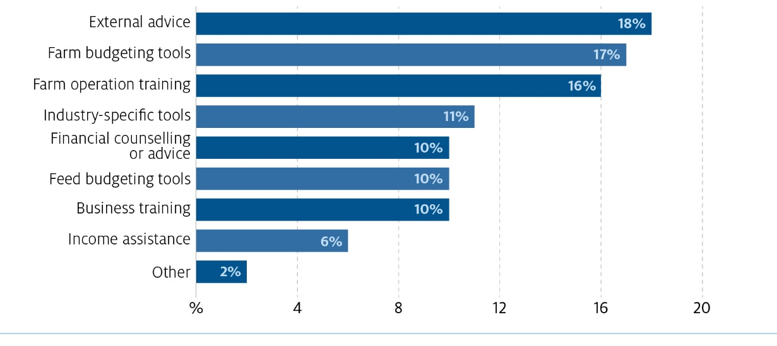
Source: 2018 FHA Review 2018 Have Your Say Survey, which had 83 respondents as at 18 November 2018.
Figure 10 FHA Review Survey: who provides business advice to farmers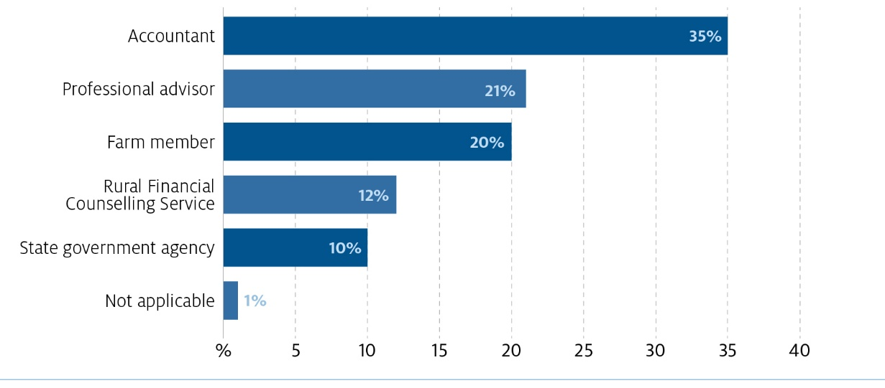
Source: 2018 FHA Review 2018 Have Your Say Survey, which had 83 respondents as at 18 November 2018.
It is noted that in Chapter 4, the Panel has included an action for government to develop a hub with training information to assist farmers in understanding what training and other activities are available to them.
Action 2.7 Provide FHA recipients with optional funding to help them undertake training and other activities to improve their situation.

Increasing access to the FHA while encouraging self-sufficiency and structural change
The FHA is an important income support program for farmers in financial hardship and is currently available for a period of three years in a lifetime. As part of its terms of reference, the Panel was requested to examine this time limit in the context of the recommendation on access that was made by the PC in its 2009 inquiry into drought support. The PC recommended that income support to farmers be limited to a maximum claim per farm household for three years out of every seven (Productivity Commission 2009).
The FHA program was established with a three-year time limit over a farmer’s lifetime. This period was extended to four years on 19 June 2018 as an acknowledgement of the severity of the current drought across the eastern seaboard and to provide support to farmers who have not had the opportunity to implement their plans for financial self-sufficiency. The rationale for the current limit is provided in the guidelines for the program, which states ‘this four-year period will provide recipients with sufficient time to develop strategies for self-reliance and create an incentive to make significant business decisions where the farm business is unsustainable’ (Department of Agriculture and Water Resources 2018).
The Panel considers that, in order to facilitate structural change, it is imperative that access to the program is not extended. However, the Panel acknowledges the current time limit to the program is not realistic and does not acknowledge the realities that farming in Australia is volatile and successful businesses can face multiple income shocks over their lifetime. Further, the ability of some farm businesses to recover is reduced when the shocks happen concurrently or in quick succession. The Panel considers a revised time limit must be set that is fairer, but also continues to encourage recipients to act and better prepare for future shocks, whether they are weather or market-related. This section of the report outlines the case for increasing the time limit for the program to four years in every ten.

Staying the course with the time limit
The Panel considers it is important the time limit to accessing the program remains untouched once set, because increasing the available cumulative years creates expectations of ongoing support (welfare dependency) and impedes the effective delivery of the structural change objectives of the program. A strict limit on access to the program will encourage action and preparedness by recipients, as they will know they do not have ongoing access to income support and need to make changes to their situation. The time limit has proven an effective mechanism to assist the RFCS and FHCOs in having difficult conversations with recipients about their future. The Panel heard that changing the time limit has created an expectation that changes may continue, which causes decision-making to be delayed.
This issue was raised by stakeholders during consultations, particularly in the context of the 2018 change to the period of access from three to four years.
The theory of a three year payment was a good one and was able to be used as leverage to get people to act. After the introduction of the fourth year the message of ‘no more, this is it’ was erased. Some customers are already asking ‘if it does not rain will there be a fifth year?’ (Farm Household Case Officer, Victoria)
It was difficult when the fourth year was announced as it undid the work of the counsellors telling people it is time limited and they need to use the time to do the hard thinking and make the strategic decisions to be able to improve their circumstances. (Rural financial counsellor, New South Wales)

Once in a lifetime is not sufficient
The Panel considers a time limit to accessing the FHA encourages self-sufficiency, preparedness for future shocks and structural change, while discouraging welfare dependency. However, limiting access to four years in a lifetime is unrealistic because farmers will likely experience multiple droughts and other financial shocks over their lifetime. Allowing access only once in a lifetime does not acknowledge that good and viable farmers can be affected by multiple financial downturns outside of their control over the course of their lives.
The Panel considers an approach more in line with the Productivity Commission (2009) recommendation is needed, and that access to the program for a maximum period of four years in every ten would be appropriate. This approach provides farmers with a reasonable level of support over their lifetime and strikes a balance between acknowledging the variability of agriculture and supporting farmers in need, while not impeding structural change and entrenching welfare dependency. Combined with a strengthened mutual obligation, this approach will provide more tailored delivery of the program.
Several stakeholders also raised concerns about the current cap of four years in a lifetime:
The cumulative four-year limit on FHA support is not reflective of the volatility of the industry that a primary producer will face across their life. (AgForce Queensland)
…the current cap of 4 years cumulative over the course of a farmer’s working life may pose issues especially for Victorian dairy farmers who already have faced a milk price step down then drought conditions in recent years, and then may be unable to access the FHA if they face any other financial hardships in the future. (Victorian Farmers Federation)
Action 2.8 Provide farmers with access to the FHA program for a maximum period of four years in every ten years.

Addressing ongoing access to income support
The Panel heard anecdotal evidence that some farmers have been on various types of government income assistance programs over recent years. The Panel has been unable to verify whether this is correct. If so, it raises concerns about how some recipients may be using these farm income support programs and reinforces the importance of limiting access to avoid welfare dependency.
It is vital that income support provided under the FHA is temporary and that recipients are taking action to ensure they can live without the FHA at the end of their four-year access period. With this in mind, the Panel considers it vital that past FHA recipients do not have their time limit restarted on the commencement of any rebuilt FHA program.
Action 2.9 Ensure farmers who have already accessed the FHA for four years in the last ten years do not receive additional years of income support within any rebuilt FHA program.

Refocus the roles in FHA delivery towards business support
Recommendation 3: Revise the Rural Financial Counselling Service (RFCS) role within the FHA towards business support
Enhance the role of the RFCS under the FHA program to focus on business coaching of recipients, with the addition of a role for a financial advisor. To minimise duplication, this should utilise existing processes undertaken by the RFCS.
As part of its terms of reference, the Panel was requested to assess the suitability and effectiveness of current delivery settings, including the role of Farm Household Case Officers (FHCOs) and involvement by the Rural Financial Counselling Service (RFCS).
The Panel met with numerous FHCOs and rural financial counsellors (RFCs) to discuss their roles under the FHA program and their perspectives on how it can be improved. Both these parties play a significant role in helping farmers get on payment, manage their responsibilities under the program and take action to improve their circumstances. The Panel heard from many FHA recipients who greatly valued the assistance and support provided by RFCs and FHCOs, which was received at a time when many were under significant stress.
Although both FHCOs and RFCs have greatly assisted farmers in accessing the program, the Panel considers their roles could be modified to better utilise existing relationships and expertise, and provide a more tailored service to recipients.

Effectiveness of current roles

FHCOs
FHCOs were established to support the delivery of the FHA program. They focus on providing case management services to support the mutual obligation requirements for FHA recipients, such as the completion of the FIA. FHCOs also provide recipients with information about the full range of Department of Human Services (DHS) programs, with a specific focus on relevant rural support and services. They also provide generalist information, advice, referral and discussion services, principally to other Australian Government services, but also using wider local knowledge.
The Panel heard from FHA recipients that spoke about the rapport they have with their FHCO and that they were well liked and respected. The exit surveys completed by recipients indicated 97 per cent of recipients found their FHCO to be either helpful or very helpful in helping them understand their obligations under the FHA program. The FHCOs who spoke to the Panel were also aware of the important help they provide to farmers and were clearly mindful of the unique circumstances of recipients.
The suitability of the FHCOs in driving action by recipients was raised several times with the Panel. Some stakeholders considered that FHCOs do not have sufficient agribusiness experience and are not best placed to negotiate the Financial Improvement Agreement (FIA), which details the actions to be undertaken by the recipient to improve their capacity for financial self-reliance. This was seen to undermine the effectiveness of the FIA.
In some circumstances, case managers are not providing the support a client requires to assess their situation due to a lack of understanding of the industry and how agricultural businesses operate. (AgForce Queensland)
DHS also raised concerns to the Panel about whether FHCOs are best placed to formulate improvement agreements with recipients and considered this work would be better undertaken by the RFCS or other external professional providers. DHS highlighted that, although FHCOs are often praised by farmers for their assistance, they do not have expert skills in agronomy or the provision of financial advice, and may not be best placed to provide genuinely meaningful advice on structural change to individual farmers.

RFCS
The RFCS is jointly funded by the Australian and state governments to provide free financial counselling to primary producers, fishers and small rural businesses who are suffering financial hardship and have no alternative sources of impartial support. There are currently approximately 130 RFCs working across the country. RFCs help clients to identify financial and business options and to develop an action plan.
Farmers experiencing difficulties as a result of the recent drought were directed to see an RFC to talk through their FHA application. Although holding no formal role in the FHA program prior to this, the RFCS has taken up the new role effectively. While receiving much gratitude for the support, some RFCs noted that time spent assisting people with applications meant they had less time to undertake their primary role of providing people at imminent risk of financial hardship with assistance and financial counselling.
There does not appear to have been any supplementary training for RFCs prior to them taking a more prominent role in assisting farmers with their FHA application. This is problematic because RFCs may not know the detail of social security legislation and its requirements. It also makes it difficult for RFCs to assist their clients as they navigate through the application process or help them understand eligibility requirements and decisions made by DHS on an FHA application.

Support during the application process
Currently, through the application process, farmers can receive assistance through Centrelink offices, the Farmer Assistance Hotline and by speaking to the RFCS.
Box 12 Farmer Assistance Hotline
The Farmer Assistance Hotline is a dedicated phone service for farmers and their partners to talk about the FHA. Operators provide advice and support on a range of matters including eligibility, claiming, progress of applications, appeals, changes in circumstances, reporting income and other matters. This line is also used by RFCs and accountants who are assisting farmers in obtaining the FHA.
Throughout consultation, farmers were always complementary and grateful for the availability of the Farmer Assistance Hotline and its operators. However, farmers, as well as RFCs and accountants assisting farmers to submit an application, found it frustrating that each time they called, they would speak to a new person with no history of their case. They noted that it would have been more helpful to have a single dedicated contact person to ask follow-up questions and discuss their application assessment status, requirements and progress.

Refocusing roles
There is scope to better use the expertise of the RFCS under the program. The Panel suggests the government change the role of the RFCS so counsellors provide coaching to FHA recipients to help them understand their situation and identify changes that can be made to improve their position (outlined further in Recommendation 2). This would involve an extension of their existing support to FHA recipients, enabling the RFCS to further support clients in the decision making process (not an extension to provide advice, which is currently not the scope of the service). This would recognise the existing relationship RFCs have with many recipients and provide for more tailored and closer contact in what can be difficult and sensitive discussions.
Action 3.1 Change the role of the Rural Financial Counselling Service (RFCS) under the rebuilt FHA program to focus on business coaching of recipients, utilising existing processes undertaken by the RFCS where possible.
As detailed in Recommendation 2, the Panel has recommended that a viability assessment of the recipient’s farm business be undertaken after recipients have been on the program for 12 to 18 months. The Panel considers the RFCS is generally well placed to help recipients undertake viability assessments of their business, but is aware that not all RFCS providers will be in a position to deliver this function. Given this, the Panel considers there should be scope for providers to outsource this to an appropriate local external advisor, such as financial advisors who have agribusiness expertise.
Action 3.2 Enable the RFCS to provide the viability assessment function either internally or through accessing appropriately skilled and qualified external advisors.
The broader wellbeing of farmers and their communities is important. The Panel is cognisant that when facing financial hardship some farmers may be feeling overwhelmed and under duress and may need other forms of support in addition to the RFCS and FHA. Further, the Panel considers it is harder for people to make significant changes to their situation when under duress, and ensuring health support is available is an important consideration when incentivising change. The Panel recognises some RFCS are already working successfully with health services, such as Rural Alive and Well in Tasmania, and these should be maintained.
Primary Health Networks were established to increase the efficiency and effectiveness of health services for patients, particularly those at risk of poor health outcomes, and to improve coordination of care to ensure patients receive ‘the right care in the right place at the right time’ (Department of Health 2018).
In their work, it is likely RFCs will meet farmers who are in need of health support, and the Panel considers there is scope for greater and more consistent collaboration between the RFCS and Primary Health Networks. This collaboration should focus on ensuring farmers have access to support and linkages with a range of health care providers.
Action 3.3 Enable the RFCS to develop stronger relationships with Primary Health Networks to allow for greater collaboration with on-the-ground health support.
The Panel considers individual support to farmers in the application process is vital, particularly given the need for farmers to have a resolution on their application as soon as possible. The Panel considers there needs to be a role created in the agency delivering the program that provides a single point of contact for farmers through the application process and for payment management, so RFCs can focus on helping farmers evaluate and improve their financial situation.
Action 3.4 Change the role of the case officer in the delivery agency to focus on assisting farmers through the application process and payment management.

Improve communications
Recommendation 4: Improve communications
Prioritise effective communication of the FHA to provide clarity of program purpose and requirements at all stages from application to completion.
As part of the FHA Review the government requested the Panel assess the suitability and effectiveness of the current delivery settings. Throughout the consultation the theme of communication was raised frequently and the Panel notes that inadequate communication was creating a barrier for the program. A lack of clear, concise, targeted and behaviourally informed communication tools is inhibiting understanding of the program’s objectives and making it difficult for farmers to access support. The Panel noted that because messaging around the FHA was unclear about what is involved in the process and the objectives of the program, there was often uncertainty about: what the payment was for; eligibility requirements; whether it was a business or household payment; and what was involved in applying. As outlined in Chapter 5, many people were also confused about whether the FHA was a drought or other emergency payment. Clear, concise and timely communication is critical for the successful delivery of the current program and to establish a rebuilt program. This chapter offers some actions that can be taken to improve communications.

Re-branding the FHA
The Panel found that online communication is still a barrier for many farmers to access information and apply for the FHA. A number of applicants noted to the Panel the difficulty in accessing information online through platforms such as MyGov and also locating information and resources online. As noted in Chapter 1 this is also an issue for the application process. The Panel encourages the government to ensure communication plans and approaches focus on reaching all potentially eligible farmers. This includes an understanding that a segment of the farming community is not engaging online.
Elderly people may lack awareness of the FHA and also the internet skills to participate in online application procedures. (Western Australian Government)
The FHA needs to rebrand to disassociate it from the negativity around the current program. The Panel discovered that the links to the social security system and the adverse media coverage of the application process has led to some farmers being aware of the program, but unlikely to apply. The Panel heard from a number of farmers that there was a negative stigma attached to dealing with Centrelink—for some, Centrelink is viewed as an agency for the unemployed not farmers. Some farmers’ experience of Centrelink has reinforced this view and these experiences are often shared quickly in rural communities, leading to a generally negative view of Centrelink.
Centrelink uses a model of Newstart. Farmers are not unemployed wage earners. That is not what we are. The system is not designed for us and doesn’t cater for our circumstances. (Farmer, New South Wales)
In rebuilding the FHA away from the social security system as outlined in Chapter 1, there is an opportunity to rebrand it to focus on the positives it offers for farmers. The Panel believes the program is an important tool for farmers to access in times of financial hardship and is concerned that negative perceptions may be leading to a lower uptake. The survey commissioned for the review asked participants why they did not apply for the FHA, with the most common answer being the program seems like it would take too much time or the form is too long (Figure 11).
Figure 11 FHA Review Survey: reasons people did not apply for FHA 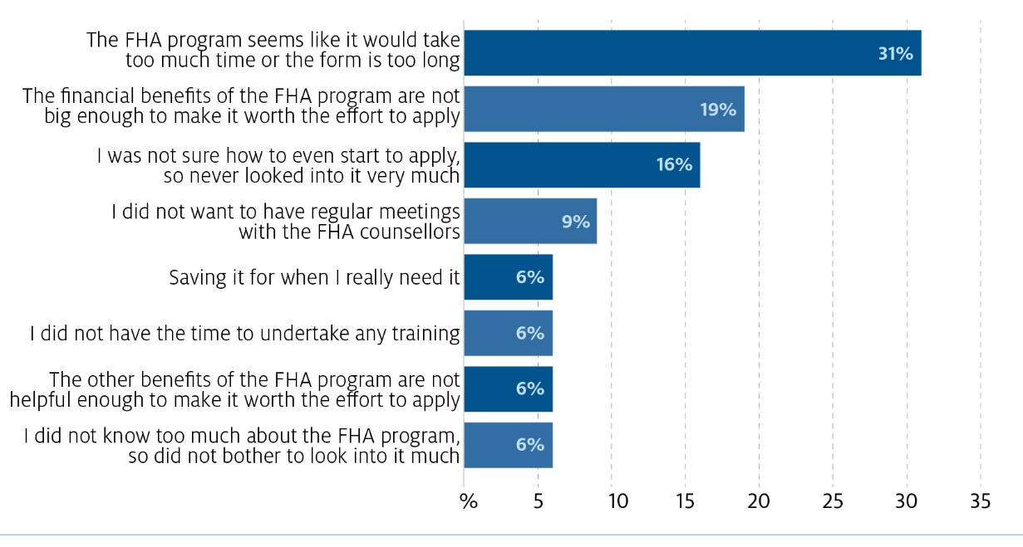
Source: 2018 FHA Review 2018 Have Your Say Survey, which had 83 respondents as at 18 November 2018.
In developing this new approach, the Panel recommends the government re-position and rebrand the FHA to focus on how it supports farming households so they can focus on their business during adverse times. FHA communication should be explicit about the dual objectives of the program and that the program is aimed at farmers experiencing financial hardship (emphasis on financial), regardless of the cause. It is especially important for communication to be clear that eligibility is centred around the financial situation of the individual farmer. This should assist in ensuring the FHA attracts the cohort of farmers it is seeking to assist. Also, those farmers not in financial hardship, as defined by the limits set for the program, would not spend time and effort applying for a program not designed for them. This change in communication approach, along with the program alterations, should assist in better positioning the FHA for its target audience.
To further build this altered positioning of the FHA, the Panel recommends the government make use of farmers who have successfully exited the industry to communicate to other farmers about their experiences. The Panel notes that one of the key challenges for farmers in regards to structural change is the inability to envision a pathway outside farming. The Panel considers that the messenger is critical to cut through this barrier—specifically, real-life stories delivered by farmers who have exited the industry could assist some farmers in understanding how changes made under the FHA could lead to positive outcomes. It is critical that farmers who have previously undertaken this change be engaged to deliver this message. This message will be more effectively delivered by someone who is ‘like them’ as opposed to other advisors such as Farm Household Case Officers (FHCOs) and rural financial counsellors (RFCs). Engaging other farmers who have successfully exited the industry should result in a greater sense of understanding.
Action 4.1 Re-position and rebrand the messaging for the FHA so it is clearly distinct from social security and emphasise that FHA is for financial hardship, as defined by the program.
Action 4.2 Engage farmers who have successfully exited the industry to communicate to other farmers about their experiences.

Improving communication
The Panel found that the key reason for a lot of people’s frustration with the FHA was their inability to understand what was required of them and why. The Panel cited various letters to applicants that lacked clarity and relevance. For example, a number of farmers shared with the Panel letters for debts raised and the Panel noted the letters lacked clear detail on the reason for the debt and next steps. The Panel heard from an accountant in South Australia that the information is complex and confusing for accountants. It was noted numerous times that many farmers would have given up without the help of RFCs. The Panel found that farmers are business people used to interacting with government on numerous taxation and regulatory matters and need clear, tailored communication to assist them in applying for the FHA and complying with requirements.
To improve tailoring of communication, the Panel recommends the government create a small communication advisory panel to assist with implementing the rebuilt FHA program. Membership should represent a range of backgrounds and disciplines. This includes:
- a specialist in behavioural insights to ensure the messaging is not only clear, but also concise, relevant, timely and motivating for potential recipients
- an agricultural industry body to ensure the messaging represents the realities of farming life
- the Rural Financial Counselling Service to bring an understanding of life for farmers in financial hardship
- the agency responsible for program delivery
- the Department of Agriculture and Water Resources as the agency with policy responsibility.
Action 4.3 As a matter of priority, create a small communication advisory panel to assist with implementing the rebuilt FHA program and all the communication action items, with membership representing:
- experience in behavioural insights
- an agricultural industry body
- the Rural Financial Counselling Service
- the agency responsible for program delivery
- the Department of Agriculture and Water Resources (as the agency with policy responsibility).
Action 4.4 As a matter of priority, have the communication advisory panel review all FHA webpages and written communications provided to recipients under the current program (such as program materials and letters) to ensure the information dissemination, tone and messaging is appropriate.
The Panel recommends the government create a dedicated website for the FHA that provides simple, farmer-centric information about the program to create a targeted online presence. Information on the FHA is currently split across two websites—the Department of Human Services (DHS) website and the Department of Agriculture and Water Resources website—which can make it difficult for applicants to find all the information required. The Panel has found that the websites provide a number of resources that could improve understanding but the resources are not easy to find and access. One of the National Farmers’ Federation’s recommendations is for the FHA platform to be improved to reduce the occurrence of the website crashing when stressed farmers are applying for assistance. The Panel believes a website that clearly explains the program, eligibility and the process in language that is easy to understand and targeted to farmers would improve initial interactions on the program. The new FHA website would be a key part of the rebranding and assist in communicating the separation from broader social security.
In September, October and November 2018, DHS held weekend workshops to support farmers in areas severely affected by drought. At these sessions farmers received personalised assistance from staff to complete their FHA claim. The sessions were very well received by farmers—one farmer stated that he achieved more from that day than he had in weeks prior. This is an example of targeted information and support that assisted farmers in a timely manner. However, some farmers noted that entering a Centrelink bus in the centre of town still had stigma attached to it.
Action 4.5 Create a dedicated website for the FHA that is separate and distinct from Centrelink and provides simple, farmer-centric information about the program.

Training information
The Panel discovered in talking to farmers and advisors there may be a lack of information on what training and support is available to farmers. To fill this information gap, the Panel recommends government extend the recently established Farm Hub to include information on training, advisors and consultancies. This hub should be available to all farmers, not just those on the FHA. The Panel is of the view that increasing access to training and support may prevent some farmers ever needing to access the FHA.
Action 4.6 Expand the recently developed Farm Hub to include information on training, advisors and consultancies that are relevant to small agricultural businesses.

Rethinking ‘don’t self-assess’
Communication for the FHA program includes the key message ‘don’t self-assess’. The message has been used for farmer-related programs for a number of years to counteract the perceived issue of farmers generally self-assessing that they are not eligible, without fully understanding the requirements. It also seeks to combat the issue that farmers are used to going without when times are tough and as a generalisation aren’t the type of people who ask for or expect help.
The Panel found this message may work for some potential recipients who are likely to assume they are not eligible without checking. For example, one regional banker said ‘a lot of people need help…and think they are not eligible’. However, there is a group that are frustrated by this communication approach. The Panel heard from a potential recipient in Bairnsdale—‘we should not need to go through the process before realising you’re not eligible’. The group discussion around this indicated there needs to be something up front in simple language about eligibility, for example, a one-page document with simple language. Some noted a checklist for eligibility would be helpful.
The ‘don’t self-assess’ message, along with a lack of easily available detailed information on the program, has also resulted in people who think they are eligible applying and being frustrated when they are deemed ineligible.
For some, the issue was deeper than frustrating, it was demeaning. A number of farmers noted they are expected to self-assess all the time to run a farm business and when it comes to the FHA they are unable to access adequate information to understand the program. Further, once on payment, farmers are expected to assess and manage their finances to avoid overpayments and debts. In one consultation, the Panel heard from a number of people who opted not to apply because they could not find information to test the stories they had heard about income and asset tests.
The lack of clear straight forward printed guide does not help. (Farmer, New South Wales)
The process. You go on the website, you’re told not to self-assess – what a load of rubbish. You go to look for the criteria – there are no criteria – who is eligible, not eligible – so you don’t end up wasting your time applying. Off farm income. Why isn’t it clear anywhere - how much can we earn? We want to know. Want to know criteria. Don’t want hidden stuff. We are trusted to do our tax, trusted to pay our staff but not trusted when it comes to Centrelink. (Farmer, New South Wales)
The Panel recommends a simple, farmer-centric one-page factsheet that explains each of the FHA’s eligibility settings. This would be an important resource for those who want to be informed about the program. The Panel does acknowledge it received feedback from DHS processing staff that ‘communicating policy that covers all of those situations is difficult and likely to be more exceptions than rules’. This one-page resource could be supported by further information and tools on specific issues such as superannuation and trusts. It is also noted that this report recommends steps to simplify the current program, which should also significantly assist in reducing the current levels of complexity.
Further, as there are a number of support measures available for farmers experiencing financial hardship, it is important that farmers have the information to choose the right form of assistance for them. The Panel noted that although assistance differed across the regions, a common thread was the need for farmers to assess which one was right for their situation. The Panel recommends that the government develop a fact sheet for each support measure with a similar format to allow farmers to understand the support available and decide what is best for their situation. This would allow those not eligible for the FHA to understand what other options are available.
Action 4.7 As a matter of priority, have the communication advisory panel develop a simple, farmer-centric one-page fact sheet that explains each of the FHA’s eligibility settings.
Action 4.8 As a matter of priority, have the communication advisory panel develop a simple, one-page summary for each of the support measures that are available to farmers so they can choose the right source of assistance. Each fact sheet should feature eligibility, benefits, how to apply, contacts and links.
The Panel believes communication products need to clearly outline the purpose and process for the FHA in all stages of the program. Empowering applicants with clear information and updates should continue from when applicants apply through to their time on payment. The Panel was advised by a number of applicants that after applying they did not receive advice when further information had been received and the status of their application. In their written submission, Rural Financial Counselling Service (RFCS) North Queensland mentioned the need for a FHA processing tracker to show where an application is currently in the process.
An all in one timeline would help applicants be aware of what is required when and what to expect whilst being on payment. Although all of this information is on the DHS site there is no one document which explains [it] all with links to where to obtain further info. Should correspondence be delayed via post or DHS IT issues (which occur from time to time and have been increasing in line with the demand on the system) the applicant is not aware of the process or if something has not been sent that should have. (RFCS North Queensland)
It was also noted in another submission (confidential) that recipients need to understand the implications of the income assessments in order to actively participate in the program and manage overpayments.
Action 4.9 Ensure the expectations and requirements of FHA recipients are clearly communicated in all stages of the program.

Improving communication support for RFCs
The Panel found the lack of detailed information was not isolated to the recipients. The current process for the FHA encourages applicants to seek assistance from the RFCS during the application process. A number of RFCs admitted they did not understand the detail of the program. RFCs noted they often don’t understand why some people are approved and some aren’t. The lack of understanding of the detailed social security system makes it difficult for the counsellors to provide concrete answers for their clients. It can also allow incorrect information to be shared across a service provider.
A number of RFCS providers suggested establishing an FHA information hub for RFCs. This hub could include detail on the rationale for eligibility criteria, frequently asked questions, frequently encountered misconceptions, a discussion board and some case studies of more complex applications. The Panel supports this idea and believe it would offer an opportunity to better use the RFCS as a communication channel. The idea of a dedicated hotline for RFCs to access FHA assessors was also suggested. The Panel would only support this approach if it did not reduce the resources for the Farmers Assistance Hotline.
Action 4.10 Establish an information hub on the FHA for rural financial counsellors.

Distinguish the FHA from drought
Recommendation 5: Distinguish the FHA from drought
The FHA was designed to support farmers during financial hardship irrespective of the cause and should be communicated and promoted to align with its broader purpose.
As part of the terms of reference for the review, the Panel was asked to review whether the current settings of the program contribute to an enduring approach to income support for farmers in financial hardship, including drought. Recommending reintroducing exceptional circumstance, or any type of drought assistance program, is out of scope for this review.
As outlined in Chapter 4, the Panel believes that during drought there is a need to communicate the FHA clearly. A lack of explicit communication on the eligibility requirements relating to financial hardship, as well as the objectives of the program, has led to confusion and frustration. It has also resulted in the FHA being strongly associated with drought, which could limit those in other forms of financial hardship accessing the FHA. Further, a misunderstanding about the purpose and rationale of the FHA could result in some farmers incorrectly assuming drought support payments are part of their management plan for droughts. It is anticipated that the implementation of the changes outlined in this report would allow the FHA to be a better targeted means of support in any future issue that leads to financial hardship.

Drought in Australia
In considering the FHA in the context of drought, the Panel noted that Australia is the driest inhabited continent on earth and has one of the most highly variable climates, with lower mean rainfall and higher rainfall variability than most other nations. As a result, Australian agriculture is subject to more revenue volatility than almost any other country in the world.
Drought, which is a recurring and expected feature of the Australian landscape, is one of the biggest challenges farmers face and has a significant impact on agricultural output, productivity and on-farm incomes. Climate change is anticipated to increase the frequency of extreme weather events, including drought, therefore impacting the agriculture sector further.
The FHA forms part of the Australian Government’s contributions to the Intergovernmental Agreement (IGA) on National Drought Program Reform, which was agreed by Australian, state and territory primary industries ministers in May 2013.
Despite being included in the IGA, the FHA is not a drought payment and instead is available to all individuals in farm households experiencing financial hardship, irrespective of the cause of the hardship. This setting, based on a recommendation by the 2009 Productivity Commission report Inquiry into Government Drought Support, was designed to remove the inequality created by the ‘lines on maps’ of the previous exceptional circumstances framework. Further, the FHA is not a drought support tool for every farmer experiencing drought, just those who meet the financial hardship tests.

Confusion over demand for the FHA in drought
The Panel met with FHA recipients who accessed the payment for a range of reasons, however, a significant and recurring reason provided to the Panel for accessing the FHA was still drought. In New South Wales, a large number of farmers indicated they had applied for the payment, or were in the process of applying, due to the current drought conditions. Likewise in Queensland a number of recipients and advisors noted the prolonged drought had resulted in a number of farmers accessing the FHA. In some areas of Victoria consultation participants also indicated they were accessing the FHA as a result of drought conditions.
In August 2018 the Australian Government announced supplementary payments and changes to the asset limit in response to the impact of drought on financial hardship (Box 13).
Box 13 Changes to the FHA in 2018 in response to drought
On 19 June 2018 the government announced a permanent extension of the FHA from three to four cumulative years.
On 5 August 2018 the government announced a package of drought relief for farming families including two temporary changes to FHA for 2018–19:
- two supplementary payments up to a total of $12,000 to FHA recipients
- temporarily lifting the farm asset threshold from $2.6 million to $5.0 million.
Following these changes the number of applications has increased significantly (Figure 12).
Figure 12 FHA applications received per week, 7 May 2018 to 29 October 2018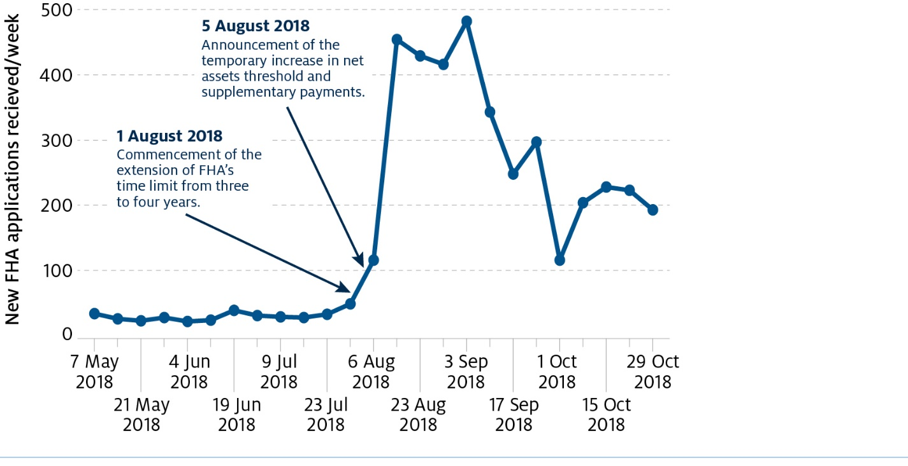
Note: Data as at 21 December 2018.
Source: Department of Human Services.
The Panel notes that, in responding to this demand, the Department of Human Services (DHS) focused on key aspects of FHA delivery, such as streamlining the claim assessment process, increasing the number of staff processing claims and using speech analytics to refine communication. The changes were well received with several reports, particularly when people were returning for their fourth year, that the claim process was significantly quicker and easier than their initial application.

Expectations of drought support
The Panel discovered there was an expectation in some segments of the farming community that the government should provide drought assistance payments, the same as it does for other natural disasters. For many potential applicants, the FHA was seen as a drought relief payment, rather than an income support program. This led to people being confused and frustrated when they found they were unable to access the payment by virtue of being in drought.
The government’s position on drought assistance payments may have evolved as reflected in the IGA, but the Panel found that this position has not flowed through to all farmers. This was particularly prominent in New South Wales where people are entering a drought situation for the first time since the exceptional circumstance related programs ceased and the new IGA position was embedded.
The drought is a natural, national disaster and should be treated the same as giving help to people affected by floods or bushfires, why is this any different? (Farmer, New South Wales)
Despite the FHA support being a ‘hardship’ payment, it is still deemed or self-assessed by any farmers to be a drought payment. (RFCS Southern Queensland)
The material is pointed to a drought payment but it is setup as a dole payment that does not reflect what people think it is when they apply. (Farmer, Queensland)
Not Farm Household Support – should be drought support. (Farmer, New South Wales)
The Panel observed that people in drought areas expected to be eligible for the FHA because they were affected by drought. This is compounded by many farmers being busier and more emotionally stretched than ever during periods of drought. The Panel found a fundamental factor for people’s irritations was that the payment did not meet the expectations of farmers in terms of access and the mutual obligations. The program’s dual objective created an issue for farmers simply wanting a cash injection during a difficult time. The program is currently designed for a longer-term financial improvement of recipients rather than an immediate financial payment to cover increasing costs during drought. The payments under the FHA are also for households rather than business support.
My husband and I are farmers in the Tamworth district and are struggling with the ongoing drought. I have not been able to determine yet if we are eligible for any assistance because of the complexity and number of forms to be filled out. (Farmer, New South Wales)
We certainly do not view the FHA as a vehicle to improve our long-term financial circumstance. Therefore we do not regard it as a long-term solution, but a short term assistance to buy food to put on the table. (Farmer, New South Wales)
The FHA was not designed as an immediate and fast financial response to adverse events such as industry downturn and drought. However, communication of the FHA often focuses on the financial support available, rather than clearly outlining the purpose, eligibility requirements and rationale for the program.
It was apparent to the Panel that some farmers were looking to the FHA as a business support payment to support the farm business during times of drought. This becomes a source of friction, where farmers are told the FHA provides assistance, but it is not on the same scale that they needed to manage their business costs. It is the view of the Panel that the FHA should remain a payment to support the personal costs of farmers in financial hardship and communication of the program needs to reflect this.

Messaging about the FHA
It is the view of the Panel that government should ensure any communication about the FHA is clear about the purpose and the objective of the program. Communication is vital—unfortunately many farmers’ expectations are that the FHA is a drought support tool. It is not. It is about supporting farmers in financial hardship and providing incentives for them to make changes to their business.
[A] point of confusion regarding the purpose of the FHA program has been whether it is only for farmers impacted by drought or farmers experiencing financial hardship at any time. NFF considers this confusion could be overcome relatively simply by an awareness campaign that provides clear information on the FHA including eligibility. (National Farmers Federation)
Action 5.1 Ensure communication and marketing clearly indicates that the FHA is available to farmers in financial hardship, irrespective of cause.

Impact of supplementary payment
The Panel found that the inclusion of the supplementary payment in the FHA program has increased confusion about the FHA. There was a sharp increase in applications following the announcement of the supplement (Figure 12). The purpose and objective of the FHA has been lost to a large extent in the promotion of the supplementary payment. One Toowoomba farmer told the Panel ‘we don’t want government to provide a fortnight payment, we just need some money for hay’. The farmer went on to express his frustration at having to be eligible for the FHA to access the supplementary payment. As he said ‘if they say they will give farmers money – then do it. Don’t make us jump through hoops and go through a rigmarole’. The Panel observed a number farmers intended to use the supplementary payment to cover farm business costs. This has led to confusion about whether the funds are for the family or business. The Panel recommends that any payment to a business must occur outside of the FHA.
The Panel considers that the drought supplement being linked to the FHA may have also attracted a cohort of farmers not suited to the objectives of the FHA. The Panel heard examples from rural financial counsellors (RFCs) of pensioners who were moving off the pension onto the FHA to receive the FHA supplement payment. It was noted by one RFC that the program has diverted from its original purpose—providing assistance available during a time of adjustment—to a welfare payment for those in drought. This RFC went on to note this will mean that at some point effort will need to be put into ensuring people know it is not a drought welfare payment when the drought ends. In the interim, getting people to engage in the strategic aspects of the program, such as the FIA, will be difficult because recipients will see it as a payment until it rains and everything is okay again.
Linking the FHA program to drought via communication and supplementary payments could also have two perverse outcomes. Firstly, it may lead those suffering from other forms of financial hardship from not applying because they believe it is only for drought support. Secondly, with an emphasis on support during drought, some farmers may assume support is available during drought instead of taking actions to prepare for future droughts. This could create a dependency relationship. Better communication as well as placing time limits on support as outlined in Chapter 2 should counteract these issues. The Panel notes the government is being informed on drought response via the Special Envoy for Drought Assistance and Recovery, the Hon. Barnaby Joyce MP, and the Coordinator-General for Drought, Major General Stephen Day. The Panel considers that the FHA program should not be used to provide one-off drought relief payments, and that the government should find alternative programs to provide such assistance.
Action 5.2 If the government determines it will provide assistance targeted specifically to drought, it should be delivered through an individually tailored program.

Drought in the redesign of the program
The Panel believes the changes it is suggesting to the program design (Chapters 2 and 3) should assist in allowing the program to have the flexibility to assist farmers in financial distress regardless of the cause, including due to drought. For those farmers that need short-term financial assistance to manage through a bad year, the program should be designed to provide income support to put food on the table. As the National Farmers Federation stated in its submission ‘these farmers do not need advice on their farm business, they need assistance to enable them to manage through the extreme downturn’. Those who face prolonged downturns and are on the FHA, from year two to year four, will have access to tailored support and training as well as income support.
The Panel has further considered some of the unique situations of those in drought. Issues such as forced sale of stock of livestock and the unpredictable nature of income during drought is discussed in Section 1.3.2 of Chapter 1.

Build in regular assessment of performance
Recommendation 6: Build in regular assessment of performance
In rebuilding the FHA, the agency tasked with delivering the program must capture information to effectively measure its performance. This data should be used as the basis for regular reviews and to guide future changes.

Improved data collection
In preparing this report, the Panel discovered there was limited data collected to evaluate the FHA program’s long-term outcomes. This reduced the Panel’s ability to use data to understand the factors that could assist in improving the outcomes of the program. With the data provided, the Panel struggled to answer some of the most basic questions about the effectiveness of the program and its dual objectives. For instance, it was difficult to understand how many farmers across Australia are in financial hardship, and of those what percentage are aware and choose to access the FHA. Likewise, it was difficult to assess whether the activities undertaken as part of the FIA are leading to longer-term success for farmers. While the Panel acknowledges these are not easy tasks – it is critical for programs to gather this information to truly understand whether this program is meeting its objectives.
The Panel notes there is some descriptive data available to understand the segment of the farming community that accesses the FHA, as well as the payment information and time on payment. Nonetheless, surface-level information such as take up provides very little insight into whether the program is reaching those who need to access the program. However, aside from exit survey data and anecdotal evidence, there is little concrete information to assess the overall effectiveness of the program. The Panel has used available information as well as the insights it has gathered during consultation to inform this report. The Panel would recommend government invest in information technology systems and processes to improve this data collection and management.
The Panel recommends that in rebuilding the FHA the government prioritise the development of a system that gathers the necessary information to continually manage and review the effectiveness of the FHA, specifically its short-term effectiveness and its impact on long-term viability. To focus the evaluation, the government needs to clearly identify what success for this program looks like and build a data gathering process and evaluation program around this. For example, under the dual objective the reach of the FHA (are the people who need the financial support receiving it) and outcomes (are those on payment improving their financial situation now and into the future) need to be measured.
In developing the evaluation plan, the Panel recommends the government consider other datasets that could enable assessment of the broader benefits of the program. For example, links to the University of Canberra’s Regional Wellbeing Survey could allow government to monitor any improvements to the health and wellbeing of communities as a result of the FHA.
The Panel has appreciated the opportunity to review the FHA program and provide insights on how to enhance the program. Given the span of issues highlighted through the review—in particular, aspects of the program being identified as not operating effectively—the Panel considers there is strong rationale to review the settings every two years. The next review could look into how the revised settings and delivery agency are operating and ensure the rebuilt program assists the government in meeting the dual objectives.
It was noted there was industry support to improve the evaluation aspect of the program. AgForce Queensland noted in their submission that:
Establishment of an evaluation tool and framework with industry input is sought as a means of ensuring those who have engaged with the support have been better off in the long-term. Reporting of statistics and figures do not provide a full picture for the department and industry to fully understand the Farm Household Allowance’s success for a client both while and after receiving the support. (AgForce Queensland)
The Panel notes the National Farmers Federation (NFF) suggested as part of their submission that data collection and analysis of the FHA and other farm assistance programs be significantly increased and analysed in order to ensure programs meet their objectives. The NFF and AgForce Queensland both noted a need to have more transparency around the effectiveness of the programs.
…this data be made publicly available to help inform recipients and the community at large as to the extent and impact of these programs. (National Farmers Federation)
While information has been provided regarding the uptake of the support and how many have indicated ‘satisfaction’ post-exit, the wellbeing of clients is unknown. While the program has been in place for four years and some have exhausted their initial three years support, ongoing reporting or ‘check-ins’ with previous clients (at a range of intervals) could assist in ongoing improvements to ensure the FHA’s effectiveness. (Agforce Queensland)
It is recommended that, in developing a better evaluation system, the government consider what aspects of data could be made publicly available.
Action 6.1 Ensure data is collected throughout the delivery of the FHA program to allow greater monitoring and evaluation of policy and delivery settings.
Action 6.2 Arrange for an independent streamlined review of the rebuilt program every two years of operation to examine how the revised settings are meeting the program’s objectives.

Exit survey data
The Panel notes each recipient of the FHA is able to undertake a written exit survey when they leave the FHA program. The information this survey has gathered is useful and does give some indication of how recipients view their FHA experience. To bolster the benefits of this information, it is recommended the government also introduce an exit interview. The use of an interview by a trained researcher would allow more robust information to be gathered. To give a deeper understanding of the long-term benefits of the program there may need to be a continuing survey to look at longer-term success. This insight could be used to continually improve and enhance the FHA program short term and longer term.
Action 6.3 Undertake an exit interview of every recipient that leaves the FHA program to collect information on the change in a recipient’s situation over the course of the program.

Observation: avoiding financial hardship should be the long-term goal
The Panel would like to offer the government some insights it has gathered on the broader environment the FHA operates in. The Panel strongly believes the FHA is a financial safety net that can assist farmers currently in need, but the longer-term goal should be to facilitate an environment that minimises farmers experiencing financial hardship and not needing access to income support. The government should continue to focus on existing and innovative preemptive policies that help farmers avoid financial hardship and reduce the need for FHA-type programs.
Farmers face a variety of risks in their work, including: weather uncertainty, an increasingly changing climate, variable market prices, and pests and diseases affecting production. Australian farmers also face higher risks than their international counterparts (see Figure 4) as well as other industries in Australia (see Figure 5).
Following its consultations, the Panel is concerned that smaller farm businesses can be particularly vulnerable when addressing the challenges of agriculture due to the reduced resources at their disposal compared with larger businesses. For example, smaller farm businesses lack economies of scale in production, the ability to implement technological changes and are less able to diversify risks given a paucity of insurance products.
The Panel also found the ability of small to medium farm businesses to recover is more difficult when shocks happen concurrently or in quick succession. Farm resilience requires the ability to rebuild financial equity and natural capital that can be lost due to a shock. One impact of climate change on agriculture is that the ability to recover is going to be more difficult due to increased climate extremes (Australian Farm Institute 2018).
Support programs like the FHA and the RFCS have their place and should continue to be funded by government to assist those who are in financial hardship. However, governments at all levels should continue to invest in existing programs, as well as explore new and innovative approaches that allow farmers to manage risk, prepare for downturns and prevent the need to access the FHA. The Panel heard on a number of occasions ‘no one wants to need FHA’ and considers that governments should continue to invest energy in prevention.
The Panel acknowledges the range of policies and programs that are available to help farmers prepare for drought and other shocks, and encourages the government to ensure existing and new programs aimed at building farm resilience are achieving objectives and delivered in a coordinated manner. This especially applies to more vulnerable farm businesses, who need tailored support to help them improve their resilience to downturns and avoid financial hardship.

Appendix A: FHA program settings
To access the FHA, farmers need to meet an eligibility test, two assets tests (farm and non-farm) and an income test.

Eligibility test
To be eligible for payment a farmer must:
- be a farmer or the partner of a farmer
- be aged 16 years or over
- have a right or interest in the land used for the purpose of a farm enterprise
- use the land wholly or mainly for the purpose of the farm enterprise
- have a farm enterprise with a ‘significant commercial purpose or character’
- contribute significant labour and capital to the farm enterprise
- have a farm located in Australia
- be an Australian resident, meaning the person resides in Australia and is:
  - an Australian citizen
  - a holder of a permanent visa or
  - a holder of a protected Special Category Visa (SCV) who is a protected SCV holder
- be physically present in Australia on the day the claim is submitted and continue to be an Australian resident for as long as payment is received
- meet the income and assets tests
- be willing and agree to comply with activity requirements
- have received less than 1,460 cumulative days of FHA.

Assets tests
The assets test has two parts. An applicant must meet both a farm and non-farm asset test. If either their farm or non-farm assets exceed the maximum thresholds, they are not eligible to receive the FHA.

Farm assets test
The total net farm assets threshold limit under the FHA is higher than the assets threshold limits for other social security payments. This is an acknowledgement that farmers typically have higher asset levels, which preclude them from accessing mainstream social security, but in times of hardship farmers are less able to liquidate farm assets without impacting their farm’s future capacity to produce income. Consequently, under the FHA, farmers are currently allowed to hold total net farm assets up to the value of $5.0 million. The rate was temporarily increased by the government from $2.6 million to $5.0 million from 1 September 2018 to 30 June 2019.

Non-farm assets test
The non-farm assets test is set at the same limit that applies to other income support allowances paid under the Social Security Act 1991.
The non-farm asset limits are indexed on 1 July each year and for the 2018–19 financial year are:
- single—$258,500 (homeowner) and $465,500 (non-homeowner)
- partnered—$387,500 (homeowner) and $594,500 (non-homeowner).
Examples of non-farm assets include cash, money in the bank (including Farm Management Deposits), money on loan and shares, real estate not related to the farm and private vehicles (list is not exhaustive).

Income test
The FHA has the same income thresholds as Newstart Allowance and Youth Allowance for those under the age of 22. Rates are indexed on 20 March and 20 September each year.
For people 22 and over, income over $104 in a fortnight will reduce the rate of payment (by 50 cents per dollar up to $254, and by 60 cents per dollar after that).
For people under 22, income over $143 in a fortnight will reduce the rate of payment (by 50 cents per dollar up to $250, and by 60 cents per dollar after that).
As at 20 September 2018 payment ceases once a recipient’s income reaches:
Status | FHA (under 22) | FHA (22 and over)
Single, no child(ren) | $915.50 | $1,060.67
Single, with child(ren) | $1,149.84 | $1,136.67
Single, 60 years or older and at least 9 continuous months on payment | – | $1,147.00
Partnered (per person) | – | $970.00
Partnered, no children (per person) | $915.50 | –
Partnered, with child(ren) (per person) | $989.67 | –
As with other social security payments, only the profit portion of business income is assessed—that is, business revenue less business expenses that are allowable deductions.
Unlike other social security payments, recipients estimate their business income over the coming financial year. The financial circumstances of FHA recipients often changes throughout the year. As a result, this estimate can be updated at any time and the rate of payment will be adjusted to reflect this change.
The income estimate will be reconciled annually using personal and business income tax returns and full financial statements. Under the FHA, the process is called business income reconciliation (BIR).
BIR determines whether a recipient receives a ‘top up’ payment or incurs a debt and ensures that FHA recipients have received their correct entitlement for the previous financial year.
FHA recipients are required to regularly make contact with their Farm Household Case Officer and report any changes to their income.
Recipients that earn fluctuating off-farm income, such as from casual shift work, may be required to report their income more regularly, such as every two weeks, to ensure they continue to receive the correct rate of payment and prevent overpayments.
Recipients who earn stable on-farm income may be required to report every six weeks as their risk of incorrect payment is minimal.
The Farm Household Support Minister’s Rule 2014 outlines certain activities for which recipients can claim deductions against their off-farm income. For example, the amount of interest repayments that can be offset against off-farm income is referred to as the ‘allowable deduction’. The maximum amount of allowable deduction is $80,000 for a tax year.

FHA support
While on payment, farmers and farmers’ partners have access to:
- income support of up to $103,597.43 (per household with two recipients, over four cumulative years of payment)
  - rates are indexed on 20 March and 20 September each year. As at 1 February 2019 the maximum payment per fortnight is:
Status | FHA (under 22) | FHA (22 and over)
Single, no child(ren) | $445.80 | $550.20
Single, with child(ren) | $584.20 | $595.10
Single, 60 years or older and more than 9 continuous months on payment | – | $595.10
Partnered (per person) | – | $496.70
Partnered, no children (per person) | $445.80 | –
Partnered, with child(ren) (per person) | $489.60 | –
- at least 17 one-on-one meetings with individual case officers
- $4,000 activity supplement ($3,000 over four years and an additional $1,000 accessible in the third and fourth year of payment)
- a $1,500 rebate for a prescribed adviser to complete a Farm Financial Assessment
- a health care card and, depending on their circumstances, pharmaceutical allowance, rent assistance, telephone allowance and remote area allowance.
Households on the FHA in the 2018-19 financial year will also be eligible for up to two lump sum payments. Couples in a household will receive up to an additional $12,000 ($3,000 each paid twice) and single households will receive up to $7,200 ($3,600 paid twice).
In 2018 the government extended the program to allow farmers to access four years of payment in total, compared with the original three years.

Activity requirements
FHA recipients are required to engage in activities that are aimed at improving their circumstances. These activities include the completion of a Farm Financial Assessment (FFA) and a Financial Improvement Agreement (FIA).

Farm Financial Assessment (FFA)
The FFA is an assessment of the farm enterprise designed to develop and evaluate options to improve the financial position of the person through resources, liabilities, barriers and goals. The government provides up to $1,500 towards the cost of a prescribed advisor completing the FFA. Once a person is found to be eligible and starts receiving payment, they have 28 days to submit a completed FFA (with one available 28-day extension).

Financial Improvement Agreement (FIA)
The FIA is an agreement that is negotiated and agreed by a farmer or their partner and their Farm Household Case Officer (FHCO). An FIA contains a goal for improving self-reliance and approved activities aimed towards achieving the goal. One of four goals that define the pathway to improving self-reliance is chosen:
- improving via on farm activities only
- improving via a mixture of on-farm and off-farm activities only
- improving via off-farm activities only
- exiting farming.
Applicants must indicate in writing that they are willing to enter into an FIA and carry out the terms of agreement.
Approved activities in an FIA could include referrals to the RFCS, training or development, succession and/or retirement planning (may include listing the farm for sale), job search requirements, appointments with professional advisers, compulsory interviews with the case manager and social or health support. FIAs contain at least one compulsory activity.
The recipient must enter into an FIA within 28 days of notification, unless an extension has been granted, or they will no longer be eligible for payment.
Agreements can be changed at any time if a new assessment shows an alternative goal or activity is more appropriate. Agreements may include a mixture of compulsory and voluntary activities.
An activity supplement of up to $3,000 over the four years of payment is made available to recipients undertaking approved activities listed in their FIA.
As at July 2016 an additional $1,000 is available for recipients from their third year of payment.
Where more than one person from the same farming enterprise claims the payment, the agreed activities may be linked.

Regular participation
As a minimum, people receiving the FHA must have contact with their FHCO quarterly. These contact appointments include a discussion on how a person is going with the activities in their FIA.

Non-compliance
If a person receiving the FHA continues to deliberately not engage in and comply with the activities in their FIA, this could lead to cancellation of payment.

Appendix B: Terms of reference
The Farm Household Allowance (FHA) is the Australian Government’s income support payment that supports farmers and their partners experiencing financial hardship, regardless of the source of that hardship. The program provides eligible farmers with up to four cumulative years of support along with assistance through planning and training for long-term financial improvements. On 19 June 2018, the Government announced access to the payment would be extended from three to four years, with new settings to begin from 1 August 2018. Then, on 5 August 2018, the Government announced an increase to the assets test eligibility threshold from $2.6 million to $5.0 million as well as two special supplementary lump sum payments in recognition of the severity of the current drought.
The FHA originally commenced on 1 July 2014 and formed part of the Commonwealth’s contribution to the 2013 Intergovernmental Agreement on National Drought Program Reform. As it has now been in operation for over four years, the Australian Government has decided it is timely to review whether the current settings of the program:
- are effective and efficient in meeting the original objectives to provide assistance while assisting farmers to improve long-term financial circumstances
- remain fit for purpose
- contribute to an enduring approach to income support for farmers in hardship, including drought.
The Review will occur in the second half of 2018 and make recommendations to Government in the first half of 2019.
The Review will be conducted by an expert panel in consultation with stakeholders. The committee will conduct a public submission process to ensure all interested stakeholders are given the opportunity to participate. The panel would then provide its findings, deliberations and recommendations in a report for Government consideration.

Guiding principles
Providing recommendations to government on an enduring approach to income support for farmers in hardship, including drought. Recommendations should be in line with the policy framework of the current Intergovernmental Agreement on National Drought Program Reform or its replacement.

Scope of the review
The review will:
- examine barriers to take up
- examine the current time limit in the context of the 2009 Productivity Commission Inquiry into Drought Support recommendation that income support payment to farmers be limited to a maximum claim per farm household for three years out of every seven in order to avoid long term welfare dependency
- assess whether current reciprocal arrangements are effective in assisting farmers to improve long-term financial circumstances
- assess whether it has been effective, and whether it is appropriate, to have one program with the dual objectives of both providing support and assisting structural change
- assess the efficacy of recipients’ ability to come on and off payment, noting it was a key policy setting in establishing the program, including looking into how it is being utilised, whether it is achieving its intended outcomes and/or possible alternative models for implementation
- assessing the suitability and effectiveness of current policy settings including:
  - the current income eligibility tests
  - the current assets eligibility tests
  - Farm Financial Assessments
  - Financial Improvement Agreements
  - activity supplement
- assessing the suitability and effectiveness of current delivery settings including:
  - the delivery model including the role of Farm Household Case Officers
  - the application process
  - involvement by the Rural Financial Counselling Service
  - statutory timeframes for the provision of documentation.

Out of scope
Out of scope for the review are:
- significant increases to Commonwealth expenditure
- removing income support to farmers
- removing means testing
- making assistance ongoing
- reinstatement of drought or exceptional circumstance declarations.

Appendix C: Review panel biographies

Mrs Michele Lawrence (Chair)
Mrs Lawrence is an experienced first generation dairy farmer. Mrs Lawrence believes in a professional approach to farming with a strong focus on people, processes and continual education and improvement. Her experience in dairy farming as well as horticulture has also given her first-hand insights and understanding into the factors that can influence or cause stress in a business, including events which may be out of farmers’ control.
Mrs Lawrence also currently holds a number of board positions including the Agricultural Industry Advisory Council, Tasmanian Dairy Industry Authority and Primary Employers Tasmania.
Mrs Lawrence’s dairy farm, which she runs together with her husband Mr Brian Lawrence, has won multiple awards including 2016 Tasmanian Dairy Business of the Year and 2015 ABC Rural Australian Dairy Farmer of the Year.

Ms Georgina Somerset
Ms Somerset has a wealth of experience across corporate governance, policy, regulatory and agribusiness roles. She is the General President of AgForce Queensland, Chair of the Red Earth Community Foundation South Burnett and a Director of the Australian Broadcasting Corporation, the Royal Flying Doctor Service (Queensland Section) and the Children’s Health Queensland Hospital and Health Service. Additionally, Ms Somerset is the current chair of the National Farmer’s Federation Telecommunications and Social Policy Committee and the AgForce Telecommunications Committee.
She is a past president of the Queensland Rural, Regional and Remote Women’s Network and has served on the board of the Queensland Rural Assistance Authority, National Rural Advisory Council and the Regional Telecommunications Independent Review Committee.
Ms Somerset holds professional qualifications from the Australian Institute of Company Directors and holds Diplomas in Rural Business Management, Agriculture and Freelance Journalism. She is a Fellow of the Australian Institute of Company Directors, Australian Rural Leadership Foundation and the Institute for Resilient Regions (University of Southern Queensland). In 2014 she was awarded the Most Outstanding Contribution to Rural Australia award and was the 2008 runner up for the RIRDC Rural Woman of the Year Queensland award.
Together with her family, Ms Somerset runs a multi-generational beef production business in the South Burnett region and is active on local economic and social committees.

Dr Robert Slonim
Dr Slonim is a professor, researcher and academic with significant research expertise in economics and human behaviour. He is currently a Professor at the School of Economics at the University of Sydney, is a Co-Editor of the Journal of the Economic Science Association, is a Research Fellow with IZA Research and serves as Chair of the Academic Advisory Panel to the Behavioural Economics Team of Australia (BETA).
From 2017 to 2018 he was a Research Director for BETA in the Department of Prime Minister and Cabinet. He has a significant research and publications record and has received numerous academic awards.
Dr Slonim holds a Bachelor’s Degree in Arts (Computer Science and Economics) and a Master’s Degree in Business Administration (Finance) from U.C. Berkeley and a PhD from Duke University.

Appendix D: Submissions and consultation

Written submissions
Over 33 written submissions were made to the Farm Household Allowance (FHA) review. Eleven of these were submitted as confidential. Non-confidential submissions can be found on the FHA Have Your Say web page. These included submissions from these individuals and organisations:
- AgForce Queensland Farmers Ltd
- Danson, B
- Dempsey, B
- Gardiner, B
- Globe Accounting Pty Ltd
- Hahn, RL and JM
- Isolated Children's Parents' Association of Australia
- Livestock SA
- Member for Hinchinbrook, Nick Dametto MP
- National Farmers' Federation
- New South Wales Drought Coordinator
- New Zealand Ministry of Foreign Affairs and Trade
- Olsen and Skidmore
- Oz Kiwi Association
- RFCSNQ
- Rural Business Tasmania Inc.
- Rural Financial Counselling Service Central Region
- Rural Solutions Queensland Inc. Trading as RFCS Southern Queensland
- Seafood Industry Australia
- Slack-Smith, M
- Victorian Farmers Federation
- Western Australian Department of Primary Industries and Regional Development.

Face-to-face consultations
Throughout October and November 2018, the Panel also conducted stakeholder consultations in a number of locations:
- Australian Capital Territory
  - industry roundtable
  - RFCS teleconference roundtable
  - state and territory jurisdiction teleconference roundtable
- New South Wales
  - Casino
  - Dubbo
  - Lismore
  - Tamworth
- Queensland
  - Warwick
- South Australia
  - Adelaide
- Victoria
  - Bairnsdale
  - Birchip
  - Mildura
  - Shepparton—ABARES Regional Outlook Conference
- Western Australia
  - Bunbury
  - Perth.

Have your say survey
During the consultation period (October to mid November 2018), the Panel also conducted an online survey through the review’s Have Your Say web page. The survey had 83 responses as at 18 November 2018. Findings of the survey were used to inform this report.

Glossary
Term | Definition
2013 Drought IGA | 2013 Intergovernmental Agreement on National Drought Program Reform
2009 PC Inquiry on Drought Support | 2009 Productivity Commission Inquiry Report on Government Drought Support
BIR | Business income reconciliation
DHS | Australian Government Department of Human Services
FFA | Farm Financial Assessment
FHA | Farm Household Allowance
FHCO | Farm Household Case Officer
FHS Act | Farm Household Support Act 2014
FIA | Financial Improvement Agreement
PC | Productivity Commission
RFC | Rural Financial Counsellor
RFCS | Rural Financial Counselling Service

References
ABARES 2018, Agriculture Commodities: December quarter 2018 (pdf 1.58mb), Australian Bureau of Agricultural and Resource Economics and Sciences, Canberra.
ABS 2018, 4627.0 - Land Management and Farming in Australia, 2016-17, Australian Bureau of Statistics, Canberra. Accessed 14 January 2019.
ABS 2016, Census of Population and Housing. Findings based on use of ABS TableBuilder data. Australian Bureau of Statistics, Canberra. Accessed 7 February 2019.
Agriculture and Food Policy Reference Group 2006, ‘Creating our Future: Agriculture and Food Policy for the Next Generation’, Australian Bureau of Agricultural and Resource Economics, Canberra.
Australian Farm Institute 2018, Farm Institute Insights Vol. 15, No. 4, November Quarter 2018 (pdf 6.87mb), Sydney.
Binks, B, Stenekes, N, Kruger, H & Kancans, R 2018, Snapshot of Australia’s Agricultural Workforce (pdf 1.18mb), Australian Bureau of Agricultural and Resource Economics and Sciences, Canberra.
Department of Agriculture and Water Resources 2018, Farm Household Allowance Guidelines (pdf 1.54mb), Canberra, May.
Department of Health 2018, Primary Health Network - Background, Canberra, accessed 31 January 2019.
Hogan, L 2018, Food demand in Australia: Trends and issues 2018 (pdf 1.91mb), ABARES research report 18, Canberra, August.
Jackson, T, Zammit, K & Hatfield-Dodds, S 2018, Snapshot of Australian Agriculture (pdf 1.74mb), Australian Bureau of Agricultural and Resource Economics and Sciences, Canberra.
Keogh, M 2012, Including risk in enterprise decisions in Australia’s riskiest businesses, paper presented at 56th Annual Conference of the Australian Agricultural and Resource Economics Society, Fremantle, WA. February 2012.
Productivity Commission 2009, Government Drought Support, report no. 46, Final Inquiry Report, Melbourne.
RIRDC 2007, Drivers of Structural Change in Australian Agriculture (pdf 0.85mb), publication no. 07/057, project no. ABA-19A, Rural Industries Research and Development Corporation, Canberra.

