Farm Management Deposits Scheme: 2021 evaluation

© Commonwealth of Australia 2021
Ownership of intellectual property rights
Unless otherwise noted, copyright (and any other intellectual property rights) in this publication is owned by the Commonwealth of Australia (referred to as the Commonwealth).
Creative Commons licence
All material in this publication is licensed under a Creative Commons Attribution 4.0 International Licence except content supplied by third parties, logos and the Commonwealth Coat of Arms.
Inquiries about the licence and any use of this document should be emailed to copyright@awe.gov.au.

Cataloguing data
This publication (and any material sourced from it) should be attributed as: DAWE 2021, Farm Management Deposits Scheme: 2021 evaluation, Department of Agriculture, Water and the Environment, Canberra. CC BY 4.0.
ISBN: 978-1-76003-508-2
This publication is available at awe.gov.au/agriculture-land/farm-food-drought/drought/assistance/fmd/review.
Department of Agriculture, Water and the Environment
GPO Box 858 Canberra ACT 2601
Telephone 1800 900 090
Web awe.gov.au
Disclaimer
The Australian Government acting through the Department of Agriculture, Water and the Environment has exercised due care and skill in preparing and compiling the information and data in this publication. Notwithstanding, the Department of Agriculture, Water and the Environment, its employees and advisers disclaim all liability, including liability for negligence and for any loss, damage, injury, expense or cost incurred by any person as a result of accessing, using or relying on any of the information or data in this publication to the maximum extent permitted by law.
Acknowledgements
The authors thank stakeholders who contributed to this evaluation, especially those who gave their time to undertake a survey, made written submissions, participated in meetings during the consultation process, or assisted with research and advice.

Contents
Summary vi
Key findings and recommendations viii
Overall findings viii
Impacts and outcomes viii
Observations viii
Recommendations ix
Introduction 1
Evaluation 1
Insights from previous reviews 4
1 Scheme efficiency 6
1.1 Governance 6
1.2 Costs 7
1.3 Communication 10
1.4 Data 11
1.5 Risk management and compliance 13
2 Scheme effectiveness 15
2.1 Summary of use 15
2.2 Why primary producers use FMDs 24
2.3 How primary producers use FMDs 29
2.4 Barrier to uptake – non-primary production income 33
2.5 Alignment with other government programs 34
2.6 Outcomes 38
Appendix A: Advisory Group terms of reference 43
Background 43
Appendix B: Stakeholder consultation 46
Appendix C: Media articles 48
The New Daily 48
FarmsOnline National 49
Queensland Country Life 52
Appendix D: Summary of taxation benefits available to primary producers, at January 2021 55
Glossary 58
References 59

Tables
Table 1 Evaluation data collection methods 4
Table 2 FMD Scheme responsibilities 6
Table 3 FMD Scheme, estimated revenue forgone ($millions), 2017 to 2024 7
Table 4 FMD taxation statistics ($millions), net farm management deposits or repayments, 2015 to 2019 8
Table 5 Government administration costs of the FMD Scheme, 2020–21 9
Table 6 FMD total holdings by electorate, decreases greater than 10%, 30 June 2019 to 30 June 2020 17
Table 7 Clients with FMD account transactions during 2019–20 and balances at 30 June 2020 19
Table 8 Growth in average FMD holdings by industry, 30 June 2011 to 30 June 2019 21
Table 9 Reasons for accessing FHA 38
Table 10 Farms with FMD accounts as proportion of total FHA farms, by jurisdiction 2014-21 38

Figures
Figure 1 Value of FMD holdings and number of holders, 30 June 1999 to 30 June 2020 16
Figure 2 FMD annual holdings by state and territory, 30 June 1999 to 30 June 2020 17
Figure 3 FMD holders, 30 June 2016 to 30 June 2020 18
Figure 4 FMD Scheme holdings by industry sector, 30 June 2020 20
Figure 5 FMD Scheme holdings ($,000), 30 June 2006 to 30 June 2020 20
Figure 6 FMD Scheme grains industry holders and holdings, 30 September 2007 to 31 December 2020 21
Figure 7 FMD average holding by grains industry, 2014 to 2020 22
Figure 8 Number of grains industry FMD account holders, 2014 to 2020 22
Figure 9 Grains industry FMD holdings by state, July 2014 to July 2020 23
Figure 10 FMD Scheme dairy industry holders and holdings, 30 September 2007 to 31 December 2020 23
Figure 11 Main reasons for not holding FMDs, percentage of broadacre farms not holding FMDs, by size, 2019–20 24
Figure 12 Impediments preventing FMD accounts being held 25
Figure 13 Number of FMDs held by age range, 2021 26
Figure 14 Risk management strategy, percentage of all broadacre farms, Australia, 2019–20 27
Figure 15 Survey question: For what purpose do your clients/members use a farm management deposits account? 28
Figure 16 Early FMD withdrawals (natural disaster), 2014 to 2019 29
Figure 17 Main reason for holding FMDs, percentage of broadacre farms by industry, 2019–20 30
Figure 18 Hypothetical use of funds in the absence of FMDs, percentage of broadacre farms, 2019–20 31
Figure 19 Survey question: For what purpose do you or your clients/members use an FMD account? 32
Figure 20 Components of government assistance, broadacre farms by FMD holdings, average per farm, 2019–20 40
Figure 21 Survey question: How the Farm Management Deposits Scheme helps Australian primary producers 41

Summary
The Department of Agriculture, Water and the Environment (DAWE) has conducted an internal evaluation into the operation of the Farm Management Deposits Scheme (FMD Scheme), which was established in 1999 to encourage increased self-reliance among primary producers, while also taking account of high variability of farm income and the vulnerability of farming businesses to natural events.
The FMD Scheme operates by providing primary producers with an incentive, a tax benefit, to establish cash reserves earned during high-income years for use when needed. The scheme was designed to address the issues of reliance on government during drought, and result in more productive, profitable farms (Productivity Commission 2009).
The scheme allows primary producers to make tax-effective deposits in higher-income years, which can then be withdrawn in lower-income years. It does this by providing a deduction for deposits into an FMD account in the year the deposit is made and taxing the income in the year it is withdrawn. This reduces the impact of progressive marginal tax rates, particularly for primary producers with highly variable incomes.
As of 30 May 2021, the total funds held in farm management deposit (FMD) accounts is $5.27 billion. In the order of 25,000 primary producers make deposits or withdrawals in their FMD accounts each year. The costs of the FMD Scheme (in revenue forgone) vary each year and depend on the extent to which primary producers invest in FMD accounts or withdraw from them. Treasury estimates the revenue forgone from the scheme of $500 million in 2017–18, reducing to approximately $110 million in 2020–21 (Treasury 2021).
This is the fourth review of the FMD Scheme; earlier reviews were undertaken in 2002, 2006 and 2012. In 2021, stakeholder views on the FMD Scheme were very similar to those expressed in earlier years. Stakeholders say the FMD Scheme is an effective tool that helps primary producers plan and manage their operations, however it is viewed by some as inflexible which may limit the extent to which the scheme is used by eligible participants.
The FMD Scheme is one of a suite of tools used by primary producers to manage business and climatic risks. Uptake is reasonable at approximately 41% of eligible primary producers, granted that the benefits of the scheme are of more limited value to smaller primary producers without available cash flow to invest in an FMD. In general, FMD holders successfully manage their primary production business in an environment where, by global standards, few subsides are provided. The FMD Scheme may have reduced the need for in-drought support from governments in 2019-20.
While lack of quantitative data means that we were unable to draw a causal link between the FMD Scheme and improved self-reliance, in 2019–20, broadacre farms with FMD holdings had superior farm financial performance on average, including higher farm cash income, higher farm business profit, higher rates of return and higher equity ratios than farms not holding FMDs. Broadacre farms with FMDs are slightly less likely to access the Farm Household Allowance than those without, but also receive slightly more government assistance overall than non-holders (Litchfield et al. 2021).
The FMD Scheme aligns well with the Australian Government’s drought reform agenda of the last decade, which seeks to transition from crisis management to long-term resilience and preparedness. The financial incentive provided by the FMD Scheme means that many primary producers have resources and an opportunity to better manage risks independently, building resilience to climatic changes rather than relying on possible government assistance during drought. The increased draw down of FMDs in the last 12 months shows that some primary producers do use FMDs to manage through drought as well as to fund recovery as conditions improve.
FMD account holders are not required to apply for funding or report on expenditure of funds directly to government; instead, data on the scheme is provided to government by Authorised Deposit-taking Institutions (ADIs) and information on use of the FMD scheme is provided to the Australian Taxation Office (ATO) through annual tax returns. While this is administratively efficient for government, data integrity and quality issues has limited our ability to accurately manage and monitor the scheme. Work to improve data on the FMD Scheme is ongoing.
There is scope for government to better understand the way primary producers use the scheme, as well as quantify its impacts. There is also potential to ensure the scheme is integrated it with broader government priorities, such as better primary production business planning and risk management, drought resilience and climate adaptation. Establishing links with relevant programs, and increasing education and awareness of the FMD Scheme, may increase uptake and use, improve monitoring and reporting, and deliver better outcomes.
Unless otherwise indicated, all data referred to in this report is sourced from our FMD Scheme Database.

Key findings and recommendations

Overall findings
- The FMD Scheme is supported by the majority of stakeholders as a valuable tool to support primary producers manage risk, including building resilience and managing through drought.
- Improved data on the FMD Scheme would support the FMD Scheme’s transparency, identification of impacts and evaluation of outcomes.
- The FMD Scheme is managed efficiently with low administrative costs and sufficient risk management and compliance processes.

Impacts and outcomes
- While the evaluation did not have access to quantitative data to determine whether there is a link between the FMD Scheme and increased financial self-reliance, the scheme supports primary producers to manage risks in an environment where few subsidies are provided.
- The FMD Scheme provides a financial benefit to participating primary producers, including income smoothing, cash flow management and tax management.
- There is some evidence that FMDs assist primary producers to manage through and recover from drought. This may reduce the need for government to provide financial support during drought.

Observations
- The average amount of an FMD held by an individual is approximately $131,801. 10% of FMD accounts are above $400,000.
- Uptake of the FMD Scheme is approximately 41% of eligible primary producers.
- Uptake and use of FMDs by primary producers is influenced by a range of variables, including industry sector, business structure and local climatic conditions.
- FMDs are more likely to be used by profitable primary producers with liquidity to participate and are above the age of 45. As there appears to be limited take up of the scheme by smaller producers with less cash flow government may wish to investigate the take up of risk management tools by these group.
- Stakeholders raised concerns that the $100,000 cap may have an impact on the ability of businesses to manage risk through income diversification.
- There is significant scope to improve linkages between the FMD Scheme and broader programs and strategies for risk management and drought resilience.
- Improved education, financial literacy and business planning for primary producers and their advisers would assist to build resilience and preparation for drought and may encourage greater use of the FMD Scheme.

Recommendations

Links with other Government initiatives
- Ensure consistency and alignment between the FMD Scheme and related government programs focussing on preparedness, resilience and recovery, including the Future Drought Fund.
- Government programs and initiatives related to risk management and building drought resilience, including the FMD Scheme, are maintained as a strategic, integrated package, including a unified approach to communication and monitoring and evaluation.

Tax averaging for primary producers
- The ATO considers undertaking specific and targeted communication with accountants and financial advisers on tax averaging for primary producers and how it relates to the FMD Scheme.

Ongoing work to improve data – DAWE and ATO
- DAWE and ATO continue to work with the ADIs to improve the collection and reporting of data on the FMD Scheme, to improve transparency on the scheme’s outputs and outcomes.

Ongoing administration – DAWE
- DAWE finalise the FMD Scheme Monitoring and Evaluation Plan with the outcomes of this evaluation.
- DAWE review the FMD Scheme Agency Responsibilities Interim Plan in early 2022 and prepare a new Memorandum of Understanding if appropriate.
- DAWE consider the cost-effectiveness of the mechanism used to determine whether FMD holders can access the early access provision of the FMD Scheme.

Introduction
The FMD Scheme was announced as part of the Agriculture: Advancing Australia (AAA) policy (Department of Primary Industries and Energy 1997) released on 14 September 1997 and commenced in 1999. The FMD Scheme replaced income equalisation schemes available to primary producers such as the Income Equalisation Deposit Scheme and Farm Management Bonds. The FMD Scheme is designed to increase financial self-reliance among primary producers. It provides an incentive for eligible primary producers to set aside pre-tax income during years of high revenue, which can be drawn upon in future years when needed. The FMD Scheme aims to improve primary producers’ capacity to manage financial fluctuations caused by environmental and market conditions.
We share responsibility for the administration of the FMD Scheme with the ATO. We have responsibility for the government’s agricultural policy and the ATO for tax compliance. The Treasury has responsibility for tax policy, tax legislation, and the tax benchmarks and variations statement (Table 2).
The Taxation Laws Amendment (Farm Management Deposits) Bill 1998 introducing the FMD Scheme described it as a tax-linked financial management tool that aims to improve primary producers’ capacity to manage financial fluctuations caused by environmental and market conditions. The FMD Scheme was designed to meet the government’s desire to encourage increased financial self-reliance among primary producers while also taking account of the high variability of farm income streams and the vulnerability of farming businesses to natural events.
In this context, financial self-reliance is understood to mean operating a successful farm business and minimising reliance on government programs. Financial fluctuations are interpreted as significant changes caused by climatic or market changes that cause a dramatic increase or decrease in income, rather than smaller variations that may be experienced from year to year and are commonly managed through income tax averaging.
In 2016, 3 significant changes were made to the FMD Scheme:
- Increasing the deposit limit from $400,000 to $800,000.
- Providing the opportunity to offset FMDs against primary production business loans.
- Enabling primary producers to access funds within 12 months if affected by drought.

Evaluation
This evaluation was undertaken to meet our obligations following the performance audit of the FMD Scheme by the Australian National Audit Office (ANAO 2019) and subsequent inquiry by the Joint Committee of Public Accounts and Audit (JCPAA 2018–19). It is also a commitment of the Australian Government Drought Response, Resilience and Preparedness Plan (DRRPP) (Department of Agriculture 2019).
The ANAO’s audit was undertaken to provide assurance on whether the FMD Scheme, a key measure delivering tax relief for primary producers, was being administered effectively. The audit was also undertaken considering the steep increase in the estimate of revenue forgone for the FMD Scheme in 2017–18 and the broader scope of the scheme following the 2016 policy changes (ANAO 2019).
Recommendation 1 of the ANAO (2019) report was that, as part of this evaluation, explicit questions be included on ‘the extent to which the scheme assists primary producers to become more financially self-reliant’. Further, the report recommended that the findings be included in the evaluation report and used to draw implications for the scheme’s administration and other policies relating to financial support to primary producers.
The JCPAA (2018-19) inquiry focused on the efficiency and effectiveness of the FMD Scheme. Its report drew on concerns raised by the ANAO that the FMD Scheme was not meeting its objectives. In our response to the JCPAA inquiry, we noted that the evaluation would also focus on impacts of the 2016 policy changes.
Action 1.10 of the DRRPP confirmed that an evaluation of the scheme would be conducted in 2020–21 and would include:
- the extent to which the objectives of the scheme have been achieved (including if the scheme assists farmers to become more financially self-reliant), as recommended by the ANAO (2019)
- the relationship between FMDs and other forms of assistance (such as income tax averaging)
- whether the scheme is being well administered (including improvements that have been made since the ANAO (2019) report) (Department of Agriculture 2019).
This evaluation will provide advice to the Australian Government. It will be of interest to stakeholders who use or are considering using FMDs and to stakeholders who work with FMDs, including primary producers, accountants and financial advisers, agricultural and farming industry associations, and ADIs.

Objectives
The purpose of this evaluation is to provide information, analysis and recommendations on the FMD Scheme for government consideration. As per the evaluation’s terms of reference, it includes:
- the extent to which the FMD Scheme meets its policy objective of assisting primary producers to become more financially self-reliant, as opposed to being utilised for other purposes, such as tax planning
- what elements of the FMD Scheme are working well, and what could be improved
- implications of the FMD Scheme for Australian Government policies and programs, including those providing financial support to primary producers.

Scope
The terms of reference define the scope of this evaluation. This evaluation has assessed:
- outcomes of the FMD Scheme, including the extent to which the scheme assists primary producers to become more financially self-reliant, including by assessing the impact of drought, natural disaster or market downturn on FMDs, and the impact of the FMD Scheme on stakeholders and interactions and alignment with other Australian Government tax measures and rural policies and programs
- administration of the FMD Scheme, including administration costs, education, compliance, enforcement and communications
- legislative framework, including client eligibility and the 2016 policy changes to the scheme
- coordination and support, including government and non-government partner relationships
- monitoring and evaluation, including data collection, data quality, data use and reporting systems
- possible changes to the FMD Scheme to improve efficiency or effectiveness.

Methodology
The FMD Scheme evaluation was guided by the terms of reference, which outline scope, data collection, consultation and governance arrangements.
An advisory group was established to provide policy and process oversight, with membership consisting of administering agencies and the National Recovery and Resilience Agency. The advisory group was guided by its own terms of reference (Appendix A), including frequency of meetings, membership and objectives.
Data was collected through a range of methods (Table 1). We identified relevant stakeholders using departmental networks and contact lists, and with reference to previous review of the FMD Scheme. Stakeholders were contacted by email and phone and offered an opportunity to discuss issues relating to the FMD Scheme, either as part of a virtual roundtable or, if appropriate, individually. Stakeholders were also asked to distribute information on the evaluation through their networks.
Table 1 Evaluation data collection methods
Analysis of data | Data was requested from Treasury, ATO, Australian Bureau of Agricultural and Resource Economics and Sciences (ABARES), DAWE
Desktop research | Review of previous evaluations of the FMD Scheme, relevant reports, media reports, analysis of policy papers and other documentation associated with the establishment of the scheme
Media | A media release was issued announcing stakeholder consultation, media clips were monitored. Social media and stakeholder networks were utilised and monitored
Roundtables | Three roundtables were held with state and national farming organisations, Regional Recovery Officers from the National Recovery and Resilience Agency and individuals from the Future Drought Fund Consultative Committee. A presentation was made to the National Farmers’ Federation Economics Committee
Semi-structured interviews | Interviews were held with government agency representatives, senior government advisers, Rural Financial Counselling Service coordinators, accountants and financial advisers
Survey and submissions | A ‘Have Your Say’ web-based tool was established, which provided participants an opportunity to answer a short survey about the FMD Scheme and/or make a written submission  The ‘Have Your Say’ survey opened on 11 March 2021 and closed on 30 April 2021. There were 212 survey responses and over 19 written submissions
For a list of stakeholders consulted, see Appendix B.

Insights from previous reviews
Since its inception, the FMD Scheme has been the subject of numerous reviews and discussion papers, which have generally found that it is an important tool for primary producers across Australia and potentially assists in building self-reliance. These include the National Rural Advisory Council’s Report on the effectiveness of the Farm Management Deposits Scheme (NRAC 2012) and the Productivity Commission’s Government drought support report (Productivity Commission 2009).
Previous FMD Scheme reviews provided insight in terms of drought, recommendations and ongoing issues with the FMD Scheme. Our first review, AAA-Farm Management Deposits Scheme Review (prepared by Resource Economic Services, 2002, internal document) showed that the scheme was functioning as expected. It noted that primary producers who joined the scheme were generally those who had large profitable farms, and it raised issues relating to extending eligibility to trusts and companies, marketing and communication, and limits to off-farm income. This review was the first of a planned triennial review of the scheme.
The next review, 2006 Review of the Farm Management Deposits Scheme, showed a decline of holdings in the years leading up to the review, likely due to drought (DAFF 2006). The findings state that the FMD Scheme met its objectives. There were more than 42,000 primary producers holding a total of $2.79 billion in FMDs. The review listed 6 main reasons why primary producers invested in FMD accounts; tax management was a key focus. It stated that this may have been due to the nature of the scheme as a tax planning instrument. Recommendations included consideration of increasing off-farm income and consideration of further review of eligibility.
In 2012, NRAC assessed the effectiveness of the FMD Scheme, including whether the scheme was meeting its policy objectives and was supporting primary producers’ ability to manage financial risk and prepare for future challenges such as climate variability and market fluctuations. It also considered the appropriateness of extending eligibility to other farm business structures (such as trusts and companies). The review concluded that there was no doubt that the scheme was an important tool for primary producers across Australia but did not recommend broadening the scheme to trusts and companies as it would be of marginal benefit to the objectives of the scheme. The recommendations were designed to enhance the scheme to further support primary producers as they manage income variability and risk (NRAC 2012).
Due to recommendations of the ANAO (2019) report and the JCPAA (2018–19) inquiry, this evaluation has a slightly different focus to the earlier reviews. There is a greater focus on the objectives of the FMD Scheme, as well as consideration of the 2016 changes to the scheme.

Scheme efficiency
This chapter discusses the administration of the FMD Scheme, including administration costs, education, compliance, enforcement, and communications, and evaluates how efficiently these services are delivered.
The ADIs offering FMDs have a range of legislative requirements, including reporting requirements (Table 2). These are specified in regulations, including under the Income Tax Assessment Act 1997 and the Tax Administration Act 1953.
Table 2 FMD Scheme responsibilities
Organisation | Responsibility
ATO | Provision of communications products  Ensuring primary producers using the FMD Scheme comply with their tax obligations  Ensuring ADIs provide certain information to the ATO as required in legislation  Monitoring the efficiency and effectiveness of data supply and tax compliance  Work with DAWE and the Treasury on FMD policy changes
ADIs | Offering FMD accounts and advice to clients  Reporting to DAWE  Reporting to the ATO through the Annual Investment Income Report  Administering changes to the FMD Scheme
DAWE | Advising primary producers about the FMD Scheme and directing them to ATO communications products for further information  Ensuring ADIs provide certain information to the department and primary producers as required in legislation  Updating the Minister for Agriculture, Drought and Emergency Management on the operation of the FMD Scheme  Monitoring the efficiency and effectiveness of the FMD Scheme  Work with ATO and the Treasury on FMD policy changes
Treasury | Work with DAWE and the ATO on FMD policy and any required legislation changes  Assisting with modelling and costings for any changes to program delivery  Preparing annual tax benchmarks and variations statements including information on actual and expected revenue forgone for the FMD Scheme
Source: Department of Agriculture, Water and the Environment

Governance
Generally, we share daily management of the FMD Scheme with the ATO. The Treasury’s main role is to provide advice on tax policy and support changes to tax legislation. The Treasury also prepares the tax benchmarks and variations statement which includes information on FMD. All agencies have their own individual governance structures and processes for decision-making relating to the FMD Scheme.
We entered a memorandum of understanding (MoU) (internal document) with the ATO on 13 March 2014, with an expiry date of 13 March 2017, which was further extended until March 2018. The purpose of the MoU was to ensure that we worked together with the ATO to deliver our respective responsibilities for the FMD Scheme. The MoU contained program management responsibilities, governance arrangements and data sharing arrangements.
The MoU was not renewed due to data integrity and data sharing issues, which are discussed in section 1.4. In place of the MoU, we exchanged a letter of understanding (internal document) with the ATO in 2018, which included the FMD Scheme Agency Responsibilities Interim Plan (internal document). The Interim Plan was updated and signed by both agencies in September 2020.
The Interim Plan aims to address recommendations 1 to 3 of the ANAO (2019) report. It contains governance arrangements on issues including data exchange, communications, and administration. A number of the activities under the Interim Plan have already been completed or are underway, with tasks due for completion during 2020–21. There are also several ongoing tasks such as communication and monitoring.
Given that most of the Interim Plan activities are occurring during 2020–21, the Interim Plan should be reviewed in early 2022 and a decision made on its extension or replacement with a new MoU.

Costs
Costs of the FMD Scheme are variable and depend on the FMD Scheme deposits and withdrawals made each year and declared in tax returns.

Revenue forgone
The revenue forgone of the FMD Scheme is greater when FMD deposits increase. As discussed in Chapter 2, FMD deposits increase during times of higher agricultural business profit, when primary producers generate higher cash surpluses and have capacity to invest in FMDs.
The revenue forgone of the FMD Scheme is estimated and published in the Treasury’s Tax Benchmarks and Variations Statement 2020 (TBaV) (Treasury 2021) (Table 3). The estimated revenue forgone from the FMD Scheme in 2021 is $110 million, a decrease from $215 million in 2020 and $500 million in 2018. Some of the revenue forgone of the scheme is returned to the Government in subsequent years as primary producers withdraw FMDs. The TBaV (Treasury 2021) estimate of revenue forgone from the FMD Scheme includes the revenue gain on assessable FMD withdrawals in the year they are made.
Table 3 FMD Scheme, estimated revenue forgone ($millions), 2017 to 2024
Year | 2016–17 | 2017–18 | 2018–19 | 2019–20 | 2020–21 | 2021–22 | 2022–23 | 2023–24
Total | 250 | 500 | 280 | 215 | 110 | n/a | n/a | n/a
n/a Estimate is not available.
Note: Variation type: Deferral. Estimate reliability: Medium. Commencement date: 1999. Legislative reference: Division 393 of the Income Tax Assessment Act 1997.
Source: Treasury (2021)
ATO tax return data provided to the evaluation shows the net FMDs or repayments made each year. This data shows that more deposits than withdrawals were made from 2014 to 2019, with a peak of $1.024 billion in 2016–17 (Table 4). Although final lodgements are not available for 2019–20, it is likely that withdrawals will exceed deposits for only the second time in 20 years and the first time since 2009–10. The 2020-21 TBaV estimate will be affected by the final taxation statistics data for the 2019-20 income year.
Table 4 FMD taxation statistics ($millions), net farm management deposits or repayments, 2015 to 2019
Year | 2014–15 | 2015–16 | 2016–17 | 2017–18 | 2018–19 | 2019–20ª
Deductible deposits | 1,278 | 1,396 | 2,114 | 1,725 | 1,753 | 1,070
Early repayments due to natural disaster | 5 | 7 | 15 | 18 | 32 | 21
Other repayments | 808 | 949 | 1,074 | 1,221 | 1,562 | 1,247
Net farm management deposits or repayments ^{b} | -464 | -438 | -1,024 | -485 | -159 | 198
a Includes 2020 year-to-date lodgements at 26 May 2021. b Where deductable deposits exceed repayments, is recorded as a ‘negative’ amount to reflect the reduction in assessable income.
Source: Australian Taxation Office
The FMD Scheme is a component of the Australian Government’s larger approach to sustainable primary production and preparation for and recovery from drought. Since 2018–19, the Australian Government has committed over $11 billion across the country to support drought response, recovery and preparedness action, including programs such as the Future Drought Fund and the On-farm Water Infrastructure Scheme, and general rural support through Farm Household Allowance and the Rural Financial Counselling Service.
The FMD Scheme is a long-standing government program, the costs of which vary each year, ranging from $110 million to $500 million (Table 3). This variability, and the fact that it is integrated into the tax system (rather than administered as a standalone program), means it is difficult to compare its value for money with other government assistance programs. However, a high-level comparison shows that it is a generous scheme with relatively broad eligibility criteria and high-level objectives. Interactions between government programs for primary producers, including Australian Government drought measures, are discussed further in Chapter 2.

Administrative costs
Government agencies and ADIs incur administrative costs for the FMD Scheme.

Government agencies
The ATO manages the FMD Scheme across a range of work areas, including call centres, compliance, communications, and data collection and analysis. This management approach is not uncommon amongst agencies with large programs and measures to administer. The ATO estimates that approximately 496 hours of resourcing was dedicated to the FMD Scheme during the 2019–20 financial year; this equates to less than one full-time equivalent (FTE) staff member per annum. (Table 5).
The Treasury estimates that 0.10 FTE is allocated to the FMD Scheme each year on an as-needs basis. We allocate 1.25 FTE to the FMD Scheme per year (Table 5). Annual staff costs across all agencies are estimated at $319,000.
Additional resources for this evaluation include ABARES’s work conducting the Australian Agricultural and Grazing Industries Survey (AAGIS) and the supplementary FMD Scheme survey and drafting the Farm management deposits: analysis of survey results report (Litchfield et al. 2021), which included 0.25 FTE in 2019–20 and 0.4 FTE in 2020–21. Resources for the FMD Scheme evaluation team consisted of 2 FTE for 2020–21. Estimated costs for this evaluation are $457,000.
Additional expenses for administration of the FMD Scheme are $81,000 per year for the FMD Scheme Rainfall Deficiency Analyser, which is provided by the Bureau of Meteorology and used solely for the early access provision to determine areas of drought, and $19,342 in annual contractor expenses for service and maintenance of the FMD Scheme Database. Costs charged by the Bureau of Meteorology are likely to increase in the coming years.
Table 5 Government administration costs of the FMD Scheme, 2020–21
Item | Treasury | ATO | DAWE | ABARES | Total (FTE) | Total ($)
Ongoing annual administration costs (FTE) | n/a | Less than 1 (0.5) | 1.25 | n/a | 1.85 | $319,000 ª
Data and analysis costs | n/a | n/a | $100,342 | n/a | n/a | $100,342
2020–21 evaluation costs (FTE) | n/a | n/a | 2 | 0.65 | 2.65 | $457,000 ª
a Department of Finance costings, average Executive level 1 staff costs, including overheads. n/a Not applicable.
Source: ABARES, Australian Taxation Office; Department of Agriculture, Water and the Environment; Treasury
Overall, it appears the FMD Scheme has low administration costs. The exception to this is the $81,000 per year for the FMD Scheme Rainfall Deficiency Analyser, which is solely used for the drought early access provision and relates to only 1.39% of FMD use in 2018–19.
In order to manage the high and increasing costs of the FMD Scheme Rainfall Deficiency Analyser, we are currently investigating alternative ways to determine whether FMD holders are eligible for the drought early access provision.
Agencies responsible for the FMD Scheme must ensure that sufficient staffing levels are maintained or increased, as needed. Staffing costs may rise or fall, depending on the requirements of government. These could include, for example, legislative changes or a review of the scheme.

Banking and finance industry
ADIs offering FMDs provide data to government to meet their legislative reporting requirements. Stakeholders consulted through this evaluation did not describe FMD Scheme monthly reporting requirements as overly onerous or unreasonable.
Certified Practising Accountants Australia members do not have concerns about the administration of the FMD Scheme, and the risk of non-compliance is believed to be low (CPA Australia 2021). At a broad level, stakeholders from both the banking and accountancy industries noted that there are some operational complexities associated with the FMD Scheme which, if resolved, could reduce costs and encourage uptake and use. For example, improvements could be made to tracking and time stamping deposits, particularly when FMD accounts are amalgamated.

FMD offset accounts
Many of the challenges mentioned by the banking and financial sector during consultation were related to FMD offset accounts (introduced as part of the 2016 FMD Scheme changes).
Submissions provided to the evaluation show that only a small number of financial institutions are providing offset accounts to customers, and that take-up may be limited (reasons for this are discussed in Chapter 2).
One stakeholder reported that the provision of this product is a significant financial burden resulting in commercial disadvantage. The Australian Banking Association (ABA 2021) noted that providing an offset arrangement should be a commercial decision for an individual bank.

Communication
There is a wide range of communication material on the FMD Scheme on our website and the website of the ATO. ADIs also maintain FMD information on their websites.
The ATO is the main contact point for people requesting information on the FMD Scheme. Information provided to the evaluation showed that although the ATO receives a significant number of enquiries, a very low percentage of these are related to the FMD Scheme:
- During 2019–20 financial year, there were over 100 million visits to the ATO website. The FMD page was visited 13,500 times, with 7,500 subsequent page visits to the ‘more detail’ sections within the web page
- From March 2019 to March 2021, the ATO received 10 million inbound phone calls (over 30 seconds in duration) from clients; 332 of these interactions mentioned FMDs. Around 74% of these interactions were with tax agents and 26% with individuals.
Our web page received 14,187 visits from 1 April 2019 to 31 March 2021, with an average time spent on the web page of around 3 minutes.
The ATO understands that most primary producers seek information about FMDs from tax accountants and financial planners. CPA Australia agreed that for most primary producers, their primary interaction with the scheme will be with the ATO, via their adviser and in conjunction with their end-of-financial-year reporting and tax obligations (CPA Australia 2021). Other stakeholders said that many primary producers operate without professional advice (see Chapter 2). Litchfield et al. (2021) noted that the main influences on FMD decision-making for broadacre farmers are accountants (55%) followed by other farmers (35%).
The ATO provides specific and targeted communiqués to financial advisers and accountants regarding the FMD Scheme.
Stakeholder input to this evaluation, however, suggests that there are parts of the FMD Scheme and related taxation arrangements of which stakeholders are unaware, and the operation of which is not well understood. For example, some stakeholders proposed that FMDs could be offset against business loans and that early access provisions for drought or natural disaster be introduced – but both features were introduced in 2016. Stakeholder submissions and discussions indicated that most stakeholders, including many national industry associations, have not considered the role of income tax averaging and its tax smoothing effect on FMD withdrawals, including on the death of an FMD holder (see Chapter 2).
Stakeholders (including ABA 2021; NFF 2021) believe there is potential to improve awareness and understanding of the FMD Scheme among financial and taxation advisers, as well as primary producers. Education and awareness activities could focus on the features of the FMD Scheme and its links to other drought management measures.
The ATO may wish to consider undertaking specific and targeted communication with accountants and financial advisers on income tax averaging and how it relates to the FMD Scheme.

Data
Data collection is an essential part of any program administration. It allows for effective monitoring and evaluation and to determine if the objectives of the program are being achieved. The FMD Scheme is no exception. There are 4 main sources of data collected and available on the FMD Scheme:
- Annual Income Investment Report (AIIR) data is provided by ADIs to the ATO annually. It includes information such as client identification number; year of return, postcode; birthdate; deposit and repayment amounts; and ADI name
- The ADIs have regulatory obligations to report to us on the number of FMDs held and the value of deposits and number of FMD accounts for each commodity type by state/territory. We maintain this data in our FMD Scheme Database and publish high-level statistics on our website each month, which provides a national overview of FMD holdings by state and industry sector. More granular data is available on request
- Survey data is collected by ABARES through the ongoing annual AAGIS and Australian Dairy Industry Survey (ADIS). Additionally, an FMD Scheme survey was conducted in 2018 and 2020. The survey focuses on broadacre farms, which dominate FMD holdings; characteristics of farms with FMDs by region and industry; reasons for using FMDs; and influences on FMD deposits and withdrawals. An analysis of survey results was partly completed in 2018. Litchfield et al. (2021) survey results has been completed and will be published simultaneously with this evaluation
- The ATO collects and publishes statistics on the FMD Scheme from information provided through individual tax returns. This data is published on data.gov.au.

ATO
Since the release of the ANAO (2019) report, which included three recommendations for data improvement, the ATO continues to work with the ADIs to improve the quality, integrity, reliability, and consistency of the AIIR data to improve consistency and completeness of reporting requirements.
The ATO will continue to work on improving data quality and integrity. This data is critical to policy monitoring and evaluation purposes.

DAWE
We have developed the FMD Scheme Monitoring and Evaluation Plan (internal document), which defines how and when the performance of the FMD Scheme will be measured and evaluated, including key performance indicators, data sources and methods for analysis. This plan was updated before the ANAO (2019) report and we intend to update the plan pending the outcome of this evaluation.
We maintain internal guidance documents to manage and monitor data quality. Additionally, we review the statistics that are submitted monthly from the ADIs to determine any anomalies, identify differences in trends between states and territories, and undertake ‘spot checks’ of certain industries as a way of monitoring the progress of the FMD Scheme.
Through our ongoing quality assurance process, it has become apparent that the data received from the ADIs can be incomplete and inaccurate due to missing or incorrect information (for example, birthdates and postcodes). While we have resolved some of these issues (particularly through ongoing integrity checks commenced in 2019), data limitations constrain our ability to accurately manage and monitor the scheme. For example, we are unable to determine the number of primary producers with FMDs (the same primary producer can hold multiple accounts at different ADIs), and we do not know how frequently FMD accounts are accessed or the average length of time an FMD Scheme deposit is held. The data quality restricts our ability to accurately report on the KPIs in our monitoring and evaluation plan. The issue of data quality and integrity and its relation to program administration has a high-risk rating in our ‘FMD Scheme Risk Assessment’ (internal document). The risk assessment and treatments for risk are discussed further in section1.5.
It is evident that we, along with ABARES and the ATO, collect a significant amount of data for various legislative and program requirements. However, the individual data sources are not regularly collated and analysed, and there are known issues with reliability and consistency of data sources. There are also legislative provisions regarding privacy and sharing of information between the administering agencies. The data is not uniformly used by agencies and not consistently reported and represented to stakeholders (the exception being our publication of high-level monthly statistics). The available data does not support robust analysis of the scheme (see Chapter 2). The limitations of data have been a theme across various reviews of the FMD Scheme, including the ANAO (2019) report and JCPAA (2018–19) inquiry.
As per the Interim Plan, we completed a review of the FMD Scheme Database in 2019 to ensure it is fit for purpose. As a result of this review, ADIs were asked to update and correct a range of data. We continue to monitor data as a way to evaluate primary producers’ overall usage of FMDs and to determine whether the scheme is meeting its objectives as a tax-linked risk management tool. The Interim Plan contains steps for us to work through together with the ATO to address data quality, integrity and privacy issues, including:
- the ATO reviewing AIIR data and proposing treatment to address issues (including AIIR pre-fill data quality and integrity issues)
- considering ways to address privacy issues (in consultation with the Treasury as appropriate)
- exchanging AIIR and FMD Scheme Database data as appropriate to assist with data quality checking
- using the ATO’s communication channels with ADIs to improve data quality and consistency across AIIR and FMD Scheme datasets.

We have worked well with the ATO to resolve the data quality and integrity issues since the ANAO (2019) report and have noted positive improvements to data quality and integrity as a result. Identifying the data quality and integrity issues and implementing updates to address them is a longer-term process and we will continue to work with the ATO to monitor and review data through the Interim Plan and through ATO’s initiatives.
During stakeholder consultations for this evaluation, it has become evident that stakeholders including the National Farmers’ Federation (NFF 2021) are seeking more detailed statistics about FMDs than those currently published, including eligibility figures, uptake rates, and account balance information which would enable analysis of the effectiveness of the FMD Scheme. This information is not currently collected through the existing FMD data collection and reporting processes. Further, some stakeholders are not aware of the data that is published on our website or by the ATO on data.gov.au.
While there are privacy restrictions which prohibit sharing of some data, further consideration is being given to the level of statistics available to the general public, the usefulness of this data, whether the data can be presented at a more granular level, and other improvements. This is in line with JCPAA recommendation 10 (June 2020) to implement specific key performance indicators to facilitate the assessment of the performance of the FMD Scheme, and for the results to be published in Annual Reports.
A large amount of data is collected from various sources but there are still qualitative data questions around the use of FMDs that cannot be answered. Alternative ways to collect information on FMD outcomes, such as additional regular surveys, would be resource intensive and are unlikely to be considered feasible in isolation. There may be ways to incorporate improved monitoring of FMDs with programs such as the Future Drought Fund, which also focuses on building resilience and preparedness.

Risk management and compliance
Risk management is considered our shared responsibility with the ATO (ANAO 2019).
In consultation with the ATO, we produced the ‘FMD Scheme Risk Assessment’ (internal document) in September 2020. The risk assessment was recommendation 2a of the ANAO’s (2019) report. Under our risk management processes, no overall risk rating is assigned to an entire program. Instead, individual ratings are assigned to identified risks. The overarching FMD Scheme Risk Assessment identified the following risks:
- DAWE is unable to accurately report on and/or monitor key elements of the scheme
- The scheme is ineffective in building primary producer financial self-reliance
- There is limited take-up of changes introduced in 2016, with few primary producers:
  - having deposits between $400,000 and $800,000
  - using early access arrangements
  - using offset arrangements
- ADIs choose not to offer FMD products to primary producers
- Compliance with the scheme is not adequately tested
- DAWE does not adequately deliver on its compliance obligations
- DAWE and the ATO fail to provide the necessary information to primary producers and ADIs about the scheme.
Short-term and long-term treatments were developed to mitigate the identified risks, including a commitment from the ATO to consult ADIs to improve data quality and integrity and to undertake further compliance activities. Some of the risks identified in the overarching FMD Scheme risk assessment were identified as issues during this evaluation, for example ongoing data issues and uptake of the 2016 policy changes. The success of the 2016 changes is discussed in Chapter 2. There may be benefit in reviewing the overarching risk assessment given the outcomes of this evaluation.
The ATO has an ongoing risk monitoring and compliance program. The ATO completed an internal FMD risk assessment in October 2020, which assessed the compliance risk as low. The ATO continues to monitor compliance with the tax treatment of FMD transactions and working with ADIs on transaction reporting. The ATO is to undertake an updated risk assessment in 2022 as per recommendation from the 2020 JCPAA enquiry into Auditor-General Report 51(2018-19).
Risk management and compliance is a key component of the FMD Scheme.

Scheme effectiveness

Summary of use
The FMD Scheme is available to individuals, (including a partner in a partnership or beneficiary of a trust) who are carrying on a primary production business in Australia. Companies and other entities are not eligible for the FMD Scheme (ATO 2021).
We do not have a definitive figure of the number of eligible individuals and active users of the FMD Scheme. The following data sources have been used to estimate the number of eligible individuals and the uptake rate of the FMD Scheme.
ABARES estimates that 96,300 individual primary producers are eligible to hold FMD accounts. This figure is calculated using ABS figures for the number of primary production businesses and an average of 1.25 people per business.
Our FMD Scheme database shows that in June 2020 there were 49,269 holders of FMD accounts. A simplification of the data to remove some of the known multiple accounts (those in more than one state/territory or across different sectors) suggests the number is closer to 40,669 holders. This figure would still include some individuals with multiple accounts across different financial institutions.
This figure is similar to the ATO estimate of 45,791 clients with FMD account transactions during 2019–20 (see Table 7).
In 2019, the ANAO estimated there were around 45,000 FMD holders participating in the scheme (ANAO 2019).
The difference between the two recent estimates (40,669 and 45,791) could be attributed to the reporting sources and the timing of reporting, in the context of the decline in national FMD holdings and holders from 2019.
ATO data, sourced from taxation statistics (personal tax returns), shows that each year in the order of 25,000 individuals make either deposits or repayments to FMD accounts, (for example 22,950 in 2014–15 and 27,408 in 2016–17). This is not the entire number of FMD holders as individuals may not make a change to their FMD account in any given year.
The FMD Scheme database shows that between 30 June 2019 and 30 June 2020, 45.5% of FMD accounts were unchanged. While this figure would include some individuals with multiple accounts across different ADIs, it also supports the view that the number of the individual users would be considerably higher than 25,000.
Bringing the available data sources together it is estimated that there are around 40,000 to 45,000 current FMD users. This equates to a take up rate of around 41% of eligible primary production individuals (40,000 out of a possible 96,300).
We should continue to work with the ATO on improving the statistical cross referencing of data (subject to privacy restrictions), particularly on the number of FMD accounts to enable more reliable estimates and support analysis.

National holdings
Since the commencement of the FMD Scheme, FMD holdings have steadily increased to a peak of around $7 billion in June 2019. On 30 June 2020 the holdings were around $6.6 billion, representing a decline of 5% from the previous June (Figure 1). The number of FMD account users also dropped from 53,790 to 49,269, a decline of 8.5%. This decline coincides with a fall in average farm cash incomes of broadacre farms that is attributed to the occurrence of drought in much of Australia (Litchfield et al. 2021) and may also reflect the uncertainty arising from the COVID-19 pandemic.
Figure 1 Value of FMD holdings and number of holders, 30 June 1999 to 30 June 2020
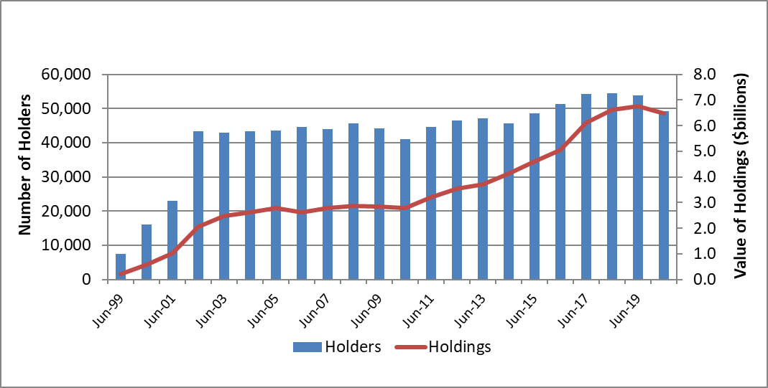
Source: DAWE (2021b)
The rate of decline in national holdings has slowed but continues through 2021. At 30 May 2021, the total funds held in FMD accounts had dropped to $5.27 billion), a decrease of $297.06 million (5.34%) from the same period in 2020 ($5.57 billion) (DAWE 2021b). This significant national drop in total FMD holdings has been led by declines in New South Wales, Western Australia, South Australia and Queensland, with drops of up to 30% of FMD holdings in some regions. However, Victoria and Tasmania recorded continued increases in FMD holdings over this period (Figure 2). The FMD Scheme is not well adopted in the Northern Territory. The electorates with the greatest drop in FMD holdings from 2019 to 2020 are detailed in Table 6.
Figure 2 FMD annual holdings by state and territory, 30 June 1999 to 30 June 2020
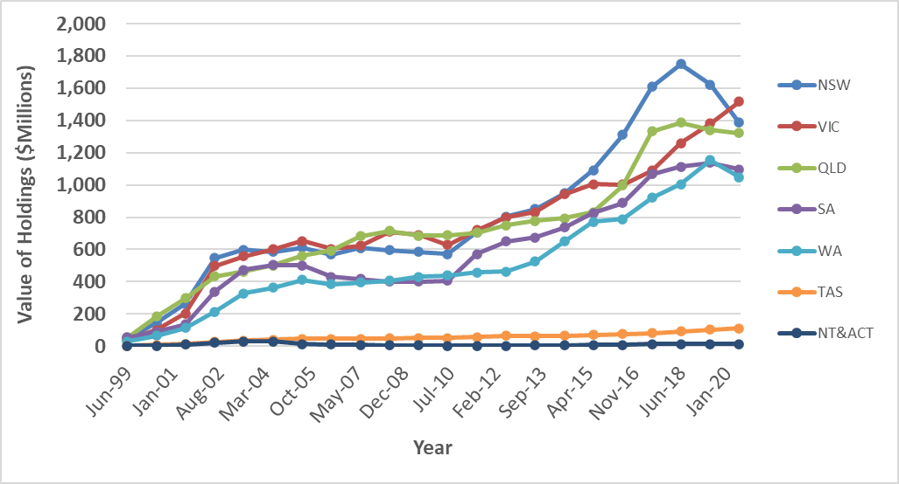
Source: DAWE (2021b)
Table 6 FMD total holdings by electorate, decreases greater than 10%, 30 June 2019 to 30 June 2020
State | Electorate | 30 June 2019  ($,000) | 30 June 2020  ($,000) | Difference ($,000) | Difference (%)
NSW | Parkes | $369,570 | $257,965 | –$111,606 | –30.20%
NSW | New England | $123,602 | $87,144 | –$36,458 | –29.50%
NSW | Riverina | $292,051 | $240,344 | –$51,707 | –17.70%
NSW | Calare | $77,435 | $64,497 | –$12,938 | –16.71%
NSW | Lyne | $23,781 | $20,083 | –$3,698 | –15.55%
QLD | Fisher | $13,733 | $10,857 | –$2,876 | –20.94%
QLD | Groom | $60,432 | $51,802 | –$8,630 | –14.28%
QLD | Maranoa | $364,913 | $324,609 | –$40,305 | –11.04%
WA | Durack | $505,179 | $446,343 | –$58,836 | –11.65%
WA | Curtin | $12,980 | $11,562 | –$1,418 | –10.92%
Note: The value of deposits reported may be greater than the actual level of FMDs as primary producers may choose not to claim a tax deduction for all deposits held in FMD accounts.
Source: DAWE 2021b

Individual holdings
There has been an ongoing increase in the average value of FMDs held by individuals. The average value of an FMD on 20 June 2019 was $119,258 (DAWE data). This has increased by 77% from $67,195 in 2001. FMD statistics show the average FMD holding in June 2020 to be $131,801. ATO data shows the average FMD holding on 30 June 2020 to be slightly higher at $139,000 (Table 7).
The average FMD holdings of broadacre farms peaked in 2017–18 at $281,800 per farm and declined to $237,400 per farm by 30 June 2020. Litchfield et al. (2021) noted that data on farm holdings is distinct from the statistics available on individual holdings, as each farm can include more than one individual FMD holding.

Growth in FMD holdings
There has been a steady increase in the number of primary producers with FMD account balances between $700,000 and $800,000 since 2016 (Figure 3).
Figure 3 FMD holders, 30 June 2016 to 30 June 2020
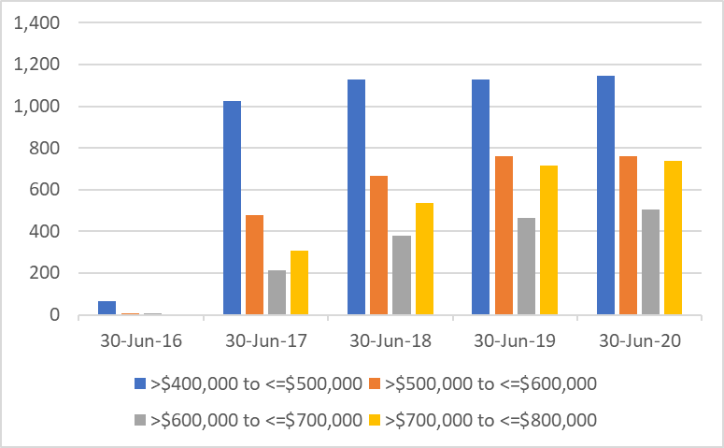
Source: DAWE (2021b)
Nevertheless, the proportion of primary producers currently taking advantage of the increased deposit limit introduced in 2016 is low. At 30 June 2020 there were around 739 FMD holders with an FMD account balance between $700,000 and $800,000. ATO data shows that fewer than 10% of FMD holders have accounts more than $400,000.

Table 7 Clients with FMD account transactions during 2019–20 and balances at 30 June 2020
Balance range | Clients | Total balances held ($m) | Average balance held
Less than $1,000 ª | 8,106 | Nominal | Nominal
$1,000–$49,999 | 10,628 | 259 | $24,393
$50,000–$99,999 | 7,915 | 526 | $66,521
$100,000–$399,999 | 14,643 | 2,900 | $197,082
$400,000–$799,999 | 3,788 | 2,000 | $525,826
At $800,000 cap | 827 | 660 | $800,000
Greater than $800,000 cap ^{b} | 64 | 65 | $1,020,469
Total | 45,971 | 6,400 | $139,009
a Approximately 8,000 of these clients had withdrawn their FMD balance to zero at 30 June 2020 and the remaining 100 had nominal balances. b 64 clients appear to have more than the stated $800,000 balance cap; this is not saying that deductions have been claimed over $800,000.
Source: Australian Taxation Office
Regions with broadacre farms with the highest average value FMDs are in the Darling Downs and Central Highlands of Queensland ($474,100), the Eyre Peninsula in South Australia ($447,000), and the central and southern wheat belts ($378,900) and northern and eastern wheat belts in Western Australia ($478,000) (Litchfield et al. 2021).
Our FMD Scheme data shows that the highest total FMD holdings (at 30 June 2020) are in the South Australian electorate of Grey ($627,093,524), followed by the Victorian electorate of Mallee ($607,760,378) and the Western Australian electorate of O’Connor ($457,905,121). However, Victoria overall has the highest total of holdings at $1,517,197,656.
The highest average FMD holdings are not uniformly within these electorates. This indicates the diversity and variability of FMD use.

Sectoral holdings
In 2020 the grain-sheep/beef sector had the greatest industry share of the total value of FMDs, closely followed by grain (Figure 4) (DAWE 2021b). According to Litchfield et al. (2021), broadacre farms (grain, sheep and beef) accounted for 73% of the total value of FMDs at 30 June 2020 (Figure 5) (DAWE 2021b).
Figure 4 FMD Scheme holdings by industry sector, 30 June 2020
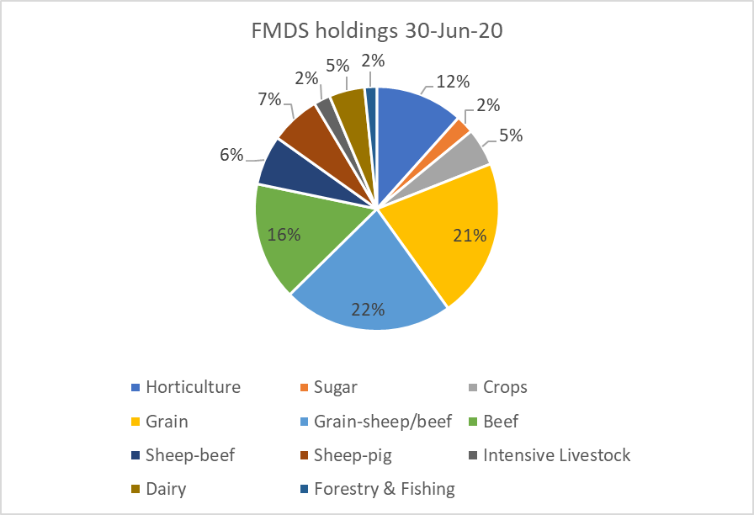
Source: (DAWE 2021b)
Figure 5 FMD Scheme holdings ($,000), 30 June 2006 to 30 June 2020
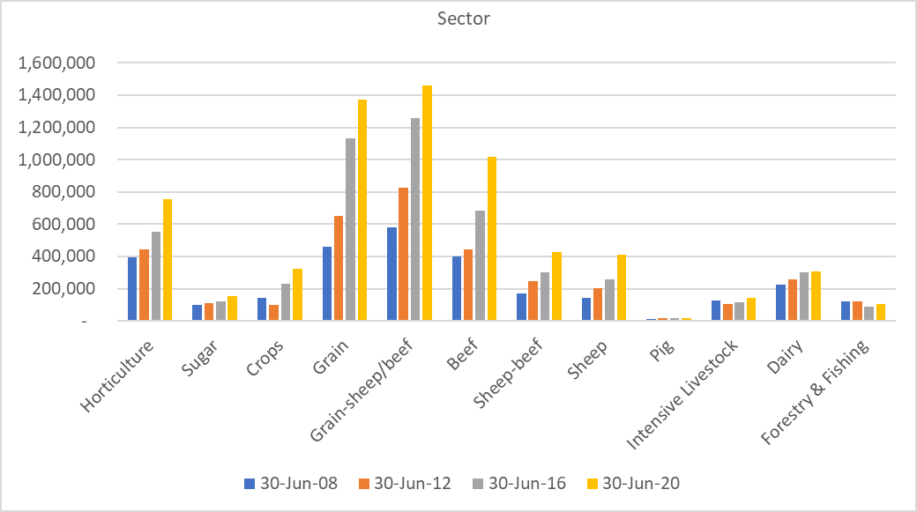
Note: The value of deposits reported may be greater than the actual level of FMDs as primary producers may choose not to claim a tax deduction for all deposits held in FMD accounts.
Source: DAWE (2021b)
Litchfield et al. (2021) reported that a significantly higher proportion of cropping farms held FMDs compared to livestock farms between 2010–11 and 2019–20, and that the average value of FMD holdings by cropping farms also increased by more than those of livestock farms. This trend is supported by data that shows the average value of FMDs held in a range of agricultural sectors (
Table 8) (DAWE 2021b).
Table 8 Growth in average FMD holdings by industry, 30 June 2011 to 30 June 2019
Industry | Average value of FMDs held at 30 June 2011 | Average value of FMDS held at 30 June 2019 | Growth (%)
Australia | $67,195 | $119,258 | 77.5
Beef | $67,839 | $117,699 | 73.5
Dairy | $64,799 | $99,400 | 53.4
Mixed livestock crops ª | $75,176 | $135,909 | 80.8
Sheep | $55,095 | $101,059 | 83.4
Sheep/beef | $61,412 | $100,129 | 63.0
Wheat and other crops ^{b} | $78,849 | $161,354 | 104.6
a Includes grain-sheep/beef, cotton and other crops. b Includes grain, cotton and other crops
Note: Average value of FMDs are an estimate as the total number of holders used in calculations does not indicate the number of primary producers participating in the FMD Scheme as a primary producer may hold multiple FMD accounts. In addition, the value of deposits used in calculations may be greater than the actual level of FMDs, as primary producers may choose not to claim a tax deduction for all deposits held in FMD accounts.
Source: DAWE (2021b)

Grains
As of June 2020, there were around 8,328 FMD holders in the grains sector, holding a total value of $1.39 billion. The number of holders increased by approximately 30% from 6,389 to 8,328 between 2007 and 2020 (Figure 6) (DAWE 2021b).
Figure 6 FMD Scheme grains industry holders and holdings, 30 September 2007 to 31 December 2020
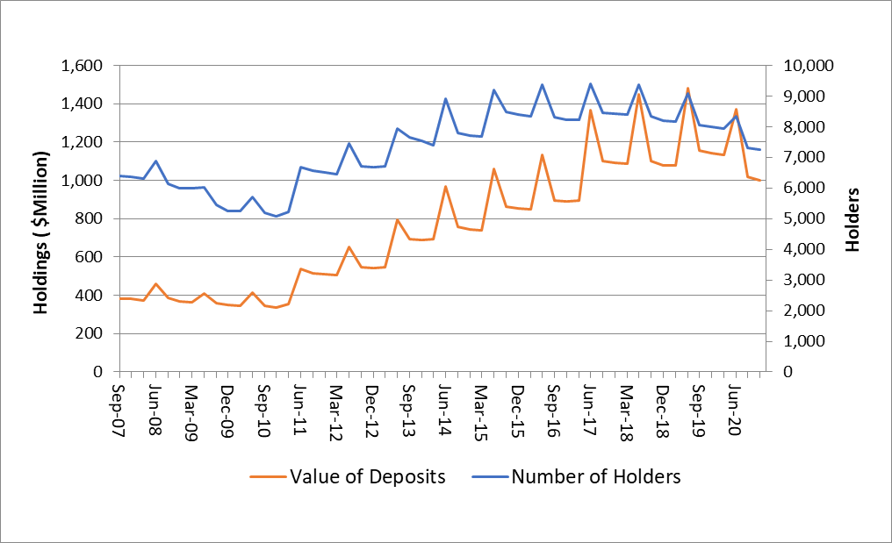
Source: DAWE (2021b)
Between 2011 and 2020, the average value of an FMD deposit in the grains industry doubled from $80,753 to $164,495 (DAWE 2021b).
Through the consultation process, GrainGrowers (2021) provided data based on a survey of over 700 respondents, 80% of whom have or have had an FMD account. The survey shows strong growth in average FMD holdings between 2014 and 2020, with a slight decline in the number of FMD holders (for both grain and grain-livestock businesses) (Figure 7 and Figure 8).
Figure 7 FMD average holding by grains industry, 2014 to 2020
Source: GrainGrowers (2021)
Figure 8 Number of grains industry FMD account holders, 2014 to 2020
Source: GrainGrowers (2021)
Between 2017 and 2019 the FMD holdings of grain producers declined, reflecting seasonal conditions in individual states (Figure 9).
Figure 9 Grains industry FMD holdings by state, July 2014 to July 2020
Source: GrainGrowers (2021)

Dairy
In contrast, the dairy industry holds only 5% of the share of FMD Scheme holdings. In 2020 there were 2,788 account holders in the dairy industry, holding a total value of $305 million (Figure Figure 10) (DAWE 2021b). Average dairy FMD holdings have grown by 69% since 2011, from $64,799 to $109,534, and there has been a 20% drop in the number of holders, from 3,360 to 2,657 (DAWE 2021b). It should be noted that the drop in the number of holders may reflect some consolidation or structural adjustment in the sector but may also represent consolidation of the number of FMD accounts held by individuals.
Litchfield et al. (2021) noted that data shows that around 18% of dairy farms held FMDs over the 3 years to 2019–20.
Figure 10 FMD Scheme dairy industry holders and holdings, 30 September 2007 to 31 December 2020
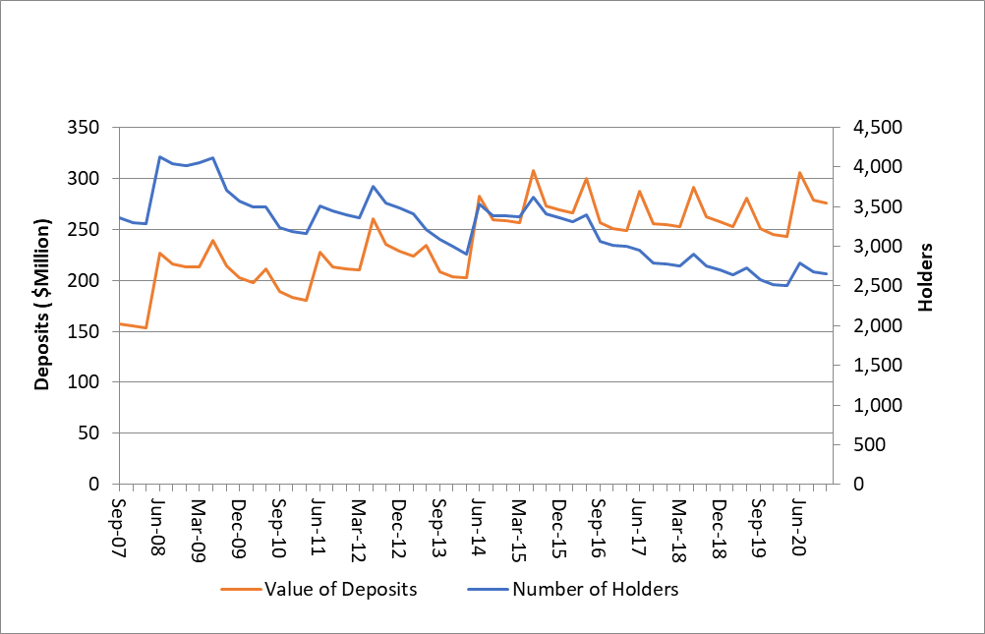Source: DAWE (2021b)

Why primary producers use FMDs
As described in section 2.1, uptake of the FMD Scheme is around 41% of eligible individuals. Stakeholders have mixed views what a successful rate of uptake would be, and the extent to which there is scope to increase uptake. Stakeholders (including AgForce (2021) and NSW Farmers (2021)) suggested that government settings could further incentivise and encourage the use and expansion of the FMD Scheme.
This section discusses the issues influencing the uptake of FMDs.

Income
An estimated 67% of broadacre farms did not hold FMDs in 2019–20. A primary reason identified in Litchfield et al. (2021) was lack of available income. Over half of non-FMD holders indicated that having insufficient funds was their main reason for not holding FMDs in 2019–20. This finding was consistent across small, medium, and very large farms. (Figure 11).
Figure 11 Main reasons for not holding FMDs, percentage of broadacre farms not holding FMDs, by size, 2019–20
Note: Size groups determined by farm business turnover. Small–medium (less than $750,000). Large–very large (more than $750,000).
Source: Litchfield et al. (2021)
GrainGrowers (2021) also showed that insufficient cash was the primary impediment to holding an FMD account (Figure 12).
Figure 12 Impediments preventing FMD accounts being held
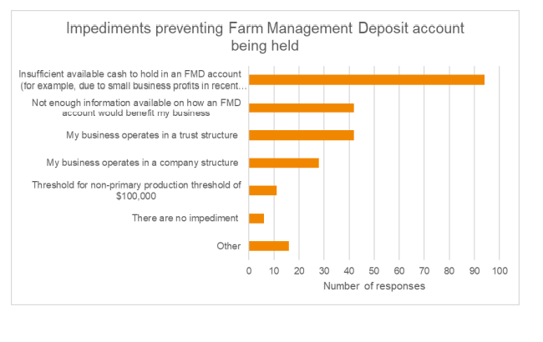
Source: GrainGrowers (2021)
Comments from our Have Your Say survey (DAWE 2021a) also showed that lack of funds was frequently identified as a reason for not holding FMDs.
‘No spare funds.’
‘Don’t make enough money to use FMD. Use alternative methods of moving income/expense. Such as deferred grain contracts, prepay accounts etc. Once an FMD has been used, it is incredibly difficult to pull it out in our environment’.
‘The ones that do not hold FMDs are for 2 reasons, they are not profitable therefore no need to put funds into these accounts. Or they are profitable all the time and there is not good time to take the funds out of the FMD so they pay money into super and pay the tax and reduce the debts.’
In explaining the predominance of the grains sector in FMD holdings, Litchfield et al. (2021) notes that during the 2010s, broadacre cropping farms generated higher and more consistent incomes compared to other broadacre industries on average, enabling greater capacity to make FMD deposits. This is particularly so in the wheat belt of Western Australia, which tripled average farm cash income between 2010–11 and 2018–19. The proportion of farms holding FMDs and the average value of FMDs per farm increased significantly in Western Australia over that period. In contrast, wide fluctuations in annual farm incomes over the last decade in the dairy industry in some states are likely to have reduced the ability of many dairy farmers to make significant FMD deposits (Litchfield et al. 2021).
A stakeholder suggested that while the FMD Scheme may work well for those with the liquidity to participate, its value is limited for smaller producers with less cash flow and fewer tax benefits from participation. There may be opportunities for government to consider incentives that may encourage smaller producers with less cash flow, and younger primary producers, to invest in FMDs or other risk management tools.

Age and business phase
Stakeholders (including AgForce (2021) and GrainGrowers (2021)), said that the FMD Scheme does not suit all primary producers and that its use will depend on the stage of business development and commodity. Younger primary producers and those in a business start-up or growth phase may prefer to reinvest in the business. One stakeholder said that FMD holders are most likely to be 55 years or older, and no longer actively investing in the farm. This perspective is supported by our data. Uptake of FMDs is dominated by primary producers in the older age groups. GrainGrowers (2021) survey results (Figure 13) also show that FMD holders in the grains industry are older, lining up with FMD holders nationally. Advice from ABARES is that older age groups also dominate farming, and this distribution may reflect the ages of primary producers.
Figure 13 Number of FMDs held by age range, 2021
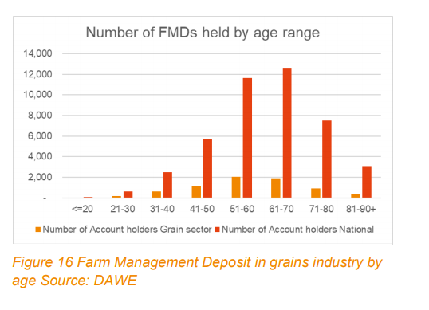
Note: The total number of holders may be different to the reported statistics as some holders may have made more deposits at different ADIs or hold more than one account.
Source: GrainGrowers (2021) using DAWE data (2021b)

Alternative risk management tools
The NFF (2021) noted that different agricultural industries will prioritise different risk management tools and that FMDs will not always be the best way to manage risk. For example, intensive horticulture and dairy farming are likely to rely less heavily on FMDs as irrigation and the purchasing of high-security water rights are readily available options. Another stakeholder, with personal experience in the dairy industry, said the regular income generated in the dairy industry may mean that the income smoothing effect of the FMD Scheme is less of an incentive than in other commodities.
Stakeholders commonly describe FMDs as one mechanism within a suite of tools available to manage risks. Litchfield et al. (2021) found that around 11% of FMD holders on broadacre farms believed FMDs were their primary risk management tool. More commonly used risk management tools are diversification of income sources through off-farm income (further discussed in section 2.4) and access to a debt facility (Figure 14).

Figure 14 Risk management strategy, percentage of all broadacre farms, Australia, 2019–20
Source: Litchfield et al. (2021)
Other viable alternatives to investing in FMDs identified by stakeholders in roundtable discussions include using income tax averaging, investing in fodder, diversification into other agricultural sectors, and repurposing land to reduce climatic risk. Accessing a debt facility or seeking an investor may also be options. One stakeholder said that primary producers are taking advantage of government support schemes, including tax deductions and loans provided through the Regional Investment Corporation, rather than investing in the FMD Scheme. The role of government support programs in influencing primary producers’ perceptions of risk and planning for drought is discussed in section 2.5.

Information and education
Litchfield et al. (2021) noted that the secondary reason for not holding an FMD is lack of information. While there may be a high level of awareness of the FMD Scheme, as it is a long-running program (AFI 2021), stakeholders agree that there is scope to improve targeted information to both primary producers and their advisers about the scheme and its benefits (for example ABA (2021)).
Stakeholders reported that accountants and ADIs are not promoting FMDs as they have done in the past. Increasing awareness of the scheme among financial and taxation advisers would contribute to greater participation in the scheme.
Professional advisers could also benefit from education about the objectives of the scheme, and the way it operates in conjunction with other government measures, including income tax averaging (see also section 2.5). The Have Your Say survey (DAWE 2021a) showed that stakeholders from the banking and financial sector have a broad understanding of the FMD Scheme but were more likely to recommend that their clients use FMDs as an income smoothing and taxation measure rather than a tool for drought resilience (Figure 15).
Figure 15 Survey question: For what purpose do your clients/members use a farm management deposits account?
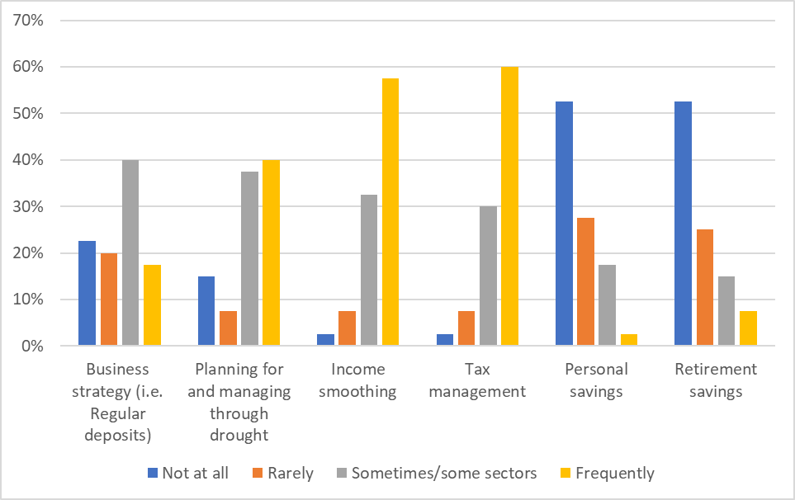
Note: The department surveyed 42 representatives from the banking and financial sector as part of its Have your Say FMD Scheme evaluation.
Source: DAWE 2021a
The NFF (2021) notes that its members, including those with accounting and financial planning expertise, have suggested that farm adviser education would benefit from a holistic overview of all drought measures and their typical use.
There also appears to be scope to increase education and information for primary producers on business planning and resilience building, including issues such as the benefits of primary producers paying themselves wages, contributing to a superannuation fund, and participating in the FMD Scheme. It could also extend to encouraging primary producers to access well-informed professional advice, including both financial planning and accountancy; one stakeholder said that it appears that younger farmers today are increasingly less likely to access professional advice and more likely to seek information through non-traditional mechanisms, including word of mouth, podcasts and social media.
Both primary producers and taxation and financial planning professionals could benefit from additional information and education about the role of FMDs. This would be likely to improve both the efficiency with which the scheme operates, and its effectiveness.

Early withdrawals
Changes were made to the FMD Scheme in 2016 to increase its flexibility and uptake. One of these was the provision enabling withdrawal of FMD funds within 12 months for FMD holders affected by drought. This provision appears to be well utilised; its use appears to have noticeably increased during recent years. Data from the ATO shows that in 2018–19, 339 primary producers accessed early repayments, which totalled $32,091,128 (Figure 16).
RSM Australia (2021) suggested that a further exemption could be introduced based on a ‘change of circumstance’ declaration. For example, after rain events, primary producers could be provided early access to FMDs to restock or plant late crops. This may increase flexibility and align the scheme with business needs. NSW Farmers (2021) suggested that primary producers eligible for concessional loans under the National Disaster Relief and Recovery Arrangements be able to retain taxation benefits for early withdrawal.
The Institute of Foresters Australia and Australian Forest Growers (2021) noted that eligibility for drought-affected primary producers to withdraw FMD funds within 12 months excludes primary producers solely involved in the felling of trees, and that the reason for this exclusion was unclear. Early access to FMDs does not extend to transporting trees that the transport logged for milling because drought conditions do not directly impact on these activities and therefore FMD owners are unlikely to need early access to amounts deposited in an FMD in a time of drought.
Figure 16 Early FMD withdrawals (natural disaster), 2014 to 2019
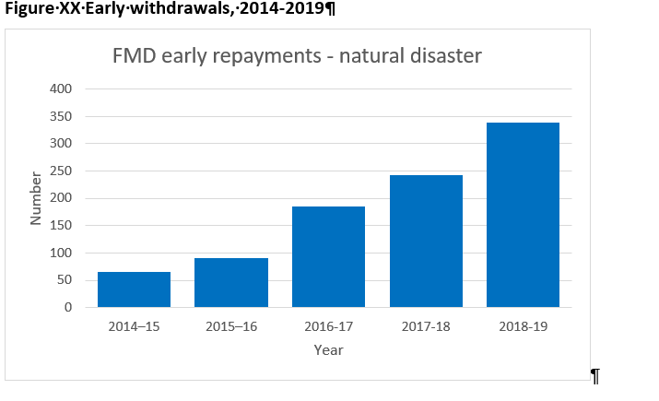
Source: Australian Taxation Office

How primary producers use FMDs
Stakeholders explained that the way primary producers use FMDs varies widely between sectors, states and individuals. Some primary producers will invest in FMDs during drought, when they are forced to sell livestock or are able to sell feed at higher prices. Others will draw down on FMDs during years of no or little income for supplementing fodder, uninsurable flood damage repairs, business continuity costs (for example, retention of workforce in remote areas), capital investment in water infrastructure, and landcare initiatives (longer term risk minimisation). Large farms may last many seasons without needing to access the FMD, while small primary producers may more regularly draw on deposits to support their households when income is low. GrainGrowers (2021) provided the evaluation with examples of the way its members use the scheme. For example:
‘We have used FMDs for some time now. Each year we utilise differently. On occasion we have been able to add to it in the rare event of two good years in a row! Recently we have not had much cash left by June 30 to invest and have needed to access FMD as capital to keep us going, which has been reassuring and especially useful. I would hope the program would continue.’ Grower, SA.

Use as a tax management tool
The clear pattern of deposits and withdrawals around the financial year cut-off is a reason why some stakeholders see FMDs as primarily a tax management tool. This pattern can be explained as due to the timing of decision-making. During May and June each year, many businesses review their financial situation, make company and trust resolutions (where relevant) and prepare their end-of-year position with their advisers. It is usually at this time of year that primary producers will be able to decide whether to deposit money into the FMD Scheme. Fluctuations in total balances are to be expected and are in line with the normal business cycle (CPA Australia 2021).
In addition to the annual pattern of deposits and withdrawals, the sustained growth of FMDs nationally, particularly during the 2010s, has led some stakeholders, particularly in the media (Appendix C), to conclude that the use of FMDs is related to tax management and personal savings rather than risk management or used to manage through drought.
Litchfield et al. (2021) identified that the main reason broadacre farms hold FMDs is to manage taxation liability, followed by income smoothing (Figure 17). The survey results differed by size, with large and very large farms using FMDs for tax management, and small and medium broadacre farms primarily using FMDs for income smoothing.
Figure 17 Main reason for holding FMDs, percentage of broadacre farms by industry, 2019–20
Source: Litchfield et al. (2021)

CPA Australia (2021) pointed out that the scheme delivers benefits through a tax concession and that it is through this mechanism that policy outcomes are achieved. RSM Australia (2021) said that as an income equalisation tool the FMD Scheme can assist with tax management but that FMDs primarily provide an incentive to improve cash flow management.
There are financial benefits for primary producers who invest in FMDs, and farms in a better financial position are more readily able to respond to drought and other market downturns. Litchfield et al. (2021) notes that broadacre farms with FMD holdings have superior farm financial performance on average, including higher farm cash incomes, business profits, rates of return and equity ratios than farms not holding FMDs.
FMD holdings are part of the liquid assets available to farm businesses and are important in complementing farm household income, particularly during challenging times. One stakeholder explained that a key benefit of FMDs is the scheme’s capacity to quarantine funds that can be readily accessed when needed. Litchfield et al. (2021) notes that hypothetical use of funds in the absence of FMDs for broadacre farms (Figure 18). Without the FMD Scheme, primary producers may be more likely to invest in other ways (such as property or the share market), reducing their capacity to respond in a timely way to climatic events and other risks, and possibly increasing their reliance on government support.
Figure 18 Hypothetical use of funds in the absence of FMDs, percentage of broadacre farms, 2019–20
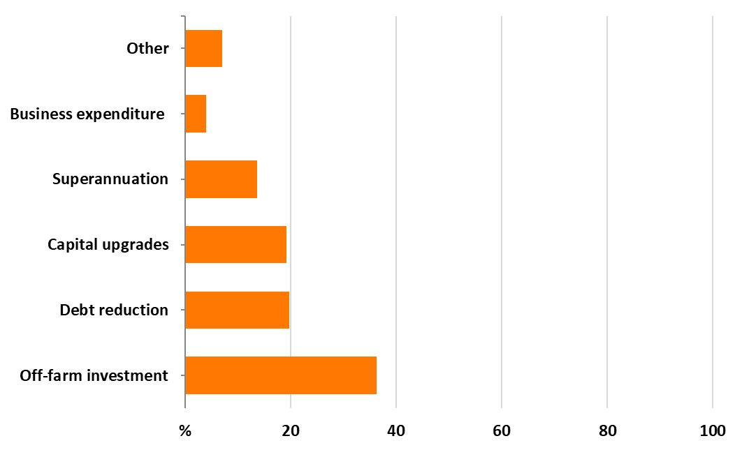
Source: Litchfield et al. (2021)

Use of FMDs during drought
In contrast to the survey results reported by Litchfield et al. (2021) showing that tax management is the main use for FMDs (Figure 17), our Have Your Say survey (DAWE 2021a) (Figure 19) showed that FMDs were frequently used for planning for and managing through drought and income smoothing.
The Have Your Say survey (DAWE 2021a) also provided examples of primary producers using FMDs during drought.
‘It was drawn down during the last drought, 2019-20 financial year.’
‘I have held Farm Management Deposits since 2000 but have had to withdraw them all as a result of the recent drought’.
‘We are no longer primary producers after a lifetime of being so however we found FMD to be vital management tools.’
‘Did have one but had to use all funds to keep farm a float in the 3 year drought period.’
‘FMD account used to negotiate drought reduced cash flow.’
The different outcomes of these surveys reflect the different survey methods and the questions asked.
Figure 19 Survey question: For what purpose do you or your clients/members use an FMD account?
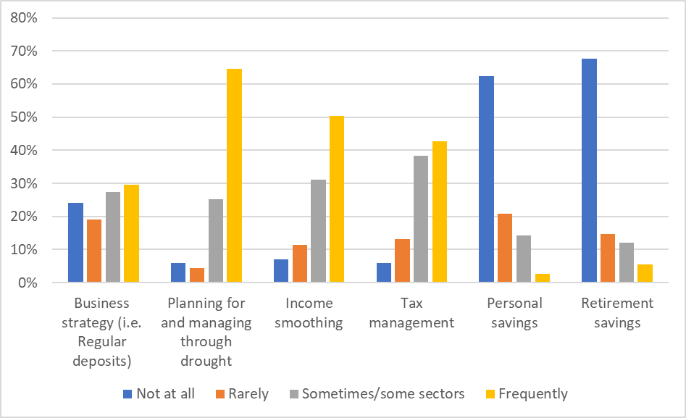
Note: The department received 183 responses to this question, out of 212 responses, as part of its Have your Say FMD Scheme evaluation.
Source: DAWE (2021a)
The recent significant decline in FMDs holdings nationally, and particularly in New South Wales, also suggests that FMDs have been used for drought support (see section 2.1). This seems particularly evident in some regions of New South Wales: one stakeholder noted the hardship experienced by primary producers in western New South Wales and said that FMDs had been a lifesaver in the far west of New South Wales.
ATO data shows that although income tax lodgements are not complete for 2019–20, it is likely that withdrawals will exceed deposits for only the second time in 20 years and the first time since 2009–10. This suggests that FMD clients accessed income from their FMD accounts at a significantly higher rate during 2019–20. A return to more typical levels of FMD holdings in future years would suggest that in general, primary producers have relied upon FMDs as a source of finance during drought.
We should continue to monitor the balance of net FMD deposits and repayments as the drought conditions ease in eastern Australia.

Business loan offset accounts
One of the policy changes introduced to the FMD Scheme in 2016 was the opportunity to offset FMDs against business loans. RSM Australia (2021) said that the loan offset arrangements provide a cost saving incentive while keeping the funds available for quick access rather than permanent debt reduction. Evidence from other stakeholders, however, suggests that a low proportion of FMD holders are taking advantage of the loan offset provision.
Low take-up is associated with eligibility requirements and levels of awareness. CPA Australia (2021) suggests that eligibility requirements for the provision (both business loans and FMDs must be in the same individual’s name, and the loan must be wholly used for business purposes) mean that the offset account is not available to many primary producers. In addition, Have Your Say survey (DAWE 2021a) data suggests that there is some confusion about the availability and purpose of offset accounts.
‘This scheme should be able to be offset against debt.’
Issues relating to the provision of business loan offset accounts by ADIs are discussed in section 1.24.
Without the revision of eligibility criteria for offset accounts, it seems unlikely that there will be an increase in either the provision or uptake of business loan offset accounts. Government may wish to revisit this issue should the current low-interest rate environment change, and primary producers’ need for business offset accounts increase.

Barrier to uptake – non-primary production income
To be eligible for an FMD a primary producer’s non-primary production income must be less than $100,000 in the financial year they make the FMD Scheme deposit. The purpose of this eligibility criterion is to ensure that the FMD Scheme is available to genuine primary producers, not individuals whose main income is from off-farm activities.
Industry stakeholders suggested that the $100,000 cap should be increased to better reflect contemporary farming practices. Primary producers are diversifying their business operations in response to climatic events and as a broader risk management approach. This diversification assists to build resilience and supports primary producers through market downturns. Stakeholders identified that primary producers are investing in new markets or see new markets on the horizon. These include renewables (wind and solar panel farms), carbon farming, biodiversity offsets, developing and marketing their own products, agritourism and hospitality. The NFF (2021) highlighted the need for consistent government policy to support off-farm income opportunities. Another stakeholder with accountancy expertise suggested revising the definitions of primary producer and primary production business to facilitate diversification and support risk management. The benefits to primary producers from these proposed changes would need to be offset against risks that non-primary producers may be able to access the scheme.
The Institute of Foresters Australia and Australian Forest Growers (2021) said that for private foresters the $100,000 off-farm limit is a barrier to access to the FMD Scheme. Significant investment is required to self-fund a plantation investment, as well as to provide income during the 25 to 40 years needed for sawlogs. This funding is likely to come from off-farm income.
The National Resilience and Recovery Agency advised that smaller farms generate a significant proportion of their income from off-farm activities compared to larger farms. As such, a change to the off-farm income cap may facilitate greater participation in the FMD Scheme by primary producers with smaller farms.

Alignment with other government programs
While Australian primary producers are some of the least subsidised in the world (Greenville 2020), the FMD Scheme is one of many Australian Government initiatives supporting primary producers.
Primary producers who use the FMD Scheme also take advantage of a range of government support measures including tax offsets and deductions. This chapter analyses the ways in which government initiatives interact with the FMD Scheme and how this may affect the outcomes and impacts of the scheme.

Tax-based schemes
A summary of the taxation benefits available to primary producers is at Appendix D. Stakeholders identified the following 3 schemes as particularly relevant to the FMD Scheme.

Profit from the forced disposal or death of livestock
This scheme allows the deferral, over a period of 5 years, of profit from the forced disposal or death of livestock. The profit could alternatively be used to offset the cost of replacement livestock in the disposal year or any of the next 5 years.
Some stakeholders described the tax smoothing effect of this scheme as an alternative to the FMD Scheme: profits are set aside for up to 5 years, and tax payments delayed. Some stakeholders also explained that the 2 schemes may work together, as profits from the sale of stock during drought can be quarantined as an FMD and support the purchase of livestock when conditions improve.

Tax averaging for primary producers
Tax averaging for primary producers enables primary producers with fluctuating incomes to even out their tax payable over a maximum of 5 years, ensuring they do not pay more tax over this time than taxpayers on comparable but steady incomes. Primary producers may withdraw from the averaging system for 10 income years and pay tax at ordinary rates; after this, averaging will recommence.
Income tax averaging was described by one stakeholder as a powerful tool that is not well understood by primary producers.
FMD withdrawals are defined as primary production income, and therefore the tax rate that applies to any FMD withdrawal is averaged across 5 years of income tax paid by the primary producer (unless the primary producer has opted out of income tax averaging). Income tax averaging and the FMD Scheme can be used simultaneously. Both have the effect of smoothing the amount of tax payable over time.
Confusion over the role of income tax averaging and its interaction with FMD accounts is evident in many stakeholder submissions. Stakeholders, including the NFF (2021), GrainGrowers (2021) and CPA Australia (2021), said that the high tax rate applying to lump sum FMD withdrawals was a reason why primary producers are reluctant to access their FMD at times of need. Almost all stakeholders called for a capping or smoothing of tax rates applying to FMDs where the holder has passed away or, alternatively, a change to regulations to enable the FMD to be transferred from the individual to the primary production business. The Institute of Foresters and the Australian Forest Growers (2021) said that extending the length of time for which a private forest owner may retain an FMD after ceasing primary production is a way of removing the disincentive period of inequity. Existing income tax averaging provisions were not acknowledged in any submissions.
Data from Treasury confirms that primary producers take advantage of both income tax averaging and the FMD Scheme. Treasury advises that around 85% of individuals who made an eligible FMD deposit or withdrawal in 2018–19 also had a tax adjustment under income tax averaging. In addition, Litchfield et al. (2021) found that while the income smoothing function of FMDs is a primary reason for holding an FMD, the availability of income tax averaging is a reason for not holding an FMD – particularly for larger primary producers.
There is an opportunity for the ATO to provide targeted communication and information on the relationship between income tax averaging and the FMD Scheme to stakeholders (including primary producers, accountants and advisers), the interaction of the 2 schemes to smooth tax payable, and the tax rate payable on an FMD deposit on the death of an FMD holder.

Accelerated depreciation
Changes to rules around the depreciation of business assets were introduced in 2020 to stimulate business activity during the COVID-19 pandemic.
This includes temporary full expensing, which enables eligible businesses with aggregated annual turnover or total income of up to $5 billion to immediately deduct the full cost of eligible depreciating assets of any value in the year they are first used or installed ready for use. It includes new assets and improvements to existing eligible assets acquired from 7:30pm (AEDT) on 6 October 2020 and first used or installed by 30 June 2022 (to be extended to 30 June 2023, subject to the passage of legislation). Small and medium-sized businesses with an aggregated annual turnover of less than $50 million can also fully deduct the cost of eligible second-hand assets.
One stakeholder described the way some primary producers are not building FMDs at present, despite high commodity prices. Media has also suggested that attractive depreciation incentives may be motivating primary producers to spend liquid assets (see the article from Queensland Country Life in Appendix C).
We should monitor the holdings of FMDs from 2021 through recovery from drought. There may also be scope for government to support best practice business planning and risk management for primary producers, including the use of the FMD Scheme.

Drought support
Under the National Drought Agreement (2018), the Australian Government and state and territory governments have agreed to develop policies and programs to plan for and manage risk; and prepare for, manage, and recover from drought. A key responsibility of the Australian Government under the National Drought Agreement is continued availability of incentives that support farming businesses’ risk management, including taxation concessions, the FMD Scheme and concessional loans.
The majority of FMD Scheme stakeholders support this government policy focus on preparedness and financial self-reliance. There was a strong view from some industry stakeholders that primary producers should not be entitled to support from government for drought as it is a foreseeable, cyclical event. Many respondents to the Have Your Say survey (DAWE 2021a) are proud of their financial self-reliance and the fact that they do not rely on government ‘handouts’ during drought.
‘FMDs have assisted our family farming business to absorb shocks and remain INDEPENDENTLY viable over several decades. We do not believe in subsidies or handouts. FMD allow us to manage our risks with our own funds without reliance upon external assistance. They have been and remain vitally important to us.’
‘I think FMDs are a valuable resource for farming families and because of FMDs we can manage our money better to prepare for conditions out of our control. We don’t need to depend on government to get handouts in hard times as we can balance our money more. I think if you take away or change FMDs you will be making our lives a lot harder.’
Nonetheless, many stakeholders believe it is inevitable that governments will continue to provide support during drought for primary producers, as evidenced by the $11 billion of drought support and resilience measures provided by the Australian Government since 2018–19. In addition to programs focusing on longer term resilience (including the Future Drought Fund), the immediate economic, social and environmental impacts of the drought saw the Australian Government initiate new support programs including drought-specific mental health assistance, cash grants to charities, and programs for better water infrastructure and pest and weed management. Initiatives also targeted local councils and small businesses, providing immediate economic stimulus. In addition, taxation concessions encourage primary producers to better manage their cash flows and invest in profitability and resilience on-farm (Department of Agriculture 2019). The drought support programs delivered by governments since 2018–19 did not appear to seek information on whether applicants held an FMD account or set eligibility criteria relating to funds available in FMDs.
Some stakeholders, including the AFI (2021), believe that the continued inconsistent and ad hoc policy response to risk management is ineffective and expensive, creates inequities between cohorts of primary producers and rewards inaction by primary producers.
There are opportunities for governments to better align drought support programs with the ongoing operation of the FMD Scheme, as well as to more widely promote the scheme as a mechanism to prepare for drought and build resilience.

Farm Household Allowance
Farm Household Allowance (FHA) is the Australian Government’s income support payment for primary producers and their partners experiencing financial hardship, regardless of its cause. Eligibility requirements for FHA include passing an income and assets test. Income includes income from the farm enterprise and directly related businesses. Combined personal and farm assets must be below $5.5 million, including any FMDs.
Consistent with Litchfield et al. (2021) findings that broadacre farms with FMDs are more profitable and have higher cash flow, only a very small proportion of individuals with FMD accounts also access FHA. Farm Financial Assessment data from Services Australia (at 30 April 2021) (internal document) shows that around 330 of the 8,778 (3.3%) farm households granted FHA since 2014 reported that they had an FMD (Table 9 and Table 10). This figure is also supported by ATO data: of the 25,151 clients who reported FMD Scheme transactions in 2018–19, 275 (1.1%) received FHA during that time. Of the combined FHA/FMD holders, 69% were over 60 years of age.
Data from Services Australia shows there is a strong correlation between FHA and drought: of the 1,100 people completing the FHA Exit Survey, 85% reported that they had accessed FHA mainly due to decrease in cash flow caused by drought.
Distribution of farms with both FMDs and FHA is shown in Table 10; the highest proportion of farms both holding FMDs and receiving FHA is in South Australia. A stakeholder from South Australia said that primary producers in the region see FMDs as a key tool for drought management; deposits are made into FMD accounts when destocking and the funds are used to restock when conditions improve and that during drought, FHA is accessed after a year or two to cover household costs. Although a timeframe was not attributed to this behaviour, it is likely that this behaviour has occurred more frequently since 1 July 2019, when profits from the forced sale of livestock are exempted from the FHA income test when they are placed in an FMD.
The ability to use both FHA and FMDs was enhanced by changes to FHA eligibility in June 2020 that no longer distinguished assets between farm assets and off-farm and liquid assets (with money in FMDs meeting the latter definition).

Table 9 Reasons for accessing FHA
Reasons for accessing FHA | Responses (no.) | Total responses (%)ª
Decrease in cash flow – drought | 540 | 86
Farm debt | 253 | 40
Decrease in cash flow – decrease in commodity prices | 243 | 39
Decrease in cash flow – other event | 66 | 10
Other reasons | 33 | 5
a This is not a count of individuals – respondents could choose multiple answers
Source: Services Australia
Table 10 Farms with FMD accounts as proportion of total FHA farms, by jurisdiction 2014-21
State/territory | FHA farms (no.) ª | FHA farms with FMD accounts (no.) | FMD farms as proportion of total FHA farms (%)
NSW | 3,312 | 126 | 3.8
Vic. | 2,091 | 66 | 3.2
Qld | 2,178 | 59 | 2.7
SA | 889 | 77 | 8.7
WA | 182 | np | np
Tas. | 107 | np | np
NT | Np | np | np
ACT | Np | np | np
Total | 8,778 | 330 | 3.8
a Based-on Farm Financial Assessment data at 2 February 2021. np Data not provided – it is either protected information or the information presents a risk of disclosure of protected information.
Source: Services Australia

Outcomes
The FMD Scheme was designed to meet the government’s desire to encourage increased financial self-reliance among primary producers whilst also taking account of the high variability of farm income streams and the vulnerability of farming businesses to natural events.
This evaluation was unable to draw a quantifiable link between the FMD Scheme and the objective of increased financial self-reliance. Relevant time-series data is not available. In the absence of this data, discussion of financial self-reliance has focussed on measures of financial success; reliance on government programs; and stakeholders’ views.
In addition to the objective of increased financial self-reliance among primary producers, this evaluation shows that there are other impacts of the scheme, including financial benefits, and improved capacity to plan for and manage through drought.

Financial self-reliance
This evaluation has found that people with an FMD account are generally successful at managing their primary production business in a broader environment that provides few subsidies. Greenville (2020) has found that Australian farmers are some of the least subsidised in the world – second only to New Zealand in terms of countries where comparable information is available. As measured by the Organisation for Economic Co-operation and Development (OECD), just over 2% of Australian farmer revenues in 2016-18 were derived from government support. Globally, Norway (61%), Iceland (59%) and Switzerland (55%) in Europe, and Korea (52%) and Japan (46%) in Asia, provide the highest levels of agricultural subsidies. Where direct farm support is provided by Australian governments, it is concentrated on risk management tools to help manage Australia’s uniquely variable climate. These tools include FMDs and income tax smoothing.
Litchfield et al. (2021) noted that in 2019–20, broadacre farms with FMD holdings had superior farm financial performance on average, including higher farm cash income, higher farm business profit, higher rates of return and higher equity ratios than farms not holding FMDs. A causal link cannot be drawn between FMDs and business success, however.
There is a high level of support for the FMD Scheme, and most industry stakeholders see the scheme as supporting increased self-reliance. Feedback from CPA Australia members (CPA Australia 2021) is that the scheme is an effective tool for providing financial security for those who are eligible. It reduces the need for primary producers facing financial insecurity to seek credit from lending institutions, often at high interest rates. It enables primary producers to save more in well-performing years without being burdened by high tax liabilities. The NFF (2021) believes that the FMD Scheme has significantly aided primary producers to become more financially self-reliant and resilient, as there is evidence that primary producers are using money from their FMD accounts. The Institute of Foresters Australia and Australian Forest Growers (2021) see the FMD Scheme as a valuable tool to help primary producers plan and manage their operations in variable future conditions.
It is notable, too, that according to Litchfield et al. (2021), FMD holders are slightly less likely to access Farm Household Allowance than non-holders. However, they also received slightly more government assistance than non-holders on average in 2019–20 (Figure 20). This may be due to a greater level of financial competency, awareness of government schemes, or advice provided by expert advisers.
Nevertheless, it shows that where support schemes continue to be offered by governments, where eligible, primary producers, including FMD holders, will continue to take advantage of their benefits. This includes drought support, short-term tax offsets and industry programs, through to support for recovery after bushfire and flood.
Figure 20 Components of government assistance, broadacre farms by FMD holdings, average per farm, 2019–20
Note: Household assistance includes Farm Household Allowance, childcare, study, unemployment and veterans assistance. Farm assistance includes JobKeeper payments. Does not include tax relief programs.
Source: Litchfield et al. (2021)

Tax management
It is inarguable that the FMD Scheme provides tax benefits to primary producers. Tax benefit is the key incentive of the scheme, which is designed to encourage investment of available funds. The financial benefits of the scheme are available only to primary producers who have the liquidity to invest in FMDs.
Broadacre farm primary producers indicated that their main reasons for using the FMD Scheme were to manage their taxation liability and for income smoothing (Figure 17) (Litchfield et al. 2021). In our Have Your Say survey (DAWE 2021a), respondents from the banking and financial sectors (42 out of the 212 responses) indicated that FMD accounts are primarily used for tax management and income smoothing (Figure 15).
In addition to tax benefits, stakeholders advise that the FMD Scheme helps smooth the impact of income tax on primary producers with often-fluctuating incomes. While the existing income tax averaging scheme provides this benefit, there may be some additional income smoothing provided through FMDs.

Managing through drought
The FMD Scheme aligns well with the Australian Government’s drought reform agenda of the last decade, which aims at transitioning from crisis management to long-term resilience and preparedness.
The increased drawdown of FMDs in the last 12 months shows that primary producers have accessed their accounts to support their farm businesses through difficult conditions, as well as to restock and rebuild their business with improved conditions. Our Have Your Say survey (DAWE 2021a) found that the FMD Scheme is considered an effective tool available to primary producers to manage risk, including building resilience and managing through drought (Figure 21). Around 60% of respondents indicated that FMDs significantly assisted primary producers to plan for and manage through climatic events such as drought and floods.
Figure 21 Survey question: How the Farm Management Deposits Scheme helps Australian primary producers
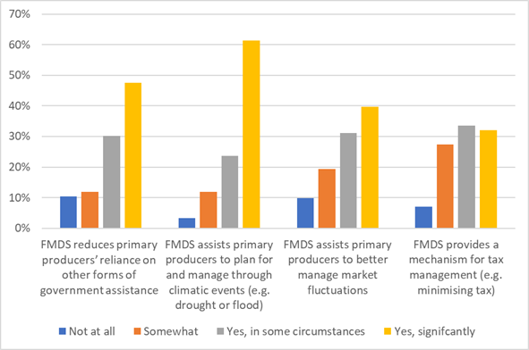
Note: The department received 212 responses as part of its Have your Say FMD Scheme evaluation.
Source: DAWE (2021a)
Use of FMDs is diverse, however, and the extent to which FMDs are being used to manage through tough times, including drought, is unclear. Some stakeholders from the financial industry found little or no correlation between drought and drawdown of FMD funds. The AFI (2021) noted that the flows of FMDs appear to be unresponsive to serious droughts and other events which would be expected to trigger withdrawal of deposits in order to smooth income flows within farm businesses.
Nonetheless, the wealth delivered through the FMD Scheme means that many primary producers have resources and an opportunity to better manage risks and build resilience to climatic changes and drought.
Given the tax benefit and cost to the budget of the FMD Scheme, there is scope for both industry and government to promote the benefits of the FMD Scheme, and better align the objectives of the scheme with related government policies and programs. This could include the Future Drought Fund, sustainable finance initiatives, and addressing barriers to private farm forestry (under Growing a Better Australia: A Billion Trees for Jobs and Growth). There are also opportunities for all stakeholders to target the use of FMD resources towards public goods, which could include adapting to climate change, improving soil quality, conserving biodiversity, and building resilience in rural communities.

Appendix A: Advisory Group terms of reference

Background
In 2021, the Department of Agriculture, Water and the Environment (DAWE) will conduct an internal evaluation into the operation of the Farm Management Deposits Scheme (FMDS). This evaluation will assess the extent to which the FMDS is delivering the outcomes as intended, and the efficiency of its administration. In doing so, the evaluation will fulfill Action 1.10 of the Australian Government Drought Response, Resilience and Preparedness Plan, which details the government’s commitment to undertake an evaluation of the FMDS, as well as recommendations of the recent Australian National Audit Office (ANAO) audit and the Joint Committee on Public Affairs and Audit (JCPAA) inquiry. It will also inform ongoing policy and program design, support better decision making and accountability.
The FMDS was designed to encourage increased financial self-reliance among primary producers. It is a tax-linked financial management tool that aims to improve the capacity of primary producers to manage financial fluctuations caused by environmental and market conditions. Eligible primary producers are able to set aside up to $800,000 in pre-tax income to draw in future years when needed.
At June 2020, the total holdings in the FMDS were $6.5 billion, held in over 49,000 accounts. As the FMDS is both a deferral and forgone revenue measure, it is not possible to give precise costings for the forward estimates. However, in 2019–20 the government provided $215 million in tax relief in net terms to primary producers through the FMDS. The FMDS is one of a number of tax concessions and measures to assist primary producers improve cash flow and provide an incentive for improved risk management. The FMDS also aligns with the Australian Government’s drought reform agenda of the last decade, which aims at transitioning from crisis management to long-term resilience and preparedness. The FMDS is a key Commonwealth commitment in the National Drought Agreement (2018) and the Australian Government’s Drought Response, Resilience and Preparedness Plan.
The FMDS is jointly administered by DAWE and the Australian Taxation Office (ATO). DAWE is the lead agency and has policy responsibility, while the ATO have responsibility for tax administration and compliance. The Treasury has responsibility for tax policy, tax legislation, and Tax Benchmarks and Variations Statements.
First implemented in 1999, there have been a number of reviews of the FMDS. These include the Department of Agriculture, Fisheries and Forestry’s 2006 Review and the National Rural Advisory Scheme’s 2013 Review. The 2015 Agricultural Competitiveness White Paper recommended reforms to the FMDS, including increasing the deposit cap to $800,000, and introducing an early access trigger for drought. More recently, the scheme was the subject of an independent audit by the ANAO (2019), and a related efficiency and effectiveness inquiry by the JCPAA (June 2020).
Conducted by a small, dedicated team within DAWE’s Bushfire and Drought Response Division, the evaluation will be finalised by mid-2021. The evaluation will include targeted and public consultation and take into consideration findings from related reviews and existing performance data. The evaluation team will work collaboratively with experts within DAWE, as well the ATO and Treasury.
The evaluation report will be provided to government for consideration mid-year.

Governance
The evaluation will be governed by an Advisory Group, which will provide guidance to the evaluation team.
The Advisory Group membership will comprise representatives of policy and program areas responsible for the FMDS.
The group will meet four times during the evaluation. Further meetings can be scheduled if required. The group will:
- endorse the evaluation’s Terms of Reference
- consider the initial findings
- review the draft report
- review the final report.
Members of the Advisory Group will bring the knowledge and skills of their organisation to the evaluation. Each member will provide information and advice from within their sphere of responsibility and will not be expected to provide advice outside of the role of their organisation.
The Assistant Secretary of the Bushfire Response Branch will chair the Advisory Group and the First Assistant Secretary, Bushfire and Drought Response Division will endorse the final evaluation report.
The final report will be provided to the Minister for Agriculture, Drought and Emergency Management for consideration. The decision to publish findings of the evaluation rests with the minister.
Membership of the Advisory Group is based on role, which can be transferred to someone acting in the position if the individual is unavailable. All Advisory Group members will act as a conduit of information for their respective area or agency.

Organisation | Position | Expertise
ATO | Assistant Commissioner | FMDS management including efficiency and effectiveness of data supply, tax compliance and risk management.
DAWE, Drought Policy Branch | Assistant Secretary | Chair
Dawe, Financial Policy and Business Support Branch | Assistant Secretary | Tax concessions and measures to assist farm businesses improve cash flow and provide an incentive for improved risk management.
National Resilience and Recovery Agency | Executive Director, Drought | Role of the FMDS in the Australian Government’s drought reform agenda, including National Drought Agreement and the Australian Government’s Drought Response, Resilience and Preparedness Plan.
Treasury | Assistant Secretary, Indirect, Industry and State Tax Branch | Tax policy, tax legislation, tax benchmarks and variations.

Contact and further information
For further information please contact fmds.evaluation@agriculture.gov.au

Appendix B: Stakeholder consultation
Over 19 written submissions were made to the evaluation. Non-confidential submissions can be found on the Have Your Say web page. The submissions were from:
- Australian Banking Association
- AgForce
- Australian Farm Institute
- Bloomfield RH & KA
- CPA Australia
- Cotton Australia
- GrainGrowers
- Icon Agriculture
- Institute of Foresters of Australia/Australian Forest Growers
- LiveStock SA
- NAB
- National Recovery and Resilience Agency
- National Farmers Federation
- NSW Farmers
- Pastoralists’ Association of West Darling Inc
- Pastoralists & Graziers Association of Western Australia (Inc)
- QFF (Queensland Farmers’ Federation)
- RSM
- Tasmanian Farmers and Graziers Association (TFGA)

Survey
During the consultation period we conducted an online survey through the evaluation’s Have Your Say web page. The survey had 212 responses. The findings of the survey were used to inform this report.

Roundtable and one-to-one consultations
Throughout the evaluation, we conducted a number of virtual stakeholder consultations including one-to-one meetings and roundtable discussions (on both efficiency and effectiveness issues) with the following organisations:
- Australian Banking Association
- AgForce Queensland
- Australian Taxation Office
- Becker & Co Chartered Accountants
- Certified Practising Accountants Australia
- Chartered Accountants Australia
- DAWE’s Financial Policy team and Farm Household Allowance team
- Future Drought Fund Consultative Committee (consulted as individual experts with relevant industry and government experience)
- GrainGrowers
- National Farmers’ Federation Economic Policy and Farm Business Committee
- Northern Territory Cattlemen’s Association
- Northern Territory Department of Industry, Tourism and Trade
- Regional Recovery Officers (National Recovery and Resilience Agency)
- Rural Financial Counselling Service

Appendix C: Media articles

The New Daily
‘Billions in drought aid raise questions of fairness’, Michael Pascoe, 3 December 2020.
It’s great to know Australian farmers are on track to reap their second-biggest ever harvest after the tough drought years – and all without having to make much of a dint in their farm management deposits.
For all the usual hyperbolic reporting of the drought – and it was a severe one with dreadful consequences for some rural communities and farmers – the useful FMD measure of agricultural wealth indicates it wasn’t nearly as bad for the industry as concerned-looking politicians handing out money might have painted it.
The national FMD total at the end of the September quarter stood at $5.396 billion. That was down 6.1 per cent from the same period last year, but 2019’s was the highest FMD had been in a September quarter.
Of course, the drought was not evenly distributed geographically.
New South Wales suffered the most with FMD down $188 million (14 per cent) to $1.151 billion from September 2019 and $281 million (19.6 per cent) below the September 2018 peak of $1.432 billion.
On the same basis, Queensland FMD fell just $28 million to $1.2 billion (2.3%) and South Australia FMD lost $52 million at $896 million (5.5%
Western Australian FMD dropped $194 million – 21 per cent – to $721 million, but FMD there had jumped 22 per cent from 2018 to 2019. The 2020 September quarter total was more in line with the 2018 and 2017 periods.
And Victoria literally made hay while the sun shone and water was available. FMD there rose 9.2 per cent to $1.325 billion over the year to September 30.
The FMD scheme is supposed to help primary producers manage the wild swings of good, bad and indifferent seasons by allowing them to claim a tax deduction for depositing funds in good times in an FMD account.
In less profitable or tough times, they are supposed to withdraw cash from the FMD, whereupon tax becomes payable on it as income.
Aside from wisely building reserves in the good seasons, a well-managed agricultural business is able to reduce its tax bill when the money is rolling in and subsequently access it when the business is reporting a loss.
FMD deposits ebb and flow as much with the tax year as the seasons. Even in the worst of the drought, FMD grew from the March quarter to the June quarter.
NSW farmers somehow found $379 million to top up their FMD from the March to the June quarter in 2018, $258 million last year and $105 million from the latest June to September.
FMD should have played an important role in providing the cash for farmers to plant this year’s very fine crop – but that so much money remains in these very tax-effective accounts raises questions about the extent of government assistance for one particular type of enterprise.
Aside from the copious emergency measures and assistance for individual farmers, a $5 billion Future Drought Fund was the centrepiece of Scott Morrison’s 2018 drought summit.
In July, the government announced money was about to finally start flowing at the rate of $100 million a year.
As this year’s crop comes in, the FMD total can be expected to more than recover from last year’s drawdowns.
Meanwhile, the best offer for all other Australian enterprises battling the ‘rona recession has been the ability to average out last year’s tax with this year’s if the business is making a loss.
It’s a one-off in extraordinary times, while the FMD Scheme is a constant opportunity for one particular type of business.

FarmsOnline National
‘Government committed to FMDs but asks farmers “do they work?”’, Andrew Marshall, 12 March 2021.
The federal government says it is under no pressure to tighten up or tinker with agriculture’s Farm Management Deposit Scheme, however it wants to evaluate if FMDs are meeting farmers’ needs.
A health check of FMD arrangements is being undertaken as part of Canberra’s Drought Response, Resilience and Preparedness Plan.
FMDs let primary producers to divert funds into long term interest bearing deposit accounts during big income years thereby avoiding tax until the money is withdrawn, typically to cover costs in tougher seasons or for major capital projects.
About 44,400 FMD accounts in banks around Australia held a total $5.3 billion in January, but FMD totals hit highs of $6.7b in June 2019. Eligible primary producers can set aside up to $800,000 in pre-tax income in their accounts to be withdrawn when big capital spending or seasonal costs need to be covered.

Few have accounts
However, although the FMD concept has been widely supported by the farm sector and agribusiness advisers, only about a quarter of farm businesses actually have FMD accounts.
In fact, more than 40 per cent of those who are using FMDs are large farming businesses with turnover of more $1m a year.
Following drought breaking seasonal conditions across much of eastern and northern Australia in the past year, all farmers and their bankers are now being urged to have a say about whether the 22-year-old ‘war chest’ initiative operates efficiently and meets the needs of those who use it.
Submissions must be made by April 26 so an evaluation report can be filed to the government by mid year. Canberra last conducted an FMD review in 2012, having previously evaluated the scheme in its early years in 2002 and 2006.
Agriculture, Drought and Emergency Management Minister David Littleproud believed FMDs helped farmers build financial self-reliance, manage risks and prepare for tough times.
He said now was their chance to say how well the scheme worked for them and how it should work into the future.
‘We need to get the settings right to ensure it remains a fit for purpose tool for farmers,’ Mr Littleproud said.
‘The FMDS helps farmers deal with the fluctuating income streams that come with climatic variations and changing market conditions,’ he said.
‘It is one of a number of tax measures designed to assist our farmers improve cash flow and provide an incentive for improved risk management.’
Despite some occasional commentary deriding the scheme’s taxation advantages and casting doubts on its effectiveness in making farmers better prepare for droughts or other seasonal setbacks, a spokesman for Mr Littleproud said there had been no mounting pressure to change the flagship FMD program.
Nor was the government looking at diluting the tax incentives which encouraged producers to salt money away in buoyant seasons.
FMDs remained a key element in the government’s 2018 National Drought Agreement, which committed it to providing continued access to incentives supporting business risk management, including taxation concessions and concessional loans.
Who benefits
However, FMDs have still copped some nasty press from the likes of The Australian Financial Review columnist Aaron Patrick who last year used the scheme’s favourable tax attraction as reason to suggest farmers were crying wolf in recent drought years.
‘Despite the sob stories, most farms were fine,’ he wrote when rain began lifting some farm sector spirits and earning prospects a year ago.
‘At the end of 2019 farmers, graziers and fishermen had $5.7b stashed in government-mandated tax shelters (farm management deposits).
‘Over the past year they’ve managed to find another $250 million to put aside in these accounts for a dry day.
‘The only state where farmers withdrew more than they deposited was NSW, where the drought hit hardest.
‘If NSW’s farming industry was on the brink of failure, you might have expected widespread withdrawals by men and women struggling to feed themselves and any livestock they had left.
‘Instead, the average withdrawal by the 13,000 farmers using the scheme in NSW was only $6000.’
The Financial Review’s provocative barrage prompted an unsurprisingly terse response from the agricultural sector, although most farm sector leaders believed the commentary was so out of touch with reality it didn’t deserve discussing.
Challenges for some
WAFarmers chief executive officer Trevor Whittington noted FMDs were not being run down to zero ‘as Patrick imagines they should be’ partly because the vast majority of farmers using them were only withdrawing funds for seasonal financing and then topping them up at harvest or when the wool clip sold.
Alternatively, they were fortunate enough to have access to cheaper capital – something many farmers with no FMDs and low equity did not have.
He said only around one in four farm businesses had money to put into FMD accounts.
Meanwhile, about 20,000 of the 45,000 accounts were held by farmers with annual turnover between $1 and $5m a year.
There was ‘obviously a structural weighting towards larger more profitable farm businesses being able to build reserves’.
‘The challenge the government faces is what to do with the three out of four farms that don’t have FMDs, the vast majority of which are relatively small enterprises,’ he said.
‘While I tend to agree the mix of drought policies rolled out in 2019 reeked of political desperation, to focus on FMDs as a gauge of the state of farm financial health was not just naive, it was unprofessional.
‘A phone call to any one of the hundreds of farm accountants across Australia would have pulled apart Aaron’s Patrick’s simplistic thinking and built a picture of an industry challenged by not just debt, but scale and access to risk capital.’

Queensland Country Life
‘Value of FMD savings in spotlight as farmer spending soars’, Andrew Marshall, 19 May 2021.
It’s been a serious year for farmer spending as upbeat commodity markets and better seasons prompt widespread big budget upgrades of machinery and farm infrastructure.
Yet producers are still showing plenty of enthusiasm to use farm management deposits to save money for tougher times, with the National Farmers Federation wanting a $800,000 cap on FMD accounts scrapped to help enhance the culture of sensible saving, drought preparedness and business resilience.
NFF also wants FMD qualification restrictions eased so more farmers with strategic off-farm earnings can hold accounts.
After a turnaround in seasonal conditions across much of eastern Australia, many farmers have milked their FMD savings during 2020-21 to pay for post-drought restocking and equipment upgrades.
Their spending plans have been further motivated by attractive tax depreciation incentives from Canberra encouraging capital equipment investment throughout the economy.
National Australia Bank’s regional and agribusiness executive Julie Rynski said boom conditions and positive outlook for many rural sectors were reflected in the bank’s latest lending and FMD data.
NAB’s total agribusiness loan book had grown 8.4 per cent year-on-year to $31 billion, while the bank’s share of Australia’s farm sector lending market was now more than 31pc.
Farm equipment lending was a standout statistic for NAB – up 132pc.
Time to spend, and save
She said strong agricultural market returns provided an ideal opportunity for farmers to both invest in infrastructure and equipment and to replenish FMD accounts before the end of the financial year.
‘Agribusiness is a very sophisticated business sector and risk management is certainly a priority for many of our customers,’ Ms Rynski said.
‘FMDs let producers set aside pre-tax income in the good years, which is then available as a cash flow management tool for lower production years.
‘As the financial year’s end approaches we’re encouraging FMD holders to discuss their position with their financial advisers.’
At the end of March there were $5.26b in FMD deposits.
The total had dropped more than $1.2b in nine months, reflecting a significant run of withdrawals to cover recent post-drought spending initiatives.
FMD drawdown
The last time FMD levels were down to $5.2b was in March 2018.
However, that total quickly jumped to $6.6b by June 2018 and then hit an all time high of $6.7b in June 2019 before drought conditions started eroding savings activity.
‘There’s no doubt FMDs are being used to help build resilience in the agricultural system,’ said NFF chief economist Ash Salardini.
‘They provide an important avenue for producers to save for bad days, which is exactly what government drought policy wants farmers to do.’
Twenty years ago only about $600m was held in FMDs, invested by 23,000 account holders. Today about 44,000 farmers use the risk management accounts.
However, the NFF is frustrated some FMD rules discourage farmers from going further with their drought preparedness and sustainability plans.
Scrap the cap
Mr Salardini noted the $800,000 cap on accounts effectively penalised high volume, low margin farming enterprises, notably grain growers in grainbelt districts where big paying crop seasons may arrive only twice a decade, often to be followed by three, four or five years when little or no crop was harvested at all.
As climatic conditions were growing more unpredictable, salting away as much income as possible in those big seasons would become increasingly important to surviving the tough years and fluctuating market trends which accompanied them.
‘Drought doesn’t just cause a climatic impact on farm businesses, it also triggers highly volatile market trends which deliver income highs and lows at unexpected times,’ he said.
‘Given FMDs provide an important way to manage that combination of seasonal and financial extremes there seems no real logic in an arbitrary cap on how much income should be saved.’
An NFF submission into a current review of the FMD system argued only a small percentage of accounts actually reached the $800,000 ceiling in recent years, which suggested the sector was not misusing the term deposits for tax avoidance.
‘We can understand governments being cautious about losing potential tax income if you had a lot of accounts with $800,000 balances, but that’s not the case,’ Mr Salardini said.
Contradictory goals
NFF is also frustrated with the off-farm income threshold which prohibits farmers who diversify their farm enterprise with outside revenue streams including earnings from vegetation or biodiversity offset credits generated from paddocks set aside from agricultural production.
Farmers with total off-farm incomes of $100,000 are unable to put their farm earnings into FMDs.
Mr Salardini said the ruling was ‘surprisingly counterintuitive’ given producers wanting to bolster the sustainability of their farm environment and their business resilience were penalised for having a second job or non-conventional earnings providing cash flow in good and bad years.
‘We want governments to support best practice strategies across all levels of drought preparedness,’ he said.
Canberra’s review of the FMD scheme received submissions throughout the farm and finance sectors, attracting 200 responses alone from a questionnaire seeking opinions from farmers.

Appendix D: Summary of taxation benefits available to primary producers, at January 2021
- Temporary loss carry-back – corporate entities with up to $5 billion turnover can offset tax losses against previous years’ profits on which tax has been paid to generate a refund. Losses incurred in the 2019–20, 2020–21 and 2021–22 financial years can be carried back against profits made in the 2018–19, 2019–20 and 2020–21 financial years. Eligible corporate entities may elect to receive a tax refund when they lodge their 2020–21 and 2021–22 tax returns. On 11 May 2021, as part of the 2021–22 federal Budget, the Australian Government announced it will extend the loss carry-back measure by one year, to include losses made in the 2022-23 income year.
- Accelerated depreciation arrangements for business entities:
  - Temporary full expensing – eligible businesses with aggregated annual turnover or total income of up to $5 billion can deduct the full cost of eligible depreciable assets acquired from 7:30pm (AEDT) on 6 October 2020 and first used or installed for use by 30 June 2022 (to be extended until 30 June 2023, subject to the passage of legislation). Eligible assets include new depreciating assets and the cost of improvements to existing eligible assets. Small and medium-sized businesses with an aggregated annual turnover of less than $50 million can also fully deduct the cost of second-hand assets.
  - Backing Business Investment incentive – For assets purchased from 12 March 2020 and first used or installed by 30 June 2021, businesses with an aggregated annual turnover of less than $500 million can deduct 50 per cent of the cost of new eligible assets, of any value, in the year of first use or installation, with ordinary depreciation rules applying to the balance of an asset’s cost.
  - Instant asset write-off – From 12 March 2020, businesses with an aggregated annual turnover between $10 million and $500 million can fully deduct eligible new and second-hand assets costing less than $150,000. Eligible assets need to be purchased by 31 December 2020 and first used or installed by 30 June 2021.
  - Simplified depreciation rules – small businesses with an aggregated annual turnover of less than $10 million can choose to use these rules to access the instant asset write-off and pooling arrangements (or temporary full expensing while it applies).
- Tax averaging for primary producers – enables primary producers with fluctuating incomes to even out their tax payable over a maximum of 5 years, ensuring they do not pay more tax over a number of years than taxpayers on comparable but steady incomes.
- Profit from the forced disposal or death of livestock – allows the deferral, over a period of 5 years, of profit from the forced disposal or death of livestock. An alternative is to reduce the cost of replacement livestock by the amount of the profit in the disposal year or any of the next 5 years.
- Double wool clip proceeds – allows the deferral of the profit on the sale of the second wool clip in an income year to the next income year.
- Insurance recoveries for trees or livestock – allows a primary producer who has an assessable insurance recovery for loss of livestock of trees that were assets of a primary production business to elect spreading income in equal instalments over 5 years.
- Zone tax offsets – applies to all people living in specified remote or isolated areas. Provides people who have lived or worked in a remote or isolated area of Australia with a tax offset in the form of a fixed amount and a percentage of a base amount.
- Research and development (R&D) tax incentive – encourages companies to engage in R&D benefiting Australia, by providing a tax offset for eligible R&D activities by either a refundable tax offset for eligible entities whose aggregated annual turnover is less than $20 million, or a non-refundable tax offset for other eligible entities.
- Accelerated depreciation for primary producers:
  - Electricity and phone connections – capital expenditure incurred in connecting a telephone line to a primary production property and capital expenditure incurred in connecting or upgrading mains electricity to a property on which a business is conducted can be deducted in equal instalments over 10 years
  - Fodder storage assets – from 19 August 2018, primary producers can immediately deduct capital expenditure on fodder storage assets
  - Water facilities – primary producers (and certain irrigation water providers) can immediately deduct capital expenditure on water facilities, such as dams, tanks and pumps.
  - Fencing – primary producers can immediately deduct capital expenditure on fencing assets.
  - Horticulture plants – capital expenditure incurred in establishing horticultural plants can be written off using an accelerated depreciation regime. The cost of establishing plants with an effective life of less than three years can be written off in the first commercial year; plants with an effective life of three or more years can be depreciated over a shorter period than their effective life using the maximum write-off periods set out in the legislation.
  - Landcare operations – primary producers and business users of rural land can claim an immediate deduction for capital expenditure on landcare operations.
  - Shelterbelts – allows deductions for establishing a shelterbelt (a line of trees or shrubs planted to protect an area from fierce weather). Immediate deductions for new fencing and reticulation; and deductions for the costs of site preparation, chemicals and trees if the shelterbelt is established mainly to prevent or fight land degradation.
  - Carbon Sink Forests – allows a deduction for capital expenditure incurred for establishing trees that meet the requirements for constituting a carbon sink forest.
  - Forestry Managed Investment Scheme (MIS) – allows deductions for contributions to forestry MIS that started on or after 1 July 2007, encouraging expansion of commercial plantation forestry in Australia by the establishment and tending of new plantations for felling.
- Fuel tax credits – provide businesses with a credit for the fuel tax (excise or customs duty) that's included in the price of fuel used in machinery, plant, equipment, heavy vehicles and light vehicles travelling off public roads or on private roads.
- Luxury car tax refund – From 1 January 2020 primary producers can claim a refund of LCT they have paid on one eligible vehicle per financial year, up to a maximum of $10,000, for vehicles delivered to them on or after 1 July 2019. (Previously up to $3,000 if delivered before 30 June 2019).
- Reduction in fringe benefits tax – allows for a reduction in the taxable value of certain fringe benefits, resulting in a reduced amount of fringe benefits tax, where the employer provides items such as fuel, food, electricity, housing, help with rent, help with mortgage repayments and relocation expenses, in certain circumstances.
- Simplified trading stock rules – eligible small businesses do not have to conduct a formal stocktake or account for the changes in trading stock’s value if the changes are less than $5,000.
- Immediate deductions for prepaid expenses – eligible small businesses can claim an immediate deduction for prepaid expenses where the payment covers a period of 12 months or less that ends in the next income year.
- Small business capital gains tax (CGT) concessions – small businesses with an aggregated annual turnover of less than $2 million or net asset value of no more than $6 million can access the following concessions:
  - 15-year exception – if a primary producer is 55 or older and retiring or permanently incapacitated and has owned an active business asset for at least 15 years, they will not pay CGT when they dispose of the asset by sale, gift or transfer. Amounts from this exemption may be able to be contributed to their super fund without affecting their non-concessional contributions limits.
  - 50% active asset reduction – this concession reduces the capital gain on an active asset by 50% (in addition to the 50% CGT discount if asset owned for 12 months or more).
  - Retirement exemption – capital gains from the sale of active assets are exempt up to a lifetime limit of $500,000. If the small business owner is aged under 55, the exempt amount must be paid into a complying super fund or a retirement savings account.
  - Rollover– upon sale of an active asset, a small business owner can defer all or part of a capital gain for two years, or longer when acquiring a replacement asset or incurring expenditure on making capital improvements to an existing asset.
- Tax relief for people affected by short-term financial difficulties – provides assistance to farmers and other taxpayers whose income is affected by short-term financial difficulties occasioned by natural disaster and droughts. Taxpayers finding it difficult to pay their tax debts can apply for more time to pay or arrange to make payments by instalment without interest being charged. There may also be remission of general interest charges.

Glossary
Term | Definition
AAA | Agriculture – Advancing Australia
AAGIS | Australian Agricultural and Grazing Industries Survey
ABA | Australian Banking Association
ABARES | Australian Bureau of Agricultural and Resource Economics and Sciences
ADI | authorised deposit-taking institution
AFI | Australian Farm Institute
AIIR | Annual Income Investment Report
ANAO | Australia National Audit Office
ATO | Australian Taxation Office
CPA Australia | Certified Practising Accountants Australia
DAWE | Department of Agriculture, Water and the Environment
DRRPP | Drought Response, Resilience and Preparedness Plan
FHA | Farm Household Allowance
FMD | farm management deposit
FTE | full-time equivalent
JCPAA | Joint Committee of Public Accounts and Audit
KPI | key performance indicator
MoU | memorandum of understanding
NFF | National Farmers’ Federation
NRAC | National Rural Advisory Council
TBaV | Tax Benchmarks and Variations Statement
white paper | A statement of government policy on a particular issue

References
ABA 2021, Evaluation of the Farm Management Deposits Scheme (Submission 1), Have Your Say survey, Department of Agriculture, Water and the Environment, Canberra, accessed 25 June 2021.
AFI 2021, Evaluation of the Farm Management Deposits Scheme (Submission 2), Have Your Say survey, Department of Agriculture, Water and the Environment, Canberra, accessed 25 June 2021.
AgForce 2021, Evaluation of the Farm Management Deposits Scheme (Submission 3), Have Your Say survey, Department of Agriculture, Water and the Environment, Canberra, accessed 25 June 2021.
ANAO 2019, Auditor-General Report No. 51 2018–19 Farm Management Deposits Scheme, Australian National Audit Office, Canberra.
Australian Government 2021, data.gov.au, Canberra, accessed 27 May 2021.
ATO 2021, Farm management deposits, Australian Taxation Office, Canberra, accessed 13 May 2021.
CPA Australia 2021, Evaluation of the Farm Management Deposits Scheme (Submission 4), Have Your Say survey, Department of Agriculture, Water and the Environment, Canberra, accessed 25 June 2021.
DAFF 2006, 2006 Review of the Farm Management Deposits Scheme, Department of Agriculture, Fisheries and Forestry, Canberra, accessed 14 May 2021.
DAWE 2021a, Evaluation of the Farm Management Deposits Scheme, Have Your Say survey, Department of Agriculture, Water and the Environment, Canberra, accessed 14 May 2021.
DAWE 2021b, Farm Management Deposits Statistics, Department of Agriculture, Water and the Environment, Canberra, accessed 14 May 2021.
Department of Agriculture 2019, Australian Government Drought Response, Resilience and Preparedness Plan, Department of Agriculture, Canberra, accessed 27 November 2020.
Department of Primary Industries and Energy 1997, Agriculture: advancing Australia – an integrated rural policy initiative of the Federal Government for farmers and rural communities, Department of Primary Industries and Energy, Canberra.
GrainGrowers 2021, Evaluation of the Farm Management Deposits Scheme (Submission 5), Have Your Say survey, Department of Agriculture, Water and the Environment, Canberra, accessed 25 June 2021.
Greenville J 2020, Analysis of government support for Australian agricultural producers, ABARES research report, Canberra, May, CC BY 4.0. https://doi.org/10.25814/5ec71d9ccf774.
Institute of Foresters Australia and the Australian Forest Growers 2021, Evaluation of the Farm Management Deposits Scheme (Submission 6), Have Your Say survey, Department of Agriculture, Water and the Environment, Canberra, accessed 25 June 2021.
JCPAA 2018–19, Efficiency and effectiveness: inquiry into Auditor-General’s reports 25, 29, 38, 42, 44, 45 and 51 (2018–19), Submission 14, Joint Committee of Public Accounts and Audit, Commonwealth of Australia, Canberra, accessed 12 November 2020.
Litchfield, F, Weragoda, A, Coelli, R & Ashton, D 2021, Farm management deposits: analysis of survey results, ABARES research report 21.06, Canberra, July.
NFF 2021, Evaluation of the Farm Management Deposits Scheme (Submission 7), Have Your Say survey, Department of Agriculture, Water and the Environment, Canberra, accessed 25 June 2021.
NRAC 2012, Report on the effectiveness of the Farm Management Deposits Scheme, National Rural Advisory Council, Canberra, accessed 12 November 2020.
NSW Farmers 2021, Evaluation of the Farm Management Deposits Scheme (Submission 8), Have Your Say survey, Department of Agriculture, Water and the Environment, Canberra, accessed 25 June 2021.
Productivity Commission 2009, Government drought support, Productivity Commission report no. 46, accessed 12 November 2020.
RSM Australia 2021, Evaluation of the Farm Management Deposits Scheme (Submission 9), Have Your Say survey, Department of Agriculture, Water and the Environment, Canberra, accessed 25 June 2021.
Treasury 2021, Tax Benchmarks and Variations Statement 2020, Department of the Treasury, Canberra, accessed 28 April 2021.

Where a business entity is eligible for multiple concessions for a particular asset, only one can apply.

