FARM MANAGEMENT DEPOSITS SCHEME STATISTICS – January 2020
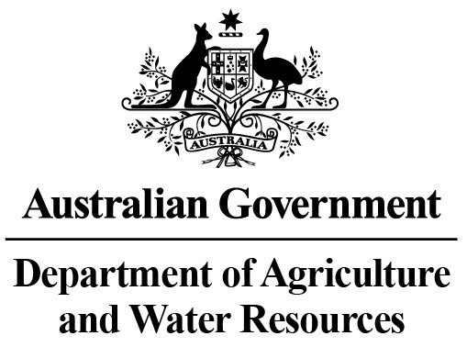
INDUSTRY DESCRIPTION | NSW |  | VIC |  | QLD |  | SA |  | WA |  | TAS |  | ACT & NT |  | NATIONAL TOTALS
 | No. of FMD accounts | Value of deposits ($’000) | No. of FMD accounts | Value of deposits ($’000) | No. of FMD accounts | Value of deposits ($’000) | No. of FMD accounts | Value of deposits ($’000) | No. of FMD accounts | Value of deposits ($’000) | No. of FMD accounts | Value of deposits ($’000) | No. of FMD accounts | Value of deposits ($’000) | No. of FMD accounts | Value of deposits ($’000)
HORTICULTURE | 1,072 | 139,660 | 1,120 | 162,409 | 1,033 | 157,255 | 896 | 106,251 | 348 | 55,267 | 116 | 15,150 | 11 | 1,320 | 4,596 | 637,312
SUGAR | 109 | 8,767 | * | * | 1,318 | 139,073 | 0 | 0 | 0 | 0 | 0 | 0 | 0 | 0 | 1,427 | 147,840
CROPS | 817 | 98,207 | 405 | 35,994 | 744 | 105,892 | 339 | 33,309 | 98 | 9,773 | 49 | 3,501 | ** | ** | 2,452 | 286,676
GRAIN | 1,514 | 191,368 | 1,630 | 179,358 | 783 | 117,377 | 2,182 | 301,503 | 1,848 | 349,134 | 12 | 1,041 | 0 | 0 | 7,969 | 1,139,781
GRAIN-SHEEP/BEEF | 2,919 | 315,247 | 2,569 | 280,899 | 917 | 102,254 | 2,168 | 270,157 | 2,099 | 335,162 | 66 | 5,300 | 10 | 2,300 | 10,748 | 1,311,319
BEEF | 2,070 | 177,497 | 1,589 | 127,924 | 3,052 | 455,216 | 333 | 40,114 | 377 | 51,183 | 238 | 23,931 | 26 | 6,575 | 7,685 | 882,440
SHEEP-BEEF | 1,484 | 140,423 | 959 | 83,386 | 482 | 51,353 | 624 | 68,824 | 214 | 25,550 | 100 | 8,339 | 6 | 332 | 3,869 | 378,207
SHEEP | 1,369 | 130,837 | 1,309 | 117,398 | 89 | 8,582 | 582 | 60,665 | 350 | 33,565 | 111 | 12,491 | 6 | 340 | 3,816 | 363,878
PIG | 27 | 3,804 | 21 | 3,052 | 27 | 2,107 | 34 | 3,471 | 14 | 1,035 | 6 | 988 | 0 | 0 | 129 | 14,457
INTENSIVE LIVESTOCK | 537 | 48,398 | 270 | 26,079 | 298 | 32,951 | 130 | 14,003 | 82 | 6,956 | 24 | 1,002 | ** | ** | 1,341 | 129,389
DAIRY | 289 | 28,095 | 1,722 | 166,362 | 226 | 20,264 | 117 | 14,047 | 75 | 6,594 | 87 | 9,548 | 0 | 0 | 2,516 | 244,910
FORESTRY & FISHING | 154 | 11,512 | 149 | 12,393 | 151 | 14,743 | 183 | 22,073 | 172 | 26,545 | 59 | 5,251 | 3 | 64 | 871 | 92,581
OTHER | 16 | 1,188 | 6 | 174 | *** | *** | 5 | 370 | *** | *** | *** | *** | 0 | 0 | 27 | 1,732
STATE/TERRITORY TOTAL  # | 12,377 | 1,295,003 | 11,749 | 1,195,428 | 9,120 | 1,207,067 | 7,593 | 934,787 | 5,677 | 900,764 | 868 | 86,542 | 62 | 10,931 | 47,446 | 5,630,522
#Note: The total number of accounts does not indicate the number of primary producers participating in the FMD Scheme as a primary producer may hold multiple FMD accounts. In addition, the value of deposits reported may be greater than the actual level of FMDs as primary producers may choose not to claim a tax deduction for all deposits held in FMD accounts.
* Victorian sugar industry FMD accounts and deposits have been aggregated with the respective New South Wales FMD accounts and deposits for privacy reasons.
** Northern Territory and Australian Capital Territory crops and intensive livestock industry FMD accounts and deposits have been aggregated with the respective
New South Wales FMD accounts and deposits for privacy reasons.
*** Queensland, Western Australian and Tasmanian other industry FMD accounts and deposits have been aggregated with the respective Victorian FMD accounts and deposits for privacy reasons.
These monthly FMD statistics are derived from data provided by Authorised Deposit-taking Institutions (ADIs) (such as banks and credit unions). These statistics may, due to the complex nature of FMDs, include a level of discrepancy, leading to a minor overstatement or understatement of the actual holdings eligible for the FMD taxation concessions. The Australian Government, acting through the Department of Agriculture and Water Resources, has exercised due care in compiling this information. Notwithstanding, the department, its employees and advisers disclaim all liability, including liability for negligence, for any loss, damage, injury, expense or cost incurred by any person as a result of accessing, using or relying upon any of the information or data on FMDs to the maximum extent permitted by law.

