FARM MANAGEMENT DEPOSITS SCHEME STATISTICS – February 2024
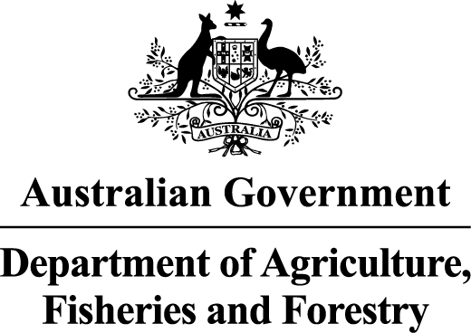
INDUSTRY DESCRIPTION | NSW |  | VIC |  | QLD |  | SA |  | WA |  | TAS |  | ACT & NT |  | NATIONAL TOTALS
 | No. of FMD accounts | Value of deposits ($’000) | No. of FMD accounts | Value of deposits ($’000) | No. of FMD accounts | Value of deposits ($’000) | No. of FMD accounts | Value of deposits ($’000) | No. of FMD accounts | Value of deposits ($’000) | No. of FMD accounts | Value of deposits ($’000) | No. of FMD accounts | Value of deposits ($’000) | No. of FMD accounts | Value of deposits ($’000)
HORTICULTURE | 917 | 132,150 | 874 | 136,711 | 892 | 154,974 | 839 | 122,170 | 295 | 53,872 | 113 | 15,358 | 0 | 0 | 3,930 | 615,235
SUGAR | 92 | 8,619 | 0 | 0 | 1,044 | 135,313 | 0 | 0 | 0 | 0 | 0 | 0 | 0 | 0 | 1,136 | 143,933
CROPS | 667 | 91,773 | 423 | 39,993 | 615 | 98,066 | 375 | 39,465 | 134 | 17,258 | 44 | 3,833 | 0 | 0 | 2,258 | 290,389
GRAIN | 1,451 | 214,165 | 1,871 | 276,635 | 674 | 113,565 | 2,029 | 336,247 | 1,291 | 278,901 | 0 | 0 | 0 | 0 | 7,316 | 1,219,512
GRAIN-SHEEP/BEEF | 2,399 | 299,428 | 2,343 | 307,519 | 738 | 93,316 | 1,656 | 227,839 | 1,368 | 231,487 | 60 | 7,897 | 0 | 0 | 8,564 | 1,167,487
BEEF | 2,022 | 219,402 | 1,864 | 193,726 | 3,173 | 568,843 | 329 | 44,314 | 451 | 74,992 | 238 | 34,467 | 27 | 6,931 | 8,104 | 1,142,674
SHEEP-BEEF | 1,161 | 121,878 | 1,059 | 128,095 | 461 | 57,800 | 466 | 60,886 | 142 | 19,480 | 77 | 10,481 | 0 | 0 | 3,366 | 398,620
SHEEP | 1,133 | 124,479 | 1,152 | 114,181 | 92 | 12,714 | 511 | 56,624 | 278 | 30,552 | 85 | 10,575 | 0 | 0 | 3,251 | 349,125
PIG | 52 | 6,907 | 0 | 0 | 30 | 2,154 | 35 | 5,170 | 0 | 0 | 0 | 0 | 0 | 0 | 117 | 14,231
INTENSIVE LIVESTOCK | 548 | 62,037 | 321 | 29,021 | 455 | 66,431 | 154 | 15,386 | 94 | 10,160 | 49 | 4,065 | 0 | 0 | 1,621 | 187,101
DAIRY | 286 | 33,195 | 1,936 | 263,908 | 226 | 24,354 | 120 | 15,637 | 74 | 8,345 | 125 | 18,691 | 0 | 0 | 2,767 | 364,131
FORESTRY & FISHING | 132 | 8,841 | 103 | 9,050 | 140 | 12,007 | 142 | 15,686 | 141 | 23,135 | 40 | 4,558 | 0 | 0 | 698 | 73,278
OTHER | 48 | 3,014 | 0 | 0 | 0 | 0 | 0 | 0 | 0 | 0 | 0 | 0 | 0 | 0 | 48 | 3,014
STATE/TERRITORY TOTAL  # | 10,908 | 1,325,890 | 11,946 | 1,498,839 | 8,540 | 1,339,537 | 6,656 | 939,424 | 4,268 | 748,182 | 831 | 109,925 | 27 | 6,931 | 43,176 | 5,968,728
#Note: The total number of accounts does not indicate the number of primary producers participating in the FMD Scheme as a primary producer may hold multiple FMD accounts. In addition, the value of deposits reported may be greater than the actual level of FMDs as primary producers may choose not to claim a tax deduction for all deposits held in FMD accounts.
* The following state/territory industry FMD accounts and holdings have been aggregated with the respective New South Wales industry FMD accounts and holdings where there are less than 20 accounts for
privacy reasons:
- Victoria – Sugar, Pig and Other
- Queensland – Other
- South Australia – Sugar and Other
- Western Australia – Sugar, Pig and Other
- Tasmania – Sugar, Grain, Pig and Other
- Australian Capital Territory and Northern Territory – Horticulture, Sugar, Crops, Grain, Grain-Sheep/Beef, Sheep-Beef, Sheep, Pig, Intensive Livestock, Dairy, Forestry & Fishing and Other
These monthly FMD statistics are derived from data provided by Authorised Deposit-taking Institutions (ADIs) (such as banks and credit unions). These statistics may, due to the complex nature of FMDs, include a level of discrepancy, leading to a minor overstatement or understatement of the actual holdings eligible for the FMD taxation concessions. The Australian Government, acting through the Department of Agriculture, Fisheries and Forestry, has exercised due care in compiling this information. Notwithstanding, the department, its employees and advisers disclaim all liability, including liability for negligence, for any loss, damage, injury, expense or cost incurred by any person as a result of accessing, using or relying upon any of the information or data on FMDs to the maximum extent permitted by law.

