FARM MANAGEMENT DEPOSITS SCHEME STATISTICS – DECEMBER 2018
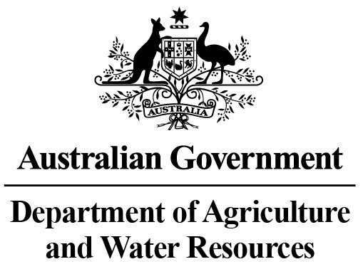
INDUSTRY DESCRIPTION | NSW |  | VIC |  | QLD |  | SA |  | WA |  | TAS |  | ACT & NT |  | NATIONAL TOTALS
 | No. of FMD accounts | Value of deposits ($’000) | No. of FMD accounts | Value of deposits ($’000) | No. of FMD accounts | Value of deposits ($’000) | No. of FMD accounts | Value of deposits ($’000) | No. of FMD accounts | Value of deposits ($’000) | No. of FMD accounts | Value of deposits ($’000) | No. of FMD accounts | Value of deposits ($’000) | No. of FMD accounts | Value of deposits ($’000)
HORTICULTURE | 1,023 | 122,271 | 1,167 | 149,026 | 1,096 | 158,301 | 939 | 102,339 | 317 | 51,522 | 111 | 15,128 | 12 | 1,370 | 4,665 | 599,957
SUGAR | 122 | 8,767 | * | * | 1,403 | 133,329 | 0 | 0 | 0 | 0 | 0 | 0 | 0 | 0 | 1,525 | 142,096
CROPS | 805 | 84,672 | 389 | 28,707 | 742 | 96,429 | 339 | 27,567 | 121 | 13,867 | 57 | 3,490 | ** | ** | 2,453 | 254,732
GRAIN | 1,805 | 217,792 | 1,655 | 167,857 | 860 | 123,309 | 2,524 | 304,528 | 1,467 | 264,880 | 17 | 1,328 | ** | ** | 8,328 | 1,079,694
GRAIN-SHEEP/BEEF | 3,465 | 363,313 | 2,496 | 248,136 | 981 | 109,861 | 2,318 | 253,475 | 1,730 | 262,438 | 70 | 7,022 | 14 | 2,203 | 11,074 | 1,246,448
BEEF | 2,405 | 202,513 | 1,603 | 121,253 | 3,211 | 435,909 | 349 | 37,027 | 375 | 50,016 | 230 | 20,781 | 31 | 7,573 | 8,204 | 875,072
SHEEP-BEEF | 1,695 | 148,293 | 995 | 80,284 | 506 | 50,528 | 636 | 57,818 | 198 | 21,112 | 108 | 8,823 | 9 | 300 | 4,147 | 367,158
SHEEP | 1,534 | 143,611 | 1,196 | 92,509 | 110 | 9,948 | 585 | 53,495 | 332 | 31,985 | 96 | 8,506 | 8 | 467 | 3,861 | 340,521
PIG | 27 | 3,703 | 25 | 3,508 | 34 | 2,570 | 40 | 3,271 | 13 | 1,610 | 6 | 588 | 0 | 0 | 145 | 15,250
INTENSIVE LIVESTOCK | 581 | 50,719 | 279 | 24,014 | 309 | 32,355 | 158 | 12,388 | 81 | 7,027 | 30 | 1,228 | ** | ** | 1,438 | 127,731
DAIRY | 328 | 30,384 | 1,882 | 172,881 | 251 | 21,259 | 137 | 14,286 | 77 | 7,973 | 119 | 10,285 | 0 | 0 | 2,794 | 257,068
FORESTRY & FISHING | 186 | 15,014 | 157 | 12,605 | 163 | 13,201 | 208 | 22,719 | 167 | 25,898 | 56 | 3,609 | ** | ** | 937 | 93,046
OTHER | 14 | 857 | 19 | 1,110 | *** | *** | 8 | 620 | *** | *** | *** | *** | 0 | 0 | 41 | 2,587
STATE/TERRITORY TOTAL  # | 13,990 | 1,391,909 | 11,863 | 1,101,890 | 9,666 | 1,186,999 | 8,241 | 889,533 | 4,878 | 738,328 | 900 | 80,788 | 74 | 11,913 | 49,612 | 5,401,360
#Note: The total number of accounts does not indicate the number of primary producers participating in the FMD Scheme as a primary producer may hold multiple FMD accounts.
* Victorian sugar industry FMD accounts and holdings have been aggregated with the respective New South Wales FMD accounts and holdings for privacy reasons.
** Northern Territory and Australian Capital Territory crops, grain, intensive livestock and forestry & fishing industries FMD accounts and holdings have been aggregated with the respective New South Wales FMD accounts and holdings for privacy reasons.
*** Queensland, Western Australian and Tasmanian other industry FMD accounts and holdings have been aggregated with the respective Victorian FMD accounts and holdings for privacy reasons.
These monthly FMD statistics are derived from data provided by Authorised Deposit-taking Institutions (ADIs) (such as banks and credit unions). These statistics may, due to the complex nature of FMDs, include a level of discrepancy, leading to a minor overstatement or understatement of the actual holdings eligible for the FMD taxation concessions. The Australian Government, acting through the Department of Agriculture and Water Resources, has exercised due care in compiling this information. Notwithstanding, the department, its employees and advisers disclaim all liability, including liability for negligence, for any loss, damage, injury, expense or cost incurred by any person as a result of accessing, using or relying upon any of the information or data on FMDs to the maximum extent permitted by law.

