FARM MANAGEMENT DEPOSITS SCHEME STATISTICS – November 2016
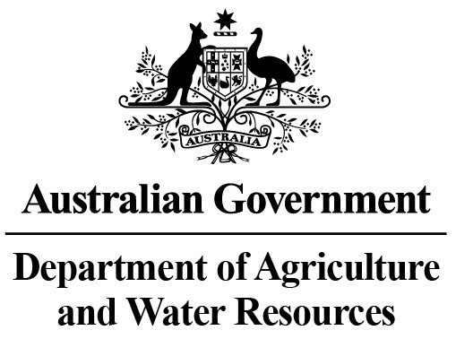
INDUSTRY DESCRIPTION | NSW |  | VIC |  | QLD |  | SA |  | WA |  | TAS |  | ACT & NT |  | NATIONAL TOTALS
 | No. of FMD accounts | Value of deposits ($’000) | No. of FMD accounts | Value of deposits ($’000) | No. of FMD accounts | Value of deposits ($’000) | No. of FMD accounts | Value of deposits ($’000) | No. of FMD accounts | Value of deposits ($’000) | No. of FMD accounts | Value of deposits ($’000) | No. of FMD accounts | Value of deposits ($’000) | No. of FMD accounts | Value of deposits ($’000)
HORTICULTURE | 981 | 94,081 | 1,022 | 115,054 | 1,076 | 133,687 | 864 | 85,020 | 347 | 41,548 | 118 | 12,452 | 14 | 1,475 | 4,422 | 483,317
SUGAR | 79 | 4,345 | * | * | 1,290 | 109,423 | 0 | 0 | 0 | 0 | 0 | 0 | 0 | 0 | 1,369 | 113,768
CROPS | 727 | 65,071 | 363 | 23,402 | 663 | 68,095 | 340 | 24,602 | 96 | 8,832 | 57 | 3,846 | ** | ** | 2,246 | 193,848
GRAIN | 2,019 | 209,675 | 1,355 | 109,359 | 851 | 98,223 | 2,489 | 263,659 | 1,524 | 204,327 | 14 | 701 | ** | ** | 8,252 | 885,944
GRAIN-SHEEP/BEEF | 3,496 | 315,958 | 2,243 | 185,867 | 1,006 | 85,095 | 2,261 | 215,733 | 1,801 | 215,213 | 84 | 6,312 | 10 | 1,660 | 10,901 | 1,025,838
BEEF | 2,012 | 144,710 | 1,525 | 98,312 | 2,877 | 314,952 | 312 | 26,613 | 332 | 31,089 | 222 | 17,254 | 24 | 2,819 | 7,304 | 635,749
SHEEP-BEEF | 1,524 | 110,003 | 879 | 55,979 | 453 | 37,889 | 569 | 48,750 | 178 | 14,866 | 104 | 5,937 | 9 | 306 | 3,716 | 273,730
SHEEP | 1,306 | 93,991 | 927 | 60,951 | 108 | 9,182 | 502 | 32,926 | 255 | 21,826 | 87 | 6,693 | ** | ** | 3,185 | 225,569
PIG | 30 | 2,688 | 28 | 3,215 | 44 | 3,372 | 40 | 3,786 | 12 | 840 | *** | *** | 0 | 0 | 154 | 13,901
INTENSIVE LIVESTOCK | 507 | 39,449 | 288 | 21,793 | 303 | 26,840 | 164 | 11,705 | 85 | 5,586 | 35 | 2,208 | ** | ** | 1,382 | 107,581
DAIRY | 365 | 30,059 | 2,016 | 170,417 | 288 | 21,180 | 157 | 14,826 | 83 | 7,094 | 128 | 10,072 | ** | ** | 3,037 | 253,648
FORESTRY & FISHING | 211 | 13,838 | 163 | 10,427 | 172 | 13,202 | 192 | 18,600 | 182 | 21,669 | 44 | 2,490 | ** | ** | 964 | 80,226
OTHER | 16 | 629 | 9 | 313 | **** | **** | 7 | 260 | **** | **** | **** | **** | 0 | 0 | 32 | 1,202
STATE/TERRITORY TOTAL  # | 13,273 | 1,124,497 | 10,818 | 855,089 | 9,131 | 921,140 | 7,897 | 746,480 | 4,895 | 572,890 | 893 | 67,965 | 57 | 6,260 | 46,964 | 4,294,321
#Note: The total number of accounts does not indicate the number of primary producers participating in the FMD Scheme as a primary producer may hold multiple FMD accounts.
* Victorian sugar industry FMD accounts and holdings have been aggregated with the respective New South Wales FMD accounts and holdings for privacy reasons.
** Northern Territory and Australian Capital Territory crops, grain, sheep, intensive livestock, dairy and forestry & fishing industries FMD accounts and holdings have been aggregated with the respective New South Wales FMD accounts and holdings for privacy reasons.
*** Tasmanian pig industry FMD accounts and holdings have been aggregated with the respective New South Wales FMD accounts and holdings for privacy reasons.
**** Queensland, Western Australian and Tasmanian other industry FMD accounts and holdings have been aggregated with the respective Victorian FMD accounts and holdings for privacy reasons.
These monthly FMD statistics are derived from data provided by Authorised Deposit-taking Institutions (ADIs) (such as banks and credit unions). These statistics may, due to the complex nature of FMDs, include a level of discrepancy, leading to a minor overstatement or understatement of the actual holdings eligible for the FMD taxation concessions. The Australian Government, acting through the Department of Agriculture and Water Resources, has exercised due care in compiling this information. Notwithstanding, the department, its employees and advisers disclaim all liability, including liability for negligence, for any loss, damage, injury, expense or cost incurred by any person as a result of accessing, using or relying upon any of the information or data on FMDs to the maximum extent permitted by law.

