FARM MANAGEMENT DEPOSITS SCHEME STATISTICS – September 2019
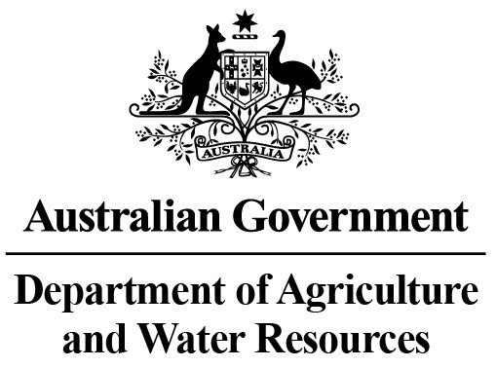
INDUSTRY DESCRIPTION | NSW |  | VIC |  | QLD |  | SA |  | WA |  | TAS |  | ACT & NT |  | NATIONAL TOTALS
 | No. of FMD accounts | Value of deposits ($’000) | No. of FMD accounts | Value of deposits ($’000) | No. of FMD accounts | Value of deposits ($’000) | No. of FMD accounts | Value of deposits ($’000) | No. of FMD accounts | Value of deposits ($’000) | No. of FMD accounts | Value of deposits ($’000) | No. of FMD accounts | Value of deposits ($’000) | No. of FMD accounts | Value of deposits ($’000)
HORTICULTURE | 1,088 | 143,662 | 1,150 | 170,672 | 1,064 | 164,452 | 911 | 107,939 | 358 | 56,114 | 121 | 16,475 | 11 | 1,320 | 4,703 | 660,634
SUGAR | 114 | 8,818 | * | * | 1,332 | 138,119 | 0 | 0 | 0 | 0 | * | * | 0 | 0 | 1,446 | 146,937
CROPS | 839 | 100,615 | 397 | 35,898 | 761 | 108,599 | 347 | 34,699 | 100 | 9,942 | 50 | 3,791 | ** | ** | 2,494 | 293,544
GRAIN | 1,568 | 200,711 | 1,616 | 178,015 | 785 | 115,714 | 2,210 | 306,676 | 1,865 | 352,835 | 12 | 1,201 | 0 | 0 | 8,056 | 1,155,152
GRAIN-SHEEP/BEEF | 3,007 | 326,938 | 2,589 | 281,768 | 922 | 102,869 | 2,203 | 272,670 | 2,138 | 343,046 | 69 | 5,579 | 12 | 2,360 | 10,940 | 1,335,230
BEEF | 2,123 | 181,858 | 1,613 | 129,629 | 3,105 | 464,637 | 342 | 41,553 | 388 | 53,257 | 242 | 24,716 | 25 | 6,335 | 7,838 | 901,985
SHEEP-BEEF | 1,530 | 145,486 | 981 | 85,350 | 492 | 52,696 | 627 | 68,854 | 216 | 25,730 | 103 | 8,527 | 6 | 332 | 3,955 | 386,975
SHEEP | 1,416 | 134,830 | 1,344 | 120,402 | 93 | 9,217 | 586 | 61,289 | 352 | 33,443 | 113 | 13,016 | 6 | 340 | 3,910 | 372,537
PIG | 27 | 3,854 | 21 | 3,052 | 29 | 2,145 | 36 | 3,571 | 14 | 1,035 | 6 | 988 | 0 | 0 | 133 | 14,645
INTENSIVE LIVESTOCK | 554 | 50,498 | 277 | 26,395 | 298 | 33,007 | 133 | 13,898 | 83 | 6,518 | 27 | 1,099 | ** | ** | 1,372 | 131,415
DAIRY | 306 | 29,086 | 1,757 | 169,793 | 233 | 21,164 | 118 | 14,242 | 76 | 6,827 | 89 | 9,895 | 0 | 0 | 2,579 | 251,007
FORESTRY & FISHING | 159 | 11,756 | 157 | 12,579 | 154 | 15,066 | 184 | 22,124 | 174 | 27,060 | 61 | 5,626 | ** | ** | 889 | 94,211
OTHER | 18 | 1,238 | 6 | 174 | *** | *** | 5 | 370 | *** | *** | *** | *** | 0 | 0 | 29 | 1,782
STATE/TERRITORY TOTAL  # | 12,749 | 1,339,350 | 11,908 | 1,213,727 | 9,268 | 1,227,685 | 7,702 | 947,885 | 5,764 | 915,807 | 893 | 90,913 | 60 | 10,687 | 48,344 | 5,746,054
#Note: The total number of accounts does not indicate the number of primary producers participating in the FMD Scheme as a primary producer may hold multiple FMD accounts. In addition, the value of deposits reported may be greater than the actual level of FMDs as primary producers may choose not to claim a tax deduction for all deposits held in FMD accounts.
* Victorian and Tasmanian sugar industry FMD accounts and holdings have been aggregated with the respective New South Wales FMD accounts and holdings for privacy reasons.
** Northern Territory and Australian Capital Territory crops, intensive livestock and forestry & fishing industries FMD accounts and holdings have been aggregated with the respective New South Wales FMD accounts and holdings for privacy reasons.
*** Queensland, Western Australian and Tasmanian other industry FMD accounts and holdings have been aggregated with the respective New South Wales FMD accounts and holdings for privacy reasons.
These monthly FMD statistics are derived from data provided by Authorised Deposit-taking Institutions (ADIs) (such as banks and credit unions). These statistics may, due to the complex nature of FMDs, include a level of discrepancy, leading to a minor overstatement or understatement of the actual holdings eligible for the FMD taxation concessions. The Australian Government, acting through the Department of Agriculture, has exercised due care in compiling this information. Notwithstanding, the department, its employees and advisers disclaim all liability, including liability for negligence, for any loss, damage, injury, expense or cost incurred by any person as a result of accessing, using or relying upon any of the information or data on FMDs to the maximum extent permitted by law.

