Future Drought Fund annual report 2024–25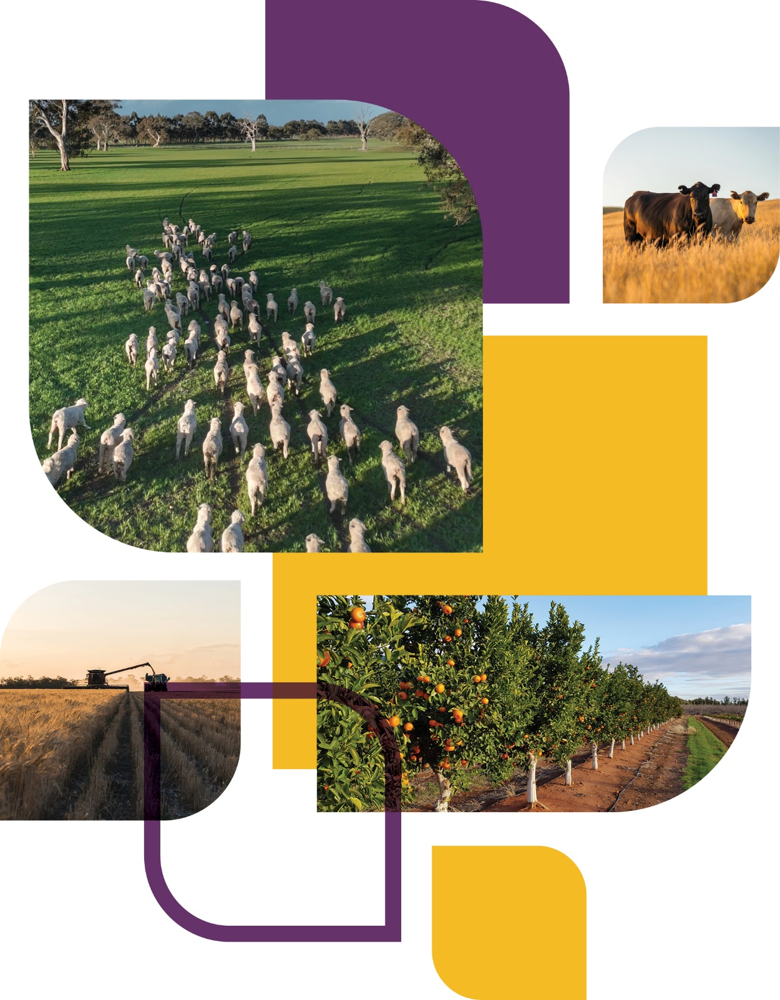

© Commonwealth of Australia 2026
Ownership of intellectual property rights
Unless otherwise noted, copyright (and any other intellectual property rights) in this publication is owned by the Commonwealth of Australia (referred to as the Commonwealth).
Creative Commons licence
All material in this publication is licensed under a Creative Commons Attribution 4.0 International Licence except content supplied by third parties, logos and the Commonwealth Coat of Arms.

Cataloguing data
This publication (and any material sourced from it) should be attributed as: DAFF 2026, Future Drought Fund annual report 2024–25, Department of Agriculture, Fisheries and Forestry, Canberra CC BY 4.0.
This publication is available at agriculture.gov.au/agriculture-land/farm-food-drought/drought/future-drought-fund.
Department of Agriculture, Fisheries and Forestry
GPO Box 858 Canberra ACT 2601
Telephone 1800 900 090
Web agriculture.gov.au
Disclaimer
The Australian Government acting through the Department of Agriculture, Fisheries and Forestry has exercised due care and skill in preparing and compiling the information and data in this publication. Notwithstanding, the Department of Agriculture, Fisheries and Forestry, its employees and advisers disclaim all liability, including liability for negligence and for any loss, damage, injury, expense or cost incurred by any person as a result of accessing, using or relying on any of the information or data in this publication to the maximum extent permitted by law.
Acknowledgements
The authors thank interview and case study participants for their input and ongoing engagement with the Future Drought Fund. We would also like to acknowledge our diverse range of key stakeholders for their enduring support.
Acknowledgement of Country
We acknowledge the continuous connection of First Nations Traditional Owners and Custodians to the lands, seas and waters of Australia. We recognise their care for and cultivation of Country. We pay respect to Elders past and present, and recognise their knowledge and contribution to the productivity, innovation and sustainability of Australia’s agriculture, fisheries and forestry industries.
We also acknowledge and respect First Nations peoples’ rights to control, own and maintain their Indigenous Cultural and Intellectual Property. Any First Nations knowledge shared remains the property of its First Nations owners and is used only with free, prior and informed consent.

Minister’s message
Sadly, drought is part of life in Australia. It is not a question of if, but when. Farmers understand this better than anyone, and most build drought into their business planning. Yet, as the climate changes, being prepared and well informed is more important than ever. That is why the Australian Government is investing in long-term resilience, through the Future Drought Fund (FDF).
We have seen firsthand the tough conditions unfolding during 2024–25 across parts of Australia. I have visited drought-affected farms and communities to hear directly the challenges farmers and local leaders are facing, and discuss their priorities.
Many regions have experienced dry conditions for several years, with families, farms and communities facing hard choices about their businesses, livestock and crops. These realities reinforce the importance of a coordinated national approach.
The National Drought Agreement guides our national approach to drought. In December 2024 I released the Australian Government Drought Plan to outline how we support farmers and communities across the drought cycle.
The FDF is central to this effort through investment in practical projects and initiatives that strengthen resilience on the ground, helping farmers and communities prepare for future droughts.
Alongside FDF we deliver a number of programs that directly support those in hardship from drought such as Farm Household Allowance, Rural Financial Counselling Services and Regional Investment Corporation loans.
The FDF continues to deliver results. Across the country, farmers are trialling innovative practices, improving natural resource management, and building networks that share knowledge and support. These efforts are complemented by our commitment to climate resilience and by deepening partnerships with First Nations’ peoples whose knowledges and connections to Country are essential to building resilience.
Drought will always be part of Australia’s story, but with ongoing commitment, planning and collaboration, we can ensure Australia’s agricultural sector remains strong and sustainable. The FDF is helping make that possible, and I look forward to seeing its impact continue to grow in the years ahead.


Hon Julie Collins MP
Minister for Agriculture, Fisheries and Forestry

Foreword
As Australia faces the realities of a changing climate, the Future Drought Fund (FDF) plays an important role in helping the agricultural sector, farmers and regional communities prepare for drought and other climate risks.
This year marks another exciting milestone with the FDF entering a new 4-year funding cycle under the 2024 to 2028 Drought Resilience Funding Plan. In 2024–25, we deepened our investment in long-term preparedness by delivering programs that focus on partnering for local solutions; First Nations initiatives; building knowledge, skills and capability; innovating for transformation; and measuring progress and knowledge sharing.
Recognising that drought is part of a bigger picture of a changing climate, we have also placed greater emphasis on supporting practical solutions that will help farmers and communities strengthen resilience, not just to drought, but for the broader climate challenges shaping our agricultural future.
In January 2025 we published the new FDF Investment Strategy. The strategy provides a roadmap for building drought-resilient farms, landscapes and communities. Importantly, it tells stakeholders when they can engage with FDF programs and activities.
Guided by the strategy, we have built on the lessons of the previous 4 years to enhance program design and delivery, strengthen partnerships with states and territories and industry, and better align with local, regional and national drought-resilience goals.
The FDF continues to work closely with a network of partners that help deliver the fund’s programs and projects on the ground. We work together to bring local ideas to life, building drought and climate resilience across Australia.
This year’s annual report outlines the fund’s progress during 2024–25. This reflects not only the investments made by the FDF, but the shared drive of those working on the ground – farmers, researchers, community leaders and organisations alike. It has been a busy year for the FDF, but there is still much work to do. As we look ahead, we are excited to continue building on our successes, learning from our challenges and evolving in response to the needs of farmers and communities.


Brent Finlay
Chair
FDF Consultative Committee
Contents
Minister’s message iii
Foreword iv
Funding priorities 1
Partnering for local solutions 3
Drought Resilience Adoption and Innovation Hubs 3
Regional Drought Resilience Planning 8
Helping Regional Communities Prepare for Drought Initiative 11
Partnering for First Nations initiatives 18
Strengthening Drought Resilience on Country 18
First Nations supporting participation activities 18
Building knowledge, skills and capability 20
Farm Business Resilience 20
Drought Resilience Scholarships 23
Climate Services for Agriculture 26
Scaling Success 29
Innovating for transformation 31
Long-term Trials of Drought Resilient Practices 31
Resilient Landscapes 31
Innovation Challenges Pilot 32
Extension and Adoption of Drought Resilience Farming Practices 32
Drought Resilient Soils and Landscapes 33
Drought Resilience Commercialisation Initiative 34
Drought Resilience Innovation Grants 36
Measuring progress and knowledge sharing 38
Monitoring, evaluation and learning 38
Knowledge management 39
Science to Practice 2.0 39
United Nations Convention to Combat Desertification 41
Administration and governance 42
Future Drought Fund Consultative Committee 42
First Nations Advisory Group 43
Funding 44
References 45

Tables
Table 1 Funding allocation, 30 June 2025 44
Figures
Figure 1 Funding priority highlights and achievements 2
Figure 2 Regional Drought Resilience plan activities, by theme 9
Figure 3 Community Impact Program and Small Network Grants snapshot 12
Figure 4 National Mentoring Program snapshot 13
Figure 5 Drought Ready Network snapshot 13
Figure 6 National Expertise Pool snapshot 14
Figure 7 Farm Business Resilience program participants, by industry 21
Figure 8 Commodities available on My Climate View 26
Figure 9 Growcom postcard using My Climate View data 28
Maps
Map 1 Drought Resilience Adoption and Innovation Hub locations 3
Map 2 Regional Drought Resilience Planning – participating regions 9
Photos
Photo 1 TNQ Drought Hub Technical Adoption Officer Keerah Steele with producer Phil Bensted, 2024 6
Photo 2 Changemaker workshop participant Rana Everett 15
Photo 3 Attendees at a Contact Inc. community event 16
Photo 4 Hamish Robertson, 2025 scholarship recipient 25
Photo 5 Innovator Sarah Preston presenting at Evoke Ag 2025 35
Photo 6 Rice harvest at the trial site near Widgelli, NSW 37
Photo 7 Science to Practice 2.0 filming with TNQ Hub 40
Photo 8 Science to Practice 2.0 filming with SQNNSW Hub 40
Photo 9 Future Drought Fund Consultative Committee, November 2024. 42
Photo 10 Future Drought Fund First Nations Advisory Group, January 2025 43
Case studies
Case study 1 Improving resilience by transforming water and energy management 6
Case study 2 Ngarrindjeri Climate Yarning Circles 7
Case study 3 Indigenous Women Food and Fibre Entrepreneurs 7
Case study 4 Mental health first aid training and awareness 10
Case study 5 Rana Everett: building welding skills and confidence in Albany 15
Case study 6 Strengthening connections for drought resilience in remote NSW 16
Case study 7 Far West Oysters 22
Case study 8 Farming through the dry: Hamish Robertson’s drought strategy 25
Case study 9 Using My Climate View sparks ‘lightbulb moments’ for Queensland mango growers 28
Case study 10 Building win-win relationships: CSA Indigenous engagement 29
Case study 11 Pork Innovation WA: managing water in a changing climate 33
Case study 12 Building resilience: moisture conservation in the Mingenew–Irwin Region 34
Case study 13 Deakin University trials aerobic rice in the Murrumbidgee 37

Funding priorities
The Future Drought Fund (FDF) continues to play an important role in helping farmers and regional communities prepare for and manage the impacts of drought and a changing climate. Through strategic investment and collaboration, the FDF is supporting practical solutions that strengthen the agricultural sector and rural communities against future climate risks.
In the 2024–25 Budget, the Australian Government committed $519.1 million over 8 years to deliver activities under the Future Drought Fund (Drought Resilience Funding Plan 2024-2028) Determination 2024. This investment focuses on 5 priority areas:
- Partnering for local solutions
- Partnering for First Nations initiatives
- Building knowledge, skills and capability
- Innovating for transformation
- Measuring progress and knowledge sharing.
Guided by stakeholder feedback and the Productivity Commission’s 2023 Review of Part 3 of the Future Drought Fund Act, the FDF is delivering 10 on-ground programs and a national enabling program designed to drive high-impact, enduring outcomes for Australian agriculture and regional communities. Figure 1 shows highlights and achievements for each FDF funding priority.
Figure 1 Funding priority highlights and achievements
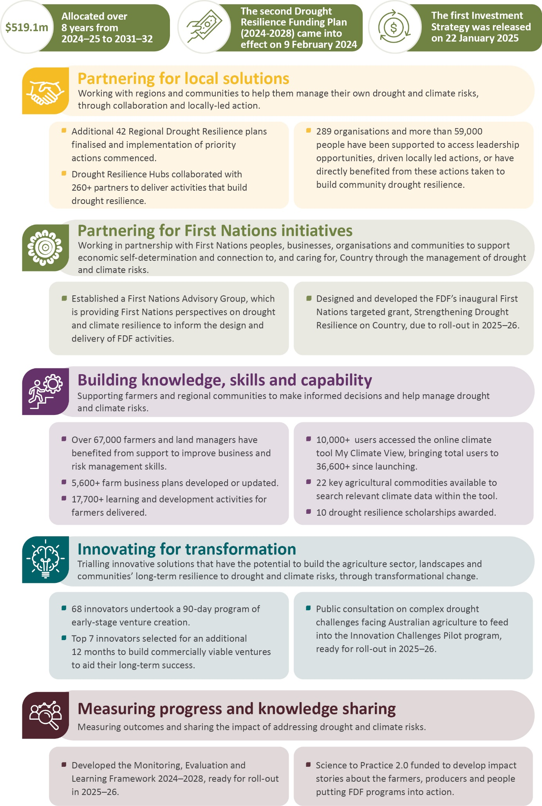

Partnering for local solutions
Partnering for local solutions involves working with regions and communities to help them manage their own drought and climate risks, through collaboration and locally led action.

Drought Resilience Adoption and Innovation Hubs
The Drought Resilience Adoption and Innovation Hubs bring together a range of stakeholders, including industry, state and territory governments, researchers, farmers, and community groups. Map 1 shows the location of the 8 hubs across key climatic and agricultural zones of Australia.
Map 1 Drought Resilience Adoption and Innovation Hub locations
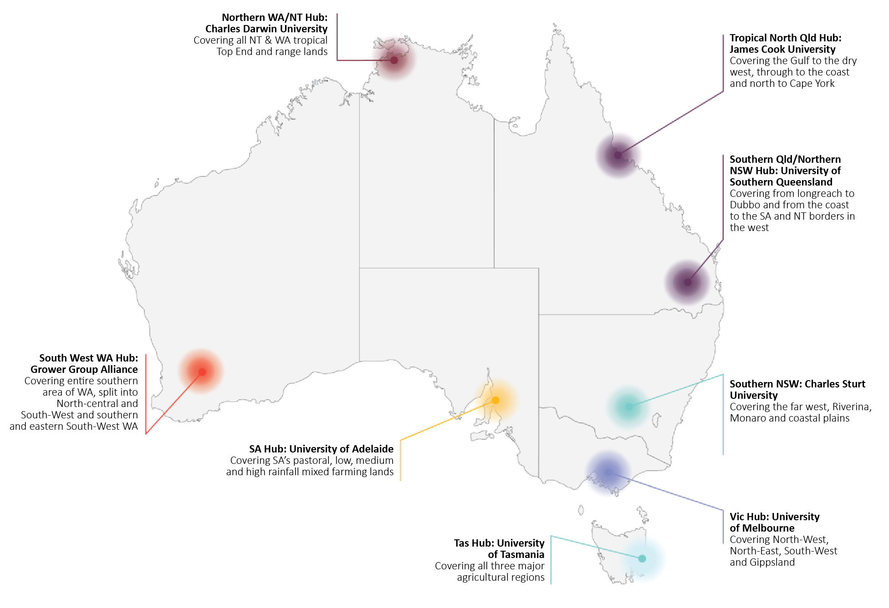

Program highlights
In 2024–25, the Drought Resilience Adoption and Innovation Hubs program delivered significant achievements that strengthened drought resilience and preparedness across Australia, including:
- conducting a review as recommended by the Productivity Commission and delivering the report to the department.
- collaborating with more than 260 partners across Australia to deliver activities that support drought resilience and preparedness.
- engaging with key stakeholder groups and individuals – including farmers, government, research and development corporations, natural resource managers (NRMs), industry, and research organisations – on drought-resilience resources, projects, and opportunities.
- continuing to provide opportunities for stakeholders to access, use and adopt drought resilience knowledge. Through knowledge brokers, adoption officers and collaborators, the hubs:
  - built connections and shared information both in person at events and workshops and online via podcasts, social media and each hub’s websites
  - worked with partners and producers to develop connections and opportunities to share learnings about drought resilience
  - delivered learning activities to producers, service providers and farming groups on the application of on-ground practices and tools to improve drought resilience.

Hubs review
The government has committed $28 million over 2 years from 2024–25 to continue on-ground activity through the current hubs model. Funding of $104 million will be available over 6 years from 2026–27. These funding commitments are in line with recommendations 3.1 and 7.4 of the Productivity Commission’s 2023 inquiry report.
The Productivity Commission recommended a mid-term hub performance review program. This hubs review began in July 2024 with the purpose of shaping the design of the future hubs program. A panel, chaired by Daryl Quinlivan with evaluation expert Charlie Tulloch, led the hubs review, consulting with each hub, industry groups, state and territory governments and other stakeholders.
The Drought Resilience Adoption and Innovation Hubs Review report, was delivered in March 2025. It evaluated the performance of each hub since establishment, reviewed the program’s governance, and assessed the appropriateness of the program into the future. The report included 51 findings and 28 recommendations to improve the hub model to support drought preparedness and resilience. The review’s recommendations have informed the design of a new open competitive grant round for the program, to be launched in early 2026.

Program update
In 2024–25 the hubs have assisted state and territory governments and industries in regions experiencing dry conditions by providing information about resources available to farmers. Hubs also continued to provide knowledge and capacity-building activities on drought preparedness, including:
- engagement activities such as workshops focused on dry and early sowing, herbicide use and soil nutrition
- events to extend the reach of technical information
- short-term preparedness activities such as confinement feeding strategies and on-farm water planning
- practice guides, case studies and podcasts.
The hubs are driving the adoption of drought-resilience technologies and practices through training, demonstrations and industry partnerships. The hubs have also played a key role in helping end users to identify opportunities to adopt solutions, including farm dam enhancements, variable-rate fertiliser strategies, automated irrigation, improved pasture management and carbon benchmarking.
Hubs and their partners also facilitated field days and farm walks to showcase solutions. These included:
- demonstrations of feedbase management in low- to medium-rainfall regions
- pasture renovation
- non-native legume establishment in native rangeland pastures to extend the period of higher protein feed availability into dry seasons
- genomic profiling for heifer selection combined with fixed-time artificial insemination as a strategy for rapidly recovering genetic potential and herd numbers after drought.

Community and organisational level projects
All hubs are engaging with First Nations groups at community and organisational levels to establish relationships and deliver projects to strengthen resilience to drought and climate change. Examples include:
- engaging with local First Nations communities and groups to understand local priorities and co-design activities
- supporting climate yarning circles to bring together traditional knowledge and scientific insights to explore the cultural, environmental and community impacts of climate change
- supporting the development of seasonal calendars to track ecological cycle changes caused by climate change
- engaging young people in land- and river-management opportunities that align to future job opportunities in the regions
- supporting the planting of native food trees and medicinal crops
- integrating traditional knowledge into agricultural innovation and exploring how this can offer approaches to tackling climate challenges in agriculture.

Farm-level projects
The hubs are strengthening drought resilience at the farm level through knowledge sharing and promotion of innovative technologies and practices. Examples include:
- farmers gaining additional skills in on-farm water management to improve water use efficiency and conservation through water management plans
- forage mapping technology helping pastoralists better predict feed availability to provide greater flexibility in managing grazing on pastures
- satellite imagery and drone mapping to help investigate the drivers of persistent bare soil to inform rehabilitation efforts
- containment feeding strategies that help livestock producers manage pasture and feed availability during drought
- soil zone mapping, which provides farmers with decision-making information for improving soil health and the resilience and sustainability of crops and pastures
- drought toolkits to help farmers identify vulnerability to the impacts of drought and pathways to increase their preparedness.
Case study 1 Improving resilience by transforming water and energy management
To improve drought resilience and farm profitability, the Tropical North Queensland (TNQ) Drought Hub is trialling an integrated irrigation automation system in the Atherton Tablelands, building on the success of a similar initiative in the Burdekin region. The trial site in Dimbulah features smart technologies, including sensors, actuators and a unified digital platform, that help farmers manage water and energy use more efficiently.
The system enables data-driven decisions by quantifying water usage, energy costs, and crop needs, reducing manual labour and improving productivity. Farmers can remotely control irrigation, optimise irrigation schedules to electricity tariff periods, and monitor performance in real time. Early results in one demonstration suggest potential savings of up to $87,000 over 2 years.
Beyond financial benefits, the technology supports social wellbeing by freeing up time previously spent on manual irrigation. The streamlined platform also reduces adoption fatigue by integrating multiple tools into one user-friendly system.
With strong farmer engagement and proven success in the Burdekin, the project is expected to deliver lasting improvements in water management and drought preparedness across the Atherton Tablelands region. Photo 1 shows Keerah Steele, who at the time was TNQ Drought Hub Technical Adoption Officer, reviewing the digital platform with producer Phil Bensted.
Photo 1 TNQ Drought Hub Technical Adoption Officer Keerah Steele with producer Phil Bensted, 2024
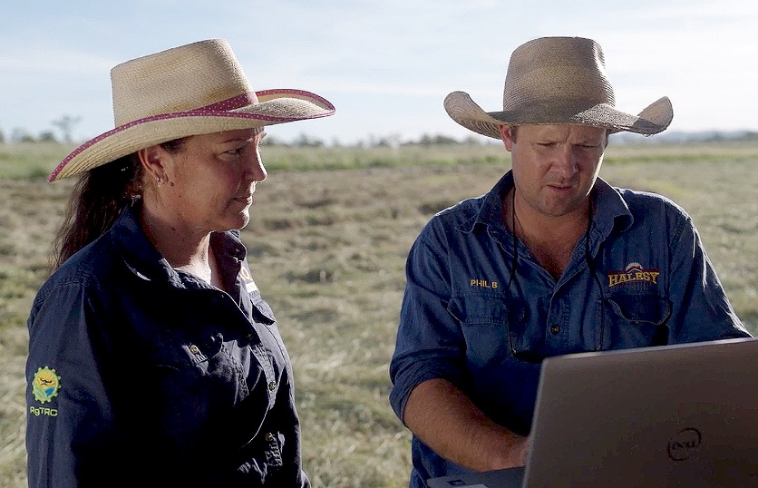
Case study 2 Ngarrindjeri Climate Yarning Circles
In partnership with the Ngarrindjeri Aboriginal Corporation (NAC), the South Australian Drought Resilience Adoption and Innovation Hub has funded a project for Ngarrindjeri Climate Yarning Circles.
Yarning circles are a culturally appropriate knowledge sharing forum for the Ngarrindjeri people, the Traditional Owners of the Lower Lakes, Murray Mouth, Coorong and lower River Murray in South Australia.
Yarning circles focused on climate change impacts on Ngarrindjeri Yarluwar-Ruwe (lands and waters) have been held in Meningie, Strathalbyn and Murray Bridge as part of the NAC-led Building the Resilience of Ngarrindjeri Yarluwar-Ruwe Landscape Priority Fund project.
The yarning circles have been used to facilitate a dialogue that bridged cultural knowledge with scientific insights, enabling the Ngarrindjeri community to articulate a clear stance on climate change, focusing on actionable mitigation and adaptation strategies that respect and incorporate Ngarrindjeri cultural values. Outcomes include:
- enhanced understanding of climate change impacts on traditional lands and waters
- insights into how Ngarrindjeri cultural practices can mitigate the impacts of climate change
- development of a carbon-neutral stance for NAC and advocacy for sustainable water management practices
- a framework for integrating scientific and First Nations Knowledge.
In engaging a broad range of community members, from Elders to children, the yarning circles also supported the intergenerational transmission of knowledge crucial for long-term cultural and environmental sustainability. The project has set a precedent for community-led climate-resilience initiatives and offers a model for other First Nations communities facing similar challenges.
The hub is continuing to develop climate yarning circles with First Nations communities after the success of the Ngarrindjeri Climate Yarning Circles project. Project development was undertaken with the River Murray and Mallee Aboriginal Corporation, with 3 climate yarning circles occurring in Autumn 2025.
Case study 3 Indigenous Women Food and Fibre Entrepreneurs
In partnership with the South West Indigenous Network, Rural Economies Centre of Excellence and Catholic Care Social Services, the Southern Queensland and Northern New South Wales (SQNNSW) Innovation Hub is delivering an Indigenous Women Food and Fibre Entrepreneurs program (IWFFE).
The program has been designed to develop the storytelling capabilities of Indigenous women building sustainable food and fibre businesses across Queensland and northern NSW. Most of these utilise native plants through culturally safe practices that align with sustainable care for Country.
IWFFE combines in-person workshops and mentoring, including one-on-one, with an overnight retreat format to support the exploration and development of First Nations food and fibre opportunities.
The hub is also working to support an online platform to amplify the great stories Indigenous women are telling about their sustainable production and their diversification projects.

Regional Drought Resilience Planning
The Regional Drought Resilience Planning (RDRP) program brings together regional organisations, local government, industry and communities to develop and implement regional-level drought resilience plans (RDR plans). It is designed, delivered and funded in partnership with the state and territory governments.
The RDR plans are locally led and owned, empowering regions to determine their priorities, needs and opportunities. The program aims to build a culture of deliberate, proactive and coordinated drought-resilience planning and action, built on strong partnerships and evidence. Once a plan is finalised, regions can access funding to implement priority activities within their plans.

Program highlights
Some key achievements and highlights for the RDRP program in 2024–25 include:
- 24 draft RDR plans were reviewed by CSIRO to ensure actions to prepare for future droughts are based on evidence and regional communities have access to best-practice data and information in their decision-making.
- 42 RDR plans across Australia were finalised and published, bringing the number of finalised plans to 57 of the 69 regions participating in the program.
- 50 regions have progressed to the implementation phase, with 99 activities already funded across 27 regions.
- 1,369 stakeholder groups engaged in the planning process across all regions, making a total of 8,566 involved in developing plans since the start of the program in 2021.
- 1,291 planning and engagement activities held across all regions, for a total of 5,973 since the program began in 2021. These numbers are lower than the previous years, because most regions have finished planning and moved into the implementation phase.
- 6 all-jurisdictional co-design workshops were held to explore and agree on key elements of Phase 2 program design.

Program update
Throughout 2024–25, 42 RDR plans were finalised, taking the total of published RDR plans to 57 across the agricultural regions of Australia. As Phase 1 of the program neared completion and Phase 2 approached commencement, program activities transitioned from planning to implementing priority actions identified in plans.
The program’s 69 participating regions are listed at Regional Drought Resilience Planning and shown in Map 2.
Map 2 Regional Drought Resilience Planning – participating regions
Note: Current at November 2025. Changes or additions to regions may occur over the course of the Regional Drought Resilience Planning program.
Source: Local government areas (ABS 2021)
Of the 57 regions for which RDR plans that have been finalised and published, 27 have received implementation funding to deliver activities from their RDR plans. The activities fall under the themes of agriculture; communities; economy; governance, knowledge and physical connectivity; landscapes, environment and First Nations; and water systems. Figure 2 shows the percentage of activities across RDR plans that fall into these themes.
Figure 2 Regional Drought Resilience plan activities, by theme
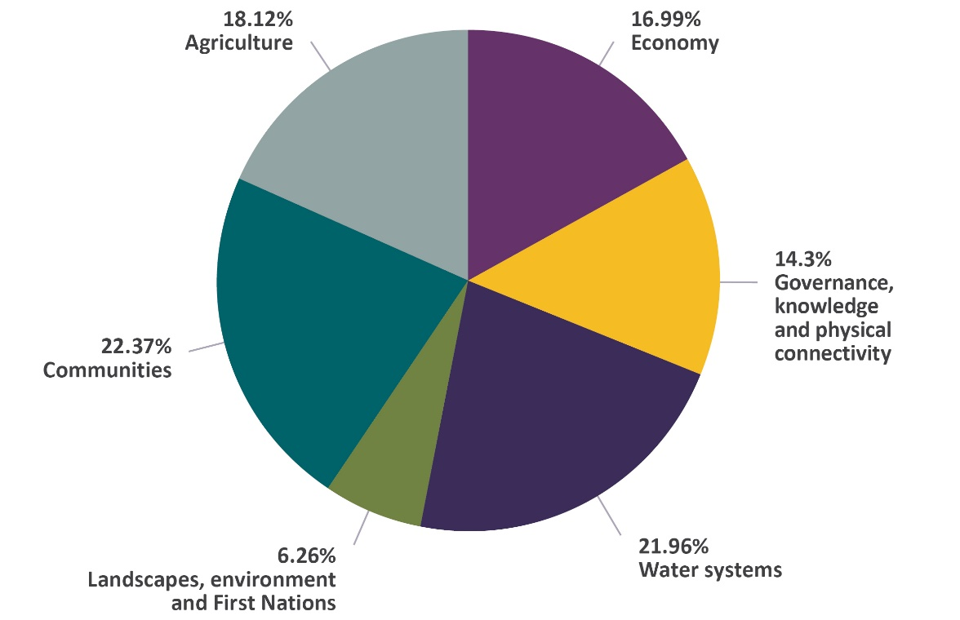
Case study 4 Mental health first aid training and awareness
Goulburn Broken Catchment Management Authority (CMA) received a $300,000 RDRP implementation grant, to deliver a mental health-focused activity. The CMA hosted a free screening of Just A Farmer, an Australian-made film that portrays the challenges and triumphs of a resilient farmer in rural Australia. It amplifies the often-overlooked voices of rural communities and sheds light on mental health struggles.
On 27 November 2024, more than 120 people attended a screening in Kyabram, which was supported by Goulburn Murray Landcare Network, Kyabram Urban Landcare Group, Dairy Farmers Victoria, Kyabram Health, StandBy, Support After Suicide, Rural Aid and Centrelink.
The CMA provided tips to community members to help them identify and assist people who may need mental health support. Centrelink, Rural Aid and Kyabram Health also provided mental health–focused information and resources to attendees. An additional screening was held in the town of Yea and attended by 180 people.
Goulburn Broken CMA Interim CEO, Carl Walters, said the event was a ‘huge success, providing those in attendance with awareness of and access to important services, while also connecting people’. He also reiterated the vital importance of community wellbeing to the Goulburn RDR Plan, noting that a key theme of the Goulburn RDR Plan is people and community – developing resilience through proactive and efficient wellbeing support services and networks.
The following quotes were provided by attendees:
‘Thank you so much for a terrific night! It was lovely to see everyone come together. I thoroughly enjoyed the movie – emotional, heart retching and a good insight regarding suicides and family pressures, something that needs to be recognised.’
‘I could relate to the issues in Just a Farmer which portrayed the life of a fourth-generation farmer in a rural town perfectly.’
‘The issue of mental health is important to address across the community.’
‘I am a mental health worker, and I am pleased to see the turnout and interest in this subject through this film.’
One highlight of this project has been the engagement of the agricultural, NRM and health communities and partners in the screenings of this film. This has reinvigorated conversations about mental health in the local farming and regional communities. Additional screenings across the region are planned in 2025–26 to meet ongoing interest from communities to screen the film and open up these important conversations.
The timeframe to complete activities in this first phase of the RDRP program has been extended to November 2025, enabling delayed regions to finalise RDR plans and deliver activities. However, the program will continue for a further 4 years, with a commitment in the 2024–25 Budget to provide an additional $67 million. This second phase of the program will focus on the implementation, governance and refinement of RDR plans in line with Productivity Commission recommendations 3.1 and 7.3. It will provide:
- implementation funding for eligible activities in RDR plans
- support for regions to govern, maintain, update and improve RDR plans
- support for additional agricultural regions to develop an RDR plan where they do not have one in place.
The FDF worked with all state and territory governments to co-design Phase 2 of the RDRP program during 2024–25. This involved a series of all-jurisdictional co-design workshops that explored and developed the key priorities, principles and parameters for Phase 2.
The workshops involved sharing learnings from Phase 1 and considered advice from the FDF Consultative Committee and recommendations from the 2023 Productivity Commission inquiry. The co-design also considered how RDRP Phase 2 would reflect the requirements of the Drought Resilience Funding Plan, the FDF Investment Strategy, the Australian Government Drought Plan and the National Drought Agreement.

Connections across programs
In addition to RDRP implementation funding, regions with RDR plans have opportunities to leverage their plans to access other sources of funding. The next phase of the FDF Communities Program incorporates streams that support regions to implement social and community-focused actions in their RDR plans. RDR plans have also helped inform the design of other FDF funding investments, such as the Innovation Challenges Pilot program.

Helping Regional Communities Prepare for Drought Initiative
Delivery of the Helping Regional Communities Prepare for Drought Initiative (HRCPDI) finished in June 2025 and a program evaluation is expected to be completed in early 2026. HRCPDI consisted of 5 elements: the Community Impact Program, Small Network Grants, the National Mentoring Program, the National Learning Network and the National Expertise Pool.
The purpose of HRCPDI was to build community capacity by strengthening social and community networking, support, engagement and wellbeing. The HRCPDI helped to build enduring resilience to climate change impacts, including drought, while enhancing the public good in agriculture-dependent communities.

Community Impact Program highlights
The Community Impact Program (CIP) formalised and strengthened community-based networks, creating new platforms for collaboration and knowledge sharing. Approximately 75% of projects reported a large improvement in community belonging and stronger social connection, trust and collaboration. The CIP reduced isolation and built resilience across diverse communities, equipping emerging and established leaders to coordinate local action. Projects revitalised or created shared spaces, improved access to support services and embedded practical knowledge for ongoing adaptation.
Through the CIP, the Australian Rural Leadership Foundation (ARLF) delivered leadership workshops to individuals across the 35 regions to build community drought resilience. These activities strengthened social capital and enabled collaboration and collective action. They also created opportunities for participants to connect across sectors, regions and roles. Participants developed practical skills in adaptive leadership, systems thinking and collaborative problem-solving. Many now lead initiatives in their communities and workplaces. Figure 3 shows the highlights of the CIP and Small Network Grants.

Small Network Grants highlights
The Small Network Grants (SNG) program supported community organisations in remote, rural and regional Australia to deliver one-off events or initiatives that strengthen community networks, social capital and drought-preparedness capabilities. Grants of up to $20,000 funded networks, events, infrastructure and training, and development and learning initiatives. The program was delivered by the Foundation for Rural & Regional Renewal (FRRR).
The program strengthened belonging and social connection through locally designed events and activities and helped communities feel connected and ready to support one another during drought. An average of 200 participants attended each event, with some events attracting over 1,500 people. SNG enabled communities to invest in assets and training that matched local needs. Mobile and shared resources extended reach into isolated areas, while training initiatives built confidence in first aid, mental health and emergency response. Figure 3 shows the highlights of the CIP and SNG.
Figure 3 Community Impact Program and Small Network Grants snapshot
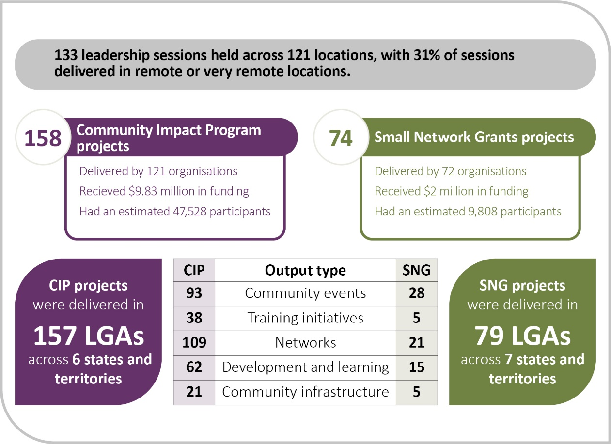
CIP Community Impact Program. SNG Small Network Grants. LGAs Local government areas.

National Mentoring Program highlights
Delivered by ARLF, the National Mentoring Program strengthened leadership capability and confidence among participants. Mentees reported the experience as a turning point in their leadership journey. The program’s impact extended beyond individual growth, with participants using their new skills and networks to deliver real benefits for their organisations, communities and the sector. Figure 4 shows a snapshot of the program.
Figure 4 National Mentoring Program snapshot
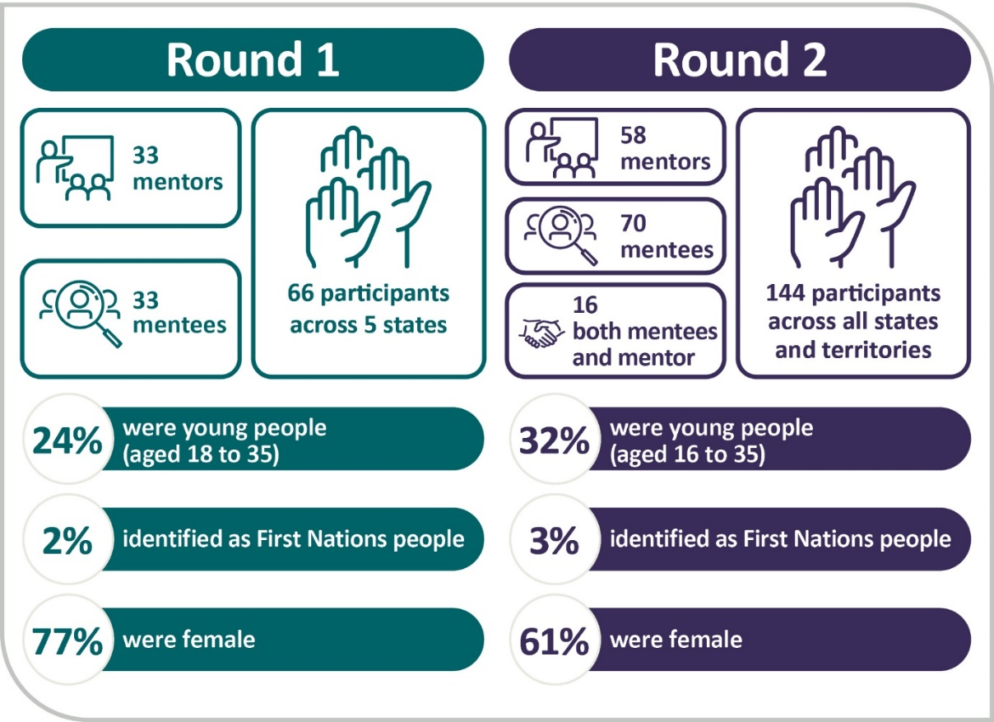

National Learning Network highlights
The National Learning Network, known as the Drought Ready Network, is now in a self-sufficient phase. Members of the group share resources and events to increase knowledge and awareness about drought preparedness. In 2024–25, members accessed resources, peer-learning opportunities and practical tools for resilience, and reported increased confidence, motivation and a stronger sense of belonging. Figure 5 shows a snapshot of the Drought Ready Network.
Figure 5 Drought Ready Network snapshot
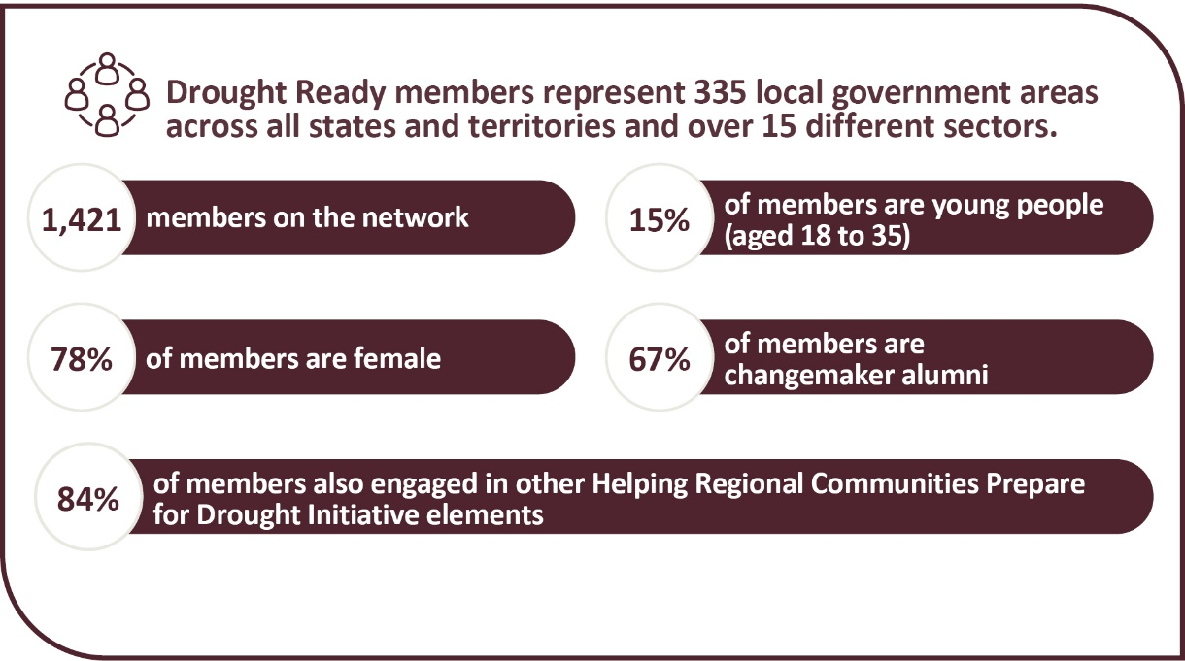

National Expertise Pool highlights
The National Expertise Pool was designed as a national online platform to offer regional leaders and community organisations a database of experts that could be drawn on to deliver projects and assist with community activities. The service launched in mid-2023 and was available to all FRRR-supported organisations and the not-for-profit sector. It offered access to specialists across more than 67 areas of expertise. The free concierge service helped organisations clarify their needs, provided tailored referrals and practical guidance to a small number of organisations on issues such as legal structure, governance and funding strategies. Figure 6 shows a snapshot of the National Expertise Pool.
Figure 6 National Expertise Pool snapshot
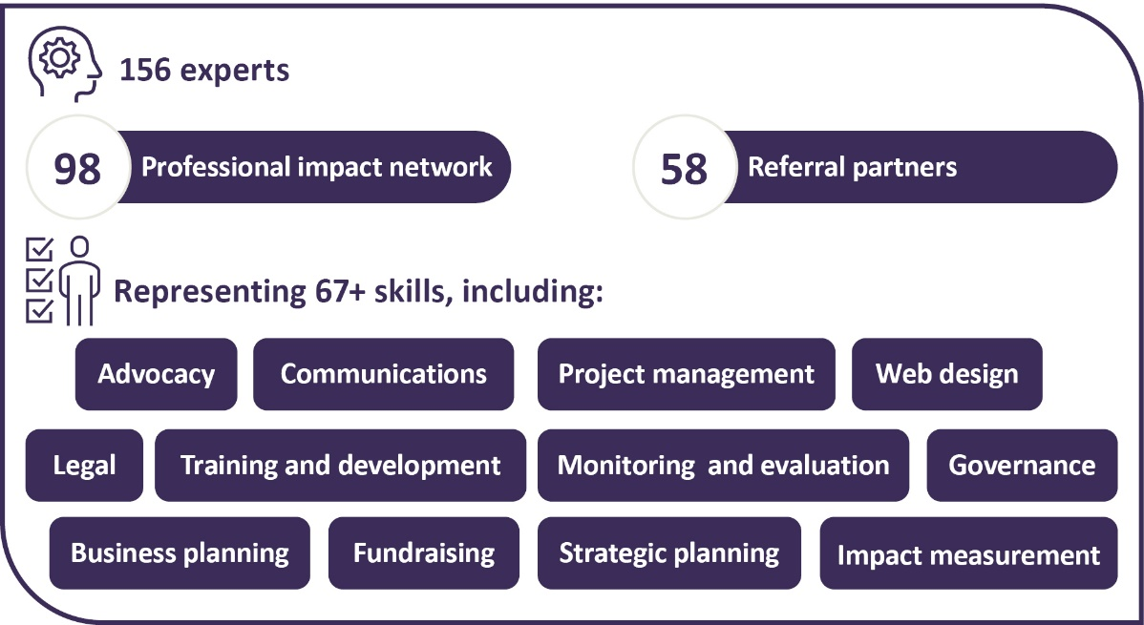
We received positive feedback from participants:
(The project) gave us the tools to bring people together and start deeper conversations about what drought resilience really means, not just in terms of land and water, but also mental health, business planning, leadership and strong community connections. This has helped create a broader understanding of resilience, while also strengthening the bonds between organisations and individuals across the region. – Program participant 1
We are most proud of how the program created a safe, collaborative space where participants felt empowered to share experiences, learn new land management practices, and openly discuss mental health challenges related to drought. This holistic approach to drought resilience, covering both land and wellbeing, focused on a ground up approach on topics of interest, has laid strong foundations for ongoing community-led adaptation and support. – Program participant 2
In one community, a First Nations Elder shared that the project made people feel seen and included:
It was so wonderful to have a project that was about us, not just a generic ‘one size fits all’ approach. This really meant you could feel heard; it is not often we feel heard in our region. – Program participant 3
Case study 5 Rana Everett: building welding skills and confidence in Albany
ARLF, in partnership with FRRR, delivered Changemaker workshops across more than 30 regions as part of the HRCPDI. These workshops encourage people to explore local challenges through new perspectives and act on practical opportunities for change.
Mechanical engineer Rana Everett moved from Darwin to Albany in Western Australia and quickly noticed a gap in the local welding workforce. A major prototype project was underway, yet local capacity did not meet the demand for specialist welders.
Through a Changemaker workshop, Rana connected with others in her community who were keen to create opportunities for young people. They recognised the challenge was not only about labour shortages, but also about access, confidence and possibility. Photo 2 shows Changemaker participant Rana Everett.
Photo 2 Changemaker workshop participant Rana Everett
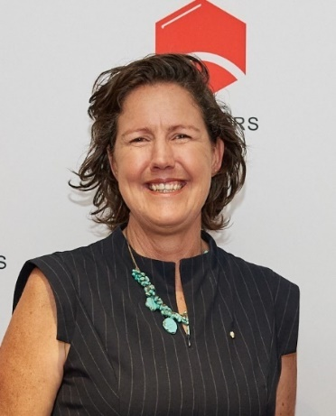
Rana partnered with Weld Australia to bring augmented reality welding simulators into the region. These simulators gave students, and other people considering trades, a safe and engaging way to experience welding. The initiative captured attention – some young people embraced it as ‘like gaming’, while others were drawn to its creative and artistic aspects. Schools and TAFEs began investing in their own simulators, and industry partners started to see the benefits of developing local skills.
What began as a single idea is now creating broader opportunities for the Albany community. The project has inspired young people to consider careers in trades, opened pathways for women into non-traditional roles, and strengthened local training and workforce capacity.
For Rana, the Changemaker workshop was the springboard. It provided the space to listen, test ideas, and act with courage. Her story shows how local insight and technical expertise, supported by the FDF, can generate practical and lasting impact.
To hear about Rana’s journey as a Changemaker, listen to Episode 2 of the Rural Leadership Unearthed Changemaker Series podcast.
Case study 6 Strengthening connections for drought resilience in remote NSW
Residents in far western NSW are known for their resourcefulness and resilience, but a unique set of challenges can make life tough. Contact Inc. is helping families across the region feel more connected and equipped to face future droughts.
Geographic isolation, limited access to services, higher suicide rates and socioeconomic disadvantage all compound the impacts of drought. Many children study via distance education and miss out on playing with peers, joining holiday activities or exploring hobbies in a group setting. Parents and carers also often struggle to access child and family support services, while ongoing stress, social isolation and poor health outcomes increase the pressure.
With a $49,969 Small Network Grant, Contact Inc. delivered community gatherings and virtual sessions where children, parents, Elders and local service providers came together, to build networks that will reduce isolation and strengthen community resilience. The grant helped Contact Inc. work closely with communities to design events that reflected their priorities and needs. Photo 3 shows attendees at a Contact Inc. community event.
Photo 3 Attendees at a Contact Inc. community event
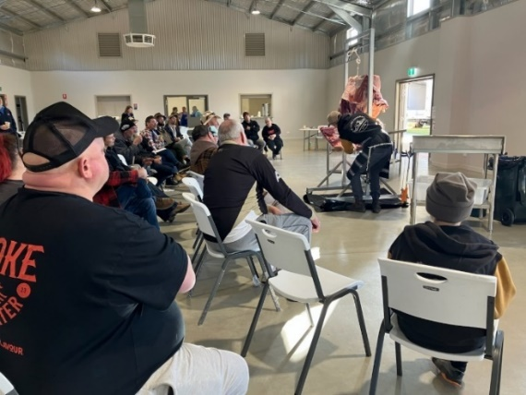
Community link-up days were hosted in Ivanhoe, Louth, Pooncarie and Tibooburra, timed with Royal Flying Doctor Service clinic days to maximise attendance. Families enjoyed children’s activities, practical wellbeing sessions, informal time with service providers and the chance to connect with neighbours. Follow-up virtual events extended the reach. This enabled people across the region to stay in touch and develop self-support networks alongside advice from professionals and presentations about parenting, health and wellbeing. Contact Inc. utilised trusted networks such as the Isolated Children’s Parents’ Association, Maari Ma and local Aboriginal Land Councils to ensure young parents and First Nations community members were actively engaged throughout the project. Joint activities for Indigenous and non-Indigenous families were designed to build interpersonal skills, encourage collaboration and challenge stereotypes.
The project involved professional talks, learning and wellbeing activities, and opportunities for private, informal consultation with recommended local services. Grant funds supported everything from project management to venue hire to engaging specialist consultants.
Contact Inc. described the impact of the gatherings as ‘profound’. Families reported feeling less alone and more aware of the services available to them. Children had the chance to play and socialise with one another and build confidence in settings beyond their immediate family. Agencies gained valuable insights into the realities of life in remote communities, strengthening relationships that will support future collaboration. Community members spoke of renewed energy and optimism, while local groups benefited from fundraising opportunities tied to the events. These gatherings laid the groundwork for stronger, lasting networks – helping families, communities and service providers to be better connected and more resilient when the next drought comes.
‘Drought preparedness is not only about water and land – it’s about people. Our project was developed with the understanding that when communities are connected, supported and engaged, they are better able to withstand and recover from the challenges of drought. By providing a framework that brought children, families and community members together, we created vital opportunities for access to services, practical learning and social connection – foundations that strengthen resilience for the future.’ – Sue Kingwill Contact Inc.

Communities Program
Recognising the ongoing importance of strong and connected agriculture-dependent communities, the government announced a new iteration of the Communities Program in the 2024–25 Budget. The program will receive $36 million in funding over 4 years from 2025. This funding will expand and enhance the previous work under the HRCPDI. Learnings from previous programs are informing the design and planning of the new program. Consistent with Productivity Commission recommendations 3.1 and 7.6, the program will provide implementation pathways for social-resilience activities identified in RDRPs. In addition, the program will make continuous efforts to explore and implement additional ways to connect with other FDF programs, ensuring a cohesive and integrated approach to building social resilience.

Partnering for First Nations initiatives
The government is partnering with First Nations peoples, businesses, organisations and communities to support economic self-determination and connection to, and caring for, Country through the management of drought and climate risks.

Strengthening Drought Resilience on Country
During 2024–25 we designed the Strengthening Drought Resilience on Country program – the first of its kind for the FDF. This $12 million initiative will support First Nations–led, place-based projects that build drought and climate resilience. First Nations delivery partners selected through the grant will co-design community-led activities, aligned with local priorities.
The program supports Closing the Gap Priority Reform 2 and socioeconomic targets 8, 15 and 16 (Coalition of Peaks 2020) and is consistent with Productivity Commission recommendation 3.1.

Program update
The Strengthening Drought Resilience on Country program is progressing on schedule. The Grant Opportunity Guidelines included strategic input from key stakeholders, including the department, the FDF First Nations Advisory Group, the National Indigenous Australians Agency (NIAA) and the Department of Climate Change, Energy the Environment and Water (DCCEEW). The program remains on track with the grant round opening in late 2025.
The advisory group provided critical advice on the development of the grant, offering culturally grounded, ecological and community-based perspectives. Their guidance on Caring for Country principles, traditional ecological knowledge and cultural protocols enhanced the program’s design in sustainable land management and climate resilience considerations. The advisory group brings valuable insights into fire and water stewardship, community engagement models, workforce development, and helping to build inclusive and locally relevant agricultural practices across rural, regional and remote communities. The advisory group also helped the department embrace a program design aimed at reducing the administrative burden on applicants and future grantees.

First Nations supporting participation activities
First Nations peoples and organisations have always been eligible to participate in FDF programs, but uptake has been low. In response, and consistent with Productivity Commission recommendations 3.1 and 6.1, the government committed $3 million over 4 years to support activities that improve First Nations participation in FDF drought and climate resilience activities. These activities will aim to address structural barriers to access, enhance cultural capability within the FDF, and increase engagement and satisfaction among First Nations participants.
To inform this work, the advisory group identified opportunities for improvement across the FDF. Drawing on stakeholder feedback and member expertise the group considered barriers to participation and explored ways to build on existing FDF initiatives, including:
- First Nations focused, culturally safe market research to provide additional insights into the barriers to participation, and First Nations preferences which commenced in June 2025
- development of the new FDF monitoring, evaluation and learning (MEL) Framework, with advice provided to highlight principles for a culturally safe and informed MEL
- engagement, projects and support delivered by FDF delivery partners, including but not limited to business planning, mentoring, leadership training and knowledge brokers.
To increase First Nations participation in the FDF the advisory group have identified 3 key priorities for 2024–25 and 2025–26:
- Engaging Cultural Navigators to provide one-on-one support to First Nations peoples, businesses and organisations. Navigators will connect people and organisations to relevant support and projects under the FDF and facilitate improved coordination of on-ground engagement and networking.
- Delivering targeted training workshops to help First Nations peoples and organisations prepare high-quality grant applications and navigate the FDF grant processes. Training will also strengthen governance, budgeting, and MEL capabilities.
- Improving awareness through culturally appropriate communications, including developing a tailored communication and engagement strategy, engaging First Nations content creators, and producing targeted resources such as guidelines for culturally inclusive communication, case studies, and innovative communication products.

Building knowledge, skills and capability
The government is supporting farmers and regional communities to make informed decisions and better manage drought and climate risks.

Farm Business Resilience
The Farm Business Resilience (FBR) program supports long-term resilience of farm businesses by building participants’ knowledge, skills and capability to manage risks, including drought and other climate risks.
Delivered in partnership with state and territory governments, the program encourages participants to proactively develop long-term strategies and actions, that build the drought and climate resilience of their business, the land and themselves.
Participants receive professionally backed, tailored support for farm business planning and access to capacity building activities across a range of interconnected learning areas including:
- climate adaptation
- NRM
- transformational practices
- decision-making and risk management
- personal and social resilience, including mental wellbeing.

Program highlights
From program commencement to 30 June 2025:
- 67,955 farmers have taken part in the program in all jurisdictions across Australia.
- 17,704 learning and development activities and events have been held.
- 3,097 farm business plans reviewed or advised on by professionals during their development.
- 5,617 farm business plans completed (new plans developed or existing plans updated).
- 6,022 farm performance assessments completed.
Figures may include duplication due to some instances where individuals attend multiple events and were not uniquely recorded.

Program update
Since 2021, over 67,000 people have benefited from the program, which continues to attract broad participation across more than 18 agricultural industries (see Figure 7).
Figure 7 Farm Business Resilience program participants, by industry
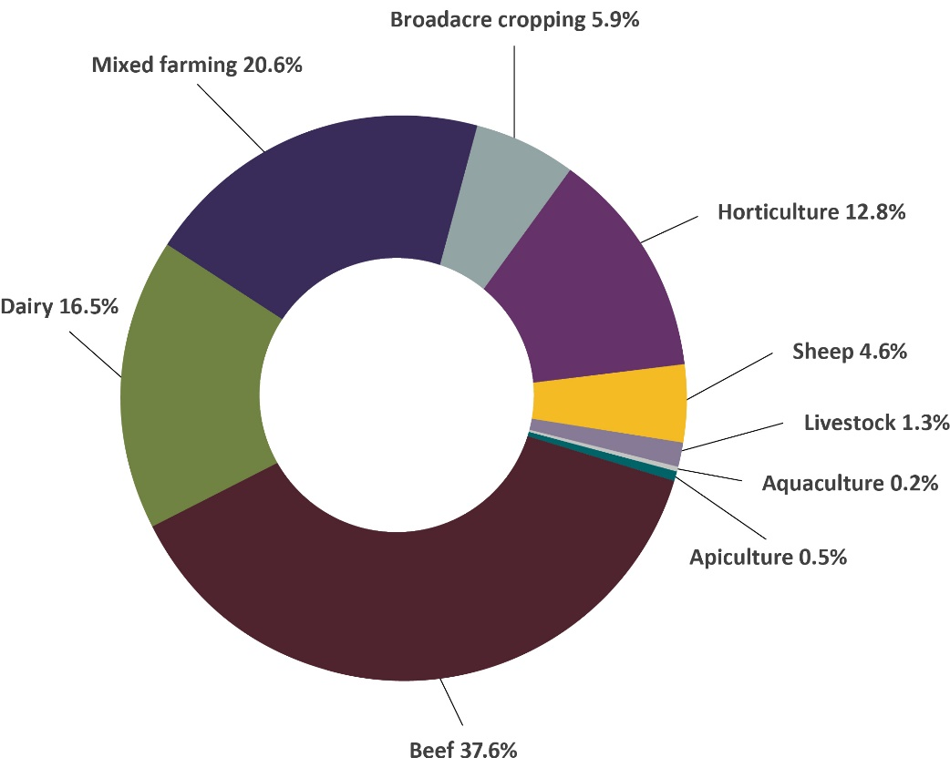
Note: Broadacre cropping includes cropping, sugarcane and cotton. Horticulture includes orchard fruit, nuts, berries, plantation fruit, grapes and vegetables. Livestock includes pigs, poultry and eggs and other livestock (e.g. goats, alpacas).
In its fourth year, the program continues to show growing positive impact on Australian farm businesses. In NSW, farmers are benefiting from incorporating drought planning into their farm business plans, with 87.8% indicating an intent to implement changes based on their plans, and 77.6% already putting changes into practice. For example, some participants have adjusted farm plans to include clear drought risk indicators, increasing their confidence to adapt and thrive in uncertain conditions. Others are taking proactive steps to prepare for drought such as adjusting their feeding schedules or stockpiling fodder ahead of the dry times. This demonstrates that the program is both fostering the intention to change and driving tangible improvements.
In the ACT, all training and coaching participants reported increased confidence in their business’s future viability and a greater belief in their ability to remain resilient and profitable despite challenges like drought and market variability. In Victoria, over 79% of past participants have implemented changes or improvements based on their plans, and 70% of participants involved in NRM activities intend to change or improve their on-farm practices. For example, after attending 3 farm-dam workshops in south-west Victoria, all livestock producers identified practice changes, including monitoring dam volumes and increasing reticulation systems to support their drought resilience and better manage run-off and water quality.
The program also continues to foster connections to Country and communities through First Nations initiatives, including Aboriginal Economic Development in WA and Agriculture Victoria’s Aboriginal Landholder Information Service (ALIS). In October 2024, ALIS delivered a 2-day native seed harvesting workshop at the Dalki Garringa Arboretum, hosted by the Barengi Gadjin Land Council. The event brought together staff from Dalki Garringa Native Nursery, First People of the Millewa-Mallee Aboriginal Corporation’s Belar Nursery, Dja Dja Wurrung Clans Aboriginal Corporation, and Wadawurrung Traditional Owners Aboriginal Corporation, highlighting the importance of cultural exchange and Knowledge sharing. One 2024 workshop participant shared:
Having opportunities like this to have cross-Country workshops and knowledge sharing brings so much to the moment… We have young ones and us older ones meeting and talking about seeds and harvesting but at the same time we are sharing stories and keeping our traditional methods of identifying Country alive. – Native seed harvesting workshop participant
Case study 7 Far West Oysters
‘Oyster leases need a land base, and we have a few ideas for improving this block but want to make sure we are planning the right way’ said Stephanie Sutcliffe of Far West Oysters.
It was an extremely windy day when Allison Clark and Belinda Hazell of the Resilient Farming Tas team arrived to discuss future plans for Stephanie and Henry Hewish’s land at Montagu. Stephanie led the team to a shed housing some oyster equipment, to escape the wind and exchange meaningful ideas.
Farming both oysters and beef, Stephanie outlined current improvements, including fencing, and shared her thoughts on other needs. Topics such as water management, pasture care, and shelter were discussed as part of a possible property management plan. The discussion also touched on the couple’s farming goals, their business structure, and how their oyster and beef farming operations shaped these decisions.
Over several months, conversations exploring the business’s history, vision, risks and opportunities helped shape a clear plan.
‘Working through the process with Allison gave Henry and me a chance to identify what truly mattered for making our business more resilient,’ Stephanie said. ‘The structured risk assessment process helped us focus on immediate priorities. We moved ahead with our livestock plans, but what really made a difference was discussing how to refine our business structure to align with our vision for the future.’
With a visit from Safe Farming Tasmania planned, Stephanie is optimistic about receiving insights into both their water and land-based activities. This will help maintain confidence working in their isolated Tasmanian operations, knowing they’re taking the right steps.
Completing an action plan also enables Stephanie to participate in the 2025 series of workshops and mentoring, further strengthening their business and future plans.
In the 2024–25 Budget, an additional $80 million was committed to continue the program for a further 4-years, from 1 July 2025 until 30 June 2029.
The FDF worked with all state and territory governments to co-design Phase 2 of the FBR program during 2024–25. This involved a series of all-jurisdictional co-design workshops that explored and developed the key priorities, principles and parameters for Phase 2. The co-design workshops involved the sharing of collective learnings from Phase 1 and considered advice from the FDF Consultative Committee and recommendations from the 2023 Productivity Commission inquiry. The co-design also considered how Phase 2 would reflect the requirements of the Drought Resilience Funding Plan, the FDF Investment Strategy, the Australian Government’s Drought Plan and the National Drought Agreement.
This next phase will build on the successes and learnings of the first phase and aims to drive change at a meaningful scale by supporting a diverse range of participants, including First Nations peoples, remote participants, young people, and women. The program will also enhance post-program participation through improved follow-up, peer learning and networking opportunities. These efforts will foster ongoing knowledge sharing among and beyond direct participants, enabling enduring and where appropriate, transformational outcomes.

Drought Resilience Scholarships
The Drought Resilience Scholarship program supports up to 5 drought resilience scholars each year through Nuffield Australia. It aims to build drought resilience expertise and strengthen farmers’ knowledge of innovative tools and practices to help the agricultural sector respond to a changing climate.
The initial program delivered 10 drought resilience scholarships in 2024 and 2025 and supported other Nuffield scholars to undertake drought and climate resilience activities.

Program highlights
In 2024–25:
- the 2024 Drought Resilience Scholars progressed their research
- 5 Drought Resilience Scholarships were awarded
- the FDF hosted the Nuffield Australia Pre-Contemporary Scholar Conference in Canberra in March 2025.

Program update
In September 2024, 5 agricultural leaders were awarded the 2025 Drought Resilience Scholarships. The scholarships were presented at the Nuffield Australia Awards Dinner and National Conference in Launceston, Tasmania. The scholars commenced their studies in early 2025 focusing on the following topics:
- studying how growing and improving farm businesses affects drought resilience – Jock Barnett (NSW)
- looking at global agriculture organisations and industries, and how they inform drought preparedness – Tyson Cattle (WA)
- exploring ways small poultry farms can adapt and improve their resilience to drought – Lucy Dodd (SA)
- investigating how commitments to sustainability affect decision-making and influence drought resilience – Kari Moffat (Qld.)
- researching how efficient farming can improve product demand and affordability and contribute to farm business resilience to drought – Hamish Robertson (Vic.).
The 2024 and 2025 Drought Resilience Scholarship program also supported all Nuffield scholars to take part in drought-related activities. This included participation in the Australian Focus Program; a week-long experience held in Canberra, focusing on Australian agricultural drought-resilience, sustainability, policy, politics and advocacy.
The 2025 Pre-Contemporary Scholar Conference held in March 2025 showcased resilience in a changing climate. The event brought together department and Nuffield Australia executives, the 2025 scholars, and international scholars and alumni from the Netherlands, Germany, Romania and Japan. It successfully facilitated collaboration between the department and scholars, allowing attendees to deep dive into FDF and department initiatives. Specific initiatives included our First Nations programs, the Sustainable Agriculture Facilitators program supported by the Natural Heritage Trust and the FDF’s My Climate View tool. Scholars also attended the ABARES Outlook Conference and participated in field trips to CanTurf, CSIRO and The Truffle Farm (Mount Majura).
The 2025 Nuffield International Contemporary Scholar Conference in New Zealand offered scholars a valuable platform to connect, exchange ideas, and strengthen industry relationships that enriched their research and learning. Many participants described the experience as inspiring, noting a broadened worldview and deeper insights into resilience-thinking, both personally and professionally.
In 2025 the Drought Resilience Scholars participated in the Global Focus Program, a 5-week international study tour, to engage with global leaders on key topics including drought resilience, agricultural marketing, trade and environmental issues. Scholars visited Singapore, Taiwan, Zimbabwe, Romania, Poland, Chile, New Zealand, Kenya, the Netherlands, the USA and Japan.
In November 2025, the 2024 Drought Resilience Scholars were invited to present their research topics to state and territory government representatives from the FDF’s FBR and RDRP programs.
The scholars’ presentations were well received and facilitated fruitful conversations. This meeting fostered valuable connections between the scholars and government representatives, enabling ongoing information exchange.
FBR and the Drought Resilience Scholarship programs are linked through their knowledge sharing and peer-networking mechanisms. From 2025–26, further opportunities will be explored to strengthen connections between the two programs.
Case study 8 Farming through the dry: Hamish Robertson’s drought strategy
Hamish Robertson is a 2025 Nuffield Drought Resilience Scholar based in Tarrenlea, Victoria. Together with his wife Diana and their 2 children, he owns and runs a 3,000-acre property, producing fine Merino wool and lamb.
In recent years, Hamish has experienced variable seasonal conditions, with drought in many parts of Victoria. resulting in failed spring and autumn periods. These conditions have reduced feed availability, limited water access, and affected overall farm viability. As a result, he has reassessed how drought resilience is incorporated into both the technical and financial aspects of his operation.
Photo 4 Hamish Robertson, 2025 scholarship recipient
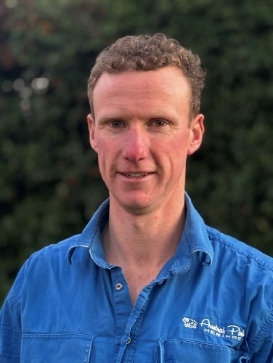
Supported by the FDF, Hamish’s research focuses on developing strategies to strengthen business resilience during drought whilst also managing other compounding factors. This includes water planning, pasture protection, budgeting, cash flow management, and exploring off-farm income opportunities to reduce financial pressure.
Hamish’s approach to farming is deeply hands-on and multidisciplinary. ‘We’ve got to wear a lot of hats. From vet and animal health to agronomy, pasture, soil, science, ecologists... and then into the business side of things, you’ve got to know about finance and bookkeeping and budgeting to be able to produce that end product,’ he explains. This broad skillset is essential to managing a modern wool enterprise, especially in the face of climate uncertainty.
Beyond the farm, Hamish is committed to sharing his learnings with the local community. He’s becoming a regular speaker at local, regional and national events and encourages open conversations among neighbours and fellow producers.
‘Talking to people makes a massive difference, and there is a thousand different ways to farm. It’s just that flow on effect to get that information and spread it in the local community and help people become better farmers, to produce better products for all Australians into the future.’
Through his leadership and openness, Hamish is helping shift the conversation around drought resilience in the wool industry. His research contributes to the growing body of work emerging from other Nuffield Scholars, highlighting the value of proactive planning, peer learning and community connection in building a more sustainable future for Australian agriculture.

Climate Services for Agriculture
The Climate Services for Agriculture (CSA) program supports farm businesses, farmland managers, and agricultural communities to prepare for climate variability and future droughts. It does this by providing tailored, location-specific climate information through the free online tool My Climate View (MCV).
MCV offers historical climate data, seasonal outlooks and future projections for 22 agricultural commodities at a fine resolution (5 km²) across Australia. The tool helps farmers plan, manage risks and build resilience to drought and climate change. Figure 8 shows the commodities available on MCV.
Figure 8 Commodities available on My Climate View
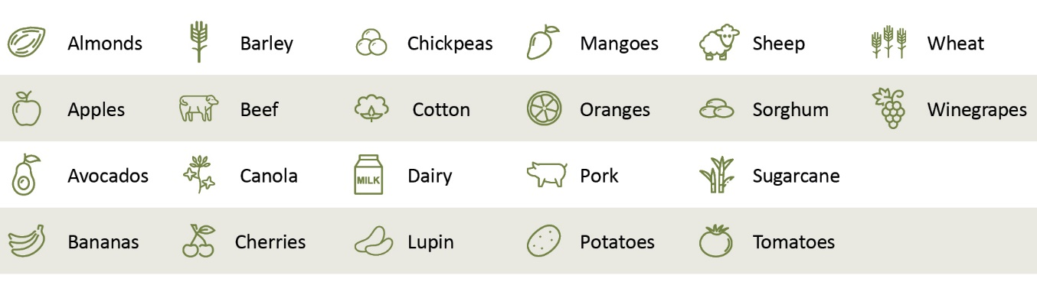

Program highlights
Key highlights and achievements during 2024–25 include:
- a strategic reset of our vision for CSA, goals for the new phase of the program, principles for decision-making about CSA, and the governance and advisory structures to support our management of the program and achievement of the vision and goals
- ongoing maintenance and 5 updates of MCV to maintain and improve the tool
- establishing relationships with First Nations communities across Northern Australia to explore and co-design the adaptation of CSA tools and activities to better serve Indigenous farm businesses and farmland managers
- integrating the prototype Australian Agricultural Drought Indicator (AADI) into the CSA program
- completing a review of the decommissioned Drought Resilience Self-Assessment Tool (DR.SAT) that identified the elements of most value that could be incorporated into MCV
- delivering presentations and papers to various drought resilience, climate agricultural forums.

Program update
The 2024–25 year was a bridging period between Phase 1 and Phase 2 of the CSA program. this allowed for considered planning of CSA’s Phase 2 direction. Planning for Phase 2 included a reset of the program’s vision and goals, review and strengthening of the program governance structures, establishment of decision-making principles, and improvements to collaboration with stakeholders.
The planning for Phase 2 temporarily slowed external communication and engagement, but it laid the groundwork for a stronger, more coordinated program.
Consistent with Productivity Commission recommendation 7.1, the department reviewed the decommissioned DR.SAT and identified its most valuable elements for integration into MCV during Phase 2, including the Birds Eye View mapping feature.
Toward the end of 2024–25, the department focused on engaging with First Nations communities, state and territory governments, universities and industry stakeholders, for improved product development. Efforts also focused on better integrating CSA and the MCV tool with other FDF programs.
This work supports Phase 2 goals to further enhance the MCV tool, including:
- exploring and integrating new datasets or features that provide additional value to farm businesses, agricultural land managers, and rural communities
- adapting program tools and services to the decision-making needs and priorities of government users with an interest in drought policy and programs and First Nations users
- building awareness and promoting adoption of the program’s tools and services among government users.
These new goals sit alongside work continuing the delivery and development of CSA tools and services, including:
- continuing to provide drought and climate tools and services to support risk management and adaptation decisions by farm businesses
- embedding the program as a trusted information source for farm users, agricultural advisers, and extension services, and improving adoption among users who can influence and support on-the-ground adaptation and practice change.
Case study 9 Using My Climate View sparks ‘lightbulb moments’ for Queensland mango growers
Using My Climate View (MCV) was a ‘lightbulb moment’ for many North Queensland mango growers participating in the FBR program, says Ebony Faichney, Managing Director of Farmour. Farmour is an independent agricultural service provider that is working with Growcom, to implement FBR for horticulture in Queensland.
Ebony found climate change could be a difficult topic for many older farmers. ‘A lot of growers here don’t believe in climate change and don’t want anything to do with it. Changing the language we use and using MCV for practical insights is helpful, like more days over 35°C or fewer cool nights for flowering.’
When a mango grower reads that, they start talking about the practical implications. ‘It’s a light bulb moment for many people. We have experienced poor winters in recent years which drastically reduced mango crops, and growers have witnessed that.’
Farmour integrates MCV into its extension and advisory work to support growers with climate informed decision making. While many climate modelling tools and programs exist, MCV is the only one Ebony uses regularly. ‘It’s the only one that’s easy to use and provides good information specific to the horticulture industry. For example, its detail for crops such as mango and avocado is unique.’
Looking ahead, Ebony and Growcom would like to expand the industry approach beyond mangoes. ‘We hope to do it with other commodity groups. We’re just doing the mango pilot first to see how it goes – it’s been really successful.’
Growcom project manager, Kristy Banks, leads the FBR horticulture project in Queensland. She agrees that MCV is user-friendly and a good conversation starter with growers, particularly from a farm business resilience and risk perspective.
Growcom was ‘hoping to replicate what we’re doing across the major peak industry bodies where data exists in MCV.’ Figure 9 shows the MCV logo and data included on a postcard developed by Growcom with the Australian Mango Industry Association.
Figure 9 Growcom postcard using My Climate View data
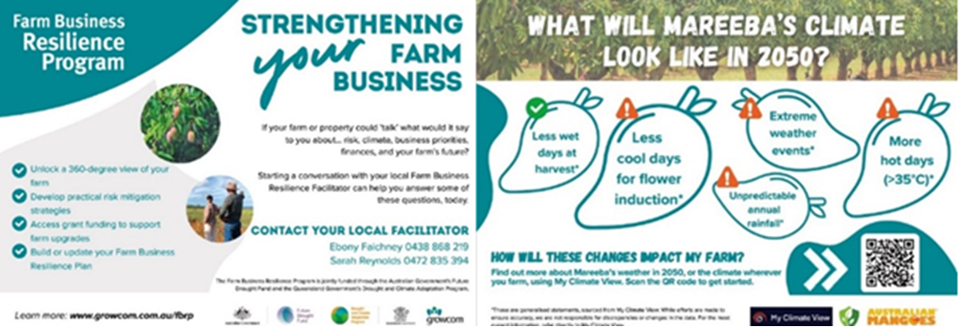
Source: Growcom
Case study 10 Building win-win relationships: CSA Indigenous engagement
First Nations communities across Northern Australia see value in CSA’s MCV and are actively engaging with CSA’s Indigenous engagement and tool improvement teams to receive briefings and suggest tool modifications to better meet their needs.
Reporting on the team’s 2024–25 engagement activities, CSA Indigenous engagement lead Tammy Hunter said, ‘This demonstrates the value people see in the climate information (provided by MCV) and that word of mouth is taking effect.’
CSA engaged with Indigenous rangers, bush-food producers, land managers and women on Country across Nhulunbuy (the Northern Territory) and WA’s Kimberly region.
‘Climate change on Country is strongly felt by First Nations people, and CSA is looking to collaborate with communities to co-design a future program of work to help understand and meet their climate information needs’, Ms Hunter said.
Participants in CSA’s First Nations engagement program shared insights on shifting seasons, harvest and land management practices as well as environmental indicators observed on Country like the impact of increasing sand temperatures on the sex ratio of sea turtle populations. In exchange, the CSA team briefed participants on CSA products such as MCV, and the in-development MapView tool.
CSA’s Indigenous engagement program included 3 workshops and a forum. Two workshops were held in July in Nhulunbuy (Northern Territory) with the Yirralka and Dhimurru Rangers, and a third was held in Darwin in August with representatives from ranger groups, Indigenous-owned bush food producers, and land managers.
In August 2024, CSA’s Indigenous engagement team was invited to a week-long bush medicine trip and ‘Women on Country’ workshop organised by the Wilinggin Aboriginal Corporation in WA’s Kimberly region.
In May 2025, Ms Hunter presented on CSA to the West Kimberley Traditional Owner Climate Adaptation Forum at the University of Notre Dame’s Broome campus. The forum was part of a Western Australian Government project on climate change impacts on Country and First Nations communities.
All activities were designed to build mutual trust and two-way learning in a culturally safe way, help CSA plan future work with First Nations stakeholders and deepen its understanding of their climate information needs and opportunities.

Scaling Success
The Scaling Success program is in the development stage. The grant round is scheduled to open in late 2025 through a targeted competitive process. Grantees are to be awarded in June 2026.
The invited candidates have successfully completed projects identified against 4 FDF programs:
- Drought Resilience Innovation Grants
- Drought Resilient Soils and Landscape Grants
- NRM Drought Resilience Grants
- Extension and Adoption of Drought Resilience Farming Practices program.
Consistent with Productivity Commission recommendation 3.1, the program will support transformational actions and invest in activities that build natural capital by enabling selected FDF projects to have impact beyond their initial scope, capitalising on existing success. The program will utilise existing momentum and networks to continue and expand FDF projects for greater impact. It will support activities that are designed to deliver enduring outcomes, that will target improved drought and climate resilience for the public good of the Australian agricultural sector, landscapes and communities as a primary focus. The program provides $27 million over 2 years from 2025–26, with grants valued between $100,000 and $3 million.

Innovating for transformation
The government is supporting trials of innovative solutions that have the potential to build the long-term resilience of the agricultural sector, landscapes and communities to drought and climate risks, through transformational change.

Long-term Trials of Drought Resilient Practices
The long-term nature of the Long-term Trials of Drought Resilient Practices program is critical to its success and makes support for transformational actions a higher priority, consistent with Productivity Commission recommendation 3.1. Long-term trials over multiple seasons provide robust testing of prospective drought resilient farming practices and give farmers the confidence to try them.

Program highlights
Highlights for the Long-term Trials of Drought Resilient Practices program include:
- Round 1 grants commenced in 2023, awarding 6 projects with a total of $38 million in grant funding. These projects are currently progressing into year 3.
- Round 2 grants commenced in 2025, awarding 5 projects with a total of $39 million in grant funding.

Program update
Round 1 projects continue to generate data and run extension activities. Round 2 projects will be delivered from 2025–26 to 2029–30. Projects will be undertaken across all states and territories, with most grantees running trials across multiple states.
Projects focus on the following areas:
- novel cropping and pasture management in dryland farming systems
- sheep production in low rainfall farming regions
- monitoring water stress levels in the horticulture industry
- adapting temperate viticulture and horticulture crops in systems with high rainfall dependency and limited irrigation
- monitoring crops and soils in cotton-growing regions.

Resilient Landscapes
The Resilient Landscapes program funds projects that focus on achieving and measuring transformational change and impact at landscape scale in line with Productivity Commission recommendation 3.1. The program focuses on identifying tipping points or thresholds within landscapes. It supports the demonstration of practices, technologies and approaches to improve the management of natural capital. The program aims to build resilience by enabling farmers to prepare for drought with a diverse range of options to respond effectively.
The program will provide $40 million in funding from 2024–25 until 2029–30 through an open competitive grant process for applicants that have formed a consortium.

Program update
Under the Resilient Landscapes program 8 grants were awarded. These projects aim to strengthen farmers’ capacity to prepare for and respond to future droughts and climate impacts. Projects will be undertaken across all states and territories.

Innovation Challenges Pilot
The Innovation Challenges Pilot program will provide $20 million over 3 years from 2025–26 for high-impact projects that provide solutions to 3 complex and multidimensional challenges caused by drought and climate impacts. It aims to increase the resilience of Australian agriculture, farmers and communities by fast-tracking innovation and transformational solutions to these challenges providing a strong evidence base for their adoption and directly involving a consortium of project partners including farmers.

Program update
The Productivity Commission recommended piloting a new, challenge-based approach to innovation investments (recommendation 7.5) to prioritise grant funding for innovative solutions to a small number of complex and multi-dimensional challenges arising from drought and climate change.
The department ran a Have Your Say consultation from 6 February 2025 to 13 March 2025 to hear from the public, industry and other stakeholders about the challenges they face. Respondents identified barriers to resilience such as water scarcity and high costs of new technologies, and suggested solutions like improved land monitoring and changes in crop rotations. The feedback emphasised the interconnected nature of these impacts and the need for comprehensive strategies to build long-term drought resilience.
An Innovation Advisory Committee of 4 experts considered this feedback and RDR plans as part of broader research and engagement to identify 3 pressing challenges for the program:
- Advancing natural capital and biodiversity for drought preparedness and resilience.
- Innovating water management for enhanced drought resilience in Australian agriculture.
- National innovation for enhancing community resilience to drought in Australian agricultural regions.
The remainder of work in 2024–25 focused on other design elements, including eligibility and application criteria ahead of the program opening for applications in August 2025. Grants will be awarded to innovative projects at the proof-of-concept stage that address one or more of the challenges.

Extension and Adoption of Drought Resilience Farming Practices
The Extension and Adoption of Drought Resilience Farming Practices program aims to accelerate the uptake of proven drought resilience practices and technologies by supporting activities that promote their demonstration, extension and future adoption. These practices and technologies are selected based on their ability to:
- reduce the impact of drought on agricultural productivity and/or support faster recovery of farmers and landscapes
- be scalable across multiple farms, farming systems, landscapes, regions or industries
- deliver clear public benefits.

Program highlights
Some highlights for the Extension and Adoption of Drought Resilience Farming Practices program were:
- $13 million in grants was awarded to 18 projects aimed at driving adoption of proven drought resilient farming practices.
- Projects were undertaken across all states and territories except Tasmania, with some grantees successfully operating across multiple regions and states.
No projects were funded in Tasmania due to the significant interest in a highly competitive grant opportunity. Some project activities occurred in multiple states, including Tasmania.

Program update
In June 2025, 16 grantees successfully completed their project activities. Final reports for these projects are due by 30 September 2025. An additional 2 grantees are scheduled to complete their project activities by 31 December 2025, with final reports expected by 31 March 2026. Evaluation of this program is scheduled to occur in 2025–26.
Case study 11 Pork Innovation WA: managing water in a changing climate
Through the Managing water in a changing climate project Pork Innovation WA developed an extension toolkit to facilitate adoption of best practice water management for pork and poultry producers in WA. The project included a series of interactive workshops, field days, and practical resources such as fact sheets and education notes to support producers in improving water resource management.
Survey results from workshop participants showed that over 80% of producers planned to improve their water management practices, expecting gains in productivity, sustainability, and profitability. Of the participants, 83% reported being better able to identify the benefits of improved water security, and 81% indicated they are experimenting with or planning to adopt improvements in water security as a direct result of participating in the project.

Drought Resilient Soils and Landscapes
The Drought Resilient Soils and Landscapes program supports projects that demonstrate broad scale practices that help make both agricultural and broader landscapes more resilient to future droughts.

Program update and highlights
The following milestones were achieved under the program Drought Resilient Soils and Landscapes program:
- 26 projects were funded at a total of $23.1 million.
- Most projects were completed by June 2024, with 8 projects requiring short extensions.
- All project activities were completed by 30 June 2025 with significant farmer engagement reported across the projects.
An evaluation of the program is scheduled to be undertaken in 2025–26.
Case study 12 Building resilience: moisture conservation in the Mingenew–Irwin Region
The Mingenew Irwin Group’s project, Making Every Drop Count – Below and Above Ground Targeted Moisture Conservation from Paddock to Landscape, has driven increased experimentation with drought-resilient technologies and the adoption of innovative practices across the Mingenew–Irwin region near Geraldton in Western Australia.
Through 10 on-farm demonstrations, the project showcased a range of land management strategies that collectively improved drought resilience across 369 hectares of agricultural landscape. Evidence-based results were gathered through soil and water sampling, landscape analysis, and case studies, which were shared with landholders to support informed future decision-making. The initiative also strengthened community engagement through field days, presentations, and training events, fostering collaboration among farmers, consultants, and stakeholders.
The project delivered public good benefits, including improved soil health, enhanced biodiversity and ecosystem connectivity, increased groundcover, and positive changes in biomass, contributing to the sustainable management of natural capital.

Drought Resilience Commercialisation Initiative
Beanstalk AgTech are delivering the $10 million Drought Resilience Commercialisation Initiative over 2 years to 30 April 2026. This pilot program aims to accelerate the availability of drought-resilience tools for Australian farmers and farming communities. It supports innovators through the commercialisation process, helping them turn their research, intellectual property (IP) and ideas into drought-resilient products and services that can be made publicly available.

Program highlights
Key achievements and highlights of the Drought Resilience Commercialisation Initiative include:
- 68 innovators have participated in the 90-day program.
- Each cohort has had innovators from every state and territory and from a range of agricultural industries.
- Innovators who have completed the 90-day program reported an increase in their commercialisation understanding of almost 20%.
- Innovators have been given the opportunity to attend a range of events to foster networking and develop presentation skills.
- 7 innovators have progressed to the 12-month program receiving dedicated support to progress the commercialisation process.

Program update
Up to 96 innovators across 4 cohorts will be selected to participate in the 90-day program under the Drought Venture Studio. At 30 June 2025, 68 innovators had been selected across the first 3 cohorts, with cohorts 1 and 2 complete. Cohort 3 is due for completion in July 2025 and expressions of interest for the fourth and final cohort were open to 27 July 2025. Innovators use the Venture Assessment Tool to self-report their progress throughout the 90-days by scoring themselves across 5 commercialisation categories:
- team and network
- market and customers
- product and IP
- industry and impact
- business model and operation.
Data from innovators in cohorts 1 and 2 have shown on average a significant improvement from the start of the program to the midway point and at the program’s conclusion.
In addition to the 90-day program, innovators attended multiple events, giving them exposure to potential investors and the opportunity to improve communication and presentation skills. Close to 200 people attended Beanstalk’s showcase events for cohorts 1 and 2, where the top 8 innovators from each cohort pitched their ideas to the audience. Beanstalk also facilitated innovator attendance at several state-based and national events, such as EvokeAG, where the Beanstalk-led Drought Resilience Pitchathon was attended by 150 investors, agribusiness leaders and government representatives. Photo 5 shows Innovator Sarah Preston presenting at Evoke Ag 2025 on her innovation, SwabTec, a saliva-based testing solution that improves sheep health management.
At 30 June 2025, 7 innovators had been selected to participate in the 12-month, intensive program and were in the early stages of their involvement. Future annual reports will present detail on the progress of this, and the 90-day program, as it becomes available.
Photo 5 Innovator Sarah Preston presenting at Evoke Ag 2025
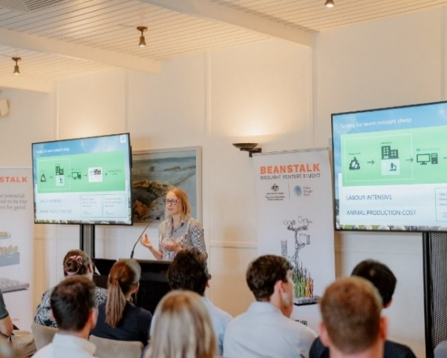

Drought Resilience Innovation Grants
The Drought Resilience Innovation Grants program has supported projects to test, and drive, the development and adoption of innovative technologies and practices to improve the drought resilience of Australian farmers and agriculture-dependent communities.
To help cater for projects and ideas at different stages of development 3 grant types were available:
- Ideas Grants – providing $45,000 for 12 months to help develop early-stage proposals.
- Proof-of-Concept Grants – providing up to $120,000 for 12 months to test the feasibility of innovative products, processes and services.
- Innovation Grants – providing between $300,000 and $1.1 million per year for up to 3 years for large-scale innovation projects.

Program highlights
Key highlights and achievements of the Drought Resilience Innovation Grants program include:
- All 15 Innovation Grants projects were completed by 30 June 2025.
- Project activities, including extension activities, trials and demonstration sites, were delivered across every state and territory.
- The projects established partnerships with farmers, grower groups, industry consultants and advisors, Landcare networks, universities and research institutions and state governments to share learnings and information.
- A diverse range of themes and topics were explored to help build drought resilience including focus on behavioural science, community resilience, agtech and digital decision support tools, native crops, crop insurance, irrigation, and water management.

Program update
All 15 Innovation Grants projects, including 7 that received extensions, were completed by 30 June 2025.
Innovation Grant projects focused activities such as utilising irrigation technology to trial aerobic rice, farm dam enhancement and design solutions, the use of deep-rooted legumes to reduce the impacts of drought, and the improvement of online decision support tools to help inform drought resilient crop management practices.
A comprehensive end of program evaluation will be undertaken to explore the outcomes of the program. Innovation remains a key point of focus for the FDF and the lessons learned from these projects will be used to inform the new Innovation Challenges Pilot program, which will be launched in 2025–26.

Case study 13 Deakin University trials aerobic rice in the Murrumbidgee
Funding under the Drought Resilience Innovation Grants program has enabled Deakin University to trial the use of irrigation management technology to grow aerobic rice in the NSW Murrumbidgee region.
Using low-cost irrigation automation technology, the research team trialled aerobic rice against traditionally managed (ponded) rice across 2 growing seasons.
Irrigation automation technology, including automated outlets and Wi-Fi floats, were used to trigger the opening and closing of irrigation outlets, reducing labour and improving water management. Photo 6 shows rice harvesting at the trial site near Widgelli.
These trials demonstrated that, when irrigation is managed appropriately, aerobic rice can match the high grain yields of ponded rice, whilst reducing water consumption by 15% to 20%. This has previously been deemed unachievable due to the high cost of labour associated with frequent irrigation.
The positive results from the trials have piqued interest, with over 200 people visiting the sites across the life of the project. Lucerne growers were particularly interested in how they could also apply the low-cost irrigation automation technologies being demonstrated in this project in their own industry.
This project has demonstrated that aerobic rice is clearly an effective strategy for improving drought resilience for Australian rice growers and their communities, with the potential for expansion to other industries.
Photo 6 Rice harvest at the trial site near Widgelli, NSW
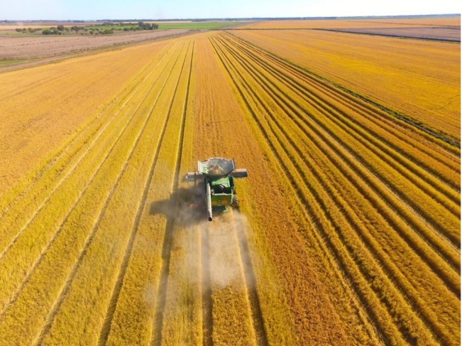
Source: Deakin University

Measuring progress and knowledge sharing
The government has committed to measuring outcomes and sharing the impact of addressing our drought and climate risks.

Monitoring, evaluation and learning

Strategy and framework
A monitoring, evaluation and learning (MEL) strategy is being implemented, in line with Productivity Commission recommendations 3.2 and 5.1. The strategy focuses on strengthening MEL and ensuring these activities are fit for purpose. To support this, the FDF has prioritised embedding sound evaluation principles and practices, and fostering a culture that supports continuous learning about what works, why, and for whom.
A new FDF MEL Framework (2024 to 2028) is being developed. It aligns with the Drought Resilience Funding Plan, Investment Strategy, and the Commonwealth Evaluation Policy. It also ensures MEL is culturally informed and safe, aligning with the Australian Evaluation Society First Nations Cultural Safety Framework and the Indigenous Evaluation Strategy.
The framework draws on input from users and lessons from implementing the 2020 to 2024 MEL Framework. It also uses findings from FDF programs to date, and from the Productivity Commission inquiry. The framework will outline ways to monitor and evaluate the efficiency and effectiveness of the FDF and its programs in achieving the funding plan’s strategic objectives of social, economic and environmental resilience.
Systems thinking, including social-ecological resilience principles, underpins the framework and Theory of Change (ToC). Key elements of this approach are:
- monitoring of outcomes from program linkages and evaluating these outcomes against the ToC
- recognising the FDF’s role within the broader resilience and sustainability context
- introducing MEL principles that focus on purpose and learning, with flexible processes that adapt to the changing nature of the FDF, drought and climate challenges
- applying the ‘levers for change’ to deliver outcomes and achieve change
- targeting improvement across 5 key areas, important for sustainability and resilience: natural, physical, financial, human and social (the 5 capitals)
- embracing failure as an opportunity for learning and adaptation.

Program evaluations
Independent evaluators completed assessments of the CSA, FBR, and RDRP programs in 2024−25. The insights and recommendations of these are informing the design of the new phases of these programs. Further evaluations of the FDF and its programs are planned over the next 3 years.

Building capacity across the FDF
MEL capacity and capability building is in place across the FDF. Activities include an FDF MEL Community of Practice (CoP), formal MEL training opportunities and mentoring through on the job learning. The MEL CoP provides a space for members to connect and share ideas on all aspects of MEL. This includes expert presentations on topics such as resilience, sustainability and climate change, with a focus on their relevance to MEL. These efforts are helping to build a strong MEL system and evaluative culture within the FDF.

Knowledge management
In 2024–25 the FDF began planning a new knowledge management solution for the FDF. This work included partnering with ICT and digital expertise within the department and engaging with the Digital Transformation Agency. The FDF also undertook user research to identify problems as well as key design features to improve knowledge sharing and program management.
Consistent with Productivity Commission recommendations 3.1 and 3.4, the knowledge management solution aims to ensure that data, information, and knowledge generated from FDF investments is collected, stored and shared in ways that deliver the most value. This will help drive adoption of drought and climate resilient technologies and practices. The project is expected to simplify and centralise information management, apply quality standards. The project will pilot a searchable public interface to make drought resilience knowledge more accessible. These improvements will allow the FDF to answer questions from stakeholders about FDF programs and projects that are currently difficult to address. This work is supported by $7.35 million of FDF funding, until June 2028.
The design of the knowledge management solution will be informed by our work on the FDF’s broader knowledge strategy. This strategy will describe our role in working with drought resilience knowledge and in the wider knowledge landscape. Development of the strategy is proceeding in consultation with people across government, industry and community, including First Nations knowledge custodians.

Science to Practice 2.0
The Science to Practice 2.0 program (S2P 2.0) builds on the success of the former Science to Practice Forum, held annually from 2021 to 2023. This event was designed to bring together key stakeholders across the spectrum of researchers, practitioners, farmers, agri-businesses, governments, trusted agricultural advisors and end users, to build awareness of the FDF and increase engagement. In its new iteration, S2P 2.0 is part of the FDF Measuring progress and knowledge sharing theme.
Consistent with Productivity Commission recommendation 3.4, S2P 2.0 builds on the FDF’s existing body of impact stories by creating content to demonstrate the intersection of program outcomes, FDF themes, regional motifs, and industry and commodity sector priorities and opportunities. Content is disseminated through various channels, including social media, agriculture.gov.au and FDF delivery partners. This strategy aligns with the FDF model of regional and place-based program delivery and knowledge sharing and will help contribute to building awareness of and engagement with the Fund on the ground. Photo 7 shows the behind the scenes of S2P filming with the TNQ Hub.
Photo 7 Science to Practice 2.0 filming with TNQ Hub
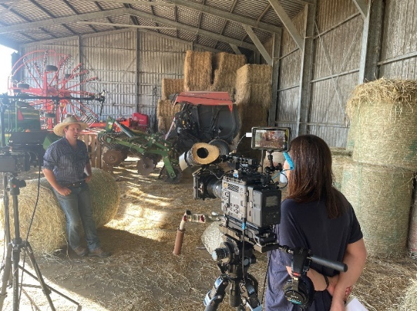
S2P 2.0 aims to position the FDF as a key contributor to Australia’s drought and climate resilience efforts. By investing in programs that empower farmers and regional communities to make informed decisions, adopt best practices, and take a proactive approach to drought preparedness, the FDF translates national drought policy into tangible regional and local impact. Working closely with stakeholders on the ground, the FDF contributes to strengthening production systems and communities and supports a more sustainable and adaptive future for Australian agriculture.
To learn about the 4 case study videos delivered, these are available on the FDF Case Studies page. A case study database has also been built to ensure delivery-partner case studies are stored and promoted, contributing to the knowledge-sharing capacity of the FDF. Photo 8 shows members of the FDF and the SQNNSW Hub during case study filming in April 2025.
Photo 8 Science to Practice 2.0 filming with SQNNSW Hub
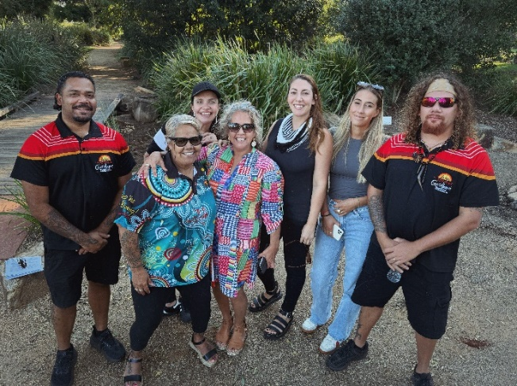
Members of the FDF and SQNNSW Hub (left to right): Jamahl McCarthy, Elizabeth Adams, Shannon Wilson-McClinton, Dr Raelene Ward, Katie Johnston, Liv Coles, William Haupt

United Nations Convention to Combat Desertification
In December 2024, 2 delegates from the FDF attended the 16th session of the Conference of the Parties (COP16) of the United Nations Convention to Combat Desertification (UNCCD), which took place in Riyadh, Saudi Arabia, from 2 to 13 December 2024.
Attending COP16 allowed the department to defend Australia’s agricultural interests, promote Australian innovation and trade opportunities, showcase the significant work of the FDF, and meet international obligations and expectations.
Many anticipated that a decision on drought would be a key outcome at this COP. However, despite 2 weeks of intense negotiations, delegates were unable to agree on whether to negotiate a framework or a legally binding protocol for addressing drought worldwide.
Nevertheless, COP16 laid the groundwork for increased global collaboration on drought – the Riyadh Global Drought Resilience Partnership was launched with USD 12.15 billion in pledges to promote drought-resilience activities for vulnerable countries.
Thirty-nine decisions were also agreed by consensus, including an 8% increase to the convention’s budget and the establishment of a new caucus for Indigenous peoples and another for local communities.
The Australian Government has since provided seed funding to support the Indigenous Peoples Caucus and ensure First Nations voices are embedded in UNCCD discussions on sustainable agriculture, drought resilience, water security and food systems.
Attendance at COP16 by FDF delegates was not funded through the FDF Special Account.

Administration and governance

Future Drought Fund Consultative Committee
During 2024–25, the FDF Consultative Committee – Brent Finlay (Chair), Bronwyn Harch, Lucinda Corrigan, Joshua Gilbert and Ashley Herbert – convened 6 times. Priorities of these meetings included reviewing the FDF program progress, ensuring alignment of programs with the Drought Resilience Funding Plan, and prioritising agricultural sustainability initiatives, including climate action, First Nations engagement and strengthening farmer connections. The committee also focused on emphasising goals such as enhancing MEL practices, deepening First Nations engagement and improving data management.
In July 2024, the FDF Consultative Committee and the Hubs Advisory Committee held their third joint meeting, in Canberra. While each committee has its own work program, they meet annually to discuss the Hubs program.
Highlights from this meeting included:
- National collaboration – The committees noted the collaborative nature of the hubs, which are now working as a collective national network. This represents a significant maturing in their relationships since establishment in 2021.
- Independent Review – Attendees welcomed the forthcoming independent review of the hubs, as an opportunity to improve performance of the hubs as a key FDF investment to increase the drought resilience of farmers and regional communities.
- First Nations engagement – The committees acknowledged the priority accorded to First Nations engagement by all hubs and commended their efforts to strengthen approaches.
Photo 9 shows members of the FDF Consultative Committee when they met in Canberra.
Photo 9 Future Drought Fund Consultative Committee, November 2024.
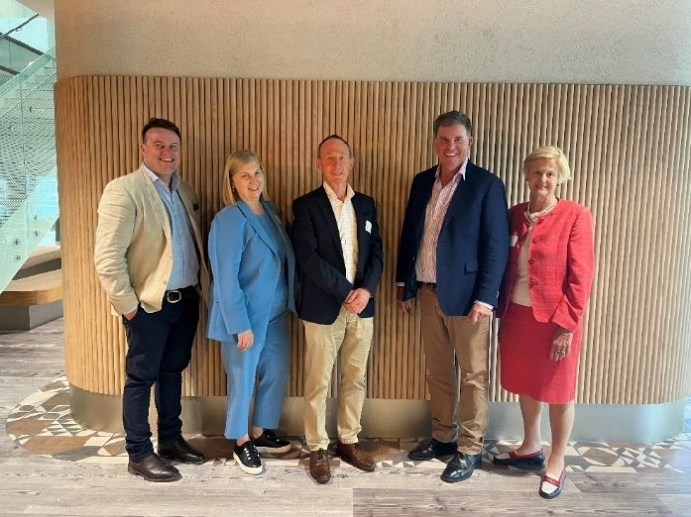
FDF Consultative Committee (left to right): Joshua Gilbert, Bronwyn Harch, Ashley Herbert, Brent Finaly (Chair), Lucinda Corrigan
Photo: Kylie Crimmins, Department of Agriculture, Fisheries and Forestry

First Nations Advisory Group
Aboriginal and Torres Strait Islander peoples have been caring for lands, waters and seas for tens of thousands of years, and continue to hold and develop highly valuable Indigenous knowledge. This knowledge, with the agreement and recognition of First Nations people, can add to the range of tools available to improve the sustainability of the Australian agricultural sector, landscapes and communities – for the benefit of all.
The FDF’s First Nations Advisory Group was established in January 2025 to provide culturally informed guidance on FDF drought and climate change resilience initiatives that involve or impact First Nations communities. This achieved the department’s commitments to Closing the Gap in bringing First Nations voices and perspectives to the forefront, and is consistent with Productivity Commission recommendation 6.1. Six eminent individuals – Ian Hamm (Chair), Emma Lee OAM, Michael O’Keeffe, Natalie Sommerville, Oscar Colbung and Suzanne Thompson – were engaged for their skills and expertise in areas such as environmental, social and economic initiatives, including drought and climate resilience. Photo 10 shows the members of the advisory group when they met in Canberra.
Photo 10 Future Drought Fund First Nations Advisory Group, January 2025
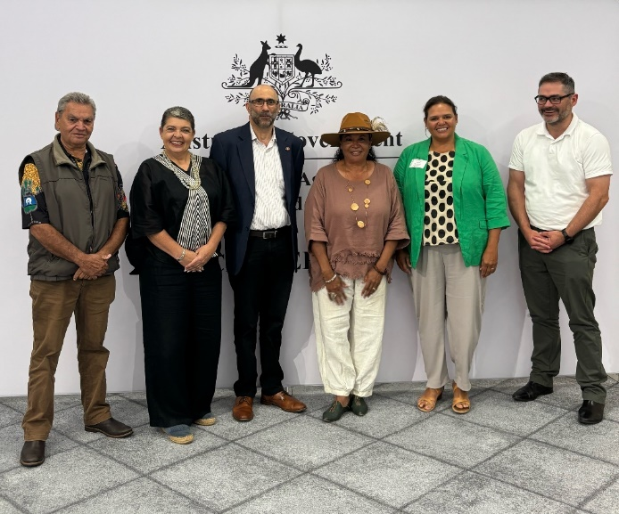
Left to right: Oscar Colbung, Emma Lee OAM, Ian Hamm (Chair), Suzanne Thompson, Natalie Sommerville and Michael O’Keeffe
Photo: Zara McCall, Department of Agriculture, Fisheries and Forestry
In its first 6 months, the advisory group published its Terms of Reference and finalised its work plan. It also provided strategic advice, including on:
- development of the Strengthening Drought Resilience on Country program
- activities to support First Nations individuals, businesses and organisations to access FDF programs
- FDF design of First Nations-focused market research
- development of the new FDF MEL Framework, and development of the Grant Opportunity Guidelines for the Innovation Challenges program.
The advisory group’s work will be complemented by direct engagement with First Nations communities on the ground, ensuring lived experience and local knowledge inform the advisory group’s advice to the FDF.

Funding
As part of the 2024–25 Budget, the government allocated a further $519.1 million over 8 years for the FDF to continue funding, extend and refine existing programs, and develop new initiatives. In 2024–25, $29,010,996 was spent from the FDF. Table 1 shows the allocation of funds across the FDF programs from 2024 to 2028, as well as the amount spent in 2024–25.
Table 1 Funding allocation, 30 June 2025
Programs | Total allocated 2024 to 2032 ($) | Total spent 2024–25 ($)
Drought Resilience Adoption and Innovation Hubs | 132,000,000 | 16,000,000
Communities Program | 36,000,000 | 11,000,000
Regional Drought Resilience Planning | 67,000,000 | 0
Strengthening Drought Resilience on Country | 12,000,000 | 0
First Nations Supporting Activities | 3,000,000 | 0
Farm Business Resilience | 80,000,000 | 0
Farm Business Resilience program (Scholarships component) | 3,200,000 | 800,000
Climate Services for Agriculture | 17,200,000 | 4,800,000
Scaling Success | 37,000,000 | 0
Innovation Challenges Program | 20,000,000 | 0
Resilient Landscapes | 40,000,000 | 1,113,427
Long-term Trials of Drought Resilient Practices | 60,315,000 | 0
Monitoring, evaluation and learning | 3,250,000 | 0
Knowledge sharing and Science to Practice 2.0 | 8,150,000 | 97,568.90
Total | 519,115,001 | 29,010,995.90
Note: The Drought Resilience Commercialisation Initiative and Extension and Adoption of Drought Resilience Farming Practices programs mentioned in this report were funded under the Drought Resilience Funding Plan (2020-2024).

References
Coalition of Peaks 2020, National Agreement on Closing the Gap, National Indigenous Australians Agency, Canberra, accessed 17 October 2025.
Productivity Commission 2023, Review of Part 3 of the Future Drought Fund Act: Inquiry report no. 102, Canberra, September, accessed 26 October 2025.

