Future Drought Fund Annual Report 2020−21
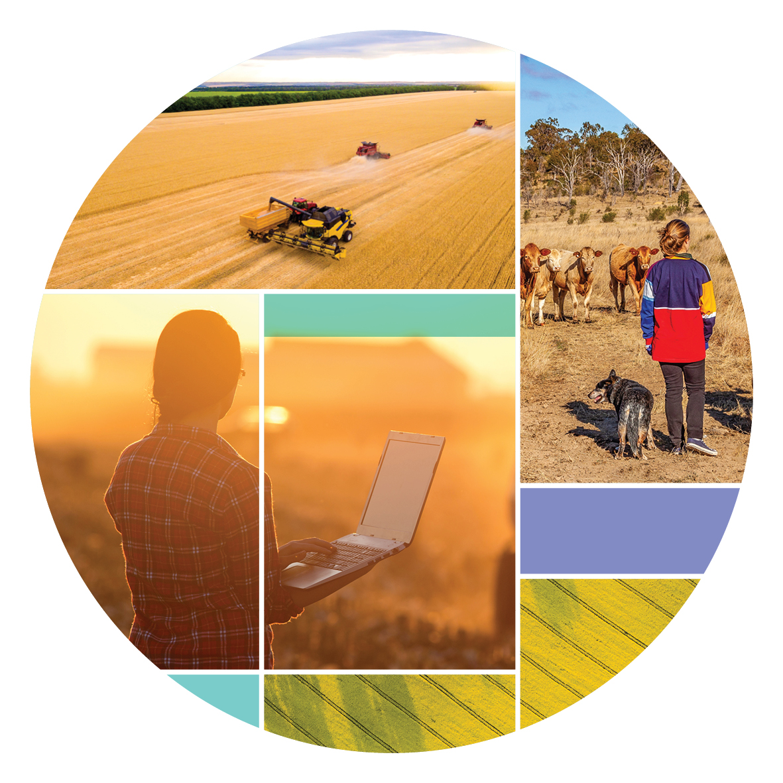
© Commonwealth of Australia 2021
Ownership of intellectual property rights
Unless otherwise noted, copyright (and any other intellectual property rights) in this publication is owned by the Commonwealth of Australia (referred to as the Commonwealth).
Creative Commons licence
All material in this publication is licensed under a Creative Commons Attribution 4.0 International Licence except content supplied by third parties, logos and the Commonwealth Coat of Arms.
Inquiries about the licence and any use of this document should be emailed to copyright@awe.gov.au.

Cataloguing data
This publication (and any material sourced from it) should be attributed as: DAWE 2021, Future Drought Fund Annual Report 2020–21, Department of Agriculture, Water and the Environment, Canberra, October 2021 CC BY 4.0..
ISBN 978-1-76003-473-3
This publication is available at awe.gov.au/publications.
Department of Agriculture, Water and the Environment
GPO Box 858 Canberra ACT 2601
Telephone 1800 900 090
Web awe.gov.au
Contact Us
Email droughtresilience@agriculture.gov.au
Web haveyoursay.awe.gov.au/future-drought-fund
Disclaimer
The Australian Government acting through the Department of Agriculture, Water and the Environment has exercised due care and skill in preparing and compiling the information and data in this publication. Notwithstanding, the Department of Agriculture, Water and the Environment, its employees and advisers disclaim all liability, including liability for negligence and for any loss, damage, injury, expense or cost incurred by any person as a result of accessing, using or relying on any of the information or data in this publication to the maximum extent permitted by law.
Acknowledgements
The authors thank interview and survey participants for their input.

Minister’s message
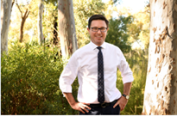
I’m pleased to present the inaugural Future Drought Fund Annual Report covering the year 2020–21 – the first year of the fund’s operation.
The Future Drought Fund was announced by the Australian Government in October 2018 to provide an investment of $100 million each year from 2020 onwards to build drought resilience in regional Australia. And we have got on with the job.
The Act was passed, a consultative committee was established to consult across Australia to develop a 4-year plan and eight foundational programs were announced.
This report demonstrates the great progress we have made to build strong foundations in our first year of work.
- We’ve established 8 Drought Resilience Adoption and Innovation Hubs across Australia to drive regionally focused efforts to develop, extend, adopt and commercialise drought resilient practices and technologies. With the Hub nodes we have over 40 locations to work with farmers and communities across Australia and listen to their priorities.
- We’ve worked with state and territory governments to establish tailored programs to deliver training to farmers on risk planning, and to develop local led community plans to manage drought risks.
- We’ve released the first prototypes of online tools to make climate risk and resilience information more accessible and useful for farmers, agricultural businesses and communities so they can better understand drought and other climate risks.
- We’ve partnered with the Australian Rural Leadership Foundation and the Foundation for Rural and Regional Renewal to establish programs to bolster the role community organisations, networks, leaders and mentors play in driving action to get better prepared for drought, and to support people in times of drought.
- We have 80 on-ground projects underway to trial and support adoption of land management practices that can lessen the effects of drought on agricultural productivity.
We’ve learnt from these programs and listened to feedback along the way. This has informed a second round of programs that was announced in the 2021-22 Budget. We’ll continue to take this iterative approach to the Future Drought Fund – listening, learning and adapting as we go. Annual reports such as this one is a key part of that cycle.
The Future Drought Fund is an important part of the Government’s Drought Response, Resilience and Preparedness Plan to deliver the support Australian farmers and communities need to be sustainable and productive.


The Hon David Littleproud MP
Minister for Agriculture and Northern Australia

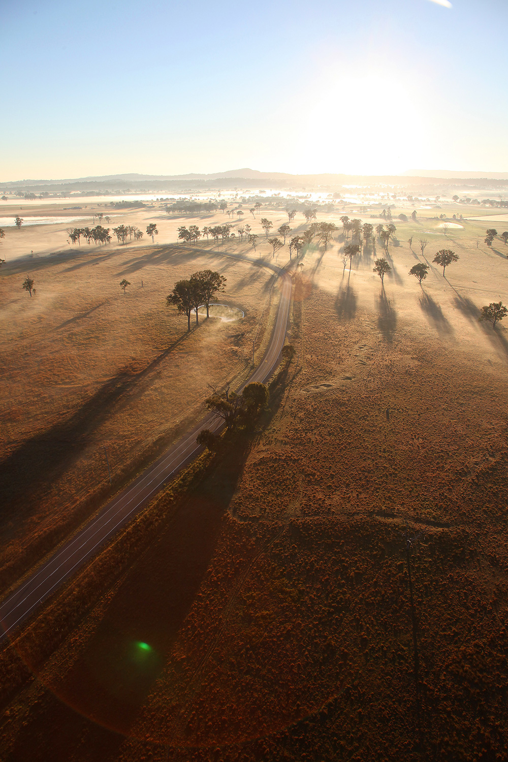

Message from the Future Drought Fund Consultative Committee Chair
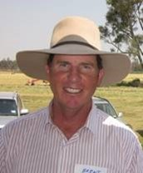
Financial year 2020–21 has been an exciting one for the Future Drought Fund – a chance to start to put plans into action and build the foundations for the fund.
The Future Drought Fund has moved steadily, but rapidly, since its beginning. It’s now 2 years ago – 1 September 2019 – that the Future Drought Fund Act 2019 took effect and the fund came into being. A lot has been done in this time.
- The Future Drought Fund Consultative Committee was formed, and we’ve met 30 times since our formation, to provide independent expertise to guide the use of the fund.
- The committee consulted broadly, right around Australia, hearing ideas from more than 690 people about what we should do to help Australian agriculture get better prepared for inevitable future droughts.
- We developed the Drought Resilience Funding Plan 2020–2024, setting out objectives and actions to guide spending from the Future Drought Fund over the next 4 years.
- A first round of programs was announced on 1 July 2020, as soon as the first allocation of funding became available. We’ve maintained an active role in overseeing the rollout of these programs to ensure they remain consistent with the Funding Plan.
- Those programs were rapidly rolled out, starting the long task of building drought resilience and, just as importantly, generating engagement, momentum and collaboration around the important issue of drought resilience.
Added to these foundations, we’ve set up arrangements to properly administer the Future Drought Fund and its programs. These provide critical underpinnings for long-term success. This includes a monitoring, evaluation and learning framework, because regular review, reporting and, if needed, adjustment is critical. So too is continued regular engagement with stakeholders to get their views on how things are going and what we should be thinking about for the future.
This annual report supports both of these things. It’s a central part of how we’ll regularly communicate about what we’re doing and whether it’s working. It will support discussions with stakeholders about what we should do next.
This is so important because the Future Drought Fund is for everybody involved in Australian agriculture, and we need your regular input to ensure we get it right.

Brent Finlay
Chair
Future Drought Fund Consultative Committee

Contents
Minister’s message iii
Message from the Future Drought Fund Consultative Committee Chair vi
About this report x
What’s not in this report? x
About the Future Drought Fund 11
Future Drought Fund programs 12
Harnessing innovation 14
Drought Resilience Research and Adoption program 14
Drought Resilience Adoption and Innovation Hubs 15
Drought Resilience Innovation Grants 17
Drought Resilience Research and Adoption Investment Plan 18
Science to Practice forum 18
Better risk management 20
Farm Business Resilience Program 20
Regional Drought Resilience Planning 23
Better climate information 26
Climate Services for Agriculture; Drought Resilience Self-Assessment Tool 26
More resilient communities 31
Networks to Build Drought Resilience; Drought Resilience Leaders 31
Better land management 34
Natural Resource Management Drought Resilience Program 34
Progress in building drought resilience 37
Future Drought Fund administration 39
Allocation and spending of funding to date 41
2020–21 funding 41
Future year funding 43
Monitoring, evaluation and learning 44
Consultation and engagement 45
Appendix A: Potential measures of drought resilience 46
Glossary 50
References 51

Tables
Table 1 Overview of Future Drought Fund programs 13
Table 2 Annual reporting on progress and performance 14
Table 3 Annual reporting on progress and performance 230
Table 4 Annual reporting on progress and performance ……………………………………………………… 23
Table 5 Pilot regions 24
Table 6 Annual reporting on progress and performance 26
Table 7 Annual reporting on progress and performance 31
Table 8 Locations of Drought Resilience Leaders Development pilot program 33
Table 9 Annual reporting on progress and performance 34
Table 10 Measuring changes in drought resilience 37
Table 11 FDF funding allocated, contracted and expensed, 2020–21 42
Table 12 FDF future funding 433

Table A1 Potential measures identified 46

Figures
Figure 1 Future Drought Fund themes 12

Maps
Map 1 Hubs and nodes 17
Map 2 Pilot regions indicative boundaries 30

About this report
Regular review and reporting is critical to the delivery of any program. This is particularly true for the delivery of an ambitious and enduring investment such as the Future Drought Fund.
This annual report is a part of the regular review and reporting arrangements in place for the Future Drought Fund. As well as providing an explanation of what has been achieved, it provides a framework for reporting on performance. This includes setting out and reporting against criteria and indicators for measuring and tracking success.
As the first annual report for the Future Drought Fund, this report has a focus on establishing a robust framework for measuring and reporting on performance. Future reports will increasingly focus on putting that framework into operation, as programs begin to deliver results and reach scheduled evaluation points.
This high-level reporting framework is complemented by detailed monitoring, evaluation and learning plans for each program. They contain more detailed arrangements for tracking and measuring success.
Annual reports are envisaged as a central part of an annual cycle for the Future Drought Fund. Following publication of the report, a submission and consultation process will be undertaken. This will provide an opportunity for stakeholders to share their views on performance and their ideas for what should be done into the future. Among other things, this will inform reporting to government as part of the annual federal budget process, including consideration of the allocation of Future Drought Fund funding.

What’s not in this report?
This annual report provides a whole of Future Drought Fund view across the multiple programs and activities underway. This includes a high-level framework for measuring and reporting success across the fund. The report does not cover the more detailed monitoring, evaluation and learning arrangements in place for each individual program.
This annual report covers drought resilience programs funded from the Future Drought Fund. It does not cover, in detail, the performance of the fund itself, – that is, the $5 billion invested by the Future Fund Board of Guardians. A $100 million is made available from the fund each year for spending on drought resilience. The Future Fund Board of Guardians reports annually on the investment performance of funds under its management.

About the Future Drought Fund
The Future Drought Fund is the key investment by the Australian Government to build drought resilience in Australia’s agriculture sector, the agricultural landscape, and communities. It is a $5 billion commitment with $100 million each year allocated to drought resilience programs.
Design of programs is guided by the 4-year Drought Resilience Funding Plan 2020–2024.
The government has already allocated $318.5 million to 2023–24.

Vision
The vision of the Future Drought Fund is an innovative and profitable farming sector, a sustainable natural environment and adaptable, rural, regional and remote communities – all with increased resilience to the impacts of drought and climate change.
Strategic priorities
The Future Drought Fund has 3 interconnected strategic priorities:
- Economic resilience for an innovative and profitable agriculture sector
- Environmental resilience for sustainable and improved functioning of farming landscapes
- Social resilience for resourceful and adaptable communities.
Objectives
To achieve the strategic priorities, the Future Drought Fund will enhance the public good by building drought resilience through programs that will achieve 3 objectives:
- Grow the self-reliance and performance (productivity and profitability) of the agricultural sector
- Improve the natural capital of agricultural landscapes for better environmental outcomes
- Strengthen the wellbeing and social capital of rural, regional and remote communities.

Future Drought Fund programs
The programs underway (shown in Table 1) funded from the Future Drought Fund are structured around the 5 themes shown in Figure 1 and contribute to the 3 strategic objectives of economic, environmental and social resilience to drought.
This report, in order:
- reports against each of the 5 themes, including activities, achievements, and performance reporting
- sets out a framework for how we will measure progress against the 3 strategic objectives of economic, environmental and social resilience to drought
- reports on the administration of the Future Drought Fund, including the expenditure of funds and the operations of the Future Drought Fund Consultative Committee.
Figure 1 Future Drought Fund themes
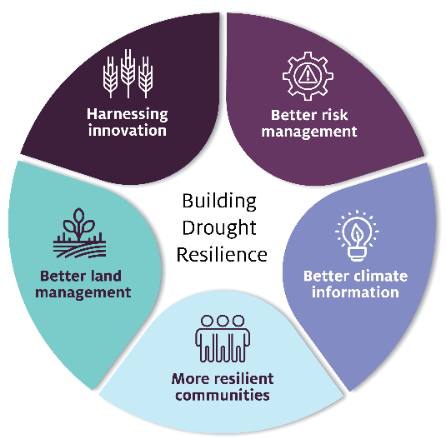
Harnessing innovation – driving adoption of new drought resilient technologies and practices
Better risk management – helping farmers and regions plan for drought
Better climate information – making climate information accessible and useful
More resilient communities – building social capital to drive change and support resilient communities
Better land management – trial and adoption of land management practices that support landscape resilience
Table 1 Overview of Future Drought Fund programs
Themes | Program | Program overview | Funding to 2023−24  ($’000) | Economic | Environmental | Social
Harnessing innovation | Drought Resilience Research and Adoption Program | Investing in collaborative research, development, extension and adoption and commercialisation activities | 121,053 | yes | yes | yes
Better risk management | Farm Business Resilience Program | Supporting learning and development for famers in strategic business management, farm risk management, natural resource management and personal and social resilience | 75,965 | yes | yes | yes
Better risk management | Regional Drought Resilience Planning | Supporting regions to develop drought resilience plans | 40,853 | yes | yes | yes
Better climate information | Climate Services for Agriculture | Delivering an interactive digital platform, bringing together a variety of climate information specifically for farmers and the agricultural sector | 15,000 | yes | yes | yes
Better climate information | Drought Resilience Self-Assessment Tool (DRSAT) | Delivering an online tool that will enable farmers to assess their exposure to drought and other climate risks | 10,000 | yes | yes | yes
More resilient communities | Networks to Build Drought Resilience | Building capacity and capability of community organisations to support drought preparedness | 7,750 |  |  | yes
More resilient communities | Drought Resilience Leaders | Enabling leaders to support their communities to meet the future challenges arising from drought and changing climate | 11,450 | yes | yes | yes
Better land management | NRM Drought Resilience  Drought Resilient Agricultural Landscapes | Trialling and adopting transformational on-ground practices, approaches and systems to mitigate the future effects on a region’s agriculture and broader landscapes | 36,429 | yes | yes
Total |  |  | 318,500

Harnessing innovation
Driving the development and adoption of new drought resilient technologies and practices

Drought Resilience Research and Adoption program
Objectives | Program information
The strategy | Drive the development, extension, adoption and commercialisation of new drought resilient technologies and practices, including through new Drought Resilience Adoption and Innovation Hubs
What are we trying to achieve? | A step-change in the development, adoption and commercialisation of drought resilience technologies and practices
How will this support drought resilience? | Uptake of new technologies and practices can reduce exposure to drought risks, enabling agricultural businesses to sustain productivity and profitability in times of drought
How will we assess whether it’s successful? | Overall success measures  - There’s an increase in availability and accessibility of, and capacity to use and adopt, knowledge that can be applied to improve drought resilience (HI 1)  - There’s increased adoption and commercialisation of drought resilience technologies and practices (HI 2)  - The technologies and practices adopted are effective in improving drought resilience (HI 3)  - Design and delivery of hub activities is responsive to end-user needs (HI 4)
Table 2 Annual reporting on progress and performance
2020–21 results | 2021–22 | 2022–23 | 2023–24
8 Drought Resilience Adoption and Innovation Hubs established  Inaugural Science to Practice forum held | (HI 1) Drought Resilience Research and Adoption Investment Plan delivered  (HI 4) Hub partnership arrangements are embedded, and co-designed activity plans in place  (HI 1, HI 2) Number and nature of activities to support research, development, extension, adoption and commercialisation (RDEA&C) and uptake by end users  (HI 1) Attendance at annual Science to Practice forum (SPF) | (HI 1) Hub linkages in the innovation system  (HI 2, HI 3, HI 4) Uptake of the Drought Resilience Research and Adoption Investment Plan priorities by hubs and research organisations  (HI 1) Improvement in end-user access to DEA&C information  (HI 1, HI 2) Number of activities to support RDEA&C uptake by end users  Attendance at SPF (HI 1)  (All measures) Reporting on mid-program evaluation | (All measures) As in 2022–23 – activities to support DEA&C  (HI 2, HI 3, HI 4) Case studies of uptake by end users  (HI 4) Number of partnerships developed to support RDEA&C  (HI 1) Attendance at SPF  (HI2, HI3) End-of-program evaluation - extent to which there is increased adoption of drought resilience technologies and practices and evidence that these are effective in improving drought resilience.
The Drought Resilience Research and Adoption program is helping farmers and rural and regional communities build drought resilience through investment into collaborative research, development, extension, adoption and commercialisation (RDEA&C) activities.
The program has the following interconnected elements:
- Drought Resilience Adoption and Innovation Hubs around Australia to provide RDEA&C support that is responsive to regional needs and opportunities
- Innovation grants to support RDEA&C projects (grants available in 2021–22)
- On-ground adoption officers to facilitate uptake by farmers and agribusinesses of services and activities provided by the hubs (funding from 2021–22)
- Enabling activities that inform and connect RDEA&C activities:
  - a Drought Resilience Research and Adoption Investment Plan to identify the highest national drought RDEA&C priorities (to be published in 2021–22)
  - a knowledge platform to capture and share drought resilience knowledge
  - annual Science to Practice forums to support dissemination and uptake of innovative practices.

Drought Resilience Adoption and Innovation Hubs
In April 2021, 8 hubs were selected following a competitive grants process.
The hubs are located in major climatic and agriculture zones across Australia. Each hub has several nodes, providing a dispersed presence throughout the region. Currently the hubs and nodes cover over 40 locations, and involve 143 partners.
Hubs will support primary producers in building drought resilience through practical development, extension, adoption and commercialisation services. These services will meet needs specific to primary producers in each hub region.
For example, hub activities will include:
- on-farm trials of drought resilient practices
- training in the use of decision-support tools such as soil moisture predictors and climate forecasting
- training packages to share Indigenous knowledge regarding drought
- educating researchers in effective co-design of research activities
- peer-to-peer learning among primary producers through workshops, farm visits, seminars and other collaborative networks
- upskilling primary producers in commercialisation opportunities and practices
- commercialising products and processes that increase drought resilience.
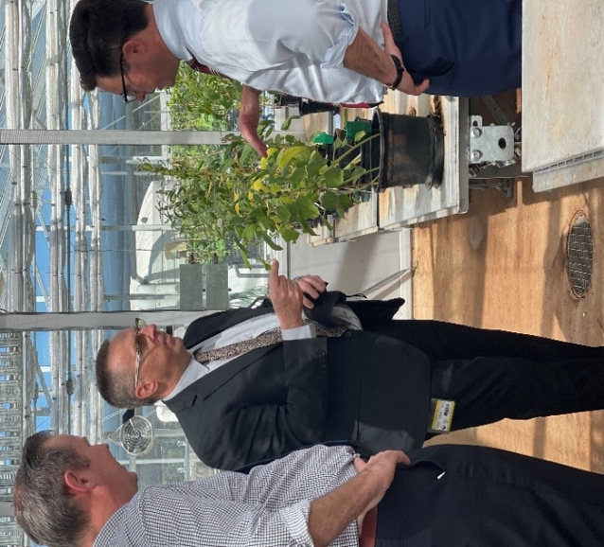
(L–R) Garth Hamilton MP, Professor Gavin Ash and Minister Littleproud at the Southern Queensland–Northern New South Wales Hub launch. Photo: Emma Anderson
The hubs were formally established (i.e. contracted) just before the end of the 2020–21 financial year. Their first task is to develop detailed activity plans, through co-design and participatory processes with stakeholders in their region. This is to ensure that hub activities are strongly responsive to the needs and opportunities of the region they service.
To support this initial planning, as well as ongoing engagement, each hub has a knowledge broker. Knowledge brokers help intended users of research and innovation to define the questions they need answered by science, then help to translate the science into practice. Knowledge brokers will also connect the hubs to other Future Drought Fund (FDF) programs to ensure there is information and capability flow across all FDF programs.
The 2021-22 Budget also allocated funding to enable hubs to employ adoption officers to connect people to the support available from their hub. A process to get adoption officers in place will be run in early 2022, once each hub completes its activity planning.
The department provides support and connections across the hubs. This includes building networks and communities of practice between the hubs to foster cross-hub collaboration.
Map 1 Hubs and nodes
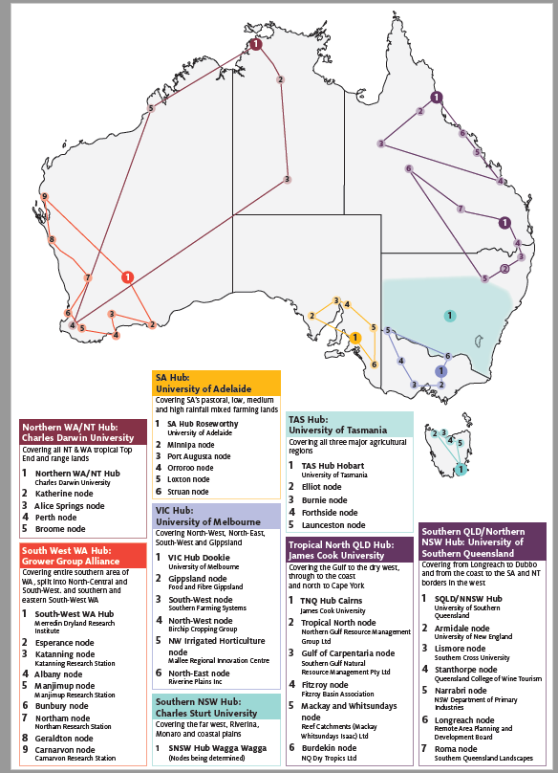
Drought Resilience Research and Adoption Advisory Committee
In May 2021 the Drought Resilience Research and Adoption Advisory Committee was established to support strategic oversight of the Drought Resilience Adoption and Innovation Hubs and the broader Drought Resilience Research and Adoption program. Among other things, the committee helps to provide a cross-hub, national perspective. It provides advice to the minister and the department.
The Advisory Committee is chaired by Mr Brent Finlay (also the Chair of the Future Drought Fund Consultative Committee), and the other members are Caroline Welsh (also a member of the Future Drought Fund Consultative Committee), Emeritus Professor James Rowe, Dale Park, Trent De Paoli and Dr Christine Pitt.

Drought Resilience Innovation Grants
Drought Resilience Innovation Grants will fund RDEA&C activities.
In the 2021-22 Budget, the government announced that funding allocated in 2020–21 as part of the first tranche of foundational FDF programs would be combined with funding in future years to support a larger and longer innovation grants process. There is now $34.1 million available over 2021 to 2023–24. A call for expressions of interest opened in July 2021.

Drought Resilience Research and Adoption Investment Plan
The Drought Resilience Research and Adoption Investment Plan will identify national priorities for drought resilience related research and adoption. The plan is intended to inform:
- the activities of the hubs
- entities undertaking research and development, such as rural research and development corporations, universities, and the Commonwealth Scientific and Industrial Research Organisation (CSIRO)
- potential future FDF investments.
In 2020–21 a consultative process was undertaken to inform the development of the plan. This included engagement with agricultural producers and communities through a survey, online workshops, private submissions, a stocktake of drought resilience research in Australia and a review of international literature on drought resilience.
This work was led by a consortium involving Alluvium Consulting, Natural Capital Economics, the Australian Farm Institute and Climate Communications.
The department will undertake further consultations in 2021–22 before finalising the plan in early 2022.

Science to Practice forum
Science to Practice forums showcase the activities of the Drought Resilience Research and Adoption program and, through this, support change and adoption
At the inaugural forum in June 2021, the 8 new Drought Resilience Adoption and Innovation Hubs presented their co-design priorities. In addition, presenters including farmers, economists and Indigenous knowledge holders explored the economic, environmental and social aspects of building drought resilience.
Across 3 days, more than 800 registrants engaged with more than 40 presentations, joining online or attending events across Australia. Participants spent an average of 10 hours online. There were more than 1,000 comments made in the online chat and more than 100 questions to presenters. Primary producers reported that they were able to address issues on their properties without missing presentations.
Planning is underway for the 2022 Science to Practice forum.

Forum feedback
‘It was absolutely fantastic that the entire event was online. I had urgent field work to attend to and was able to follow the presentations quite well’
‘The most valuable thing I learned [at the forum] was collaboration is possible between federal, state, regional and industry groups and landholders.’
Have Your Say survey respondents

Forum host Andrew Bell and First Assistant Secretary, Drought and Farm Resilience, Kerren Crosthwaite, in the Canberra studio. Photo: Lucy Morrell

Better risk management
Helping farmers and regions plan for drought
There are 2 programs under this theme:
- Farm Business Resilience Program
- Regional Drought Resilience Planning.

Farm Business Resilience Program
Objectives | Program information
The strategy | Build the capacity of farmers to plan for and manage risks, including drought
What are we trying to achieve? | A step-change in the use of farm business management skills to proactively manage drought risks
How will this support drought resilience? | Farmers who have better business management skills, and plan for risks, are more likely to take actions that help sustain farm business productivity and profitability in times of drought
How will we assess whether it’s successful? | Overall success measures  - There’s an increase in the business management skills and confidence of farmers to manage risk (RM 1)  - There’s an increase in farm business plans that consider drought risks (RM 2)  - More farmers are taking actions to manage risk, including drought (RM 3)
Table 3 Annual reporting on progress and performance
2020–21 results | 2021–22 | 2022–23 | 2023–24
All states and territories agreed to partner with the Commonwealth, and designed programs | (RM 1, RM 2) Number of participants, training and other learning events, and farm performance assessments  (RM 2) Number of farm business plans developed/updated and professionally reviewed  (All measures) Change in participant surveys and farm performance assessments  (RM 1, RM 3) Case studies selected for monitoring post participation | As for 2021–22, plus:  - (All measures) Monitoring of case studies  - (All measures) mid-program evaluation | As for 2021–22, plus:  - (All measures) final evaluation
Working with state and territory governments, the Farm Business Resilience Program is providing farmers, including farm managers and employees, with access to learning and development opportunities in strategic business management, farm risk management and decision-making, natural resource management, and personal and social resilience.
The program supports farmers to develop or update their existing farm business plan, tailored to their circumstances. Farmers also have access to one-on-one professional advice on the plan and its implementation.
In 2020–21 all states and territories agreed to partner with the Commonwealth to design and deliver the program. Within the context of a national framework, each state and territory has tailored its design and delivery for its local context, building on existing initiatives delivered via government and industry.
Stakeholder comments: National Farmers’ Federation
‘This [Farm Business Resilience] program will be crucial in building our farmers fundamental business and strategic planning skills with respect to resilience and preparedness …
‘It is pleasing to see federal and state governments working together and pooling resources to deliver resilience and preparedness measures to farmers …
‘These workshops will be a great opportunity for farmers to take their business to the next level from a risk management, resilience and preparedness perspective.’
Tony Mahar, Chief Executive Officer, National Farmers’ Federation
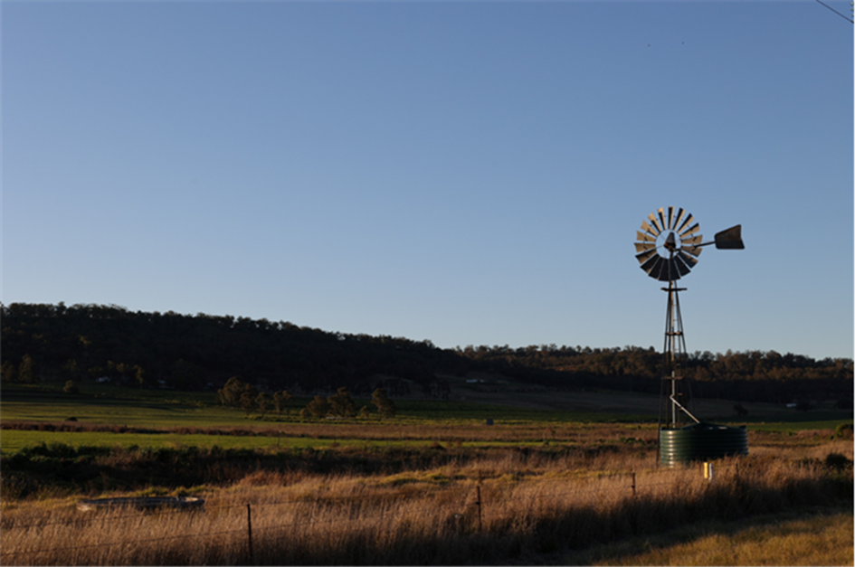In 2021–22 state and territory governments will start rolling out the program. The Commonwealth will also work with each jurisdiction to agree on the details of an extension to the program, announced in the 2021–22 Budget. The extended program allocates $60 million over the next 3 years. This aims to achieve change at a meaningful scale – reaching as many as 17,000 farmers and providing follow-up support for participants.

Case studies: Programs tailored to the needs of the regions receive positive feedback
In New South Wales, through the NSW Department of Primary Industries, farmers will be supported by expert business coaches to take a custom co-designed learning journey, in both a small-group setting and via extensive one-on-one coaching.
The competitive expressions of interest process, which closed on 31 August 2021, resulted in over 170 applications from farm businesses, of which 150 will be selected to participate in the program. This means that potentially 300 farmers will be coached, as most businesses will have at least 2 participants. Other public events will engage a further 3,000 farmers in skill-building activities such as webinars and farmer-led field days.
‘The feedback from farmers has been very positive to date,’ said NSW program manager Alex Hicks.
‘The farmers we have spoken with have all been really excited by the opportunity to utilise the coaching for capacity and skill building and the support to help take their business to the next level.’
In Victoria, Agriculture Victoria is piloting the program to farmers from the grains, red meat, and dairy industries, as well as all young farmers. Farmers will undertake peer-group and one-on-one learning, supported by Agriculture Victoria staff and a professional farm management consultant, through practical and interactive workshop sessions.
Dairy Australia is collaborating with Agriculture Victoria to build on and leverage its existing Our Farm, Our Plan program to pilot the dairy component of the program.
The program will support farmers to adapt to a changing climate and strengthen the resilience of their farm business to withstand future shocks and challenges. Sixty-three participants have been involved in the program delivery to date (1 September 2021).
One participant attending a ‘Successful People’ session commented that it was a ‘great event, was very happy with how it was presented, had some really quality speakers and I got a lot out of the discussions we had’.

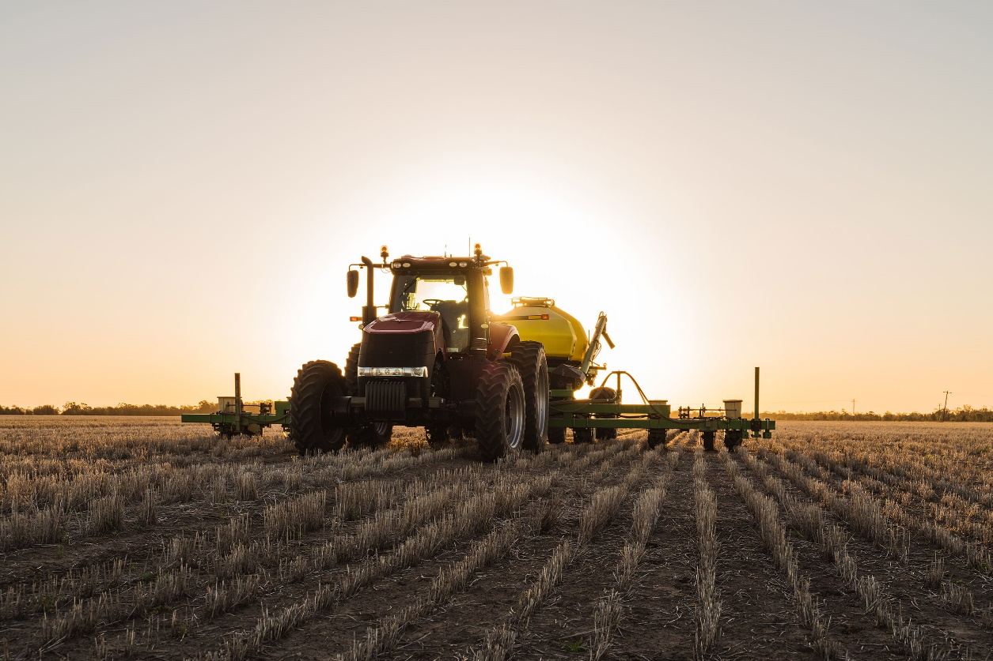

Regional Drought Resilience Planning
Objectives | Program information
The strategy | Establish drought resilience plans across agricultural regions, based on evidence and collaboration, to drive proactive management of drought risks
What are we trying to achieve? | Regional drought resilience plans drive decisions, actions and investments to proactively manage drought risks
How will this support drought resilience? | Informed and planned action to manage drought risks at a regional scale will support resilience of the region’s economy, farmers, businesses, communities, and the landscape
How will we assess whether it’s successful? | Overall success measures  - There’s an increase in the number of agricultural regions that have drought resilience plans (RM 4)  - Plans have buy-in from key stakeholders in the region (RM 5)  - Plans are informed by relevant data, co-design and best practice approaches to resilience planning (RM6)  - Plans are implemented (RM 7)
Table 4 Annual reporting on progress and performance
2020–21 results | 2021–22 | 2022–23 | 2023–24
All states and territories agreed to partner with the Commonwealth, and designed detailed programs | (RM 4, RM 6) Number of plans commenced developed, drafted, assessed, approved and published  (RM 5) Number and extent of stakeholder engagements in planning processes  (RM 5, RM 6, RM 7) Case studies selected for monitoring post-planning (e.g. stakeholder buy-in and implementation) | (All measures) As in 2021–22 – monitoring outputs, independent assessments, and implementation  (RM 4, RM 6) Extent to which plans identify and respond to key risks  (RM 5, RM 6) Extent to which stakeholders co-designed/partnered in planning (qualitative via independent assessments, surveys)  (RM 7) Number of plans implemented (grants or other means)  (All measures) Interim evaluation | (All measures) As in 2022–23 – monitoring outputs, surveys and/or independent assessments, implementation, and case studies  (All measures) End-of-program evaluation
Working with the state and territory governments, the Regional Drought Resilience Planning program is supporting regions to develop regional drought resilience plans to prepare for and manage future drought risks.
These plans will be community led and will be owned through partnerships of local governments, regional organisations, communities and industry. They will be independently assessed and published to allow communities to learn from each other, considering each region’s unique conditions – socially, economically and environmentally.
Regions will also partner with networks of primary producers and community groups through their local Drought Resilience Adoption and Innovation Hub to improve drought resilience.
From 2021–22, small grants will be available to take forward priority actions identified in regional plans.
The focus in 2020–21 was to seek agreement from all states and territories to partner with the Commonwealth and co-design tailored delivery arrangements in each jurisdiction. Planning activities are now getting underway in 23 regions.
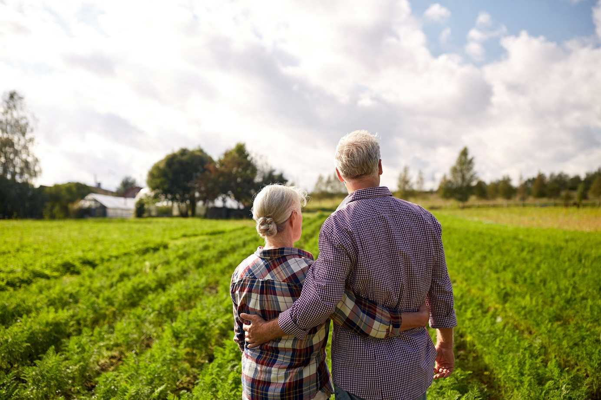
Table 5 Pilot regions
NSW | VIC | QLD | SA | WA | NT | TAS | ACT
3 regions | 3 regions | 5 regions | 3 regions | 3 regions | 2 regions | 3 regions | 1 region
Yet to be announced | Wimmera Southern Mallee Regional Partnership  Goulburn Regional Partnership and Gippsland Regional Partnership | Yet to be announced | Yet to be announced | Northern Midwest, Southern Wheatbelt and Great Southern Inland | Southern Alice Springs Pastoral District and Barkly Pastoral District | South, North, North-West | Whole of ACT
In 2021–22 this first round of regional plans will be developed. The Commonwealth will also work with each jurisdiction to agree on the details of an extension to the program. The extended program, announced in the 2021-22 Budget, has been allocated $31 million. It aims to establish regional drought resilience plans for all major agricultural regions. It will also provide some funding to help with the implementation of the regional plans.
Stakeholder comments: Red Cross and CSIRO
The Red Cross has been advocating for some time for more attention and resources to be directed towards building real capacity at community level for drought resilience planning and preparedness.
‘Through our recent Drought Discussion Paper, we found a widespread need for more practical community-based planning for drought Resilience, Relief and Recovery.
‘Drought has a variety of different types of impacts – hydrological, agricultural, economic as well as environmental, social, cultural, wellbeing and “psychosocial” – which affect each community and region very differently.
‘We have designed a community-led model that supports regions to identify their critical impacts, understand what resources are available to them and then propose priority actions. It is really heartening to see that the Future Drought Fund has included so many of these critical elements in the design of their new Regional Drought Resilience Planning (RDRP) program.
‘Well done. The Red Cross looks forward to cooperating with RDRP projects in whatever way we can.’
Collin Sivalingum, Australian Red Cross, State Emergency Services Manager, Queensland
‘The Regional Drought Resilience Plan is an important investment that recognises resilience to drought needs to be developed at multiple scales including at a regional level. The program framework guide aligns with the Resilience, Adaptation and Transformation Approach (RAPTA), a best practice guideline synthesising planning of interventions for building regional resilience, drawing from research across CSIRO, Australia and internationally and consistent with the with Community Resilience work package of CSIRO Drought Resilience Mission.’
Yiheyis T Maru, Commonwealth Scientific and Industrial Research Organisation (CSIRO), Principal Research Scientist – Team Leader: Adaptation Pathways and Social Transition
Case studies: Delivery across Australia is tailored to the needs of regions, building on existing regional structures and strategic planning
In Western Australia the Department of Primary Industries and Regional Development is working with the state’s Regional Development Commissions to pilot regional drought resilience plans in selected local authority areas of the Midwest, Wheatbelt, and Great Southern regions (covering some 16 local government areas). Regional Development Commissions will facilitate partnerships with local government, communities, industry and NRM groups, among others, to develop a community led and owned drought resilience plan to prepare for and manage the impacts of drought.
In Tasmania the Local Government Association will play a leading role in the Regional Drought Resilience Planning program across 3 key regions: the south, the north, and the north-west.
A Department of Premier and Cabinet representative said, ‘By working closely with our partners at a local government level and leveraging off the existing regional networks the Local Government Association of Tasmania already has in place, we will enable the program to capitalise at a regional level and build local capacity to increase drought resilience.’
The Queensland program will work with the Rural Economies Centre of Excellence to engage with local governments and other local stakeholders to develop up to 5 regional drought resilience plans in its pilot year. The regional drought resilience plans will form supplements to broader resilience plans being developed through the Queensland Reconstruction Authority’s Queensland Strategy for Disaster Resilience and its implementation plan Resilient Queensland.

Better climate information
Making climate information more accessible and useful

Climate Services for Agriculture; Drought Resilience Self-Assessment Tool
Objectives | Program information
The strategy | Establish new authoritative national capabilities that make climate information accessible and useful for understanding climate risk and resilience
What are we trying to achieve? | The new national capabilities are actively used by farmers, agribusinesses and communities to understand climate risks, resilience, and adaptation pathways, and to inform action
How will this support drought resilience? | Farmers, businesses and communities that better understand their climate risks, resilience, and adaptation pathways are more likely to take action to manage drought risk
How will we assess whether it’s successful? | Overall success measures  - The climate information capabilities are used and valued by the target audience (CI 1)  - Users take action in response to the improved information and understanding (CI 2)  - The climate services platform and the self-assessment tool are scientifically rigorous (CI 3)
Table 6 Annual reporting on progress and performance
2020–21 results | 2021–22 | 2022–23 | 2023–24
Digital prototype of the Climate Services for Agriculture (CSA) platform released  Web-based Drought Resilience Self-Assessment Tool (DRSAT) prototype released  Four pilot regions selected as a basis for further development of the capabilities | (CI 1) User numbers and experiences measured from reference group feedback and web statistics (CSA and DRSAT prototypes)  (CI 1) Evidence of co-design process | (CI 1) FDF-level survey to gauge and extend reach, and to help set target reach  (CI 2) FDF-level survey to gauge actions taken in response to improved information from (a) CSA and (b) DRSAT  (CI 3) Peer review has validated further platform development for CSA, including impact insights and adaptation opportunities | (All measures) Program case studies and commissioned studies explore and assess reasons/drivers/barriers around farmers’ use of the CSA platform and DRSAT  (CI 1, CI 2) Evaluation: use and value placed on CSA and DRSAT to base local and regional agricultural resilience decisions and related actions on

Climate Services for Agriculture program
The Climate Services for Agriculture (CSA) program will deliver an interactive digital platform bringing together a variety of climate information specifically for farmers and the agricultural sector. It will enable agricultural businesses, planners, communities and others to explore climate data and projections, understand how projected future climates may impact different regions and commodities, and identify associated risks and adaptation pathways. This will help people to anticipate and plan for the impacts of a variable and changing climate.
The CSA platform will be complimented by the Drought Resilience Self-Assessment Tool (DRSAT). The DRSAT will enable farmers to get a farm-scale perspective on climate risk and resilience, whereas the platform is regional in focus. The platform will also be more data and analytics rich, catering to more data-driven users, whereas the DRSAT is being designed as a readily accessible decision support tool for farm businesses.
When fully developed, the platform will include:
- analysis of climate impacts and risks for all major agricultural commodities at national and regional scales, as well as seasonal forecasts
- information on regional-scale adaptation options and actions that can help build resilience – including natural capital, water, community resilience, farm finances and markets.
The platform is being developed by the Commonwealth Scientific and Industrial Research Organisation (CSIRO) and the Bureau of Meteorology (BOM), drawing on their climate data and analytical capabilities.
A prototype of the platform was developed in 2020–21 and released in June 2021. This prototype brings together historical and future projected climate information at a resolution of 5 km across Australia. This includes information about past and future rainfall, temperature, heat and frost risk and evapotranspiration. This is the first time the bite-size pieces of data and analytics relating to climate have been provided in a single location.

The further development of the platform will involve co-design and engagement within pilot regions. Four pilot regions were selected in 2020–21, and others will be selected in the future. Pilot regions were selected to include a broad range of different climatic zones, commodities, and production systems. This provides a basis for ultimately extrapolating from pilot regions to a national capability.
The first 4 pilot regions are North Queensland Dry Tropics, Condamine and Northern Tablelands, Victorian Mallee, and south-east South Australia and Western Australia sheep-wheat belt.
Within each pilot region, CSIRO and BOM will engage with intended users of the platform to understand how future climate could impact their region and their production systems, and identify possible adaptation options. User input will also inform the look and feel of the platform, to ensure information is accessible and engaging. Co-design is primarily targeting farmers and advisers in the establishment phase of the program but will be expanded in future years to include input from other intended users including state and local governments, NRM planners and the finance sector.
In 2021–22 the priorities are:
- to evolve the digital platform, making it simple and intuitive to use while increasing functionality, data availability and insights. This includes providing analysis of future climate impacts on 13 key agricultural commodities across 4 pilot regions and incorporating a seasonal forecast capability
- to continue to work with end users to understand their needs and the potential climate vulnerabilities of their production systems and to start developing possible adaptation options.

Drought Resilience Self-Assessment Tool
The DRSAT is an online tool that will enable farmers to work through an assessment of their exposure to future drought and other climate risks based on economic, social, and environmental indicators. Based on their personal circumstances, the tool will suggest ways in which farmers can build their resilience and adaptive capacity.
The DRSAT complements the CSA platform (see above). The DRSAT is targeted at the farm scale, whereas the CSA platform is regional in focus. The DRSAT will allow farmers to add farm-scale data to the regional-scale data and analysis of the CSA platform, producing a farm-scale picture of climate risks, resilience, and areas for attention.
A prototype, informed by expert advice and user testing, was released on 30 June 2021. The prototype at this point is a basis for engagement with expected users of the DRSAT on intended functionality and usability.
Engagement with expected users of the tool will occur primarily in the same pilot regions as for the CSA program.
A first version of a functional DRSAT is expected to be launched in December 2021, with further updates following. Once the tool is launched, farmers anywhere in Australia will be able to use it to:
- get a range of farm-specific information, such as information about the status of ground cover
- complete assessments of their personal, social and financial resilience
- discover pathways to build resilience – linking users to support tools and networks.
In pilot regions, farmers with dryland cereal crops and cattle graziers will also be able to:
- complete a farm-scale assessment of their environmental resilience
- get sector-specific insights such as projected future changes to production conditions.
The tool is being developed by Deloitte Touche Tohmatsu, following a competitive tender process.
Case study: Designing the Drought Resilience Self-Assessment Tool together
‘We believe that the best way to understand what farmers want is to simply ask them – and keep asking. But we don’t just listen – we act on what we have heard. To ensure that our designs remain aligned to farmers’ goals, we refine based on what we learn.
‘We are taking farmers along on the journey of developing their drought resilience tool.’
DAWE and Deloitte Touche Tohmatsu
A tool for farmers
To build a practical and trusted tool, we’ve been engaging with farmers and their advisers throughout the design of the Drought Resilience Self-Assessment Tool (DRSAT) prototype. To date, this includes 23 interviews across 4 pilot regions and 169 survey responses, helping us to understand the challenges farmers face because of drought and which types of information and resources would be most useful, and to test initial designs to see what resonates.
The majority of participants interviewed or surveyed were over the age of 45. Two-thirds had over 20 years in the farming industry, 68% were small to medium farmers, and 25% were advisers. We continue to seek a variety of perspectives to reflect the diversity of DRSAT’s potential users.
Insights from our research have informed the development of user personas and a set of design principles, which will continue to be refined as we build the tool.
A trusted source
DRSAT enables assessment of resilience across environmental, financial and personal/social dimensions. To develop it, we’ve worked with more than 80 experts from a range of fields, including those with direct farming experience. They have also helped to refine the options for adaptation pathways – helping farmers improve their response to drought.
User feedback
‘If it’s easy to navigate, doesn’t take up too much time and has some useful practical information, then I would not hesitate to check it out.’
‘I’m not restricted by what my grandfather has done, if there is a better way to do it, we do it that way … we’re always looking to improve.’
‘Anything that can make access to advice and resources easier and facilitate that is certainly a good thing.’
Map 2 Pilot regions indicative boundaries
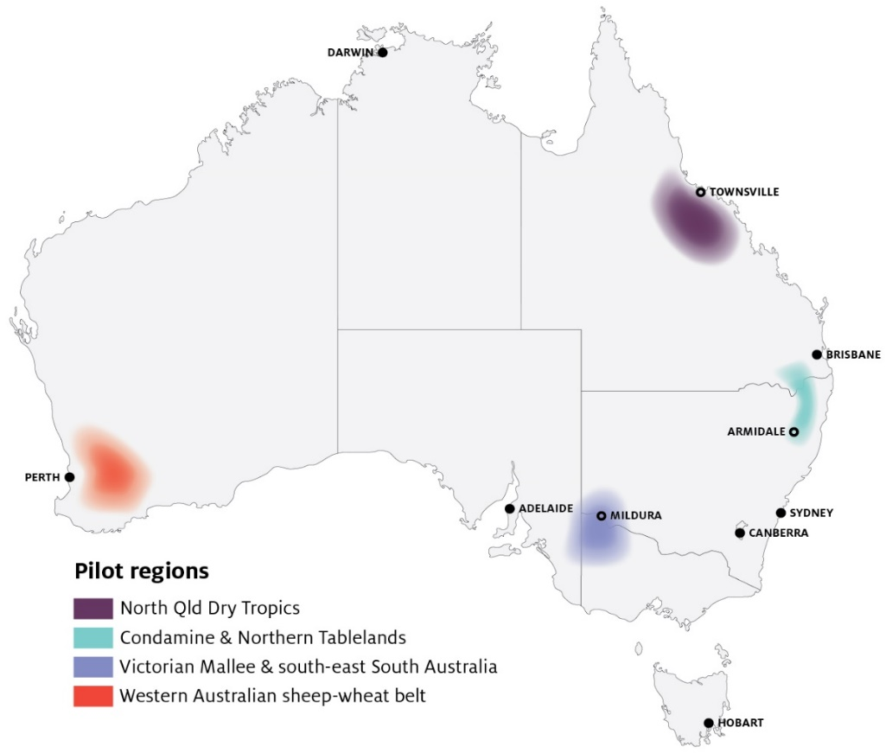

More resilient communities
Building social capital to drive change and support resilient communities

Networks to Build Drought Resilience; Drought Resilience Leaders
Objectives | Program Information
The strategy | Establish and support a national cohort of community leaders, networks, mentors and organisations to drive action on drought resilience in their community
What are we trying to achieve? | Communities have the capabilities and motivation to drive action to plan and prepare for drought
How will this support drought resilience? | Community leaders, mentors, networks and organisations play a key role in driving changes in drought preparedness attitudes and action, and supporting people in times of drought
How will we assess whether it’s successful? | Overall success measures  - There’s an increase in the reach and activities of community leaders, mentors, networks and organisations driving action on drought resilience (RC 1)  - There’s a change in awareness of and attitudes to drought preparedness at the community level (RC 2)
Table 7 Annual reporting on progress and performance
2020–21 results | 2021–22 | 2022–23 | 2023–24
Partnered with the Australian Rural Leadership Foundation to develop a program to build leadership and mentoring networks  Partnered with the Foundation for Rural and Regional Renewal (FRRR) to design programs to support community networks and organisations | (RC 1) Numbers, types and reach of people trained, mentored, mentoring, or engaged in other activities  (RC 1) Numbers and types of community capacity building and engagement projects  (RC 2) Baseline assessment of awareness, attitudes and sense of preparedness (survey) | (RC 1, RC 2) As in 2021 -22  (RC 1) Evaluation: evidence that program activities have increased capacity where gaps existed  (RC 1) Evaluation: evidence of communities planning to manage drought risk  (RC 2) Evaluation: evidence of behaviour change/action (e.g. income diversification) | (RC1, RC 2) As in 2022-23  (RC 1) Mapping of gaps  (RC 1) Evaluation: evidence of impact from programs, and testing the theory of how this occurs  (RC1, RC 2) Revision of program approach

Networks to Build Drought Resilience
The Networks to Build Drought Resilience program seeks to build the capacity and capability of community organisations and networks to support drought preparedness.
In 2020–21 the FRRR was selected through a competitive grants process to design and deliver the program. The program will provide support to community groups through 4 streams:
- Activities that strengthen the capacity and capability of network organisations, including increasing the reach of network members
- Activities that facilitate professional, social and community network events that contribute to building a positive community culture
- Training that improves the skills and capacity of network members to plan and drive community projects
- Small-scale community infrastructure, such as improved community meeting places.
In early 2021–22 the FRRR opened the first of 2 rounds seeking applications for small-scale competitive grants addressing these 4 streams. All projects will be completed by late 2022.
Case studies: Networks to build drought resilience
Women on the Land Ltd, South Australia: This project will deliver 5 workshops to improve the confidence and reduce social isolation of rural and regional women, while also providing planning and coping tools for the participants to share with their broader networks. Focusing on decision-making, preparedness and land management, the workshops will provide a platform to discuss mental health issues of rural and regional women, while also providing access to service providers and the opportunity to build networks for ongoing cohesion.
FarmLink Research Ltd: This FarmLink project will host an interactive workshop for young farmers to build the skills and networks required to manage the impacts of stress during drought, intergenerational relationships and communicating effectively within family farm businesses. This event will bring together young farmers and experts in rural and regional resilience and mental health. Through facilitated discussions, the project will build awareness in practical on-farm strategies that improve the participants’ capability to manage the stresses associated with drought and climate change in preparing for the future.

Drought Resilience Leaders
The Drought Resilience Leaders program is providing opportunities for young (18–34 year old) and emerging (any age) community leaders to gain the knowledge and skills required to support their rural, regional and remote communities to meet the future challenges arising from drought and a changing climate.
In 2020–21 the Australian Rural Leadership Foundation was selected through a competitive grants process to design and deliver the program’s 3 streams:
- Drought Resilience Leadership Development – to develop the leadership, communication and engagement skills and networks of young and emerging leaders in agriculture-dependent communities, with a focus on drought and climate resilience and adaptation. Delivered across 12 regions, this stream will develop a cohort of at least 480 future leaders.
- Community Extension Grants – to support selected participants from the Drought Resilience Leadership Development stream to undertake a community engagement project in their local community that builds the community’s resilience to the risks of future droughts.
- Drought Resilience Mentoring – to build farmers’ skills in managing drought and climate resilience and adaptation, by connecting farmers with other farmers and professionals who have demonstrated experience in managing through drought and a changing climate. Connecting 300 mentees with 250 mentors, this stream also includes a community of practice bringing participants together to continue sharing their knowledge and skills.
Table 8 Locations of Drought Resilience Leaders Development pilot program
State | Location
NSW | Western New South Wales and North West Slopes & Plains
VIC | Goulburn Valley and Mallee
QLD | Central West and South West Queensland
SA | Eyre Peninsula and Murraylands
WA | Northern Wheatbelt and Gascoyne Murchison
TAS | North East Tasmania
NT | Katherine region

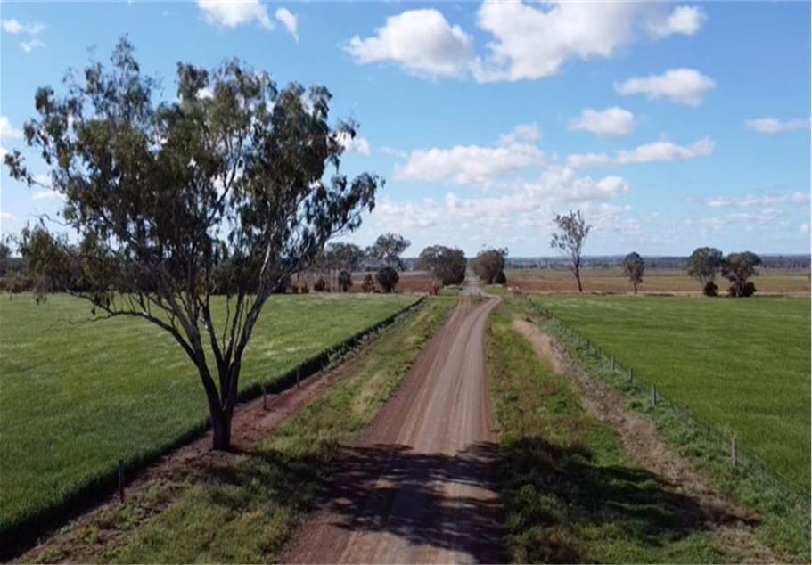

Better land management
Trial and adoption of land management practices that support agricultural landscape resilience

Natural Resource Management Drought Resilience Program
Objectives | Program information
The strategy | Make land management practices that improve and sustain the drought resilience of agricultural landscapes the norm
What are we trying to achieve? | A step-change in awareness, acceptance and adoption of drought resilient land management practices among farmers and other land managers
How will this support drought resilience? | Careful management of natural capital can make agricultural landscapes more resilient to drought, which in turn can support farm productivity and profitability during and following droughts
How will we assess whether it’s successful? | Overall success measures  - There’s an increase in land managers trialling and adopting drought resilience land management practices (LM 1)  - Collaborative networks between farmers and other land managers in support of increased adoption of drought resilience land management practices are strengthened (LM 2)  - The land management practices supported are effective in improving drought resilience (LM 3)
Table 9 Annual reporting on progress and performance
2020–21 results | 2021–22 | 2022–23 | 2023–24
80 projects funded following competitive processes | (LM 1) Grantees’ baseline data and targets for change in land management practices  (LM 1, LM 2) Numbers and types of services (activities) in grantees’ activity plans  (LM 2) Number of land managers and other stakeholders engaged through grantees’ activities  (LM 3) Grantees’ baseline data and early evidence of biophysical impacts of project activities (i.e. improvement in natural capital health and resilience) | (All measures) Reviewing final reporting from initial grants (with project outcome data)  (All measures) As in 2021–22, reporting against activity plans and targets  (LM1) Evaluation: case studies of land management practices trialled  (LM 2) Evaluation: methods to assess network strengths and role in adoption (applied to case studies)  (LM 2, LM 3) Evaluation: early evidence of practices that may be adopted (case studies) | (All measures) As in 2022, reviewing final reporting from remaining initial grants (with project outcome data)  (LM 3) Evaluation: assess practices that have been or could be adopted; generate learning  (All measures) Map project outcomes against soil and other natural capital data, as well as relevant economic and social outcomes, to begin assessing contributions to long-term trends
The Natural Resource Management Drought Resilience Program is providing funding for the trial and adoption of on-ground practices that contribute to the drought resilience of broader landscapes.
The program was rolled out through 2 streams:
- A landscapes stream, open only to regional NRM bodies
- A grants stream, open to all.
Following a competitive process:
- 14 projects were funded under the landscapes stream, amounting to $5.6 million
- 66 projects were funded under the grants stream, amounting to $7.8 million.
The successful projects involve:
- testing and demonstrating new farming practices, including the use of different pasture/forage varieties and novel grazing strategies
- tracking and forecasting pasture biomass to plan operations and schedule decision points
- using drought-tolerant native trees and shrub species as windbreaks
- experimenting with new and innovative ways to maintain continuous perennial ground cover
- analysing soil moisture to assist in preparing for and responding to drought conditions
- peer-to-peer learning and sharing the latest thinking on drought resilience.
These projects are underway and will be implemented throughout 2021–22. The 2021-22 Budget announced a further $23 million in funding for activities improving the drought resilience of agricultural landscapes. This process is expected to open in November 2021.
Case studies: Natural Resource Management Drought Resilience Program
Landscapes stream – Mallee Catchment Management Authority, Victoria: This $494,000 project will support the identification and adoption of innovative practices that increase local resilience and help mitigate the future effects of drought on the region’s agricultural and natural systems. It will deliver targeted engagement and capacity-building activities with farmers in the severely drought-affected Millewa-Carwarp district and those managing livestock operations in the broader region to enhance awareness of soil erosion risks, appropriate interventions to stabilise and reclaim soils in impacted areas, and ongoing management practices that provide appropriate levels of protection to high-risk soils in a variable climate. Implementation will address the immediate impacts and risks of recent conditions by focusing on those parts of the farm that present the greatest challenges (e.g. areas first to lose ground cover and expose soils to erosion risk), while also assisting farmers to adjust their systems to mitigate the risks posed by future droughts.
This is a collaborative project that successfully demonstrates linkages between farm and landscape scales. The focus is on innovative and transformative long-term practice change that reduces future risks, rather than short-term actions to ‘survive’ a drought. Public good is also addressed through soil stabilisation outcomes in reducing the frequency and severity of wind-driven erosion events (i.e. dust storms) and associated off-farm impacts.
Grants stream – Agricultural Bureau of South Australia: This $178,000 project will develop farmers’ skills in using innovative tools to identify and overcome soil limitations, leading to improved water use efficiency, higher yields and reduced incidence of wind erosion, salinity, subsoil constraints and seeps. Tools and new information will be drawn from a variety of sources including current research sites funded through a range of organisations, and farmer innovations. The project will also develop water security plans with farmers, including innovative methods of water capture, storage and reticulation allowing improved grazing practices. This will result in less impact on natural watercourses. It will also build farmer, industry and community awareness and understanding through effective promotion of project activities and findings through social media platforms. Participants will be engaged through the Agricultural Bureau of South Australia, which has 60 farmer branches across the state and 1,100 members.
The project takes an integrated social-ecological system approach that uses innovative tools in addressing major soil management issues. It will build the resilience of natural capital and stakeholders to drought while also promoting findings and activities and helping farmers develop water security plans.
Stakeholder comments: Farmers and farming groups
‘The Rowsley Valley contains some of the most erosive soil in Victoria. Extended periods of drought have increased the rate of erosion on many farms which is further exacerbated by lack of ground cover. Thanks to funding from the Australian Federal Government, our consortium of farmers and environmentally-focused community groups is establishing two demonstration sites that will illustrate innovative ways of overcoming substantial soil erosion. We are transforming steep, tunnel-eroded grazing land into a shrub/forage grazing site through contour ripping and planting to stabilise the soil, and concurrently increasing production through extra grazing capacity that can withstand the harsh summer conditions. We are also showcasing how farm forestry productivity can be increased while stabilising highly erosive country. Our project aims to demonstrate how drought resilient farming practices can concurrently protect the land and improve productivity.’
Dr Jacob Pearce (General Manager), E.M. Lakey & J.V. Pearce, Victoria
‘Our project, funded by the NRM Drought Resilience Program is a trial using drone technology for low impact seeding of pastures, rivers and sparely vegetated areas to re-establish ground cover, clean waterways, prevent erosion and increase productivity through the creation of more drought resilient farms. The funding has allowed us to research and trial new technology that will have a major role to play now and in the future. It has allowed us to engage with agronomists, seed suppliers, farmers and technology developers to find and develop more innovative ways to combat drought.’
Thomas Philip Bannigan (farmer), Central Tablelands, New South Wales
‘The NRM funding from the future drought fund is facilitating our farmer-led production group to test and demonstrate farming methods that allow the sharing of knowledge and skills to build the confidence of our region's farmers to better prepare for and respond to dry times. The projects are practical, relevant, and accessible to the region's farmers to assist with the building of knowledge, skills, and confidence to facilitate adaptation within their own farming systems in ways that will build true resilience and capacity to respond to Australia's variable climate.’
Jen Smith (farmer), Gippsland Agriculture Group, Victoria
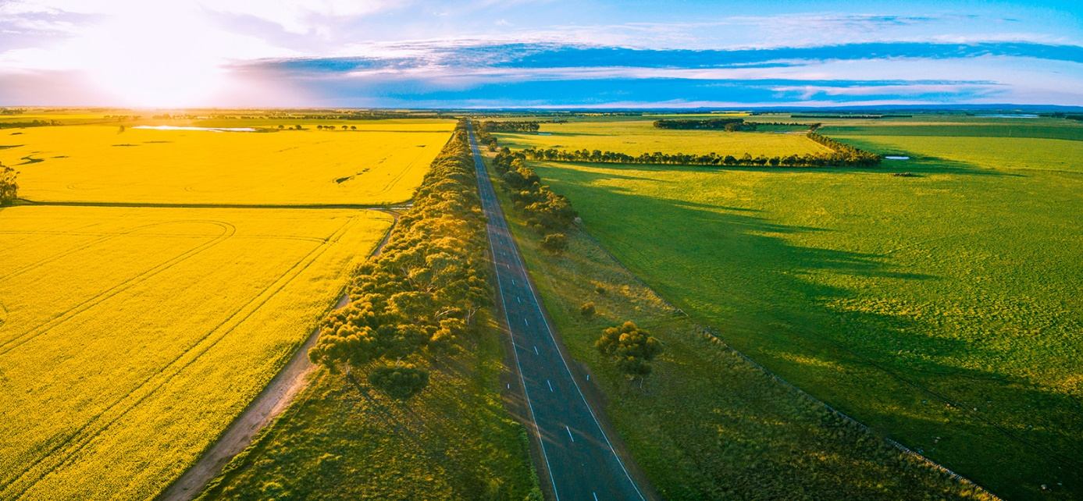

Progress in building drought resilience
The Drought Resilience Funding Plan 2020–2024 sets 3 objectives for the Future Drought Fund (FDF):
- Economic resilience – grow the self-reliance and performance (productivity and profitability) of the agricultural sector
- Environmental resilience – improve the natural capital of agricultural landscapes for better environmental outcomes
- Social resilience – strengthen the wellbeing and social capital of rural, regional and remote communities.
The success measures for each theme, described in the preceding section, provide confidence on whether FDF investments are contributing to drought resilience. But they do not, on their own, tell us what the impact on drought resilience is – that is, they are primarily directional in nature.
Measuring drought resilience across economic, environmental and social dimensions is a complex task. It requires the development of bespoke indicators and methodologies, and the collection of new streams of data. Even more complex is attributing changes in drought resilience to particular actions.
A framework is being developed by the Department to attempt to do these things. It is set out below, with further details in Appendix A. Almost all of the identified indicators require further development (including possible refinement or expansion) and validation as part of the next steps.
A priority for 2021–22 is to further develop the framework, in consultation with stakeholders. The aim is to have a settled framework in place, with baseline data, for the next annual report.
The intent is that this framework will not only support the evaluation of FDF performance but also support understanding of broader trends in drought resilience in order to inform a wide range of policies, programs and actions by governments, industry and others.
Table 10 Measuring changes in drought resilience
Performance Information | Economic resilience | Environmental resilience | Social resilience
Objective | Agricultural businesses are self-reliant, productive and profitable in the context of drought risks. | Agricultural landscapes are functional and sustainable, with healthy natural capital, in the context of drought. | Agricultural communities are resourceful, adaptable and thriving in the context of drought.
Outcome indicators | Farm business drought profit risk indicator (ABARES) – measures the degree to which farm business profit would be expected to fall in the event of a drought.  Total factor productivity growth (ABARES) – comparing productivity growth with and without adjustment for climate volatility provides an indication of whether productivity is becoming less impacted by climate factors. | Ground cover and vegetation cover indices (ABARES) – provides an indication of the environmental resilience of agricultural landscapes (e.g. risk of soil erosion, soil water infiltration, soil carbon). | Community capital index and social capital index (Regional Wellbeing Survey) – provides measures of capacity to adapt to challenges and change, through community activity, services and decision-making.
Output indicators | Percentage of farmers with a written farm plan (ABARES).  Combined planning index (Regional Wellbeing Survey) – percentage of farmers who had a farm plan containing strategies for coping with drought, addressed other risks in their plan, and actively used their plan to make decisions.  NRM and farm management practices (ABARES) – use of farm management practices for drought resilience. | NRM and farm management practices (ABARES) – use of farm management practices for drought resilience. | Community attitudes towards drought preparedness – awareness and attitudes towards drought, accounting for drought conditions.  Community action on drought preparedness – extent of the reach and drought-related activities of community organisations, networks and leaders.
Future Drought Fund contributing inputs | Increase in the skills and confidence of farmers to manage risk (RM 1)  Increase in farm business plans that consider drought risks (RM 2)  Increase in agricultural regions that have drought resilience plans (RM 4)  Climate information used to inform decisions (CI 1)  More farmers are taking actions to manage risk, including drought (RM 3)  Increased availability and accessibility of, and capacity to use and adopt, knowledge that can be applied to improve drought resilience (HI 1)  Increased adoption and commercialisation of drought resilience technologies and practices (HI 2) | Increase in land managers trialling and adopting drought resilience land management practices (LM 1)  Stronger collaborative networks between farmers and other land managers in support of increased adoption of drought resilience land management practices (LM 2)  Increase in agricultural regions that have drought resilience plans (RM 4)  Increased availability and accessibility of, and capacity to use and adopt, knowledge that can be applied to improve drought resilience (HI 1)  Increased adoption and commercialisation of drought resilience technologies and practices (HI 2) | Increase in the reach and activities of community leaders, mentors, networks and organisations driving action on drought resilience (RC 1)  Change in awareness of and attitudes to drought preparedness at the community level (RC 2)  Increase in the number of agricultural regions that have drought resilience plans (RM 4)

Future Drought Fund administration
The Future Drought Fund Act 2019 establishes the Future Drought Fund (FDF), invested by the Future Fund Board of Guardians. The FDF was initially $3.968 billion and will grow to $5 billion through investment activities. As at 30 June 2021 the balance of the FDF was $4.601 billion. The investment performance of the FDF is not the subject of this report. The Future Fund Board of Guardians reports regularly on the performance of all funds under its management.
Each year, starting in 2020–21, $100 million is made available to the Future Drought Fund for drought resilience programs.
The Minister for Agriculture and Northern Australia and the Department of Agriculture, Water and the Environment are responsible for the design and delivery of programs to build drought resilience funded from the Future Drought Fund, supported by the independent, expert-based Future Drought Fund Consultative Committee (see below).
Programs to build drought resilience are determined by the Australian Government in the context of federal budget processes. Design of programs is guided by the 4-year Drought Resilience Funding Plan 2020–2024. The Funding Plan was developed by the Consultative Committee after extensive research and stakeholder consultation. The committee consulted with more than 690 people to inform development of the plan. The plan took effect on 12 February 2020.
The minister must also, under the FDF Act, seek advice from the Consultative Committee on whether the design of each program is consistent with the Funding Plan. In practice the Consultative Committee is actively engaged with the Future Drought Fund, and the department works closely with the committee to develop and deliver proposed FDF programs.
The Future Drought Fund Consultative Committee
The independent Future Drought Fund Consultative Committee was established in September 2019. It comprises experts in fields including agricultural economics, climate risk, rural and regional development and natural resource management.
The Consultative Committee is chaired by Mr Brent Finlay. Committee members are Dr Kate Andrews, Dr Wendy Craik AM, Dr Elizabeth Peterson and Ms Caroline Welsh. More information is in Minister Littleproud’s media release on the Future Drought Consultative Committee.
In 2019–20 the Consultative Committee led the consultation across Australia to develop the Drought Resilience Funding Plan 2020–2024.
In 2020–21 the Consultative Committee met 12 times. Discussions covered topics such as:
- the design and delivery of FDF programs and consistency with the Funding Plan
- progress being made towards achieving the Funding Plan’s strategic priorities and objectives
- monitoring, evaluation and learning arrangements for FDF programs
- stakeholder engagement approaches and feedback
- communications strategies
- risks to FDF delivery and management strategies.
The committee, primarily through its chair, also met regularly with stakeholders to discuss the Future Drought Fund and its programs and hear a wide range of perspectives on its activities.
A priority for the department in the foundation year has been to put in place governance arrangements to support the effective administration of FDF programs. This includes:
- an FDF Risk Management Framework, and risk management plans for each program and major activity
- an FDF Probity, Accountability and Transparency Framework, and probity plans for each program and major activity
- arrangements for legislative governance setting out processes to ensure compliance with the FDF Act and other legislation.
- an FDF Compliance and Assurance Framework, to support oversight of the appropriate use of FDF funds by third parties.
- a memorandum of understanding between the department and the Regional Investment Corporation (RIC) Board to facilitate the role of the RIC Board in providing advice under the FDF Act.
FDF programs are delivered by the department using grant and procurement processes governed by the Commonwealth Grants Rules and Guidelines and the Commonwealth Procurement Rules. Some programs are also being delivered through Federation Funding Agreements with state and territory governments. In 2020–21 the department delivered FDF programs through:
- 4 competitive grant programs
- 5 tender processes
- 2 Federation Funding Agreements, each with 8 schedules setting out delivery arrangements in each state and territory.
Before entering into any funding arrangement, the minister (or delegate) must seek advice from the RIC Board. This serves as a final check and balance on spending from the Future Drought Fund.
The Regional Investment Corporation Board
The Regional Investment Corporation (RIC) is a corporate Commonwealth entity governed by an independent board.
The RIC Board plays a role in the governance arrangements for the Future Drought Fund. Under section 28 of the FDF Act, the RIC Board must provide advice to the relevant minister about whether a proposed arrangement, grant or agreement should be made. In 2020–21 the RIC Board considered 8 such requests. This involved 80 open competitive grants, 2 open competitive processes delivering devolved grants, 8 targeted competitive grants, 2 open competitive procurements, 2 targeted competitive procurements, and 2 rounds of state/territory grants via the Federal Financial Relationships Framework.

Allocation and spending of funding to date
While not required by the FDF Act, the government’s approach is to consider annually, as part of each federal budget process, FDF programs to build drought resilience. This supports an adaptive approach to FDF delivery, informed by ongoing review, reporting, engagement and learning.
The programs in the first round, announced in 2020–21, were intentionally designed to be short term and foundationally focused. They accounted for the full $100 million available in 2020–21, and in once instance included allocations in future years out to 2023–24.
A second round of programs was announced in the 2021-22 Budget, building on the foundation year programs. In most cases, these programs allocate funds over a 3-year period, from 2021–22 to 2023–24.
Further allocations from the Future Drought Fund are expected to be considered in the 2022–23 budget process.
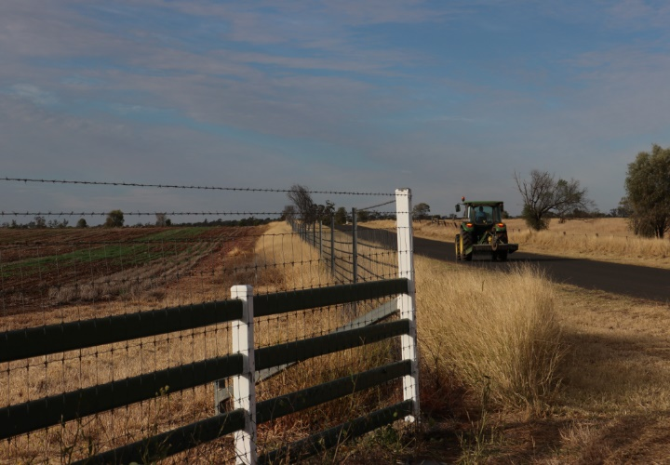

2020–21 funding
All of the $100 million made available from the Future Drought Fund in 2020–21 has been allocated to programs.
Of that $100 million, $79.828 million has been contracted, with the balance relating to:
- an innovation grants process currently underway – the government announced in the 2021-22 Budget that it will combine 2020–21 funding with additional funding in future financial years to support a larger and longer innovation grants process than originally contemplated
- the expansion of the Southern Queensland–Northern NSW Drought Resilience Adoption and Innovation Hub to include an additional node in Armidale – a process to contract this funding was ongoing at the end of the 2020–21 financial year.
Of the $79.828 million contracted, $65.127 million had been spent at the end of the 2020–21 financial year. The balance relates to contracts that have milestone payments in 2021–22.
Table 11 FDF funding allocated, contracted and expensed, 2020–21
Theme | Initial Allocation  $’000 | Actual Allocation  $’000 | Contracted  $’000 | Expensed  $’000
Harnessing innovation | 30,800 | 18,385 | 16,385 | 16,380
Drought Resilience Adoption and Innovation Hubs | 16,000 | 18,000 b | 16,000 a | 16,000
Drought Resilience Innovation Grants | 14,170 | 0 | 0 | 0
Drought Research and Adoption Investment Plan | 500 | 235 | 235 | 235
Science to Practice forum | 130 | 150 | 150 | 145
Better risk management | 30,000 | 25,818 | 25,818 | 25,818
Farm Business Resilience Program | 20,000 | 15,965 | 15,965 | 15,965
Regional Drought Resilience Planning | 10,000 | 9,853 | 9,853 | 9,853
Better climate information | 13,000 | 13,000 | 13,000 | 4,940
Climate Services for Agriculture | 10,000 | 10,000 | 10,000 | 3,500
Drought Resilience Self-Assessment Tool | 3,000 | 3,000 | 3,000 | 1,440
More resilient communities | 11,200 | 11,200 | 11,196 | 11,196
Drought Resilient Leaders | 7,450 | 7,450 | 7,446 | 7,446
Networks to Build Drought Resilience | 3,750 | 3,750 | 3,750 | 3,750
Better land management | 15,000 | 13,429 | 13,429 | 6,793
Natural Resource Management Drought Resilience Program – Grants | 10,000 | 7,807 | 7,806 | 1,171 c
National Resource Management Drought Resilience Program – Landscapes | 5,000 | 5,622 | 5,622 | 5,622
Totals | 100,000 | 81,832 b | 79,828 | 65,127 c
a The Drought Resilience Adoption and Innovation Hubs have been contracted for $64 million over 2020-21 to 2023–24. The table only captures the use of the $100 million available in 2020-21. b Differences between initial allocations and final allocations reflects reallocations of funding: $2 million additional to expand one of the Drought Resilience Adoption and Innovation Hubs; $18.168 million for Drought Resilience Innovation Grants, with this funding moved into 2021-22 (see table 12). c 2020-21 funding that has not been spent in 2020-21 will be moved into 2021-22 as part of the Mid-Year Fiscal and Economic Outlook process.

Future year funding
In addition to the $100 million in 2020–21, the government has allocated $218.5 million to FDF programs over the period 2021–22 to 2023–24. This takes total allocations for FDF programs to $318.5 million over the period 2020–21 to 2023–24. This leaves $81.5 million available to be allocated by the government across 2022–23 and 2023–24, and $100 million each year beyond this.
Table 12 FDF future funding
Program | 2020−21  ($’000) | 2021−22  ($’000) | 2022−23  ($’000) | 2023−24  ($’000) | Totals
Harnessing innovation | 18,385 | 49,668 | 26,500 | 26,500 | 121,053
Drought Resilience Innovation Grants | − | 24,168 | 5,000 | 5,000 | 34,168
Drought Resilience Adoption and Innovation Hub projects | − | 4,000 | − | − | 4,000
Adoption officers | − | 3,000 | 3,000 | 3,000 | 9,000
National enabling activities | 385 | 2,500 | 2,500 | 2,500 | 7,885
Drought Resilience Adoption and Innovation Hubs | 18,000 | 16,000 | 16,000 | 16,000 | 66,000
Better risk management | 25,818 | 39,000 | 31,000 | 21,000 | 116,818
Farm Business Resilience Program | 15,965 | 25,000 | 20,000 | 15,000 | 75,965
Regional Drought Resilience Planning | 9,853 | 14,000 | 11,000 | 6,000 | 40,853
Better climate information | 13,000 | 7,500 | 2,500 | 2,000 | 25,000
Climate Services for Agriculture | 10,000 | 5,000 | − | − | 15,000
Drought Resilience Self-Assessment Tool | 3,000 | 2,500 | 2,500 | 2,000 | 10,000
More resilient communities | 11,200 | 5,000 | 1,500 | 1,500 | 19,200
Drought Resilient Leaders | 7,450 | 1,000 | 1,500 | 1,500 | 11,450
Networks to Build Drought Resilience | 3,750 | 4,000 | − | − | 7,750
Better land management | 13,429 | 17,000 | 3,000 | 3,000 | 36,429
Drought Resilience NRM | 13, 429 | − | − | − | 13,429
Drought Resilient Agricultural Landscapes | − | 17,000 | 3,000 | 3,000 | 23,000
Totals | 81,832 a | 118,168 a | 64,500 | 54,000 | 318,500
a This table reflects the movement of $18.168 million from 2020–21 to 2021–22, associated with the Drought Resilience Innovation Grants. A further $16.7 million will be moved from 2020-21 into 2021-22 as part of the Mid-Year Fiscal and Economic Outlook process. This funding reflects contracts entered into in 2020-21, with payment milestones in 2021-22.

Monitoring, evaluation and learning
Monitoring, evaluation, reporting and learning are fundamental to delivery of the Future Drought Fund.
During 2020–21 a Future Drought Fund Monitoring, Evaluation and Learning Framework (MEL Framework) was established. It is designed to monitor the effectiveness of each program in achieving its outcomes, as well as whether the Future Drought Fund as a whole is achieving the triple bottom line objectives set out in the Funding Plan of increasing economic, social and environmental resilience.
The MEL Framework commits to:
- each program having
  - a monitoring, evaluation and learning plan that sets out targeted outcomes, a program logic explaining how activities are expected to lead to the targeted outcomes, and indicators for measuring and monitoring success
  - a mid-term and end-of-program evaluation
- for the Future Drought Fund as a whole
  - the development of indicators to monitor performance of FDF programs, as a whole, in contributing to the Funding Plan objectives of improved economic, environmental and social resilience
  - an annual report to communicate and support feedback on activities and performance.
In addition, the FDF Act establishes a 4-year review cycle:
- The funding plan that guides FDF programs runs for a maximum of 4 years – the current plan will expire on 12 February 2024 (unless replaced earlier).
- Within 3 years of a funding plan commencing (by 12 February 2023 for the current plan), a referral must be made to the Productivity Commission requesting that it review the effectiveness of the funding plan and FDF programs.
- The Productivity Commission must report no later than 5 months before the expiry of the funding plan (12 September 2023 for the current plan).
- A new funding plan must be developed before the existing funding plan expires, guided by the Consultative Committee and with public consultation.
The MEL Framework and plans are being designed and developed in a way that will support the regular Productivity Commission review.
This annual report and the performance measurement framework it presents are key parts of operationalising the MEL Framework. We will continue to develop, review and improve these frameworks over time, including with input from stakeholders during 2021–22.

Consultation and engagement
Consultation and engagement with stakeholders is fundamental to delivery of the Future Drought Fund.
The Consultative Committee (primarily through its chair) and the department meet regularly with stakeholders to discuss the Future Drought Fund and its programs. In 2020–21 this involved more than 40 stakeholder meetings. Currently 1,270 people are registered to receive regular updates on the Future Drought Fund, and 29 updates were circulated during 2020–21.
Moving forward, we will establish a more formalised cycle of consultation and engagement, complementing ongoing ad hoc engagement.
- Each year (around October), we will publish and present an annual report to communicate about activities, progress and performance.
- Following this, we will undertake a consultation process to seek feedback and other input. This will include an opportunity to put forward ideas for potential FDF investment. This input will help to inform reporting to government as part of the annual federal budget process, and decisions about allocations from the Future Drought Fund to drought resilience programs.
- Following the Budget, we will proactively communicate about any new or changed programs.
- Stakeholders will be engaged in the delivery of programs – for example, consulting on design details and on communications to support grant and other processes.
This annual cycle will be complemented by the 4-yearly review cycle described above – that is, a Productivity Commission review followed by a refresh of the Drought Resilience Funding Plan, both involving consultation and engagement processes.
These consultation and engagement arrangements will be tested and refined during 2021–22.

Appendix A: Potential measures of drought resilience
Table A1 Potential measures identified
Measure | Detail of measure | Method, source, links
Farm business drought risk:  Farm business drought profit risk indicator (national broadacre average, annual) | The farm business drought profit risk indicator is a long run metric measuring the degree to which farm profits would fall in the event of drought, as a percentage change.  The indicator uses farm profit and household income to gauge the effect of ‘drought years’ compared with ‘normal years’, over time. | ABARES analysis and use of the farmpredict model incorporating data from the ABARES broadacre farm survey (ABARES Australian Agricultural and Grazing Industry Survey). The model takes into account details of farm performance, commodity prices, costs of inputs and outputs, rainfall, temperature, soil moisture and other climate parameters from the Bureau of Meteorology at individual farm scale. Results are aggregated to give results regionally (ABARES region and Australian Bureau of Statistics Statistical Area 4) and by sector, using ABARES farm weights. Refer to ABARES Research Report 20.17 (2020) for detailed methodology of the analysis to 2018–19, which was updated and re-run to 2019–20 in early 2021.
Climate adjusted total factor productivity:  Climate adjusted total factor productivity growth per year (average previous 10 years, annual update) | Climate adjusted total factor productivity growth indicates technological change and innovations in the production process, adjusted to remove the short-term influence of climate volatility to measure underlying productivity performance. | Climate adjusted productivity estimates are key measures of farm performance. They measure the efficiency with which farmers use inputs (such as seed, fertiliser and fodder) to produce outputs (such as crops and livestock). Productivity growth measures technological change and innovations in the production process.  Explore productivity estimates in the ABARES Productivity Data Dashboard, with links to methods
Farm planning and management practices:  Percentage of farmers with a written farm plan (annual) | The proportion of farmers with a written farm plan with business objectives (national average for broadacre cropping and livestock, dairy, horticulture, and sugar). | ABARES commissioned survey of farm practices with a national sample size of 2,355 farmers in 2021. The survey was developed to gauge current practices related to natural resource management (NRM) and drought resilience and preparedness. The survey used a stratified sample to represent agriculture sectors nationally and to state level, covering farms with an estimated value of agricultural operations of $40,000 or more. The total sample in 2021 comprised broadacre grazing livestock and cropping (1,530 farmers), dairy (201), horticulture (425) and sugar (and other livestock) sectors (199).  The ABARES survey source is used here because of its greater representation of farmers across all states compared with the Regional Wellbeing Survey (RWS).  See the ABARES 2021 survey results dashboard, available in November 2021.
Farm planning and management practices:  Combined planning index (annual or biennial) | The combined planning index measures the percentage of farmers surveyed, or for whom the index could be calculated, who met all 3 of these criteria: their farm plan had strategies for coping with drought; it covered a range of other risks; they actively used it to make decisions.  The practices are applicable to all farm types and are also reported separately. | RWS and ABARES 2021 survey. Important factors around farm planning and sub-components linked to building resilience have been informed by research by the University of Canberra.  In 2020 the RWS sample of farmers that this index could be calculated for was 1,429. Some farmers have a plan and have discussed it with others, but it is not written down. Questions on planning and drought are generally asked biennially in the RWS.  The ABARES survey covered 2,355 farmers. The combined index from this source is for farmers who had a written farm plan with business objectives.
Ground cover:  Australian agricultural land | The metrics reported are based on maintaining the proportion of area of Australia’s agricultural land with sufficient vegetation cover to protect soils against erosion above the lowest (10th percentile) results previously observed in the archive. | Australia’s agricultural area is calculated according to available land use and forest maps and classifications as at 2018, based on a mosaic of mapping dates and scales. For an explanation of this and other method details, see Setting targets for National Landcare Program monitoring and reporting vegetation cover for Australia (2020).  The proportion of Australia’s agricultural area protected from erosion across Australia is usually lowest in January. Therefore, this measure is a useful indicator of erosion risk between years.  ABARES analysis of monthly total vegetation cover from MODIS satellite imagery at 500 m x 500 m resolution (using the Rangelands and Pasture Productivity online monitoring tool (RaPP Map).
Ground cover:  Percentage of Australian agricultural land protected from wind erosion (annual, in January) | Proportion of agricultural area across Australia. For each pixel, a threshold of at least 50% ground cover is required to protect soil from wind erosion. | ABARES is developing metrics suitable for long-term monitoring compared to a baseline at the start of the Future Drought Fund (FDF), with this work building on monitoring work under the National Landcare Program (Regional Land Partnerships).
Ground cover:  Percentage of Australian agricultural land protected from water erosion (annual, in January) | Proportion of agricultural area across Australia. For each pixel, a threshold of at least 70% ground cover is required to protect soil from water erosion. At least 80% ground cover is required for high-risk areas with steep slopes, high rainfall or erodible soils. | ABARES is developing metrics suitable for long-term monitoring compared to a baseline at the start of the FDF, with this work building on monitoring work under the National Landcare Program (Regional Land Partnerships).
Ground cover:  Number of months in a year that wind erosion targets were met nationally (annual) | Number of months in which the proportion of agricultural area across Australia protected from wind erosion was above the target (58% protected). | Annual target for agricultural land is that every month, 58% or more is protected from wind erosion, with at least 50% total vegetation cover each pixel. These values are set based on the 10th percentile of the MODIS-derived monthly fractional cover archive from January 2001 to December 2019.
Ground cover:  Number of months in a year that water erosion targets were met, nationally (annual) | Number of months in which the proportion of agricultural area across Australia protected from water erosion was above the target (29% protected). | Annual target for agricultural land is that every month, 29% or more is protected from water erosion, with at least 70% total vegetation cover on each pixel. These values are set based on the 10th percentile of the MODIS-derived monthly fractional cover archive from January 2001 to December 2019.
Ground cover:  Natural resource management regions meeting targets for area protected from wind or water erosion, for 12 months of the year (annual) | Proportion of NRM regions (with valid targets) that were above target for all of previous 12 months. Appropriate targets vary by region. Targets based on either wind erosion protection (50% total vegetation cover) or water erosion protection (70% or 80% total vegetation cover) have been used. | 54 NRM regions have targets to maintain the proportion of area of agriculture protected from wind and or water erosion in all months of the year (by maintaining 50%, 70% or 80% total vegetation cover as appropriate for that region, based on the 10th percentile of the MODIS-derived fractional cover archive from January 2001 to December 2019). To pass, all valid targets for that region must be met in all 12 months.
Natural resource management and farm practices:  Percentage of farmers who destock early to maintain ground cover  Percentage of farmers who increase on-farm water storage (annual)  Percentage of farmers reducing long-term stocking rates (annual)  Percentage of farmers using more water-efficient crop or pasture varieties (annual)  Percentage of farmers increasing fodder and grain storage (annual) | Farmers were asked whether they had used these specific practices, as a routine part of their farm management, over the last 3 years.  Other measures and farming practices surveyed with expected links to drought resilience were:  - improving soil water retention  - use of carbon-farming or sequestration  - optimising pesticide or fertiliser use. | ABARES 2021 survey (see ‘Farm planning and management practices’ in this table for details and coverage).  The set of measures has been developed building on research by the University of Canberra (Regional Wellbeing Survey) on NRM and associated potential resilience measures for farmers.  Estimates in the ABARES 2021 survey for these measures are the percentage of farms that used the practice, of those farms that could use the practice (e.g. the question about destocking was not asked of horticulture farms).  Farmers were also asked in this survey how important different motivations were, such as to increase drought resilience or because of personal, environmental or financial considerations.  Explore the ABARES 2021 survey results.
Social capital index:  Social capital index for general population, nationally (annual)  Social capital index for farmers, nationally (annual) | This index equally combines 3 components of the RWS, measuring the extent to which respondents:  - volunteer regularly in their local community  - feel welcome in their local community (sense of belonging)  - regularly engage in local events and networking (including online).  The index is rated on a scale from 1 to 7 and can be compared at regional scale for the general population and state scale for farmers. | Managed by the University of Canberra since 2013, the annual RWS covers up to 13,000 residents across rural Australia, including non-farmers and around 3,000 farmers. The sample is recruited using a range of methods including emails to participants in previous surveys, direct mail to a selection of households, social media advertising, and a survey panel provider. Data from the survey is weighted to be representative of the adult population of Australia (similar to Australian Bureau of Statistics survey methods). The RWS examines factors influencing wellbeing, liveability and resilience of farmers and regional communities.  The RWS provides a view of residents’ experience of their local community dynamics, which is a different perspective to that of census data. Another advantage is that annual collection enables tracking changes over a shorter period.
Community capital index:  Community capital index for general population, nationally (annual)  Community capital index for farmers, nationally (annual) | This index equally combines 4 components of the RWS, measuring respondents’ agreement to:  - their local community being a safe place to live  - having good access to general health services in their local community  - having good access to local government services in their local community  - having confidence in the effectiveness of local governance.  The index is rated on a scale from 1 to 7 and can be compared at regional scale for the general population and at state scale for farmers. | See ‘Social capital index’ above.

Glossary
Term | Definition
ABARES | Australian Bureau of Agricultural and Resource Economics and Sciences
BOM | Bureau of Meteorology
CSA | Climate Services for Agriculture
CSIRO | Commonwealth Scientific and Industrial Research Organisation
Consultative Committee | Future Drought Fund Consultative Committee
DAWE | Department of Agriculture, Water and the Environment
department | Department of Agriculture, Water and the Environment
DRSAT | Drought Resilience Self-Assessment Tool
FDF | Future Drought Fund  The Future Drought Fund is a suite of programs, funded through to 2023–24, that will continue to provide farmers and regional and rural communities with the tools they need for building drought resilience.
FDF Act | Future Drought Fund Act 2019
FRRR | Foundation for Rural and Regional Renewal
Funding Plan | Drought Resilience Funding Plan 2020–2024
hub | Drought Resilience Adoption and Innovation Hub
MEL Framework | Future Drought Funding Monitoring, Evaluation and Learning Framework
NRM | natural resource management
Productivity Commission | The Productivity Commission is the Australian Government’s independent research and advisory body on a range of economic, social and environmental issues affecting the welfare of Australians.
RIC | Regional Investment Corporation
RDEA&C | research, development, extension, adoption and commercialisation
RWS | Regional Wellbeing Survey

References
DAWE 2020, Future Drought Fund Monitoring, Evaluation and Learning Framework, Department of Agriculture, Water and the Environment, Canberra, December.
Department of Agriculture 2019, Australian Government Drought Response, Resilience and Preparedness Plan, Canberra, November.
Future Drought Fund Act 2019, No. 55, 2019.
Peel, D and Schirmer, J 2021, Drought resilience indicators provided to the Department of Agriculture, Water and the Environment (unpublished report prepared for the Department of Agriculture, Water and the Environment).
Commonwealth of Australia 2021, Budget 2021–22: Securing Australia’s recovery – Building a more secure and resilient Australia, ‘Preparing for future droughts’, Canberra.

