Future Drought Fund annual report 2022–23
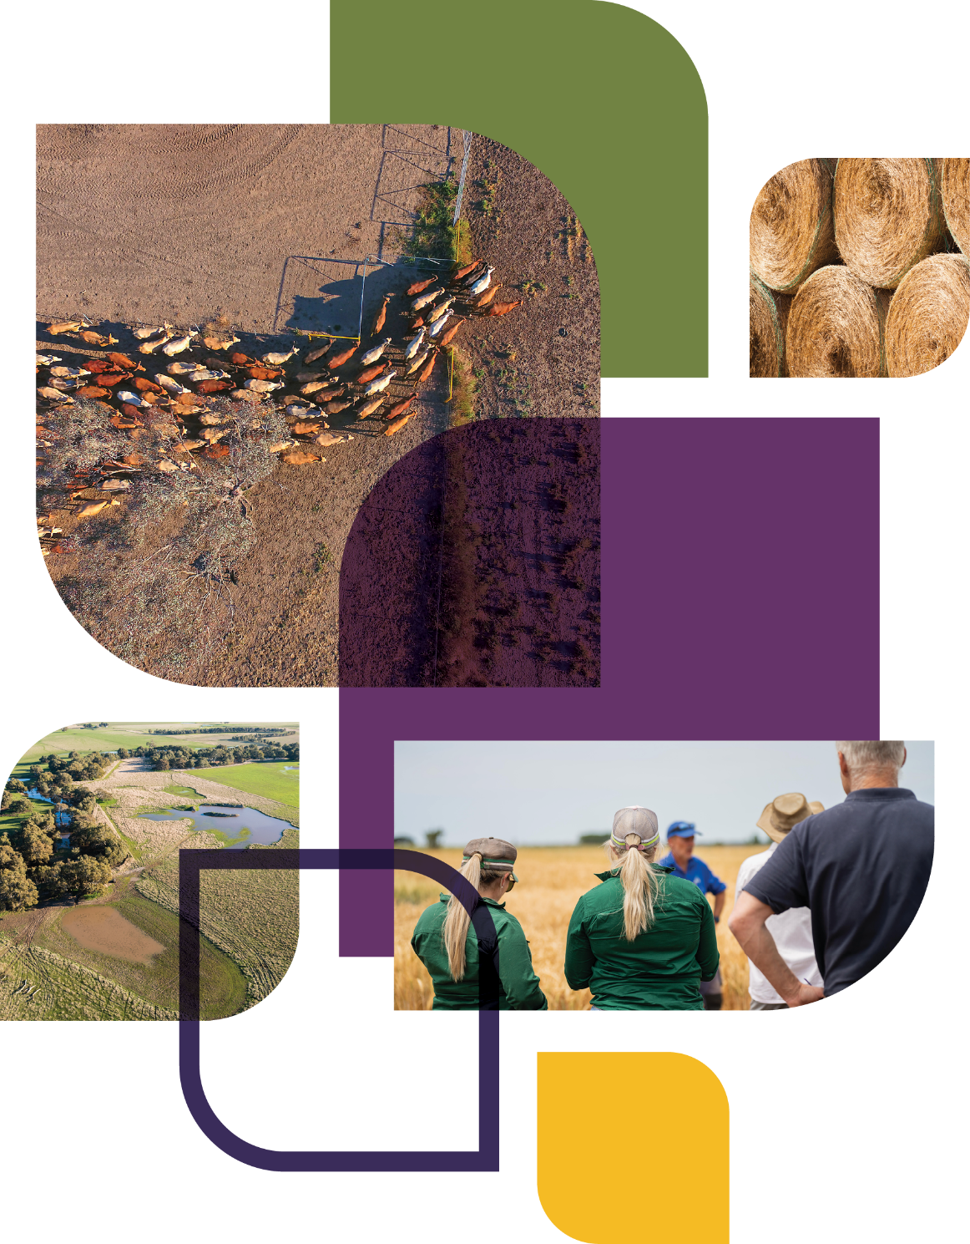
© Commonwealth of Australia 2025
Ownership of intellectual property rights
Unless otherwise noted, copyright (and any other intellectual property rights) in this publication is owned by the Commonwealth of Australia (referred to as the Commonwealth).
Creative Commons licence
All material in this publication is licensed under a Creative Commons Attribution 4.0 International Licence except content supplied by third parties, logos and the Commonwealth Coat of Arms.

Cataloguing data
This publication (and any material sourced from it) should be attributed as: DAFF 2025, Future Drought Fund annual report 2022–23, Department of Agriculture, Fisheries and Forestry, Canberra. CC BY 4.0.
This publication is available at agriculture.gov.au/agriculture-land/farm-food-drought/drought/future-drought-fund.
Department of Agriculture, Fisheries and Forestry
GPO Box 858 Canberra ACT 2601
Telephone 1800 900 090
Web agriculture.gov.au
Disclaimer
The Australian Government acting through the Department of Agriculture, Fisheries and Forestry has exercised due care and skill in preparing and compiling the information and data in this publication. Notwithstanding, the Department of Agriculture, Fisheries and Forestry, its employees and advisers disclaim all liability, including liability for negligence and for any loss, damage, injury, expense or cost incurred by any person as a result of accessing, using or relying on any of the information or data in this publication to the maximum extent permitted by law.
Acknowledgements
The authors thank interview and case study participants for their input and ongoing engagement with the Future Drought Fund. We would also like to acknowledge our diverse range of key stakeholders for their enduring support.
Acknowledgement of Country
We acknowledge the Traditional Custodians of Australia and their continuing connection to land and sea, waters, environment, and community. We pay our respects to the Traditional Custodians of the lands we live and work on, their culture, and their Elders past and present.

Foreword
After our third year of operation, it has been fantastic to see engagement in the Future Drought Fund (FDF) continue to grow across Australia.
In the 2022–23 financial year, we launched 6 new and expanded programs to showcase real results that people can take home and apply within their farm business or community. The programs include better climate information, longer-term projects, integrated communities programs, as well as funding grants for the demonstration and extension of drought resilience practices.
The FDF Consultative Committee welcomed the commencement of the Productivity Commission’s first review into the FDF in 2023 – setting us down a path of review and renewal. These legislated review cycles provide an important opportunity for the government to hear from stakeholders and participants, to understand lessons learned from each phase of the FDF and shape the future direction of programs. The FDF is for everyone in Australia, so it’s essential we have your regular input to make sure we’re getting it right.
In addition to these review cycles, the committee continues to gain regular feedback from stakeholders and provide independent expertise to government on the design of programs. In 2022–23, we met 8 times to discuss the progress being made towards the Drought Resilience Funding Plan’s strategic priorities and objectives.
Although the last drought is in the rear-view mirror for most regional communities, the FDF is playing an important role in helping farmers and their communities to get on the front foot. We need to capitalise on the good times by ensuring that good plans, practices and decision-making skills are in place when the next drought hits. I invite you to read this report to learn how the FDF is making an impact in your region.
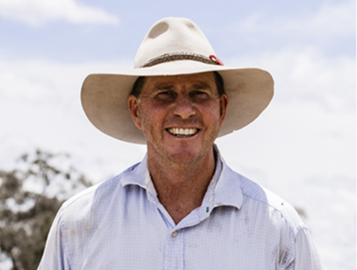

Brent Finlay
Chair
Future Drought Fund Consultative Committee

Contents
Foreword iii
Introduction vii
Building drought resilience 2
Future Drought Fund investment programs 3
Achievements 5
Better climate information 6
Climate Services for Agriculture platform 7
Drought Resilience Self-Assessment Tool 8
Better planning 11
Farm Business Resilience 11
Regional Drought Resilience Planning 16
Better practices 25
Adoption and innovation – Drought Resilience Adoption and Innovation Hubs 28
Adoption and innovation – national enabling activities 31
Drought Resilience Innovation Grants 33
Natural Resource Management Drought Resilience 34
Drought Resilient Soils and Landscapes 36
Extension and Adoption of Drought Resilience Farming Practices Grants 37
Long-term Trials of Drought Resilience Farming Practices 38
Drought Resilience Commercialisation Initiative 38
Drought Resilience Scholarships 39
Better prepared communities 40
Helping Regional Communities Prepare for Drought Initiative 41
Networks to Build Drought Resilience 42
Drought Resilience Leaders 43
Future Drought Fund administration 45
Governance 46
Program design and delivery 47
Review and evaluation 48
Funding 50
Glossary 53
References 54

Tables
Table 1 Better climate information – program information 6
Table 2 Better climate information – progress and performance, 2020–21 to 2023–24 6
Table 3 Climate Services for Agriculture – achievements and next steps, 2022–23 7
Table 4 Drought Resilience Self-Assessment Tool – achievements and next steps, 2022–23 8
Table 5 Farm Business Resilience – program information 11
Table 6 Farm Business Resilience – progress and performance, 2020–21 to 2023–24 11
Table 7 Farm Business Resilience program – achievements and next steps, 2022–23 11
Table 8 Regional Drought Resilience Planning – program information 16
Table 9 Regional Drought Resilience Planning – progress and performance, 2020–21 to 2023–24 17
Table 10 Regional Drought Resilience Planning – achievements and next steps, 2022–23 17
Table 11 Better practices – program information 25
Table 12 Better practices – progress and performance, 2020–21 to 2023–24 25
Table 13 Better practices – achievements and next steps, 2022–23 27
Table 14 Better prepared communities – program information 40
Table 15 Better prepared communities – progress and performance, 2020–21 to 2023–24 40
Table 16 Better prepared communities – achievements and next steps, 2022–23 41
Table 17 Funding allocation, 30 June 2023 51
Figures
Figure 1 About the Future Drought Fund 1
Figure 2 Future Drought Fund investment themes and programs 4
Figure 3 Future Drought Fund achievements, 2022–23 5
Figure 4 Climate tools’ coverage of agricultural commodities 8
Figure 5 Farm Business Resilience program participants, by industry 13
Figure 6 Regional Drought Resilience Planning – stakeholder engagement 19
Figure 7 Regional priorities across 6 themes 21
Figure 8 Future Drought Fund administration 45
Figure 9 Future Drought Fund consultation and engagement 50
Maps
Map 1 Regional Drought Resilience Planning – participating regions 18
Map 2 Drought Resilience Adoption and Innovation Hub locations, Australia 28
Map 3 Community Impact Program regions 42
Case studies
Case study 1 Human-centred approach to delivering climate information 9
Case study 2 Victorian cropper Ed Rickard 15
Case study 3 Father and son’s participation in Farm Business Resilience program, ACT 16
Case study 4 Regional Drought Resilience Planning in the Murraylands and Riverland, SA 22
Case study 5 Queensland regional drought resilience planning project wins major award 23
Case study 6 A voice for First Nations farmers and communities at drought resilience hub 30
Case study 7 Jono’s farm makeover protects natural assets 35
Case study 8 Jake and Frankie strengthen their herd from the ground up 36
Photos
Photo 1 CSA engagement activity 10
Photo 2 Farm Business Resilience program grantee Ed Rickard 15
Photo 3 Farm Business Resilience program participants 16
Photo 4 Knowledge Broker Dr Raelene Ward 31
Photo 5 Live broadcasting from the Science to Practice Forum 2023 studio, Canberra 33
Photo 6 NRM Drought Resilience Program participant Jono Fitzgerald 35
Photo 7 Cattle on Wintinna Station 36
Photo 8 FDF Consultative Committee 46
Photo 9 Drought Resilience Adoption and Innovation Hubs Advisory Committee 47

Introduction
Drought is an enduring feature of the Australian landscape. It has significant economic, social and environmental impacts. The Future Drought Fund (FDF) is an investment by the Australian Government to build drought resilience in Australia’s agricultural sector, landscapes and communities (Figure 1). The Department of Agriculture, Fisheries and Forestry manages drought resilience initiatives paid for out of the fund. The department, along with a range of partners, delivers programs across Australia.
In 2022–23 the FDF continued to make good progress towards building drought resilience. The FDF’s third year of operation was marked by periods of flooding over large parts of Australia. La Niña became established in September and peaked in November before easing in early 2023. For most of the country, the agricultural sector was rebounding from the last drought.
However, drought is a case of when – not if. Farmers need to prepare while times are good. To help, the FDF has delivered a significant program of work. This work was even more important with La Niña ending and the Bureau of Meteorology forecasting a 50% chance of El Niño developing in 2023–24.
In the 2022–23 Budget, the Australian Government announced an investment of $94.5 million over 6 years from the FDF. Six new and expanded programs continued a strong focus on supporting better climate information, drought resilient practices and community-led drought preparedness activities. These Budget investments included:
- $1.6 million to establish drought resilience scholarships
- $14.3 million in grants for demonstration and extension of drought resilience practices
- $40 million to deliver long-term trials of drought resilient farming practices
- $10 million to implement a drought resilience commercialisation initiative
- $21.6 million to support drought resilient communities
- $7 million to deliver the Climate Services for Agriculture platform across Australia.
Highlights from 2022–23 included:
- assisting the Productivity Commission’s review of part 3 of the Future Drought Fund Act 2019
- securing 6 additional Budget investments
- hosting the 2023 FDF Science to Practice Forum
- implementing an updated FDF governance framework

Figure 1 About the Future Drought Fund
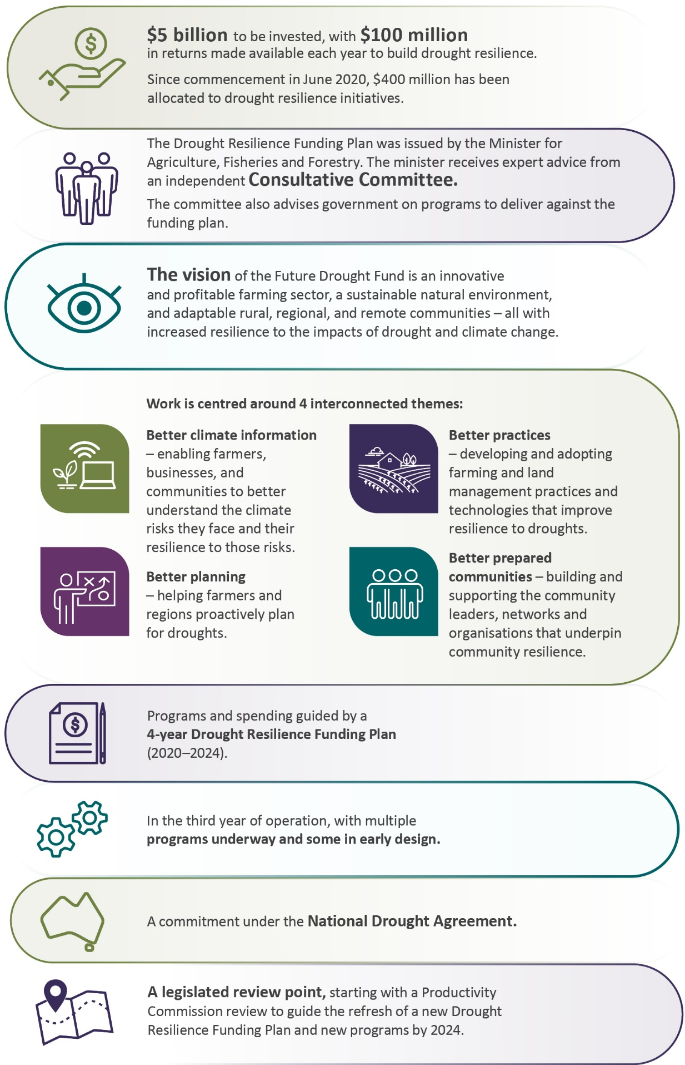

Building drought resilience
Drought resilience is the ability to adapt, reorganise or transform in response to changing temperature, increasing variability and scarcity of rainfall and changed seasonality of rainfall, for improved economic, environmental and social wellbeing (DAWE 2021).
Building drought resilience is a complex and long-term endeavour. Resilience does not have a single meaning or measure and an endpoint is unlikely. Resilience is context-dependent and has different consequences for each person, farm, community and agricultural landscape impacted by drought. This is why holistic, tailored and practical interventions are required to increase drought resilience – there is no ‘one-size-fits-all approach’.
The effects of drought generally build and subside over time and are one of many challenges faced by farmers, businesses, landscapes and communities. The dynamic nature of drought means that building drought resilience requires an ability to respond effectively to a continuously changing context, across economic, social and natural capital domains.
For these reasons, FDF investments are focused on building economic, social and natural capital resilience through better resources, practices and capabilities. These investments will enable farmers, agribusinesses, communities and others to make better decisions about how to best manage the risks and impacts of droughts for their context.

Future Drought Fund investment programs
The 2022–23 financial year marked the third year of FDF investment since the fund was established. During this period, spending was directed towards continuing existing programs and establishing new programs announced in the 2022–23 Budget.
After the 2022–23 Budget, funding for the first 4-year Drought Resilience Funding Plan was fully allocated and activities were well underway. Our programs follow 4 themes (Figure 2) and contribute to the funding plan’s 3 strategic objectives of economic, environmental and social resilience to drought.
Figure 2 Future Drought Fund investment themes and programs
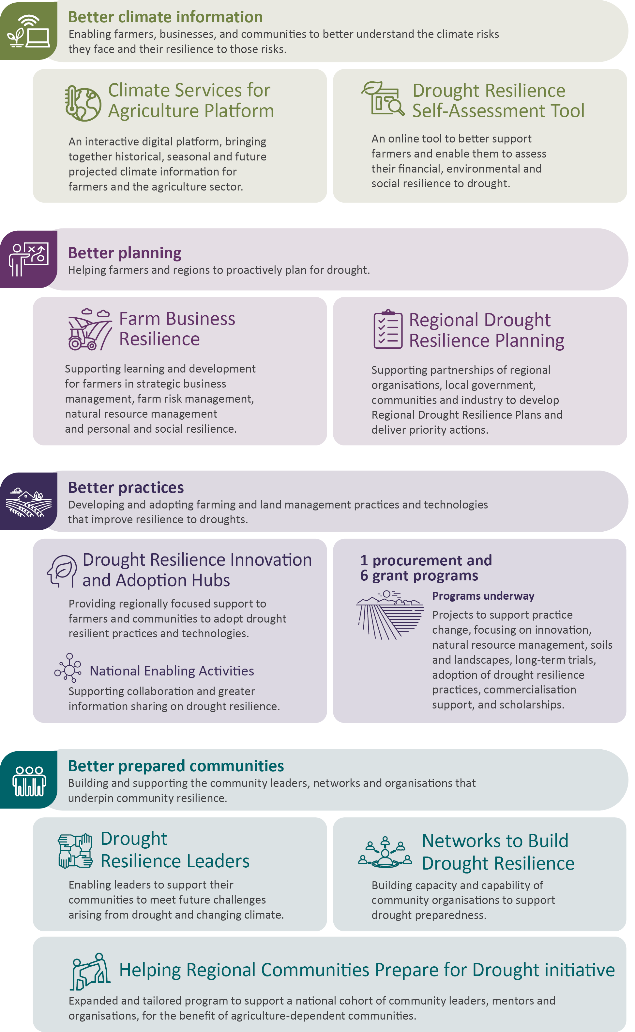

Achievements
Figure 3 Future Drought Fund achievements, 2022–23
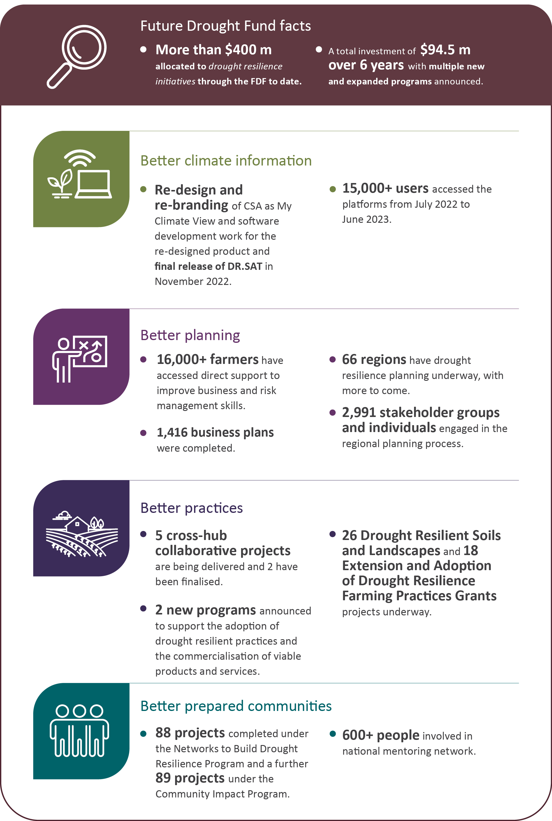
CSA Climate Services for Agriculture. DR.SAT Drought Resilience Self-Assessment Tool.

Better climate information
Enabling farmers, businesses and communities to better understand the climate risks they face and their resilience to those risks.
Table 1 Better climate information – program information
Strategy | Establish new authoritative national capabilities that make climate information accessible and useful for understanding climate risk and resilience
What we are trying to achieve | The new national capabilities are actively used by farmers, agribusinesses and communities to understand climate risks, resilience and adaptation pathways and to inform action
How this will support drought resilience | Farmers, businesses and communities that better understand their climate risks, resilience and adaptation pathways are more likely to take action to manage drought risk
How we will assess whether it is successful | Overall success measures:  - the climate information capabilities are used and valued by the target audience (CI 1)  - users take action in response to the improved information and understanding (CI 2)  - the climate services platform and self-assessment tool are scientifically rigorous (CI 3).
CI Climate information.
Table 2 Better climate information – progress and performance, 2020–21 to 2023–24
Year | Measure | Result
2020–21 | Release of digital prototype of the Climate Services for Agriculture (CSA) platform | Met – see 2020–21 annual report
 | Release of web-based Drought Resilience Self-Assessment Tool (DR.SAT) prototype | Met – see 2020–21 annual report
 | Four pilot regions selected as a basis for further development of the capabilities | Met – see 2020–21 annual report
2021–22 | (CI 1) User numbers and experiences measured from reference group feedback and web statistics (CSA and DR.SAT prototypes) | Met – see 2021–22 annual report
 | (CI 1) Evidence of co-design process | Met – see 2021–22 annual report and case study 1
2022–23 | (CI 1) FDF-level survey to gauge and extend reach, and to help set target reach | CSA: Met.  DR.SAT: Not met
 | (CI 2) FDF-level survey to gauge actions taken in response to improved information from (a) CSA and (b) DR.SAT | CSA: Met.  DR.SAT: Not met
 | (CI 3) Peer review has validated further platform development for CSA, including impact insights and adaptation opportunities | Met
2023–24 | (CI 1, CI 2, CI 3) Program case studies and commissioned studies explore and assess reasons, drivers and barriers around farmers’ use of the CSA platform and DR.SAT | To be published in 2023–24 annual report
 | (CI 1, CI 2) Evaluation: use and value placed on CSA and DR.SAT, to base local and regional agricultural resilience decisions and related actions on | To be published in 2023–24 annual report
CI Climate information.

Climate Services for Agriculture platform
Table 3 Climate Services for Agriculture – achievements and next steps, 2022–23
Achievements | Next steps
Enhancements to digital platform include tailored climate information for more commodities and regions, information on potential impacts and information to support adaptation | Climate Services for Agriculture tool and web platform re-branded to ‘My Climate View’ by July 2023
Development of Climate Services for Agriculture ‘My Climate View’ re-branding and software development work for the re-designed product | Information to be tailored to more than 20 of Australia’s top agricultural commodities
9,442 users accessed the platform from July 2022 to June 2023 consisting of 6,035 new users and 4,523 returning users | Nil
Climate Services for Agriculture Annual MEL Report | Nil
339 engagement events and consultation sessions in 2022 and 2023 to co-design the platform across 8 pilot regions | Nil
1,739 people reached with engagement and outreach to promote platform | Nil
Information tailored to 17 agricultural commodities | Nil
Climate Services for Agriculture (CSA) My Climate View is an interactive digital platform co-designed with Australian farmers and communities to help them adapt to climate change and increase their business viability. It is delivered by the Bureau of Meteorology and CSIRO.
CSA helps inform farm business planning decisions by providing historical climate data, seasonal outlooks and long-term projections for future emission scenarios, based on scientifically rigorous Bureau and CSIRO data. It aims to build drought resilience by enabling users to anticipate future climate conditions, draw comparisons with recent weather and consider what changes could mean for the commodities they produce.
A third update of the platform was released in June 2022, and a fourth in February 2023. The updates extended CSA to cover an additional 17 of Australia’s key agricultural crop and livestock commodities. The platform provides access to historical, seasonal and forecasted climate data and analytics across the nation with a detailed 5 km² resolution. It stands as Australia’s first climate prediction tool that consolidates such information in a single location for the agricultural sector. In 2022–23, commodities included beef, sheep, wheat, winegrapes, chickpeas and various fruit crops (Figure 4).
Figure 4 Climate tools’ coverage of agricultural commodities
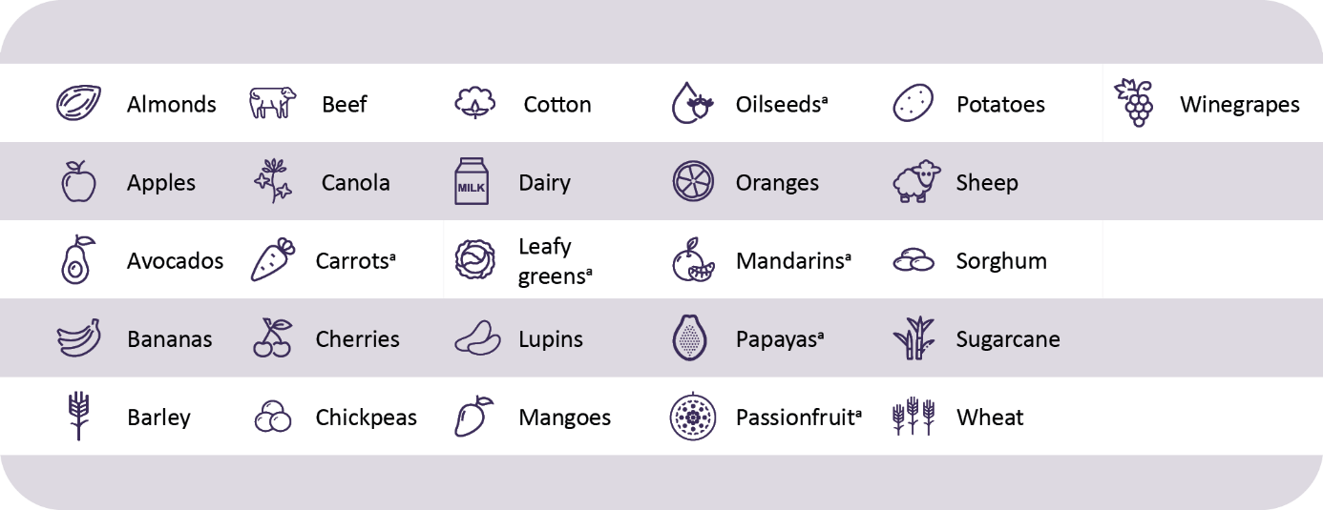
a Commodities included in the Drought Resilience Self-Assessment Tool only
The prototype covered 8 key pilot regions across different climatic zones, commodities and production systems before CSA achieved national coverage in October 2022.
In the 2022–23 Budget, $7 million of additional funding was announced to complete the development of the platform. This brings the total funding to $28.99 million.

Drought Resilience Self-Assessment Tool
Table 4 Drought Resilience Self-Assessment Tool – achievements and next steps, 2022–23
Achievements | Next steps
Fourth and final release of Drought Resilience Self-Assessment Tool in November 2022 | Continued maintenance of Drought Resilience Self-Assessment Tool to ensure content is accessible and up to date
Approximately 6,000 users from July 2022 to June 2023 with 686 creating accounts | Development completed with nation-wide coverage of financial and personal resilience assessments by early 2023
961 resilience self-assessments completed by more than 300 users | Monitoring and evaluation of the tool and program
Enhancements to tool, including addition of public view of the pathways to allow greater discoverability | Nil
Expansion of environmental resilience metrics, pathways and climate impacts to cover more commodities and regions | Nil
The Drought Resilience Self-Assessment Tool (DR.SAT) is an online tool to help farmers enhance their resilience to drought and climate variability. It allows the integration of individual farm data with larger regional data, providing insights into farm specific resilience, climate forecasts and satellite imagery and recommends resilience strengthening measures.
DR.SAT was released in December 2021 and released for the fourth and final time in November 2022.
Key features of DR.SAT include:
- Bird’s Eye View – satellite imagery and data for landscape monitoring
- Resilience assessment – self-assessment through questions on various resilience aspects
- Pathways and goals – personalised options for resilience improvement and goal tracking
- Climate impacts – scientific data on climate projections and potential impacts.
In May 2023, stakeholder engagement indicated that despite user-needs testing and co-design processes throughout 2021–22, the tool still presents several barriers to adoption. This, coupled with low stakeholder awareness of the tool, has meant user numbers have not substantially increased in 2022–23.
Following the final release of DR.SAT in November 2022, the tool has remained publicly available and accessible. Major content reviews occurred in March and April 2023, which focused on ensuring content was accurate and up to date. A further content review is planned for August 2023.
Case study 1 Human-centred approach to delivering climate information
The CSA program uses a human-centred approach to delivering climate information products and services for Australian farmers.
The program team consulted with growers, graziers and producers to understand what climate information will help with on-farm decisions. This collaborative design process ensures climate information is designed with, and for, farmers and their advisors. The team has engaged with users across the country – in person and online – to discuss the various climate information needs and different commodities.
For example, feedback from agronomists in Western Australia provided useful suggestions such as including climate information about heat stress during flowering. Another suggestion was to enable farmers to tailor threshold information on the climate information product, such as for date ranges and temperature.
Livestock producers in southern Australia volunteered location and commodity-specific knowledge, potential climate factors to be included and further suggestions that could support wider adoption of the tool.
Requests were made for continued engagement through training and development to increase advisor confidence when interpreting information and sharing relevant climate adaptation measures.
The engagement team is now consulting further to develop a training program that will suit a variety of industries.
User feedback received this year has led to the inclusion of climate information for bananas and potatoes on the platform and the development of avocado, cherry and chickpea. Photo 1 shows a broadacre farmer demonstrating nitrogen-fixing root nodules present on a seedling from their chickpea crop during a CSA engagement activity.
To get involved, visit My Climate View.
Photo 1 CSA engagement activity
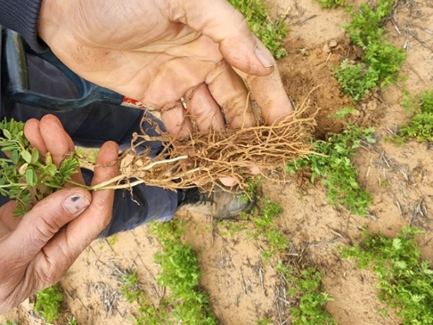
Source: Bureau of Meteorology

Better planning
Helping farmers and regions to proactively plan for drought.

Farm Business Resilience
Table 5 Farm Business Resilience – program information
Strategy | Build the capacity of farmers to plan for and manage risks, including drought
What we are trying to achieve | A step-change in the use of farm business management skills to proactively manage drought risks
How this will support drought resilience | Farmers who have better business management skills and plan for risks are more likely to take actions that help sustain farm business productivity and profitability in times of drought
How we will assess whether it is successful | Overall success measures:  - increase in the business management skills and confidence of farmers to manage risk (RM 1)  - increase in farm business plans that consider drought risks (RM 2)  - more farmers are taking actions to manage risk, including drought (RM 3).
RM Risk management.
Table 6 Farm Business Resilience – progress and performance, 2020–21 to 2023–24
Year | Measure | Result
2020–21 | All states and territories agree to partner with the Australian Government and design programs | Met – see 2020–21 annual report
2021–22 | (RM 1, RM 2) Number of participants, training and other learning events and farm performance assessments | Met – see 2021–22 annual report
 | (RM 2) Number of farm business plans developed/updated and professionally reviewed | Met – see 2021–22 annual report
 | (RM 1, RM 2, RM 3) Change in participant surveys and farm performance assessments | Met – see 2021–22 annual report
 | (RM 1, RM 3) Case studies selected for monitoring post participation | Met – see 2021–22 annual report
2022–23 | (RM 1, RM 2, RM 3) As in 2021–22, monitoring of case studies | Met
2023–24 | (RM 1, RM 2, RM 3) As in 2022–23, monitoring of case studies | To be published in 2023–24 annual report
RM Risk management.
Table 7 Farm Business Resilience program – achievements and next steps, 2022–23
Achievements | Next steps
16,330 farmers took part in the program in all jurisdictions across Australia | Continuing to roll out support to reach as many as 25,000 farmers by 2025
9,458 learning and development activities and events held | Expanding to more industries and more learning areas, including First Nations primary producers
1,737 farm business plans were reviewed or advised on by a professional during their development | Harnessing program achievements for the broader public good, by encouraging greater peer-to-peer and community knowledge sharing
1,416 farm business plans were completed (new plans developed or existing plans updated) | Nil
Note: This may include duplication due to some instances where individuals attend multiple events and were not uniquely recorded.
The Farm Business Resilience program, delivered in partnership with state and territory governments, aims to build the capacity of farmers to plan for and manage risks, including drought. Across Australia, subsidised learning and development opportunities are being rolled out in areas such as strategic business skills, risk management, natural resource management (NRM) and personal and social resilience. The program also supports farm business planning, tailored to participants’ circumstances and the opportunity for professional feedback on plans.
In 2022–23 the program was extended for a further 12 months to 30 June 2025, providing the opportunity for more farmers from more industries to engage with the program. Over 16,000 farmers across a variety of industries have benefited from support delivered through the program since it commenced. Figure 5 summarises the industries that program participants represent.
Within the national framework, each state and territory has tailored its design or delivery for its local context, building on existing initiatives delivered via government and industry. For example, Queensland is working in partnership with industry to deliver the program in the sugarcane, horticulture, grazing, broadacre and dairy sectors. New South Wales has capitalised on the success of its Young Farmer Business Program model, with the participating farmers undergoing intensive one-on-one coaching with an expert business coach and connecting with other farmers through small-group networks.
Feedback from participants has been overwhelmingly positive. Participants are using the skills and knowledge learnt to make changes to their farming practices to improve their businesses’ economic and environmental resilience to climate and drought risks.
Figure 5 Farm Business Resilience program participants, by industry
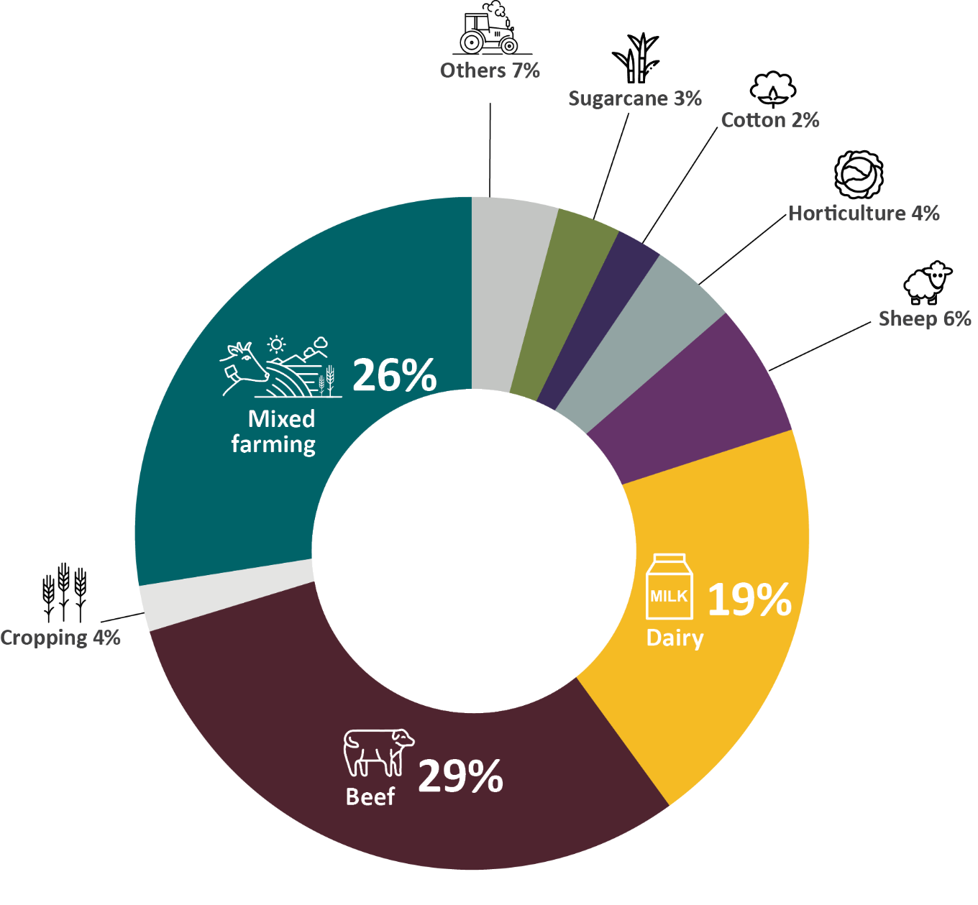
Note: Others includes other livestock such as pigs, poultry and eggs, aquaculture, apiculture and unknown. Sheep includes wool and meat.

Farm Business Resilience program highlights
In Victoria, over 86% of participating farmers now intend to adopt or implement changes to improve their farm business resilience. More than 82% reported that engaging in group activities with other farmers supported them to increase their knowledge and skills. Participants reported an average satisfaction rating of 89%, with 94% saying they would recommend the program to other farmers.
In the Australian Capital Territory, 100% of coaching participants have incorporated improved NRM practices in their farm business plan. Participants have identified opportunities to supplement income by diversifying farm enterprises particularly leading up to and throughout drought.
In Tasmania, 79% of participants in Dairy Australia’s Our Farm, Our Plan program reported they were very likely to take action to manage their farms differently because of the skills gained through the program. Over 90% of participants indicated they would implement changes within 6 months.
In New South Wales, 85% of coaching participants reported they intended to make specific changes to their business management in the future. Many participants said that their overall confidence about the business had improved, with 79% reporting a moderate or significant improvement in confidence and an intention to make changes to their financial management in the future. All coaching participants said they valued completing a self-assessed farm performance assessment.
In Queensland, 94% of grains industry participants agreed that the Building Business Resilience workshop would improve their ability to develop specific plans to better prepare for drought. A significant number of participants (95%) also said that completing a holistic farm performance assessment was a very, or extremely, useful process. All participants in the What’s Your Plan workshops reported the intention to make changes to their farm business, including to complete business plans, document learnings from previous droughts, increase water retention to improve pasture growth, and investigate apps for record keeping.
The extension through to 2025 will see expansion to more industries as farmer awareness about the program builds. The beginnings of this expansion include an emphasis on reaching First Nations farmers. For example, in Western Australia, program delivery includes 5 targeted Indigenous Business Training streams to provide tailored support to a range of Aboriginal primary industry businesses. These include programs such as Aboriginal Pastoral Academy, Indigenous Aquaculture Capacity Building, Indigenous Sandalwood Country Regeneration, Indigenous Regenerative Agriculture and Indigenous Bushfoods Business Support.
As part of the program’s aim to encourage long-term resilience, it focuses on the impact beyond participation, including following up with past participants. Through these check-ins, producers have been sharing stories of transformational change that they’ve put in place on their farms since participating. Follow-up also helps to connect producers to additional training and support.
The establishment of peer and community groups where farmers can share learnings and learn from one another has ensured that participants and communities can harness the spill-over effects of the program. Participants have reported that they value these groups highly. In Victoria, 75% of participants have joined or stayed connected with farming or community networks since participation.
Feedback from a Victorian participant:
‘What I liked about the program was the opportunity to engage with people outside of our own business, as well as meeting fellow farmers from within the area and to get an understanding of who they are, how they go about it and see what we can learn from not only the program but also from them as well.’
Case study 2 Victorian cropper Ed Rickard
Victorian cropper Ed Rickard is a prime example of how the Farm Business Resilience program is supporting farm businesses. Ed works alongside his brother and father on their cropping farm in Birchip, Victoria. Through the program, Ed has developed and received professional feedback on a farm business plan. Ed and his family have engaged over the period, receiving follow up and one-on-one support to discuss their goals and farm business plan. The Rickards will have the opportunity to keep engaging in the program through follow-up support in the future.
Ed’s plan sets out his farm business’s short-, medium- and long-term goals, including:
- installing a weather station to inform strategic decisions
- soil testing to better inform crop requirements
- diversifying crop types to reduce impact of future droughts
- increasing on-farm infrastructure to store more grain and fertilisers
- succession planning with the family to plan for the future management of the business.
After participating in the program, Ed said, ‘We’re putting a bit more thought into each big investment decision we make in terms of machinery and expanding our farm. The program also helped create a framework for succession planning, which we’ve started to implement. The program was great in that it helps identify some technologies that we would find valuable. For example, we’ve installed weather stations all throughout the farm and soil moisture probes’. Photo 2 shows Farm Business Resilience program grantee Ed Rickard, with his dog.
Photo 2 Farm Business Resilience program grantee Ed Rickard
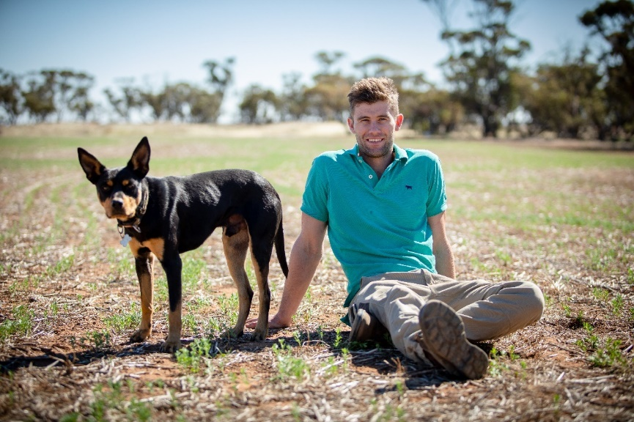
Source: Agriculture Victoria
Case study 3 Father and son’s participation in Farm Business Resilience program, ACT
John and Adam Lilleyman from Amberly Farm outside Kambah in the ACT are cattle and free-range egg producers who completed the Farm Business Resilience program via the ACT Natural Resource Management Coaching and Mentoring pilot.
The coaching program provides individual support to farmers to upskill them in business decision-making, learning about risk management, how to prepare and adapt to drought, climate change and other farming risks.
John and Adam believe that resilience ‘is the ability to forecast what will get in our way. We know we’ve had droughts before and we know we’re going to have droughts again … Our job from a resilience perspective is to be best prepared for when the drought changes the business’.
Working with coach Stuart Goodfellow, the Lilleymans were able to put together a comprehensive business plan to diversify the business and make it more resilient. Photo 3 shows Farm Business Resilience program participants John and Adam Lilleyman.
Photo 3 Farm Business Resilience program participants
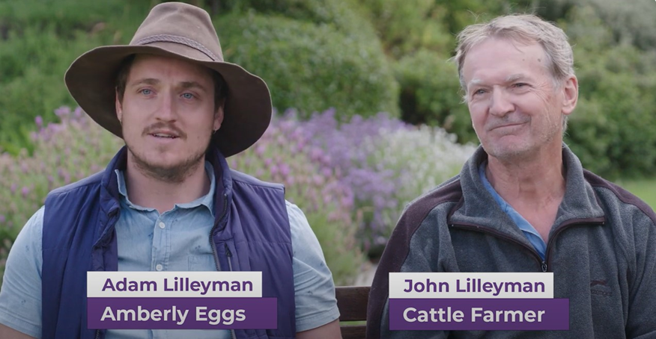
Source: ACT NRM

Regional Drought Resilience Planning
Table 8 Regional Drought Resilience Planning – program information
Strategy | Establish drought resilience plans across agricultural regions, based on evidence and collaboration, to drive proactive management of drought risks
What we are trying to achieve | Regional drought resilience plans drive decisions, actions and investments to proactively manage drought risks
How this will support drought resilience | Informed and planned action to manage drought risks at a regional scale will support resilience of the region’s economy, farmers, businesses, communities and the landscape
How we will assess whether it is successful | Overall success measures:  - increase in the number of agricultural regions that have drought resilience plans (RM 4)  - plans have buy-in from key stakeholders in the region (RM 5)  - plans are informed by relevant data, co-design and best practice approaches to resilience planning (RM 6)  - plans are implemented (RM 7).
RM Risk management.
Table 9 Regional Drought Resilience Planning – progress and performance, 2020–21 to 2023–24
Year | Measure | Result
2020–21 | All states and territories agree to partner with the Commonwealth and design detailed programs | Met – see 2020–21 annual report
2021–22 | (RM 4, RM 6) Number of plans commenced drafted, assessed, approved and published | Met – see 2021–22 annual report
 | (RM 5) Number and extent of stakeholder engagements in planning processes | Met – see 2021–22 annual report
 | (RM 5, RM 6, RM 7) Case studies selected for monitoring post-planning (for example, stakeholder buy-in and implementation) | Met – see 2021–22 annual report
2022–23 | (RM 4, RM 5, RM 6, RM 7) As in 2021–22, monitoring outputs, independent assessments and implementation | Met
 | (RM 4, RM 6) Extent to which plans identify and respond to key risks | Met
 | (RM 5, RM 6) Extent to which stakeholders co-designed/partnered in planning (qualitative via independent assessments, surveys) | Met
 | (RM 7) Number of plans implemented (grants or other means) | Partially met
 | (RM 4, RM 5, RM 6, RM 7) Interim evaluation | Partially met
2023–24 | (RM 4, RM 5, RM 6, RM 7) As in 2022–23, monitoring outputs, surveys and/or independent assessments, implementation and case studies | To be published in 2023–24 annual report
 | (RM 4, RM 5, RM 6, RM 7) End-of-program evaluation | To be published in 2023–24 annual report
RM Risk management.
Table 10 Regional Drought Resilience Planning – achievements and next steps, 2022–23
Achievements | Next steps
66 regions participating across all Australian states and territories | Planning continues in regions through 2023–24
11 final plans submitted to Australian Government and state and territory ministers | Grants to support regions to implement priority actions in their plans to be available from 2023–24
17 draft plans reviewed by CSIRO | Nil
2,991 stakeholder groups and individuals engaged in planning process | Nil
2,135 planning, consultation and engagement activities informed plan development | Nil
The Regional Drought Resilience Planning (RDRP) program, delivered in partnership with state and territory governments, supports regions to develop drought resilience plans to drive proactive management of drought risks. Plans are community-led and owned through partnerships between local governments, regional organisations, community organisations and industry. The program also provides grant opportunities to kick-start implementation of actions identified in regional plans. Final plans are submitted to relevant state, territory and Australian Government ministers for consideration and published online to enable regions to share learnings.
In 2022–23, the program was extended for 12 months to 30 June 2025. This provides time for regions to plan and take early action in line with their plans. As part of the extension, a further 43 regions, to a total of 66, confirmed their participation, with more to come. The regions are shown in Map 1 and listed at Regional Drought Resilience Planning. By 30 June 2023, plan development had resulted in 2,135 consultation and engagement activities, involving 2,991 stakeholder groups and individuals across Australia.
Map 1 Regional Drought Resilience Planning – participating regions
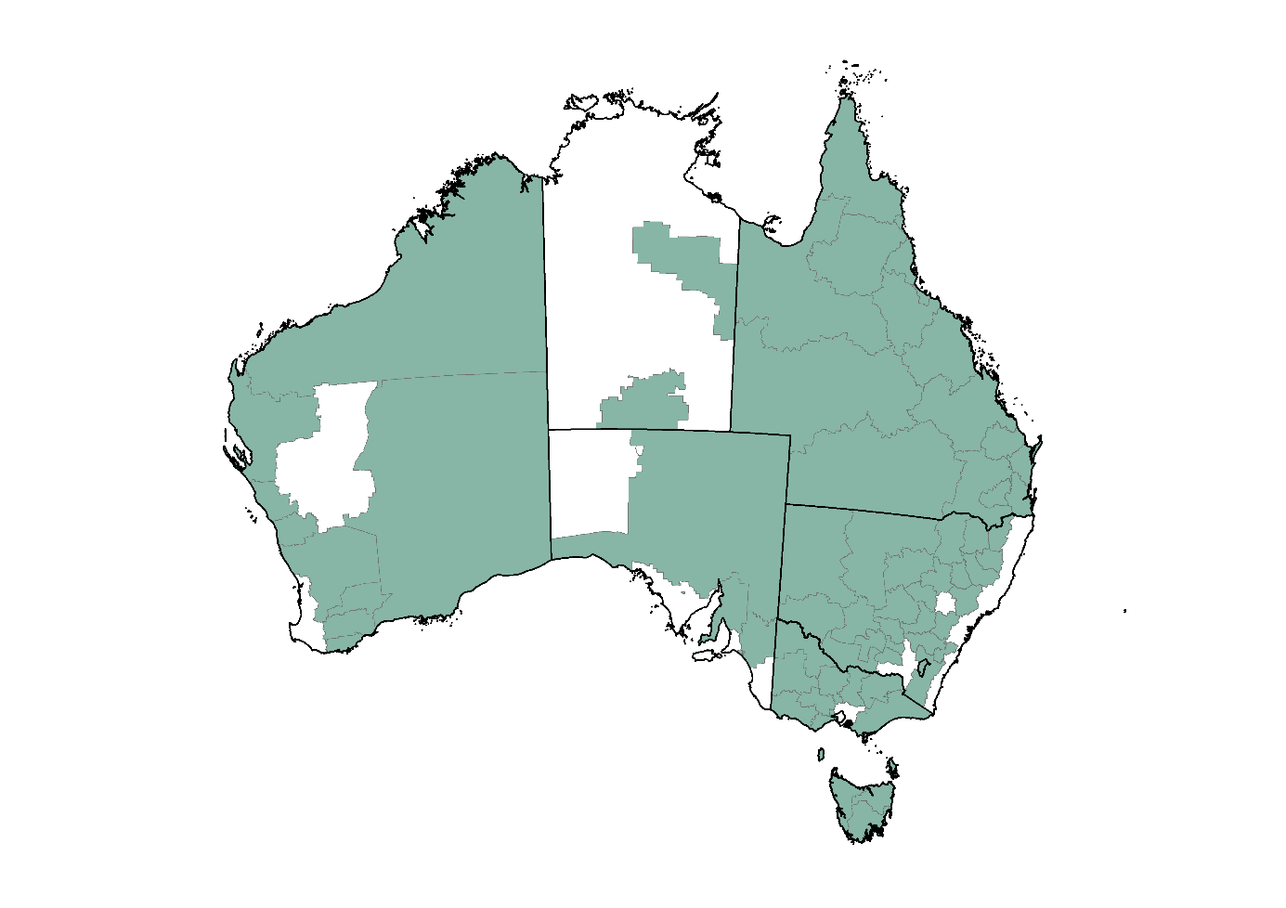
Note: Changes or additions to regions may occur over the course of the Regional Drought Resilience Planning program (see Regional Drought Resilience Planning).
Source: Local government areas (ABS 2021)
Consultation on plans has been extensive and input has been diverse (Figure 6). Local governments, First Nations peoples, community service organisations, farming groups and agriculture representative bodies continue to be the most represented partners and stakeholders. Planning activities varied across the country and included one-on-one meetings and interviews, kitchen table conversations, community-led workshops and forums, regional summits and online surveys.
Figure 6 Regional Drought Resilience Planning – stakeholder engagement
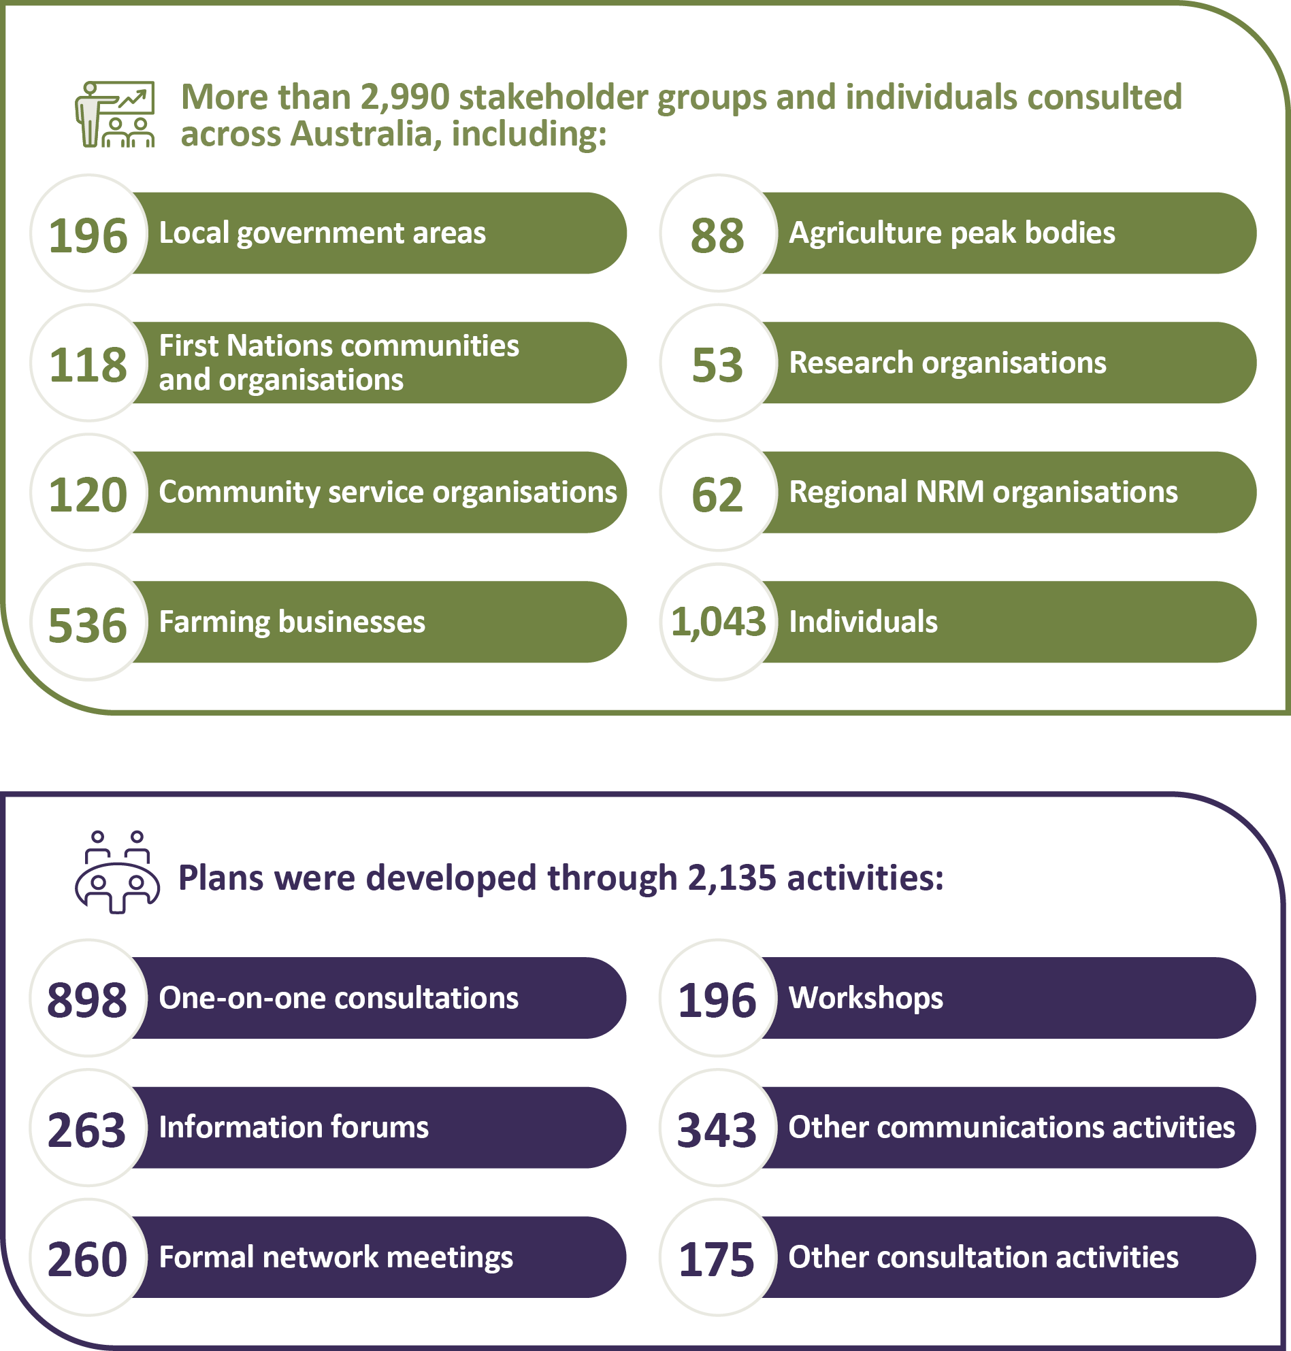
CSIRO provided expert feedback on 17 plans throughout 2022–23. This process enables best practice and learnings to be applied across Australia and ensure regions are well-placed to tackle the risk of future droughts. As part of their independent assessment role, CSIRO also developed a guide on drought resilience planning, informed by current resilience thinking, principles and leading practices. This guide is being used as a basis for their reviews of draft plans and to help build the knowledge of those planning ‘on the ground’ in the regions.
An analysis of the first 15 draft plans reviewed by CSIRO found these regions were largely successful in conducting effective and inclusive engagement, building on past and current planning, and developing a practical and achievable vision, goals and outcomes for their plan. CSIRO also observed that some of these first plans had room for improvement in how they explored future scenarios, assessed the likely effectiveness of proposed actions, and articulated monitoring and evaluation processes.
Figure 7 shows the priorities that came up frequently across regions. These include:
- diversification of the regional economy, such as exploring alternative land uses
- water infrastructure planning, such as for better efficiency or future needs
- agricultural research and development, such as better collaboration and research into drought tolerant crops
- regional health care, including supporting mental health and wellbeing
- data, particularly improved drought, climate and weather data and forecasting
- supporting, increasing or improving networks between people in the region.
Figure 7 Regional priorities across 6 themes
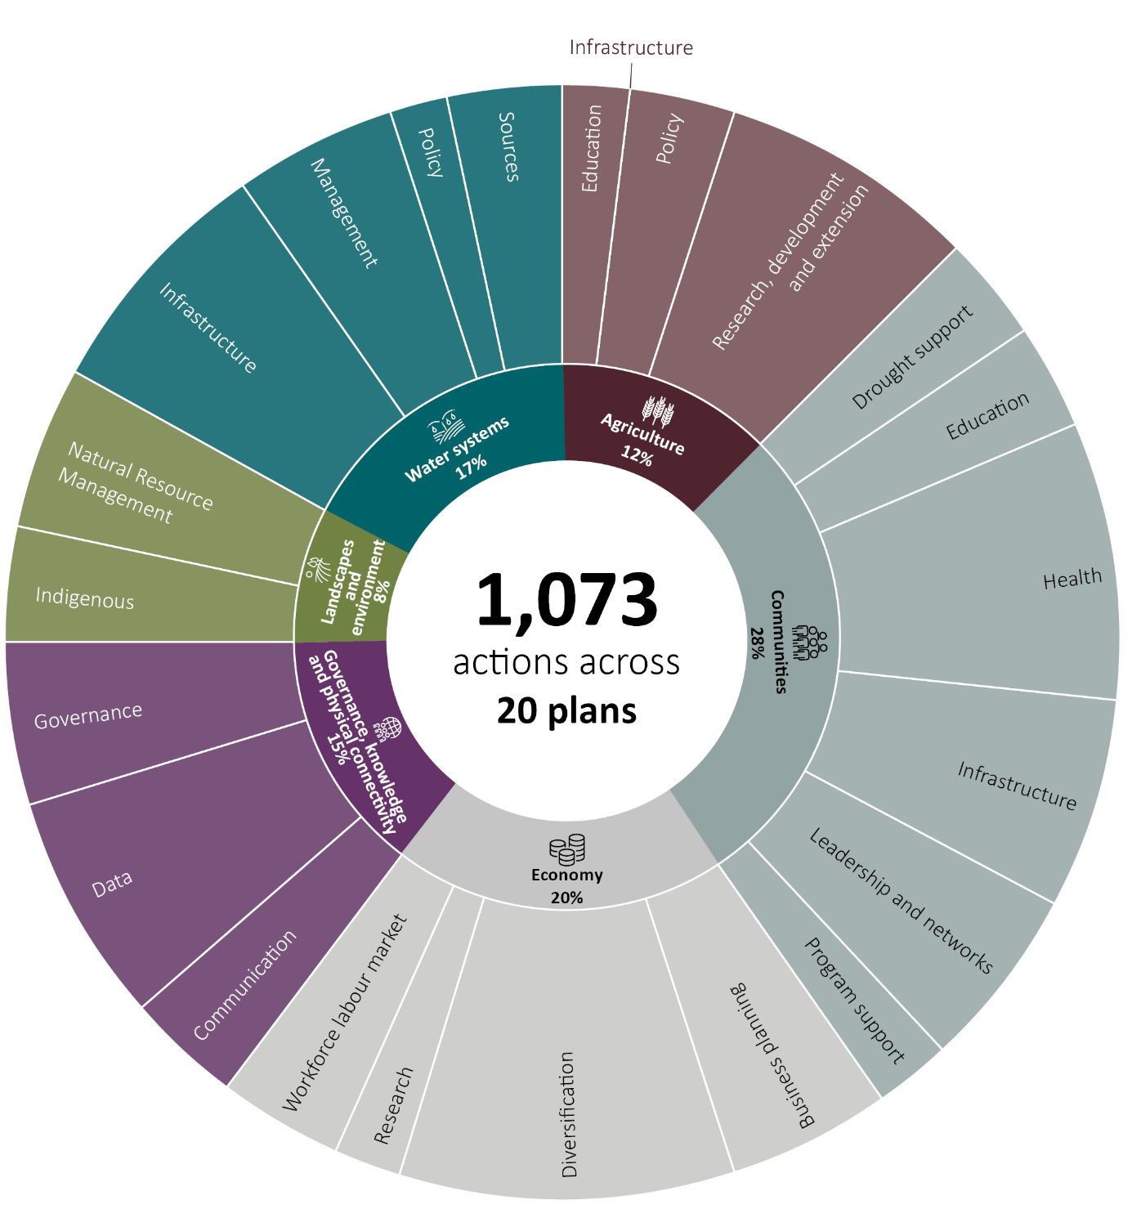
The plans deal explicitly with drought and its impacts on agriculture and related industries. However, regions have recognised that development of a regional drought resilience plan is an opportunity to consider drought in the context of inherently interconnected issues across their whole regional system, such as the broader community and economy, and resilience to other threats such as natural disasters and climate change. Therefore, many actions identified in plans that aim to build drought resilience are likely have co-benefits for the region’s resilience more broadly. A whole-of-region approach acknowledging these interlinkages was adopted explicitly by some regions – for example, in the Murraylands and Riverland, South Australia (Case study 4).
A program evaluation is planned for 2024–25 to assess the extent to which the outcomes have been achieved, inform future design and ensure a continual process of learning and improvement.
Case study 4 Regional Drought Resilience Planning in the Murraylands and Riverland, SA
The Murraylands and Riverland Plan (MR Plan) is one example of how the RDRP program has opened the conversation about resilience within a community. A partnership of Regional Development Australia (RDA) Murraylands and Riverland, Murraylands and Riverland Landscape Board and Murraylands and Riverland Local Government Association led the development of the MR Plan through a process of collaboration and empowerment of the community and local stakeholders.
Emily Jenkie from DemocracyCo, who supported the development of the MR Plan, said, ‘Drought tests everything. It tests relationships, it tests businesses, it tests community structures. It is the ultimate test of resilience’.
Hannah Loller from the Karoonda East Murray District Council said, ‘It’s not an uncommon occurrence to have low rainfall years in their region. While businesses are set up to adapt to low rainfall, when multiple periods of low rainfall fall together their financial ability to cope is stretched’.
Drought and record-breaking flood all happened in the one year in the Murraylands and Riverland region, with the impacts of climate change only expected to make things worse. Hannah said, ‘During those tough times, people withdraw, they stop communicating, they stop meeting. It challenges the fibre of what a country community is about’.
Through the development of the MR Plan, the region committed to developing an enduring process. It was not about another document that sits on a shelf, but about getting people genuinely involved.
The MR Plan was designed and written by the community from a blank sheet. This included defining resilience and the things that the region needed to do to move towards being more resilient. It took a grass roots approach of kitchen table conversations led by individuals across the community.
Hannah said, ‘We went out and heard the less heard first. We reached out to those informal leaders of the region and heard their voices to bring a collective voice up through the plan, which gave it great power’.
The planning process included:
- involvement of 550 people
- 28 regional interviews
- 52 community conversations – involving more than 300 people
- 134 Regional Summit participants
- 240+ hours of steering committee meetings
- 2,700+ hours regional leaders and interest panels
- 4,080+ hours work by the community.
Ben Fee from the RDA said, ‘they heard from people that it was more than drought – it was about building resilience to multiple shocks to the system. As community interviews and discussions grew, the scope grew, encompassing all elements of the regional ecosystem – including the supporting and service industries to agriculture and its many communities, and considering the impacts of climate change from floods and storms to droughts, pandemic and other biosecurity risks and changes in global financial and trade settings’.
‘We now see that the system is connected. It is complex. We understand the system is now better than when we started but the hero of this process remains agriculture, and the villain, drought. The impacts of drought on agriculture may well have been the “problem” on which this process focused at the start, but we can now see that building resilience in and around our agricultural sector is at the heart of the “solution” for our entire regional ecosystem.’ (RDAMR 2022)
The MR Plan includes 4 priority principles for regional resilience:
- together community – enable and support the development of a connected and inclusive community
- prepared and proactive – create a proactive, adaptive and innovative system of planning for and leveraging disruption
- leadership in action – develop a system of leadership and nurture both formal and informal leaders in the region
- productive and collaborative futures – create the conditions for industry and business to thrive now and into the future.
Those involved are passionate about ensuring the MR Plan lives on and has a legacy. For example, the RDA now sits with the plan in the middle of the board table every single meeting and measure everything they do against that community voice through the plan.
Likewise, the Landscape Board is taking the plan, and actions forward in a way that aligns with its regional landscape plan. It will be leading action on projects relating to climate change data and trends that threaten the region’s productivity and resilience, along with agricultural production methods that focus on soil health and biomass.
‘We know that we’re going to keep getting droughts, we’re going keep getting floods and they’re going to be worse. This work around resilience building is something that needs to be consistent, so the FDF is actually really fundamentally important to the future of our Australian regional communities,’ Emily said.
For more information on the MR Plan, see Regional Development Australia Murraylands and Riverland.
Case study 5 Queensland regional drought resilience planning project wins major award
In 2022, the Yellow Company was engaged to support the RDRP program in Queensland. This large-scale project involved collaboration with multiple organisations across different geographical locations. The project faced various unforeseen challenges, such as scheduling changes, external disruptions caused by the COVID-19 pandemic and natural disasters beyond the project team’s control. The project team had to coordinate with various stakeholders to ensure successful project delivery despite external challenges.
As Regional Facilitator for the Darling Downs and Southwest Queensland regions, Julia Spicer’s determination and commitment during one of Queensland’s wettest years is typical of the RDRP team across the state. Julia said one of her biggest challenges was engaging online with regional farmers and communities to ask about their experiences of drought, in the middle of a major flood event.
‘We had to rely on virtual get-togethers and meetings, we re-jigged our whole in-person meeting schedule,’ she said. ‘We had fairly raw conversations about drought and its challenges, it was a tough time to have to ask about this. I had to say ‘Hi, you don’t really want to talk to us right now, but we need to – even when so much else is going on.’
Julia said, ‘My personal relationships were on the line, I had to make sure people didn’t feel taken advantage of. It was much more stressful than trying to get water out of our house!’
Julia added that, ‘These meetings made people feel comfortable to talk about a very uncomfortable subject, they felt respected in the consultation process even though the timing wasn’t of their choosing. In the end, people felt heard, they felt understood and we were able to show them the plans we put together with their input, after the consultations were over’.
The Queensland RDRP project team coordinated more than 370 engagement activities with almost 200 regional community stakeholders to deliver 5 drought resilience plans as part of a pilot jointly funded by the Queensland and Australian governments.
Yellow’s project management approach brought rigour, discipline and timeliness to the coordination and project reporting that ensured the RDRP project’s success. The project’s success has been recognised by various bodies, including the Australian Institute of Project Management (AIPM), which declared the project as the 2022 recipient of the Queensland Project of the Year award, Queensland Government Projects category award and the National Winner accolade for the Government Projects category at the 2022 AIPM National Project Management Achievement Awards.
The success of the RDRP project has enabled Yellow to continue providing project management support to the remaining 9 Queensland regions.

Better practices
Developing and adopting farming and land management practices and technologies that improve resilience to droughts.
Table 11 Better practices – program information
Strategy | Improve the drought resilience of agricultural landscapes and drive the development, extension, adoption and commercialisation of drought resilient technologies and practices
What we are trying to achieve | A step-change in:  - awareness, acceptance and adoption of drought resilient land management practices among farmers and other land managers  - the development, adoption and commercialisation of drought resilience technologies and practices
How this will support drought resilience | The careful management of natural capital and uptake of new technologies and practices can make agricultural landscapes and agricultural businesses more resilient to drought, enabling productivity and profitability to be sustained during and following droughts
How we will assess whether it is successful | Overall success measures:  - increase in availability and accessibility of, and capacity to use and adopt, knowledge that can be applied to improve drought resilience (HI 1)  - increase in land managers trialling and adopting land management practices (LM 1)  - increased adoption and commercialisation of drought resilience technologies practices (HI 2)  - collaborative networks between farmers and other land managers in support of increased adoption of drought resilience land management practices are strengthened (LM 2)  - technologies and land management practices adopted are effective in improving drought resilience (HI 3/LM 3)  - design and delivery of hub activities is responsive to end user needs (HI 4).
HI Harnessing innovation. LM Land management.
Table 12 Better practices – progress and performance, 2020–21 to 2023–24
Year | Measure | Result
2020–21 | Establish 8 Drought Resilience Adoption and Innovation Hubs | Met – see 2020–21 annual report
 | Hold inaugural Science to Practice Forum | Met – see 2020–21 annual report
 | 80 NRM projects funded following competitive processes | Met – see 2020–21 annual report
2021–22 | (HI 1) Drought Resilience Research and Adoption Investment Plan delivered | Met – see 2021–22 annual report
 | (HI 4) Hub partnership arrangements are embedded, and co-designed activity plans in place | Met – see 2021–22 annual report
 | (HI 1, HI 2) Number and nature of activities to support research, development, extension, adoption and commercialisation (RDEA&C) and uptake by end users | Met – see 2021–22 annual report
 | (HI 1) Attendance at annual Science to Practice Forum | Met – see 2021–22 annual report
 | (LM 1) Grantees’ baseline data and targets for change in land management practices | Met – see 2021–22 annual report
 | (LM 1, LM 2) Numbers and types of services (activities) in grantees’ activity plans | Met – see 2021–22 annual report
 | (LM 2) Number of land managers and other stakeholders engaged through grantees’ activities | Met – see 2021–22 annual report
 | (LM 3) Grantees’ baseline data and early evidence of biophysical impacts of project activities (that is, improvement in natural capital health and resilience) | Met – see 2021–22 annual report
 | 26 Drought Resilient Soils and Landscapes projects funded following competitive processes | Met – see 2021–22 annual report
 | 44 Drought Resilience Innovation projects funded following competitive processes | Met – see 2021–22 annual report
2022–23 | (HI 1) Hub linkages in the innovation system | Met
 | (HI 2, HI 3, HI 4) Uptake of the Drought Resilience Research and Adoption Investment Plan priorities by hubs and research organisations | No longer applicable, see 2021–22 annual report
 | (HI 1) Improvement in end user access to RDEA&C information | Met
 | (HI 1, HI 2) Number of activities to support RDEA&C uptake by end users | Met
 | Attendance at Science to Practice Forum (HI 1) | Met
 | (HI 1, LM 1, HI 2, LM 2, HI 3, LM 3, HI 4) Reporting on mid-program evaluation | Met
 | (HI 1, LM 1, HI 2, LM 2, HI 3, LM 3, HI 4) Reviewing final reporting from initial grants (with project outcome data) | Met
 | (HI 1, LM 1, HI 2, LM 2, HI 3, LM 3, HI 4) As in 2021–22, reporting against activity plans and targets | Met
 | (LM1) Evaluation: case studies of land management practices trialled | Met
 | (LM 2) Evaluation: methods to assess network strengths and role in adoption (applied to case studies) | Met
 | (LM 2, LM 3) Evaluation: early evidence of practices that may be adopted (case studies) | Met
 | (LM 3) Evaluation: early evidence practices are effective in improving drought resilience | Met
 | 18 extension and adoption projects funded following competitive processes | Met
2023–24 | (HI 1, LM 1, HI 2, LM 2, HI 3, LM 3, HI 4) As in 2022–23, activities to support RDEA&C | To be published in 2023–24 annual report
 | (HI 2, HI 3, HI 4) Case studies of uptake by end users | To be published in 2023–24 annual report
 | (HI 4) Number of partnerships developed to support RDEA&C | To be published in 2023–24 annual report
 | (HI 1) Attendance at Science to Practice Forum | To be published in 2023–24 annual report
 | (HI 2, HI 3) End-of-program evaluation – extent to which there is increased adoption of drought resilience technologies and practices, and evidence that these are effective in improving drought resilience | To be published in 2023–24 annual report
 | (HI 1, LM 1, HI 2, LM 2, HI 3, LM 3, HI 4) As in 2022, reviewing final reporting from remaining initial grants (with project outcome data) | To be published in 2023–24 annual report
 | (LM 3) Evaluation: assess practices that have been or could be adopted; generate learning | To be published in 2023–24 annual report
 | (HI 1, LM 1, HI 2, LM 2, HI 3, LM 3, HI 4) Map project outcomes against soil and other natural capital data, as well as relevant economic and social outcomes, to begin assessing contributions to long-term trends | To be published in 2023–24 annual report
 | (LM 2) Evaluation: collaborative networks engaged are effective at increasing adoption | To be published in 2023–24 annual report
 | (HI 1, HI 3, LM 2) Evaluation: early evidence of increased adoption of drought resilient strategies | To be published in 2023–24 annual report
 | (LM 1) Evaluation: increased awareness and experimentation of drought resilience technologies and practices | To be published in 2023–24 annual report
 | (HI 1) Primary producers (including land managers) have increased awareness of technologies and practices to strengthen drought resilience | To be published in 2023–24 annual report
 | (HI 1) Drought resilience practices and technologies are better understood by researchers and primary producers through demonstrations | To be published in 2023–24 annual report
 | (HI 3) Primary producers increase their experimentation with technologies and practices which facilitates adoption to strengthen drought resilience | To be published in 2023–24 annual report
HI Harnessing innovation. LM Land management.
Table 13 Better practices – achievements and next steps, 2022–23
Achievements | Next steps
The 8 Drought Resilience Adoption and Innovation Hubs are continuing to build strong connections and linkages with stakeholders in their regions to support, promote and deliver co-designed drought resilience activities and projects with their partners | Hubs will continue to collaborate with their partners to implement and deliver their drought resilience activities and on-ground projects
All hubs identified each of their region’s drought resilience priorities through stakeholder consultation. Hub priorities are published on their websites | Hubs will continue to build partnerships and co-design opportunities to deliver drought resilience priorities for their regions
Hubs have implemented and engaged adoption officer functions and roles to drive uptake of drought resilience practices | Hubs will work to promote the adoption of tools and practices and share knowledge to support end users to build their drought resilience and preparedness
5 cross-hub collaborative projects are being delivered with 2 being finalised | Hubs are working to complete 3 cross-hub projects by the end of 2023
Science to Practice Forum held from 6 to 8 June 2023 | Consolidate learnings to inform future activities
44 Drought Resilience Innovation projects underway | Innovation projects are due for completion between 30 June 2023 and 30 September 2024
80 projects rolled out for the NRM Drought Resilience program with all projects completed by 30 June 2023 | All 80 projects have been finalised. Project results and outcomes to be reported in the next annual report
26 Drought Resilient Soils and Landscapes projects underway | Projects are due for completion between 30 June and 31 December 2024
18 projects were announced under the Extension and Adoption of Drought Resilience Farming Practices Grants program | Projects are due for completion by 30 June 2025
Announcement of 2 new programs: Long-Term Trials of Drought Resilience Farming Practices program and Drought Resilience Commercialisation Initiative | Department to process submissions and announce successful applicants/grantees

Adoption and innovation – Drought Resilience Adoption and Innovation Hubs
During 2022–23 the 8 Drought Resilience Adoption and Innovation Hubs consulted their stakeholders to identify their regions’ drought resilience and preparedness priorities and needs. Hubs continued to deliver and implement their co-designed research, development, extension and adoption activities and on-ground projects, supporting end users in building resilience across the 8 hub regions. Map 2 shows the locations of the hubs throughout Australia.
Map 2 Drought Resilience Adoption and Innovation Hub locations, Australia
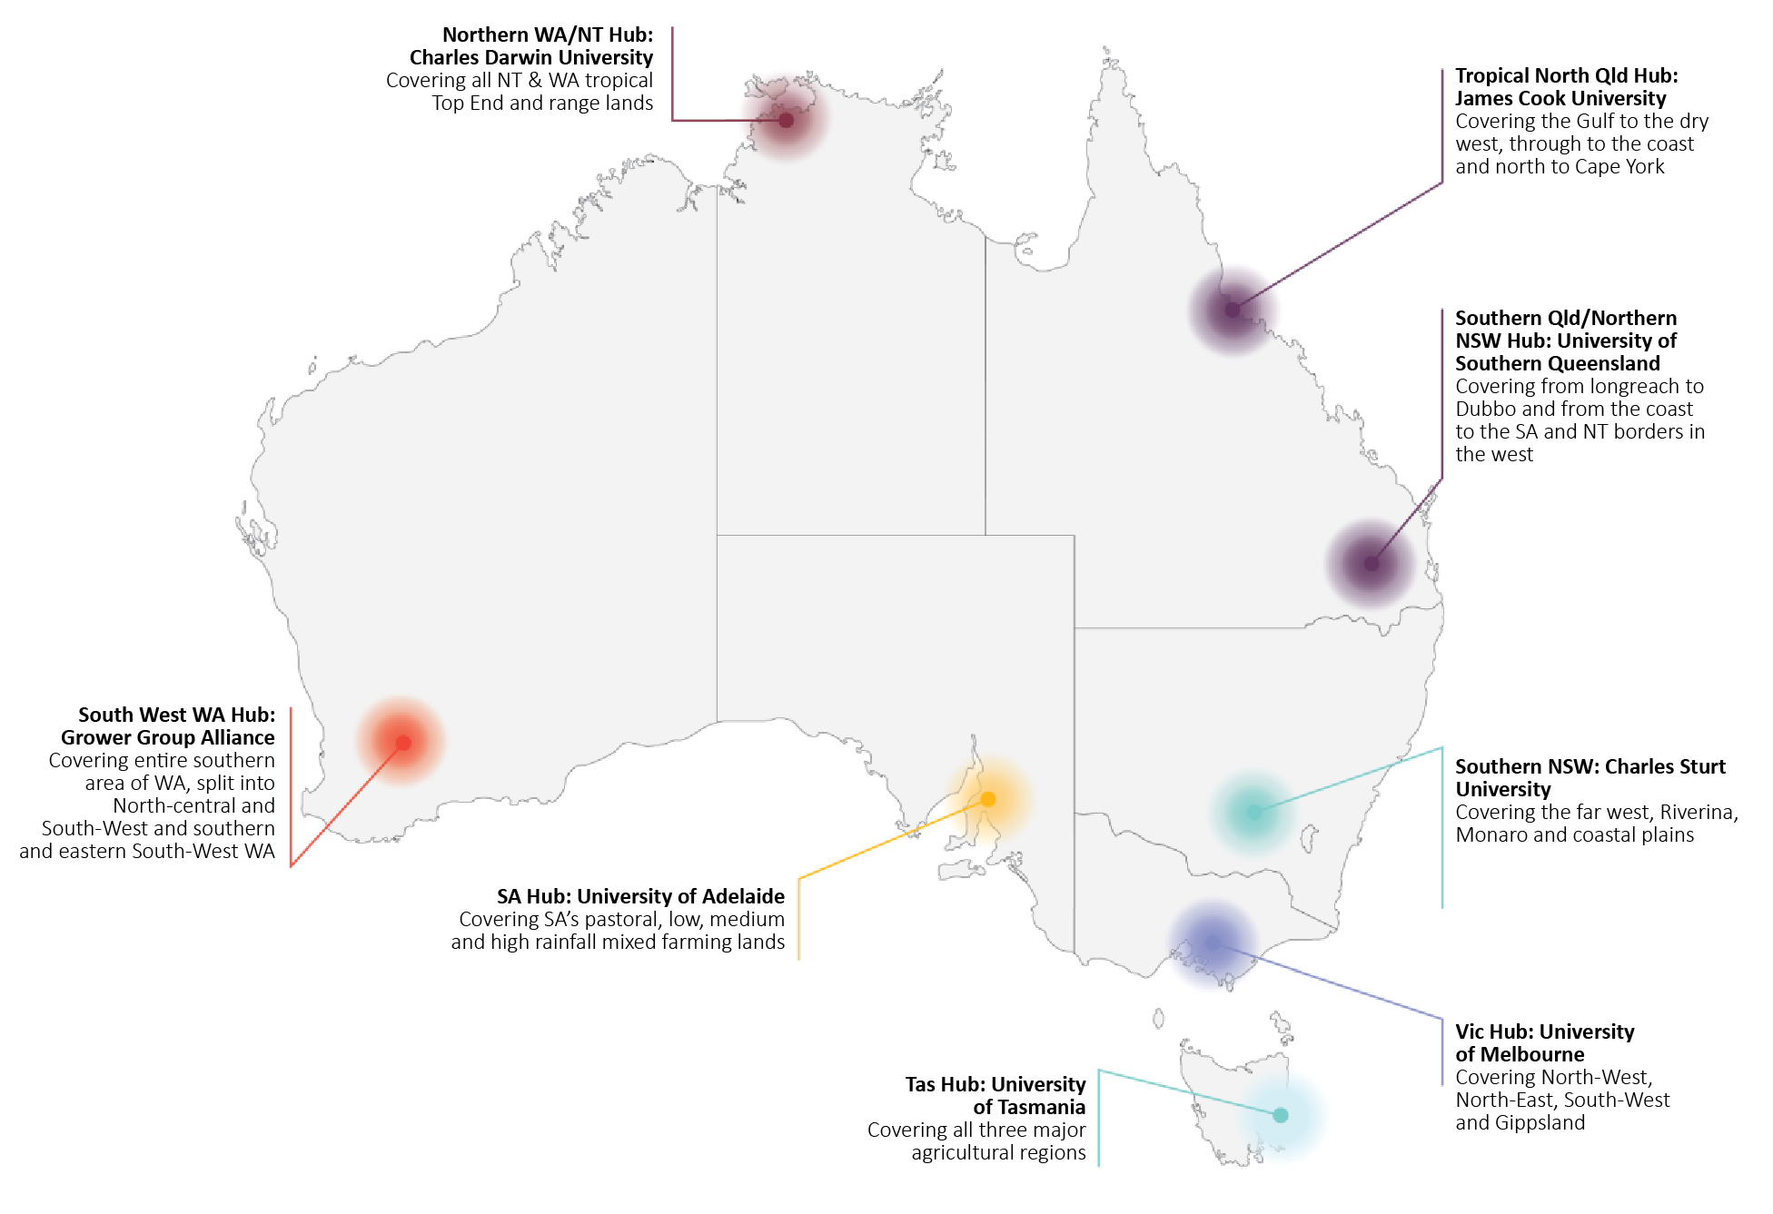
Activities in 2022–23 included:
- building connections between farming groups, Landcare networks, universities, governments and end users to support knowledge sharing and collaboration
- increasing collaboration and partnerships to co-design activities, with many activities being delivered through partners
- promoting adoption of drought resilience technologies and practices, including through demonstration site projects and on-farm trials
- coordinating extension activities such as workshops, field days, webinars and presentations to engage end users and foster drought resilience practices
- fostering networks and peer-to-peer learning among primary producers and other stakeholders through workshops, farm visits and seminars, to share knowledge and build professional networks
- developing and testing commercialisation opportunities with stakeholders
- promoting and sharing drought resilience information and resources captured from the hubs through events, hub websites, and knowledge broker and adoption officer activities
- supporting stakeholders in accessing drought resilience opportunities offered by the FDF and the broader agriculture system
- engaging with First Nations businesses and communities to develop relationships and identify opportunities
- developing tools and technologies to support planning, management and decision-making
- showcasing hub activities at the 2023 Science to Practice Forum.
All hubs have engaged knowledge brokers to translate science into practice for their region to encourage collaboration and learning and help build connections with other FDF programs and the broader agriculture innovation ecosystem.
Hubs have established and engaged adoption officers to help drive uptake of new innovations by working with farmers and their communities to pick up drought resilience tools, knowledge and support provided by the hubs and others. Adoption officers will help identify and engage individuals who could benefit from the services and support provided by the hubs and share information on the many FDF opportunities.
In 2021–22, 5 collaborative cross-hub projects were identified, with each project involving at least 2 hubs and their regions. Activities for 2 of these projects have ended and 3 projects will end in 2023–24. The 5 collaborative cross-hub projects are:
- Modern soil moisture monitoring to improve irrigation management – 31 on-farm demonstration sites have been established at grower properties across southern Western Australia, northern Western Australia, the Northern Territory and Victoria. Soil moisture monitoring technologies have been installed across the sites, with growers being supported by irrigation development officers to learn and adopt the technology and build their capacity to strategically implement soil moisture monitoring and irrigation management.
- Fast tracking Western Australia and the Northern Territory to align with nutritional feed base mapping technology advancements at a national level – Trialling and calibrating on-farm/station dynamic feed base mapping technology in the pastoral industry in remote Western Australia and the Northern Territory. This project is to refine an established system to remote parts of Australia and allow pastoralists to manage grazing pressure and better prepare properties for changing climatic conditions.
- Managing rangelands – 12 demonstration sites have been established and a range of extension activities are being delivered to showcase technologies and techniques that use mapping and other technologies at the property scale to improve grazing management. Each site is being analysed using property use and land condition tools to improve rangeland management and support producers in becoming more resilient to drought.
- Modern drought management for the health and longevity of perennial horticulture plants – The project delivered 21 demonstration sites for grape, citrus and almonds across South Australia, New South Wales, Victoria and Tasmania. These sites integrated remotely monitored climate, soil moisture and canopy growth data to support irrigation management decision-making for increased water-use efficiency.
- Drought resilience practices in mixed farming systems – The project supported cropping and livestock farmers across Victoria, South Australia and Tasmania in managing pastures and use of livestock containment and feeding systems for drought resilience. It did this by increasing awareness, knowledge and understanding of best practice containment systems, developing a decision matrix to support the decision-making process based on locally relevant trigger points, and trialling drought tolerant crop rotation options.
Case study 6 A voice for First Nations farmers and communities at drought resilience hub
Dr Raelene Ward is a proud Kunja woman who is giving First Nations farmers and communities a voice across southern Queensland and northern New South Wales to better prepare for future dry times.
Dr Ward is the Knowledge Broker, First Nations Engagement at the Southern Queensland and Northern NSW Drought Resilience Adoption and Innovation Hub (SQNNSW hub). She is on a mission to build strong relationships between First Nations people and the SQNNSW hub.
‘I always say this is a unique opportunity at the hub because we’re creating leadership positions that allow us as First Nations people to be part of significant decision-making,’ she said.
As a senior nursing lecturer at the University of Southern Queensland and expert in Indigenous suicide and social and emotional wellbeing, Dr Ward is helping the SQNNSW hub include First Nations perspectives in its drought and climate change preparation planning.
‘Young, old, everyone has an experience to share and it’s up to us to position those stories in the right way without people losing their cultural intellectual property,’ says Dr Ward.
Drought was part of Dr Ward’s life growing up as a Traditional Owner in Cunnamulla, 800 km west of Brisbane, where her grandparents were drovers in a once-bustling cattle industry. As conditions in the region have become warmer and drier, droving and shearing has reduced dramatically.
The word ‘Cunnamulla’ means ‘long stretch of water’ or ‘big waterhole’ in the language of the Kunja people.
‘In my childhood, the rivers were full of water, or at the very least there was enough to swim,’ she said.
‘The river was our happy place and we all congregated there – the whole community. It was like going to a theme park.’
‘The river represented our culture, food, practices, protocols, totems and a sense of connection and belonging to the land.’
‘When I was in my 20s, weirs started going up, stopping the natural flow and now there are a lot of control measures to decide who gets the water and for what purpose.’
‘First Nations people have a lot to say culturally and holistically about the drought and water, but they get little chance to make any serious input.’
‘Elders would have seen drought affecting those communities over time.’
‘I will use my position to be their voice and drive their agendas.’
The SQNNSW hub is committed to listening to First Nations voices throughout the life of projects, starting with program design. Dr Ward is acutely aware of ‘consultation fatigue’, where community members are tired of sharing their stories over and over with few results. She looks forward to meaningful conversations and action.
‘We need to look at education and training needs, for example, maybe replicating traditional fish traps,’ she said.
‘We have to preserve our rights to cultural knowledge and also apply it, for example with cultural burning, to contribute to the longevity of the soil and of communities.’
She describes the whole environment, from rivers and soils to plants and animals, as one interconnected system that must be respected. The concept of interconnectedness is fundamental for Dr Ward, who remembers her mother saying, ‘When they take the trees away, the river systems are never the same, neither are our communities or our country’.
‘When we see changes in our communities or across our environments it has an impact on us and our stories,’ she said.
‘It affects how we feel about places, and it has impact on our social and emotional wellbeing and mental health.’
Dr Ward will consider data and scientific information in measuring the success of her role, but those are not the only performance markers she will monitor.
‘If our hub news starts to travel by word of mouth on the “Murri grapevine”, if First Nations people across our entire hub are talking about what we do, I’ll feel like I’ve been pivotal in seeing opportunities come to life,’ she said. Photo 4 shows SQNNSW hub Knowledge Broker, First Nations Engagement Dr Raelene Ward.
Photo 4 Knowledge Broker Dr Raelene Ward
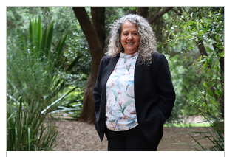
Source: Dr Raelene Ward

Adoption and innovation – national enabling activities
The FDF provides funding for a range of activities that will help farmers and regional communities build drought resilience through investments in collaboration, including greater information sharing.

Knowledge management
Nous Group delivered its final report to the department in August 2022 with advice on possible future directions for a drought resilience knowledge management system, with options to improve information management, sharing and flow. The department considered the report among other inputs to inform a review of future FDF knowledge management options.

First Nations engagement
First Nations peoples have a unique connection to Country, strong cultural knowledge and ways of managing the land for drought resilience that date back thousands of years. The FDF acknowledges the impact drought has on First Nations Australians and is committed to delivering outcomes consistent with the National Agreement on Closing the Gap.
The focus for 2022–23 has been on the development of a long-term plan to embed the perspectives of First Nations Australians into the policy and program design of the FDF. To ensure that this is done appropriately and effectively will take time. A staged approach will focus on:
- improving staff capabilities
- ensuring culturally appropriate engagement and communications
- including First Nations Australians’ participation in decision-making
- developing grant applications and processes that are more culturally inclusive
- consideration of First Nations focused grants, either through existing or new programs.
To drive hub-to-hub learning and support continuous improvement in working with First Nations stakeholders at local levels, the hub directors have included a First Nations standing item at their regular meetings with the department.
An internal FDF Community of Practice has been established to build a shared approach to our First Nations work and lift internal capability. Linkages with other stakeholders have included CSIRO, Landcare Australia and the hubs’ knowledge brokers. This forum is improving staff understanding of First Nations considerations when developing policies or programs.
Initial scoping for an FDF First Nations strategy and the feasibility of establishing a First Nations advisory group is also underway. These 2 pieces of work will consider findings of the Productivity Commission’s review due to be released in September 2023.
This planning will ensure that consideration of First Nations Australians’ knowledges and connection to the land, sea and waterways is embedded in the development of FDF programs and policies. It should also support the creation of collaborative partnerships that improve First Nations Australians’ opportunities to benefit from the FDF.

Science to Practice Forum
The third annual Science to Practice Forum was held from 6 to 8 June 2023, as a free online event. It was hosted by Pip Courtney, host of ABC TV’s Landline program, and showcased some of the innovative tools and practices helping Australian farmers and communities to build drought resilience, as a result of the FDF’s investment. The forum is one of the national enabling activities of the FDF Research and Adoption program, which contributes to the agricultural sector adapting, reorganising and transforming to build drought resilience.
The Science to Practice Forum program included keynote speakers, presentations, panel discussions and video content demonstrating a cross-section of FDF initiatives and impacts on the ground, including through the 8 hubs across Australia. Each day’s program covered a different theme featuring content targeted at and relevant to various audiences, from research and development stakeholders (Day 1), to farmer, producer and agricultural adviser stakeholders (Day 2) and community and policy stakeholders (Day 3).
Presenters included First Nations farming advocate and researcher, Joshua Gilbert, 2022 Australian Farmer of the Year, Michael Taylor, and Queensland’s first regional Chief Entrepreneur, Julia Spicer OAM.
Science to Practice Forum at a glance
- 1,062 registrations
- 3 feature speakers
- 3 panel discussions
- 30 presentations
- 18 videos featuring FDF projects
See all 2023 recorded sessions and forum highlight video reels.
Photo 5 shows live broadcasting from the Science to Practice Forum 2023 studio, Canberra – host presenter Pip Courtney (right foreground screen) with Mel Brown, First Assistant Secretary, Farm Resilience Division (centre foreground and rear) and Laura Smith, Principal Director, Innovation and Adoption Branch, Farm Resilience Division (right).
Photo 5 Live broadcasting from the Science to Practice Forum 2023 studio, Canberra
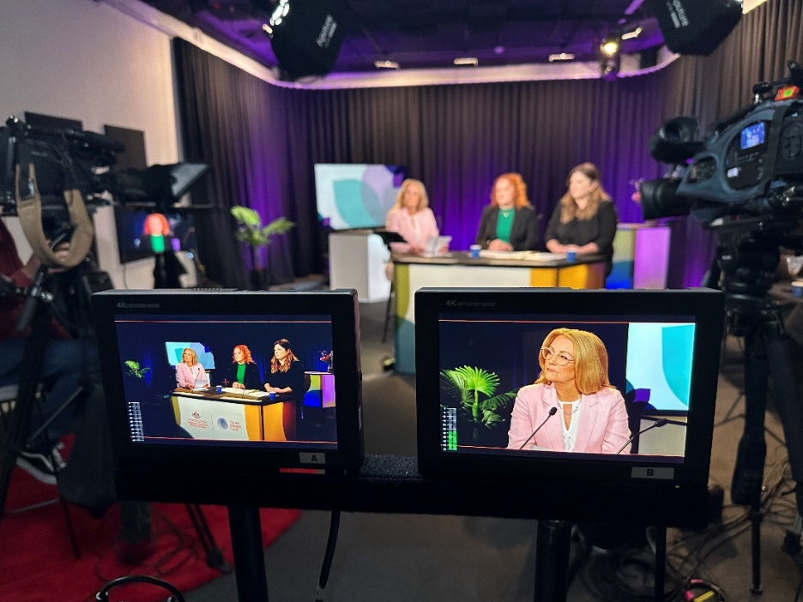
Source: By George Studios

Drought Resilience Innovation Grants
The Drought Resilience Innovation Grants program supports projects that will drive the development and adoption of new and innovative technologies and practices to improve the drought resilience of Australian farmers and agriculture-dependent communities. A variety of projects are being supported at different stages of development, including early-stage proposals, feasibility testing for new products, processes and services and large-scale innovation projects.
In 2022–23, after 2 projects ceased, 15 Innovation Grants, 7 Proof of Concept Grants and 22 Ideas Grants continued to be funded worth $28.85 million.
The funded projects are diverse and encompass activities such as:
- harvesting atmospheric moisture
- using irrigation management technology and livestock ranking strategies
- trialling diversified vegetation cover
- demonstrating different crop rotation cycles
- developing digital tools to support decision-making ahead of droughts
- using behavioural science approaches to building drought resilience.
Most of the 12-month grant projects (Proof of Concept and Ideas projects) were completed by June 2023 with the remainder due to finish in 2024. Innovation Grants for larger scale projects of up to 3 years are progressing well and most will be completed by 30 June 2024 with reports due before the end of 2024. Several projects will finish in 2025.

Natural Resource Management Drought Resilience
The Natural Resource Management Drought Resilience program was the first FDF program to provide funding for the trial and adoption of on-ground practices that contribute to drought resilience. The program was rolled out through 2 streams, and projects were implemented during 2021–22 across all states and territories, reaching hundreds of people. The 2 streams include:
- 14 landscapes projects to the value of $5.6 million, to assist regional NRM bodies to promote and implement transformational approaches to improve the management and drought resilience of natural resources and agricultural landscapes
- 66 grants worth a total of $7.8 million, awarded to organisations, farmer groups and individuals to build drought resilience in agricultural landscapes through management of natural capital.
Each project plan contains baseline information and targets for change in land management practices. Examples of the practices and approaches that were trialled under these projects include:
- novel approaches to grazing management
- groundcover and soil monitoring and management
- use of native shelterbelts
- rehabilitating farm dams and riparian areas.
Individual projects varied as to their planned outreach to stakeholders. Some have focused engagement at catchment scale, with a small number of adjoining landholders. Others have held large regional extension or industry-focused events.
In total, 53 out the 80 projects were extended beyond 30 June 2022 due to the impacts of COVID-19, floods and other adverse weather conditions. The combination of these factors delayed the ability of some grantees to complete activities and to measure, monitor and evaluate their projects. All 80 projects across the 2 streams have been completed with some final reports to be received in September 2023. Results and outcomes of this program will be published in the next annual report.
Case study 7 Jono’s farm makeover protects natural assets
Jono and Kristy Fitzgerald are the custodians of an Endangered Ecological Community on their Luskintyre property in the Lower Hunter. With the help of the FDF’s NRM Drought Resilience program and Hunter Local Land Services they’re giving their farm a ‘makeover’.
Their goal is to protect their natural assets and improve their grazing management.
‘We were interested [in the program] because we went through the drought and we wanted to prepare for the next one. We were nearly down to nothing,’ Jono said.
‘Basically, one dam was completely dry, the other one didn’t have a great deal left and the third one only had enough to survive.’
The Fitzgeralds hadn’t heard about the benefits of dam fencing before joining the program.
‘We fenced off the dams to try to stop some of the erosion and things like that from happening.’
‘We’ve just started to split the paddocks up and rotate them through and part of the plan is to have water from the river so we can split it up even further.’
Part of the reason the Fitzgeralds bought the property was for its remnant woodland. Photo 6 shows Jono standing in front of remnant woodland on the property.
Photo 6 NRM Drought Resilience Program participant Jono Fitzgerald
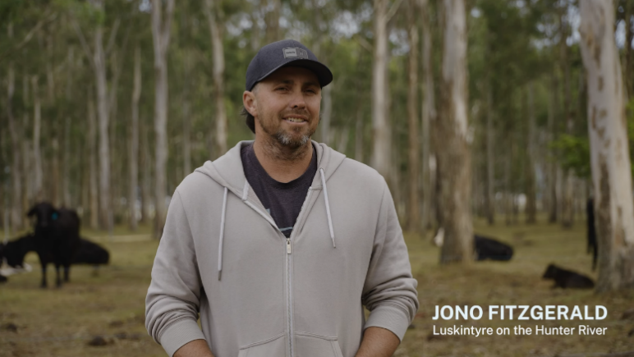
Source: New South Wales Local Land Services
‘We’re trying to preserve it as much as we can by only putting the stock through as little as possible.’
‘With the farm planning course we did, we have seen the benefits of rotating your cattle through on smaller paddocks to raise a whole area rather than set stocking.’
The Fitzgeralds now have 12 paddocks they rotate their cattle through. By the end of the project, they hope to have 20 paddocks.
‘Our plan is to stop the cattle from grazing around the dams where we’ve fenced off, limit the amount of manure, and try and stop a bit of the erosion around the dams.’
‘I’ve got a plan to put troughs around, so they don’t have to go in there at all. Hopefully, when it comes to dry times, that should help out a lot.’
See how Jono prepared for drought through whole farm planning.

Drought Resilient Soils and Landscapes
In April 2022, 26 projects were announced under the Drought Resilient Soils and Landscapes (DRSL) program at a total value of $23.1 million. The program builds on the FDF’s initial NRM Drought Resilience Program and the practices that were trialled under it.
In 2022–23 the DRSL program has continued to trial and demonstrate the ability of mature practices to have impacts at scale. This includes commonly established practices that have been successful on individual farms but not scaled up to more than one location or context. Through this, the program aims to create and communicate an evidence-base and case studies that contribute to scaling out the successful practices.
Projects supported under the program are due to be completed by 30 June 2024.
Case study 8 Jake and Frankie strengthen their herd from the ground up
Mixed-cattle farmers Jake and Frankie Fennell run a 4,000-strong beef herd on their property, Wintinna Station, in outback South Australia. After the 2017 to 2019 drought, they embraced GPS cattle tracking tags and rotational grazing to better prepare their business for drought.
‘We came across the idea of resting country in 2019 when it was really dry and it forced our hand to do it. We were running out of feed, so we had to build new paddocks,’ Jake said. Photo 7 shows cattle on Jake and Frankie Fennell’s Wintinna Station in South Australia.
Photo 7 Cattle on Wintinna Station
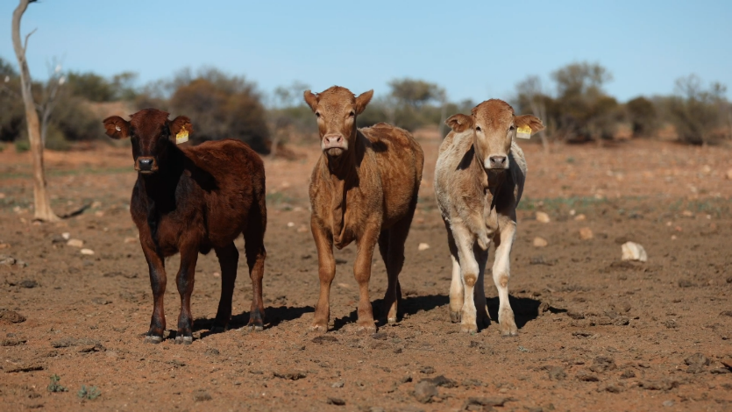
Source: South Australian Arid Lands Landscape Board
Over time the Fennells saw how moving the cattle around these newer paddocks allowed smaller rain events to have a bigger impact.
‘We had a few little rain events, say 10 or 12 mm, and the amount of growth that we saw while there were no cows in there, you’d think you’ve had 25 or 30 mm’
But the cost of new infrastructure limited Jake and Frankie’s ability to further expand their more drought resilient grazing practice. To help overcome some of the cost, the Fennells agreed to host an FDF project led by SA Arid Lands Landscape Board under the DRSL program.
Jake and Frankie now show other rangelands farmers how resting country means they can go 2 years without rain and still maintain production and soil health.
‘We think we’re cattle farmers,’ Jake said. ‘But cattle farmers grow grass and grass comes from soil. So, you need to look after your soils first and go from there’.
Andrea Tschirner from SA Arid Lands said the goal of the project is to keep the rangelands cattle industry thriving as the climate changes.
‘We really want to see businesses become more resilient in dryer times and we think a big component of that is maintaining vegetative cover,’ Andrea said.
Learn more about the FDF’s work with cattle farmers to build drought resilience.

Extension and Adoption of Drought Resilience Farming Practices Grants
In May 2023, 18 projects were announced under the Extension and Adoption of Drought Resilience Farming Practices Grants program with a total value of $13.02 million. These grants were formerly known as ‘Grants to Support the Adoption of Drought Resilient Practices’.
The program evolved from the Drought Resilience Innovation Grants program, which demonstrated significant interest in mobilising drought resilience practices. It supports larger grants (up to $3 million) over a longer period (until June 2025) and builds on the learnings from the previous NRM Drought Resilience program.
This program supports adoption of proven drought resilient farming practices and technologies, based on existing Australian and international research and development. The projects will focus on driving adoption at a large scale, either across multiple farms, a farming system, landscapes, regions or industries.
Activities that have commenced under the program include:
- training, empowering and upskilling farmers in drought resilience management
- soil health, land condition and water monitoring and management practices
- landscape rehydration techniques
- trialling the role of diverse pastures in managing soils for drought and broader climate resilience
- regenerative soil management practices.
Robust monitoring, evaluation and learning (MEL) plans are being developed with grantees, and baseline information and targets are being set to ensure project deliverables can be reported.

Long-term Trials of Drought Resilience Farming Practices
Between 2022 and 2028, $40 million is available for investment in projects that investigate innovative and transformational cropping, grazing and mixed farming practices that support farmers to develop drought resilience and adapt to the impacts of climate change. The program will support projects to undertake trials that test drought resilience practices over the long term and in real-world conditions.
The long-term nature of this program is critical to its success. Long-term trials over multiple seasons are needed to robustly test prospective drought resilient practices. This evidence-based approach will provide farmers with the confidence to make informed decisions to consider adopting the practice. An independent expert advisory panel was established to assist with program design and development of the grant selection criteria.
An open, competitive grant round was held through the Community Grants Hub and closed on 15 March 2023. Grants of up to $8 million per application were available for the grain cropping and livestock grazing sector. Applications were invited from collaborative consortia that included farmers to ensure the trials are relevant. Co-design and continued farmer involvement will be required during the project. They will also be required to undertake extension activities to support the adoption of successful drought resilient innovations.
Successful applicants will be reported in the next annual report.

Drought Resilience Commercialisation Initiative
The Drought Resilience Commercialisation Initiative is a 2-year pilot program valued at up to $10 million. The initiative will support innovators turn their ideas into commercially viable, drought resilient products and services. The initiative aligns with the FDF’s aim to increase the volume of drought resilience products and services available to farmers.
Once a delivery partner is appointed, the initiative will deliver expert, coordinated, commercialisation activities, services and advice to innovators who face barriers bringing their drought resilience product or service to market. The delivery partner will provide a one-stop-shop commercialisation facilitation service to support innovators, including one-on-one facilitation services, in-depth analysis of market barriers, commercialisation planning and other specialist activities that assist innovators to increase their commercial viability.
The pilot seeks to:
- prove the impact of public funding in drought resilience commercialisation
- increase the commercial viability of a participant’s product or service
- gather feedback through participant evaluation to inform future policy development.
The department ran an open tender procurement on AusTender from 7 February to 14 March 2023 to select a delivery partner. Tenderers responded to evaluation criteria and were assessed by a 5-member evaluation panel that included 3 non-Australian Public Service members with commercialisation expertise. The contract was announced in December 2023.

Drought Resilience Scholarships
The Drought Resilience Scholarship program aims to support leaders and innovators to drive a continued focus on drought resilience. In March 2023, $1.6 million was committed to sponsor drought resilience focused scholarships through Nuffield Australia’s prestigious agricultural scholarship program. Program planning and communications have started in preparation for scholars to commence in 2024 and 2025. Each scholar will receive $35,000 to undertake research on a topic of their choice, with a focus on building drought resilience in agriculture. Scholars will benefit from the support of Nuffield Australia and the department to disseminate their findings, expand their networks and apply their research within Australia’s agricultural communities. The program will also support other Nuffield scholars in the 2024 and 2025 cohorts to engage in drought resilience activities during their scholarship tenure.
The scholarship program travel and learning opportunities include:
- participating in the Nuffield Australian Focus Program – a week-long program held in Canberra, focusing on Australian agricultural drought resilience, sustainability, policy, politics and advocacy
- attending the Nuffield International Contemporary Scholars Conference
- undertaking the Nuffield Global Focus Program – a 5-week overseas travel program, scholars investigate drought resilience, agricultural marketing, trade, environmental issues and experience social and cultural aspects of each region
- undertaking the Nuffield Australian Drought Resilience Regional Tour
- undertaking an individual drought resilience focused research project, with research being undertaken abroad and within Australia
- completing a research paper on their chosen research topic and presenting at the Nuffield National Conference in the year following their scholarship.
Applications for the 2024 Nuffield scholarships opened on 6 March and closed on 9 June 2023. Successful applicants will be announced at the Nuffield National Awards Dinner in September 2023.

Better prepared communities
Building and supporting the community leaders, networks and organisations that underpin community resilience.
Table 14 Better prepared communities – program information
Strategy | Establish, support and maintain a national cohort of community leaders, networks, mentors and organisations to drive action on drought resilience in their community
What we are trying to achieve | Support community-based organisations and individuals to drive local action to plan and prepare for drought
How this will support drought resilience | Community leaders, mentors, networks and organisations play a key role in driving changes in drought preparedness attitudes and action and supporting people in times of drought
How we will assess whether it is successful | Overall success measures  - increase in the reach and activities of community leaders, mentors, networks and organisations driving action on drought resilience (RC 1)  - change in awareness of and attitudes to drought preparedness at the community level (RC 2).
RC Resilient communities.
Table 15 Better prepared communities – progress and performance, 2020–21 to 2023–24
Year | Measure | Result
2020–21 | Partnered with the Australian Rural Leadership Foundation to develop a program to build leadership and mentoring networks | Met – see 2020–21 annual report
 | Partnered with the Foundation for Rural and Regional Renewal to design programs to support community networks and organisations | Met – see 2020–21 annual report
2021–22 | (RC 1) Numbers, types and reach of people trained, mentored, mentoring or engaged in other activities | Met – see 2021–22 annual report
 | (RC 1) Numbers and types of community capacity building and engagement projects | Met – see 2021–22 annual report
 | (RC 2) Baseline assessment of awareness, attitudes, and sense of preparedness (survey) | Met – see 2021–22 annual report
2022–23 | (RC 1, RC 2) As in 2021–22 | Met
 | (RC1) There is an increase in the reach and activities of community leaders, mentors, networks and organisations driving action on drought resilience | Met
 | (RC 2) There is a change in awareness of and attitudes to drought preparedness at the community level | Met
2023–24 | (RC 1, RC 2) As in 2022–23 | To be published in 2023–24 annual report
 | (RC 1, RC 2) Improved communication, social connection and collaboration within and between communities to support drought preparedness | To be published in 2023–24 annual report
 | (RC 1) A greater diversity of community members and organisations contribute to drought preparedness activities | To be published in 2023–24 annual report
 | (RC 1) Growth and improved strength of community-based networks | To be published in 2023–24 annual report
RC Resilient communities.
Table 16 Better prepared communities – achievements and next steps, 2022–23
Achievements | Next steps
More than 600 people involved in national mentoring network.  88 projects completed under the Networks to Build Drought Resilience program and a further 89 projects under the Community Impact Program commenced to strengthen the role of community organisations and networks in preparing for drought.  309 people across 12 regions supported to take on drought resilience leadership roles, with 67 of them accessing Community Extension Grants to implement activities within their community. | Continue the delivery of the Helping Regional Communities Prepare for Drought Initiative under 5 program elements:  - Community Impact Program – Working with local community organisations across 35 regions to develop and deliver projects and leadership activities that build resilience to drought  - Small Network Grants – Grants of up to $20,000 to support community organisations to build stronger connectedness and networks, starting early 2024  - National Mentoring program – A 12-month learning program, connecting mentors with mentees who want to contribute to their community’s drought resilience  - National Expertise Pool – An online platform launching in July 2023 to help community organisations access specialist expertise to activate drought resilience activities  - National Learning Network – Launching in August 2023, the network connects individuals, organisations and communities so that they can continue to learn from and support each other’s drought preparedness efforts.

Helping Regional Communities Prepare for Drought Initiative
Launched in August 2022, the $29.64 million Helping Regional Communities Prepare for Drought Initiative extends and integrates the Networks to Build Drought Resilience and Drought Resilience Leaders programs. It consists of 5 different elements to June 2025 and is being delivered in partnership with the Foundation for Rural and Regional Renewal (FRRR) and Australian Rural Leadership Foundation (ARLF).
The Community Impact Program is the main program element and offers:
- grants of up to $500,000 to community organisations across 290 local government areas in 35 regions (Map 3) – delivered by FRRR
- leadership training options to individuals in these regions – delivered by ARLF.
Regions have developed projects through a locally-led co-design process, which identified suitable community organisations to deliver the program. In 2022–23, $5.46 million in grants were provided for 89 projects announced across 16 regions. The remaining regions will undergo co-design through the remainder of 2023 with further projects to be announced.
FRRR will also deliver a second, complementary grants program through the Small Network Grants, as well as a National Expertise Pool where community organisations will be able to access expert support through an online platform. ARLF will deliver a National Mentoring program, like that offered under the Drought Resilience Leaders program and a National Learning Network that will aim to engage alumni from across the FDF to continue learning and networking opportunities. These remaining elements will be delivered to June 2025.
A social impact evaluation will underpin the Helping Regional Communities Prepare for Drought Initiative. This evaluation will assess the effectiveness of the program elements in building community resilience to drought. In June 2023, Nous Group were announced as the evaluation partner following an approach to market.
Map 3 Community Impact Program regions
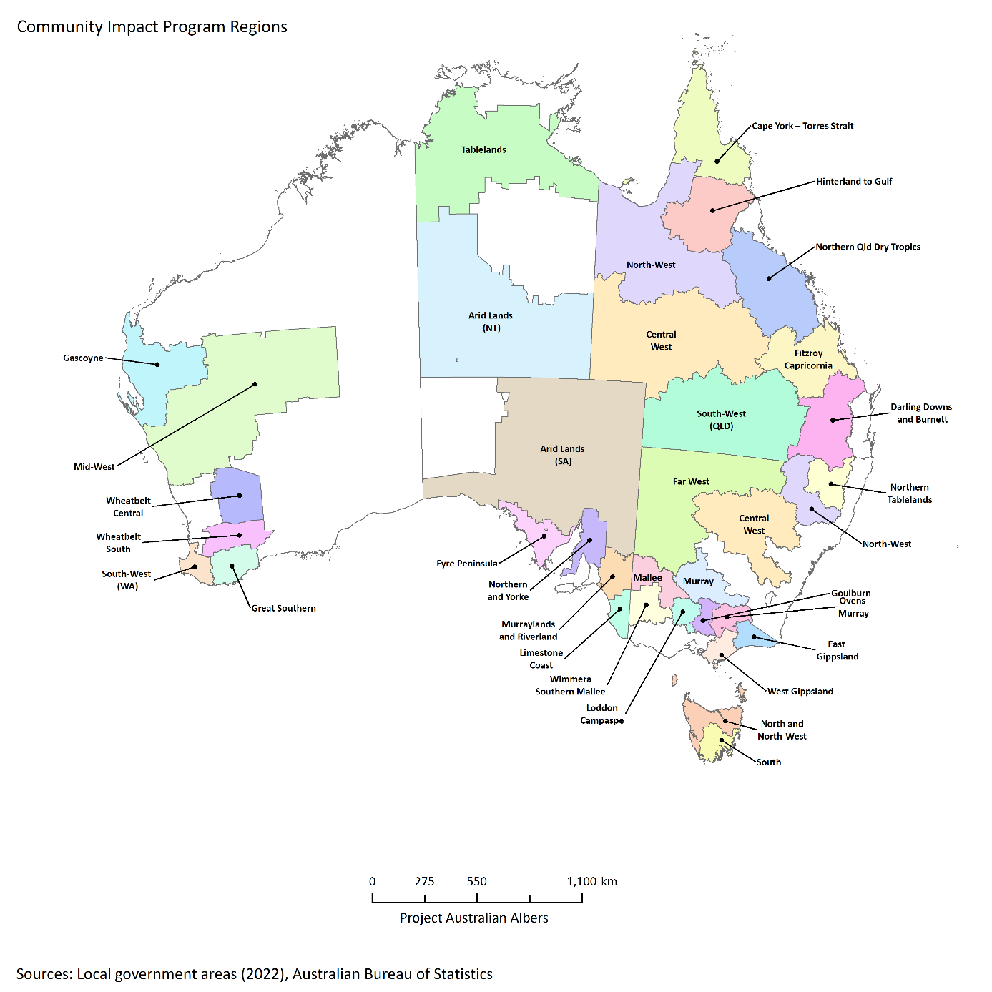
Note: Regions shown are those eligible at the launch of the program in September 2022.

Networks to Build Drought Resilience
The Networks to Build Drought Resilience program builds the capacity and capability of community organisations and networks to support drought preparedness. This program was delivered by the FRRR.
From 2021–22 to 2022–23, 88 out of a total of 93 funded projects were completed through the program. Projects assisted community organisations to build their capacity and capability, hold community events and strengthen ties across community networks. Five projects were discontinued, and the funds returned to FRRR. Grants were awarded across every state and territory and included funding for several First Nations organisations as well as projects to benefit rural youth and women.
The program provided events, education and support to strengthen community networks and social cohesion. It had a particular focus on supporting mental health and engaging with young people, First Nations community members and women in embracing a local approach to building drought resilience. The program also confirmed the importance of preparing for the social impacts of drought and being proactive in preparing for drought.
The program reached 37,841 participants across all projects. A total of $4.2 million in grants were awarded from FDF funding and contributions from FRRR’s donor partners.
The program concluded in December 2022, with FRRR submitting a final report in February 2023. Analysis of the report and of the lessons learnt have helped guide program design under the Helping Regional Communities Prepare for Drought Initiative.

Drought Resilience Leaders
The Drought Resilience Leaders program provides opportunities for individuals from agriculture-dependent communities in 12 regions to gain leadership knowledge and skills to support their communities to meet the challenges arising from drought and a changing climate. This program is delivered by the ARLF.
To 30 June 2023, the ARLF delivered leadership programs to 309 people in 12 regions. Participants learnt and shared knowledge across personal and community leadership, climate resilience and collaboration skills in order to work with their communities to prepare for the impacts of drought. COVID-19 posed some challenges with courses adapting to a mix of in-person and virtual sessions.
Participants in the leadership development course were also eligible to apply for Community Extension Grants, giving them an opportunity to apply the skills and knowledge developed through the course. Participants could elect to work on a community initiative individually, or collectively with some of their leadership cohort. From 2021–22 to 2022–23, 67 participants took up the opportunity, implementing 27 projects valued at a total of $268,000. These projects included workshops for women in rural communities and community field days to discuss drought adaptation strategies at a local level, and a community garden that brought community members together to share skills and experiences while tending to a communal facility.
A further 537 people were involved in the National Mentoring program component of the Drought Resilience Leaders program. Mentees were matched with a mentor for a 12-month learning course where participants shared knowledge and skills to build resilience in their communities. Another key aspect of the program was a series of 6 development webinars, designed to challenge thinking, provide new ideas and introduce new skills and knowledge.

Drought Resilience Leaders Mentoring Program participant quotes
‘I have had an amazing experience with my mentor and following the sessions. [The program] has been very helpful in my day-to-day work and made me a lot more confident in my role.’
‘My area of growth is that I feel more confident to be able to approach complex issues within my community. I have become more open to others’ opinions and ideas, and it has changed the way I look at leading others and am now working with my community to develop a community resilience workshop.’

Future Drought Fund administration
Strong governance arrangements are in place to support the effective administration of our programs (Figure 8).
Figure 8 Future Drought Fund administration
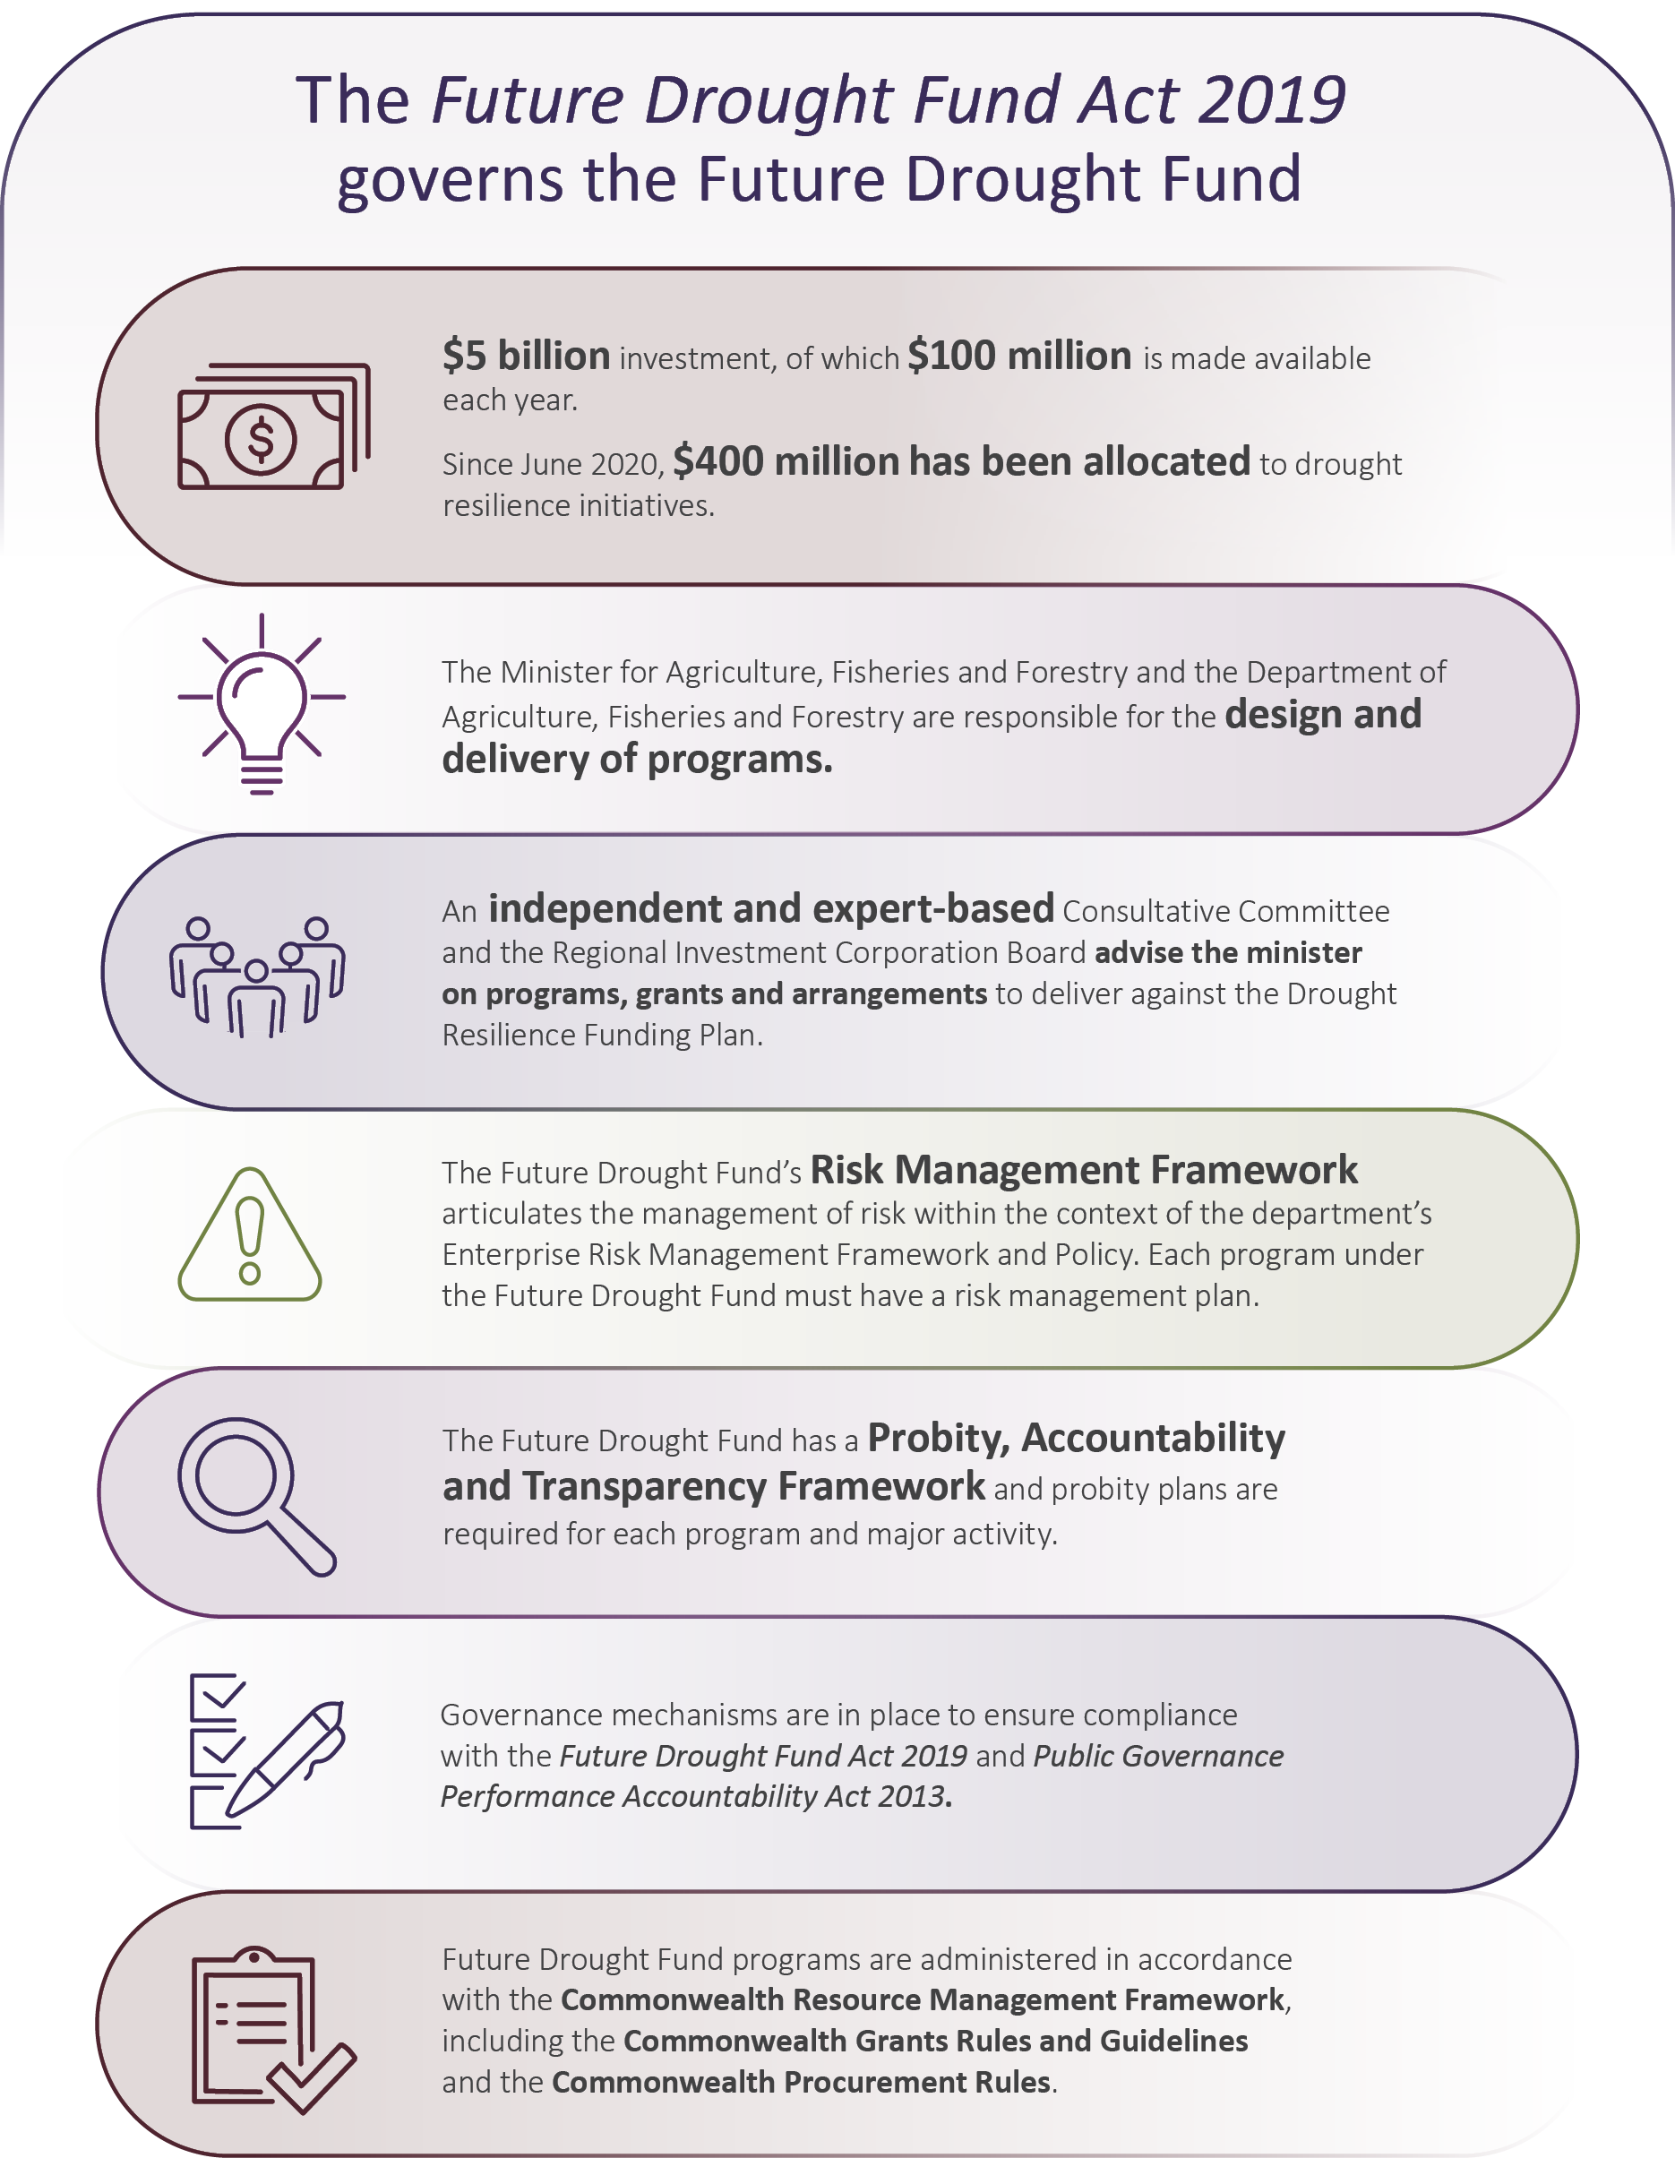

Governance

FDF Consultative Committee
Under the Future Drought Fund Act 2019, the minister must seek advice from the independent, expert-based FDF Consultative Committee on whether the design of each new program is consistent with the funding plan. In 2022–23, the committee was chaired by Mr Brent Finlay and membership included Dr Kate Andrews, Dr Wendy Craik AM, Dr Elizabeth Peterson and Ms Caroline Welsh.
The committee met 8 times to discuss the progress of FDF programs as they evolved and continued to monitor consistency with the funding plan. During this period, the committee focused on key priorities such as the sustainability of Australian agriculture, climate change, First Nations engagement and connecting with farmers. Photo 8 shows members of the committee when they came to Canberra to meet in April 2023.
Photo 8 FDF Consultative Committee
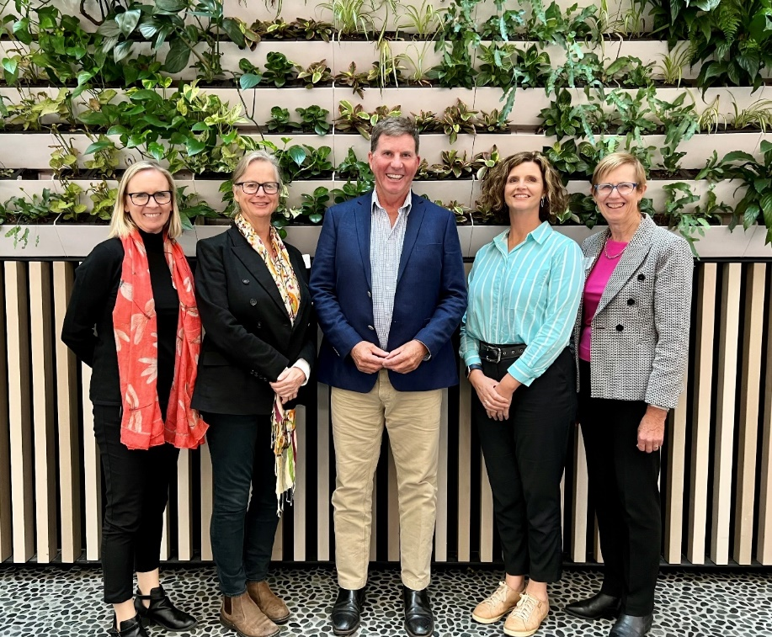
Note: FDF Consultative Committee Dr Elizabeth Petersen, Dr Kate Andrews, Mr Brent Finlay (Chair), Ms Caroline Welsh, Dr Wendy Craik AM (left to right).
Source: Sway Measham, Department of Agriculture, Fisheries and Forestry
The committee considered ways the FDF could focus on objectives such as better MEL practices, First Nations engagement and improving data management. As proud custodians of the FDF, members reflected on the funding plan’s principles and considered how climate change and Australia’s extreme weather events could influence the new funding plan. The committee also considered how an underspend of funds could be reallocated to complement the FDF, and they prepared a written submission to the Productivity Commission’s review.
As a central role, the committee, primarily through its chair, sustained regular engagement with stakeholders to discuss the FDF and hear a wide range of feedback on its activities. This included discussions with a range of representatives from agricultural and industry groups, universities, NRM, local community groups, the National Farmers’ Federation, research and development corporations, and local, state and territory governments. The committee held a joint meeting with the Drought Resilience Adoption and Innovation Hubs Advisory Committee on 16 June 2023. At this meeting, the hub directors provided the committees with an overview of each hub’s progress.

Drought Resilience Adoption and Innovation Hubs Advisory Committee
Mr Brent Finlay also chairs the Drought Resilience Adoption and Innovation Hubs Advisory Committee. The other members are Ms Caroline Welsh (also a member of the FDF Consultative Committee), Emeritus Professor James Rowe OAM, Mr Dale Park, Mr Trent De Paoli, Dr Christine Pitt and Professor Bronwyn Harch.
In 2022–23, the committee met 5 times to discuss and provide advice to the hubs on their on-ground activities, projects and approaches to strengthening partnerships and stakeholder relations. The committee has continued to focus on key strategic risks, innovation, cross-hub collaboration efforts and strengthening connections nationally, and performance, monitoring and evaluation. Professor Harch’s term of appointment ceased on 30 June 2023. Photo 9 shows members of the Drought Resilience Adoption and Innovation Hubs Advisory Committee with the Victoria hub Director during a Mildura visit in December 2022.
Photo 9 Drought Resilience Adoption and Innovation Hubs Advisory Committee
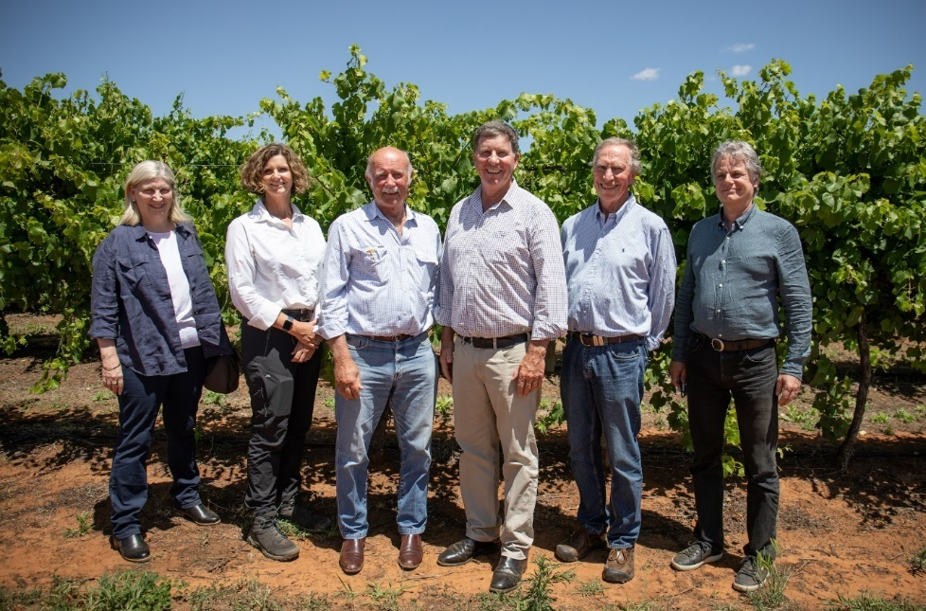
Note: Members of the Drought Resilience Adoption and Innovation Hubs Advisory Committee Professor Bronwyn Harch, Ms Caroline Welsh, Mr Dale Park, Mr Brent Finlay (Chair), Emeritus Professor James Rowe OAM with Professor Michael Tausz Victoria hub Director. Missing members Mr Trent De Paoli and Dr Christine Pitt.
Source: Kirrilly Allen, Department of Agriculture, Fisheries and Forestry

Program design and delivery
Design and funding of new drought resilience programs has been done progressively, in support of an adaptive approach to FDF delivery, informed by ongoing review, reporting, engagement and learning. Program design and delivery is guided by a 4-year Drought Resilience Funding Plan. Funding plans are subject to legislated review points, including:
- Productivity Commission review
- public consultation on the draft funding plan
- advice from an independent, expert-based Consultative Committee on the draft funding plan and proposed program design.
The programs in the first year, announced in conjunction with the 2020–21 Budget, were designed to be short term and set the stage for future programs. They accounted for the full $100 million available in 2020–21. The establishment of the hubs was also included in the 2020–21 Budget announcement as a longer-term program, with funding, out to 2023–24.
Second and third rounds of programs were announced in conjunction with the 2021–22 and 2022–23 Budgets, building on the first year’s programs. The new and extended programs consolidate the aims of the funding plan by embedding learnings of established programs.

Review and evaluation

Productivity Commission review
During 2022–23, the inaugural Productivity Commission review of the effectiveness of the FDF commenced on 10 January 2023. Required by the Future Drought Fund Act 2019, the purpose of the review was to inform the development of a new funding plan (2024 to 2028) and the design and delivery of a second phase of programs. An interim report was released on 13 June 2023 and stakeholders were provided an opportunity to provide feedback to the Productivity Commission. The department and the Consultative Committee provided submissions to the process. The final inquiry report is due to be released on 26 September 2023.

Monitoring, evaluation and learning
MEL is fundamental to the delivery of the FDF and its programs. The mid-term evaluation is a requirement of the FDF MEL Framework, which outlines the approach to monitoring and evaluation under the FDF. A mid-term evaluation of the funding plan (2020 to 2024) was conducted between September and December 2022, a little over 2 years into the funding plan’s implementation.
The mid-term evaluation was process orientated and considered the appropriateness, efficiency and effectiveness of programs implemented under the funding plan. The evaluation included a review of the 8 foundational programs, which commenced 1 July 2020, supplemented by a deeper dive into the 3 programs:
- Natural Resource Management Drought Resilience
- Drought Resilience Leaders
- Networks to Build Drought Resilience.
Programs approved after 1 July 2020 were only partially in scope, included to assess alignment with the funding plan.
The evaluation found that progress toward program implementation and delivery had been substantial. It highlighted opportunities to continue to work toward the intent of the funding plan in the remaining 2 years and into the next funding plan.
In 2022–23, the department continued to improve MEL processes across the FDF and its programs. Achievements included:
- developing tailored reporting templates for FDF programs, such as final reporting templates for the Innovation Grants program Proof of Concept and Ideas Grant projects and a new project MEL plan template for the Drought Resilience Soils and Landscapes grantees
- hosting MEL workshops with the Drought Resilience Soils and Landscapes grantees in November and December 2022 and the extension and adoption grantees in June 2023
- improving the FDF MEL progress reporting templates and the program and project MEL Plan templates, with different iterations based on the size and complexity of individual projects
- streamlining the reporting processes and reducing reporting replication for grantees by incorporating MEL requirements into other key program requirements such as the activity work plan template
- continuing to develop MEL plans in preparation for new programs such as the Drought Resilience Scholarship program.

Consultation and engagement
The FDF has a variety of consultation and engagement processes to ensure stakeholders are aware of FDF activity and can inform improvements to the FDF, including the design and delivery of programs (Figure 9).
Figure 9 Future Drought Fund consultation and engagement
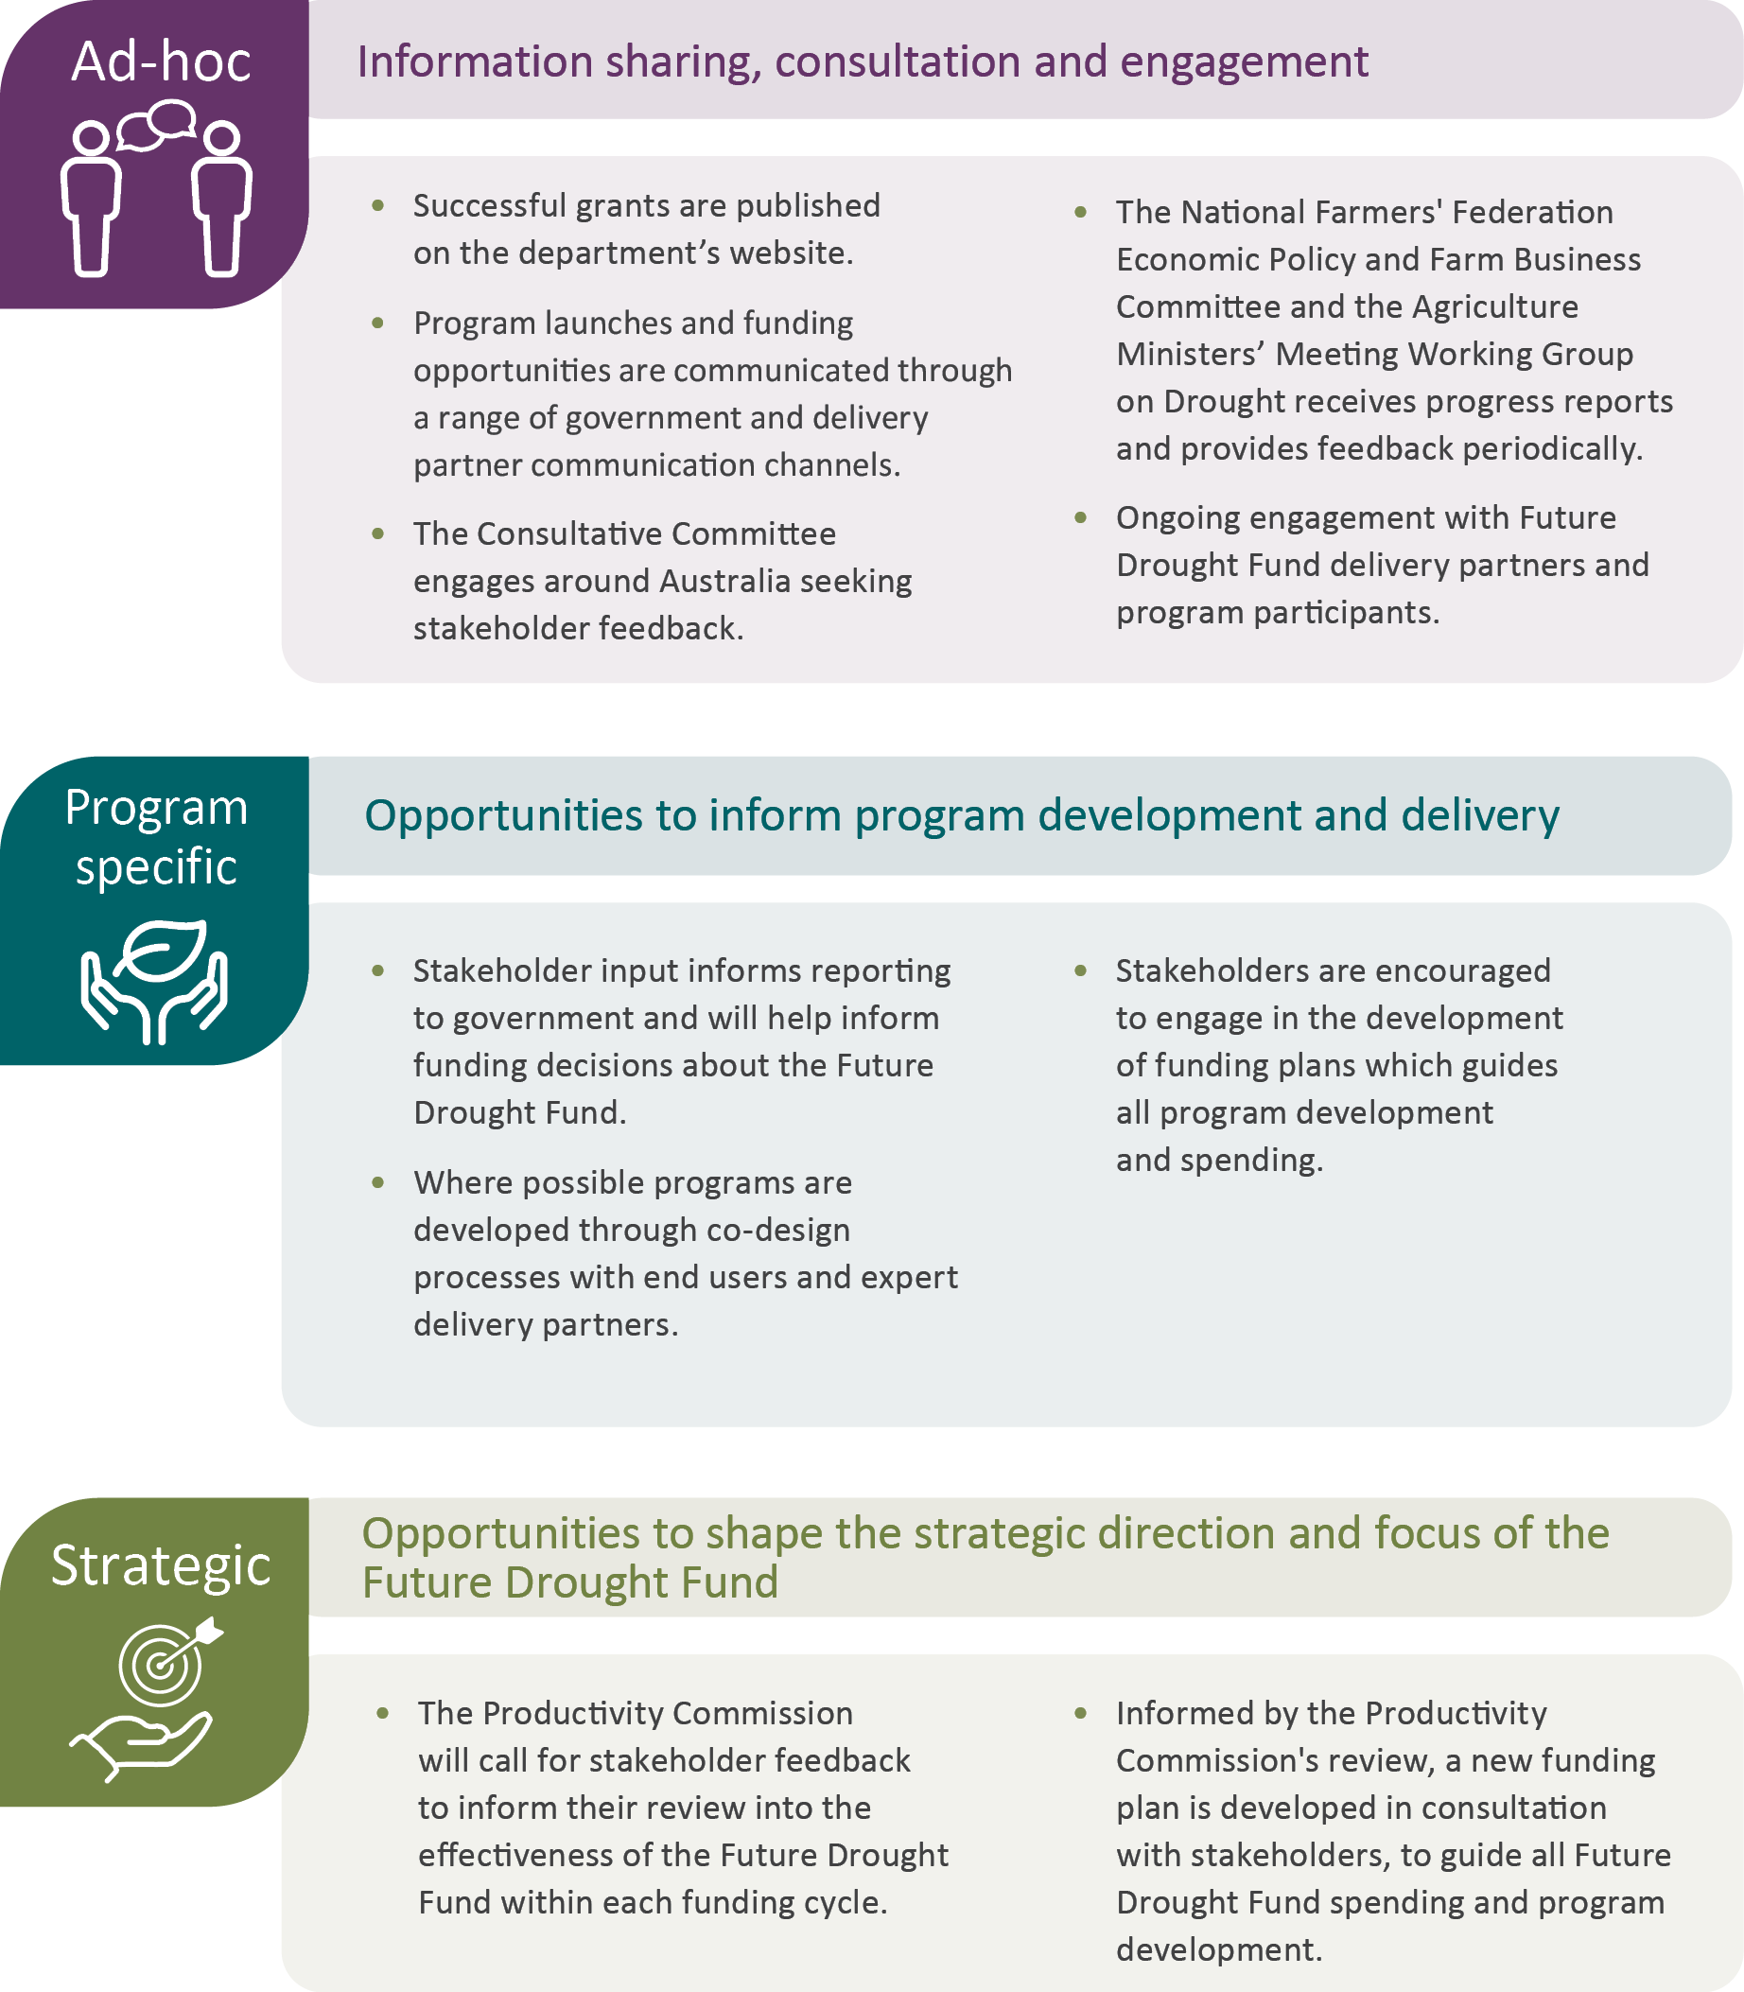

Funding
Since June 2020, the government has allocated a total of $400 million to FDF programs.
In 2022–23, $99.8 million was spent from the FDF. A total of $229.76 million was spent from 1 July 2020 to 30 June 2023. Unspent funds from 2022–23 were moved to 2023–24 to continue to meet existing contractual arrangements and reallocated to projects within the FDF as needed.
Table 17 Funding allocation, 30 June 2023
Theme and programs | Total allocated ($) | Total spent ($) | 2020–21 spent ($) | 2021–22 spent ($) | 2022–23 spent ($)
Better climate information | 38,991,000.00 | 28,702,470.81 | 5,030,802.09 | 12,656,052.58 | 11,015,616.14
Climate Services for Agriculture | 28,991,000.00 | 19,711,193.36 | 3,590,802.09 | 8,796,109.40 | 7,324,281.87
Drought Resilience Self-Assessment Tool | 10,000,000.00 | 8,991,277.45 | 1,440,000.00 | 3,859,943.18 | 3,691,334.27
Better planning | 116,818,000.00 | 46,137,545.41 | 25,817,735.00 | 262,983.64 | 20,056,826.77
Farm Business Resilience Program | 75,965,000.00 | 25,624,878.00 | 15,965,120.00 | 0.00 | 9,659,758.00
Regional Drought Resilience Planning | 40,853,000.00 | 20,512,667.41 | 9,852,615.00 | 262,983.64 | 10,397,068.77
Better practices | 203,347,000.00 | 126,181,193.27 | $23,013,815.97 | $46,837,017.92 | 56,330,359.38
Drought Resilience Adoption and Innovation Hubs ª | 66,000,000.00 | 50,000,000.00 | 16,000,000.00 | 18,000,000.00 | 16,000,000.00
Hub Projects | 4,097,216.50 | 4,097,216.50 | 0.00 | 0.00 | 4,097,216.50
Adoption Officers | 9,000,000.00 | 6,000,000.00 | 0.00 | 3,000,000.00 | 3,000,000.00
National Enabling Activities ª | 7,886,783.50 | 1,622,258.92 | 220,462.80 | 814,631.31 | 587,164.81
Drought Resilience Innovation Grants | 33,961,000.00 | 23,859,153.85 | 0.00 | 18,820,517.50 | 5,038,636.35
Natural Resource Management Drought Resilience Program – Grants | 7,807,000.00 | 7,806,394.46 | 1,170,959.17 | 6,635,435.29 | 0.00
National Resource Management Drought Resilience Program – Landscapes | 5,600,000.00 | 5,622,394.00 | 5,622,394.00 | 0.00 | 0.00
Drought Resilience Soils and Landscapes | 23,130,000.00 | 20,109,558.95 | 0.00 | 2,566,433.82 | 17,543,125.13
Extension and Adoption of Drought Resilience Farming Practices | 14,265,000.00 | 6,264,000.00 | 0.00 | 0.00 | 6,264,000.00
Drought Resilience Long Term Trials | 20,000,000.00 | 0.00 | 0.00 | 0.00 | 0.00
Drought Resilience Commercialisation Initiative | 10,000,000.00 | 0.00 | 0.00 | 0.00 | 0.00
Drought Resilience Scholarships | 1,600,000.00 | 800,000.00 | 0.00 | 0.00 | 800,000.00
Better prepared communities  Helping Regional Communities Prepare for Drought Initiative | 40,844,000.00 | 28,694,890.00 | 11,196,015.00 | 5,003,985.00 | 12,494,890.00
Drought Resilient Leaders | 17,450,000.00 | 13,008,856.00 | 7,446,015.00 | 1,003,985.00 | 4,558,856.00
Networks to Build Drought Resilience | 23,394,000.00 | 15,686,034.00 | 3,750,000.00 | 4,000,000.00 | 7,936,034.00
Total | 400,000,000.00 | 229,716,099.49 | $65,058,368.06 | $64,760,039.14 | 99,897,692.29
a. Total allocated for these two programs have changed since the previously published annual reports, due to Future Drought Fund underspends being reallocated in 2023–24.

Glossary
Term | Definition
ARLF | Australian Rural Leadership Foundation
Bureau | Bureau of Meteorology
CSA | Climate Services for Agriculture
CSIRO | Commonwealth Scientific and Industrial Research Organisation
Consultative Committee | Future Drought Fund Consultative Committee
DAFF | Department of Agriculture, Fisheries and Forestry
DR.SAT | Drought Resilience Self-Assessment Tool
drought resilience | The ability to adapt, reorganise or transform in response to changing temperature, increasing variability and scarcity of rainfall and changed seasonality of rainfall, for improved economic, environmental and social wellbeing.
FDF | Future Drought Fund
FRRR | Foundation for Rural and Regional Renewal
funding plan | Drought Resilience Funding Plan 2020–2024
hub | Drought Resilience Adoption and Innovation Hub
MEL | Monitoring, evaluation and learning
NRM | Natural resource management
Productivity Commission | The Australian Government’s independent research and advisory body on a range of economic, social, and environmental issues affecting the welfare of Australians.
RDEA&C | Research, development, extension, adoption and commercialisation

References
ABS 2021, Local Government Areas, Australian Bureau of Statistics, Canberra, accessed 9 July 2024.
DAFF 2021, Future Drought Fund Drought Resilience Funding Plan 2020 to 2024, Department of Agriculture, Water and the Environment, Canberra, April, accessed 20 January 2024.
——2022, Future Drought Fund Annual Report 2021–22, Department of Agriculture, Fisheries and Forestry, Canberra, November, accessed 10 April 2024.
DAWE 2020, Future Drought Fund Monitoring, Evaluation and Learning Framework, Department of Agriculture, Water and the Environment, Canberra, December, accessed 15 March 2024.
——2021, Future Drought Fund Annual Report 2020–21, Department of Agriculture, Water and the Environment, Canberra, October, accessed 10 January 2024.
Productivity Commission 2023, Review of Part 3 of the Future Drought Fund Act, Australian Government, accessed 29 October 2024.
RDAMR 2022, The Murraylands and Riverland Plan, Regional Development Australia Murraylands and Riverland, South Australia, June, accessed 18 March 2024.

