Future Drought Fund annual report 2023–24
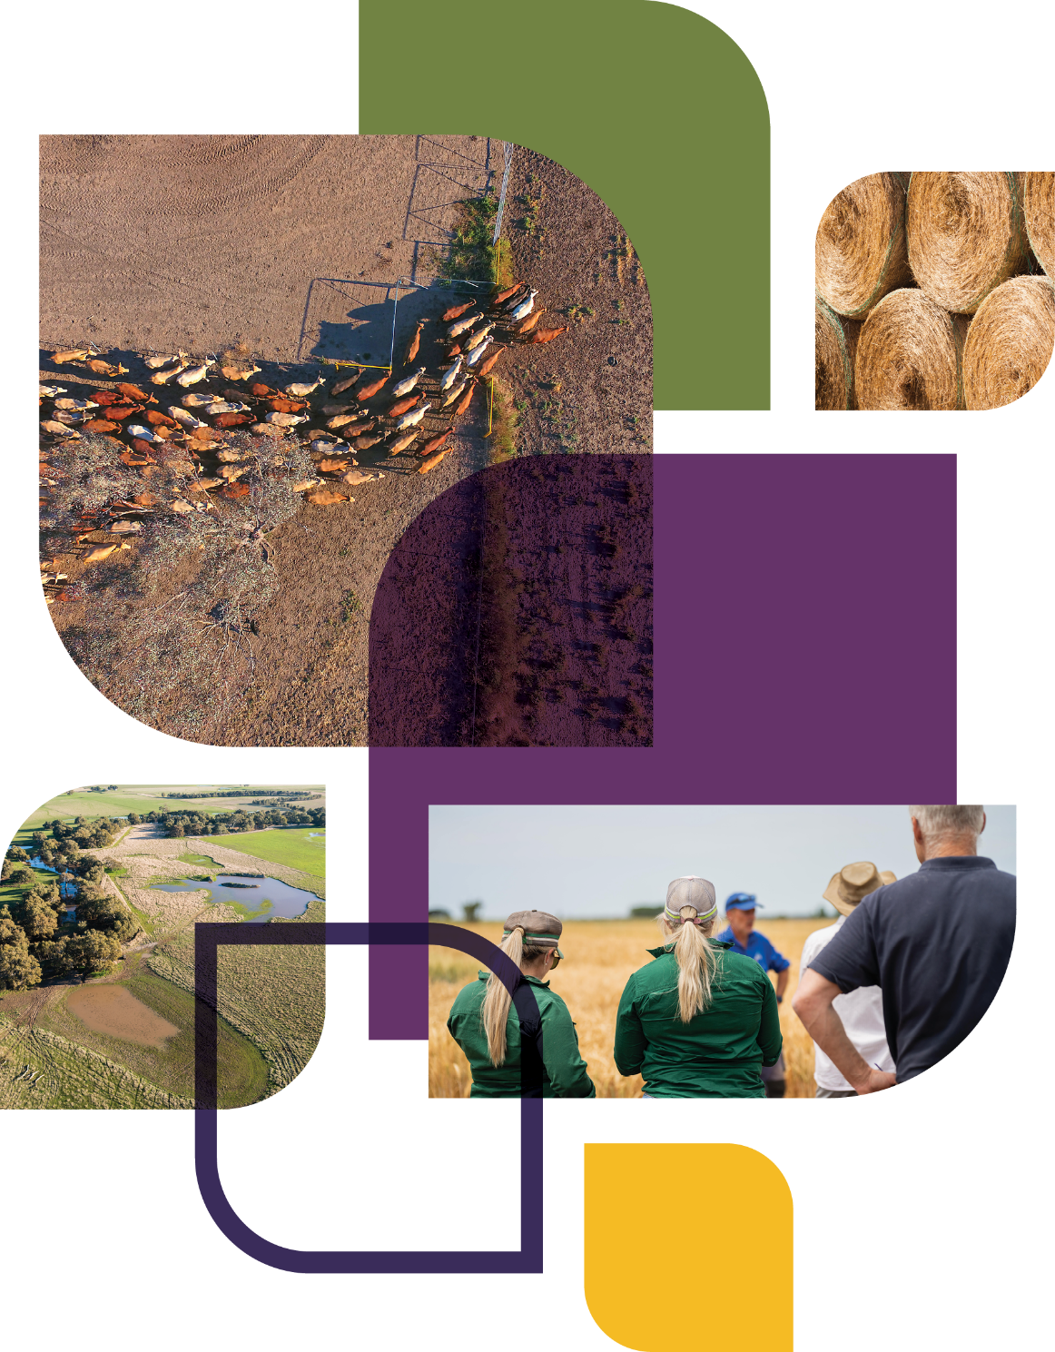
© Commonwealth of Australia 2025
Ownership of intellectual property rights
Unless otherwise noted, copyright (and any other intellectual property rights) in this publication is owned by the Commonwealth of Australia (referred to as the Commonwealth).
Creative Commons licence
All material in this publication is licensed under a Creative Commons Attribution 4.0 International Licence except content supplied by third parties, logos and the Commonwealth Coat of Arms.

Cataloguing data
This publication (and any material sourced from it) should be attributed as: DAFF 2025, Future Drought Fund annual report 2023–24, Department of Agriculture, Fisheries and Forestry, Canberra, February. CC BY 4.0.
This publication is available at agriculture.gov.au/agriculture-land/farm-food-drought/drought/future-drought-fund.
Department of Agriculture, Fisheries and Forestry
GPO Box 858 Canberra ACT 2601
Telephone 1800 900 090
Web agriculture.gov.au
Disclaimer
The Australian Government acting through the Department of Agriculture, Fisheries and Forestry has exercised due care and skill in preparing and compiling the information and data in this publication. Notwithstanding, the Department of Agriculture, Fisheries and Forestry, its employees and advisers disclaim all liability, including liability for negligence and for any loss, damage, injury, expense or cost incurred by any person as a result of accessing, using or relying on any of the information or data in this publication to the maximum extent permitted by law.
Acknowledgements
The authors thank interview and case study participants for their input and ongoing engagement with the Future Drought Fund. We would also like to acknowledge our diverse range of key stakeholders for their enduring support.
Acknowledgement of Country
We acknowledge the continuous connection of First Nations Traditional Owners and Custodians to the lands, seas and waters of Australia. We recognise their care for and cultivation of Country. We pay respect to Elders past and present, and recognise their knowledge and contribution to the productivity, innovation and sustainability of Australia’s agriculture, fisheries and forestry industries.

Foreword
We have reached an exciting milestone for the Future Drought Fund (FDF) with 2023–24 marking the end of the first 4-year funding cycle. This is an opportunity to reflect on the achievements of the fund since it began in 2020, and to consider how we can enhance the FDF’s work in the next phase.
We welcomed the Productivity Commission’s inquiry report on the effectiveness, efficiency and appropriateness of the FDF in September 2023. The report provided recommendations that will inform the direction of investment and activities over the next 4 years. These recommendations consider opportunities to improve drought resilience programs and the overall operation of the fund, as well as opportunities to include broader climate resilience and enhance engagement with, and benefits for, First Nations peoples. Work on addressing the recommendations started on the day the report was released with the announcement of First Nations representation on the FDF Consultative Committee.
A highlight of 2023–24 was the publication of the new Drought Resilience Funding Plan, which came into effect in February 2024. The FDF Consultative Committee was delighted to consult with stakeholders across Australia in late 2023 to hear valuable feedback on the draft funding plan and investment strategy. Stakeholders reiterated the importance of a people-centred and place-based approach that emphasises the needs of local communities. The FDF is for everyone in Australia, so it’s important that it’s reflective of diverse perspectives and lived experiences. Your input helps make sure we’re getting it right. On behalf of the Consultative Committee, I thank everyone who took the time to provide considered and generous feedback.
Another exciting step forward for the FDF was the Australian Government’s 2024–25 Budget announcement committing $519.1 million in May 2024 for the second phase of the fund. I am excited that this funding supports a longer-term focus to ensure rural and regional communities have what they need to plan for future drought.
The FDF is continuing to support on-the-ground initiatives helping to build drought resilience across Australia. This year’s annual report outlines the fund’s progress during 2023–24 and reflects on the achievements of the last 4 years. Whilst we have made considerable progress during the first phase of the FDF, we are excited to continue building on this success as we begin to roll out the second phase of investment.


Brent Finlay
Chair
Future Drought Fund Consultative Committee
Contents
Foreword iii
Highlights vii
Introduction 1
Future Drought Fund investment programs 3
Achievements – 2020 to 2024 5
Better climate information 7
Climate Services for Agriculture 8
Drought Resilience Self-Assessment Tool 10
Better planning 11
Farm Business Resilience 11
Regional Drought Resilience Planning 15
Better practices 20
Adoption and Innovation – Drought Resilience Adoption and Innovation Hubs 23
Adoption and Innovation – National Enabling Activities 26
Drought Resilience Innovation Grants 27
Natural Resource Management Drought Resilience 27
Drought Resilient Soils and Landscapes 27
Extension and Adoption of Drought Resilience Farming Practices Grants 29
Long-term Trials of Drought Resilient Farming Practices 29
Drought Resilience Commercialisation Initiative 29
Drought Resilience Scholarships 30
Science to Practice Forum 32
Better prepared communities 33
Helping Regional Communities Prepare for Drought Initiative 34
Community Impact Program 35
Small Network Grants 36
National Mentoring Program 37
National Learning Network 37
National Expertise Pool 37
Future Drought Fund administration 38
Governance 39
Program design and delivery 40
Productivity Commission review 41
Developing a new funding plan and investment strategy 42
Monitoring, evaluation and learning 44
Funding 46
Looking to the future 48
Appendix A: Funding tables 50
References 51

Tables
Table 1 Better climate information – program information 7
Table 2 Better climate information – progress and performance, 2020–21 to 2023–24 7
Table 3 Climate Services for Agriculture – achievements and next steps, 2023–24 8
Table 4 Drought Resilience Self-Assessment Tool – achievements and next steps, 2023–24 10
Table 5 Farm Business Resilience – program information 11
Table 6 Farm Business Resilience – progress and performance, 2020–21 to 2023–24 11
Table 7 Farm Business Resilience – achievements and next steps, 2023–24 11
Table 8 Regional Drought Resilience Planning – program information 15
Table 9 Regional Drought Resilience Planning – progress and performance, 2020–21 to 2023–24 16
Table 10 Regional Drought Resilience Planning – achievements and next steps, 2023–24 16
Table 11 Better practices – program information 20
Table 12 Better practices – progress and performance, 2020–21 to 2023–24 20
Table 13 Better practices – achievements and next steps, 2023–24 22
Table 14 Better prepared communities – program information 33
Table 15 Better prepared communities – progress and performance, 2020–21 to 2023–24 33
Table 16 Better prepared communities – achievements and next steps, 2023–24 34
Table 17 Future Drought Fund funding allocation, 30 June 2024 46
Table 18 Priority funding areas for the Future Drought Fund from 2024–25 48

Table A1 Links to Future Drought Fund funding information 50
Figures
Figure 1 About the Future Drought Fund 2
Figure 2 Future Drought Fund investment themes and programs 4
Figure 3 Achievements, 2020 to 2024 6
Figure 4 Agricultural commodities included in climate tools 9
Figure 5 Farm Business Resilience program participants by industry 12
Figure 6 Regional Drought Resilience Planning – stakeholder engagement, 2023–24 18
Figure 7 Future Drought Fund administration 38
Figure 8 Stakeholder consultation on the second phase of the Future Drought Fund 44
Maps
Map 1 Regional Drought Resilience Planning – participating regions 17
Map 2 Drought Resilience Adoption and Innovation Hub locations 23
Map 3 Community Impact Program regions 36
Case studies
Case study 1 Adviser uses My Climate View with drought-affected sheep farmer 9
Case study 2 Grapegrower uses Climate Services for Agriculture as a basis for future actions 9
Case study 3 Navigating change: A farmer’s tale of resilience 14
Case study 4 Mixed farmers Simon and Kate 15
Case study 5 Drought Ready Tasmania Forum – informing regional drought resilience planning 18
Case study 6 Regional Drought Resilience Planning in north-western New South Wales 19
Case study 7 Drought hubs delivering for farmers 25
Case study 8 University of New England Drought Resilient Pasture and Landscapes Project 28
Case study 9 Nuffield Scholar for 2024, Caitlin Herbert 31
Photos
Photo 1 Simon Nuske and Kate Cooke 15
Photo 2 Jaimi-lee Edwards 28
Photo 3 Caitlin Herbert 32
Photo 4 Future Drought Fund Consultative Committee 39

Highlights
In its fourth year, the Future Drought Fund (FDF) has continued to support farmers and communities across Australia, helping to build drought resilience for the agricultural sector and regional areas.
We recognise that Australia’s changing climate is likely to mean more frequent, longer lasting and intense droughts. 2023–24 was Australia’s second warmest year on record. Although rainfall was above average for parts of northern Australia, it was the lowest on record for south-western Western Australia, south-eastern South Australia, south-western Victoria and northern Tasmania (ABS 2024). This year we have continued to drive a considerable program of work to support farmers and regional communities to prepare for and manage future droughts.
Our highlights for 2023–24 included:
- finalising the Future Drought Fund (Drought Resilience Funding Plan 2024-2028) Determination 2024, which came into effect on 9 February 2024
- commencing new programs, including Long-term Trials of Drought Resilient Farming Practices ($40 million) and the Drought Resilience Commercialisation Initiative ($10 million)
- welcoming the findings of the Productivity Commission’s review into Part 3 of the Future Drought Fund Act 2019
- reallocating approximately $17.71 million across FDF programs to take early action to address the Productivity Commission’s findings
- inviting stakeholders to have their say on the funding plan and investment strategy for the FDF over a 6-week period from 20 October to 6 December 2023
- announcing the new independent FDF Consultative Committee in September 2023
- launching the Drought Ready Network.
This annual report is an opportunity to reflect the achievements of 2023–24 and the first 4 years of operation, but we are also looking ahead to the design and implementation of the second phase of funding. In May 2024 the Australian Government announced a commitment of $519.1 million over the next 8 years to deliver this next phase, starting from 2024–25.
Learn more about the next phase of the Future Drought Fund and how to get involved.

Introduction
The Australian Government is committed to implementing policies and programs that support the Australian agricultural sector and communities to adapt to drought and climate risks, ensuring they can continue to prosper and grow into the future.
The FDF is an investment by the government to build resilience to drought and climate risks in Australia’s agricultural sectors, landscapes and communities. The FDF focuses on working alongside, and in partnership with, a range of stakeholders including primary producers, government, non-government organisations, industry representatives, First Nations peoples, agricultural advisers and researchers. This is a commitment to enhancing the public good for all Australians.
A key aspect of drought resilience under the Drought Resilience Funding Plan 2024 to 2028 is the ability to adapt, reorganise or transform in response to changing temperature, increasing variability and scarcity of rainfall and or changed seasonality of rainfall, for improved economic, environmental and social resilience.
Building drought and climate resilience is a complex and long-term endeavour. Resilience does not have a simple definition or measurement and is unlikely to have an endpoint. Resilience is context dependent and has different consequences for each person, farm, community and agricultural landscape impacted by drought. This is why holistic, tailored and practical interventions are required to increase drought resilience – there is no ‘one-size-fits-all approach’.
Additionally, climate change is driving an increase in the frequency and severity of climatic events, including drought. More frequent and severe droughts are one of the many impacts of climate change that farmers and regional communities need to prepare for, respond to and recover from. This means that building drought resilience requires an ability to adapt and respond effectively to a continuously changing context, across economic, social and environmental domains.
For these reasons, FDF investments are focused on building economic, social and environmental resilience, through better resources, practices and capabilities. These investments will enable farmers, agribusinesses, communities and others to make better decisions about how to best manage the risks and impacts of droughts for their context.
Drought and climate resilience initiatives paid for out of the fund are managed by the Department of Agriculture, Fisheries and Forestry and delivered by a range of delivery partners across Australia.
Figure 1 About the Future Drought Fund
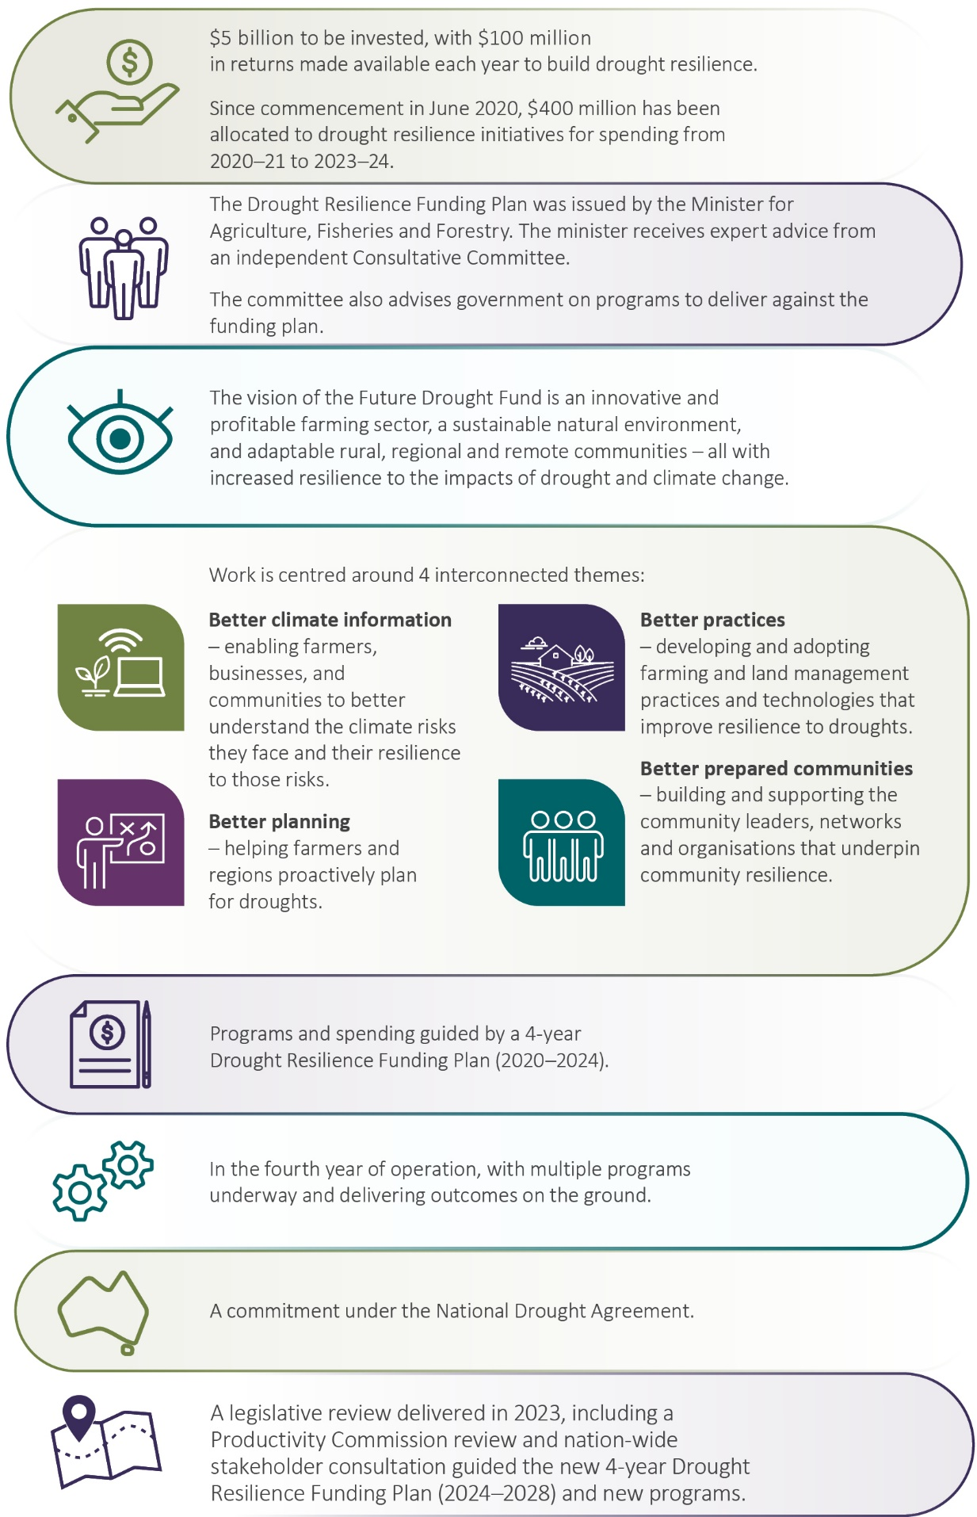

Future Drought Fund investment programs
The 2023–24 financial year marked the fourth year of FDF investment – a milestone year that finalised the first phase of the FDF. Spending focused on existing programs as well as the implementation of several new programs.
In October 2023 the government announced the reallocation of $17.71 million to progress essential activities and ensure continuity of the Drought Resilience Adoption and Innovation Hubs and Climate Services for Agriculture program, through to June 2025. This meant sustained access for farmers and communities to valuable information and services while evaluation and planning is undertaken for these programs, to ensure the settings are right to build long-term drought resilience.
Throughout the first phase of the FDF our programs centred on 4 themes (Figure 2) and contributed to the 3 strategic objectives of economic, environmental and social resilience to drought detailed in the Drought Resilience Funding Plan 2020 to 2024.
Figure 2 Future Drought Fund investment themes and programs
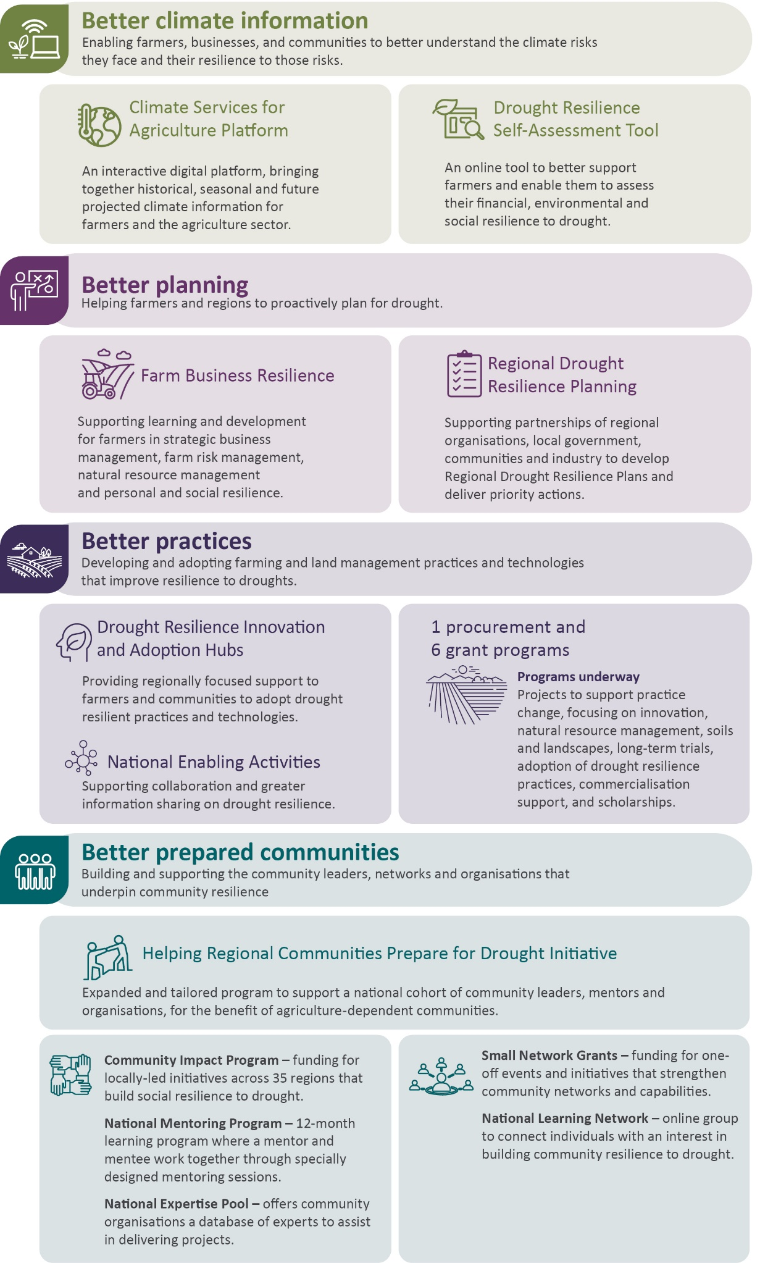

Achievements – 2020 to 2024
Since its inception 4 years ago, the FDF has made a significant contribution to bolstering Australia’s drought and climate resilience. The fund is supporting farmers and communities by providing access to climate tools, fostering resilient farming practices, encouraging proactive planning and promoting regional leadership and networks. These efforts have collectively strengthened the capacity of rural and regional communities to withstand and adapt to drought conditions.
Over the last 4 years:
- $400 million has been allocated from the FDF to drought resilience initiatives during the first phase. At 30 June 2024, $340.09 million had been spent, with unspent funding returned to the FDF for reallocation to new and existing FDF programs.
- 16 programs have been rolled out to support better climate information, drought planning, practices and prepared communities.
- My Climate View’s regional and commodity specific climate information has been accessed by over 26,000 people. This tool is helping farmers, farm advisers, businesses and communities better understand the climate risks they face and their resilience to those risks.
- More than 37,000 farmers have benefited from business and risk management learning and development activities.
- 69 regions are at various stages of drought resilience planning.
- 8 Drought Resilience Adoption and Innovation Hubs are providing regionally focused support with over 125 on-ground projects, including 5 collaborative cross-hub projects.
- Over 180 additional projects are supporting development, demonstration and extension of drought resilient practices, including long-term trials.
- 289 organisations and more than 1,000 people have been supported to access leadership opportunities and drive locally led actions to build community drought resilience.
- 5 Drought Resilience Scholarships have been awarded.
Figure 3 Achievements, 2020 to 2024
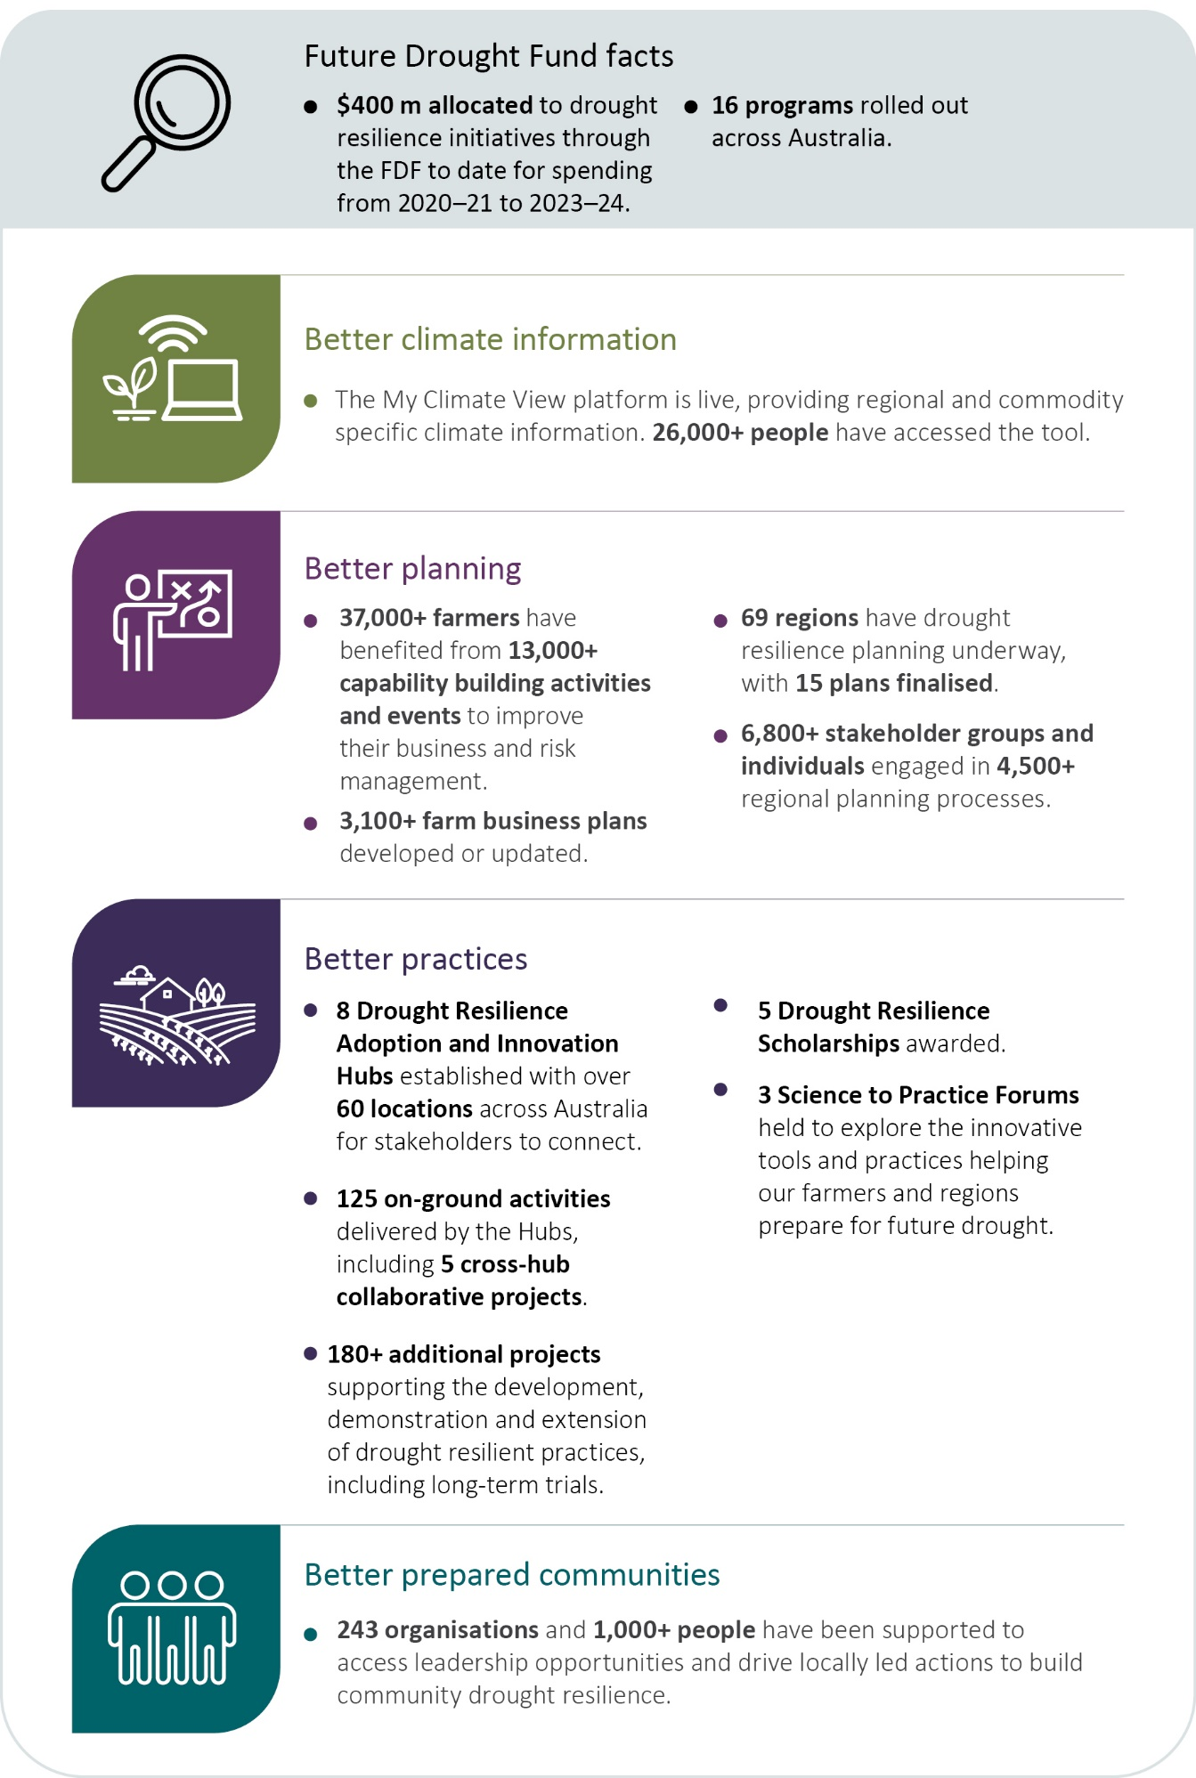

Better climate information
Enabling farmers, businesses and communities to better understand the climate risks they face and their resilience to those risks.
Table 1 Better climate information – program information
Strategy | Establish new authoritative national capabilities that make climate information accessible and useful for understanding climate risk and resilience
Aim | Farmers, agribusinesses and communities use the new national capabilities to understand climate risks, resilience and adaptation pathways and to inform action
How this will support drought resilience | Farmers, businesses and communities that better understand their climate risks, resilience and adaptation pathways are more likely to take action to manage drought risk
Success measures | - Climate information capabilities are used and valued by the target audience (CI 1)  - Users take action in response to the improved information and understanding (CI 2)  - Climate services platform and self-assessment tool are scientifically rigorous (CI 3)
CI Climate information.
Table 2 Better climate information – progress and performance, 2020–21 to 2023–24
Year | Measure | Result
2020–21 | Release of digital prototype of the Climate Services for Agriculture (CSA) platform | Met – see 2020–21 annual report
 | Release of web-based Drought Resilience Self-Assessment Tool (DR.SAT) prototype | Met – see 2020–21 annual report
 | Four pilot regions selected as a basis for further development of the capabilities | Met – see 2020–21 annual report
2021–22 | (CI 1) User numbers and experiences measured from reference group feedback and web statistics (CSA and DR.SAT prototypes) | Met – see 2021–22 annual report
 | (CI 1) Evidence of co-design process | Met – see 2021–22 annual report
2022–23 | (CI 1) FDF-level survey to gauge and extend reach, and to help set target reach | CSA: met. DR.SAT: not met. See 2022–23 annual report
 | (CI 2) FDF-level survey to gauge actions taken in response to improved information from CSA and DR.SAT | CSA: met. DR.SAT: not met. See 2022–23 annual report
 | (CI 3) Peer review has validated further platform development for CSA, including impact insights and adaptation opportunities | Met – see 2022–23 annual report
2023–24 | (CI 1, CI 2, CI 3) Program case studies and commissioned studies explore and assess reasons, drivers and barriers around farmers’ use of the CSA platform and DR.SAT | Met – see case studies 1 and 2
 | (CI 1, CI 2) Evaluation: CSA and DR.SAT are valued and used to base local and regional agricultural resilience decisions and related actions on. | Expected completion early 2025
 | (CI 1) Follow-up feedback web survey taken to capture engaged user reactions, interest and likely use of the tools on CSA | Met
 | (CI 2) Train-the-trainer activities rolled out to address barriers for interpreting and using long-term climate information among service providers | Met
 | (CI 3) Social science research published in peer-reviewed journals and commodity indices reviewed by industry experts (e.g. tomatoes, irrigation, mangoes and bananas) | Met
 | (CI 1, CI 2, CI 3) Program narratives and studies collected that explore reasons, drivers and barriers around potential users of My Climate View | Met
CI Climate information.

Climate Services for Agriculture
Table 3 Climate Services for Agriculture – achievements and next steps, 2023–24
Achievements | Next steps
Launch of the rebranded My Climate View tool in July 2023 | Co-design with farmers, advisers, agricultural communities and state and territory governments will continue to inform future enhancements and developments, to ensure the tool is fit for purpose.
$4.8 million in reallocated funding announced in October 2023 to continue the program until 30 June 2025 | Early progress will be made to address the Productivity Commission’s recommendation to investigate elements of greatest value in Drought Resilience Self-Assessment Tool that could be integrated into the Climate Services for Agriculture program.
Fifth product release in November 2023 with 2 new commodities added (pork and tomatoes), for a total of 22 key Australian commodities included in the tool | Co-design activities with First Nations communities and organisations will continue across the Northern Territory to identify potential opportunities for the tool to benefit communities in this region.
Sixth product release in March 2024 to allow users to compare past and projected monthly rainfall and temperature | Future product releases will be informed by end user feedback and needs.
Trusted relationships with First Nations communities in the Tropical Savannah region are being built and co-design activities are gaining momentum | Nil
Approximately 16,800 new users and 4,291 return users of My Climate View from July 2023 to June 2024. Over 26,000 new users in since 2021 | Nil
The Climate Services for Agriculture (CSA) program has been co-designed with farmers and the agricultural sector to provide climate projections for specific commodities at a local scale via the free online platform My Climate View.
My Climate View offers regionally relevant, commodity specific climate information for every location in Australia. The information relates to 22 key Australian commodities and includes climate data from the past (1961 to 2023), seasonal forecasts (1 to 3 months into the future), and climate projections for 2030, 2050 and 2070.
The program aims to build drought resilience by enabling users to anticipate future climate conditions, compare those conditions with historical climate records, and consider potential impacts on the food and fibre products they produce. The information can assist farmers to adapt their medium and longer-term plans and production strategies to prepare for future drought and climate change. Its intended users include farmers, farm advisers, agricultural industry bodies and government policy makers. It is being developed by CSIRO and the Bureau of Meteorology.
Figure 4 Agricultural commodities included in climate tools
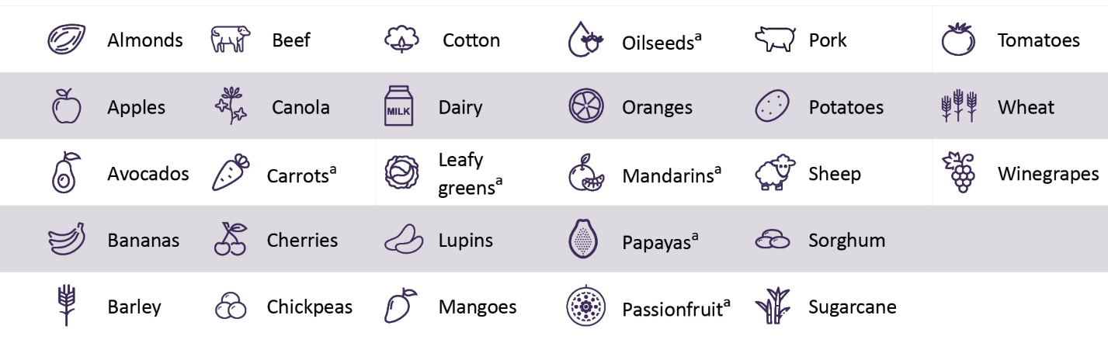
a Commodities included in the Drought Resilience Self-Assessment Tool only.
Case study 1 Adviser uses My Climate View with drought-affected sheep farmer
An adviser in the Northern South Australia node of the South Australian Drought Resilience and Adoption Hub (SA Drought Hub) had a client, who is a sheep farmer, who recently experienced several bad years in a row. The client was starting to wonder whether these difficult years were becoming normal and was concerned about the longevity of their business.
The adviser had heard about an upcoming CSA Train-the-Trainer workshop at the SA Drought Hub and invited the farmer to attend.
After the workshop, the adviser and the farmer met to discuss the farmer’s situation. They used My Climate View to look at the climate and seasonal projections in the farmer’s area to see where the farmer could adapt and to identify what their options could be long-term.
The customer engagement staff on the CSA program followed up with the adviser several weeks after the workshop. The adviser said they’d found the tool useful for talking with the farmer and are looking at other situations to use the tool. As a result, the adviser is subsequently working on a project proposal for the SA Drought Hub that will use CSA data to inform decision-making about future farming systems in very marginal farming areas.
Case study 2 Grapegrower uses Climate Services for Agriculture as a basis for future actions
A grapegrower – with 25 acres in the South Burnett region of Queensland and 23 years of experience working in wine – was interviewed by CSA’s social science team about perceived climate risks, use of CSA and use of forecasts and technology in decision-making.
The grower felt that CSA and its My Climate View platform affirmed the existing research they had conducted independently and considered CSA to be a useful basis for future actions. The grower commented: ‘[CSA] is affirming what I believe. I believe in climate change, and I believe things will get worse before they get better. How viable is this business going to be in 20 years considering all this stuff?’
‘The reason why I’m really excited by what I can see here [in My Climate View] is that I spend a lot of time on different websites … trying to find all this information, but being able to go to one place and it’s all correlated with all the data that I want to look at is really exciting.’
The grower highlighted that by using CSA to understand the changing frost risk, they can be confident that their pruning schedule can allow for the best chance of a quality crop by the end of the season. ‘The frost risk [on My Climate View] is something I’ve never seen before. I normally make judgement calls based on forecasts and what the observed weather patterns are – but [CSA] could mitigate risks.’
CSA was also used by the grower to reflect on future business viability, particularly considering drying conditions. ‘COVID had a really strong effect on our business. People got out and started exploring their backyard a bit more and they’ve kept those habits. So I’m under a lot of pressure to increase our production from the vineyard. If we’ve got no water left in the dam and we’re seeing more of these hot dry conditions [looking at the CSA website], then we won’t be able to increase production.’

Drought Resilience Self-Assessment Tool
Table 4 Drought Resilience Self-Assessment Tool – achievements and next steps, 2023–24
Achievements | Next steps
1,268 Drought Resilience Self-Assessment Tool (DR.SAT) user accounts were created over the life of the program. 114 of these accounts set resilience goals. | On 24 June 2024, DR.SAT was decommissioned. Work is underway to investigate elements of greatest value of DR.SAT that could be integrated into the Climate Services for Agriculture program.
341 users accessed the ‘Public pathways’ in DR.SAT, where no account login was required. | Nil
The Drought Resilience Self-Assessment Tool (DR.SAT) was a free resilience self-assessment tool that offered farmers the opportunity to undertake farm-scale resilience assessments in financial, personal, social and environmental indicators. DR.SAT was developed to be a holistic tool for end users to find resources and information across multiple resilience areas.
DR.SAT was contracted until June 2024 and was decommissioned following the finalisation of the contract. Following recommendations from the Productivity Commission review in 2023, the department is currently exploring if any elements from DR.SAT could be integrated into the CSA program.

Better planning
Helping farmers and regions to proactively plan for drought.

Farm Business Resilience
Table 5 Farm Business Resilience – program information
Strategy | Build the capacity of farmers to plan for and manage risks, including drought
Aim | A step-change in the use of farm business management skills to proactively manage drought risks
How this will support drought resilience | Farmers who have better business management skills and plan for risks are more likely to take actions that help sustain farm business productivity and profitability in times of drought
Success measures | - Increase in business management skills and confidence of farmers to manage risk (RM 1)  - Increase in farm business plans that consider drought risks (RM 2)  - Increase in number of farmers taking actions to manage risk, including drought (RM 3)
RM Risk management.
Table 6 Farm Business Resilience – progress and performance, 2020–21 to 2023–24
Year | Measure | Result
2020–21 | All states and territories agree to partner with the Australian Government and design programs | Met – see 2020–21 annual report
2021–22 | (RM 1, RM 2) Number of participants, training and other learning events and farm performance assessments | Met – see 2021–22 annual report
 | (RM 2) Number of farm business plans developed or updated and professionally reviewed | Met – see 2021–22 annual report
 | (RM 1, RM 2, RM 3) Change in participant surveys and farm performance assessments | Met – see 2021–22 annual report
 | (RM 1, RM 3) Case studies selected for monitoring post participation | Met – see 2021–22 annual report
2022–23 | (RM 1, RM 2, RM 3) As in 2021–22, monitoring of case studies | Met – see 2022–23 annual report
2023–24 | (RM 1, RM 2, RM 3) As in 2022–23, monitoring of case studies | Met
 | (RM 1, RM 2, RM 3) End-of-program evaluation | Expected completion early 2025
RM Risk management.
Table 7 Farm Business Resilience – achievements and next steps, 2023–24
Achievements | Next steps
37,446 farmers have taken part in the program in all jurisdictions across Australia | Continuing to roll out support to reach as many as 43,000 farmers by 2025
13,277 learning and development activities and events held | Expanding to more industries and more learning areas, including First Nations primary producers. Harnessing program achievements for the broader public good, by encouraging greater peer to peer and community knowledge sharing
- 2,467 farm business plans reviewed or advised on by a professional during their development  - 3,148 farm business plans completed (new plans developed or existing plans updated)  - 3,860 farm performance assessments completed | Active follow-up support for past participants to refresh learning, review business plans and monitor action
Note: Figures are from program commencement to 30 June 2024. This may include duplication due to some instances where individuals attend multiple events and were not uniquely recorded.
The Farm Business Resilience program aims to build the capacity of farmers to plan for and manage risks associated with drought and climate change. The program is delivered in partnership with state and territory governments under a national framework adapted for local needs and context and to leverage existing initiatives. Farmers (including managers and employees) have access to subsidised learning and development opportunities in areas such as strategic business skills, risk management, natural resource management (NRM), and personal and social resilience. A key benefit of the program is allowing participants the opportunity to develop farm plans tailored to their individual circumstances and then seek feedback from industry professionals on these plans.
Since its foundational year in 2021, over 37,000 farmers have benefited directly from the program and it continues to attract a wide network of farmers across more than 18 agricultural industries, as highlighted by Figure 5. In 2023–24 beef and dairy farmers continued to have strong representation amongst participants, in part due to the success of the program in leveraging and building upon existing initiatives delivered via government and industry such as Dairy Australia’s Our Farm, Our Plan program.
Figure 5 Farm Business Resilience program participants by industry
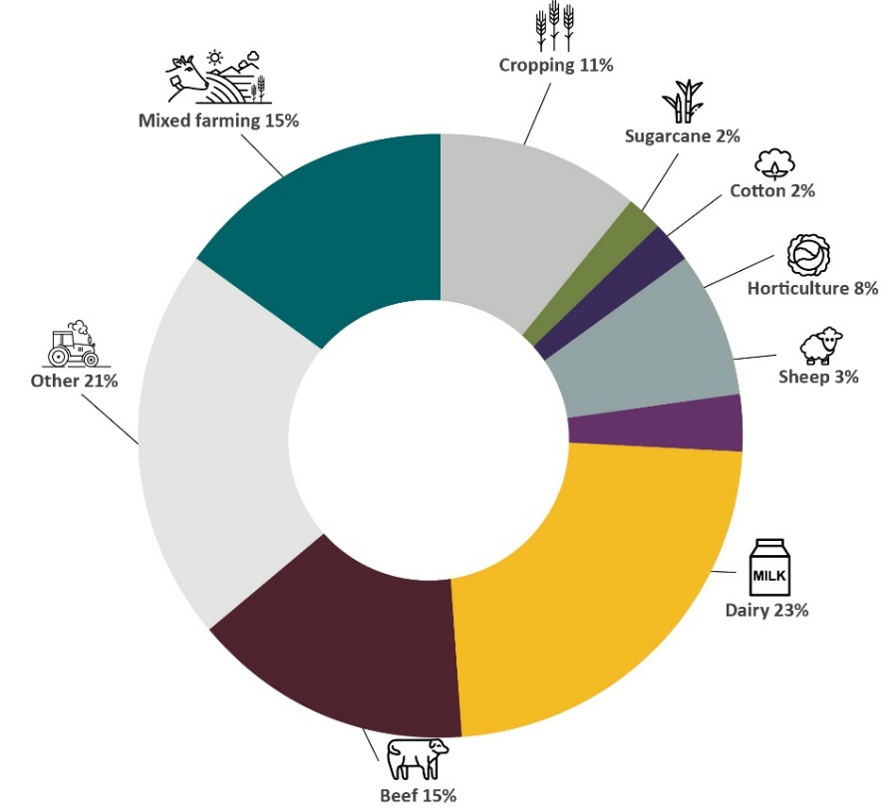
Note: Other includes other livestock such as pigs, poultry and eggs, aquaculture, apiculture and unknown. Sheep includes wool and meat.
The program has received overwhelmingly positive feedback so far, with participants using the skills and knowledge learnt to make changes to their farming practices. This has resulted in a reported improved ability to manage business risks, specifically the financial, human and environmental aspects of drought and climate risks.

Farm Business Resilience program highlights
In New South Wales 85% of participating farmers said they intended to make specific changes to their business management in the future. Over 78% of participants indicated they were likely to change their behaviour because of the event they attended. Over 96% of participants identified taking major steps in the past 12 months to prepare for bad years.
In Tasmania 76% of dairy participants indicated that they found the Farm Fitness Checklist which helps farmers to assess their farm performance, very or extremely useful. Around 59% reported improved business preparedness to manage drought, while 54% reported better risk management as a result of participating.
In Victoria over 93% agreed that engaging in group activities with other farmers supported them to increase their knowledge and skills, with 71% saying that they had joined or stayed connected with farming or community networks since completing program activities. Over 96% intend to adopt or implement changes to improve their farm business resilience.
In the Australian Capital Territory 100% of participants have drought planning and resilience built into their business plans, while reporting greater understanding of successful business management and increased confidence to make decisions around drought risk. One participant said, ‘The program has transformed our approach from reactive to proactive, instilling a sense of resilience that permeates every aspect of our operation.’
The program has emphasised targeting new cohorts such as young farmers and female farmers to build their skills and knowledge. For example, in the ACT, 3 targeted social network groups have been established – the Young Farmers Network, Women in Agriculture (Chicks in the Sticks) and the Grazing Group. These groups meet on a regular basis to share knowledge and experience and engage with external training providers and guest speakers to discuss and learn about drought and climate resilience topics.
The program’s aim to reach First Nations farmers and Traditional Landowners has continued in 2023–24. In Western Australia, 5 targeted Indigenous Business Training streams have been developed to provide tailored support to a range of Aboriginal primary industry businesses. These include Aboriginal Pastoral Academy, Indigenous Aquaculture Capacity Building, Indigenous Sandalwood Country Regeneration, Indigenous Regenerative Agriculture and Indigenous Bushfoods Business Support.
In 2024 the Queensland Department of Agriculture and Fisheries was nominated for, and subsequently won, the government category of the Queensland 2024 Resilient Australia Awards for the Farm Business Resilience program. The award was based on program’s collaborative design with industry, alongside its holistic risk management and planning approach that considers drought and other disaster impacts within the context of overall environmental, economic and social sustainability aspects of a farming business.
The impact of the program beyond participation continues to be a key focus as part of the aim to encourage long-term resilience. By checking in with past participants, producers can share stories and examples of changes they’ve made that are leading to transformational change. Actively following up affords the opportunity to see how additional training or coaching could benefit farmers, while continuing to offer support.
Case study 3 Navigating change: A farmer’s tale of resilience
Fred and his family have weathered many storms on their farm, both literal and metaphorical. Yet, it was the Farm Business Resilience program that brought about some of the most impactful changes they’ve seen in their operation.
The program was guided by Farm Business Coach, Stuart Goodfellow. The mentorship prompted them to hold regular business meetings, a practice that proved invaluable for aligning everyone’s efforts, setting clear goals and addressing challenges head-on. These meetings are now the cornerstone of their business strategy, fostering better communication and accountability among team members.
Understanding cash flow management was another key takeaway from the program. While there’s always room for improvement, Fred and his family now have a better grasp of their financials, allowing them to anticipate and mitigate cash flow issues, especially during tough times like droughts. They've also adapted their pricing strategies to better reflect market dynamics while maintaining profitability.
Their stance on drought and resilience underwent a profound shift, evolving from reactive to proactive. Through the program, they developed contingency plans and invested in infrastructure like a new hay shed, enhancing their ability to weather dry spells and manage their land more effectively.
Reflecting on their overall experience, Fred and his family highlight the program’s positive impact on their business management skills and communication within the family. While they encountered challenges and competing priorities, the program equipped them with the tools to navigate these obstacles with confidence.
Among the highlights were the opportunities to learn new management techniques, access expert advice and strengthen their resolve as a family unit. They now see farm business planning as an ongoing process, essential for guiding their operations and fostering long-term sustainability.
Their perspectives on learning and coaching remain steadfast, recognising the value of continuous improvement and seeking guidance when needed. Moving forward, they emphasise the importance of cash flow projections, adaptive planning and proactive management in sustaining their business.
In Fred’s words, ‘The program has transformed our approach from reactive to proactive, instilling a sense of resilience that permeates every aspect of our operation.’
Case study 4 Mixed farmers Simon and Kate
Simon Nuske and Kate Cross own a cropping and livestock farm in Dimboola, Vic. They signed up to the Farm Business Resilience program to improve their business management and finance skills, on-farm infrastructure and learn new practices to improve their farm.
Simon and Kate developed a farm plan to prioritise their business goals. ‘I think that, as farmers, you generally have a lot of ideas that are floating around in your head. To put pen to paper and structuralise was really important for us moving forward for the sustainability of our business.’
The program also supported Simon and Kate to appreciate what is within and outside their control, ‘Climate is a big factor and it's something that's in the back of your mind always. So, you've got to learn and work with it, you can't work against it.’
Simon and Kate appreciated the opportunity to engage with, and learn from, other farmers in the surrounding area. ‘I think that we had a great range of age groups, people starting out in businesses, running different operations. We're always looking for new ways to improve ourselves and the business.’
Photo 1 shows Simon and Kate on their Dimboola farm. Hear more about Simon and Kate’s experience in the program.
Photo 1 Simon Nuske and Kate Cooke
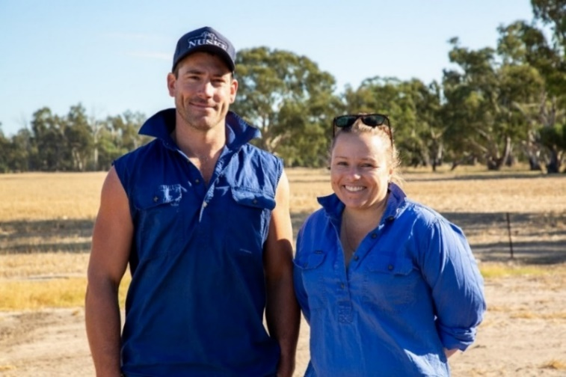
Source: Agriculture Victoria

Regional Drought Resilience Planning
Table 8 Regional Drought Resilience Planning – program information
Strategy | Establish drought resilience plans across agricultural regions, based on evidence and collaboration, to drive proactive management of drought risks
Aim | Regional drought resilience plans drive decisions, actions and investments to proactively manage drought risks
How this will support drought resilience | Informed and planned action to manage drought risks at a regional scale will support resilience of the region’s economy, farmers, businesses, communities and the landscape
Success measures | - Increase in number of agricultural regions that have drought resilience plans (RM 4)  - Plans have buy-in from key stakeholders in the region (RM 5)  - Plans are informed by relevant data, co-design and best practice approaches to resilience planning (RM 6)  - Plans are implemented (RM 7)
RM Risk management.
Table 9 Regional Drought Resilience Planning – progress and performance, 2020–21 to 2023–24
Year | Measure | Result
2020–21 | All states and territories agree to partner with the Commonwealth and design detailed programs | Met – see 2020–21 annual report
2021–22 | (RM 4, RM 6) Number of plans commenced drafted, assessed, approved and published | Met – see 2021–22 annual report
 | (RM 5) Number and extent of stakeholder engagements in planning processes | Met – see 2021–22 annual report
 | (RM 5, RM 6, RM 7) Case studies selected for monitoring post-planning (for example, stakeholder buy-in and implementation) | Met – see 2021–22 annual report
2022–23 | (RM 4, RM 5, RM 6, RM 7) As in 2021–22, monitoring outputs, independent assessments and implementation | Met – see 2022–23 annual report
 | (RM 4, RM 6) Extent to which plans identify and respond to key risks | Met – see 2022–23 annual report
 | (RM 5, RM 6) Extent to which stakeholders co-designed or partnered in planning (qualitative via independent assessments, surveys) | Met – see 2022–23 annual report
 | (RM 7) Number of plans implemented (grants or other means) | Partially met – see 2022–23 annual report
 | (RM 4, RM 5, RM 6, RM 7) Interim evaluation | Partially met – see 2022–23 annual report
2023–24 | (RM 4, RM 5, RM 6, RM 7) As in 2022–23, monitoring outputs, surveys and independent assessments, implementation and case studies | Met
 | (RM 4, RM 5, RM 6, RM 7) End-of-program evaluation | Expected completion early 2025
RM Risk management.
Table 10 Regional Drought Resilience Planning – achievements and next steps, 2023–24
Achievements | Next steps
- 69 regions participating across Australia  - 3,731 stakeholder groups and individuals engaged in planning process  - 2,309 planning, consultation and engagement activities informed plan development | Planning continues in regions in early 2024–25, with most to be completed by December 2024.
- 24 draft plans reviewed by CSIRO  - 15 plans finalised and published | Remaining plans to be reviewed in 2024–25.
Jurisdictions progressing processes for administering implementation grants to regions with finalised plans | Grants to support regions to implement priority actions in their plans to be available through 2024–25.
The Regional Drought Resilience Planning (RDRP) program, delivered in partnership with state and territory governments, supports regions to develop drought resilience plans to drive proactive management of drought risks. Plans are community led and owned through partnerships between local governments, regional organisations, community and industry. The program also provides funding to kick-start the implementation of actions identified in regional plans. Final plans are published online to enable regions to share learnings.
The program’s 69 participating regions are listed at Regional Drought Resilience Planning and shown in Map 1. By 2023–24 the program covered the majority of agricultural regions across Australia with potential for more regions to be added over time.
Map 1 Regional Drought Resilience Planning – participating regions
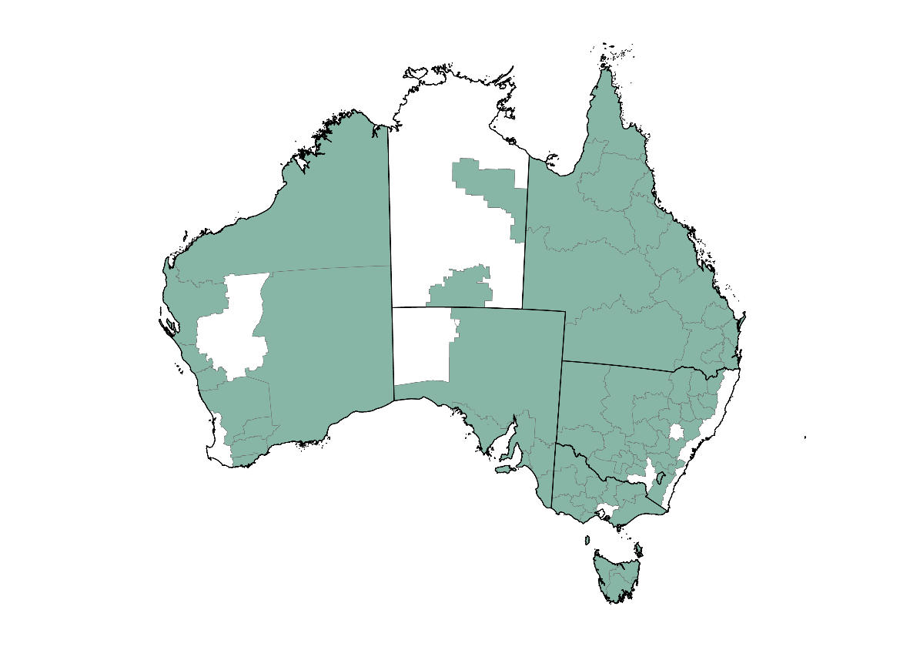
Note: Current at November 2024. Changes or additions to regions may occur over the course of the Regional Drought Resilience Planning program (see Regional Drought Resilience Planning).
Source: Local government areas (ABS 2021)
Following the 12-month extension of the program in 2022–23 (to 30 June 2025), consultation with agricultural communities to inform plans has continued, with 3,731 stakeholder groups and individuals participating in 2,309 consultation and engagement activities across Australia in 2023–24.
Consultation on draft plans has been extensive and input has been diverse (Figure 6). Some of the most represented stakeholders continue to be local governments, First Nations peoples, community service organisations, farming groups and agriculture representative bodies. Input was sought through a wide range of forums – from large community led meetings, regional summits and online surveys, to more personal interactions such as kitchen table conversations and one-on-one interviews.
Figure 6 Regional Drought Resilience Planning – stakeholder engagement, 2023–24
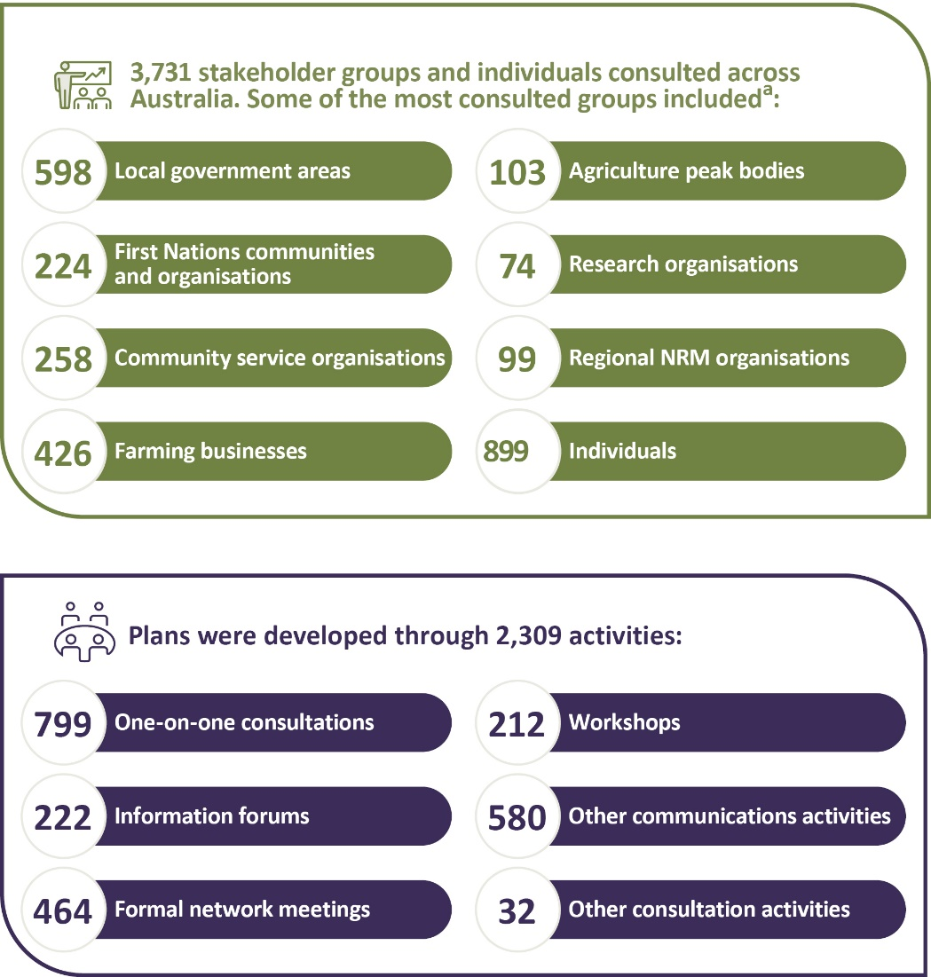
a Efforts have been made to reduce duplication of stakeholder counts, but some stakeholders who have engaged across multiple jurisdictions may be double counted.
CSIRO provided expert feedback on 24 plans throughout 2023–24. This process enables best practice and learnings to be applied across Australia and ensures regions are well-placed to tackle the risk of future droughts. CSIRO also developed a guide on drought resilience planning, informed by current resilience thinking, principles and leading practices. This guide is being used as a basis for their reviews of draft plans and to help build the knowledge of those planning ‘on the ground’ in the regions.
In 2023–24 many regions completed their plans with a total of 15 plans finalised under the program and published at Regional Drought Resilience Planning. These regions are now moving towards implementing the actions and priorities within their plans.
Case study 5 Drought Ready Tasmania Forum – informing regional drought resilience planning
In November 2023 the Tasmanian Government hosted the state’s first Drought Ready Forum, the first stakeholder event as part of the RDRP program in Tas.
The forum brought together stakeholders from across the state to share experiences and knowledge of the impacts of drought on the state’s economy and environment, to discuss business preparedness strategies, and how the state can build business and social resilience capacity. The event was a key component of the early community engagement and knowledge sharing work of the RDRP program.
The event was attended by NRM professionals including James Stronach, the Land Program Manager of NRM South, and Tom O’Malley, regional agriculture Landcare facilitator with Cradle Coast NRM.
Both James and Tom agreed that the value of the event lay in bringing organisations and people with a different focus, different perspectives to share knowledge and experience and find common objectives and a collective understanding. James appreciated the opportunity for drought experienced regions to share their knowledge with less experienced areas, which are potentially more vulnerable to drought, as well as the value of having government representatives in the room – the people directing decisions about drought funding.
James said, ‘A drought resilient Tasmania for me looks like a community that's able to adapt, able to understand what's happening and able to support each other and understand strategically where they're trying to get to’.
Following on from the forum, work has continued in Tasmania’s regional communities to develop regional drought resilience plans for the northern, southern and north-western regions of the state. Data analysis of regional drought risk and resilience reports has been undertaken to inform robust drought and related climate impact reports for the 3 plans, looking at the current and future prevalence, severity and impacts of drought along with vulnerability and gaps in preparedness for drought. Local governments, regional organisations, community and industry will share their ideas and experiences, and result in plans with practical, locally-tailored actions to prepare for future droughts.
Case study 6 Regional Drought Resilience Planning in north-western New South Wales
Belinda Colless, Drought Plan Coordinator for the NSW Far North West Joint Organisation, leads the coordination for the development of 2 regional drought resilience plans (Bourke-Brewarrina-Walgett-Cobar and Coonamble-Warren-Bogan Council groups).
Belinda said, ‘When the opportunity to become a part of the Far North West Joint Organisation’s team to deliver the regional drought resilience plan, it was actually quite exciting because drought is one of those things that, unfortunately the climate and the country that we live in, it is a part of our life.’
‘The RDRP program is really an exciting time for communities to take control of, and to examine, what has happened in the past with drought historically.’
‘It is a good opportunity for communities to be involved in having a say about what happens in their own community. What we've seen happen in the past is that a crisis occurs, and when people are under crisis and there's pressure, it's very, very difficult to think straight about what it is that you're doing and how to manage things.’
‘Within this area and the 7 local government areas that I will be working with, I hope that we will elevate community champions who will then take stock of taking that plan forward and if you know a plan is always a living document, it doesn't have an end date. But for it to be that living document, we need to make sure that we have those champions on board that are going to take it to NSW Farmers … that are going to keep it front of mind for politicians and policymakers going forward into the future.’

Better practices
Developing and adopting farming and land management practices and technologies that improve resilience to droughts.
Table 11 Better practices – program information
Strategy | Improve the drought resilience of agricultural landscapes and drive the development, extension, adoption and commercialisation of drought resilient technologies and practices
Aim | A step-change in:  - awareness, acceptance and adoption of drought resilient land management practices among farmers and other land managers  - the development, adoption and commercialisation of drought resilience technologies and practices
How this will support drought resilience | The careful management of natural capital and uptake of new technologies and practices can make agricultural landscapes and agricultural businesses more resilient to drought, enabling productivity and profitability to be sustained during and following droughts
Success measures | - Increased availability and accessibility of, and capacity to use and adopt, knowledge that can be applied to improve drought resilience (HI 1)  - Increased land managers trialling and adopting land management practices (LM 1)  - Increased adoption and commercialisation of drought resilience technological practices (HI 2)  - Strengthened collaborative networks between farmers and other land managers to support increased adoption of drought resilience land management practices (LM 2)  - Adopted technologies and land management practices are effective in improving drought resilience (HI 3, LM 3)  - Design and delivery of hub activities is responsive to end user needs (HI 4)
HI Harnessing innovation. LM Land management.
Table 12 Better practices – progress and performance, 2020–21 to 2023–24
Year | Measure | Result
2020–21 | Establish 8 Drought Resilience Adoption and Innovation Hubs | Met – see 2020–21 annual report
 | Hold inaugural Science to Practice Forum | Met – see 2020–21 annual report
 | 80 NRM projects funded following competitive processes | Met – see 2020–21 annual report
2021–22 | (HI 1) Drought Resilience Research and Adoption Investment Plan delivered | Met – see 2021–22 annual report
 | (HI 4) Hub partnership arrangements are embedded, and co-designed activity plans in place | Met – see 2021–22 annual report
 | (HI 1, HI 2) Number and nature of activities to support research, development, extension, adoption and commercialisation (RDEA&C) and uptake by end users | Met – see 2021–22 annual report
 | (HI 1) Attendance at annual Science to Practice Forum | Met – see 2021–22 annual report
 | (LM 1) Grantees’ baseline data and targets for change in land management practices | Met – see 2021–22 annual report
 | (LM 1, LM 2) Numbers and types of services (activities) in grantees’ activity plans | Met – see 2021–22 annual report
 | (LM 2) Number of land managers and other stakeholders engaged through grantees’ activities | Met – see 2021–22 annual report
 | (LM 3) Grantees’ baseline data and early evidence of biophysical impacts of project activities (that is, improvement in natural capital health and resilience) | Met – see 2021–22 annual report
 | 26 Drought Resilient Soils and Landscapes projects funded following competitive processes | Met – see 2021–22 annual report
 | 44 Drought Resilience Innovation projects funded following competitive processes | Met – see 2021–22 annual report
2022–23 | (HI 1) Hub linkages in the innovation system | Met – see 2022–23 annual report
 | (HI 2, HI 3, HI 4) Uptake of the Drought Resilience Research and Adoption Investment Plan priorities by hubs and research organisations | No longer applicable, see 2021–22 annual report
 | (HI 1) Improvement in end user access to RDEA&C information | Met – see 2022–23 annual report
 | (HI 1, HI 2) Number of activities to support RDEA&C uptake by end users | Met – see 2022–23 annual report
 | (HI 1) Attendance at Science to Practice Forum | Met – see 2022–23 annual report
 | (HI 1, LM 1, HI 2, LM 2, HI 3, LM 3, HI 4) Reporting on mid-program evaluation | Met – see 2022–23 annual report
 | (HI 1, LM 1, HI 2, LM 2, HI 3, LM 3, HI 4) Reviewing final reporting from initial grants (with project outcome data) | Met – see 2022–23 annual report
 | (HI 1, LM 1, HI 2, LM 2, HI 3, LM 3, HI 4) As in 2021–22, reporting against activity plans and targets | Met – see 2022–23 annual report
 | (LM1) Evaluation: case studies of land management practices trialled | Met – see 2022–23 annual report
 | (LM 2) Evaluation: methods to assess network strengths and role in adoption (applied to case studies) | Met – see 2022–23 annual report
 | (LM 2, LM 3) Evaluation: early evidence of practices that may be adopted (case studies) | Met – see 2022–23 annual report
 | (LM 3) Evaluation: early evidence practices are effective in improving drought resilience | Met – see 2022–23 annual report
 | 18 Extension and Adoption projects funded following competitive processes | Met – see 2022–23 annual report
2023–24 | (HI 1, LM 1, HI 2, LM 2, HI 3, LM 3, HI 4) As in 2022–23 – activities to support RDEA&C | Met and ongoing
 | (HI 2, HI 3, HI 4) Case studies of uptake by end users | Met and ongoing – see case study 7
 | (HI 4) Number of partnerships developed to support RDEA&C | Met
 | (HI 1) Attendance at Science to Practice Forum | Not applicable – Science to Practice Forum was not held in 2023–24, funds were reallocated within the FDF
 | (HI 2, HI 3) End-of-program evaluation – extent to which there is increased adoption of drought resilience technologies and practices and evidence that these are effective in improving drought resilience | Not applicable yet – program evaluations are expected to start from 2024–25
 | (HI 1, LM 1, HI 2, LM 2, HI 3, LM 3, HI 4) As in 2022, reviewing final reporting from remaining initial grants (with project outcome data) | Met and ongoing
 | (LM 3) Evaluation: assess practices that have been or could be adopted; generate learning | Not applicable yet – program evaluations are expected to start from 2024–25
 | (HI 1, LM 1, HI 2, LM 2, HI 3, LM 3, HI 4) Map project outcomes against soil and other natural capital data, as well as relevant economic and social outcomes, to begin assessing contributions to long-term trends | Met and ongoing
 | (LM 2) Evaluation: collaborative networks engaged are effective at increasing adoption | Not applicable yet – program evaluations are expected to start from 2024–25
 | (HI 1, HI 3, LM 2) Evaluation: early evidence of increased adoption of drought resilient strategies | Not applicable yet – program evaluations are expected to start from 2024–25
 | (LM 1) Evaluation: increased awareness and experimentation of drought resilience technologies and practices | Not applicable yet – program evaluations are expected to start from 2024–25
 | (HI 1) Primary producers (including land managers) have increased awareness of technologies and practices to strengthen drought resilience | Met
 | (HI 1) Drought resilience practices and technologies are better understood by researchers and primary producers through demonstrations | Met
 | (HI 3) Primary producers increase their experimentation with technologies and practices which facilitates adoption to strengthen drought resilience | Met
HI Harnessing innovation. LM Land management.
Table 13 Better practices – achievements and next steps, 2023–24
Achievements | Next steps
Five drought resilience scholarships were awarded for research projects focused on drought resilience practices and innovative technologies from overseas which could be adapted to the Australian agricultural industry. | Five more scholarships will be awarded in September 2024.
Worked in collaboration with over 240 partners across Australia to deliver activities that support and build drought resilience and preparedness. | Expanding collaboration and developing further partnerships.
Over 340 stakeholders were engaged by the hubs including farmers, government, research and development corporations, NRMs, industry and research organisations on drought resilience resources, projects and opportunities. | Expanding stakeholder network to extend the reach and impact of the hubs.
All 12-month Proof of Concept Grants and Ideas Grants projects were completed by 30 June 2024. | Nil
All projects under the NRM Drought Resilience program were completed, with the last of the final reports received by the department in September 2023. | Nil
Six successful projects were selected in round 1 of the Long-term Trials program to receive a total of $38 million in grant funding. | Long-term trials over multiple seasons will be conducted to robustly test prospective drought resilient farming practices and give farms the confidence to try them.
Beanstalk AgTech was selected as the delivery partner for the Drought Resilience Commercialisation Initiative following a competitive, open-tender process. | Up to 96 innovators will be selected across 4 cohorts, over 2 years to undertake a 90-day program through which the studio will deliver expert support and advice.
Note: Figures are from program commencement to 30 June 2024.
Map 2 Drought Resilience Adoption and Innovation Hub locations
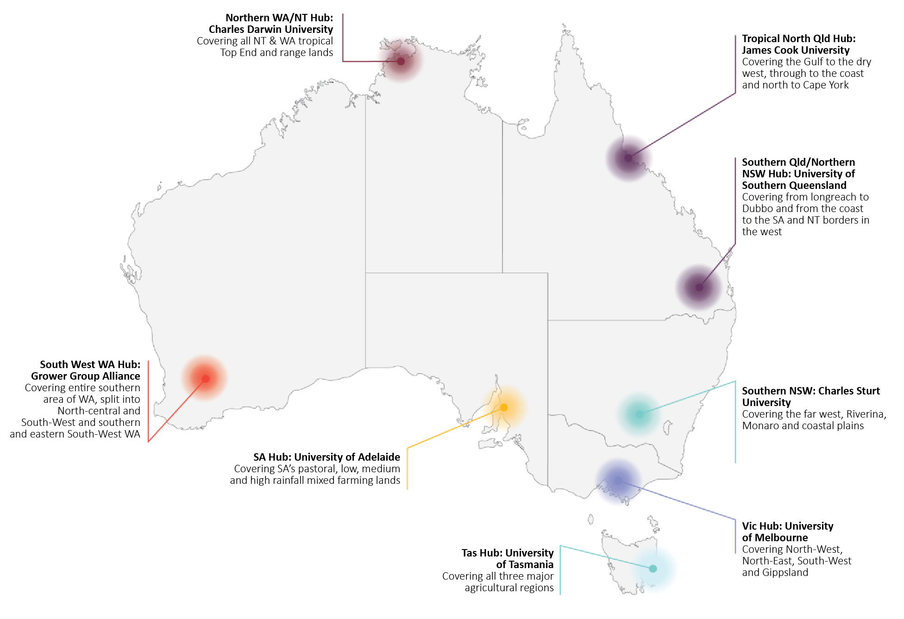

Adoption and Innovation – Drought Resilience Adoption and Innovation Hubs
The Drought Resilience Adoption and Innovation Hubs program is delivered through 8 hubs across Australia. Seven hubs are led by regional universities, and one is led by a grower group alliance.
Hubs are made up of various stakeholders including industry, state and territory government, researchers, farmers and community groups, and have over 60 locations across Australia for stakeholders to connect.
Hubs work with farmers and their rural and regional communities to prepare for and build drought resilience. They share and promote drought resilience knowledge, support farmers and communities to adopt new technologies and practices and connect farmers with agricultural experts in their region.
Over the 2023–24 period, hubs have continued to work with their partners to deliver on co-designed activities that build and support drought resilience and preparedness with their stakeholders.
Several hub regions across Australia experienced drying conditions in early 2024. To support farmers affected by these conditions, hubs worked with the state and territory governments, industry and farmers to raise awareness of hub resources and to develop and deliver localised activities. These activities included facilitating workshops and learning activities, as well as developing strategies and tools to assist farmers with management options and timely and informed decision-making so that they are well placed to recover when seasonal conditions improved.
Key achievements:
- Worked in collaboration with over 240 partners across Australia to deliver activities that support and build drought resilience and preparedness.
- Engaged with over 340 stakeholders including farmers, government, research and development corporations, NRMs, industry and research organisations on drought resilience resources, projects and opportunities.
- Promoted and shared drought resilience information and resources through a range of pathways
  - Knowledge brokers supported collaboration and learning and helped build connections with and across hub stakeholders.
  - Adoption officers across the 8 hubs drove the uptake of new innovations by working with farmers and their communities to pick up relevant tools and knowledge.
  - Hubs delivered a large number of extension activities promoting the use of drought resilience tools, practices and products.
  - Hub websites supported information sharing by including regionally identified priorities, providing drought resilience resources and through listing hub events and activities.
- Promoted, facilitated training and supported the setting up of drought resilience commercialisation technological practices, tools and products to demonstrate application and to support adoption.
  - Adoption officers were used to promote, train and support end users in technology and digital tools to support farmers in their practical on-farm application.
  - The hubs have also developed digi-tools that can be commercialised, to support farmers in decision-making.
- Delivered a large number of demonstrations and trial sites to support adoption of drought resilient technology and practices, including collaborations with AgTech companies to improve the access and use of technologies across Australia. This resulted in a number of farmers continuing to implement technology and practices after trials concluded.
- Delivered a range of field days and farm walks with farmers to showcase and implement drought resilient land management practices, such as containment feeding and dry seeding practices to enhance farm resilience.
- Technologies and land management practices adopted are starting to show signs of enhanced drought resilience on the ground. For example
  - Farmers are gaining confidence and skills in their on-farm water management capabilities to improve water use efficiencies and conservation through on-farm water management plans.
  - Forage mapping technology has helped pastoralists better predict feed availability providing greater flexibility to manage grazing on pastures in accordance with the season.
  - Satellite imagery and drone mapping has been used to investigate the drivers of persistent bare soil to inform rehabilitation efforts.
In 2022, 5 collaborative cross-hub projects were identified, with each project involving at least 2 hubs and their regions. Two of the projects were completed in 2022–23. Three projects were completed over 2023–24:
- Modern soil moisture monitoring to improve irrigation management – 27 demonstration sites were established for grape, citrus and almonds across NSW, Vic., SA and Tas. Soil moisture monitoring technologies were installed across the sites, with growers being supported by Irrigation Development Officers. Through learning and adoption of the technology, participants built their capacity to strategically implement soil moisture monitoring and irrigation management. Outcomes of the project included improved irrigation practices, better allocation of existing and future water resources and a better ability to deal with drought by building business resilience.
- Fast tracking WA and NT to align with nutritional feed base mapping technology advancements at a national level – The project trialled and calibrated on-farm dynamic feed base mapping technology for remote parts of WA and the NT and supported pastoralists in managing grazing pressure and better preparing properties for changing climatic conditions. The project upskilled pastoralists by demonstrating how calibration by pasture cuts and visual checks can create a more useful tool for station management and show much or how little feed is actually on the ground.
- Managing rangelands for drought resilience – The project showcased techniques used for forage mapping (mapping by satellite and mapping by drone) to improve rangeland management. The project established and analysed 12 demonstration sites using property utilisation and land condition tools to improve rangeland management and support producers in becoming more resilient to drought. Participants in the project are now actively using the Australian Feedbase Monitor tool and the Pasture Monitoring Package to support grazing management decisions since the project was completed.
Case study 7 Drought hubs delivering for farmers
Responding to dry seasonal conditions across much of Tas. in early 2024, the Tasmanian Farm Innovation Hub proved its value. While the FDF’s Drought Resilience Adoption and Innovation Hubs program is focused on longer-term farm business resilience and preparedness, the Tasmanian Farm Innovation Hub was able to swing into action to help farmers with short-term decision-making in places like King Island, which was facing unprecedented drought conditions.
In response to the immediate crisis, the hub partnered with the state government, local farmer groups and industry service providers to co-design and deliver targeted workshops and on-farm events to get relevant information directly to those who needed it.
This included workshop topics such as feed budgeting for dry times, management decisions for a dry winter and managing winter stocking rates and stock water workshops.
On-farm events were designed to provide space for connection and peer-to-peer learning, with local farmers sharing their experiences and demonstrating how they were implementing drought management strategies.
These activities built confidence in local farmers to implement decisions to assist their farm businesses adapt to the conditions.
The collaborative effort has helped demonstrate to local farmers the value of the hub in supporting drought preparedness and contributed to strengthened relationships with partners and stakeholders.
This will help with the hub’s key purpose: to build long-term drought preparedness so farmers are better positioned to manage through dry conditions and quickly recover when conditions improve.

Adoption and Innovation – National Enabling Activities
The FDF provides funding for a range of activities that will help farmers and regional communities build drought resilience through investments in collaboration.

Knowledge management
Building on the findings of the Productivity Commission, the department began developing an FDF knowledge strategy. Action under the strategy, along with improvements to FDF knowledge, information and data systems, will help improve the capability and capacity of the FDF team and delivery partners to collect and manage information and share FDF and drought resilience knowledge. This will help us maximise benefits from the government’s investments.
The knowledge strategy is expected to outline the department’s wider role in creating and communicating climate and drought resilience knowledge generally – not limited to that generated by FDF programs – and the role of other stakeholders in knowledge creation and dissemination. The strategy is expected to be delivered by mid-2025.
Improved data systems and a public interface will also enhance our capability to retrieve, analyse and share data and information from program delivery to better inform program management and future program design – in partnership with our delivery partners.

First Nations Engagement
First Nations peoples are the country’s first farmers, fishers and foresters whose ancestral and cultural knowledges have been instrumental to the stewardship of Australia’s lands and waters for over 65,000 years. Over thousands of generations, First Nations peoples have cared for and protected Country, lived sustainably on Country and adapted to a changing climate. First Nations practices have shaped the longevity of Australia’s unique lands and waterways and continues to support and cultivate the thriving biodiversity of this vast country.
With free, prior and informed consent and appropriate recognition of First Nations people, this knowledge could add to the range of tools to improve the sustainability of the Australian agricultural sector, landscape and communities – for the benefit of all.
During consultation for the second phase of the fund there were 13 attendees at a virtual session for First Nations people held on 27 November 2023. First Nations people also attended other public consultation sessions and some First Nations organisations provided written submissions on the design of the second phase. A summary of all public consultation activities highlighted a strong desire for further engagement and collaboration with First Nations peoples and communities.

Drought Resilience Innovation Grants
The Drought Resilience Innovation Grants program supports projects that drive the development and adoption of new and innovative technologies and practices to improve the drought resilience of Australian farmers and agriculture-dependent communities. A variety of projects were supported at different stages of development, including early-stage proposals, feasibility testing for new products, processes and services and large-scale innovation projects.
Throughout 2023–24 there were 15 Innovation Grants that continued to be funded with a total of $3.68 million paid in 2023–24. The department moved $1.31 million to the 2024–25 financial year as payments to extended projects. The total program funding remains $28.85 million.
The funded projects are diverse and encompass activities such as: harvesting atmospheric moisture; using irrigation management technology and livestock ranking strategies; trialling diversified vegetation cover; demonstrating different crop rotation cycles; developing digital tools to support decision-making ahead of droughts; and using behavioural science approaches to building drought resilience.
After a small number of project extensions were issued, all 12-month Proof-of-Concept Grants and Ideas Grants projects were completed by 30 June 2024. Most of the Innovation Grants for larger scale projects of up to 3 years were completed by 30 June 2024, with final reports due 30 September 2024. Seven projects are due to be completed in 2024–25, with a small number of final reports due by 30 September 2025.

Natural Resource Management Drought Resilience
The NRM Drought Resilience program (Landscapes and Grants streams) invested $13.4 million for 80 projects. All projects are now complete with the last of the final reports received by the department in September 2023. NRM programs are designed to help farms stay productive during drought and assist with quicker recovery. The programs support transformational practices, approaches or systems that improve the management of natural resources and build drought resilient agricultural landscapes.
The NRM Drought Resilience Landscapes stream fostered innovation and transformational change in the management of natural capital to improve the resilience of agricultural and broader landscapes.
The NRM Drought Resilience Grants stream supported experimentation in NRM practices, systems and approaches that go beyond current best practice, improve drought resilience of agricultural landscapes and contribute to resilience of broader landscapes.

Drought Resilient Soils and Landscapes
This program supports projects that demonstrate practices at a broad scale that will contribute to both agricultural and broader landscapes being more resilient to future droughts. The program funded 26 projects valued at a total of $23.1 million. Most of these projects were completed by June 2024, but 8 projects have been extended. All project activities will be completed by 30 June 2025.
Case study 8 University of New England Drought Resilient Pasture and Landscapes Project
The University of New England’s Jaimi-lee Edwards knows farmers learn best alongside their peers as they work with experts on real-world problems.
That’s why Jaimi-lee travels the Northern Tablelands of NSW as a pasture coach.
Jaimi-lee can coach groups of farmers to better predict their pasture availability thanks to the FDF’s Drought Resilient Soils and Landscapes program.
Correctly estimating future pasture availability helps farmers make better stocking and land management decisions as conditions dry.
‘At each of the early sessions we focused on estimating herbage mass, ground cover and green content. We did this by visiting a range of pastures on different properties, taking pasture cuts to build confidence,’ Jaimi-lee said.
‘As the coach, I provided feedback to help make any changes to their assessments that were necessary.’
As the sessions continued, Jaimi-lee focused on helping farmers incorporate long-range weather forecasts into their feed budgets to better predict future pasture and livestock performance.
‘We’re enabling farmers to expand their planning that affects the next 6 months on their farm. This helps them know what their A, B and C plans look like – before decisions are critical.’ Photo 2 shows Jaimi-lee measuring pasture growth as part of a coaching session.
Photo 2 Jaimi-lee Edwards
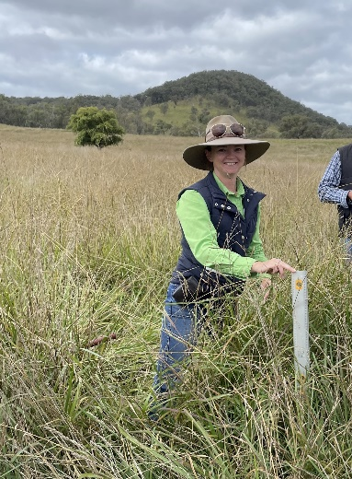
Source: University of New England Armidale

Extension and Adoption of Drought Resilience Farming Practices Grants
This program awarded over $13 million in grants to 18 extension and adoption projects to drive adoption of proven drought resilient farming practices. These projects are expected to have their activities completed by 30 June 2025.
Grantees are undertaking activities:
- to reduce the impacts of drought on agricultural productivity and enable a quicker recovery of farmers and their lands from drought
- that have potential to be adopted at a large scale (either across multiple farms, a farming system, landscapes, regions or industries)
- that can demonstrate public benefits.

Long-term Trials of Drought Resilient Farming Practices
The Long-term Trials of Drought Resilient Farming Practices program supports investigation of innovative farming techniques for cereal and other broadacre crops, horticulture crops, livestock and mixed farming practices to assist farmers to develop drought resilience and adapt to the impacts of climate change.
Round 1 of the program closed in March 2023. Six successful projects were announced on 11 August 2023 receiving a total of $38 million in grant funding.
The long-term nature of this program is critical to its success. Long-term trials over multiple seasons are needed to robustly test prospective drought resilient farming practices and to give farmers the confidence to try them.
Grantees will also undertake activities to support the adoption of drought resilience innovations on farms, with the aim of reducing exposure to drought risks and improving farmers’ economic, environmental and social resilience to drought.
This evidence-based approach will provide farmers with the information and confidence they need to try the practices themselves.

Drought Resilience Commercialisation Initiative
The Drought Resilience Commercialisation Initiative is a $10 million, 2-year pilot program, ending on 30 April 2026. The initiative supports innovators to turn their research, intellectual property (IP) and ideas into commercially viable, drought resilient products and services. The initiative aligns with the FDF’s aim to accelerate the availability of drought resilience products and tools for Australian farmers and farming communities.
In September 2023, following a competitive, open-tender process, Beanstalk AgTech (Beanstalk) was selected as the delivery partner for the initiative and will deliver this through their Drought Venture Studio. The initiative seeks to:
- prove the impact of public funding in drought resilience commercialisation
- increase the commercial viability of a participant’s product or service
- gather feedback through participant evaluation to inform future policy development.
The Drought Venture Studio will select up to 96 innovators across 4 cohorts over 2 years to undertake a 90-day program where they will deliver expert support and advice. This may include identifying barriers to market, developing a business model, developing an IP strategy, raising capital and proving commercial viability of a drought resilience product or service.
Eight ventures (4 from each of the first 2 cohorts) with the best investment and market-ready compelling drought resilience innovations will be selected to receive an additional year of hands-on dedicated support and up to $250,000 of in-kind non-dilutive financial support. These successful ventures will be matched with an experienced co-founder to lead the commercialisation of the venture full-time.
The Drought Venture Studio provides a one-stop-shop commercialisation facilitation service to support cohorts of innovators, including one-on-one facilitation services, in-depth analysis of market barriers, commercialisation planning and other specialist activities that assist innovators to increase their commercial viability.
Beanstalk launched the Drought Venture Studio in May 2024 and expressions of interest for the first cohort of 24 innovators opened on 24 May 2024 and closed on 12 July 2024.

Drought Resilience Scholarships
In March 2023, $1.6 million was committed to Nuffield Australia to deliver 10 Drought Resilience Scholarships in 2024 and 2025. The scholarships aim to support leaders and innovators to drive a continued focus on drought and climate resilience, with international learning and networking opportunities.
In September 2023, 5 individuals were awarded 2024 Drought Resilience Scholarships, during the Nuffield Australia National Awards Dinner and National Conference held in Perth, WA:
- Caitlin Herbert from Eugowra, NSW, is researching the role cattle feedlots can play in helping the beef supply chain prepare for drought.
- Michael Taylor from Kentucky, NSW, is a former Australian Farmer of the Year and is studying solutions to the challenges that hinder the widespread adoption of agroforestry.
- Claudia Benn from Injune, QLD, is extending on the work of previous scholars to help Australian farmers farm more profitably in alignment with natural systems.
- Ben Poschelk farms at Glen Innes, NSW, and is undertaking a global analysis of resilience thinking and change in people and communities who have adapted to adverse weather conditions.
- Natalie Schlitz from Kerang, Vic., is investigating weaknesses that threaten the viability of the Australian fodder export sector in a water-limited future.
The 2023 National Conference focused on ‘Enhancing a resilient and sustainable industry’, with presentations on the FDF, agricultural data in resilience and NRM (CSIRO), and from former Nuffield alumni. Scholars also attended a regional tour, which included visits to Katy Joy Farm (free range eggs, honey and oats), Bell Pasture Seeds and Fulwood Grain Company.
Alongside the dedicated drought resilience scholars, all Nuffield scholars in the broader cohorts receive drought resilience learnings through participation in the Australian Focus Program (AFP), a week-long experience held in Canberra focusing on Australian agricultural drought resilience, sustainability, policy, politics and advocacy. The 2024 AFP, held in March, included workshops on FDF programs, the ABARES Outlook Conference ‘Shaping the future: Opportunities, Risks and Resilience’, as well as field trips around the Canberra region including to CanTurf, CSIRO and Mount Majura Winery.
The 2024 Nuffield International Contemporary Scholar Conference, held in Brazil, provided another opportunity for scholars to network and build industry connections to inform their learning and research. Scholars reported inspiration and a ‘different view of the world’, both personally and in terms of resilience-thinking, following the conference.
During 2023–24 there were 3 Drought Resilience Scholars who attended the Global Focus Program (GFP) – 5 weeks of overseas travel enabling scholars to engage with international leaders on issues such as drought resilience, agricultural marketing, trade, environment and more. Two scholars travelled to Brazil, Texas, Germany and Ireland. One scholar travelled to WA, Zimbabwe, the United Kingdom, the Netherlands and Georgia. The remaining 2 scholars travelled to Borneo, Taiwan, Japan, Poland and Italy.
Case study 9 Nuffield Scholar for 2024, Caitlin Herbert
2024 Nuffield Drought Resilience Scholar, Caitlin Herbert, is a sixth-generation cattle farmer. Her family has owned and operated Gundamain Pastoral Co for 150 years. Located in Eugowra, Central West, NSW, the Herberts produce grain fed cattle, Merino wool and prime lambs, as well as a dryland cropping operation. Photo 3 shows Caitlin on her family’s property in Eugowra.
Through her scholarship, Caitlin is using her farming background to examine the ways feedlots can help the beef supply chain through drought.
‘I’ve been very fortunate, and I’ve had a great 12 months – I’ve been able to travel to North and South America and visit feeding facilities across 5 countries,’ Caitlin said.
‘This learning opportunity has allowed me to be able to see other people doing what we do, but in a different way. It’s been really good for me to bring knowledge back to Gundamain so we’re better prepared for future drought, but it’s also been good for the wider Australian feed lotting and cattle industry.’
Caitlin’s scholarship has allowed her to investigate how feedlots can help the cattle industry prepare for and manage through drought, allowing for alternate feed sources, increased animal welfare and creating contingency plans.
‘I think one of the main reasons the feedlot industry took off in Australia was because of our weather extremes, particularly the droughts we experience. They are a little longer and harder than what our ancestors experienced, and we are experiencing them more often. It forces an intensification of the extensive beef industry. We’ve taken a lot of our knowledge on food storage, for example, and applied it to our cattle breeding production.’
Photo 3 Caitlin Herbert
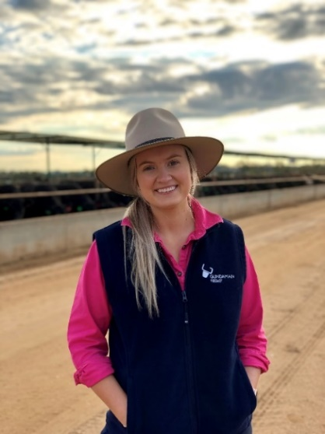
Source: Nuffield Australia

Science to Practice Forum
After 3 years of delivering the Science to Practice Forum as a 3-day virtual event, and ahead of the 2024–25 Budget, the department considered the arrangements for delivery of the forum. Key considerations included audience feedback, the Productivity Commission’s suggestions and resourcing requirements and whether this key enabling activity was delivering on its intended objectives. Pending a decision on the reallocation of resources, the forum was not delivered in 2024. Subsequent feedback resulted in the forum being re-positioned as a funded program under the FDF Measuring Progress and Knowledge Sharing theme – the Science to Practice 2.0 program.

Better prepared communities
Building and supporting the community leaders, networks and organisations that underpin community resilience.
Table 14 Better prepared communities – program information
Strategy | Establish, support and maintain a national cohort of community leaders, networks, mentors and organisations to drive action on drought resilience in their community
Aim | Support community-based organisations and individuals to drive local action to plan and prepare for drought
How this will support drought resilience | Community leaders, mentors, networks and organisations play a key role in driving changes in drought preparedness attitudes and action and supporting people in times of drought
Success measures | - Increase in the reach and activities of community leaders, mentors, networks and organisations driving action on drought resilience (RC 1)  - Change in awareness of and attitudes to drought preparedness at the community level (RC 2)  - Improved communication, social connection and collaboration within and between communities to support drought preparedness (PO 1)  - A greater diversity of community members and organisations contribute to drought preparedness activities (PO 3)  - Growth and improved strength of community-based networks (PO 7)
PO Program outcomes. RC Resilient communities.
Note: In 2023–24 the Monitoring, Evaluation and Learning Plan for the Helping Regional Communities Prepare for Drought Initiative was released. The plan identifies 7 short-term outcomes that provide a consistent basis to measure the progress and impact of the initiative at a national level.
Table 15 Better prepared communities – progress and performance, 2020–21 to 2023–24
Year | Measure | Result
2020–21 | Partnered with the Australian Rural Leadership Foundation to develop a program to build leadership and mentoring networks | Met – see 2020–21 annual report
 | Partnered with the Foundation for Rural and Regional Renewal to design programs to support community networks and organisations | Met – see 2020–21 annual report
2021–22 | (RC 1) Numbers, types and reach of people trained, mentored, mentoring or engaged in other activities | Met – see 2021–22 annual report
 | (RC 1) Numbers and types of community capacity building and engagement projects | Met – see 2021–22 annual report
 | (RC 2) Baseline assessment of awareness, attitudes, and sense of preparedness (survey) | Met – see 2021–22 annual report
2022–23 | (RC 1, RC 2) As in 2021–22 | Met – see 2022–23 annual report
 | (RC1) There is an increase in the reach and activities of community leaders, mentors, networks and organisations driving action on drought resilience | Met – see 2022–23 annual report
 | (RC 2) There is a change in awareness of and attitudes to drought preparedness at the community level | Met – see 2022–23 annual report
2023–24 | (RC 1, RC 2) As in 2022–23 | Met
 | (PO1) Improved communication, social connection and collaboration within and between communities to support drought preparedness | Met
 | (PO3) A greater diversity of community members and organisations contribute to drought preparedness activities | Met
 | (PO7) Growth and improved strength of community-based networks captured in detail under the Helping Regional Communities Prepare for Drought Initiative MEL Plan | Met
PO Program outcomes. RC Resilient communities.
Table 16 Better prepared communities – achievements and next steps, 2023–24
Achievements | Next steps
The delivery of funds across all Community Impact Program (CIP) regions. As of June 2024, the CIP grants have been awarded across 30 CIP regions in 6 states. This includes 121 organisations with 161 active grants, valued at over $10.1 million. | Ongoing delivery of the Helping Regional Communities Prepare for Drought Initiative (HRCPDI) to June 2025, with projects under CIP and Small Network Grants to continue, supported by the National Expertise Pool and National Learning Network.
Delivery of funds under round 1 of the Small Network Grants. As of June 2024, the 29 projects were funded at a value of $737,774, across 7 states and territories. | Finalisation and release of the mid-term evaluation report for HRCPDI.
The National Mentoring Program completed its 12-months as a mentoring and learning source. Over 2 rounds it had a total of 250 participants across all states and territories. | Initial design of program activities from funding allocated in the 2024–25 Budget, for the $36 million Communities program.
The Drought Ready Network was launched in August 2023 to help individuals and communities connect, support and learn from each other. To help their communities adapt and prepare for drought. As of June 2024, the numbers have grown to 611 members on the platform. | Nil

Helping Regional Communities Prepare for Drought Initiative
The $29.64 million Helping Regional Communities Prepare for Drought Initiative (HRCPDI) was launched in August 2022, with activities running to June 2025. It is being delivered in partnership with the Foundation for Rural and Regional Renewal (FRRR) and Australian Rural Leadership Foundation (ARLF). The initiative extends and integrates foundational year programs under the FDF’s better prepared communities theme, the Networks to Build Drought Resilience and the Drought Resilience Leaders programs. It consists of 5 program elements:
- Community Impact Program
- Small Network Grants
- National Mentoring Program
- National Learning Network (Drought Ready)
- National Expertise Pool.
Nous Group were engaged to evaluate the impact of the HRCPDI. It is too early to assess the effectiveness of the HRCPDI, but all partners collaborated to finalise a Monitoring, Evaluation and Learning Plan in September 2023 that will guide the evaluation. Nous Group delivered a mid-term evaluation report in October 2024 to assess early progress towards outcomes. A final evaluation report will be delivered in September 2025 upon completion of HRCPDI activities.

Community Impact Program
The Community Impact Program was designed to fund locally-led initiatives across 35 regions that aim to strengthen community networks, capabilities and facilities that support drought preparedness. Each region is offered up to $500,000 in grant funding for community organisations and individuals to participate in a co-design process to identify community priorities for investment. The program is being delivered by FRRR with all projects to be completed by June 2025. During the 2023–24 financial year, 75 projects across 14 regions were awarded almost $4.65 million in funding. Across the program, 30 regions have completed co-design with 121 organisations delivering 161 projects valued at over $10.1 million. Five regions are not participating in the Community Impact Program due to capacity shortages in coordinating across the regions. The funding for these regions was instead reallocated to a separate stream of the Small Network Grants, specifically established to cater for the regions that missed out on Community Impact Program funding.
The Community Impact Program is also providing leadership workshops, delivered by ARLF, to individuals across the 35 regions to build drought resilience in their community. At June 2024, 32 leadership workshops have been delivered with a significant amount more planned over the 12 months to June 2025.
Map 3 Community Impact Program regions
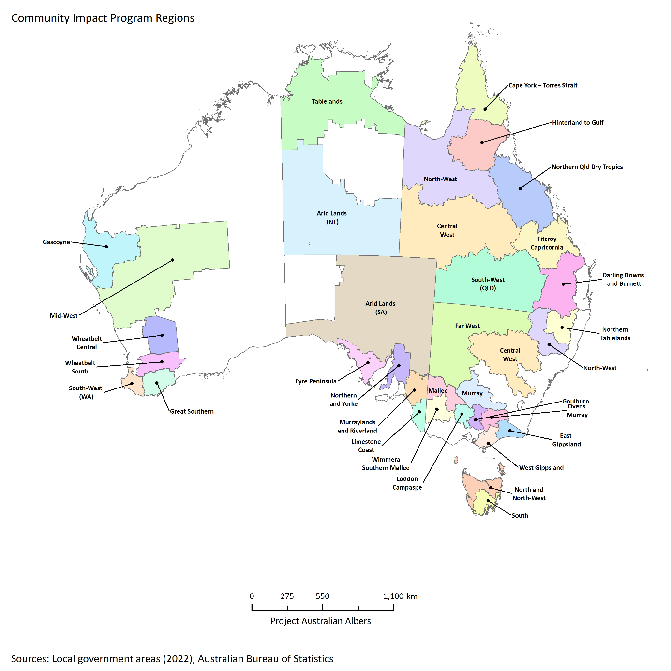
Note: Regions shown are those eligible at the launch of the program in September 2022.
Source: Local government areas (ABS 2022)

Small Network Grants
The Small Network Grants program is for community organisations in remote, rural and regional Australia to develop and deliver one-off events or initiatives that strengthen community networks and capabilities to build drought preparedness. The grants will fund networks, community events, training initiatives, community infrastructure, development and learning initiatives that assist local people and communities to strengthen social capital and capability to prepare for future droughts.
The Small Network Grants program is delivered by FRRR. It is a complementary grants program to the Community Impact Program, offering grants of up to $20,000 to support community organisations to build stronger connectedness and networks. Grants of up to $50,000 are available for organisations in the 5 regions that had funding reallocated from the Community Impact Program.
At June 2024, 29 organisations have been allocated a total of $737,774 in grants under the first round of the program.

National Mentoring Program
The National Mentoring Program connected an experienced mentor with a mentee for a 12-month learning program that included one-on-one engagement and targeted mentoring sessions to assist in developing a cohort of community leaders ahead of future drought. It was delivered by ARLF across 2 rounds with a total of 150 individuals taking part from across the country. The second and final round concluded in June 2024. A mentoring summit occurred in October 2024, where program participants came together in Canberra for further structured learning and networking opportunities. The summit will be reported on in the 2024–25 annual report.

National Learning Network
The National Learning Network, referred to by its members as ‘Drought Ready’, uses a Facebook group to connect with individuals who have participated in the HRCPDI and other FDF initiatives. ARLF have been managing the network and have been facilitating a series of topic-based and regional network building forums to connect members on the theme of drought resilience across communities. Members of the group also share resources and events with each other to increase knowledge and awareness on drought preparedness. At June 2024, the National Learning Network had 611 members. ARLF will continue to manage the network until the conclusion of HRCPDI activities by which time the expectation is that it will be self-sufficient.

National Expertise Pool
The National Expertise Pool has been designed to offer regional leaders and community organisations a database of experts that can be drawn on to deliver projects and assist with community activities. It aims to address the challenge in some regional, rural and remote communities in accessing expert services, such as facilitation, business support and strategic planning. The National Expertise Pool was initially designed to support activities funded under the Community Impact Program and Small Network Grants program with experts offering a range of services required to deliver projects.
FRRR have contracted the Social Impact Hub to manage the online platform where experts can advertise services and community organisations can search for the support that they are looking for. At June 2024, the National Expertise Pool had 34 successful occasions of engagement with community organisations and has onboarded 114 experts nationwide.

Future Drought Fund administration
Strong governance arrangements are in place to support the effective administration of our programs.
Figure 7 Future Drought Fund administration
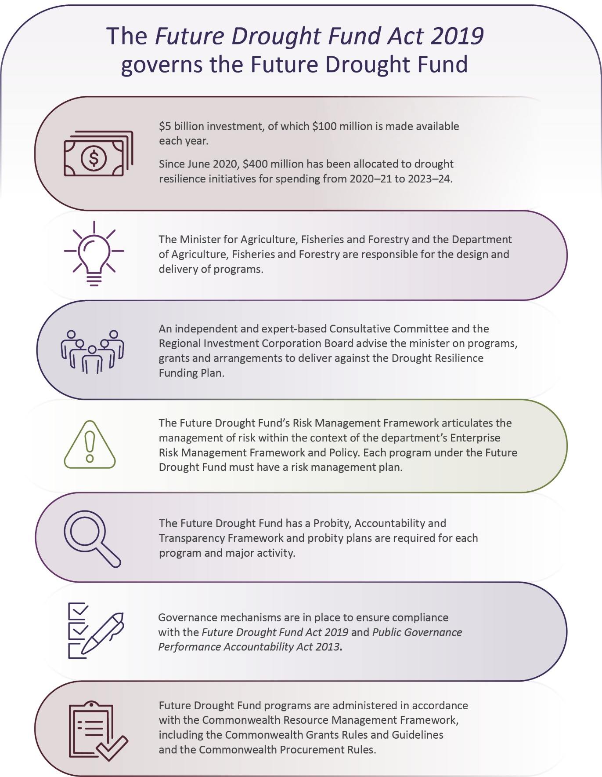

Governance

Future Drought Fund Consultative Committee
The Future Drought Fund Act 2019 establishes the independent, expert-based FDF Consultative Committee. The role of the Consultative Committee is to provide advice to the drought minister on a draft funding plan, and subsequently whether the proposed design of FDF programs of arrangements or grants are consistent with the funding plan.
The first Consultative Committee was chaired by Mr Brent Finlay and included committee members, Dr Kate Andrews, Dr Wendy Craik AM, Dr Elizabeth Peterson and Ms Caroline Welsh. The 4-year term of appointment for that committee expired on 18 September 2023. Prior to its conclusion, the committee met twice in 2023–24 to discuss their response to the Productivity Commission’s interim report on the FDF. Additionally, they reflected on the previous 4 years and provided feedback and lessons learnt to the department and for the next Consultative Committee.
On 19 September 2023 the Drought Minister appointed the second Consultative Committee. Mr Brent Finlay was reappointed as Chair, with new committee members Professor Bronwyn Harch, Ms Lucinda Corrigan, Mr Joshua Gilbert and Mr Ashley Herbert. The new committee members have expertise in drought resilience measures, climate risk, rural and regional development, First Nations engagement, applied research, agricultural extension and economics. Photo 4 shows members of the new committee when they met in Canberra in October 2023.
Photo 4 Future Drought Fund Consultative Committee
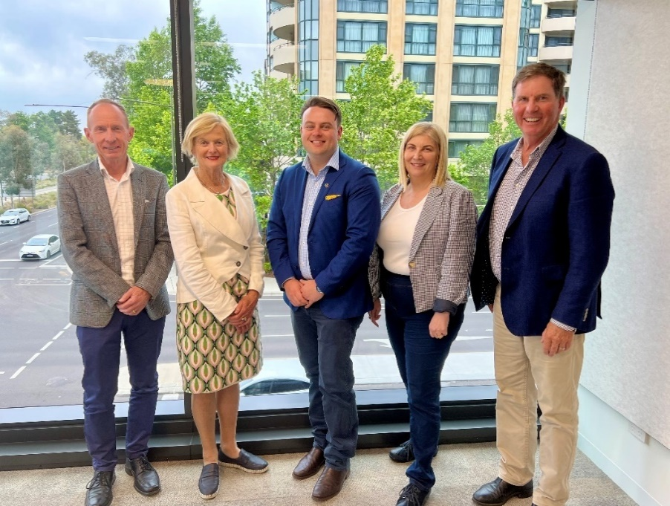
Left to right: Mr Ashley Herbert, Ms Lucinda Corrigan, Mr Joshua Gilbert, Professor Bronwyn Harch and Mr Brent Finlay (Chair).
Source: Sway Measham, Department of Agriculture, Fisheries and Forestry.
Since their appointment in September 2023, the committee met 8 times and engaged on the following priorities:
- lead public consultations across Australia to seek feedback on the draft funding plan and investment strategy
- discussed the development of the final funding plan
- ensured the design and delivery of FDF programs under the second phase of funding were consistent with the Drought Resilience Funding Plan 2024 to 2028
- considered recommendations made by the Productivity Commission and feedback received through the public consultation process
- discussed FDF communication strategies and the inclusion of an FDF First Nations Engagement Strategy.

Drought Resilience Adoption and Innovation Hubs Advisory Committee
The Drought Resilience Adoption and Innovation Hubs Advisory Committee was appointed by the Drought Minister to provide advice to the minister, department and hubs on the hubs’ strategic objectives, program delivery and implementation. The committee’s role is to help ensure the 8 regionally focused hubs are well placed to deliver drought resilience outcomes and remain connected to national priorities.
The Hubs Advisory Committee was chaired by Mr Brent Finlay, also Chair of the FDF Consultative Committee. Members included Ms Caroline Welsh, Mr Dale Park, Dr Christine Pitt, Emeritus Professor James Rowe (resigned September 2023) and Mr Trent De Paoli (resigned August 2023).
In 2023–24 the committee met 5 times in a virtual capacity to discuss the Drought Resilience Adoption and Innovation Hubs and the delivery of their projects, collaboration efforts and the hubs strategic risks and mitigation activities. Due to budgetary constraints the committee was unable to visit the hubs in this financial year and all meetings were by video conference.
The committee met with hub representatives virtually to discuss hub operations, performance, their priority setting, strengthening partnerships and engagement with First Nations peoples, universities, agricultural industry bodies and state and territory governments.

Program design and delivery
The design and funding of drought resilience programs over the last 4 years have been carried out gradually, informed by continuous review, reporting, engagement and learning. This flexible and adaptive approach was designed to get it right, every step of the way, for those who would benefit most from the fund’s success – Australian farmers and regional communities.
Program design and delivery to 8 February 2024 was guided by the Drought Resilience Funding Plan 2020 to 2024. Funding from 9 February 2024 is being guided by the Drought Resilience Funding Plan 2024 to 2028.
Drought Resilience Funding Plans ensure that FDF funding is consistent across programs. They provide a guide for decision-making under the Future Drought Fund Act 2019.
Each funding plan is subject to legislated review points, including:
- a Productivity Commission review every 4 years
- nationwide public consultation on the draft funding plan
- advice from the independent, expert-based FDF Consultative Committee on the draft funding plan and proposed program design.
Programs in the first year, announced in conjunction with the 2020–21 Budget, were designed to be short-term and foundationally focused. They accounted for the full $100 million available in 2020–21, as well as one longer-term program, supporting the establishment of the hubs with funding, out to 2023–24.
Second and third rounds of programs were announced in conjunction with the 2021–22 and the 2022–23 Budgets, building on the foundation year programs. The new and extended programs consolidate the Drought Resilience Funding Plan 2020 to 2024 by embedding learnings of established programs.
Unspent funds from 2022–23 were moved to 2023–24 to continue meeting existing contractual arrangements or reallocated to projects within the FDF as needed.
Moving into the second phase of the FDF from 2024–25, program design will capitalise on learnings from the first phase of the FDF including what stakeholders told us they value during consultation in 2023 and recommendations from the Productivity Commission review of the FDF.

Productivity Commission review
The Future Drought Fund Act 2019 establishes a 4-year review cycle to ensure the fund remains effective. In September 2023, following significant stakeholder consultation, the Productivity Commission completed its review of the FDF. The inquiry report was provided to the government in September 2023 and included 14 recommendations to improve the FDF. These recommendations were reflective of stakeholder views and feedback and have guided the FDF investment approach for the second funding cycle, commencing on 1 July 2024.
The Productivity Commission was largely supportive of the FDF and its programs, acknowledging the progress made to support farmers and their communities prepare for drought. The report indicated that although in its infancy, the FDF is establishing a solid foundation for building drought resilience.
Several challenges that impacted the effectiveness of the first funding cycle were also identified, including the rapid roll-out of the initial programs. As such, there are opportunities for the FDF to enhance outcomes over the next 4 years.
Key points from the Productivity Commission
- Drought and climate change are expected to put Australia’s agricultural industries and regional communities under mounting economic, environmental and social pressure. The Future Drought Fund (FDF) could be a catalyst for locally led transformational change to meet these pressures.
- Despite early challenges, the FDF is establishing a solid foundation for building drought resilience. The first years have revealed opportunities to improve the design and delivery of the fund’s programs, including through identifying gaps in existing resilience programs, more planning around how the FDF will prioritise programs and improved knowledge sharing.
- A stronger focus on activities that generate lasting public benefits is needed. The FDF should focus on activities that generate transformational change, build natural capital and support a place-based approach to building social resilience.
- Drought is just one of the risks from climate change that farmers and agricultural communities face. While drought should remain the focus, the FDF should explicitly recognise climate change resilience to confirm that, where appropriate, programs address a broader range of climatic risks.
- Establishing an Aboriginal and Torres Strait Islander working group to partner with the Department of Agriculture, Fisheries and Forestry could improve the design and implementation of the fund for the benefit of Aboriginal and Torres Strait Islander people.
A number of FDF programs can be improved by:
- consolidating the climate information tools into a single tool, tailored to the needs of end users
- clarifying ownership, governance and funding for regional drought resilience plans
- tightening eligibility and increasing support for natural resource management and transformational practices in the Farm Business Resilience program
- supporting transformational change through the Drought Resilience Innovation Grants program by piloting a challenge-based approach to innovation
- clarifying the role of the Drought Resilience Adoption and Innovation Hubs followed by a mid-term review of their performance
- strengthening the links between regional planning and community grant funding to ensure a strategic, place-based approach to building social resilience. (Productivity Commission 2023)
In October 2023 the government took early action on the Productivity Commission’s findings by reallocating approximately $17.71 million across FDF, including:
- $10 million – Short-term extension to the Drought Resilience Adoption and Innovation Hubs (to 30 June 2025), so farmers and regional communities can continue to access information and services, while a review is undertaken
- $4.8 million – Short-term extension to the CSA program (to 30 June 2025), so farmers and regional communities can continue to access climate information through the My Climate View tool while future program offerings are considered
- $2.91 million – Activities to evaluate key programs, better understand the needs of First Nations communities through market research to commence later in 2024, and improve collaboration, information sharing and the way success is measured.

Developing a new funding plan and investment strategy
To ensure the FDF remains effective, a 4-year review cycle is in place. In preparation for the next phase of the FDF a new funding plan was established. The Drought Resilience Funding Plan 2024 to 2028 came into effect on 9 February 2024 and will guide all funding decisions under the FDF over the next 4 years.
The new funding plan was informed by findings from the Productivity Commission, stakeholder feedback and the independent FDF Consultative Committee.
The development of an investment strategy was also recommended by the Productivity Commission in their review to provide detailed information about the delivery of FDF programs and activities over the next 4 years and to assist stakeholders to better understand the FDF. The investment strategy will be consistent with the vision, aim and strategic objectives of the funding plan and will be released in early 2025.

Consultation
Nation-wide public consultation on the draft funding plan and investment strategy took place in late 2023. Consultation was extensive and included 22 discussions across Australia, with over 320 people who provided us with valuable and informative feedback. This included 2 virtual public meetings, with one focusing on enhancing engagement with and outcomes for First Nations communities. We also received 87 written submissions and 71 responses to the online survey. We heard from FDF participants and partners, industry, state and territory governments, professional advisers, research institutes, non-government organisations, farmers and people living in rural communities.
Stakeholders were broadly supportive of the draft documents, which set out proposed investment priorities and key features of new programs.
Figure 8 Stakeholder consultation on the second phase of the Future Drought Fund
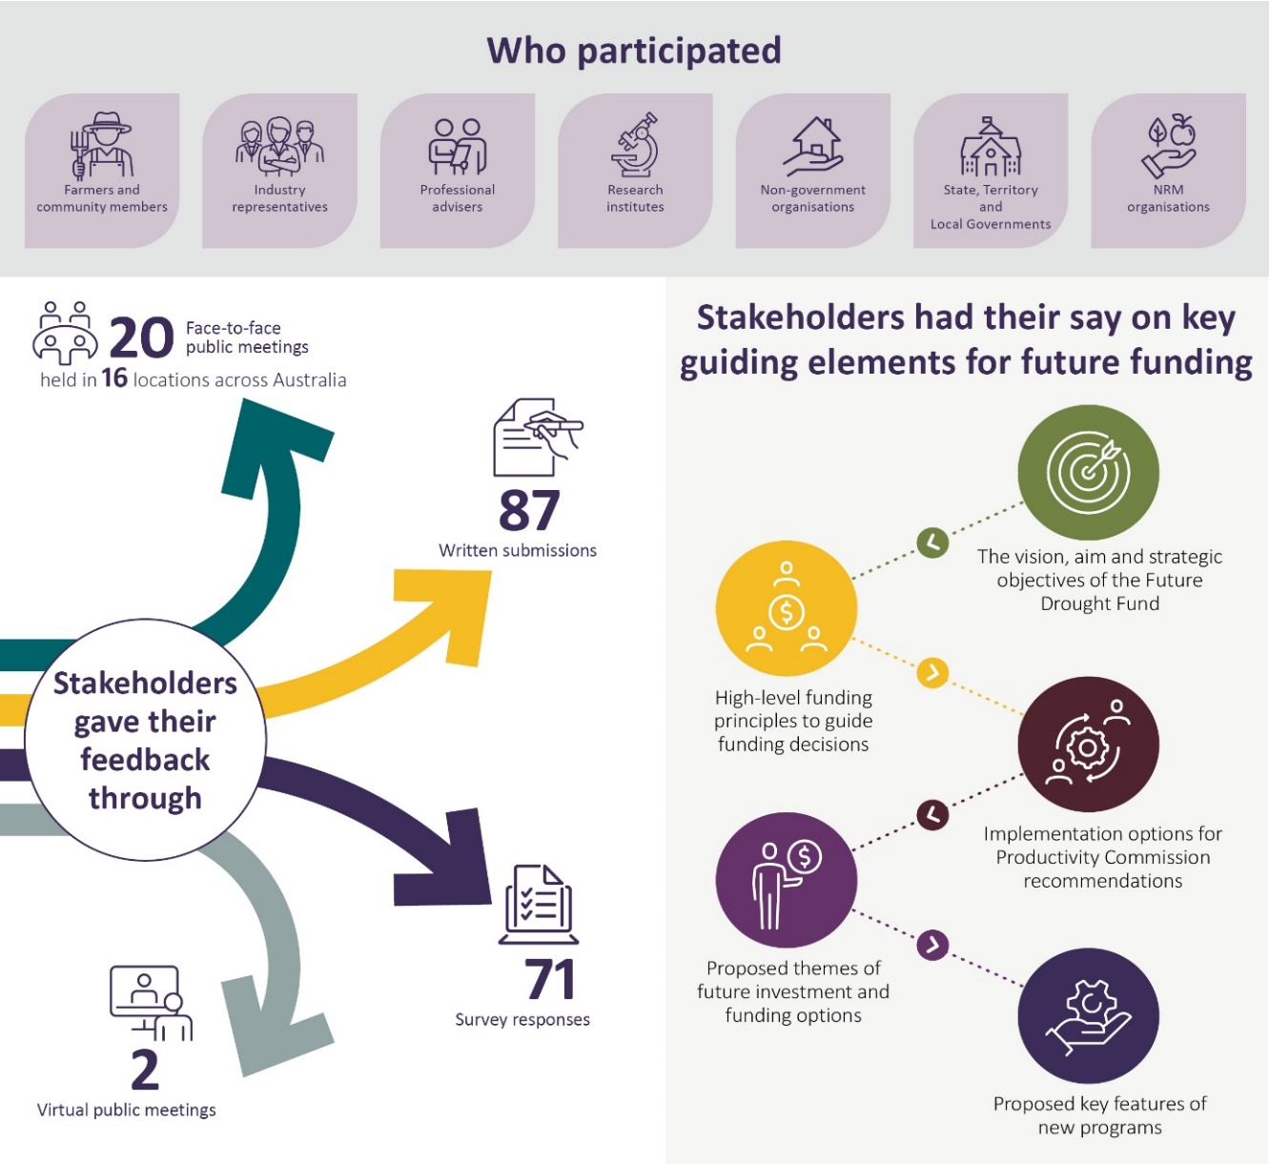

Monitoring, evaluation and learning
Monitoring, evaluation and learning (MEL) continues to be fundamental to the delivery of FDF and its programs. MEL ensures learning from work to date and improving how and to what extent FDF contributes to building drought and broader climate resilience and sustainability. The Productivity Commission provided valuable recommendations and findings regarding MEL. Following the inquiry report, and as part of the $519 million 2024–25 Budget, a dedicated team was created to prioritise MEL for the FDF and its programs. Development of a multipronged strategy, underpinned by building an evaluative culture in the FDF, started in 2023–24 for that purpose. The strategy includes ways to support FDF staff and delivery partners in designing and implementing MEL. This also includes capacity and capability building through training, a MEL Community of Practice and direct on-the-job learning.
A new MEL Framework (2024 to 2028) and other MEL deliverables are being developed. The framework, which includes a revised FDF theory of change, takes into account lessons learned from the implementation of the previous framework to date. The framework will outline ways to monitor and evaluate the efficiency and effectiveness of FDF and its programs in achieving the desired interlinked strategic objectives of social, economic and environmental resilience set out in the funding plan. Evaluations of a select number of FDF programs are also underway. Further evaluations of continuing programs and the FDF are expected over the next 4 years. Updates on this important work will be included in the next annual report.

Funding
The government allocated a total of $400 million to FDF programs to 30 June 2024 for the first 4-years of the FDF. In 2023–24, $110.37 million was spent from the FDF. A total of $340.09 million was spent from 1 July 2020 to 30 June 2024.
Table 17 Future Drought Fund funding allocation, 30 June 2024
Theme and programs | Total allocated ($) | Total spent ($) | 2020–21 spent ($) | 2021–22 spent ($) | 2022–23 spent ($) | 2023–24 spent ($)
Better climate information | 38,991,000.00 | 38,582,211.01 | 5,030,802.09 | 12,656,052.58 | 11,015,616.14 | 9,879,740.20
Climate Services for Agriculture | 28,991,000.00 | 29,079,192.40 | 3,590,802.09 | 8,796,109.40 | 7,324,281.87 | 9,367,999.04
Drought Resilience Self-Assessment Tool | 10,000,000.00 | 9,503,018.61 | 1,440,000.00 | 3,859,943.18 | 3,691,334.27 | 511,741.16
Better planning | 116,818,000.00 | 81,402,327.82 | 25,817,735.00 | 262,983.64 | 20,056,826.77 | 35,264,782.41
Farm Business Resilience | 75,965,000.00 | 51,593,804.00 | 15,965,120.00 | 0.00 | 9,659,758.00 | 25,968,926.00
Regional Drought Resilience Planning | 40,853,000.00 | 29,808,523.82 | 9,852,615.00 | 262,983.64 | 10,397,068.77 | 9,295,856.41
Better practices | 203,347,000.00 | 179,265,289.17 | 23,013,815.97 | 49,837,017.92 | 53,330,142.79 | 53,084,312.49
Drought Resilience Adoption and Innovation Hubs ª | 66,000,000.00 | 74,000,000.00 | 16,000,000.00 | 18,000,000.00 | 16,000,000.00 | 24,000,000.00
Hub Projects | 4,097,216.50 | 4,097,216.50 | 0.00 | 0.00 | 4,097,216.50 | 0.00
Adoption Officers | 9,000,000.00 | 9,000,000.00 | 0.00 | 3,000,000.00 | 3,000,000.00 | 3,000,000.00
National Enabling Activities ª | 7,886,783.50 | 1,850,925.61 | 220,462.80 | 814,631.31 | 587,164.81 | 228,666.69
Drought Resilience Innovation Grants | 33,961,000.00 | 27,545,436.80 | 0.00 | 18,820,517.50 | 5,038,636.35 | 3,686,282.95
Natural Resource Management Drought Resilience Program – Grants stream | 7,807,000.00 | 7,806,394.46 | 1,170,959.17 | 6,635,435.29 | 0.00 | 0.00
National Resource Management Drought Resilience Program – Landscapes stream | 5,600,000.00 | 5,622,394.00 | 5,622,394.00 | 0.00 | 0.00 | 0.00
Drought Resilience Soils and Landscapes | 23,130,000.00 | 23,044,650.80 | 0.00 | 2,566,433.82 | 17,543,125.13 | 2,935,091.85
Extension and Adoption of Drought Resilience Farming Practices | 14,265,000.00 | 13,019,191.00 | 0.00 | 0.00 | 6,264,000.00 | 6,755,191.00
Long-term Trials of Drought Resilient Farming Practices | 20,000,000.00 | 7,179,080.00 | 0.00 | 0.00 | 0.00 | 7,179,080.00
Drought Resilience Commercialisation Initiative | 10,000,000.00 | 4,500,000 | 0.00 | 0.00 | 0.00 | 4,500,000.00
Drought Resilience Scholarships | 1,600,000.00 | 1,600,000.00 | 0.00 | 0.00 | 800,000.00 | 800,000.00
Better prepared communities – Helping Regional Communities Prepare for Drought Initiative | 40,844,000.00 | 40,843,570.00 | 11,196,015.00 | 5,003,985.00 | 12,494,890.00 | 12,148,680.00
Drought Resilient Leaders | 17,450,000.00 | 17,450,000.00 | 7,446,015.00 | 1,003,985.00 | 4,558,856.00 | 4,441,144.00
Networks to Build Drought Resilience | 23,394,000.00 | 23,393,570.00 | 3,750,000.00 | 4,000,000.00 | 7,936,034.00 | 7,707,536.00
Total | 400,000,000.00 | 340,093,398.00 | 65,058,368.06 | 67,760,039.14 | 96,897,475.70 | 110,377,515.10
a Total allocations for these 2 programs have changed since the previously published annual reports, due to FDF underspends being reallocated in 2023–24.

Looking to the future
On 7 May 2024, as part of the 2024–25 Budget announcement, the Australian Government committed $519.1 million over 8 years from the FDF to deliver 10 on-ground programs as well as national enabling activities to better measure progress and share knowledge.
The second phase of the FDF, including the priority funding areas and programs, has been designed to build on learnings to date. This includes what stakeholders told us they value during nation-wide consultation in 2023, as well as the Productivity Commission review. Stakeholders wanted fewer, longer and high-impact programs, guided by a clear plan for the next phase of investment.
A further $42.2 million of departmental funding over 4 years was committed to ensure the effective management of the FDF.
We are committed to delivering even greater impact in the next phase of the FDF, building on successful projects and on-ground networks that are already driving change.
Learn more about the next phase of the Future Drought Fund and how to get involved.
Table 18 Priority funding areas for the Future Drought Fund from 2024–25
Funding area | Program | Funding | Description
Partnering for Local Solutions | Drought Resilience Adoption and Innovation Hubs | $28 million over 2 years from 2024–25 then $104 million over 6 years from 2026–27, contingent on the outcomes of a review | Providing regionally focused information and support to develop, extend and encourage the adoption of drought resilient technologies and practices.
 | Regional Drought Resilience Planning | $67 million over 4 years from 2025–26 | Helping regions prepare for and manage drought and other interconnected risks through locally tailored actions identified in community-owned and led plans.
 | Communities | $36 million over 4 years from 2024–25 | Strengthening social resilience to drought and other climate impacts by supporting and developing leaders, networks and organisations in agriculture-dependent communities.
Partnering for First Nations Initiatives | Strengthening Drought Resilience on Country pilot program | $12 million over 3 years from 2025–26 | A new pilot program will be established to facilitate place-based, First Nations-led activities. First Nations delivery partners will facilitate co-design and delivery of projects, with First Nations peoples. Projects will support First Nations individuals, businesses and communities to build drought and climate resilience.
 | First Nations Supporting Participation Activities | $3 million over 4 years from 2024–25 | Funding will be provided to deliver activities which seek to improve the participation of First Nations peoples in the FDF’s drought and climate resilience activities.
 | First Nations Advisory Group | Additional departmental funding to 2027–28 | A strategic policy partnership with eminent First Nations peoples to facilitate improved strategic outcomes from the FDF for First Nations peoples within the agriculture sector, landscapes, and communities.
Building Knowledge, Skills and Capability | Farm Business Resilience | $83.2 million over 5 years from 2024–25 | Helping farmers build skills and capabilities to plan for and manage all kinds of risks, including drought and other climate risks. This program will include and integrate Drought Resilience Scholarships.
 | Climate Services for Agriculture | $17.2 million over 4 years from 2024–25 | Enabling farmers and farm advisers, rural communities and others to access local, regional and commodity-specific climate information, useful for informing farm business, community and government decision-making to prepare for future drought and climate change.
 | Scaling Success | $37 million over 3 years from 2025–26 | Extending the reach of previous FDF projects that have proved successful in building drought and climate resilience and contributing to broader change.
Innovating for Transformation | Long-term Trials | $60.3 million over 6 years from 2024–25 | Investigating innovative farming practices, technologies and approaches through evidence-based trials to inform farmers, drive adoption and foster transformational change to build drought and climate resilience.
 | Resilient Landscapes | $40 million over 6 years from 2024–25 | Supporting projects to demonstrate how implementing and scaling of practices, technologies or approaches to manage natural resources on farm contribute to building drought and climate resilience by improving landscape function and ecosystem services.
 | Innovation Challenges Pilot | $20 million over 3 years from 2025–26 | Fostering innovative solutions for challenges related to drought and climate impacts.
Measuring Progress and Knowledge Sharing | Evaluation and Support | $3.25 million over 4 years from 2024–25 | Determining how, and to what extent, the FDF and its programs contribute to building social, economic and environmental resilience to drought and broader climate risks.
 | Knowledge Management | $7.3 million over 4 years from 2024–25 | Making the knowledge generated by the FDF more accessible and promoting wider adoption through a systematic and strategic approach.
 | Science to Practice 2.0 | $800,000 over 4 years from 2024–25 | Generating accessible, visual evidence of the FDF’s influence on the ground.

Appendix A: Funding tables
Table A1 Links to Future Drought Fund funding information
Theme | Program | Funding information
Better climate information | Climate Services for Agriculture | Climate Services for Agriculture funding information
 | Drought Resilience Self-Assessment Tool | Drought Resilience Self-Assessment Tool funding information
Better planning | Farm Business Resilience | Farm Business Resilience funding Information
 | Regional Drought Resilience Planning | Regional Drought Resilience Planning funding Information
Better practices | Drought Resilience Adoption and Innovation Hubs | Drought Resilience Adoption and Innovation Hubs funding information
 | Adoption and Innovation – National Enabling Activities | Adoption and Innovation – National Enabling Activities funding Information
 | Drought Resilience Innovation Grants | Drought Resilience Innovation Grants funding information
 | Natural Resource Management Drought Resilience – Grants stream | Natural Resource Management Drought Resilience – Grants stream funding information
 | Natural Resource Management Drought Resilience – Landscapes stream | Natural Resource Management Drought Resilience – Landscapes stream funding information
 | Drought Resilient Soils and Landscapes | Drought Resilient Soils and Landscapes funding information
 | Extension and Adoption of Drought Resilient Farming Practices Grants | Extension and Adoption of Drought Resilient Farming Practices Grants funding information
 | Long-term Trials of Drought Resilient Farming Practices | Long-term Trials of Drought Resilient Farming Practices funding information
 | Drought Resilience Commercialisation Initiative | Drought Resilience Commercialisation Initiative funding information
 | Drought Resilience Scholarships | Drought Resilience Scholarships funding information
Better prepared communities | Helping Regional Communities Prepare for Drought Initiative | Helping Regional Communities Prepare for Drought Initiative funding information

References
Bureau of Meteorology 2024, Financial year climate and water statement 2023–24, Bureau of Meteorology, Canberra, July, accessed 21 October 2024.
DAFF 2022, Future Drought Fund annual report 2021–22, Department of Agriculture, Fisheries and Forestry, Canberra, November, accessed 10 April 2024.
DAWE 2020, Future Drought Fund Monitoring, Evaluation and Learning Framework, Department of Agriculture, Water and the Environment, Canberra, December, accessed 15 March 2024.
——2021, Future Drought Fund annual report 2020–21, Department of Agriculture, Water and the Environment, Canberra, October, accessed 10 January 2024.
Productivity Commission 2023, Review of Part 3 of the Future Drought Fund Act: Inquiry report no. 102, Canberra, September, accessed 6 October 2024.

