January 2025

Future Drought Fund First Nations Advisory Group
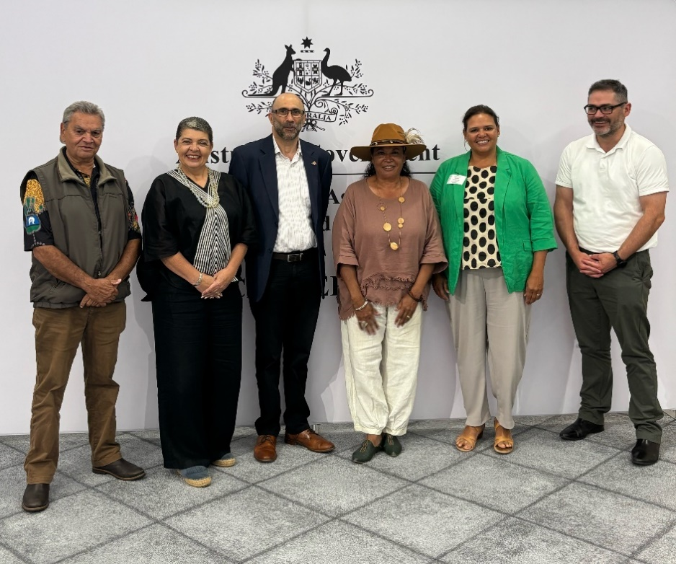
Future Drought Fund First Nations Advisory Group Chair and Members
From left to right: Oscar Colbung (member), Emma Lee (member), Ian Hamm (chair), Suzanne Thompson (member), Natalie Sommerville (member) and Michael O’Keeffe (member).

Role and establishment
The Future Drought Fund’s (FDF) First Nations Advisory Group was established by the Department of Agriculture, Fisheries and Forestry on 28 January 2025. The advisory group will develop its Terms of Reference and work plan in partnership with the Department. It is expected the advisory group will advise on:
- design and implementation of FDF First Nations Initiatives, including the Strengthening Drought Resilience on Country pilot program and Supporting Participation Activities
- how to better target all FDF programs to be inclusive of First Nations people by using culturally sensitive approaches.
Aboriginal and Torres Strait Islander people have been caring for lands, waters and seas for tens of thousands of years, and continue to hold and develop highly valuable Indigenous knowledge. With the agreement and recognition of First Nations people, this knowledge could add to the range of tools available to improve the sustainability of the Australian agricultural sector, landscape and communities – for the benefit of all.

Membership
Six First Nations Advisory Group members have been engaged for their individual skills and expertise. Membership comprises First Nations people with established and diverse expertise in areas such as environmental, social and economic initiatives, including drought and climate resilience.

Members
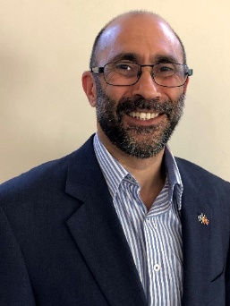
Ian Hamm (Chair)
A Yorta Yorta man, Ian has extensive government and community sector experience, particularly at executive and governance levels. Ian has overseen major policy and strategic reforms for government and community organisations. He works with people from a vast array of backgrounds, managing complex and sensitive relationships to achieve mutually beneficial outcomes. Ian was CEO of a major Aboriginal community organisation from January to August 2018.
Ian chairs, and is a member of, a number of boards, including the Indigenous Land & Sea Corporation, the Community Broadcast Foundation, the First Nations Foundation, the Australian Institute of Company Directors, The Healing Foundation, Community First Development and Holmesglen TAFE. He is also devoting himself to improving the representation of Aboriginal people on boards and other high-level governance, through strategic action, advocacy and mentoring.
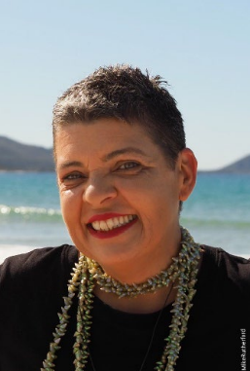
Emma Lee (Member)
Professor Emma Lee is a trawlwulwuy woman from tebrakunna country, north-east Tasmania, and resides in north-west Tasmania. She holds a Doctorate in Regional Development from the University of Tasmania. She joined Federation University in March 2023 to further the research and social impacts of the National Centre for Reconciliation, Truth, and Justice.
Emma is an internationally recognised expert on Indigenous methodologies, especially as applied to land and sea management. She has written books, papers and reports on Indigenous rights, democracy, government policy and regional development. She sits on numerous Federal Government councils, committees and advisory groups and has had several roles in Tasmanian Aboriginal organisations.

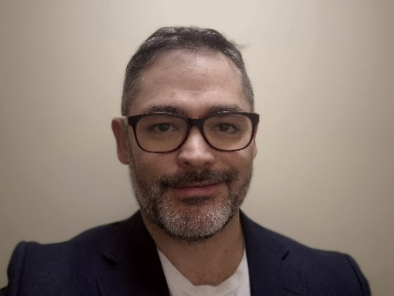
Michael O’Keeffe (Member)
Michael is a proud Quandamooka man living on Ngunnawal country. He brings 20 years of experience working across the public and private sectors including areas of agribusiness, business management, natural resource management, drought, science, and digital transformation. Currently he is the Chief Technology Officer for Wuna, a digital identity platform supporting self-determination for Indigenous and under-documented peoples.
Micheal previously worked for the federal Department of Agriculture as a senior scientist leading a team charged with building tools to assess the economic, social and environmental impact of drought on agricultural businesses.
Michael is also the founder of Soojik Farms, a Controlled Environment Agriculture startup specialising in aquaculture and aquaponics and the development of systems to propagate and grow a variety of traditional bush foods and medicinal plants in controlled environments.
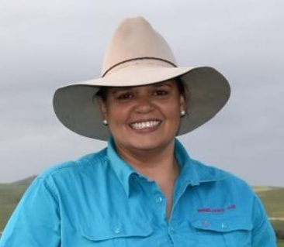
Natalie Sommerville (Member)
Natalie Sommerville has been farming on Ngadjuri Country in South Australia’s Mid North for over 20 years in her family farming business Windjara Ag and brings operational and strategic experience in managing a grain and livestock agribusiness.
Natalie has a Bachelor of Applied Science in Natural Resources Management and Agriculture combining her key interests of sustainable agriculture and the environment with a holistic approach to build robust and resilient farming systems. Natalie has a background in crop agronomy and Aboriginal and Torres Strait Islander engagement. She also has strong facilitation experience for both adults and youth.
Natalie brings creative strategic leadership to her board directorship roles, strong governance, and a First Nations lens. She has been non-executive director for National Farmers’ Federation, current non-executive director for the Grains Research and Development Corporation, Landcare Australia, President of Australian Women in Agriculture, and representative on industry committees and First Nations advisory groups.

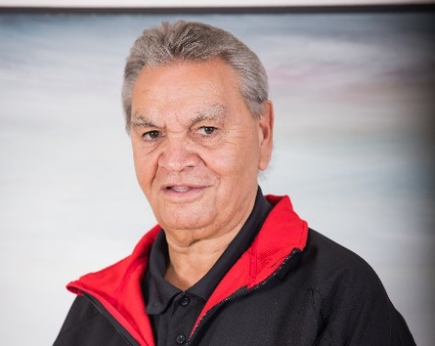
Oscar Colbung (Member)
Oscar is a traditional owner of the Menang region, with traditional connections to Bibbulmun, Wardandi and Ganeang Noongar native title regions in Western Australia.
Oscar is currently a Chairperson of Walitj Aboriginal Corporation and manager at the Southern Aboriginal Corporation. He has worked for the Southern Aboriginal Corporation for over 27 years, leading cultural competency and cultural decision making. The Southern Aboriginal Corporation is a lead Aboriginal body representing the interests of Noongar people in the Great Southern region.
Oscar’s involvement in Indigenous affairs over 30 years has been significant and has represented the Great Southern region community on many committees such as Aboriginal Legal Service, Aboriginal and Torres Strait Islander Commission, Southwest Aboriginal Land and Sea Council, Relationship Committee, Local Aboriginal Community-Controlled Organisations.
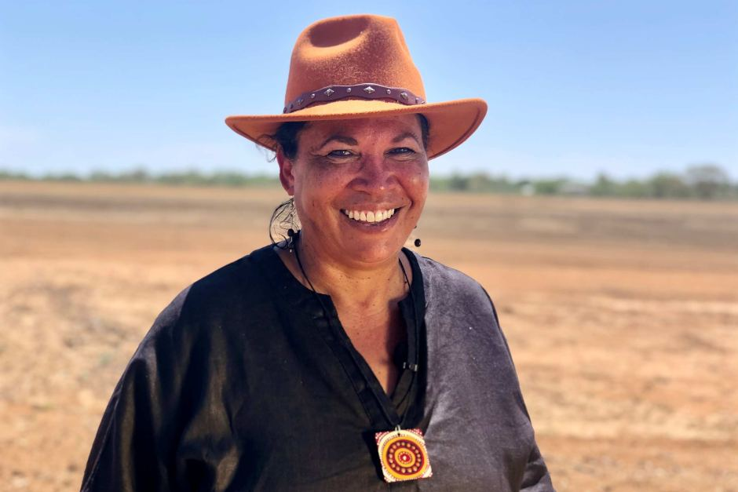
Suzanne Thompson (Member)
Suzanne Thompson is a proud Aboriginal woman born and raised in the Central Western Queensland town of Barcaldine. She is currently fostering support and investment for nature-based economies, including Indigenous Land Management, Carbon Farming and First Foods & Medicines, and the recognition, protection, and renumeration of Indigenous intellectual knowledge.
Suzanne is the Founder and Managing Director of Yambangku Aboriginal Cultural Heritage and Tourism Development Aboriginal Corporation (YACHATDAC) which manages a 22,000-acre property in outback central Western Queensland.
Suzanne volunteers her time as the chair of the Australian Native Foods & Botanicals National Peak body. She was recently appointed as Indigenous advisor to the Tourism & Events Queensland board, and interim secretary for the Queensland First Nations Tourism Council. She is a member of the Landcare Australia’s First Nations Working Group, and a participant and contributor to the Central Western Queensland Ministerial Round Table. She is also the Director of the Indigenous Carbon Industry Network and was recently appointed as the First Nations Integrity member to the Emissions Reduction Assurance Committee.

Background
The term of the First Nations Advisory Group commenced on 28 January 2025 and will cease on 30 June 2028.
The establishment of the First Nations Advisory Group responds to a recommendation from the 2023 Productivity Commission Inquiry and stakeholder feedback received during public consultation in late 2023. Its establishment also delivers on a 2024–25 Australian Government Budget measure.
A key funding priority for the Future Drought Fund is partnering with First Nations peoples, businesses, organisations and communities to support economic self-determination and connection to, and caring for, Country through the management of drought and climate risks. Government has committed $15 million over 4 years from 2024-25 for First Nations Initiatives.

More information
Learn more about the Future Drought Fund
Web agriculture-land/farm-food-drought/drought/future-drought-fund
Email droughtresilience@agriculture.gov.au
Acknowledgement of Country
We acknowledge the Traditional Custodians of Australia and their continuing connection to land and sea, waters, environment and community. We pay our respects to the Traditional Custodians of the lands we live and work on, their culture, and their Elders past and present.
© Commonwealth of Australia 2025
Unless otherwise noted, copyright (and any other intellectual property rights) in this publication is owned by the Commonwealth of Australia (referred to as the Commonwealth).
All material in this publication is licensed under a Creative Commons Attribution 4.0 International Licence except content supplied by third parties, logos and the Commonwealth Coat of Arms.
The Australian Government acting through the Department of Agriculture, Fisheries and Forestry has exercised due care and skill in preparing and compiling the information and data in this publication. Notwithstanding, the Department of Agriculture, Fisheries and Forestry, its employees and advisers disclaim all liability, including liability for negligence and for any loss, damage, injury, expense or cost incurred by any person as a result of accessing, using or relying on any of the information or data in this publication to the maximum extent permitted by law.

