Renewing the Australian Animal Welfare Strategy: discussion paper
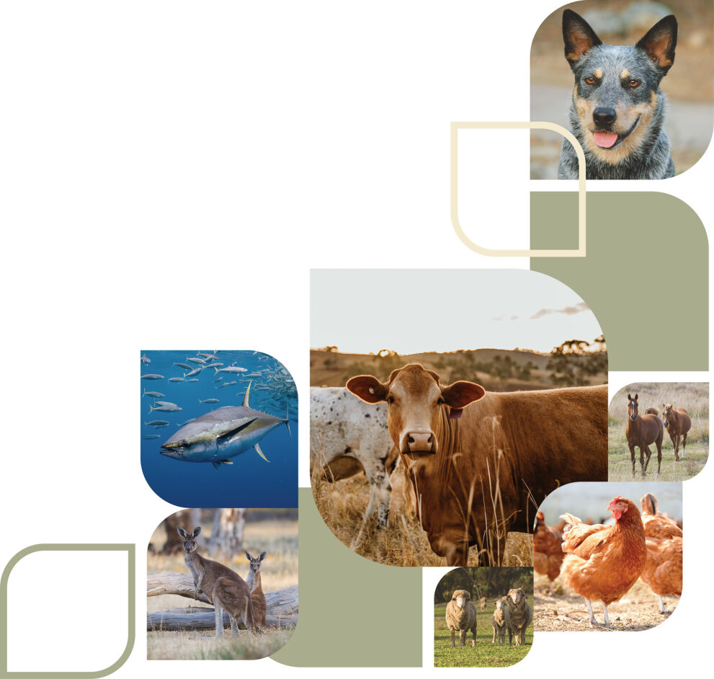
© Commonwealth of Australia 2024
Ownership of intellectual property rights
Unless otherwise noted, copyright (and any other intellectual property rights) in this publication is owned by the Commonwealth of Australia (referred to as the Commonwealth).
Creative Commons licence
All material in this publication is licensed under a Creative Commons Attribution 4.0 International Licence except content supplied by third parties, logos and the Commonwealth Coat of Arms.

Cataloguing data
This publication (and any material sourced from it) should be attributed as: DAFF 2024, Renewing the Australian Animal Welfare Strategy: discussion paper, Department of Agriculture, Fisheries and Forestry, Canberra. CC BY 4.0.
This publication is available at agriculture.gov.au/haveyoursay/aaws.
Department of Agriculture, Fisheries and Forestry
GPO Box 858 Canberra ACT 2601
Telephone 1800 900 090
Web agriculture.gov.au
Disclaimer
The Australian Government acting through the Department of Agriculture, Fisheries and Forestry has exercised due care and skill in preparing and compiling the information and data in this publication. Notwithstanding, the Department of Agriculture, Fisheries and Forestry, its employees and advisers disclaim all liability, including liability for negligence and for any loss, damage, injury, expense or cost incurred by any person as a result of accessing, using or relying on any of the information or data in this publication to the maximum extent permitted by law.
Acknowledgement of Country
We acknowledge the Traditional Custodians of Australia and their continuing connection to land and sea, waters, environment and community. We pay our respects to the Traditional Custodians of the lands we live and work on, their culture, and their Elders past and present.

Contents
Purpose 1
Next steps 1
Context 2
History 2
Australia’s animal welfare system 2
Scope 4
Approach 4
Discussion questions 6
Vision 6
Work streams 6
Challenges 7
Opportunities 8

Purpose
A renewed Australian Animal Welfare Strategy (AAWS) will establish Australia’s commitment to modern, sustainable, evidence and science-based welfare practices. It will provide a national framework to bring key stakeholders together on animal welfare issues of national significance.
This discussion paper facilitates initial stakeholder feedback on what a renewed AAWS should look like.
The Australian Government is funding and developing the renewed AAWS and will work closely with states and territories, and a broad range of stakeholders. We are seeking your views and insights on the following aspects of the renewed AAWS:
- vision for the strategy
- work streams
- challenges and opportunities for animal welfare in Australia.
Learn more about the renewed Australian Animal Welfare Strategy.

Next steps
Your views will help shape the renewed strategy. We will publish a summary of views expressed during consultation and received through the Have Your Say process.
This discussion paper is the first step in an extensive stakeholder engagement process that will take place over the next 3 years. Consultation will be ongoing. We will test insights and priorities throughout the development process from 2024 to 2026. The final renewed strategy is expected to be published in 2027.

Context

History
Animals are important for Australia socially, culturally, and economically. They are our companions, providers of assistance, contributors to health and ecological well-being, and suppliers of essential food and fibre resources. Animal and animal-related industries generate billions of dollars of economic activity and tens of thousands of jobs across rural, regional, and urban Australia.
The original Australian Animal Welfare Strategy lapsed in 2014. The original strategy was an overarching national framework that identified priorities, coordinated stakeholder action, and improved all animal use sectors. The Council of Australian Governments’ (CoAG) Primary Industries Ministerial Council endorsed the original strategy in May 2004. Its first National Implementation Plan was endorsed in 2006. The original strategy was updated in 2010 after stakeholder consultation and an independent review of Phase 1 of the strategy. Phase 2 of the strategy ran from 1 July 2010 to 30 June 2014.
The vision of the original strategy was to ensure ‘the welfare of all animals in Australia is promoted and protected by the development and adoption of sound animal welfare standards and practices.’
The original strategy had 6 animal groups, to ensure that the strategy was comprehensive. These 6 groups were:
- livestock and production animals
- companion animals
- aquatic animals
- animals used for work, recreation, entertainment and display
- animals used in research and teaching
- native, introduced and feral animals.
At its conclusion, the original strategy was in its implementation phase, supported by a range of working groups.

Australia’s animal welfare system
Animal welfare within Australia is generally a state and territory responsibility. However, there is a collaborative approach to managing animal welfare. The 3 tiers of government – the Australian Government, state and territory governments, and local governments – each have animal welfare responsibilities.
The Australian Government’s responsibility relates primarily to international trade. This includes export of livestock and meat products, and consideration of trading partner requirements when negotiating trade deals. The Australian Government is also responsible for providing input to international negotiations on animal welfare and supports the development of international standards through its membership of the World Organisation for Animal Health. It negotiates treaties (e.g. the Convention on International Trade in Endangered Species of Wild Fauna and Flora – CITES) and ensures compliance with treaties it signs.
State and territory governments have the primary responsibility for animal welfare regulation in Australia. This includes preparing and enforcing animal welfare legislation, providing suitable institutional and legislative frameworks, developing appropriate policies and programs, and making policies and programs readily accessible to the public.
Local governments have responsibility for some areas of domestic animal control which can impact both animal welfare and public health, such as dangerous dog provisions. This includes providing feedback to state and territory governments on animal welfare legislation and the promotion and maintenance of responsible animal ownership.
Animal industries also play an important role in Australia’s system. Animal industries work with governments and other stakeholders like veterinarians, animal welfare groups and research bodies to deliver optimal animal welfare outcomes domestically and, where applicable, for the international market. This role includes engagement with animal welfare standards and guidelines development and implementation. Various animal industries have also developed their own best practice guidelines for animal welfare, as well as certification and quality assurance systems. Many industries have also developed sustainability frameworks to guide and monitor the sustainability of industry practices into the future. Industry and the Australian Government co-invest in a range of research, development and extension activities to support continuous improvement in animal welfare.
The Animal Welfare Task Group (AWTG) promotes the national consistency of farm animal welfare regulations across jurisdictions and oversees the development and review of standards and guidelines for farm animals. It resolves animal welfare policy and regulatory matters that have national and inter-jurisdictional scope and delivers on animal welfare priorities of national interest referred to it by the Agriculture Senior Officials’ Committee (AGSOC). The AWTG has officials from the Australian Government, and state and territory governments. The New Zealand government is also a part of AWTG, as an observer. The AWTG is a subgroup of AGSOC, which reports to Agriculture Ministers.
Since the 1980s, the welfare of farm animals in Australia has been supported by a series of Model Codes of Practice for the Welfare of Animals (MCOP). Animal industry sectors have voluntarily adopted the codes.
In 2005, Australian Governments agreed to convert the codes into Australian Animal Welfare Standards and Guidelines, with Australian states and territories to adopt the standards as minimum legal standards, and the guidelines for recommended practice to be adopted voluntarily by industry.
The introduction of animal welfare standards and guidelines aimed to improve welfare regulation in Australia through a greater focus on improved welfare outcomes, practical implementation for industry, and consistency across all Australian jurisdictions.
National standards and guidelines are based on science and evidence. They take into account practicalities and costs to industry. They are also underpinned by stakeholder engagement.
The development of national animal welfare standards and guidelines through the collaborative mechanism of the AWTG helps provide clarity and consistency, as well as facilitate the understanding of animal welfare requirements across industry, the community and trading partners.

Scope
The Australian Government has committed $5 million over 4 years to renew the AAWS. A renewed AAWS will facilitate joint leadership from the Australian Government and state and territory governments to animal welfare, with a view to:
- establishing a national framework for bringing key stakeholders together on animal welfare issues of national significance
- providing a forward direction for animal welfare in Australia to address community and international expectations
- maintaining Australia’s commitment to modern, sustainable animal welfare practices informed by science and evidence.
Key learnings and successes from the lapsed strategy will inform the renewed strategy. The renewed strategy will also consider modern challenges, opportunities, science and evidence.
The funding commitment by the Australian Government allows for the development of a strategy that:
- provides a vision for the welfare of all animals
- outlines the challenges and opportunities for animal welfare in Australia
- defines relevant work streams of practical actions for meaningful improvements in Australia’s animal welfare system.
Current funding does not cover the implementation of the strategy. There are a number of factors that would need to be considered as part of an implementation phase, such as re-establishing sector-specific working groups.

Approach
The strategy will be released in chapters, each dedicated to one of 6 animal groups, with the final strategy expected in 2027:
- livestock and production animals
- aquatic animals (including aquatic animals in production and wildlife)
- animals in the wild (native, introduced and feral animals)
- companion animals
- animals used for work, sport and recreation
- animals used in research and teaching.
Each animal group chapter will include practical actions, grouped under a relevant work stream. The practical actions describe the measures needed for meaningful improvements in Australia’s animal welfare system.
An inclusive stakeholder engagement approach will ensure a broad range of people are involved in, and contribute to, the development of the renewed strategy. This Have Your Say survey is the start of the public engagement process.

Discussion questions
The strategy will build on successes of the lapsed AAWS while reflecting contemporary animal welfare science and evidence and recognising modern challenges and opportunities. The renewal process will consider the following elements:
- Vision – ‘the why’, describing the aspiration for the renewed AAWS.
- Work streams – priority areas for the strategy, or categories of actions that will support the achievement of the strategy’s vision.
- Challenges – describing key weaknesses and blockers in the animal welfare system.
- Opportunities – describing key strengths and areas of leverage in the animal welfare system.

Vision
The vision statement will describe the aspiration for the future. It should be proactive, have a positive focus, and describe the type of system and values needed to ensure animal welfare is protected for all animals. In short, the vision articulates ‘why’ the strategy exists.
An overarching vision statement guided the lapsed strategy, and was developed after extensive consultation with stakeholders:
To establish an Australian animal welfare system that brings stakeholders together, identifies national priorities with actions and outcomes, and demonstrates to the public and international partners that Australia values the welfare of all animals.
Question 1: Does this vision statement reflect everything you feel an Australian Animal Welfare Strategy should aim to achieve?
Question 1a: Is there anything else it should include?

Work streams
Each animal group chapter will include practical actions, grouped under a relevant work stream. The work streams will describe the measures needed for meaningful improvements in Australia’s animal welfare system.
There are 6 work streams proposed for the new strategy. The work streams will describe priority areas of work that support the achievement of the strategy’s purpose and vision.
The work streams need to be suitable for the scope of the strategy (identified within the Discussion Paper, see ‘Scope’). These work streams build on the goals of the lapsed AAWS that focused on animals, national systems, people and the international scene.

Proposed work streams for the strategy
- Leadership and coordination – this stream establishes governance arrangements to oversee strategy implementation and coordination of activities.
- Research and development – this stream implements a coordinated approach to animal welfare research and extension activities.
- Standards and implementation – this stream implements an overarching framework for standards development that identifies national priorities and streamlines development and adoption by jurisdictions.
- Education and communication – this stream promotes best-practice to industry and showcases outcomes to domestic audiences and international partners.
- Reporting and compliance – this stream establishes systems to track outcomes and monitor compliance.
- International engagement – this stream contributes to our sustainable trade credentials by showcasing and maturing Australia's national approach to animal welfare.
Question 2: Do the above proposed streams cover the right priority areas for the strategy?
Question 2a: Are there other priority areas that you think are important and should be added to the strategy?
Question 2b: Are there any you feel are not a priority area?
Question 3: Are there any shared factors affecting animal welfare that cut across all, or multiple, animal groups? For example: Climate change, innovation, workforce retention.
Question 3a: How can the Australian Animal Welfare Strategy address these in a practical way?

Challenges
Engagement with animal welfare groups, industry, governments, First Nations people, farmers, researchers and other stakeholders across Australia’s animal welfare system over several years has identified several pressing challenges that impede progress across various priority areas.
The animal welfare system in Australia operates through a combination of laws, regulations and practices designed to ensure the well-being and humane treatment of animals in the country. The animal welfare system contains various elements, such as national standards and guidelines, laws preventing animal cruelty, powers for inspection and enforcement, the operation of animal shelters and rescue organisations, the presence of organisations dedicated to animal welfare and education and awareness campaigns. The system aims to strike a balance between the interests of humans and animals, promoting responsible pet ownership, humane treatment of livestock, and the regulation of activities like research, recreation and entertainment.
Your input in identifying the most pressing challenges in the system will help inform the creation of this strategy.
Question 4: What do you think are the biggest challenges facing Australia’s animal welfare system?
- Developing a fit-for-purpose national strategy that suits all audiences, taking into account that different groups of stakeholders may have different expectations and interests.
- Animal welfare is primarily a state and territory responsibility, providing challenges to a harmonised approach to decision-making.
- Community values and expectations about animal welfare issues are constantly changing, while improvements in animal welfare science can take time to develop and implement.
- There is a complex relationship between animal welfare regulation, productivity and community expectations.
- The national standards development system is complex and not currently meeting all stakeholder needs.
Question 5: Are there additional challenges in the animal welfare system that have not been listed above, which the renewed strategy should consider?

Opportunities
Despite the challenges, there are opportunities for meaningful change within Australia’s animal welfare system. Animals are important for Australia socially, culturally and economically. Animal welfare is a priority for the community, the agriculture industry and Australian governments. A renewed strategy provides an opportunity to consider animal welfare in the context of contemporary science and evidence and reflect on the needs and expectations of all stakeholders. All Australian governments have committed to address standards setting for animal welfare. This work has been directed by Agriculture Ministers and is being led by the AWTG.
Identifying opportunities for meaningful improvements in Australia’s animal welfare system will be an important part of developing actions under a renewed strategy.
Question 6: What do you think are the biggest opportunities for Australia’s animal welfare system?
- Overseas trading partners are increasingly interested in Australia’s animal welfare credentials.
- Animal and animal-related industries are increasingly building animal welfare into industry-level sustainability plans and work practices.
- There is a strong research community, focused on developing and considering contemporary animal welfare science and evidence and coordinating research and data collection across jurisdictions.
- Animal welfare has become part of national conversations including biosecurity, animal health and productivity.
- There is a changing social licence, reflecting the intrinsic value of animals and their importance to people.
- Agriculture Ministers are focused on animal welfare and work is underway to improve national standards setting.
Question 7: Are there additional opportunities for improvements in the animal welfare system that have not been listed above, which the renewed strategy should consider?
Question 8: Is there anything else you would like to be considered in the development of the strategy, within the scope described in this discussion paper?

