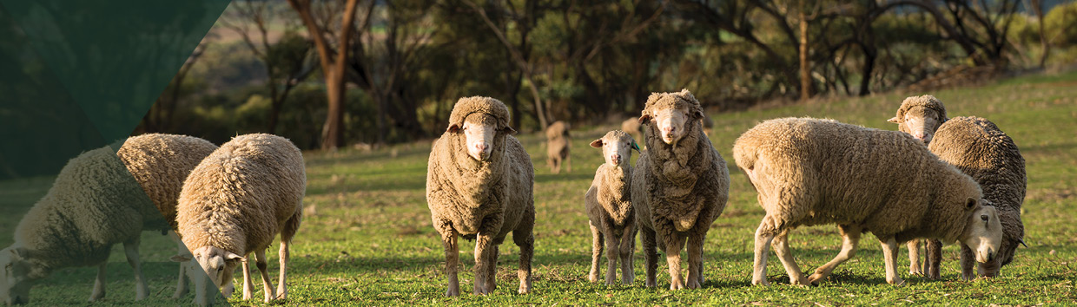


Renewed Australian
Animal Welfare Strategy
$5 million
The Australian Government has committed to develop a renewed Australian Animal Welfare Strategy that was last active in 2014. A renewed strategy will provide a contemporary framework for ensuring animal welfare in Australia.
The strategy will cement a national approach to animal welfare and signal to our international trading partners and Australian consumers that animal welfare is a priority for our nation.
It will also confirm Australia’s commitment to a modern, sustainable and science-based approach to animal welfare.
What’s in this year’s Budget
The government is strengthening our national approach to animal welfare by investing $5 million over 4 years to renew the Australian Animal Welfare Strategy, restoring much needed national leadership on our nation’s approach to animal welfare.
Why this is important
Animal welfare is a priority for the community, the agriculture industry and the Australian Government. Renewing the Australian Animal Welfare Strategy reflects the community’s desire for joint leadership from all Australian governments on animal welfare.
The strategy delivers on the government’s election commitment to strengthen animal welfare transparency and assurance, and complements the October Budget measure to create an Inspector-General of Animal Welfare and Live Animal Exports.
A renewed Australian Animal Welfare Strategy re-establishes a national framework for priority setting and associated national standards and measures of improvement for animal welfare outcomes.
Demonstrating Australia’s strong animal welfare standards will support increased access to overseas markets, while strengthening the reputation of our animal and agricultural industries with trading partners.
The renewal of the Australian Animal Welfare Strategy will be undertaken in collaboration with state and territory governments and in consultation with non-government and industry bodies, animal welfare groups, First Nations peoples and the Australian community.
How much this will cost
 | 2023-24  $m | 2024-25  $m | 2025-26  $m | 2026-27  $m | TOTAL  $m
Renewed Australian Animal Welfare Strategy
Renewed Australian Animal Welfare Strategy | 1.172 | 1.194 | 1.348 | 1.285 | 4.999
Subtotal | 1.172 | 1.194 | 1.348 | 1.285 | 4.999

More information
For more information about our renewed Australian Animal Welfare Strategy visit agriculture.gov.au
For more information about the 2023–24 Budget visit budget.gov.au

