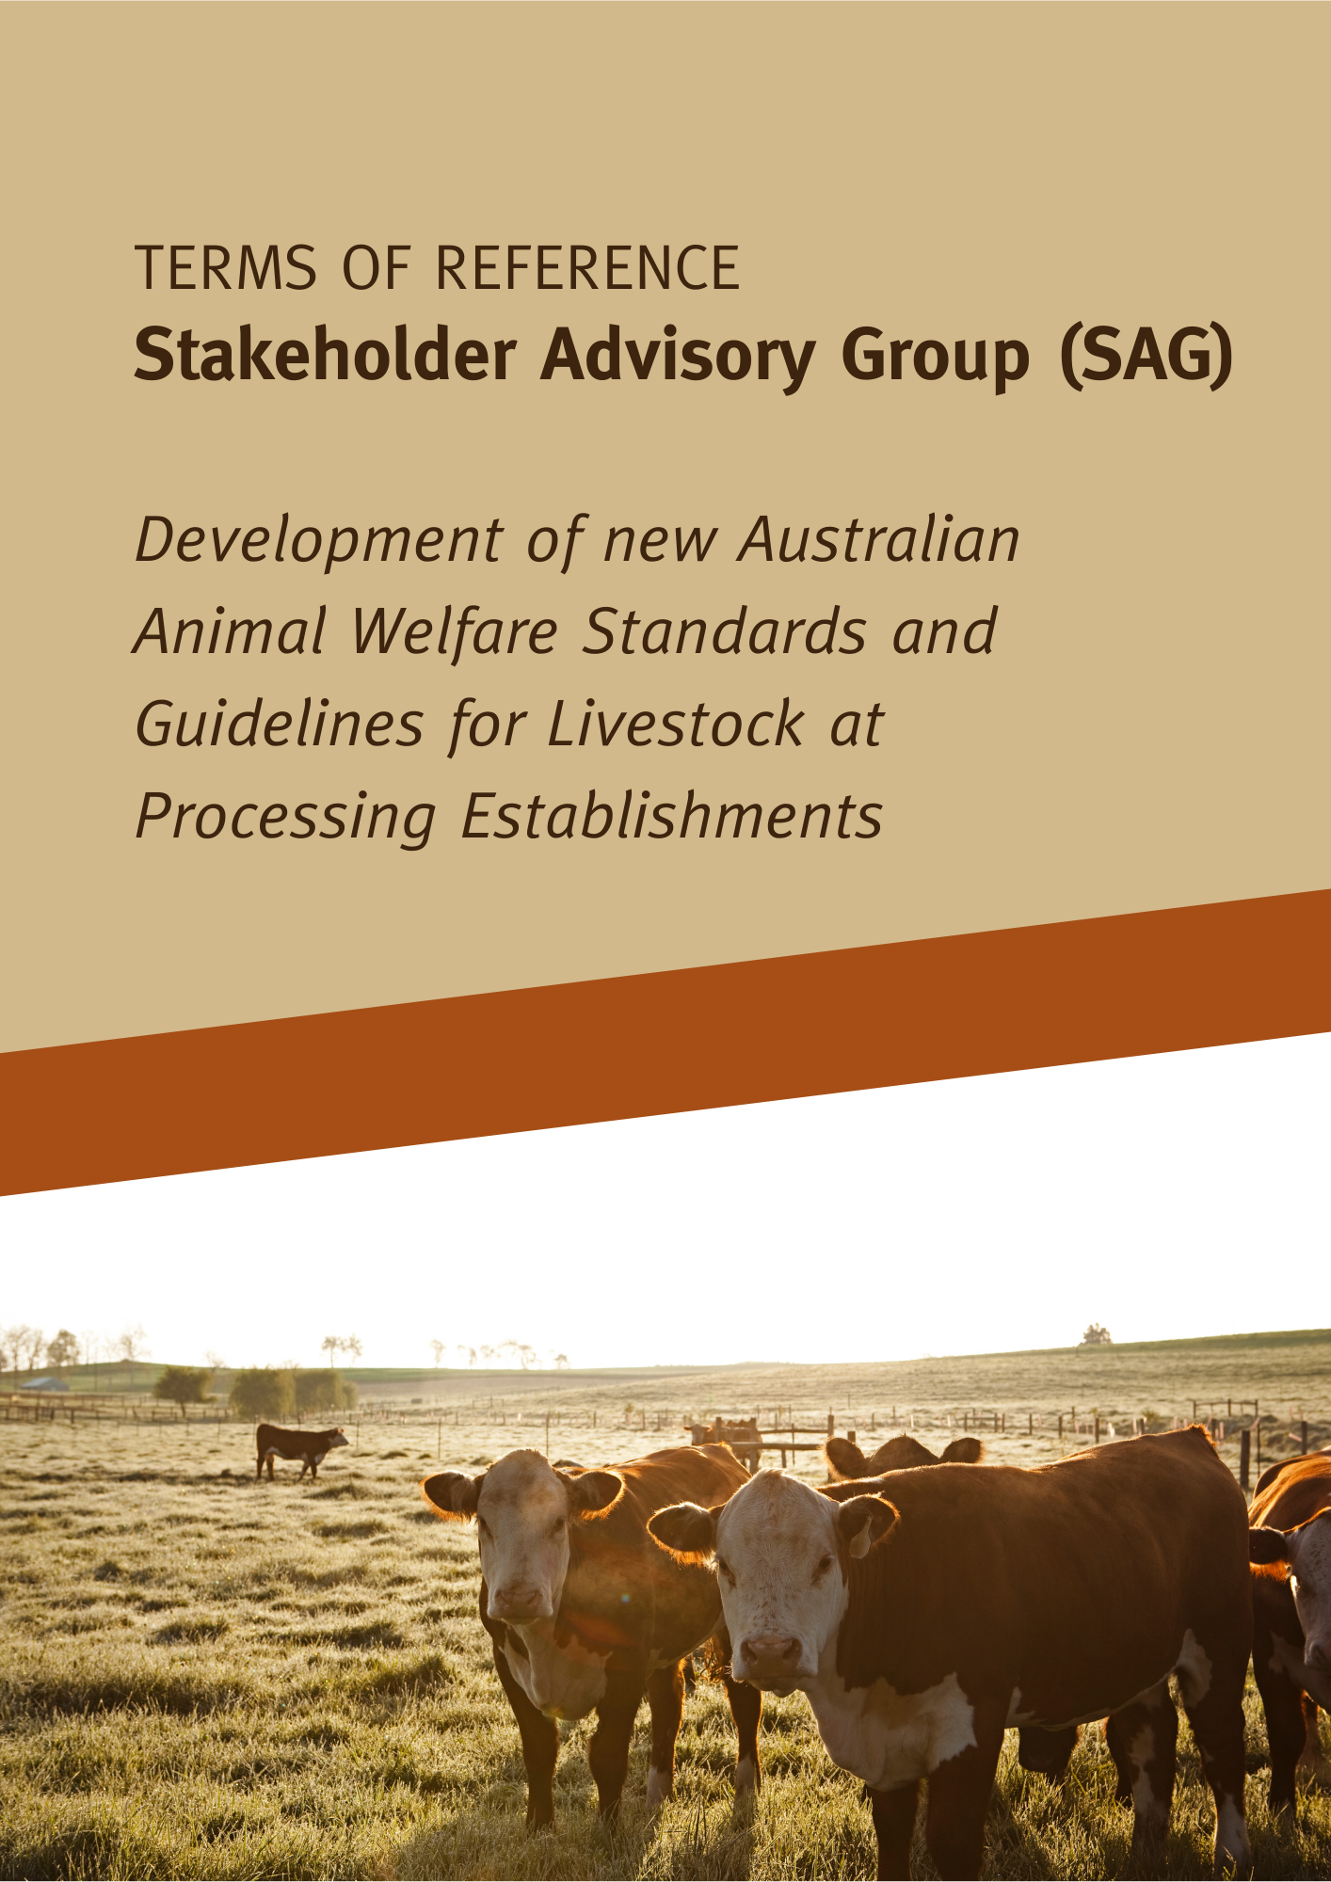

Background
Animal welfare is held in high regard by the community and our animal welfare standards are increasingly being scrutinised by our international trading partners. Therefore, it is important for animal welfare standards and guidelines to keep pace with community expectations and contemporary research and science.
The current Model Code of Practice for the Welfare of Animals – Livestock at Slaughtering Establishments (the Model Code) was published by CSIRO in 2002. The Model Code, and other Model Codes of Practice for the Welfare of Animals are gradually being replaced by the Australian Animal Welfare Standards and Guidelines.

In February 2020, the Animal Welfare Task Group (AWTG) began a process to develop new Australian Animal Welfare Standards and Guidelines for Livestock at Processing Facilities. The AWTG is comprised of representatives from each state and territory and the Commonwealth governments and currently reports to the Agriculture Senior Officials Committee.

The new standards and guidelines will cover all the main commercial livestock species that are handled in Australian meat processing facilities, including cattle (including bobby calves), sheep, goats, horses, pigs, rabbits, deer, buffalo, camels, alpaca, donkeys and poultry. The new standards and guidelines are expected to be finalised by mid-2023.

A literature review of contemporary research and science about the welfare of animals at slaughter establishments is being prepared by independent consultants and will underpin the new standards and guidelines.
Stakeholder consultation will form an important part of the development of the new standards and guidelines and will ensure feedback is considered. To provide an opportunity to engage with key national stakeholders in a structured manner during the development of the new standards and guidelines, a Stakeholder Advisory Group (SAG) will be formed.
Purpose of SAG
Key purposes of the SAG are to:
- serve as a consultation group during the development process for the new standards and guideline,
- provide advice and, where appropriate, recommendations to the AWTG
- facilitate the exchange of information on matters relating to the development of the new standards and guidelines to and from represented organisations and networks.
The SAG will not be part of the drafting group for the new standards and guidelines. However, advice and recommendations provided by members of the SAG will be considered by the drafting group and AWTG during the drafting process.
Please note, the SAG will not be the only means of consultation. Consultation with other stakeholders and the community will be facilitated by the AWTG, including through a national regulatory impact process.
Scope and duration
The SAG may provide advice and recommendations to the AWTG regarding any matter directly related to animal welfare at processing facilities.
The SAG will be invited to consider key documents including draft standards and guidelines, the independent scientific literature review, policy papers and regulatory impact analysis material.
The SAG will exist for the duration of the development of the standards and guidelines.
Membership
Membership of the SAG will include representatives from the meat processing industry, meat retail, animal welfare, veterinary science and relevant regulators from across Australia.
State and Territory animal welfare agencies and other relevant government agencies may observe SAG meetings to ensure they have a good understanding of discussions leading to SAG advice and recommendations.
Chair
The SAG will be chaired by an independent facilitator (details to be advised). The chair will be independent from the meat processing industry, meat retail, animal welfare, veterinary science and regulation areas, and will have professional expertise in facilitation.
Expectations of members
Members of the SAG are expected to:
- represent their organisations, bringing relevant knowledge and skills
- respect the diverse views of other members of the SAG
- not share any information identified as confidential during the meetings
- adequately prepare themselves for meetings including considering any meeting papers, and seeking input and briefings from their staff, membership or networks if appropriate
- provide feedback in a timely and constructive manner.
Where a representative is unavailable for a meeting, a suitable proxy may attend on the representative’s behalf.
Remuneration
There will be no remuneration for participation in meetings. All meetings will be conducted remotely. Any expenses associated with participating in the SAG are to be met by each members’ respective organisations.
Secretariat support
The Queensland Department of Agriculture and Fisheries will provide secretariat support to the SAG on behalf of the AWTG. This support will consist of:
- preparing and distributing agendas and minutes of meetings
- acting as an interface between the SAG and AWTG
- providing background information about topics relevant to the SAG discussions.
Frequency and format of meetings
Meetings will be held regularly during the development of the standards and guidelines (specific schedule to be advised). Some correspondence may be circulated out of session to ensure the development of the standards and guidelines can be progressed in a timely manner.

