Preparing to import goods during the Brown Marmorated Stink Bug season
For the Brown Marmorated Stink Bug (BMSB) risk season, BMSB seasonal measures will apply to:
- Targeted goods manufactured in and/or shipped from target risk countries between 1 September and 30 April (inclusive).
- Vessels that berth, load or tranship from target risk countries within this period.
Note: The ‘shipped on board date’ (as indicated on the Ocean Bill of Lading) will be used to determine when goods have been shipped. ‘Gate in’ dates and times will not be accepted.

Check if your goods need to comply with the BMSB seasonal measures
If you answer yes to all of the following questions, then the BMSB seasonal measures will apply to your goods:
- Will the goods be shipped between 1 September and 30 April (inclusive)?
- Will the goods be shipped as sea cargo?
- Have the goods been manufactured in or shipped from a target risk country?
- Are the goods categorised as target high risk or target risk goods?
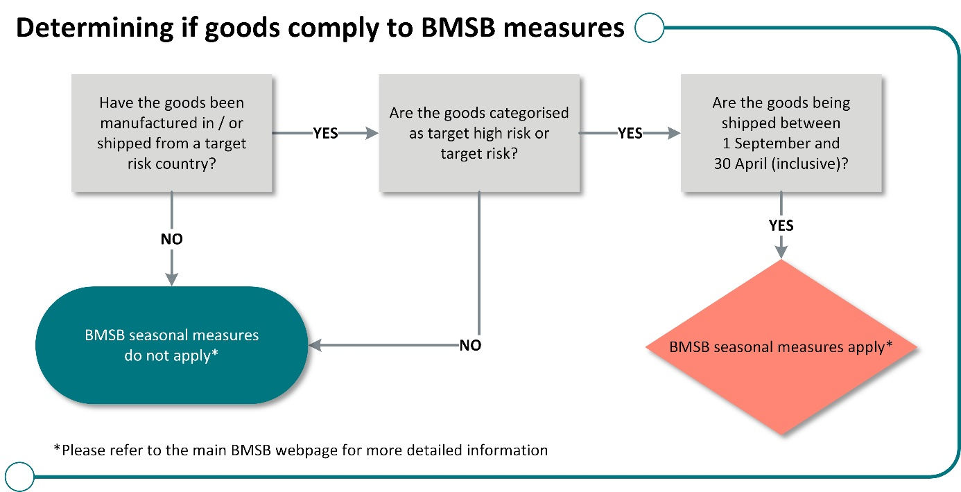

Check if your goods require mandatory offshore treatment
If you answer yes to all questions, your goods must be treated offshore before arrival. Untreated target high risk goods that arrive as break bulk, in open top containers or on flat rack containers will be denied discharge and directed for export.
- Are the goods categorised as target high risk goods?
- Are the goods shipped as break bulk, in open top containers, or on flat rack containers?
- Will the goods be shipped between 1 September and 30 April (inclusive)?
- Have the goods been manufactured in, or shipped from, a target risk country?
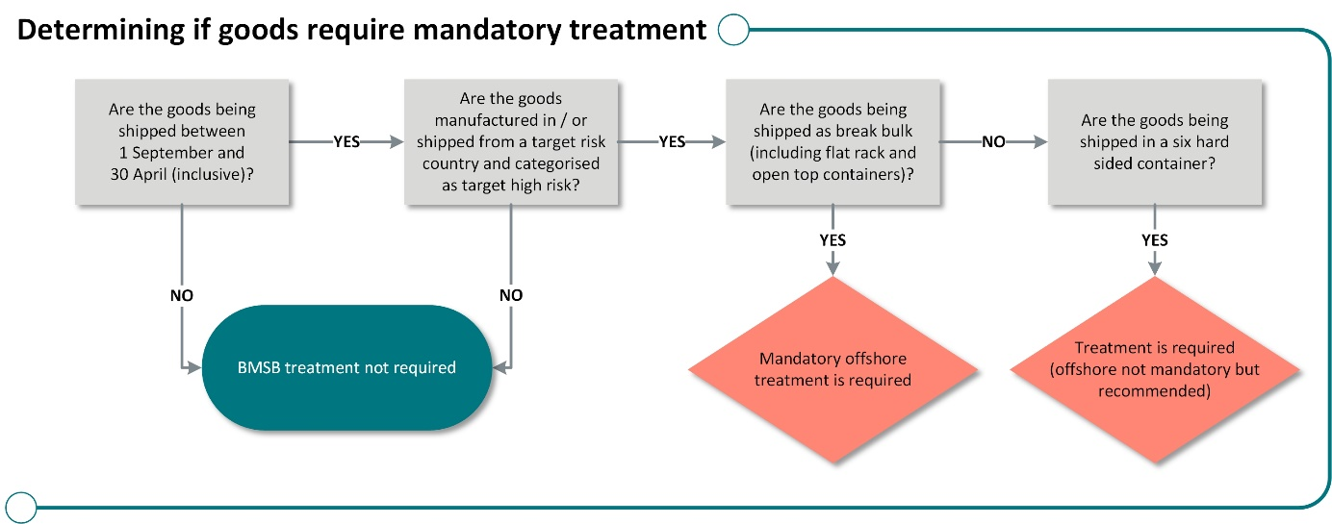
Cargo arriving in sealed hard six-sided containers with target high risk goods can be treated offshore or onshore. Deconsolidation or removal of goods from the container will not be permitted before onshore treatment.

Treatment requirements

Mandatory offshore treatment of break bulk consignments
Mandatory offshore treatment of target high risk goods shipped as break bulk cargo will be required, including goods shipped in open top containers or on flat rack containers or modified containers that are no longer sealed.
Untreated cargo of this type will be directed for export. Where these goods are identified before a vessel’s arrival into Australia, they will be denied discharge from that vessel.
Target high risk goods requiring mandatory offshore treatment that arrive untreated or treated by
an unapproved treatment provider in a target risk country, will be directed for export on arrival.

Containerised Cargo - mandatory offshore or onshore treatment
Mandatory offshore or onshore treatment of target high risk goods shipped in sealed 6 hard sided containers will be required. Deconsolidation or segregation of goods will not be permitted.
Containerised cargo shipped as Less than Container Load (LCL) and Freight of All Kinds (FAK) containers also require mandatory offshore and/or onshore treatment of target high risk goods.
Less than Container Load (LCL) and Freight of All Kinds (FAK) containers with target high risk goods will be managed at the container level for BMSB risk prior to deconsolidation.
To assist with container clearance, the department recommends early reporting by Master Consolidators. Containers treated offshore will encounter reduced delays at the wharf and will be permitted to deconsolidate. Containers seeking onshore treatment will be permitted to move to an Approved Arrangement site for treatment. Deconsolidation or removal of goods will not be permitted prior to onshore treatment.
Consideration must be given to ensure containers are packed in a manner that will enable effective
onshore treatment if required, to avoid possible export of goods.

Treatment options
The approved treatment options for BMSB risk are heat treatment, methyl bromide fumigation, sulfuryl fluoride fumigation and Ethyl Formate. Treatment rates can be found here.

Offshore treatments
All goods subject to BMSB measures must be treated by a treatment provider listed as ‘approved’ on the list of treatment providers. Treatment providers from target risk countries that wish to become registered to conduct BMSB treatments can do so under AusTreat.
Treatment providers in other countries who intend to conduct BMSB treatments for goods manufactured in or shipped from any of the target risk countries are encouraged to register under an offshore treatment assurance scheme.
Treatment providers registered under one of our offshore treatment assurance schemes, who intend conducting BMSB treatments, are encouraged to lodge their treatment certificates in the certificate lodgement portal. If you require access to the certificate lodgement portal, please contact the Offshore Treatments Team.

Offshore treatment providers – suspension
Treatment certificates from target risk countries will not be accepted from unregistered treatment providers or treatment providers listed as ‘suspended’, ‘withdrawn’ or ‘under review’ on the list of treatment providers. Goods will be subject to onshore treatment (if permitted) or directed for export.
Treatment certificates issued by a treatment provider in a non-target risk country will be accepted unless the:
- treatment provider is listed as ‘suspended’, ‘withdrawn’ or ‘under review’ on the list of treatment providers; or
- unregistered treatment provider is listed as ‘unacceptable’ or ‘under review’ on our webpage.

Post treatment window of 120 hours
A post treatment window applies to goods after they have been treated offshore. Goods must either be loaded into a container and sealed or loaded onto a vessel for export from the target risk country within 120 hours.
It is important all goods are managed to prevent re-contamination or cross-contamination after treatment.
Goods treated on/or after 1 December, are not subject to the post treatment window requirement of 120 hours.
Further information on 120 hour post treatment windows can be found here.

Documentary and evidence requirements

BMSB sealing declarations
This document can be used to demonstrate that goods were sealed inside a container before 1 September or after treatment. This document is required where:
- Goods were packed and sealed in a container before 1 September but shipped after this date.
- The bill of lading does not state the ‘shipped on board date’.
- Target high risk goods were manufactured, packed and sealed in a container in a non-target risk country but have been shipped from a target risk country.
- Goods were sealed inside a container within 120 hours of treatment occurring offshore.

BMSB 120 hour tranship declarations by road and by sea
These documents can be used to demonstrate the amount of time spent in a target risk country for break bulk, open top or flat rack containers subject to BMSB measures. These documents are required where:
- Goods were treated in a target risk country and shipped to a non-target risk country within 120 hours of treatment.
- Goods were treated in a non-target risk country but transhipped through a target risk country within 120 hours of treatment.
- Goods were shipped from a non-target risk country, transhipped through a target risk country, but did not spend longer than 120 hours in the target risk country.

Who can make BMSB declarations?
Declaration templates must be completed by either the exporter, freight forwarder, shipping company, offshore treatment provider or manufacturer at the port of origin.
Declarations made by Australian based importer/brokers will not be accepted by the department.
Note: Container tracking information may be used as a supplementary means of confirming ‘shipped on board date’. It cannot be used as the primary form of evidence. Container tracking information is insufficient for demonstrating when goods were sealed in a container.

New, unused, and not field-tested goods
Under the BMSB seasonal measures, certain goods that meet all the new, unused and not field-tested criteria will not be subject to mandatory treatment. The criteria include goods classified under tariff chapters 82, 84, 85, 86, 87, 88 and 89 only that are manufactured on or after 1 December.
The start date of manufacture is determined by the date manufacture of the goods (as a whole) was started and does not include the requirement to verify any or all complex components within the manufactured unit unless they are required to be reported as separate components by Australian Border Force (ABF). Goods must be accompanied by relevant supporting evidence.
NUFT declarations may be used for eligible goods shipped in sealed six hard sided containers, goods shipped as break bulk (including flat rack and open top containers) and consignments in LCL / FAK containers.

Unaccompanied household goods and personal effects
Household goods and personal effects imported as unaccompanied personal effects (UPE), and that are categorised as target high risk goods, will not be subject to mandatory treatment requirements if they are imported under the Australian Border Force B534 form and declared under concessional tariff 99.
However, goods that are required to be reported under a Full Import Declaration (for example motor vehicles and motorbikes), will require mandatory BMSB treatment either offshore for breakbulk, open top or flat rack containers or onshore for goods shipped in sealed 6 hard sided containers.
Important: To be exempt from the measures, all goods must be reported under concessional tariff 99. A description noting UPEs / household goods, and / or a B534 form only, is not acceptable evidence to exempt the goods under this condition.

Carnets, military and diplomatic goods
If a carnet or a consignment of military or diplomatic goods (including all goods imported under concessional tariff 99 other than UPEs as defined above) contains BMSB target high risk goods from a target risk country, they will be subject to mandatory BMSB treatment either offshore or onshore at the container level (where permitted). These goods are not exempt from BMSB seasonal measures.

Mixed pathways
The measures apply to certain goods arriving into Australia as sea cargo. If target high risk and risk goods are shipped from a target risk country with a mixture of pathways (for example, air cargo to a non-target risk country and then shipped as sea cargo to Australia), seasonal measures will apply. Goods arriving through other pathways will be monitored for BMSB risk.

Treating for both commodity and BMSB risk
If your consignment has goods that require treatment for both commodity and BMSB risk, you may be able to treat the goods at the highest rate to meet both requirements. To meet the requirements for offshore treatment, you must still provide treatment certificates (and phytosanitary certificates if required) as evidence the treatment has been completed.

Appropriate treatment space when packing containers
Consideration must be given to ensure containers are packed in a manner that will enable effective offshore/onshore treatment. Containers not able to be treated onshore (either as FCL or under a class 4.7 approved arrangement) will be subject to re-export.
Consignment suitability factsheets can be found on our webpage.

See. Secure. Report.
Seen something unusual? Report it, even if you are not sure.
Pests and diseases can spread quickly over large distances, so it is essential that you report what you find as soon as possible.
If you see something that could have entered Australia with imported goods, secure the goods and report it by phoning 1800 798 636 or completing the online form available on agriculture.gov.au.

More information
Visit agriculture.gov.au/bmsb for:
- seasonal measures for BMSB.
- preparing to import BMSB goods.
- what happens to your goods on arrival?
- a list of risk countries for BMSB.
- a complete list of goods categorised as ‘target high risk’ and ‘target risk’.
Watch the hitchhiker pest webinar series available at agriculture.gov.au.
Email HPP@aff.gov.au for policy related queries.
Visit agriculture.gov.au/subscribe to subscribe to newsletter and Industry Advice Notices and keep up to date on changes to import requirements, including updates to BMSB seasonal measures.

