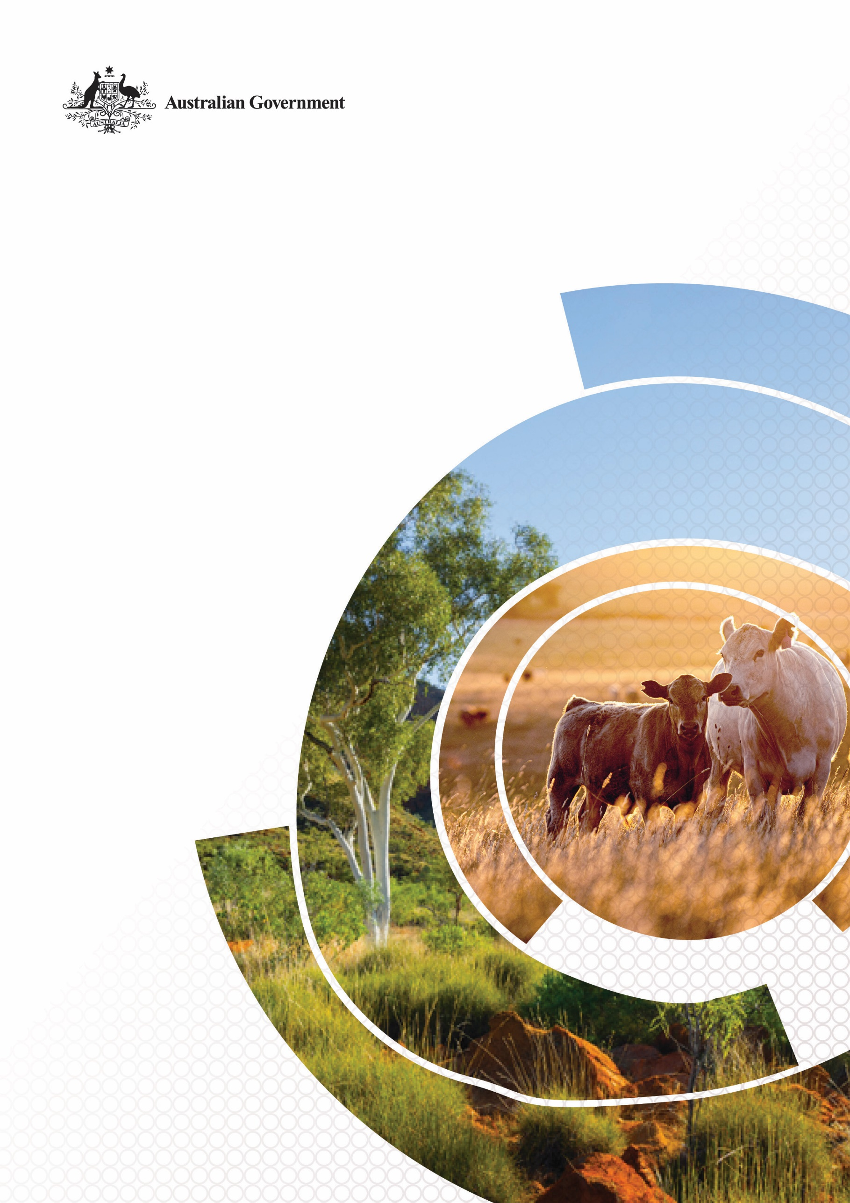
Agriculture and Land Sector Plan
© Commonwealth of Australia 2025
Ownership of intellectual property rights
Unless otherwise noted, copyright (and any other intellectual property rights) in this publication is owned by the Commonwealth of Australia (referred to as the Commonwealth).
Creative Commons licence
All material in this publication is licensed under a Creative Commons Attribution 4.0 International Licence except content supplied by third parties, logos and the Commonwealth Coat of Arms.

Cataloguing data
This publication (and any material sourced from it) should be attributed as: DAFF 2025, Agriculture and Land Sector Plan, Department of Agriculture, Fisheries and Forestry, Canberra. CC BY 4.0.
This publication is available at www.agriculture.gov.au/agriculture-land/farm-food-drought/climatechange/ag-and-land-sector-plan.
Department of Agriculture, Fisheries and Forestry
GPO Box 858 Canberra ACT 2601
Telephone 1800 900 090
Web agriculture.gov.au
Disclaimer
The Australian Government acting through the Department of Agriculture, Fisheries and Forestry has exercised due care and skill in preparing and compiling the information and data in this publication. Notwithstanding, the Department of Agriculture, Fisheries and Forestry, its employees and advisers disclaim all liability, including liability for negligence and for any loss, damage, injury, expense or cost incurred by any person as a result of accessing, using or relying on any of the information or data in this publication to the maximum extent permitted by law.
Acknowledgement of Country
We acknowledge the continuous connection of First Nations Traditional Owners and Custodians to the lands, seas and waters of Australia. We recognise their care for and cultivation of Country. We pay respect to Elders past and present, and recognise their knowledge and contribution to the productivity, innovation and sustainability of Australia’s agriculture, fisheries and forestry industries.

Ministers’ foreword
As a nation, we pride ourselves on our world-class agriculture, fisheries and forestry industries and spectacular natural environment. They are essential to Australia’s economic prosperity and the wellbeing of our communities. However, the climate in which producers and land managers operate is rapidly changing. Global action to reduce emissions is required to protect our industries and landscapes from the negative impacts of climate change and Australia must play an active part. Through collective effort and strong industry leadership we can harness opportunities from the net zero transition.
Agriculture and land have already made important contributions to Australia’s emissions reduction efforts. But more is needed. For the first time, the Agriculture and Land Sector Plan establishes a framework for the sectors to appropriately contribute to Australia’s net zero target. The plan establishes the foundations for future action and explores pathways as we chart a course to 2050. It is one of six sector plans supporting the Government’s Net Zero Plan, which together, cover all major sectors of the economy.
Addressing climate change must go hand in hand with supporting prosperous industries, thriving communities and a healthy natural environment. With that in mind, the plan’s development has been guided by three important principles we outlined at the Sustainable Agriculture Summit in 2024.
First, agricultural decarbonisation must be achieved with the sector, not imposed on the sector. We can only achieve our shared climate goals through partnership and collaboration. Our progress will rely on industry ambition and action, underpinned by community support. The development of this plan was informed by extensive stakeholder consultation, and we thank everyone for their engagement in submission processes, workshops, roundtables and many other valuable discussions. Your contributions have shaped the direction for the sector to 2050 and beyond.
Second, while action on climate change is necessary to ensure food security, action will not come at the expense of food security. The Government’s modelling shows Australia can reach its climate goals while maintaining a strong agricultural sector. Agriculture and land will play a vital role in contributing to the net zero transition while meeting growing food and fibre demand.
Third, while agriculture and land must make an appropriate contribution to net zero, they will not be taken for granted to balance emissions from other sectors. Through the Net Zero Plan, the Government has committed to taking early and consistent action across the economy and prioritised the delivery of clean and affordable energy. Carbon storage activities in the land will need to be well-planned and provide economic opportunities to producers and land managers who choose to pursue them.
We do not have every element in place yet, but we will continue to shape the pathway to 2050 in collaboration with industry, communities and with all levels of government. Together we can overcome the challenges and unlock new opportunities well into the future.
The Hon Julie Collins Minister for Agriculture, Fisheries and Forestry
The Hon Chris Bowen Minister for Climate Change and Energy
Senator the Hon Murray Watt Minister for the Environment and Water
Contents
Ministers’ foreword iii
Executive summary vi
1 Introduction 1
Benefits of taking action 2
2 Emissions from agriculture and land 5
3 Contribution to net zero 8
The pathway to 2050 8
Framework for supporting the sectors’ contribution 14
4 Foundational actions 16
Action 1 Understand emissions at the enterprise and national level 16
Action 2 Support innovation to deliver commercially viable abatement options 18
Action 3 Strengthen on-ground action 22
Action 4 Enhance land’s role in a net zero economy 24
5 Moving forwards 30
Everyone has a role to play 32
Glossary 33
References 35

Figures
Figure 1 Projected emissions under the Baseline Scenario, by Sector vi
Figure 2 Framework for agriculture and land to contribute to Australia’s net zero goal vii
Figure 3 Scope of the Agriculture and Land Sector Plan 5
Figure 4 Emissions from agriculture 6
Figure 5 Emissions from land use, land-use change and forestry 7
Figure 6 Projected emissions under the Baseline Scenario, by Sector 9
Figure 7 Agricultural production to 2050 under the Baseline Scenario 10
Figure 8 Energy, methane and nitrous oxide emissions in agriculture to 2050 under the Baseline Scenario 11
Figure 9 Projected sources of land-based sequestration under the Baseline Scenario 12
Figure 10 Opportunities for agriculture and land as Australia approaches net zero 13
Figure 11 Framework for agriculture and land to contribute to Australia’s net zero goal 14
Figure 12 Examples of organisations with Scope 3 emissions reduction targets or other climate-related ambitions 18
Figure 13 Technologies and practices supporting emissions reduction 19

Boxes
Box 1 The Net Zero Plan 2
Box 2 Average warming in Australia 2
Box 3 Enhancing adaptation and resilience to climate change 4
Box 4 Emissions from agriculture and land in 2023–24 5
Box 5 Methane in the spotlight 7
Box 6 Contributing to Closing the Gap priority reforms and targets 15
Box 7 Improving emissions accounting on farm 17
Box 8 Zero Net Emissions Agriculture CRC primary research programs 20
Box 9 Circular economy 21
Box 10 Leveraging private investment and incentivising adoption 22
Box 11 Improving energy performance 24
Box 12 Supporting carbon and nature outcomes through the Nature Repair Market 27
Box 13 Production of low carbon liquid fuel feedstocks contributes to net zero 29
Box 14 Examples of state and territory government emissions reduction commitments and strategies 31

Executive summary
The effects of climate change are already being felt across the globe. In Australia and overseas, governments, industry groups and businesses are taking steps to reduce their emissions and limit the worst impacts of climate change. By taking a proactive approach, we can harness opportunities that arise from shifting market expectations, identify emissions and productivity improvements, and optimise for carbon and nature in our landscapes.
Australia’s agriculture and land sectors make up a significant part of Australia’s greenhouse gas emissions. Reducing emissions associated with agricultural production and growing carbon stores in the land will be critical for Australia to meet its net zero by 2050 goal. In the Baseline Scenario modelled by the Treasury (Figure 1), agriculture emissions are projected to reduce by 28% and the carbon sink in the land is expected to increase by 126% to 2050. These changes are not targets, rather they are indicative of one potential pathway agriculture and land may take in a cost-effective economy-wide transition to net zero in 2050.
Figure 1 Projected emissions under the Baseline Scenario, by Sector
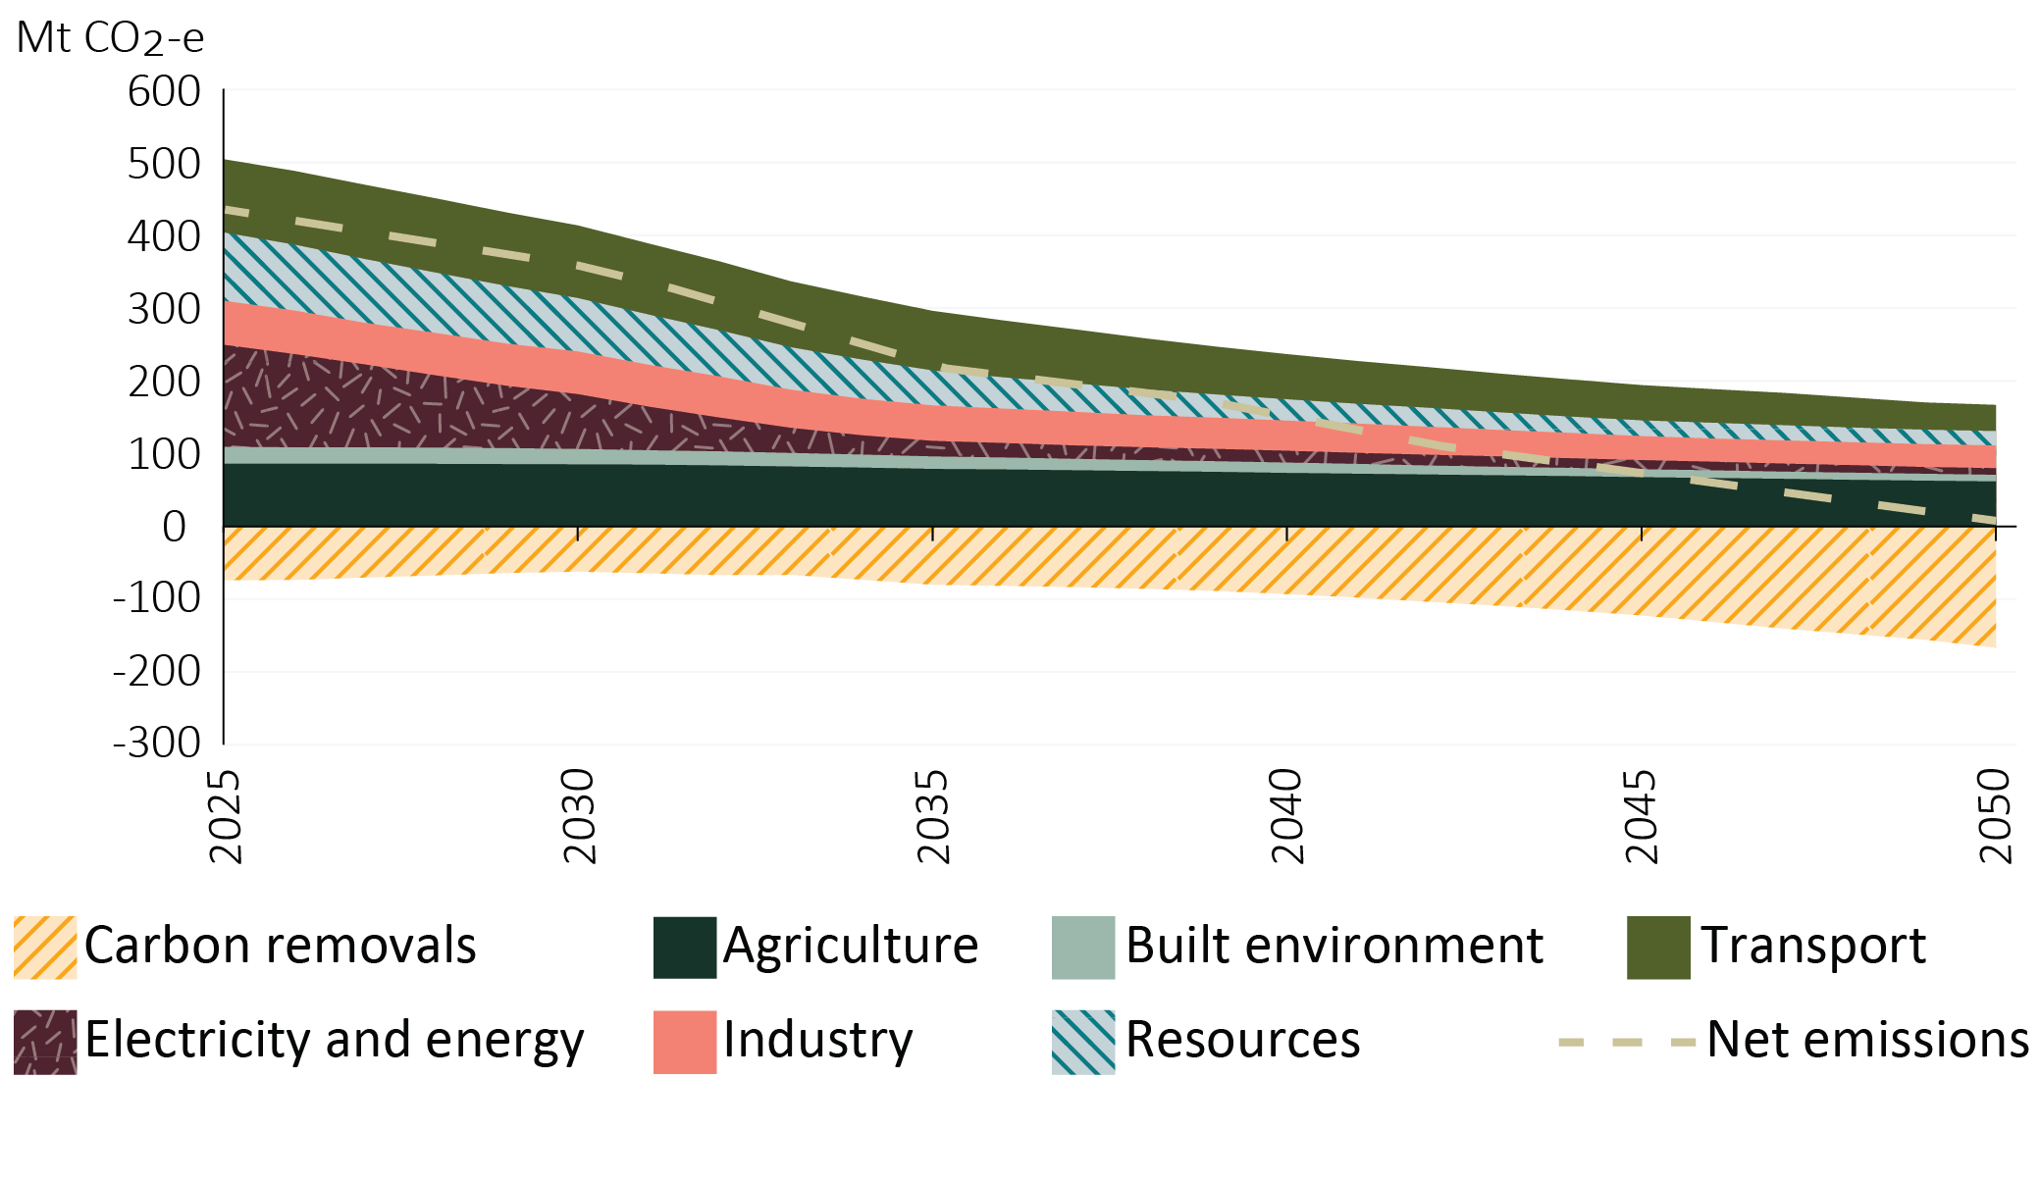
Source: Treasury modelling
The Agriculture and Land Sector Plan outlines a framework to enable these outcomes (Figure 2). Three strategic objectives underpin an appropriate contribution from the sectors towards Australia’s net zero goal.
First, Australian producers remain global leaders in low-emissions food and fibre production. Action on climate change cannot come at the expense of food security. Therefore, continued efficiency gains and improvements to the emissions intensity of production will be necessary to meet growing demand while contributing to emissions reduction goals.
Second, we must support diverse landscapes that balance agricultural production, carbon storage and nature repair. Growing carbon storage in the land is critical for Australia to meet its net zero goal. However, in doing so, we must consider multiple priorities and land uses.
Finally, decarbonisation of agriculture and land must deliver real benefits for regional communities, producers and land managers, including First Nations peoples. It is critical to enable a fair and orderly transition for regional, rural and remote communities.
To achieve these multiple objectives, four foundational areas for action have been identified:
- understand emissions at the enterprise and national level
- support innovation to deliver commercially viable abatement options
- strengthen on-ground action
- enhance the role of Australia’s land in a net zero economy.
Figure 2 Framework for agriculture and land to contribute to Australia’s net zero goal
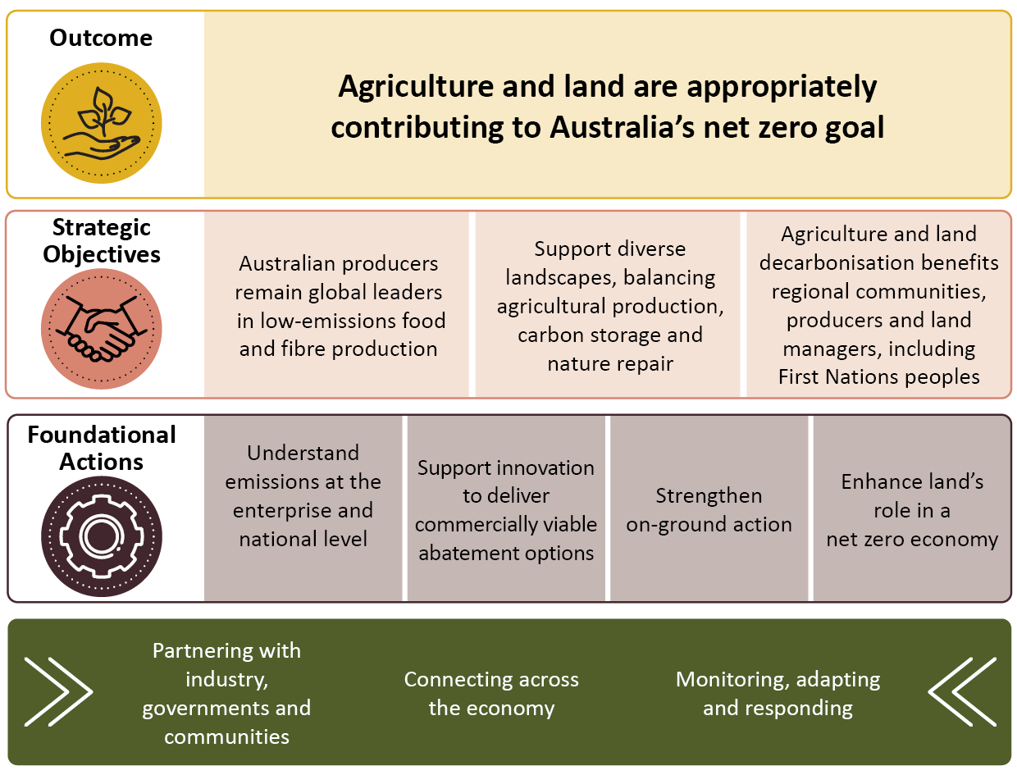
The Australian Government is investing in a range of programs that support these actions, building on extensive work already underway from across the sectors and other levels of government. The Government has announced a further $1 billion for loans from the Regional Investment Corporation. This funding will support the expansion of the corporation’s scope to support improved climate resilience, emissions reduction and sector productivity as we move towards net zero by 2050. There are also opportunities that will flow from the Government’s $1.1 billion investment in a Cleaner Fuels Program.
Government investment is expected to be complemented by strong action from industry groups and the private sector. Moving forward, we will work together in partnership and collaboration to chart the pathway to 2050.

Introduction
Agriculture and land are critical to Australia’s economic prosperity and wellbeing, providing food and fibre for tens of millions of people across the world and supporting valuable ecosystem services. These activities underpin communities, industries and the natural environment. But the effects of climate change are already widely felt. More frequent and extreme weather events, together with changing seasonal conditions, are increasing pressure on productivity, farm performance, water resources and landscape health (ACS 2025).
A global response to limit the worst impacts of climate change is underway. As part of that effort, Australia has committed to a 43% reduction in emissions by 2030 and a 62-70% reduction in emissions by 2035 below 2005 levels, then to reaching net zero emissions by 2050.
Reaching these goals requires a whole-of-economy approach. The Agriculture and Land Sector Plan (the plan) explores the role for agriculture and land in supporting these national outcomes. It is one of six sector plans under the Australian Government’s Net Zero Plan (Box 1).
Agriculture and land, including vegetation management and forestry, have already made valuable contributions to Australia’s emissions reductions, but further efforts will be needed. The plan explores how these sectors can continue to make an appropriate contribution to Australia’s climate goals by reducing emissions and storing more carbon. It considers the strategic objectives that must be achieved alongside further decarbonisation and sets out the foundational actions that will enable our producers and land managers, including First Nations peoples, to continue playing an important part in the net zero transition.
Decarbonisation in agriculture and land must be achieved in partnership with industry, not imposed on it. That is why development of the plan has been underpinned by extensive and ongoing stakeholder engagement, including a public submission process, workshops, roundtables, a summit and regular discussions. Throughout engagement, stakeholders expressed a strong commitment to the transition to the net zero economy and playing their part. Many producers and land managers are actively exploring options to reduce emissions and support healthy landscapes.
The plan is the next step in an ongoing partnership between governments, industry, communities, and the private sector as we chart a course to economy-wide net zero by 2050. It will build on the work already underway, including by state, territory and local governments.
Box 1 The Net Zero Plan
The Net Zero Plan sets out Australia’s pathway to achieve our legislated target of net zero greenhouse gas emissions (GHG) by 2050. The Net Zero Plan identifies 5 priority decarbonisation actions to reduce key emissions sources across the economy:
- decarbonise and expand the electricity network
- electrify and increase energy and materials performance
- switch to low-carbon alternatives
- innovate to expand technology options
- scale up carbon removals to balance residual emissions.
The Agriculture and Land Sector Plan particularly supports innovation of abatement solutions and the scaling up of carbon storage in the land in alignment with the sector’s decarbonisation pathway set out in chapter 3.

Benefits of taking action
The effects of climate change are already being felt across landscapes and farming communities (Box 2). Analysis has shown that recent seasonal conditions (2001 to 2020) reduced the profitability of Australian broadacre farms by an average of 23%, or around $29,200 per farm, relative to the previous 50 years (Hughes & Gooday 2021). Going forward, climate change poses significant risks to the productivity and profitability of primary industries, and the quality of food and fibre products (ACS 2025).
Box 2 Average warming in Australia
+1.51°C
Average warming in Australia since national records began in 1910 (BOM & CSIRO 2024).
Climate change is also exacerbating threats to the natural environment, increasing the risk of ecosystem transformation or collapse, and the loss or extinction of native species. In turn, the degradation of Australia’s ecosystems is limiting the ability of natural landscapes to store carbon and reducing nature’s resilience to climate impacts (ACS 2025). Adaptation is critical (Box 3), but there are limits to what can be achieved through adaptation alone. Reducing emissions globally, with Australia playing its part, is a fundamental step in avoiding the most severe impacts of climate change over coming decades.
As Australia exports around 70% of agricultural production (ABARES 2025), reducing emissions is critical for positioning the industry to be internationally competitive on the basis of its sustainability into the future. The majority of 136 of the largest global agrifood companies have made net zero commitments or set emissions reductions targets, some of which will impact global food and fibre supply chains (Purdie 2024). As global economies decarbonise, markets, supply chains and consumer preferences will shift with implications for Australian agriculture. A proactive approach to lowering emissions from food and fibre production will position industry to harness new opportunities and ensure ongoing access to markets and capital.
Australia is already well placed in this regard. Australian cattle and grain producers operate with lower than average emissions intensities compared to other major agricultural exporter countries (Read et al. 2023). Australian producers also have relatively low application rates of fertiliser and pesticides, which may be driven in part by Australia having one of the lowest levels of agricultural support globally. Research shows that agricultural producer support policies, such as subsidies and tariffs, are linked to environmental harm and higher GHG emissions (Read et al. 2023).
Further action to reduce emissions will be required to enable producers to maintain their competitive advantage and capitalise on the increasing market expectations around sustainability and nature outcomes. Taking action on climate can also have direct economic benefits for producers and land managers by helping to identify new business opportunities and boost resilience. Understanding emissions sources and options for reducing emissions can enable management decisions that align with business priorities and future plans.
Achieving Australia’s net zero transition and ambitions to protect, repair and better manage nature can and should be complementary. Nature provides the foundation for thriving societies, prosperous economies and regional jobs. Industries like agriculture, fisheries, forestry, tourism, construction and manufacturing all derive resources from nature and depend on healthy, well-functioning ecosystems. In Australia, and overseas, nature is under pressure from climate change, habitat loss, invasive species, pollution and unsustainable use of natural resources.
As a signatory to the Convention on Biological Diversity’s Kunming-Montreal Global Biodiversity Framework (GBF), Australia is committed to halting and reversing biodiversity loss by 2030. This commitment and Australia’s contribution to the GBF is set out in Australia’s Strategy for Nature 2024–2030. Reducing emissions and storing more carbon can support the national targets in our Strategy for Nature, including to minimise the impact of climate change on biodiversity and ensuring priority degraded areas are under effective restoration. Similarly, designing ecosystem restoration activities to be resilient to changes in water availability, temperature and extreme events can provide carbon storage co-benefits and help progress Australia’s net zero goal.
Box 3 Enhancing adaptation and resilience to climate change
Decisive action to reduce emissions is essential to limiting the future impacts of climate change. At the same time, climate change is already causing significant and increasing harm to Australia’s economy, society and environment, including primary production (ACS 2025). The Australian Government recognises the importance of considering decarbonisation, escalating climate risks and adaptation to changing conditions together. Incorporating these considerations as part of the agriculture and land sectors’ net zero pathway will help ensure action is designed to deliver emissions reductions in a hotter and more volatile climate and to harness adaptation co-benefits.
To better prepare for and manage the increasing risks from climate change, the Government has delivered Australia’s first National Climate Risk Assessment and National Adaptation Plan.
The National Climate Risk Assessment represents the first comprehensive overview of the impacts Australia will face under future climate scenarios, based on the best available scientific evidence compiled by the Australian Climate Service. The assessment identifies several increasing risks to primary industries and the natural environment, including increased time spent in drought, further declines in water availability in major agricultural regions, and greater pressure on native species.
The National Adaptation Plan sets out the Australian Government’s policy framework to respond to the findings of the National Climate Risk Assessment. It provides a vision for a well-adapted Australia, and current and prospective actions for key sectors including primary industries and food, and the natural environment. The adaptation plan also outlines principles to guide future action. It provides the Australian Government context for adaptation planning, to assist other levels of government, businesses and the community.
Drought is one of the many climate risks that producers will continue to face with increasing frequency and severity. Resilience to drought requires tailored and practical support. The Government provides secure and continuous funding through the Future Drought Fund to support producers and regional communities to build their drought and climate resilience. Concessional loans are also available through the Regional Investment Corporation to prepare for, manage through and recover from financial disruption due to drought, natural disasters, and cumulative events.
Australia’s food system is a national strength but it is under increasing pressure from risks, such as climate change, biosecurity threats, geopolitical instability and supply chain vulnerabilities. The Australian Government has committed to developing a National Food Security Strategy in consultation with industry, community and government to boost the productivity, resilience and security of Australia’s food system.
Australia must continue to build on its adaptation and resilience efforts to effectively respond to climate impacts on primary production, the environment, the economy, regional communities and other disproportionately impacted cohorts. Efforts must support a range of outcomes including drought resilience, water-use efficiency, soil health, innovation, and availability of climate information.

Emissions from agriculture and land
This plan covers emissions and carbon storage associated with activity in agriculture and the land. This includes the emissions from electricity and fuel use associated with the agriculture, fisheries and forestry industries. Emissions that occur beyond the farm gate – such as emissions from the manufacturing and transport of fertiliser, chemicals and animal feed – are addressed in other sector plans.
Emissions from agriculture and land arise from diverse biological sources (Figure 3). Unlike other sectors, agriculture emissions are dominated by methane from enteric fermentation in ruminant livestock and management of manure (Box 5), and nitrous oxide from agricultural soils.
The agriculture and land sectors make up a significant part of Australia’s GHG emissions (Box 4).
Box 4 Emissions from agriculture and land in 2023–24
- 19.6%: Agriculture’s contribution to Australia’s net emissions
- The land sector is a net sink, equivalent to −16.5% of Australia’s net emissions
Note: agriculture emissions include electricity and fuel use
Figure 3 Scope of the Agriculture and Land Sector Plan
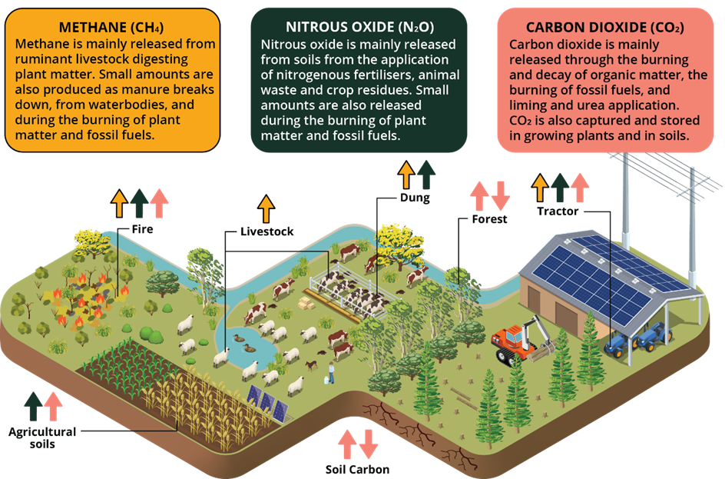
Agriculture emissions have remained relatively stable since 2004–05 (Figure 4), fluctuating in response to market and climatic conditions. For example, since 2004 periods of decline in absolute agriculture emissions can largely be attributed to reduced livestock numbers and crop production under drought conditions (DCCEEW 2025a). Over the same period, the land sector changed from a net source to a net sink (Figure 5) – driven by a reduction in conversions of forest to agricultural land uses, declines in harvesting of native forests and expansion of forest cover including through plantation establishment (DCCEEW 2025a).
In commercial fisheries and aquaculture, the largest sources of emissions are from electricity and fuel use. Actions taken in the Electricity and Energy Sector Plan, the Maritime Emissions Reduction National Action Plan, and the Transport and Infrastructure Net Zero Roadmap and Action Plan will have a direct impact on the industry’s ability to decarbonise.
Figure 4 Emissions from agriculture
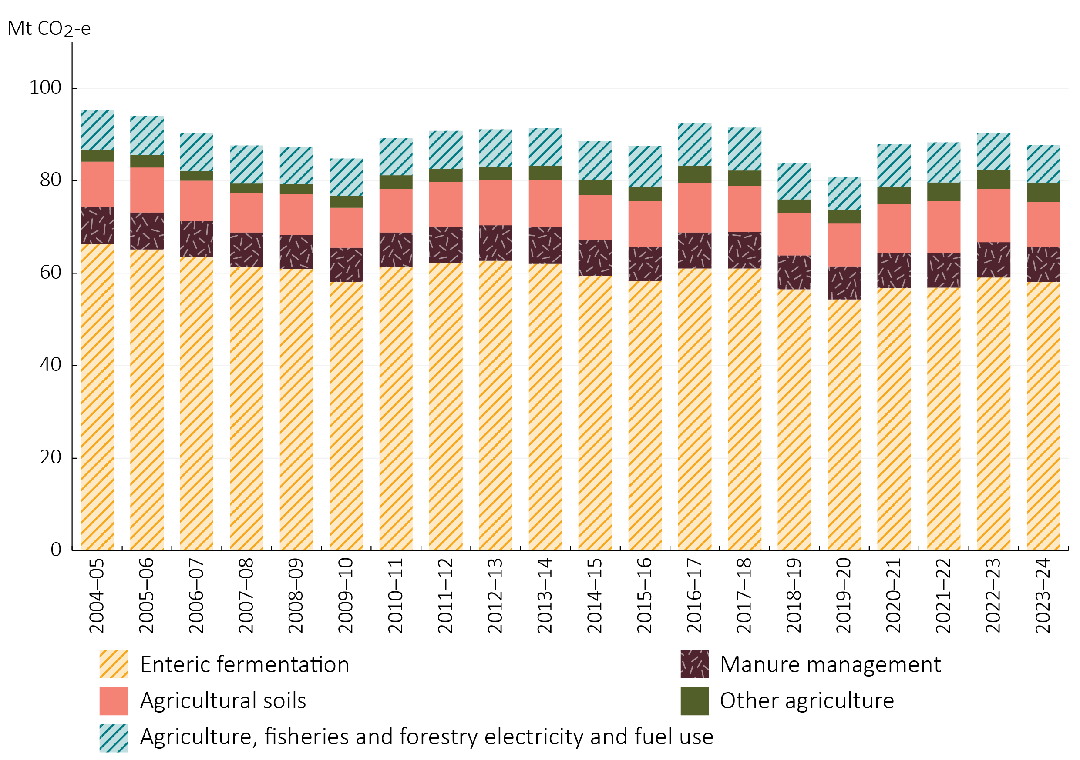
Source: DCCEEW 2025b
Figure 5 Emissions from land use, land-use change and forestry
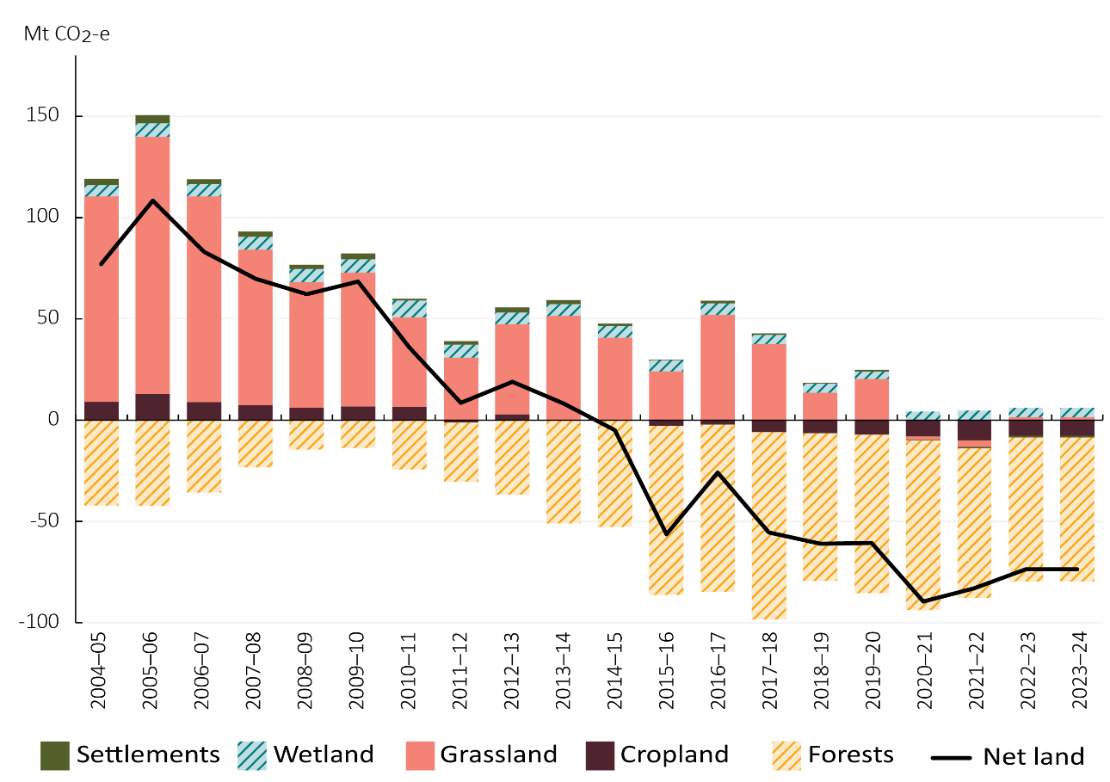
Source: DCCEEW 2025b
Box 5 Methane in the spotlight
Methane emissions, including those from agriculture, are the second largest cause of climate change after carbon dioxide emissions and account for approximately 30% of present-day warming (OECD 2025).
Methane emissions have a high potency and short lifetime relative to carbon dioxide. This means that reducing methane emissions has significant climate benefits in the near-term, which is critical to slowing warming and keeping Paris aligned targets within reach (IPCC 2023).
The Intergovernmental Panel on Climate Change (IPCC) (2023) has presented emissions pathways that keep warming to 1.5°C, or well below 2°C, to align with the Paris Agreement. These IPCC pathways show that significant reductions in global methane emissions are needed. That is why it is important for agriculture to take all available steps that can reduce methane in a productive and profitable way. Chapter 4 discusses a range of foundational actions to support this goal.

Contribution to net zero
Agriculture and land’s contribution to net zero will depend on many factors – technologies, financial markets, policy settings, international commitments and community choices. The future will also be shaped by the readiness of producers and land managers to take advantage of opportunities that emerge at both the sector and business level. This plan is not setting an emissions reduction target, although many businesses and industry groups are setting their own emissions reduction goals. Instead, the plan makes it clear that agriculture and land must play an increasingly important role in Australia’s net zero transition.

The pathway to 2050
Under current policies and technologies, it is projected that agriculture emissions will remain relatively flat to 2040 (DCCEEW 2024). The land sector is projected to remain a net sink to 2040, albeit at a reduced level (DCCEEW 2024).
If Australia is to meet its emissions reduction targets, contributions from agriculture and the land will need to increase.
A range of analyses indicate potential pathways to net zero for Australia, including the Climate Change Authority’s Sector Pathways Review (2024) and recent modelling and analysis undertaken by the Treasury (2025) to help inform the development of the Net Zero Plan. These show there are opportunities to reduce agriculture’s absolute emissions and emissions intensity by 2050. There is also a need to increase carbon stored in the land, to balance residual emissions from agriculture and other sectors in 2050.
The Treasury’s Baseline Scenario (Figure 6) illustrates one possible pathway for the agriculture and land sectors in a cost-effective economy-wide transition to net zero by 2050, based on the best available information today. While the scenario is not representative of emissions reduction targets for the sectors, it provides useful insights on the potential timing and sequencing of emissions reduction contributions. In the scenario, agriculture and land appropriately contribute to Australia’s net zero goal.
Under the Baseline Scenario, agricultural production is projected to increase by 32% to 2050 while the sector’s emissions decrease, with outcomes underpinned by improvements in emissions intensity of production (Figure 7).
Figure 6 Projected emissions under the Baseline Scenario, by Sector

Source: Treasury modelling

Agriculture
Looking in more detail at agriculture under the Baseline Scenario, emissions are projected to remain steady through to 2030. Improvements to emissions intensity continue to be achieved as available technologies and practices are more widely adopted, supporting absolute emissions reductions to 2050.
In ruminant livestock, adoption of technologies and practices, such as feed additives and genetics, are projected to contribute sizeable emissions reductions to 2050. Reductions in nitrous oxide emissions are driven by increased adoption of slow-release fertilisers, crop rotation, nitrification inhibitors and precision agriculture. There are also opportunities for gradual electrification in agriculture, fisheries and forestry – for example, through a shift away from diesel-powered light vehicles and machinery, towards their electrified counterparts.
By 2050, emissions from agriculture and from energy used in the agriculture, fisheries and forestry industries could reduce to 62 Mt CO₂-e from 86 Mt CO₂-e in 2025 under the Treasury’s Baseline Scenario (Figure 8). This relatively limited level of emissions reduction reflects the fact that while technologies will advance and implementation costs are expected to fall, barriers to larger reductions are projected to remain. As a result, agriculture will have residual emissions in 2050. The residual emissions are equivalent to 37% of economy-wide emissions (excluding land use, land-use change and forestry) in the Treasury’s Baseline Scenario.
Figure 7 Agricultural production to 2050 under the Baseline Scenario
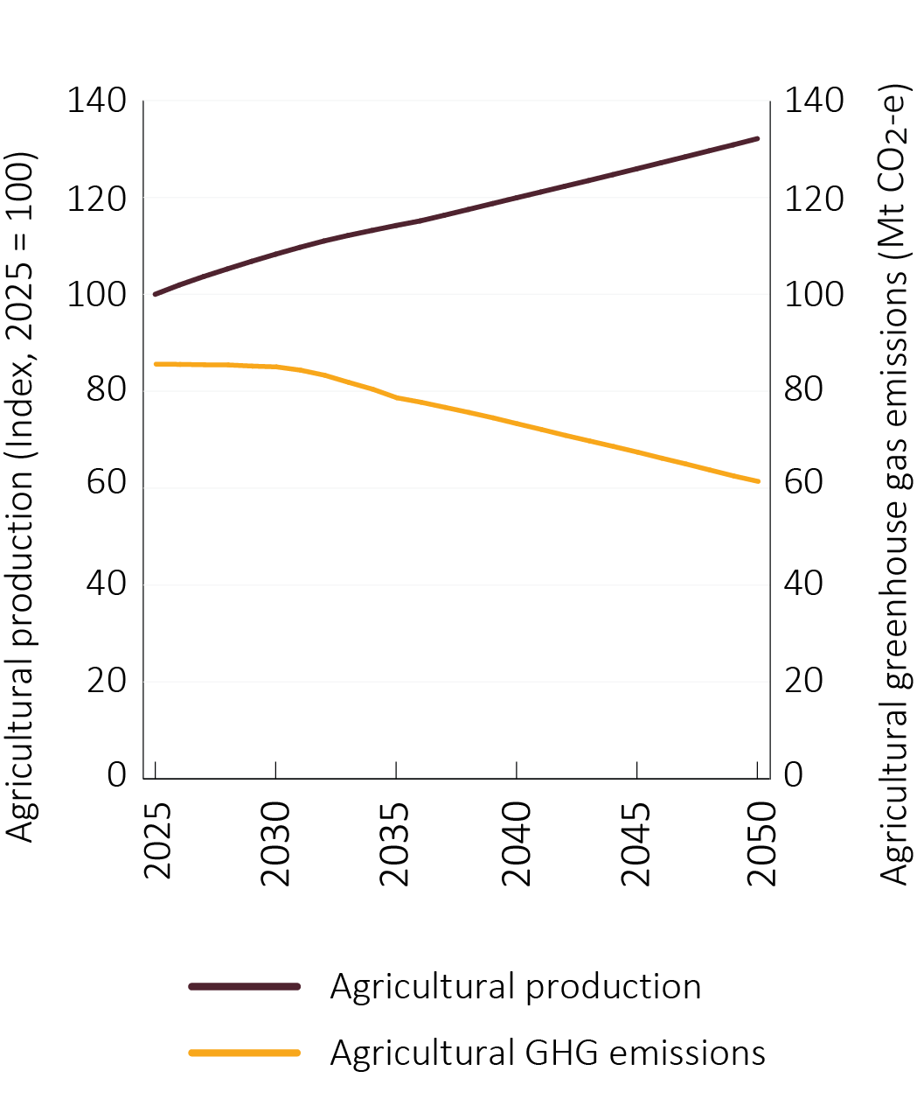
Note: Includes production from agriculture, fisheries and forestry
Source: Treasury modelling
Figure 8 Energy, methane and nitrous oxide emissions in agriculture to 2050 under the Baseline Scenario
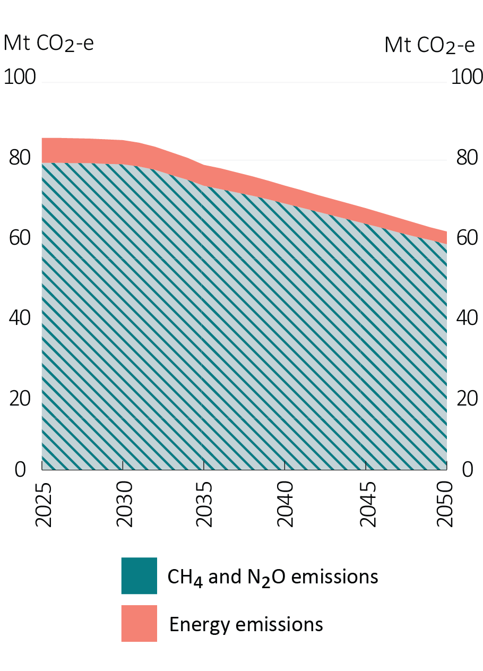
Source: Treasury modelling

Land
Under the Treasury’s Baseline Scenario, residual emissions across the economy (excluding land use, land-use change and forestry) are projected to be 167 Mt CO₂-e in 2050, down from 504 Mt CO₂-e in 2025 (Figure 6). Therefore, carbon removals play a crucial role in balancing these emissions so Australia achieves its 2050 net zero goal. In the near term, reductions in land-based sequestration reflect moderating growth in carbon stores after a strong La Niña in the early 2020s.
Looking to 2050, land-based sequestration is projected to be the primary form of carbon removal. The majority of this is from increased reforestation, which is typically the most cost-effective and scalable method of sequestration (Figure 9). Other forms of land-based sequestration – including soil carbon, savanna fire management, forest regeneration and blue carbon – are also projected to contribute.
The costs of technology-based approaches to engineered carbon removals, an alternative to land-based sequestration, are currently projected to remain relatively high to 2050. Engineered carbon removals are discussed further in the Net Zero Plan.
However, there is considerable uncertainty around the scale of land-based sequestration required to 2050, given uncertainties in abatement technology cost pathways across the economy, analytical and data constraints about the carbon sequestration potential of different land types, and uncertainty about the revenue landowners may need if they wish to repurpose their land.
Figure 9 Projected sources of land-based sequestration under the Baseline Scenario
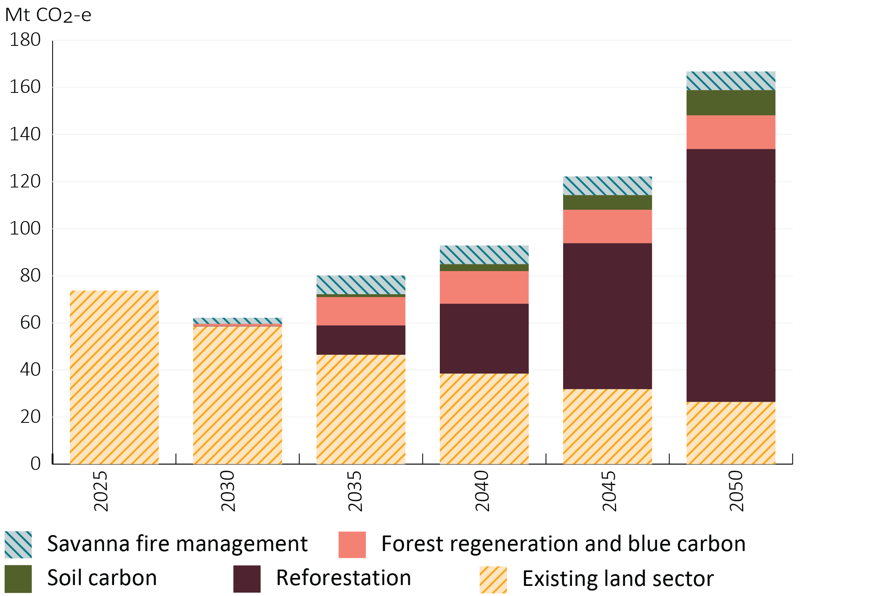
Note: The ‘Existing land sector’ category refers to the existing net sink, including emissions reductions and sequestration being generated from existing ACCU projects. The decline in this category reflects the ageing of existing vegetation and the related decline in the ability to sequester carbon. The category does not include the sequestration from new sequestration projects incentivised through the Safeguard Mechanism. The sequestration volumes for reforestation, forest regeneration and blue carbon, soil carbon, and savanna fire management represent new sequestration projects in the Baseline Scenario.
Source: Treasury modelling

An evolving response
The Baseline Scenario modelled by the Treasury illustrates just one pathway for agriculture and the land to 2050. Treasury modelling provides useful insights on the potential cost-effective timing, sequencing and size of sectoral contributions to the economy-wide emissions reduction task.
While scenario-based analysis is a powerful tool in helping inform Australia’s net zero pathway, it is not possible to precisely predict how the transition will unfold. The future is uncertain and there are many factors that will shape the pathway over time, including technology breakthroughs, market shifts, domestic and international policy directions, and community responses. By working in partnership, we can build on the foundations outlined in the plan to grow and harness opportunities from the net zero transition (Figure 10).
Figure 10 Opportunities for agriculture and land as Australia approaches net zero
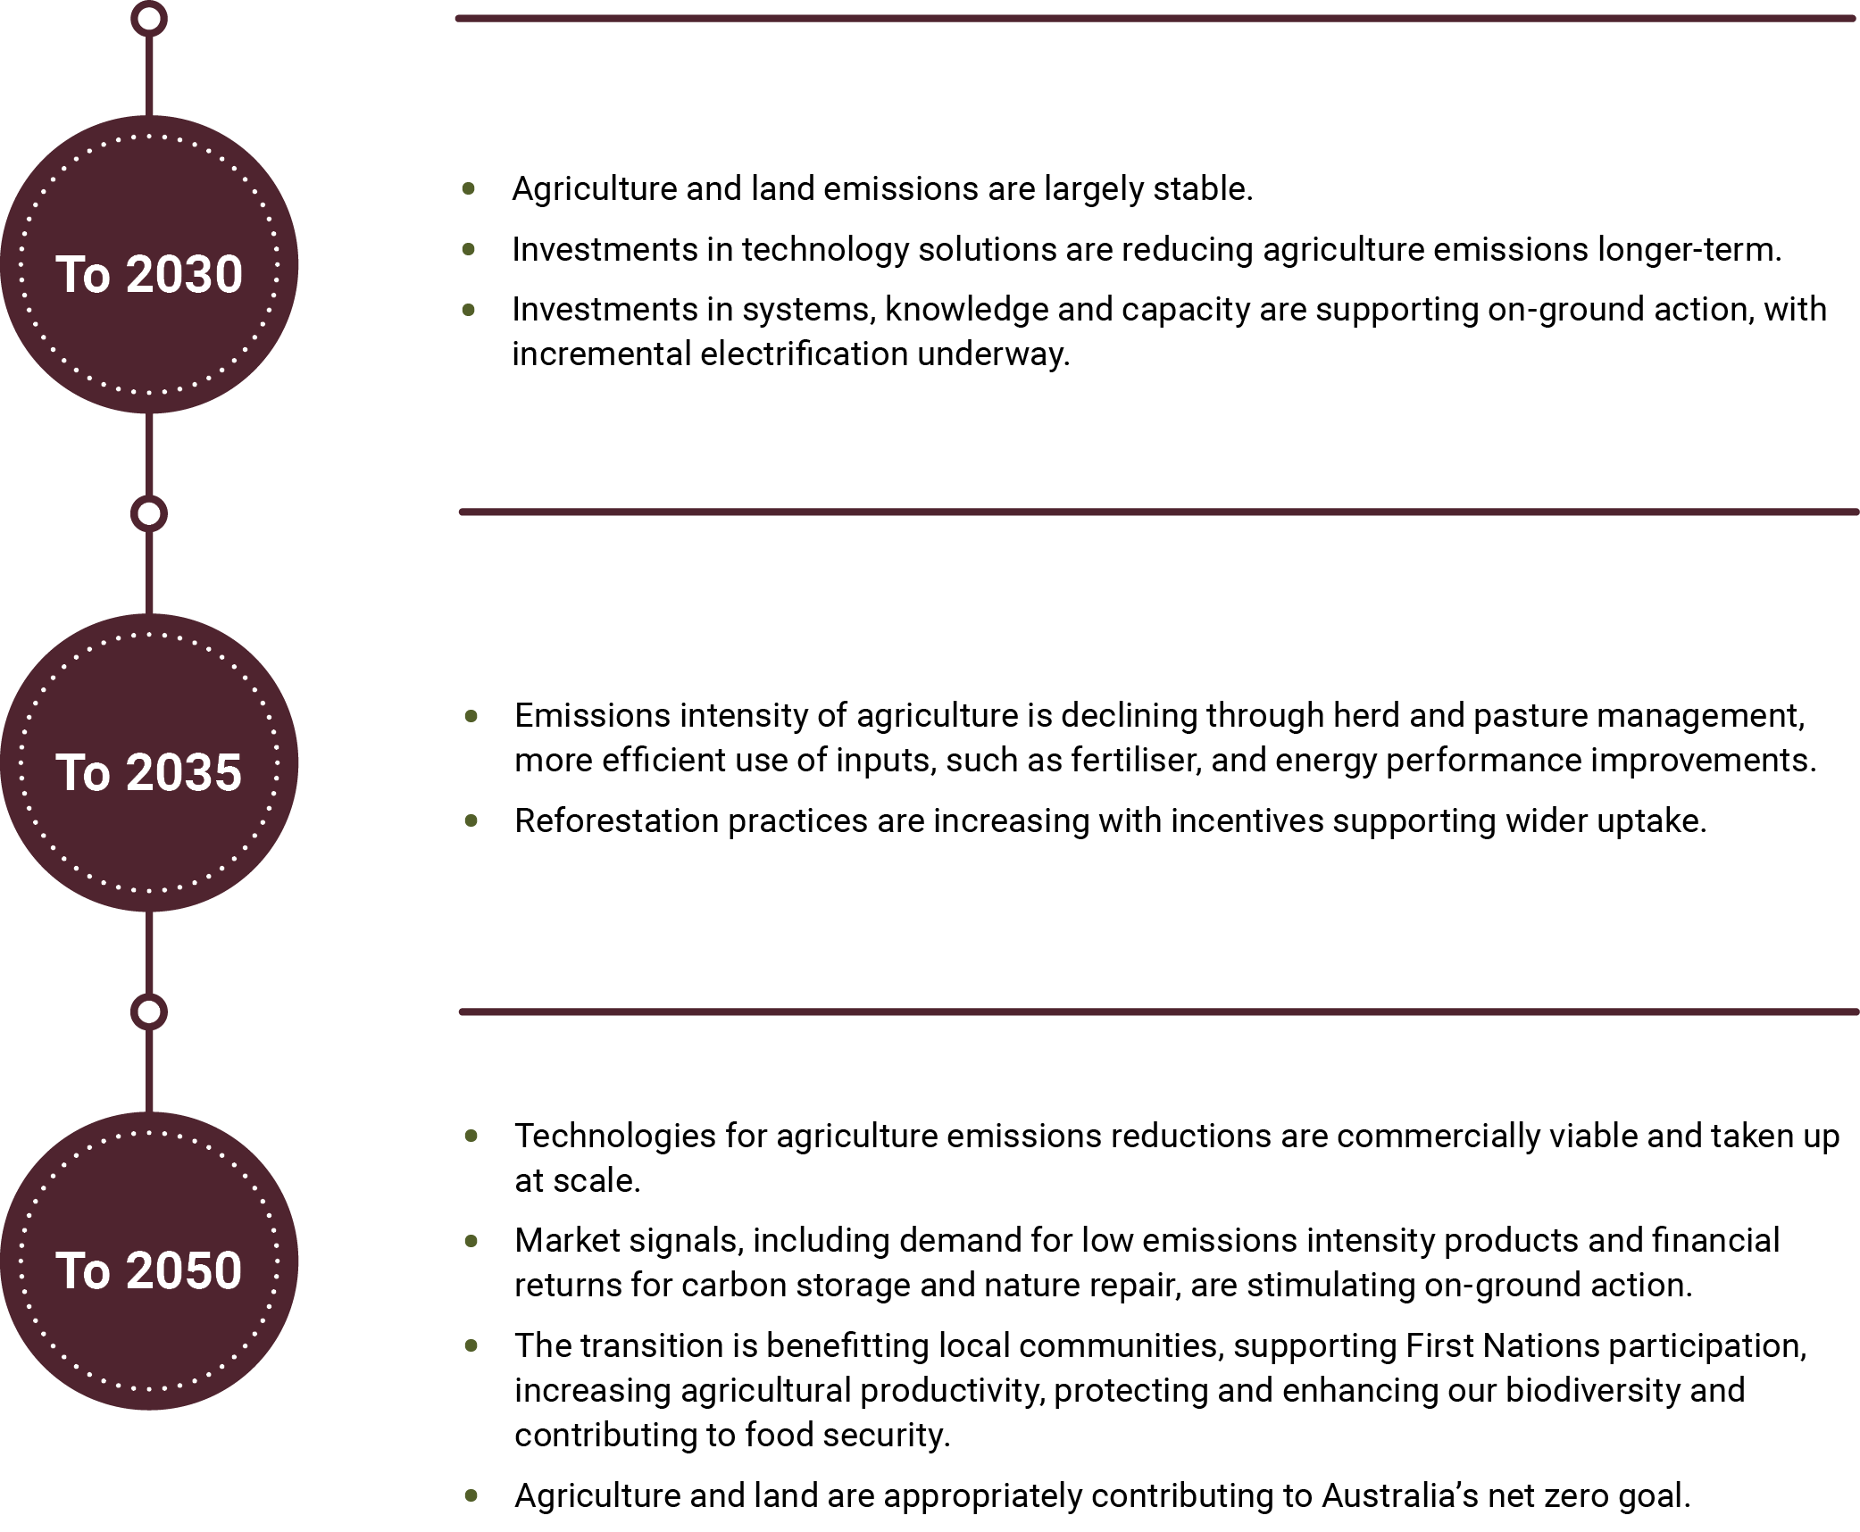

Framework for supporting the sectors’ contribution
This plan provides a framework for agriculture and land to make an appropriate contribution to Australia’s net zero goal (Figure 11). Extensive consultation highlighted strategic objectives that must be achieved alongside this outcome, foundational actions needed to guide effort and investment, and guiding principles to support action going forward.
Figure 11 Framework for agriculture and land to contribute to Australia’s net zero goal

Three strategic objectives must go hand in hand with the sectors’ net zero contributions.
First, Australian producers must remain global leaders in low-emissions food and fibre production. Global and regional food demand is growing and Australian exports can support this demand (Hafi et al. 2023; Linehan et al. 2012). It will become increasingly important to decouple food production from emissions as agricultural production increases to 2050, enabling more food to be produced with reduced emissions intensity. Australia will need to continue to demonstrate it is a trusted supplier of sustainable agricultural products to maintain competitive advantage, and support access to premium export markets, global supply chains and finance.
Second, we must support diverse landscapes, balancing agricultural production, carbon storage and nature repair. Growing carbon storage in the land sector to help reach the net zero goal will require balancing multiple priorities. These include maintaining food security, growing agricultural industries, protecting and repairing nature, and safeguarding Indigenous owned, managed, co-managed and special rights lands.
Third, decarbonisation of agriculture and land must benefit regional communities, producers and land managers, including First Nations peoples (Box 6). Much of the transformation required in agriculture and land will occur in regional and remote areas. Decarbonisation strategies must deliver real benefits to the people and communities of these regions, in line with the guiding principles of the Australian Government’s Regional Investment Framework.
Four foundational areas for action will form the basis for coordinated action, enabling the sectors to achieve multiple objectives:
- understand emissions at the enterprise and national level
- support innovation to deliver commercially viable abatement options
- strengthen on-ground action
- enhance the role of Australia’s land in a net zero economy.
These foundational actions are supported by a commitment to partnership, strong connections across the economy and ongoing processes for monitoring, adapting and responding. Achieving the objectives identified will require sustained and expanded effort and action from industry, government, the private sector and individuals. This framework aligns with the principles and five decarbonisation actions outlined in the Net Zero Plan.
Box 6 Contributing to Closing the Gap priority reforms and targets
First Nations peoples have deep-rooted knowledge in caring for Country and are leaders in sustainable land management. Initiatives to progress decarbonisation should be driven by genuine partnership with, and the provision of adequate resourcing to, First Nations partners and stakeholders.
Aligning agriculture and land emissions reduction policy to the National Agreement on Closing the Gap is vital to improving outcomes for First Nations peoples and communities. The National Agreement is built around Priority Reforms and socioeconomic targets including a distinctive cultural relationship with land and waters, shared decision-making, increased inclusion in employment, education and training, strong economic participation, and development of Aboriginal and Torres Strait Islander peoples and their communities.
This plan outlines ongoing opportunities to assist progress towards Closing the Gap, including:
- integration of First Nations knowledge into abatement solutions through a two-way learning and knowledge exchange through the Zero Net Emissions Agriculture Cooperative Research Centre
- tailored resources for First Nations peoples to increase access to culturally appropriate information through the Carbon Farming Outreach Program
- engagement of First Nations communities in carbon farming, including through savanna fire management projects and the Nature Repair Market.
Decarbonisation efforts across government, industry and communities must continue to share benefits and reduce the disproportional impacts of climate change on First Nations peoples (ACS 2025).

Foundational actions

Action 1 Understand emissions at the enterprise and national level
For producers and land managers, understanding the GHG emissions profile of their business or activities is a fundamental first step to managing them. ‘Knowing your number’ allows producers and land managers to build a more connected picture of their production, energy and land management emissions in a way that can inform ongoing business decisions. It can facilitate a deeper understanding of business inputs, outputs and therefore costs, further informing on-farm decision-making.
The Australian Government is already responding to calls for more standardised approaches to GHG accounting by prioritising improvements in emissions accounting at the national level through to the farm level. In the 2024–25 Budget, the Government committed to:
- improving the quality and consistency of GHG emissions accounting methods and tools by developing voluntary emissions estimation and reporting standards and incorporating the standards into new or existing GHG emissions calculators (Box 7)
- improving the National Greenhouse Accounts (NGA) methods and data, to better reflect regional differences and mitigation actions, and making these more accessible so that GHG calculators can stay up to date.
These investments are aimed at delivering the trust in emissions calculators that producers have been calling for. In addition, the upgrades to the NGA will better enable recognition of producers’ and land managers’ efforts to reduce emissions and will unlock reporting of emerging low-emissions technologies and practices. In time, this will help incentivise adoption of emerging opportunities at the business level.
The Government’s investment needs to be supported with strong action across industry to work with producers to engage with available tools and better understand their farm emissions profile. This is a role for industry groups, Rural Research and Development Corporations (RDCs) and supply chains. Many have taken initial steps but there is a need to scale this up significantly to deliver long-term outcomes for the industry.
Box 7 Improving emissions accounting on farm
As part of the Improving Consistency of On-farm Emissions Estimates program, Agricultural Innovation Australia has been awarded a grant of $6.4 million (GST exclusive) over 3 years to June 2028, in partnership with the Zero Net Emissions Agriculture Cooperative Research Centre, to help improve the consistency of farm-level GHG emissions calculators.
This grant will make it easier for third-party accounting tool and calculator providers to align with the voluntary emissions estimation and reporting standards. It will fund free access to an application programming interface and open-source calculator code until June 2028. This foundational investment will provide greater consistency and trust in GHG estimates, and support producers as they seek to understand and reduce their on-farm emissions.

Role of supply chains
Global and domestic supply chains and financial institutions are stepping up efforts to measure and manage their emissions (Figure 12). These efforts are being driven by voluntary commitments including net zero targets and sustainability linked finance, and mandatory reporting requirements such as climate-related financial disclosure (CRFD) regimes.
Under Australia’s CRFD regime, reporting entities are not required to collect primary data from producers in their supply chain to comply. The AASB S2 Climate-related Disclosures Standard (2024) includes a presumption that Scope 3 emissions – that is the emissions that occur upstream or downstream in a company’s supply chain – can be reliably estimated using industry averages and secondary data. However, companies with voluntary climate commitments may be more likely to request farm-level data, particularly from larger agribusinesses, so they can monitor performance and improvements in their Scope 3 emissions over time. Climate reporting can be integrated with voluntary nature-related disclosures where relevant.
Many supply chain businesses are already encouraging producers to participate in programs that develop and share emissions data, or providing extension programs that encourage producers to manage their emissions. Producers who know their emissions profile will be able to engage more influentially with organisations in the supply chain and banks.
Looking ahead, there will be increasing benefits to producers and supply chains from developing more integrated and streamlined approaches to GHG accounting and reporting. Improved data sharing arrangements, including greater clarity on what should be measured, can enable producers to be recognised and rewarded for emissions reduction and land management actions that lower the emissions of food and fibre across the supply chain.
Similarly, efforts to improve emissions intensity metrics and implement insetting would help producers to promote their low-emissions credentials and gain recognition for their contributions to net zero. Aligning indicators of success at the business level with the needs of the supply chain will support greater climate action and cooperation, while enabling emissions reduction efforts to remain within the agrifood supply chain. Achieving this will require ongoing stewardship across the supply chain – necessitating coordination and partnership from governments, peak industry bodies and diverse private sector organisations. The Australian Agricultural Sustainability Framework, led by the National Farmers’ Federation with support from the Australian Government, is one example of this approach.
Figure 12 Examples of organisations with Scope 3 emissions reduction targets or other climate-related ambitions
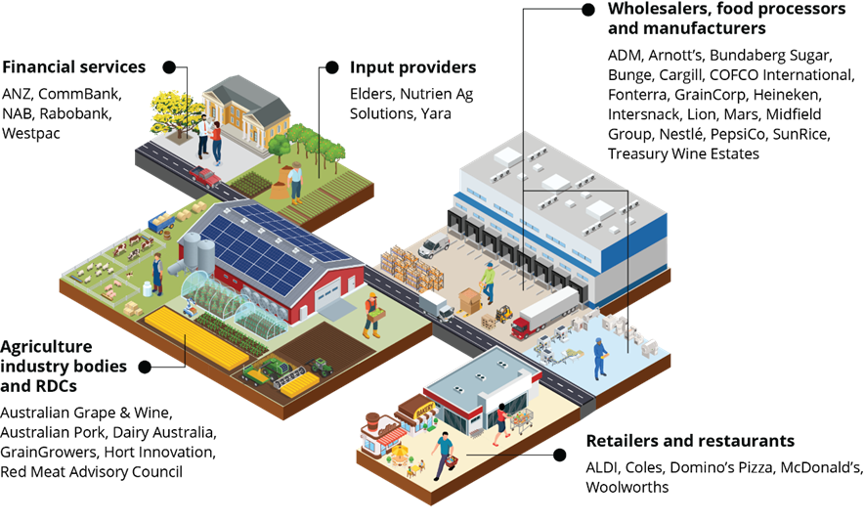
Note: Non-exhaustive list intended to illustrate the current breadth of ambitions

Key Australian Government investments
- $28.7 million over 10 years from 2024 to 2034 to improve GHG accounting in the agriculture and land sectors at the national through to the farm level.

Action 2 Support innovation to deliver commercially viable abatement options
The agriculture and land sectors involve biological systems that have unique emissions reduction challenges and opportunities. A suite of existing and emerging technologies and practices will be required to improve emissions outcomes (Figure 13).
There are currently limited options for deep reductions in agriculture emissions. However, there is the potential for options to be stacked together to deliver steady reductions in emissions and there are promising prospective technologies. Greater uptake of a combination of existing practices can support efficiency gains, and technological advances in precision agriculture will help fine tune the management of herds, pastures and inputs. Key emissions reduction technologies include feed additives for livestock, and enhanced efficiency fertilisers (for example, slow-release and nitrification inhibiting fertilisers) in the cropping industry, although further development is needed to see uptake at scale (CCA 2024).
In contrast, approaches to increasing carbon stored in the land are relatively mature and there is significant potential for enhancing carbon storage (CCA 2024). Practices that increase carbon storage in the land are well established, but more can be done to increase integration into agricultural businesses and the landscape.
Figure 13 Technologies and practices supporting emissions reduction
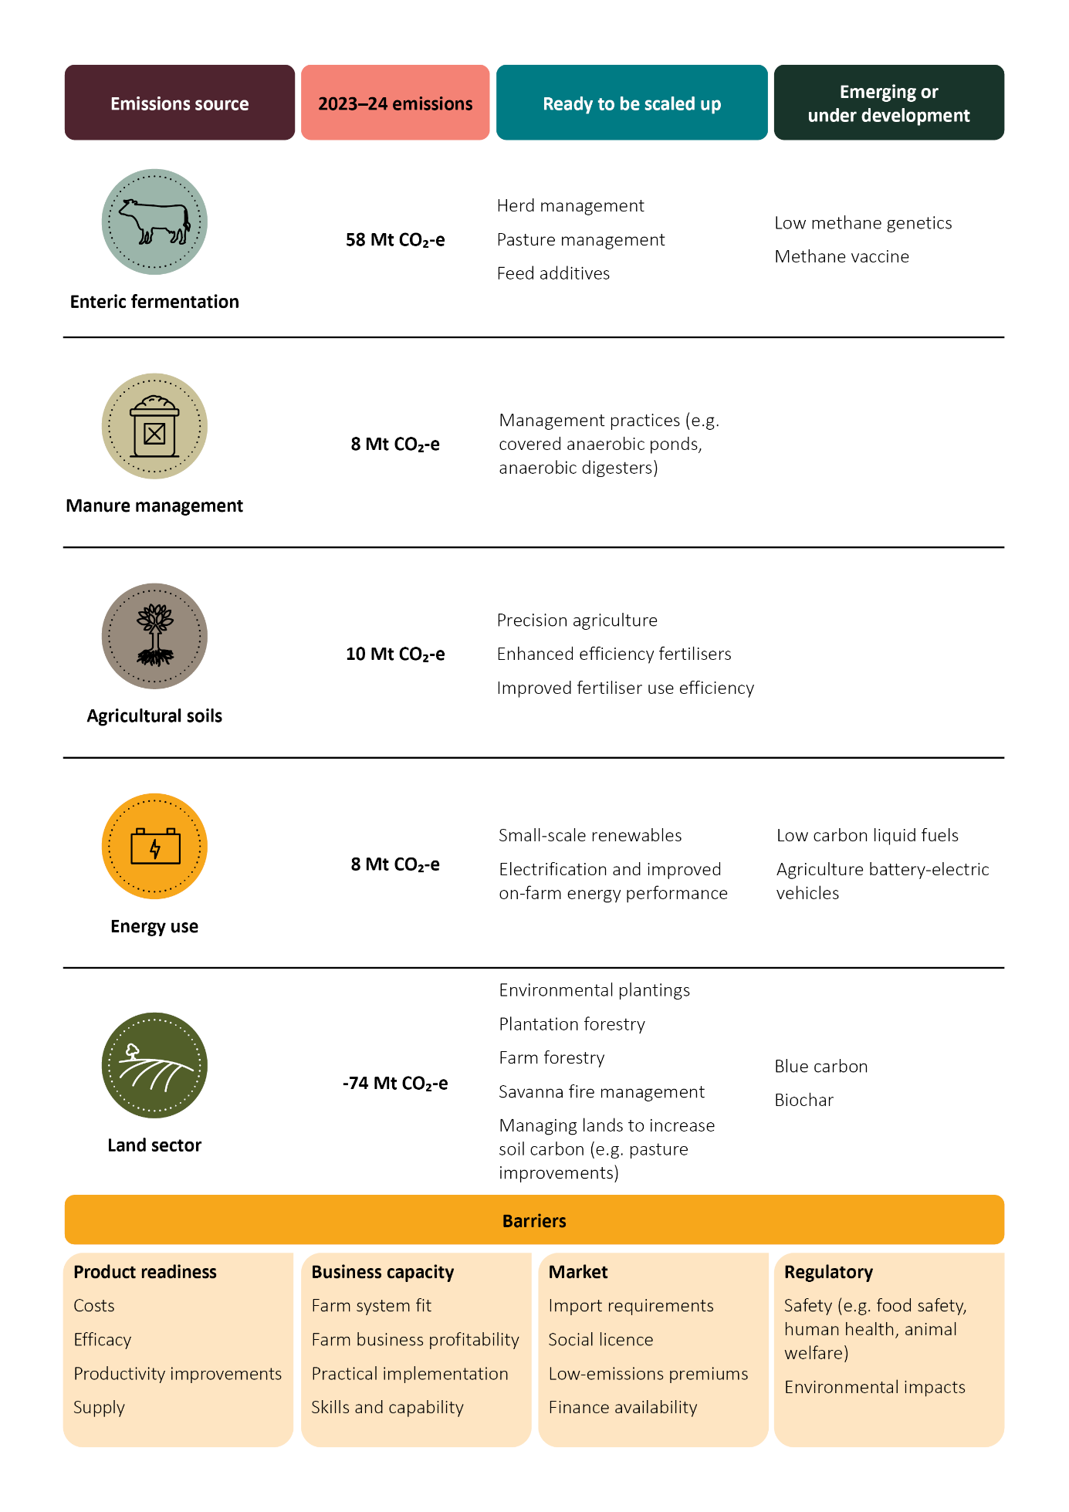

Focusing on research, development and investment
Research and development (R&D) will be fundamental to increasing the availability of effective and commercially viable technologies and practices needed to achieve deeper cuts in emissions in the agriculture and land sectors. R&D can help scale up emerging technologies and drive the innovation of new solutions. Substantial uplift in R&D will be needed across the innovation system to open up new opportunities for on-ground adoption and practice change.
A key focus for R&D should be the development of tools and information to help producers and land managers evaluate and compare the emissions and productivity outcomes of different practices. Evaluating the bundling of multiple emissions interventions will be important, given the lack of ‘silver-bullet’ technologies that can achieve large cuts in emissions. The implications of stacking technologies, including for business management, productivity, agronomy, and the natural environment, must also be considered (Bilotto et al. 2025).
The Zero Net Emissions Agriculture Cooperative Research Centre (ZNE-Ag CRC), which commenced in July 2024, represents a significant and ambitious step up in Australia’s R&D effort (Box 8). The ZNE-Ag CRC has secured funding from its 70 partners across industry, government, RDCs, the research sector, First Nations groups and small-medium sized enterprises. This includes the Australian Government’s investment of $87 million over 10 years to establish the ZNE-Ag CRC, to which it has added a further $4.4 million investment to support the Department of Agriculture, Fisheries and Forestry becoming a formal partner. As partners in the ZNE-Ag CRC, both the Australian Government and state and territory governments are working to improve the linkage between science and policy over the next decade.
Box 8 Zero Net Emissions Agriculture CRC primary research programs
The Zero Net Emissions Agriculture CRC has four research programs:
- Low-emissions plant solutions: Developing solutions to reduce emissions across broadacre, horticultural and livestock systems, including the use of enhanced efficiency fertilisers, legumes and in-setting options, as well as reducing emissions in cattle and sheep via the delivery of new low-emissions pasture and forage systems.
- Towards methane-free cattle and sheep: Providing the technology and quantification required to transition livestock production to a low-methane emission future.
- Whole-farm mixed enterprise systems analysis: Integrating the science emerging from the CRC to provide farmers with the guidelines, resources, metrics, and benchmarking tools required for a profitable transition to Australia’s net zero economy.
- Delivering value from net zero: Developing renewable energy and circular economy solutions that create profitable opportunities for agribusinesses and rural communities. Improving supply chain management and enhancing access to key export markets.
The commitment to the ZNE-Ag CRC builds on existing Australian Government investments in emissions mitigation. Examples include the Methane Emissions Reduction in Livestock program, support for commercialising the methane-inhibiting Australian red seaweed Asparagopsis, the National Soil Carbon Innovation Challenge, and Australian Forest and Wood Innovations.
Critically, there is also a significant collective investment made into agricultural innovation through the RDCs. In 2024–25, the RDCs received over $1 billion through industry levies for R&D (and marketing) and government matching funding for eligible research, development and extension activities. Analysis undertaken by the Council of Rural Research and Development Corporations (2024) found that the RDCs invested $384 million in emissions reduction efforts over the 3 years to 30 June 2024, including projects to leverage opportunities in energy efficiency, natural capital and systems innovation.
Looking forward, there are significant opportunities to increase investment and improve collaboration and coordination on R&D across industry, RDCs, CSIRO, universities, governments and with international partners. Industry groups play a leadership role in providing guidance for RDC investment, communicating producer needs to government and researchers, and facilitating partnerships. A proactive approach to investing in emissions mitigation technologies and practices will deliver gains for producers in the medium to long term. There are also opportunities through increased collaboration to elevate First Nations voices in the sector and drive Indigenous economic inclusion. Increased transparency and communication of R&D strategies and outcomes across different entities will help make the best use of collective investments. Aligning with circular economy principles can also optimise outcomes (Box 9).
Box 9 Circular economy
Enhancing Australia’s circular economy will assist with decarbonising the agriculture and land sectors. A more circular economy lowers energy demand and associated emissions by retaining existing goods and materials for longer. Many practices that producers already undertake align closely with the principles of the circular economy and reduce emissions, such as using resources efficiently, reducing waste and regenerating nature. Increasing the circularity of agricultural production can further support emissions reduction efforts.
The Australian Government has developed Australia’s Circular Economy Framework, with the goal of doubling the circularity rate by 2035. The framework identifies opportunities and priorities for driving the circular economy transformation across four key sectors, one of which is food and agriculture.
The ZNE-Ag CRC will also have a focus on circular economy solutions that create profitable opportunities for agribusinesses and rural communities.
Innovation also requires significant private investment. Capital markets in Australia and globally are increasingly interested in investing in climate mitigation – not just to develop technologies but also for the take-up of new practices on farms and other land. Coordinated support from both the public and private sectors is critical, including providing incentives such as access to green finance.
The Australian Government is taking a range of actions to help attract and grow private investment for the transition to the net zero economy. The priority actions in the Government’s Sustainable Finance Roadmap will support investors to identify new green investment opportunities. The Government has a range of specialist investment vehicles that will help to leverage the private sector’s support for the commercialisation, adoption and demonstration of innovative solutions (Box 10).

Key Australian Government investments
- $87 million over 10 years from 2024 to 2034 to establish the ZNE-Ag CRC, leveraging 2–3 times that amount in partner cash and in-kind contributions.
- $4.4 million over 10 years from 2024 to 2034 for the Department of Agriculture, Fisheries and Forestry to become a formal partner in the ZNE-Ag CRC.
- $29 million over 6 years from 2021 to 2027 to support research and development of methane-reducing livestock feed solutions through the Methane Emissions Reduction in Livestock program.
Box 10 Leveraging private investment and incentivising adoption
Strategic public sector investment can help share risks with the private sector of commercialising and deploying new technologies, and accelerate investment and adoption. The Government’s specialist investment vehicles are providing concessional debt, equity and in some cases grants to crowd in and de-risk private capital to support net zero aligned investment.
The Government is supporting the growth, resilience and sustainability of Australia’s agriculture sector, with an additional $1 billion in new loan funding through the Regional Investment Corporation. This funding broadens the Corporation’s loan scope to include assistance for improving climate resilience, boosting sector productivity, and supporting agriculture to be part of Australia’s net zero transition. This funding will ensure farmers can continue to access concessional lending to improve their long-term resilience and profitability – and brings total support for the agriculture sector through RIC loans to over $5 billion.
The Clean Energy Finance Corporation has also made several large investments in the agriculture and land sectors, including a $100 million partnership with NAB to support discounted interest rates for farmers on a range of emission reduction activities.
There are a range of other investment opportunities through specialist investment vehicles that can accelerate innovation and on-ground action. This includes an emerging role for the National Reconstruction Fund Corporation, which identifies agriculture, fisheries and forestry as a priority area for investment. The Net Zero Plan further discusses actions the Government is taking to support private investment for decarbonisation.

Action 3 Strengthen on-ground action
People and communities are at the heart of agriculture and the land’s role in the net zero transition. The sectors’ contributions to the net zero goal will ultimately be driven by the capacity and actions of producers and land managers across Australia.
A successful transition to the net zero economy will require trusted information and the expertise of a broad network of trusted advisers. Industry, governments and the private sector have a role to play in providing trusted climate information, noting producers access advice from a range of sources including independent consultants, agronomists, grower groups, government extension providers, research institutions and RDCs. Climate-related extension and outreach is a focus for state and territory governments in working with the agriculture and land sectors to help them reduce emissions and build resilience (for example, see case study in Box 11).
The Australian Government’s Carbon Farming Outreach Program (CFOP) is already supporting producers and land managers, including First Nations peoples, to understand their emissions and make informed decisions to manage them over time. The Government has committed an additional $27.8 million to expand CFOP. This builds on $17.5 million provided for trusted and independent advisers, and extends the program to 2028. This additional investment will increase access to trusted advice on emissions management and carbon farming by providing additional training to advisers and establishing a knowledge bank of centralised information. Producers and land managers will also have access to commodity-specific information, helping them make informed decisions about technologies and practices that best suit their enterprise.
The Australian Government expects to see this investment complemented by strong action across industry groups, which can be trusted sources of advice and can provide industry, commodity and regionally nuanced information.
The Natural Heritage Trust (NHT) is the Australian Government’s key investment platform for achieving environmental protection, sustainable agriculture and natural resource management outcomes. The NHT’s Climate-Smart Agriculture Program commits $302.1 million over 5 years to build capacity and knowledge, and accelerate the uptake of sustainable practices in agriculture. The program supports producers and land managers to adopt practices for sustainable natural resource management, emissions reduction and climate resilience. As part of this investment, $153.4 million in dedicated funding is provided to regional natural resource management organisations, recognising their vital role in achieving on-ground outcomes.
Formal education and training will also need to evolve over time so that the agriculture and land workforces have the skills they need to engage with the net zero economy. Building this capability is a collective challenge across governments, industry and education and training systems. A study by Jobs and Skills Australia found that climate change and net zero is producing significant economic shifts with a range of workforce skills required to support new production and land-use practices (JSA 2025). Skills Insight, the agribusiness Jobs and Skills Council, is responding to future needs through workforce planning and strategies. Alongside its research programs, the ZNE-Ag CRC will create a national education and training program offering a suite of short, applied courses and its demonstration sites will provide a hub for sector-wide outreach and engagement.
Changing workforce needs provide an opportunity to increase the participation of underrepresented groups in the agricultural industry, including women, young people and First Nations peoples. Supporting a safe, diverse and inclusive agricultural workforce will ensure the sector benefits from the full range of talents available in the net zero transition. This will also be critical to meeting skills shortages while unlocking innovation and driving productivity.

Key Australian Government investments
- $27.8 million over 4 years from 2024 to 2028 to expand the Carbon Farming Outreach Program.
- $302.1 million over 5 years from 2023 to 2028 through the Climate-Smart Agriculture Program to support trials, on-farm demonstrations and practices that address priorities for sustainable agriculture.
Box 11 Improving energy performance
Addressing emissions from energy use provides an opportunity to deliver a small but important contribution to the decarbonisation of the agriculture and land sectors. Energy use can represent a large proportion of emissions for certain sub-sectors including intensive animal operations such as poultry, irrigated cropping, horticulture and land-based aquaculture.
There are many actions the sectors can already undertake to reduce these emissions. There are a growing number of cheaper renewable energy technologies and energy performance improvements related to energy efficiency, electrification and demand flexibility that are available to reduce emissions from energy consumption. For example, converting diesel-powered water pumps to electric solar-powered pumps can deliver energy efficiency gains and achieve cost savings within a few years, while helping to reduce emissions. Also, incorporating sources of energy storage can aid in demand flexibility, for example, by using stored energy generated from solar photovoltaic systems for pumping and irrigation at night.
Energy audits and tailored advice are valuable in demonstrating the emissions benefits and cost savings that can result from producers and land managers improving the energy performance of their activities.
Electrifying wherever possible, complemented by other energy performance improvements, storage and use of renewable energy, provides a pathway to decarbonise energy use in agriculture, fisheries and forestry. In the long term this will depend on the electrification of heavy machinery and vehicles and the availability of cost-effective low carbon liquid fuels. These outcomes are broadly supported by policies in other sector plans.
Case study: The electrification of a New South Wales sheep dairy provided multiple benefits
Cressida and Michael Cains’ sheep dairy and cheesery in Robertson, New South Wales previously experienced energy supply issues, such as power outages and an insecure supply of liquified petroleum gas (LPG) to the farm. Their farm, Pecora Dairy, was supported as a pilot under the NSW Department of Primary Industries and Regional Development’s Energy Efficiency Solutions project to demonstrate on-farm energy efficiency improvements (NSW DPI 2024).
The Cains installed a solar photovoltaic and battery system allowing the site’s LPG boiler to be replaced by a new heat pump powered by renewable electricity. Energy costs fell by two-thirds and LPG is no longer needed. Broader benefits included reduced food waste due to the reliable energy supply and stronger sustainability credentials through reduced carbon emissions.
‘Electrifying our dairy has been transformative, we’ve cut energy costs, improved reliability and reduced our carbon footprint, all while strengthening the long-term sustainability of our farm and business.’ Pecora Dairy

Action 4 Enhance land’s role in a net zero economy
In the last 30 years Australia’s land sector has shifted from being a large source of emissions to being a large sink of emissions. As Australia transitions to net zero, this sink will need to be protected and considerably enhanced. There is a strong expectation from stakeholders and the community that this will be achieved while also delivering wider benefits for agricultural production, regional communities, First Nations peoples and nature.

Opportunities to scale up carbon storage
Protecting and enhancing carbon storage while also supporting diverse land uses, such as agricultural production and nature repair, will require action, engagement, cooperation and investment across all levels of government and the private sector.
Producers are already delivering tangible carbon storage and biodiversity outcomes through practices such as rotational grazing, planting shelterbelts, and fencing off and revegetating riparian areas. In some areas, there are also opportunities to invest in on-farm forestry. All of these can be taken up more widely in a way that builds carbon stores, enhances sustainability, and adds to farm productivity and income diversification.
Australia’s forests also provide carbon storage and biodiversity outcomes. Forests cover 17% of Australia’s land area, comprising 132 million hectares of native forest and 2 million hectares of commercial plantations and other forest types (MIG & NFISC 2024). The forestry industry will continue to play a key role in supporting Australia’s climate ambitions, through carbon storage and provision of wood products that displace carbon intensive construction materials and plastics.
Expansion of plantation forestry will enhance the industry’s contribution to net zero. However, there are challenges. The Australian Government is supporting expansion of the plantation forest estate by providing $73.8 million over 4 years from 2023–24 through the Support Plantation Establishment program. This program aims to increase future plantation forest resources available for processing while also contributing to Australia’s emissions reduction targets.
Coastal blue carbon ecosystems (mangroves, tidal marshes and seagrasses) are widely recognised for their ability to capture and store large amounts of carbon. Investors are increasingly attracted to opportunities to enhance these systems but work is required to address challenges to scaling up the number of blue carbon projects. Through its Blue Carbon Conservation, Restoration and Accounting Program, the Government has supported projects to restore coastal blue carbon ecosystems. These projects have benefits for habitats and coastal protection, as well as reducing emissions and storing carbon.

Leveraging carbon and environmental markets
The Australian Carbon Credit Unit (ACCU) Scheme is a key mechanism for incentivising emissions reductions and carbon storage. The ACCU Scheme is already enabling producers and land managers to earn carbon credits for certain activities. Of the 168 million ACCU credits generated under the Scheme as at 30 June 2025, 65% were from methods related to vegetation (mainly reforestation), savanna burning and agriculture (CER 2025). The Government has already invested more than $1 billion in purchasing ACCUs to stimulate and build the market. The Government is considering its future role as a direct purchaser of abatement in light of Safeguard Mechanism reforms and the evolving role of the ACCU Scheme. ACCU purchasing can provide a flexible and scalable mechanism to drive abatement to help meet Australia’s emission reduction goals. Going forward, the reformed Safeguard Mechanism will increasingly drive demand for ACCUs from private buyers.
The Government has implemented a proponent-led method development process for the ACCU Scheme, as recommended by the 2022 Independent Review of ACCUs (Chubb et al. 2022). This approach enables stakeholders to suggest new methods or changes to existing methods. Over time, this process will provide new opportunities to incentivise emissions reductions and carbon storage where it meets the requirements of the scheme.
In addition to the proponent-led process, the Government is progressing the development of the Integrated Farm and Land Management (IFLM) method and two new savanna fire management methods. The IFLM method will enable producers and land managers to implement multiple carbon storage activities on a single property, without having to register multiple ACCU Scheme projects. The Government is developing the IFLM method in a co-design consultation approach with stakeholders.
The Indigenous Estate comprises 536 million hectares, equating to 70% of Australia’s land area, and includes land over which Indigenous peoples and communities have ownership, management or co-management, and other special rights (ABARES 2024). First Nations-led land management projects under the ACCU Scheme, such as savanna fire management, reforestation and native forest regeneration projects, can increase carbon stores while fostering employment, training, economic opportunities and the transfer of traditional knowledge (CCA 2023). For example, First Nations land managers in northern Australia are reintroducing traditional strategic early dry season savanna fire management practices. These practices improve ecosystem resilience by supporting mosaic vegetation patterns, stimulating grass regrowth and inhibiting woody weeds. At the same time, these practices reduce emissions and support carbon storage by lessening the size, intensity and frequency of fires.
The emergence of new environmental markets such as Australia’s Nature Repair Market is further incentivising emissions reductions alongside important biodiversity outcomes (Box 12). The Nature Repair Market operates alongside the ACCU Scheme, with both schemes administered by the Clean Energy Regulator. This alignment is intended to make it easier for land managers to participate in and benefit from both schemes, whilst helping to achieve Australia’s broader net zero and nature goals. Additional income from biodiversity outcomes can help increase the financial viability of carbon projects, especially on marginal land, and contribute to landscape resilience.
The ACCU Scheme and Nature Repair Market are also explored in the Net Zero Plan.
Box 12 Supporting carbon and nature outcomes through the Nature Repair Market
Landholders are interested in optimising use of their land to provide sustainable outcomes. Through the Nature Repair Market landholders can undertake projects to deliver both biodiversity and carbon outcomes, and generate income.
The first Nature Repair Market method, the Replanting Native Forest and Woodland Ecosystems method, focuses on revegetation in historically cleared regions. The method is designed to allow biodiversity projects alongside ACCU projects on the same parcel of land. The landholder can earn both a biodiversity certificate and ACCUs where they meet requirements.
There is strong landholder interest in this approach. The Government’s Carbon + Biodiversity Pilots under the Agriculture Biodiversity Stewardship Package demonstrate how carbon and biodiversity projects can be successfully integrated within a farm business. Pilot projects show how landholders can maximise opportunities to achieve multiple outcomes on their land.
There are currently 46 pilot projects across Australia, most of which are on small privately-owned farms. These projects cover over 1,600 hectares of biodiverse plantings and participants are planting over 760,000 native trees and shrubs. These plantings are expected to sequester an estimated 350,000 tonnes of carbon dioxide over the 25-year Carbon + Biodiversity permanence period.

Protecting existing carbon stores
Protecting and enhancing carbon stores in natural landscapes will contribute to Australia’s net zero goal while providing essential ecosystem services, including clean air and water, habitat, soil fertility and pollination. The Australian Government is working to expand protected and conserved areas, deliver biodiversity conservation and restoration programs, and enhance broader natural resource management approaches. States and territories are also changing how they manage their native forest estates to support emissions, nature and other goals.
Australia is committed to halting and reversing biodiversity loss. Expanding protected and conserved areas and restoring priority degraded areas will help meet Australia’s targets under the Global Biodiversity Framework. Through the Australian Bushland Program, the Government will provide $250 million over 5 years from 2025–26 to help meet Australia’s target to protect and conserve 30% of Australia’s land by 2030 (30 by 30). The program will support partnerships with state and territory governments, expand Indigenous Protected Areas, invest in Nature Repair Market projects, and leverage stakeholder partnerships to protect properties with high biodiversity value. The program complements existing Government funding, including the $231.5 million Indigenous Protected Areas Program and the $25 million Protecting Important Biodiversity Areas Program.
State and territory governments, alongside the Australian Government, play an important role in ensuring relevant land clearing regulations are operating effectively to conserve biodiversity, protect existing carbon stores and prevent illegal land clearing. The Australian Government is currently piloting an enhanced vegetation change monitoring program through the National Vegetation Monitoring System. The system will better monitor vegetation change and assist in identifying illegal land clearing in Australia to enable early intervention.

Land use in the transition
Agriculture and land will support diverse forms of decarbonisation required for the net zero transition across the economy. This will often involve new uses of land, which can generate alternative revenue streams for landholders. Examples include increasing carbon storage (mainly through reforestation), hosting renewable energy generation and transmission infrastructure and producing feedstocks for low carbon liquid fuels (LCLFs) (Box 13). Integrating these activities into regional landscapes, including agricultural production systems, can attract investment, create new employment opportunities and support diversified and more resilient local economies. Appropriate planning and coordination will be needed to reduce transitional risks, balance different land uses and support benefits for communities.
The renewable energy transition will require new infrastructure across regional Australia. Initial analyses suggest that while some renewable energy infrastructure will be located on or alongside agricultural land, overlap with agricultural land may be minimal (CEC 2025; NSW Agriculture Commissioner 2022). Hosting renewable energy infrastructure on farm can provide a more climate-resilient income source while continuing agricultural production, for example, through agrivoltaics. However, there are concerns in some regional communities about agricultural land being removed from production for renewable energy. The Net Zero Plan and the Electricity and Energy Sector Plan discuss the actions the Australian Government is taking to build community support for the transition.
There are also broader concerns from communities about the potential for land sector abatement to drive large-scale land-use change. Moving forwards, land management planning and community engagement will be critical, including genuine, ongoing engagement with First Nations peoples. This needs to be underpinned by information and transparency around how land is used and how land use is changing. The Net Zero Plan explores this further. Ultimately, decisions about how land is used will largely be made by individual landholders in line with their own interests and motivations.
All levels of government must take action in their sphere of responsibility. State and territory governments will continue to work with local governments and communities to ensure land is used in a way that aligns with social and community goals. Local governments are responsible for land-use planning, zoning and approvals in their jurisdictions, and will continue to play an important role in community capacity building, advocacy and facilitating on-ground action. The Australian Government maintains the regulatory and policy frameworks that govern the ACCU Scheme and Nature Repair Market. The Carbon Credits (Carbon Farming Initiative) Act 2011 has a strong framework for assessing and managing potential adverse impacts including for land use, such as legally requiring the Minister to consider adverse social, environmental or economic impacts when making ACCU Scheme methods and detailed consent requirements before area-based projects can be credited. Projects under the ACCU Scheme are also required to consider consistency with regional natural resource management plans during development and are not exempt from compliance with state and territory laws, which is important for having the legal right to carry out each project. Legislative rules also exclude classes of projects which could have material adverse impacts, including on land use for agricultural production, water access or biodiversity.
Box 13 Production of low carbon liquid fuel feedstocks contributes to net zero
Agriculture can contribute to decarbonisation across the economy by producing feedstocks for LCLFs and low carbon gases. These fossil fuel alternatives present an opportunity to decarbonise hard-to-electrify energy demands, including aviation, maritime (including fishing vessels), heavy transport and some industrial processes. LCLFs are a critical technology in the Transport and Infrastructure Net Zero Roadmap and Action Plan and the Electricity and Energy Sector Plan.
The production of LCLFs will rely heavily upon biogenic feedstocks from the agriculture and forestry industries. The use of non-edible, ‘second-generation’ feedstocks –such as crop and forest residues and dedicated energy crops – could allow producers to extract additional value from otherwise under-utilised resources.
Australian producers are already producing significant quantities of LCLF feedstock for export and refinement into biofuels overseas. There is also a pipeline of 11 LCLF projects using biogenic feedstocks under development in Australia (CEFC 2025).
To help establish a LCLF industry, the Government is delivering $250 million in grant funding to be provided through the Australian Renewable Energy Agency as part of the Future Made in Australia Innovation Fund. This funding will seek to accelerate the development and deployment of a domestic LCLF supply chain, including nascent production technologies and feedstock sources. To ensure public investment such as this benefits communities during the net zero transition, the Future Made in Australia Act 2024 requires consideration of the community benefit principles.
To further build a supply chain for Australian LCLFs, the Australian Government will invest $1.1 billion in a new Cleaner Fuels Program. This will help stimulate private investment in Australia’s first onshore LCLF refineries, backing local innovators, making fuel supply more resilient and bridging the price gap for early adopters. The Government will engage with industry on how to make sure Australian liquid fuel users have a fair chance to capture the emissions reduction potential unlocked by low emission Australian fuels.
The Government has committed to developing a National Bioenergy Feedstock Strategy, to strategically examine the potential to grow a feedstock industry in a way that maximises opportunities for producers and supports emissions reductions, without compromising food and fibre security. The work will be progressed alongside the development of a National Food Security Strategy to ensure a coordinated approach.

Key Australian Government investments
- $73.8 million over 4 years from 2023 to 2027 for the Support Plantation Establishment program, which is helping to expand the wood production estate.
- $66.1 million over 5 years from 2023 to 2028 to deliver essential reforms to the ACCU Scheme, including implementing a new proponent-led method development process and supporting First Nations groups to participate in up-front consent processes for ACCU Scheme projects.
- $250 million over 5 years from 2025 to 2030 for the Australian Bushland Program.

Moving forwards
The plan has set out a range of foundational responses to prepare agriculture and land to play an important part in Australia’s low-emissions economy. The extensive collaboration and analysis that has informed its development is only the beginning. We can all play a role in enabling agriculture and land to appropriately contribute to Australia’s net zero goal.
Foundational actions identified in the plan have been designed to ensure engagement with industry and other stakeholders is embedded in implementation. Industry will need to continue with strong efforts towards decarbonisation, building on the many examples of industry leadership towards Australia’s net zero goal. Ongoing partnerships will be necessary not only to achieve the goals of this plan, but to identify opportunities for further ambition as we chart a course to 2050.
All states and territories have set a target of net zero emissions by 2050 or earlier, and several have already established emissions reduction plans for agriculture and land (Box 14). Ongoing coordination and collaboration between federal, state and territory governments is critical to maximise Australia’s chances of achieving our collective goals.
Ministerial forums between the Australian Government and state and territory governments for agriculture, environment, forestry, fisheries, energy and climate change are already in place to guide collaboration as we move forward. Commitments such as the National Statement on Climate Change and Agriculture, and the National Statement on First Nations in Agriculture, Fisheries and Forestry currently under development, highlight the shared ambitions of governments.
Box 14 Examples of state and territory government emissions reduction commitments and strategies
New South Wales: The Primary Industries Productivity and Abatement program is a key element of the state’s Net Zero Plan Stage 1: 2020–2030. The program is further detailed in the NSW government’s publication, Growing NSW’s primary industries and land sector in a low carbon world.
Victoria: The 2021 to 2025 Agriculture sector emissions reduction pledge ensures farmers are preparing to achieve emissions reductions towards 2030. The Land use, land use change and forestry sector emissions reduction pledge aims to help protect and add to existing sources of natural carbon storage.
Queensland: The Queensland Low Emissions Agriculture Roadmap 2022–2032 provides a framework to achieve a low-emissions agriculture sector by reducing production-based emissions and increasing carbon farming.
Western Australia: The 2023 Sectoral Emissions Reduction Strategy for Western Australia includes pathways for the agriculture and land sectors.
South Australia: South Australia’s Net Zero Strategy 2024–2030 guides the state’s net zero emissions future and includes policy priorities for agriculture and land use.
Tasmania: Tasmania’s first legislated Emissions Reduction and Resilience Plans for agriculture, and land use, land-use change and forestry from 2024–29 outline pathways to reduce emissions and build resilience.
Australian Capital Territory: The goals and actions in the ACT Climate Change Strategy 2019–25 include protecting local species and habitats, sequestering carbon in the landscape and encouraging sustainable and resilient farming.
Northern Territory: The 2020 Northern Territory Climate Change Response: Towards 2050 outlines opportunities to grow the carbon farming industry and the government’s actions to respond to climate risks faced by the agriculture, horticulture, fisheries and biosecurity industries.
Addressing emissions from agriculture and land is a global challenge and advances are being made in other countries that can be leveraged to further support emissions reduction goals. Australia is a strong contributor to global alliances, initiatives and efforts, and like-minded countries, including Canada and New Zealand, have reached out to Australia to undertake joint work to support decarbonisation in agriculture. Australia must continue to display leadership and collaboration, and contribute to the international agenda on climate-smart agricultural production and market access requirements.
The Net Zero Plan outlines Australia’s framework to ensure Australia remains on track to reach net zero emissions, through the Climate Change Act 2022. This framework supports transparency and accountability. It also provides a clear cycle for reviewing and improving climate policies over time, including the outcomes and actions outlined in the framework for supporting the agriculture and land sectors’ contributions to Australia’s net zero goal.
Many industry organisations are also already undertaking monitoring and reporting. Industry has growing data and reporting capabilities, with some industry bodies already reporting annually against climate change related indicators as part of their sustainability frameworks. It is critical that there is continued leadership shown by industry and supported by government where appropriate.
Through ongoing reporting and monitoring, new opportunities for strengthened action will be identified to support greater emissions reductions. As was the case for this plan, the engagement and contributions of the sectors will be fundamental to this process.

Everyone has a role to play

Governments
All levels of government must play their part in supporting a fair and orderly transition across the economy. Strong coordination and collaboration domestically, and also internationally, will provide the necessary guidance and direction to 2050 and beyond. Ensuring appropriate enablers are in place and smoothing barriers to decarbonisation will be critical to support everyone to play their role.

The research community
Research and development will play a crucial role in creating a suite of commercially viable abatement technologies and practices that enable decarbonisation across agriculture and land. Strong collaboration across the research community, together with the private sector and our international partners, will maximise investments and optimise outcomes.

Industry and the private sector
The agricultural industry and private sector actors, including banks and supply chain organisations, have shown leadership on sustainability and emissions reductions. These organisations are establishing sustainability frameworks, setting their own climate goals and working with stakeholders to achieve shared objectives. Continued action will be critical for encouraging best practice, establishing strategic partnerships and guiding ambition.

Producers and land managers
Producers and land managers are at the heart of decarbonising the agriculture and land sectors. Their production decisions, investments and stewardship will drive emissions reductions and increases in carbon stores.
Though efforts of producers and land managers are critical, they are not acting alone. With the support of industry groups, communities, researchers and governments, action taken on the ground will contribute to our collective goals.

First Nations peoples
As the traditional custodians and knowledge‑holders of the land and waters of Australia, First Nations peoples must be involved in, and benefit from, efforts to decarbonise the agriculture and land sectors. As significant land managers, co-managers, custodians and owners, First Nations peoples are at the forefront of engaging with the intersecting challenges of climate change, biodiversity loss and economic development.

Glossary
Term | Definition
abatement | The removal of one or more greenhouse gases from the atmosphere; or the avoidance of emissions of one or more greenhouse gases.
agriculture sector | Emissions from agriculture and associated management activities, which fall under the agriculture sector in the National Greenhouse Accounts, and emissions from agriculture, fisheries and forestry electricity and fuel use.
agrivoltaics | The use of land for both agriculture and solar photovoltaic energy generation.
Australian Carbon Credit Unit (ACCU) | Represents one tonne of carbon dioxide equivalent stored or avoided from a registered ACCU Scheme project.
carbon dioxide equivalent (CO₂-e) | A description of, for given amounts of greenhouse gases, the amount of carbon dioxide that would have the same global warming potential over a specified time period.
carbon storage | Carbon stored in carbon pools, such as plants and soils.
CFOP | Carbon Farming Outreach Program
circular economy | An economic model that promotes sustainable and efficient use of resources by recovering, retaining or adding to their value.
CRFD | Climate-related financial disclosures
CSIRO | Commonwealth Scientific and Industrial Research Organisation
decarbonisation | Removal or reduction of greenhouse gas emissions from or emitted to the atmosphere.
direct air capture and storage | A range of processes that separate and remove carbon dioxide from the atmosphere, storing the captured carbon dioxide underground in geological formations.
electrification | The replacement of other energy sources, such as liquid fuels, with electricity.
emissions intensity | A measure of the amount of emissions associated with a unit of output– for example, emissions per tonne of grain produced, or per head of cattle.
energy performance | Covers the broad management of energy demand, including energy efficiency, demand flexibility (or load shifting), and electrification and fuel switching.
enteric fermentation | The process in ruminant animals by which microbes in the digestive tract, or rumen, decompose and ferment food, producing methane as a by-product.
farm forestry | Establishing or managing trees on agricultural land for wood production.
feedstock | A type of renewable biomass, such as agricultural crops and forest residues, that is converted into a renewable fuel.
greenhouse gas (GHG) | Gases that trap heat in the earth’s atmosphere. Carbon dioxide (CO₂), nitrous oxide (N₂O) and methane (CH₄) are examples of greenhouse gases.
IFLM | Integrated Farm and Land Management
Indigenous Estate | Areas of land over which First Nations peoples and communities have ownership, management or other special legal rights.
insetting | Reducing emissions or storing carbon within an operation, and counting the emissions reductions or carbon storage towards the operation’s total emissions.
IPCC | Intergovernmental Panel on Climate Change
land manager | Someone who oversees the maintenance, use, development, protection or rehabilitation of public or private land.
land sector | The land uses and the land management activities which fall within the ‘land use, land-use change and forestry’ sector of the National Greenhouse Accounts.
low carbon liquid fuel (LCLF) | Liquid fuels with lower lifecycle emissions than conventional fossil fuels. LCLFs can be sustainably produced from biomass, waste materials and/or green hydrogen.
LPG | Liquid petroleum gas
NGA | Australia’s National Greenhouse Accounts
net zero | Greenhouse gas emissions produced are balanced with emissions removed from the atmosphere.
NHT | Natural Heritage Trust
producer | Includes farmers, graziers, pastoralists, foresters and fishers.
R&D | Research and development
RDC | Rural Research and Development Corporation
reforestation | The restoration of previously forested land back to forest.
Scope 3 emissions | All indirect greenhouse gas emissions that occur upstream and downstream in a company’s supply chain as a result of what it buys, sells or finances, excluding emissions from electricity production (Scope 2 emissions).
sink | Removes more carbon from the atmosphere than is released.
supply chain | The network of all the individuals, organisations, resources, activities, processes and technologies involved in the creation and sale of a product.
ZNE-Ag CRC | Zero Net Emissions Agriculture Cooperative Research Centre

References
AASB 2024, Australian Sustainability Reporting Standard AASB S2 Climate-related Disclosures, Australian Accounting Standards Board, Victoria, accessed 23 July 2025.
ABARES 2024, Australia’s Indigenous land and forest estate 2024, Australian Bureau of Agricultural and Resource Economics and Sciences, Canberra, accessed 4 August 2025.
ABARES 2025, Snapshot of Australian Agriculture 2025, ABARES Insights, issue 1, Australian Bureau of Agricultural and Resource Economics and Sciences, Canberra, February, DOI:10.25814/gs4g-ys39, accessed 18 June 2025.
ACS 2025, Australia’s National Climate Risk Assessment Report, Australian Climate Service, Canberra, accessed 15 September 2025.
Bilotto, F, Christie-Whitehead, K, Malcolm, B, Barnes, N, Cullen, B, Ayre, M & Harrison, M 2025, Costs of transitioning the livestock sector to net-zero emissions under future climates, Nature Communications, vol. 16, DOI:10.1038/s41467-025-59203-5, accessed 18 June 2025.
BOM & CSIRO 2024, State of the Climate 2024, Bureau of Meteorology and Commonwealth Scientific and Industrial Research Organisation, Canberra, December, ISBN:978-1-4863-2124-7, accessed 30 July 2025.
CCA 2023, 2023 Review of the Carbon Credits (Carbon Farming Initiative) Act 2011, Climate Change Authority, Canberra, accessed 4 August 2024.
CCA 2024, Sector Pathways Review, Climate Change Authority, Canberra, accessed 4 August 2025.
CEC 2025, Solar synergies: how renewable energy and agriculture thrive together, Clean Energy Council, Melbourne, accessed 1 August 2025.
CEFC 2025, Refined Ambitions: Exploring Australia’s Low Carbon Liquid Fuel Potential, Clean Energy Finance Corporation, Sydney, accessed 23 July 2025.
CER 2025, ACCU Scheme Project Register, Clean Energy Regulator, Canberra, accessed 1 August 2025.
Chubb, I, Bennett, A, Gorring, A, Hatfield-Dodds, S 2022, Independent Review of ACCUs, Department of Climate Change, Energy, the Environment and Water, Canberra, accessed 29 July 2025.
CRRDC 2024, Driving emissions reduction in Australia's rural sector, Council of Rural Research and Development Corporations, Canberra, accessed 24 July 2025.
DCCEEW 2024, Australia’s emissions projections 2024, Department of Climate Change, Energy, the Environment and Water, Canberra, November, accessed 5 August 2025.
DCCEEW 2025a, National Inventory Report 2023, Volume I, Department of Climate Change, Energy, the Environment and Water, Canberra, accessed 6 June 2025.
DCCEEW 2025b, Quarterly Update of Australia’s National Greenhouse Gas Inventory: December 2024, Department of Climate Change, Energy, the Environment and Water, Canberra, accessed 6 August 2025.
Hafi, A, Parker, J, Fell, J, Duver, A & Addai, D 2023, What Asia Wants: Long-term agrifood demand in Asia (2023 Revision), ABARES Research Report 23.10, Australian Bureau of Resource Economics and Sciences, Canberra, May, DOI:10.25814/kbgc-ag60, accessed 4 August 2025.
Hughes, N & Gooday, P 2021, Climate change impacts and adaptation on Australian farms, ABARES Insights, issue 3, Australian Bureau of Agricultural and Resource Economics and Sciences, Canberra, September, DOI:10.25814/589v-7662, accessed 30 July 2025.
IPCC 2023, Summary for Policymakers, in Lee, H & Romero, J (eds), Climate Change 2023: Synthesis Report. Contribution of Working Groups I, II and III to the Sixth Assessment Report of the Intergovernmental Panel on Climate Change, Intergovernmental Panel on Climate Change, Geneva, pp. 1-34, DOI:10.327/IPCC/AP6-9789291691647.001, accessed 30 July 2025.
JSA 2025, An Essential Ingredient: The Food Supply Chain Workforce, Jobs and Skills Australia, accessed 20 June 2025.
Linehan, V, Thorpe, S, Andrew, N, Kim, Y & Beaini, F 2012, Food demand to 2050: Opportunities for Australian agriculture, paper presented at the 42nd ABARES Outlook 2012 conference, Canberra, 6-7 March, accessed 4 August 2025.
MIG & NFISC (Montreal Process Implementation Group for Australia and National Forest Inventory Steering Committee) 2024, Australia’s State of the Forests Report: Synthesis 2023, (2nd ed.) Australian Bureau of Agricultural and Resource Economics and Sciences, Canberra, DOI:10.25814/649h-hk82, accessed 8 July 2025.
NSW Agriculture Commissioner 2022, Renewable energy generation and agriculture in NSW’s rural landscape and economy – growth sectors on a complementary path, accessed 18 June 2025.
NSW DPI 2024, Climate change research strategy – energy efficiency solutions: On-farm energy pilot case study – Pecora Dairy, Robertson, NSW Department of Primary Industries, February, accessed 4 August 2025.
OECD 2025, Targeting methane emissions to mitigate the risk of climate overshoot, OECD Net Zero+ Policy Papers, No. 14, The Organisation for Economic Co-operation and Development Publishing, Paris, https://doi.org/10.1787/5fa37719-en, accessed 5 August 2025.
Purdie, A 2024, Corporate Sustainability in the Agri-Food System, BloombergNEF, accessed 30 July 2025.
Read, A, Rollan, J, Creed, C & Fell, J 2023, Environmental sustainability and agri-environmental indicators – international comparisons, ABARES Insights, issue 2, Australian Bureau of Agricultural and Resource Economics and Sciences, Canberra, July, DOI:10.25814/zzdq-4t23, accessed 30 July 2025.

Treasury 2025, Australia’s net zero transformation: Treasury modelling and analysis, Treasury.

