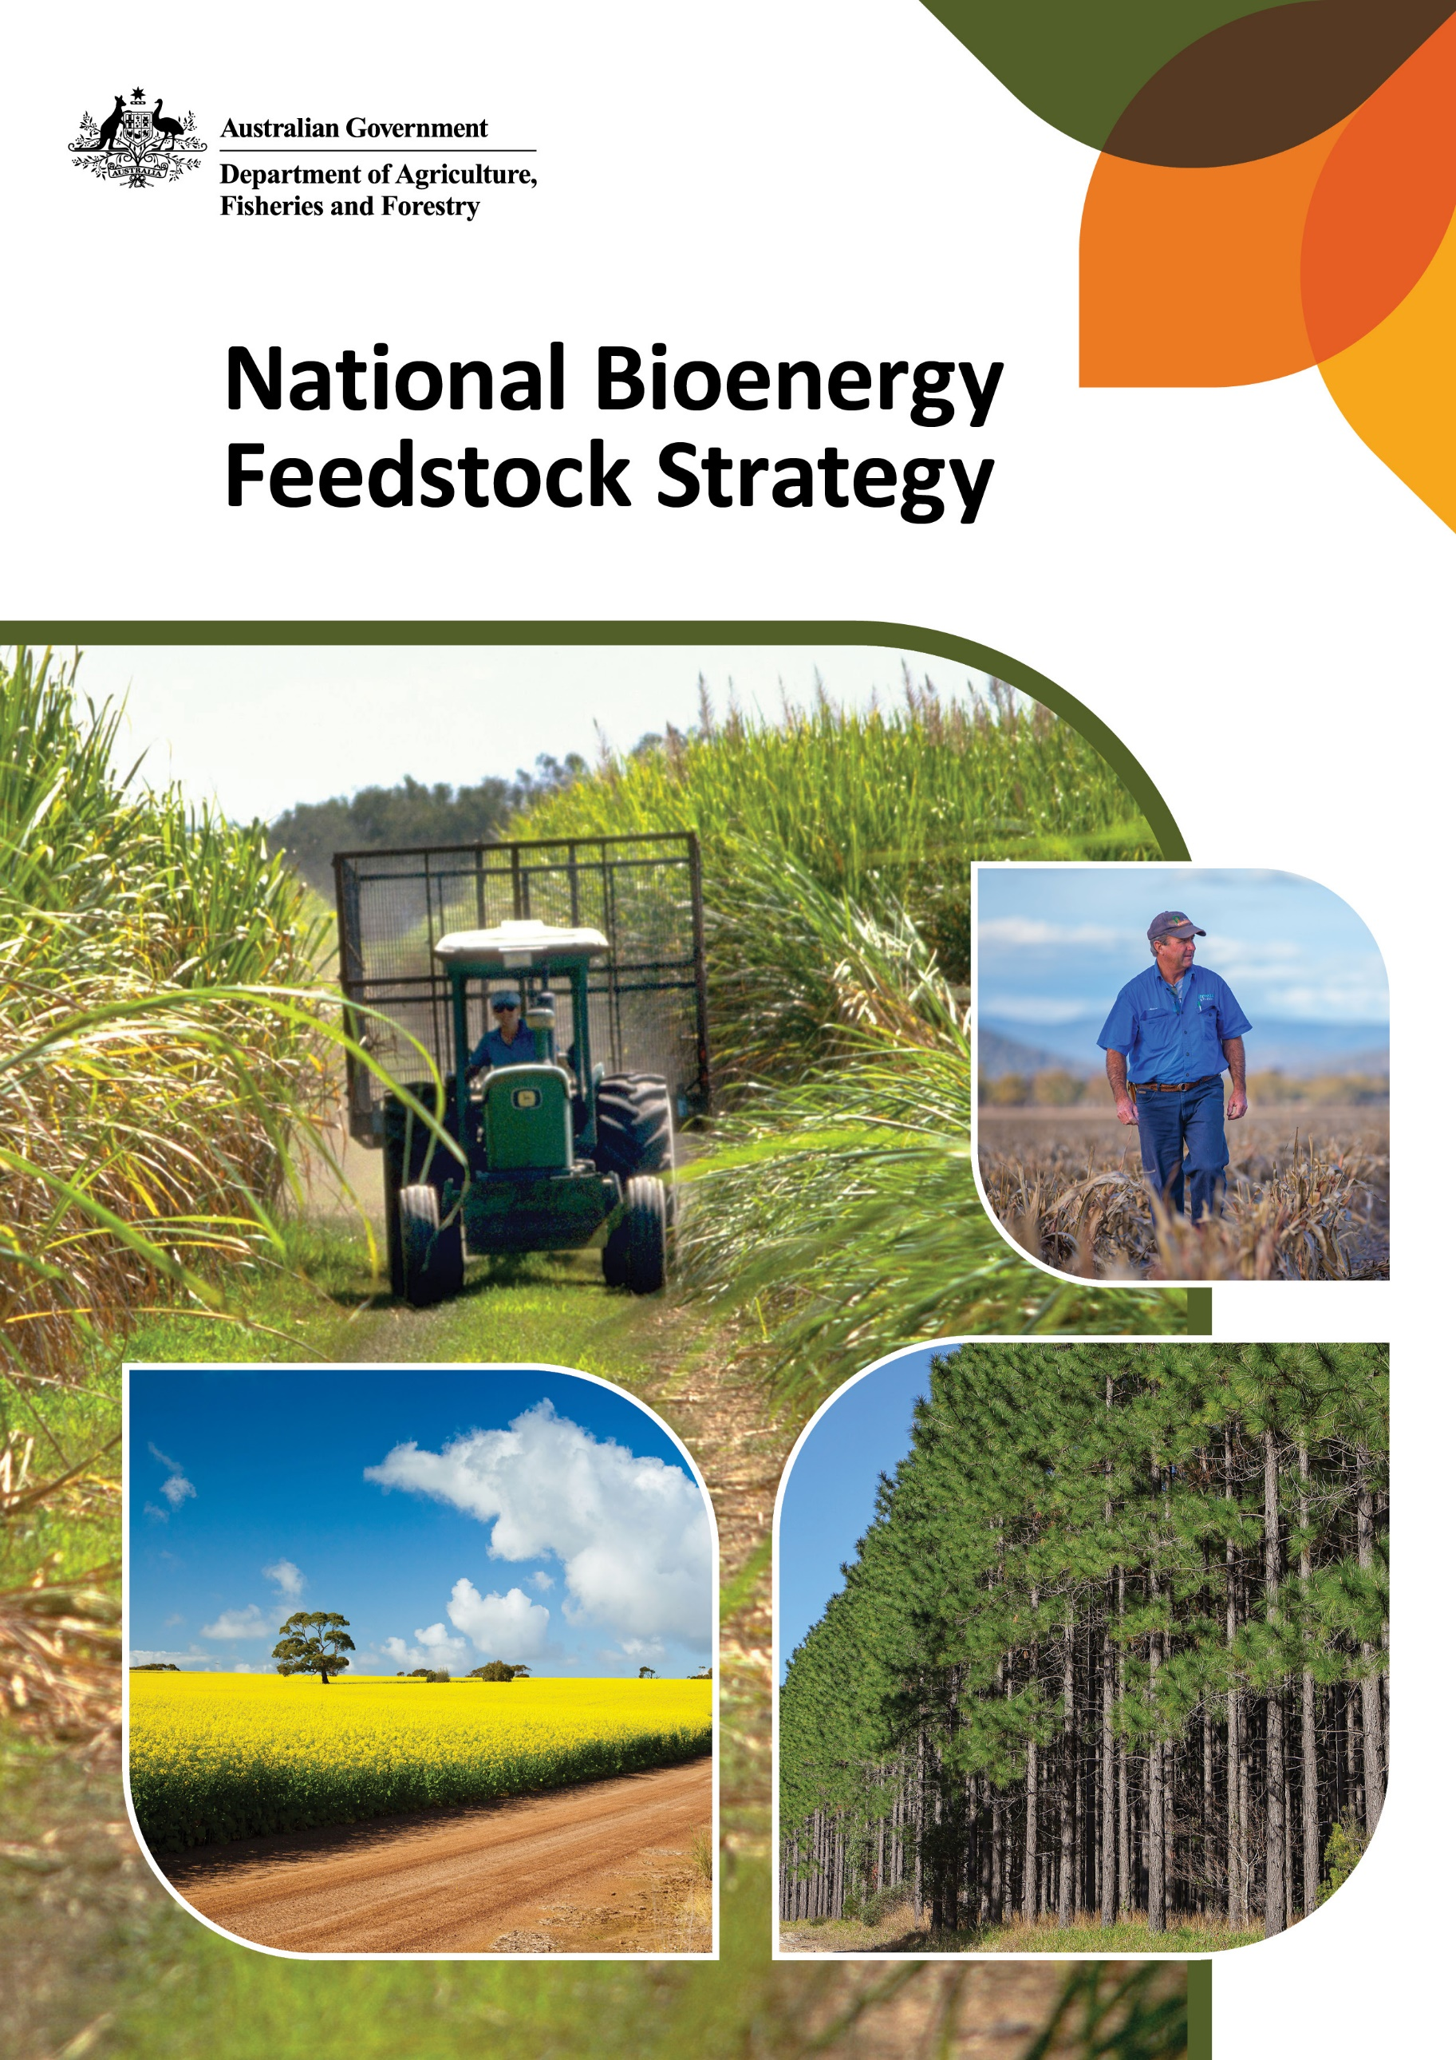
© Commonwealth of Australia 2026
Ownership of intellectual property rights
Unless otherwise noted, copyright (and any other intellectual property rights) in this publication is owned by the Commonwealth of Australia (referred to as the Commonwealth).
Creative Commons licence
All material in this publication is licensed under a Creative Commons Attribution 4.0 International Licence except content supplied by third parties, logos and the Commonwealth Coat of Arms.

Cataloguing data
This publication (and any material sourced from it) should be attributed as: DAFF 2026, National Bioenergy Feedstock Strategy, Department of Agriculture, Fisheries and Forestry, Canberra. CC BY 4.0.
This publication is available at agriculture.gov.au/publications.
Department of Agriculture, Fisheries and Forestry
GPO Box 858 Canberra ACT 2601
Telephone 1800 900 090
Web agriculture.gov.au
Disclaimer
The Australian Government acting through the Department of Agriculture, Fisheries and Forestry has exercised due care and skill in preparing and compiling the information and data in this publication. Notwithstanding, the Department of Agriculture, Fisheries and Forestry, its employees and advisers disclaim all liability, including liability for negligence and for any loss, damage, injury, expense or cost incurred by any person as a result of accessing, using or relying on any of the information or data in this publication to the maximum extent permitted by law.
Acknowledgements
The authors thank stakeholders for their contributions to the development of this strategy.
Acknowledgement of Country
We acknowledge the continuous connection of First Nations Traditional Owners and Custodians to the lands, seas and waters of Australia. We recognise their care for and cultivation of Country. We pay respect to Elders past and present, and recognise their knowledge and contribution to the productivity, innovation and sustainability of Australia’s agriculture, fisheries and forestry industries.
Credits
All photos © Department of Agriculture, Fisheries and Forestry.

Minister’s foreword
Australia’s farmers and foresters are at the heart of our regional communities. They support our economy, strengthen our regions and provide the food, fibre and forestry products that Australians and our trading partners rely on. The Australian Government is committed to backing our producers to seize new opportunities and strengthen their businesses.
Developing a domestic bioenergy feedstock industry is one of those opportunities.
As Australia works towards a lower-emissions future, bioenergy - including low carbon liquid fuels - can help reduce emissions, strengthen fuel security and support new economic growth. For Australian farmers, foresters and regional communities, it presents a significant economic opportunity to supply feedstocks to these emerging markets.
Australia is well placed to respond to growing global demand. We produce world-class agricultural and forestry products and are already participating in global bioenergy supply chains. Building on these strengths can increase access to emerging markets, attract investment and support jobs across regional Australia.
The National Bioenergy Feedstock Strategy provides a shared direction for governments, industry, producers and the broader supply chain to work together to support sustainable growth of Australia’s bioenergy feedstock industry. It identifies priority areas for collective action including improving market ready data, supporting innovation, strengthening regional supply chains, building credible sustainability and certification systems, and improving sector capability. These are the foundations needed to support investment and industry growth.
Importantly, this strategy supports a market-led approach, recognising that opportunities will vary across feedstocks, technologies and regions. It focuses on creating the conditions for industry to grow in a way that complements food, fibre and forestry production, maintains community confidence and maximises opportunities for producers and regional communities.
The strategy has been shaped by extensive engagement with producers, industry, researchers, investors and governments across Australia. I thank everyone who contributed their expertise. Their input has helped ensure this strategy reflects both the opportunities and the practical realities of developing a domestic feedstock industry.
By working together, we can ensure Australian farmers, foresters and regional communities benefit from this growing industry. In doing so, we can strengthen Australia’s fuel security, support emissions reduction and create lasting economic opportunities across regional Australia.

Contents
Minister’s foreword iii
Executive summary vi
National Bioenergy Feedstock Strategy vii
1 Introduction 1
1.1 Bioenergy for fuel security and decarbonisation 1
1.2 Increasing global investment 1
1.3 Australia’s policy landscape 2
1.4 Feedstocks are a critical input for production 3
2 Australia’s feedstock opportunity 6
2.1 Diversity is an advantage 6
2.2 Industry needs to scale progressively 7
2.3 International competitiveness is fundamental 8
3 A shared direction for industry development 10
3.1 Priority areas for collective effort 10
3.2 Embedding producer participation in industry development 11
4 Priority area: data to underpin investment 12
4.1 Data quality and access is variable 12
4.2 Work towards nationally consistent, market-ready information 14
5 Priority area: innovation to advance feedstock readiness 16
5.1 Innovation at the feedstock end of the supply chain is a priority 16
5.2 Increasing scale of investment 17
5.3 Stronger coordination and collaboration 18
6 Priority area: regional supply chain development 20
6.1 Strengthening regional approaches 20
6.2 Investing in infrastructure 22
7 Priority area: sustainability and certification 24
7.1 Certification is core to value creation and market access 24
7.2 Emissions intensity underpins competitiveness 25
7.3 Sustainability beyond emissions 26
7.4 Traceability and system integrity 26
7.5 Integration with food, fibre and feed systems 26
8 Priority area: building sector capability 28
8.1 Strong existing base to support industry development 28
8.2 Integration across the supply chain 29
8.3 Ensuring accessible information flow 29
8.4 Workforce planning 30
8.5 Coordinated policy 30
Glossary 32
References 34

Figures
Figure 1 Priority areas for collective effort vii
Figure 2 Key agricultural and forestry derived feedstocks 3
Figure 3 Major bioenergy conversion technologies and feedstocks 4
Figure 4 Potential feedstock production to support a domestic low carbon liquid fuel industry 7
Figure 5 Diversifying feedstocks towards market readiness 8
Figure 6 Priority areas for collective effort 10
Figure 7 Theoretical bioenergy feedstock potential 13
Figure 8 Opportunities for RD&E to enable bioenergy feedstock industry development 17
Figure 9 Examples of state government support for bioenergy supply chain development 22
Boxes
Box 1 Broader policy integration 3
Box 2 Improving the feedstock evidence base 15
Box 3 The role of Research and Development Corporation investment 18
Box 4 Future Made in Australia Innovation Fund 18
Box 5 CSIRO applied science and research to advance low carbon liquid fuels 19
Box 6 Ararat Renewable Energy Park 21
Box 7 Regional approaches to supply chain infrastructure 21
Box 8 Australian Government investments that can support supply chain infrastructure 23
Box 9 Industry led connectivity across supply chains - Nuseed, bp and carinata 29
Box 10 Low carbon liquid fuel knowledge hub 30

Executive summary
Energy underpins Australia’s economy, national security and social wellbeing. Liquid fuel makes up almost half of all energy used in Australia, supporting food production and distribution, freight movement, critical supply chains, national security and economic stability.
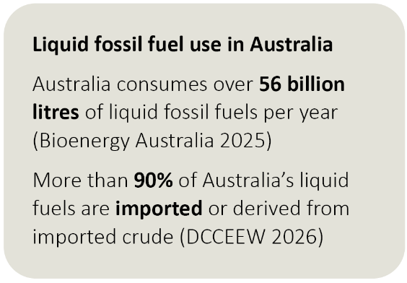
Over 90% of that liquid fuel is currently imported. Recent global disruptions associated with instability in the Middle East have brought to the fore the strategic risks of this dependence, and the need to find new ways to build the reliability, resilience and security of energy supply chains that support Australia’s economy.
Australia must also reduce emissions in fuel-intensive sectors. Electrification has a significant role to play, however, liquid fuels will remain important in aviation, heavy transport, agriculture, mining and maritime sectors well beyond 2050. Bioenergy, especially low carbon liquid fuels (LCLFs), will be essential to decarbonising this longer-term liquid fuel use.
Global investment in bioenergy is accelerating. Countries that move early are attracting investment, building capability and securing long-term economic and emissions benefits.
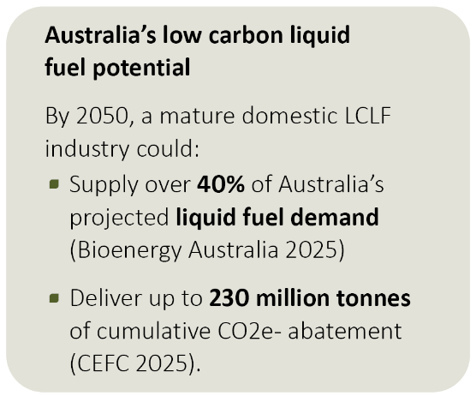
Government and industry are positioning Australia to participate in this growing global market, creating new economic opportunities, strengthening fuel resilience and capturing opportunities from the transition to lower-emissions fuels.
The Australian Government has committed significant support for the production of LCLFs, through the $1.1 billion Cleaner Fuels Program. The 2026-27 Budget also included a commitment to introduce a market mechanism to help drive demand. Together, these measures will create certainty needed to secure significant new private investment in domestic LCLF production and use.
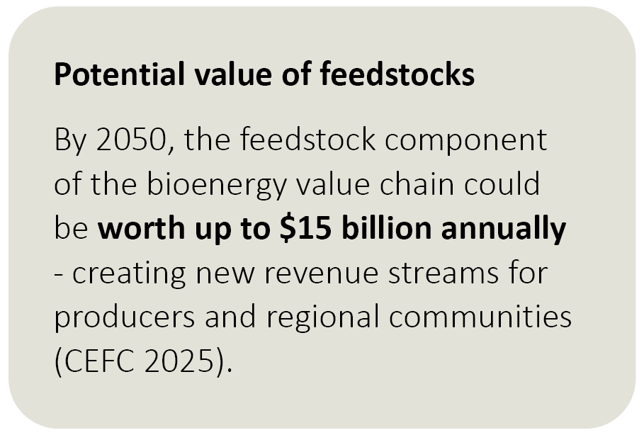
Access to a reliable, high-quality supply of feedstocks is a critical enabler for a domestic LCLF industry.
Australia has a strong competitive advantage in this area. Our agricultural and forestry systems are world-class, with skilled producers who respond to market signals and deliver high-quality products. Australia already produces feedstocks for export markets and for domestic ethanol and biodiesel production.

There is significant potential to build on this existing capacity. However, further work is needed to realise our full feedstock potential. Governments, industry, producers and the wider supply chain need to work together to build capacity and address common challenges. Without a proactive approach, domestic LCLF production is likely to remain reliant on imported inputs; missing the opportunity to increase energy resilience and deliver benefits to regional economies and communities.

National Bioenergy Feedstock Strategy
The National Bioenergy Feedstock Strategy sets out how governments, industry and the supply chain can work together to strengthen the supporting conditions for a competitive domestic feedstock industry. It identifies feedstocks as a critical enabler of a low-emissions fuel future and provides a shared national direction to unlock production, mobilisation and investment.
The strategy provides direction for building a feedstock industry that is competitive, scalable, sustainable and internationally connected. It does not prescribe projects or mandate particular feedstocks. Instead, it focuses on the enabling conditions and shared priorities needed to help align activity by governments, industry, producers and investors.
By reducing uncertainty, improving coordination and clarifying opportunities for further activity, the strategy lays the foundation for a feedstock industry that strengthens fuel security, supports emissions reduction and creates lasting opportunities for regional Australia.
The strategy focuses on 5 priority areas where collective effort would enable the development of a robust and competitive bioenergy feedstock industry. These are:
- Data to underpin investment
- Innovation to advance feedstock readiness
- Regional supply chain development
- Sustainability and certification
- Building sector capability.
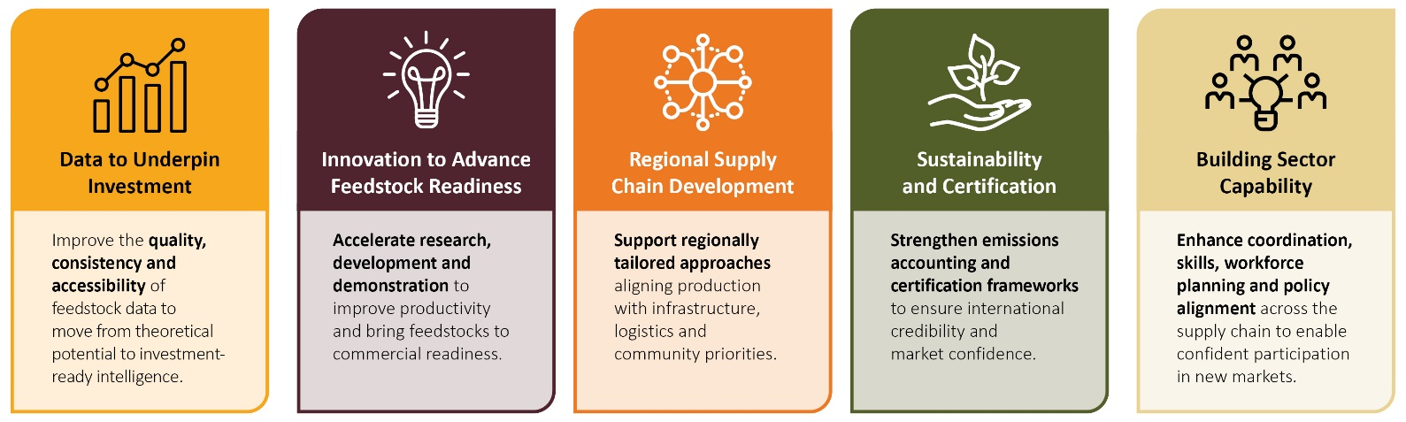
Figure 1 Priority areas for collective effort

The strategy recognises that no single feedstock, region or technology will deliver the scale required. Australia will need to build on its existing feedstock production capacity, scaling that up and diversifying into new feedstocks over time. This approach will allow the industry to respond to growing global demand and adapt to manage climate, market and supply risks, technological change, and protect food and fibre systems. Farmers, foresters and regional communities will be central to this effort as partners in shaping how feedstock and bioenergy industries develop.

Introduction

Bioenergy for fuel security and decarbonisation
Energy underpins Australia’s economy, national security and social wellbeing. Liquid fuels currently make up almost half of all energy used in Australia, with more than 56 billion litres consumed each year (Bioenergy Australia 2025). More than 90% of that is imported or derived from imported crude (DCCEEW 2026), at a cost of over $50 billion (CEFC 2025). Liquid fuels also contribute about 32% of national greenhouse gas (GHG) emissions (DCCEEW 2026).
Australia’s reliance on imported liquid fuels leaves the country exposed to global market volatility and supply chain disruption. It also makes it harder to meet Australia’s climate targets.
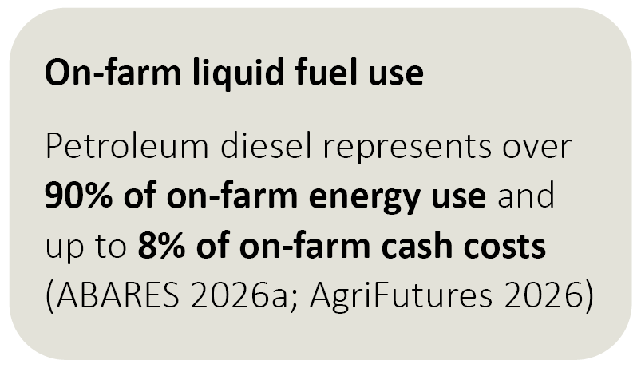
Electrification is critical to reducing reliance on imported fuels and achieving climate targets. However, parts of the economy are hard-to-electrify and are expected to continue relying on liquid fuels through to 2050. This includes aviation, heavy freight, mining, agriculture, maritime transport and construction. Australian demand for liquid fuels is projected to remain around 30 billion litres a year in 2050 (Bioenergy Australia 2025).
Reducing emissions in these hard-to-electrify sectors will require a shift to low carbon energy sources, especially low carbon liquid fuels (LCLFs).
LCLFs – which include biofuels and e-fuels – offer a path forward. These fuels are most commonly made from non-fossil carbon sources including agricultural commodities, forestry and cropping residues, and waste streams. They currently make up less than 1% of Australia’s fuel use (DCCEEW 2026), but by expanding production and use they could significantly reduce reliance on imported fuels and support cumulative emissions reduction of up to 230 million tonnes of CO₂ by 2050 (CEFC 2025).

Increasing global investment
Momentum around the use of bioenergy and LCLFs is expanding globally. Advanced drop-in LCLFs and gases are becoming increasingly important in hard-to-electrify sectors. These fuels, which can be used in existing engines and infrastructure without modification, include sustainable aviation fuel (SAF), renewable diesel and biomethane. SAF made from biogenic feedstocks is one of the lowest-cost pathways for low-emissions aviation fuel, while renewable diesel and biomethane help reduce emissions from long-lived assets in other industries (CEFC 2025; CSIRO 2023).
Global growth in use of bioenergy is supported by policy settings such as fuel blending mandates and low carbon fuel standards across the Asia-Pacific, Europe and the Americas (IEA 2025a). These policies saw global LCLF production quadruple since 2014. Investment reached USD $16 billion in 2025-26, supporting about 30 billion litres of annual production (CEFC 2025).
The global outlook is positive. Demand for LCLF is projected to reach 43 billion litres by 2030, or about 8% of total transport fuel demand (IEA 2025a). Meeting this demand will require a major increase in feedstock supply, with global feedstock demand projected to rise by almost 25% by 2030, reaching nearly 825 million tonnes a year in total (IEA 2025a).

Australia’s policy landscape
The Australian Government is supporting a domestic LCLF industry through its fuel security and decarbonisation agenda, with the important role of these alternative fuels recognised in the Net Zero Plan and sector emissions reduction plans.
The $1.1 billion Cleaner Fuels Program is a key measure and is intended to assist first movers and help establish a domestic industry. It will provide production-linked incentives and support for projects that are advanced in development and target production in the near future.
Alongside this, in the 2026-27 Budget, the government announced its commitment to work with industry to introduce a market measure that drives demand for new Australian LCLF production. Industry has been calling strongly for this to provide it with market certainty needed to support significant new investments in domestic production capacity.
These initiatives build on the $250 million investment through the Future Made in Australia Innovation Fund to support pre-commercial innovation, demonstration and deployment of LCLF projects. The Sustainable Aviation Fuel Funding Initiative also provided $33.5 million across five projects to support domestic production.
Government is also working to improve energy market transparency through standards and certification frameworks to support better decision-making and stronger confidence across the value chain. This includes expanding the Guarantee of Origin (GO) Scheme – a voluntary framework for emissions accounting of products – to incorporate the measurement and certification of emissions intensity of LCLFs. It also includes developing the Paraffinic Diesel Fuel Standard to support system integrity in both domestic and international markets.
In 2025, the government announced it would develop a National Bioenergy Feedstock Strategy. This recognised the importance of feedstocks to a domestic LCLF industry and the need to grow a competitive feedstock supply alongside increased domestic LCLF production capacity. The commitment aligns with the government's Future Made in Australia agenda; maximising the economic and industrial benefits of the transition to net zero, supporting jobs, investment and economic opportunities in regional communities.
Integrating feedstock development with broader policy goals, including food security, circular economy and net zero outcomes, will also help ensure industry development is sustainable and able to capture emerging economic opportunities (Box 1).

Box 1 Broader policy integration
This strategy supports efforts to build a stronger, more resilient Australian economy. It aligns with national productivity priorities, including an adaptable workforce, digital technology and innovation, a more dynamic economy, building sovereign capability and net zero at least cost.
The strategy sits alongside the $3.5 million National Food Security Strategy, which sets a long-term, whole-of-system plan to strengthen the productivity, resilience and security of Australia’s food system. Alignment will help ensure the domestic feedstock industry creates new opportunities without compromising food security.
The strategy also links with Australia’s Circular Economy Framework and National Waste Policy Action Plan. These links support waste reduction by capturing more value from biomass resources, including organic waste, co-products, by-products, and agricultural and forestry residues. This can improve the economics of bioenergy pathways through value stacking and co-products which contribute to overall returns.

Feedstocks are a critical input for production
Biogenic feedstocks are organic materials used in the production of bioenergy, including liquid or gaseous biofuels. Sustainably produced feedstocks are considered a renewable resource as they are sourced from materials that can be regenerated (IEA 2024). Their production is the critical first step in the bioenergy value chain.
Different bioenergy systems use different feedstock types, including agricultural, forestry and organic waste streams. Of those, the key agricultural and forestry derived feedstocks include lipids, carbohydrates, lignocellulosics and other developing and emerging feedstocks (Figure 2).
Figure 2 Key agricultural and forestry derived feedstocks
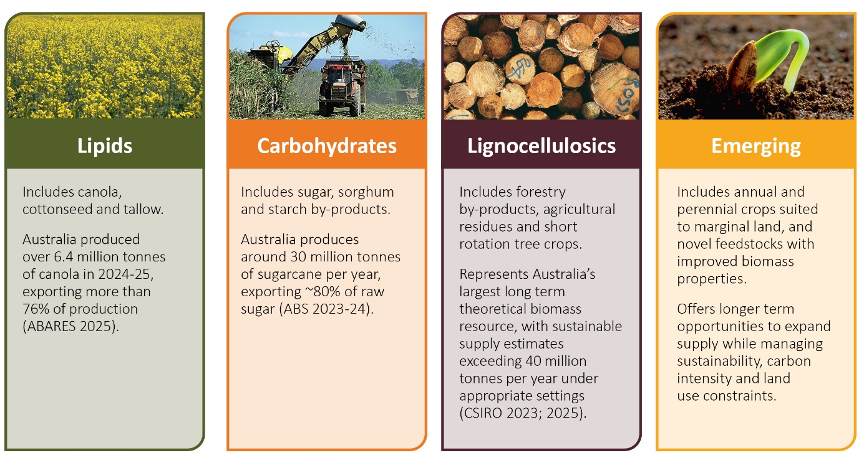
A range of different technologies are used to convert those feedstocks into liquid and gaseous fuels (Figure 3). Those processes impose different requirements on feedstocks, including factors such as quality, consistency, moisture, contamination and chemical composition (GrainCorp 2026). The combination of established processing technologies and supply chains means that used cooking oil, tallow, oil seeds and sugarcane are generally considered to be most ready for near-term deployment in LCLF production (GrainCorp 2026). Forestry residues are also attracting increasing interest as conversion technologies continue to develop.
The implications of this for Australia’s feedstock opportunity is discussed further in Chapter 2.
Figure 3 Major bioenergy conversion technologies and feedstocks
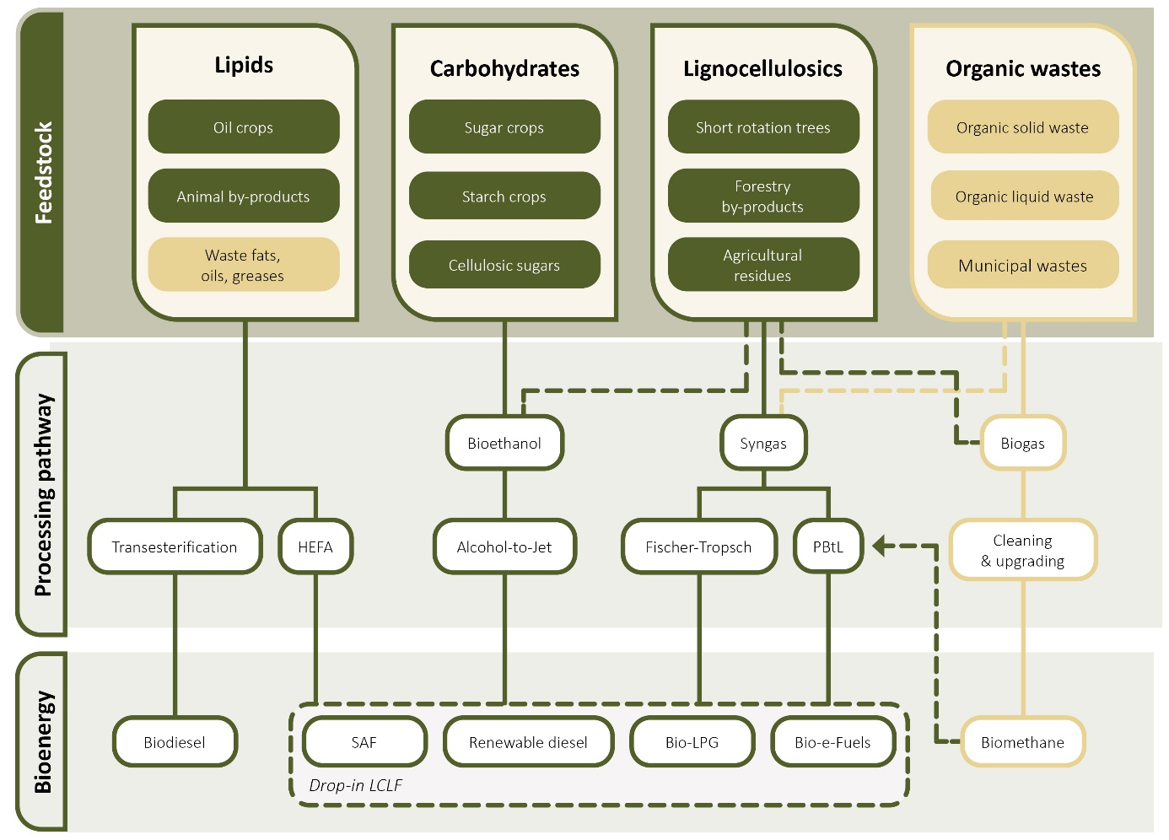
Adapted from CSIRO 2023; IEA 2025b. Dark green boxes highlight agricultural and forestry feedstocks of primary focus in the strategy. Light green boxes show other feedstocks that may contribute to bioenergy production. Power-and-Biomass-to-Liquids (PBtL) pathways can produce bio-electro-fuels (bio-e-fuels), which utilise CO₂ sourced from biomass feedstocks in combination with renewable hydrogen. HEFA = Hydroprocessed Esters and Fatty Acids. LPG = Liquefied Petroleum Gas.
This strategy focuses on biogenic feedstocks – specifically agricultural and forestry feedstocks – as they represent the largest immediate and medium-term opportunities for LCLFs. While power-to-Liquid (PtL) technology can produce synthetic or electro-fuels (e-fuels) (CEFC 2025), substantial technological advancements are required to reach commerciality (CSIRO 2025b).
Feedstocks from agricultural and forestry sectors also represent only part of Australia’s overall bioenergy resource potential. Other biogenic feedstocks – such as used vegetable oils, municipal solid and liquid wastes, and landfill gas – contribute to bioenergy production, emissions reduction and circular economy outcomes. For example, around 100,000 tonnes per year of fats, oils and greases, including used cooking oil, are used for bioenergy production (CSIRO 2023). This part of the industry will continue to grow and is being supported by policy discussion in areas such as waste management and adoption of circular economy principles.
Renewable gases, such as biomethane, will also play an important role in Australia’s energy transition, with Australia currently consuming over 1,400 petajoules of gas per year (DCCEEW 2025). Organic wastes, including from intensive livestock and horticulture industries, are commonly used as feedstocks in the production of biomethane. These supply chains involve different markets, infrastructure and policy settings. Accordingly, gas-based pathways are addressed through separate government initiatives and frameworks. For example, through the Energy and Climate Ministerial Council, governments are working collaboratively to jointly progress options for a National Renewable Gas Policy.

Australia’s feedstock opportunity
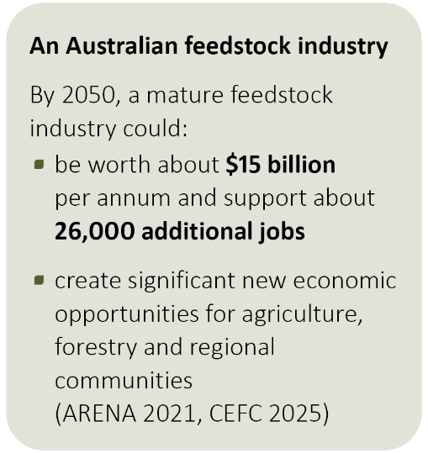
Australia already produces and exports around $6 billion of feedstocks each year; particularly significant volumes of canola and tallow for global markets. Australian feedstocks also support some local production of biodiesel and ethanol. There is strong potential to build on that capacity and increase the scale of production across a range of feedstock types.
There are varying projections for the potential scale of an Australian feedstock industry by 2050. CSIRO analysis (2025a) suggests that, with the right settings, Australia could reach a biomass production capacity of 168 million tonnes a year by 2050, much of it from agricultural and forestry feedstocks. This would be enough to produce more than 12 billion litres of LCLF annually. More recent analysis by GrainCorp (2026) suggests that 17.1 billion litres of SAF could be produced based on a different set of existing and potential feedstocks.

Diversity is an advantage
A key strength for an Australian industry is the potential to produce a diverse range of agricultural and forestry feedstocks. We have a large landmass with different climatic conditions and production systems. Whilst there are challenges associated with distance, regional variation provides the opportunity to produce a balanced and adaptable feedstock portfolio, with the volume, resilience and cost profile needed to support a competitive industry at scale. This compares well with markets that rely on narrower, often waste-focused feedstock sources (CEFC 2025). It also supports participation across multiple bioenergy pathways (Figure 3).
As the projection in Figure 4 shows, future production is expected to come from a range of feedstock types. This starts with the current feedstock capacity and builds on that through enhanced production and then expansion into next generation feedstocks over time.
In the long-term, a diversified production base will reduce exposure to climate variability, seasonal fluctuations and price volatility. It will also help align production with regional land capability and existing agricultural and forestry systems. This diversified approach will be important for sustainable industry development and for integrating feedstock production with food, fibre and feed systems.
Figure 4 Potential feedstock production to support a domestic low carbon liquid fuel industry
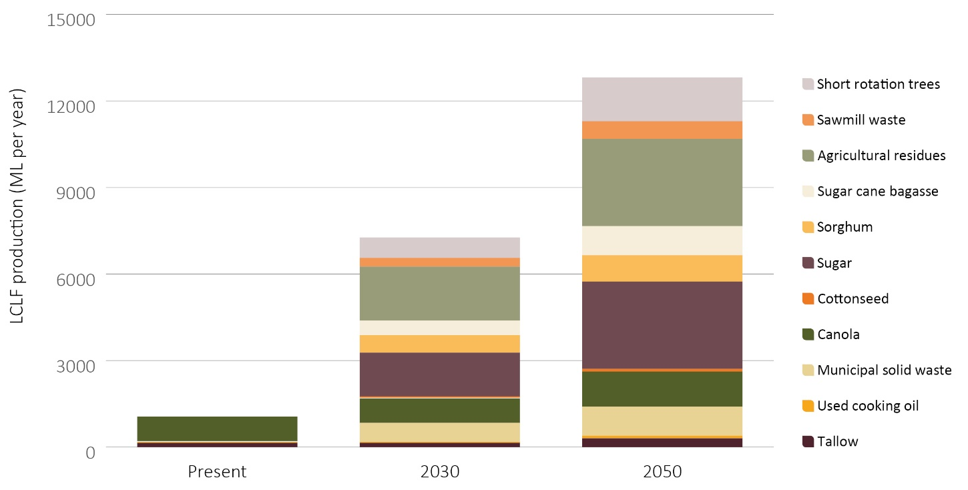
Data source: CSIRO 2025a

Industry needs to scale progressively
Whilst diversification will be important, not all feedstocks are at the same stage of development. Some are already produced and traded at scale, such as canola and sugar, and have established supply chains and compatibility with mature technology conversion pathways. These established feedstocks are well placed to meet early demand, expand their production and benefit from further investments in improved yields and supply chain improvements.
Others, including lignocellulosic residues and dedicated energy crops, need more investment in technology development, supply chain integration and commercial-scale demonstration to reach market readiness.
Industry development is therefore unlikely to follow one pathway or move at a uniform pace. It is more likely to scale progressively (Figure 5).
- In the near term, production is likely to involve established feedstocks and existing supply chains. A focus on improving existing production systems and optimising supply chain efficiency will support early fuel production and build momentum.
- In the medium term, a broader set of feedstocks that are currently characterised as developing will unlock more volume and improve the cost and emissions profile of supply. Achieving this means working now to address feedstock-specific challenges, including cost, logistics, processing pathways and sustainability, along with investment in supply chains and demonstration of integrated systems.
- Over the longer term, emerging feedstocks can create step-change gains in productivity, diversification and emissions reduction. Achieving this will depend on sustained investment in research, development and demonstration so these feedstocks can reach commercial readiness as the domestic production industry matures.
Progressive scaling will let industry test and refine new opportunities, manage risk, respond to changing technologies and markets, and build capability across the supply chain. This progressive development pathway is consistent with analysis outlined by GrainCorp (2026), focussing on initial use and improvement of established feedstocks, moving over time into lower emissions intensity feedstocks supported by innovation and investment.
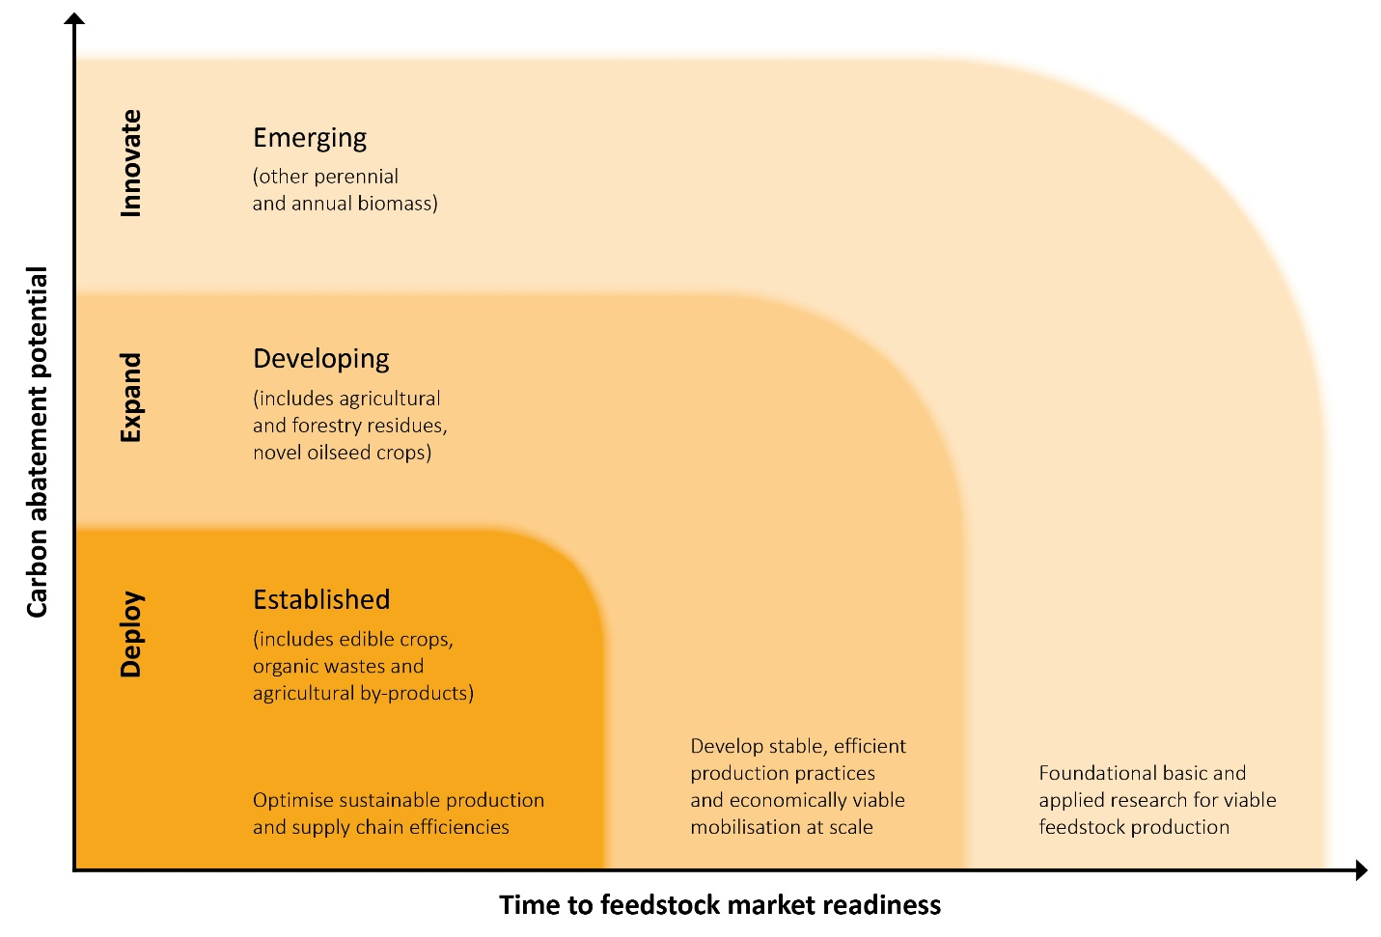
Figure 5 Diversifying feedstocks towards market readiness
Adapted from CEFC 2025 and CSIRO 2025a

International competitiveness is fundamental
The feedstock industry has significant potential, but its development will ultimately be driven by market forces. Producers, investors, processors and end users will make decisions based on demand, price signals, technology maturity, comparative advantage and regional capability. These commercial factors will determine how the industry develops in practice.
In this context, Australian feedstocks must be internationally competitive. They need to be supplied reliably at scale, meet the quality requirements of bioenergy production, and be delivered at a cost that compares well with global alternatives. These attributes are critical because feedstocks are traded in international markets and represent a substantial proportion of total bioenergy production costs.
The strong connection with international markets can also help provide the scale, demand certainty and commercial capability needed to grow some feedstock supply chains. Building export-capable and internationally competitive feedstock industries can complement domestic fuel production by strengthening the production base, logistics and certification systems needed to support future Australian refining opportunities and sovereign capability.
Strengthening competitiveness across key dimensions – including scale, sustainability, embedded emissions intensity, suitability for bioenergy conversion and cost – will position Australia to fully realise both domestic growth opportunities and export potential.

A shared direction for industry development
As part of developing the strategy, government consulted extensively with stakeholders to identify areas where a coordinated approach could help unlock Australia’s feedstock opportunity. This included a public consultation process with over 90 submissions from government, industry, research and academic stakeholders, and the broader community. This process was followed by direct engagement with a range of key industry stakeholders across the supply chain to test key themes and messages.

Priority areas for collective effort
Those discussions identified five priority areas where stakeholders felt collective effort would enable the development of a robust and competitive bioenergy feedstock industry (Figure 6). They form the basis of the strategy:
- Improving data to underpin investment
- Investing in innovation to advance feedstock readiness
- Regional supply chain development to drive efficiencies
- Sustainability and certification to create public confidence
- Building sector capability.
Together, these priority areas set a strategic direction for this industry to grow and scale. They go towards reducing barriers to investment, improving market confidence and enabling the sector to respond effectively to growing demand. They also address sustainability and other requirements that are core to bioenergy markets globally.
Figure 6 Priority areas for collective effort


Embedding producer participation in industry development
Development of the strategy has highlighted the importance of close engagement between producers and other parts of the supply chain to support coherent industry growth. Agriculture and forestry producers are key players in the fuel production systems. Their decisions affect the availability, cost and sustainability of feedstocks, and their participation is essential to building reliable and scalable supply. Involving producers in policy development and investment planning will support more practical, regionally appropriate and commercially viable outcomes.
Producers bring established strengths in managing variability, responding to markets and operating in complex systems. Many also work in international markets and have experience with certification frameworks and sustainability requirements. Using this expertise can better align domestic industry development with market expectations and improve overall system performance.
Producer involvement will help ensure industry development reflects regional realities. Land capability, seasonal variability and infrastructure constraints are all critical to designing systems that are practical, aligned with food, fibre and environmental objectives, and ensure benefits are shared with regional areas and communities.
Stronger connections between producers and other supply chain participants can better align supply and demand, improve information flow and support more effective investment. This will help build a coordinated and resilient industry that can develop and diversify over time.

Priority area: data to underpin investment
 | Improving the quality, consistency and accessibility of feedstock data to move from theoretical potential to investment-ready intelligence
Future direction:
- Improve the consistency, quality, accessibility and integration of feedstock data.
- Move from theoretical resource estimates to region-specific, investment-ready information on commercially viable and sustainable feedstock supply.
- Expand data coverage for developing and emerging feedstocks, including emissions, seasonality, variability and competing uses.
- Develop nationally aligned standards, definitions, assumptions and methods for feedstock assessment and reporting.
Confidence, participation, innovation and investment across the sector, from farm level to large refining plants, depend on a shared understanding of which feedstocks can be produced and mobilised reliably and cost-effectively at scale. Stronger data is therefore both an evidence issue and an action issue: without it, project assessment, commercial planning and policy design will remain higher risk.

Data quality and access is variable
A large amount of public and private data on feedstock availability already exists. For example, the Australian Renewable Energy Agency (ARENA)-funded Australian Biomass for Bioenergy Assessment (ABBA) project (2015 to 2021) provided state-level data on the location and potential volumes of biomass, by-products and residues from industries including forestry, cropping, livestock and horticulture. This data helped estimate the national potential for bioenergy feedstocks, as shown in Figure 7.
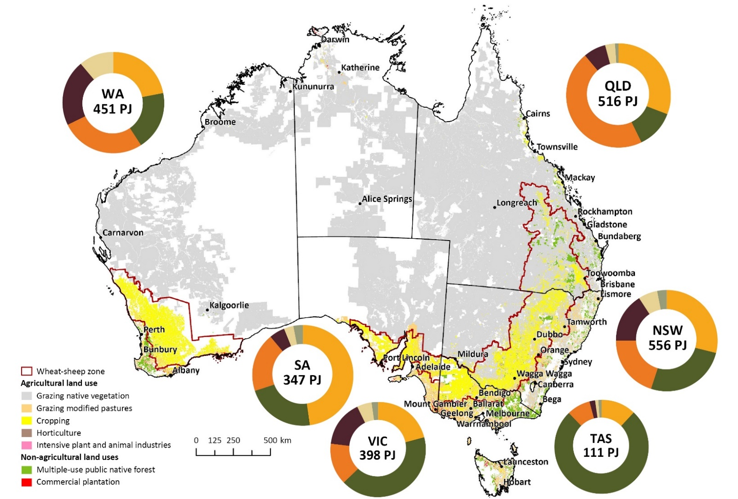
Figure 7 Theoretical bioenergy feedstock potential

Adapted from ABARES 2026b; data sourced from AgriFutures 2021 and Bioenergy Australia 2022. The crops category refers to crop residues, horticulture residues, and non-food crop products. Energy potential was based on Fischer-Tropsch processing pathways for crops, forestry, and waste feedstocks, Alcohol-to-Jet for carbohydrates, and HEFA for lipids. 'Other' feedstocks were not specified.
However, stakeholders across the supply chain have said the evidence base remains a major barrier to industry development. It does not always provide a shared understanding of how much feedstock can be produced and mobilised for bioenergy in an economically viable and sustainable way. Stakeholders said:
- data is often variable in quantity, quality, consistency and accessibility, as well as being too coarse and lacking currency to support credible assessments of potential projects
- current national assessments remain theoretical, estimating aggregate volumes without accounting for the regional conditions and infrastructure networks that determine whether feedstock can actually be mobilised
- less developed and emerging feedstocks remain under-characterised, particularly novel energy crops, and crop and forestry residues, which constrain confidence and limit scalability
- data on all the aspects of feedstock production and supply chain requirements needed to underpin commercial assessment, sustainability assurance, investment decision making and planning is often not integrated.
Overall, stakeholders are calling for more granular, consistent and investment-ready information, including for example GrainCorp (2026) advocating for the development of a fact-base to attract private investment to commercialise new feedstocks.

Work towards nationally consistent, market-ready information
Australia would benefit from a more coordinated national approach to data; moving from high-level estimates of feedstock potential to a clearer view of what can be delivered commercially and sustainably. This includes improving the consistency, accessibility and integration of existing datasets. It also includes expanding coverage to better capture less well-characterised and emerging feedstocks, and adding key supply-side factors such as seasonality, variability, emissions intensity and competing uses.
Consistent approaches to data collection and assessment is important. Nationally aligned standards, definitions, assumptions and methods can improve comparability across jurisdictions, reduce duplication and strengthen confidence in the evidence base. They would also support more integrated policy and market development.
There is also a need for more market-ready information. This means moving beyond theoretical supply estimates to more granular, region-specific information about feedstocks that are technically recoverable, economically viable and able to be supplied reliably. Linking feedstock data with information on infrastructure, transport, workforce and processing capacity will further support commercial assessment and investment decisions.
Some jurisdictions are already improving feedstock data and how it is presented. For example, New South Wales has developed the BioSMART Tool to provide accessible and integrated data, while Queensland is identifying feedstock suitability and supply chain opportunities through its Biofuels Feedstock Expansion Study (Box 2). Both approaches build on the earlier work undertaken through the ABBA project.
There is an opportunity for governments and industry to work together to improve data consistency and accessibility, expand and harmonise existing datasets, and develop nationally consistent standards, definitions and methods to support ongoing and comparable data collection and analysis. This could include a national access point that links existing data sources, reduces fragmentation, improves transparency and helps investors and policymakers identify opportunities, constraints and risks more easily.
Industry-led investment in new data, especially emissions values for the cultivation and pre-treatment of developing and emerging feedstocks, could also support the development and refinement of life cycle assessments. Additional data on land use change linked with commodity expansion will help in managing associated concerns. This would strengthen confidence in feedstock attributes and improve commercial viability.
Box 2 Improving the feedstock evidence base
The NSW Biomass Spatial and Modular Assessment of Resources Tool (NSW BioSMART), developed by the Department of Primary Industries and Regional Development in collaboration with CSIRO, is an interactive, spatial tool that enables users to determine the potential for using biomass in NSW for a range of applications. While the tool was initially focused on electricity generation options from biomass, future versions will include industrial heat applications, liquid biofuels and biochar (NSW DPI 2025).
The biomass data within the tool was derived from the ABBA Project. In addition to a variety of existing biomass sources derived from agriculture, forestry, and organic waste, the tool also allows users to identify potentially suitable lands where woody biomass crops could be produced.
The Queensland Government’s Biofuels Feedstock Expansion Study is considering opportunities across 22 crop and non-crop feedstocks. The study will provide an evidence base on the most viable feedstocks to meet commercial biofuels production requirements.

Priority area: innovation to advance feedstock readiness
 | Accelerating research, development and demonstration to improve productivity and bring feedstocks to commercial readiness.
Future direction:
- Improve feedstock productivity, quality, sustainability and emissions performance, while accelerating the readiness of developing and emerging feedstocks.
- Reduce production, logistics and supply chain costs to strengthen competitiveness.
- Drive greater cross-sector coordination, collaboration, knowledge sharing and investment alignment across the RD&E system.
- Support investment and demonstration activity to bridge the gap between pilot projects and commercial-scale deployment.
Advancing a diverse range of high-quality, low-emissions feedstocks to commercial readiness means overcoming technical challenges that vary by feedstock type, maturity and supply chain. Innovation and continuous improvement will be critical to scaling production and mobilisation, lowering costs and reducing the risk that promising feedstocks fail to progress beyond pilot stages. A more strategic approach to research, development and extension (RD&E), backed by stronger collaboration and greater investment, would help the sector to produce feedstocks at scale, at the right quality and at a price that can compete globally.

Innovation at the feedstock end of the supply chain is a priority
Despite significant bioenergy RD&E activity, stakeholders said investment and effort remain skewed towards downstream processing technologies. Investment in upstream areas, including feedstock production and near-farm-gate supply chain components, is still underrepresented in strategic agendas and investment portfolios.
More RD&E is needed at the feedstock end of the supply chain to achieve competitive supply at greater scale. The core challenges are:
- sustainably increasing production and mobilisation – enabling diversification of feedstocks with improved yields, higher quality and increased integration with production systems
- increasing emissions abatement – improving the emissions intensity of feedstocks and supply chains to maximise emissions reduction outcomes
- improving long-term cost effectiveness – reducing production, processing and logistics costs to support international competitiveness.
A range of innovation is needed to address these challenges and complement ongoing work on downstream processing technologies (Figure 8). Current needs are most acute for less developed and emerging feedstocks, including novel energy crops and agriculture and forestry residues, where uncertainty about yield, cost, sustainability and logistics creates major barriers to scale. Developing and emerging feedstocks also need more RD&E to develop market-ready co-products and create more value. Addressing these barriers will require a stronger focus on early-stage innovation that reduces supply risk, strengthens producer participation and supports downstream investment.
Figure 8 Opportunities for RD&E to enable bioenergy feedstock industry development
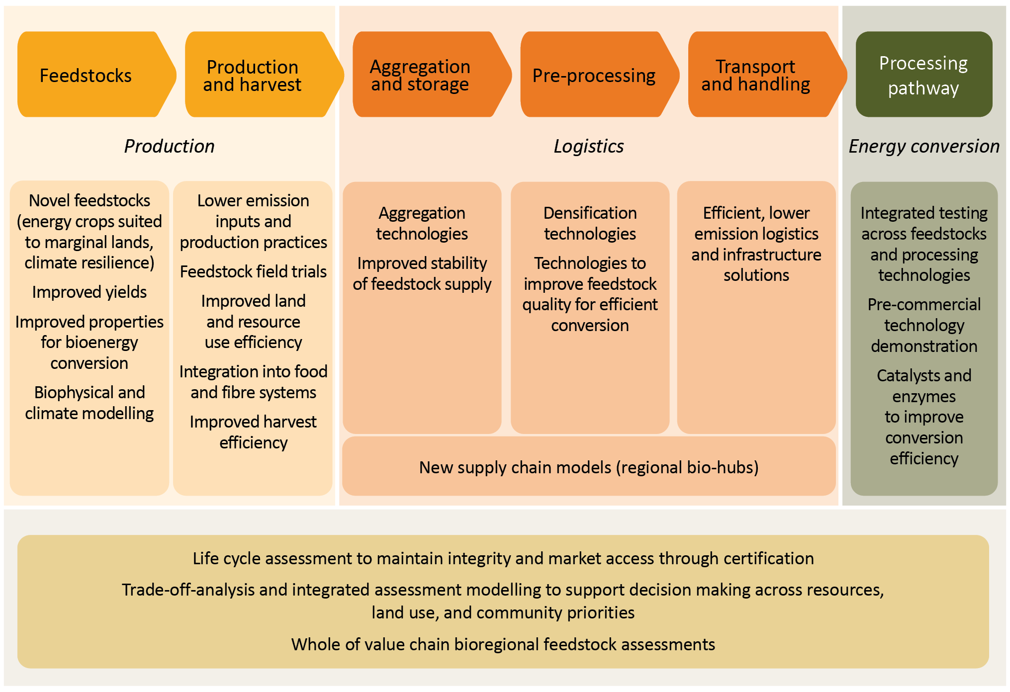

Increasing scale of investment
Greater collective innovation effort is needed to address key barriers to industry development. Stakeholders consistently identified the transition from pilot to commercial-scale production as a major challenge, especially for developing and emerging feedstocks. Targeted, sustained investment is needed across the innovation pipeline, while also enabling rapid innovation cycles through parallel development pathways, from feedstock development to advanced harvesting and aggregation technologies, and through to full supply chain integration under real-world conditions.
Through the Research and Development Corporation (RDC) system, government and industry are already investing heavily in innovation across a wide range of agricultural and forestry commodities. There is scope to increase the focus on feedstock development and strengthen alignment across RDCs (Box 3). For example, AgriFutures invests in RD&E that supports the development of emerging, high-potential agricultural industries and has already done work on emerging feedstocks such as pongamia. In future, AgriFutures could expand this work in its forward plans to complement RD&E on more established commodities led by other RDCs.
Box 3 The role of Research and Development Corporation investment
The RDC model is a successful partnership combining industry levies and Australian Government matched funding for eligible research, development and extension activities. In 2024-25, activities included the Grains Research Development Corporation exploring opportunities for farmers to participate in the bioenergy feedstock sector, outlining innovation opportunities from improving existing feedstocks to advancing novel biomass oil crops (GRDC Low Carbon Liquid Fuels Roadmap 2025).
RDCs also have an opportunity to align their efforts with each other to achieve gains across the sector. The Council of Rural RDCs could play a convening or leadership role in this area, alongside AgriFutures Australia with its cross-industry and cross-sectoral remit.
The Australian Government is also supporting innovation and commercialisation through investments such as the Future Made in Australia Innovation Fund. Under the LCLF Technology Focus Area, funding is available for innovative projects that accelerate commercial-scale domestic production, pre-commercial technology demonstration, and feedstock and supply chain enablement (Box 4).
Box 4 Future Made in Australia Innovation Fund
ARENA’s Future Made in Australia Innovation Fund has allocated $250 million in grant funding under the LCLF Technology Focus Area. This builds on previous investments made under ARENA’s SAF Funding Initiative.
This funding will accelerate the development of a domestic LCLF industry - supporting the development of biogenic feedstocks through innovative approaches to production, processing and aggregation and the enablement of innovative supply chain infrastructure.

Stronger coordination and collaboration
Stakeholders have said that better coordination and collaboration between governments, industry and research institutions is needed to reduce duplication, integrate effort, share knowledge and support co-investment that helps de-risk transformative projects. Clearer roles and stronger collaboration will help align activities across the RD&E pipeline and get more value from investment.
Stakeholders also identified opportunities to build feedstock-specific collaborative initiatives that deliver greater RD&E impact. The Australian Government is delivering coordinated science and research through Australia’s national science agency, CSIRO (Box 5). This work spans feedstock development, biophysical and socio-economic system modelling, supply chain analysis, and downstream processing and conversion technology development. Models such as the CSIRO Towards Net Zero Mission and the Zero Net Emissions Agriculture Cooperative Research Centre show the value of this kind of collaboration.
The Australian Government will also consider opportunities to work together with RDCs and industry to strengthen cross-sector coordination and collaboration on feedstock RD&E. The recent Energy Transition Roadmap for the Agriculture, Fisheries and Forestry Sector (AgriFutures 2026) highlights the feedstock opportunity and the need to align behind a shared pathway to overcome fragmented effort and support a coherent, whole-of-sector transition. AgriFutures, together with the Council of Rural RDCs, could help connect RD&E efforts, support knowledge sharing, and align the investment and capability development needed to bring diverse feedstock pathways to commercial readiness.
Box 5 CSIRO applied science and research to advance low carbon liquid fuels
The Australian Government is delivering coordinated science and research contributing to a Future Made in Australia through CSIRO.
CSIRO science has shaped the foundations for LCLFs in Australia, through initiatives such as the Towards Net Zero Mission, the Sustainable Aviation Fuel roadmap (2023), the Opportunities for LCLFs report (2025a), and the State of Energy Transition Technologies report (2025b). As the LCLF supply chain is highly interconnected, coordinating research across the supply chain enables CSIRO to deliver end-to-end solutions for industry and government to advance LCLFs, while integrating community co-benefits, economic viability and environmental impact assessments.

Priority area: regional supply chain development
 | Supporting regionally tailored approaches aligning production with infrastructure, logistics and community priorities.
Future direction:
- Develop regionally tailored supply chains (including efficient aggregation, storage, preprocessing and transport solutions) that align feedstock production with infrastructure, logistics, workforce capability and end-use demand.
- Support integrated planning and community engagement to build confidence, participation and social licence.
- Improve regulatory consistency and reduce supply chain barriers across jurisdictions.
Efficient, resilient supply chains are essential if Australian feedstocks are to be internationally competitive. Increasing production matters, but so does moving feedstocks cost-effectively, which is difficult because they are dispersed, bulky and seasonal. Without regionally tailored solutions, supply chains risk remaining fragmented, high-cost and unable to support reliable scale. Addressing these challenges will require approaches tailored to different feedstocks and regional contexts, backed by coordinated infrastructure investment and streamlined regulation.

Strengthening regional approaches
Feedstock supply chains are inherently complex, with considerable seasonal variability and biomass moving through multiple stages before it reaches end use. Challenges in aggregation, preprocessing, transport and storage must be addressed to build efficient supply chains. There is no single solution. Feedstock type and availability, proximity to end uses, infrastructure, workforce capability and market dynamics vary across Australia, so place-based design is essential. Integrated planning and strong community engagement, backed by coordinated infrastructure investment and regulatory alignment, are critical to achieving regionally optimised outcomes.
Stakeholders widely identified aggregation hubs as a useful approach to supply chain design because they can create co-location efficiencies across multiple feedstocks and end uses. But stakeholders also said these models must be shaped by regional characteristics and priorities. Rather than being a universal solution, hubs are best understood as an outcome of well-designed supply chains that reinforce regional strengths.
The Ararat Renewable Energy Park (Box 6) shows how this can work in practice. It demonstrates how a regionally aligned approach can secure reliable feedstock supply, build community confidence and support investment. Stakeholders pointed to examples like this as models that could be replicated more broadly.
Box 6 Ararat Renewable Energy Park
Ararat Rural City Council, located in the Central Highlands of Victoria, is supporting efforts to establish bioenergy production within its Renewable Energy Park through a proposed $400 million biomethane plant led by bioenergy developer Valorify. When developed, the plant will process local agricultural residues into renewable gas, to be fed into a local gas pipeline (ARC 2025).
In developing the project, significant attention has been given to planning and engagement to quantify the seasonal aggregate cereal-straw volume that might be contractable and available for delivery from local farms.
Several years of engagement with the farming community and those across the supply chain resulted in a supply agreement that reflected the needs of feedstock producers – taking into account farming practices, seasonal and climate variability impacts on the cereal cropping sector and required minimum rates of stubble retention. Valorify was able to secure sufficient feedstock under contract to progress the Ararat Bioenergy project as the first single feedstock, straw-based anaerobic digestion platform in Australia (AB 2024).
Aligning feedstock industry development with national, regional and local planning frameworks, including land use, infrastructure and broader economic development strategies, is central to determining the best supply chain approach. This includes identifying where hubs can add most value and coordinating infrastructure investment. It also helps make sure existing assets, such as transport and logistics networks, industrial precincts and workforce capability, are used effectively and that new investment is well targeted. Box 7 shows how different supply chain infrastructure approaches can build on existing regional assets.
Box 7 Regional approaches to supply chain infrastructure
Forestry in south eastern Australia
The Green Triangle region covers approximately 17% of Australia's forestry area. HAMR Energy plans to use a vertically integrated 'Hub & Spoke' model to address supply chain constraints associated with converting under-utilised forestry by-products and residues into SAF (HAMR 2025a). A centralised SAF refining hub will be supported by regional biomass to methanol facilities across the region (HAMR 2025b).
Sugarcane in Queensland
Sugarcane has an established network of nearly 4,000 km of railways linking to mills, which usually operate between June and December; out of season there is potential to leverage the network to transport other feedstocks, such as woody biomass.
Canola in Western Australia
An established canola export supply chain comprises a growing area of approximately 65,000 square km (GIWA 2025), over 100 grain receival sites (CBH 2026) and more than 1,450 km of dedicated rail track (Office of the Auditor General 2013). There are opportunities to pivot toward domestic biofuel production and leverage this supply chain by adding additional infrastructure such as crushing facilities.
Early and ongoing community engagement, supported by strong local leadership, is equally important. Working with producers, communities, local governments and First Nations groups can improve supply chain design, strengthen participation and help secure reliable feedstock supply. It also helps ensure infrastructure decisions reflect local conditions and maintain social licence. With networks across Australia, Regional Development Australia (RDA) committees can play an important role in enabling these place-based approaches and using local knowledge to tailor solutions to regional conditions and opportunities.
Stakeholders also identified regulatory fragmentation as a barrier to supply chain development. Differences across jurisdictions in areas such as transport, waste regulation, biosecurity and approval processes can stop supply chains operating efficiently across regions and reduce the ability to take full advantage of regional strengths. Improving consistency, harmonising frameworks and streamlining approvals were seen as critical to enabling integrated, cross-jurisdictional supply chains.
There is an opportunity for governments to work together to harmonise regulatory frameworks. Mapping regulatory variation across jurisdictions to identify barriers and friction points could be a practical step towards a more integrated and efficient supply chain.

Investing in infrastructure
More investment in infrastructure will be needed across the supply chain. Production facilities alone are estimated to require between $25 billion and $30 billion (ARENA, CEFC 2019). Stakeholders are looking for opportunities to de-risk early investments and enable aggregation and co-location models that align with regional production strengths.
There is significant government investment underway to support industry development. Figure 9 illustrates work across several state governments on enabling infrastructure and supply chain development. Whilst feedstocks are generally part of government activity, there is an opportunity for feedstock supply to be more comprehensively integrated into broader planning and investment settings. For example, the National Freight and Supply Chain Strategy (NFSCS) sets a national agenda for action across governments and the transport and logistics industry. Key actions under the NFSCS are to model the current and future freight networks and develop a National Freight Resilience Plan. Together with actions to improve supply chain productivity and support for the development of a domestic LCLF industry, the NFSCS will help address a range of challenges facing the feedstock sector.
Figure 9 Examples of state government support for bioenergy supply chain development
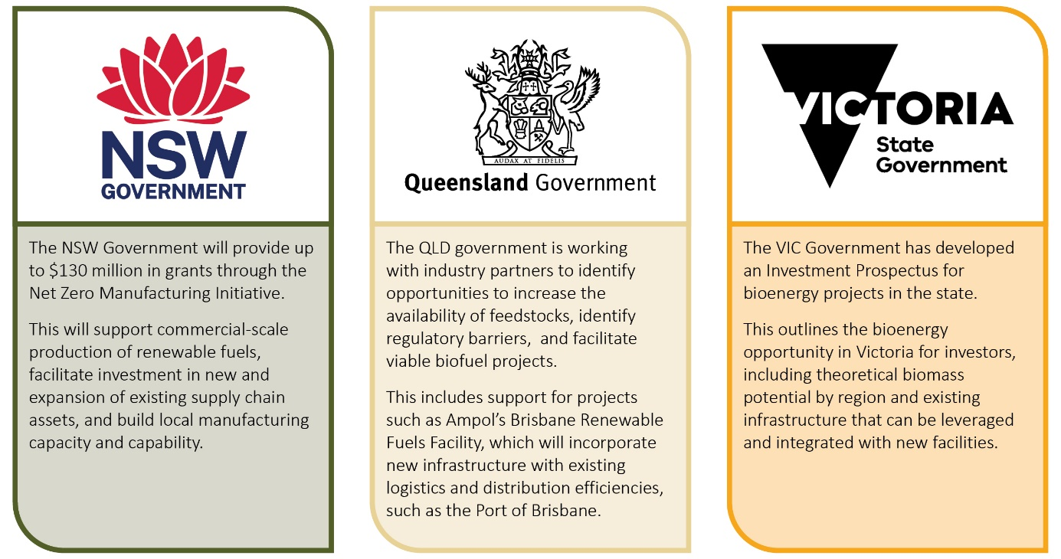

The Australian Government is also playing an active role through targeted investments that support industry across the value chain. For example, capital to de-risk industry investment is available through the Clean Energy Finance Corporation (CEFC), the National Reconstruction Fund (NRF) and the Northern Australia Infrastructure Facility (NAIF). ARENA is also investing in supply chain innovation, proof of concept and trials of new approaches (Box 8).
In 2026, the Australian Government launched the Investor Front Door to help unlock investment in Australia’s fuel security, supply chain resilience and critical minerals. The Investor Front Door offers selected projects, including HAMR Energy’s LCLF project, dedicated support to navigate regulatory requirements more efficiently and identify suitable government financing options.
The Australian Trade and Investment Commission (Austrade) also helps attract and facilitate investment in bioenergy supply chains by connecting domestic projects with international investors. This includes helping projects across the supply chain navigate foreign investment opportunities and connect with the right stakeholders.
Box 8 Australian Government investments that can support supply chain infrastructure
CEFC: Investing more than $33 billion into decarbonisation and nation-building infrastructure projects, including for projects that prioritise renewable energy, energy efficiency and low emissions technologies. CEFC finance has been investing in biofuels for a number of years, including working with institutional investors to back early-stage and demonstration projects, and to accelerate the evolution of biofuel feedstocks and end-user markets.
NRF: The $15 billion fund facilitates increased flows of finance into the Australian economy through targeted investment in manufacturing businesses across 8 priority areas including value add in agriculture, forestry, and fisheries. Additionally, the $5 billion Net Zero Fund, delivered through the NRF Corporation, supports large industrial facilities to transition to net zero and scaling up domestic manufacturing of renewables and low emissions technologies.
NAIF: An Australian Government financier, providing concessional loans for the development of infrastructure projects in northern Australia that demonstrate clear public benefit and support sustainable growth in remote regions.
ARENA: Funding of up to $250 million towards the LCLF Technology Focus Area of the Future Made in Australia Innovation Fund, to progress supply chain innovation.

Priority area: sustainability and certification
 | Strengthening emissions accounting and certification frameworks to ensure international credibility and market confidence.
Future direction:
- Ensure certification frameworks support market access, credibility and value recognition, and align with feedstock production systems.
- Increase availability of high-quality emissions data, particularly for developing and emerging feedstocks to improve emissions accounting and lifecycle assessment capability.
- Improve coordination, traceability and data sharing to support credible sustainability outcomes.
- Improve understandings of interactions between feedstock production and food, fibre and feed systems, including identifying co-benefits and managing trade-offs.
Demonstration of carbon abatement and sustainability credentials is a key part of accessing bioenergy markets globally. Certification schemes enable feedstock attributes, such as emissions intensity, to be differentiated and traded. Broader sustainability considerations are also important for maintaining social licence, with some international regulatory frameworks requiring these attributes to be verified for market access. Close engagement with feedstock producers will be important as the Australian Government considers the appropriate policy and regulatory settings for our domestic bioenergy market, as the design of these frameworks can directly affect the relative competitiveness of feedstocks.

Certification is core to value creation and market access
Certification of feedstock attributes is increasingly a prerequisite for value creation and recognition. Policy frameworks, including demand-side measures and production incentives, are built around demonstrated emissions reductions compared with fossil fuels. Verification of this and other attributes often determines whether a product is eligible for market incentives and procurement schemes. Where market mechanisms are designed around an emissions intensity standard, a greater abatement effect is directly tied to financial value. Current international frameworks such as the EU Renewable Energy Directive (RED) and ICAO’s Carbon Offsetting and Reduction Scheme for International Aviation (CORSIA) show how certified feedstock attributes effectively underpin market participation.
Stakeholders have consistently noted the importance of appropriate certification settings to ensure the competitiveness of Australia’s developing feedstock industry. Given that significant volumes of feedstocks exported from Australia are already certified under international frameworks, maintaining alignment and interoperability (where possible) is a priority.
Australia’s bioenergy market requirements are evolving in response to policy development, market demand and community expectations. The GO Scheme will be Australia’s primary mechanism for measuring and recognising the emissions intensity of LCLF and low carbon gases. Product Guarantee of Origin (PGO) certificates provide a foundation for linking certified emissions intensity attributes to the eligibility requirements of future domestic policy frameworks, including a demand-side measure. The expansion and refinement of the scheme will, over time, provide opportunities for feedstock industry input and help it to meet both international and domestic market requirements.

Emissions intensity underpins competitiveness
A clear understanding of emissions intensity across the supply chain is essential to capturing value and staying competitive. Feedstock production, processing and transport often make up a large share of lifecycle GHG emissions for the final bioenergy product. This makes upstream emissions accounting, data quality, data integrity and data transmission critical to accurately determining overall fuel emissions intensity.
Certification frameworks use different methods for life cycle assessments (LCA) which can lead to very different carbon abatement results. One example is how indirect/induced land use change (ILUC) is treated. In cases where feedstocks are produced on land cleared prior to 2008, CORSIA will apply default ILUC emissions values in their LCA, whereas the European Commission notes a lack of certainty around ILUC modelling and instead applies a qualitative, risk-based approach through the RED (EU 2018).
Global certification frameworks often rely on default emissions values to simplify verification across complex supply chains. These defaults can understate the competitiveness of Australian feedstocks because Australian production systems are often less emissions-intensive than global averages (ABARES 2023). CSIRO has produced analysis demonstrating the lower emissions profile of Australian canola, which has subsequently been recognised by the European Commission (Sevenster 2023).
The continuing expansion of the GO Scheme provides a mechanism to incorporate data specific to Australian systems and best-practice carbon accounting. This includes the potential recognition of site-specific emissions data (where supported by evidence and third-party verification), and for alignment with Australia’s voluntary emissions estimation and reporting guidelines for agriculture, fisheries and forestry. The Australian Government is playing an active role in improving emissions calculation practices at the farm level, including a $6.4m investment supporting farm-level GHG emissions calculators and tools to align with those guidelines. It is also investing in the Carbon Farming Outreach Program, to help producers to better understand emissions management opportunities.
Ongoing industry engagement in certification development, including the GO Scheme, will be critical to making sure systems are both credible and workable. More RD&E and better commodity-level and regional emissions data can help refine default emissions factors, better reflecting Australia’s emissions intensity advantage and strengthening confidence in emissions outcomes. Better availability of high-quality emissions data, especially for developing and emerging feedstocks, will support more accurate and defensible outcomes and could, over time, reduce reliance on generic defaults.
By continuing to engage in the overarching policy development, producers can help shape frameworks that recognise Australian production practices, stay aligned with international systems where suitable and allow low-emissions feedstocks to capture their value.

Sustainability beyond emissions
International bioenergy frameworks increasingly include sustainability criteria beyond emissions, covering issues such as water use, soil health, biodiversity and social factors. For Australian producers, many of these requirements align with existing regulation, although gaps can remain between minimum compliance and best-practice sustainability outcomes.
There are differing views on how sustainability frameworks and certification schemes should be applied to a future domestic bioenergy sector. Stakeholders have noted that sustainability standards are important to build social licence and, at minimum, reduce reputational risks from imported feedstocks produced outside Australia’s regulatory jurisdiction. But these will likely add complexity and regulatory burden for producers. Developing a bespoke framework could better reflect Australian production systems than existing international schemes but could create challenges for interoperability with international markets.
Designing an effective approach will require the right balance. The Australian Government has committed to work with industry to introduce a LCLF demand-side policy which will articulate the core market requirements for biofuels used here in Australia. Development of this policy will involve consideration of sustainability and certification in more detail in order to resolve issues around domestic market requirements.

Traceability and system integrity
Traceability is central to certification systems and underpins confidence in emissions and sustainability claims. As value increasingly depends on certified attributes, effective traceability becomes essential for market participation. Without it, emissions outcomes cannot be substantiated, market access is limited and feedstocks cannot capture their full value. Robust chain-of-custody arrangements are needed to verify inputs, allocate emissions across co-products and prevent fraud, non-compliance and double counting, especially in systems involving co-processing, blending and international trade.
Traceability systems will need to keep developing as supply chains become more complex and internationally integrated. The GO Scheme and international certification schemes such as the International Sustainability and Carbon Certification (ISCC) and the Roundtable on Sustainable Biomaterials (RSB) are likely to play an important role in meeting these requirements. Further consideration of traceability needs will be considered during policy design for the demand-side measure.

Integration with food, fibre and feed systems
Some stakeholders, particularly in the intensive livestock sector, have raised concerns that using edible feedstocks for bioenergy could intensify competition for agricultural commodities, potentially driving price pressures and supply constraints that could have downstream impacts on food affordability and security. This is not just a domestic concern. Some international regulatory frameworks have taken steps to cap the proportion of food crop-derived biofuels within their overall energy mix and are positioning for an eventual phase-out. However, these approaches can overlook the diversified and complementary nature of primary production systems, which have in-built risk mitigations.
Bioenergy feedstocks are produced within multifunctional agricultural and forestry systems that produce a range of outputs alongside food and fibre. Industry feedback identified no material constraint or conflict in the short term between feedstock production and food, fibre or other outputs.
Australia already produces and trades large volumes of commodities such as canola into global bioenergy markets, showing that our production systems can support multiple uses. Our agricultural innovation system continues to drive productivity improvements within existing cropping footprints. It is also important to consider that reliable and affordable liquid fuels are essential inputs to agricultural production, processing and distribution. Strengthening domestic LCLF production therefore supports the resilience of the food system to supply shocks.
Evidence also points to co-benefits from integrated production systems and value stacking, where a single feedstock supports multiple food, feed and fuel outputs. It is possible that an increased supply of co-products from bioenergy production, such as canola meal and distillers’ dried grains, could be utilised in the animal feed industry (though this will depend on consistent supply and suitable nutritional properties). In Australia, canola and other oilseeds are grown in rotation with cereal grains and serve as a useful break crop with benefits for disease and pest management, which supports food production.
Diversification of feedstocks will be an important part of addressing concerns around competition with food and fibre production in the longer term. While first-generation feedstocks remain among the most commercially ready and lowest-cost options in the short term (CEFC 2025), Australia will need a diversified feedstock base to achieve scale and reduce over-reliance on individual commodities. This includes expanding the use of non-edible residues, by-products and novel energy crops, which may be grown on marginal lands. Even so, as demand for feedstocks grows, it will be important to maintain visibility over land use, input allocation and price signals as systems evolve.
While major competition issues appear unlikely in the short term, maintaining social licence will require a robust and transparent evidence base that demonstrates how feedstock production can align with other national objectives. That means better data on trends in feedstock cultivation and collection, co-product and market flows, a stronger understanding of system interactions, and mitigation strategies for emerging risks. There is an opportunity for industry and governments to work together to strengthen the evidence base and ensure overarching policy settings do not lead to unintended outcomes. In the meantime, there is an opportunity for the feedstock industry to be proactive in addressing concerns regarding competition for resources, and to engage with other affected industries to ensure complementarity can be maintained.

Priority area: building sector capability
 | Enhancing coordination, skills, workforce planning and policy alignment across the supply chain to enable confident participation in new markets.
Future direction:
- Strengthen connections, communication and collaboration across feedstock production, aggregation, processing and end-use markets.
- Improve access to credible, practical and evidence-based information across the supply chain.
- Develop tools, guidance and market frameworks that reduce barriers to participation and improve market transparency.
- Build workforce capability and incorporate workforce needs into regional and supply chain planning.
- Strengthen policy coordination and collaboration across sectors, jurisdictions and supply chain participants.
Developing a domestic bioenergy feedstock industry will depend on Australia’s ability to translate strong existing agricultural capability into new, integrated supply chains. The sector starts from a position of productivity, adaptability and global competitiveness, but participating in bioenergy markets introduces new requirements, especially around information, coordination and market engagement. Targeted capability uplift across the supply chain will be needed to support confident participation, reduce coordination gaps and enable a connected, investable and scalable industry.

Strong existing base to support industry development
Australian agriculture is well placed to support a domestic bioenergy industry. Australia’s natural resource base, institutional settings and export orientation, with more than two-thirds of production exported, reinforce this capability. Producers continue to adapt to climate variability and changing market demands, and operate in highly constrained environments, with only about 6% of agricultural land suitable for annual cropping (AFI 2014). This has driven efficient and resilient production systems.
These strengths are already visible in Australia’s participation in international bioenergy supply chains. But scaling a domestic LCLF industry creates new dynamics. Historically, agriculture and fuel manufacturing have operated largely separately. Bringing them together will require stronger coordination, new capabilities and better market understanding. Without targeted capability uplift, participation is likely to remain uneven, which will limit the pace and scale of industry development.

Integration across the supply chain
Bioenergy feedstocks are part of a new and more integrated value chain that requires alignment across production, aggregation, processing and end use. Participation means meeting emerging market requirements, including emissions accounting, product quality and certification.
Stronger connectivity across the supply chain is therefore critical. This includes improving two-way understanding between producers and fuel manufacturers, increasing visibility of feedstock availability, and helping producers understand market requirements and risks.
This capability uplift must go both ways. Feedstock buyers need practical understanding of agricultural systems and constraints, while producers need clarity about downstream demand and commercial terms. Better integration will support stronger contracting, reduce risk and improve investment readiness.
Industry partnerships show what this can look like in practice. Long-term agreements, such as those for certified carinata oil, show how coordinated engagement can align production systems with fuel market requirements and give both producers and investors more confidence (Box 9).
Box 9 Industry led connectivity across supply chains - Nuseed, bp and carinata
Nuseed carinata is a proprietary low-carbon oilseed cover crop that is certified by the RSB for the EU RED market, as a low-carbon fuel feedstock (Nufarm 2019). Nuseed and bp Products North America Inc. have entered into a 10-year strategic agreement for the supply of carinata oil for sustainable biofuel production (bp 2022).
Under the agreement Nuseed will expand its existing network of growers and supply chain partners to deliver certified carinata oil. Carinata has potential to be integrated, in rotation, in existing cropping regions and more marginal areas that may have physical or economic restrictions for conventional crops. It can also be grown as a break crop for irrigated systems (such as cotton), that normally have an extended fallow period (Grains Central 2024).
Commercial scale trials of Nuseed’s non-food oilseed carinata varieties are under way in Australia, with plots located in cotton-growing regions of New South Wales and southern Queensland. The communication of trial outcomes will allow growers and Nuseed to evaluate carinata’s value proposition and enable informed evidence-based conversations around participation in developing supply chains.

Ensuring accessible information flow
Accessible, credible and fit-for-purpose information underpins sector capability. Better information flow helps stakeholders across the supply chain understand risks and make decisions about investment and participation. It also supports stronger connections between feedstock producers and downstream participants, helping build markets and more efficient supply chains.
Extension services, RDC programs and state and territory initiatives all play an important role, but stakeholders said information remains fragmented, uneven in quality and not always aligned with user needs. Better coordination and accessibility, through improved data integration, clearer market requirements (including certification, sustainability and quality standards) and more practical, evidence-based guidance, will lower barriers to entry and support more consistent participation.
The Australian Government is supporting information flow through initiatives such as the Australian Jet Zero Council and work to establish a national LCLF knowledge hub. This hub will help address current gaps by providing a central, publicly accessible platform for validated information, including case studies, datasets and technical guidance (Box 10). Over time, maintaining the quality, relevance and usability of this information through ongoing collaboration between government, industry and research organisations will be critical to helping the sector build capability and respond to changing market conditions.
Alongside better access to information, there is also a role for industry-led tools and frameworks that support participation in emerging feedstock markets. Stakeholders said standard approaches such as template contracts, pricing frameworks and guidance materials could reduce transaction costs, clarify commercial arrangements and support more consistent engagement between producers, aggregators and end users. Similar industry-led initiatives in other markets, such as codes of practice and landholder guidance, show how this can build confidence, improve transparency and help markets form more quickly.
Box 10 Low carbon liquid fuel knowledge hub
An iMove CRC project being progressed through the Queensland University of Technology will deliver a LCLF knowledge hub to serve as Australia’s primary evidence-based platform for LCLF information, communication, and stakeholder engagement. The publicly accessible hub will consolidate reputable and validated information, including factsheets, databases and case studies, into an intuitive online resource. It will include relevant feedstock specific information.
Delivery of the hub will accelerate national understanding, collaboration, and investment in LCLF technologies and feedstocks by providing an authoritative and accessible resource for stakeholders (iMove 2025).

Workforce planning
The development of feedstock markets creates new workforce requirements across production, logistics and processing. Many relevant skills already exist, but they are not always aligned with the specific needs of bioenergy supply chains.
Targeted workforce planning can help identify and address skill gaps early, reducing risks to project delivery and industry growth. Embedding workforce considerations into regional and project planning will help ensure labour availability supports industry development rather than constrains it.
Access to reliable information and stronger coordination across stakeholders will also support workforce capability uplift.

Coordinated policy
Clear, consistent and coordinated policy settings are essential to support capability building and market confidence. Feedstocks need to be treated as a central part of bioenergy policy, not just as an upstream input. This requires active representation of feedstock stakeholders in policy development, alignment across agriculture, energy, transport and environmental portfolios, and consistent signals that support investment, participation and long-term confidence.
The Australian Government will consider opportunities to keep policy direction clear and coordinated. Close alignment between the Department of Agriculture, Fisheries and Forestry, other relevant portfolios, agencies and participants across the value chain will be important to ensure feedstock industry development is embedded in a coordinated policy approach. Existing structures such as the Australian Jet Zero Council can help strengthen this coordination.
There is also an opportunity for stronger policy coordination between the Australian Government and states and territories through existing intergovernmental forums. The Agriculture Ministers’ Meeting (AMM) and Forestry Ministers’ Meeting (FMM) bring together ministers from all jurisdictions with responsibility for primary industries and forestry. These meetings, and their subordinate committees, can provide a forum for national collaboration on bioenergy industry development. Continuing this work will remain important, including collaboration on capability building and stronger community engagement.

Glossary
Term | Definition
ABARES | Australian Bureau of Agricultural and Resource Economics and Sciences
ABBA | Australian Biomass for Bioenergy Assessment
AgriFutures | An Australian research and development corporation representing 13 rural industries and across a range of emerging rural industries.
alcohol-to-jet (AtJ) | The process of converting alcohol (typically ethanol) to jet fuel through a series of catalytic reactions.
AMM | Agricultural Ministers' Meeting
ARENA | Australian Renewable Energy Agency
bioenergy | A form of renewable energy generated from the conversion of biomass resources into heat, electricity, gas, and/or liquid fuels.
biomethane | A renewable gas produced by upgrading biogas (derived from organic waste) into a near‑pure methane that is chemically equivalent to natural gas and can be used as a drop-in fuel.
biofuel | A renewable, combustible fuel made from organic materials, which can be blended with fossil fuel. Term commonly refers to liquid fuels but can also include gaseous and solid fuels.
byproducts and residues | Materials that remain after the primary processing of agricultural and forestry biomass which can have alternative purposes, including bioenergy.
carinata | A non-edible oilseed crop, grown between main crop rotations and used as a lower carbon liquid fuel feedstock.
CEFC | Clean Energy Finance Corporation
CO₂-e | Carbon dioxide equivalents
co-product | Biogenic materials that are intentionally produced alongside the main agricultural or forestry production process and have specific market uses or value.
CRC | Cooperative Research Centre
CSIRO | Commonwealth Scientific and Industrial Research Organisation
DAFF | Department of Agriculture, Fisheries and Forestry (Commonwealth)
densification | The use of heating and pressure to increase the density and energy of biomass, resulting in products such as pellets or briquettes.
DLUC | Direct land use change
e-fuels | Electro-fuels, produced with green hydrogen and a non-fossil source of carbon.
feedstock, biogenic | Biological materials that are used as input to process energy carriers including liquid fuels and gases. These materials can come from agricultural crops (such as oilseeds), agricultural and forestry residues, livestock waste, or even municipal solid waste.
Fischer-Tropsch (FT) | The process of converting feedstocks (primarily lignocellulosic and wastes) to syngas through FT synthesis pathways.
FMM | Forestry Ministers' Meeting
generations (feedstock) | Categorisation of biomass and biofuels as first (from edible sources), second (non-edible sources), and third (algae and other microorganisms) generation.
GHG | Greenhouse gas
GO Scheme | Guarantee of Origin Scheme
Hydroprocessed Esters and Fatty Acids (HEFA) | The use of hydrogen and a catalyst to process high-fat content feedstocks (such as oilseeds) to create liquid biofuels, including biodiesel and sustainable aviation fuel.
ICAO | International Civil Aviation Organisation
ILUC | Indirect land use change
ISCC | International Sustainability and Carbon Certification
LCA | Lifecycle assessment
lignocellulosic | Biomass derived from dry plant matter, including agricultural residues, forestry residues, and short rotation trees.
low carbon liquid fuel (LCLF) | Alternative liquid fuels with lower lifecycle emissions compared to fossil fuels. Commonly (but not exclusively) produced with biogenic feedstocks.
LUC | Land use change
MT | Mega tonne
PGO Certificate | Product Guarantee of Origin Certificate
PJ | Petajoule
pongamia | A drought-tolerant oilseed crop that can be grown on marginal land and used as LCLF feedstock.
PtL | Power-to-liquid
RDA | Regional Development Australia
RDC | Research Development Corporation
RED | Renewable Energy Directive
renewable diesel | A drop-in LCLF that is chemically similar to standard diesel and can be used directly in existing diesel engines without modifications.
RSB | Roundtable on Sustainable Biomaterials
SRT | Short rotation tree
sustainable aviation fuel (SAF) | A LCLF replacement to traditional jet fuels produced from a range of feedstocks, that meets aviation fuel standards and reduces lifecycle emissions.
torrefaction | The heating of biomass in an oxygen-limited environment, to improve energy density and reduce water content.
waste | Materials or products that are unwanted, surplus, discarded, rejected, abandoned or  left over, including those materials or products intended for or managed by recycling,  energy recovery, treatment, storage and disposal.

References
ABARES 2023, ABARES Insights: Environmental sustainability and agri-environmental indicators – international comparisons, Australian Bureau of Agricultural and Resource Economics and Sciences, Issue 2, Canberra, July, DOI: https://doi.org/10.25814/zzdq-4t23, accessed 28 May 2026
ABARES 2026a, Agricultural Commodities: March quarter 2026, Australian Bureau of Agricultural and Resource Economics and Sciences, Canberra, DOI: 10.25814/98pm-3f48, accessed 17 April 2026.
ABARES 2026b, Snapshot of Australian Agriculture 2026, Australian Bureau of Agricultural and Resource Economics and Sciences, Canberra, accessed 21 April 2026.
AB 2024, Ararat Bioenergy reaches key project milestone, Ararat Bioenergy, Melbourne, accessed 21 April 2026.
AFI 2014, Optimising Australian agriculture's competitive advantages, Australian Farm Institute, Canberra, accessed 21 April 2026.
AgriFutures 2021, Australian Biomass for Bioenergy Assessment 2015-2021 Final report, AgriFutures Australia, Wagga Wagga, accessed 10 December 2025.
AgriFutures 2026, Australian Agriculture Fisheries and Forestry Sector Energy Transition Roadmap 2026-2035, AgriFutures Australia, Wagga Wagga, accessed 7 May 2026.
ARC 2025, Ararat Rural City Council Leads Push for Renewable Gas, Ararat Rural City Council, Ararat, accessed 21 April 2026.
ARENA, CEFC 2019, Biofuels and Transport: An Australian Opportunity, Australian Renewable Energy Agency and Clean Energy Finance Corporation, accessed 20 April 2026.
ARENA 2021, Australia’s Bioenergy Roadmap, Australian Renewable Energy Agency, Canberra, accessed 10 December 2025.
Bioenergy Australia 2022, Transitioning Australia’s Liquid Fuel Sector: The role of renewable fuels, Bioenergy Australia Pty Ltd, Canberra, accessed 10 December 2025.
Bioenergy Australia 2025, Securing our Fuel Future: Resilience Through Low Carbon Liquid Fuels, Bioenergy Australia Pty Ltd, Canberra, accessed 10 December 2025.
Bp 2022, bp welcomes strategic agreement with Nuseed Carinata, Air bp, Melbourne, accessed 21 April 2026.
CBH 2026, Storage and Handling, CBH Group, Perth, accessed 24 April 2026.
CSIRO 2023, Sustainable Aviation Fuel Roadmap, Commonwealth Scientific and Industrial Research Organisation, Canberra, accessed 10 December 2025.
CSIRO 2025a, Opportunities and Priorities for a Low Carbon Liquid Fuel Industry in Australia, Commonwealth Scientific and Industrial Research Organisation, Canberra, accessed 10 December 2025.
CSIRO 2025b, The State of Energy Transition Technologies: Low Carbon Fuels Technical Appendix, Commonwealth Scientific and Industrial Research Organisation, Canberra, accessed 29 May 2026.
CEFC 2025, Refined Ambitions: Exploring Australia’s Low Carbon Liquid Fuel Potential, Clean Energy Finance Corporation, Sydney.
DCCEEW 2025, Australian Energy Statistics: Energy Consumption (Table C), Department of Climate Change, Energy, the Environment and Water, Canberra, accessed 23 April 2026.
DCCEEW 2026, Securing Australia’s Cleaner Fuels Industry: Consultation paper on a demand mechanism, Department of Climate Change, Energy, the Environment and Water, Canberra, accessed 10 July 2026.
European Union, Directive 2018/2001 of the European Parliament and of the Council on the Promotion of the Use of Energy from Renewable Sources, accessed 24 March 2026
GIWA 2025, GIWA Crop Report – February 2025, Grain Industry Association of Western Australia, Perth, accessed 24 April 2026.
Grains Central 2024, Nuseed trials, talks up carinata as fit with cotton, Grain Central, Brisbane, accessed 21 April 2026.
GrainCorp 2026, From Paddock to Plane: Feedstock White Paper. Unlocking Australia’s domestic sustainable aviation feedstock potential, accessed 10 July 2026.
GRDC 2025, Low Carbon Liquid Fuels Roadmap, Grains Research Development Corporation, Canberra, accessed 20 April 2026.
HAMR 2025a, Portland Renewable Fuels, HAMR Energy, Melbourne, accessed 21 April 2026.
HAMR 2025b, Methanol to Jet SAF Energy Park, HAMR Energy, Melbourne, accessed 21 April 2026.
IEA 2024, What is bioenergy?, International Energy Agency, Paris, accessed 27 May 2026.
IEA 2025a, Renewables 2025: Analysis and forecasts to 2030, International Energy Agency, Paris, accessed 30 April 2026.
IEA 2025b, Outlook for Biogas and Biomethane: A global geospatial assessment, International Energy Agency, Paris, accessed 22 May 2026.
IEA Bioenergy 2026, Task 43: Biomass Supply in a Nature Positive Circular Economy (2025-2027 Workplan), International Energy Agency, Paris, accessed 27 May 2026.
iMove 2025, Low Carbon Liquid Fuels Knowledge Hub, iMove Australia, Melbourne, accessed 21 April 2026.
NSW DPI 2025, NSW BioSMART Tool, NSW Department of Primary Industries and Regional Development, Orange, accessed 21 April 2026.
Nufarm 2019, Carinata new to Nuseed’s Global Portfolio, Nufarm Limited, Melbourne, accessed 21 April 2026.
Office of the Auditor General 2013, Management of the Rail Freight Network Lease: Twelve Years Down the Track (PDF 823K) Office of the Auditor General, Western Australia, accessed 24 April 2026.
Sevenster, Maartje 2023, Greenhouse gas emissions from the cultivation of canola oilseed in Australia, CSIRO, Canberra, accessed 20 May 2026.

