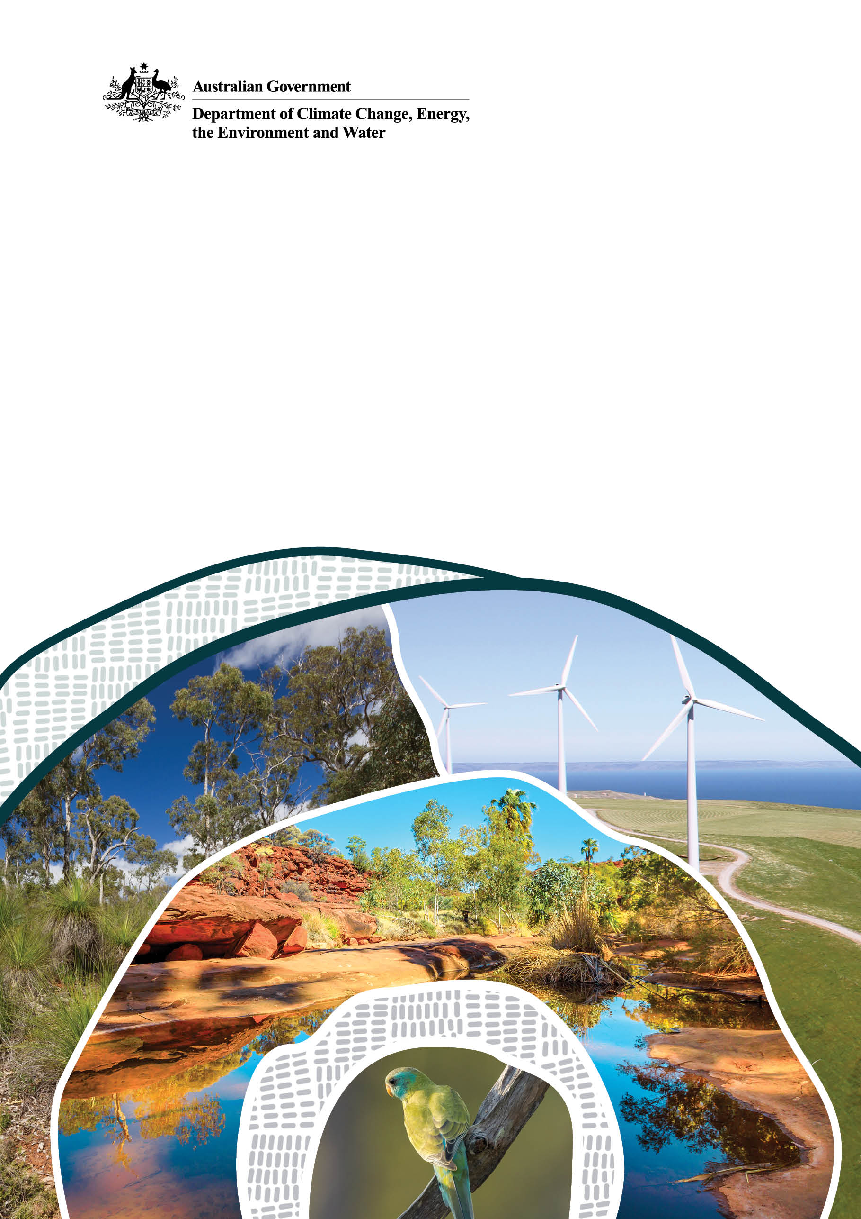
Carbon Farming Outreach Program
training package
Glossary

© Commonwealth of Australia 2025
Ownership of intellectual property rights
Unless otherwise noted, copyright (and any other intellectual property rights) in this publication is owned by the Commonwealth of Australia (referred to as the Commonwealth).
Creative Commons licence
All material in this publication is licensed under a Creative Commons Attribution 4.0 International Licence except content supplied by third parties, logos and the Commonwealth Coat of Arms.
Inquiries about the licence and any use of this document should be emailed to copyright@dcceew.gov.au.

Cataloguing data
This publication (and any material sourced from it) should be attributed as: DCCEEW 2025, Carbon Farming Outreach Program training package: Glossary, Department of Climate Change, Energy, the Environment and Water, Canberra. CC BY 4.0.
This publication is available at https://www.dcceew.gov.au/climate-change/emissions-reduction/agricultural-land-sectors/carbon-farming-outreach-program-training-package.
Department of Climate Change, Energy, the Environment and Water
GPO Box 3090 Canberra ACT 2601
Telephone 1800 920 528
Web dcceew.gov.au

Disclaimer
The Australian Government acting through the Department of Climate Change, Energy, the Environment and Water has exercised due care and skill in preparing and compiling the information and data in this publication. Notwithstanding, the Department of Climate Change, Energy, the Environment and Water, its employees and advisers disclaim all liability, including liability for negligence and for any loss, damage, injury, expense or cost incurred by any person as a result of accessing, using or relying on any of the information or data in this publication to the maximum extent permitted by law.

Contents
Carbon Farming Outreach Program training package 4
Glossary 9

Carbon Farming Outreach Program training package
The Carbon Farming Outreach Program training package provides information to help farmers and land managers make decisions about reducing greenhouse gas (GHG) emissions and storing carbon.
The training package comprises 5 topics:
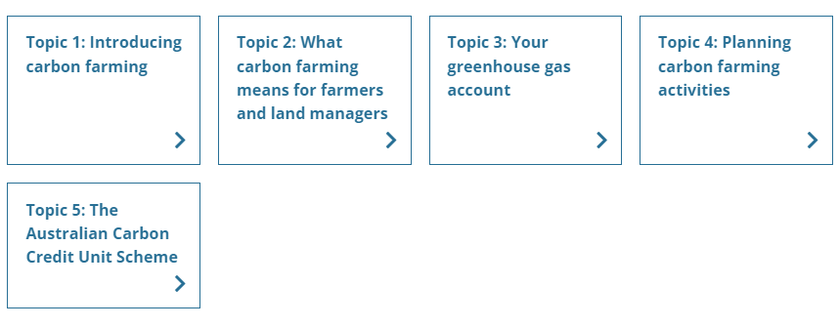

Watch these videos
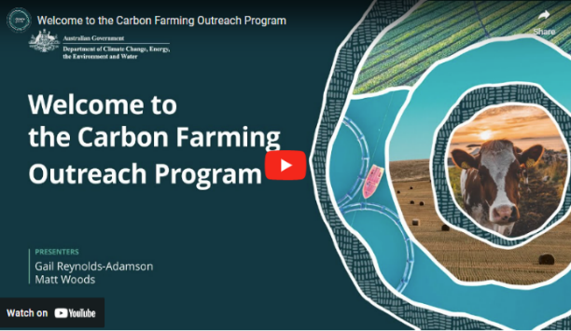
In this video (4:38 minutes), presenters Gail Reynolds-Adamson and Matt Woods introduce the Carbon Farming Outreach Program, and the training package structure and content.
Video: Welcome to the Carbon Farming Outreach Program (youtube.com)

Transcript
GAIL REYNOLDS-ADAMSON: Hi, and welcome to Carbon Farming Outreach Training package.
Kaya Kepa Kurl Noongar Boodja. My name is Gail Reynolds-Adamson, and I'm a proud Noongar woman from Wudjari Country, on the eastern border of the Noongar nation in Kepa Kurl, also known as Esperance. 'Kepa' is water, 'Kurl' is boomerang, and its where the waters lie like a boomerang.
MATT WOODS: Hi, Gail, and welcome, everyone. I'm Matt Woods, an agricultural and science journalist.
Today, we're at my home, outside Bacchus Marsh, on the border of Wurundjeri, Woiwurrung, and Wathaurong Country of the Kulin Nation, and I pay my respects to Elders past, present, and future.
In the valley below me is the Bacchus Marsh agricultural district, where market gardeners and orchardists farm some of the deepest top soil in Australia.
I've been on hundreds of farms and spoken to thousands of farmers from one end of Australia to the other. And if there's one subject top of mind for every farmer, it's profitability.
And that's actually what this training package is about. Because, in most cases, good carbon farming practices will improve the profitability and health of your land. Whether you want to enter the carbon market or not, the truly great outcome with carbon farming is that it can be a win-win: good for your farm business, land, and the environment.
REYNOLDS-ADAMSON: Thanks, Matt. It's great to be part of this Carbon Farming Outreach Program training package, and to be able to share with farmers and land managers from all over Australia some of the who, what, when, where, and why, of carbon farming.
This includes evidence-based knowledge and practices both from Western and traditional Aboriginal Torres Strait Islander culture.
I'm the chairperson of Esperance Tjaltjraak Native Title Aboriginal Corporation in Western Australia. I'll be sharing more about the tree rejuvenation project we are running at Kardutjaanup to show you the many benefits, but also the risk requirements involved with this type of carbon farming.
WOODS: The aim of this package, through five short topics, is to give you the carbon farming essentials from expert practitioners, farmers, and land managers in all Ag (agriculture) sectors across Australia, like Gail, who've already embarked on carbon farming projects.
They'll share some tips and tricks with you, including why and how they did it, what technology and techniques they used, what worked, what didn't and who helped them along the way. We've also carefully researched and selected resources, materials, and tools that may benefit you and presented them by Ag (agriculture) sector and location for your convenience.
We know that you don't have loads of time to spend sitting in front of a computer. And that you need your learning to be relevant, targeted, accessible, and practical.
Each of the five topics should take you no more than one hour individually.
But we've also provided additional content and case studies if you want to find out more.
Short videos like this, as well as interviews and explainers, will allow you to access this package anywhere, anytime.
REYNOLDS-ADAMSON: The Carbon Farming Outreach Program training package won't make you an expert in carbon farming, but it will teach you the essential things you should know before embarking on carbon farming.
This includes benefits and risks, potential pathways to action, and the decision you will need to make, including whether or not to trade carbon credits, and some resources you can refer to for your location and type of practice. Importantly, we will help you to understand who you should talk to, what you should look out for when you are choosing advisors, and to ensure that you are getting quality, trusted, independent advice.
WOODS: Finally, each topic concludes with some relevant focusing questions, for you to consider in relation to your own circumstances.
Whether you're just learning about carbon farming for the first time and are exploring your options or had some experience and want to find out more, this package can help you. Think of it as like having a yarn with your neighbours over the fence about their carbon farming project.
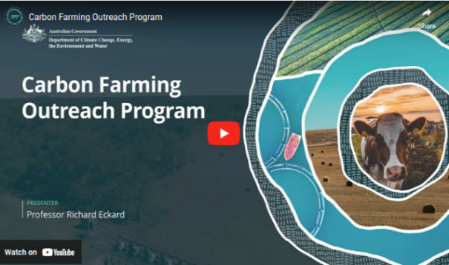
In this video (4:03 minutes), Professor Richard Eckard discusses the need for carbon farming.
Video: Carbon Farming Outreach Program (youtube.com)

Transcript
PROFESSOR RICHARD ECKARD: For farmers and land managers to meet the goal of reduced emissions starting in 2030 through to 2050, they need to know what to do next, what steps to do next, and they need to know where the policy environment is coming from, who's asking them to be low emissions, what the targets are, and then what the options are for them to start responding.
Hi. I'm Richard Eckard, professor in the Faculty of Science at the University of Melbourne. I lead the Primary Industries Climate Challenges Centre, which researches the impact of climate change on agriculture and agriculture on climate.
What we're seeing is all the multinational supply chain companies that deal with agricultural produce have set targets, targets for reduced greenhouse gas emissions. And they average somewhere around 30 percent less emissions by 2030 and net zero by 2050. What we also know is about 70 percent of Australian agricultural produce is exported down these multinational supply chain targets. And so how does Australia perform on the global stage when those companies start buying globally to meet their target?
So it's really imperative that farmers and land managers get on board to know how do they gear their system to deliver the low emissions product that the supply chain will want to buy by 2030. What we're trying to do is just bring up the knowledge that carbon farming is a part of their future.
There is this trajectory towards lower emissions. So making them aware of the policy environment, of the supply chain constraints, of how they need a partnership with their supply chain, to achieve this. And then some awareness of what is their number, how do they get their number, and how do they move down the track towards improving that number. And what are the technologies they can bring to bear to reduce their number, their greenhouse gas footprint?
So these will be things to start with are just best practice. Best practice that we've known for the last 40 years. Things like nitrogen use efficiency, better crop yields, better soil testing, better growth rates in livestock, feeding animals better, bringing legumes into agriculture. These are all things we've known for a long time that improve efficiency, but also reduce the greenhouse gas footprint.
Australia is already 22 percent more rainfall variable than any other country in the world, and the historic management of the land took that into account. Now we're becoming aware of this in how we do carbon farming, that we have to actually change from strictly European farming systems to systems that are more attuned to this high variability we're encountering. And so there's a lot to be learned from the Indigenous land management practices that we need to then incorporate into traditional farming, non Indigenous farming, so that it actually is a bit more in tune with the high variability we have in Australia.
Now the world needs to go net zero by 2050. What we haven't really reconciled is where does the big emission reduction take place? Obviously, it has to happen in the fossil fuel sector.
But we need to move towards, well, what can agriculture contribute to that inevitable net zero? And what can they contribute towards the 2030 goal? Now not every agricultural sector has the identical opportunity. We've got some intensive horticulture for example that have very low emissions and almost nothing to do to get to net zero apart from renewable energy. But you've got an extensive livestock sector where a lot of northern cattle stations, we don't even know how many cattle are there. So the challenges are vastly different, and this is what the program is trying to address is who has what options to move forward and what are those options.

Glossary
The glossary provides definitions for key words and terms used in the training package. The glossary is included at the end of this document.

Using this training package
This training package provides introductory information, and sources of further information and advice. References to third-party material, information or products or services do not represent endorsements. This training package does not provide detailed information that farmers and land managers may need when making decisions about carbon farming for their own particular circumstances. This training package is not a substitute for independent professional advice. Before making decisions about carbon farming, you may need to obtain more information and independent advice relevant to your particular circumstances.

Acknowledgement of Country
The Australian Government acknowledges the Traditional Owners and custodians of all the lands across Australia. We pay respect to all Aboriginal and Torres Strait Islanders, including elders, past and present. We also express our gratitude and appreciation for the ongoing stewardship of Country that Aboriginal and Torres Strait Islanders have practised for thousands of years. We understand that we all have much to learn from traditional ways of knowing, being and doing.

Statement of intent
This training package has been developed in consultation and collaboration with an Aboriginal and Torres Strait Islander reference group. We thank them for their generosity with time, expertise, and patience. We recognise Aboriginal and Torres Strait Islanders as rights holders and value the opportunity for Aboriginal and Torres Strait Islanders to engage with farmers and land managers in meaningful dialogue to weave traditional practices into carbon farming. Aboriginal and Torres Strait Islanders offer invaluable traditional ecological knowledge that complements the expertise of other farmers and land managers. Together, farmers, land managers and Aboriginal and Torres Strait Islanders are practising carbon farming methods that respect traditional insights and modern science. As co-innovators, we are exploring new pathways to reduce carbon footprints through joint carbon farming initiatives and preserving the land for future generations.
Aboriginal and Torres Strait Islander people should be aware that this website, the videos it contains and links to First Nations resources may contain images, voices and names of deceased persons.

Glossary
The glossary provides definitions for key words and terms used in the training package.
Abatement: a reduction in atmospheric GHGs through emissions avoidance or removal and storage of carbon from the atmosphere.
Abatement estimates: estimates of abatement, which may include estimates of potential abatement, or estimates of abatement that has been achieved.
Additionality: the extent to which emissions avoidance or carbon storage would be unlikely to occur in the ordinary course of events (i.e. in the absence of an incentive such as that provided by a carbon crediting scheme). Additionality ensures carbon credits used to offset emissions represent genuine reductions in GHG emissions.
Australian Carbon Credit Unit (ACCU): a unit issued under the Carbon Credits (Carbon Farming Initiative) Act 2011, equal to 1 tonne of carbon dioxide equivalent emissions (as Topic 5 explains).
Australian Carbon Credit Unit (ACCU) Scheme: an Australian Government scheme that offers landholders, communities and businesses the opportunity to undertake projects in Australia that avoid releasing GHG emissions or remove and store carbon from the atmosphere. It is enacted through the Carbon Credits (Carbon Farming Initiative) Act 2011 and the Carbon Credits (Carbon Farming Initiative) Rule 2015 (as Topic 5 explains).
Afforestation: establishing a forest on land where there was no previous forest (as Topic 2.3 explains).
Agroforestry: planting and maintaining trees and shrubs around or on agricultural land, integrating trees and shrubs with crops and livestock (as Topic 2.3 explains).
Australian National Registry of Emissions Units: a secure system administered by the Clean Energy Regulator that tracks the location and ownership of ACCUs (as Topic 5.2 explains).
Anaerobic (pond): A small, deep primary effluent treatment pond where bacteria break down organic matter in the absence of oxygen, releasing methane and carbon dioxide (as Topic 2.3 explains).
Baseline: An estimate of GHG emissions and carbon storage for a nominated year or years, which provides a starting point for comparing changes in emissions and carbon storage over time.
Biodiversity: the variety of genetic information in plants, animals and microorganisms, of species and of habitats, ecological communities and ecological processes.
Biogas: a mix of methane and other gases generated by anaerobic digestion (microorganisms breaking down materials) of food, crop waste and manure.
Biomass: the total mass of living organisms present in an area, ecosystem, environment or a category of organisms.
Blue carbon: the carbon stored by plants and soils of coastal ecosystems that support mangroves, tidal marshes and seagrasses, prevalent along most coastlines in the world, that can capture and store large amounts of carbon in their soils, roots and plants (as Topic 2.3 explains).
Carbon: a non-metallic element found in all animals and plants and in substances such as coal and oil. When carbon is burned it produces carbon dioxide and carbon monoxide.
Carbon cycle: the flow of carbon in various forms (such as carbon dioxide) through the atmosphere, land and oceans (as Topic 1.7 explains).
Carbon dioxide equivalent (CO₂-e): a unit based on the global warming potential of different GHGs compared to carbon dioxide. For example, in 2024, one tonne of methane released into the atmosphere is estimated to contribute as much to climate change as 28 tonnes of carbon dioxide. Therefore, one tonne of methane equals 28 tonnes of CO₂-e.
Carbon farming: changing agricultural practices or land management to increase the amount of carbon stored in the soil and vegetation and to reduce GHG emissions from agricultural production or land management.
Carbon footprint: the amount of GHGs emitted minus the amount of carbon stored, for example by a farm, region or country.
Carbon neutral: a state of emissions and absorption of GHGs from the atmosphere being in balance (as Topic 1.8 explains).
Carbon service provider: a business that offers services to help establish and manage carbon farming activities, including ACCU Scheme projects, in exchange for a fee (for example, a payment or some of the ACCUs issued for the project). They are also known as a carbon project aggregator or developer (as Topic 4.3 explains).
Carbon sequestration: the process of removing carbon from the atmosphere and storing it in trees, soils, geologic formations, oceans and in engineered technologies.
Carbon storage: another term for carbon sequestration.
Caring for Country: activities by First Nations people that draw on laws, knowledge and customs inherited from ancestors and ancestral beings to ensure the continued health of lands and seas with which they have a traditional attachment or relationship.
Clean Energy Regulator: a statutory authority responsible for administering legislation that will contribute to a reduction in Australia's GHG emissions. It has administrative responsibilities for the National Greenhouse and Energy Reporting Scheme, ACCU Scheme, Australian National Registry of Emissions Units, Safeguard Mechanism and Renewable Energy Target.
Climate Active: an Australian Government program, administered by DCCEEW, that encourages business decarbonisation through certifying credible voluntary climate action.
Co-benefit: the benefits in addition to reducing GHG emissions and storing carbon. These are benefits for farmers and land managers, the environment and communities (as Topics 1 and 2 explain).

Country: the First Nations concept of everything within a cultural landscape, including the land and sea; the plants and animals within them; the history, culture and traditions associated with them; and the connections between people and the landscape. Country is a distinct geographic, cultural and ecological space common to a specific Indigenous people, group of peoples or local community. Tenure is held collectively – whether formally recognised legally or otherwise – and resource definition and use and cultural practice are governed within a common property context.
Crediting period (ACCU Scheme): the period during which an ACCU Scheme project can generate ACCUs: generally 7 years for emissions avoidance projects and 25 years for carbon storage projects (as Topic 5.3 explains).
Cultural burning: deliberate burning of the landscape authorised and led by the Traditional Owners of that Country for purposes including ceremonies, protecting cultural and natural assets, reducing fuel, healing Country’s spirit and managing and regenerating food, fibre, medicines and plant and animal habitat (as Topic 1.4 explains).
Ecosystem: a community of living things and the non-living environment functioning together as an ecological system.
Eligible interest holder (ACCU Scheme): a person or organisation with a legal interest in the land on which an ACCU Scheme project will be run, including landholders, banks or mortgagees, state and territory Crown Lands Ministers and registered native title bodies corporate (as Topic 5.3 explains).
Emissions: outputs and discharges, as in the introduction of chemicals or particles into the atmosphere, usually used in relation to GHG emissions.
Enteric fermentation: the process by which microbes in the rumen of ruminant livestock produce methane as their feed ferments, which the animal then belches (as Topic 1.6 explains).
Fallow land: land rested from cropping for a time so the soil can maintain its capacity to support plant growth and high crop yields.
First Nations: a generic term for Indigenous peoples. It is not specific to Australian Indigenous peoples and can be applied to describe Indigenous peoples from other countries.
Forward abatement estimate (ACCU Scheme): an estimate of the expected total amount of carbon stored, or GHG emissions avoided, by an ACCU Scheme project in tonnes of carbon dioxide equivalent. A project proponent provides the estimate when applying to register an ACCU Scheme project.
Free, Prior and Informed Consent (FPIC): FPIC is a decision-making process and a framework for ensuring First Nations people are properly engaged in any decision that may affect their lands, territories or livelihoods and that outside organisations engage with First Nations people in a culturally appropriate way.
Global warming potential: a value used to compare the ability of different GHGs to trap heat in the atmosphere, with carbon dioxide used as a benchmark. For example, in 2024, methane’s global warming potential (GWP) value was 28. This means that one tonne of methane released into the atmosphere is estimated to contribute as much to climate change as 28 tonnes of carbon dioxide (as Topic 1.8 explains).
Greenhouse gas (GHG): a gas that traps heat in the atmosphere. The main GHGs are carbon dioxide (CO₂), methane (CH₄), nitrous oxide (N₂O), hydrofluorocarbons (HFCs), perfluorocarbons (PFCs) and sulfur hexafluoride (SF₆).
Insetting: undertaking activities that reduce or avoid emissions, or store carbon within a value chain, which may comprise a farm and its supply chain, and counting the emissions reductions or carbon storage towards the operation’s total emissions.
Life cycle assessment: an assessment of the environmental aspects and potential impacts of a product, process or service by compiling an inventory of relevant energy and material inputs and environmental releases, evaluating the potential environmental impacts of those inputs and releases and interpreting the results to inform decision-makers (as Topic 3.5 explains).
Methane: one of the main GHGs produced by agricultural activities: methane emissions, mainly by beef and dairy cattle and sheep, but also pigs, account for most of Australia’s agricultural emissions (as Topic 1.6 explains).
Method (ACCU Scheme): a legislated set of requirements and rules for running an ACCU Scheme project. Each method specifies the activities you can conduct, how to measure carbon abatement and monitoring, record-keeping and reporting requirements (as Topic 5 explains).
National Plantation Inventory (NPI) region: regions in which tree plantations are grown primarily for timber production. The regions are defined in National Plantation Inventory reports prepared by the Australian Bureau of Agricultural and Resource Economics and Sciences.
Nature positive: a term used to describe circumstances where nature – species and ecosystems – is being repaired and is regenerating rather than declining.
Net zero emissions: taking steps to reduce GHG emissions as much as possible and to use carbon storage to balance remaining emissions, over a specified period (as Topic 1.8 explains).
Nitrogen cycle: a biogeochemical process that begins with the conversion of nitrogen in the atmosphere into ammonia by bacteria in the soil (nitrogen fixation) and its transformation into nitrites and nitrates (nitrification) that plants use to grow and develop (assimilation). When plants and the animals that eat them die, organic matter breaks down, releasing nitrogen back into the soil as ammonium (ammonification). Finally, bacteria convert the nitrates back into atmospheric nitrogen gas (denitrification) (as Topic 1.6 explains).
Nitrous oxide: one of the main GHGs produced by agricultural activities. Sources include burning crop residues and using fertilisers (as Topic 1.6 explains).
Offsetting: the buying and cancelling (also referred to as retiring) of ACCUs or other eligible carbon credits by an organisation to compensate for the emissions it produces.
Permanence period (ACCU Scheme): the period over which carbon stored by an ACCU Scheme project must be maintained. A period of either 25 or 100 years can be adopted (as Topic 5.3 explains).
Precision agriculture: the use of technology and data analysis to optimise various aspects of agricultural production (as Topic 2.3 explains in relation to soil organic carbon). It is also called ‘precision farming’.
Project proponent (ACCU Scheme): the party with the legal right to carry out an ACCU Scheme project. A project proponent is responsible for carrying out the project, is issued all ACCUs and is legally responsible for meeting all obligations under the law (as Topic 5.3 explains).
Relinquish: (ACCU Scheme): to return ACCUs to the Clean Energy Regulator. Project proponents may voluntarily relinquish ACCUs in some circumstances. There may also be circumstances where the Clean Energy Regulator requires ACCUs to be relinquished.
Revoke: (ACCU Scheme): to withdraw a registered ACCU Scheme project. A project proponent can elect to revoke their project. They may need to meet certain obligations associated with the revocation.
Reforestation: establishing a forest on land where there has previously been a forest (as Topic 2.3 explains).
Risk of reversal buffer (ACCU Scheme): a discount applied to the number of ACCUs issued to carbon storage projects to protect the ACCU Scheme against the potential loss of carbon and other risks that can't be managed by other permanence arrangements. The risk of reversal buffer reduces the ACCUs issued for each reporting period by 5% for vegetation and soil carbon projects (as Topic 5.2 explains).
Savanna: land characterised by a tropical or sub-tropical vegetation formation with continuous grass cover occasionally interrupted by trees and shrubs.
Scope 1 emissions: emissions released into the atmosphere from operations a business owns or controls, such as methane from livestock digestion and manure management and nitrous oxide from fertiliser use on a farm. Scope 1 emissions are also called direct emissions (as Topic 1.6 explains).
Scope 2 emissions: emissions released into the atmosphere from generating electricity, steam, heat or cooling a business buys (for example, emissions from burning coal to produce electricity a farm uses). Scope 2 emissions are also called indirect emissions (as Topic 1.6 explains).
Scope 3 emissions: all indirect (off-farm) emissions (other than scope 2 emissions) that occur in the business’ value chain. For a farm business, this could include upstream emissions from producing and transporting fertilisers and pesticides and downstream emissions from transporting, processing and consumption of the farming business’ products, including waste disposal (as Topic 1.6 explains).
Sink (carbon): places where carbon dioxide that is captured and removed from the atmosphere is stored, including trees, other vegetation, soil, geological formations (via carbon capture and storage), long-lived products (via carbon capture and use) and minerals.
Soil organic carbon (SOC): all living and dead organic material — plants, soil organisms and animal materials — in the soil in various stages of decomposition, but not the fresh, undecomposed organic material on the surface (as Topic 1.7 explains).
Spot price (ACCU Scheme): the price of ACCUs bought for immediate delivery (as Topic 5.5 explains).
Supply chain: the sequence of processes involved in producing and distributing a commodity. For an agricultural commodity, this includes the inputs needed to produce it, the production activities, and the subsequent processes for distribution and sale.
Sustainability loan: a loan from a government or private financier for equipment or operations to improve sustainability, including of farming systems and natural resources, for investment in areas such as drought and climate change preparedness, biosecurity and net zero operations.
Tillage: the manipulation of the soil into a desired condition by mechanical means (as Topic 2.3 explains).
Traditional Owner: a First Nations owner of their traditional Country, as determined through the purchase of freehold, as granted by a government or as determined through the native title process.
Value chain: the range of value-adding activities involved in producing and selling a commodity.
Water cycle: the continuous movement of water above and below the ground and in the atmosphere.
Whole of Country plan: overarching, long-term visions developed by Traditional Owner groups that set out clear goals and priorities, principles of engagement and measures of success in Caring for Country.

