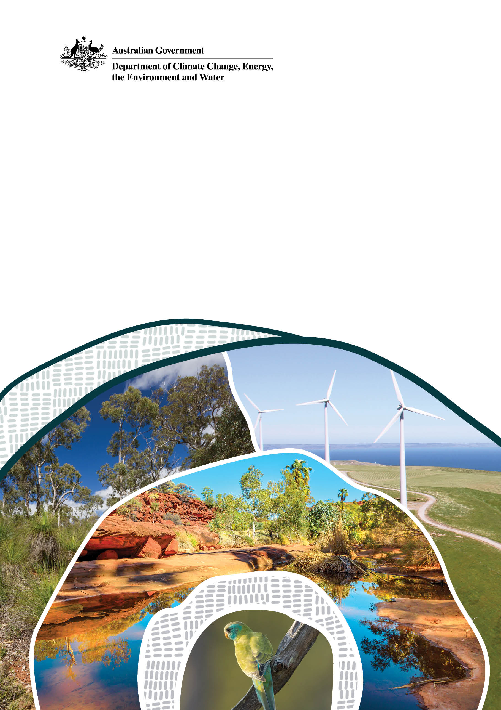
Carbon Farming Outreach Program training package
© Commonwealth of Australia 2025
Ownership of intellectual property rights
Unless otherwise noted, copyright (and any other intellectual property rights) in this publication is owned by the Commonwealth of Australia (referred to as the Commonwealth).
Creative Commons licence
All material in this publication is licensed under a Creative Commons Attribution 4.0 International Licence except content supplied by third parties, logos and the Commonwealth Coat of Arms.


Cataloguing data
This publication (and any material sourced from it) should be attributed as: DAFF 2025, Carbon Farming Outreach Program training package, Department of Agriculture, Fisheries and Forestry, Canberra. CC BY 4.0.
This publication is available at https://www.agriculture.gov.au/agriculture-land/farm-food-drought/climatechange/carbon-farming-outreach-program/training-package.
Department of Agriculture, Fisheries and Forestry
GPO Box 858 Canberra ACT 2601
Telephone 1800 900 090
Web agriculture.gov.au

Update
On 11 March 2026 minor updates were made to the Carbon Farming Outreach Program training package to correct outdated figures and links.

Disclaimer
The Australian Government acting through the Department of Agriculture, Fisheries and Forestry has exercised due care and skill in preparing and compiling the information and data in this publication. Notwithstanding, the Department of Agriculture, Fisheries and Forestry, its employees and advisers disclaim all liability, including liability for negligence and for any loss, damage, injury, expense or cost incurred by any person as a result of accessing, using or relying on any of the information or data in this publication to the maximum extent permitted by law.

Acknowledgement of Country
We acknowledge the continuous connection of First Nations Traditional Owners and Custodians to the lands, seas and waters of Australia. We recognise their care for and cultivation of Country. We pay respect to Elders past and present, and recognise their knowledge and contribution to the productivity, innovation and sustainability of Australia’s agriculture, fisheries and forestry industries.

Contents
Carbon Farming Outreach Program training package 5
Topic 1: Introducing carbon farming 10
1.1 Overview and learning outcomes 11
1.2 Carbon farming reduces emissions, stores carbon 15
1.3 Carbon farming is good for business, good for the environment and Country 16
1.4 How carbon farming responds to climate change 24
1.5 Reducing emissions 26
1.6 Increasing carbon storage 34
1.7 Key concepts 37
1.8 Case study 39
1.9 Actions: What might you do? 42
1.10 Other resources 43
Topic 2: What carbon farming means for farmers and land managers 44
2.1 Overview and learning outcomes 44
2.2 Why you might undertake carbon farming 48
2.3 Carbon farming activities and co-benefits 48
2.4 Potential trade-offs and risks 59
2.5 Expert interviews and case study 60
2.6 Activity 71
2.7 Other resources 72
Topic 3: Your greenhouse gas account 75
3.1 Overview and learning outcomes 75
3.2 Greenhouse gas accounting and accounts 77
3.3 Accounting approaches 78
3.4 Calculators 81
3.5 Meeting calculation requirements 86
3.6 Activities 87
3.7 Other resources 90
Topic 4: Planning carbon farming activities 100
4.1 Overview and learning outcomes 100
4.2 Identifying your carbon farming purpose or motivation 102
4.3 Planning for carbon farming 105
4.4 Understanding greenhouse gas accounting requirements 111
4.5 Climate Active 112
4.6 Case study and expert interviews 113
4.7 Other resources 125
Topic 5: The Australian Carbon Credit Unit Scheme 127
5.1 Overview and learning outcomes 127
5.2 Australian Carbon Credit Units 129
5.3 Establishing an ACCU Scheme project 135
5.4 Earning ACCUs 139
5.5 Trading ACCUs 139
5.6 Activity 142
5.7 Other resources 143
Glossary 145

Carbon Farming Outreach Program training package
The Carbon Farming Outreach Program training package provides information to help farmers and land managers make decisions about reducing greenhouse gas (GHG) emissions and storing carbon.
The training package comprises 5 topics:
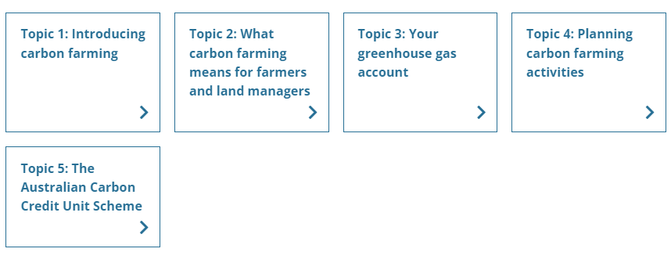

Watch these videos
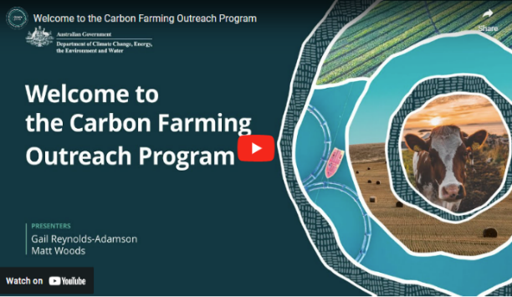
In this video (4:38 minutes), presenters Gail Reynolds-Adamson and Matt Woods introduce the Carbon Farming Outreach Program, and the training package structure and content.
Video: Welcome to the Carbon Farming Outreach Program (youtube.com)

Transcript
GAIL REYNOLDS-ADAMSON: Hi, and welcome to Carbon Farming Outreach Training package.
Kaya Kepa Kurl Noongar Boodja. My name is Gail Reynolds-Adamson, and I'm a proud Noongar woman from Wudjari Country, on the eastern border of the Noongar nation in Kepa Kurl, also known as Esperance. 'Kepa' is water, 'Kurl' is boomerang, and its where the waters lie like a boomerang.
MATT WOODS: Hi, Gail, and welcome, everyone. I'm Matt Woods, an agricultural and science journalist.
Today, we're at my home, outside Bacchus Marsh, on the border of Wurundjeri, Woiwurrung, and Wathaurong Country of the Kulin Nation, and I pay my respects to Elders past, present, and future.
In the valley below me is the Bacchus Marsh agricultural district, where market gardeners and orchardists farm some of the deepest top soil in Australia.
I've been on hundreds of farms and spoken to thousands of farmers from one end of Australia to the other. And if there's one subject top of mind for every farmer, it's profitability.
And that's actually what this training package is about. Because, in most cases, good carbon farming practices will improve the profitability and health of your land. Whether you want to enter the carbon market or not, the truly great outcome with carbon farming is that it can be a win-win: good for your farm business, land, and the environment.
REYNOLDS-ADAMSON: Thanks, Matt. It's great to be part of this Carbon Farming Outreach Program training package, and to be able to share with farmers and land managers from all over Australia some of the who, what, when, where, and why, of carbon farming.
This includes evidence-based knowledge and practices both from Western and traditional Aboriginal Torres Strait Islander culture.
I'm the chairperson of Esperance Tjaltjraak Native Title Aboriginal Corporation in Western Australia. I'll be sharing more about the tree rejuvenation project we are running at Kardutjaanup to show you the many benefits, but also the risk requirements involved with this type of carbon farming.
WOODS: The aim of this package, through five short topics, is to give you the carbon farming essentials from expert practitioners, farmers, and land managers in all Ag (agriculture) sectors across Australia, like Gail, who've already embarked on carbon farming projects.
They'll share some tips and tricks with you, including why and how they did it, what technology and techniques they used, what worked, what didn't and who helped them along the way. We've also carefully researched and selected resources, materials, and tools that may benefit you and presented them by Ag (agriculture) sector and location for your convenience.
We know that you don't have loads of time to spend sitting in front of a computer. And that you need your learning to be relevant, targeted, accessible, and practical.
Each of the five topics should take you no more than one hour individually.
But we've also provided additional content and case studies if you want to find out more.
Short videos like this, as well as interviews and explainers, will allow you to access this package anywhere, anytime.
REYNOLDS-ADAMSON: The Carbon Farming Outreach Program training package won't make you an expert in carbon farming, but it will teach you the essential things you should know before embarking on carbon farming.
This includes benefits and risks, potential pathways to action, and the decision you will need to make, including whether or not to trade carbon credits, and some resources you can refer to for your location and type of practice. Importantly, we will help you to understand who you should talk to, what you should look out for when you are choosing advisors, and to ensure that you are getting quality, trusted, independent advice.
WOODS: Finally, each topic concludes with some relevant focusing questions, for you to consider in relation to your own circumstances.
Whether you're just learning about carbon farming for the first time and are exploring your options or had some experience and want to find out more, this package can help you. Think of it as like having a yarn with your neighbours over the fence about their carbon farming project.
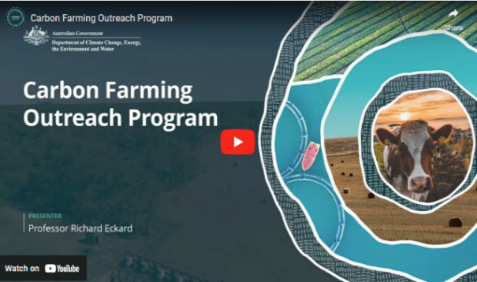
In this video (4:03 minutes), Professor Richard Eckard discusses the need for carbon farming.
Video: Carbon Farming Outreach Program (youtube.com)

Transcript
PROFESSOR RICHARD ECKARD: For farmers and land managers to meet the goal of reduced emissions starting in 2030 through to 2050, they need to know what to do next, what steps to do next, and they need to know where the policy environment is coming from, who's asking them to be low emissions, what the targets are, and then what the options are for them to start responding.
Hi. I'm Richard Eckard, professor in the Faculty of Science at the University of Melbourne. I lead the Primary Industries Climate Challenges Centre, which researches the impact of climate change on agriculture and agriculture on climate.
What we're seeing is all the multinational supply chain companies that deal with agricultural produce have set targets, targets for reduced greenhouse gas emissions. And they average somewhere around 30 percent less emissions by 2030 and net zero by 2050. What we also know is about 70 percent of Australian agricultural produce is exported down these multinational supply chain targets. And so how does Australia perform on the global stage when those companies start buying globally to meet their target?
So it's really imperative that farmers and land managers get on board to know how do they gear their system to deliver the low emissions product that the supply chain will want to buy by 2030. What we're trying to do is just bring up the knowledge that carbon farming is a part of their future.
There is this trajectory towards lower emissions. So making them aware of the policy environment, of the supply chain constraints, of how they need a partnership with their supply chain, to achieve this. And then some awareness of what is their number, how do they get their number, and how do they move down the track towards improving that number. And what are the technologies they can bring to bear to reduce their number, their greenhouse gas footprint?
So these will be things to start with are just best practice. Best practice that we've known for the last 40 years. Things like nitrogen use efficiency, better crop yields, better soil testing, better growth rates in livestock, feeding animals better, bringing legumes into agriculture. These are all things we've known for a long time that improve efficiency, but also reduce the greenhouse gas footprint.
Australia is already 22 percent more rainfall variable than any other country in the world, and the historic management of the land took that into account. Now we're becoming aware of this in how we do carbon farming, that we have to actually change from strictly European farming systems to systems that are more attuned to this high variability we're encountering. And so there's a lot to be learned from the Indigenous land management practices that we need to then incorporate into traditional farming, non Indigenous farming, so that it actually is a bit more in tune with the high variability we have in Australia.
Now the world needs to go net zero by 2050. What we haven't really reconciled is where does the big emission reduction take place? Obviously, it has to happen in the fossil fuel sector.
But we need to move towards, well, what can agriculture contribute to that inevitable net zero? And what can they contribute towards the 2030 goal? Now not every agricultural sector has the identical opportunity. We've got some intensive horticulture for example that have very low emissions and almost nothing to do to get to net zero apart from renewable energy. But you've got an extensive livestock sector where a lot of northern cattle stations, we don't even know how many cattle are there. So the challenges are vastly different, and this is what the program is trying to address is who has what options to move forward and what are those options.

Glossary
The glossary provides definitions for key words and terms used in the training package. The glossary is included at the end of this document.

Using this training package
This training package provides introductory information, and sources of further information and advice. References to third-party material, information or products or services do not represent endorsements. This training package does not provide detailed information that farmers and land managers may need when making decisions about carbon farming for their own particular circumstances. This training package is not a substitute for independent professional advice. Before making decisions about carbon farming, you may need to obtain more information and independent advice relevant to your particular circumstances.

Acknowledgement of Country
The Australian Government acknowledges the Traditional Owners and custodians of all the lands across Australia. We pay respect to all Aboriginal and Torres Strait Islanders, including elders, past and present. We also express our gratitude and appreciation for the ongoing stewardship of Country that Aboriginal and Torres Strait Islanders have practised for thousands of years. We understand that we all have much to learn from traditional ways of knowing, being and doing.

Statement of intent
This training package has been developed in consultation and collaboration with an Aboriginal and Torres Strait Islander reference group. We thank them for their generosity with time, expertise, and patience. We recognise Aboriginal and Torres Strait Islanders as rights holders and value the opportunity for Aboriginal and Torres Strait Islanders to engage with farmers and land managers in meaningful dialogue to weave traditional practices into carbon farming. Aboriginal and Torres Strait Islanders offer invaluable traditional ecological knowledge that complements the expertise of other farmers and land managers. Together, farmers, land managers and Aboriginal and Torres Strait Islanders are practising carbon farming methods that respect traditional insights and modern science. As co-innovators, we are exploring new pathways to reduce carbon footprints through joint carbon farming initiatives and preserving the land for future generations.
Aboriginal and Torres Strait Islander people should be aware that this website, the videos it contains and links to First Nations resources may contain images, voices and names of deceased persons.

Topic 1: Introducing carbon farming

Time to complete this topic
About 60 minutes to read the information in this topic. Additional content includes videos, activities and links to other resources which may require extra time to complete.
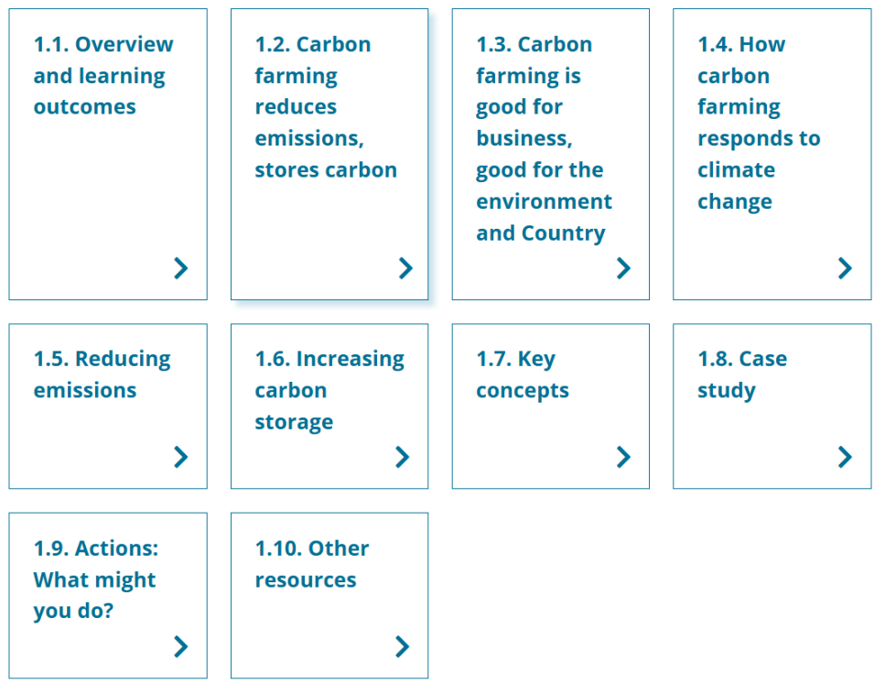
In this topic:

  - Overview and learning outcomes

Overview
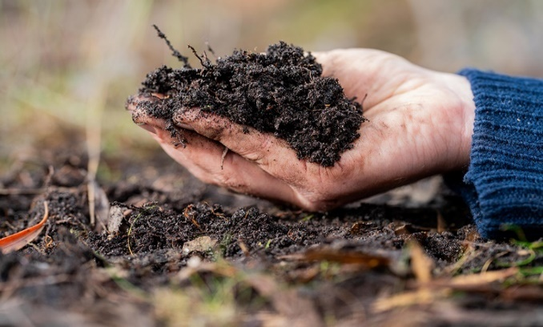
Topic 1 introduces carbon farming, carbon farming activities, and their purposes, which include:
- reducing emissions
- storing more carbon
- delivering economic and other co-benefits to farmers and land managers, the environment and communities.
This topic introduces key concepts from the farmer’s and land manager’s viewpoint: how increasing carbon storage on their land and reducing emissions from their operations helps reduce their carbon footprint. It introduces carbon accounting, tools and calculators to estimate a carbon footprint.
The topic explains how Aboriginal and Torres Strait Islander people (Australia’s First Peoples, referred to in this program as First Nations people) have cared for Country for over 60,000 years and that carbon farming activities can potentially align First Nations peoples’ traditional knowledge and recent science-based farming and land management methods.
The topic drills down into increasing carbon storage (sequestration) by explaining the carbon cycle, soil organic carbon, the greenhouse effect, and climate change. It examines the agriculture sector’s emissions profile, which is mostly methane and nitrous oxide emissions.
The topic concludes by explaining ‘carbon neutral’, ‘net zero emissions’ and possible pathways for action — earning Australian Carbon Credit Units (ACCUs) under the Australian Carbon Credit Unit Scheme (ACCU Scheme) and gaining Climate Active certification — while recognising some farmers and land managers will choose to do neither.

Learning outcomes
After completing this topic, you will be able to:
- describe carbon farming and carbon farming activities
- classify greenhouse gas (GHG) emissions and carbon sinks relevant to agriculture and land management
- explain how carbon farming can potentially align First Nations peoples’ traditional knowledge with recent science based farming and land management methods
- acknowledge the carbon cycle and nitrogen cycle, their relationship to GHGs, and their role in climate change
- outline key carbon farming-related concepts, including carbon neutrality, net zero emissions, Australian Carbon Credit Units (ACCUs), and Climate Active certification.

Watch these videos
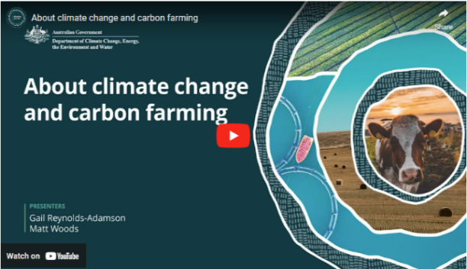
In this video (3:59 minutes), presenters Gail Reynolds-Adamson and Matt Woods introduce Topic 1 and provide important context.
Video: About climate change and carbon farming

Transcript
GAIL REYNOLDS-ADAMSON: In this first topic, we'll look at the basics of carbon farming, what it is, and why we need it. There are many different reasons why you might choose to carbon farm, and we will cover these benefits in the next topic.
But there's one reason why carbon farming is important, and it affects all of us. Yep. Climate change.
MATT WOODS: Now we know that we don't need to tell you how a warming planet, because of carbon and other emissions in the atmosphere, is playing havoc with our climate.
As farmers, you're experiencing firsthand increasingly severe and frequent extreme weather events like drought, fire, and floods that are negatively affecting your livelihoods.
The hard reality is that farming is part of the problem, with agriculture accounting for about 17 per cent of total greenhouse gas emissions in Australia.
The good news is that farmers can also be a big part of the solution, and carbon farming helps with this.
REYNOLDS-ADAMSON: Aboriginal and Torres Strait Islander people, like all First Nations people around the world, have been caring for our land for tens of thousands of years. We are connected to Country. We are part of the Country, and Country is part of us.
We take a holistic approach and acknowledge the importance of sustainable land management, emphasising health of our land, the well-being of the ecosystem, and the preservation of cultural heritage.
In short, through traditional land management practices, we care for Country and Country cares for us.
Of course, it's not only First Nations people who have a connection to this land and a desire to care for it. The beauty of carbon farming is it allows us to combine the best of both worlds, applying ancient cultural practices such as savanna burning with the Western scientific knowledge system.
Modern day technologies can help Indigenous and non-Indigenous farmers alike to reduce carbon emissions.
We've learned in our tree rejuvenation project there are different approaches that you can use to gain both financial and non-financial benefits.
WOODS: Carbon farming is also usually good for business.
Sequestering carbon and reducing greenhouse gas emissions can increase profitability.
Climate change and carbon credits aside, carbon farming can make sense for farmers and land managers if they want to improve their bottom line and the environment.
Selling carbon credits is a further option for land managers and farmers.
However, making money from carbon credits is complex and, like most ventures, has risks.
In this topic, we'll look at some basic climate science and the impact of agricultural greenhouse gas emissions.
We'll also explore carbon farming in more detail and the types of activities you can do to reduce greenhouse gas emissions in your sector.
In addition, we'll see some traditional First Nations practices, and finally, look at the difference between carbon credits and carbon neutral accreditation.
REYNOLDS-ADAMSON: We all have a connection to this land. For Aboriginal and Torres Strait Islander people, we know this is caring for Country, which we have done since time immemorial.
Now with climate change, we need to look at repairing Country for future generations.
Mother Earth does not see colour.
Collectively, we have a responsibility to repair our environment.
Let us share our knowledge and experiences to support each other to have a mutually beneficial outcome and leave this Country better than how we received it.

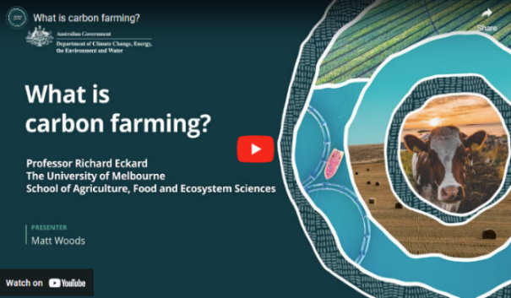
In this video (2:13 minutes), Matt Woods and Professor Richard Eckard of the University of Melbourne discuss carbon farming in relation to carbon capture in plants through photosynthesis.
Video: What is carbon farming?

Transcript
MATT WOODS: Hello. I'm Matt Woods, and I'm here with Professor Richard Eckard. Richard has been working for over 20 years on addressing the impacts of a changing climate on agriculture.
How would you describe what carbon farming actually is?
PROFESSOR RICHARD ECKARD: Well, ironically, carbon farming all farmers are in the carbon business because what most people don't realise is that almost half of all organic vegetation, this is wheat, pastures, any crops that we produce, almost half of it is carbon. So, actually, we're in the game of carbon conversion. We capture carbon out of the atmosphere through photosynthesis.
It takes CO₂ out of the atmosphere, carbon dioxide, locks it into plants in carbohydrates. We either feed that to humans or feed it to animals. So, actually, all farmers are in the carbon business. We've just never asked the question, how do you be more efficient at that conversion process? How do we capture more carbon out the atmosphere into a better wheat crop, into a better pasture?
And then how efficient are we at converting that into a product that goes through to humans?
But also how are we efficient at capturing or leaving excess carbon in the soil to end up with a greater soil health?

1.2 Carbon farming reduces emissions, stores carbon

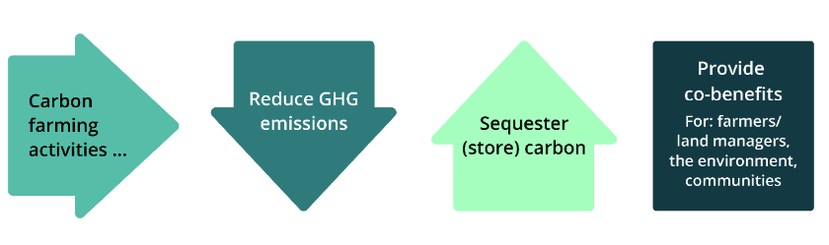
Carbon farming
'Carbon farming' describes agricultural and land management activities that help mitigate climate change by:
- reducing emissions of the main GHGs: methane, nitrous oxide and carbon dioxide, by avoiding or minimising them
- storing more carbon — also called sequestering carbon — which means capturing and removing carbon dioxide from the atmosphere and storing carbon in 'carbon sinks': vegetation and soil. Carbon is stored in land and coastal ecosystems (such as mangroves).
Each carbon sink stores carbon differently. For example:
- in vegetation (such as trees and grasslands), carbon is stored in the stems, trunks and roots
- in soil, carbon is stored in living and dead organic material.
Topic 2 looks at the carbon farming activities in the following table.

Carbon farming activities
Group | Activity
Soil | Conservation and strategic tillage  Crop and pasture management  Efficient fertiliser use
Livestock | Reduce beef and dairy cattle and sheep methane emissions  Manage piggery and dairy effluent  Grazing management
Vegetation | Afforestation  Reforestation  Agroforestry  Retain existing native vegetation
Blue carbon | Restore wetlands, saltmarsh and seagrass  Remove or modify barriers to tidal flow
First Nations traditional ecological practices | Cultural burning, including savanna fire management

1.3 Carbon farming is good for business, good for the environment and Country
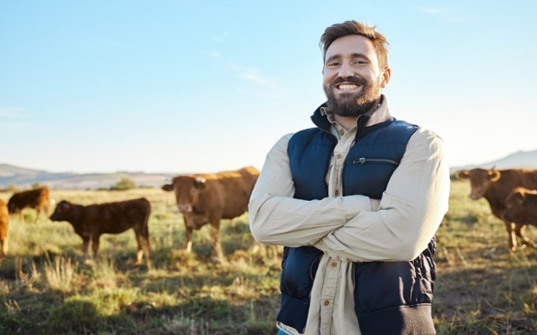
Carbon farming not only benefits the climate by reducing GHG emissions and storing more carbon. It can also provide other benefits — called co-benefits — including:
- healthier and more productive soils, better managed and more productive livestock and pasture, better use of water
- more diversified income streams, increased income and the ability to deliver products for environmentally conscious supply chains, consumers and overseas markets pursuing emissions reduction or nature positive policies
- improved biodiversity and ecosystems, such as connected habitat and traditional ecological practices that maintain a balance between human activities and the natural environment
- stronger, more resilient communities, better quality food, more jobs, better-protected settlements and infrastructure, and better community health
- direct benefits for First Nations people, including meaningful jobs on Country, independent revenue, getting back to and caring for Country and protecting cultural sites, and indirect benefits, including meeting cultural obligations, strong governance, community cohesion, self-determination, pride in community, and healthy Country.
Industry and government sustainability plans
Agriculture industry bodies have developed or are developing sustainability plans, as the following table shows. These plans include reducing GHG emissions, increasing carbon storage, and achieving carbon neutrality.
Agriculture sector sustainability plans
Sector | Plan
Beef, sheep | Red Meat 2030  Meat and Livestock Australia (MLA) 2030 Strategic Plan (PDF 2.2 MB)  The Australian Beef Sustainability Framework  Sheep Sustainability Framework
Cotton | Australian Cotton Sustainability Framework
Dairy | Australian Dairy Sustainability Framework
Grain | Grains Research & Development Corporation Sustainability Initiative 2023 (PDF 4.6 MB)
Horticulture | 2023/24 Australian-Grown Horticulture Sustainability Framework (PDF 12.6 MB)
Pork | Australian Pork Ltd Strategic Plan 2020–2025 (PDF 4.4 MB)
Poultry | Sustainability Framework Report 2020 (PDF 2.8 MB) (Australian Eggs)  Chicken Meat Sustainability Strategy (being developed by the Australian Chicken Meat Federation)
Rice | AgriFutures Rice Program Strategic RD&E Plan 2021-2026
Sugar | Sugar Research Australia Strategic Plan 2021–2026 (PDF 1.9 MB)
Wine | Wine Australia Emissions Reductions Roadmap (PDF 8.6 MB)

These industry initiatives complement efforts by Australian, state and territory governments to help farmers and land managers respond to climate change. These efforts include:
- Australian Government climate change strategies, including a Net Zero 2050 plan, the Agriculture and Land Sector Plan and the ACCU Scheme
- state and territory policies (such as Victoria’s Agriculture sector emissions reduction pledge 2026-30 (PDF 3.8 MB) and the New South Wales Net Zero Plan and Climate Change (Net Zero Future) Act 2023
- state and territory programs (such as Queensland’s Land Restoration Fund).
Actions taken by governments are consistent with the United Nations Framework Convention on Climate Change, a framework for international cooperation and action to reduce GHG emissions and adapt to climate change impacts.

First Nations communities protecting culture and Country

Indigenous-owned carbon projects across Australia are making a huge difference to our lives through creating jobs and supporting opportunities for Indigenous people to care for country.

Cissy Gore-Birch and Dean Yibarbuk,
Indigenous Carbon Industry Network Co-Chairs
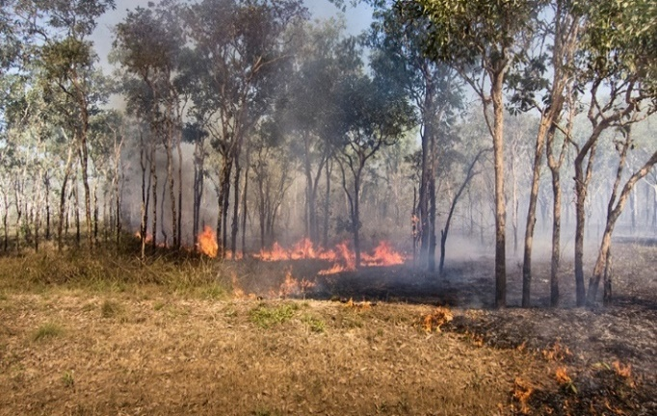
First Nations traditional ecological practices are deeply ingrained with cultural, spiritual, and ecological knowledge, and they focus on sustainability, ecosystem balance, and health.
For example, cultural burning — lighting slow, ‘cool’ fires early in the dry season — reduces the risk of hot summer bushfires that produce greater quantities of GHGs. Cultural burning, which is just one of many such traditional practices, also improves the richness of species.
Carbon farming activities can potentially align First Nations peoples’ traditional knowledge and recent science-based farming and land management methods by:
- focusing on efficient water use and sustainable irrigation practices, which is important in our dry continent and increasingly necessary to adapt to climate change impacts
- emphasising the interconnectedness of people, land and ecosystems (such as regenerative agriculture, which integrates economic, social and environmental considerations)
- using low-intensity planned burning to create firebreaks and a mosaic of burnt and unburnt land.
Carbon projects offer First Nations land managers the opportunity to generate income to support the carbon project and/or other community initiatives. So far, this opportunity has been accessed mainly by First Nations groups undertaking savanna fire management in northern Australia. Topics 2 and 5 provide information on savanna fire management.
There are further opportunities for First Nations land managers around Australia to participate in carbon projects. Carbon projects must follow approved ACCU Scheme methods. Land sector management activities (covered by methods) most relevant to First Nations groups can include:
- Savanna fire management (emissions avoidance method, or sequestration and emissions avoidance method)
- seed or tubestock planting to re-establish native vegetation (Reforestation by environmental or mallee plantings method)
- removal of tidal restrictions (Tidal restoration of blue carbon ecosystems method).
The Indigenous Carbon Industry Network’s 2022 Indigenous Carbon Projects Guide (PDF 8.5 MB) provides more information about the carbon industry for First Nations people. It covers the carbon market, ACCU Scheme method and project requirements and planning, and running a carbon project. It also has information specific to First Nations people, including Indigenous rights and interests, co-benefits and the power of story.

Watch these videos
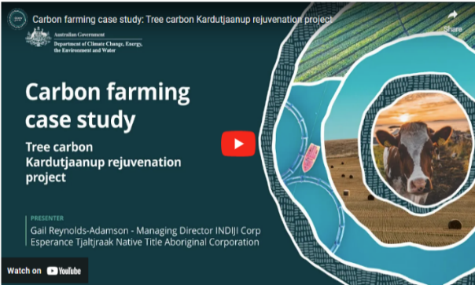
In this video, (6:10 minutes), Gail Reynolds-Adamson shares her insights into some of the traditional practices and benefits for First Nations farmers and land managers.
Video: Carbon farming case study: Tree Carbon Kardutjaanup rejuvenation project

Transcript
GAIL REYNOLDS-ADAMSON: So my name is Gail Reynolds-Adamson, I'm the chairperson for Esperance Tjaltjraak Native Title Aboriginal Corporation, and we're currently standing at Kardutjaanup, which is a property that we purchased a couple of years ago to look at carbon farming.
Our people have been doing carbon farming for millennia. We just didn't call it carbon farming back then. So where we are today is taking an ancient culture and applying modern technology to do the carbon farming and do it in different ways. So Tjaltjraak is a PBC and the PBC is a prescribed body corp, which once native title has been determined you set up a PBC for the organisation.
One of the issues that we found, with the organisation is that whilst we get a bundle of rights, there's nothing else that we get and so we had to look at innovative ways on how we can generate income into the future. Also, not only looking at generating income, but how do we look at it- do it in a sustainable way, and we do it in a way, which is, in line with us looking after Country and a part of our healthy Country plan. So the marriage between us and doing work in the carbon farming area was an area which we were interested in and certainly were like everything in the carbon farming, it's new. Each farm that we look at or each location that we look at, the technique that our specialists have to apply is quite different. But it's a way of us as an organisation to generate income into the future, and it's about self-determination.
And Esperance is a huge farming community. So if you're not in farming, you're not in the local economy.
This property here, we purchased it, and behind me is you'll see a peak, which is called Peak Charles, but we know it as Aboriginal people as Kardutjaanup. And when we purchased this property as Esperance Tjaltjraak to commence our journey into the carbon farming world, we decided that it was more appropriate to rename this property and call it Kardutjaanup, which is linking us to not only the Peak Charles or the peak behind us, but also to the UCL, the unallocated crown land, which is the land which we're trying to mimic back on Country here.
So Tjaltjraak are actually engaged in doing a number of different carbon farming products.
This one here at Kardutjaanup is actually broad acre. And then we've got another property, which is, Cocanarup, which is another property closer to to the coastline.
And that property there hasn't been as farmed as extensively as this one and other projects that we're involved in is around our healthy Country plan, which is planting our trees for carbon, but as part of restoration of Country at the same time. So it's just not one size fits all for us it's about looking at each of those locations. And as you saw with Kardutjaanup the harshness of this area, the low rainfall means that the technique that we applied last year hasn't quite worked.
We didn't get the growth that we wanted to. So we're gonna be trying a different technique each year. So each year, we're learning more. And it's like any piece of land it's about understanding your land, it's about applying different techniques, and what will have worked here may not work in another location.
How do we improve and how do we do something different from last year to have a better outcome next year? And if that doesn't work, then what do we need to do from the two years that we've learned, to then have something different the following year? So we're looking at the long term game here and sustainability into the future for future generations.
We employed our experts in this area who approached us in relation to an innovative way of looking at creating a sustainable income for us as an organisation, but doing one that's in line with our philosophy around caring for Country. And so carbon farming meets that, its about us generating income from selling the the carbon units, but also rejuvenation of our Country, you know, replanting Country and generating an income off that. So it's this holistic approach to how we actually look after Country, not just the traditional way that we've gone, on the coastal areas where we're actually funded by the government to do the rehabilitation. Here, it's a sustainable way that we're actually looking at as a private industry and a private company that we've actually entered into a business arrangement with to do carbon farming.
We have, you know, employment outcomes for our people. You know, we've got a large young Aboriginal population in our community, and 50 per cent of our population is under the age of 25. So it means that we've gotta find creative ways to employ, to train, and also the carbon farming and the different types of skills and techniques that required from both, you know, going out there and farming, planting trees, manually opposed to planting with the tractors.
All of those elements, elements of skills that we're teaching our mob and it's a different way of caring for Country. So it's restoration, it's carbon farming, and we're generating an income for us so that we're sustainable into the future as an organisation.
We're a year into carbon farming. It is so new, and we have so much to learn in this space. We don't know what the future holds for us in relation to if this is going to be successful.
But what we see is there's a glimmer of hope and part of that is the seedlings that, have broken through and and the resistance that some of them had in such a harsh environment. And then we also the outcomes, the employment outcomes for our mob is just so important. You know, they're learning things outside of just being a ranger. They're coming out and learning to be farmers.
And along the way, we grow the knowledge with our community with our mob. It’s about, you know, self-determination for us is about looking at how do we actually do farming in a different way, today, but a way in which we have been doing for thousands of years, but applying different techniques today to be able to have the same outcomes on caring for Country.
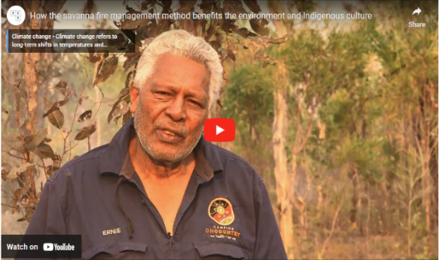
This video from the Clean Energy Regulator (6:48 minutes) explains how First Nations savanna burning works in Northern Australia and its many benefits, including reducing emissions.
Video: How the savanna fire management method benefits the environment and Indigenous culture (youtube.com)
Transcript
With its vast and rugged landscapes, immense beauty, wildlife, scenery, history, lore, culture and ancient art. Northern Australia is one of the most spectacular places on earth. However, like all our natural treasures it remains vulnerable to the impacts of climate change. The good news though, there's some amazing work happening right here on these impressive landscapes to help combat it. G’day, Ernie Dingo here. I'm sharing a story of how fire management across the top half of Australia is helping to reduce emissions, benefit community and businesses, and help the environment. That fire has been part of our lives since the beginning of time. We probably invented fire. Healthy Country, healthy people, and fire played a big part in that.
Embedded in the culture and in the land, traditional fire management has been more recently reinvigorated with the support of the Australian Government's Emissions Reduction Fund. The fund supports farmers, Indigenous Australians, and other businesses to reduce greenhouse gas emissions. It's the ways of burning country so we have green grass to grow again. And it's more like burning a bit earlier than having a late fire.
Our Country is better looked after when savanna fire management projects are underway. These projects restore the similar fire regime that was used for tens of thousands of years by Indigenous Australians. These projects are creating healthier ecosystems with benefits for plants and animals. We've seen all the tracks for wallabies, big kangaroo and the small one, they just came back, when we had a fire. All our old people, they were telling the story about you do 'right way' fire, you will get good rain, animal will come back, a lot of good flower, good honey. Savanna fire management reduces emissions by reducing frequency and extent of destructive late dry season wildfires. these huge wildfires are bad for the climate, damaging our atmosphere. Savanna projects use the latest science to track fire management activity and estimate emission reductions. This translates into Australian carbon credit units. So far savanna projects have already reduces more than 7 million tonnes in emissions.
This story of savanna fire management isn't a new one. These techniques have been used for tens of thousands of years but it's the 'right way' fire mob who's been combining modern science and traditional knowledge to build an industry and make a big difference in our Country. Projects are generating income by selling carbon credits to the Government and businesses. With the extra income, project participants are able to spend money on more important projects to look after their community and Country.
It brings in more opportunities, more jobs for local people and our people as well, so that, you know, people can continue what we're doing today - is keep on looking after the land and our Country. We're using helicopter because we're earning good income from a carbon program. And the money that we bring from carbon, we distribute to the community, and we get rangers and TO's more salary, and getting more equipment. Fire was there for many reasons. Cleaning up Country, cleaning spirit, so that families can go back and use that Country. Paying respect for that Country. We've got that fire, it brings life. And them old people living, they say you do 'right way' fire, you get em good fish, you get em good rain, you get em, Country it reward you.
Being a woman ranger, it's just great. You get to go around and see a lot of other places and you know what's happening on their land and we know and they know what's happening on their land.
Being a ranger is my dream job and it's really great, taking kids around country and learning about culture and stuff Carbon farming is good for us cause we have a ranger job. Wunambal Gaambera has our rangers. It’s good for, like, it's good for like, to get people back out on Country, and keep their Country strong and healthy.
Well it helps, it helps to employ more young people and then you know it helps us to buy more equipment. Saving the planet, making money, but something we've been doing for centuries.
Our ancestors have been using fire for hunting, gathering, even using fire for getting 'right way' married. So fire it's a big stuff for us.
Savanna fire mob have been combining modern science and traditional knowledge to build an industry and make a big difference in our Country.
This film was produced by bush TV Enterprises on behalf of the Australian Government. Bush TV.

Activity: Your land and First Nations people
Reflect on your connection to your land and consider the following questions.
- What is its history?
- Do you know which Aboriginal or Torres Strait Islander group are the Traditional Owners of your land?
There is more information on the Map of Indigenous Australia.
 Caring for Country practices we want, such as fire management, weed management, feral animal management, revegetation programs, traditional food harvesting, cultural mapping and ecological surveys, provide an opportunity for Aboriginal and Torres Strait Islander people to reestablish or strengthen their connection to Country.

For such a long time, people lived on Country, managing fire and the Country for thousands and thousands of years. But nobody lives here and walks here like the old people did. Now, fires have become too fierce because we haven't been managing fire, so destructive fires have come. The ways of the old people have passed, we need to make new ways to make this land healthy.

Dean Yibarbuk, Warddeken Land Management Ltd (Co-chair) and Co-Chair,
Indigenous Carbon Industry Network

  - How carbon farming responds to climate change

Carbon farming helps reduce your carbon footprint
Carbon farming, as we have seen, reduces GHG emissions and stores carbon, which are essential to Australia’s response to climate change.
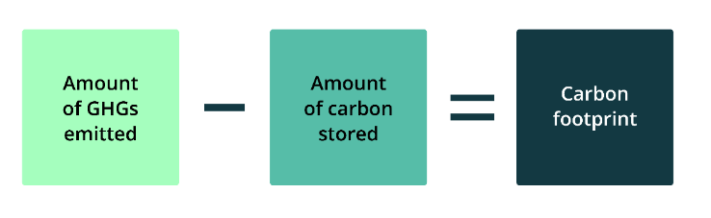
A ‘carbon footprint’ or ‘greenhouse gas footprint’ is the amount of GHGs emitted minus the amount of carbon stored by, for example, a farm, region or country.

Reducing your carbon footprint
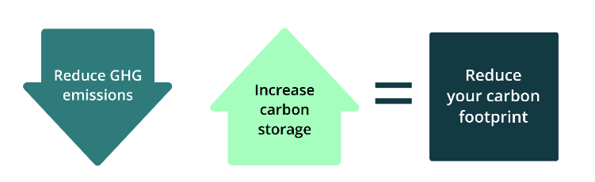
Reducing GHG emissions, storing more carbon or both helps reduce a farm’s or land area’s carbon footprint.

Knowing your carbon footprint
Getting serious about carbon farming means drilling down into detail to calculate your GHG emissions and carbon stored.
Topic 3 looks at some of the many calculators and tools available from governments, industry bodies and others to estimate GHG emissions and carbon storage.

Climate change and Earth’s increasing emissions
Human activities are causing increasing amounts of GHGs in the atmosphere.
Earth’s GHG emissions are mainly the result of:
- the burning of fossil fuels — the ancient remains of plants and animals that geological processes have transformed into carbon-rich coal, oil and gas — releasing carbon stored for millions of years into the air as carbon dioxide
- a range of human activities that release methane and nitrous oxide into the atmosphere.
The clearing of forests contributes to emissions and reduces Earth’s capacity to absorb carbon dioxide.
The greenhouse effect
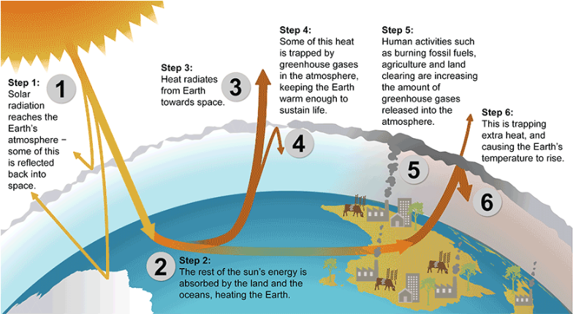
The Earth is heated by the sun, and some solar energy is reflected from its surface. GHGs prevent the loss or escape of heat into space, just as glass traps heat inside a greenhouse. This warming is essential for life on Earth. However, an increasing blanket of GHGs is trapping too much heat, preventing it from radiating back into space. This results in excessive global heating, which has consequences including changing climate patterns, upward-trending temperatures, melting ice, rising sea levels and extreme weather events, including droughts, floods, cyclones, and bushfires.
To learn more about climate change, read Understanding climate change.
Two resources for farmers to better understand how climate change is likely to affect their area and products are:
- My Climate View, which provides tailored climate overviews about what to expect from the climate at the user’s nominated location in the future and the climate impact on selected commodities
- Climate change impacts and adaptation on Australian farms, which presents the latest modelling by the Australian Bureau of Agricultural and Resource Economics and Sciences (ABARES) that examines the effect of recent and possible future climate changes on the profitability of Australian farms.

Other resources about climate change include:
- the Australian Government Department of Climate Change, Energy, the Environment and Water (DCCEEW) Climate change website which has information about climate science and adaptation, Australia’s climate change strategies, emissions reduction and reporting and other climate change topics.
- Climate Change in Australia which provides climate information, projections, tools and data to help in understanding and planning how to adapt to the impacts of climate change.
- Some states also have climate change adaptation plans. An example is the AdaptNSW website, which has information about actions to adapt to climate change by region.
  - Reducing emissions
Agricultural production, including livestock and crops, contributed 18.2% of Australia's total GHG emissions in 2022-23 in Australia’s National Greenhouse Accounts. This does not include emissions associated with electricity, energy and fuel use in agriculture.
Emissions and sequestration associated with land management are accounted for under a separate category called land use, land use change and forestry (LULUCF). This category includes forests, land clearing, savanna fires and changes in soil carbon levels. As shown below, in 2022-23 this category was a net sink, reducing Australia’s overall emissions by 16.3%.
The following figure shows the share of total emissions by sector for 2022-23.
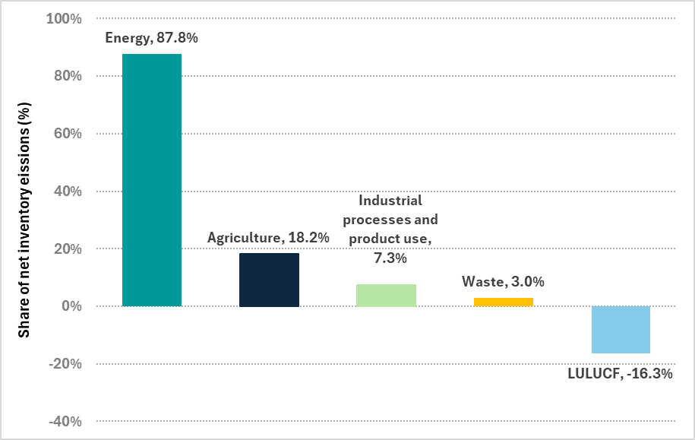
Chart created using source: National Inventory Report 2023 published May 2025.

About this data
The sectors and their shares of total emissions in 2022-23 were: energy (87.8%), agriculture (18.2%), industrial processes and product use (7.3%), waste (3.0%) and LULUCF (-16.3%).

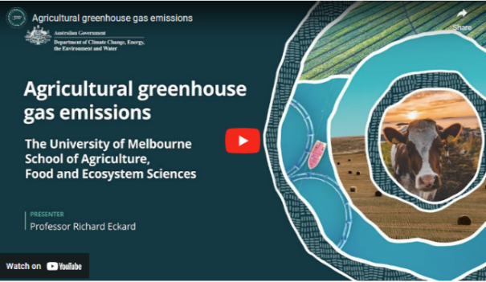
Watch this video
In this video (9:14 minutes), Professor Richard Eckard of the University of Melbourne gives an overview of the GHGs emitted by the agriculture sector.
Video: Agricultural greenhouse gas emissions

Transcript
PROFESSOR RICHARD ECKARD: We introduce what are greenhouse gases.
Now what we know from two separate studies, and there's a number around the world you can find, they don't vary that much, that agriculture globally contributes somewhere between 13 and 14 per cent of greenhouse gas emissions. This is just the on farm emissions, not the supply chain emissions, which would include some, transport, some of the energy consumption.
So overall agriculture, food supply chain is responsible for about 22 to 25 per cent of greenhouse gas emissions globally.
Now, what makes a greenhouse gas?
A disclaimer on this slide first up is I used to run a course where a climate science expert would spend an entire day explaining what's on this slide, so forgive me when I try to do it in two minutes.
But essentially, if you think of the atmosphere, the air that you breathe, the majority of it is made up of oxygen, O₂, so double bond, and nitrogen, 78 per cent of the atmosphere is nitrogen, dinitrogen, two nitrogen bonds.
That effectively makes the baseline of the vibrational frequency of the atmosphere, because those bonds are vibrating at a certain frequency.
So they would absorb a certain amount of heat and re-radiate it. Because that's the majority of the atmosphere, then that forms the baseline of the atmosphere, as I said.
Greenhouse gas emissions tend to be any molecule, any gas that has more than the baseline number of bonds. In other words, CO₂’s got an oxygen, carbon and two oxygens. Methane's got a carbon and four hydrogens.
So there's four bonds involved there. So the moment you go from the baseline and you start adding more of these other gases into the atmosphere, you've got molecules that can hold more temperature, more radiation, that can absorb more wavelength radiated from the sun, and therefore re-radiate it back to the Earth. So hopefully that explains why water vapour, carbon dioxide, methane, and nitrous oxide can hold, absorb, and re-radiate more than the baseline of the atmosphere. So even though their concentration is right quite small in the atmosphere, that's where the change from the baseline is occurring.
Now, what is the effect of these major greenhouse gases? On the left, you've got the radiative forcing, and on the right, you've got the concentration in carbon dioxide equivalents.
And so you can see that the majority of the problem in the climate system is carbon dioxide from industrial fossil fuel emissions, But methane makes a fair contribution to the radiative forcing in the atmosphere, so we can't ignore it. Nitrous oxide also makes its contribution, and synthetic gases will be like sulphur hexafluoride, completely synthetic gas, but has a global warming of well over a thousand that times of CO₂.
So they all make a contribution, but if we had to really address the core problem, it is industrial emissions.
On the right, you've got the difference in the global mean CO₂ concentration from just CO₂. So that's the blue on the left, and on the right you've got the concentration, but what the equivalent CO₂ emissions would be if we added all the gases together. So clearly the other agricultural gases make their contribution as well.
Now we know that methane continues to increase in the atmosphere. This is data from the Cape Grim Research Station, which is on the northwest point of Cape Grim in Tasmania.
If you look due west from that point, there's nothing but ocean until you get to the southern tip of South America.
So it's one of the stations in the world that would be completely fully mixed air, unaffected by local pollution, and so this is where we get these results from. You can download them yourself from the CSIRO website.
The fluctuations annually is because we've got a larger landmass in the northern hemisphere than the southern, and so during the northern summer, a lot of the Siberian ice fields would melt somewhat, and you would get more methane produced from peat bogs in those extensive lands in the north.
Because the Southern Ocean dominates the southern hemisphere, there's more ocean than land, then in the southern summer we don't get as much of a pulse of methane, so we get this oscillation, but the bottom line is it continues to increase in the atmosphere.
Now we know that methane has a shorter lifetime in the atmosphere, somewhere around a half life of 11.8 years of lifetime, and the concentrations continue to increase relative to pre-industrial. On the right hand side I have given you the IPCC assessment reports from the second assessment report through to the sixth assessment report and what they published as the global warming potential either of a 20 year period or a 100 year period. These are the global warming potentials for methane. So the latest methane multiplier is 27 times that of carbon dioxide on a 100 year timescale.
Now for those of you wondering whether there is a difference between biogenic and fossil methane, there is.
It is already accounted for in the IPCC guidelines, as I have in the table there. A lot of people make a lot of fuss about this, but it doesn't actually make a big difference. Just to explain, methane is methane while it is in the atmosphere for 12 years.
The atmosphere doesn't see a difference in the methane molecule depending on where it came from. So for the duration that it's in the atmosphere, its warming is identical.
It therefore only comes back to what the original carbon molecule was before it became methane and where that came from. Was that a recent molecule from photosynthesis in the case of biogenic?
It would be in photosynthesis that went into a plant in the last 12 months and then went through the animal, came out as methane for 12 years, and then went back to the atmosphere as the original CO₂ that was there 12 years prior.
Whereas fossil methane would be ancient photosynthesis that went into an ancient forest that got buried deep under the earth for millions of years and therefore when that methane breaks down, it's technically releasing a CO₂ molecule that is new to the atmosphere in millions of years timescale.
So it only matters the original breakdown products of CO₂ and water vapour once methane breaks down, and that's what's accounted in the difference between 27 times methane or 29.8 times methane.
Hopefully, that makes sense.
So here is the trend in nitrous oxide emissions from the Cape Grim weather station as well. You can see it is a lot more consistent because we don’t have the northern southern hemisphere issue. It is mainly driven by the expansion of food production around the world and the use of fossil fuel fertilisers.
Some of that would be legumes and the increase in livestock, but majority by the Haber Bosch process, one would argue.
Now we know that nitrous oxide has a longer residence time in the atmosphere than other greenhouse gases, so well over 110 years, somewhere around there.
But it has two actions in the atmosphere. One, it is inert in the troposphere, but it absorbs infrared radiation.
But secondly, it also causes ozone depletion in the stratosphere. So, two points of action.
Concentrations are fairly modest in the atmosphere, but it’s a very powerful greenhouse gas. And you can see from the various assessment reports that because it's a long lived greenhouse gas, 20 years versus 100 years doesn't make much of a difference to its global warming, and the multiplier has been fairly consistent over time, so 273 times that of CO₂.
The average emissions from a grain farm might only be 250 grams of nitrous oxide nitrogen per hectare per year, but you have to multiply that by 273 to get the actual warming effect.

Agricultural emissions
The main sources of emissions from agriculture are:
- methane emissions from livestock (enteric fermentation) — mainly beef and dairy cattle and sheep — which together accounted for 71.9% of the agriculture sector’s emissions in 2022-23
- nitrous oxide emissions from soils — including from applying fertilisers and incorporating crop residues in soil — which totalled 13.4% of sector emissions in 2022-23
- methane and nitrous oxide emissions from managing manure (primarily from cattle, sheep and pigs), which represented 9.7% of the sector’s emissions in 2022-23.
Sources of agricultural GHG emissions
The following figure shows the contribution of each emissions source to total agricultural production emissions.
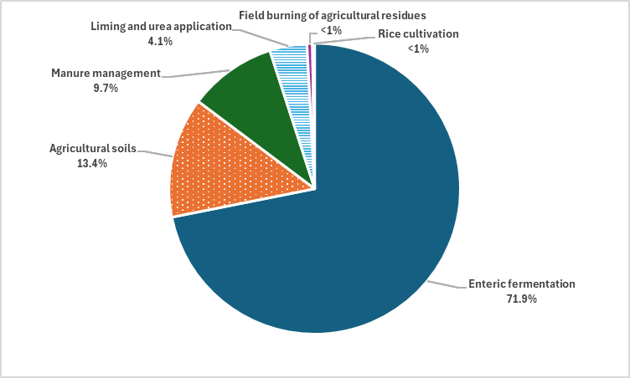
Chart created using source: National Inventory Report 2023 published May 2025.

About this data
Sources of emissions from agriculture in 2022-23 were enteric fermentation (71.9%), agricultural soils (13.4%), manure management (9.7%), liming and urea application (4.1%), field burning of agricultural residues (less than 1%) and rice cultivation (less than 1%).
For more information about methane emissions through enteric fermentation and nitrous oxide and how volumes of these emissions have changed over the last 3 decades, click a heading of interest below.

Methane emissions
In 2022-23, methane emissions from livestock in Australia through enteric fermentation increased by 2.4%, from 55Mt of CO₂-e in 2021-22 to 66.7 Mt of CO₂-e. However, over the past 33 years there has been a gradual decline in methane emissions from livestock in Australia. The long term reduction is mainly due to the declining numbers of beef and dairy cattle in Australia..
Enteric fermentation is the process by which microbes in the digestive system of ruminant livestock decompose and ferment food, producing methane which the animal then belches. About 6–10% of gross energy intake is lost as methane, which is energy lost from the production system that could be converted to income-generating milk or meat.
Almost all of these emissions are from cattle and sheep. The proportion of emissions coming from sheep has steadily declined since 1990, reflecting reductions in the number of sheep.

Nitrous oxide emissions
Over the 33 years to 2022–23, agriculture contributed most of Australia’s nitrous oxide emissions, which totalled 12.3 million tonnes CO₂-e in 2022–23. Nitrous oxide has 265 times the global warming potential of carbon dioxide.
The following figure shows sources of nitrous oxide emissions from 1989-90 to 2022-23.
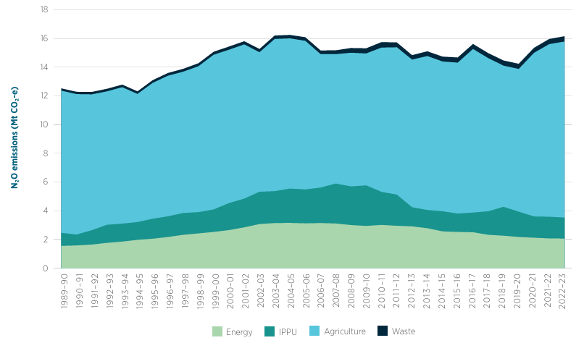
Source: National Inventory Report 2023 published May 2025.
About this data
In 2022-23, nitrous oxide emissions from each sector were (in millions of tonnes CO₂-e): energy (2.3), industrial processes and product use (1.5), agriculture (12.3) and waste (0.3).
Certain bacteria produce nitrous oxide as part of the nitrogen cycle, the process by which nitrogen moves from the atmosphere into the soil, to plants and animals and back to the atmosphere. Nitrous oxide is produced:
- through the nitrification process; some soil bacteria convert ammonium to nitrate via nitrite, producing nitrous oxide as a by-product
- through the denitrification process; some soil bacteria convert nitrate and nitrite back into nitrogen gas and nitrous oxide.
The excess nitrogen from inefficient use of fertiliser can increase nitrous oxide emissions by enhancing nitrification and making more nitrate available for denitrification.

Watch this video
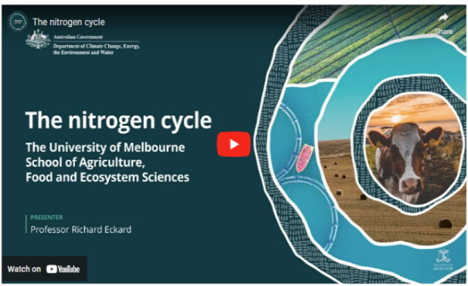
In this video (2:50 minutes), Professor Richard Eckard of the University of Melbourne explains the nitrogen cycle.
Video: The Nitrogen cycle

Transcript
PROFESSOR RICHARD ECKARD: This is an animation of the nitrogen cycle in agriculture. Although this includes a grazing animal, the principles for cropping systems is much the same. While most of the nitrogen cycling in agriculture comes out of the microbial breakdown of a soil organic matter, the left-hand side of this diagram explains some of the primary input sources. Small amounts of nitrogen can come from rainfall and possibly volcanic events.
But the majority of nitrogen entering our agricultural systems comes from synthetic fertiliser, legumes fixing nitrogen from the atmosphere, or from animal dung and urine recycling nitrogen. Nitrogen can enter the soil in many forms, but would mainly be in either the ammonium form or the nitrate form. In most aerobic soils, the ammonium is then converted fairly quickly to nitrate. In cold, wet soils, common in Southern Australia, that conversion can be much slower and plants might preferentially take up ammonium.
Whereas in Northern Australia, in drier, hotter, warmer conditions, less anaerobic conditions, the conversion of ammonium to nitrate can complete in a few days. The other input of nitrogen into the soil is obviously from animal excreta in the form of dung or urine, which would largely be in the ammonium form. Plants then take up the nitrogen, either in the ammonium or nitrate form. In colder weather conditions, common in Southern Australia wet winters there could be preferential uptake of ammonia. In drier soils, there may be preferential uptake of nitrate. In the case of a livestock system, the animal then consumes the nitrogen in the plant and recycles some of this back to the soil through their excreta. Unfortunately, in most of our agricultural systems, the nitrogen is exported out of the system, down the supply chain, instead of being returned in more of a circular, closed loop nutrient cycle.
Nitrogen can be lost from the soil in three main processes. Nitrate in the soil moves readily with water. So if there's leaching of water beyond the root zone, this will carry nitrate with it into the groundwater. In waterlogged soils, nitrate can be denitrified and lost as a gas of either nitrous oxide or dinitrogen.
Nitrogen can be lost as ammonia gas, either directly from urea fertiliser being applied to soils, or livestock urine volatilising as ammonia gas.

Scope 1, 2 and 3 emissions
So far, this topic has looked at on-farm emissions, mainly methane and nitrous oxide. However, as we delve deeper into calculating emissions, we see that there are different types of emission sources of importance to farmers and land managers.
There are 3 types of emissions — called ‘scopes’ — that are part of a business’s total emissions but may not be evident at first sight. They are:
scope 1 emissions: emissions from operations a business owns or controls; for a farm, this could include methane from livestock digestion and manure management and nitrous oxide from fertiliser use
scope 2 emissions: indirect (off-farm) emissions from generating electricity, steam, heat or cooling the business buys
scope 3 emissions: all indirect (off-farm) emissions (other than scope 2 emissions) that occur in the business’ value chain for a farm. This could include upstream emissions from producing and transporting fertilisers and pesticides and downstream emissions from transporting, processing and consumption of the farming business’ products, including waste disposal.
These are important distinctions. Farmers and land managers serious about calculating their carbon footprint must follow the conventions of carbon accounting — the quantification of emissions and storage — which Topic 3 examines.

  - Increasing carbon storage


About carbon
Carbon is an amazing atom. It loves to bond with other atoms, which is why it has been called 'the glue of life'. Carbon is the fourth most abundant element in the universe. It is found in all organic matter, and makes up a large proportion of all living material. Diamonds and graphite are both examples of pure carbon.

The carbon cycle
The carbon cycle includes the movement of carbon between the soil, the things that live on it and the atmosphere.
Plants — trees, shrubs, grasses, crops and other vegetation — take carbon dioxide from the air through their leaves and use sunlight — the photosynthesis process — to transform carbon dioxide and water into oxygen, and into the sugars and starches the plants use to grow. Plants store carbon in their wood, leaves and roots.
Plants shed organic matter as they decay and die, which microorganisms (like bacteria and fungi) break down. This releases the plants' carbon back into the soil, increasing soil organic carbon and releasing carbon dioxide into the atmosphere.
Animals similarly contribute to the carbon cycle. When they breathe, they release carbon dioxide; when they die in the natural environment, their decaying remains release carbon back into the soil.
Oceans also absorb carbon dioxide from the atmosphere. Rocks and other geological deposits (such as coal) store carbon. Burning coal and other fossil fuels releases the stored carbon into the atmosphere.

Watch this video
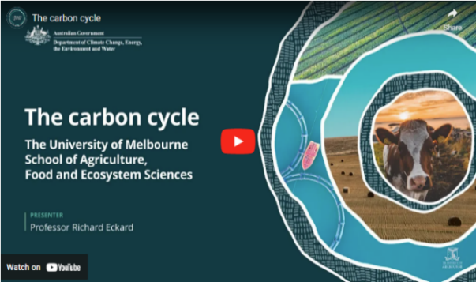
In this video (4:15 minutes), Professor Richard Eckard of the University of Melbourne discusses how the carbon cycle works in agriculture.
Video: The Carbon cycle

Transcript
PROFESSOR RICHARD ECKARD: This is an explanation of the carbon cycle in agriculture.
It's based on a grazing system, but the same principles apply to a cropping system.
It all starts with sunlight energy and the process of photosynthesis in plants, which allows plants to capture carbon dioxide from the atmosphere and lock it away into a plant.
You will notice that we've highlighted the letter c in its various forms of carbon, showing that carbon in CO₂ is a gas, but carbon in the plant is CHO, which is a sugar, not a gas. The key point is that carbon takes many forms as it cycles through our agricultural systems.
In a cropping system, we would then harvest that plant. In a grazing system, an animal will graze the pasture and convert the carbohydrate into animal products.
The majority of the carbon consumed by the animal is belched out or breathed out as CO₂ back to the atmosphere.
The majority of the animal products or crop products, eaten by humans is also respired back to the atmosphere within 12 months as CO₂.
If that was all that happened, the carbon cycle would be completely balanced, with all inputs returning to the atmosphere in the same form within a short period of time.
However, a small amount of carbon entering the rumen of the animal is converted into methane, CH₄, which is carbon in another gaseous form. Methane is fundamentally different to CO₂ and has a far higher warming potential in the atmosphere for the duration that it's there.
The animal defecates, and so there's faecal carbon in an organic form going back to the soil.
Plants will leave litter on the soil surface as a form of organic carbon.
As the plant grows, it produces roots, and these roots leave carbon behind either as root fragments or as root exudates of sugars.
This organic form of carbon in the soil can either be in a larger fraction, which we call the particulate organic carbon, and turns over fairly fast through microbial action, perhaps in hours through to a few years.
The smaller, more resistant fractions of organic carbon in the soil are called humus.
These are the more resistant fractions that last for decades through to hundreds of years.
In the soil, there are billions of microbes that then work actively on this organic carbon as their food source, actively breaking down the carbon to release the stored nutrients back to the soil to allow the crop or pasture to grow.
In the process, these microbes then release the carbon stored in the organic material as carbon dioxide back to the atmosphere, and the carbon cycle completes itself.
In a cropping system, this process of mineralization may release 30 to 50 kilograms of nitrogen per hectare per year out of the soil organic matter. In a dairy pasture system, it can be as much as 250 kilograms of nitrogen per hectare per year from the organic matter.
The point of carbon farming is to capture and make that cycle as efficient as possible so that we can transfer as much of the carbon from the atmosphere into product that we're interested in producing, which could be meat, wool, milk, grain, and crops.
Carbon farming is therefore focused on maximising the carbon from photosynthesis through to a product that goes to market as efficiently as possible.
In the process, good carbon farming would aim to leave as much carbon in the soil as possible, capture some of the carbon in trees growing in the landscape, and minimise the amount of carbon lost as methane and as a nitrogen gas.

About soil organic carbon
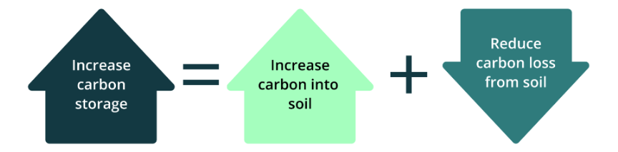
To increase carbon storage in soil, you need to increase carbon content in the soil, reduce carbon lost from the soil, and preferably both.

Along with air, water and inorganic matter, soils naturally contain a small proportion of soil organic matter. Soil organic matter is all the living and dead organic material — plants, soil organisms and animal materials — in various stages of decomposition, but not the fresh, undecomposed organic material on the surface. Soil organic matter:
- binds soils together, increasing their resistance to erosion
- provides nutrients for vegetation
- supports soil microbiology and cycling of nutrients (reducing the need for fertilisers) and improves water infiltration and water-holding capacity and the soil's ability to retain nutrients.
Soil organic carbon (SOC) makes up a large component of soil organic matter. The amount of SOC can vary depending on soil type, environmental conditions (including rainfall) and land management practices. It is generally high in clay soils under pasture, and it can be the highest in peat soils. Soil organic matter and SOC are usually expressed as a percentage of the soil by weight. Carbon farming activities that can increase SOC include cover cropping, no-till farming and agroforestry. Carbon farming activities that can reduce carbon loss include avoiding land management practices like over-grazing, over-tilling and stubble burning.

  - Key concepts
Finally, let’s look at key concepts that flow from this initial topic to all topics:
- carbon neutral
- net zero emissions
- ACCUs
- Climate Active certification
- carbon dioxide equivalent (CO₂-e).
‘Carbon neutral’ and ‘net zero emissions’
The terms ‘carbon neutral’ and ‘net zero emissions’ are commonly used to describe taking action to reduce GHG emissions and increase carbon storage and taking other steps, such as use of offsets, to balance the remaining emissions.
Carbon neutrality is commonly described in terms of balancing all GHG emissions and carbon storage. It is sometimes described only in terms of carbon dioxide rather than all GHGs. Net zero is commonly described as taking steps to reduce all GHG emissions as much as possible and to use carbon storage to balance remaining emissions.
For a farmer or land manager, attaining carbon neutrality or net zero emissions may involve:
- insetting: doing carbon farming activities that reduce or avoid emissions or store carbon within their value chain, which could include their land and their supply chain
- offsetting: buying and cancelling carbon credits derived from projects that reduce or avoid emissions or store carbon elsewhere.
The concept of insetting is gaining increased focus in Australia and overseas. In some cases, it is considered to refer to carbon storage activities only. While insetting is a developing concept, typical features include:
- accounting for carbon storage or emissions reduction or avoidance when it occurs, without needing to demonstrate that it is additional to normal practice (as is required for generating carbon credits for offsets)
- accounting for any losses of stored carbon where those stores have previously been claimed.
Farmers and land managers interested in insetting as an option may need to consider its suitability for their purposes. If participating in a reporting system, you may need to check whether insetting is eligible. If it is eligible, you may also need to check for any rules on insetting. These might include rules for measurement, monitoring, verification, reporting, maintaining stored carbon over time and accounting for losses of stored carbon. Insetting may preclude claiming carbon storage, emissions reduction or avoidance benefits for other purposes (such as offsetting).
Topic 5 explains offsetting in more detail.
Any carbon neutral or net zero claims need to be robust and meet any applicable regulatory requirements. The Australian Competition & Consumer Commission monitors environmental and sustainability claims.

Australian Carbon Credit Units
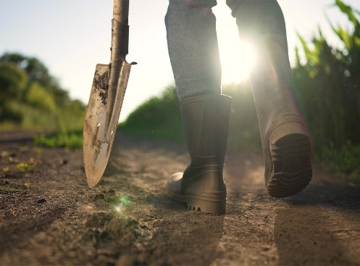
Australian Carbon Credit Units (ACCUs) are also known as carbon credits. Some people think carbon farming is the same as earning ACCUs, but that’s not the case.
The farmer or land manager might decide to do carbon farming activities:
- to earn ACCUs they can sell to generate income
- to reduce their carbon footprint
- to get a lower-interest sustainability loan from a financier
- to meet requirements from their supply chain
- for productivity and profitability gains.
We will return to these options throughout the course, and Topic 5 looks in detail at the requirements for the ACCU Scheme, previously known as the Emissions Reduction Fund. Participation in the ACCU Scheme is voluntary. Farmers and land managers can earn ACCUs by reducing emissions or storing more carbon in soil and vegetation. To earn ACCUs, they must follow detailed rules administered by the Clean Energy Regulator.

Climate Active Certification
Climate Active is a voluntary Australian Government program that certifies credible voluntary climate action by businesses. Certification is available for organisations, products, services and other categories. Businesses seeking certification must set their emissions boundary (all sources of emissions that would be considered under a certification) and measure emissions in accordance with Climate Active’s rules and guidance material available on the Climate Active website.
Farmers can use Climate Active certification in marketing their products, appealing to environmentally conscious consumers and potentially commanding price premiums.

Carbon dioxide equivalent (CO₂-e)
The main GHGs, as we have seen, are carbon dioxide, methane and nitrous oxide. We have also seen how these gases are all added up to indicate the percentage contribution of agriculture sector GHGs to national totals. Which raises the question: how do you add quantities of entirely different gases?
The answer is to calculate the ‘global warming potential’ (GWP) of a gas based on its ability to trap the sun’s heat and how long it stays in the atmosphere. Using its GWP, any GHGs can be converted to a 'carbon dioxide equivalent' (CO₂-e) amount of gas. Using the values in the following table, we can see, for example, that one tonne of nitrous oxide is equivalent to 265 tonnes of carbon dioxide.
Looked at another way, 1 tonne of methane has a 28 times greater contribution to global warming than 1 tonne of carbon dioxide.
Global warming potential of main greenhouse gases*
Greenhouse gas | Global warming potential (GWPs)
Carbon dioxide | 1
Methane | 28
Nitrous oxide | 265
* The Intergovernmental Panel on Climate Change periodically updates these values as understanding of the physical properties of these gases improves.

  - Case study

Watch this video
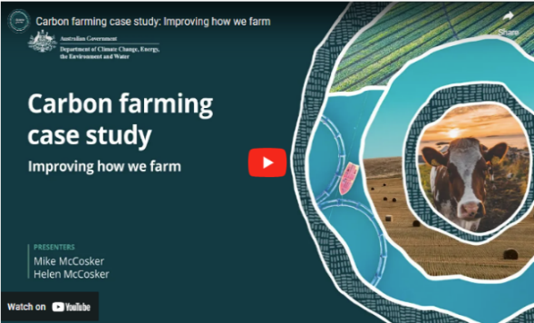
In this video (7:11 minutes), New South Wales graziers Mike and Helen McCosker explain how they improved their farm.
Video: Carbon farming case study: Improving how we farm

Transcript
MIKE MCCOSKER: Hi. I'm Mike McCosker. I'm actually a fourth generation farmer on this farm.
HELEN MCCOSKER: And I'm Helen McCosker. I'm a first generation farmer.
M. MCCOSKER: Our farm is largely a mixed livestock and cropping operation, and we focus on beef cattle. I think the journey really started back in the late 90s – 97, 98.
H. MCCOSKER: Yeah. And I think from there, that really, like, started the momentum of, like, really understanding what is it that we wanted to change on our farm. So we had a feedlot business, and it was, it was 24/7. It was a really hard slog.
And part of that process was, like, really understanding, you know, from a farm planning perspective, what are the things that you know, the opportunity cost? What are the things that we're doing that's not working? And what are the things that we think we should be doing? So there was a real, like, you know, navel-gazing process, wasn't there?
M. MCCOSKER: Those changes were about making the best food that we can make, ensuring that our farm was in excellent health to hand on to the kids because we wanted a generational legacy.
And lastly, it it had to be profitable as well.
Yeah. So a bit of a change of focus, you know, rather than lock the cattle into a small area and grow crops to feed to the cattle, how could we use the cattle differently out on the farm to help regenerate the the pasture land? So the spade test is where we actually get into the soil to see what's going on.
And when we're thinking of soil carbon, what we need is good active biology, and good biological activity will show up as this beautiful crumbly soil structure.
This is what lets the water get into the soil, the rainfall get into the soil. This is what creates the space that holds the moisture in the soil for the plants.
This is what the end result becomes soil carbon in the soil. So the smell should be alive and sweet and earthy.
If this smells like a sewer or even if this smells bland, then the biology is not healthy and not doing its thing of storing carbon.
If the soil is tight and compacted, when the soil carbon is missing, the structure of the soil collapses. So we don't have the pore spaces. This is why the water can't get into the soil.
So some of this, carbon is actually living and cycling in the soil biology, and some of it has been stored and is more stable.
Now I think the chemical model, you know, the cost of inputs just continues to go up and up and up and up. And getting control of that process was actually about coming back to the principles, the underlying principles of soil health.
Do you need an adviser in this? I think you need to work out what works on your own farm, and I think you need a trusted person to talk to.
That trusted person may not be the chemical sales agronomist in town. It might be an agronomist that knows more about soil health or about alternative ways of farming.
That trusted person may be a farmer next door that's trying a few different things and talking to them and seeing what has worked for them and what hasn't worked for them. And I think that's where the communication at a community level comes in. You know, don't be frightened of being a little bit different, and don't be frightened of talking to your neighbours about different ideas.
H. MCCOSKER: Yeah. And I think even from a carbon farming perspective, there is actually, extraordinary value in farmers in an area coming together and working together and you know, understanding the things that aren't working, the things that are working in a mentoring space. Because it's actually farmers that come up with the solutions. You know? So when you're able to be in dialogue with other farmers, then we're actually the perfect advisers, really, aren't we?
M. MCCOSKER: I suppose in the last five years, even though we've been doing this for some time, you know, the the focus has started to come in on to soil carbon, and, you know, there's opportunities there potentially.
What we're doing in our farm plan to build back resilience could give us an extra source of income by actually, you know, being paid for the carbon that we're taking out of the atmosphere and putting back into the soil.
One piece of advice that I would give to people is hasten slowly and that, don't be afraid to fail.
But if you do fail, make sure you've failed on just a little bit of the farm and work that out before you try and do it over the whole farm.
So the transition period is actually the hardest. It's transitioning your knowledge bank into practical profitable farm ability. That transition can be a little tricky, and don't give up on it.
H. MCCOSKER: Yeah. And I think that you talk about risks. It is a risky you know, the change in mindset is the hardest one. So when you're talking about the risk aspect, like, if you sort of feel like, I'm I'm just gonna keep on doing it this way because I know what's in front of me, you need that mindset change of, well, if I keep on doing the same thing, I'm gonna get the same result over and over again.
So what is it that you need to change, as of-
M. MCCOSKER: So if I want a different future for my children, then I have to make a change here.
And how do we take the risk out of the change? Well, we educate ourselves, and we talk about the ideas, and we plan carefully. We implement slowly, but we make sure that we're always moving forward.
So our costs have gone down. You know, we're using a fraction of the chemical that we used to use. We're under five per cent of what we used to use.
The animal performance with, you know, shelter farming. We've improved our calving percentages, and our weaning weights have gone up.
Possibly 40 to 50 kilos per head on you know, across 200 head is a lot of extra kilos of beef that we're producing on the farm.
H. MCCOSKER: And that affects his direct bottom line.
M. MCCOSKER: Absolutely. Yep.

  - Actions: What might you do?

Activity: Respond to the following questions
Think about how what is covered in this topic might apply to your land management or farming practice.
Consider the following questions and make notes about carbon farming activities that might suit your enterprise.
The following points will help you have informed discussions with advisers.
Please note that the next topic explores the risks and requirements of various carbon farming activities, which should be considered before starting a project.
- Why are you interested in carbon farming?
- What are your main emission contributions? (Are they scope 1, 2 and/or 3?)
- Go to My Climate View and note any projected changes based on your location and commodity. (Note: these are projections only, not necessarily the reality of your situation)
- Learn about carbon targets in your supply chain.
- Based on the information provided in this topic, what else is important for you to note for future reference?

  - Other resources

Annual Climate Change Statement 2025
The Annual Climate Change Statement 2025, published by DCCEEW, explains Australian and state and territory government climate change policies, adapting to climate change and progress towards achieving Australia’s targets for reducing GHG emissions.

Low Emissions Agriculture (New South Wales Department of Primary Industries and Regional Development)
The New South Wales Department of Primary Industries and Regional Development Low Emissions Agriculture webpage provides information about GHG emissions and carbon sinks, and carbon farming opportunities for farmers.

Making cent$ of carbon and emissions on-farm (Agriculture Victoria)
The Agriculture Victoria Making cent$ of carbon and emissions on-farm booklet focuses on practical actions that farm businesses can take to improve their emissions performance.

Building a world-leading, climate-smart agriculture industry (Department of Agriculture, Fisheries and Forestry)
This Agriculture and Land Sector Plan document has examples of:
- a New South Wales sheep dairy who has used new electrification technologies to improve energy efficiency and costs
This Australian Government Department of Agriculture, Fisheries and Forestry website has examples of:
- a New South Wales orchardist who has used new technologies to improve water efficiency
- producing drought resilience plans that recognise and represent the needs of Aboriginal communities who speak for Country.

Topic 2: What carbon farming means for farmers and land managers

Time to complete this topic
About 60 minutes to read the information in this topic. Additional content includes videos, activities and links to other resources which may require extra time to complete.
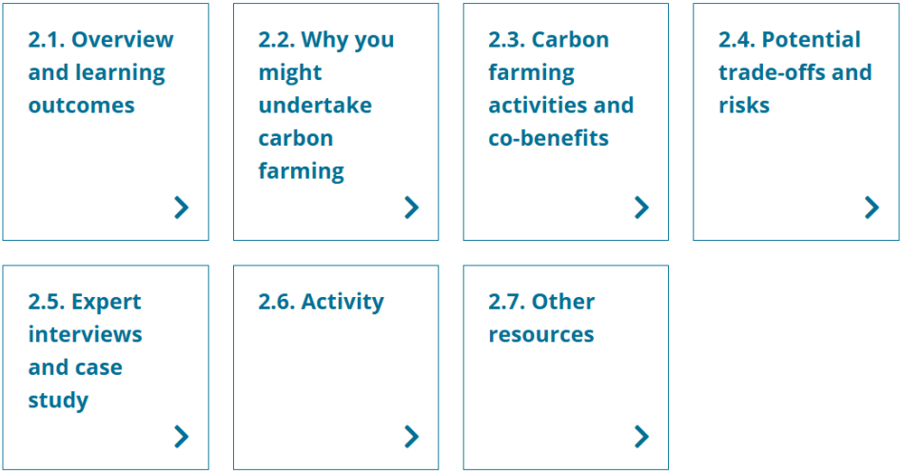
In this topic:

2.1 Overview and learning outcomes

Overview
In this topic, you will learn about the carbon farming activities introduced in Topic 1 and their potential co-benefits: benefits beyond reducing emissions and storing more carbon.
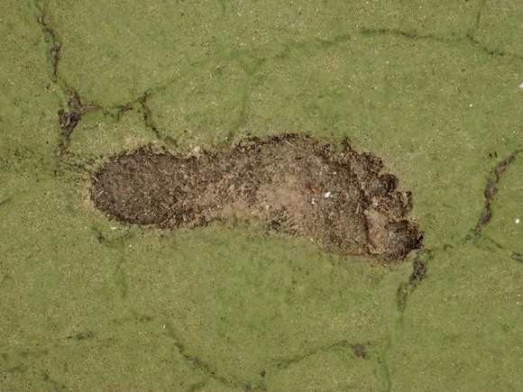
Farmers and land managers can be attracted to carbon farming because of the co-benefits, which include:
- more productive, better-preserved assets (such as soil, crops, livestock and Country)
- better water cycle
- protected and enhanced biodiversity and ecosystem function and resilience
- restored wetlands and salt-affected land
- reduced input costs and increased income, including from diversified income sources
- earning Australian Carbon Credit Units (ACCUs) and gaining Climate Active certification, although many farmers and land managers do carbon farming without being involved in the ACCU Scheme or Climate Active certification
- meeting requirements from supply chains or markets
- helping First Nations people pass on cultural traditions and knowledge and maintain spiritual connections to Country.
There are also trade-offs and risks involved in carbon farming. The topic also explores these.

Learning outcomes
After completing this topic, you will be able to:
- describe carbon farming activities and technologies
- explain the co-benefits and risks of carbon farming
- recognise First Nations peoples’ traditional land management practices
- identify the relevance (or not) of carbon market participation.

Watch this video
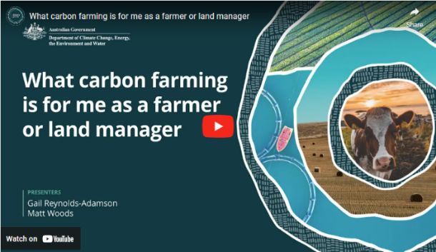
In this video (4:27 minutes), presenters Gail Reynolds-Adamson and Matt Woods introduce Topic 2 and provide important context.
Video: What carbon farming is for me as a farmer or land manager

Transcript
GAIL REYNOLDS-ADAMSON: Welcome to topic two. What carbon farming is for me as a farmer or land manager.
This is where we look more deeply into the types of carbon farming activities you can undertake to help you think about the different options that suit your sector.
MATT WOODS: We'll also drill down more specifically into benefits for particular categories of farmers and landholders.
In addition, we'll explore options and opportunities through technology and practices to manage emissions and sequester or store carbon.
Touching on the pros and cons also.
REYNOLDS-ADAMSON: In topic one, we discussed climate change as the main reason why carbon farming is so important.
We also looked at how Aboriginal and Torres Strait Islander peoples have been using traditional practices to care for Country for a millennia.
These along with some Western agricultural practices allow farmers and land managers to not only manage emissions, but to care for their land more sustainably.
One of the most important things is to think about time.
Many First Nations people think in cyclical, not linear time. We also consider what generations both past and present will think about our decisions.
This helps us to think about long term, not just short term rewards.
This is a helpful perspective to consider for carbon farming as the benefits are not always immediate.
WOODS: Now let's look more specifically at your own reasons for considering carbon farming.
Chances are you're considering the economic benefits that it can bring, whether directly through carbon credits or indirectly by meeting the increasing expectations of supply chains and customers that you are reducing emissions.
Perhaps you're also interested in the many environmental benefits it can bring to your land, including habitat restoration, increasing biodiversity, and creating healthier soils and waterways.
There is no right or wrong reason, and no matter what's your original motivation, before embarking on a carbon farming project, it's important that you're aware of all the potential benefits and risks.
It can also be helpful to keep your why in mind when things get tough because at times, they will.
REYNOLDS-ADAMSON: For me, the why is about putting Country first. The Kardutjaanup Tree Rejuvenation Project is an example of this. With commercial partners, Esperance Tjaltjraak Native Title Aboriginal Corporation has bought 4000 hectares of farming land where we will plant 4.5 million trees.
In the longer term, this project will generate income through carbon credits, but there are other benefits such as creating healthy Country, increasing biodiversity, reducing carbon emissions, and giving Wudjari Traditional Owners self determination over their future. I will share more about the Kardutjaanup story in a case study later in this package.
WOODS: There are schemes specifically for Indigenous farmers and land managers to benefit economically from these practices, but Indigenous and non-Indigenous farmers and landholders alike can benefit from collaborative approaches that consider multiple perspectives to ensure that carbon farming projects are not only economically beneficial, but also environmentally sustainable, and culturally and socially equitable. This recognition of diverse values and priorities can lead to more inclusive and effective environmental and land management initiatives.
REYNOLDS-ADAMSON: So, as you work through this topic, you will learn about potential benefits and disbenefits and sources of emissions, i.e., your footprint, both direct and indirect.
We'll look at opportunities for avoidance and or reduction, see some examples, and hear from some experts.
At the end, you'll be again prompted to respond to these focused questions in preparation for informed discussions with the right experts to guide your decisions.

2.2 Why you might undertake carbon farming
First, let’s briefly provide an overview of some of the co-benefits of carbon farming before looking into the co-benefits of particular carbon farming activities.
Carbon farming helps tackle climate change by reducing or avoiding greenhouse gas emissions and storing more carbon in soil and vegetation.
As explained in Topic 1, carbon farming activities also deliver a variety of co-benefits for farmers and land managers, the environment, people and communities.
Depending on the activity, carbon farming can:
- improve soil health, stability and fertility by reducing erosion, minimising soil disturbance, improving soil structure, making better use of water, and improving nutrient retention and cycling.
- introduce efficient farming practices that support emissions reductions and diversify income streams through developing low-emission products that meet value chain demands.
- improve food quality and community health, creating secure jobs, protecting settlements and infrastructure and improving the liveability of spaces.
- protect biodiversity and ecosystems by improving and increasing diverse habitats and through traditional ecological practices that maintain a balance between human activities and the natural environment.
- improve animal productivity, health and welfare by increasing feed quality and managing herds better.
- improve nitrogen use efficiency.
- improve water use efficiency by reducing evaporation and run-off and increasing infiltration of water into the soil.
- support rehabilitation of wetlands and other waterways.

2.3 Carbon farming activities and co-benefits
As Topic 1 examined, carbon farming activities aim to reduce greenhouse gas emissions and store carbon. They also deliver economic and other co-benefits for farmers, land managers, environmental values and communities.
These co-benefits include earning ACCUs and gaining Climate Active certification, which Topics 4 and 5 examine. Many people also do carbon farming for its other co-benefits without being involved in the ACCU Scheme or Climate Active certification.
The following table shows the carbon farming activities this topic examines. These activities may deliver economic and other co-benefits.

Carbon farming activities
Group | Activity
Soil | Conservation and strategic tillage  Crop and pasture management  Efficient fertiliser use
Livestock | Reduce beef and dairy cattle and sheep methane emissions  Manage piggery and dairy effluent  Grazing management
Vegetation | Afforestation  Reforestation  Agroforestry  Retain existing native vegetation
Blue carbon | Restore wetlands, saltmarsh and seagrass  Remove or modify barriers to tidal flow
First Nations traditional ecological practices | Cultural burning, including savanna fire management

Soil
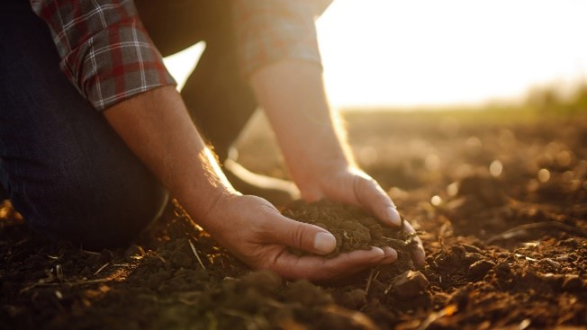
Maintaining or increasing soil organic carbon (SOC) helps mitigate climate change and provides many on-farm co-benefits. SOC content can be measured using laboratory techniques or calibrated soil sensors. SOC content values are used with other information to make farm management decisions.
The extent to which SOC can be maintained or increased depends mainly on the type of soil, climate, existing SOC level and how the soil is managed. In general, management practices that improve SOC levels will need to be maintained to provide sustained improvements. Soil characteristics and climate will influence the effectiveness of management practices to improve and maintain SOC levels.
Maintaining or increasing soil organic carbon
Activities to maintain or increase SOC are explained below. Maintaining good groundcover is a common feature of many of these activities.
Conservation tillage activities include:
- changing from intensive to reduced or no-tillage farming, minimising mechanical cultivation of the soil during sowing and harvesting
- retaining stubble after harvesting a crop for ground cover.
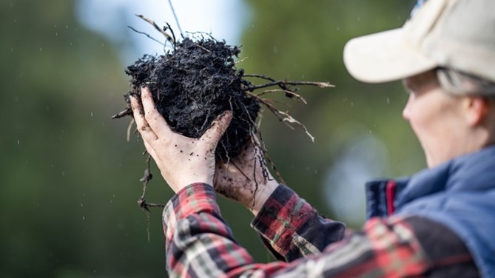
Strategic tillage includes remediating land by modifying landscape or landform features (such as by mechanically adding or redistributing soil). Before deciding to strategically manage soil by redistributing it, you must understand soil constraints (such as clay delving or clay spreading in the case of sandy soils).
Crop and pasture management activities include:
- planting and permanently maintaining pasture on land with no or little pasture (such as on cropland or bare fallow land)
- using legume species, which add nitrogen to the soil
- changing the stocking rate, duration or intensity of grazing.
Grazing management, which the Livestock section below examines, can also help improve pastures and soil.
Planting different crops sequentially on the same paddock (rotational cropping) or growing between main crops (cover cropping) keeps the soil covered. This helps to minimise soil erosion, improve soil fertility, restore SOC and optimise nutrients in the soil.
The Agriculture Victoria Soil Carbon Snapshot book (PDF 7.1 MB) introduces soil carbon and its role, overviews recent research and implications for land management practices and has links to sources of further information.

Precision agriculture to manage soil organic carbon
Precision agriculture (also called 'precision farming') involves using technology and data analysis to optimise various aspects of agricultural production, whether it concerns livestock, soil, forests or blue carbon. Applications of precision agriculture to managing SOC include:
- strategic sampling of soil to capture spatial variability and using laboratory and soil-sensing techniques for measurement and analysis
- using geographic information system (GIS) technology to store, visualise, analyse and interpret geographic data, including soil properties
- using variable rate technology to apply seed and fertiliser or a soil ameliorant at variable rates across a field, depending on the specific soil properties, historical soil performance and crop condition at a particular location.

Benefits of maintaining or increasing soil organic carbon
Activities that maintain or increase SOC may also:
- improve soil health and fertility by using fertilisers appropriately and growing nitrogen-fixing legumes (such as clover) with another crop and making nitrogen available for other plants
- improve soil stability by minimising soil disturbance, helping to maintain the soil’s structure, reduce erosion and improve soil health
- increase biodiversity and ecosystem function/resilience by growing together or rotating crop and pasture species to provide a diverse habitat for a variety of organisms; or by growing perennial pasture that can suppress weeds and reduce the need for herbicides
- reduce evaporation by minimising soil disturbance, resulting in better retention of water and more efficient use of water resources.

Reducing nitrous oxide emissions
Using nitrogen fertilisers more efficiently can help reduce nitrous oxide emissions from soils. This includes using a suitable fertiliser product type and applying fertiliser at a time and rate that meets the needs of particular crops, pastures and soil characteristics. Fertiliser use can be optimised with controlled-release or variable-rate application. GHG emissions can be reduced by using nitrogen inhibitors to slow the rate at which ammonia is converted to nitrate, so plants use nitrogen more efficiently.
There is more information about nitrous oxide, fertilisers and inhibitors on the Primary Industries Climate Challenges Centre website.

Livestock
Reducing emissions from livestock can also have productivity benefits. The potential options for reducing emissions vary with types of livestock and production systems.
Reducing beef and dairy cattle and sheep methane emissions
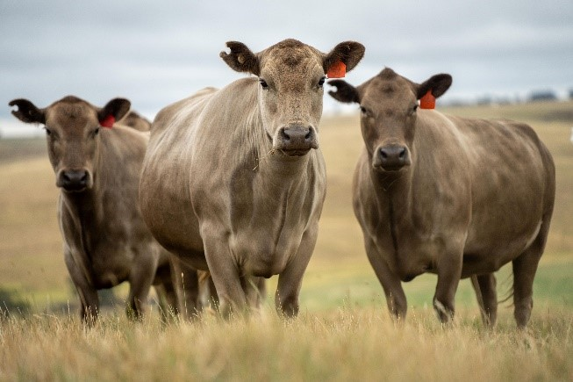
These activities aim to reduce emissions from beef and dairy cattle and sheep by:
- improving growth rates and reducing the age of herds, so they produce emissions for fewer days
- culling less-productive animals, so fewer are needed for the same output
- providing a balanced, optimised diet of high-quality, easily digestible feed and supplements (such as legumes like Leucaena or Desmanthus, tannins, oils, fats and methane inhibitors (like Asparagopsis or 3-NOP)) to improve their growth and reduce methane emissions
- substituting urea supplements with nitrate supplements in the form of lick blocks so the cattle produce less methane
- improving pasture management, including by grazing management.

Managing piggery and dairy effluent
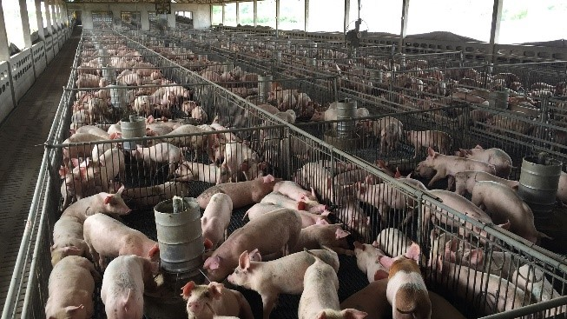
The main activities that manage piggery and dairy effluent to mitigate methane emissions aim to:
- avoid emissions by promoting aeration, and preventing the generation of methane
- generate biogas, which can be used to generate heat or produce electricity.
Some dairy and piggery effluent management activities are eligible to generate ACCUs under the ACCU Scheme Animal effluent management method, which is outlined in Topic 5.
Better management of piggery and dairy effluent can:
- reduce nitrous oxide emissions from the application of manure by applying it at the right place, rate and time
- reduce methane emissions by using anaerobic digestion systems to capture and use methane to produce energy
- by generating electricity on-farm, reduce the need to buy it from the grid
- improve soil fertility by using effluent as fertiliser, which also reduces farm costs and the GHG emissions that arise from the production and use of synthetic fertilisers
- improve animal welfare by making their living conditions cleaner and healthier
- improve water quality by reducing the run-off of nutrient-rich effluent that can cause algal blooms and damage to aquatic ecosystems
- help manage effluent odours
- protect community and animal health by controlling the spread of pathogens and diseases from poorly managed effluent.

Grazing management
Grazing management activities include:
- systematically moving livestock to different areas to prevent over-grazing
- letting the land recover after a short period of intense grazing
- monitoring the land, vegetation and livestock and changing plans as necessary.
In the right conditions, grazing management can:
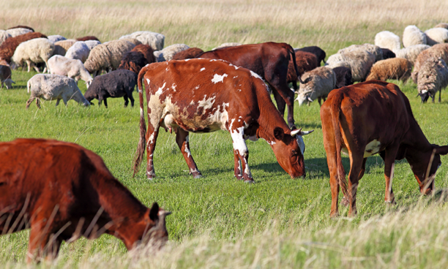
- reduce methane emissions from livestock by improving the digestion and overall health of animals
- help maintain soil carbon by improving plant health and root growth
- improve soil health, stability and fertility, by allowing organic matter to build up
- improve pastures by giving them more time to recover between grazing and minimising overgrazing
- increase forage quality by giving livestock access to fresh, young vegetation in each paddock, which also improves the nutritional content of the feed and, therefore, animal health
- improve animal productivity, as livestock tend to grow more efficiently on high-quality forage, and there may be less need for supplemental feeding, reducing farm costs
- improve water use efficiency by improving water infiltration, reducing run-off, and improving water quality
- increase biodiversity and ecosystem function/resilience, as vegetation can recover between grazing periods, providing diverse habitat for a variety of organisms and helping improve ecosystem stability
- reduce manure and nutrient run-off into waterways, preventing pollution and protecting aquatic ecosystems.

Vegetation
Carbon farming activities to establish and maintain forests — areas with a large number of trees and shrubs — and other vegetation include:
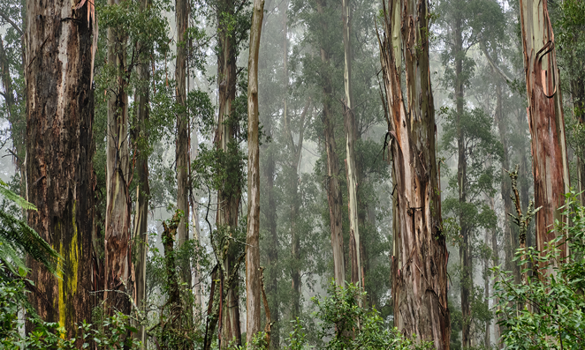
- afforestation: establishing a forest on land with little or no previous tree cover (such as degraded or barren land)
- reforestation: establishing a forest on land where there has previously been a forest and where there is little or no tree cover
- agroforestry: planting and maintaining trees and shrubs around or on agricultural land, integrating trees and shrubs with crops and livestock
- retaining existing native vegetation rather than clearing it.
Vegetation benefits
Vegetation can:
- remove carbon dioxide from the atmosphere and store carbon through photosynthesis in their above-ground biomass and the soil
- reduce nutrient run-off and prevent erosion
- improve living conditions for livestock and other animals by providing shade, mitigating exposure to extreme temperatures and providing windbreaks
- attract pollinators and other beneficial species
- absorb and slow down rainwater run-off, increasing groundwater, reducing flooding risks and improving water quality
- increase income and diversify income sources by opening up opportunities for timber production, non-timber products (such as fruit, nuts and medicinal plants) and eco-tourism
- provide habitat and ecological niches for diverse plant and animal species, including threatened and endangered species, contributing to healthy ecosystems
- benefit people and communities by moderating temperatures, increasing humidity, improving air quality, reducing extreme weather impacts and providing green spaces people can enjoy and use to maintain cultural and spiritual connections to the land
- create jobs in tree planting, forest management and harvesting.

Blue carbon farming activities
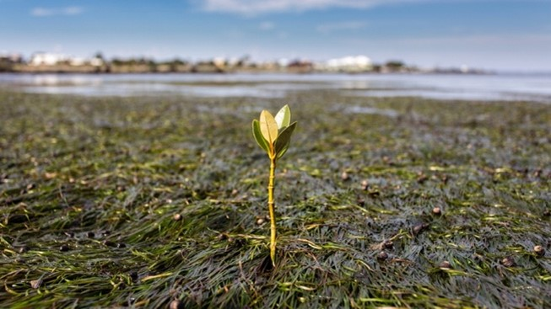
Blue carbon farming can occur in coastal wetland and marine ecosystems where management practices can increase carbon stores and, in some cases, reduce emissions. These include:
- mangroves, which store carbon in their above-ground biomass and below-ground sediments, help protect coastlines and offer habitat for diverse species
- seagrasses, which also have root systems that stabilise coastal sediments
- salt marshes, which store carbon by accumulating organic matter in their soils.
The term ‘blue carbon’ draws attention to the importance of these coastal ecosystems in mitigating climate change by storing carbon and avoiding GHG emissions. These and other wetlands provide a broad range of environmental benefits, including filtering water, providing habitat for diverse species and controlling flooding.
Blue carbon farming activities include:
- removing or modifying barriers to tidal flow (such as a sea wall), resulting in the rewetting of drained or partly drained coastal wetlands and converting freshwater wetlands to brackish or saline wetlands
- planting mangrove trees in areas from which they have been removed or degraded and rehabilitating degraded areas of mangrove
- restoring saltmarshes and seagrass.
Blue carbon activities can store carbon in vegetation and soil. Introducing tidal flows to wetlands that have previously been converted to freshwater systems avoids emissions. It does this by reducing the anaerobic (without oxygen) decomposition of organic material in soils, which releases GHGs, in particular methane.
Wetland restoration benefits
Restoring wetlands:
- stores carbon in the soil and wetland vegetation
- improves soil health by filtering and retaining nutrients
- prevents excessive run-off and reduces erosion; particularly important along the coasts as sea levels rise and wetlands are natural barriers against storm surges and tidal erosion
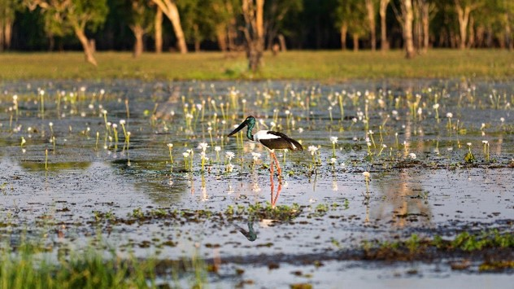
- improves water quality by trapping and breaking down pollutants and by reducing sedimentation
- protects and improves biodiversity by providing essential habitat for plant and animal species, including to breed, feed and nest, and by being habitat for natural predators — insects, birds, and amphibians — that help control pests on nearby agricultural land
- makes better use of salt-affected land, that is, unproductive land
- supports diversified income streams from wetland-related activities such as fishing, boating and bird watching
- promotes community collaboration, as farmers and land managers collaborate with local communities, environmental organisations and government agencies to restore wetlands, strengthening community bonds and sharing responsibility for environmental stewardship
- protects settlements and infrastructure by providing a natural buffer against flooding, absorbing and storing excess water during heavy rainfall, and reducing the risk of downstream flooding, including of nearby agricultural land.

First Nations traditional ecological practices

The traditional ecological practices of First Nations people are deeply rooted in millennia-old traditions.
First Nations people have a holistic relationship with the environment that balances land use with conservation, valuing traditional ecological and cultural knowledge and practices passed down through generations.
These practices include cultural burning, sustainable hunting and fishing, and protecting sacred sites and their associated totems. These practices promote ecological balance, reduce the risk of wildfires and contribute to the land's overall health.
First Nations-led carbon farming activities that combine traditional ecological and cultural knowledge with contemporary science are increasingly recognised as effective for environmental sustainability and carbon storage.
First Nations traditional ecological practices benefits
First Nations traditional ecological practices:
- preserve and pass on cultural traditions from one generation to the next, including knowledge, stories and rituals
- maintain a spiritual connection to Country, with practices often being guided by spiritual beliefs integral to Indigenous identities
- build community cohesion, as they involve communal decision-making and cooperation that improves the overall well-being of communities
- emphasise the sustainable use of resources so ecosystems continue to provide resources and environmental health for future generations
- improve biodiversity and ecosystems, including through traditional ecological practices, by maintaining a balance between human activities and the natural environment
- can create secure, long-term jobs, particularly for people living in remote communities
- support people and communities by improving spiritual well-being and helping build leadership skills, increasing confidence in working with public sector organisations and building partnerships
- potentially align First Nations peoples’ traditional knowledge and recent science-based farming and land management methods while also increasing community awareness about land rights
- improve food quality and community health by increasing access to traditional foods for more people
- provide economic opportunities for First Nations communities, which can potentially generate income through ACCUs by reducing emissions from uncontrolled intensive fires and enhancing carbon storage.

Cultural burning, including savanna fire management
For thousands of years, First Nations people have done cultural burning, also referred to as fire-stick farming and cool burning. Cultural burning can be of:
- grasslands to promote new growth and reduce fuel loads, helping prevent larger, more destructive wildfires
- savanna, which is a mix of grasses and trees, to maintain them and encourage specific plant species
- woodlands to maintain their health and promote biodiversity
- rainforests to clear undergrowth and reduce the risk of catastrophic fires.
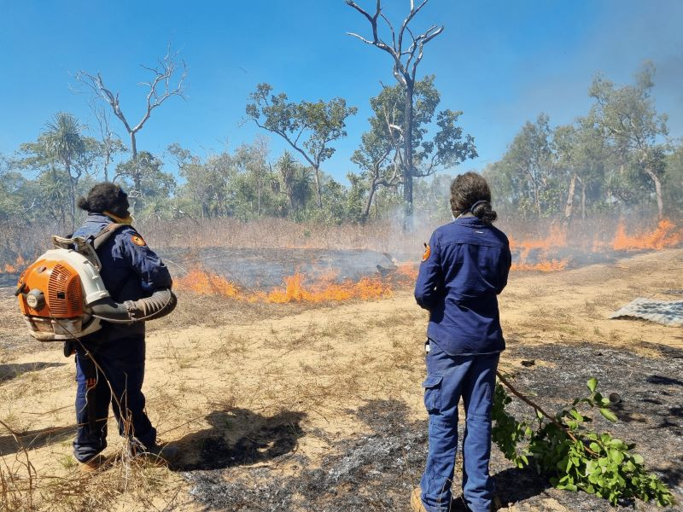
Cultural burning involves small fires lit in a mosaic pattern. This low-intensity burning reduces fuel while protecting the tree canopy, clearing the ground, flushing out animals for hunting and encouraging new growth.
Cultural burning of savanna — savanna fire management — occurs in the Northern Territory, northern Queensland and northern Western Australia. Savanna covers about 1.9 million km² — about 23% — of the Australian continent. Here, the cycle of wet and dry seasons makes the savanna particularly prone to fire. In particular, savanna fire management involves shifting from late-dry season planned burning to burning early in the dry season, to prevent large, uncontrolled bushfires late in the dry season sweeping across the north of the country.
Mimal Women Rangers. Source: Mimal Land Management Ltd
Cultural burning maintains a traditional method that has worked effectively for tens of thousands of years. Importantly, cultural burning, as a traditional ecological practice, is also deeply intertwined with First Nations peoples' cultural and spiritual heritage.
Cultural burning benefits
Cultural burning:
- reduces GHG emissions and helps store carbon by reducing the frequency and extent of large, intense fires that release large quantities of carbon dioxide and methane. It helps keep the carbon in vegetation and soil
- reduces the intensity and risks of bushfires by reducing the build-up of vegetation, and therefore the overall fuel load, slowing the spread of bushfires and decreasing the risk of their intensity and destructiveness
- improves soil health, stability and fertility, as ash returning to the soil helps replenish nutrients and helps new vegetation grow
- increases biodiversity and ecosystem function and resilience by creating mosaics of vegetation patches of different ages, providing diverse habitats for various plant and animal species
- improves habitat quality by preventing shrubs and small trees from encroaching on grasslands, helping preserve savannas as open grasslands
- improves pastures by stimulating the growth of fresh, nutritious grasses for livestock and wildlife
- helps protect life and property by reducing the intensity of bushfires
- delivers direct and indirect benefits for First Nations people, including the direct benefits of meaningful jobs on Country, independent revenue, getting back to and caring for Country and protecting cultural sites, and indirect benefits of meeting cultural obligations, strong governance, community cohesion, self-determination, pride in community and healthy Country. For more information on benefits for First Nations People, see page 65 of the Indigenous Carbon Industry Network’s 2022 Indigenous Carbon Project Guide (PDF 8.5 MB).

Other ways to reduce the carbon footprint
Other ways a farm can reduce its carbon footprint include using:
- clean, renewable energy (such as solar and wind power and biofuels), reducing reliance on fossil fuels, which can not only reduce farm operating costs but also reduce its scope 2 emissions and, therefore, its carbon footprint
- energy-efficient irrigation systems that make the most efficient use of water and minimise the use of energy, which also reduces farm costs and its carbon footprint
- organic manure from livestock: organic manure is rich in carbon, microbes and other nutrients (such as nitrogen and phosphorus) essential for carbon storage, soil health and plant growth. Using organic manure also reduces reliance on synthetic fertilisers, reducing farm costs and the farm’s carbon footprint.
The Farmers for Climate Action Climate-Smart Farming Toolkit provides information about topics including: drivers for reducing farm emissions; understanding and estimating emissions; and options for reducing emissions, including improving energy efficiency and installing renewable energy systems.

2.4 Potential trade-offs and risks
While carbon farming has many co-benefits, it's also essential to consider the trade-offs and risks. Here’s an overview of some potential trade-offs and risks, using examples of carbon farming activities.
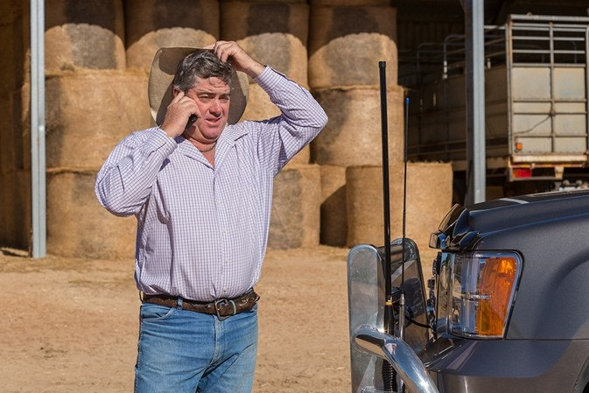
Suitability of location: features of the location (such as local rainfall and temperature patterns, soil type and land management history) determine the extent to which vegetation can be grown and soil carbon content can be improved and, therefore, the likely success of carbon farming activities. Similarly, there may be locations and practices where achieving improvements in soil carbon levels does not benefit agricultural production.
Compatibility with agricultural production: establishing trees on farms may reduce the land available for agricultural production. Carefully positioned plantings can complement agricultural production (such as if they provide windbreaks or are on less-productive land).
Biodiversity impacts: decisions about, for example, which trees to plant and their location and layout of tree plantings should consider impacts on biodiversity.
Water availability: adopting carbon farming activities that need more water (such as irrigated crops) may depend on water availability.
Permanence of carbon storage: storing carbon in vegetation and soil requires ongoing management. Fire, drought or management changes could lead to losses of stored carbon. Managing this risk in carbon markets requires a long-term — many decades — commitment to maintain carbon stores and restore any losses, with implications for land, financial and succession planning.
Legal considerations: legal aspects of participating in carbon markets may include land use agreements, complying with legislation and contracts.
Financial factors: carbon farming can provide an additional source of income from the sale of ACCUs and on-farm productivity gains. Carbon market participation involves costs in addition to those incurred in investing in new equipment and changing practices. Other costs may include obtaining legal and financial advice, estimating emissions reductions and carbon storage, and monitoring, reporting and auditing. The time commitments involved also need to be considered. There is likely to be a lag between paying initial costs and earning revenue from the sale of ACCUs. This is particularly so for carbon storage activities, where building carbon levels in vegetation and soils takes time and can be subject to variability. Where carbon farming is conducted without participating in the ACCU Scheme, costs of making new purchases and changing practices need to be weighed up against benefits such as improved production.
Considerations for fire management activities include:
- the need to provide more detailed knowledge about local ecosystems, appropriate timing, fire behaviour and ecological responses to people undertaking fire management
- the need for community engagement and education about what constitutes ‘good’ and ‘bad’ burning
- getting the timing and intensity of burning right
- the potential for fires to escape
- air quality concerns from smoke
- impacts on non-native species on which cultural burning may have different ecological effects
- the need for expert knowledge about vegetation, weather patterns and fire behaviour.
  - Expert interviews and case study

Watch these videos
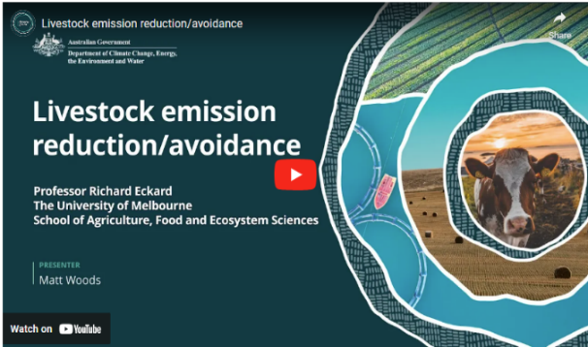
In this video (6:20 minutes), Matt Woods and Professor Richard Eckard of the University of Melbourne discuss livestock emission reduction and avoidance.
Video: Livestock emission reduction/avoidance

Transcript
MATT WOODS: Hello.
I'm Matt Woods.
And I'm here with Professor Richard Eckard. Richard has been working for over 20 years on addressing the impacts of a changing climate on agriculture.
A big part of the emissions story in Australia is livestock emissions. Can you briefly describe what they are and why they matter?
PROFESSOR RICHARD ECKARD: So the majority of livestock emissions come from what we call ruminants. Ruminants have got four stomachs. We've only got one. So ruminants are your cattle, sheep, goats; they would be your classic ruminants.
And because of the first stomach, so, a ruminant can actually digest cellulose; grass. You and I can't live on grass.
And they can because the first of their four stomachs called the rumen is a microbial digestion vat. So it's a massive vat with microbes that are there to break down the cellulose and turn it into sugars. So they can live on grass when you and I can't. But unfortunately, the moment you put organic material; grass, in an anaerobic environment, so no oxygen, you generate methane as well. We've known that for centuries because we know that when you put organic material or waste into an anaerobic pit, it'll generate a methane gas. Now unfortunately, that's what happens in ruminants as well. They generate this gas, methane. And methane is a powerful greenhouse gas. For every day that methane's in the atmosphere, it warms the planet a hundred times more than carbon dioxide. So it's important.
WOODS: Why is it important to farmers and farm businesses that they know this?
ECKARD: Well, 20 years ago, most farmers would not have even been aware that their cattle are producing methane.
But since climate change is now becoming quite a pressing issue, what we're seeing is not necessarily government policy, but we're seeing the supply chain starting to respond to the Paris Climate Agreement. And so all our multinational supply chain companies have started setting targets based on what we call the Science-Based Targets Initiative. So, you try to sell your meat to one of the major meat companies; by 2030, they'll be looking for 30 per cent less emissions from your meat. Because they're reporting down their supply chain to shareholders who are responding to customers.
And the major banks are on the same trajectory as well, where they are required to report to their - the Central European Bank, for example, on the emissions profile of their loan portfolios.
So, they're concerned about exposure to greenhouse gas emissions, and if you think of Australian agriculture, 70 per cent of what we produce is exported down these multinational supply chains.
And we know that by 2030, they are putting restrictions on what they will buy in terms of greenhouse gas emissions. So it's not got much to do with government targets. It's got to do with our supply chains that are actually wanting lower emissions supply in the future, which is why then it is of concern to farmers, whether they agree or not, it's in place. So we're in that phase right now of doing a lot of the research required to give farmers cost-effective solutions. That's actually really important.
But between now and 2030, raising awareness that you need to know your number; what is your emission, and what can you do about it between now and 2030? So that you remain at the head of the marketing queue when the supply chain come buying for low emissions product.
WOODS: Right. You mentioned cost effective things that farmers can do about it. What are some of those things?
ECKARD: So to answer that question, we need to understand how the supply chain can buy. You see, they can't buy on actual emissions, because then they just buy a small farm rather than a big farm, because a big farm produces more than a small farm. They can only buy on a unitary value, like emissions per unit of production, emissions per kilogram milk solids, emissions per kilogram of wool, or kilogram of meat - which is what we call emissions intensity.
So how do you shift the dial on emissions intensity? You just become more efficient. So you use current best practice of nitrogen use efficiency, fertiliser efficiency using legumes, grazing management, weaning rates.
The reason why a prime lamb operation has a lower emissions intensity. It's just because you get 150 per cent weaning, relative to a beef system that gets a bit somewhat below 100 per cent weaning. So you haven't changed the emissions, you've changed the denominator, which is how much live weight you're producing.
So getting that more efficient by reducing unproductive animal numbers, just current best practice will put you at the head of the queue by 2030.
WOODS: If I'm a farmer sitting here listening to this, and I'm a prime lamb producer, let's say. What's the first cab off the rank for me to try and bring my emissions down?
ECKARD: So your prime lamb is a good example in that you're focusing on a meat product, which means that you can get your weaning rates up to a 150 per cent. You can get them up to maybe, some exceptional producers, up to a 170 per cent.
That means that for every ewe that you have on the farm that is producing methane, you're now dividing it by 1.5 or 1.75 lambs that are coming out of the system that go down the supply chain. So that actually means that per unit of meat produced, you are lower emissions than your neighbour, who might be a 100 per cent weaning or 120 per cent.
So that can be achieved through better genetic selection, feed conversion efficiency, selecting for or reducing health costs... basically anything that reduces every day that the breeder herd is unproductive on the farm.

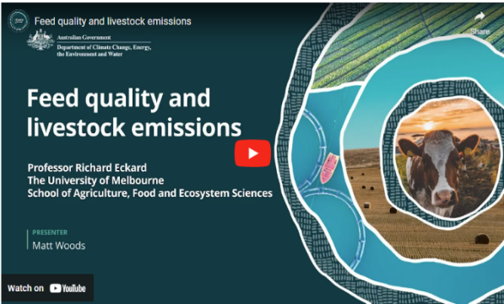
In this video (7:42 minutes), Matt Woods and Professor Richard Eckard of the University of Melbourne discuss feed quality and livestock emissions.
Video: Feed quality and livestock emissions
Transcript
MATT WOODS: Hello. I'm Matt Woods, and I'm here with Professor Richard Eckard. Richard has been working for over 20 years on addressing the impacts of a changing climate on agriculture.
A part of methane emissions from ruminants is quality of feed that's going into the animal.
If I feed my prime lambs better quality feed, does that bring emissions down?
PROFESSOR RICHARD ECKARD: Most definitely. So, more so in Northern Australia than Southern Australia because in Northern Australia, the inherent range land is lower quality than some of our temperate grasses in the south. But no doubt if you're a lamb producer in Western Victoria and you bring more legumes into your pasture, the growth rate of the lambs will increase relative to just being a grass based pasture.
The same in Northern Australia, if you've got a beef system and you have a leucaena for example, or desmanthus or some of these these novel legumes, they would have two modes of action. One, they would improve the average quality of the grass, because a lot of the northern grasses are poor quality. So your growth rate would pick up from, say, 0.3 kilograms per day, to about 0.9 kilograms a day. So you're actually finishing animals for market earlier, but some of these legumes also have secondary compounds in them, like tannins that reduce methane for every day they're on the pasture. So you get two effects. One, better feed quality gets the animal growing faster so it gets out to market earlier, and that reduces your emissions intensity.
But the secondary compounds reduce methane for every day they're on the pasture, and that's a completely separate effect.
WOODS: Dairy farmers feed their cows pretty well. Are they going to produce less emissions per cow on a dairy farm than, say, a beef operation?
ECKARD: So here's the unfortunate irony, is that methane is very strongly related to dry matter intake.
And so you've got a Brahman in Northern Australia eating four, five kilos of dry matter a day because it's low quality; it takes longer time to go through the rumen. And you've got a dairy cow in Victoria that's producing 50 litres of milk at peak lactation on high quality pasture, eating 23 kilos of dry matter a day. So the dairy cow is producing more methane per kilogram, for total intake.
But per kilogram dry matter intake, they're actually no different. They're both producing about 20 times methane per kilogram dry matter intake.
The difference is that the emissions intensity of the dairy cow is much better.
Because it's eating 20 kilos, so it's producing more methane, but it's producing more product.
And so the emissions intensity of the dairy cow on better quality forage is much lower than say a beef cow in Northern Queensland growing at 0.3 kilos a day.
WOODS: Now are there some up and coming technologies that might be useful for farmers to to reduce some livestock emissions?
ECKARD: So there's a couple of things that farmers can do. We started off with the 'do now' stuff, which is, reducing unproductive animal numbers, animal health, breeding; breeding better, better genetics, better, faster gain.
There's a bunch of things that we can do around feeding animals.
Better legumes. There's a lot of legume technologies coming through, like desmanthus, leuceana. There's a lot of interest in using the current legumes in Southern Australia like white clover and lucerne, that we can actually express these secondary compounds more in those.
And so, in the pipeline coming through would be: yesterday, you bought white clover tomorrow you buy white clover with tannin in it that reduces methane as well as giving you a boost to production. So that's a space to watch, and it's an actively emerging space.
But stepping into the future, there are technologies like the seaweed option.
We've heard a lot about seaweed. There's another product, 3-NOP Bovaer, which does the same as seaweed.
Those are coming through in the marketplace. The problem is those methane inhibited products really only work where you've got confined animals, and you can feed them every day. Because you think of an inhibitor...
WOODS: So the dairy operation, for instance, it might be useful.
ECKARD: Yeah. In a dairy where you're feeding twice a day, that could work. If you're in a feedlot, it'll obviously work.
If you've got an inhibitor that only lasts for an hour in the rumen and before the rumen breaks it down. You think about that. It's gotta be in every mouthful of every mouthful the animal eats to be effective.
WOODS: Right. Yeah.
ECKARD: So, a feedlot works because you can mix it into every mouthful. And in a dairy might work because you can feed it twice a day, but it would be a lumpy effect.
WOODS: Yes, okay.
ECKARD: But in the end, we've got to move to something a bit more sustainable for the extensive grazing industries because these daily supplements - well, first of all, we don't want to doom farmers to have to pay a feed company every day for a supplement to reduce methane.
WOODS: Just out of interest, what are we talking about, sort of cost to a farmer?
ECKARD: The cheapest of these supplements for dairy would be about 50 cents per cow per day.
WOODS: Right. Okay.
ECKARD: And at the current carbon price of about 34 dollars a tonne, we're talking of seven cents per day as the pain point. So a farmer could afford seven cents a day if they're getting paid a carbon credit for that, and the price is 50; 50 cents.
WOODS: Right.
ECKARD: So we've got a way to go before methane supplements become a viable solution, which is why we're more interested in the legume technology because that's things we can do now. We have farmers using these legumes in across all the grazing industries.
So let's work with what we've got and at least we can get 20 per cent reduction in methane out of that.
But looking forward into the future, there are more speculative technologies coming through like early life programming.
Which is the concept that your and my gut microflora are a product of our upbringing, of our home environment. We inherit that.
It turns out the rumen could be the same. And there's a few papers published now showing that if you feed one of these inhibitors to cows and calves through pre-parturition, and through the birthing phase, and through the weaning phase that the animals can remain lower methane afterwards without supplementation.
And so that gives us hope that -
WOODS: Sorry, just to clarify that -
They get inoculated early in life, and then they wouldn't need any further supplementation.
ECKARD: Correct. That's the aim.
And so you start thinking of the Northern Territory where we don't even know where most of the cattle are, legume technology could work.
But establishing it on, you know, hundreds of square kilometres is a logistical issue.
But if you could come up with a once in a generation intervention, that resulted in all the calves being 20 per cent less methane, that's quite a big breakthrough.
It's not costing the farmer daily, you set them on the right course, and then they just are lower methane. So that has to be the ultimate goal of research, but it is still very speculative.

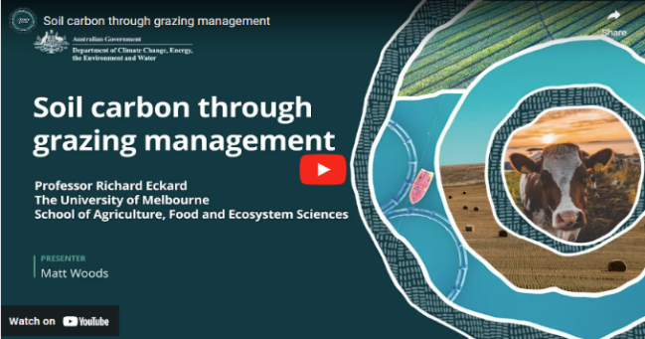
In this video (5:14 minutes), Matt Woods and Professor Richard Eckard of the University of Melbourne discuss soil carbon through grazing management.
Video: Soil carbon through grazing management
Transcript
MATT WOODS: Hello. I'm Matt Woods, and I'm here with Professor Richard Eckard.
Richard has been working for over 20 years on addressing the impacts of a changing climate on agriculture.
I'm going to move now to soil carbon and ask you about grazing management. Can you effectively build soil carbon through grazing management?
PROFESSOR RICHARD ECKARD: So there are a lot of claims around grazing management but the only actual evidence we have in the peer-reviewed literature would be that if you move out of a set stocking environment; a continuous grazing environment, where you might get caught out in a drought period will lead to erosion.
It will lead to the loss of soil organic matter off the surface of the soil through hoof action.
That we know; that we've seen in long term trials.
Once you move beyond that into some form of conservative rotational or adaptive grazing management strategy, there is no data to suggest that one would do soil carbon better than another.
They would all enhance soil carbon relative to the set stocked example.
So the best practice that we can advise farmers to do to build soil carbon in grazing systems is to move out of a set stocking environment into what we would call more adaptive rotational grazing.
Once you're into that environment of rotational grazing, there's no evidence that says one of the ten philosophies that are out there is better than another.
And that's as much as we can say right now.
WOODS: Ten philosophies, ten things to choose from. There must be a system that's going to work better for some farmers than others.
Is that right or is or is it just a bit of pot luck when they go to choose their system?
ECKARD: I think, it's fair to say that 40 years ago we thought there were recipes.
WOODS: Yep.
ECKARD: But then along came more variable climates and along came climate change. And that threw recipes out of the window because a recipe that you stick to religiously is going to get you in trouble when the climate varies.
So where we now say is all ten of those grazing philosophies have some merit at some time.
What we need to do is step back from fixed recipes to understand the principles of: if I overgraze or I have animals in too long and they regraze the same plant twice in a row, they will graze the more productive plants first.
And so I'll get an increase in unproductive plants. And so your grazing management needs to be more adaptive than ever before.
So understanding the principles of grazing management, the need to rest those productive plants; those nutritious plants, the need to balance unproductive versus productive grasses, in the way you manage range land then becomes more critical.
And then you go to those ten philosophies and say, well, for this next three month period, because the El Niño's coming, I need to pick a different strategy. Because the one I'm doing will get me in trouble.
And so adaptive grazing says, understand the principles around how plants are productive and animals interact with the grassland system.
And then apply those principles in some form of conservative rotational resting, allowing plants to recover, allowing productive plants more time to recover, not allowing re-grazing of plants, all become important. But unfortunately, with a variable climate, we can't have fixed recipes.
WOODS: Sounds like what you're saying is that farmers need to be flexible in how they approach their grazing. Understand the concepts and be very flexible depending on what's happening.
Is that right?
ECKARD: Yeah. Most definitely, we need to be adaptive in our grazing management. The only thing we need to be fixed about, and some of the better farmers have figured this out, is have immovable and non-emotive cutoff dates.
So if you haven't got 25 millimetres by the 23rd of February, you need to lighten your stocking rate by x per cent.
Those are more critical rules that have emerged over time is: not having this emotion of "I'll just keep them for another week". Because that's how you get caught out.
WOODS: Okay.
ECKARD: The market's gone by then, and you've lost your opportunity.
So the better farmers have critical cutoff dates to make decisions.
But that decision is really still adaptive grazing. How do I adapt to this condition? I've got to unload a third of the animals and send them down to market, even though I might not get the best price, I now have the right stocking rate for the next three months.

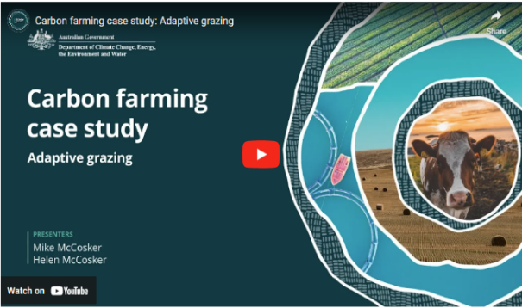
In this video (8:39 minutes), New South Wales graziers Mike and Helen McCosker discuss adaptive grazing and soil health.
Video: Carbon farming case study: Adaptive grazing

Transcript
MIKE MCCOSKER: So the importance of soil carbon in understanding the health of my farm is critical. Soil carbon is the end result of all of the ecosystem functions working properly.
Whatever I'm producing relies on the green plants harvesting sunlight energy, turning that sunlight energy into sugars.
Soil carbon is the end result of all the ecosystems working properly.
So when we look at what's here now, the diversity above the ground indicates that I've got diversity of roots and diversity of biology under the ground. And that's the key to turning the sunlight energy into soil health and soil carbon.
So the greater the diversity of roots, the greater the diversity of biology, and that's what turns sunlight energy into soil carbon forming.
The penetrometer is a great tool to give me an indication of if there is a hardpan in this soil. So after years of planting oats every year and running the cattle across the country, then you know, there would be a hardpan somewhere in the first three or four inches. And the penetrometer shows me that as soon as I hit four hundred, the roots are no longer growing in that soil. So that shows me if the hardpan is just, you know, two inches or four inches under the soil.
So at the moment, I've got half a metre of good functional soil there.
And that means no hardpan for me, no restriction of root growth. I've got the all of the biology and the roots doing exactly what they're meant to be doing under there, and that includes taking in water and holding the water for the crop.
Soil carbon and the ability of this soil to take in water are directly proportional.
So when my soil carbon levels are low and the soil structure has collapsed, this soil can only take a maximum of, you know, 50 millimetres of rain in an hour. If I get more than 50 millimetres of rain in an hour, that water would hit the soil and run away.
When I get my soil carbon up, it makes the soil like a sponge. And so now that I could take in anything up to 500, 700 millimetres of rain in an hour. So I could get my whole annual rainfall in one hour, and it would all go into the soil. So the importance of soil carbon and the ability of the soil to take in water and make my rainfall now efficiently turn into to crops and production directly proportional.
So grazing management for soil carbon and for diversity, it comes back to a planned rotation.
So I pull the cattle together so that my cattle impact when the cattle are in here. It's like a quick mow. So we're a short period of time with high stock density.
And then the other thing that I really plan is the rest period. So how long does this pasture need to then recover from that grazing?
So, we talk about time controlled grazing or planned grazing, but that's all about planning the rest period.
And to get the rest period, I plan the density of the stock and how long that land is impacted for.
I'm looking for indicator species. So I'll be looking for if this is one of my main grasses because it's nice and sweet and it's high in nutrition, then I'm looking for this grass to be fully recovered before I'm bringing those cattle back here.
This gets a little bit counterintuitive because when the growth is happening really quickly, I want to avoid, this grass having to draw from its root reserves to grow. So I'm wanting to avoid the animals coming back and taking a second bite before it's actually fully recovered and replenished the root system.
So when things are growing really quickly, I actually need to move the stock around the farm more quickly. When things are recovering slowly, I actually need a longer rest period because it takes longer for the plant to get away from where it's drawing on the root reserves back up to, what we call a late phase three or early phase four.
That so if things are recovering slowly because we're a bit short of moisture, we just haven't had the rain, then I'll actually slow the cattle down. There's no risk when things are running slowly that the animals will get a second bite, but there is risk that we don't get back to a fully recovered plant if I come back too quickly.
Does the soil carbon level show up as being different if we get dry weather? I would say absolutely.
The ability of the soil to absorb the water when it does rain means that my water cycle efficiency, that actually shows up when it stops raining because I'll have, you know, two times, three times more water held in my soil compared to the neighbour's place.
And, you know, so the pasture will stop growing on my neighbours and still be growing on my place simply because I've got more water held in the soil. 2018 and 2019 were horrendous years. They were bad for everyone.
I can say that we didn't need to feed the cattle for a lot longer into the drought before we had to start feeding.
And then when it did rain at the end of the drought, the land just recovered and regenerated so much more quickly. So the resilience of the farming operation, shows up in the extremes of the weather. When it's dry or even when it's particularly wet, having that soil carbon in the soil just gives this land much more resilience.
M. MCCOSKER: From the point of view of building soil carbon, you know we understand that it's not just one practice that makes that change. And in fact, I would say that we've stacked different practices together. We've changed the management of the cattle, and we've changed to a multispecies cover crops. And we've
HELEN MCCOSKER: And compost.
M. MCCOSKER: Included mineralised compost.
So we've stacked the changes.
When I think back about how the farm has changed, one of the things that is a little more subtle, but you do notice it really quickly, is that the soil gets softer.
And, it's soft when you walk on it. Yeah. It's easy for the tractor, so we actually probably now use less fuel.
And I noticed that because we also contract plant for other farms in the district.
And when we go on to another farm, we're pulling the same equipment, but we -
H. MCCOSKER: Gear
M. MCCOSKER: Gear slower.
H. MCCOSKER: Yeah.
M.MCCOSKER: And using more fuel.
H. MCCOSKER: Yep.
M. MCCOSKER: And then we come back home, and we go, wow. Isn't the soil so soft?
One piece of advice that I would give to people is hasten slowly, that don't be afraid to fail.
But if you do fail, make sure you've failed on just a little bit of the farm and work that out before you try and do it over the whole farm.

  - Activity

Activity: Respond to the following questions
Think about how what is covered in this topic might apply to your land management or farming practice. Consider the following questions and make notes about carbon farming activities that might suit your enterprise. The following points will help you have informed discussions with advisers.
- What potential benefits are you hoping to gain from carbon farming? Consider both financial and non-financial potential benefits.
- Which activities might you undertake?
- What do you need to consider based on your practice and location?
- Based on the information provided in this topic, what else is important for you to note for future reference?
- What further questions do you have?
- Consider the following risks associated with doing or not doing carbon farming that might apply to you. You may also identify other risks. This can inform your discussion with an adviser.
Risk
… associated with doing carbon farming activities
The location could be unsuitable
Land could be lost for production
Biodiversity could be harmed
There could be insufficient water
Meeting any permanence requirements for carbon storage could be difficult
There could be too much financial risk
… associated with not doing carbon farming activities
Not mitigating climate change
Soil degradation
Water cycle degradation
Loss of biodiversity and ecosystem function/resilience
Not accessing new income opportunities
Not meeting emerging supply chain and market requirements

  - Other resources

Livestock
Reducing methane from livestock (DCCEEW)
This DCCEEW webpage Reducing methane from livestock provides information on research into reducing methane emissions through feeding and grazing practices.
Climate and environment (Dairy Australia)
This Dairy Australia website provides resources on sources of dairy emissions and Dairy Farm Emissions Reduction Strategies:
- Reducing dairy's greenhouse gas emissions (PDF 662 KB)
- Reducing fossil fuel emissions (PDF 615 KB)
- Reducing manure emissions (PDF 457 KB)
- Reducing nitrous oxide emissions (PDF 538 KB)
- Reducing rumen emissions (PDF 453 KB)
- Storing more carbon (PDF 796 KB)
Environmental sustainability (Australian Pork)
This Australian Pork website provides information on research and resources for environmentally sustainable pork. There are 2 roadmaps for producers:
- Low Carbon Emission Roadmap (PDF 5 MB): to help understand emissions and learn what practices can be implemented to reduce emissions
- Closing the Loop (PDF 2 MB): to help understand how to minimise feed inputs, improve efficiency to minimise waste, utilise manure nutrients and discover new ways to manage hard waste.

Cropping, horticulture and forestry
Sustainability Initiative (Grains Research and Development Corporation)
The Grains Research and Development Corporation’s Sustainability Initiative (PDF 4.6 MB) summarises GRDC’s position and plan for ongoing investment in sustainability (including climate mitigation and adaptation). Work stream 2 of the initiative includes information on emissions reduction practices for the sector as well as references to relevant resources and tools.
Sustainability framework for Australian horticulture (Hort Innovation)
This Hort Innovation website provides information on sustainable agricultural practices within the Horticulture sustainability framework and links to industry-led sustainable production assurance programs (Hort360, EnviroVeg, Banana BMP, Freshcare Environmental and EcoHort).
Emissions Reduction Guide (Wine Australia)
This Wine Australia website provides an Emissions Reduction Roadmap, a reference manual containing tools, resources and advice to help Australia’s grapegrowers and winemakers take action in their own businesses.
FWPA Carbon Guides (Forest & Wood Products Australia)
This Forest & Wood Products Australia website provides information including the Forests & Wood Products and Australia’s Carbon Balance Guide that describes the key concepts associated with the life cycle of carbon in forests and forest products and provides guidance on forest management.

Additional
Accounting for Nature methods
The Accounting for Nature website has a catalogue of methodologies to measure and report on environmental assets to prepare an environmental account. Accounting for Nature is one approach to measuring environmental conditions.
Zero Net Emissions from Agriculture Cooperative Research Centre
The Zero Net Emissions from Agriculture Cooperative Research Centre aims to catalyse industry, community and government action to achieve zero net emissions from agriculture from 2040 and below zero net emissions by 2050. Its four research programs focus on:
- low-emissions plant solutions
- towards methane-free cattle and sheep
- whole-farm and mixed enterprise systems analysis
- delivering value from net zero.
Blue Carbon – Opportunities for First Nations Peoples
The Blue Carbon in Australia, understanding the opportunity for Indigenous People report provides information and mapping related to First Nations participation in Blue Carbon projects.

Topic 3: Your greenhouse gas account

Time to complete this topic
About 60 minutes to read the information in this topic. Additional content includes videos, activities and links to other resources which may require extra time to complete.
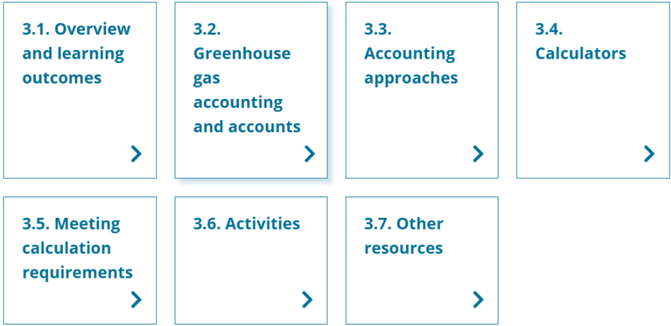
In this topic:

  - Overview and learning outcomes

Overview
In this topic, you will learn about a greenhouse gas (GHG) account and how it quantifies and records your GHG emissions and carbon storage.
The topic starts by explaining GHG accounting and the reasons for doing it. It examines the benefits of a farmer or land manager having a GHG account. It also examines accounting for co-benefits and the uses of a GHG account.
Keeping a GHG account is about estimating GHG emissions and carbon storage using a GHG calculator and recording these estimates. There are many calculators available. Some make quick, simple estimates that give a general understanding and allow users to run ‘what if?’ scenarios. Others are more complex and make more precise estimates where needed, for example, to earn ACCUs. This topic explains 3 calculators, covering various sectors and levels of complexity and gives farmers and land managers hands-on experience using them. The 3 calculators are:
- the Meat and Livestock Australia (MLA) Quick Start Carbon Calculator, a simple calculator that estimates GHG emissions and carbon storage that only needs basic data
- the Greenhouse Accounting Framework (GAF) tools, a group of agriculture-specific tools produced by the Primary Industries Climate Challenges Centre and the University of Melbourne
- the Commonwealth Scientific and Industrial Research Organisation (CSIRO) LOOC-C (Landscape Options and Opportunities for Carbon abatement Calculator), which gives estimates and options for action linked to the ACCU Scheme.
Section 7 provides information on other calculators, including a table summarising them, to help in considering their suitability for a particular purpose.
Farmers and land managers often already have the data they need to use these calculators or are likely to be able to collect the data. For example, a farmer might have the data for farm input benchmarking or management or tax accounting.

Learning outcomes
After completing this topic, you will be able to:
- describe GHG accounts and the need for them
- identify 3 calculators and what data they need
- calculate GHG emissions and carbon storage for a property using a GHG calculator
- identify the largest sources of emissions and potential options to reduce emissions or store carbon.

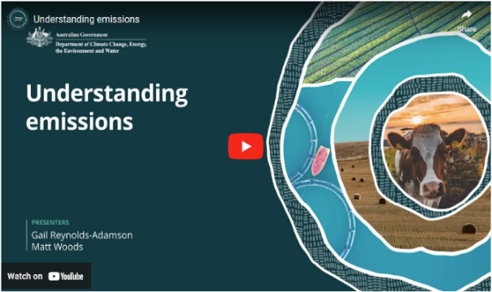
Watch this video
In this video (2:10 minutes), presenters Gail Reynolds-Adamson and Matt Woods introduce Topic 3 and provide important context.
Video: Understanding emissions

Transcript
GAIL REYNOLDS-ADAMSON: Welcome to topic three, where we look at understanding emissions in more detail, and in particular, how to accurately measure them.
MATT WOODS: Einstein supposedly once said, "Not everything that can be counted counts, and not everything that counts can be counted". Now he obviously wasn't talking about carbon farming because measuring emissions are what counts, and they can be counted.
The key is knowing how much emissions are going out and how much are being avoided or saved.
We call this carbon accounting.
REYNOLDS-ADAMSON: And carbon accounting is important when carbon farming. Whether you intend to sell carbon credits or not, being able to establish a baseline measure and report your emissions is vital for the Australian Carbon Credit Unit, ACCU, schemes.
But equally, for demonstrating to supply chains and to customers the fruits of your carbon farming endeavour. The key is knowing what to measure and how, and this is where this topic will help. Like most things agricultural, it's not always straightforward, and there's many different tools and techniques with various pros and cons.
Sometimes it can be hard to sort the wheat from the chaff.
WOODS: This topic will cover the on farm information needed to measure emissions. We'll look at various carbon calculators, how to choose the right ones for your sector, and the kinds of data they need.
REYNOLDS-ADAMSON: Again, you will hear from experts and see relevant case studies and be prompted to respond to the focus questions in preparation for discussions with the experts to guide your decisions.
And one more thing before you go.
Whilst we can and must measure emissions and other co-benefits such as biodiversity, there are some that, whilst they count, simply cannot be counted.

  - Greenhouse gas accounting and accounts
About greenhouse gas accounts
A farmer or land manager uses a GHG account to record GHG emissions and carbon stored. They or their advisers keep the account. It is an ‘account’ only in the sense that it records:
- ‘debits’ (scope 1, 2 and 3 emissions)
- ‘credits’ (carbon stored)
- the resulting balance.
The opening balance of an account is GHG emissions minus carbon stored, estimated for a defined period. The opening balance helps in understanding your emissions sources. It provides a starting point or a baseline against which you can measure the progress of carbon farming activities to reduce emissions and store carbon.
The emissions boundary covered by your footprint may be all the sources of emissions and increase in carbon storage on your land, or it may also include your supply chain. The boundary should be defined in line with your purpose for determining your footprint and any associated requirements you may need to meet.
There are different ways to construct a GHG account, and the approach you use depends on the purpose of preparing the account. It might be a simple account with limited, approximate data to, for example, track livestock emissions over time. Or the account might conform to a standard (such as a Climate Active Standard), to support a farmer’s claims about the emissions intensity of their products (such as wool, meat and grain). Depending on the purpose of an account, it may record insetting and offsets in addition to emissions and carbon stored.
The government is developing voluntary emissions estimation and reporting guidelines (Guidelines) for agriculture, fisheries and forestry industries. The Guidelines are focused on estimating farm-level emissions from cradle to farm-gate and will be updated annually to align with the National Greenhouse Gas Inventory.
The Guidelines will be published in mid-2026 and aim to:
- Improve the consistency and quality of farm-level GHG accounting methods.
- Enhance the consistency and quality of the emissions estimates calculated by GHG accounting tools used by primary producers.
‘Carbon’ vs ‘greenhouse gas’
The commonly used term ‘carbon accounting’ generally refers to accounting for all GHGs, not just carbon dioxide and stored carbon.
  - Accounting approaches
Greenhouse gas accounts
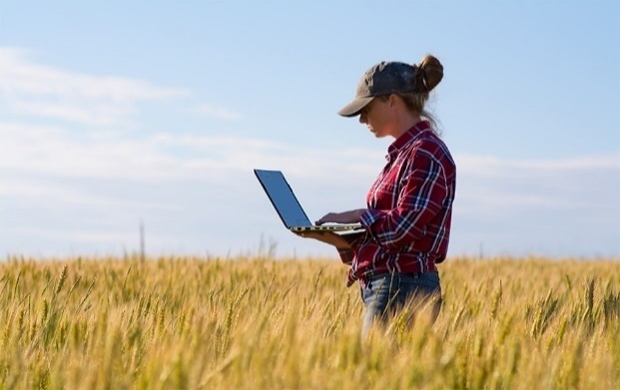
Keeping a GHG account means quantifying GHG emissions and carbon stored. A farmer or land manager keeping an account solely for their own purposes can choose any suitable approach. However, if they keep an account to participate in a program (such as the ACCU Scheme), they will need to use the program’s specified approach for their calculations. These approaches may differ from whole-of-farm calculators such as GAF calculators. Program-specific approaches can include:
- the applicable scheme’s eligibility requirements
- the emissions sources and carbon stores to be included
- the monitoring and measurement tools and methods (such as for remote sensing and soil sampling and analysis)
- the calculator and tools to estimate quantities of GHGs emitted and carbon stored; calculators are custom-made software, or spreadsheets, usually in Microsoft® Excel®
- the frequency of estimates, to track changes over time
- reporting and verification standards.
The two main Australian Government initiatives with requirements for estimating or calculating GHG emissions and/or carbon stored are:
- the ACCU Scheme, administered by the Clean Energy Regulator, the statutory body that administers initiatives legislated by the Australian Government for measuring, managing, reducing and offsetting Australia's GHG emissions
- the Australian Government’s Climate Active program, administered by DCCEEW, which encourages business decarbonisation by certifying voluntary climate action.

Accounting for co-benefits
Topic 2 examined the co-benefits of carbon farming for a farmer or land manager, the environment and the community. Accounting for co-benefits is in its infancy, but it is maturing as governments and an environmentally conscious public want to know the cultural, environmental and social impacts of farming and land management. Examples of accounting for co-benefits include:
- the Queensland Government’s Land Restoration Fund, which requires projects to follow a specified carbon storage method and deliver at least one environmental co-benefit, with the option of including social and/or First Nations peoples' co-benefits, as explained in its LRF Co-benefits Standard (PDF 2.1 MB)
- the Western Australian Government’s Carbon Farming and Land Restoration Program’s Co-benefits Standard 2022-2023 (PDF 1 MB), which outlines eligible co-benefits with examples, data and guidance about monitoring and reporting and a CF-LRP Co-benefits Portal, a digital mapping tool for applicants to identify co-benefits
- the Aboriginal Carbon Foundation's Core Benefits Verification Framework for the Environmental, Social and Cultural Values of Aboriginal Carbon Farming for determining values for benefits in First Nations carbon market projects.
Uses of a GHG account
A GHG account can help a farmer or land manager to:
- baseline their GHG emissions and changes in carbon storage, to help in identifying emissions reduction and carbon storage options and to set benchmarks for monitoring their emissions profile over time
- track and report on emissions reductions and carbon storage in an ACCU Scheme project if the GHG accounting is done in line with the specified method for the project
- achieve and maintain Climate Active certification for voluntary climate action
- provide evidence (when prepared within a suitable framework) to consumers, retailers, lower-interest sustainability loan providers and others who are interested in the carbon footprint of your product or business
- quantify productivity improvements and other carbon farming co-benefits
- use the data generated to work with regional natural resource management (NRM) organisations to reduce GHG emissions and store carbon at the landscape scale.
If selling produce internationally, farmers may need GHG accounts to demonstrate their emissions management credentials.

  - Calculators
Next, we look at 3 calculators covering various sectors, levels of complexity and purposes to give you hands-on calculator experience. Some initiatives (such as the ACCU Scheme) specify requirements for estimating GHG emissions and carbon storage, which include using specific calculators. The results of these calculators may not suit your particular purposes: no calculator suits all uses and all initiatives.

Watch this video
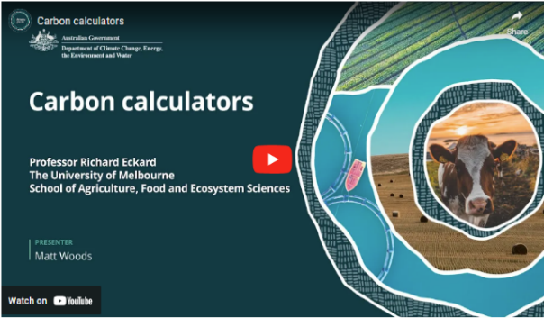
In this video (1:57 minutes), Matt Woods and Professor Richard Eckard of the University of Melbourne discuss what a carbon calculator is and what it does.
Video: Carbon calculators

Transcript
MATT WOODS: Hello. I'm Matt Woods, and I'm here with Professor Richard Eckard. Richard has been working for over twenty years on addressing the impacts of a changing climate on agriculture.
Can you briefly describe what a carbon calculator is?
PROFESSOR RICHARD ECKARD: So a carbon calculator is just -- in our case, we've got the greenhouse accounting framework calculator. So we've got one called the sheep and beef calculator, another one called the feedlot calculator; a dairy calculator.
And it's a simple spreadsheet.
It has all complex calculations behind the scenes that you can go and look at if you want to. There's nothing hidden there. But the data input page is one page where you just put in your animal numbers, how much fertiliser you've used, how much lime you used, and what energy you used, and what you bought onto the farm.
WOODS: Right.
ECKARD: And it breaks it down to a simple number at the end that says "this is how much methane is produced". "This is how much nitrous oxide is produced". "This is how much carbon dioxide you're losing".
And "this is how much total emissions your farm produces and emissions per unit product it produces".
At the end, those are the numbers that matter. And over time, that's what the supply chain will look at and say, what is your emissions intensity? How much methane are you producing?
And those are the numbers that matter.
WOODS: Terrific. Thank you very much Richard. I appreciate your time.

MLA Quick Start Carbon Calculator
We start by looking at a simple, straightforward calculator that requires basic data inputs and allows users to understand GHG emissions sources and carbon storage.

The MLA (Meat and Livestock Australia) Quick Start Carbon Calculator is a quick, easy way for farmers to estimate their GHG emissions and carbon storage through on-farm tree growth. The calculator also estimates how much pasture growth and tree planting you will need to balance out emissions.
The calculator needs minimal data to estimate on-farm emissions, although the better the data, the more accurate the result.
The calculator gives farmers and land managers just starting their calculation journey a quick assessment of their GHG emissions and carbon storage. It also gives a taste of what the MLA’s more comprehensive calculator (the MLA Carbon Calculator) and other sector-specific calculators can provide.
The calculator is based on the Greenhouse Accounting Framework tools developed by the University of Melbourne, which this topic examines later.

Watch this video
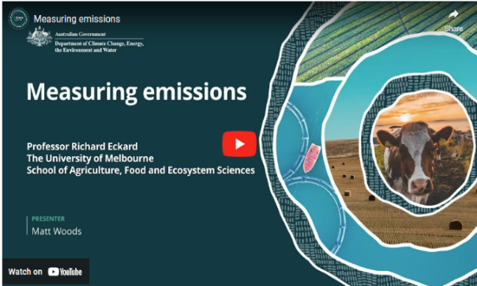
In this video (4:59 minutes), Matt Woods and Professor Richard Eckard of the University of Melbourne discuss the basics of the MLA Carbon Calculator and its main functions, providing information to help you decide whether this calculator suits you. Section 6 has an activity to use a simplified version of this calculator.
Video: Measuring emissions
Transcript
MATT WOODS: Hello. I'm Matt Woods, and I'm here with Professor Richard Eckard.
Richard's been working for over 20 years on addressing the impacts of a changing climate on agriculture.
WOODS: If that farmer wanted to monitor and measure their emissions, how would they start?
Where would they start to work out actually how much emissions they're producing?
PROFESSOR RICHARD ECKARD: So, there is some thought out there that farmers might need to measure emissions. That’ll never happen. It is too complex; it is too complicated from a science point of view to get accurate profiles on methane from animals in a farm setting - so that’s impractical.
However, the research we've done says that 20.7 times dry matter intake is a fairly reliable number. And we're starting to quantify all the mitigation strategies against that. So if you feed oils to your cows at seven percent, that 20.7 becomes 16. We know that. If you feed seaweed, it might become five.
So we know how to adjust calculations to accommodate it. The biggest uncertainty in knowing what your number is on a livestock farm is knowing how many animals you've got. That's actually far bigger than the methane conversion that we use.
WOODS: You'd think most farmers know their animal numbers, wouldn't you?
ECKARD: It is surprising, we do case studies across farms right from the Northern Territory right down to Tasmania, and getting animal numbers right is the biggest struggle we have in doing an accurate carbon audit on farms. Even though they have a stock book - because there's no such thing as static number of animals on a farm. A dairy farm will milk different number of animals every day of the year.
A beef system, a prime lamb system, lambs are being born, lambs are dying. So actually knowing exactly how many animals you've got on any one day, and locking that into a calculator is actually quite difficult.
Even some of the best farmers, we have to go back to them two or three times to say "did you mean culling before or after the weaning rate you quoted?"
Because it doesn't reconcile and you realise that; we had one case of a Queensland farmer that the numbers didn't add up when we said, you know, what was your weaning rate? What was your reproductive rate? How many animals are you producing? And it turns out that there were a thousand animals down the back of the farm that they lost for a couple of years. It gives you some perspective on some of the bigger properties in Australia where you can lose a thousand animals for a period of time. Not ultimately, but you can miss them in a muster that isn't perfect.
WOODS: So farmers won't be required to actually measure their emissions, but it's useful for them to start maybe calculating their emissions and carbon calculators is something that you've got a real history in, and were a first mover in. How do they work and what are the sort of inputs that farmers might need to put into them?
ECKARD: Correct. So at the moment, we've got fairly simple spreadsheet calculators. They are being coded up into online tools like Meat and Livestock Australia have a identical version of our sheep and beef calculator now online, and it will give you the same answer. We've made sure that the various calculators are not giving different answers.
The biggest input is animal numbers.
So if you're a sheep or beef producer somewhere in Australia, getting the animal numbers right into the calculator on a seasonal basis is probably the biggest input.
If you know your animal numbers, you can pretty much complete the calculator in ten minutes. We've tried to keep it as simple as possible. So that if you know the data that needs to go in, you can put it in in about ten minutes. The other inputs you need to know is fertiliser used. So if you're a dairy farmer, you might be using nitrogen fertiliser, you need to know how much you put on. Most dairy farmers know that.
And the other inputs is electricity and diesel consumption on the farm, and we just put that on an annual time step basis.
So emphasising again, they're simple spreadsheets, they have a single page of data input, and, we try to keep it down to about ten minutes to get in and out if you've got all the data required.

Greenhouse Accounting Framework sector-specific tools
The second calculator is actually a group of more comprehensive tools. The Greenhouse Accounting Frameworks (GAF) for Australian Primary Industries tools are for various agriculture and land management sectors. These tools, in the form of Microsoft® Excel® spreadsheets, allow users to predict the sources and amounts of GHGs emitted from a farm and a product at the farm gate.
There are industry-specific tools for dairy, sheep and beef, cropping, feedlot, sugar, cotton, horticulture, pork, buffalo, deer, goat, poultry and rice. The tools are designed to be easy to download and use, although you need to be familiar with Microsoft® Excel®.
Each tool has:
- a Data summary tab, which itemises and totals scope 1, 2 and 3 GHG emissions in CO₂-e as well as carbon stored to estimate net farm emissions
- data input tabs, in which the user inputs crop, vegetation, livestock or other data as relevant tabs for each of the emissions line items, showing the assumptions, formulas and values used for the item.
The data summary tab shows GHG emissions and storage items at a glance and in chart form. The example in the Australian Dairy Carbon Calculator shows that methane emissions from enteric fermentation make up almost two-thirds of scope 1 emissions. Fertiliser on-farm and manure make up about one-quarter and pre-farm emissions one-tenth.
The data input tab requires data that many farmers would have at hand for farm input benchmarking, or management or tax accounting purposes, or that is reasonably easy to collect. For example, the sheep and beef tool needs sheep class numbers, live weight by class and live weight gain by class, broken down by season.
The tabs for each GHG emissions line item have detailed analyses useful to farmers, land managers and their advisers. The Primary Industries Climate Challenges Centre and the University of Melbourne developed these tools as part of their Farm Greenhouse Accounting Framework, which is designed to align with the Australian National Greenhouse Accounts, a series of comprehensive reports and databases that estimate and account for Australia’s GHG emissions from 1990 onwards.
AIA Environmental Accounting Platform (EAP)
The Environmental Accounting Platform (EAP) developed by Agricultural Innovation Australia (AIA) is a free, standardised tool for calculating GHG emissions across 17 commodities. Built with investment from 10 rural Research and Development Corporations, it enables producers and mixed farming businesses to calculate their emissions at a commodity and whole of enterprise level, establish operational baselines, and scenario-plan to support decisions aimed at reducing emissions.
The EAP is supported by a Technical Advisory Panel comprising Australia’s leading experts in GHG accounting, emissions reduction, lifecycle assessment, and climate science. It is consistently updated to ensure alignment with the latest versions of the Greenhouse Accounting Framework (GAF) tools. Once published in mid-2026, AIA’s EAP will transition to alignment with the Guidelines.

LOOC-C
Unlike the MLA Quick Start Carbon Calculator and GAF tools, the CSIRO’s LOOC-C (Landscape Options and Opportunities for Carbon abatement Calculator) isn’t used to calculate a farm’s GHG emissions and carbon storage. Instead, it allows a quick assessment of emissions reductions or carbon storage that could be achieved by conducting some types of ACCU Scheme projects.
LOOC-C lets you select a land area on a map and assess the suitability of the listed ACCU Scheme methods for the land. It provides indicative estimates of the number of ACCUs that could be generated for the selected area.
LOOC-C can also help people who may not intend to run an ACCU Scheme project because it indicates the carbon storage potential of management activities at a selected location and the co-benefits of these activities.

  - Meeting calculation requirements
As we have seen, there are basic calculators and other calculators that meet a specific baselining or reporting requirement (such as for an ACCU Scheme method). The basic calculators are informative and widely used but only produce general results. Also, they lack quality control over data input and may not align with the Australian National Greenhouse Accounts or be eligible for use under programs such as Climate Active. The government has is developing voluntary emissions estimation and reporting guidelines (Guidelines), which will outline the methods calculators should use to estimate farm-level emissions for different purposes.
Initiatives such as the ACCU Scheme specify detailed requirements for estimating GHG emissions. The requirements may include making calculations using a model or data derived from field sampling or a combination of these approaches.
If a farmer or land manager considering participating in the ACCU Scheme decides they can’t produce a calculation that meets the scheme requirements, they would commonly engage an adviser. Advisers include carbon service providers. Topic 4 provides more information.
Any adviser would need to have the necessary experience and knowledge in GHG accounting or environmental auditing aligned with relevant standards, which could include:
- the Australian National Greenhouse Accounts methodologies
- Climate Active carbon accounting and technical requirements for certification
- international value chain reporting requirements, including pre-farm to farm gate life
cycle assessment framework, consistent with ISO 14040:2006(en) Environmental management — Life cycle assessment — Principles and framework.
Changes in carbon storage in vegetation and soils over time can be calculated using data from physical sampling of trees and soil. Samples must be collected and analysed using robust processes to obtain accurate estimates. For example, soil sampling locations may need to be selected randomly to avoid bias and samples collected to a specified depth. Samples may need to be analysed in a laboratory using analytical methods and soil sensing techniques. While this approach can produce accurate estimates, it requires specialist skills and may be expensive. Simulation models can estimate carbon storage in vegetation and trees without the need to collect and analyse field samples.
Third-party verification of data and calculations can help ensure benchmarking and reporting requirements are met and that claims about reduced GHG emissions and carbon storage are well-supported.
The University of Melbourne’s Guidelines for conducting a carbon audit on farm and farm products (PDF 171 KB) provide more details on this topic.
ACCU Scheme methods
Farmers and land managers planning to run an ACCU Scheme project must calculate their GHG emissions and carbon storage using a legislated method. Topic 5 examines ACCU Scheme methods.
The Full Carbon Accounting Model (FullCAM) is used to produce abatement estimates for several ACCU Scheme vegetation management methods. It is also used to estimate net emissions from the land sector for Australia's National Greenhouse Accounts.
Each ACCU Scheme method specifies how to calculate GHG emissions. Some methods have their own calculator, such as:
- the Blue Carbon Accounting Model (BlueCAM)
- tools for the ACCU Scheme’s Savanna Fire Management methods (Savtools)
  - Activities

Activity: Respond to the following questions
Consider how this topic might apply to your land management or farming practice.
Consider the following questions and make notes about ways to calculate GHG emissions and carbon storage that might suit your purpose.
The following points will help you have informed discussions with advisers.
- Working through the following activities, which calculators are most appropriate for you?
- Who might you speak to for further advice about calculating your GHG emissions?

Activity: MLA Quick Start Carbon Calculator
The purpose of this activity is not to yield results that can be actioned on a property but to introduce you to a calculator, the type of data required and how to use the MLA Quick Start Carbon Calculator to get a result. The MLA calculators are intended for livestock production enterprises (see section 7 for a summary of calculators). Note that the steps in the calculator may change over time, so check the current version before using it.
- Read the How to work through the calculator page, which explains the calculator’s methods and assumptions for livestock, vegetation and scope 2 and 3 emissions.
- Open the MLA Carbon in action webpage, which explains the MLA e-learning module that walks you through how to use the calculator.
- Complete the Introductory survey.
- Move on to Background, the key point being that the only data required is the total property area (in hectares), areas of pasture and trees and the number of livestock.
- Move on to the Calculator, where the user enters data about their property. Use the following example data if you don’t want to use the calculator for your property.
Data | Value
Property area | 4,000ha
Location | South Australia
Zone | Mount Gambier
Beef cattle herd size | 0 head
Sheep flock size | 2,000 head
Area under pasture | 3,900ha
Dominant pasture species | Aust Phalaris, clover, annuals
Dominant soil type | Clay
Area under trees | 100ha
Dominant tree type | Mixed species

Activity: Greenhouse Accounting Framework Tools
Again, the purpose of this activity is not to yield results that can be actioned on a farm but to introduce you to these calculators, the type of data required and how to use the calculator to get a result.
- Open the GAF for Australian Primary Industries Tools. Click on the version of the framework relevant to you, which will download the spreadsheet to your computer, which you must then open.
- Click on the data input tab and enter the data relevant to your farm profile.
- Click on the data summary tab and work through the top 2 or 3 GHG emissions items, which is where there may be the greatest potential to reduce GHG emissions. Are you surprised by their size or that they are the main items?

Activity: LOOC-C calculator
The purpose of this activity is not to yield results that can be actioned on a farm but to introduce you to the idea of a calculator, the type of data required and how to use the calculator to get a result.
- Open LOOC-C. Choose your area on the map using the Area tool and select all relevant options on this page.
- On the next page, explore the available methods, which will be addressed in greater detail in Topic 5. Select a method of interest and explore the results. Note that while these are ACCU Scheme methods, the practices within the methods can be used for carbon farming activities other than an ACCU scheme project.
- In particular, explore the Farm Co-benefits tab and discuss the findings.
- Click on the Save as PDF line at the foot of the Available methods page to summarise the results.

  - Other resources

Calculators
While there are many other calculators, some of which are below, the logic of the original GAF tools (developed by the Primary Industries Climate Challenges Centre and the University of Melbourne) sits under many of them. All the calculators below are free to use unless otherwise indicated. This is not a comprehensive list of available calculators.
Australian Dairy Carbon Calculator
The Australian Dairy Carbon Calculator was developed by the Tasmanian Institute of Agriculture and Dairy Australia. The calculator is a spreadsheet to provide an understanding of GHG emissions under current management practices and to explore potential management practices to reduce on-farm GHG emissions. These practices include the management of herds, feed and soil, and reducing energy use and switching to renewables.
Australian Wine Carbon Calculator
The Australian Wine Carbon Calculator was developed by the Australian Wine Research Institute. It is a spreadsheet for estimating scope 1 and 2 emissions of vineyards and wineries. It also provides information on calculating scope 3 emissions, but it does not include them in calculations. The institute provides advice about carbon accounting (PDF 520 KB) in viticulture and additional links to information about vineyard soil health, soil analysis, salinity and management practices to improve soil structure and grapevine nutrition.
DairyBase
DairyBase, developed by Dairy Australia, helps dairy farmers and advisers measure and compare farm business performance over time. Dairy farmers already using DairyBase can estimate their GHG emissions using pre-populated data from their DairyBase farm dataset. The calculator is only accessible to registered users. The website has guides to using DairyBase.
MLA Carbon Calculator
The MLA Carbon Calculator enables farmers to calculate total enterprise GHG emissions and emissions intensity for beef, sheep, goat, wool, feedlot and crops. The MLA has digitised the Sheep and Beef Greenhouse Accounting Framework (SB-GAF) (XLSX 2.6 MB) and the Grains Accounting Framework (G-GAF) (XLSX 2.5 MB). MLA provides a Carbon accounting technical manual (PDF 1.8 MB) and a video about how to use the calculator.

Platform for Land and Nature Repair
The Australian Government’s Platform for Land and Nature Repair (PLANR) provides a calculator enabling users to estimate their GHG emissions and the condition of the natural assets on their land. They can then compare the results to other areas in their region.
Ruminati
The Ruminati calculator is managed by a group of industry experts and has BASE and PRIME versions that help estimate a farm’s GHG emissions and carbon storage. Ruminati PRIME, an enhanced, purchasable version, allows for modelling of GHG abatement options, creating emissions reduction plans and sharing emissions-related information with other organisations in their supply chain. The website provides access to a video about how to use the calculator.

Carbon calculator summary
The following information summarises the applicability and requirements of the carbon calculators discussed in this topic, to help farmers and land managers consider calculators that may meet their particular needs and circumstances. Notes below the summary provide more details.

Calculator | Sector or land use | Type of estimate or analysis | Data required | Relevant carbon farming categories | Accessibility | General description
Australian Dairy Carbon Calculator (Dairy Australia) | Dairy | GHG emissions  Abatement estimates | Property information  Livestock  Cropping  Vegetation  Waste management Consumables usage | Soil  Livestock  Vegetation  Other – renewable energy and manure management | Microsoft® Excel® spreadsheet  Downloadable for offline use  Free  No account required | Used to estimate GHG emissions, impacts of management activities on emissions and carbon storage in trees and explore different management actions. Based on Dairy GHG Accounting Framework (D-GAF).
Australian Wine Carbon Calculator (Australian Wine Research Institute) | Viticulture  Winemaking | GHG emissions | Cropping  Waste management  Consumables usage | Soil  Other – renewable energy and energy-efficient irrigation systems | Microsoft® Excel® spreadsheet  Downloadable for offline use  Free  No account required | Used to estimate GHG emissions from vineyards and wineries and impacts of management activities on GHG emissions.
Blue Carbon Accounting Model (BlueCAM) (Australian Government) | Blue carbon | ACCU Scheme  Abatement estimates | Property information  Cropping  Vegetation  Consumables usage  External – tidal ranges | Blue carbon | Microsoft® Excel® spreadsheet  Downloadable for offline use  Free  No account required | Used to estimate abatement for projects under the ACCU Scheme Tidal Restoration of Blue Carbon Ecosystems method.
DairyBase (Dairy Australia) | Dairy | GHG emissions  Abatement estimates | Property information  Livestock  Cropping  Vegetation  Waste management Consumables usage | Soil  Livestock  Vegetation  Other – renewable energy and manure management | Online only  Internet required  Free  Account required | Used to estimate GHG emissions, impacts of management activities on emissions and carbon storage in trees and explores different management actions. Based on D-GAF.
Environmental Accounting Platform (Agricultural Innovation Australia) | Beef (Feedlot)  Beef (Pasture)  Buffalo  Deer  Goats  Poultry (Broiler)  Poultry (Layer)  Pork  Sheep  Cotton  Cropping (Grains)  Horticulture  Rice  Sugar  Wild Sea Fishery  Wine  Aquaculture  Eggs | GHG emissions | Property information  Livestock  Cropping  Vegetation  Fisheries  Waste management  Consumables usage | Soil  Livestock  Vegetation  Other – renewable  energy and manure  management  Savanna fire  management | Online  Internet required  Free  Account required | Calculator used to estimate GHG emissions at a commodity or whole of enterprise level,  impacts of management activities on emissions and carbon storage in trees
Full Carbon Accounting Model (FullCAM) (Australian Government) | Forestry  Cropping  Grazing  Non-agricultural land use | GHG emissions  ACCU Scheme  Abatement estimates | Property information  Cropping  Vegetation | Soil  Vegetation | Online and downloadable  Internet required  Free  No account required | Used to estimate GHG emissions, impacts of management activities on emissions and carbon storage in soil and vegetation. Also used to estimate abatement for some vegetation and soil carbon methods under the ACCU Scheme.
Greenhouse Accounting Frameworks (GAF) for Australian Primary Industries Tools (The University of Melbourne) | Beef (feedlot)  Beef (grazing)  Buffalo  Dairy  Deer  Goats  Poultry  Pork  Sheep  Cotton  Cropping  Horticulture  Rice  Sugar | GHG emissions  Abatement estimates | Property information  Livestock  Cropping  Vegetation  Waste management  Consumables usage | Soil  Livestock  Vegetation  Other – renewable energy and manure management  Savanna fire management | Microsoft® Excel® spreadsheets  Downloadable for offline use  Free  No account required | Individual sector-specific calculators used to estimate GHG emissions, impacts of management activities on emissions and carbon storage in trees.
Landscape Options and Opportunities for Carbon abatement Calculator (LOOC-C) (CSIRO) | Agricultural or non-agricultural land use | Abatement estimates | Property information  Cropping  Vegetation  Consumables usage | Soil  Livestock  Vegetation | Online only  Internet required  Free  No account required | Used to produce indicative estimates of potential abatement under some ACCU Scheme methods, for a specified land area and time period.
MLA Carbon Calculator (Meat and Livestock Australia) | Beef (feedlot)  Beef (grazing)  Goats  Sheep  Cropping | GHG emissions  Abatement estimates | Property information  Livestock  Cropping  Vegetation  Consumables usage | Soil  Livestock  Vegetation  Other – renewable energy  Savanna fire management | Online only  Internet required  Free  Account optional | Used to estimate GHG emissions, impacts of management activities on emissions and carbon storage in trees and explore different farm management actions. Built on Sheep and Beef Greenhouse Accounting Framework (SB-GAF) and Grains Accounting Framework (G-GAF). Emissions estimates include consumables usage and feedlots which are not included in the MLA Quick Start calculator (explained below).
MLA Quick Start Carbon Calculator  (Meat and Livestock Australia) | Beef  Sheep  Cropping | GHG emissions  Abatement estimates | Property information  Livestock  Cropping  Vegetation | Soil  Livestock  Vegetation | Online only  Internet required  Free  Account optional | Used to estimate GHG emissions, impacts of management activities on emissions and carbon storage in trees.
Platform for Land and Nature Repair (PLANR) (Australian Government) | Beef  Sheep  Dairy  Pork  Poultry  Cropping  Forestry  Horticulture  Non-agricultural land use | GHG emissions  Abatement estimates  Biodiversity | Property information  Livestock  Cropping  Vegetation  Consumables usage | Soil  Vegetation | Online only  Internet required  Free  Account optional | Used to estimate GHG emissions, impacts of management activities on emissions and carbon storage in trees. PLANR also estimates biodiversity condition and can support planning of vegetation projects under the ACCU Scheme.
Ruminati (Ruminati) | Beef (feedlot)  Beef (grazing)  Sheep  Cropping | GHG emissions  Abatement estimates | Property Information  Livestock  Cropping  Vegetation  Consumables usage | Soil  Livestock  Vegetation  Other – renewable energy | Online only  Internet required  Free and paid options  Account required | BASE (free) and PRIME (paid) versions are used to estimate GHG emissions, impacts of management activities on emissions and carbon storage in trees. Based on GAF tools. Ruminati PRIME can estimate emissions from feedlots and can be used to explore different management actions.
Savtools (Australian Government) | Agricultural or non-agricultural land use | Abatement estimates | Property information  Vegetation  External – vegetation map of project region | Savanna fire management | Online only  Internet required  Free  No account required | Used to estimate abatement for projects under the ACCU Scheme Savanna Fire Management methods.

The presentation of material in this summary table does not imply the expression of any opinion, and the mention of specific companies or calculators does not imply that these have been endorsed or recommended by DCCEEW. Every effort has been made to ensure the information on calculators is accurate and linked to the most recent version of the calculator at the time of publication.

Supporting information
Calculator: calculator name and responsible organisation. Some products include functions other than calculations; all are referred to as calculators for simplicity. A carbon calculator can be custom-made software or a spreadsheet (usually in Microsoft® Excel®) that can be used to conduct activities including estimating quantities of GHGs emitted and providing abatement estimates.
Sector or land use: agricultural and non-agricultural sectors or land uses that a calculator relates to.
Type of estimate or analysis: types of estimates or analyses the calculators can be used for.
  - GHG emissions: calculator can be used to estimate GHG emissions, which may include scope 1, 2 and 3 emissions, and could be for an operation (e.g. a farm or winery), a land area, or an activity.
  - ACCU Scheme: calculator is specified in an ACCU Scheme method for estimating abatement from projects conducted under the method.
  - Abatement estimates: calculator can be used to estimate abatement (emissions avoided or reduced or carbon stored) from activities. May provide for forecasts of abatement and/or estimates of abatement already achieved.
  - Biodiversity: tool can be used to examine biodiversity condition.
Data required: types of input data that may be required.
  - Property information: may include area boundary, property name and size, location/region, annual rainfall, workforce, ownership status and distribution of land use activities on property. The calculator may include a geospatial tool to define an area boundary.
  - Livestock: may include livestock numbers, seasonal liveweights, animal sexes, liveweight gain, crude protein, dry matter digestibility, livestock purchase and sale inventory, milk production and supplementary feed use (e.g. hay, grain, cotton seed).
  - Cropping: may include crop varieties grown, area sown, average/yearly pasture and crop yields, soil properties (e.g. soil organic carbon), fertiliser usage and herbicide and pesticide usage.
  - Vegetation: may include species of trees, soil type, area of trees, age of trees, vegetation management actions, and fire management.
  - Waste management: may include solid waste (e.g. packaging), wastewater and organic waste (e.g. manure and vines). May also include how waste is managed (e.g. how much solid waste is recyclable or how much manure is drained to the paddock).
  - Consumables usage: may include water usage (e.g. irrigation types, water sources), fuel consumption (e.g. petrol, diesel, natural gas, liquified petroleum gas, biodiesel), vehicle types and farm transport data, and electricity usage (e.g. how much energy used has been purchased or generated) and winemaking products (e.g. CO₂ and synthetic refrigerant).
  - External data: refers to specific information required by a calculator which is obtained from an external source.
Relevant carbon farming categories: guidance on relevant carbon farming groups/activities, as identified in Topic 2.
Accessibility: refers to the how the calculator can be accessed and used. This includes:
- format of calculator: Microsoft® Excel® spreadsheet or online platform
- online or offline use: downloadable for offline use; or online only, and internet required
- user fees and accounts: free and no account required; free and account required; free and account optional (calculator can be used without account but account needed to save calculations); free and paid options (users are required to pay a fee to access the full content of the calculator).
General description: outlines the main features of each calculator. For consistency, descriptions have been based on whether:
  - the calculator estimates GHG emissions and/or carbon storage
  - the calculator explores the effect of different management practices on GHG emissions and explores management actions
  - the calculator is based on a GAF calculator
  - the calculator is used in an ACCU Scheme method.
The calculators may have more functions than those described. Users of the summary table are encouraged to click on the link for each calculator to explore all available functions, and any recent or upcoming updates to the calculator.

Other materials
Understanding carbon co-benefits (Indigenous Carbon Industry Network)
Chapter 10. Understanding Co-Benefits (PDF 844 KB) from the downloads page of the Indigenous Carbon Industry Network provides information about co-benefits from carbon farming practices for First Nations farmers and land managers.
Evaluation of potential indicators for the co-benefits of carbon farming (New South Wales Department of Primary Industries and Regional Development)
Potential indicators for the co-benefits of carbon farming (PDF 2 MB) is a report from a workshop hosted in 2019 on indicators relating to the potential co-benefits of carbon farming by the New South Wales Department of Primary Industries and Regional Development in collaboration with the University of New South Wales and the University of Technology Sydney.
Life Cycle Assessments (AgriFutures)
Life Cycle Assessments: A Useful Tool for Australian Agriculture (PDF 864 KB) is a booklet by the entity formerly known as the Rural Industries Research and Development Corporation, now called AgriFutures, that explains the main aspects of assessments, including the methodology for conducting one. It also provides several case studies of life cycle assessments.
What is a life cycle assessment? (Australian Pork Limited)
Life Cycle Assessment (PDF 4 MB) is a fact sheet produced by Australian Pork, explains life-cycle assessment, its difference from a carbon footprint and the different scopes of emissions included in a life cycle assessment.
Calculating net emissions and reduction strategies for a broadacre farm (Grains Research and Development Corporation)
Carbon Neutral Grain Farming by 2050 – an example in calculating net emissions for a broadacre farm and strategies to reduce net emissions is a Grains Research and Development Corporation report that looks at example GHG accounts from Western Australian cropping enterprises.

Topic 4: Planning carbon farming activities

Time to complete this topic
About 60 minutes to read the information in this topic. Additional content includes videos, activities and links to other resources which may require extra time to complete.
In this topic: 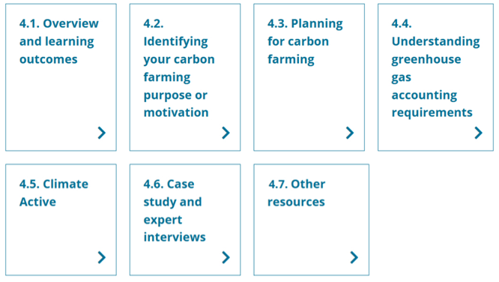

4.1 Overview and learning outcomes

Overview
This topic examines steps you might want to take to prepare to engage in carbon farming, starting with understanding your purpose or motivation. The topic then sets out some considerations you need to take into account when planning for your carbon farming activity or project. Once you understand these considerations, you can start to decide which carbon farming activities, practices or programs are most appropriate for your operation.
Topic 2 looked at carbon farming activities and practices you can implement, either outside of any private or government program or by participating in the ACCU Scheme, Climate Active or another program.
Conducting an ACCU Scheme project or seeking Climate Active certification have requirements with which you must comply. This topic examines some Climate Active requirements and refers you to other useful sources of information relevant to the Climate Active program, while Topic 5 expands on ACCU Scheme requirements. Topic 5, as well as the Clean Energy Regulator’s website, will help ensure you are accessing the most up-to-date information about the ACCU Scheme.

Learning outcomes
After completing this topic, you will be able to:
- identify your purpose or motivation to engage in carbon farming
- recognise important considerations for planning a carbon farming activity or project, including existing relevant plans, carbon farming opportunities, requirements, available advisers and support, and the feasibility of your preferred activity or project, including estimated revenue and costs
- describe greenhouse gas (GHG) accounting requirements
- determine the most appropriate carbon farming activities or practices for your operation.

Watch this video
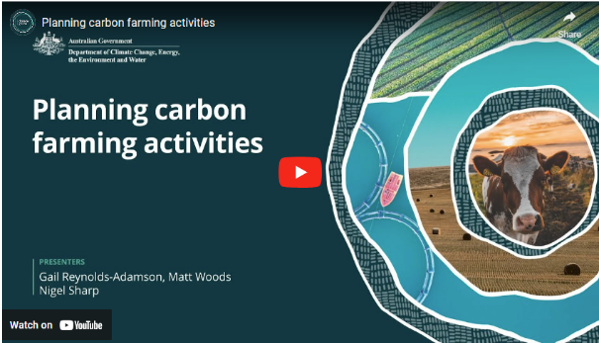
In this video (2:20 minutes), presenters Gail Reynolds-Adamson, Matt Woods and Nigel Sharp introduce Topic 4 and provide important context.
Video: Planning carbon farming activities

Transcript
MATT WOODS: Welcome to topic four, planning carbon farming activities. This is where the rubber really hits the road as we start to look at some of the actions, pathways, and decisions you'll need to make before embarking on carbon farming.
GAIL REYNOLDS-ADAMSON: We'll also get our hands dirty. As we start to plan carbon farming activities for emission management and restoration based on what we've covered in this package so far, by the end of this topic, you'll have carefully considered which carbon farming activities are most useful for your sector, farming system, location, and particular circumstances.
WOODS: We'll explore key sector specific carbon farming techniques and technologies and hear their benefits and drawbacks firsthand from experts, including farmers who are using them.
REYNOLDS-ADAMSON: This topic will also guide you with your decision about whether or not to participate in an Australian Carbon Credit Unit or ACCU scheme or seek Climate Active certification.
And importantly, it will help prepare you through focused questions to have informed discussions with advisers before making any final decisions.
If you are considering participating in an ACCU scheme, then the next topic will explore this in detail.
NIGEL SHARP: This topic is laying out a systematic process that farmers can use to decide their carbon farming purpose.
The process starts with farm planning, which should inform your objectives and what drives you to carbon farming.
Do you want to earn carbon credits?
Do you only want on farm co-benefits like healthy soil, water, and produce, more productive livestock, and better managed pastures?
It's essential to be clear about your purpose because some purposes, like earning carbon credits, have lots of work and responsibilities you might not want to take on.
What is your purpose for carbon farming, and what sort of factors did you take into account when deciding to do it?

  - Identifying your carbon farming purpose or motivation
Understanding what motivates you to engage in carbon farming is an important step in deciding your best pathway. You may be motivated to participate in carbon farming for one or more of the following reasons.

Meeting increasing demand from investors, creditors and supply chains for less emissions-intensive production
The Australian Government is improving the quality of climate-related financial disclosures to provide greater transparency and more comparable information about an entity’s exposure to climate-related financial risks and opportunities and climate-related plans and strategies.
This and other domestic and international initiatives (such as the Science-Based Targets Initiative) are increasing climate-related reporting requirements for investors, creditors and supply chains that, as a result, are increasingly preferring lower-emissions investments, transactions and suppliers.

Meeting increasing demand from consumers for more sustainable products
As the world shifts to a net zero emissions trajectory, it is likely that people will increasingly prefer lower-emissions agricultural products. For example, a 2023 study by McKinsey and NielsenIQ in the US found that products making environmental, social and governance (ESG) related claims averaged 28% cumulative growth from 2017 to 2022, compared to 20% growth for products that made no such claims over the same period. The study found that products that made ESG-related claims grew faster than those that didn’t, and it revealed, in many categories, a clear and material link between ESG-related claims and consumer spending.

Securing continued market access in the face of increasingly stringent climate-related requirements in trade agreements and potential future trade barriers
For example, Australia’s three largest beef export markets — Japan, China and South Korea — all have net zero emissions targets to be met by around mid-century. Adopting carbon farming activities and practices in our beef production would strengthen our existing reputation for clean and safe produce, enabling Australian producers to prosper in emerging markets for low-carbon meat products.
In 2023, Deloitte Access Economics undertook a global scan of carbon taxes, including the European Union’s Carbon Border Adjustment Mechanism, and investigated what this means for Australian agriculture. It found that if agricultural products were to be included in the mechanism in the future, Australian agricultural output could be reduced by a total of $1 billion between 2026 and 2040 in present value terms. Emerging climate-related trade demands will be better met with agriculture products that are less emissions-intensive.

Diversifying income streams by taking advantage of increasing demand across the economy for carbon offsets
Farmers and land managers can participate in carbon markets (such as the ACCU Scheme) to diversify their income streams. However, they need to be aware that selling carbon credits means they can’t claim the same benefit towards their (or their supply chain’s) low-emissions claims, which would limit their capacity to meet other purposes or motivations for participating in carbon farming.

Supporting the agriculture sector to meet climate mitigation goals, including improving industry’s resilience to climate change
As Topic 1 explained, Australian agriculture industry bodies have ambitious climate targets driven mainly by emerging domestic and international market requirements. Examples include Dairy Australia’s aim for a 30% reduction in emissions intensity across the industry in the same timeframe and wool production’s move towards carbon neutrality. Meeting these targets relies on emissions reductions and carbon storage by producers.

Supporting Australia to meet its emissions reduction commitments
The Australian Government has committed to reducing Australia’s emissions by 62-70% below 2005 levels by 2035 and to reach net zero emissions by 2050. It has developed the Net Zero Plan to guide Australia’s transition to net zero emissions by 2050, as well as six sectoral plans, including one for agriculture and land, to support the net zero plan.
Australia is a signatory to the Global Methane Pledge, a voluntary global commitment to reduce global methane emissions by at least 30% below 2020 levels by 2030. The pledge commits Australia to comprehensive domestic action to achieve this target, including seeking abatement of agriculture emissions through technological innovation as well as incentives and partnerships with farmers.

Achieving economic, social and environmental co-benefits
Carbon farming co-benefits that may be of interest to farmers and land managers include: improving biodiversity, soil quality, water quality and farm productivity; reducing erosion and run-off; and enhancing cultural connection and opportunity for social and economic advancement.

Activity: What is your motivation?
What is your purpose or motivation for doing carbon farming? And what factors did you weigh up when deciding your purpose or motivation?

Activity: A tale of 2 purposes
This case study presents 2 carbon farming projects, each with different purposes. As you read about each of the following projects, reflect on whether either of these purposes aligns with your motivations for a carbon farming project.

Victorian beef producer Julian Carroll participated in Agriculture Victoria’s On-Farm Emissions Action Plan Pilot. In the video, Reducing emissions and being feed additive ready (3:37 minutes), he explains how his farm reduced emissions by improving its feeding systems.
The Nyaliga Aboriginal Corporation manages a savanna fire carbon project across 6,400 km² of traditional Country a short distance from Wyndham in Western Australia. In the Clean Energy Regulator’s article Fighting fire with fire, board member and Elder Kathleen O'Reeri explains the corporation’s ACCU Scheme project, which started in 2017. The project is improving the landscape, earning ACCUs, protecting sacred places, making areas for food gathering and hunting and providing jobs and fire training opportunities to the Nyaliga people.

  - Planning for carbon farming
Once you understand your carbon farming motivations, you can consider planning and seeking advice about taking the next steps.
Draw on existing plans
Existing plans can help you start your carbon farming planning process. For example:
- a farmer might have a farm plan that identifies their farm or product objectives and activities to meet those objectives
- a land manager is likely to have some form of land management plan
- a First Nations land manager may have a whole of Country plan or a caring for Country approach that may include carbon farming considerations.
A plan sets the operation’s high-level context. It helps bring long-term vision into quarterly, weekly and daily actions and decisions. It identifies personal and business values, key metrics and risks. It can be considered a living document, evolving continually with use. It might also draw on an audit of natural resources and infrastructure, providing helpful planning information.
If your plan is old or out of date, this is an opportunity to update it. If you haven’t done planning before, preparing one can support your decisions on carbon farming.
A plan is likely to identify the main business objectives (such as profit and productivity) but may also provide insights into the implicit or explicit carbon-related objectives you aim to achieve. For example, your plan may refer to:
- enhancing your sustainability credentials to access new markets or price premiums
- unlocking additional potential sources of income
- increasing soil health and water quality
- restoring your operation’s landscape and environment, including habitat for birds, pollinators and wildlife.
Plans come in many forms. For example, a whole of Country plan developed by Traditional Owners may identify direct and indirect co-benefits for First Nations farmers and land managers. Direct benefits include jobs on Country, independent revenue, getting back to and caring for Country and protecting cultural sites. Indirect benefits may include meeting cultural obligations, strong governance, community cohesion, self-determination, pride in community and healthy Country.
A plan can also identify other helpful information (such as locations for carbon farming activities and the broader catchment management context).
Short courses, including online courses, are available about farm planning. Many of these courses are based on the unit of competency AHCAGB513 - Develop a farm plan from the national Agriculture, Horticulture and Conservation and Land Management Training Package.

Identify carbon farming opportunities
Once you determine your carbon farming purpose, you can decide what carbon farming opportunities you want to pursue. Topic 2 provides information about carbon farming activities and practices you can implement.
The AgriFutures Australia Carbon Opportunity Decision Support Tool takes users through a decision tree questionnaire to identify carbon farming opportunities (including some government programs). The tool identifies the following possible opportunities:
- Emissions Reduction Fund (now the ACCU Scheme) participation
- private carbon markets, which refers to markets for types of carbon credits other than ACCUs
- sustainability-linked loans
- low-emissions certification
- productivity gains.
The tool invites users to 'choose their own adventure' and encourages them to consider the pros and cons of the different opportunities. It asks users questions about their business situation, plans, risk appetite and attitudes. There are also fact sheets for each opportunity.
AgriFutures’ A farmer’s handbook to on-farm carbon management is another helpful tool for identifying opportunities for on-farm carbon farming focused on carbon storage. It has a graphic decision tree on page 6 that takes account of the type of farm, its location and other factors to identify applicable ACCU Scheme methods, which Topic 5 explains.
Increasingly, there are government programs to support farmers and land managers to deliver environmental, social and economic co-benefits as well as reduce or avoid GHG emissions and store carbon. For example:
- the PLANR, an Australian Government website that supports the Nature Repair Market, allows users to identify opportunities to earn income from protecting and improving biodiversity
- the Western Australian Carbon Farming and Land Restoration Program, which supports projects to realise agriculture's potential to store carbon, generate ACCUs, grow WA's carbon farming industry and deliver environmental, economic and social co-benefits
- the Queensland Government’s Land Restoration Fund, which helps farmers and land managers turn carbon into income while restoring the state's soils and vegetation and delivering other co-benefits
- the New South Wales Government’s Primary Industries Productivity and Abatement program which supports farmers and land managers to reduce emissions, improve carbon management and enhance biodiversity on their land alongside production.

Identify carbon farming requirements
Before deciding on a carbon farming activity or project, you must understand its requirements fully. For example, the ACCU Scheme’s methods set out rules for estimating, measuring, verifying and reporting GHG emissions and carbon storage, among other things. ACCU Scheme projects that store carbon in vegetation and soils are required to maintain the carbon stores for either 100 or 25 years. The project proponent must understand these responsibilities and obligations (and consider the associated risks) and be prepared to comply with them. They also need to consider legal and financial implications.
State and territory government schemes supporting carbon farming activities may also have requirements for participants.

Recognition of Free, Prior and Informed Consent
It is important to consider the principles set out in the United Nations Declaration on the Rights of Indigenous Peoples (UNDRIP), in particular the principle of Free, Prior and Informed Consent (FPIC), when planning carbon farming activities on land subject to native title. FPIC is a decision-making process and a framework for ensuring First Nations people are properly engaged in any decision that may affect their lands, territories or livelihoods and that outside organisations engage with First Nations people in a culturally appropriate way. Engagement with First Nations communities should be considered when planning for carbon farming.
For more information and guidance on how FPIC applies to ACCU Scheme projects, refer to Topic 5.3 Establishing an ACCU Scheme project.

Identify carbon farming advisers
Farmers and land managers planning a carbon farming activity or project will benefit from independent, professional advice about its feasibility and integration with current activities. These advisers may include agronomists, environmental planners, other agribusiness advisers and financial and legal advisers. Carbon farming specialists in government agencies and universities can also provide advice.
Several state government agencies publish lists of advisers about carbon farming and state government carbon farming support programs. These advisers can help farmers and land managers decide whether carbon farming suits their land and business. Some examples are:
- Western Australia’s Service Provider Directory – Carbon Farming Advisors
- Tasmania’s Carbon Farming Advice Rebate Pilot Program
- Queensland’s Approved Adviser Directory under its former Carbon Farming Advice Scheme.
Farmers and land managers aiming for ACCU Scheme participation sometimes engage a carbon service provider. These businesses offer services to help establish and manage an ACCU Scheme project in exchange for a fee (for example, a payment or some of the ACCUs issued for the project). Their services may include project planning and feasibility studies, preparing a carbon farming plan or land management strategy, calculating carbon stored using an ACCU Scheme method's rules and preparing project reports. They may also act as the project proponent. Topic 5 examines ways to engage with carbon service providers.
The Australian Carbon Industry Code of Conduct is a voluntary, industry-led code for entities providing services in relation to carbon activities, projects and credits. It aims to enhance the integrity, transparency and accountability of Australia’s carbon industry by using the code’s framework to monitor, review and define industry best practice. The code is intended to protect consumers’ rights in the carbon market by defining the minimum standards that all signatories, which are listed on the code’s webpage, agree to meet.
For Climate Active, DCCEEW publishes a register of consultants for Climate Active certification that users can filter by state and search by keyword. Registered consultants help prepare applications for certification, help with ongoing reporting and can carry out technical assessments for certification.
Some criteria to consider when choosing an adviser are whether they:
- have worked with enterprises of a similar size in your industry and preferably in your sector
- have relevant training and credentials (such as qualifications, membership of a professional association or a licence)
- provide the range of services you need if you want to engage just one adviser
- communicate well, are up to date with the latest requirements and technologies and will take the time to give you the information you want
- are good value for money
- have had experience working with First Nations people, if working with First Nations farmers and land managers
- can demonstrate relevant cultural awareness and competency before engaging with a First Nations project.
Inclusion in a list of advisers is no guarantee the adviser meets the criteria above. Before engaging an adviser, you should talk with them and get evidence they meet your criteria. You may also want to consider getting a second opinion on any advice.
If an adviser provides financial advice, they must have an Australian Financial Services License by law.

Identify other support services
To obtain information, land managers could also contact their local Natural Resource Management organisation and, for farmers, be active members of their grower groups.
Commonwealth, state and territory agriculture and land management agencies also have many online resources. For example, the CSIRO’s Soil and Landscape Grid of Australia provides detailed digital maps of the country’s soil and landscape attributes so farmers and land managers can better understand their soils and, therefore, their potential to store carbon.
Many industry bodies are leading the development of tools and resources to help farmers understand carbon farming.
There are also many not-for-profit and private fee-for-service consultancies working with farmers and land managers to understand the feasibility of carbon farming on their land.

Determine feasibility
Making as realistic an estimate as possible of the likely revenue and expense of your carbon farming activity or project is an essential part of carbon farming planning.
Revenue
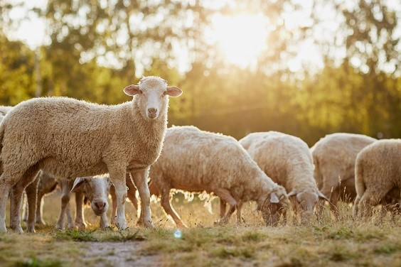
If, for example, you are conducting an ACCU Scheme project, you must provide at registration an estimate of the total amount of GHG emissions your project will reduce or avoid and/or the carbon it will store. This can provide the basis for estimating revenue. Actual revenue will depend on the effectiveness of project activities, as well as ACCU prices.
Other government programs may also offer financial incentives for carbon farming (such as the Western Australian Carbon Farming and Land Restoration Program and the Queensland Government’s Land Restoration Fund).
Indirect revenue sources can include higher prices for premium, low-emission products and increased sales into new domestic and overseas markets. Carbon farming activities can also reduce on-farm costs, for example, by reducing water and fertiliser use and having more productive livestock.
CSIRO’s LOOC-B: biodiversity co-benefits calculator enables users to quantify the biodiversity co-benefits of land management actions (such as carbon farming) anywhere in Australia. This may allow biodiversity co-benefits to be fully accounted for, realised and rewarded.
Although it is uncommon for Australian farmers and land managers to do so, they can sell other types of carbon credits (not ACCUs) on the voluntary (non-ACCU Scheme) market through organisations such as Verra and Gold Standard.
Costs
Costs to establish and maintain a carbon farming activity or project include:
- time and money to design, implement and manage the activity or project
- professional planning and establishment advice (such as from a professional adviser about agronomy, livestock nutrition, soil sampling or revegetation)
- technology replacement or purchasing of other assets
- ongoing monitoring, compliance, auditing, verification and reporting costs.
Some examples of costs of carbon farming activities are:
- the Indicative costs for projects related to soil carbon and Indicative costs for planting or forest related sequestration projects on the Kondinin Group’s website
- the Western Australian Department of Primary Industries and Regional Development’s WA Carbon Farming and Land Restoration Program – Costing Guide (XLSX 38 KB), which has typical expense items for establishing a carbon farming activity.
If you are considering the costs of conducting an ACCU Scheme project, the Clean Energy Regulator website provides the latest information about the scheme’s requirements, including current methods.

Watch this video
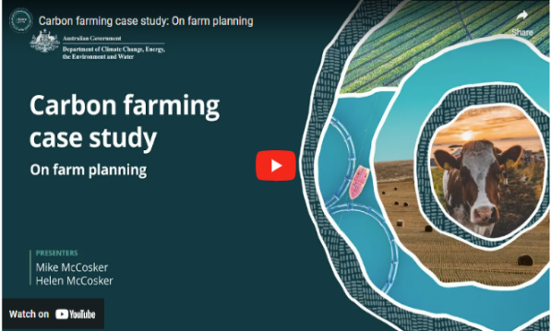
In this video (3:15 minutes), New South Wales graziers Mike and Helen McCosker share their insights and experiences in planning their carbon farming project.
Video: Carbon farming case study: On farm planning

Transcript
HELEN MCCOSKER: Our farm planning process has been a really long process. We make sure that it's a living document. That's the most important thing. So we're always adapting and changing our farm plan. But I think to start with, we look at our vision. So what is the vision that we want on our farm long term? So for us, our vision is that we're a generational farm, and we want to leave a legacy. So that's really important to us. And then the other thing is what are the goals to get to that vision, you know. So we sort of talk about what our goals are. So for us, one of our goals is to make sure that we have longer term goals, it includes
MIKE MCCOSKER: It includes regeneration in the soil.
HELEN MCCOSKER: Yep.
MIKE MCCOSKER: We grow the best food that we possibly can. Yeah. We're community-focused, where possible.
HELEN MCCOSKER: Yeah.
MIKE MCCOSKER: Yeah.
You know, our business is our business, and we make money. But, we're also aware of the community around us and how we engage with that.
HELEN MCCOSKER: Yep.
MIKE MCCOSKER: So, you know, how that has probably landed, how we turn sort of long term vision into practical day to day stuff is that, you know, we started probably 20 years ago with a map of the farm and looking at how and where we were gonna break up into smaller paddocks. You know, we changed the fences, so they ran up and down the hill, or across the slope, and we broke what was originally sort of 200 acres into four paddocks, first. Then we broke that down in half again. And so we came down in a couple of steps.
So one of the ways that planned grazing sort of originally turns up in the first few years is all about water and wire. Where are we gonna put the water points and when is it appropriate to break a paddock in half so that we've got smaller paddocks to manage.
We can then plan out 12 months in front. So we'll go through this plan, and we know that we wanna be near the cattle yards, you know, in early May, for weaning, So we can actually work back from there and know exactly where we're going to put the cattle and when, for how many days. And then how many days of rest we need before we're back in that paddock again. So we plan that out just as a mark on the page. And then what we plan and what we achieve is sometimes just a little bit different.
So we go through with the highlighter and colour in the days that we were actually in the paddock, and that just gives us a really easy visual aid because I can see there that I've had 120 days of rest from that grazing to that grazing.

  - Understanding greenhouse gas accounting requirements
Whatever your carbon farming activity or project, GHG accounting, which Topic 3 explained, is increasingly an indispensable part of farming and land management.

What type of GHG accounting do you need?
A farmer’s or land manager’s first GHG account might be as simple as one produced by the MLA Quick Start Carbon Calculator, in which it takes only a few minutes to estimate your carbon footprint. It will give an indicative starting point. It also starts your journey to collect and understand the data required for a more precise carbon footprint. Also, even a basic GHG account can yield valuable insights (for example, that fertiliser use is appropriate or that herd management is optimised) about what you’re doing right and what can be improved.
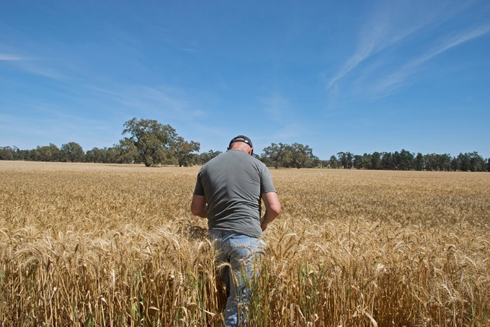
The ACCU Scheme requires robust calculations of emissions reduced or avoided and carbon stored to ensure the integrity of ACCUs and market confidence.
Climate Active certification requires setting an emissions boundary and measuring emissions. Businesses can use the Register of consultants for Climate Active certification to help prepare their reports if they don’t have expertise in GHG accounting.
Many farmers and land managers doing carbon farming for co-benefits other than earning ACCUs or Climate Active certification (for example, to improve soil health) may not keep a GHG account. However, as Topic 3 explained, a GHG account enables a farmer or land manager to:
- access low-carbon product market opportunities or meet potential market access requirements
- demonstrate their emissions and storage performance, for example, in agricultural supply chains
- work with others (such as regional NRM organisation) to reduce GHG emissions and store carbon at the landscape scale
- baseline their GHG emissions and changes in carbon storage, allowing them to benchmark and monitor their performance’
- identify on-farm productivity improvements and track the effectiveness of good farming practices.
A GHG account’s opening balance (or baseline) is a point for future reference. Changes in the account (that is, in the carbon footprint) show the overall performance of carbon farming activities in reducing emissions and storing more carbon. For example, GHGs emitted and carbon stored might be measured every 12 months to identify changes that can be further investigated.

Validation, monitoring and reporting
A farmer or land manager may choose to calculate indicative estimates of their GHG footprint to guide management decisions. But for the ACCU Scheme, the data must be high quality, verified and compliant with reporting timelines and standards.
Climate Active requires independent third-party validation for organisation and product certifications, including verification of the source data in the farmer’s and land manager’s GHG accounts. According to the organisation’s size (which is determined by various criteria), they might also need a technical assessment for certification to help ensure their reporting aligns with Climate Active program requirements. Both schemes also have monitoring and reporting requirements.
A farmer or land manager not involved in either scheme may not be required to monitor their carbon footprint over time or report externally. However, as explained above, supply chain expectations for them to do so will likely increase. Also, monitoring is a good part of adaptive planning, demonstrating successes and failures and where farmers and land managers can improve their operations.
As Topic 3 explained, many calculators are available to estimate GHG emissions and carbon stored. They range from simple and straightforward, requiring basic data while producing robust outputs, to comprehensive and tailored to particular agriculture and land management sectors. The government is developing voluntary emissions estimation and reporting guidelines (Guidelines) for agriculture, fisheries and forestry industries. The Guidelines aim to improve the quality and consistency of accounting methods and tools. The guidelines are focused on estimating farm-level emissions from cradle to farm-gate and will be updated annually to align with the National Greenhouse Gas Inventory.
  - Climate Active
The steps in previous sections are common to any carbon farming activities or practices. The ACCU Scheme and Climate Active certification have additional requirements. Topic 5 examines ACCU Scheme requirements.
Climate Active certification is available for a farm (as an organisation) or agricultural products or services. Once certified, businesses can use a trade mark to promote their certification (subject to Climate Active approval of the use of its trade mark).
To be certified, a farm, agricultural product or service must meet all the requirements of the applicable Climate Active standard and supporting documentation available on the Climate Active website.
  - Case study and expert interviews
The following videos provide further information and discussion on soil and vegetation carbon farming through a case study and interviews.

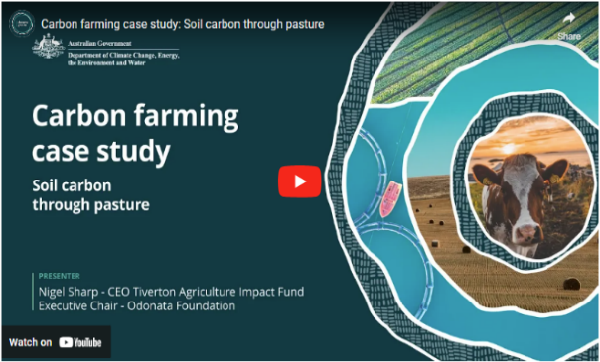
Watch these videos
In this video (8:28 minutes), Nigel Sharp, CEO of Tiverton Agriculture Impact Fund, discusses soil carbon through pasture.
Video: Carbon farming case study: Soil carbon through pasture

Transcript
My name is Nigel Sharp. I'm CEO of Tiverton Agriculture Impact Fund.
Our main objectives include demonstrating carbon farming and assisting other farmers with their carbon farming ambitions.
Carbon farming is about drawing carbon out of the atmosphere into our soils and growing trees. It's about sequestering carbon, as it's called, the drawdown process. My inspiration for carbon farming comes from the concern of future generations and their livelihoods.
It comes from making profits on the farm and having longevity and resilience in our farming practices.
We have a concern about the longevity of our soils, and so carbon farming helps us think long term about the soil, which helps to build the value of our property. Land appreciation is a key part of our farming productivity.
When we acquired Orana Park, we master planned it so that we could bring changes from conventional agriculture to a carbon farming project. We included shelter belts in our master plan, and we wanted to look at broad acre cropping and olive groves so that we could achieve diversification of income and bring horticulture into the picture. With our shelter belts, we included a sanctuary, which is not that common in farming, but we had some beautiful remnant vegetation that would be home to some fantastic biodiversity, and that could complete our carbon farming picture. Orana was a conventionally fertilised farm at the start. When we acquired it with our master plan, we decided to start using compost, so we were making a lot of compost on the farm.
It was an expensive process, the composting, so we've evolved to a liquid biofertiliser product that we develop on the farm here. The soils have changed since we developed the farming system we've put in place here. The soil structure is stronger, we've got a much higher water holding capacity and a far greater worm count.
As we've evolved the liquid biofertiliser, we've started applying it to all of the crops and the olives here.
In the canola, our oil content is now 52 per cent, which is 10 per cent higher than the district average. So we're seeing, significant changes to the health of the produce, and we're seeing the soil starting to sequester carbon.
Orana Park has been master planned over a long term. So in putting in a thousand hectares of olives, they take seven years to develop. We started the the changes of composting moving to liquid biofertiliser.
So the profitability is a steady grow that then hopefully ends up in an exponential type curve. So we're expecting in another three years, which is seven years into ownership of this property, to be highly profitable, much more significantly profitable than when we commenced. The resilience in having a more resilient cropping regime as a result of carbon farming is really critical because it can extend the season in a dry season. It can assist us in a wet season. So it makes the farming, more adaptable to climate change and varying weather conditions that we're experiencing.
We've registered a soil carbon project here. When we started the soil carbon project, there's 0.7 per cent carbon in the soil. We're hoping to take that to 2.7. That should lead to carbon credits and carbon profitability for us.
Also, in developing our shelter belts and setting up the sanctuary, we're looking forward to biodiversity credits becoming a market. Asset value is critical to farmers. Carbon farming is extending the life of our soils, hopefully, in perpetuity, and that it's a productivity of a farm that ultimately drives the value of your asset. We believe carbon farming is going to increase our asset above the historical asset growth targets.
The measurements are guided by the Clean Energy Regulator, we're also using some satellite technology to help us monitor the changes to our soil and the carbon content, and to help us in making predictions and our planning, with the use of our interventions such as the liquid biofertiliser.
Being able to get, almost on time measurement, means that we can have a look at the changes, and the applications that we might make even within one calendar year. There's a significant process to register a soil carbon project. There's completing the application. There's doing a farm plan. There's baselining and collecting all the samples so that the baseline can be registered as well. So, again, we're coming back to talk to other farmers that have been through this process to make it easier because when you just start reading all of the information required, it can feel overwhelming.
When we acquired Orana Park, we set up a master plan, which included shelter belts and biodiversity corridors throughout the entire farm. Those plantings qualify for carbon credits through the REMP, part of the Emissions Reduction Fund. We're intending to complete those plantings, and they become part of our carbon farming story. You can have soil carbon and tree carbon projects on your property.
There's not a double count where soil and trees are grown on the same piece of land. That is a tree carbon project. The soil carbon project will sit separately from where you are growing trees. It's important to be aware of the risks when you transition to carbon farming.
It may be such as changing some of your machinery or equipment. In our experience, it was putting a liquid injection system into our seeder. It can be owning additional tanks. Some of the other transitional pieces will be watching and monitoring your soil changes so that your application rates of the change of your practice is fully understood as well.
We've all made changes in our lives, and this is a major change for a farmer. But if you're fully informed and then you can look at what you need to do and change your equipment, how your soils will change, and you can monitor the changes. You can continue to make the decisions down the pathway to achieve that objective.
Internationally, the EU is really interested to see carbon farming taking a hold in Australia, and they wanna see farming on a trajectory to reduce their carbon emissions.
I think that the markets are going to start to dictate our carbon farming practices, and that will drive the change. So we might as well take a step forward and be farming down this direction ourselves. I think there's a significant risk if we don't adopt this carbon farming practice for Australia. A lot of farmers that we talked to are worried about the longevity of their soil and having to apply more and more fertiliser to get the same productivity so asset values are relying on longevity of productivity.
We've got a human health issue.
We can use less pesticide. We can use less herbicide. All of those things flow through to the quality of the food that we're all eating.
We're convinced that carbon farming is a win win. The improvement in the land value from carbon farming is gonna help the future generations as they come through. Carbon farming is also a win for the planet in that we're addressing sustainability.
Carbon farming is a win for the health of the consumer and that they're eating healthier food. So there's there's a triple win sitting in carbon farming. If you're interested to become a carbon farmer, our advice would be to talk to farmers that are in the game, talk to farmers that are carbon farming now, ask lots of questions, develop support groups amongst yourselves.
You can approach Tiverton. We're a demonstration farm. We're very happy to share all of our knowledge and help people on the carbon farming journey. It's critical to become very informed. Doing courses like this will help you gain your knowledge, talking to others, and being part of support groups. Being informed will give you the confidence to go forward because conventionally, there'll be a lot of people that'll try and talk you out of carbon farming.
There's no reason from our experience not to take that risk.
The opportunity is there for us. In 15 years, well, hopefully, we're not talking about carbon farming. We think it'll be an embedded practice because we're all interested in profitability, soil health, the health of the consumer, the products that we're selling to the world.
Hopefully, we're just talking about farming.
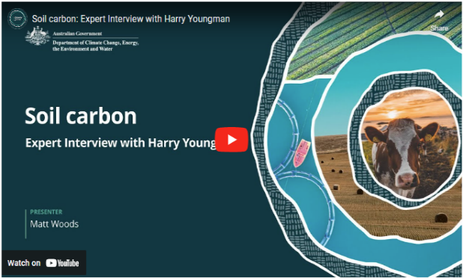
In this video (9:40 minutes), Matt Woods and Harry Youngman discuss soil carbon.
Video: Soil carbon: Expert Interview with Harry Youngman

Transcript
MATT WOODS: Hello. I'm Matt Woods and I'm with Harry Youngman to talk about soil carbon. Harry is a fourth generation farmer on the family property Ardgartan in southwest Victoria, where they run prime lambs, beef cattle, and some agroforestry.
Back in 2003, Harry began getting a bit disgruntled with certain aspects of the traditional farming system, and he decided to trial something different on Ardgartan. Harry, what did you trial and why did you do it?
HARRY YOUNGMAN: So, Matt, what prompted it was a sort of a diminishing return from the traditional systems of fertilising and stock ill-thrift and a demise in species composition.
So what we did was initially do a heap of plant tissue tests and showed up an imbalance of certain elements. And so then to rectify that, we first adopted a liquid fertiliser system using sulfates.
And then that was from sort of 2003 to 2008. And about 2008, we were introduced to compost, properly humidified compost.
And we embarked on a four year trial from 2008 to 2012, and we had some pretty spectacular results from that compost process.
We had control, zero tonnes and up to four tonnes per hectare. And then each year, we did quite a lot of microbiological testing and found some really impressive improvements.
WOODS: So I'm a farmer and or land manager, and I'm looking to improve my soil carbon. What's the sort of top line advice that Harry Youngman would give to a farmer or land manager looking to do that?
YOUNGMAN: So my advice would be to improve your knowledge of soil science or understanding of how the soil works in the first instance.
WOODS: What about, I know on Ardgartan, you did some trials before going into, heavily into certain aspects of this farming style. Should other farmers, do you think, put aside a portion of the property just to do a trial before they invest too heavily in this?
YOUNGMAN: I think we're blessed at the moment, where there's so much information and there's so many trials that have been done that people can research that, and understand what's happened. There's some great early adopters that are well down the path of the benefits of some of these processes.
However, there's nothing better than seeing is believing. And so if you do have a small scale trial or you wanna trial something like you may have done with your fertiliser trials on the farm, set something up. There's certain technology around that can allow you to do it on a paddock by paddock basis now, which is fantastic.
But there is no better education tool than seeing it for yourself. Now whether that's at a field day on your own farm, highly recommend undertaking some on farm trials.
WOODS: And can farmers expect to see instant results, or are they gonna need a bit of patience here to sort of keep going with the program?
YOUNGMAN: Farmers will see response in certain aspects very rapidly. For instance, they may see a reduction in red-legged earth mite infestations within 12 months.
However, they might not see soil carbon improvements for four to five years. So it's not a miracle that happens overnight, but there are definitely some canary in the coal mine type principles that you can pick up on and see change pretty quickly. You just gotta know what to anticipate and what to look for and most importantly, what to test for.
WOODS: Well, let's move on to testing then. What can they test for? How do you monitor this and know that your soil carbon is improving?
YOUNGMAN: So some of the early indicators that we've found to be reasonably good and reliable proxies for improvement in soil health. As I said at the start, after we did the four years of compost, we did some soil DNA testing, which showed dramatic improvements where extra compost had been put out.
Those tests have morphed, and you can have them done all around the world. We are using two tests based out of America now, which are testing DNA and improvements in soil microbial fungal populations and bacterial populations and the various diversity of microbes.
Bearing in mind that there's about eight billion microbes in a teaspoon of soil, you are not gonna see it with the naked eye. So you have to go to a DNA type of testing. As discussed, it's like the canary in the coal mine. So you are picking up well in advance DNA tests that you can't see with the human eye.
WOODS: Harry, what's some of the advice you would give farmers and land managers who are looking to improve their soil carbon and their soil health?
YOUNGMAN: One of the first things I'd look at doing is is getting a piece of paper out and writing down all those things in the current production system that are frustrating you.
Maybe broadleaf weeds, maybe dags on sheep, it may be tensile strength in the fine wool merino operation, all those sorts of things that you just keep scratching your head about why is this happening.
Once you've done that, it'll help you synthesise down what are the important things that you might wanna try and address that no one's been able to help you with.
Secondly, you need to think through if you are going into a carbon project, how you're going to record everything that's going on on the farm in a concise and logical manner. It's a major part of any soil carbon project and it needs to be well thought out because the questions from the clean energy regulator and any auditors that might come onto your property will be pretty forensic.
WOODS: What about the knowledge that they're gonna need? Is that important to ensure maybe you're not talked out of your approach?
YOUNGMAN: Absolutely. Most of the time, people that have an agenda or a product to sell you will invariably talk down the benefits of self help, and they'll want to peddle you more of their product.
And so what my advice would be is just to empower yourself to be able to argue or discuss the point objectively and make it clear that you understand exactly what you're going to potentially replace their product with and be comfortable that it's going to work.
WOODS: Harry, it sounds like for farmers, it just makes business sense to improve the health of their soil. How did it work on Ardgartan in terms of the business outcomes?
YOUNGMAN: So what we've found on Ardgartan after benchmarking our whole operation, each enterprise for 20 plus years, is that we've been able to improve our output per hectare as measured by our dry sheep equivalent carrying capacity or DSE capacity. For instance, our district average is about 14 DSE per hectare.
WOODS: Harry, a farmer or landholder has gone down this path to improve their soil health. How are they gonna know if it's working or not?
YOUNGMAN: So some of the things that we saw were improved clover content, improved clover nodulation, less broad-leaf weeds, less dags on sheep. Cropping enterprises can probably look to see, less fungal infestations and other diseases. So I would think that healthier plants are more resilient and perform the way they are supposed to perform.
WOODS: Harry, why is it important that farmers and land managers get soil testing done, and and what sort of tests are out there that they can utilise?
YOUNGMAN: It's a bit like weighing your lambs or your cattle or measuring the yield of your crop. You need to measure so you can manage. There's chemical soil testing, there's biological soil testing, and there's soil structure soil testing. There's practical on farm soil testing you can do as simple as getting a shovel, digging some holes on your farm, and counting the worms that are in your shovel full.
That's a really good litmus test of how well your soil is functioning right now. The chemical soil tests will give you a really good picture on your macro elements, but also your carbon. You've probably already got carbon measurements going back many years if you've been testing for a long time. And you can sort of understand the cause and effect of different management practices that you may have overlaid across your property.
WOODS: Great. Harry, thank you very much for your time. Appreciate it.
YOUNGMAN: Thank you, Matt.

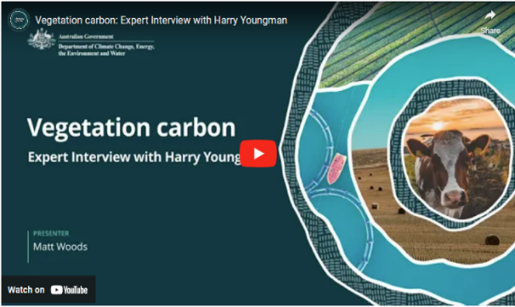
In this video (11:14 minutes), Matt Woods and Harry Youngman discuss vegetation carbon.
Video: Vegetation carbon: Expert Interview with Harry Youngman

Transcript
MATT WOODS: Hello. I'm Matt Woods, and I'm talking with Harry Youngman. Harry is a fourth generation farmer on the family property Ardgartan in southwest Victoria, where they run prime lambs, beef cattle, and some agroforestry.
Harry, you've planted a lot of woodlots and shelter belts on your property. Why did you choose to do this?
HARRY YOUNGMAN: Matt, I think my forebears possibly over cleared the property. And if you've ever been to the southwest of Victoria, you know, it's fairly inclement and harsh conditions. And so taking the lead from the Pastoral Veterinary Institute in Hamilton, and doctor Rod Bird back in the eighties, clearly demonstrated the benefits of shelter belts on farm. And I think he actually, deduced that you could put between 12 and 15 percent shelter belts back on the farm before losing any productivity, such was the benefits of breaking up that wind and the benefits to livestock, etcetera, etcetera, which we've actually found on r
eplicated trials across the farm. Our lambing percentages in our more sheltered paddocks are consistently between sort of seven percent to 13 percent better.
And, we're also finding good interception of recharge areas down to discharge areas and sort of combating some of the smaller salinity areas on the property. We've also observed the local indigenous bush around the farm, and we've sought to perpetuate that out in as groynes of biodiverse plantings.
The theory behind that is we create harbour for, birds and insects to help combat things like red-legged earth mite, and other parasites.
So they're the main benefits apart from the obvious beautification of the property.
WOODS: Planting trees contributes to storing carbon in vegetation, and that's all part of the carbon cycle.
Can you just give me a little brief overview of what the carbon cycle is?
YOUNGMAN: So we're blessed with a process called photosynthesis.
Plants will absorb CO₂ out of the atmosphere.
They will respire O₂, which keeps us alive, and they'll make complex organic compounds, which we see as biomass above the ground.
WOODS: So even if a farmer or land manager is not looking to get carbon credits by planting trees and getting vegetation carbon, what are some of the financial and business benefits they might see out of plantations?
YOUNGMAN: So on the plantation front, we've done both radiata pine and eucalyptus globulus, which is short rotation and long rotation plantations, both of which provided, very good return on investment and provided also blocks of capital for things like succession planning and debt repayment and also smoothing out or compensation of poor years.
WOODS: Harry, in terms of shelter belts then, what sort of advantages are farmers gonna see in their business by planting those?
YOUNGMAN: So in addition to the livestock benefits that we've talked about, the evapotranspiration is a massive factor that isn't talked about a lot.
And so breaking up that wind flow has been very, very beneficial to extending the growth of the season and maintaining or not losing so much moisture. The shelter belt's also at a micro scale on the farm. We're aiming to try and fit in with the macro sort of catchment management planning and thinking, and we've sought advice from our catchment management authority and indeed received grants for plantings to enhance that macro catchment benefit.
WOODS: And are they gonna see benefits in terms of predatory insects and things in those shelter belts?
YOUNGMAN: Yes. So our shelter belts consist of sort of shrubs, medium trees, and then even taller trees, which could potentially be used for, timber lot or, furniture grade material in the future. So in our plantations, we actually view the shrubs and small trees as being very, very valuable for the harbouring of important insects and bird life. An example of some of those insects might be a special wasp, which lives in the shrub called bursaria.
And that wasp is actually really effective in controlling red headed cockchafer.
The red headed cockchafer grub, which is the bane of the pasture farmer's life, is beyond control with conventional chemistry, but, interestingly enough, these wasps seem to be able to control them.
WOODS: And your own experience with that? You've seen that effectively happening on your property?
YOUNGMAN: Yes. So we have, had a dramatic reduction in the need for spraying red headed cockchafer and black headed cockchafer.
In fact, we don't spray for it anymore.
WOODS: So if I'm a farmer or land manager looking to get into this, what's Harry Youngman's kind of top level advice to start getting into it?
YOUNGMAN: So one of the key things is to develop and understand, what you want, and part of that process is developing a whole farm plan or a farm plan.
And that needs to respect things like waterways, roads, current roads and future roads, easements, title boundaries, council planting requirements, the right to harvest, and access to good public roads.
So shape and also the shape of plantations need to obviously consider the prevailing winds. Not only that, we need to understand that a whole farm plan is a microscopic or micro look at the broader, catchment and that in conjunction with people like your catchment management authority, you can look at the macro benefits of your plantings and how that may tie in with local indigenous bush or neighbours' plantings and indeed the waterways that feed into the major rivers in your catchment.
WOODS: So planting all those trees, you can add to your vegetation carbon. How are you gonna measure that vegetation carbon?
How are you gonna know how much you're sequestering?
YOUNGMAN: So the conventional forestry measurement systems are one method, and that's more in woodlot and having a random plot measurement system. The next level is, using the government provided FullCAM or full carbon accounting model, which actually predicts on a point and shoot basis how many tonnes of CO₂ equivalents you may be able to generate in your particular area using either mixed indigenous plantings or indeed Mallee plantings depending where you are and whether they're block or whether they're belt.
And so all those considerations need to be put in place. So they're all found in the Clean Energy Regulator's website.
WOODS: A farmer or land manager may not be looking for carbon credits now, but is there anything that they should think about or take into account? Because down the track, maybe they will be looking for carbon credits.
YOUNGMAN: So there are certain protocols that require a project to be registered before you actually plant. So you can't, today, retrospectively claim carbon credits on plantings that you have done. There's also some really good, technology coming along with not only from satellite, measures the volume of timber, but it also measures the health of the planting by picking up the gases that should be coming out, and it can give you a score out of 10 as to how healthy your biodiverse planting or your monoculture may or may not be.
So there's lots of, technology that's gonna help us do this for less cost and also do it more regularly.
WOODS: Harry, if a farmer or land manager wants to get into the carbon credits, is there any legal considerations they need to take into account?
YOUNGMAN: Matt, there are. There's, when you do go into a project, you need to consider, what encumbrance you are going to put on your land. And that may be determined by whether you elect for a 25 year permanence or a hundred year permanence, and it will vary. And also, in that process, they might like to consider the shape and style of project that they're going into, whether they're going to be employing a shelter belt model or a block planting model.
WOODS: It gets pretty complex, this stuff. Is there a place that farmers and land managers can go, you know, advisers or something that might be able to help them?
YOUNGMAN: Yeah. I strongly recommend getting not only legal advice, but also, try and find good carbon project developers that will help you work through not only the planning, the obligations, but also the potential pooling of those credits and effecting more lucrative sales.
WOODS: Harry, you mentioned FullCAM. What is that?
YOUNGMAN: So FullCAM stands for Full Carbon Accounting Modelling. And essentially, it's a point and shoot system, which was developed by the CSIRO and allows you to put in your coordinates and it will predict how many tonnes of CO₂ equivalents per hectare you can generate over a 25 year period.
WOODS: Harry, it all gets fairly complicated when you get into the carbon credits side of things. So where should land owners and farmers look for more information or maybe some expert advice?
YOUNGMAN: So we are blessed with a central body called the Carbon Market Institute, and all of the reputable, providers or service providers are actually subscribers to the agreed protocols of the CMI. And I would start with their website, and that will give you a list of, service providers.
In addition obviously, you need to canvass your trusted legal and accounting advisers as well.
WOODS: And maybe farmers could ask advice from other farmers that might have gone down this track?
YOUNGMAN: Absolutely. Yes. There's, so certainly, the Bush Telegraph is very, very appropriate in this situation where service providers have failed to provide the base service, farmers will be able to recognise that.
WOODS: Harry, that's been fascinating, and thank you very much for your time.
YOUNGMAN: Thanks, Matt.

  - Other resources

Carbon EDGE training (MLA)
Carbon EDGE is a 2-day MLA training program for the red meat industry, providing participants with an understanding of the opportunities for emissions reduction and carbon storage activities in a livestock grazing business. Participants use their own information to develop an action plan for their business as they learn about the practices and technologies that could reduce their carbon footprint and improve sustainability and productivity.

On-Farm Carbon Advice (New South Wales Department of Primary Industries and Regional Development)
The New South Wales Department of Primary Industries and Regional Development’s On-Farm Carbon Advice project provides advice on carbon farming practices in extensive beef, sheep, dairy, and mixed farming systems. It covers topics including understanding climate change, agricultural emissions, emissions reduction and carbon storage strategies, and pros and cons of carbon farming.

Farm Business Resilience Plan – planning template (Business Queensland)
Business Queensland’s Farm Business Resilience Plan provides templates and advice for writing a plan, including identifying opportunities to support and improve your business’ productivity and profitability.

Calculating net emissions and reduction strategies for a broadacre farming (Grains Research and Development Corporation)
This article Carbon Neutral Grain Farming by 2050 – an example in calculating net emissions for a broadacre farm and strategies to reduce net emissions on the Grains Research and Development Corporation website looks at calculating emissions for a broadacre farm and ways those emissions might be reduced.

Environmental Economic Accounting Dashboard
The Environmental Economic Accounting Dashboard administered by DCCEEW lets users explore, visualise and customise content from various government databases. The content is presented as account tables, charts, customisable stories and underlying spatial data maps. Users can answer questions like ‘How is our land cover changing over time in a particular state or territory?’ and ‘What is the economic value of mangroves for a particular stretch of coastline?’.

Co-Benefits Standards - Western Australian Carbon Farming and Land Restoration Program (Western Australia Department of Primary Industries and Regional Development)
The Co-Benefits Standard 2022-2023 (PDF 1 MB) provides guidance and resources for the Western Australian Carbon Farming and Land Restoration Program. It addresses monitoring and reporting for 5 co-benefits: biodiversity and conservation, agricultural productivity, soil health, salinity mitigation and Aboriginal economic and cultural wellbeing. The program’s Co-Benefits Information Portal allows applicants to assess co-benefits for any particular area or location.

Indigenous Carbon Project Guide (Indigenous Carbon Industry Network)
The Indigenous Carbon Industry Network’s 2022 Indigenous Carbon Project Guide (PDF 8.5 MB) aims to ensure that First Nations groups are well-informed to position themselves to maximise the benefits from carbon projects for their country and community. It covers 13 topics, including what is the carbon market; free, prior and informed consent; project feasibility; project governance; First Nations rights and interests; understanding co-benefits; and keeping your story strong. The guide can be downloaded as a whole or for relevant areas of interest.

Land Restoration Fund Co-benefits Standard (Queensland Government)
The Land Restoration Fund Co-benefits Standard (PDF 2.1 MB) is focused on growing the carbon farming industry by supporting carbon projects that deliver priority co-benefits for Queensland. This document is the framework that specifies how co-benefits generated from a carbon project are to be measured, reported, and verified for the purposes of the Land Restoration Fund.

Topic 5: The Australian Carbon Credit Unit Scheme

Time to complete this topic
About 60 minutes to read the information in this topic. Additional content includes videos, activities and links to other resources which may require extra time to complete.
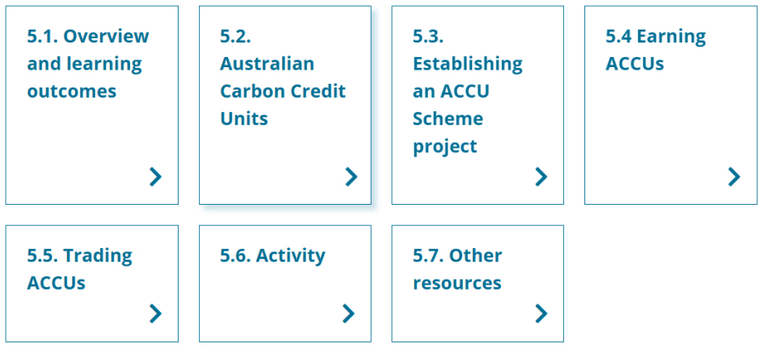
In this topic:

  - Overview and learning outcomes

Overview
In this topic, you will learn about the Australian Carbon Credit Unit (ACCU) Scheme (previously known as the Emissions Reduction Fund). You will learn how farmers and land managers can run an ACCU Scheme project and earn ACCUs.
The topic broadly looks at requirements for ACCU Scheme projects. The requirements include following a legislated method. Before deciding whether to run an ACCU Scheme project, you must understand the scheme’s requirements.
The topic examines how to set up an ACCU Scheme project. This includes deciding the project proponent, determining your legal right to run the project and getting the consent of eligible interest holders, which might include First Nations people and their organisations.
The topic explains providing evidence of GHG emissions reduced or avoided or carbon stored and earning ACCUs. It looks at selling the ACCUs a project earns. It explains ‘offsetting’: a process where organisations or individuals buy and then cancel ACCUs to reduce their net emissions. It briefly explains how the market works.

Learning outcomes
After completing this topic, you will be able to:
- describe the ACCU Scheme and ACCUs
- outline the methods applicable to ACCU Scheme projects
- explain the scheme’s eligibility requirements and the process of establishing an ACCU Scheme project
- recognise the obligations and risks involved in establishing and running a project
- identify First Nations ACCU Scheme projects and activities
- explain why and how ACCUs are bought and sold
- recognise how ACCUs with verified, in-demand co-benefits can attract higher prices in the market.
This topic and other topics provide links to a range of sources of useful information about the ACCU Scheme. Some aspects of the ACCU Scheme, such as available methods, are subject to change over time. Before making any decisions about conducting an ACCU Scheme project, you should check the Clean Energy Regulator website for up-to-date information about the scheme.

Watch this video
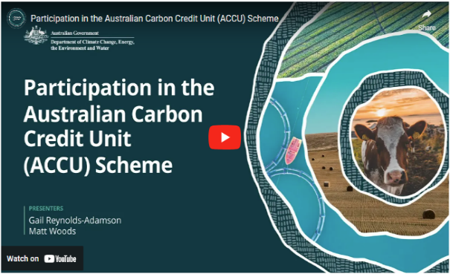
In this video (2:12 minutes), presenters Gail Reynolds-Adamson and Matt Woods introduce Topic 5 and provide important context.
Video: Participation in the Australian Carbon Credit Unit (ACCU) Scheme

Transcript
MATT WOODS: If you're watching this video, chances are you're seriously considering participating in an ACCU scheme. You may also have identified trusted advisers in your area to discuss this with further.
Alternatively, you may still be undecided and needing information before making your decision.
This is a good call. It's important not to rush into these things. Either way, you've come to the right place.
GAIL REYNOLDS-ADAMSON: In this topic, we'll investigate the ins and outs of the ACCU scheme in more detail, including farming and or landholders' obligations and the process of applying, establishing a contract, reporting, auditing, and how payments work. We'll run through the various activities that the ACCU scheme supports and discuss the pros and cons of these activities and other factors you must consider before deciding to participate.
WOODS: We'll provide detailed information from the Clean Energy Regulator, the government body that oversees the ACCU scheme. In addition, we're going to introduce you to some farmers and landholders who are participating to learn more about how it works in practice and give us some tips and tricks to avoid traps and pitfalls.
REYNOLDS-ADAMSON: There are also some specific benefits for First Nations people participating in the scheme, and it's important for all farmers and landholders to be aware of the specific legal and cultural requirements of these.
WOODS: When you complete this topic, including the focus questions, you'll have come to the end of the Carbon Farming Outreach Program training package. As you know, there are plenty of additional resources to delve into to extend your learning.
REYNOLDS-ADAMSON: And remember, this package is only a guide, and you need to seek trusted, independent advice before making any final decisions. Good luck.

  - Australian Carbon Credit Units

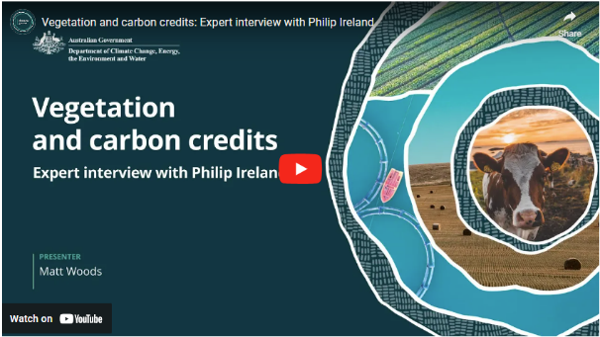
Watch this video
In this video (13:25 minutes), Matt Woods and Dr Philip Ireland discuss vegetation carbon projects and how the ACCU Scheme works.
Video: Vegetation and carbon credits: Expert interview with Philip Ireland

Transcript
MATT WOODS: Hello. I'm Matt Woods, and with me is doctor Philip Ireland. Phil has worked in climate change policy for 20 years. And is currently the CEO of Carbon Neutral, one of Australia's oldest carbon project developers. He's worked on large scale environmental initiatives at a global level, is a founder and director of Hone Carbon, a soil carbon measurement startup, and a director of the national Soil Carbon Industry Group. Phil has a PhD in Climate Change adaptation and has worked in UN climate change negotiations. Phil, why is carbon farming as a mitigation to climate change important?
DOCTOR PHILIP IRELAND: Thank you. Carbon farming is incredibly important. In my work in climate change over 20 years, most of what I've done has been working on policy to reduce emissions going into the atmosphere. But as my career has progressed, I've recognised and the broader scientific community has recognised that we need to also draw carbon emissions out of the atmosphere if we're to achieve any of our targets and keep a safe climate. One of the best ways to draw carbon out of the atmosphere is through agricultural methods, through sequestering carbon into biomass, but also into soil organic carbon.
WOODS: In Australia, agriculture accounts for about seventeen percent of our emissions, can agriculture be seen as part of solution to climate change?
IRELAND: Agriculture has to be part of the solution. We can't achieve our targets without it.
One of the really interesting facts that has come out recently is that if we were to take all of the world's agricultural soils, and increase soil organic carbon by one percent in one metre of those soils, we would draw almost half of the historical emissions of our species out of the atmosphere. Soils and biomass have a huge potential to help us get to our net zero targets.
WOODS: I'm gonna move to carbon credits now. How does that system work in Australia, the carbon credit system?
IRELAND: So the Australian carbon credit system is one of the longest-standing carbon credit systems in the world, and it's been developed over successive governments. There are a number of methods that we use. In very broad terms, the system works by incentivising individuals and businesses to reduce their emissions, to avoid potential emissions and to draw carbon dioxide out of the atmosphere.
Using methods that sit under those broad three categories, individuals and businesses are then awarded a carbon credit unit or in Australia, we call it an ACCU, an Australian Carbon Credit Unit. That unit represents a tonne of carbon and that, once it's generated, can be sold and traded.
WOODS: Okay. I think there's a bit of confusion with farmers and landowners about how mature this market is. Is this something they can do today? Can they get involved in it now?
IRELAND: Absolutely. The market was first established a bit over ten years ago around 2011, and since it has had a number of changes and evolutions.
It's become a lot more sophisticated in recent years, with a number of very specific methodologies for very specific approaches to reducing emissions and drawing carbon out of the atmosphere. On the ACCU scheme website, the methods for farmers and landholders fall under the sections of agriculture and vegetation.
Under agriculture, there are a number of methods to reduce animal waste and effluent going into the atmosphere. There's also a method for increasing soil organic carbon, which is one of the fastest growing methods, and I believe one of the most exciting.
Under vegetation, there are a number of different things that landholders can do. They can plant plantations that have to remain in the ground for a set number of years, and they can also do reforestation using native and biodiverse species.
So carbon farming has a whole range of benefits for landholders, and a lot of these aren't talked about. Upfront, better management of your land for carbon can increase yield and profitability of your property. We know, greater soil organic carbon can reduce the need for more expensive fertilisers and chemicals.
We can think about carbon also as another crop. You're going in a process of de-risking the revenue of your property by providing more possible pathways for revenue. So that's number one, increasing yields and profitability.
Number two is climate change adaptation and resilience.
You're increasing your farm's and your land's ability to adapt to changes that are happening and are coming into the climate. We know increased soil organic carbon can increase water retention and water holding capacity of soils for times of drought. We know that trees and windbreaks can protect livestock from inclement weather, and we know the weather may become more windy and more unpredictable into the future. So you're making your property more resilient and adapted.
The third thing is that you're also contributing to climate change mitigation.
Farmers and landholders can get involved right now. They can register projects. They can be drawing carbon out of the atmosphere, and they can be generating extra revenue for their properties.
WOODS: Great. I'm sure every farmer's interested in extra revenue. What about the risks, though, to their business?
IRELAND: There are a number of risks. There are risks in all aspects of agriculture.
I'd encourage anyone looking at getting involved in carbon farming to do good due diligence on the people that they're working with and the methods.
The key thing to keep in mind is the long term obligations and commitments that you're putting your farm and future generations that are managing your farm under.
Under most carbon credit methods, you're making a commitment to permanence. We call it a permanence period of 25 to a hundred years. So in the instance of soil carbon, you're committing to draw carbon out of the atmosphere and then hold that carbon in the soil for a period of time. In vegetation and biomass methods, you're committing to growing trees, plants and shrubs and keeping those trees, plants and shrubs growing, and on the land, for a set period of time. There are obviously other risks associated with it as well, which are covered in this course.
One is that there is some volatility in the market for carbon as there are in all agricultural commodities. You can think about carbon as another crop. Another thing that you're growing on your property and you have to manage that in a similar way you have to manage other commodities that you're producing.
WOODS: Okay. So if I'm a farmer or land manager, and I want to get involved in it today, what's your top line advice of where to start and what to do?
IRELAND: There are lots of carbon project developers out there. They'll have different revenue and partnership models, which will suit different farmers in different ways. Definitely look into what they're offering and how they're getting paid for that offering. Is it an upfront fee or is it a long term share of the carbon credits? Both are legitimate ways, but they'll have different applications for you and different prices.
The second thing I would say is whilst it can be overwhelming, don't be overwhelmed and take your time. This isn't going anywhere, And over time, there will become more requirements, not just of farmers and landholders, but of all businesses - to be measuring their greenhouse gas emissions, reducing where they can, and in some cases, like landholders, drawing carbon out of the atmosphere. And engaging with this system will ultimately hopefully help for your farm's productivity and resilience to a changing climate.
So the first place to start is with the government website. So there's this thing called the ACCU scheme, the A-C-C-U scheme. It used to be called the Emissions Reduction Fund. You might be familiar with that. And this all sits under a government agency called the Clean Energy Regulator.
Over many years, they've made those materials more accessible, but that's your first stop when dealing with anything like this, because those websites cover the policy. They also are the doorways into registering projects and all these types of things.
From there, there are lots of carbon project developers and advisors that sit around that. But all of those bodies as well will be referring back to the government website.
WOODS: Okay. Any advice for people looking into this about potential consultants that they might want to get involved with?
IRELAND: There are a number of different consultants. I obviously work for one of those companies. There are ten to fifteen companies in Australia; a simple web search will bring up a number of these.
My encouragement would be to: If you want to bring on an advisor or a carbon project developer, look around, do your due diligence, really try to understand what their revenue model is. Some carbon project developers will support you for an upfront fee, and that's all. Other carbon project developers may not charge you a fee, but will take a share of your long term carbon.
Other carbon project developers will partner with you and help you generate the carbon, whereas others will stand back. So depending on what your needs are, there will be an advisor and a developer to help you, but definitely look around.
WOODS: Maybe ask some other people that have been involved, that you trust; farmers, land managers?
IRELAND: Absolutely. You should be able to find some other farmers in your region who have done something in this space. And if not, there are networks on social media and other places. There are also more and more media articles about this. Landline has started covering this. It's on the ABC. So you should be able to verify who's around and what they're doing.
WOODS: Terrific. Final question, Phil. What is the win-win-win scenario for carbon farming?
IRELAND: So I believe for farmers, there are at least three wins with engaging carbon farming. It's increased farm profitability, it's farm adaptation to climate change and it's contribution to mitigation of climate change. On farm profitability, managing and increasing carbon on your property can increase yields of crops.
For example, we know that increased soil organic carbon increases the fertility of the soil, which can reduce the need for more expensive, and also carbon intensive fertilisers.
Windbreaks can help sheep and other animals survive inclement weather. And carbon could be thought of as another crop in your property. So when you're growing a crop, you've got your above-ground yield with whatever you're producing. You've got your below-ground yield of carbon. So it's contributing to de-risking of your future revenue flows by finding more diversified income bases.
Secondly, with adaptation, we know we're facing currently a changing climate, and it will change further into the future. A healthy farm, a farm with greater soil organic carbon with more trees, is a farm that's more resilient to those changes. We know soil with more soil organic carbon can hold and retain more water for dry times. We know trees form windbreaks and shade for animals, and there are a whole range of other co-benefits.
And finally, with mitigation, I believe over the long term, most farms will be drawing more carbon out of the atmosphere than they're actually putting into the atmosphere.
So farms and landholders are gonna play huge role in the mitigation of climate change, which isn't just good for future generations and the environment. It's going to be good for profitability of that property.
WOODS: Terrific. Thanks, Phil. I really appreciate your time.
IRELAND: My pleasure. Thanks for having me.

The ACCU Scheme
The ACCU Scheme offers farmers and land managers opportunities to run projects in Australia that reduce or avoid GHG emissions or store more carbon. Carbon farming projects, as well as energy efficiency, waste, transport and industrial processes projects, can take part in the scheme. The scheme is established under the Carbon Credits (Carbon Farming Initiative) Act 2011. Participation in the ACCU Scheme is voluntary.

ACCUs
An ACCU is a regulated, tradeable financial unit. One ACCU represents one tonne of CO₂-e stored or avoided by an ACCU project.
The Australian Government’s Clean Energy Regulator administers the ACCU Scheme. It issues ACCUs for an approved project once the project proponent shows their project has reduced emissions or stored carbon and submits an offsets report. Before issuing ACCUs, the Clean Energy Regulator verifies the reported emissions reductions or carbon stored against the eligibility requirements of the applicable method. Then, the Clean Energy Regulator issues ACCUs in the Unit and Certificate Registry, under the proponent’s account in the Australian National Registry of Emissions Units (ANREU) system. The proponent can sell or keep their ACCUs.
The Clean Energy Regulator’s ACCU Scheme project register has a summary of registered ACCU projects and ACCUs issued and relinquished (returned).

ACCU Scheme project eligibility requirements
An ACCU Scheme project must:
- follow a legislated method
- be new: the activity cannot have started before being registered with the Clean Energy Regulator
- not be required to be conducted by Commonwealth, State or Territory law or regulation
- not be already funded by a government program listed in the Carbon Credits (Carbon Farming Initiative) Rule 2015
- not be a type of project defined as an excluded offsets project in the Carbon Credits (Carbon Farming Initiative) Rule 2015.
Some ACCU Scheme methods provide exceptions to the requirements to be a new activity or not being required by regulations.
These requirements aim to ensure projects deliver genuine emission reductions or carbon storage that would not have otherwise occurred.
You can review eligibility requirements and use the Clean Energy Regulator’s interactive Australian Carbon Credit Unit Scheme Questionnaire to help determine if your project meets the ACCU Scheme’s eligibility requirements.
Other requirements not covered in this topic may also apply to your project. More information about how to participate in the scheme is available from the Clean Energy Regulator. Section 3 outlines the steps in establishing a project.

ACCU Scheme methods
An ACCU Scheme project must follow a specified method to be eligible to earn ACCUs. Methods spell out rules for conducting ACCU Scheme projects, including:
- eligible project activities
- requirements about conducting project activities
- rules for estimating emission reductions and carbon storage
- monitoring, reporting and record-keeping requirements.
Methods are legislative instruments approved by the Australian Government. They provide for projects delivering real emissions reductions and carbon storage that can count towards Australia’s emissions reduction commitments. Methods must meet legislated standards. The standards include additionality, which means reducing or avoiding emissions or storing more carbon that would be unlikely to occur in the ordinary course of events.
Approved methods and supporting materials are available at the Clean Energy Regulator’s website ACCU Scheme methods.
The number of methods changes as existing methods are retired and new methods are introduced. When a method is closed, projects already registered under that method can continue. New projects may not be registered under closed methods. In section 6, there is an activity for you to explore the method that most interests you.
ACCU Scheme permanence obligations and risk of reversal buffer
Because of human-induced or natural events (such as bushfires), the carbon an ACCU Scheme vegetation or soil carbon project stores can be released back into the atmosphere. Therefore, projects that store carbon have permanence obligations. The scheme considers carbon storage to be permanent if the carbon is stored for 100 years.
A permanence obligation is a requirement to maintain the carbon stored for a set minimum period of time, including preparing a permanence plan and taking steps to deal with any loss of stored carbon. These steps may involve restoring lost carbon stores or relinquishing ACCUs already issued. The permanence obligations webpage provides more details. Farmers and land managers should closely consider the implications of permanence obligations and permanence risks for their plans.
When registering a project with a permanence obligation, a project proponent must choose a permanence period of either 25 or 100 years. They can’t change this period after they nominate it.
A project proponent that chooses a 25-year permanence period is issued fewer ACCUs than if they had chosen a 100-year period. This is called a permanence period discount. It helps manage the scheme-wide risk to the Australian Government if carbon stores are not maintained after projects with 25-year permanence periods conclude. For most methods, proponents choosing a 25-year permanence period receive 20% fewer ACCUs.
This permanence period discount is additional to the 5% risk of reversal buffer, which applies to all projects that store carbon. The risk of reversal buffer reduces the ACCUs issued during a reporting period (see section 4) by 5%.
If a property where there is a project with permanence obligations is sold, the obligations continue to apply for the duration of the permanence period.
  - Establishing an ACCU Scheme project
This section outlines the main requirements involved in establishing projects.
ACCU Scheme project proponent obligations
The project proponent is the person, multiple people or entity responsible for the carbon farming project. The project proponent:
- must plan and manage the project according to the method specified in law for that type of project
- must have the legal right to carry out the project
- must be a fit and proper person
- must meet the obligations set out in the Carbon Credits (Carbon Farming Initiative) Act 2011 for the life of the project, including record-keeping, reporting, audit and notification requirements (such as the need to notify the Clean Energy Regulator of any changes to the project or project participants)
- must maintain carbon stores throughout the permanence period (for projects that store carbon)
- will be issued with the ACCUs for the project. If there are multiple proponents, they can choose to appoint a nominee to act on their behalf and who can have the ACCUs issued to their account.
The Clean Energy Regulator’s Choose a project proponent webpage provides more information.
Proponents that want to make changes to their project must also follow the Clean Energy Regulator’s requirements in Making changes to your project. Changes that may be allowed include:
- varying the project area
- varying any conditions that may have been applied to the project when it was registered
- varying the project proponent
- varying the project’s crediting period start date
- varying the project method
- dividing the project into parts for separate reporting
- revoking (withdrawing) the project.
Revoked projects can no longer be issued ACCUs. There are particular obligations for revoked carbon storage projects, including a requirement to return all ACCUs issued if the carbon has been stored for less than the permanence period.

Deciding on the project proponent
Some farmers and land managers decide to be the project proponent for a project on their land. They consider they know enough about the ACCU Scheme’s requirements and can draw on support from others who have successfully run projects.
Other farmers and land managers decide they need support developing an ACCU Scheme project, usually from a carbon service provider or consultant. A carbon service provider (CSP), also known as a carbon project developer, is a business offering services to farmers and land managers in relation to carbon farming projects.
Different CSPs have different business models. Some CSPs will only provide services if they are also the project proponent. A Clean Energy Regulator fact sheet (PDF 211 KB) sets out its minimum performance expectations for project proponents who are CSPs. With other CSPs, the farmer or land manager is the project proponent, and the CSP provides them with services. CSPs may charge fees or take a proportion of the income from the sale of ACCUs.
In all cases, it is the farmer or land manager as the legal right holder that chooses to be the proponent or assigns that role to another entity.
The roles and decision-making responsibilities of the farmer or land manager and the CSP are agreed between them. The farmer or land manager needs to be well-informed when agreeing about who will be responsible for what, and they should get independent advice and talk with several CSPs if they feel it necessary.
If they are the project proponent, a CSP typically controls project development and management and the sale of ACCUs. They also handle all administrative and technical aspects of the project.
In considering whether to engage a CSP, you might consider whether they are a signatory to the Australian Carbon Industry Code of Conduct, which Topic 4 explains. The Carbon Market Institute’s Example Contract Clauses and guidance can assist in understanding what is involved in entering into an agreement with a CSP, where either the CSP or the farmer or land manager will be the project proponent.
AgriFutures’ A farmer’s handbook to on-farm carbon management (PDF 7.4 MB) provides more information about ways to manage your carbon farming project, including working with CSPs.
If you are considering doing an ACCU Scheme project, you should get legal and financial advice. You may also need other advice (such as about technical matters). As ACCUs are financial products, anyone providing financial advice about ACCUs is required by law to have an Australian financial services licence.

Determining legal right and getting consent from eligible interest holders
Legal right
To conduct a project, the proponent must first confirm they have the legal right to do so. This includes the right to carry out the project activities on the site and the right to be issued all ACCUs the project earns. This step commonly involves identifying all stakeholders affected by the project (such as lessees and Native Title holders) and determining if they have legal rights to be satisfied before the project can proceed. First Nations organisations are estimated to have a legal right — a shared legal right in some instances — to undertake a carbon project over about 27% of Australia.
The processes for securing legal right will differ depending on the individual circumstances of each project, including which State or Territory it is in. Establishing legal right will generally involve establishing who has a legal interest in the land where the project will be carried out and whether that interest confers a right to undertake project activities.
Eligible interest holder consents
Proponents must then identify all eligible interest holders in the land where the project is to be carried out and obtain their consent, which may take some time to organise. Eligible interest holders may include:
- landholders
- banks or mortgagees
- state and territory Crown Lands Minister
- registered native title body corporate.
First Nations organisations are eligible interest holders for an estimated 28% of Australia. Adding together their legal and eligible interest holder rights, First Nations’ interests cover some 55% of Australia. With respect to First Nations eligible interest holders, the principle of Free, Prior and Informed Consent (FPIC) should be understood and considered. FPIC is an important international principle that applies to First Nations peoples, enabling them to give or withhold consent to projects that may affect their lands and resources. FPIC helps ensure proponents develop ACCU Scheme projects in a way that respects the wishes of First Nations eligible interest holders.
Relevant resources when seeking the consent of eligible interest holders include:
- the Clean Energy Regulator’s Native title, legal right and eligible interest-holder consent guidance (PDF 2.3 MB), which helps project proponents navigate this step and provides guidance about native title and legal right issues
- the Indigenous Carbon Industry Network Indigenous Carbon Projects Guide (PDF 8.5 MB), which explains FPIC and includes a 9-step engagement process
- Native Title Vision, a free online tool by the National Native Title Tribunal that provides a map with details of native title matters.

Registering the project with the Clean Energy Regulator
The process of registering a project with the Clean Energy Regulator includes:
- opening an account through the Clean Energy Regulator’s Online systems webpage and obtaining access to the Clean Energy Regulator’s Online Services platform
- establishing the proponent’s legal right to conduct the project
- completing a scheme enrolment form, establishing the identity of the project proponents and that they meet the fit and proper person test
- opening an ANREU account so the project proponent can be issued ACCUs. The ANREU is a secure system in the Unit and Certificate Registry, that tracks the ownership of ACCUs
- completing an application to register a project under the appropriate method.
At registration, the proponent must also provide a forward abatement estimate of the total amount of GHG emissions it will avoid or carbon it will store in tonnes of CO₂-e over its crediting period. The crediting period is the length of time projects can earn ACCUs. Emissions avoidance methods generally have a 7-year crediting period, and carbon storage methods have a 25-year crediting period. The Clean Energy Regulator uses the forward abatement estimate to set the project’s audit schedule.

ACCU Scheme projects around Australia
The ACCU Scheme projects map provides an overview of all scheme projects. The map is a way of discovering carbon farming projects around Australia.

First Nations ACCU Scheme projects
The Indigenous Carbon Industry Network (ICIN) has an Industry Snapshot on its website that lists the 34 member organisations of the network. It also has links to each member and shows how Indigenous people across Australia are reducing Australia’s GHG emissions by caring for their Country.
ICIN’s Indigenous Carbon Projects Guide (PDF 8.5 MB) is a comprehensive guide to the carbon industry for First Nations people. It covers the carbon market, ACCU Scheme project requirements and planning and running a carbon project. It also has information specific to First Nations people, including Indigenous rights and interests, co-benefits and the power of story.

  - Earning ACCUs
The Clean Energy Regulator issues a project proponent ACCUs after the proponent submits an offsets report demonstrating the project has delivered emissions reductions or carbon storage. This report identifies the tonnes of CO₂-e avoided or stored over a particular period (called the reporting period). If the Clean Energy Regulator is satisfied that the report verifies abatement achieved, it will issue one ACCU for each tonne of CO₂-e avoided or stored.

As explained earlier in this topic, the risk of reversal buffer and permanence obligations apply to projects that store carbon. These will be taken into account in calculating the number of ACCUs issued for projects that store carbon.
The project proponent will usually lodge the first offsets report between 6 months and 5 years after the project starts. Proponents can choose when to lodge offsets reports, subject to minimum and maximum reporting periods. While the report may trigger the issuing of ACCUs, preparing it incurs measurement and administrative costs.
The Clean Energy Regulator requires some offsets reports for each project to be audited to provide assurance the calculation of a project’s emissions reductions or carbon storage is accurate. Auditors are independent, and the Clean Energy Regulator maintains a register of accredited auditors with relevant qualifications. The Clean Energy Regulator’s Project reporting and audits webpage has information about audit requirements, choosing an auditor and the types and frequencies of audits. The Clean Energy Regulator’s website also has its Compliance and Assurance Framework (PDF 289 KB) for the ACCU Scheme. The Clean Energy Regulator will set an audit schedule for each project when registering it. Details will depend on the project and be guided by the proponent’s forward abatement estimate. The Clean Energy Regulator requires at least 3 audits for most projects and can also require unscheduled audits.
The Clean Energy Regulator may take up to 90 days to assess an offsets report and may also ask the proponent to provide more information. The Clean Energy Regulator will issue ACCUs earned by the project into the proponent’s ANREU account in the Unit and Certificate Registry.
  - Trading ACCUs
The following section explains carbon markets and how they work.
Carbon markets
A carbon market is a market in which carbon units, representing emissions reduced or avoided or carbon stored, are exchanged within a defined framework.
Although ‘carbon market’ is a commonly used term, there is no centralised exchange where buyers and sellers come together to trade ACCUs or other carbon credits.
Instead, sellers — which may include carbon service providers acting as project proponents or on behalf of the farmer or land manager running a carbon farming project — locate buyers and negotiate a price and quantity acceptable to both parties. Commercial organisations run several platforms that handle transactions. The Clean Energy Regulator facilitates the holding, transfer, delivery, cancellation and surrender of ACCUs through the ANREU.
The Clean Energy Regulator’s Markets webpage provides details about carbon markets.
The Clean Energy Regulator is developing the Australian Carbon Exchange. The exchange will create a centralised, standardised, and regulated marketplace, making it easier to trade ACCUs.
Rather than selling them, the farmer or land manager may decide to retain and cancel ACCUs for insetting purposes. In deciding whether to do this, they would need to consider the costs of generating ACCUs and the benefits of insetting. Topic 1 explains insetting.
It’s also worth noting the Australian Government’s new Nature Repair Market is now operational. The Nature Repair Market is a voluntary national market designed to drive investment into activities that restore and protect the environment. Landholders can participate in both the ACCU Scheme and the Nature Repair Market, with the first method for nature repair activities complementing the Environmental Plantings ACCU method. The department is working with organisations to create new methods including those that leverage First Nations knowledge and values.
About ‘offsetting’
Why would people want to buy ACCUs?
Going back to the beginning of the process, the Clean Energy Regulator issues one ACCU for every tonne of CO₂-e stored or emissions avoided by an ACCU project. The ACCU Scheme provides a mechanism for organisations to counterbalance, or ‘offset’, a proportion of their emissions.
For example, suppose you run an enterprise that emits 5,000 tonnes of CO₂-e a year and is committed to reducing emissions. In that case, you will naturally review every part of your operations to reduce emissions. You are able to reduce emissions by 3,000 tonnes a year, leaving 2,000 tonnes emitted a year. What do you do about the remaining 2,000 tonnes? Another farmer has earned 2,000 ACCUs by reducing their emissions or storing carbon. These ACCUs are proof that there are now 2,000 fewer tonnes of GHG in the atmosphere than there would otherwise have been, thanks to the farmer’s efforts. If the farmer sells you their ACCUs, it has the effect of reducing your net emissions for a year. You must then ‘cancel’ (also called ‘retire’) the ACCUs, which removes them from the market because you have ‘redeemed’ the tonnes of CO₂-e they represent and used them to offset the emissions you haven’t been able to cut. By taking them out of circulation, cancelling the ACCUs ensures no 2 (or more) entities count the emissions reduction benefit that the ACCUs represent.
For the same reason, if you generate ACCUs and sell them to someone else, you cannot claim the emissions reduction or carbon storage benefit in your GHG account.

Buyers and sellers
People speak of the ‘compliance’ and ‘voluntary’ carbon markets.
In terms of ‘compliance’, the Australian Government’s Safeguard Mechanism sets legislated limits on net GHG emissions from the largest industrial facilities. It applies to about 215 mining, oil, gas, manufacturing, transport and waste facilities. The amount they are allowed to emit will decline yearly, but they can buy and surrender ACCUs to reduce their net emissions and meet their obligations.
In terms of ‘voluntary’, many organisations buy ACCUs to offset their emissions for non-regulated reasons. These include meeting company or supply-chain pledges to reduce net emissions. Again, they can decide to buy ACCUs and then cancel them. This is a fast-growing area of demand as more organisations commit to reducing their carbon footprints.
Some organisations are buying ACCUs, expecting their value to increase over time. They may plan on selling their ACCUs for a profit when prices rise.

The trading process
There are 3 main ways ACCUs are traded in Australia.
The first is direct contracting between buyers and sellers for a set quantity of ACCUs at a set price.
The second involves trading on exchange platforms where sellers can offer ACCUs at a price, or buyers can seek ACCUs at a price. This represents a spot market. Brokers managing exchange platforms may charge transaction fees, for example, as a fixed value per ACCU or a percentage of the total transaction.
The third is through the Australian Government purchasing ACCUs. Between 2015 and 2023, the Clean Energy Regulator bought ACCUs on behalf of the Australian Government by conducting reverse auctions for carbon abatement contracts. Some contracts were optional, providing the ACCU owner with the option but not the obligation to sell their ACCUs to the Commonwealth at a future date. This provided the security of a future set price while still being free to seek higher prices from private buyers. The Australian Government is developing future arrangements for purchasing ACCUs. It will continue purchasing ACCUs through the Powering the Regions Fund.

Co-benefits increase the ACCU price
The ‘generic ACCU’ spot price is the price if the buyer and seller do not stipulate a particular carbon farming project or ACCU method. If they do, the price will generally be higher because of the verified co-benefits the project delivers. These include benefits to the community and environment beyond avoiding emissions and storing carbon.
For example, a project in an industrial setting might have few environmental benefits. On the other hand, a First Nations organisation running a savanna fire management project may have taken a rigorous approach to identifying and verifying other benefits (such as through the Aboriginal Carbon Foundation's Core Benefits Verification Framework for the Environmental, Social and Cultural Values of Aboriginal Carbon Farming). These benefits may include income and other opportunities for First Nations communities and restored and improved habitat for native plants and animals.
Many buyers want ACCUs with co-benefits and will pay more for them. Factors influencing the price include the project’s reputation, location, ownership and frequency of producing ACCUs.

  - Activity

Activity: Respond to the following questions
Section 2 of this topic provides links for the Clean Energy Regulator’s webpages about each ACCU Scheme method. Each webpage has detailed information about the method.
- Choose a method of particular interest to you and click on the link to the webpage.
- Some methods have a ‘simple method guide’ that provides a step-by-step approach to registering, running and reporting on the project. Download this guide and read it. If there is no guide for the method, there may be a factsheet or other resource to help you understand the method.
- Does the method specify a calculator for estimating emissions reductions or carbon storage? If it is not a calculator you used in Topic 3, open it up and see how far your current knowledge and skills take you in using it.

  - Other resources

Carbon on Country – A guide for NSW Aboriginal landholders and managers (New South Wales Government)
The New South Wales Government’s Carbon on Country (PDF 31 MB) guide for Aboriginal landholders and managers explains carbon farming, participating in carbon markets, conducting ACCU Scheme projects and sources of funding and support.

Fighting fire with fire (Clean Energy Regulator)
Fighting fire with fire explains a savanna burning project managed by the Nyaliga Aboriginal Corporation on 6,400 km² of Country just southwest of Wyndham, Western Australia.

Jawoyn Fire Project (Jawoyn Association)
The Jawoyn Fire Project (PDF 5.4 MB) is an Australian Government-approved project that recognises ACCUs produced by reducing wildfires through strategic, controlled savanna burning. Please note this resource does not cover potential costs or risks, which should always be considered before embarking on a project.

Savanna Burning
Savanna Burning, a 7:33 minute video (supported by NAILSMA, Live and Learn Environmental Education), overviews savanna burning to earn ACCUs. It includes animated diagrams explaining how ACCUs are created. It also explores the co-benefits of savanna burning by addressing, from an Indigenous perspective, the question, ‘Why would we want to be involved?’.

Carbon Farming Planning Guide (Western Australia Department of Primary Industries and Regional Development)
This Western Australian Government Carbon Farming Plan Guidance (PDF 682 KB) explains the process of developing a carbon farming plan for the ACCU Scheme, including the need for a cost-benefit analysis.

Case studies (Clean Energy Regulator)
ACCU Scheme case studies highlight different emissions reduction projects and show how each has benefitted participants.

Integrity in the Australian Carbon Market Explainer (Carbon Market Institute)
The Carbon Market Institute Integrity in the Australian Carbon Market Explainer (PDF 433 KB) factsheet overviews the ACCU Scheme and the checks and balances to ensure that ACCUs achieve environmental integrity, are only issued for abatement that has actually occurred and that abatement cannot be credited twice.

Mapping the Opportunities for Indigenous Carbon in Australia (Indigenous Carbon Industry Network)
The Indigenous Carbon Industry Network’s Mapping the Opportunities (PDF 7 MB) report provides First Nations carbon farming opportunities in Australia.

Arnhem Land Fire Abatement (Clean Energy Regulator)
The Arnhem Land Fire Abatement project is a savanna fire management project combining traditional Indigenous knowledge with modern technologies conducted under the ACCU Scheme.

Video – North Australia Savanna Fire Forum
2020 North Australia Savanna Fire Forum video, a 6:16 minute video, is from an event where some 320 people from across northern Australia, including Indigenous fire managers, government representatives, scientists and carbon businesses, gathered on Larrakia Country to discuss savanna fire management. Fire is central to Indigenous knowledge and culture. Right-way fire is an important tool for looking after Country, supporting biodiversity, reducing greenhouse gas emissions and renewing connections to cultural stories and traditional knowledge.

Video – Storing blue carbon (Clean Energy Regulator)
Watch the video (1:30 minutes) Storing blue carbon in our coastal ecosystems. This video describes the process of storing blue carbon in our coastal ecosystems and how ACCUs can be earned by doing so.

Glossary
The glossary provides definitions for key words and terms used in the training package.
Abatement: a reduction in atmospheric GHGs through emissions avoidance or removal and storage of carbon from the atmosphere.
Abatement estimates: estimates of abatement, which may include estimates of potential abatement, or estimates of abatement that has been achieved.
Additionality: the extent to which emissions avoidance or carbon storage would be unlikely to occur in the ordinary course of events (i.e. in the absence of an incentive such as that provided by a carbon crediting scheme). Additionality ensures carbon credits used to offset emissions represent genuine reductions in GHG emissions.
Australian Carbon Credit Unit (ACCU): a unit issued under the Carbon Credits (Carbon Farming Initiative) Act 2011, equal to 1 tonne of carbon dioxide equivalent emissions (as Topic 5 explains).
Australian Carbon Credit Unit (ACCU) Scheme: an Australian Government scheme that offers landholders, communities and businesses the opportunity to undertake projects in Australia that avoid releasing GHG emissions or remove and store carbon from the atmosphere. It is enacted through the Carbon Credits (Carbon Farming Initiative) Act 2011 and the Carbon Credits (Carbon Farming Initiative) Rule 2015 (as Topic 5 explains).
Afforestation: establishing a forest on land where there was no previous forest (as Topic 2.3 explains).
Agroforestry: planting and maintaining trees and shrubs around or on agricultural land, integrating trees and shrubs with crops and livestock (as Topic 2.3 explains).
Australian National Registry of Emissions Units: a secure system administered by the Clean Energy Regulator that tracks the location and ownership of ACCUs (as Topic 5.2 explains).
Anaerobic (pond): A small, deep primary effluent treatment pond where bacteria break down organic matter in the absence of oxygen, releasing methane and carbon dioxide (as Topic 2.3 explains).
Baseline: An estimate of GHG emissions and carbon storage for a nominated year or years, which provides a starting point for comparing changes in emissions and carbon storage over time.
Biodiversity: the variety of genetic information in plants, animals and microorganisms, of species and of habitats, ecological communities and ecological processes.
Biogas: a mix of methane and other gases generated by anaerobic digestion (microorganisms breaking down materials) of food, crop waste and manure.
Biomass: the total mass of living organisms present in an area, ecosystem, environment or a category of organisms.
Blue carbon: the carbon stored by plants and soils of coastal ecosystems that support mangroves, tidal marshes and seagrasses, prevalent along most coastlines in the world, that can capture and store large amounts of carbon in their soils, roots and plants (as Topic 2.3 explains).
Carbon: a non-metallic element found in all animals and plants and in substances such as coal and oil. When carbon is burned it produces carbon dioxide and carbon monoxide.
Carbon cycle: the flow of carbon in various forms (such as carbon dioxide) through the atmosphere, land and oceans (as Topic 1.7 explains).
Carbon dioxide equivalent (CO₂-e): a unit based on the global warming potential of different GHGs compared to carbon dioxide. For example, in 2024, one tonne of methane released into the atmosphere is estimated to contribute as much to climate change as 28 tonnes of carbon dioxide. Therefore, one tonne of methane equals 28 tonnes of CO₂-e.
Carbon farming: changing agricultural practices or land management to increase the amount of carbon stored in the soil and vegetation and to reduce GHG emissions from agricultural production or land management.
Carbon footprint: the amount of GHGs emitted minus the amount of carbon stored, for example by a farm, region or country.
Carbon neutral: a state of emissions and absorption of GHGs from the atmosphere being in balance (as Topic 1.8 explains).
Carbon service provider: a business that offers services to help establish and manage carbon farming activities, including ACCU Scheme projects, in exchange for a fee (for example, a payment or some of the ACCUs issued for the project). They are also known as a carbon project aggregator or developer (as Topic 4.3 explains).
Carbon sequestration: the process of removing carbon from the atmosphere and storing it in trees, soils, geologic formations, oceans and in engineered technologies.
Carbon storage: another term for carbon sequestration.
Caring for Country: activities by First Nations people that draw on laws, knowledge and customs inherited from ancestors and ancestral beings to ensure the continued health of lands and seas with which they have a traditional attachment or relationship.
Clean Energy Regulator: a statutory authority responsible for administering legislation that will contribute to a reduction in Australia's GHG emissions. It has administrative responsibilities for the National Greenhouse and Energy Reporting Scheme, ACCU Scheme, Australian National Registry of Emissions Units, Safeguard Mechanism and Renewable Energy Target.
Climate Active: an Australian Government program, administered by DCCEEW, that encourages business decarbonisation through certifying credible voluntary climate action.
Co-benefit: the benefits in addition to reducing GHG emissions and storing carbon. These are benefits for farmers and land managers, the environment and communities (as Topics 1 and 2 explain).
Country: the First Nations concept of everything within a cultural landscape, including the land and sea; the plants and animals within them; the history, culture and traditions associated with them; and the connections between people and the landscape. Country is a distinct geographic, cultural and ecological space common to a specific Indigenous people, group of peoples or local community. Tenure is held collectively – whether formally recognised legally or otherwise – and resource definition and use and cultural practice are governed within a common property context.
Crediting period (ACCU Scheme): the period during which an ACCU Scheme project can generate ACCUs: generally 7 years for emissions avoidance projects and 25 years for carbon storage projects (as Topic 5.3 explains).
Cultural burning: deliberate burning of the landscape authorised and led by the Traditional Owners of that Country for purposes including ceremonies, protecting cultural and natural assets, reducing fuel, healing Country’s spirit and managing and regenerating food, fibre, medicines and plant and animal habitat (as Topic 1.4 explains).
Ecosystem: a community of living things and the non-living environment functioning together as an ecological system.
Eligible interest holder (ACCU Scheme): a person or organisation with a legal interest in the land on which an ACCU Scheme project will be run, including landholders, banks or mortgagees, state and territory Crown Lands Ministers and registered native title bodies corporate (as Topic 5.3 explains).
Emissions: outputs and discharges, as in the introduction of chemicals or particles into the atmosphere, usually used in relation to GHG emissions.
Enteric fermentation: the process by which microbes in the rumen of ruminant livestock produce methane as their feed ferments, which the animal then belches (as Topic 1.6 explains).
Fallow land: land rested from cropping for a time so the soil can maintain its capacity to support plant growth and high crop yields.
First Nations: a generic term for Indigenous peoples. It is not specific to Australian Indigenous peoples and can be applied to describe Indigenous peoples from other countries.
Forward abatement estimate (ACCU Scheme): an estimate of the expected total amount of carbon stored, or GHG emissions avoided, by an ACCU Scheme project in tonnes of carbon dioxide equivalent. A project proponent provides the estimate when applying to register an ACCU Scheme project.
Free, Prior and Informed Consent (FPIC): FPIC is a decision-making process and a framework for ensuring First Nations people are properly engaged in any decision that may affect their lands, territories or livelihoods and that outside organisations engage with First Nations people in a culturally appropriate way.
Global warming potential: a value used to compare the ability of different GHGs to trap heat in the atmosphere, with carbon dioxide used as a benchmark. For example, in 2024, methane’s global warming potential (GWP) value was 28. This means that one tonne of methane released into the atmosphere is estimated to contribute as much to climate change as 28 tonnes of carbon dioxide (as Topic 1.8 explains).
Greenhouse gas (GHG): a gas that traps heat in the atmosphere. The main GHGs are carbon dioxide (CO₂), methane (CH₄), nitrous oxide (N₂O), hydrofluorocarbons (HFCs), perfluorocarbons (PFCs) and sulfur hexafluoride (SF₆).
Insetting: undertaking activities that reduce or avoid emissions, or store carbon within a value chain, which may comprise a farm and its supply chain, and counting the emissions reductions or carbon storage towards the operation’s total emissions.
Life cycle assessment: an assessment of the environmental aspects and potential impacts of a product, process or service by compiling an inventory of relevant energy and material inputs and environmental releases, evaluating the potential environmental impacts of those inputs and releases and interpreting the results to inform decision-makers (as Topic 3.5 explains).
Methane: one of the main GHGs produced by agricultural activities: methane emissions, mainly by beef and dairy cattle and sheep, but also pigs, account for most of Australia’s agricultural emissions (as Topic 1.6 explains).
Method (ACCU Scheme): a legislated set of requirements and rules for running an ACCU Scheme project. Each method specifies the activities you can conduct, how to measure carbon abatement and monitoring, record-keeping and reporting requirements (as Topic 5 explains).
National Plantation Inventory (NPI) region: regions in which tree plantations are grown primarily for timber production. The regions are defined in National Plantation Inventory reports prepared by the Australian Bureau of Agricultural and Resource Economics and Sciences.
Nature positive: a term used to describe circumstances where nature – species and ecosystems – is being repaired and is regenerating rather than declining.
Net zero emissions: taking steps to reduce GHG emissions as much as possible and to use carbon storage to balance remaining emissions, over a specified period (as Topic 1.8 explains).
Nitrogen cycle: a biogeochemical process that begins with the conversion of nitrogen in the atmosphere into ammonia by bacteria in the soil (nitrogen fixation) and its transformation into nitrites and nitrates (nitrification) that plants use to grow and develop (assimilation). When plants and the animals that eat them die, organic matter breaks down, releasing nitrogen back into the soil as ammonium (ammonification). Finally, bacteria convert the nitrates back into atmospheric nitrogen gas (denitrification) (as Topic 1.6 explains).
Nitrous oxide: one of the main GHGs produced by agricultural activities. Sources include burning crop residues and using fertilisers (as Topic 1.6 explains).
Offsetting: the buying and cancelling (also referred to as retiring) of ACCUs or other eligible carbon credits by an organisation to compensate for the emissions it produces.
Permanence period (ACCU Scheme): the period over which carbon stored by an ACCU Scheme project must be maintained. A period of either 25 or 100 years can be adopted (as Topic 5.3 explains).
Precision agriculture: the use of technology and data analysis to optimise various aspects of agricultural production (as Topic 2.3 explains in relation to soil organic carbon). It is also called ‘precision farming’.
Project proponent (ACCU Scheme): the party with the legal right to carry out an ACCU Scheme project. A project proponent is responsible for carrying out the project, is issued all ACCUs and is legally responsible for meeting all obligations under the law (as Topic 5.3 explains).
Relinquish: (ACCU Scheme): to return ACCUs to the Clean Energy Regulator. Project proponents may voluntarily relinquish ACCUs in some circumstances. There may also be circumstances where the Clean Energy Regulator requires ACCUs to be relinquished.
Revoke: (ACCU Scheme): to withdraw a registered ACCU Scheme project. A project proponent can elect to revoke their project. They may need to meet certain obligations associated with the revocation.
Reforestation: establishing a forest on land where there has previously been a forest (as Topic 2.3 explains).
Risk of reversal buffer (ACCU Scheme): a discount applied to the number of ACCUs issued to carbon storage projects to protect the ACCU Scheme against the potential loss of carbon and other risks that can't be managed by other permanence arrangements. The risk of reversal buffer reduces the ACCUs issued for each reporting period by 5% for vegetation and soil carbon projects (as Topic 5.2 explains).
Savanna: land characterised by a tropical or sub-tropical vegetation formation with continuous grass cover occasionally interrupted by trees and shrubs.
Scope 1 emissions: emissions released into the atmosphere from operations a business owns or controls, such as methane from livestock digestion and manure management and nitrous oxide from fertiliser use on a farm. Scope 1 emissions are also called direct emissions (as Topic 1.6 explains).
Scope 2 emissions: emissions released into the atmosphere from generating electricity, steam, heat or cooling a business buys (for example, emissions from burning coal to produce electricity a farm uses). Scope 2 emissions are also called indirect emissions (as Topic 1.6 explains).
Scope 3 emissions: all indirect (off-farm) emissions (other than scope 2 emissions) that occur in the business’ value chain. For a farm business, this could include upstream emissions from producing and transporting fertilisers and pesticides and downstream emissions from transporting, processing and consumption of the farming business’ products, including waste disposal (as Topic 1.6 explains).
Sink (carbon): places where carbon dioxide that is captured and removed from the atmosphere is stored, including trees, other vegetation, soil, geological formations (via carbon capture and storage), long-lived products (via carbon capture and use) and minerals.
Soil organic carbon (SOC): all living and dead organic material — plants, soil organisms and animal materials — in the soil in various stages of decomposition, but not the fresh, undecomposed organic material on the surface (as Topic 1.7 explains).
Spot price (ACCU Scheme): the price of ACCUs bought for immediate delivery (as Topic 5.5 explains).
Supply chain: the sequence of processes involved in producing and distributing a commodity. For an agricultural commodity, this includes the inputs needed to produce it, the production activities, and the subsequent processes for distribution and sale.
Sustainability loan: a loan from a government or private financier for equipment or operations to improve sustainability, including of farming systems and natural resources, for investment in areas such as drought and climate change preparedness, biosecurity and net zero operations.
Tillage: the manipulation of the soil into a desired condition by mechanical means (as Topic 2.3 explains).
Traditional Owner: a First Nations owner of their traditional Country, as determined through the purchase of freehold, as granted by a government or as determined through the native title process.
Value chain: the range of value-adding activities involved in producing and selling a commodity.
Water cycle: the continuous movement of water above and below the ground and in the atmosphere.
Whole of Country plan: overarching, long-term visions developed by Traditional Owner groups that set out clear goals and priorities, principles of engagement and measures of success in Caring for Country.

