Proposed changes to regulatory charging for biosecurity activities

Consultation paper
Biosecurity Cost Recovery Arrangement
© Commonwealth of Australia 2023
Ownership of intellectual property rights
Unless otherwise noted, copyright (and any other intellectual property rights) in this publication is owned by the Commonwealth of Australia (referred to as the Commonwealth).
Creative Commons licence
All material in this publication is licensed under a Creative Commons Attribution 4.0 International Licence except content supplied by third parties, logos and the Commonwealth Coat of Arms.

Cataloguing data
This publication (and any material sourced from it) should be attributed as: DAFF 2023, Proposed changes to regulatory charging for biosecurity activities: consultation paper, Department of Agriculture, Fisheries and Forestry, Canberra, March. CC BY 4.0.
This publication is available at haveyoursay.agriculture.gov.au/.
Department of Agriculture, Fisheries and Forestry
GPO Box 858 Canberra ACT 2601
Telephone 1800 900 090
Web agriculture.gov.au
Disclaimer
The Australian Government acting through the Department of Agriculture, Fisheries and Forestry has exercised due care and skill in preparing and compiling the information and data in this publication. Notwithstanding, the Department of Agriculture, Fisheries and Forestry, its employees and advisers disclaim all liability, including liability for negligence and for any loss, damage, injury, expense or cost incurred by any person as a result of accessing, using or relying on any of the information or data in this publication to the maximum extent permitted by law.
Acknowledgement of Country
We acknowledge the Traditional Custodians of Australia and their continuing connection to land and sea, waters, environment and community. We pay our respects to the Traditional Custodians of the lands we live and work on, their culture, and their Elders past and present.

Contents
1 Purpose 6
How to provide feedback 6
2 Scope of review 8
3 Overview and background 9
3.1 Overview of proposed changes 9
3.2 Indexation and annual review of prices 10
3.3 Key differences between 2022–23 and 2023–24 10
4 Proposed changes to regulatory charges for biosecurity activities 12
4.1 The review of the biosecurity cost recovery arrangement 12
4.2 Comparison of current and proposed regulatory charges 13
5 The biosecurity system 17
5.1 A changing biosecurity system 17
5.2 Risk creators 21
5.3 Strengthening the biosecurity system 21
6 The biosecurity cost recovery arrangement 24
6.1 Three streams 24
6.2 Four key user groups 24
6.3 Regulatory activities 25
7 Changing costs 26
7.1 Changes in the total cost of the biosecurity arrangement 26
7.2 Current cost to deliver biosecurity regulatory activities 29
8 Changes in activity volumes 31
9 How will changed prices affect user groups? 33
9.1 Importing cats 33
9.2 Importing strawberries and associated husbandry in PEQ 33
9.3 Operating 2 sites under an approved arrangement 34
9.4 Importing plant-based stockfeed from the Solomon Islands 34
9.5 Full Import Declaration and assessment by a biosecurity officer with inspection 35
9.6 Importing a consignment of used vehicles 35
9.7 Commercial vessel arriving to load 35
9.8 Importing horses 36
Appendix A: Biosecurity cost recovery charging framework 38
Policy and statutory authority to cost recover 38
Determining the cost of regulatory charging 39
Allocation of costs 39
Charge and fee related activities and associated outputs 41
Appendix B Government approval to cost recover 44
References 46

Tables
Table 1 Timeline for engagement and implementation 7
Table 2 Comparison of current and proposed charges for biosecurity regulatory activities 13
Table 3 Comparison of current and proposed fees for fee bearing biosecurity regulatory activities 14
Table 4 Regulatory activities provided to user groups 24
Table 5 Regulatory activity categories 25
Table 6 Biosecurity cost recovery arrangement cost breakdown, 2023–24 30
Table 7 Change in cost for importing cats 33
Table 8 Change in cost to import strawberries 34
Table 9 Change in cost to operate 2 sites under an approved arrangement 34
Table 10 Change in cost to Import plant based stockfeed from the Solomon Islands 34
Table 11 Change in cost when a FID, assessment and inspection is required 35
Table 12 Change in cost when importing a consignment of used vehicles 35
Table 13 Change in cost for a commercial vessel arriving to load 36
Table 14 Change in cost to import horses 36
Table A1 Cost drivers for corporate activities 39
Table B1 Government approval for continued and expanded regulatory charging for biosecurity activities 44
Figures
Figure 1 Growth in cargo volumes 18
Figure 2 Snapshot of biosecurity threats since 2016 to 2023 20
Figure 3 Changes in biosecurity cost recovery arrangement costs 27
Figure 4 Changes in biosecurity cost recovery arrangement costs by stream 28
Figure 5 Post entry quarantine cost by stream 29
Figure 6 Summary of the total volume of biosecurity charge-related activity 31
Figure 7 Summary of the total volume of biosecurity fee-related activity 32
Figure A1 Charge and fee related activities and associated outputs 40
Boxes
Box 1 Factors driving change and increased complexity of biosecurity threats 18
Box 2 Examples of biosecurity reform, initiatives and benefits to industry 21
Box A1 Program management and administration activities (charge) 41
Box A2 Assurance activities (charge) 41
Box A3 Incident management activities (charge) 42
Box A4 Intervention activities (fee) 42

Purpose
Australia’s biosecurity system protects our economy and our way of life – our agricultural, fisheries and forestry exports are forecast to be $75 billion in 2022–23 (Greenville 2023), our environmental assets worth over $5.7 trillion, and more than 1.6 million jobs across the agricultural supply chain (DAWE 2021).
Our biosecurity system is strong but faces increasing pressure to manage growing risks in our region and it is not well-aligned with emerging threats and the demands of our trading partners.
In recognition of this, the Australian Government has committed to strengthening Australia’s biosecurity system.
We commenced this work by seeking feedback on a long-term sustainable funding model and views on what this would look like, including potential additional funding sources. We are currently considering the feedback received and will make recommendations to the government this year.
This consultation paper relates to the current biosecurity cost recovery arrangement and the outcome is a down payment towards the long-term sustainable funding model. Its purpose is to seek your views on proposed changes including increases to regulatory fees and charges. The paper outlines the increased cost to deliver regulatory activities, the department’s cost calculation methodology and the reasons for the proposed changes to fees and charges.
The proposed changes presented in this paper are the outcome of a comprehensive review of the cost to deliver existing regulatory activities to effectively manage biosecurity risk, undertaken by the Department of Agriculture, Fisheries and Forestry.
Implementation of any proposed changes to fees and charges will only occur after a decision of government and amendments to current biosecurity and imported foods charging legislation. Further details about the legislation are in Appendix A: Biosecurity cost recovery charging framework.

How to provide feedback
The department is interested in your perspective on the proposed changes to regulatory fees and charges and how they will affect the industry or business you represent.
We invite you to provide feedback which can be raised through your Industry Consultative Committee, directly to BioCRIS@agriculture.gov.au, or via a submission on the department’s ‘Have Your Say’ website.
The timeline for engagement and implementation is outlined in Table 1.
Table 1 Timeline for engagement and implementation
Action | Date
Industry consultation paper released | 27 March 2023
Industry Consultative Committee meetings and public forums held | 5 April – 20 April 2023
Closing date for engagement and feedback submissions | 24 April 2023
Consolidate and finalise feedback | 1 May 2023
Release of new Cost Recovery Implementation Statement (CRIS) | 15 June 2023
Expected commencement of new regulatory charges | 1 July 2023
Further information on the proposed changes and anticipated implementation of new regulatory fees and charges in 2023 will be made available on the department’s website, communicated via Industry Import Advice Notices and through industry consultative committees.

Scope of review
The review of the biosecurity cost recovery arrangement was a comprehensive consideration of the activities for which the department has both government approval and statutory authority to cost recover. That is, it covers existing regulatory activities only.
Changes in the biosecurity system, as discussed throughout this paper, and decisions made to delay the review of the arrangement as a result of the global pandemic, have meant the current fees and charges are no longer sufficient to recover our biosecurity regulatory effort. Adjustments need to be made to re-align regulatory fees and charges with the actual cost to deliver these activities.
Through the review we have also been able to ensure fees and charges for activities remain appropriate to users of the biosecurity system. Through internal effort surveys, we have determined how much effort our staff are applying to deliver regulatory activities. This ensures we only charge users of the biosecurity system for our reasonable costs for a particular activity, keeping costs to industry at a minimum for those activities.
New regulatory charging options and alternative funding sources are being considered separate to this review – as part of a broader discussion on the development of a sustainable funding and investment model for biosecurity. This is essential to strengthen Australia’s biosecurity system and support long term operating requirements. Further information on the development of this model is available on the department’s website.

Overview and background
Biosecurity is critical to managing the risk of pests and diseases that threaten the economy and environment. The department undertakes a range of regulatory activity and recovers the costs associated with this activity to ensure our biosecurity system remains robust and efficient. Cost recovery contributes to the department’s funding for work to ensure we maintain our biosecurity status and continued market access for our products.
There are 5 main pathways through which a pest or disease can reach Australia: cargo, sea vessels and aircraft, international travellers, overseas mail and natural pathways. The department’s regulatory activities manage the biosecurity risks arising from the movement of people, goods and conveyances (vessel and aircraft) entering Australia through these pathways. These activities also include assessing compliance of imported food with relevant food standards and public health and safety requirements.
The biosecurity cost recovery arrangement was last reviewed in 2015, prior to the commencement of the Biosecurity Act 2015 and Biosecurity Regulations 2016. Except for some minor increases to specific charges in 2018, 2020 and 2023, fees and charges have largely remained static.
Since the 2015 review, both the Australian and global economy have changed significantly, and Australia’s biosecurity system has become more complex. These changes have placed pressure on the department’s resources and ability to continue to deliver biosecurity activities efficiently.
We continue to respond to changes such as:
- increasing and changing patterns of global trade, travel and land use
- increased volume and complexity of imports requiring assessment
- climate events creating suitable environments for pests, weeds and diseases to establish
- global emergence of novel pest and disease threats, including to human health
- changing distribution of pests and diseases in nearby countries
- inflation on wages, suppliers, systems, property and utility costs
- increases in staff, high attrition rates, time required to train new staff and tight labour markets.
These factors continue to impact the department’s operations and have driven the need to review our fees and charges and implement adjustments to meet the actual cost of delivering regulatory activities. A major update to our cost recovery arrangement will help ensure the department can continue to manage our biosecurity system, so it remains strong and protects Australia’s economy, environment and way of life.

Overview of proposed changes
Set out in this paper are proposed changes to fees and charges in response to the changes in our biosecurity environment and the cost of delivering regulatory activities. The paper also includes information on initiatives and reforms undertaken by the department to improve our management of risks and speed up cargo clearance times for importers.
Most prices are proposed to increase, reflecting a corresponding increase in biosecurity regulatory activity and complexity of the biosecurity system since prices were last modelled in 2015–16. In some cases, prices will decrease reflecting the reduced risk and effort for those activities.
The largest proposed increases relate to post entry quarantine activities which have largely been under-recovered for several years, with the exception of horses, cats and dogs. The proposed changes address this under-recovery going forward. Horse importation charges will increase as part of the realignment of effort with charges. In previous years we had not been allocating sufficient effort to horse regulatory activities and using departmental funds, so it appeared the horse stream was over-recovering which was not the case. The realignment of our effort and the amalgamation of the import charge and husbandry fee for horses has resulted in an overall increase in the cost of importing a horse.
Details of pricing are at in section 4.2 set out in Table 2 and Table 3.

Indexation and annual review of prices
Regular review of forward year efficient costs is a requirement under the Australian Government Charging Framework. Ongoing monitoring and review of the cost model will identify any efficiencies with regulatory processes that could be passed on to industry. The review and indexation of the cost elements in future years will be determined prior to the commencement of the year. Applying regular price reviews aims to align increases in wage and supplier costs or pass on efficiencies each year.
To recognise that our costs do not remain static and to avoid large increases in the future, the department is proposing to index appropriate cost elements annually, based on an agreed growth index from the Australian Bureau of Statistics or the Reserve Bank and that is publicly available. This will be done in conjunction with an annual rebasing review of the actual minimal costs to identify any efficiencies with regulatory processes.
We will continue to review our costs each year and ensure they remain aligned with the price and we do not under or over recover the minimum efficient costs to provide regulatory activities. The cost rebasing and proposed indexation could be built into the appropriate biosecurity legislation. The review and indexation of the cost model in future years will be determined prior to the commencement of the year and the department would advise prices with sufficient time for industry to adjust systems, as necessary.
This should provide industry with a greater degree of certainty on the timing and value of price changes, as well as reduce the need for amendment of legislation each time prices change.

Key differences between 2022–23 and 2023–24
In addition to proposed changes in prices, we are proposing several other changes from the charging arrangements that apply in 2022–23, including:
- The horse husbandry fee be removed and amalgamated into the horse importation charge to better reflect the import and quarantine process for horses. A husbandry fee will only apply if a horse overstays the 14-day quarantine period.
- The importation charge for bees, cats, dogs, horses and other animals move to the same charging arrangements that currently applies to live birds and hatching eggs. That is, 20% of the importation charge will be required as a non-refundable reservation charge. The remainder of the importation charge will be payable, along with the applicable husbandry fee, when the animal is confirmed for entry. This policy will not apply to plants.
- Out-of-office fees will be payable for any fee-for-service activity where a departmental officer is required to travel to a site other than a departmental office. This will mainly affect manned site arrangements that currently pay an in-office rate and is intended to bring equity between manned and unmanned sites that receive the same level of service from the department.
- In line with the Biosecurity Regulations 2016, vessels will no longer be referred to as greater than or less than 25 metres. Vessels are referred to as either ‘non-commercial’ or ‘vessels other than non-commercial’ in status. Non-commercial vessels are vessels that are used, or are intended to be used, wholly for recreational purposes. Commercial vessels are all other vessels.

Proposed changes to regulatory charges for biosecurity activities
As noted earlier, the biosecurity cost recovery arrangement was last comprehensively reviewed following the introduction of new legislation in 2016. Since this review, only minor prices changes have been implemented as follows:
- 2018 – increases to approved arrangements fees and vessel arrival charges
- 2020 – increases to Full Import Declaration (FID) and vessel arrival charges
- 2023 – increase to the Sea FID charge.
These increases were to fund additional work across the biosecurity system and implement decisions of government. Fees and charges for biosecurity activities have largely remained static since 2015. This means for the last 8 years a large proportion of our revenue has remained fixed, while our costs and effort have continued to increase.

The review of the biosecurity cost recovery arrangement
From July 2021 to December 2022, the department undertook a comprehensive review of the biosecurity cost recovery arrangement to determine the adjustments needed to stabilise the cost base. This included surveying current regulatory effort and biosecurity activities, validating data (cost and effort) and modelling the impacts on prices across all charge points. The outcome of the review is the proposed changes to regulatory fees and charges shown in Table 2 and Table 3.
As noted earlier, most prices are proposed to increase. In some cases, prices will decrease reflecting the reduced risk and effort for those activities.

Post Entry Quarantine (PEQ)
The largest proposed changes are those relating to PEQ activities at Mickleham. PEQ costs have been under-recovered across streams for several years and our charges needed realignment with our effort and costs. The proposed changes address this under-recovery going forward, noting our proposal to use indexation in future years (section 3.2 Indexation and annual review of prices).
Price increases reflect the high costs to maintain some facilities (hatching eggs) or are the result of low import volumes for some species (live birds, bees, ruminants) where a facility needs to be maintained regardless of import volumes.
In the case of live birds, bees and ruminants, we maintain facilities at the PEQ and may not receive any consignments for several years. Adequate cost recovery is challenging. This issue will be explored further as part of the sustainable funding agenda. For now, we have increased prices for bees and ruminants at a similar rate to that for horses, however, this will not recover all of our costs for these compounds.
Our costs for the importation of hatching eggs and live birds are significant due to the type of facilities provided at the PEQ and the current high cost of electricity and gas required to run them. Prices are reflective of these increased costs and effort.
Conversely, the cost of husbandry for live birds and hatching eggs has reduced, partly due to better techniques and the involvement of industry in the husbandry process. The large increase for hatching eggs still maintains a competitive price when compared to the cost of using a private facility.
Plant quarantine charges are proposed to increase resulting from a combination of previous under-recovery, high running costs for the facility, especially electricity and gas, and increased staff numbers to manage growing volumes. However, the PEQ is also looking at measures to reduce costs through updates to the hothouses, such as using solar energy generation.

Fees
Fee-for-service prices are harmonised across 4 activities – inspection, document assessment, supervision and audits. The increase in fee-for-service prices reflect salary and travel cost increases, which have increased by around 20% from 2015 prices.

Full import declarations (FIDs)
FIDS for air and sea cargo have modest increases in line with increased staffing costs, growing complexity of cargo imports and the effort required to manage the biosecurity system.

Approved arrangements
Approved arrangements allow operators to manage biosecurity risks without constant supervision by the department and with occasional compliance monitoring or auditing. Regulatory costs for approved arrangements have increased. However, at the same time the types of approved arrangements have expanded and increased partnership and collaboration with industry. This continues through joint development of compliance and assurance models that mean faster clearance and reduced costs for industry.

Comparison of current and proposed regulatory charges
Table 2 and Table 3 set out current (on 16 January 2023) and proposed new fees and charges for biosecurity regulatory activities in 2023–24.
Table 2 Comparison of current and proposed charges for biosecurity regulatory activities
Type of charge | Charge point | Unit | Current  Price ($) | Proposed  Price ($) | Movement
Charges | Full Import Declaration charge – air | Per import declaration | 38 | 43 | Increase
 | Full Import Declaration charge – sea | Per import declaration | 58 | 63 | Increase
 | Non-commercial vessel arrival charge | Per vessel | 120 | 155 | Increase
 | Vessel, other than a non-commercial vessel arrival charge | Per vessel | 1,054 | 1,354 | Increase
 | Permit application charge | Per application | 120 | 122 | Increase
 | Approved arrangement application charge | Per application | 180 | 194 | Increase
 | Approved arrangement – AEPCOMM entry | Per item | 18 | 20 | Increase
 | Approved arrangement – single site | Per item | 2,500 | 2,680 | Increase
 | Approved arrangement – multi site | Per item | 2,900 | 3,110 | Increase
 | Approved arrangement – broker | Per item | 500 | 536 | Increase
 | Compliance agreement – imported foods | Per item | 2,500 | 2,680 | Increase
 | PEQ importation charge – horses  Includes both the importation charge and the husbandry fee for 14 days under the current arrangement | Per animal | 3,840 | 5,068 | Increase
 | PEQ importation charge –ruminants or animal >25 kgs other than a cat or dog | Per animal | 3,000 | 5,024 | Increase
 | PEQ importation charge – cat, dog or other animal ≤25 kgs | Per animal | 1,200 | 1,265 | Increase
 | PEQ importation charge – bees | Per bee consignment | 2,500 | 4,187 | Increase
 | PEQ importation charge – avian (fertile eggs) | Per hatching egg consignment | 39,130 | 65,543 | Increase
 | PEQ importation charge – avian (live bird) | Per live bird consignment | 14,050 | 23,534 | Increase
 | PEQ importation charge – plants | Per m² | 110 | 291 | Increase
Table 3 Comparison of current and proposed fees for fee bearing biosecurity regulatory activities
Type of charge | Charge point | Unit | Current  Price ($) | Proposed  Price ($) | Movement
Fee for service – assessment, approval, inspection, treatment, and audit | In-office fee during ordinary hours of duty, including virtual inspections | Per 15 minutes | 30 | 37 | Increase
 | Out-of-office fee during ordinary hours of duty | Per 15 minutes | 50 | 62 | Increase
 | Out-of-office fee during ordinary hours of duty | Daily | 1,000 | 1,221 | Increase
 | In-office fee outside ordinary hours – weekday  Lower rate charged only when activity is provided immediately before or after ordinary hours | Per 15 minutes | 45/90 | 55/110 | Increase
 | In-office fee outside ordinary hours – weekend | Per 30 minutes | 100 | 120 | Increase
 | Out-of-office fee outside ordinary hours – weekday  Lower rate charged only when activity is provided immediately before or after ordinary hours only | Per 30 minutes | 65/130 | 80/160 | Increase
 | Out-of-office fee outside ordinary hours – weekend | Per 30 minutes | 140 | 170 | Increase
 | Diagnostic testing | Per 15 minutes | 30 | 37 | Increase
Fee for service – husbandry | PEQ husbandry fee – horses | Per animal per day | 60 | 0 | Decrease  Now included in import charge
 | PEQ husbandry fee – horses that overstay the initial 14-day period | Per animal per day over 14 days | 0 | 44 | Proposed new charge for overstay of horses
 | PEQ husbandry fee – other animals >25 kgs, other than a cat, dog or horse | Per animal per day | 60 | 101 | Increase  Excludes horses
 | PEQ husbandry fee – other animals ≤ 25 kgs, cat or dog | Per animal per day | 29 | 50 | Increase
 | PEQ husbandry fee – avian (fertile eggs) | Per egg consignment per day | 200 | 76 | Decrease
 | PEQ husbandry fee – avian  (live birds) | Per live bird consignment per day | 150 | 57 | Decrease
 | PEQ husbandry fee – bees | Per bee consignment monthly | 280 | 469 | Increase
 | PEQ husbandry fee – plants | Per m² monthly | 20 | 60 | Increase
Fee for service—assessment of permit application | Assessment category 1 permit application | Each application | 60 | 74 | Increase
 | Assessment category 2 permit application | Each application | 120 | 148 | Increase
 | Assessment category 3 permit application | Each application | 240 | 296 | Increase
 | Assessment category 4 permit application | Each application | 360 | 444 | Increase
 | Assessment category 5 permit application | Each application | 480 | 592 | Increase
 | Out-of-hours fee – weekday (permit assessment only) | Per 15 minutes | 15 | 18 | Increase
 | Out-of-hours fee – weekend (permit assessment only) | Per 15 minutes | 20 | 23 | Increase
Fee for service – temporary storage in relation to international travellers and their baggage | Temporary storage at premises owned or managed by the Commonwealth for baggage brought into Australian territory | Per 30 days per item of baggage | 30 | 45 | Increase
Fee for service – special processing areas, agreed fee in relation to international travellers and their baggage | Any period up to 3 hours during which one or more fee bearing activities are carried out | First 3 hours for each person carrying out those activities | At least $420 but not more than $840 | At least $518, but not more than $1036 | Increase
 | Immediately following the first 3 hours during which those activities are carried out | Per 15 minutes immediately following first 3 hours for each person carrying out those activities | At least $35 but not more than $70 for each | At least $41, but not more than $82 | Increase

The biosecurity system
Australia’s animal, plant, human and environmental health outcomes rely on strong biosecurity. That is, the controls and measures used to manage and minimise the risk of pests, weeds and diseases entering, emerging, establishing or spreading within Australia. Strong biosecurity outcomes facilitate trade and the movement of plants, animals, people and products. It is a responsibility that is shared by all Australians.
Our biosecurity system is critical to protect Australia’s economy, environment and way of life. By reducing the impacts of pests and diseases, an effective biosecurity system supports the sustainability, profitability and competitiveness of Australia’s agriculture, fisheries and forestry industries – exports are forecast to be $75 billion in 2022-23 (Greenville 2023) – which helps drive a stronger Australian economy. For example, our agricultural supply chain is estimated to support more than 1.6 million jobs and our tourism sector contributed over $50 billion to GDP in 2019-20 (DAWE, 2021). The reduction in pest and disease impacts also contributes to the health of the environment through better functioning ecosystems, protecting Australia’s environmental assets worth more than $5.7 trillion (DAWE, 2021).

A changing biosecurity system
While ever-changing, our biosecurity environment has experienced significant events and challenges over the past few years. Recent global disruptions, like the COVID-19 pandemic, combined with increases in international trade and travel, and the changing biosecurity risk profiles of near neighbours and trading partners, have placed additional pressure on the biosecurity system and our ability to respond with speed and scale to emerging threats.

Cargo volumes
Cargo volumes have grown exponentially in recent years shown in Figure 1Figure 1. This is especially evident in low value cargo imported through on-line channels, largely driven by consumer behaviour in response to constraints of the global pandemic and its continuing effects.
Consumers’ shopping habits changed to more regular buying from home and paying for delivery, rather than going to shops, changing the supply chain by becoming a key component within it.
Figure 1 Growth in cargo volumes
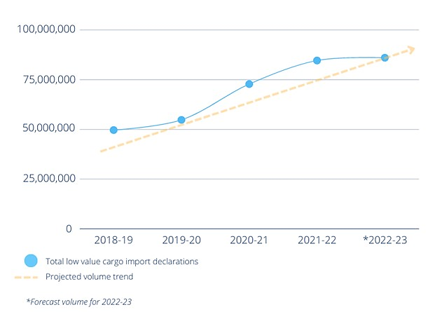

Factors driving change and the increased complexity of biosecurity threats
Box 1 describes some of the many factors driving changes across the biosecurity system which are contributing to the increased complexity of biosecurity threats.
Box 1 Factors driving change and increased complexity of biosecurity threats
Climate change is impacting the global environment, causing changes in weather patterns and more extreme weather events. It is altering the habitat, range and distribution of many pests, weeds and diseases, as well as increasing their ability to spread and establish in new areas. This has seen an increase in seasonal pests such as brown marmorated stink bug (BSMB).
BMSB utilise a very wide range of hosts and affects many plants, particularly tree nuts. While originally from eastern Asia, it has recently been introduced to North America and Europe, quickly having a significant impact on agriculture. Given Australia’s broad range of trading partners and commodities imported, this is just one of many hitchhiker pests we need to be vigilant in monitoring and keeping out of our country.
Shifting trade and travel patterns have seen Australia’s supply chains and demand for goods change and increase in complexity, changing the pathways through which biosecurity risk enters our borders, impacting how we work with trading partners and each other.
Predicted increases in trade and vessel movements will result in a greater likelihood of the introduction of marine pests like Asian green mussel (Perna viridis), which poses a serious threat to our aquaculture, native species and ability to export seafood.
Changing land uses are altering the interface between urban and non-urban areas and the environment. As cities expand and scattered and dispersed urban growth increases, the risk of the introduction and spread of pests, weeds and diseases may also increase through land development, habitat loss and the movement of people and goods into new areas.
Illegal activity has increased in recent years, leading to a higher risk of biosecurity threats. The growth and increasing complexity of trade and online shopping – exacerbated by the COVID-19 pandemic – has inadvertently opened new pathways for illegal plants and animals to reach Australia.
Major global disruptions such as the COVID-19 pandemic, can shock supply chains and impact the movement of goods and people. While these changes are often temporary, they can act as a catalyst for permanent changes in behaviour and supply chain pathways. For example, many businesses, unsure of when goods might arrive, moved from purchasing ‘just in time’ to ‘just in case’ to ensure supply.
Further information about the changing and emerging biosecurity risk and the department’s strategic biosecurity future can be found in both the Commonwealth Biosecurity 2030 and The National Biosecurity Strategy.
Figure 2 Snapshot of biosecurity threats since 2016 to presents a snapshot of some of the key biosecurity threats the department has faced since 2016. This is not an exhaustive list; rather it highlights the importance of a strong biosecurity system. In addition to the threats managed across the 2022 calendar year the department identified in the order of 26,000 pest and disease incidents.
The impact of these threats on our response capability is dependent on the threat risk level and ranges from implementing programs for ongoing management, to being highly responsive – an immediate need to increase or divert resources from other biosecurity functions.
Responding to biosecurity threats does not come without a cost. The management of these threats can have long lasting consequences on the allocation of resources and place significant pressure on the department’s ability to respond to and manage these threats.
Figure 2 Snapshot of biosecurity threats since 2016 to 2023
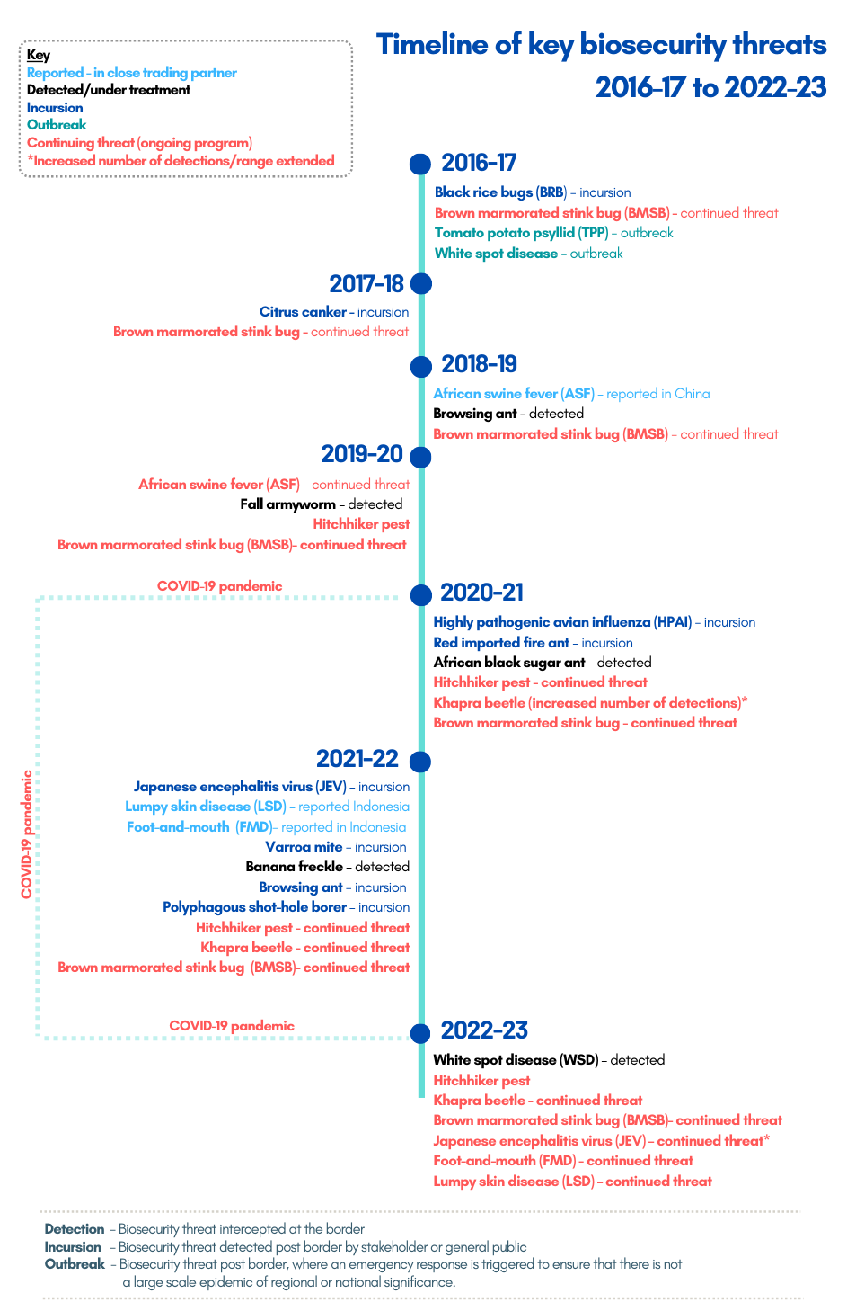

Risk creators
Participants in the biosecurity system – such as international travellers, those who import goods as cargo or receive goods through the mail pathway, those who operate conveyances (vessels and aircraft) – have the potential to introduce pests and diseases into Australia. In this context, all participants are ‘risk creators’ and drive the need for a strong biosecurity system.

Strengthening the biosecurity system
The current and future success of our biosecurity system relies on partnerships with stakeholders, working collaboratively and proactively towards a common goal – an effective biosecurity system which supports the sustainability, profitability and competitiveness of Australia’s agriculture, fisheries and forestry industries.
In addition to developing options to deliver a long-term sustainable funding model for biosecurity, the department continues to focus on collaboration and building strong partnerships with industry through a range of initiatives including (Box 2):
- compliance and assurance
- investment in self-service platforms
- improved risk management and detection techniques
- advances in science and technology
- enhancements to information management systems
- strengthening data analytics capability.
By undertaking these actions, together we build a fast and safe clearance process reducing the cost burden on industry. We must continue building on the examples described in Box 2.
Box 2 Examples of biosecurity reform, initiatives and benefits to industry
Approved arrangements – industry collaboration to manage risk
The establishment of new approved arrangement classes has provided opportunities for industry to adopt increased responsibilities for the management of biosecurity risks through the performance of activities using their own sites, facilities, equipment and people, with compliance monitoring provided by the department. This gives control to industry on how they manage risk and allocate resources to meet the department’s expectations.
Risk based compliance schemes – rewarding compliant behaviour
Industry is benefiting from the development of risk-based compliance schemes that move away from 100 per cent interventions and rewards industry participants with reduced need for inspection resulting in quicker clearance for compliant participants.
Self-service platforms – industry drive bookings
By using integrated self-service platforms across the department’s regulatory functions, industry benefits from real-time changes to their bookings to fit their schedules and minimise any downtime.
A consolidated Post Entry Quarantine (PEQ) – better risk management
A consolidation of post entry quarantine operations from 5 facilities across 4 states, means all imported animals and plants can complete their post entry quarantine at a single state-of-the-art facility. The new facility has greater capacity to manage biosecurity risk and is a central point of contact for stakeholders across commodities.
Science education partnerships – reduced quarantine times
These partnerships have resulted in the development of innovative diagnostics that reduce quarantine times and enables the extension of import permit validity periods. Industry benefits from shorter quarantine periods and a reduced need to renew import permits.
Diagnostics capability in the field – faster clearance
The introduction of devices that extends some of the diagnostics capability to the field, enabling faster pest identification and quicker clearance of goods for importers. The early detection of risks prevents additional cost and reduces disruption to importers and agricultural production.
Data and analytics – more accurate risk profiling
Strengthening our data analytics capability, data collection and information management systems that support risk-based compliance schemes, approved arrangements, and better management and allocation of resources, enables more accurate risk profiling. Departmental interventions only occur where they are needed. This reduces the impact on importers of low-risk commodities.
Enhancements to existing systems – more efficient clearance
Enhancements to the Maritime and Aircraft Reporting System (MARS) means pratique can be automatically granted when vessels arrive at 12 nautical miles from our shores. Management of non-commercial vessel data in MARS enables streamlining of the non-commercial vessel arrival process and better management of biosecurity threats posed by sea vessels. In addition, aircraft arrival information managed through MARS supports a more efficient clearance process for commercial aircraft.
Investment in our workforce – building a skilled, efficient and agile workforce
The establishment of the Biosecurity Training Centre to increase the department’s frontline capability. Industry benefits from increased capability that focuses on high-risk consignments and quickly clears commodities that are low risk.

Funding the biosecurity system
Options for a long-term sustainable funding model for biosecurity is being developed. Funding for biosecurity is delivered through a combination of government appropriation and regulatory charging via cost recovery through fees and charges.
The department is analysing the feedback it received during the recent stakeholder consultation on Sustainable funding and investment to strengthen biosecurity. This cost recovery review aligns to the government’s commitment to strengthening biosecurity work but relates to the current biosecurity cost recovery arrangement which is part of the overall sustainable funding model.

Cost recovery
The department commenced partial cost recovery of selected biosecurity activities in 1979 and full cost recovery from 1 January 1991 for activities within scope of the Australian Government Charging Framework.
Industry cost-recovery arrangements must be consistent with policy from the government and international trade law obligations, as well as domestic legislation. Our current fees and charges are established through biosecurity and imported foods legislation, set out in Appendix A: Biosecurity cost recovery charging framework.
The department determines appropriate regulatory cost recovery for biosecurity activities after establishing the activity costs and expected volumes. We use a combination of regulatory fees and charges depending on whether an activity is for a specific individual or organisation, or group of recipients.
- Fees are used to recover the costs of direct intervention and certification activities undertaken for particular importers or regulated entities, or a particular consignment.
- Charges are imposed when regulatory activities are provided to a group of individuals or organisations and help recover costs to manage the overall biosecurity system.
The costs recovered in delivering specific regulatory activities and the fees and charges to be applied to those activities, are set out in the department’s Biosecurity Cost Recovery Implementation Statement (CRIS).
Proposed fees and charges for 2023-24 are shown in Table 2 Comparison of current and proposed charges for biosecurity regulatory activities and Table 3.

The biosecurity cost recovery arrangement
The government charges the non-government sector for a range of regulatory activities by recovering some or all of the costs of those activities. Regulatory charging is appropriate for biosecurity activities because they are provided to a clearly identifiable group – individuals and organisations that participate in the biosecurity system and create the risks. This means the recipients or beneficiaries of biosecurity regulatory activity bear the costs, rather than the general public.
The department has authority for regulatory charging of biosecurity activities to prevent, respond to and recover from pests and diseases that threaten the economy and environment. We call our activities under this authority the biosecurity cost recovery arrangement.

Three streams
The biosecurity cost recovery arrangement is comprised of 3 streams that assist us in managing the related activities:
- Import Clearance
- Seaports
- Post Entry Quarantine (PEQ):
  - Horses
  - Non-horse - cats, dogs, ruminants, bees, hatching eggs and avian imports
  - Plants.

Four key user groups
We identify 4 key user groups across these streams that the department provides biosecurity activities to:
- Importers
- Conveyance (vessel and aircraft) operators
- Arrangement participants
- Passengers, to a limited extent.
Regulatory fees and charges apply to these groups when cost-recovered biosecurity activities are provided, as described in Table 4.
Table 4 Regulatory activities provided to user groups
User group | Regulatory activities
Importers | Inspection, assessment and management of the biosecurity risks associated with imported goods and packaging, including air and sea cargo, containers, international mail, food, live animals and plants.  This also includes husbandry activities associated with the quarantine of live animals and plants prior to release into Australia, such as horses, dogs, cats, hatching eggs, birds, ruminants, bees, nursery stock and viable seeds.
Conveyance operators | Vessels and aircraft entering Australia.  This includes assessments and inspections to manage the risks posed by the vessel itself, contaminants on the vessel, human biosecurity risks, ballast water and biofouling on vessels, and aircraft disinsection (where non-compliant on arrival) and assessment of aircraft for release from biosecurity control.
Arrangement participants | Managing the administration as well as policy, processes and conditions-setting for regulatory arrangements approved by the department, including biosecurity approved arrangements and imported food compliance agreements.
Passengers | Assessment and management of biosecurity risks posed by baggage accompanying passengers. Can also include the treatment and disposal of goods.  Inspection and assessment of baggage is only cost recovered when provided outside of designated international airports or seaports.

Regulatory activities
Regulatory activities are generally activities provided where the government seeks to control or influence behaviour, manage risk and/or protect the community.
The purpose of biosecurity regulatory activity is to manage biosecurity risk, safeguarding Australia’s animal and plant health status and protecting the economy and environment from the impact of exotic pests and diseases.
Biosecurity regulatory activities are grouped into 4 categories set out in Table 5.
Table 5 Regulatory activity categories
Category | Description
Program management and administration | Administrative activities that support us to deliver our biosecurity regulatory activities.
Assurance | Activities that mitigate risks to collective user groups by assessing departmental controls of systems and processes to ensure they operate in accordance with their intended design.
Incident management | Activities that respond to incidents concerning alleged breaches of Australian regulation or import conditions
Intervention | Activities provided directly to an individual, business or organisation to meet import requirements, such as inspection, audit or assessment of a permit application.
These categories are described in detail in Appendix A: Biosecurity cost recovery charging framework, in the Charge and fee related activities and associated outputs section.

Changing costs
The changing biosecurity environment has placed increasing pressure on the department to deliver regulatory activities and continue to manage biosecurity risk both efficiently and effectively. Like any other business, our costs have increased and we need to adjust our charges to meet the actual cost of delivering our activities.

Changes in the total cost of the biosecurity arrangement
In the 2015–16 financial year the total cost of the biosecurity cost recovery arrangement was approximately $226.7 million. Costs in 2023–24 are forecast to be $348.8 million, an increase over 8 years of over $122.1 million or 53.9%.
Some of this increase has been driven by additional activity funded through budget measures which the government has decided to cost recover, including:
- Expanded cost recovery for regulatory biosecurity activities on behalf of the Government ($23.0 million per annum from 1 January 2020), which changed the funding source of some biosecurity activities from government funding to cost recovery.
- Management of the biosecurity risk posed by hitchhiker pests arriving in imported cargo ($11.7 million in 2021–22, $18.0 million in 2022–23, $15.5 million in 2023–24).
For 2023–24, these measures make up $38.5 million of the total increase in forecast costs, leaving around $83.6 million as the increase on the 2015–16 effort required to manage biosecurity regulatory activities. This amount is a combination of:
- Inflation on all of our costs – salaries and wages for public servants and contractors, suppliers, consultants, ICT, utilities, rent – past prices have been modelled with little by way of inflationary measures so have not kept pace with actual inflation.
- Increased effort to manage the changing risk profiles – more staff managing more threats and more cargo that could contain those threats.
- Increased complexity in logistics – there are simply more things for us to consider, for example, when containers arrive with multiple consignments and multiple commodities.
- Changed approaches to biosecurity system management – the costs would be higher without some efficiency gains in our regulatory activities achieved through reform and innovation.
- Challenges from government policies limiting the number of public servants employed, often referred to as the FTE cap. Contractors have been used in the past to fulfil roles on both the frontline and in back-office support, however, we are slowing bringing more of these people into our FTE cap.
- Investment in technology and innovation to improve clearance times at the border, as noted in Section 5.3, comes with a cost once the projects are implemented.
The graphs in Figures 3, 4 and 5 are various views of the biosecurity cost recovery arrangement and how costs have increased over time.
Figure 3 Changes in biosecurity cost recovery arrangement costs
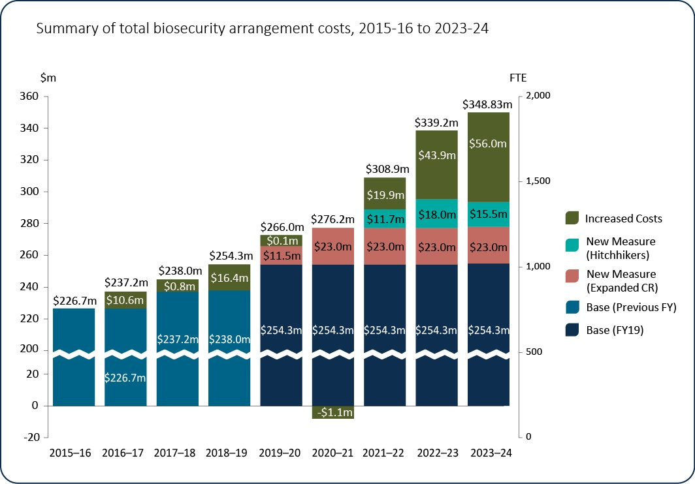
Figure 3 presents the changes in the total cost of the biosecurity cost recovery arrangement from the 2015–16 financial year through to 2023–24 financial year.
Indicated in the breakdown is the base cost of the biosecurity cost recovery arrangement, the costs associated with additional regulatory activities to implement new budget measures, and the increased costs for new effort due to the factors described earlier.
The additional $56 million indicated in 2023–24 represents the accumulated value of inflation and our additional effort required in response to the growth and complexity experience over the past 8 years.
Figure 4 Changes in biosecurity cost recovery arrangement costs by stream
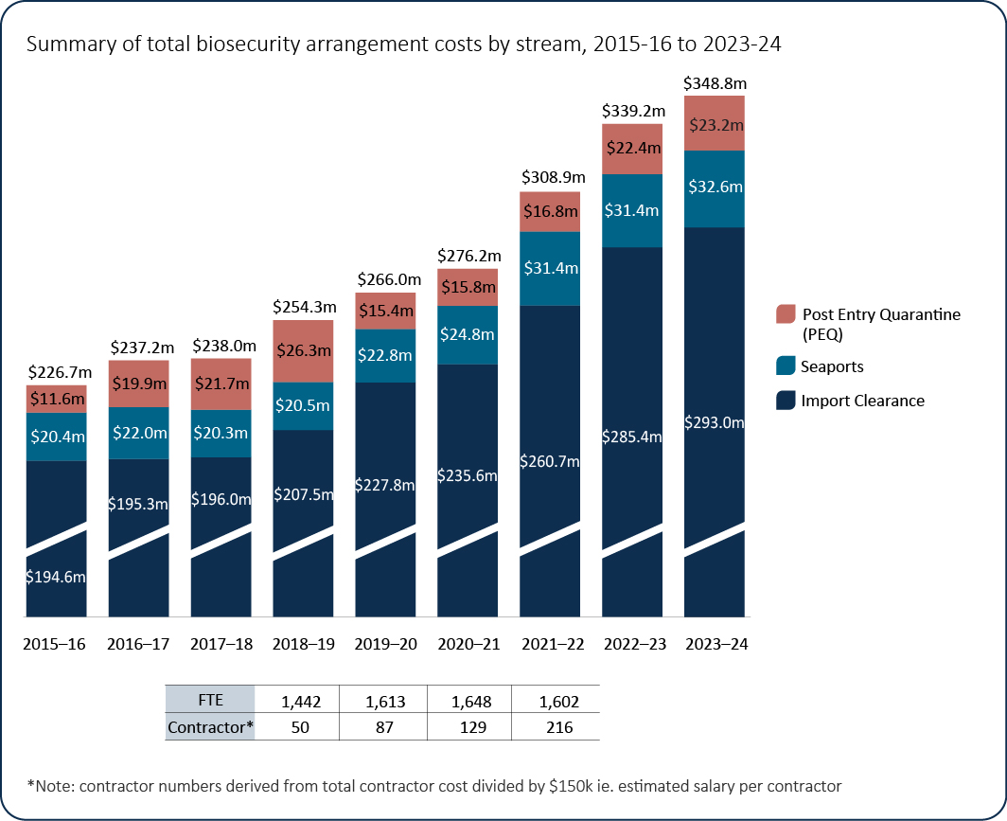
Figure 4 outlines the changes in costs and human resources across the biosecurity cost recovery arrangement streams since 2015–16.
An additional 170 full time staff were recruited in 2019–20, increasing the workforce from 1,442 to 1,613, or by 11.8%. At the same time, the contractor workforce also increased by 37 people, or 74%. These increases were needed to deliver the expanded cost recovered biosecurity activities measure described in section 7.1.
While the total departmental and contractor numbers have largely remained static, additional resources are still required to manage risks and meet standards for import clearance activities. Our challenge is to recruit, train and maintain new staff in a low unemployment environment.
Staffing will increase again in 2022–23 and 2023–24, but as we transition away from contractors to public servants, modelling for this will be included in a new CRIS.
Figure 5 Post entry quarantine cost by stream
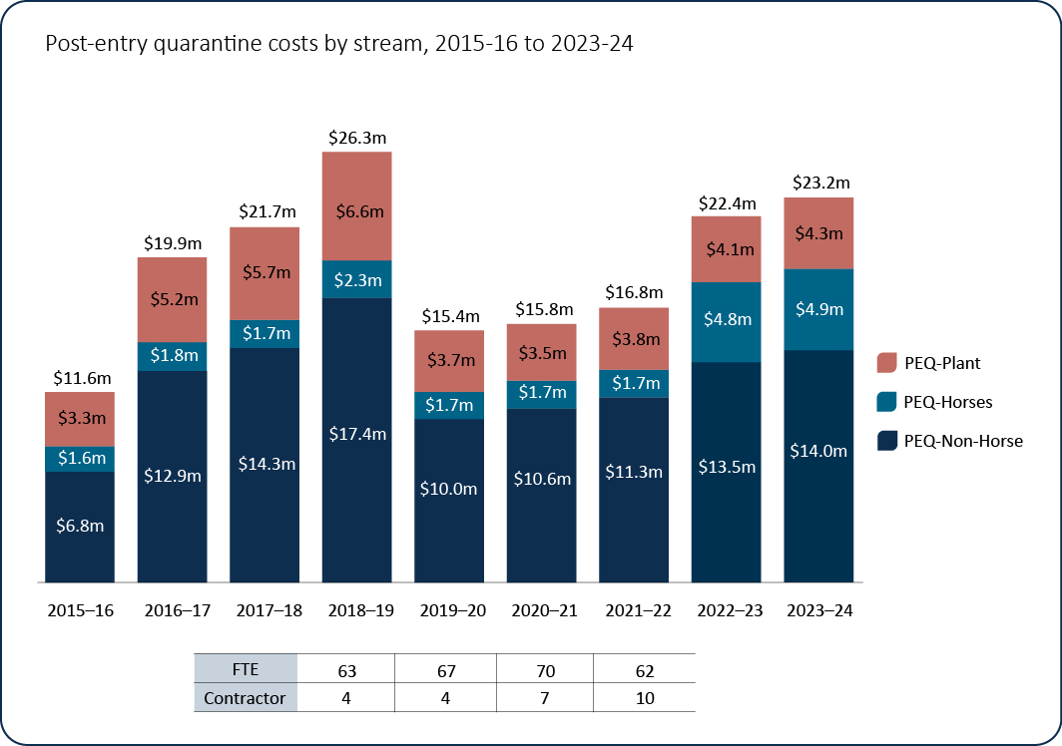
Figure 5 shows the movement in costs across the PEQ streams since 2015–16.
Prior to 2015, multiple PEQ facilities operated around Australia. The PEQ facility in Mickleham, Victoria was opened in 2015, marking the first stage of the department’s move to a single PEQ facility. In 2018, stage 2 was completed offering quarantine for imported plants and animal species, except for avian imports. The capacity to house avian consignments commenced later, with the first consignment of live birds arriving in 2019 and hatching eggs in 2020.
The significant decrease in costs evident from 2018–19 to 2019–20 reflects the transition and closure costs associated with consolidation of multiple PEQ facilities. However, our costs for the new PEQ continue to rise through supplier, utility and wage costs, plus the increased volume of plants and animals that are coming through the PEQ facilities post the height of the COVID-19 pandemic.

Current cost to deliver biosecurity regulatory activities
In 2023–24 the estimated total cost for the biosecurity cost recovery cost recovery is around $348.8 million, comprised of:
- $269.0 million in charge related activity
- $79.8 million in fee related activity
Table 6 shows the direct and indirect costs for regulatory charges and fees proposed for 2023–24.
Table 6 Biosecurity cost recovery arrangement cost breakdown, 2023–24
Cost recovery charges and fees | Direct costs ($) | Indirect costs ($) | Total ($)
Charges | 168,272,216 | 100,752,010 | 269,024,226
Full import declaration charges | 139,161,722 | 79,097,118 | 218,258,840
Approved arrangements and food import compliance agreements | 5,283,238 | 2,312,238 | 7,595,476
Vessel arrival charges | 14,509,884 | 9,927,669 | 24,437,553
Permit applications | 968,479 | 661,442 | 1,629,921
PEQ importation charge | 8,348,893 | 8,753,543 | 17,102,436
Fees | 75,577,356 | 4,226,310 | 79,803,666
Assessment | 28,869,946 | 1,366,528 | 30,236,474
Inspection | 36,779,726 | 2,516,560 | 39,296,286
Audit | 3,482,917 | 106,195 | 3,589,112
Husbandry | 3,850,121 | 132,597 | 3,982,718
Diagnostics | 2,594,646 | 104,430 | 2,699,076
Total | 243,849,572 | 104,978,320 | 348,827,892
Direct costs can be directly attributed to the provision of an activity, for example, inspections, audit and assessments. They comprise staff salaries and supplier costs including direct capital expenses, which includes plant, property and depreciation.
Indirect costs support the effective and necessary provision of our direct expense activity. Indirect expenses include corporate employee salaries and overheads such as information technology, finance, human resource costs, and indirect capital expenses, which includes plant, property and depreciation.

Changes in activity volumes
Since 2015 there has been an overall increase of almost 20% in the volume of biosecurity fee and charge related activities, aligning with the increased growth evident in the cost base since the 2015–16 financial year, shown in Figure 3.
Figure 6 and Figure 7 show the volumes of fee and charge related activity since 2015–16 and forecast to 2023–24.
Figure 6 Summary of the total volume of biosecurity charge-related activity
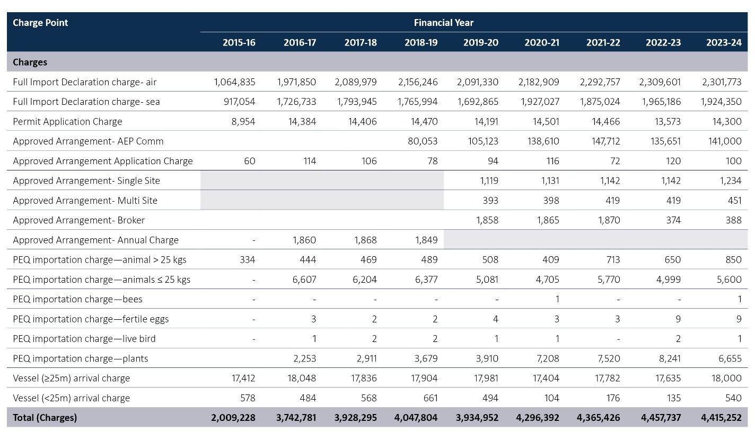
Greyed out areas show where there is insufficient data available to reflect true growth patterns.
A dash indicates nil volume.
The charge point breakdown does not include volumetrics for outside ordinary hours activity, part year approved arrangement charges, or consumables charged at cost.
2015–16 figures are indicative and represent half the 2015–16 financial year. 2015–16 was a transition year and prior to this, the biosecurity arrangement was separated into individual arrangements by stream.
Charging for approved arrangements were not categorised by number of sites or type of arrangements until 2019–20, which coincides with the removal of the annual charge.
Figure 7 Summary of the total volume of biosecurity fee-related activity
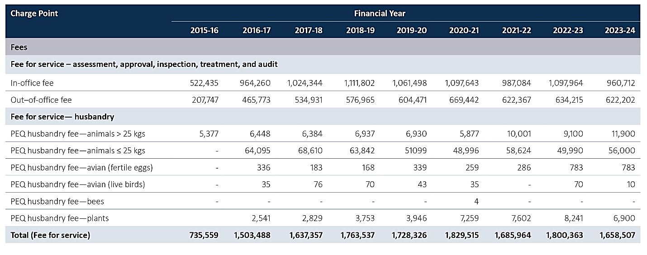 A dash indicates nil activity which means there is insufficient data available to reflect true growth patterns.
2015–16 figures are indicative and represent half the 2015–16 financial year.
2015–16 was a transition year and prior to this, the biosecurity arrangement was separated into individual arrangements by stream.

How will changed prices affect user groups?
This section sets out scenarios describing how the proposed price changes would be applied, comparing current and proposed fees and charges.

Importing cats
Sally is importing her 2 cats from the United Kingdom (Group 3 country) in a single consignment. An import permit is required for each animal. The cats must undergo all required pre-export checks and vaccinations as part of their import permit application process. These are provided by a third party, who Sally pays directly for this service. The department charges Sally for an application and assessment of 2 separate import permits (first cat and additional cat).
Sally books the cats into the PEQ facility. The cats and their paperwork are assessed at the PEQ facility on arrival, and they remain in PEQ for the scheduled 30 days. Sally’s fees and charges are described in Table 7.
Table 7 Change in cost for importing cats
Fees and charges | 2022–23 Current prices |  | Proposed prices
Import permit application (lodgement) | 2 x $120 | $240 | 2 x $122 | $244
Assessment of Category 4 permit application (first cat) | - | $360 | - | $444
Assessment of Category 2 permit application (additional cat) | - | $120 | - | $148
PEQ charge | 2 x $1,200 | $2,400 | 2 x $1,265 | $2,530*
In-office inspection  (Cats against permit conditions) | 2 x 2 x $30 | $120 | 2 x 2 x $37 | $148
In-office inspection  (Veterinary health check) | 2 x 2 x $30 | $120 | 2 x 2 x $37 | $148
Husbandry daily fee  (30 days x 2 cats) | 30 x 2 x $29 | $1,740 | 30 x 2 x $50 | $3,000
Total | - | $5,100 | - | $6,662
Total change in cost | - | - | - | $1562
*20% taken when booking made and is proposed to become non-refundable, balance payable when booking is confirmed.

Importing strawberries and associated husbandry in PEQ
Damien is importing 1 strawberry variety and requires 1 m² of space (1 m² of bench per cultivar) at the PEQ facility. The strawberries will need to be in PEQ for a minimum period of 12 months. Damien will need to pay for the lodgement and assessment of a permit in addition to inspection charges, plant monthly space, husbandry charges, and any testing charges. PEQ charges (excluding any testing charges) for this import are described in Table 8.
Table 8 Change in cost to import strawberries
Fees and charges | 2022–23 Current prices |  | Proposed prices
Import permit application (lodgement) | 1 X $120 | $120 | 1 X $122 | $122
Assessment of Category 2 permit application | - | $120 | - | $148
Inspection by biosecurity officer  (2 x ¼ hour units) | 2 x $30 | $60 | 2 x $37 | $74
PEQ Plant monthly charge  (1 m² x 12 months) | 1 x 12 x $110 | $1,320 | 1 x 12 x $291 | $3,492
Plant husbandry  (1 m² x 12 months x $20) | 1 x 12 x $20 | $240 | 1 x 12 x $60 | $720
Total | - | $1,860 | - | $4,556
Total change in cost | - | - | - | $2696

Operating 2 sites under an approved arrangement
Each year the business is audited a total of 4 hours for each arrangement. This includes 2 hours in-office and 2 hours out-of-office including the work undertaken in preparation for the audit and reporting after the audit is conducted. The fees and charges are described in Table 9.
Table 9 Change in cost to operate 2 sites under an approved arrangement
Fees and charges | 2022–23 Current prices |  | Proposed prices
Annual charge | - | $2,900 | - | $3,110
In-office Audit fee (8 x 15 minutes) | 8 X $30 | $240 | 8 X $37 | $296
Out-of-office Audit fee (8 x 15 minutes) | 8 X $50 | $400 | 8 X $62 | $496
Total | - | $3,540 | - | $3,902
Total change in cost | - | - | - | $362

Importing plant-based stockfeed from the Solomon Islands
A stock feed producer has lodged an import permit application for a plant-based stockfeed product from the Solomon Islands to be used in animal feed. The complexity of the application means that the time taken to assess and approve the permit is a total of 4 hours, which is longer than the expected 3 hours of assessment for a Category 4 permit. The fees and charges are described in Table 10.
Table 10 Change in cost to Import plant-based stockfeed from the Solomon Islands
Fees and charges | 2022–23 Current prices |  | Proposed prices
Import permit application (lodgement) | 1 X $120 | $120 | 1 X $122 | $122
Assessment of Category 4 permit application | 3 x $120 | $360 | 3 x $148 | $444
In-office assessment fee (one additional hour or 4 x ¼ hour units) | 4 x $30 | $120 | 4 x $37 | $148
Total | - | $600 | - | $714
Total change in cost | - | - | - | $114

Full Import Declaration and assessment by a biosecurity officer with inspection
Kim is importing a container of rice. She submits documents to the department for assessment. It takes 8 minutes for the biosecurity officer to conduct the in-office assessment. An inspection of the rice is required. Kim books an appointment for an inspection at her warehouse. There is no officer permanently stationed there and the inspection takes 25 minutes. The fees and charges are described in Table 11.
Table 11 Change in cost when a FID, assessment and inspection is required
Fees and charges | 2022–23 Current prices |  | Proposed prices
Full import declaration charge – sea | - | $58 | - | $63
In-office assessment fee  (1 x ¼ hour unit) | 1 x $30 | $30 | 1 x $37 | $37
Out-of-office inspection fee  (2 x ¼ hour units) | 2 x $50 | $100 | 2 x $62 | $124
Total | - | $188 | - | $224
Total change in cost | - | - | - | $36

Importing a consignment of used vehicles
RefurbAuto imports a consignment of containerised used vehicles with parts and used spare tyres. On arrival, the vehicles are directed to an approved arrangement site for inspection that takes 4 hours. One of the vehicles is contaminated and requires treatment at the site. The vehicle is re-inspected after it is cleaned which takes 30 minutes. RefurbAuto’s fees and charges are described in Table 12.
Table 12 Change in cost when importing a consignment of used vehicles
 | 2022–23 Current prices |  | Proposed price
Full import declaration charge – sea | - | $58 | - | $63
In-office assessment fee  (AIMS document, 1 x ¼ hour unit) | 1 x $30 | $30 | 1 x $37 | $37
Out-of-office Inspection  (4 hours x ¼ hour units) | 16 x $50 | $800 | 16 x $62 | $992
Out-of-office Inspection  (Re-inspection of vehicle, 2 x ¼ hour units) | 2 x $50 | $100 | 2 x $62 | $124
In-office assessment fee  (closing AIMS entry, 1 x ¼ hour unit) | 1 x $30 | $30 | 1 x $37 | $37
Total  - | - | $1,018 | - | $1,253
Total change in cost  - | - | - | - | $235

Commercial vessel arriving to load
A bulk coal vessel is arriving in Newcastle to load export coal. It is classed as a commercial vessel.
The agent has submitted a Pre-Arrival Report, and Ballast Water Report in the Maritime and Aircraft Reporting System (MARS). MARS advises the vessel through the Biosecurity Status Document (BSD) that three of the tanks are ineligible for discharge.
The agent contacts the National Maritime Centre (NMC) to assist with rectifying the ballast issues prior to submission of a second ballast water report. This takes 15 minutes and is charged by the NMC. A Routine Vessel Inspection (RVI), Crew Change, Human Health and Waste Inspection were automatically created in MARS.
The officers prepare for the inspection and creates the appointment in MARS prior to leaving the office. This takes 15 minutes. The RVI inspection including the ballast water verification, human health, crew change, waste surveillance and landing order was completed in 2 hours and 15 minutes. The fees and charges that apply are described in Table 13.
Table 13 Change in cost for a commercial vessel arriving to load
 | 2022–23 Current prices |  | Proposed prices
Vessel other than a non-commercial vessel arrival charge | - | $1,054 | - | $1,354
In-office assessment fee  (2 x 15 minutes) | 2 X $30 | $60 | 2 X $37 | $74
Out-of-office inspection fee  (9 x 15 minutes) | 9 x $50 | $450 | 9 x $62 | $558
Total | - | $1,564 | - | $1,986
Total change in cost | - | - | - | $422

Importing horses
An international horse transportation company is importing 40 horses from Europe with 3 countries of origin. The importer or their agent will submit an import permit application based on the number of horses arriving from the same country of origin. All horses within the consignment undertake pre-export checks and vaccinations prior to export. The department applies a fee for the assessment of each import permit application.
The importer or their agent books the horse consignment into the PEQ facility*. Each horse and their paperwork are assessed on arrival, and the consignment remains in post entry quarantine for the minimum 14-day period. The fees and charges are described in Table 14.
Table 14 Change in cost to import horses
 | 2022-23 Current prices |  | Proposed prices
Import permit application (lodgement) | 3 x $120 | $360 | 3 x $122 | $366
Assessment of category 4 permit application | 3 x $360 | $1,080 | 3 x $444 | $1,332
PEQ Booking assessment fee | 1 x $30 | $30 | 1 x $37 | $37
PEQ Reservation charge (20% of PEQ importation charge) | - | - | 40 x $1014^ | $40,560
PEQ Importation charge (proposed price, remaining 80%) | 40 x $3,000 | $120,000 | 40 x $4,054^ | $162,160
Husbandry daily fee (14 days) | 40 x 14 x $60 | $33,600 | - | $0
Total | - | $155,070 | - | $204,455
Total change in cost | - | - | - | $49,385
*20% of PEQ Importation charge, taken when booking made and is proposed to become non-refundable.
^proposed PEQ Importation charge per horse is $5,068 (20%=$1,014, 80%=$4,054).
Note: A husbandry fee of $44 per day is proposed to apply for horses that ‘overstay’ the initial 14-day period at PEQ.
Additional fees will apply for any additional test, disposal and/or equipment required during the quarantine period.

Appendix A: Biosecurity cost recovery charging framework
The Australian Government Charging Framework applies to all new and existing charging activities and relates to regulatory charging activities, and charging activities involving access to public resources, infrastructure and/or equipment.

Policy and statutory authority to cost recover
Under the Australian Government Charging Framework, regulatory charging requires both government approval and statutory authority. The following section provides information on government approval of regulatory charging for biosecurity activities and the legislation that enables us to collect fees and charges.

Statutory authority
Fees and charges for biosecurity regulatory activities are recovered under separate statutory authorities which are set out below.

Fees
The Biosecurity Act 2015 is the primary biosecurity legislation in Australia. The Imported Food Control Act 1992 is the primary food importation legislation. Subordinate legislation and supporting policies affect the management of ballast water, approved arrangements and import risk analysis.
The Biosecurity Regulation 2016 provides fees for different biosecurity regulatory activities. Section 592 of the Biosecurity Act 2015 states that fees charged in relation to activities carried out by, or on behalf of the Commonwealth, are to be prescribed in regulations made under the Act.
The Imported Food Regulations 2019 provides fees for different chargeable services. Section 36 of the Imported Food Control Act 1992 states that fees charged in relation to certain chargeable services, are to be prescribed in regulations made under this Act.

Charges
Charges are imposed through specific biosecurity, imported food charging acts, and associated delegated legislation, which provide powers to impose and collect charges for biosecurity and imported food regulatory activities.
- Biosecurity Charges Imposition (Customs) Act 2015
- Biosecurity Charges Imposition (Excise) Act 2015
- Biosecurity Charges Imposition (General) Act 2015
- Imported Food Charges (Imposition—Customs) Act 2015
- Imported Food Charges (Imposition—Excise) Act 2015
- Imported Food Charges (Imposition—General) Act 2015
- Imported Food Charges (Collection) Act 2015
Specific charges are prescribed in the Biosecurity Charges Imposition (Customs) Regulation 2016 and the Biosecurity Charges Imposition (General) Regulation 2016.
Specific charges are prescribed in the Imported Food Charges (Imposition—Customs) Regulation 2015 and the Imported Food Charges (Imposition—General) Regulation 2019.

Determining the cost of regulatory charging
The department uses an activity-based costing (ABC) system to determine the cost of biosecurity regulatory activities. The ABC allocation methodology reflects effort incurred in delivering regulatory activities to an individual or entity.
There are 2 expense categories used to calculate cost, direct and indirect.
- Direct costs can be directly attributed to the provision of an activity, for example, inspections, audit and assessments. They comprise staff salaries and supplier costs including direct capital expenses, which includes plant, property and depreciation.
- Indirect costs support the effective and necessary provision of our direct expense activity. Indirect costs include corporate staff salaries and overheads for services such as information technology, finance, human resources, and indirect capital expenses, which includes plant, property and depreciation.

Allocation of costs
The cost allocation process apportions indirect and direct costs to the processes and activities set out in Figure A1 Charge and fee related activities and associated outputs. Indirect costs are included in the cost base to reflect the systems and processes that assist with administration, which the cost recovered arrangement benefits from. The same methodology is applied to allocate indirect costs to activities funded by budget appropriation, in line with our internal cost allocation policy.
The ABC system allocates costs in a staged approach. The steps are:
- Indirect costs are allocated to direct cost centres using a cost driver that estimates the relative use of each activity.
Cost drivers for corporate activities are described in Table A1.
Table A1 Cost drivers for corporate activities
Cost driver | Description
Workpoints | Distributes costs based on space occupied, with the workpoint count reflecting the space where a person may be able to work.
FTE | Distributes costs based on each program's full-time equivalent staff numbers.
PC count/IT assets | Distributes costs based on the number of IT assets in a program.
Transactions | Distributes costs based on the number of transactions incurred over a period.  This driver is used to allocate expenses related to accounts receivable and accounts payable functions.
Headcount | Allocates costs based on the number of staff a program area has as a proportion of the total number of the department’s total staff.
Custom drivers | Allocate costs to specific cost centres, primarily based on usage for shared program resources.
Cost drivers are reviewed on an annual basis, or as required. Changes to direct cost drivers are substantiated through effort or other data.
- Direct costs (which now include the indirect costs allocated in step 1) are allocated to the activity and cost recovered arrangements that best reflect the activity undertaken. Time recording systems allow the accurate allocation of effort to specific activities and arrangements, particularly intervention activities.
The primary variable used in the allocation of costs to a specific activity is effort. As a result, cost estimates vary with changes in activity. If actual activity levels change significantly during a financial year, the costs allocated to the biosecurity arrangement may require adjustment to realign effort.
- Activity/arrangement costs from step 2, are allocated to charge points that identify the cost associated with that charge. A combination of regulatory fees and charges is used.
Figure A1 shows how we attribute cost recovered activities to either charges or fees.
Figure A1 Charge and fee related activities and associated outputs
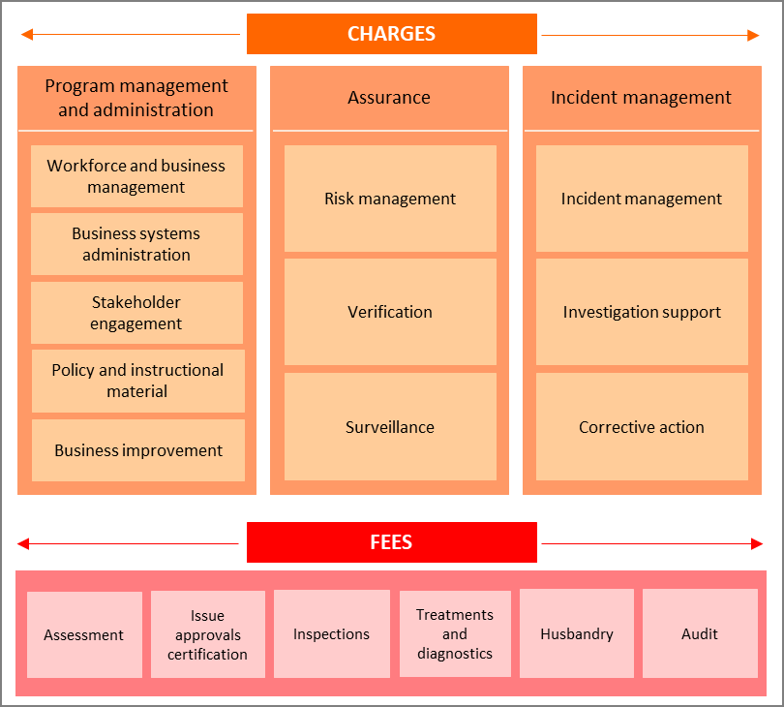

Charge and fee related activities and associated outputs
This section describes the charge and fee related biosecurity activities the department provides to individuals or groups.
Box A1 Program management and administration activities (charge)
Workforce and business management
This activity comprises 4 categories:
- Workforce management activities include staff supervision, allocating workforce resources, managing employee performance, leave, training and other conditions, managing Work, Health and Safety requirements, recruitment and termination.
- Business management activities include business planning and continuity, requesting legal advice, procurement and contracts, program and project administration, assurance, design and management, management of fixtures, facilities, equipment, supplies and logistics.
- Financial management activities include billing and accounting, budgeting, charges and payments, collections and receivables, debt management, financial accounts, reporting and policy development.
- Information management activities include data management, information and records management, and information sharing and collaboration.
Business systems administration
Includes developing, acquiring, testing, implementing and supporting applications and business systems. It encompasses technical support and maintenance of all business systems including information and communication technology.
Stakeholder engagement
Involves proactive engagement with any person, business, or organisation including any associated travel. This includes, engaging with peak industry bodies, secretariat support and attendance at industry consultative committee meetings, consultation on new standards and requirements, publishing website content and other information.
Policy and instructional material
Includes developing, maintaining and communicating our policy and instructional material, such as operational and corporate policies, scientific advice, guidelines and work instructions, and associated training development and delivery. Examples include developing or revising policy, processes and developing new instructional material.
Business improvement
Includes assessment, monitoring and development of initiatives to improve performance. Examples include adjustments to improve program and service delivery, business performance reports against key performance indicators and similar activities.
Box A2 Assurance activities (charge)
Risk management
Involves assessing and managing the risks posed to Australia’s biosecurity and imported food systems. This includes communicating results of risk analysis, modelling and forecasting to operational areas and the collection, receipt and use of data, information and intelligence to meet our compliance objectives. This work also includes any associated travel and client assistance work, such as assessment of risks associated with cargo, vessels, plants, animals, food, biological and genetic material.
Verification
Includes activities that provide our executive and stakeholders with confidence that our systems and processes are operating in accordance with their intended design and associated documentation and managing the identified risk. For example, internal quality assurance systems and verification activities to ensure officers are following procedures, processes or instructional material and are making appropriate decisions.
Surveillance
Includes formal and informal monitoring to detect changes in Australia’s pest or disease status, or the presence of food safety concerns which may affect imports and onshore production. Surveillance differs from an inspection as it is not conducted for a specific client.
It includes all pre and post work, travel and client assistance in relation to surveillance. Examples include deploying detector dogs, wharf surveillance, vector monitoring at first points of entry, new car surveillance, break bulk surveillance, monitoring the entry of exotic pests, weeds and disease across passenger and cargo pathways, monitoring of animal welfare issues and monitoring for microbiological or chemical hazards in food.
Box A3 Incident management activities (charge)
Incident management
Includes the department’s effort in the coordination and management of any incident including post-border detections and biosecurity and imported food incidents. This includes all associated pre and post work, travel and client assistance in relation to an incident. It excludes cost-sharing for emergency responses under the formal national disease and pest response arrangements.
Investigation support
Involves providing support for enforcement activities relating to an alleged breach of portfolio legislation, including any related client assistance and travel. It does not include the work of the enforcement officers. Examples of investigation support include data extraction and analysis to support an investigation.
Corrective action
Includes actions taken in response to non-compliance with or contravention of legislation or procedures that are managed without a formal investigation by an Enforcement officer. Corrective action activities include advice and support to operational staff and clients on the management of non-compliance and the development of options to effectively manage the risk.
Box A4 Intervention activities (fee)
Assessment
Involves assessing information to determine if it meets the department’s requirements. This includes the assessment of import-related documentation for cargo, vessels, plants, animals, food, biological and genetic material, including administration of applications.
Issue approvals and certification
Includes issuing of a decision in relation to an assessment for cargo, vessels, plants, animals, food, biological and genetic material. This includes the work from the end of the assessment period to the completion of the decision-notification process.
Inspection
Includes the physical examination and supervision of a physical examination, of cargo, vessels, plants, animals, food, biological and genetic material, to determine compliance with biosecurity and food safety requirements. Inspections also include activities related to post-quarantine detections of biosecurity-risk goods.
Treatments
Includes the physical treatment of cargo, vessels, plants, animals, food, biological and genetic material, other conveyances or premises, to prevent an adverse biosecurity outcome from occurring.
Husbandry
Includes activities relating to the care of plants and animals that we are responsible for, including transport of plants and animals, housing, daily monitoring, feeding, cleaning of facilities, administering of medication, bookings and client assistance.
Audit
Includes the examination of industry systems and processes to determine whether activities and related results comply with regulatory requirements. This includes desktop audits, remote audits, site audits, reviews of standard operating procedures for new and existing approved arrangement sites, overseas manufacturing facilities and pre-export quarantine facilities and their procedures.

Appendix B Government approval to cost recover
Table 1B describes the key Government approval for continued and expanded regulatory charging for biosecurity activities since 2017.
Table B1 Government approval for continued and expanded regulatory charging for biosecurity activities
Date of decision | Government decision
May 2021 | Better manage the risk of hitchhiker pests and diseases Importers  Government committed $96.9 million over 4 years to better manage the risk of hitchhiker pests and diseases that can cause considerable cost and disruption to agricultural production, the environment, and the way of life of all Australians.  The program addresses the risk of major hitchhiker pests, for example khapra beetle and brown marmorated stink bug, which can be carried in and on containers and their contents (around 2.5 million containers arrive each year).  Commencing 16 January 2023, the Sea FID increased from $49 to $58.
November 2019 | Expansion of cost recovered regulatory activities  Government decided to expand cost recovered regulatory activities to include $23.0 million per year of biosecurity activities. These directly relate to our regulatory framework.  From 1 January 2020 regulatory activities included in regulatory charges were expanded to include:  - Assurance and verification activities to provide confidence in compliance controls and support enforcement of regulation, contributing to the efficiency and effectiveness of the biosecurity system that facilitates importers to bring goods safely into Australia. This activity included:  - applying best practice regulatory procedures and monitoring their implementation to verify ongoing effectiveness of regulatory activity  - implementing and maintaining a decision-making tool that allows us to calculate benefits and risks of change in regulatory activity  - investigations of importer compliance with biosecurity regulation to maintain the integrity of the system, including provision and monitoring of corrective actions.  - Increased analytics and intelligence activities, including the use of data to identify trends to inform intervention and compliance activities. This was intended to minimise the risk of incursions and prevent harm to Australia’s agricultural production and environment. These activities included:  - the application, maintenance and refinement of algorithms and work processes that analyse biosecurity data and inform coordination of biosecurity risk management measures and compliance controls. The intelligence helps us identify which imports are most likely to expose Australia to exotic pests and/or diseases.  - This allows for more targeted risk management activities that streamline the border experience for importers and reduces intervention with importers with minimal risk.  - The provision of technical and scientific advice to maintain up to date biosecurity risk management information within our Biosecurity Import Condition (BICON) system. Through BICON, we provide a single source of truth for biosecurity officers and importers to identify goods quickly and easily, relevant import conditions and further biosecurity risk management options for the safe import of goods.  - Import pest and disease risk mitigation planning, which ensures that we have the capability to mitigate the impact of pest and disease incursions that result from the import of goods. The activities include the development and maintenance of risk mitigation processes and plans, including the maintenance of the capability required to implement actions in those plans, which facilitates the import of goods. Importers will be able to either choose to rely on publicly available plans or choose to develop their own plans subject to the department granting a permit.  The effect of this decision to expand cost recovery for biosecurity activities was an increase in 4 charges:  - Full Import Declaration charge—air was $33, to $38.  - Full Import Declaration charge—sea was $42 to $49.  - Vessels greater than or equal to 25 metres—arrival charge was $920, to $1054.  - Vessels less than 25 metres—arrival charge was $100, to $120.
October 2018 | Charging for approved arrangements  Government approved a change to regulatory charging for biosecurity-approved arrangements. As part of this change, a new throughput charge was introduced, together with remissions for the annual charges payable by some industry participants.  The new throughput charge applies to each entry made under the Automatic Entry Processing (AEP) for Commodities (AEPCOMM). A rate of $18 is charged for each entry by a person covered by an approved arrangement, for goods to be brought or imported into Australian territory.  The annual charge for biosecurity-approved arrangements is set at $2,900 per year. As part of the introduction of the throughput charge, the annual charges payable for some industry participants have been able to be reduced by remission. Biosecurity approved arrangements operated at a single site – $2,500 Biosecurity approved arrangements operated as an AEP Broker only – $500. These operators will also pay a throughput charge of $18 for each AEP entry they process.
May 2017 | Vessel arrival charge  As part of the 2017–18 Budget measures the Government directed us to increase the international vessel arrival charge to address the volume forecast and cost recover the expenses of the expanded ballast water biosecurity activities.  The international vessel arrival charge for vessels over 25 metres in length increased from $720 to $920, with effect from April 2018.

References
DAWE, 2021 Commonwealth Biosecurity 2030 (PDF 5.7 Mb), Department of Agriculture, Water and the Environment, Canberra, May 2021, accessed 14 February 2023.
Greenville, J 2023, La Nina’s last hurrah as drier conditions expected ahead, media release, Department of Agriculture, Fisheries and Forestry, Canberra 7 March 2023, accessed 9 March 2023.

